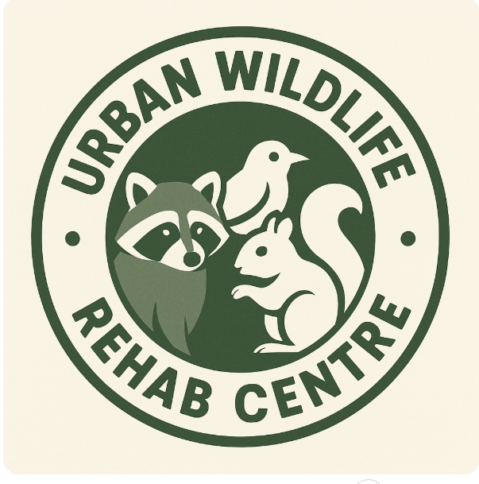
BUSINESS PLAN
Urban Wildlife Rejuvenation and Rehabilitation Centre

Kirsty Lloyd-Truslove
Business & Management 2025
Sustainable Enterprise BMSE4010

Executive Summary
A new service called ‘Urban Wildlife Rejuvenation and Rehab Centre’ is committed to offering creative and long-lasting solutions to the problems facing wildlife in cities. Through eco-friendly products, education, and sustainable habitat management techniques, we hope to foster peaceful coexistence between wildlife and urban dwellers. UWRRC aims, objectives, resources, marketing plan, and financial projections are all described in this business plan.

Description of Business
The Urban Wildlife Rejuvenation and Rehab Centre (UWRRC) is a facility focused on nurturing and protecting wildlife in urban areas. Its primary mission is to rescue, rehabilitate, and release injured, orphaned, or displaced animals back into their natural habitats. By providing medical care and safe recovery environments, the centre ensures that urban wildlife thrives among the challenges of city life.
As well as rehabilitation, the centre plays a crucial role in adopting coexistence between humans and wildlife. It will achieve this through public education programs, community partnerships, and conservation initiatives aimed at restoring natural spaces in urban environments. Whether it's planting native trees or raising awareness about humane practices, the centre is committed to creating a harmonious balance between urban development and ecological preservation.

SMART Objectives
Specific
- Create rehabilitation facilities that can treat and release at least 100 injured animals annually.
- Develop an educational program about urban wildlife conservation for schools in Carmarthen.
Measurable
- Achieve an 80% success rate in treating and releasing wildlife within the first two years.
- Increase public awareness and engagement by hosting 10 conservation workshops in the first year.
Achievable
- Partner with local business’ and secure funding to cover operational costs for the first three years.
- Recruit and train 20 volunteers within six months to support daily operations.
Relevant
- Support biodiversity in Carmarthen by planting 500 native trees and shrubs in urban green spaces over three years.
- Reduce conflicts between humans and urban wildlife by creating at least 5 educational campaigns on cohabitation tips.
Time-bound
- Open the centre within 12 months and launch initial wildlife care programs within 3 months of opening.
- Publish a quarterly report tracking rehabilitation success and conservation efforts.

  - Mission Statement
Our mission is to rescue, rehabilitate, and release urban wildlife, stimulating coexistence and fostering compassion for all living beings.
  - Vision Statement
Our vision is to create a world where urban wildlife thrives harmoniously alongside human communities, with every animal receiving the care and respect it deserves.
Physical Resources
- Facility: A building with specialized areas, such as animal treatment rooms, quarantine zones, holding cages, and rehabilitation enclosures.
- Equipment: Veterinary tools (e.g surgical kits, diagnostic devices), animal transportation carriers, feeding supplies, cleaning materials, and habitat enrichment items.
- Technology: Computers for record-keeping, monitoring systems (CCTV for animal observation), and any research-related equipment.
- Outdoor Space: Secure, naturalistic enclosures for rehabilitation and a garden or green space for ecological restoration projects.
Human Resources
- Veterinarians: Skilled professionals for medical care and treatment of injured animals.
- Rehabilitation Experts: Specialists trained to help wildlife regain their independence.
- Support Staff: Administrative staff to handle paperwork, manage funding, and coordinate programs.
- Volunteers: Community members assisting in tasks like cleaning, feeding, and outreach.
- Educators: Individuals to lead conservation workshops, public engagement, and awareness programs.
Financial Resources
- Startup Costs: Securing the facility, renovating spaces, and acquiring initial equipment.
- Operational Costs: Regular expenses, such as staff salaries, utilities, maintenance, food, and medical supplies.
- Funding Sources: Grants from environmental organizations, crowdfunding, sponsorships, and potential revenue from educational programs or merchandise sales.
- Emergency Fund: Budget for unexpected expenses, such as rescue missions or specialized equipment.

Business Description

Ownership
Urban Wildlife Rejuvenation and Rehab Centre will be a privately owned organization founded by a group of wildlife enthusiasts and veterinarians. The ownership structure includes a board of directors to oversee the strategic direction and ensure adherence to our mission and vision statements.

Location
The centre will be in the heart of a city to ensure easy access for both the wildlife and the community. The location is chosen based on factors such as proximity to green spaces, ease of transport for injured wildlife, and accessibility for volunteers and visitors.

Hours of Operation
We plan to operate 24/7, with staff and volunteers working in shifts to provide constant care and support to the animals. This round-the-clock operation ensures that we can respond to wildlife emergencies at any time.

Third-Party Contracts with Charities
We plan to work with local and national wildlife charities, using their expertise and resources to enhance our operations. Alliances will include cross-promotion, joint fundraising efforts, and shared volunteer programs. By collaborating alongside charity’s, we would be able to raise funding and resources, share expertise, expand our volunteer network, engage with the community. By partnering with charities, it could lead to joint workshops and educational opportunities. A Memorandum of Understanding would be created to clearly outline the goals and responsibilities for a strong and productive collaboration.

Marketing Section
Primary Research
I conducted a questionnaire on Urban Wildlife Rejuvenation and Rehabilitation Centre’s and what people think they’re usage would be of such service, and whether they are aware of any current business’ that provide similar services. These were the results I found from 8 people’s responses -
QUESTIONAIRE SEE APPENDIX – Figures 1-7

Secondary Research
Studies indicate a growing public awareness and concern for urban wildlife, with many people willing to support initiatives that protect local animals. The demand for wildlife rehabilitation centres in urban areas is increasing due to habitat loss and human-wildlife conflicts. Research data from environmental organizations show a 20% increase in urban wildlife incidents over the past five years. Additionally, surveys indicate that 75% of urban residents support the establishment of wildlife rehabilitation facilities.
The usage of Urban Wildlife Centres can vary on location, population and public awareness.
When researching, a study on hedgehogs that were admitted to RSPCA wildlife centres shows that survival rates improved by 26% over a 13-year span. Young hedgehogs had a higher survival rate of 33% compared to the adults.

SWOT ANALYSIS
Strengths
- Few centres in urban areas focus on wildlife care, making your service stand out.
- Dedication from staff and volunteers who share a love for wildlife and conservation.
Weaknesses
- Significant funding required for facilities, equipment, and staff salaries.
- Reliance on continuous financial support from donors or grants to sustain operations.
- A potential shortage of trained staff or volunteers for specialized tasks.
Opportunities
- Increased public and corporate interest in eco-friendly initiatives provides opportunities for partnerships and funding.
- Introducing workshops and tours can raise awareness and generate additional revenue.
Threats
- Other non-profits and environmental causes may compete for the same grants and donations.
- Handling wildlife may pose health risks if not managed properly, requiring strong safety protocols.
- Negative perceptions of urban wildlife (e.g pests) could hinder community support.

PESTEL Analysis

Political
Government policies on wildlife protection and rehabilitation can significantly impact operations. Supportive policies can provide grants and subsidies, while restrictive regulations may pose challenges.

Economic
Economic conditions directly affect funding and donations. A healthy economy encourages generosity, while economic downturns may reduce the financial support we receive. Our plan is to mitigate this risk by diversifying our funding sources, including grants, donations, sales and fundraising events.

Social
Increasing public concern for wildlife welfare push the demand for our services. Educational outreach and community engagement can further enhance support. We aim to adopt a culture of wildlife conservation through public talks, workshops, and school programs.

Technological
Advancements in veterinary medicine and wildlife tracking technology can improve our rehabilitation success rates and operational efficiency.

Environmental
Climate change and habitat destruction is the push needed for wildlife rehabilitation.

Legal
Compliance with wildlife protection laws and regulations is mandatory. Keeping above the legal changes ensures smooth operations.

Market Segmentation
Our target market includes:
- Animal lovers and wildlife enthusiasts who are passionate about conservation and willing to support our cause through donations and volunteering
- Urban residents concerned about local wildlife and interested in learning how to coexist peacefully with urban fauna
- Schools and educational institutions seeking wildlife programs to educate students about wildlife conservation and environmental stewardship
- Environmental organizations and activists looking for collaboration opportunities to enhance their impact on wildlife conservation
Marketing Mix
Here’s a marketing mix (the 4Ps) tailored for your Urban Wildlife Rehabilitation Centre:
Product
- Core Service: Wildlife rescue, rehabilitation, and release.
- Additional Services: Conservation education programs, workshops, and public awareness campaigns.
- Unique Features: Focus on urban wildlife, specialized facilities, and community engagement initiatives.
Price
- Free Services: Rescue and rehabilitation offered at no cost to the wildlife.
- Paid Programs: Nominal fees for educational workshops, guided tours, or training sessions.
- Flexible Funding: Donation options and crowdfunding campaigns to allow supporters to contribute within their means.
Place
- Physical Location: A central, accessible location in Carmarthen for easy community engagement and animal drop-offs.
- Online Presence: A website and social media platforms for information, updates, and fundraising campaigns.
- Outreach: Local events, schools, and urban spaces to promote awareness.
Promotion
- Community Engagement: Organize local events, such as tree planting days or open house tours of the centre.
- Digital Marketing: Leverage social media, blogs, and email newsletters to reach wider audiences.
- Media Coverage: Partner with local newspapers or TV channels to highlight your mission and success stories.
- Collaborations: Partner with environmental organizations and schools to expand reach.
- Branding: Develop a strong, relatable brand identity with an engaging logo and tagline.

Competition
Other veterinary clinics, animal shelters, and wildlife rehabilitation facilities compete with us. Every one of these rivals has special advantages that might overlap with what we offer. But we stand out thanks to our distinct urban focus, extensive rehabilitation programs, and effective community engagement tactics.
The service life cycle for an Urban Wildlife Rehabilitation Centre
Introduction Stage
Planning and Launch: Establishing the centre, securing funding, developing facilities, and recruiting a skilled team.
Growth Stage
Rescue situations and community involvement increase as the centre becomes more well-known. introducing additional initiatives, including specialised habitat restoration projects or cutting-edge veterinary care. boosting one's web presence and gaining media recognition to draw in more funds and support.
Maturity Stage
A reputable facility that effectively manages a steady stream of animal cases. putting into practice best methods in habitat restoration, education, and rehabilitation. becoming a valued member of the community who is trusted for its knowledge and influence.
Renewal/Innovation Stage
By utilising cutting-edge techniques or technology to enhance conservation or wildlife care initiatives, we will outreach to other urban areas or introducing new services. interacting with laws pertaining to wildlife conservation and urban planning to produce lasting effects.
Decline or Transition Stage
Revamping the centre's approach or mission to meet changing needs or address challenges. If closure is necessary, ensuring animals under care are transferred responsibly and community programs are concluded with care.

Financial Forecast

Start-Up Expenses
To establish UWRRC, we estimate start-up expenses of £350,000. This budget covers the cost of facility setup, medical equipment, staffing, and initial operational costs. A detailed breakdown includes:
- Facility setup: £150,000
- Medical equipment: £100,000
- Staffing: £50,000
- Operational costs: £50,000

Cash Flow Forecast
We project a positive cash flow within the first year, driven by donations, grants, fundraising events, and educational programs. Below is a graph illustrating our monthly cash flow forecast for the first year: SEE FIGURE 8 IN APPENDIX
Overall Financial Health
According to the estimate, the wildlife centre’s financial situation is expected to improve significantly during the first year of operation. Donations, a gift store, grants, investor backing, bridge funding, and income from educational programs are just a few of the varied revenue streams that the company uses to successfully offset its high monthly running costs and loan obligations.
Net Cash Flow Trends
- Months 1-3 - The net cash flow is still negative, but the deficits are significantly reduced thanks to early injections from investor funding (£15,000/month) and a one-time bridge fund (£20,000 in Month 1). These funds help ease the burden of substantial start-up expenses like staffing, animal care, and facility operations.
- Months 4–8 - Revenue from the gift shop increases steadily, and educational program income begins to grow. Every 3 months we receive grant injections (Month 3 & 6) which also support operations, leading to smaller shortfalls or near-break-even months.
- Months 9–12 -
The net cash flow shifts positive, especially in Months 11 and 12, where revenues beat expenses. By this stage donations and gift shop sales are strong. Educational programs provide a consistent, reliable income and operational efficiencies likely stabilize the expense side.

Profit & Loss Analysis
- Total Revenue £300,000+
This includes the cumulative income from all streams (donations, gift shop, grants, investor funds, and education programs).
- Total Expenses ~£430,000
Including all operating costs and £46,404 in loan repayments over 12 months.
- Closing Balance
The final closing balance is positive, showing the business has sufficient cash to continue into Year 2 without needing emergency funds or taking on additional debt.
SEE FIGURE 9 IN APPENDIX for financial forecast for the first year of operation.

Key Observations
- Diversifying Revenue Was Critical
- Grants & Donations Provide Stability
- Scaling Takes Time
- Loan Repayments Are Manageable

Break-Even Analysis
Our break-even point will be reached when our total revenue matches our total expenses. With an aggressive fundraising strategy and efficient cost management, we aim to break even within three years.
This business plan outlines our strategy to rescue, rehabilitate, and release urban wildlife, fostering a friendly coexistence with our urban communities. Through careful planning, strategic partnerships UWRRC is set to make a significant impact on urban wildlife conservation.

Based on cash flow forecast:
Revenue | £25,000 – £35,000
Fixed Costs | £28,000 approx. (salaries, utilities, loan, admin)
Variable Costs | ~£2,000 – £3,000 (food, supplies, marketing)
Total Expenses | £32,000/month approx.

Contribution Margin Example (using Month 12)
- Revenue (Month 12): £37,500
- Variable Costs (est): £3,500
- Contribution Margin = £37,500 – £3,500 = £34,000
- Contribution Margin Ratio = £34,000 / £37,500 ≈ 0.91

Break-Even Revenue Calculation
Break Even Revenue = £28,000 = £30, 770
0.91
The business needs to generate about £30,770 in monthly revenue to break even.
Looking at the cashflow forecast the centre crosses the break-even threshold around Month 10 or 11, as revenue consistently exceeds £31,000/month and net cash flow turns positive. By the end of Year 1, the center achieved a positive closing balance, successfully met its monthly break-even point, and is on track for profitability.

Appendix
Figure 1
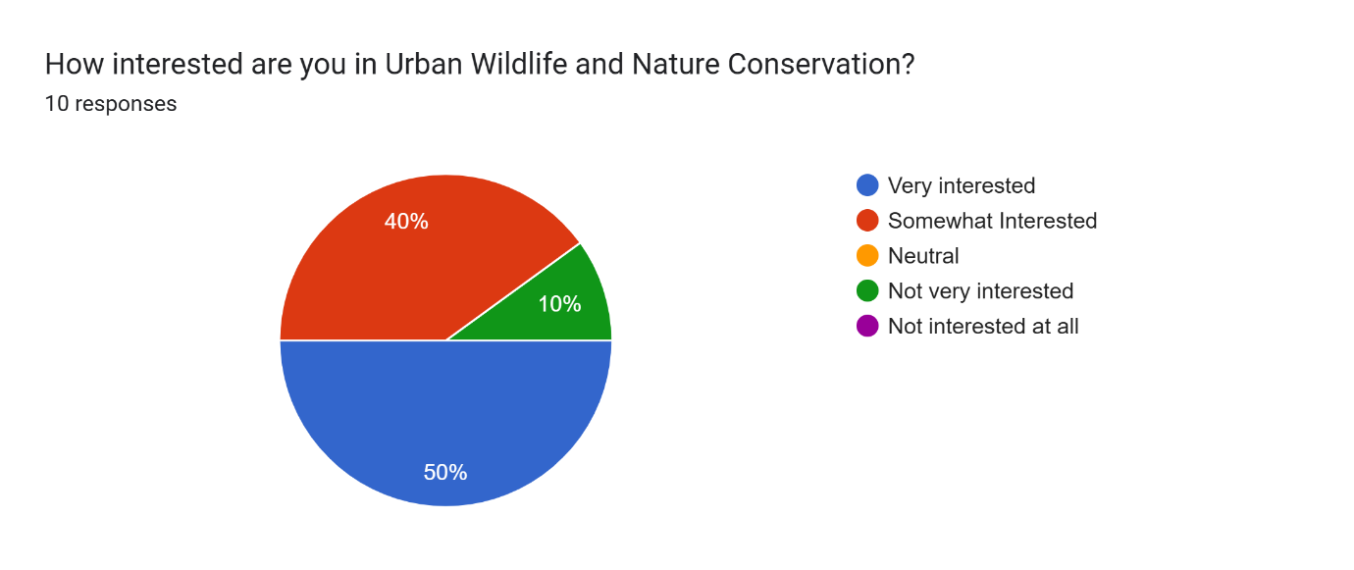
In figure 1 we can see that out of 10 responses received, 9 people would be somewhat, if not very interested in Urban Wildlife, this concludes that the centre would be visited or supported in some way by a diverse age range of people.
Figure 2
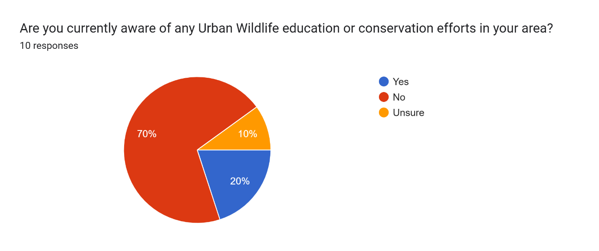
In figure 2 we asked if people were aware of any conservation efforts in their local area and 8 out of 10 people were either unsure or not aware of any conservation efforts being made which would suggest the need for such centre.

Figure 3
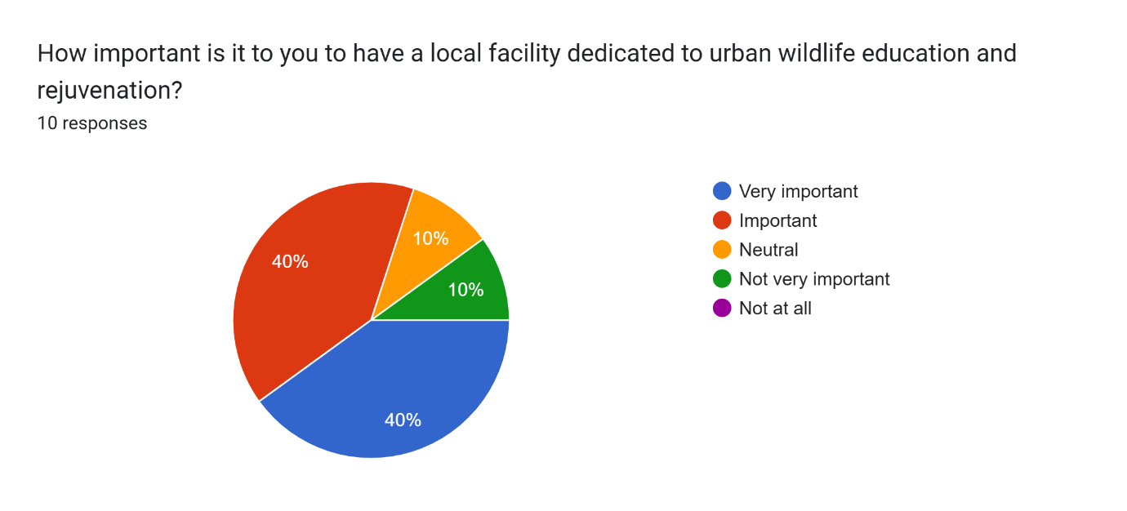
Out of 10 responses, we gathered that over 80% of respondents were open to the idea of how important and advantageous an Urban Wildlife Centre would be.
Figure 4
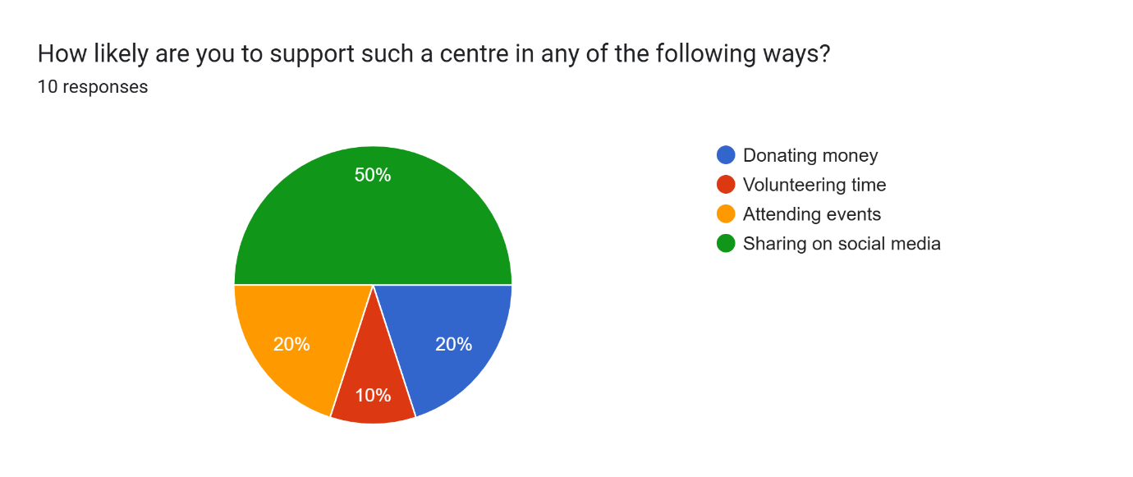
In figure 4, 50% of participants said say would share UWRCC on social media, gathering support from different areas along the way. The other 50% shows a varied response of donating money, attending events and only 1 person said they would volunteer their time.

Figure 5
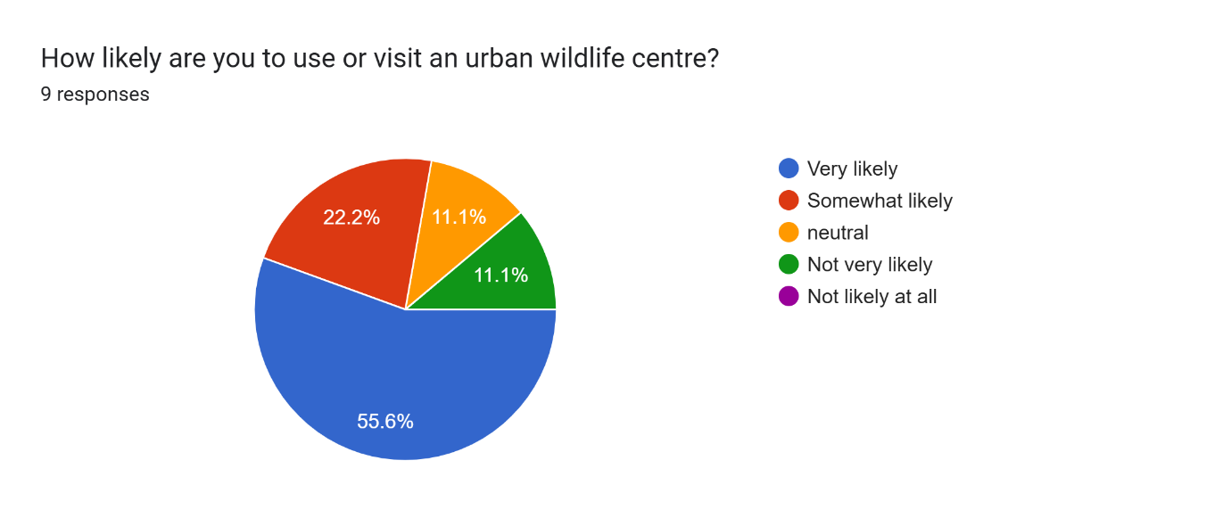
In figure 5, over 50% of people said they would visit an Urban Wildlife Centre, 20%+ were somewhat likely to visit and 20% weren’t sure.
Figure 6
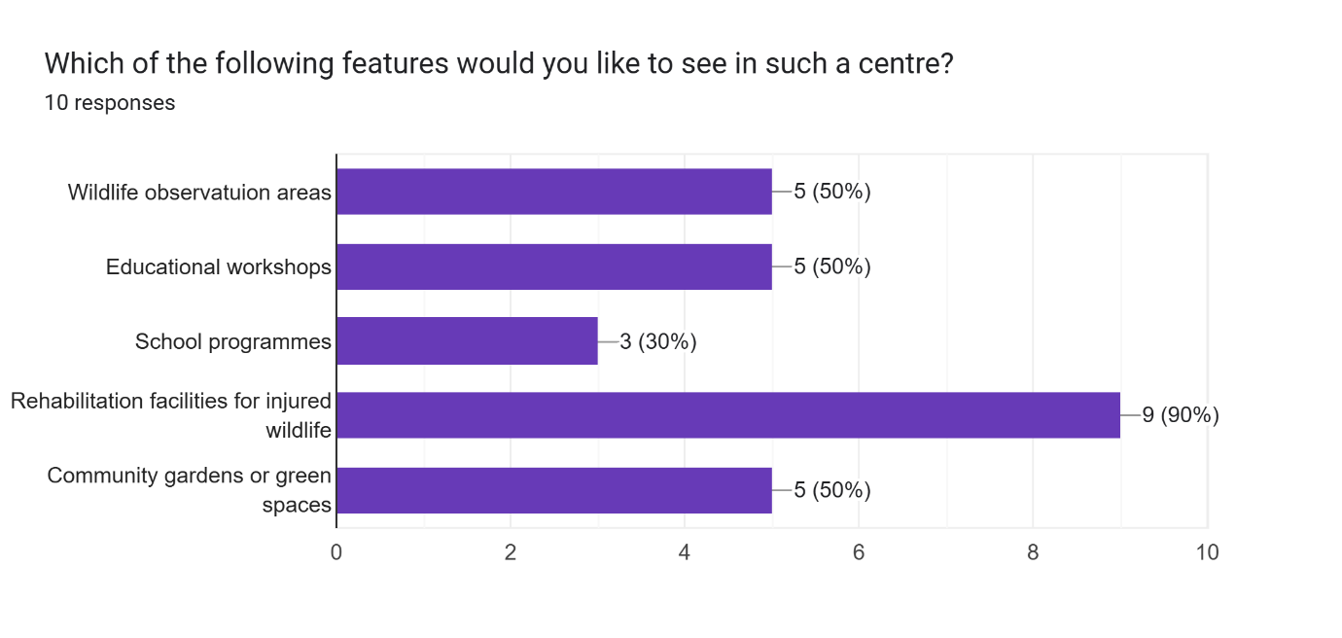
Here we can see that 90% of people wanted to see facilities being used to rehabilitate wild animals, while 50% were happy to see educational workshops as an option as well as wildlife observation areas.

Figure 7
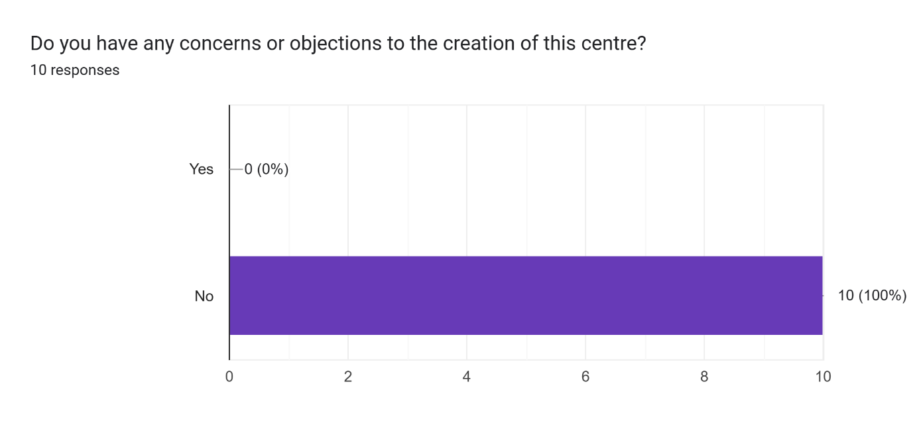
From all 10 responses I received, all 10 were in agreement of a Urban Wildlife Centre being a good service.
Below is a list of ages of the people who responded and whether they had children which would make use of the educational programmes we would hold.
19, no children
30, 2 children
31, no children
31, no children
30, no children
26, no children
43, yes children
18, no children
24, no children
54, yes children

Figure 8
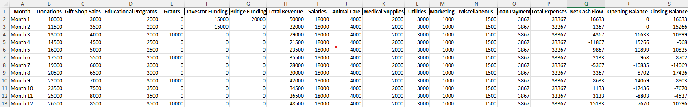

Figure 9
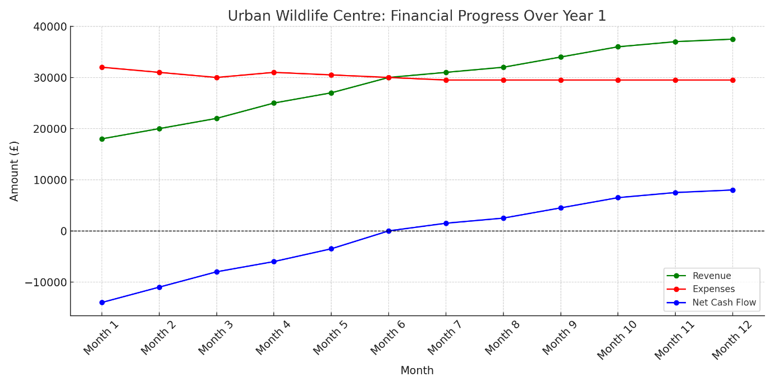
Here in this chart, you can see the financial progress of UWRRC over the first financial year of opening.

References
Amanah, D. (2015). SWOT ANALYSIS OF THE WILDLIFE PARK OF MEDAN, INDONESIA. In Medan State University, International Journal of Economics, Commerce and Management: Vol. III (Issue 10, p. 500) [Journal-article]. https://ijecm.co.uk/wp-content/uploads/2015/10/31031.pdf

Burroughes, N. D., Dowler, J., & Burroughes, G. (2021). Admission and survival trends in hedgehogs admitted to RSPCA wildlife rehabilitation centres. Proceedings of the Zoological Society, 74(2), 198–204. https://doi.org/10.1007/s12595-021-00363-9

Knight, P. (2024, January 11). Oases in the City: The role and importance of urban wildlife sanctuaries - Metro Wilds. Metro Wilds. https://metrowilds.com/oases-in-the-city-the-role-and-importance-of-urban-wildlife-sanctuaries/#:~:text=Urban%20wildlife%20sanctuaries%20are%20green%20spaces%20within%20cities,such%20as%20parks%2C%20nature%20reserves%2C%20and%20green%20belts.

Schmidt, J. (2023, December 4). Break even analysis. Corporate Finance Institute. https://corporatefinanceinstitute.com/resources/accounting/break-even-analysis/

Strategies for enhancing urban wildlife conservation. (2024, October 2). https://www.crittercarewildlife.org/strategies-for-enhancing-urban-wildlife-conservation

The Business Research Company. (2025). Environment, Conservation and Wildlife Organizations Global Market Report 2025. In The Business Research Company. https://www.thebusinessresearchcompany.com/report/environment-conservation-and-wildlife-organizations-global-market-report

Urban Wildlife Basics — The Urban Wildlife Working Group. (n.d.). The Urban Wildlife Working Group. https://urbanwildlifegroup.org/urban-wildlife-information

