Influence of Advertising on customer buying behaviour: A case study of DOVE

University of Wales Trinity Saint David

Module Title: Dissertation
Module Code: LCBB6000
Lecturer’s Name: Konstantina Mari
Student Name: Nikoleta Georgieva
Student ID: 1908764

Submission date: 01/09/2022



Table of Contents
2
Chapter 1: Introduction 6
1.0. Overview 6
1.1. Research rationale 6
Chapter 2: Literature Review 8
2.0. Overview 8
2.1. Conceptual framework 8
2.2. Concept of advertising 9
2.3. Factors affecting the advertising 10
2.3.1. Marketing objectives 10
2.3.2. Target market 11
2.3.3. Advertising message and creativity 11
2.3.4. Competitiveness 12
2.3.5. Ad source or advertiser credibility 12
2.4. Theory of consumer buying behaviour 13
2.4.1. Motivation-need theory 13
2.4.2. Engel Kollat Blackwell Model 15
2.5. Concept of customer buying behaviour 16
2.6. Factors affecting consumer buying behaviour 17
2.6.1. Social Factor 17
2.6.2. Psychological Factor 17
2.6.3. Personal Factor 17
2.6.4. Cultural Factor 18
2.6.5. Economic Factor 18
2.7. Impact of advertising on consumer buying behaviour 18
2.8. Problem Statement 19
2.9. Research Aim and Objectives 20
2.10. Organisation of the study. 20
Chapter 3: Data and Methodology 21
3.0. Introduction 21
3.1. Research question 21
3.2. Research paradigm 21
3.3. Research approach 21
3.4. Design of the Questionnaire 22
3.5. Research hypothesis 22
3.6. Sampling Method 22
3.7. Research method 23
3.8. Data collection method 23
Chapter 4: Finding and Analysis 24
4.0. Data Analysis 24
4.1. Finding from Survey 39
Chapter 5: Conclusion and Recommendations 40
5.0. Conclusion 40
5.1. Recommendations 40
5.2. Future Scope of the study 41
References 42
Appendix A 47

Chapter 1: Introduction

Overview

In today’s business world, the marketing process is based on consumer and business interactions. Therefore, advertising now plays a vital role in persuading consumers to buy services and products. At present, each organisation wants to gain maximum market share. Therefore, each organisation uses various ways to entice consumers from diverse market sections, which is the best way to become a market leader. Most of the time, customer buying behaviour is influenced by the likes and dislikes of customers towards the advertising of advertised products. In this challenging environment, organisations must promote their products to attract more customers to their products (McAlister et al., 2016). This research focuses on the influence of advertising on consumer buying behaviour in the case of the Dove Company.
Dove is an American personal care brand owned by Unilever, a UK multinational consumer goods company that has gone beyond and above the traditional goal of selling body care and beauty products to its consumers. The Dove brand was valued at around $1.51 billion in 2022. The company has developed its unique brand identity and made various products separate from many beauty brands with a practical and unique marketing strategy. As one of the iconic brands of Unilever, Dove requires a successful marketing campaign to stay within the beauty industry, which is still highly competitive. Its “campaign for real beauty” focuses on women’s self-esteem (Unilever 2022). The company has successfully communicated that people of all colours and ages are equally beautiful. The results of this study are primarily based on the feedback from potential customers of Dove Company.

Research rationale

The research analyses the influence of advertising on consumer buying behaviour concerning Dove. The study will help companies find potential strategies or ways to advertise their services or products. It will be of great value and interest to the marketing manager and assist them in marketing their services or products and creating a reasonable profit for the business. In addition, it will generate brand awareness to persuade consumers to purchase the product (Pappas 2016). This research will also identify the primary factors that affect advertising and consumer buying behaviour. This study will help find the advertising approach of Dove and how it influences its consumer buying behaviour through a practical and unique advertising strategy.

Chapter 2: Literature Review

Overview

I have identified and discussed both dependent variables and independent variables in detail. Therefore, I have developed a profound understanding of consumer buying behaviour and advertising, and the factors that influence them. The chapter also deals with the relevant theory of consumer buying behaviour, and the factors involved are considered with references from the previous research of various authors. As a result, the influence of advertising and its effects on consumers is the central theme of this chapter.

Conceptual framework
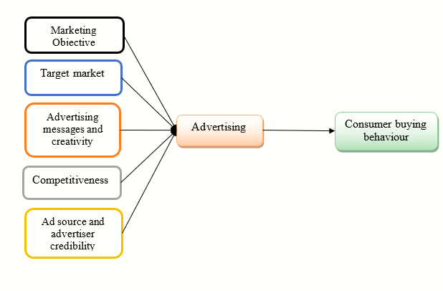
Figure 1: Conceptual Framework

The conceptual framework sheds light on the factors which impact an advertisement a company launches to market a product. As seen in figure 1, the first factor that impacts a company’s advertisement is its marketing objectives. The company considers the marketing objectives to form advertisements (Ceyhan, 2019). The second factor a company considers forming the advertisement is its target market. The company ensures that the advertisement can connect to the perceptions and buying behaviour of the target customer segments (De Veirman, Hudders and Nelson, 2019). The company should consider the third factor in advertising messages and creativity. The fourth factor which the company should consider is competitiveness. Advertisement is responsible for strengthening a company’s competitive advantage in a market (Deshpande, Rokade, and Darda 2019). That is why the company needs to consider the competition prevailing in the market to ensure that it can gain a competitive advantage by launching a particular product. The fifth factor the company considers is ad sources and advertiser credibility. Finally, the company must consider the advertising consultants’ core competencies. For example, the company usually approaches leading advertising firms while forming advertisements for its major brands. These factors ultimately go into forming advertisements which ultimately go into impacting consumer buying behaviour.

Concept of advertising

Advertising plays a vital role in developing and launching a service or product. Buyers will find the right product and what they need through advertising. While people know different products, they can compare and then buy the most suitable product according to their needs. In contrast, Middleton and Turnbull (2021) argued that advertisers typically mispresent a product’s false or unrealistic benefits and make lengthy claims to persuade individuals to take advantage, but also against customers’ interests. Therefore, it can be argued that Dove needs to know about different types of advertising. The choice will depend on the purpose, budget, and audience the advertiser wants to attract to the organisation (Ansari and Riasi, 2016). For example, during the advertising its products, Dove should ensure that it mentions facts about its products. It should mention its actual utilities and avoid mentioning utilities its products do not contain. It should also consider the customers’ different needs and expectations of products marketed under its brand name. For example, during the advertising a shampoo product, the company should highlight that the shampoo can clean dirt and grime from a user’s hair. It should also mention that the product does not rid the hair of its moisture content. It should also mention that the shampoo leaves the hair of the consumer feeling softer and moisturised scalp.
As Zhang, Liang, and Wang (2016) started, advertising helps a manufacturer or company classify and monitor competitors’ progress. When a business decides to launch or introduce a new product in the market, advertising can increase exposure and persuade customers to come and try it. Hudders and Cauberghe (2018) argued that persuasive advertising is influential in the competitive world. This persuasive advertising aims to create a competitive benefit for the organisation, persuade consumers to buy the product, facilitate communication with the dealer, and trust the product. Dove persuades its prospective customers of the benefits the products sold under its brand name would bring them by advertising its products to highlight their benefits. For example, while advertising Dove shower gel, it is highlighted that the product contains ingredients like milk which is known to nourish the skin and maintain its pH balance. Such an advertisement creates an impression among prospective consumers that Dove shower gel would suit their skin. As a result, they are more likely to prefer buying Dove shower gel products compared to competing brands of shower gels.

Factors affecting the advertising

2.3.1. Marketing objectives
Although each company’s primary goal is to influence consumer behaviour positively, specific goals may include local, national, or regional coverage to promote a product or service or create demand for the business. If national coverage is required, the company can use newspapers and television with national coverage. The main goal of an advertising campaign is to get a good response from the customers. The company will consider quick communication media like pamphlets, newspapers, and banners to get immediate results. Television, neon boards, and magazines will be considered to build brand equity and corporate goodwill (Hudders and Cauberghe 2018). It can be argued that the marketing objective significantly impacts the advertising for Dove’s skincare products. For example, the marketing objective of the owner of Dove, Unilever, as far as the brand is concerned, is to gain higher visibility in the market than competing brands. The company utilises traditional advertisement platforms strategically to ensure that the brand Dove gains visibility. It advertises Dove products at windows of retail outlets selling products marketed under the brand. It also advertises Dove products frequently on television, in magazines and newspapers.

2.3.2. Target market
Every advertising effort aims to bring the message of advertising to its potential customers. This vital task depends on identifying the potential target market for the product in terms of geographical spread, the number of customers, age group, income pattern, taste, dislikes, likes, Etc. For example, the magazine is the best way to spread the message to high-income people. When the local area is covered, outdoor advertising and newspapers help greatly. On the other hand, if companies want to reach people who have no education, television, movie ads, and radio are preferred. Hence, the target market’s characteristic significantly impacts the advertising’s effectiveness (Chen et al., 2021). For example, Dove advertises its products on traditional media like television and newspaper to target consumers who are less conversant with the digital platform.

2.3.3. Advertising message and creativity
Creative advertising is an advertising practice that combines a creative team to create an ad campaign that can share a brand’s creative story to optimise and promote conversions. Hence, creative advertising is proving to be more result driven. A newspaper would be appropriate if the advertising message is informative (Joshi and Rahman, 2017). The purpose of an advertising message is to entice customers and should provide potential consumers with a rational appeal, emotional appeal, or product demonstration. In that case, television media will be convenient for advertising. The advertising message informs potential buyers about sales promotion schemes, exchanges, festivals, and discount offers. These cases can be advertisements through banners, posters, and newspapers (Deuze, 2016). Unilever uses creativity extremely strategically while advertising Dove products to create target perceptions among the target customers. For example, while advertising Dove products, milk is shown to create a perception about the moisturising property of milk among the target customer segments. Similarly, on the package of the clay variant of Dove body wash, a picture of green clay shows an impression about the skin detoxification benefits the product can usher.

2.3.4. Competitiveness
Advertisers pay for various media platforms in the media sector, including the internet, mobile, television, radio, magazines, newspapers, and billboards. Advertisers use their brands to own the content in parts of such media. In addition, advertisers use social media platforms such as Twitter and Facebook to get the consumer’s trust and attention. We obtain information through a method of communication or media when we read our favourite magazine, watch a TV show, go online to update our Facebook statuses, or listen to music on the radio. Direct mail, tray liners in airport security bins, health club TVs, vouchers, stadium signage, and samples handed out at the doctor’s office are just a few of the media options. They and many other forms of media provide means of disseminating information to an audience (Katz, 2016).
When planning an advertisement in media, the marketer should consider the media used by industry leaders and competitors. If advertisers understand competitors’ moves regarding media, they can increase market reach through unique and creative advertisements. For example, if competitor leaders use Television advertising, Dove advertisers may consider using the same media. Advertisers should be careful about a competitor’s media strategy and advertising budget. However, marketers must not blindly follow competitors’ decisions because they may be wrong. (Djambaska, Petrovska, and Bundalevska, 2016). It can argue that the level of competition significantly affects advertising. For example, Dove advertises its products in business magazines to attract business partners like dealers. The company, on the other hand, to attract final consumers, promotes its products on channels like social media, which is more frequent by end consumers.

2.3.5. Ad source or advertiser credibility
The term “source credibility” is often used to refer to the characteristics of a communicator, including ability, expertise, and trustworthiness. Ansari and Riasi (2016) stated that credibility strongly influences attitudes towards advertisers. Attitudes towards advertisers are the most important predictors of attitudes towards advertisement. The company’s credibility is the extent to which buyers believe a company can develop and deliver a product and service that meets their desires and needs. Hence, the attitude towards advertising can positively and directly affect the brand’s attitude and buying intent (Hudders and Cauberghe 2018). Dove partners with leading media firms to promote its products globally. As a result, it helps generate the necessary high level of visibility of its products among. Increased visibility of Dove products usually has a positive impact on the buying behaviour of consumers.

Theory of consumer buying behaviour

Consumer behaviour theory studies how individuals make purchasing decisions and help marketers and businesses use those behaviours by foreseeing when and how customers will make a purchase. In addition, it helps identify what influences these decisions and emphasises strategies for actively manipulating behaviour (Madhavan and Kaliyaperumal, 2015). In this research, the researcher will use the following consumer behaviour theories to understand the way advertising influences the customer buying behaviour of Dove Skincare products.

2.4.1. Motivation-need theory
Dr Abraham Maslow has proposed a renowned human motivation theory based on the hierarchy of human needs. Maslow identified five fundamental levels of human needs, ranging from psychological needs at the lowest level to physiological needs at the highest level. Moreover, Maslow’s hierarchy of needs theory is a motivational theory that regulates consumer buying behaviour. Initially, it can be divided into five needs: esteem needs, physiological needs, love and belongingness needs, self-actualisation needs, and safety needs (Filak and Nicolini, 2018). This theory says that each person tries to meet the lower-level needs before the higher-level needs appear. However, the lower level of unsatisfied requirements that individuals experience motivates their behaviour. While these needs are met, high-level demands arise, and tensions recur. To decrease this tension, the person gets inspired and realises it. When these needs are met, new ones, that is, higher needs emerge, and the process continues throughout human life (Simamora, 2021). Maslow’s hierarchy of needs model is shown below:
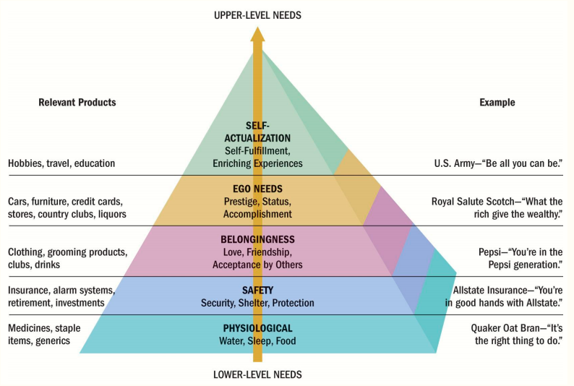

Figure 2: Maslow’s Hierarchy of Needs
Source: Yang Wang, 2021

According to HR and Aithal (2020), Maslow’s theory is used throughout marketing and business segments to understand why a customer-friendly marketing message is essential to sales achievement. For example, to attract buyers in a way that matches their needs, the marketing campaign may prioritise purchases that highlight the urgency and significance. With a robust knowledge of motivation-need consumer behaviour theory, a marketer can efficiently create ads and campaigns as artificial demands that the customer controls. For example, luxury car manufacturers highlight security and safety features in their vehicles rather than aesthetics. As a result, it persuades customers to buy an expensive luxury car as it meets the physiological safety requirements for themselves and their families (Li, Liu and Li 2019).
The consumption patterns of consumers as far as products marketed under the brand Dove is concerned can be expressed using Maslow’s theory of needs to some extent. From the above pyramid, the Dove products are in the middle needs base, i.e., belongingness.

2.4.2. Engel Kollat Blackwell Model
This model was developed to define the fast-growing and increasing body of knowledge about customer behaviour. Also, this model has made numerous adjustments to enhance the descriptive capacity of the fundamental relationship between the element and the sub-element. As a result, this model includes the following stages:
- Input:
At this phase, customers receive information from non-marketing and marketing sources, which influences the problem identification phase of the decision-making process. Whether the customer cannot reach a definite conclusion, searching for external data will be triggered to arrive at a choice. If a customer experiences dissonance, the chosen option is less satisfactory than anticipated (Buerke et al., 2017). For example, a new consumer may gain information about Dove products and their benefits through advertisements. So, he started researching to gain more information on Dove products.
- Process:
This stage includes the customer’s attention, exposure, acceptance, perception, and retention of incoming information. A customer should first communicate with the message, interpret the stimuli, retain the message, and allocate space for the information by shifting inputs to long-term memory (Sama, 2019). The consumer starts developing perceptions about Dove products. They start perceiving them as beneficial.
- Decision-making stage:
The decision-making process has five phases: identifying a need, seeking information, assessing alternatives, purchasing (or selecting), and post-purchase outcomes. However, each customer does not require to undergo all these steps. Instead, it relies on whether it is a complete or regular problem-solving behaviour (Zhang et al., 2020). The customer, at this stage, starts deciding whether he should buy Dove products. He first considers his care needs and how Dove products can meet them.
- Variables influencing the decision-making process:
This phase has environmental and individual impacts that influence the five levels of the decision-making process. Also, individual characteristics are values, motives, personality, and lifestyle. Then again, the social influences include reference groups, family, and culture. Finally, situational influences, like the financial status of customers, also affect decision-making (Martín, Pagliara and Román, 2019). For example, the consumer considers his lifestyle and spending capability to decide upon the Dove products he would buy.

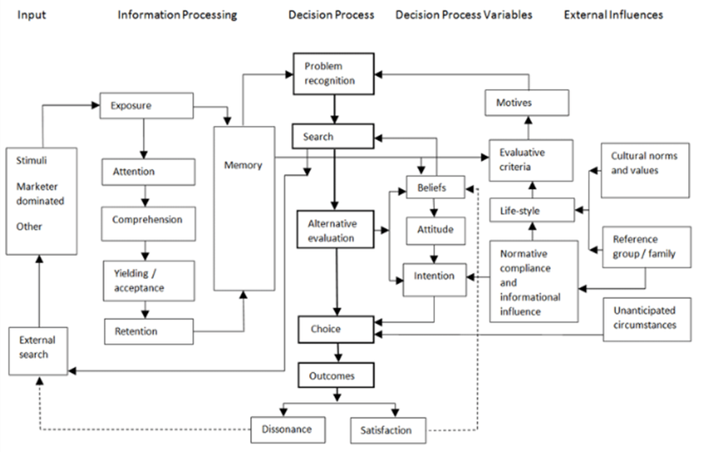
Figure 3: EKB Model
Source: Holland, 2019

Concept of customer buying behaviour

According to Maharjan (2019), consumer purchasing behaviour has always been of great importance in literature studies about the impact of advertising on its efficiency. Consumer purchasing behaviour is influenced by the likes and dislikes of customers towards advertising the advertised product.
Customer buying behaviour is the physical, mental, and emotional activity in which individuals select, purchase, use, and dispose of services and products to meet their desires and needs. Customer behaviour is an interrelated process and behaviour displayed when an individual or group selects, purchases, and uses a product, service, idea, or even experience to meet their aspirations and needs. (Pappas, 2016, Rambabu and Porika, 2020). Consumer behaviour refers to the strategic planning process of what must be made in terms of the type and quantity of commodities and goods, considering the customers’ needs, preferences, tastes, capabilities, and motives. Consumer behaviour helps determine the elements of a marketing mix and recognise potential marketing opportunities. Ramya and Ali (2016) argued that it is essential to study consumer purchasing behaviour as it allows companies to plan and implement better marketing strategies. For example, Dove considers that consumers prefer skincare products with natural ingredients. For this reason, all Dove products contain natural ingredients like milk, clay, and cocoa butter.

Factors affecting consumer buying behaviour

2.6.1. Social Factor
A reference group is a group of individuals with whom an individual associates themselves. Everyone in the reference group has standard buying behaviour and is mutually influential. The influence of the reference group varies across brands and products. The effect of a reference group on an individual can increase the overall conformity level among that group (Auf et al., 2018). For example, the rising concern in society for sustainable packaging is resonated in Dove products being marketed in packages made from recycled plastic.

2.6.2. Psychological Factor
Customer perception is an essential factor influencing consumer behaviour. When people are motivated enough, it affects their purchasing behaviour. A person has basic needs, self-actualisation needs, social needs, safety needs, esteem needs, Etc. Of these, safety and basic needs are higher than other needs. Hence, these needs can encourage consumers to purchase services and products (Chukwu, Kanu and Ezeabogu, 2019). For example, many consumers consume Dove products because of their natural ingredients, which are safe for the skin.

2.6.3. Personal Factor
Personal factors differ from one person to another, which create various consumer behaviour and perception. Lifestyle is a way and attitude in which a person stays in society. Consumer lifestyles greatly influence purchasing behaviour. For example, when customers lead a healthier lifestyle, their products will be associated with healthier alternatives to junk food (Qazzafi, 2019). Consumers prefer premium skincare products made from natural ingredients, less likely to cause allergic reactions and suit broad skin types. Dove products, to a great extent, can meet these personal needs and are consumed by millions of consumers around the globe.

2.6.4. Cultural Factor
Culture controls human behaviour and patterns people in a particular society express and holds differently. Al Amin et al. (2020) stated that group members of society influence consumer lifestyles. Therefore, the cultural factor has a substantial impact on consumer purchasing behaviour. These cultural aspects contain the basic needs, preferences, values, behaviours, and perceptions consumers perceive and learn from their family members (Chen et al., 2017). For example, Dove releases special editions and gives discounts during festivals. This way, the brand shows relatedness to the cultures of the consumers.

2.6.5. Economic Factor
Economic factors have a significant impact on consumer purchasing decisions. When individuals have a higher disposable income, their buying power rises. Disposable income is the amount that remains after spending on an individual’s basic needs. When disposable income increases, it leads to higher expenditure on different products. However, the spending on multiple items is reduced parallelly when disposable income decreases (Ringim and Reni 2019). Dove has a wide range of products, some of which are highly priced while others are more affordable. It enables the company to cater to the needs of consumers from different economic brackets.

Impact of advertising on consumer buying behaviour

According to Stankevich (2017), advertising is a marketing approach that emphasises persuading a specific group of people by communicating clear messages influencing consumer behaviour to persuade them to make certain decisions, like buying a new product. Thus, advertising is a way of communicating with individuals to persuade them of a specific issue until they decide that the advertiser should receive a benefit or return. Therefore, advertising can discover new lifestyles, trends, and images (Pappas, 2016).
Advertising is effective in changing consumer perceptions and attitudes about the product. These perceptions are pinched in their mind due to their lifestyle, environment, and culture. Hence, advertising plays a vital role in shaping consumer behaviour. Advertising is a source of inspiration that compels them to purchase specific products. Advertising is also a source of building trust. Buying attitudes can also be created through brand recognition and product evaluation (Shamout, 2016). However, the attitude created towards advertising influences the consumer’s attitude towards the brand regarding purchasing intent. The primary purpose of advertising is to encourage the consumer to buy the advertised product. Therefore, a positive attitude creates a sensitive response in the mind of consumers. When customers see an ad for a specific product and create a resemblance for that brand, they are eager to buy those products (Nishanov and Ahunjonov, 2016). Frequent advertisement of Dove has enabled the brand to create a strong positive impression among consumers about the benefits the products marketed under the brand name can bring them. This solid positive impression encourages consumers to buy Dove products.

Problem Statement

Advertisers sometimes exaggerate the benefits of a product in a tactical way that customers go psychologically under the pressure of advertising persuasion and deliberately decide to purchase advertising products. Most customers avoid the ads because they consider them misleading and annoying. Some critics have even considered and criticised advertisements as too harmful to society’s collective behaviour (Kwon et al., 2019). Some authors argue that the primary aim of advertising is to sell products and their impact on the cultural values ​​of society. However, some societal members have said that advertising can have adverse, intended, or unintended effects on consumer purchasing power. Advertising may cause customers to prefer material products over ethical and socially based alternatives. It can escalate conflict and create dissatisfied and unhappy people in society. At the same time, advertising provides creative, helpful, and new items to get lasting benefits from brand loyalty and the image of the company and product by building a persuasion and emotional relationship for purchasing such products (Danaher, 2017). Dove products generally benefit customers in the same ways as advertised. However, some consumers do not benefit from the products and remain dissatisfied.

Research Aim and Objectives

The main aim of the present research study is to investigate the influence of advertising on consumer buying behaviour by focusing on Dove skincare products.
The objectives to attain the aim of the research study are:
First, to identify ways consumer decision making buying Dove skincare products. Second, to establish how different advertisements influence consumers’ behaviour. Third, to establish a correlation between Dove advertising and consumer behaviour.

Organisation of the study.

The study consists of five chapters. Chapter one presented a brief background of the research and identified the potential problem the chosen company faces. The second chapter offered a literature review. This chapter has recognised the independent and dependent variables. In addition, the chapter also identified the impact of the independent variable on dependent variables and the association between them. Also, this chapter developed the research aim & objective of the study. The third chapter will represent different methodological tools that can be applied to conduct the research and gather relevant information efficiently. The fourth chapter will assess and interprets the gathered data using relevant data analysis tools and techniques, while the fifth and last chapter will conclude with the data collected from the literature review and data analysis to provide suitable suggestions for Dove.

Chapter 3: Data and Methodology

- Introduction

This chapter focuses on various methodological tools applied to conduct the research. I also justified the choice of specific research tools for this study. In addition, I adhered to the research principles and addressed the accessibility issues faced when I started the research.

  - Research question

How do advertisements influence the customer buying behaviour of Dove skincare products?

  - Research paradigm

I applied the interpretivism research paradigm in this paper. Interpretation is a social science method that states that in a social situation, people’s beliefs, reasoning, and motivation are essential for decoding the meaning of collected data in the context of the selected phenomena. Thus, I could examine how people interpret and interact in a social environment (Maarouf 2019).

  - Research approach

In this paper, I applied a deductive approach. The deductive approach involves developing hypotheses and theories validated in the real world through experimental or survey inspection. The deductive approach is a leading strategy in the natural sciences since it allows us to analyse variables in a controlled setting through experimentation (Crowther and Lancaster, 2008). The deductive technique aids in the formulation of the problem and theoretical context upon which the research is founded (Sanders et al., 2009)

Design of the Questionnaire

A questionnaire is created to collect precise information for data analysis and result interpretation to be reasonably obtained (Chisnall, 1992). The most appropriate method of data collecting was used to ensure accurate, fair, and relevant data gathering. Dove’s consumers completed sixty survey questionnaires as part of the collection of primary data. The fact that the questionnaire includes a substantial amount of data from the respondents is by far its most important benefit. The questionnaire was divided into three sections, each with various questions designed to gather the necessary and pertinent information. A five-point Likert scale has been chosen, from strongly agree to strongly disagree.
General questions concerning the consumer profile were asked in the first segment. A series of questions for the impact analysis of advertising are asked in the second section. A collection of questions has been constructed in the third section to assess consumer buying behaviour. Due to the purposive sampling method, the questionnaire received a 100% response rate. Only those respondents who agreed to participate in the research were given the questionnaires.

  - Research hypothesis

H0: The advertisement has no impact on consumer buying behaviour.
H1: The advertisement has an impact on consumer buying behaviour.
The hypothesis would be tested considering the findings of the data collected. Finally, the findings will be used to conclude the research.

Sampling Method

I will use the purposive sampling method to recruit respondents to collect data through a survey questionnaire. It is a deliberate participant selection where I use my discretion to select the aspects for the sample population. This non-random method does not require basic assumptions or a predetermined number of respondents. By using the purposive sampling method, the researchers could find individuals who can provide information and are willing to do so (Busetto, Wick, and Gumbinger, 2020).

Research method

The research method that I use is the critical realism method. It would enable analysing of the primary data (Hoddy 2019). This primary data analysis would shed light on the different aspects of consumer behaviour regarding the brand Dove. In addition, quantitative data analysis would be used. Finally, the survey findings will be analysed using statistical methods to answer the research question.

Data collection method

The data collection method would consist primary research. The literature review process involves gathering information from articles, books, journals, newspaper articles and magazines (van den Akker et al., 2021). It also consists of data collection from reliable websites like the official website of Dove. The primary data collection method would be a survey. The sample size would be sixty respondents, and a questionnaire would be used.

Chapter 4: Finding and Analysis

Data Analysis

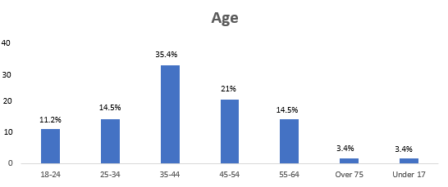
From the above analysis, it can be identified that the respondents to the survey between the ages of 35-44 are 35.4%. On the other hand, 21 % of the respondents to the survey are between the ages of 45-54 years. 14.5% of them are between the ages of 25-34 years; similarly, the respondents between the ages of 55-64 years are 14.5%. The correspondents between 18-24 years are 11.2%. The correspondents between 12-17 years and more than 75 years are 3.4 % combined.
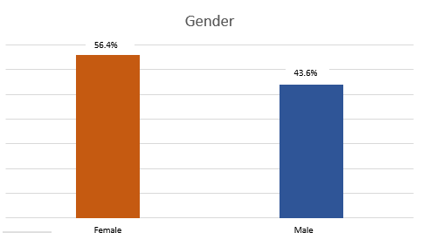
56.4% of the correspondents of the survey are female, and 43.6 % of the correspondents are male. Therefore, from the above data, it can be identified that both genders are the company’s customers utilising the products, and there is no perception among the customers regarding the product being gender specified. Therefore, it is a positive point for the company to access many customers in the market.

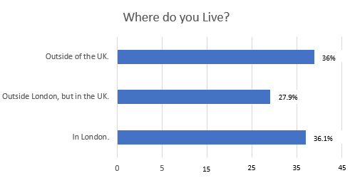
From the above analysis, 36.1% of the respondents to the survey live in London. 36% of the respondents live outside of the UK. The respondents who live outside of London but in the UK are 27.9%.

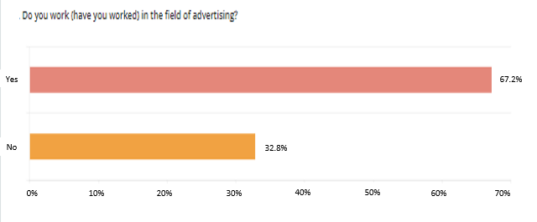
The findings above show that 67.2% of respondents had experience in the advertising industry, while 32.8% of respondents did not have experience in the advertising industry.

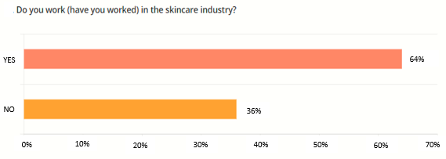
According to the data above, two-thirds of respondents had prior experience in the skincare sector. According to these statistics, most respondents have extensive experience in the cosmetics sector. It suggests that the more familiar buyers are with Dove consumer products, the more likely they will be swayed by commercials when making a purchase.

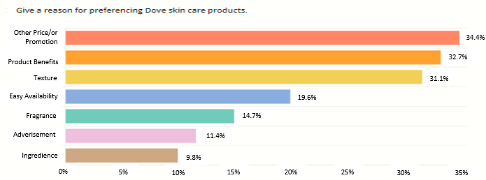
From the above data, 34.4% of respondents prefer Dove skin care products because of the price or promotion. In addition, 32.7% of the respondents prefer Dove because of its product benefits. 31.1% of the respondents like the texture of Dove’s skin care products. These findings show that the price, product benefits and texture are vital for most respondents.

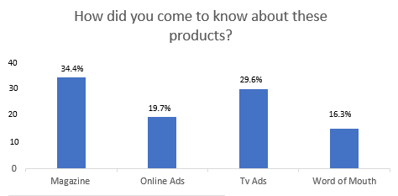
According to the data presented above, 34.4 % of respondents learned about Dove products from magazines. Furthermore, 29.6% of respondents get information from television advertisements. The remaining 19.7 % and 16.3 % of respondents obtained information from online ads and word-of-mouth advertisements. Therefore, it shows that Dove successfully promotes its products through magazine and television advertising.

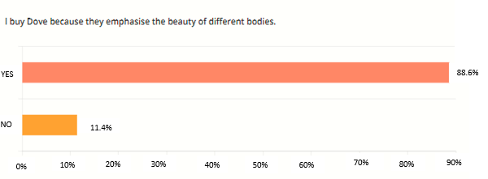
From the above data, it is seen that Dove’s advertising message has been successfully accepted as 88.6% of the respondents admit to buying Dove products because they emphasise the beauty of different bodies.

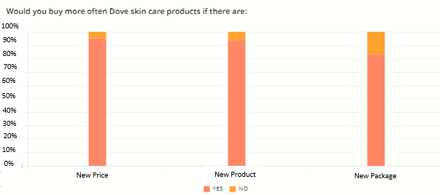
From the data above, it can identify 95% of survey respondents would frequently purchase Dove skin care products if their prices were reduced. Furthermore, 93.3% of respondents say the new product will encourage them to buy Dove skin care products. Finally, 83.3% of respondents said they would frequently purchase Dove skin care products if a new package were available. From these data, it is established that the loyalty and attention of the respondents can be retained through new prices, products, and packaging.

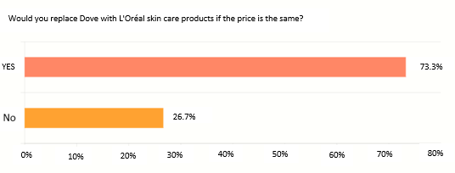
According to the survey results, 73.3% of respondents would switch from Dove to L'Oreal skin care products if the prices were the same. It demonstrates that competition in the skincare sector is fierce, but Dove manages to keep its prices competitive.
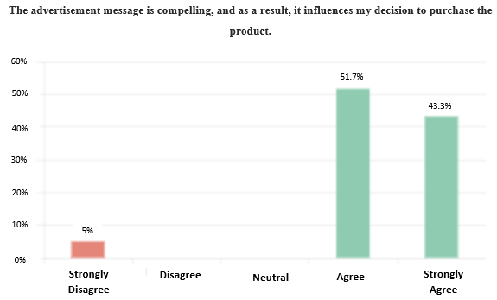
The findings above show that 51.7% of respondents agree that the advertisement message is compelling, influencing their decision to purchase the product, while 43.3% strongly agree and 5% strongly disagree. These results demonstrate that a compelling advertisement message plays a significant role in the decision-making for consumers to buy Dove products.

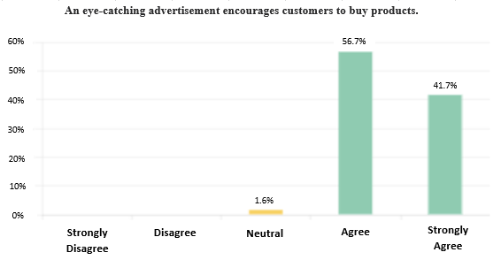
The data above shows that 56.7% of survey respondents agree that an eye-catching advertisement encourages customers to buy products. Furthermore, 41.7% of respondents strongly agree, and 1.6% of respondents are neutral. This data shows the need for innovative and creative advertising campaigns to attract and retain consumers’ attention.

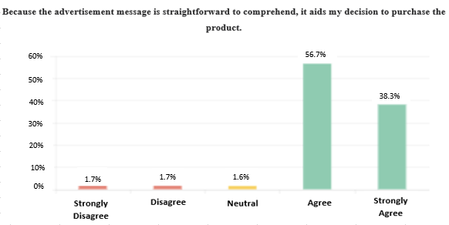
The findings above show that advertising influences consumer purchasing; after seeing advertising, first-time Dove product customers are more likely to be influenced to buy Dove’s skin care products.

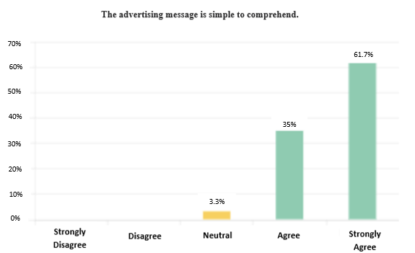
These results demonstrate that simple advertising messages can affect customer purchasing decisions. Furthermore, it suggests that people are more likely to buy a product based on the advertising message.

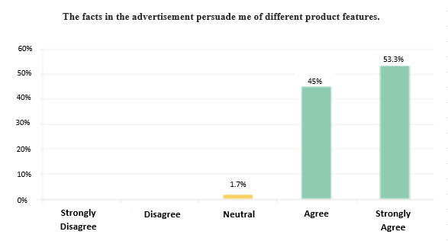
The findings above illustrate that advertising influences consumer buying behaviour by giving consumers knowledge about products, which customers use to decide whether or not to acquire the products.

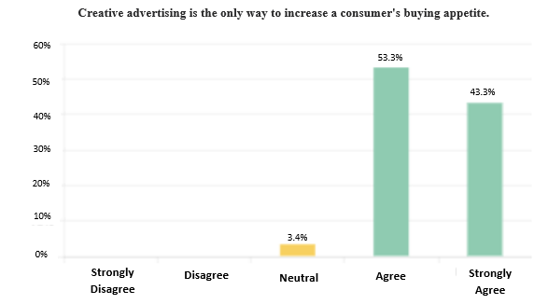
From the above data, it can be identified that most of the participants associated with the survey agree that creative advertising is the only way to increase a consumer's buying appetite 43.3% of respondents strongly agree, and 53.3% agree that advertising and consumer buying behaviour has a beneficial association. Comparing, 3.4% of respondents are neutral, and there are no respondents who show disagreement or strongly disagree. These findings indicate that consumers are more likely to be influenced to buy a product after seeing a creative advertisement.

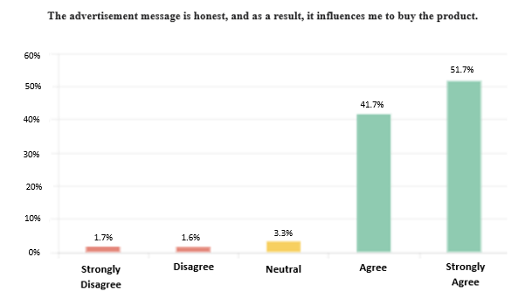
The above study shows that 51.7% of respondents strongly agree, 41.7% of respondents agree, 3.3% of respondents are neutral, 1.6% of respondents disagree, and 1.7% of respondents strongly disagree that the advertisement message is honest and, as a result, it influences them to buy the product. These studies showed that advertising messages influence consumer buying behaviour and that consumers are more likely to buy a product after being influenced by the message in advertisements.

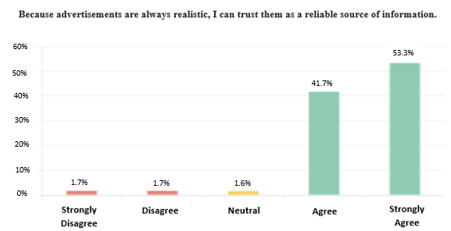
According to the statistic above, 53.3% of respondents strongly agree, and 41.7% of respondents agree that because advertisements are always realistic, they can trust them as a reliable source of information. In comparison, 1.6% of respondents are neutral, 1.7% disagree, and 1.7% strongly disagree. These data indicate that realistic advertisements influence consumer buying behaviour.

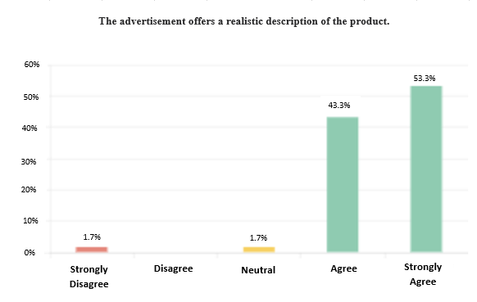
The above data show that consumers are more likely to buy a product based on the realistic product description in the advertisements.
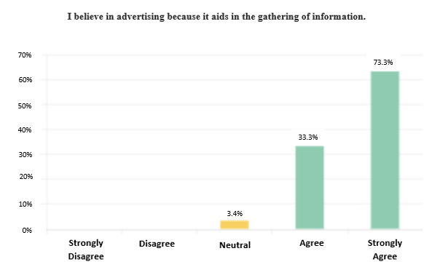
The above graph demonstrates that advertising affects consumer buying behaviour by informing customers about the products, who then use that information to decide whether or not to buy them. For example, information on a product's advantages, price, quantity, and quality can persuade customers to buy Dove cosmetics.

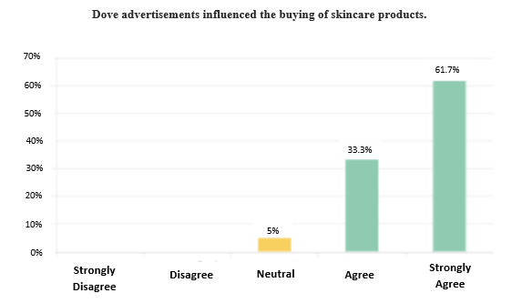
The above data state the fact that the Dove advertisements influenced the buying of skin care products, as 61.7 % of the survey participants strongly agree that Dove advertisements influenced the buying of skin care products. These findings show that Dove advertisements successfully influence customers buying behavioural.

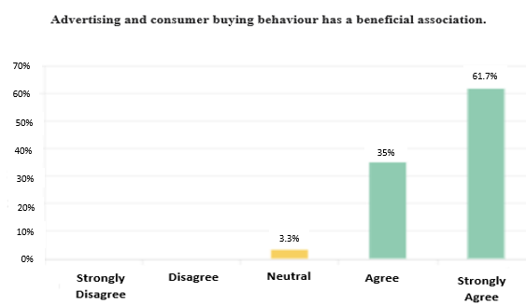
From the above data, it can be identified that most of the participants associated with the survey agree that advertising and consumer buying behaviour has a beneficial association. 61.7% of respondents strongly agree, and 35% agree that advertising and consumer buying behaviour has a beneficial association. These results imply that advertising influences buyer behaviour by encouraging consumers to choose Dove cosmetics over competing brands. In addition, Dove cosmetics product buyers are more likely to be persuaded to try the brand after seeing the advertising.

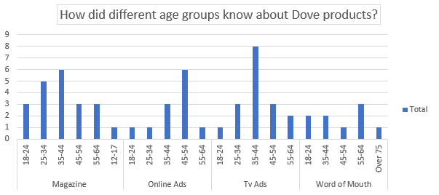
From the above data, it can be seen that the respondents between 18 and 34 years do not receive enough information through online, Tv and word to mouth advertising methods. So, Dove company need to find a different way to promote their products in this age group.

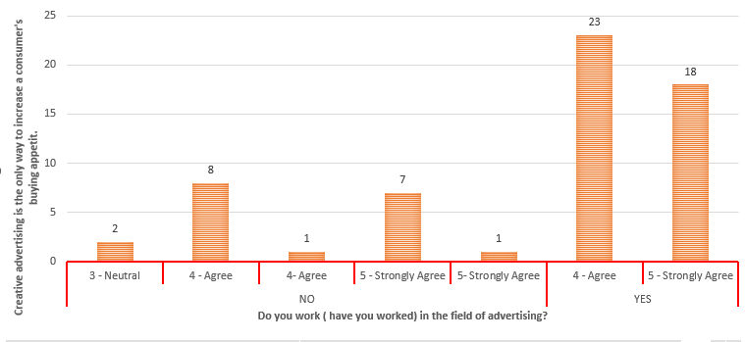
From the above data, all respondents who work in the advertisement industry agree that creative advertising is the only way to increase a consumer's buying appetite.

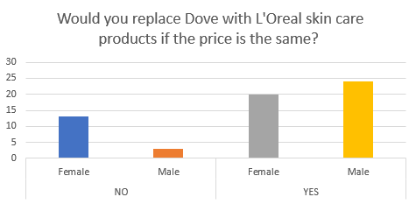
The above data showed that male respondents are more likely to replace Dove skin care products than female respondents.

Finding from Survey

In this part, a proper analysis will be conducted on the primary data that has been collected in the research paper.
It has been identified from the primary research it can be stated that advertising can change the buying behaviour of the customers that are associated with Dove company. The advertisement the company utilises can impact consumer buying behaviour by quite a considerable margin. It was identified in the literature review that advertising plays a crucial role in the development and launch of a new product. A company's buyers can find the right product they need with the help of advertising. Similarly, this data matches with the finding that has been identified in the questionary (Appendix A), in which the defined behaviour of the customers is impacted by advertisement. The study's findings, as presented in Appendix A, reveal that the most significant advertising elements on customer purchasing behaviour are prices and product benefits obtained by utilising the product. Other advertising elements influencing consumer buying behaviour include texture, easy availability, trust in the brand, emphasis on the beauty of different bodies and advertisement message. From the findings, it can be stated that most of the participants that took part in the survey identify that advertisements can impact buying behaviour. It, in turn, also matches with the findings from different questions in which the majority of the participants agreed that advertisements could impact the customers' perception regarding the products associated with Dove company. From the above findings from the survey and comparing them with the literature review theory, it can be identified that hypothesis 1 is true and hypothesis 0 can be considered not feasible in the research paper. Therefore, the findings of the research paper align with hypothesis 1 and prove the fact that advertisement has an impact on consumer buying behaviour.

Chapter 5: Conclusion and Recommendations

Conclusion

In this research, it can be concluded that advertising is a form of communication used to influence a particular group to adopt a new step. Therefore, advertising is also considered to be a significant factor in the economic growth of companies and marketers. The primary purpose of advertising is to offer innovative, new, and valuable products so that the company can benefit from image building and brand loyalty in the long run by creating an emotional connection and motivation to buy those products. Based on the authors' different perspectives in the literature review, it can be said that it is complicated to successfully persuade and influence consumer purchasing behaviour in this age of tough competition. However, much research has shown that advertising is crucial in improving the brand image and reputation. Most respondents answered that advertisement plays an essential role in introducing new products aiding them in purchasing a new product and helping them make better choices.
With success in the advertising sector, it has been recognised as a universal aspect that advertising plays a significant role in customers' behaviour. Thus, the organisation should not make exaggerated and false advertising claims since customers have now become more aware. Instead of making false claims, if the company provides valuable information to customers, the brand name can be established, and sales can be increased. Generally, people prefer branded cosmetics because they believe they provide high-quality products. Therefore, the organisation can invest heavily in research and development to enhance the quality of products.

Recommendations

The role of advertising is essential in influencing consumer purchasing behaviour. Hence, the ad must be correct, genuine, and meet the needs of customers. The organisation should use informative and attractive content to raise awareness among customers and must not depend on advertising to change customers' perceptions. In its place, Dove must use new ways to sales promotions or other ways to change customers' perceptions. It will be easier for Dove to change customer buying behaviour by making awareness and developing solid perceptions in the minds of consumers. For an ad to be effective, it must be promoted only three or four times a day; otherwise, it makes them ineffective, and customers are not interested in information about a specific product.
Additionally, the quality of advertising should be excellent and attractive as it retains a great impression on the customer's mind. It is also important to remember that other reward schemes do not force customers to buy products unless they are of good quality. In the case of Dove, advertisers must remember that ads provide direct information about a product rather than showing the fashion and style of a model. Thus, basic information about the product should always be presented instead of exaggeration and glamour. Also, the advertiser must mention the product price for the convenience of the customers.

Future Scope of the study

The study gives many opportunities for further research on consumer behaviour and the scope for durable organisations. There is a scope for other researchers to do more research among a large population. The brand loyalty of cosmetic products is a field that can be investigated further. Finally, the research can be done on modern ways of advertising, like Twitter, Instagram, and Facebook, through sponsoring events and fashion fests.

References
Books and Journals
Al Amin, M., Nowsin, N., Hossain, I. and Bala, T. (2020) ‘Impact of social media on consumer buying behaviour through online value proposition: A study on e-commerce business in Bangladesh’, Academy of Strategic Management Journal, 19(5), pp.1-18.
Ansari, A. and Riasi, A. (2016) ‘An investigation of factors affecting brand advertising success and effectiveness’, International Business Research, 9(4), pp.20-30.
Auf, M.A.A., Meddour, H., Saoula, O. and Majid, A.H.A. (2018) ‘Consumer buying behaviour: The roles of price, motivation, perceived culture importance, and religious orientation’, Journal of Business and Retail Management Research, 12(4).
Buerke, A., Straatmann, T., Lin-Hi, N. and Müller, K. (2017) ‘Consumer awareness and sustainability-focused value orientation as motivating factors of responsible consumer behavior’, Review of Managerial Science, 11(4), pp.959-991.
Busetto, L., Wick, W. and Gumbinger, C. (2020) ‘How to use and assess qualitative research methods’, Neurological Research and practice, 2(1), pp.1-10.
Ceyhan, A. (2019) ‘The impact of perception related social media marketing applications on consumers’ brand loyalty and purchase intention’, EMAJ: Emerging Markets Journal, 9(1), pp.88-100.
Chen, C.W., Liu, W.S., Chen, W.K., Hsu, P.Y. and Tang, Y.T. (2021, January) ‘Exploring consumers’ purchase intention to social media advertising: The role of advertising clicks’, In 2021 12th International Conference on E-Education, E-Business, E-Management, and E-Learning (pp. 341-347).
Chen, Y.C., Lee, Y.H., Wu, H.C., Sung, Y.C. and Chen, H.Y. (2017) ‘November. Online apparel shopping behavior: Effects of consumer information search on purchase decision making in the digital age’, In 2017 IEEE 8th International Conference on Awareness Science and Technology (iCAST) (pp. 143-148). IEEE.
Chisnall, P.M. (1992) Marketing research. (pp. 109-135). London: McGraw-Hill.
Chukwu, B.A., Kanu, E.C. and Ezeabogu, A.N. (2019) ‘The impact of advertising on consumers buying behaviour’, International Journal of Arts and Commerce, 8(1), pp.1-15.
Crowther, D. and Lancaster, G. (2008) Research Methods: A Concise Introduction to Research in Management and Business Consultancy. Oxford: Butterworth-Heinemann.
Danaher, P.J. (2017) Advertising effectiveness and media exposure. In Handbook of marketing decision models (pp. 463-481). Springer, Cham.
De Veirman, M., Hudders, L. and Nelson, M.R., 2019) ‘What is influencer marketing and how does it target children? A review and direction for future research’, Frontiers in psychology, 10, p.2685.
Deshpande, M., Rokade, Y. and Darda, P.S. (2019) ‘The Impact of Advertisement on Consumer Buying Behavior in Electronic Industry’, International Journal of Scientific Development and Research (IJSDR), 4(12), pp.2455-2631.
Deuze, M. (2016) ‘Living in Media and the Future of Advertising’, Journal of Advertising, 45(3), pp.326-333.
Djambaska, A., Petrovska, I. and Bundalevska, E. (2016) ‘Is humor advertising always effective? Parameters for effective use of humor in advertising’, Journal of Management Research, 8(1), pp.1-19.
Filak, V.F. and Nicolini, K.M. (2018) ‘Differentiations in motivation and need satisfaction based on course modality: a self-determination theory perspective’, Educational Psychology, 38(6), pp.772-784.
Hoddy, E.T. (2019) ‘Critical realism in empirical research: employing techniques from grounded theory methodology’, International Journal of Social Research Methodology, 22(1), pp.111-124.
Holland, J. (2019) Navigating Uncertainty: Tourists' Perceptions of Risk in Ocean Cruising (Doctoral dissertation, University of Brighton).
HR, G. and Aithal, P.S. (2020) ‘Consumer communication deployment tactics: an integrated framework for lifestyle brands and retailers in India (CCF-LS)’, International Journal of Applied Engineering and Management Letters (IJAEML), 4(2), pp.1-21.
Hudders, L. and Cauberghe, V. (2018) ‘The mediating role of advertising literacy and the moderating influence of parental mediation on how children of different ages react to brand placements’, Journal of Consumer Behaviour, 17(2), pp.197-210.
Joshi, Y. and Rahman, Z. (2017) ‘Investigating the determinants of consumers’ sustainable purchase behaviour’, Sustainable Production and consumption, 10, pp.110-120.
Katz, H. (2016) The media handbook: A complete guide to advertising media selection, planning, research, and buying. Routledge.
Kwon, E.S., King, K.W., Nyilasy, G. and Reid, L.N. (2019) ‘Impact of media context on advertising memory: A meta-analysis of advertising effectiveness’, Journal of Advertising Research, 59(1), pp.99-128.
Li, D., Liu, Y. and Li, S. (2019, July) ‘Understanding how parents affect children's consumer socialization? An analysis based on grounded theory’, In 2019 16th International Conference on Service Systems and Service Management (ICSSSM) (pp. 1-6). IEEE.
Maarouf, H. (2019) ‘Pragmatism as a supportive paradigm for the mixed research approach: Conceptualizing the ontological, epistemological, and axiological stances of pragmatism’, International Business Research, 12(9), pp.1-12.
Madhavan, M. and Kaliyaperumal, C. (2015) ‘Consumer buying behavior-an overview of theory and models’, St. Theresa Journal of Humanities and Social Sciences, 1(1), pp.74-112.
Maharjan, R. (2019) ‘A conceptual discourse on consumer’s preference of brandy’, Quest Journal of Management and Social Sciences, 1(2), pp.296-307.
Martín, J.C., Pagliara, F. and Román, C. (2019) ‘The research topics on e-grocery: Trends and existing gaps’, Sustainability, 11(2), p.321.
McAlister, L., Srinivasan, R., Jindal, N. and Cannella, A.A. (2016) ‘Advertising effectiveness: the moderating effect of firm strategy’, Journal of Marketing Research, 53(2), pp.207-224.
Middleton, K. and Turnbull, S. (2021) ‘How advertising got ‘woke’: The institutional role of advertising in the emergence of gender progressive market logics and practices’, Marketing Theory, 21(4), pp.561-578.
Nishanov, B. and Ahunjonov, U. (2016) ‘The influence of store characteristics on consumers’ impulse buying behaviour’, Journal of international business research and marketing, 1(3), pp.20-26.
Pappas, N. (2016) ‘Marketing strategies, perceived risks, and consumer trust in online buying behaviour’, Journal of retailing and consumer services, 29, pp.92-103.
Qazzafi, S.H.E.I.K.H. (2019) ‘Consumer buying decision process toward products’, International Journal of Scientific Research and Engineering Development, 2(5), pp.130-134.
Rambabu, L. and Porika, R. (2020) ‘Packaging strategies: knowledge outlook on consumer buying behaviour’, Journal of Industry-University Collaboration, 2(2), pp.67-78.
Ramya, N.A.S.A.M. and Ali, S.M. (2016) ‘Factors affecting consumer buying behavior’, International journal of applied research, 2(10), pp.76-80.
Ringim, K.J. and Reni, A. (2019, August) ‘Mediating effect of social media on the consumer buying behaviour of cosmetic products’, In 3rd International Conference on Accounting, Management and Economics 2018 (ICAME 2018) (pp. 291-308). Atlantis Press.
Sama, R. (2019) ‘Impact of media advertisements on consumer behaviour’, Journal of Creative Communications, 14(1), pp.54-68.
Saunders, M., Lewis, P. and Thornhill, A. (2009) Research methods for business students. Pearson education.
Shamout, M.D. (2016) ‘The impact of promotional tools on consumer buying behavior in retail market’, International Journal of Business and Social Science, 7(1), pp.75-85.
Simamora, B. (2021) ‘Toward A General Theory of Consumer Motivation: A Critical Review’, Technium Soc. Sci. J., 18, p.418.
Stankevich, A. (2017) ‘Explaining the consumer decision-making process: Critical literature review’, Journal of international business research and marketing, 2(6), pp.7-14.
van den Akker, O.R., Weston, S., Campbell, L., Chopik, B., Damian, R., Davis-Kean, P., Hall, A., Kosie, J., Kruse, E., Olsen, J. and Ritchie, S. (2021) ‘Preregistration of secondary data analysis: A template and tutorial’, Meta-psychology, 5.
Wang, Y. (2021) A study of consumers' behavior in female intimate care on Chinese E-commerce platforms.
Zhang, H., Liang, X. and Wang, S. (2016) ‘Customer value anticipation, product innovativeness, and customer lifetime value: The moderating role of advertising strategy’, Journal of Business Research, 69(9), pp.3725-3730.
Zhang, J., Xue, Y., Wen, F., Liu, D., Luo, P. and Li, Y. (2020, November) ‘Extended Engel-Kollat-Blackwell Consumption Behavior Model for Residential Customers’, In 2020 International Conference on Smart Grids and Energy Systems (SGES) (pp. 751-756). IEEE.
Online
Caldwell, A. (2022) Medicalnewstoday.com. Available at: https://www.medicalnewstoday.com/articles/best-skincare-products#normal-and-combination-skin (Accessed 25 July 2022)
Unilever.com (2022) Dove | Unilever. Available at: https://www.unilever.com/brands/beauty-personal-care/dove/ (Accessed: 20th June 2022)
Unilever.com. (2019) Unilever.com. Available at: https://www.unilever.com/news/news-search/2019/dove-moves-to-100-per-cent-recycled-plastic-bottles/ (Accessed 25 July 2022)

Appendix A



