INTERNATIONAL FINANCIAL MANAGEMENT (IFM): -lccbb6002- BP PLC
STUDENT: Bianca Constandachi 2030582@student.uwtsd.ac.uk
UNIVERSITY: Trinity Saint David
9/2/23

Table of Contents
1.0 Introduction 2
2.0 Overview of the company and the challenges 2
3.0 Dividend Distribution policy of BP Plc 3
4.0 Efficient market hypothesis theory in the context of BP Plc 5
5.0 How BP Plc appraises projects 8
6.0 Conclusion 9
References 10

Introduction

In a globalised world, businesses are vulnerable to factors that affect the international business environment or a phenomenon in one country can affect business operations in another country. Multinational corporations (MNCs) are the most affected even in normal times because they are spread over different countries or markets. To deal with the international market and its benefits and challenges, the MNCs’ management must be conversant with international financial management (IFM). It involves understanding the complexities of varying policies and exchange rate effects. Therefore, this essay analyses the case of BP Plc in the context of IFM. It also includes the company’s dividend policy, efficient market hypothesis theory, and how the company appraises projects.

2.0 Overview of the company and the challenges

BP Plc is a British multinational company in the oil and gas sector. It is vertically integrated meaning that it is involved in upstream, midstream, and downstream activities. It has its headquarters in London, England, and has approximately 70,000 employees. It is among the leading investor-owned oil and gas companies. By revenue is fourth behind ExxonMobil, Shell Plc, and TotalEnergies. As in 2022, it had revenue of US$241.39bn and an operating income of US$18.04 billion (BP Plc Annual Report 2022). It operates in 78 countries and has about 18,700 service stations worldwide (BP Plc Annual Report 2022). It is traded at London Stock Exchange (LSE), New York Stock Exchange (MYSE), and Frankfurt Stock Exchange (FSE). It is a FTSE 100 Index company at LSE.
Due to its global nature and the nature of its industry, it is affected or likely to be affected by challenges such as trade and financial regulations in different jurisdictions, changes in currency exchange rates, economic downturns, and political climate. At the same time, the company needs to keep its shareholders satisfied while maintaining a strong capital for growth and overcoming challenges.

3.0 Dividend Distribution policy of BP Plc

Dividends are part of the company’s profits that are distributed to the shareholders. A company that has strong dividends and which are distributed regularly is likely to attract more investors. However, the company also needs to retain earnings for growth and research and development. Therefore, it has to balance between satisfying shareholders’ financial needs and its own financial needs. A dividend distribution policy is thus essential to guide how and when the dividends should be distributed and what should remain (Baker and Weigand, 2015).
BP Plc dividend policy includes announcing dividend distribution quarterly with no specific fixed dates for dividends payout; however, preference shareholders receive their dividends two times a year (BP Plc, 2023). The amount of dividends can change at any time as the company’s directors decide the dividend level to be paid based on the company’s performance, cash flow, and capital requirements. Nevertheless, BP shareholders have the option of reinvesting the dividends in the company through shares as there is a dividend reinvestment programme (DRIP) (BP Plc, 2023). Although dividends reinvestment is not mandatory it somehow helps the company retain some capital that can be used in growth and development projects.
The company’s dividend growth rate has been on average of 0.00% for the last five years, with some years (2020 and 2021) having negative growth (see Figure 1). Divined per share has been constantly proportional; however, there was a significant drop from 2020, but it has been readjusting since 2022. The same case is for dividend yield which has been in an upward trajectory since and reached a peak in 2020 (from 5.93 % to 12.36%) (See Figure 2). A slump was seen in 2021 (6.32%) but in 2023 it is at 14% (Fidelity, 2023).

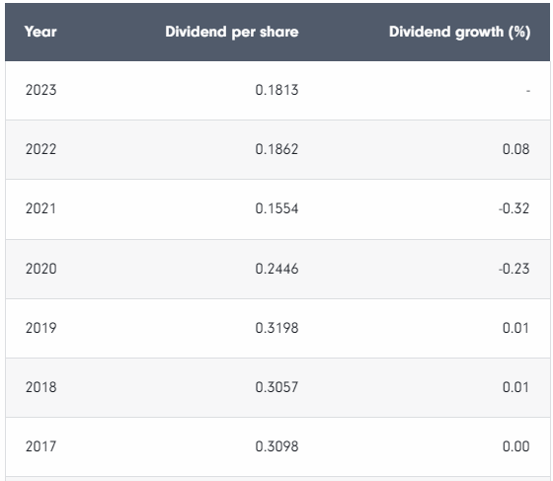
Figure 1: BP Plc Dividend history
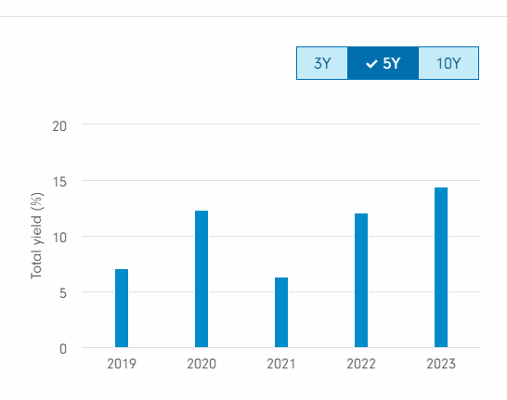
Figure 2: BP Plc dividend yield since 2019

Several factors could have contributed to these changes include the Covid-19 restrictions that affected transportation and industrial activities between 2020 and 2021. Also, the recent efforts in different parts of the world to reduce the use of fossil fuels could be a contributing factor. Nevertheless, as an old company in the industry and which is investor-based, BP has constantly paid out dividends. It has to maintain its financial strength while ensuring investors are satisfied.

4.0 Efficient market hypothesis theory in the context of BP Plc

It is common for investors to do a thorough analysis before deciding to invest in or through a certain company. However, based on the efficient market hypothesis theory (EMH), investors cannot gain more information about stock and get more returns above the market average. According to this theory, all available information is already incorporated in the stock price (Downey, 2023). Although in some cases, the efficient market postulation holds, it is not always the case. Moreover, since there are three forms of efficient market levels, it is vital to understand which holds for BP plc.
The weak form efficiency posits that current stock prices include the stock’s price and volume historical information. That is, past sock volumes and price trends are reflected in the present stock prices. Therefore, investors cannot outperform the market by analysing the historical prices and volumes. However, looking at historical data it can be seen that BP’s stock prices have ranged between USD23 and USD36; it also shows a faltering trend such as a drop of 41.32% between 2019 and 2020 and an increase of 37% between 2021 and 2022(macrotrends, 2023). The global oil and gas industry is volatile and subject to many regulations thus the present prices may not be a true reflection of the past trends. This means that, although the historical data may be included in the stock prices, this is not enough for investors as the industry is characterised by vulnerabilities and new developments that can affect future prices.
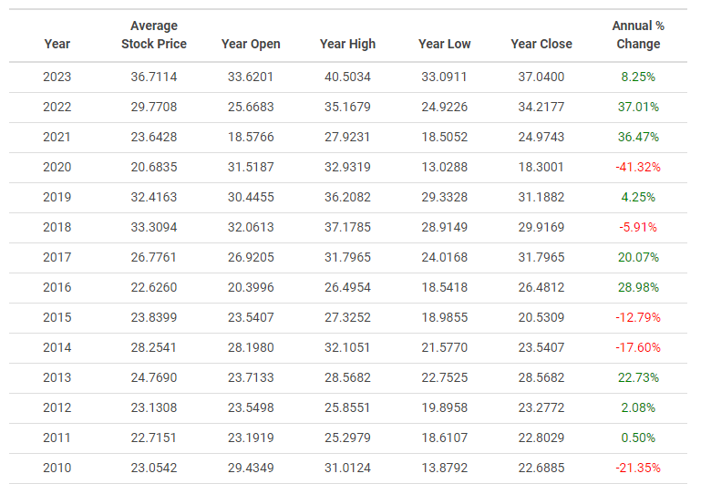
Figure 3: BP Historical Annual Stock Price Data (macrotrends, 2023).

The semi-strong form efficiency indicates that stock prices include all publicly available information. This includes historical data, financial news, management changes, and other relevant information. It means that an investor cannot outperform the market by simply analysing the publicly available information as that is already incorporated in the company’s current stock price. Moreover, BP Plc is a publicly traded company and it has been releasing annual financial reports, quarterly announcements, and press releases about new developments, issues, and changes. For example, 2022 -2023 has seen a significant upward trend in the company’s stock prices (see figure 3). This coincides with positive news about the company's new and prospective ventures as reported by several press releases on the company’s website https://www.bp.com/en/global/corporate/news-and-insights/press-releases.html. The new information including about major incidents such as oil spills is quickly incorporated to reflect on the stock prices; therefore, no investor can have an advantage above what is already available unless they have access to insider information. Moreover, according to the strong for efficiency, the stock prices also reflect all information including information known only to insiders. This form of efficiency may not be true in all cases of BP plc since in the past some fund managers have been able to outperform the market by allegedly obtaining insider information.

5.0 How BP Plc appraises projects

Like other MNCs, BP Plc has many projects in different markets, and in its growth goal, it yearns to expand and strengthen its competitiveness. However, careful appraisal of projects and investments is critical to ensure that there are meaningful returns on investment and unfavourable ones are done away with. In this, BP Plc does an appraisal of its current and prospective projects by conducting risk assessment and capital budgeting.
Although not a direct risk, BP, in recent times has abandoned projects after analysing their viability and profitability. For example, it abandoned oil exploration projects in Kazakhstan to focus on renewables (Gizitdinov, 2021). This was after understanding the volatility of the fossil fuel market especially in 2020 when the global transportation and industrial operations were affected. In addition, there is a growing campaign against fossil fuels and advocacy for renewables.
The company also assesses the risk of a country for its projects. For example, political and economic stability, competitors, level of acceptance by consumers in the market, and the local government’s behaviour. Regulations in different countries also influence BP’s investment in the market. For example, Sweden has a significantly high carbon tax (Halim et al., 2019); thus, the company may not venture into the oil and gas business in that market, but instead, it invests in clean energy.
The company also uses capital budgeting in its project appraisal. This involves evaluating which projects have the best ROI and favourable to the shareholders in the long term. This is a key aspect as in 2023, the company announced that it targets a capital expenditure of $16-18 billion (BP Plc, 2023). It has been criticised of them same because much of its capital expenditure is geared towards fossil fuels projects, which have high returns to shareholders but are detrimental to the environment (Lawson, 2022). Nevertheless, the company has to balance between satisfying its shareholders and complying with environmental concerns. Also, it must appraise projects in the context of market risks and regulations.

6.0 Conclusion

As an MNC, BP Plc navigates a complex international market with multiple operational and financial challenges and regulations. The company is investor-led in an industry where state-owned companies have become influential. It, therefore, has a dividend policy to ensure that shareholders constantly receive their dividends. Due to the nature of its industry, the semi-strong form of market efficiency is the most viable. The company diligently analyses its projects, but it needs not only to look at projects that have strong financial returns to investors but also to be wary of international trends and concerns.

References
Baker, H.K. and Weigand, R., (2015) “Corporate dividend policy revisited”. Managerial
Finance, 41(2), pp.126-144.
BP Plc BP Plc Annual Report 2022
BP Plc (2023). First quarter 2023 Results: Performing while transforming. Available at
https://www.bp.com/content/dam/bp/business-sites/en/global/corporate/pdfs/investors/bp-first-quarter-2023-results.pdf
BP Plc (2023) Dividend policy: Investors: Home, bp global. Available at: https://www.bp.com/en/global/corporate/investors/shareholder-and-dividend-information/dividends/dividend-policy.html (Accessed: 07 August 2023).
Downey, L. (2023) Efficient market hypothesis (EMH): Definition and critique, Investopedia. Available at: https://www.investopedia.com/terms/e/efficientmarkethypothesis.asp
Fidelity (2023) BP Plc (bp.), Fidelity. Available at: https://www.fidelity.co.uk/factsheet-data/factsheet/GB0007980591-bp/dividends (Accessed: 07 August 2023).
Gizitdinov, N. (2021) BP Exited Kazakh Oil Projects to Focus on Renewables Strategy, Bloomberg.com. Available at: https://www.bloomberg.com/news/articles/2021-03-10/bp-exited-kazakh-oil-projects-to-focus-on-renewables-strategy (Accessed: 07 August 2023).
Halim, I. et al. (2019) ‘Evaluating the potential impacts of carbon tax cost passing strategy on petrochemical selling prices’, SN Applied Sciences, 1(11). doi:10.1007/s42452-019-1553-6.
Lawson, A. (2022) BP criticised over plan to spend billions more on fossil fuels than Green Energy, The Guardian. Available at: https://www.theguardian.com/business/2022/dec/27/bp-plan-spend-billions-fossil-fuels-green-energy-oil-gas-renewables#:~:text=In%202021%20the%20company’s%20capital,year%20between%202023%20and%202025. (Accessed: 07 August 2023).
macrotrends (2023) BP - 46 Year stock price history: BP, Macrotrends. Available at: https://www.macrotrends.net/stocks/charts/BP/bp/stock-price-history (Accessed: 08 August 2023).

