University of Wales Trinity Saint David
School of Engineering

Technical Report on Workshop Session
M4X02063
Engineering Applications and Study Skills
Part B

Richard Parker
1902504
03/02/2020
Contents
1 Introduction 1
2 Background Research 2
3 Methodology 3
4 Discussion and Conclusions 4
5 Conclusions 5
6 References 6

Figure 1 2

Introduction

In the session on 14/11/19 in Room 022, the group used the moulds they had ready to make a blade for a miniature turbine out of fibre glass and polyester resin, as practice of composite manufacturing. This report will look into the health and safety regulations surrounding the workshop environment and the composite manufacturing process. It will also demonstrate how this particular part was made and where there was room for improvements in the process,

Background Research

Although the university is a learning environment, it must abide by the regulations set out in the Health and Safety at Work etc. Act 1974 and it’s amendments. This is a very extensive document, and as such the relevant sections to workshops are set out in HSG 129 as it was “written for people who run and work in small engineering workshops” (HSE, 2004). The topics covered in this that are relevant to the university workshops generally regard the use of proper PPE and good working environments. It also explains that the university must provide “good light” and to “use natural light where possible but try to avoid glare.”
The workshops would also come under PUWER – The Provision and Use of Work Equipment Regulations, which is also referenced in HSG 129. It says that “employers shall have regard to the working conditions and to the risks” that may face, and that they should not be subject to “any additional risks” that can be prevented or limited easily. (HSE, 2008) The university, considered an employer for the purposes of the document, also must ensure “equipment is maintained in good working order and repair” and that sufficient “training is provided for operators and supervisors” to limit accidents.
Although the fumes from the polyester resin and catalyst aren’t very dangerous, they would mean that COSHH regulations should be followed, as contact with eyes or ingestion would be harmful and could easily be prevented with proper PPE. The Control of Substances Hazardous to Health Regulations generally that the university should “look at any substance” and minimise “exposure by breathing in or skin contact.” (HSE, 2002)

Methodology

As the moulds were produced in pairs, members of the group needed to pair up with someone who’s mould was a good match for their own. Richard and Gwydion paired up, and were given a technical drawing showing the laminations, shown in Figure 1. One half of the finished mould is shown in Figure 2.
As shown in the technical drawing, each half of the mould would need 2 strips of glass fibre strips, cut with a scissors to both be the same width as the mould taking into account the contours with 5mm extra to overlap at each edge, but one cut at 45° across the weave.
Polyester resin and MEKP catalyst then had to be mixed at a ratio of 98g to 2g catalyst and mixed thoroughly. Then they brushed a small amount onto the mould surfaces to ensure there were no dry patches later on.
The first strip would be orientated at 0/90° to the mould, so the individual fibres of the weave would either be parallel or perpendicular to the mould edge. One edge of this strip was positioned at one edge of the mould, so the 5mm overlap protruded past the opposite edge. More of the resin mix was then added, ensuring there were no dry patches but minimal excess resin.
The next strip was orientated at 45°, with the 5mm overlap placed at the opposite side to ensure both halves of the mould met at each edge. More resin was brushed in.
The next step was to add the 12k Carbon Tows. These parts had 12000 strands of carbon each, and 3 lengths were added as explained in the technical drawing; one at each edge and one in the centre, all running lengthways through the part. A little more resin was brushed in.
The other half of the mould was then made in the same way, then the vacuum tube was laid through the middle and the two halves fitted together so that the 5mm overlaps were arranged properly. A cross-sectional diagram is shown in Figure 3 for clarity. The part was then vacuum bagged carefully using layers shown in Figure 4, then the vacuum was checked, and it was left to set for a week as shown in Figure 6.
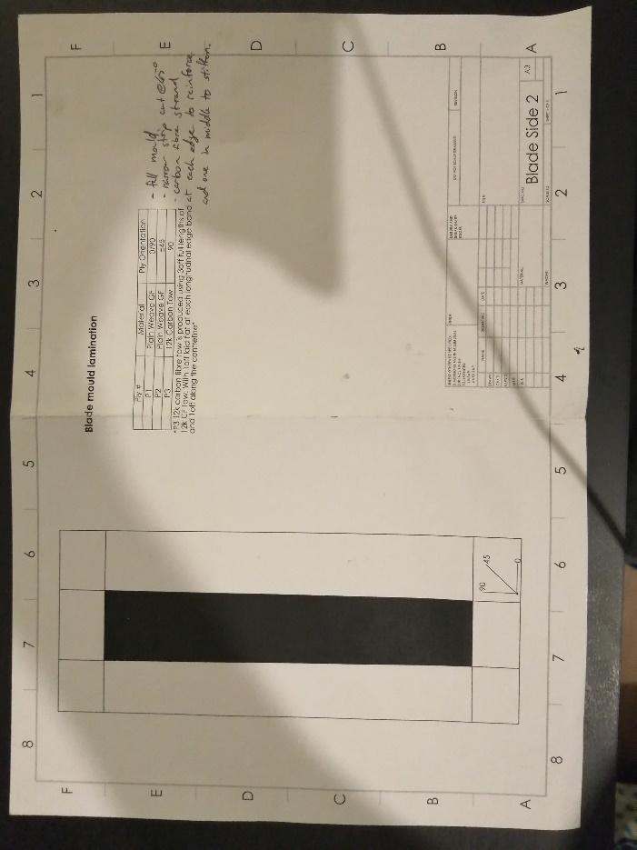
Figure 1 - Technical Drawing of Blade Mould Lamination

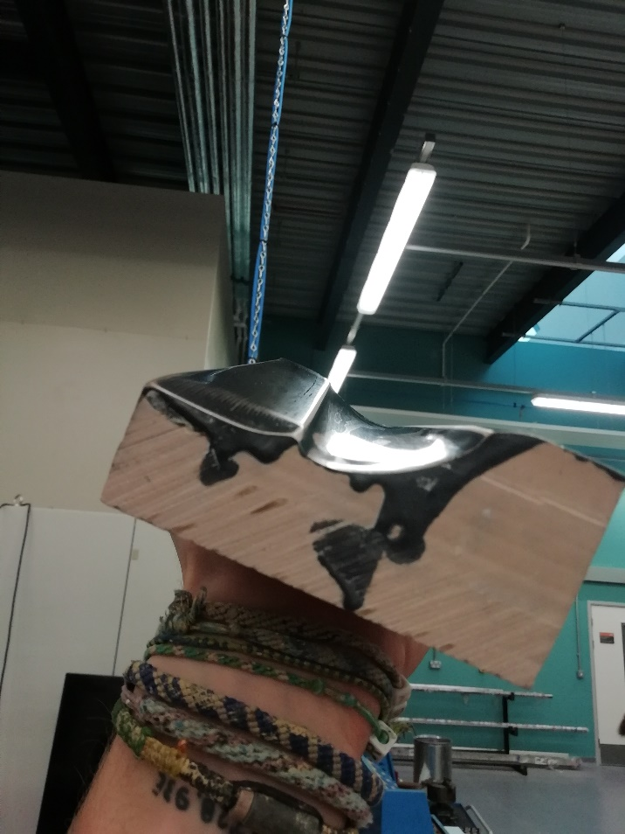
Figure 2 - Finished Surface Ready for Laminations
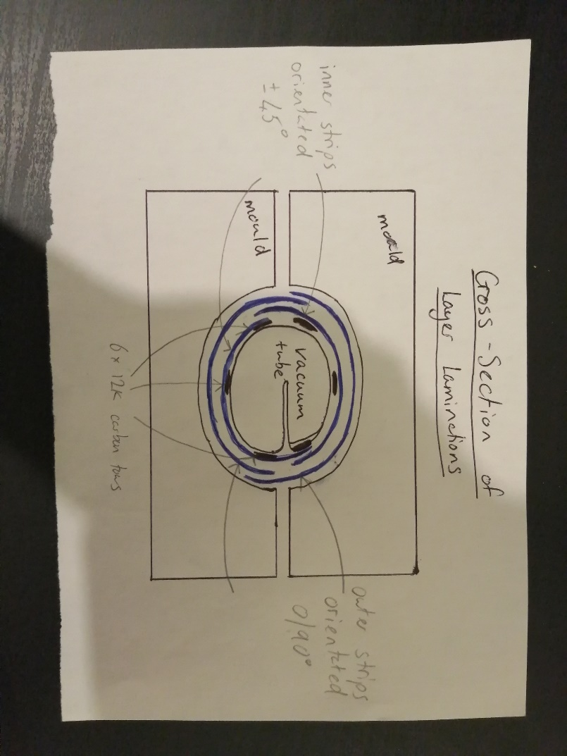
Figure 3 - Cross Section Showing Lamination Arrangements

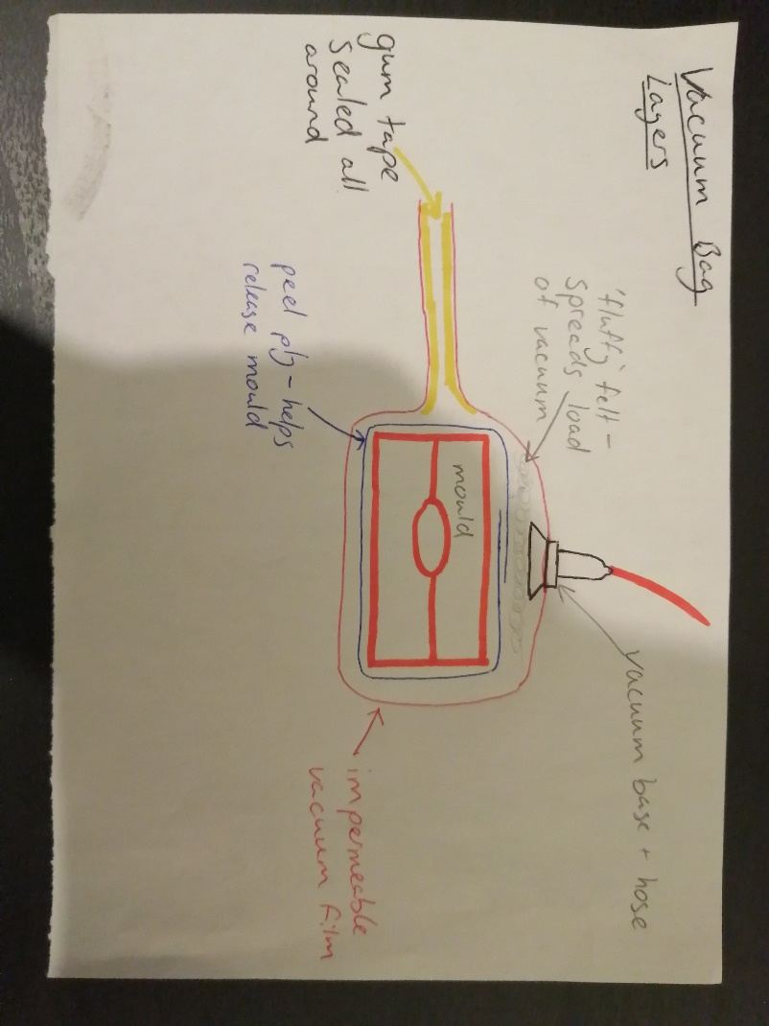
Figure 4 - Diagram Showing Vacuum Bag Layers
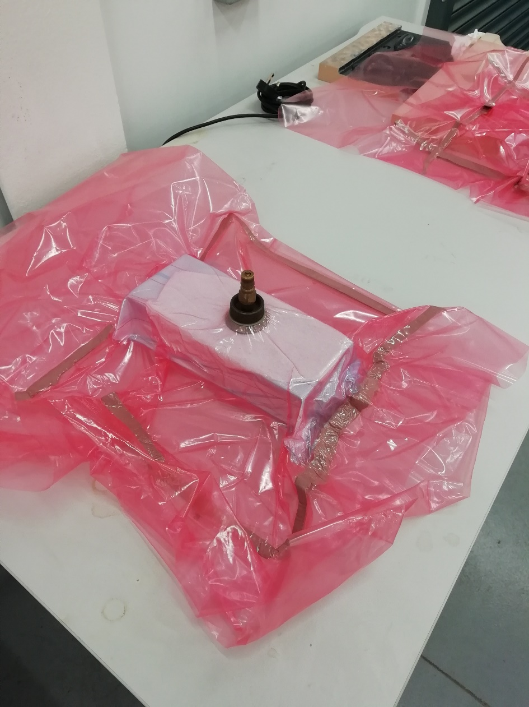
Figure 5 - Vacuum bag ready to be opened

Discussion and Conclusions

As Figure 6 shows, the part came out with some frayed edges where the edges of the glass fibre had got pinched between the moulds. However, some sections came out with a very neat surface, and after some trimming and sanding it looked much better. The problem with the method in the first attempt was that it was hard to align the layers properly because of how sticky the resin was, and as small adjustments were made other sections ended up worse. The carbon fibre tows ended up very thin, so their expected strength improvements are limited.
A new method was devised for the second blade, where the layers were formed around the inner vacuum tube, then this was laid between the moulds and bagged. This was much quicker, easier and produced a much neater part, a side by side comparison is shown in Figure 7. In the second attempt the carbon fibre tows ended up twisting along it’s length by almost 90°, which is due to a combination of the layers moving as a vacuum is formed and their limited experience of composite manufacturing. This is a key point to take from the experience, as no matter how well a part should work in theory, test runs and prototypes are key to success as lessons are always learned when initial attempts fail.

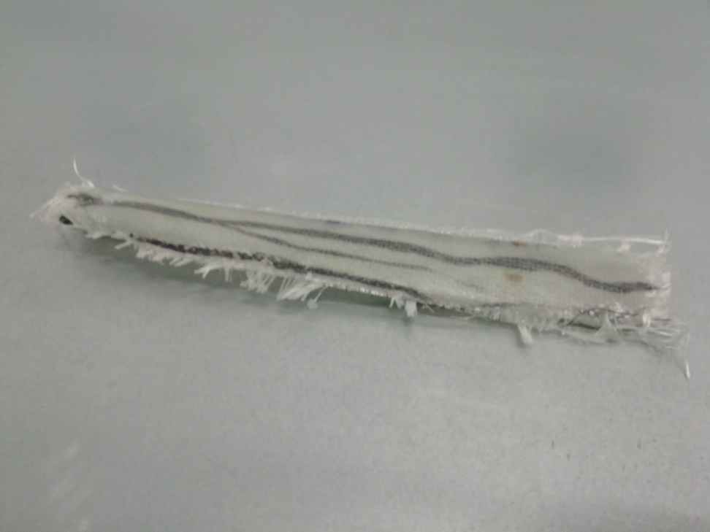
Figure 6 - Frayed Edges of First Blade
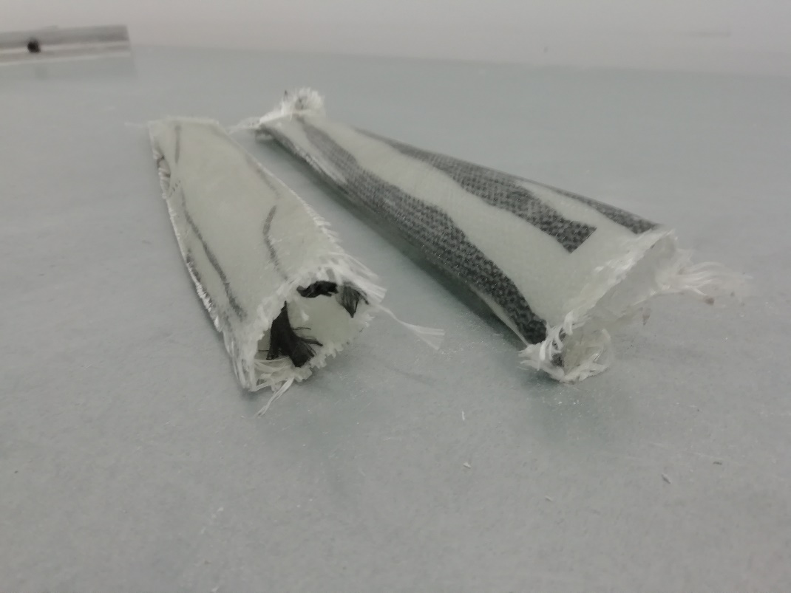
Figure 7 - Left - First Blade, Right - Second Blade

References

HSE, 1974. Health and Safety at Work etc. Act 1974. [Online]
Available at: http://www.legislation.gov.uk/ukpga/1974/37
[Accessed 02 02 2020].
HSE, 2004. HSG 129. [Online]
Available at: https://www.hse.gov.uk/pUbns/priced/hsg129.pdf
[Accessed 02 02 2020].
HSE, 2008. PUWER - Provision and Use of Work Equipment Regulations. [Online]
Available at: https://www.hse.gov.uk/pubns/priced/puwer.pdf
[Accessed 02 02 2020].
HSE, 2019. COSHH - Control of Substances Hazardous to Health. [Online]
Available at: http://www.legislation.gov.uk/ukpga/1974/37
[Accessed 02 02 2020].

