Mariusz Kalasz (1805456)

HTML & CSS Web development
Phan-site
Contents
Introduction 2
Requirements 2
Implementation 2
Validation 6
Evaluation 8
Bibliography 21

Introduction
The task was on developing a website using HTML and CSS, the topic of the website can be chosen by the author. This report will go over the development process and evaluation of the website, the evaluation will include of how well it fits for the target audience and its purpose but also how accessible it is.

Requirements
The website has inspiration from the Phantom Aficionado Website or also know as Phan-site, this website is from the game Persona 5 which is developed by Atlus. However, the purpose of this website differs from the one in game, as the in-game website is more used for plot and side quests. The purpose of this website is basically a fan site, the target audience is for anyone who likes the Persona 5 game, and that’s from people who just started playing to people who played it for a while. The purpose of it is to bring other players in the community together by having discussions with each other and sharing their creations and any tips and tricks, plus it is also a news site, but its main topic is Persona 5.

Implementation

  - Homepage
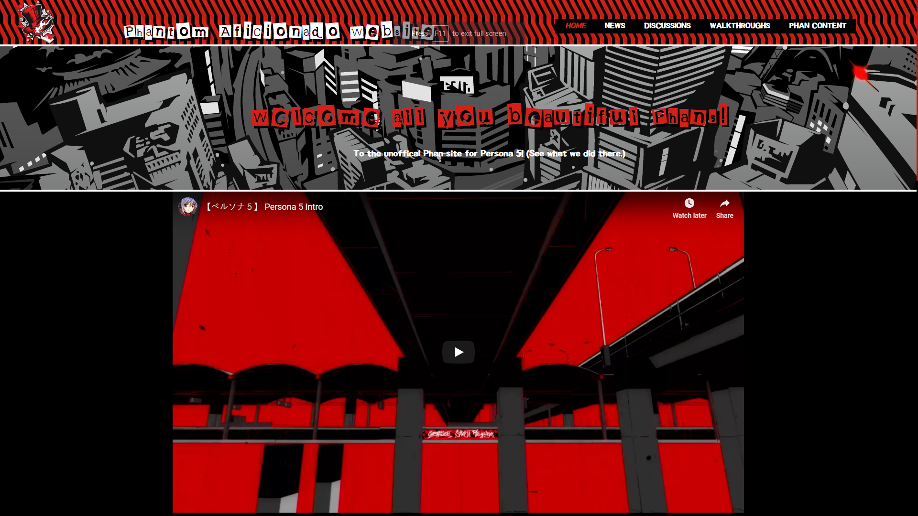
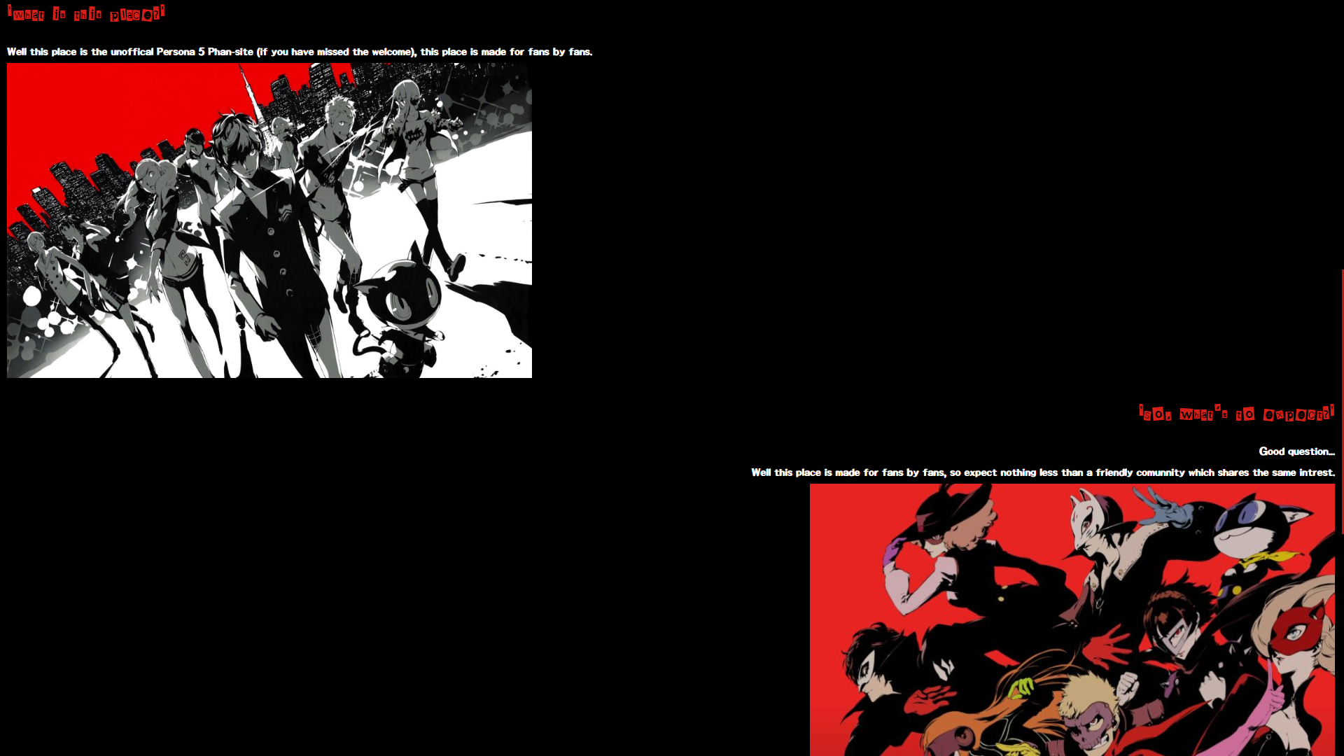
This is the home page of the website, it particularly doesn’t have much content in it, but it does tell the user of what they can expect from this website and of what it is. It also includes embedded video of the intro movie from Person 5.

  - News
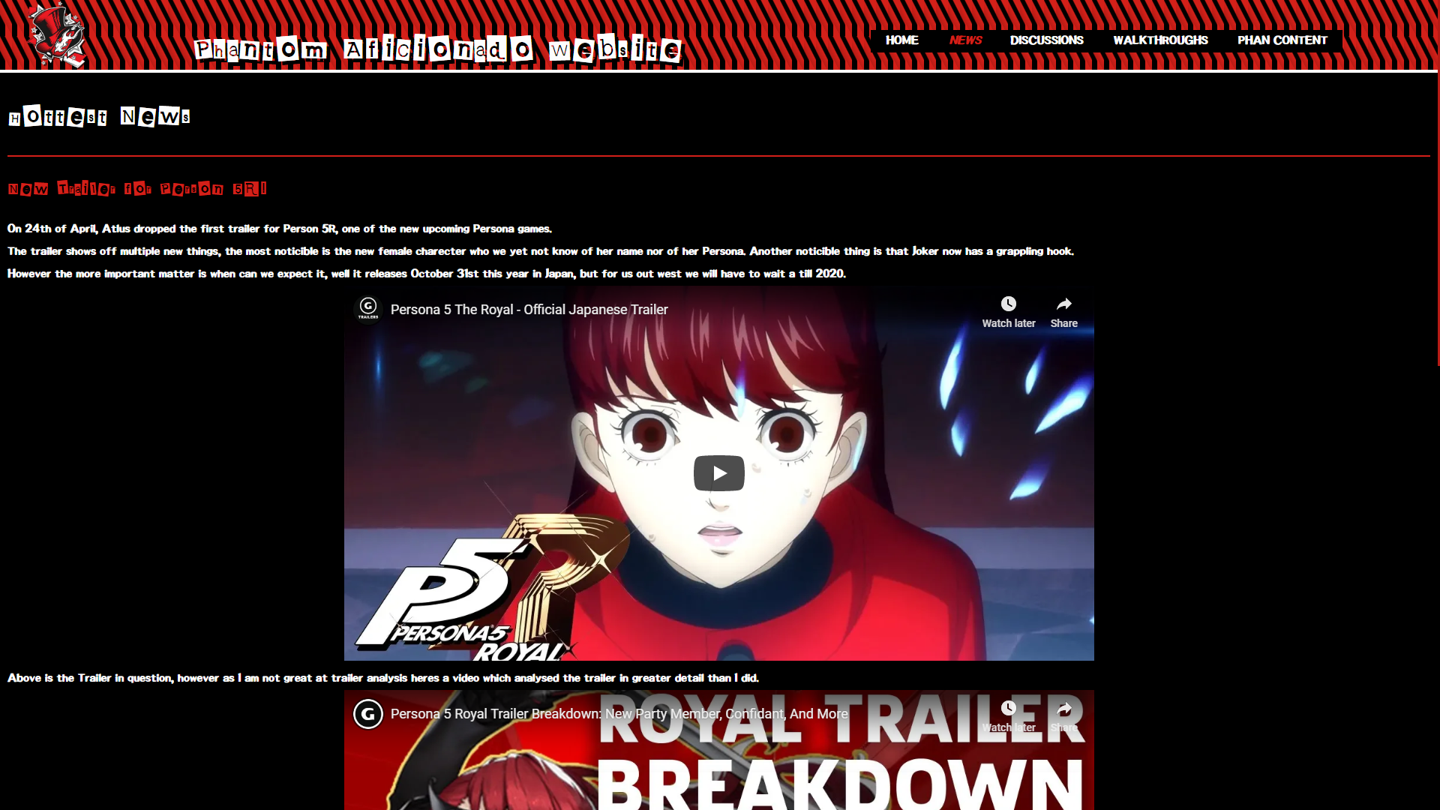
This is the news page of the website, this is where the users will get the most recent news from the Persona world, that would include new game releases or any announcements about them.

  - Discussions
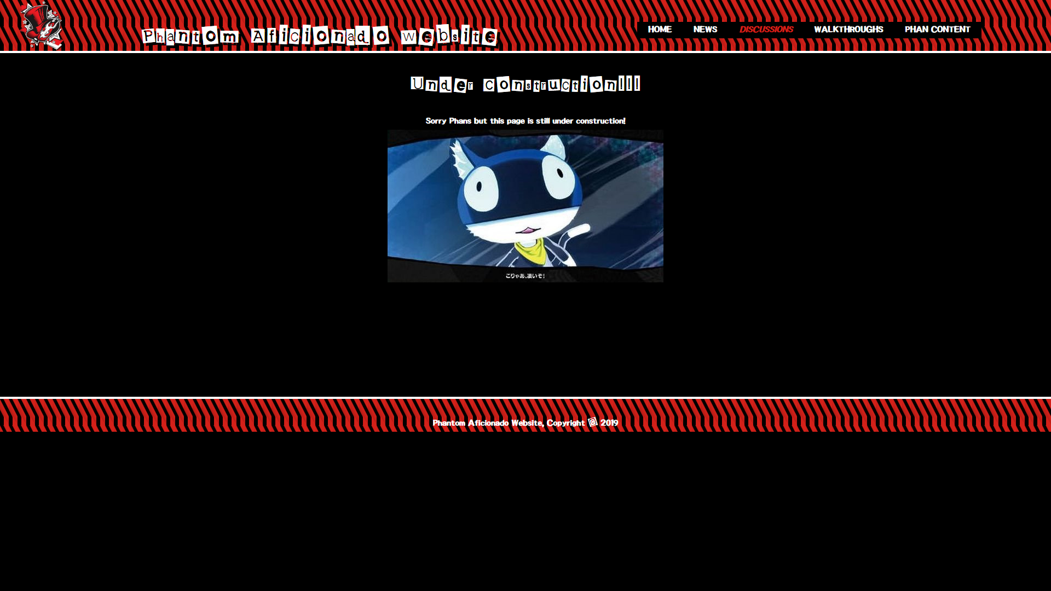
This is the discussions page, this however was not complete, but this is where all the users would be able to login and create their own posts, for example like Reddit. Then the other users will be able to comment on those posts. The posts would also have their own categories, for example one would be in the walkthrough/tips category, and another would be story discussion, also there would be a choice on marking a post as a spoiler so it will protect people who just started the game from them.

  - Walkthroughs
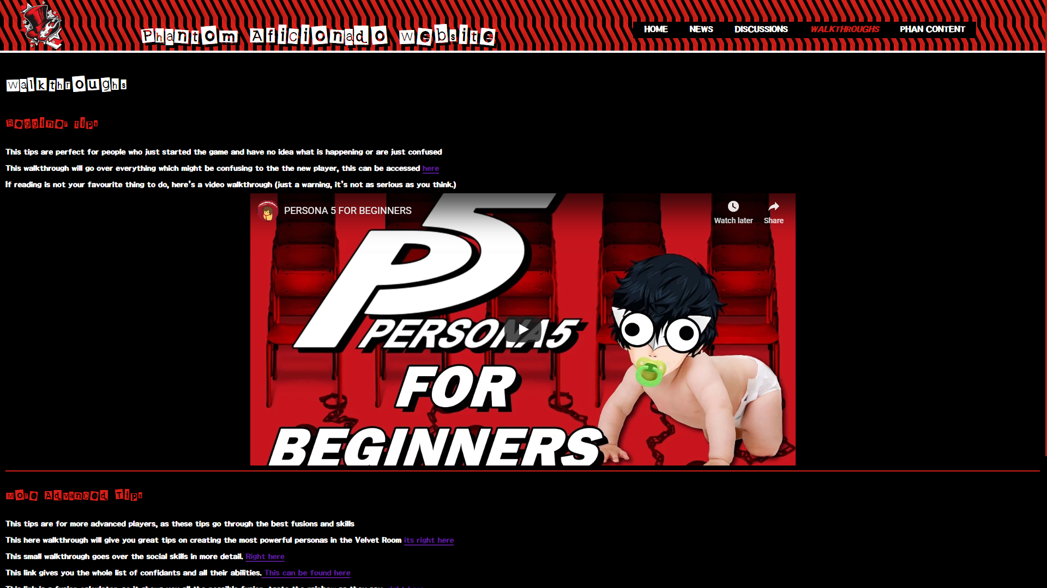
This is the walkthroughs page, this page serves the purpose of listing any useful walkthroughs or tools for Persona 5, this can include text and video-based walkthroughs. These walkthroughs are also separated by beginner and advanced categories, the categories describe themselves. Most walkthroughs on this are text, however there is a possibility of adding more in the future.

  - Phan Content
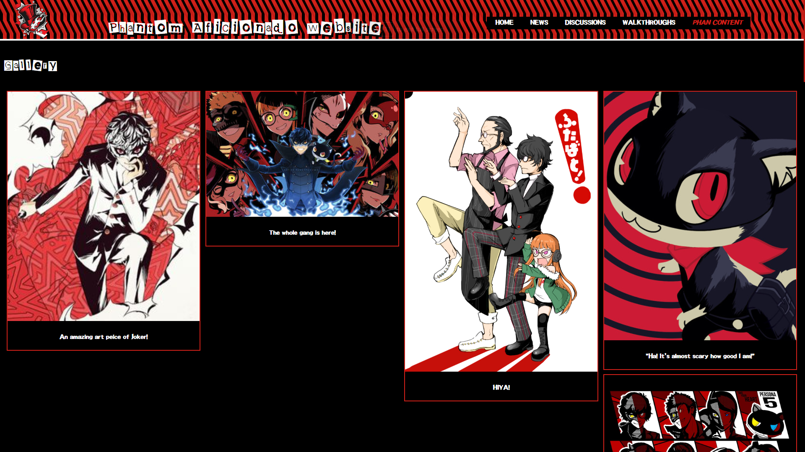
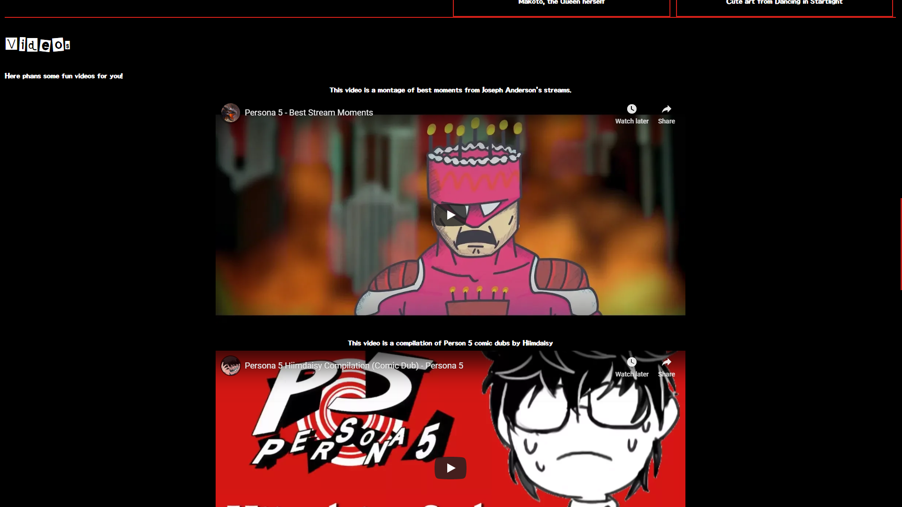
This is the Phan content page, this page includes fan creations inspired by Persona 5, this includes fan art, videos, comic dubs and song covers. Again, the content is split into categories, so any images are in the gallery and any videos are in videos.

Validation
  - Validation of the HTML of the homepage
To validate the HTML this website was the W3C Markup Validation Service [1] which allows on searching a particular website using its URL, upload the file with the HTML or straight copying the code into it. The validator highlights all possible errors and warnings in the code.
The results were:
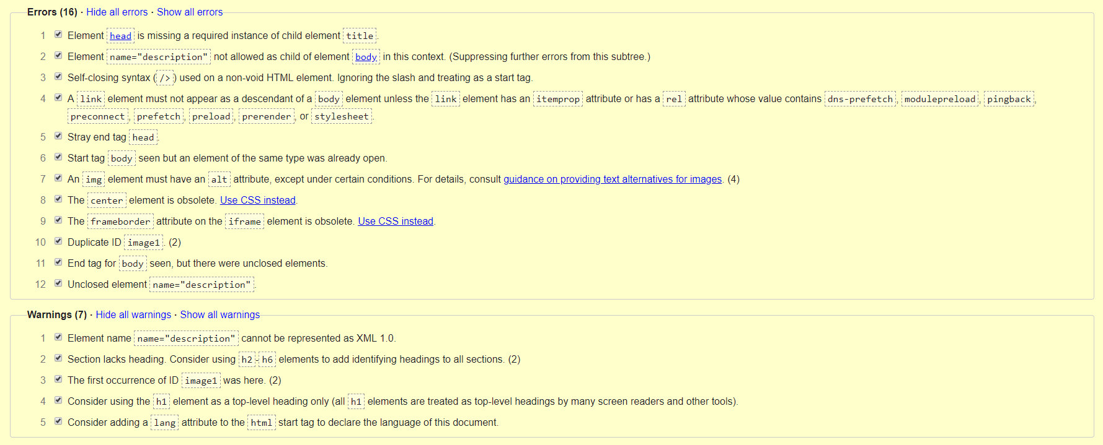
There is a total of 16 errors the majority is including this line “<name="description" content="The unofficial Phan-site for Person 5"/>”, the errors including that it can not be a child of <head> and that it is missing a required instance of child element title. To solve this error was simply deleting that line of code from the HTML file, this has now decreased the number of errors to 12 and it showed other new errors, so the new results are now:
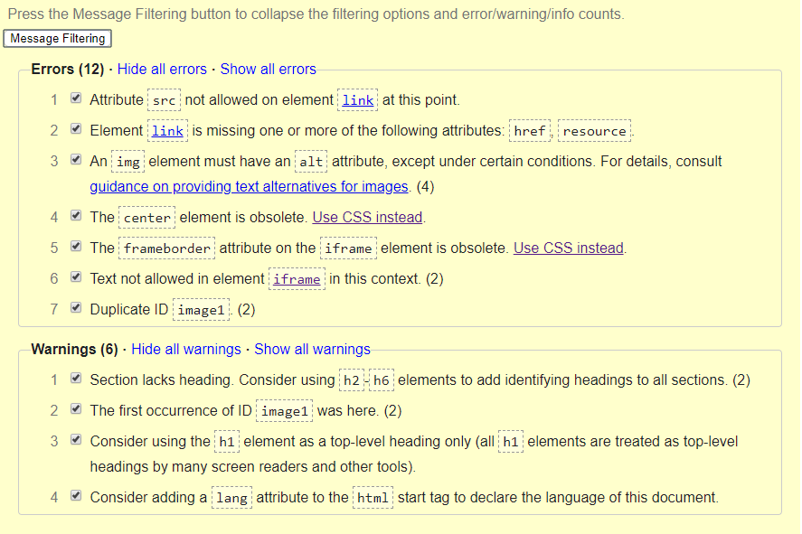
The new error is linked with the <link rel="icon" type="image/png" src="Images/image - Copy.png"> as it says the src attribute is not allowed in the link attribute. This was fixed by replacing the src with href, which has also fixed the problem with the favicon not displaying correctly.
The rest of the errors are less important as it mostly includes some parts being obsolete, duplication of an ID and the need of alt attribute in the img elements. However, these errors do not affect of how the website works or what it supposed to be, so these errors won’t be fixed.

  - Validation of the main CSS
The validator used for is was the W3C CSS Validation Service [2] which works on the same basis as the previous validator but with CSS.
The results were:
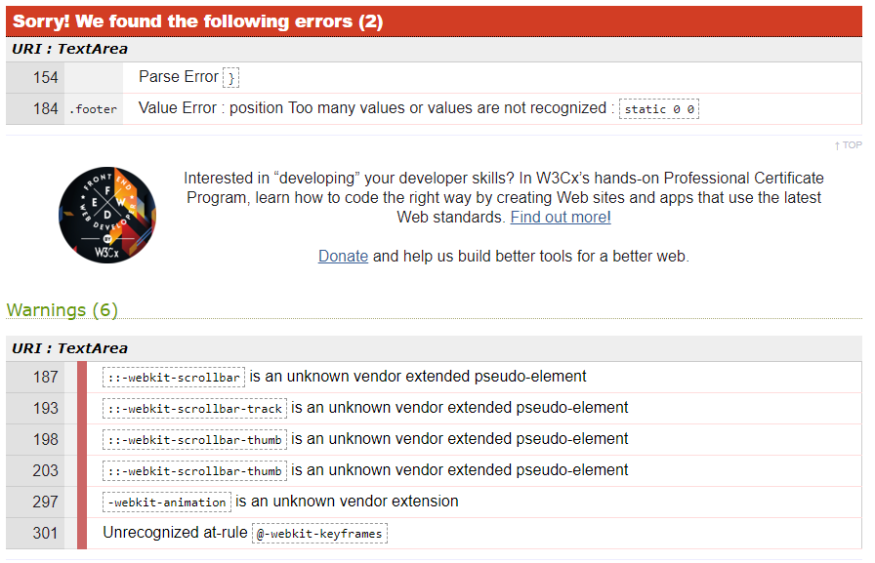
There were only 2 errors in the code, these can be simply fixed. To fix these errors was just to delete those two lines of code. By doing so it didn’t affect the website in any way.

Evaluation
Firstly, the website will be evaluated on accessibility using the WCAG 2.1 [3] and the WAVE Evaluation Tool extension for Google Chrome. The four principles of WCAG 2.1 are:
- Perceivable- Web content is made available to the senses - sight, hearing, and/or touch.
- Operable- Interface forms, controls, and navigation are operable.
- Understandable- Information and the operation of user interface must be understandable.
- Robust- Content can be used reliably by a wide variety of user agents, including assistive technologies.
[3]

  - Results for the homepage
Summery:
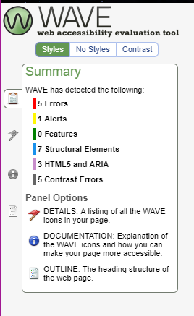
This is the summery of the evaluation for the homepage, as seen on the left there is a total of 5 errors, 1 alert, 0 features, 7 structural elements, 3 HTML 5 and ARIA, and 5 contrast errors.

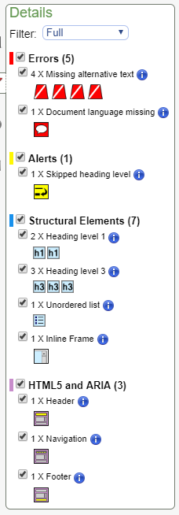
These are the full details of the evaluation, in total there 5 errors, 4 of theses is the alternative text missing from the images on the page and the other error is that the document doesn’t have a set language.
These errors can cause some problems, for example the document not having a set language might be a problem to people who do not speak the English language making the information impossible to read. The alternative text for the images is not much of a problem as they serve a decorative purpose however according to WCAG 2.1 “Images that do not convey content, are decorative, or contain content that is already conveyed in text are given null alt text (alt="")” which the code does not.

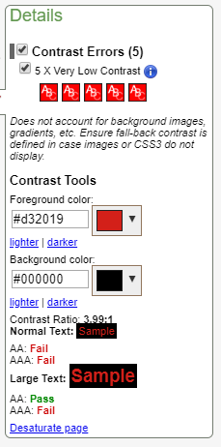
  - These show the errors on the contrast of the website, this mainly are about the red text on the black background. This has only passed the AA rating for the large text however the others were a fail. To improve on this the whole colour scheme would have to be changed as to make all the, pass the text would be way to far from the original colour. However this colour is only used for large text as the smaller text is purely white.
Results for the news page
Summery:
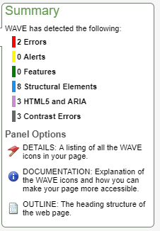

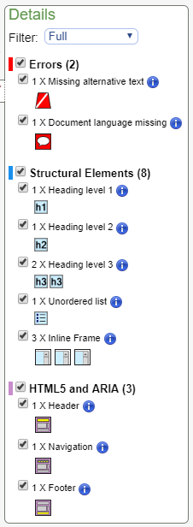
The news page has much less errors as it only has one image in it, which is the logo, the alt should be still set to null as said in the evaluation of the homepage. The other error is of the language not being set.

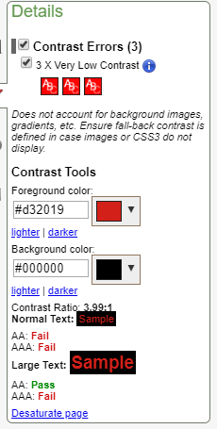
The contrast is the same as of the homepage, this is because a dark red on the background of black can be hard to read, however the text which is only in read is large, so still readable.
And the other text is in pure white.
  - Results for discussions page
Summery:
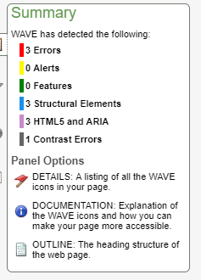
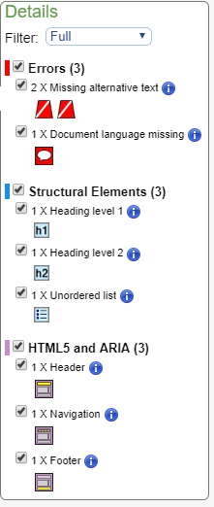
The errors are the same as of the previous pages, however the images are only used for decorative purpose, but they still do require the alt to be set to null.
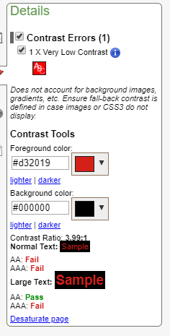
This is the same error on the contrast as the other pages, this is only found in the navigation bar of the page this due to showing on which the page the user is on, and again this text is large therefore it passes the AA.

  - Results for the walkthroughs page
Summery:
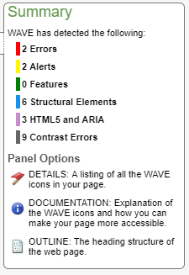

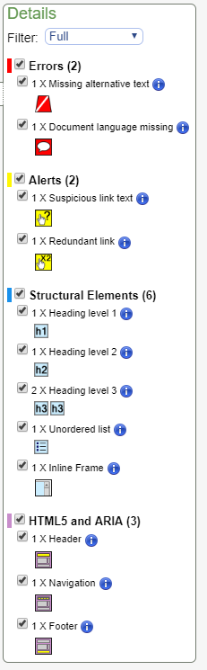
The errors are the same as in previous pages. However, the alerts are different as one of them says that on the links have suspicious text attached to it, however before the link is a sentence which explains on what the link has, so it is within context.
The other alert says that one of the links is redundant, this is due to having a repeat of the same link, on closer inspection this is true, the link before the one in question already had that URL, this has been now fixed.

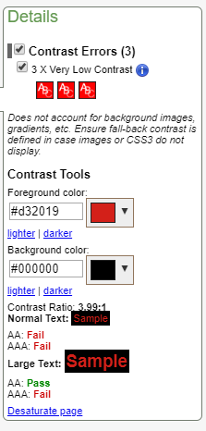
The contrast errors are the same as with previous pages, however on this page there were more due to the link colour being a dark purple which was difficult to read on the black background. This has been changed to a more brighter colour.
  - Results for the Phan content page
Summery:
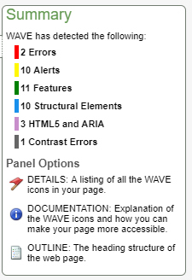

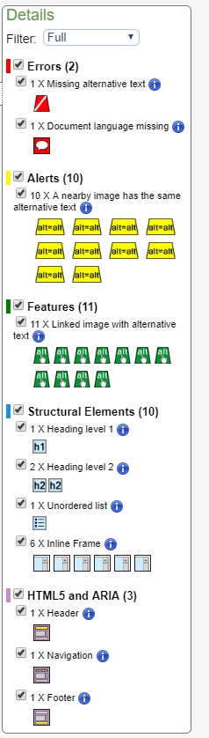
The errors are the same as on the previous pages.
However, there are much more alerts due to all nearby images have the same alt as each other, this should be changed as if the images don’t load up the user will not know of which one, is which, however below each image there is a description of what it is.
So, it does follow the first principle.

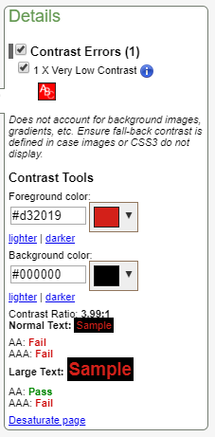
The contrast error is the same as the previous pages, however the text is large so it can still be read.

  - Final Evaluation
This is the final evaluation of the website, this will go through the design, usability and content of the website. So the design of the website, the looks of the website are good this is due to the website following the same style as the game has the background on the header and footer of the website has a pattern where you could have find in game, and the colour scheme follows the strict black, white and red colours which are colours of the game UI. The website even includes fonts which can be found in game, making it look professional and close to the topic. The feel of the website is good as well, most thing which can be clicked react to the user when the cursor hovers over them, so the website feels more responsive. The scroll bars are also designed to fit the colour scheme of the website. The only thing which could have been improved on is maybe to add a button which brings the user back to the top of the page or have the navigation bar move with the user as they scroll down so they won’t have to scroll all the way up to go to a different page.
On the front of usability, the navigation bar works, and other links do as well. There isn’t much on improving with this front as the website works the only thing which could technically be improved is on the lack of the discussion post feature which should be available on this website as it is one of the main purposes of it, also there should a login function in the website.
Finally, the last front is on the content of the website, half of the content is available to user, like the news, the fan creations and the walkthroughs. However, the website doesn’t have the discussion system which is the main part of it, so the users won’t be able to add their own content to the website nor talk with other users. Another improvement in the future would auto update of news and addition of the content.

Bibliography

[1] |  | W3C, “Markup Validation Service,” W3C, [Online]. Available: https://validator.w3.org/. [Accessed 10 May 2019].
[2] |  | W3C, “The W3C CSS Validation Service,” W3C, [Online]. Available: http://jigsaw.w3.org/css-validator/. [Accessed 10 May 2019].
[3] |  | WebAIM, “WebAim WCAG 2.1 Checklist,” 2018. [Online]. Available: https://webaim.org/standards/wcag/WCAG2Checklist.pdf. [Accessed 10 May 2019].
[4] |  | L. Verou, “CSS 3 Patterns Gallery,” [Online]. Available: https://leaverou.github.io/css3patterns/#. [Accessed 4 May 2019].
[5] |  | T. Media, “Build An HTML5 Website With a Responsive Layout,” 2016. [Online]. Available: https://youtu.be/Wm6CUkswsNw.  All images used in the website are cited inside the code.

