A customer relationships journal
Syeda savannah Davies
A critical perspective of the impact organisation’s ‘quality’ processes have on customer relationship management.
Student number 1710300
5/7/2019

Executive summary
The researcher has been asked to investigate the organisation of Lush and identify how they operate ethically, do they offer quality products and the sustainability of their organisation for the future. It will discuss how these factors impact on their CRM systems and those of other organisations. The author will conclude on the findings and offer suitable recommendations.

Contents page
Page 1 Cover page
Page 2 Executive summary
Page 3 Content page
Page 4 Terms of reference and procedure
Page 5 Introduction to Lush
Page 6, 7, 8, 9, 10, Findings
Page 11 Conclusion
Page 12 Recommendations
Page 13/14 Reference list

1.0 Terms of reference
On the 19/06/19 the editor has requested a report to be compiled by S.D consultancy 1710300 and submitted on the 5/07/19, the purpose of the report is to critically analyse and identify the impact an organisations ‘quality’ processes have on customer relationship management. (CRM) the author will look at problems within the organisation and investigate how the customers view the organisations ethical stance and sustainability polices, identify a variety of models and theorise to improve the organisations customer relationship. The author will then conclude on the findings and offer recommendations on the quality of their CRM.

2.0 Procedure
This report will source and identify varies evidence and information taken from a number of different textbooks, journals, university library resources, online journals, moodle and professional websites.

3.0 Findings
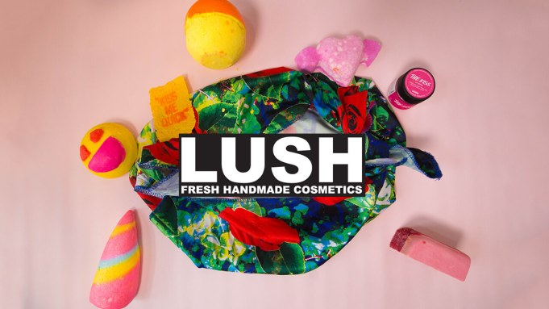
LUSH handmade cosmetics was created by Liz Weir, Mark Constantine, Mo Constantine, Rowena Bird and Helen Ambrosen in 1995 in England and then branching out to Australia in 1997, LUSH has been creating fresh handmade cosmetics for customers all over the world. They started operating on a small scale making handmade herbal hair products for hair salons. Many of their best products they started selling to the Body shop, one of the best shops for cosmetics in the 80s. They continued this partnership for 15 years before deciding to sell body shop their formulas and starting out independently and storming the market with the launch of LUSH. (Lush 2019)
LUSH exploded on to the market with colourful products such as organic soaps, shampoo bars, naked creams and bath bombs. These products have evolved to be some of the best sellers on the market of their kind. They also stand out from the crowd with its well known ethical choices for example they are strongly against the testing of animals, they show consideration for the environment by creating naked products without any packaging and waste. RESCI (2019)

Mission statement
LUSH's mission is to make their products by hand with only vegetarian ingredients and little-to-no preservatives. ... Through their transparency and open commitment to sustainability, LUSH clearly conveys their commitment to natural, vegetarian, cruelty-free products. A Lush life (2019)

3.1 Ethics
Ethics are simple concepts and fundamental principles of good human behaviour and conduct. It is the study of morality and good practice; it follows universal values such as fair trade, equality of men and women, human rights, health and safety, good working conditions and ever increasingly looking after the environment. (Mullins .L. 2016, p.618)
Ethics are essential for every organisation. Ethics are vital in business as they cannot afford to ignore anything that has serious influence and implications within the market they operate. It is necessary as making ethical choices in business is unavoidable and if they make the right ethical decisions it make things like equal pay a benefit for everyone. Business ethics are providing essential support for maximising long term owner value and customer relationship. (Sternberg.E.1994). Just business. London. Warner books.
The ethics and culture of lush
When Lush became independent they focused on issues that were close to their hearts. They made their products to be against animal testing, handmade, 85% vegan and 100% vegetarian, they are proud to campaign with the causes they truly believe in. These values and ethics are reflected in the organisations culture and are clearly voiced in their mission statement. They have implemented a buying policy to ensure that all of their suppliers share the same stance on animal testing; this is a policy that still stands today. Lush only make products from organic fruit and vegetables and safe synthetics.
(Insider trends 2019)
Lush believe that no business should stand out just for doing what is ethically right and for participating in fair trading, as they think that no company should be run from an unethical position. Lush have always conducted business so that everyone they are involved with such as suppliers, staff and consumers all benefit from their experience with lush. The organisation admit that they still have a long way to go, to be their ideal vision, but they try to stay ahead of what consumers demand, so that the business practices match their own objectives, expectations and the needs of the planet. LUSHS ethics are a key message in their mission statement they are transparent and it holds value as they are practising these core values within the everyday running of the organisation, it is clear to see from this alone that Lush operates in an ethical manner, this has bought them closer to their customers that share the same values and similar moral compasses. It has also become one of the unique selling points of its products. (Lush life 2019) (Shop ethical, 2019)
However not all organisations operate in an ethical manner big brands such as Primark. They hit the headlines after an undercover investigation by the BBC found that their factory workers were being exploited by receiving £3.50p for a 12hour day. Primark claimed on its website to deliver fast cheap fashion without breaking its ethical code and best ethical practises were of great importance to the company, as uncovered by the BBC this was found to be not true. Primark are trying to amend their past behaviour and have publicly apologised to its customers and employees. (BBC 2019)

3.2 Sustainability
Sustainability means meeting our own needs without compromising the ability of future generations to meet their own needs. In addition to natural resources, we also need social and economic resources. Sustainability is not just environmentalism. Embedded in most definitions of sustainability we also find concerns for social equity and economic development. (McGill University 2019)

The concept of sustainability is a way of conducting business not just for profit, but to make things better for everyone involved from better management of employees to consumers and the planet. For many years now more and more people are focused on the sustainability of the planet and environmental impact, many organisations have had to make big changes in the way they operate they needed to find new ways to maintain and grow their business with as little impact as possible to the environment, the people who live in it and factors such as social and economic issues, for example MCDONALDS now only use paper straws and degradable paper bags. (McDonalds.com 2019)(Business dictionary.com 2019)

The Triple Bottom Line is a model drawn out by John Elkington as a concept to encourage organisations to measure their success in more areas than just profits. Many businesses believed they were only successful by the amount of profit they generated. But John Elkington strived for a better approach.
It is the assessment of overall business performance based on three important areas planet, people and profits. Each of these 3 areas is looked at over time and measure social, financial and environmental progress of the business. (Tutor to you 2019) (Mullins, 2013, p. 299)

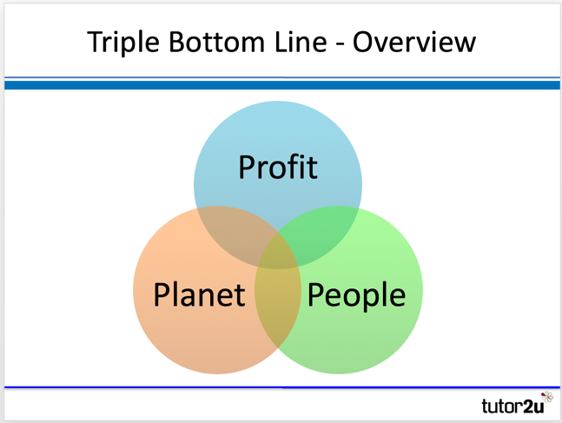

People
Lush as an organisation over the previous 10 years have been consistently resourcing and developing their relationships with its suppliers and producers in order to trust that the suppliers working conditions are dignified and that wages are fair. They ensure this by doing direct trade with companies that provide certification and auditing to show consumers that they can trust that employees further down the line are treated fairly and given workers rights, fair pay, good working hours and no child labour. Lush company profile (2019)

Planet
One of LUSHS usp’s is its pledge to the sustainability of the planet they ensure no testing of ingredients is done on animals. They use only vegetarian organic ingredients and don’t believe in genetic modification. Lush also have plans in place so that ingredients travel at minimum air freight with as little packaging as possible. (Independent, 2019)

The benefits of using the triple bottom line theory for organisations is, it allows for a better understanding of consumer needs, it attracts and retains staff, business becomes more efficiently run, it helps to build community relationships, most importantly improves sales and customer loyalty. (News bank, 2019)

3.3 Quality
Quality in business is a measure of excellence or a state that is free from defects and deficiencies. It is defined by a strict commitment to high standards that produce uniformity of a product to satisfy specific consumers or requirements. (businessdictionary.com 2019)
“Quality is not an act, it is a habit” (Aristotle 1996)
When consumers by products they expect quality that is in line with the price they pay, consumers look at aspects such as the functionality, good design, value for money and consistency. In organisations like easy jet and George at Asda clothing they are marketed as basic and this is reflected in their price range, these products may be low in quality in terms of fashion and style, but they still offer good value for money for overall quality. It is important to organisations to produce the products reliably, efficiently and at low cost. (Tutor2you2019)

One method of analysing the quality of organisations products is the Fish bone model created by Kaoru Ishikawa as a cause analyse tool to identify any causes that would create problems and to change the way managers think about improving a products quality. Ishikawa had the notion that companywide quality controlled assisted with customer service. This would provide a consumer with service even after receiving the product. (sky mark.com 2019)

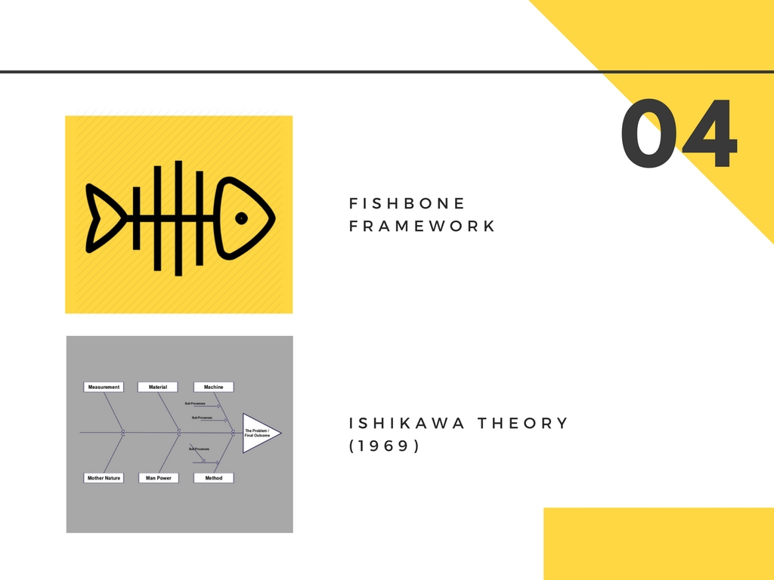

Lush takes the quality of their products and ingredients very seriously, they believe that these products should have integrity of their own and provide what they say they should for the consumers; they aim to provide value for money without taking short cuts on cost, exploiting the suppliers, employees and planet to provide the ingredients. Lush produce all products with a personal touch, even a picture of their faces are displayed on the packaging. They create many local jobs from sourcing ingredients locally; this in turn creates happy workers.( Lush handmade policy 2019)
3.4
The retailer lush uses its CRM system to manage staff, sales and reduce stock waste. It has helped them to use more recycled materials this has lead to them being more ethical as an organisation and improved turnover. In 2010 they put in new till systems and software saving employees time and the organisation money. Scott Silverthorn, the head of reporting and data services at Lush states that the company chose Qlik view business discovery at the system was easy to use for all employees that have different technical experience, this means staff have access to data so they can find ways to improve performance over all and become better at their job. Most importantly this system seem like the best cultural fit to their vision, as Lush pride themselves on its ethical stance. The organisation as a whole has reduced its losses in stock wastage by more than £1M since they started using the system in the UK. (Computer weekly.com 2019)
4.0 Conclusion
- Lush offer incentives of discounted products available to employees and daily use of products in store and while training
- Lush encourages a culture whereby employees have a personal connection with the products they sell and can give honest opinions to customers as well as demonstrating that Lush value the views and of their staff
- Lush demonstrate they are an ethical organisation through the language and symbols they use. They show this by displaying their logo 'Lush handmade and fresh' which tells their consumers/customers that they are an ethical organisation
- Ethical language/symbol - packaging and marketing their products by displaying them ‘naked’
- Lush being an activist for animal right shows strong power within their communities who share the same views
- Lush also show their power by making decisions based on ethics and the needs of their organisation and their stakeholders
- Lush are a transparent organisation. Lush tries to involve the community with campaigns so that both the organisation and the community can bring to light all the topics they believe is of importance and believe it is important to empower those around them
- Lush are passionate about current affairs and will actively campaign for change
- Lush treat all employees equally and the wage is paid regardless of age, gender and religion
- Lush source products/ingredients and take in to account the community and ensure they are benefitted
(Newsbank, 2019)(Lush, 2019)(BBC, 2018)(Evans, 2018)(Oppenheim, 2018)(Lush Times, 2019)
5.0 Recommendations
Each Lush store is run independently by different managers; this has created inconsistencies from store to store. To ensure all stores are run fairly, and managers are trained in the same manner they should take on Argos’s approach whereby all colleagues and store managers are all on the same leadership programmes through the Argos Retail Academy. Consistency determines whether the tenet of workplace culture is fleeting, or here to stay so managers demonstrating consistency will shape the company’s transparency and underlies basic assumptions.
Lush do claim that all its ingredients are natural, it was found that some products did contain dyes and chemicals to preserve items which were deemed harmful. Although it was unintentional it can create a dishonest image for Lush. As an organisation they must deliver transparency on all ingredients of their products, or anything that is used to enhance those, consumers must be informed of the information on the ingredients allowing customers to make their own decision on purchases.
Lush do like to participate in campaigns they feel strongly about and hold demonstrations over controversial topics and as a result their employees have been put at risk by threats from people who do not share the same view. To minimise such risks to their employees, they should seek advice from Gov.UK website which stipulates guidelines to stay safe. There is also advice on corporate responsibility on the website CORE.
(Lush, 2019)(Glassdoor, 2019)(Argos, 2019)(Forage Sustain, 2018)(Unilever, 2019)(BBC, 2018)(Evans, 2018)(Oppenheim, 2018)(Gov.UK, 2019)(CORE, 2019)

Reference list
(Business dictionary, 2019) available at: http://www.businessdictionary.com/definition/ethics.html (accessed 27th June 2019)
Sternberg. E. (1994). Just business. London. Warner books.
A Lush life (2019) . We believe lush fresh handmade cosmetics. Available at: https://uk.lush.com/article/lush-life-we-believe. (Accessed 24th June 2019)
RESCI (2019) . LUSH proves their commitment to customers. Available at: https://www.retentionscience.com/blog/how-the-honest-co-and-lush-turned-mission-statements-into-brand-movements. (Accessed 24th June 2019)
Insider trends (2019). 30 things you didn’t know about lush. Available at: https://www.insider-trends.com/30-things-you-didnt-know-about-lush-cosmetics. (Accessed 22nd June 2019)
Lush (2019). Our story at lush. Available at: https://au.lush.com/article/our-story. (accessed 19th June 2019)

McGill university (2019) sustainability. Available at:
https://www.mcgill.ca/sustainability/files/sustainability/what-is-sustainability.

(BBC news 2019). Primark linked to UK sweat shops. Available at: http://news.bbc.co.uk/1/hi/uk/7824291.stm (Accessed 1st July 2019)
Laurie. J. Mullins. (2016) Management and organisational behaviour.
(Tutor to you 2019). Elkingtons triple bottom line CSR. Available at: https://www.tutor2u.net/business/reference/csr-elkingtons-triple-bottom-line (accessed 2nd July 2019)
(McDonalds.com 2019). Taking care of the environment. Available at: https://www.mcdonalds.com/gb/en-gb.html. (Accessed 2nd July 2019)
Glassdoor (2019). Lush Reviews. Available at: https://www.glassdoor.co.uk/Reviews/Lush-Reviews-E11034.htm. ( Accessed 24th June 2019).
Glassdoor (2019). Lush Employee Reviews about "staff discount". Available at: https://www.glassdoor.co.uk/Reviews/Lush-staff-discount-Reviews-EI_IE11034.0,4_KH5,19.htm (accessed 4th July 2019)
Argos (2019). WHY JOIN US. Available at: https://argos.careers/why-join-us/. (Accessed 28 June 2019).
CORE (2019). What we do – CORPERATE RESPONSIBILITY. Available at: https://corporate-responsibility.org/about-core/what-we-do/. (Accessed 25th June 2019).
(sky mark.com 2019) business one step further. Available at: https://www.skymark.com/resources/leaders/ishikawa.asp (accessed 3rd July 2019)
(Computer weekly.com 2019). Lush cleans up data with QILK. Available at: https://www.computerweekly.com/news/2240222932/Lush-cleans-up-its-data-with-QlikView
BBC (2018). Lush 'anti-spy cops' campaign criticised. (Available at: https://www.bbc.co.uk/news/uk-44330078 (Accessed on 28th June 2019).
Daily Echo (2018). Lush is second best retailer to work for (and has ‘best workplace culture’). Available at: https://www.bournemouthecho.co.uk/news/16082455.lush-is-second-best-retailer-to-work-for-and-has-best-workplace-culture/. ( Accessed 28th June 2019).
Forage Sustain (2018). Are Lush Products Natural? Available at: https://forageandsustain.com/are-lush-products-natural/.
( Accessed 1st July 2019).

