


Phishing Website Detection using Ensemble Approach

Rasithabanu Abdhul Rahim

SUPERVISOR - NITHEESH KALIYAMURTHY
March - 2026

Student No: 2415470
Course: MSc Cybersecurity and Digital Forensics

DECLARATION OF ORIGINALITY
I, Rasithabanu Abdhul Rahim declare that I am the sole author of this Project; that all references cited have been consulted; that I have conducted all work of which this is a record, and that the finished work lies within the prescribed word limits.
This work has not previously been accepted as part of any other degree submission.

Signed: .............................................

Date: ...............................................

FORM OF CONSENT

I, Rasithabanu Abdhul Rahim, hereby consent that my Project, submitted in candidature for the Cybersecurity and Digital Forensics, if successful, may be made available for inter-library loan or photocopying (subject to the law of copyright), and that the title and abstract may be made available to outside organisations.

Signed: .............................................

Date: ...............................................

COPYRIGHT ACKNOWLEDGEMENT
I acknowledge that the copyright of this project report, and any product developed as part of the project, belong to University of Wales Trinity Saint David, Swansea.

ABSTRACT
Phishing attacks remain one of the most significant and widespread threats in cybersecurity, where attackers create fraudulent websites to steal sensitive information such as passwords, financial credentials, and personal data. Although many detection techniques have been proposed, several limitations remain in existing research. These include the use of limited feature sets, reliance on outdated or static datasets, and evaluation methods that focus primarily on accuracy while overlooking other important performance metrics. In addition, traditional machine learning models often struggle to generalise effectively to new and evolving phishing techniques.
This study experimentally evaluates ensemble machine learning approaches for phishing website detection while addressing several research gaps identified in the literature. A systematic literature review (SLR) was conducted following the PRISMA protocol to analyse research published between 2020 and 2025. From an initial set of 30,015 papers, 77 high-quality studies focusing on ensemble learning approaches for phishing detection were selected for detailed analysis. Guided by the Research Onion framework, the study adopted a positivist research philosophy, a deductive research approach, and an experimental quantitative methodology.
The experiments were conducted using the Kaggle Phishing Website Dataset containing 11,055 samples and 32 features describing URL structure, domain characteristics, and website behaviour indicators. Feature selection techniques including Information Gain, Gain Ratio, and Principal Component Analysis (PCA) were applied to identify the most relevant attributes for classification. Two experiments were performed. The first experiment replicated a base study by evaluating nine models across shallow machine learning, ensemble learning, and deep learning categories. The second experiment extended the evaluation by introducing two additional models: LightGBM and a stacking ensemble combining Random Forest, AdaBoost, and LightGBM using logistic regression as the meta-learner. These models were selected based on findings from the literature review, where LightGBM and stacking ensembles were frequently reported as high-performing approaches for phishing detection.
The experimental results demonstrate that ensemble learning models provide the most reliable performance for structured phishing datasets. Random Forest achieved the highest performance with 97.42% accuracy, 97.43% precision, 97.42% recall, and an F1-score of 97.42%, while the stacking ensemble achieved a comparable accuracy of 97.38%. These findings confirm that ensemble-based approaches provide effective and reliable solutions for phishing website classification.
Overall, the study experimentally validates the effectiveness of ensemble learning techniques for phishing detection and addresses several research gaps identified in previous studies. However, the use of a static dataset remains a limitation. Future research should explore the use of real-time phishing datasets, hyperparameter optimisation techniques, and explainable artificial intelligence methods to improve model transparency and real-world deployment in cybersecurity systems.
Keywords: Cybersecurity; Ensemble Learning; Feature Selection; LightGBM; Machine Learning; Phishing Detection; Random Forest; Stacking Ensemble; XGBoost.

Contents
COPYRIGHT ACKNOWLEDGEMENT 3
Chapter 1: Introduction 9
1.1 Introduction 9
1.2 Aim and Objectives 12
1.3 Research Gap 12
1.4 Structure of the Project 13
Chapter 2 - Research & Review of Literature 14
2.1 Methodology 14
2.2 Types of Literature Review 15
2.3 Approach of the Literature Review 15
2.4 Gap Analysis 16
2.5 Query for Phishing Detection Using Ensemble Approaches 16
2.5.1 PRISMA Diagram: 17
2.6 Bibliometric Analysis 18
2.6.1 Literature Performance Benchmarks 23
2.7 Critical Evaluation of Existing Literature: 23
2.8 Conclusion of Literature Review 24
Chapter 3 – Research Methodology 26
3.1 Introduction 26
3.2 Research Overview 26
3.2.1 Research Philosophy – Positivism 26
3.2.2 Research Approach – Deductive Approach 27
3.2.3 Research Strategy – Experimental Strategy 27
3.2.4 Methodological Choice – Quantitative Mono-Method 27
3.2.5 Time Horizon – Cross Sectional 27
3.2.6 Techniques and Procedures 27
3.3 Dataset Selection 28
3.4 Risk Assessment and Contingency Plan 28
3.5 Project Timeline (Gantt Chart): 29
3.6 Conclusion 29
Chapter 4 – Design and Implementation 30
4.1 Introduction 30
4.2 Problem Formulation 30
4.2.1 Problem Statement 30
4.2.2 Adopted Experimental Framework 31
4.2.3 Proposed System Architecture 31
4.3 System Design and Justification 32
4.3.1 Design Principles 32
4.3.2 Model Selection Rationale 32
4.4 Dataset Description 34
4.5 Experimental Setup 34
4.5.1 Hardware Environment 34
4.5.2 Software Environment 34
4.6 Implementation Procedure - Experimental 1 34
4.6.1 Dataset Collection 34
4.6.2 Data Validation and Cleaning 35
4.6.3 Feature Selection 36
4.6.4 Train-Test Split 39
4.6.5 Model Training 40
4.6.6 Model Evaluation 45
4.6.7 Originality of Work and Student Contribution 47
4.7 Experimental – 2 47
4.7.1 Dataset Loading 47
4.7.2 Data Validation and Cleaning 48
4.7.3 Feature Selection 49
4.7.4 Train-Test Split 54
4.7.5 Model Training 54
4.7.6 Saving the Trained Models 65
4.7.7 Model Evaluation 66
4.7.8 Originality of Work and Student Contribution 68
4.8 Ethical Considerations 68
4.9 Conclusion 68
Chapter 5 – Results and Analysis 69
5.1 Introduction 69
5.2 Experiment 1 – Base Paper Replication 69
5.2.1 Purpose of Experiment 1 69
5.2.2 Scope of Generative AI Used in Implementation 69
5.2.3 Summarised Outcomes of Experiment 1 70
5.3 Experiment 2 – Extended Model Comparison 70
5.3.1 Purpose of Experiment 2 and Justification for New Models 70
5.3.2 Summarised Outcomes of Experiment 2 71
5.4 Comparative Analysis and Discussion 72
5.4.1 Base Paper Outcomes 72
5.4.2 Three-Way Comparison: Base Paper vs Experiment 1 vs Experiment 2 73
5.4.3 Discussion of Results 73
5.5 Reflection on Aims and Objectives 74
5.5.1 Aim 1 – Systematic Literature Review 74
5.5.2 Aim 2 – Research Methodology Framework 74
5.5.3 Aim 3 – Build and Experiment with an Ensemble-Based Detection Model 74
5.5.4 Aim 4 – Compare Results and Draw Conclusions 75
Chapter 6 - Research Gap Addressing 76
6.1 Gap 1 — Traditional Models Fail in Real-World Deployment 76
6.2 Gap 2 — Limited Feature Sets 76
6.3 Gap 3 — Outdated and Static Datasets 76
6.4 Gap 4 — Accuracy-Only Evaluation 76
6.5 conclusion 77
Chapter 7 – Conclusion 78
7.1 Conclusion 78
7.2 Future Work 78
7.2.1 Use of Updated Datasets 78
7.2.2 Hyperparameter Optimisation 78
7.2.3 Explainability and Interpretability 79
7.2.4 Real-Time Detection Systems 79
Chapter 8 - Reflection 79
8.1 Technical Reflection 79
8.2 Personal Reflection 80
8.3 Conclusion 81
Chapter 9 - References 82

LIST OF FIGURES

Figure 1: Spear Phishing Attack Flow and Data Protection Mechanisms 10
Figure 2: Network Security Layout 11
Figure 3: Types of Literature Review 15
Figure 4: PRISMA Flow Diagram of the Study Selection Process 17
Figure 5: Top Authors by Number of Publications 19
Figure 6: World Map of Article Output by Country 21
Figure 7: Research Onion Method Diagram 26
Figure 8: Project Timeline (Gantt Chart) 29
Figure 9: Experimental Pipeline for Phishing Website Detection 31
Figure 10: System Flow Diagram of the Phishing Website Detection Model Implementation 32
Figure 11: Preview of the Kaggle Phishing Website Dataset 36
Figure 12: Checking the Dataset for Missing Values 37
Figure 13: Feature Selection Using Information Gain 38
Figure 14: Feature Selection Using Gain Ratio 39
Figure 15: Feature Selection Using Principal Component Analysis (PCA) 40
Figure 16: Splitting the Dataset into Training and Testing Sets 41
Figure 17: Implementation of the Support Vector Machine (SVM) classification model. 41
Figure 18: Implementation of the K-Nearest Neighbors (KNN) classification model. 42
Figure 19: Implementation of the Random Forest ensemble learning model. 42
Figure 20: Implementation of the AdaBoost ensemble learning model. 43
Figure 21: Implementation of the XGBoost classification model. 43
Figure 22: Implementation of the LSTM deep learning model. 44
Figure 23: Implementation of the RNN deep learning model. 45
Figure 24: Implementation of the GRU deep learning model 46
Figure 25: Preview of the Kaggle Phishing Website Dataset 49
Figure 26: Missing Value Inspection of the Dataset 50
Figure 27: Information Gain Values for Top Selected Features 51
Figure 28: Ranked Feature Importance Scores Based on Gain Ratio (GR) 53
Figure 29: Ranked Feature Importance Scores Based on Principal Component Analysis (PCA) 54
Figure 30: Train–test split implementation using Scikit-learn 55
Figure 31: Classification models used in the proposed phishing detection system 56
Figure 32: SVM model implementation in Python 56
Figure 33: Implementation of the Decision Tree classifier for training and prediction 57
Figure 34: Implementation of the K-Nearest Neighbours (KNN) classifier for model training and prediction 57
Figure 35: Implementation of the Random Forest classifier for training and prediction 58
Figure 36: Implementation of the AdaBoost classifier for model training and prediction 59
Figure 37: Implementation of the XGBoost classifier for training and prediction 60
Figure 38: Implementation of the LightGBM classifier for training and prediction 61
Figure 39: Implementation of the Stacking Ensemble model 62
Figure 40: Implementation of the Recurrent Neural Network (RNN) model 65
Figure 41: Implementation of the GRU model 66
Figure 42: Saving trained machine learning and deep learning models 67

LIST OF TABLES
Table 1: Criteria Used for Selecting Studies in the Systematic Review 14
Table 2: Number of Publications per Year (2020–2025) 16
Table 3: Publication Distribution 17
Table 4: Most Frequently Used Datasets in Phishing Detection Studies 17
Table 5: Literature Performance Benchmarks 20
Table 6: Research Phases with Cybersecurity Justification 25
Table 7: Risk Assessment Matrix 25
Table 8: Evaluation Results 43
Table 9: Evaluation Results 64
Table 10: Experiment 1 Results Base Paper Replication (9 Models) 67
Table 11: Experiment 2 Results - Extended Model Comparison (11 Models) 69
Table 12: Base Paper Results 69
Table 13: Comparative Results - Base Paper vs Experiment 1 vs Experiment 2 70

Chapter 1: Introduction

1.1 Introduction
Cybersecurity is the practice of protecting computers, networks, and data from harm or theft [1]. In today’s world, where we use technology for almost everything like banking, shopping, learning, and communicating keeping information safe is very important. Hackers and cybercriminals try to steal personal information, money, or disrupt services by attacking computers and networks. Cybersecurity acts like a strong shield to stop these attacks and keep our digital lives safe.
The main goals of cybersecurity are to keep information private so that only authorized people can access it, which is known as confidentiality [2] [3]. It also aims to ensure that data remains accurate and unaltered by unauthorized individuals, a concept called integrity. Additionally, cybersecurity strives to make sure that systems and data are available and functioning properly whenever they are needed, referred to as availability. Together, these goals help protect information and technology from harm or misuse. There are many types of cybersecurity threats. For example, viruses and malware can damage your computer or steal information. Phishing is when attackers send fake emails to trick you into giving your passwords or money. Hacking happens when someone breaks into a system without permission. Ransomware is a type of malware that locks your files and asks for money to unlock them.
To protect against these threats, cybersecurity uses tools like firewalls that block unwanted access, antivirus software that finds and removes harmful programs, and encryption that scrambles data so only authorized people can read it [4]. Using strong passwords and regularly updating software also helps keep systems secure. Everyone from big companies and governments to regular people needs cybersecurity. It helps protect money, personal information, and important services we rely on every day. In short, cybersecurity is about keeping our digital world safe so we can use technology without fear. By understanding and using security measures, we protect ourselves and the information that matters most.
In cybersecurity, understanding the connection between vulnerabilities, threats, and attacks is very important. Vulnerabilities are the weak spots or flaws in a computer system, software, or network like outdated software, weak passwords, or wrong settings that make it easier for bad actors to get in or cause damage [5] [6]. These vulnerabilities attract threats, which are potential dangers that try to exploit these weak points. Threats can come from hackers, malicious software, or even accidental human mistakes. Their goal is usually to steal information, damage systems, or disrupt services. When these threats turn into real actions, they become attacks. Attacks are deliberate efforts by cybercriminals to take advantage of vulnerabilities. For example, an attacker might send a phishing email to trick someone into giving their password or use malware to damage a system. In short, vulnerabilities are the weaknesses, threats are the possible dangers, and attacks are the harmful actions that exploit those weaknesses. Understanding how these three work together helps us build better defences to protect our digital systems.
Phishing is a type of attack where cybercriminals try to trick people into giving away sensitive information like passwords, credit card numbers, or personal details [7][5]. They do this by sending fake emails, messages, or websites that look like they come from trusted sources such as banks, online shops, or social media sites. Phishing attacks take advantage of vulnerabilities in human behaviour like trusting a convincing email or not noticing small signs that something is fake [8][9]. This means even if the technical systems are secure, people can still be fooled. Phishing is also a serious threat because it can lead to identity theft, financial loss, or unauthorized access to important accounts. Since phishing targets people rather than just software or networks, it’s often harder to defend against than other types of attacks. To protect against phishing, it’s important to be aware of suspicious messages, verify senders, and avoid clicking on unknown links. Training and education can reduce the chance that someone will fall victim to these attacks.
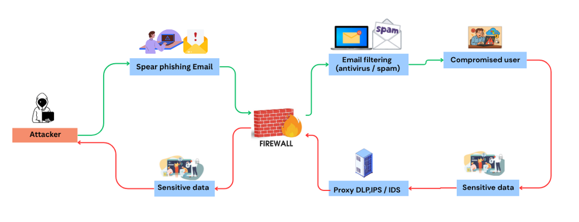
Figure 1: Spear Phishing Attack Flow and Data Protection Mechanisms
Phishing is a way that bad people try to steal your private information like passwords, bank details, or credit card numbers. They do this by pretending to be someone you trust, such as your bank, a popular website, or even a friend. These attackers send fake emails, messages, or create fake websites that look very real. When you trust them and share your information, the attackers use it to steal money or cause problems. Phishing is dangerous because it tricks people, and even careful users can sometimes fall for it. It is one of the most common ways criminals attack people online.
There are different types of phishing attacks, each working in a slightly different way:
Email Phishing is the most common type, where attackers send emails that look like they come from real companies, banks, or services. These emails often ask you to click a link or download a file, which might cause you to give your personal information without knowing it [10]. Spear Phishing is a more targeted attack, focusing on one person or company. Attackers use information about that person to make the email look very real and personal, making it easier to trick the victim [11]. Smishing is phishing done through text messages (SMS), where the attacker sends a fake message to your phone, asking you to click a link or reply with personal details. Vishing happens over the phone, with the attacker calling you pretending to be someone you trust, like a bank worker, to ask for your sensitive information. Website Phishing involves attackers creating fake websites that look like real ones, and when you enter your details on these fake sites, the attackers steal your information.
Stopping phishing is not easy because phishing emails and messages are designed to look very convincing, often using logos, names, and language that mimic real companies, making it hard to tell if they are fake. Attackers continuously develop new tricks to fool people, changing their methods whenever security improves. Even careful users can make mistakes, accidentally clicking on bad links or sharing information, especially when tired or busy. Many people don’t know what phishing is or how to recognize it, making them easy targets. Additionally, technology cannot catch every phishing attempt because attackers constantly adapt their tactics, allowing some malicious messages to slip through even the best security software.
Cloud infrastructure is the foundation that supports websites, applications, and online services by providing computing power, storage, and network resources over the internet [12] [13]. Web servers like Microsoft’s IIS and the open-source Apache are widely used in these environments to handle user requests and deliver content. However, because they connect directly to the internet, they are common targets for cyber attackers. Security gaps often appear due to misconfigurations, unpatched vulnerabilities, weak access controls, and the overall complexity of managing multiple layers such as servers, networks, and applications. Human errors, rapid changes in cloud setups, unknown vulnerabilities, and limited visibility into all assets further increase these risks. Tools like Netcraft help detect weaknesses, but closing the security gap requires regular updates, strong server configurations, strict access controls, continuous monitoring, and user training. By addressing these challenges, organizations can better protect their cloud infrastructure and keep servers like IIS and Apache safe from evolving cyber threats.
Machine Learning (ML) is a part of Artificial Intelligence (AI) that allows computers to learn from data and make predictions or decisions without being directly programmed [14] [15]. Instead of following strict instructions, ML algorithms recognize patterns in data and improve over time as they are exposed to more information. In cybersecurity, ML is used to detect unusual activities, classify threats, and identify phishing websites by analysing large amounts of data quickly and accurately. The main types of ML include supervised learning, where models are trained using labelled data such as phishing and legitimate websites; unsupervised learning, where the model groups data and identifies hidden patterns without labels; and reinforcement learning, where the model learns through trial and error by receiving rewards for correct actions and penalties for mistakes [16][1].
Cyber-attacks are deliberate attempts to exploit vulnerabilities in systems, and they come in different forms. Malware refers to harmful software such as viruses, worms, and trojans that damage systems or steal information. Ransomware is a type of malware that locks files and demands money to restore access. Denial of Service (DoS) and Distributed Denial of Service (DDoS) attacks overload systems or networks to make them unavailable. SQL injection attacks exploit weaknesses in databases to gain unauthorized access. Man in the Middle (MitM) attacks intercept communications between two parties to steal or alter information. Zero-day exploits target newly discovered vulnerabilities before developers release security patches. Each of these attacks shows how vulnerabilities can be exploited in different ways, making strong defences essential.
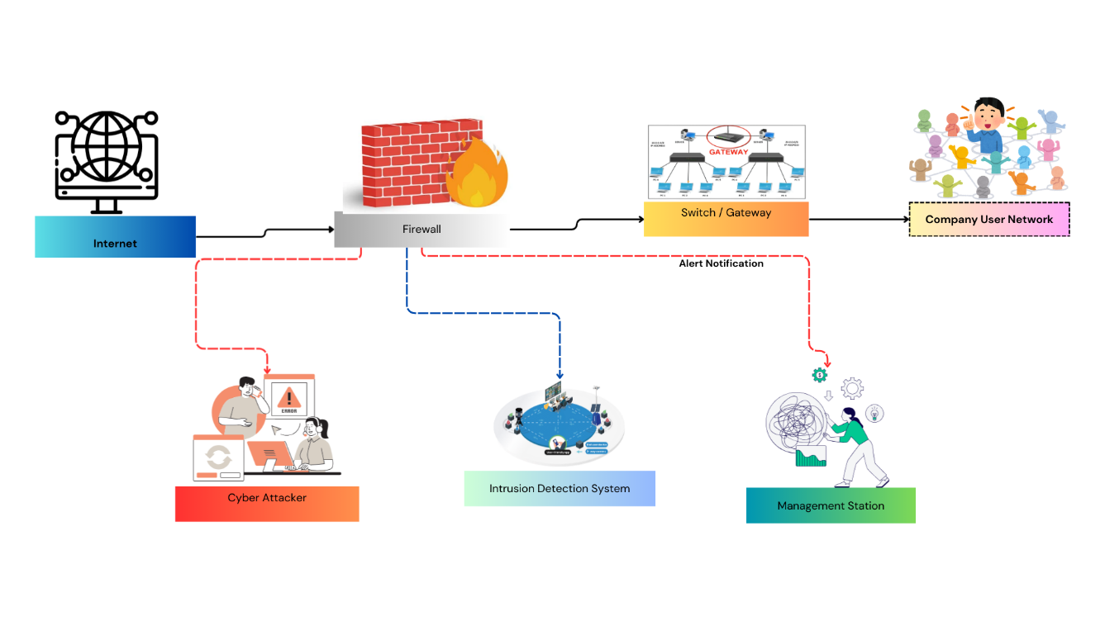
Figure 2: Network Security Layout
Ensemble learning is a machine learning technique that combines multiple models to improve prediction accuracy and reliability. Instead of depending on a single model, ensemble methods merge the strengths of different algorithms to minimize errors [17][18]. In phishing detection, ensemble learning helps reduce false positives and improves overall system performance by analysing websites from multiple perspectives. The main ensemble methods include bagging, where multiple models are trained on random subsets of the data and their results are combined, as seen in Random Forest; boosting, where models are trained sequentially and each new model corrects the errors of the previous one, as in AdaBoost, Gradient Boosting, and XGBoost; stacking, where the predictions of different models are combined using another model called a meta learner; and voting, where multiple models give predictions and the majority vote decides the final result.
This project focuses on detecting phishing websites by using an ensemble machine learning approach. It combines multiple models to analyse features such as URLs, domain information, and webpage content to identify whether a website is legitimate or fake. This method aims to improve detection accuracy and reduce false positives, helping protect users from online scams and making internet use safer.

1.2 Aim and Objectives
The aim of this project is to experiment with an ensemble learning model including XGBoost to address the identified research gaps, enhancing phishing website detection accuracy and reducing phishing threats.
- To review literatures on phishing detection by conducting a systematic literature review (SLR) and identifying gaps in previous studies.
- To apply the Research Onion framework to select the most suitable research methods and techniques for this study.
- To select and experiment an ensemble-based model for phishing detection system.
- To analyse and conclude by testing the developed system, comparing it with existing methods, and drawing meaningful conclusions.

1.3 Research Gap
Many studies have tried to detect phishing websites, but there are still some gaps in research that limit the effectiveness of existing methods. These gaps are described below:
1. Traditional methods give good results on training but fail in implementation
Traditional machine learning models such as Decision Trees, SVM, and Naïve Bayes often perform well on training data because they can learn patterns from the dataset. However, these models struggle when applied to new or unseen phishing websites [19][2]. This is because attackers constantly change their methods, so models trained on past data may not detect new types of phishing attacks.
- These models can be overfit to the training data, performing well in experiments but failing in real world scenarios.
- They lack the flexibility to recognize new or sophisticated phishing techniques that differ from previously learned patterns.
2. Use of a small set of features
Many studies rely on only a limited number of features, such as the website URL or domain information. While these features can help detect simple phishing websites, they do not capture all aspects of modern attacks. Phishing websites often use fake content, scripts, or misleading layouts to trick users, which cannot be detected with a small feature set [20][12]. Using only a few features makes detection effective for simple attacks but weak against advanced phishing strategies. Ignoring other important information, like webpage content, scripts, and hosting details, reduces the system’s reliability and accuracy.
3. Old or static datasets
Most research uses outdated or static datasets to train and test models. Since phishing attacks evolve rapidly, these datasets may not represent current threats. A model trained on old data might appear accurate in experiments but fail to detect modern phishing websites when deployed [15]. Models trained on outdated datasets may miss new phishing techniques, reducing their real-world usefulness. Static datasets prevent detection systems from keeping up with evolving phishing methods, making them less adaptable over time.
4. Evaluation focused only on accuracy, ignoring false alarms and missed phishing websites
Many studies evaluate their models only using accuracy. While accuracy is important, it does not give a complete picture of performance, especially when phishing websites are fewer than legitimate ones [21]. A model may appear accurate while still missing many phishing websites (false negatives) or raising too many false alarms (false positives).
- High accuracy alone can hide the problem of missed phishing websites, which reduces system effectiveness [22].
- Focusing only on accuracy does not account for false positives [23], which can frustrate users and reduce trust in the system. Metrics like precision, recall, and F1 score are needed for more realistic evaluation.

1.4 Structure of the Project
This project is divided into three main parts. The first part involves reviewing existing research and theories related to phishing attacks and machine learning techniques, which forms the foundation for the study. The second part focuses on the design and development of the phishing detection system, explaining the data collection, model building, and implementation process. The final part presents the testing and evaluation results, followed by conclusions and recommendations for future improvements.
Chapter One introduces the topic, states the project's aim, and outlines the key objectives and research gaps.
Chapter Two reviews related work on phishing detection methods and machine learning models through a Systematic Literature Review, identifying key research gaps.
Chapter Three describes the research methodology and design, including the Research Onion framework, dataset selection, and experimental planning.
Chapter Four explains the design and implementation of the phishing detection system, covering all eleven-machine learning and deep learning models implemented.
Chapter Five presents the experimental results from two experiments, evaluates model performance using four metrics, addresses the research gaps, and draws conclusions with recommendations for future work.

Chapter 2 - Research & Review of Literature
This chapter looks at past research on phishing website detection, with a focus on using machine learning and ensemble methods. It reviews trusted sources such as academic books, peer reviewed journal articles, and reliable websites to understand how phishing websites work and how they can be detected.
The aim is to explore how different researchers have approached this problem, what tools and models they used, and how effective their methods were. Special focus is given to ensemble learning, which combines multiple machine learning models to improve accuracy. By comparing various studies, this chapter highlights the strengths and weaknesses of existing methods, identifies current research gaps, and explains why this project takes a specific approach to improve phishing website detection.

2.1 Methodology
To complete this literature review on Phishing Website Detection using an Ensemble Approach, a clear and step by step method was followed to collect and study relevant information from trusted sources.
Approach Type: A quantitative approach was employed in this literature review, as the focus was placed on analysing and comparing numerical results such as accuracy, precision, recall, and model performance reported in previous studies.
Source Selection: Academic databases, including IEEE Xplore, SpringerLink, ScienceDirect, and Google Scholar, were used to identify reliable journal articles, books, and research papers related to phishing detection and machine learning.
Keyword Search: Keywords such as “Phishing website detection,” “Ensemble learning,” “Machine learning in cybersecurity,” “Boosting and Bagging,” and “Random Forest phishing detection” were applied to locate relevant literature.
Paper Selection: Papers published between 2020 and 2025, focusing on phishing detection using machine learning particularly ensemble methods such as Random Forest, AdaBoost, and Stacking were selected for inclusion in the review.
Comparison of Studies: Each selected study was examined and compared based on the models implemented, reported accuracy, datasets used (e.g., Phish Tank, UCI), and tools or programming frameworks employed (e.g., Python, Scikit-learn).
Strengths and Weaknesses Analysis: The strengths (e.g., high accuracy) and weaknesses (e.g., limited real-time detection capability) of the reviewed studies were analysed to identify gaps in existing research and to inform the design of the current project.

2.2 Types of Literature Review
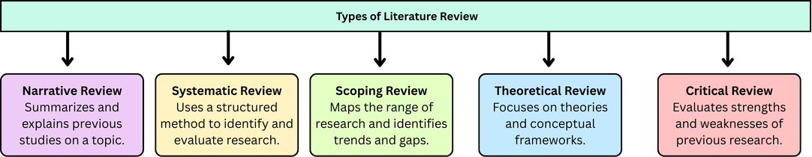
Figure 3: Types of Literature Review

Narrative (Traditional) Literature Review
A narrative literature review explains and summarizes past studies on a topic. It tells what other researchers have done, what they found, and how they did it. This type of review helps to understand the topic and shows what is missing in previous research.
Systematic Literature Review
A systematic literature review uses a clear method to find and check all research on a topic. It has rules for which studies to include or leave out. This type of review gives a complete and fair overview of all research and reduces bias [24][16].
Scoping Review
A scoping review shows the main ideas, sources, and types of research on a topic. It helps to understand the range of research without going too deep into details. It is useful to find trends, gaps, and areas where more studies are needed.
Theoretical Literature Review
A theoretical literature review focuses on ideas, theories, and models related to a topic. It shows how past research uses or develops these theories. This type helps to understand the background and concepts of a study.
Critical Literature Review
A critical literature review not only summarizes studies but also evaluates them. It points out the strengths and weaknesses of past research. This type helps to show why some methods work, what problems exist, and what your project can improve.

2.3 Approach of the Literature Review
This study mainly follows a systematic literature review (SLR) approach [25], carefully collecting and analysing previous research on phishing website detection using machine learning, deep learning, and hybrid methods. The review compares the results of different studies, highlights their strengths and weaknesses, and identifies gaps in current research. For example, some methods are accurate but cannot detect new or dynamic phishing websites, while others require very large datasets and high computing power. The review uses important SLR elements, such as systematic keyword searches, clear selection criteria, and comparisons of studies from trusted sources like IEEE Xplore. While it is not a full formal SLR, these steps ensure the review is organized, reliable, and focused, providing a strong foundation for designing an efficient ensemble-based phishing detection system that improves accuracy, stability, and real-world applicability.

2.4 Gap Analysis
Phishing detection still faces several challenges. New phishing techniques appear frequently, making it hard to keep detection methods up to date. Sometimes, safe websites are mistakenly identified as phishing, causing false alarms. Additionally, available data can be limited and noisy, which affects how well models learn. Deep learning models, while powerful, often require a lot of training time and computational resources.
To address these issues, this research adopts a structured ensemble-based classification approach combined with effective feature preprocessing and comparative evaluation. This strategy aims to improve detection accuracy, model stability, and generalisation performance in phishing website classification.
- New phishing tricks and false positives remain major challenges.
- Limited data and resource heavy models make training difficult.

2.5 Query for Phishing Detection Using Ensemble Approaches
("All Metadata:” Phishing Detection) OR ("All Metadata: “Phishing Website Detection) OR ("All Metadata: “Detecting Phishing websites) OR ("All Metadata: “phishing techniques) OR "All Metadata: “phishing URL detection) AND ("All Metadata") OR ("All Metadata: “Machine Learning) AND ("All Metadata: “Ensemble learning model) OR ("All Metadata: “ensemble model)" OR ("All Metadata: “ensemble model") ("All Metadata: “ensemble)”.
Initial Search Results
- The initial search returned 30,015 papers.
Filtering Criteria
The results were refined using the following filters to ensure relevance and quality:
- Publication years: 2020–2025
- Document type: Journals only
- Access type: Open Access
After applying these filters, the number of papers was reduced to 2,963.
Inclusion and Exclusion Criteria
Each paper was screened based on relevance to the topic. Inclusion and exclusion criteria were applied as follows:
Table 1: Criteria Used for Selecting Studies in the Systematic Review
Criteria Type | Criteria | Description
Inclusion | Document Type & Access: Peer Reviewed Journal Articles, Open Access | To include only high-quality studies that have undergone rigorous peer review and to maintain transparency, allowing other researchers to freely access and verify the reviewed studies.
Inclusion | Topic Relevance: Ensemble Learning for Phishing Detection
  To ensure all included papers directly align with the main research objective.
Inclusion |  | To include only studies that provide credible and replicable results.
  Methodological Quality: Use of validated datasets and evaluation metrics
Exclusion | Studies Lacking Sufficient Experimental Details | Excluded because incomplete or unclear methods make it impossible to assess validity or reproducibility.
Exclusion
  Studies Focused on General Cybersecurity
  Excluded to maintain focus specifically on phishing detection research.
Exclusion | Traditional Single Models Only | Excluded because they do not align with the ensemble learning focus of the study.

After screening, 127 papers were selected for detailed review.
Focus on Ensemble Learning
From the 127 selected papers, 77 papers specifically discussed ensemble learning approaches for phishing detection. These papers formed the core dataset for the literature review and further analysis.

2.5.1 PRISMA Diagram:

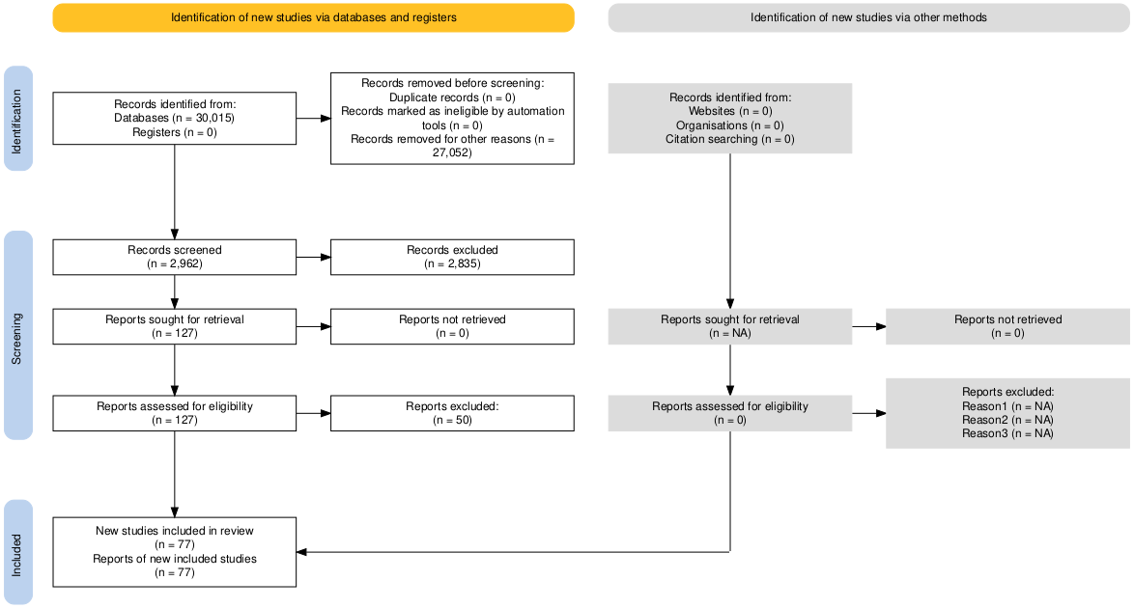
Figure 4: PRISMA Flow Diagram of the Study Selection Process
The PRISMA (Preferred Reporting Items for Systematic Reviews and Meta Analyses) flow diagram in Figure 3 illustrates the systematic procedure followed to identify, screen, evaluate, and include studies in this literature review on ensemble learning approaches for phishing detection. This structured and transparent process ensured that the study selection was both methodologically rigorous and aligned with the defined research objectives [26][27].
The process began with the identification phase, where a comprehensive search strategy was formulated using multiple relevant keywords and Boolean operators. The search query included combinations such as ("Phishing Detection") OR ("Phishing Website Detection") OR ("Detecting Phishing Websites") OR ("Phishing Techniques") OR ("Phishing URL Detection") AND ("Machine Learning") AND ("Ensemble Learning Model") OR ("Ensemble Model") OR ("Ensemble"). This query was applied to the metadata of indexed databases to capture a broad spectrum of research related to phishing detection using ensemble learning techniques.
From this initial search, a total of 30,015 records were retrieved from reputable academic databases. To ensure quality and relevance, several refinement filters were applied: publications were restricted to the years 2020 to 2025, only peer reviewed journal articles were considered, and open access availability was required. These filters were chosen to guarantee the inclusion of contemporary and credible research while ensuring that all reviewed studies were freely accessible for validation. After applying these criteria, 2,962 records remained for screening, while 27,052 records were excluded for not meeting the filtering conditions. No additional studies were identified through other methods such as citation tracking or organizational repositories.
During the screening phase, the titles and abstracts of the remaining 2,962 papers were carefully reviewed to assess their relevance to the research focus. At this stage, 2,835 records were excluded for reasons such as focusing on general cybersecurity topics, using unrelated machine learning methods, or lacking a clear connection to ensemble-based phishing detection. This step ensured that only studies potentially aligned with the review objectives were retained for detailed examination.
In the eligibility phase, the full texts of 127 papers that passed the initial screening were examined in depth. Each study was evaluated according to a predefined set of inclusion and exclusion criteria to ensure methodological rigor and relevance to the research objectives. The inclusion criteria required that studies be published between 2020 and 2025, appear in peer reviewed journals, be openly accessible, and demonstrate direct relevance to ensemble learning approaches for phishing detection. Additionally, studies were expected to show methodological soundness, including the use of validated datasets and reliable evaluation metrics. These standards ensured that all included studies were recent, credible, and scientifically robust. In contrast, the exclusion criteria ruled out papers that lacked sufficient methodological or experimental detail, duplicated or extended previously published work, focused on broader cybersecurity or unrelated detection techniques, utilized only single (non-ensemble) machine learning models, or were written in non-English languages or poorly translated, which could compromise interpretation accuracy. Applying these criteria resulted in the exclusion of 50 studies that did not meet the quality or relevance requirements for inclusion in the final review.
Finally, in the inclusion phase, a total of 77 studies met all eligibility requirements and were included in the final synthesis. These selected studies specifically examined ensemble learning based phishing detection methods, encompassing a range of ensemble strategies such as bagging, boosting, stacking, voting, and hybrid ensemble models. Together, these studies formed the core dataset for further analysis and discussion in this review.
Overall, the PRISMA guided approach demonstrates a transparent and systematic narrowing of the literature from an initial pool of 30,015 records to a refined and methodologically sound set of 77 high quality studies. Each phase identification, screening, eligibility, and inclusion was governed by explicit criteria designed to minimize bias and ensure the validity of the review. As a result, the final dataset provides a comprehensive and credible representation of current research trends and advancements in ensemble learning techniques for phishing detection.

2.6 Bibliometric Analysis
This section presents a bibliometric analysis of the 77 selected research articles related to phishing website detection and ensemble learning. The analysis examines publication trends over the period 2020 to 2025.
Table 2: Number of Publications per Year (2020–2025)
Row Labels | Count of Document Title
2020 | 6
2021 | 8
2022 | 19
2023 | 11
2024 | 15
2025 | 18
Grand Total | 77

The publication trend shows a steady increase in research activity over the years. The number of papers rose from 6 in 2020 to 8 in 2021 and reached a significant peak of 19 publications in 2022 [28]. Although there was a slight decline to 11 papers in 2023, research activity increased again in 2024 with 15 publications and continued growing in 2025 with 18 papers. This upward trend indicates increasing academic interest in phishing website detection using ensemble learning techniques, particularly in recent years.
Top Authors by Number of Publications

Figure 5: Top Authors by Number of Publications
S. Manickam has the highest number of publications with four papers. W. Li follows with three papers. Several other authors, including B. Li, C. G. Duque, R. Abdillah, S. Fernando, R. T. De Sousa, R. S. Rao, M. Mohd, and Z. Shukur, each contributed two papers. This shows that a small group of authors contribute more actively to research in phishing detection using ensemble learning.
Table 3: Publication Distribution
Row Labels | Count of Document Title
Big Data Mining and Analytics | 1
IEEE Access | 66
IEEE Open Journal of the Communications Society | 2
IEEE Transactions on Information Forensics and Security | 1
Intelligent and Converged Networks | 1
Journal of Cyber Security and Mobility | 3
Journal of Web Engineering | 2
Tsinghua Science and Technology | 1
Grand Total | 77

The publication venue analysis shows that most studies (66 out of 77) are published in IEEE Access, confirming it as the dominant platform for research on phishing detection and ensemble learning. Other venues contribute fewer papers, indicating that research in this area is concentrated mainly within high-impact IEEE journals.
Table 4: Most Frequently Used Datasets in Phishing Detection Studies
Row Labels | Count of Dataset Name
Alexa Top Websites | 7
APWG Dataset | 3
Kaggle dataset | 4
Mendeley Dataset | 4
Nazario phishing corpus | 3
OpenPhish | 3
PhishTank | 12
SpamAssassin Public Corpus | 3
UCI Machine Learning Repository | 3
UCI Phishing Website Dataset | 4
Grand Total | 46

The dataset distribution analysis of the 77 selected studies shows that several publicly available datasets are frequently used in phishing detection research. As shown in Table X, the PhishTank dataset is the most widely used dataset, appearing in 12 studies [29], because it provides a large collection of verified phishing URLs and legitimate websites. The Alexa Top Websites dataset is the second most frequently used source, appearing in 7 studies, as it provides reliable legitimate website samples. Other commonly used datasets include the Kaggle dataset (4 studies), Mendeley dataset (4 studies), and the UCI Phishing Website Dataset (4 studies). Additional datasets such as APWG, Nazario Phishing Corpus, OpenPhish, SpamAssassin Public Corpus, and the UCI Machine Learning Repository appear in three studies each.
This distribution indicates that researchers prefer publicly available and well-structured datasets to train and evaluate phishing detection models. These datasets provide labelled phishing and legitimate samples, allowing machine learning and ensemble algorithms to be tested under consistent experimental conditions.

Figure 6: World Map of Article Output by Country
The world map shows the geographic spread of the 77 selected research publications. The markers indicate that phishing website detection and ensemble learning studies are produced across multiple regions, including North America, Europe, Asia, Africa, and Australia. Most research activities are concentrated in countries such as the United States, the United Kingdom, India, China, and several Southeast Asian nations. This wide distribution demonstrates that phishing detection is a global research priority, with strong contributions from both developed and developing countries. The map also highlights growing international collaboration and increasing awareness of phishing related cybersecurity threats worldwide.
A total of seventy-seven research papers were reviewed to understand how machine learning techniques have been used for phishing and malicious website detection. Most of the studies focused on ensemble learning, where multiple algorithms are combined to increase accuracy and reduce false alarms. The review identified clear patterns across four major areas the machine learning approaches, datasets used, implementation tools, and performance outcomes.
In terms of machine learning approaches, ensemble methods such as bagging, boosting, stacking, and voting were the most widely applied [30][31]. Tree based algorithms like Random Forest, XGBoost, AdaBoost, and LightGBM appeared most frequently because of their strong predictive ability and simplicity of use. Other models such as Support Vector Machines, Decision Trees, Naïve Bayes, and Logistic Regression were commonly used as comparison baselines. A smaller number of studies also explored deep learning techniques including CNN, LSTM, GRU, and hybrid deep ensembles. Overall, tree-based ensemble methods such as Random Forest and XGBoost proved to be the most popular and effective choices, as they provided high accuracy, reduced overfitting, and handled imbalanced phishing data better than single models [32][33][34].
Regarding datasets, the most used source was the Phish Tank repository, which provides labelled phishing and legitimate URLs. Other datasets frequently used included the UCI Phishing Websites Dataset, KDD or KDDCup intrusion datasets, and email corpora such as Spam Assassin and Nazario. Many researchers collected their own real-world datasets from online sources such as Alexa, Open Phish, or Kaggle using automated crawlers and APIs.
Kaggle is an online data science and machine learning platform that provides publicly available datasets for research and experimentation. It hosts a wide range of cybersecurity related datasets, including phishing URLs, malicious website records, and email-based phishing data. These datasets are commonly used by researchers because they are well structured, easily accessible, and suitable for machine learning experiments. In the reviewed studies, four papers used datasets obtained from Kaggle for their experimental implementation. Researchers often combine Kaggle datasets with other sources such as PhishTank, Alexa, or UCI datasets to increase dataset diversity and improve model training. The availability of large, labelled datasets on Kaggle makes it a valuable resource for evaluating phishing detection models, particularly ensemble learning algorithms.
Some studies focusing on network traffic or IoT attacks used the CTU 13 or IoT23 datasets, while financial phishing studies employed datasets like Pay Sim or voice phishing corpora. Dataset sizes ranged widely from a few thousand URLs or emails to several hundred thousand. Overall, Phish Tank and real-world custom datasets were the most used sources, although many datasets were outdated or static.
In the area of implementation, most studies used Python as the primary platform, applying frameworks such as scikit learn, TensorFlow, Keras, and PyTorch [35][36][26]. A smaller number used Weka, MATLAB, or Apache Spark. Feature engineering played a crucial role in model performance. Common features included URL based characteristics like length, special characters, and use of “https”; domain or WHOIS features such as registration age and IP information; and page content features including HTML tags, JavaScript presence, and image or logo details. Some studies also included network level information such as DNS history and connection timing. Feature selection methods like Chi Square, Mutual Information, Principal Component Analysis (PCA), and Linear Discriminant Analysis (LDA) were applied to reduce redundancy. To address the issue of class imbalance, several works used Synthetic Minority Oversampling Technique (SMOTE) or cost sensitive learning approaches. Overall, Python based implementations with multiple feature types and ensemble algorithms achieved higher accuracy and stability.
In terms of performance outcomes, the most common metrics used to evaluate models were accuracy, precision, recall, F1 score, and AUC. Among the papers that reported numerical results, the average accuracy was approximately 93 percent [37][38][5], with most results ranging between 90 and 98 percent. F1 scores were typically above 0.90, indicating balanced precision and recall performance. Ensemble models such as Random Forest and XGBoost consistently achieved the highest accuracy and robustness. Deep learning models also showed good results, especially with larger datasets, but required significantly more computational resources. In general, ensemble approaches provided the best balance between accuracy, interpretability, and computational efficiency.
Despite these strong results, several limitations were repeatedly mentioned across the reviewed studies. Many datasets were outdated, unbalanced, or lacked real-world testing. Some models relied only on URL based features, ignoring host or content related information. Deep learning approaches, while powerful, often required high computational resources and longer training times. In addition, only a few studies tested their systems in real time environments, which limited their practical applicability.
Overall, the review concludes that ensemble learning is the most dominant and reliable machine learning approach for phishing detection. Algorithms such as Random Forest, XGBoost, AdaBoost, and LightGBM were the most widely applied, often within bagging, boosting, or stacking frameworks. Phish Tank and custom real-world datasets were the most used data sources, and most implementations were performed in Python using scikit learn or TensorFlow. The reported average accuracy of around 93 percent demonstrates that ensemble methods provide robust and effective performance. However, future research should focus on addressing dataset imbalance, ensuring data freshness, and testing in real time scenarios to improve generalization and real-world deployment.

2.6.1 Literature Performance Benchmarks
Table 5: Literature Performance Benchmarks
Algorithm | Accuracy | F1-Score | Papers
Random Forest | 81.60% – 100.00% | 76.60% – 100.00% | 38 / 77
XGBoost | 90.00% – 100.00% | 63.00% – 100.00% | 19 / 77
AdaBoost | 90.00% – 99.98% | 63.00% – 99.00% | 16 / 77
LightGBM | 95.48% – 99.71% | 83.40% – 99.10% | 9 / 77
Stacking Ensemble | 90.00% – 99.95% | 63.00% – 99.95% | 8 / 77
Bagging | 81.60% – 99.95% | 76.60% – 99.95% | 8 / 77

2.7 Critical Evaluation of Existing Literature:
1. Overview of Algorithm Usage in Phishing Detection Research
Research on phishing website detection shows extensive use of machine learning, ensemble, and deep learning algorithms. Traditional machine learning (ML) models remain the most frequently applied approaches, including Decision Trees, Random Forests, Support Vector Machines (SVM), Naïve Bayes, Logistic Regression, and K Nearest Neighbour [39][30]. These algorithms are preferred because they are easy to implement and perform efficiently on structured, feature based datasets. However, a critical limitation found across studies is that these models often fail to generalise to unseen data, performing well during training but poorly when deployed in real-world scenarios [40][41]. This directly aligns with Research Gap 1, which highlights the inability of traditional models to detect evolving phishing techniques.
2. Limitations Related to Feature Selection
Another important challenge in existing research is the reliance on a limited set of features, particularly URL based and domain-based attributes [42][21]. While these features are effective for identifying simple phishing attempts, they are insufficient for detecting advanced attacks that employ sophisticated website scripts, deceptive layouts, and dynamic visual content. Studies relying on narrow feature sets report good accuracy but often struggle with adaptability when facing novel phishing behaviours. This limitation corresponds with Research Gap 2, reinforcing the need for broader and richer features that incorporate webpage content, JavaScript analysis, HTML structure, SSL details, and hosting information.
3. Critical Evaluation of Datasets Used in Existing Studies
A significant weakness identified in the literature is the heavy dependence on static or outdated datasets, especially the widely used UCI Phishing Websites Dataset [43][44]. While this dataset provides a convenient benchmark, it does not reflect the constantly evolving nature of phishing attacks. Newer sources such as PhishTank, OpenPhish, and custom real time datasets offer more relevant and updated data, yet they are less frequently used due to the higher complexity involved in collecting and labelling them. The ongoing use of outdated datasets aligns with Research Gap 3, emphasising that many existing models lack practical effectiveness because they are trained on data that no longer represents current phishing threats.
4. Evaluation Metrics and Their Limitations
The literature further reveals inconsistency in evaluation practices. Many studies continue to rely primarily on accuracy as the main performance metric, despite the well-documented issue of class imbalance in phishing detection datasets [45][7]. Because legitimate websites significantly outnumber phishing ones, a model may achieve high accuracy while still failing to detect a substantial proportion of phishing instances, resulting in high false negatives. More robust evaluation metrics such as Precision, Recall, F1-score, and AUC are increasingly recommended, as they provide a more balanced and reliable assessment of classification performance. However, cross-dataset validation and real-world deployment testing remain limited, restricting the generalisability of reported results. This issue directly reflects Research Gap 4, highlighting the inadequacy of accuracy-only evaluation approaches.
5. Role and Effectiveness of Ensemble Learning Approaches
Across recent literature, ensemble methods have emerged as one of the most effective approaches for phishing detection [46][28]. Techniques such as Boosting (XGBoost, AdaBoost, Gradient Boosting, LightGBM), Bagging (Random Forest), Voting Ensembles, and particularly Stacking Ensembles consistently outperform individual machine learning models. Boosting methods excel at identifying complex phishing patterns and reducing classification errors, while stacking integrates multiple classifiers to maximise predictive performance. Although deep learning and deep ensemble architectures (such as CNNs and LSTMs) are gradually increasing in popularity, they remain less frequently used due to computational demands and the requirement for large, updated datasets. Nonetheless, ensemble methods provide better generalisation, stronger adaptability, and improved robustness compared to traditional approaches.
6. Overall Critical Summary and Implications for the Current Study
Overall, the literature demonstrates clear progress in phishing detection research, particularly through the growing adoption of ensemble learning techniques. Nevertheless, despite high reported accuracy values, several methodological weaknesses remain evident. The continued reliance on limited feature sets, outdated datasets, single dataset validation, and inconsistent evaluation practices reduces the real-world applicability of many proposed models. Although ensemble approaches such as Random Forest, XGBoost, LightGBM, and Stacking consistently demonstrate superior predictive performance compared to traditional standalone models, their effectiveness is often validated under controlled experimental conditions rather than dynamic real-world environments. Addressing these limitations forms the foundation of the current study and directly responds to the identified research gaps.
A recent study published in IEEE Access (2024), titled “Phishing Website Detection Using Deep Learning Models,” [47]provides a structured comparative framework combining feature selection techniques with shallow machine learning, ensemble learning, and deep learning classifiers. The study employed an 80/20 train-test split and evaluated performance using accuracy, precision, recall, F1-score, and AUC metrics. Although deep learning approaches achieved strong results, ensemble models such as Random Forest and XGBoost demonstrated competitive performance with lower computational complexity. The structured experimental design and evaluation methodology presented in this study directly influenced the framework adopted in the current research.

2.8 Conclusion of Literature Review
The reviewed literature shows that ensemble learning methods perform better than single machine learning models for phishing website detection. Algorithms such as Random Forest, XGBoost, LightGBM, and Stacking provide higher accuracy and better overall performance. These methods are more robust and can handle complex phishing patterns more effectively. However, several limitations still exist in current research. Many studies use outdated datasets, limited feature sets, and focus mainly on accuracy as the evaluation metric. In addition, most models are tested only on a single dataset and not validated in real-world environments. These issues reduce the practical reliability of many proposed approaches.
Notably, Random Forest recorded the highest accuracy range of 81.60% – 100.00% across 38 out of 77 reviewed studies, confirming it as the most widely adopted and reliable ensemble algorithm for phishing website detection [48][19][5]. Overall, while ensemble methods are the most promising techniques, there is still a need for improved feature selection, updated datasets, and stronger evaluation strategies. These findings support the direction of this study, which aims to develop a more reliable and adaptable ensemble-based phishing detection model.

Chapter 3 – Research Methodology

3.1 Introduction
This chapter presents the research methodology adopted for the development of a machine learning based phishing website detection system. The methodology is designed from a cybersecurity perspective to ensure that algorithm selection, dataset usage, and evaluation metrics reflect real world security requirements rather than purely theoretical data science considerations. The chapter follows the Research Onion framework and explains the philosophical stance, research approach, strategy, methodological choices, dataset selection, and analytical procedures used in the study . Each decision is justified in relation to the research objectives, which aim to develop an accurate and reliable system capable of distinguishing phishing websites from legitimate ones.

3.2 Research Overview
The objective of this research is to design, implement, and evaluate machine learning models for phishing website classification. The research design provides a structured plan guiding the study from problem definition to final evaluation. The research process is organised into five interconnected layers: research philosophy, research approach, research strategy, methodological choice, and techniques & procedures [49].
The study begins with an examination of phishing website characteristics, followed by selection of an appropriate dataset, preprocessing of numerical features, implementation of multiple machine learning algorithms, and rigorous performance evaluation. The outcome is a comparative assessment to determine the most effective model for cybersecurity deployment.

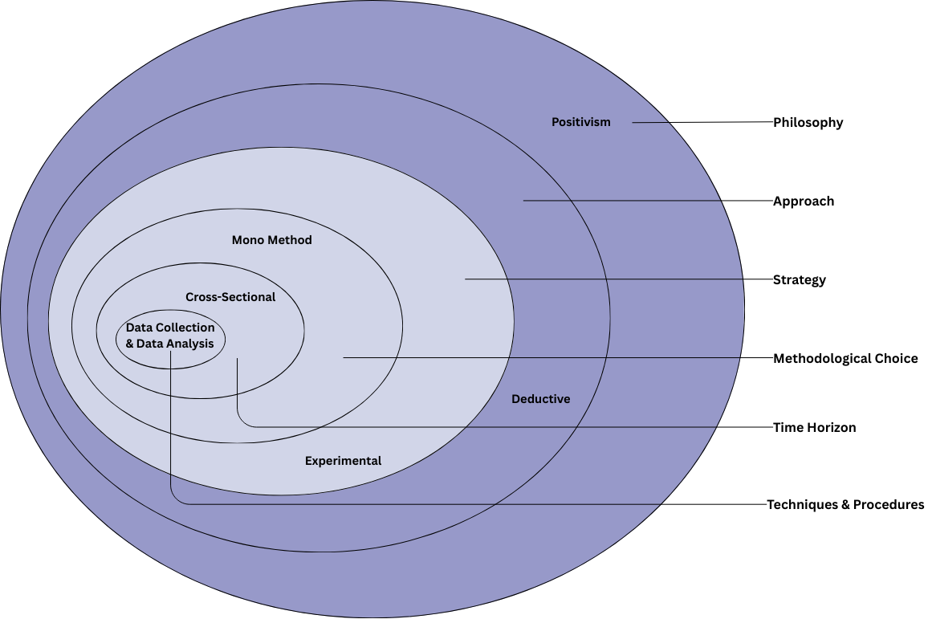
Figure 7: Research Onion Method Diagram

3.2.1 Research Philosophy – Positivism
This study adopts a positivist philosophy, which assumes that knowledge is derived from measurable and observable facts. Phishing detection relies on objective characteristics such as URL structure, domain properties, and traffic metrics; therefore, positivism is the most appropriate philosophical stance [18][12]. The research does not depend on human interpretation or subjective judgement but on numerical evidence produced by machine learning algorithms. Model performance is evaluated using quantifiable metrics including accuracy, precision, recall, F1 score, and ROC AUC. The positivist approach ensures that the findings are reliable, unbiased, and repeatable by other researchers using the same dataset and procedures.

3.2.2 Research Approach – Deductive Approach
A deductive research approach is employed in this study. Existing literature indicates that ensemble and tree-based machine learning models tend to perform more effectively in phishing website detection than single traditional classifiers [50][46]. Drawing on this theoretical background, the research hypothesises that advanced algorithms, particularly Random Forest and XGBoost, will achieve higher accuracy and better detection capability than a baseline Support Vector Machine model. This hypothesis is examined through structured experimentation using a real phishing dataset. The research therefore follows a deductive process in which established theory informs expectations, those expectations are tested with empirical data, and conclusions are drawn based on the observed results.

3.2.3 Research Strategy – Experimental Strategy
An experimental strategy was selected because machine learning research requires controlled comparison of algorithms under identical conditions [51][37]. The study implements multiple classifiers, trains them on the same training set, and evaluates them on a held-out test set. Hyperparameter optimisation is performed using Randomized Search and Grid Search to ensure fairness [52]. This strategy enables direct observation of how each algorithm behaves when exposed to identical phishing indicators, providing strong empirical evidence for model selection.

3.2.4 Methodological Choice – Quantitative Mono-Method
The project follows a quantitative mono-method approach. All inputs are numerical features extracted from URLs and webpage attributes, and the outputs are statistical performance measures [53][54]. No qualitative techniques, such as interviews or surveys, are required in this study.
The exclusive use of quantitative data is justified because phishing detection is a pattern recognition problem, where decisions must be based on measurable signals derived from website characteristics rather than human opinions or subjective interpretations. Machine learning algorithms analyse these numerical features to identify patterns that distinguish phishing websites from legitimate ones.
Model performance is evaluated using statistical metrics such as accuracy, precision, recall, F1-score, and ROC-AUC, ensuring objective and reproducible evaluation of the proposed phishing detection system [55][10] .

3.2.5 Time Horizon – Cross Sectional
A cross-sectional time horizon is adopted. The dataset represents a snapshot of phishing and legitimate websites collected at a specific period and is analysed once within the timeframe of this project. A longitudinal study was unnecessary because the objective is to evaluate algorithms rather than track behavioural change over many years [56][26].

3.2.6 Techniques and Procedures
The methodology employs quantitative data collection and analysis techniques, structured into six phases:
Table 6: Research Phases with Cybersecurity Justification
Phase | Technique | Description | Cybersecurity Justification
1. Data Acquisition | Secondary dataset from Kaggle | Collection of 11,055 website records with 32 security related features | Dataset contains validated phishing indicators widely used in research
2. Preprocessing | Data cleaning and normalisation | StandardScaler applied, handling inconsistencies, 80/20 train test split | Ensures data quality and stable model training
3. Feature Engineering | Selection of relevant attributes | Use of URL, domain and SSL based indicators from the 32 features | Focuses on features proven to reveal phishing behaviour
4. Model Development | Implementation of classifiers | SVM, Random Forest, and XGBoost models built and tuned | Defence in depth through comparison of multiple algorithms
5. Evaluation | Performance measurement | Accuracy, Precision, Recall, F1-score, ROC AUC | Measures real detection capability and false positive control
6. Validation | Cross-validation and benchmarking | 5-fold CV and comparison with prior studies | Confirms robustness and real-world applicability

3.3 Dataset Selection
This study used the Phishing Website Dataset from Kaggle[57][58], which contains 11,055 samples and 32 technical features describing URL structure, domain characteristics, and website behaviour indicators. The dataset was preprocesses using standard scaling and divided into training and testing sets with an 80/20 split to support binary classification for phishing detection.
The dataset was selected because it is publicly available, widely used in academic benchmarking, and contains security-relevant indicators that reflect real phishing behaviours, making it suitable for reproducible machine learning experimentation.

3.4 Risk Assessment and Contingency Plan
The project considered several technical and practical risks that could affect the development of the phishing detection system. Appropriate mitigation strategies were planned to ensure successful completion within the available timeframe and resources.
Table 7: Risk Assessment Matrix
Risk | Impact | Probability | Mitigation Strategy
Dataset unavailable or corrupted | High | Low | Maintain local backup and alternative public phishing datasets
Model accuracy below target | Medium | Medium | Hyperparameter tuning and comparison of multiple classifiers
High false positive rate | High | Medium | Threshold adjustment and precision recall optimisation
Computational resource limitations | Medium | Medium | Use Google Collab and reduce batch sizes during training
Overfitting of models | Medium | Medium | Apply cross validation and regularisation techniques
Time delays in experimentation | Medium | Medium | Prioritise core models and simplify non-essential tests

3.5 Project Timeline (Gantt Chart):
The project activities were organised according to a structured timeline to ensure systematic completion of all research stages, as shown in Table 9 below.

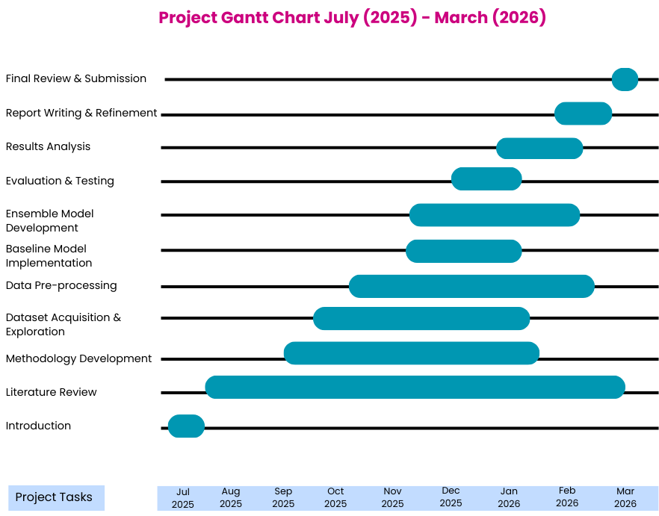
Figure 8: Project Timeline (Gantt Chart)

3.6 Conclusion
This chapter presented the research methodology adopted for this study. A positivist philosophy was selected to ensure that all findings are based on measurable and objective evidence, while a deductive approach allowed the research to be guided by existing theory and validated through structured experimentation. The experimental strategy ensured that all eleven models were evaluated under controlled and comparable conditions, and the quantitative mono-method design provided a consistent basis for performance measurement. The Kaggle Phishing Website Dataset was selected as the primary data source due to its public availability, academic credibility, and relevance to the research objectives. Risk assessment and contingency planning were also carried out to anticipate and manage potential challenges during implementation. The project timeline presented in Figure 8 confirms that all research activities were organised systematically within the available timeframe. Together, these methodological decisions provide a strong and well-justified foundation for the design and implementation work presented in Chapter 4.

Chapter 4 – Design and Implementation

4.1 Introduction
This chapter presents the detailed design and implementation of the phishing website detection system developed for this research. The experimental framework is based on the methodology proposed in the selected IEEE Access research paper titled “Phishing Website Detection Using Deep Learning Models” (2024). The selected study integrates feature selection techniques with machine learning, ensemble learning, and deep learning models to improve phishing detection accuracy.
Although the original paper evaluates shallow machine learning, ensemble learning, and deep learning approaches, this project focuses primarily on implementing and experimentally validating selected machine learning and ensemble models using the Kaggle Phishing Website Dataset. The objective is to analyse the effectiveness of ensemble-based classifiers in detecting phishing websites while minimising false positives. This chapter explains the problem formulation, system design, dataset structure, implementation steps, experimental setup, and final model selection.

4.2 Problem Formulation

4.2.1 Problem Statement
Phishing websites continue to evolve and bypass traditional blacklist and rule-based detection systems. Attackers manipulate URL structures, domain attributes, SSL indicators, and redirection mechanisms to mimic legitimate websites [59][46]. Many conventional detection methods fail to generalise to new phishing patterns, particularly zero-day attacks. Therefore, there is a need for a machine learning-based phishing detection system capable of automatically classifying websites as legitimate or phishing using structural and behavioural indicators extracted from URLs and domains.

4.2.2 Adopted Experimental Framework
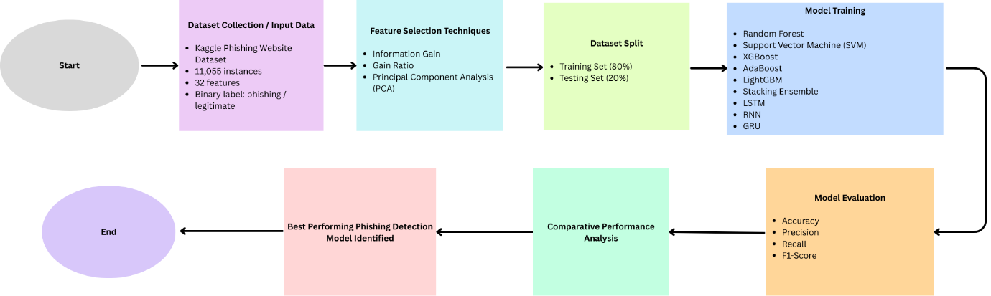
Figure 9: Experimental Pipeline for Phishing Website Detection

The selected IEEE paper proposes a structured experimental methodology consisting of:
Feature selection techniques (Information Gain, Gain Ratio, PCA)
- 80% training and 20% testing split
- Comparative analysis of multiple classifiers
- Evaluation using accuracy, precision, recall, and F1-score
In this project, the framework was adapted and experimentally implemented using:
- Random Forest
- SVM
- XGBoost
- AdaBoost
- LightGBM
- Stacking Ensemble
- LSTM
- RNN
- GRU
The purpose of this structured comparison is to determine which algorithm provides the most reliable phishing detection performance under controlled experimental conditions.

4.2.3 Proposed System Architecture
The implemented phishing detection system follows a structured computational pipeline:
- Dataset Acquisition
- Data Cleaning and Validation
- Feature Scaling
- Stratified Train-Test Split (80/20)
- Model Training (Model Training (SVM, Random Forest, XGBoost, AdaBoost, LightGBM, Stacking Ensemble, LSTM, RNN, GRU)
- Performance Evaluation
- Best Model Selection
This architecture ensures reproducibility, fair model comparison, and alignment with cybersecurity evaluation requirements.
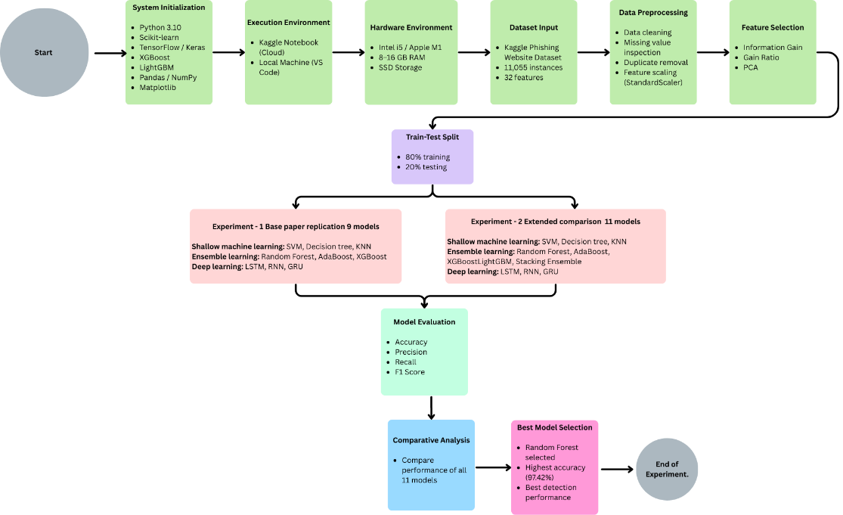
Figure 10: System Flow Diagram of the Phishing Website Detection Model Implementation
Figure 10 illustrates the complete experimental workflow of the phishing detection system. The process begins with environment configuration and dataset acquisition, followed by structured data preprocessing, feature scaling, and stratified train-test splitting. Three machine learning classifiers SVM, Random Forest, and XGBoost are trained under identical conditions. The models are evaluated using cybersecurity-relevant performance metrics, including accuracy, precision, recall, F1-score, ROC-AUC, and confusion matrix analysis. Comparative evaluation identifies the best-performing classifier based on detection capability and false positive control. Random Forest was ultimately selected as the optimal model.

4.3 System Design and Justification

4.3.1 Design Principles
The system design is guided by three core principles:
- Reproducibility – ensuring the experiment can be replicated.
- Comparative Evaluation – enabling objective model comparison.
- Cybersecurity Relevance – prioritising detection capability and false positive control.
The selected research demonstrates that ensemble learning models outperform traditional classifiers in phishing detection tasks. Therefore, this project emphasises ensemble-based approaches to validate their effectiveness.

4.3.2 Model Selection Rationale
Support Vector Machine (SVM)
SVM is included as a baseline model due to its strong theoretical foundation in binary classification. However, SVM may struggle with highly nonlinear feature interactions present in phishing datasets.
Random Forest
Random Forest was selected due to its ability to reduce overfitting through bagging [60], handle noisy and deceptive URL features, provide feature importance analysis, and deliver stable performance on structured numerical datasets.
XGBoost
XGBoost was selected to evaluate boosting-based ensemble learning. It improves prediction accuracy by iteratively correcting previous classification errors and learning complex feature interactions [61].
This multi-model strategy ensures that the final model decision is based on empirical evidence rather than assumption.
AdaBoost
AdaBoost was selected to evaluate another boosting-based ensemble technique [62]. Unlike Random Forest, which uses bagging, AdaBoost builds models sequentially and assigns higher weights to previously misclassified samples. This iterative correction mechanism allows the model to focus on difficult phishing instances and improve classification accuracy. AdaBoost was included to compare different boosting strategies and assess their effectiveness in handling structured phishing features.
LightGBM
LightGBM was selected as an advanced gradient boosting framework designed for efficient and scalable training on structured datasets. It utilises a leaf-wise tree growth strategy, which can improve accuracy while reducing training time compared to traditional boosting algorithms [63]. LightGBM is particularly effective for large feature spaces and high-dimensional data. Its inclusion enables evaluation of a more computationally efficient boosting model and comparison with XGBoost under identical experimental conditions.
Stacking Ensemble
The Stacking Ensemble model was implemented to evaluate meta-learning techniques in phishing detection. Stacking combines multiple base classifiers and uses a meta-learner to generate final predictions [64][31]. This approach aims to leverage the strengths of different models while reducing individual weaknesses. By integrating classifiers such as Random Forest, AdaBoost, and LightGBM, stacking enhances generalisation capability and improves prediction stability. The inclusion of stacking allows assessment of whether multi-model integration provides measurable performance gains over standalone ensemble models.
LSTM (Long Short-Term Memory)
LSTM was selected to evaluate deep learning capabilities in phishing detection. Although phishing datasets are structured rather than sequential in nature, LSTM networks can capture complex nonlinear relationships within feature representations [65][38]. The gated memory mechanism of LSTM allows it to learn long-range dependencies and improve classification performance. LSTM was included to compare deep learning approaches with traditional ensemble methods in terms of detection accuracy and computational requirements.
RNN (Recurrent Neural Network)
RNN was implemented to assess the performance of a simpler recurrent neural architecture in phishing detection. RNNs are designed to model sequential dependencies; however, they may suffer from vanishing gradient problems when learning long-term patterns. Including RNN enables comparison between basic recurrent models and more advanced architectures such as LSTM and GRU [66]. This comparison provides insight into whether sequential neural networks offer advantages in structured phishing datasets.
GRU (Gated Recurrent Unit)
GRU was selected as an alternative recurrent neural network architecture with fewer parameters than LSTM. GRU maintains the ability to capture nonlinear feature interactions while offering reduced computational complexity and faster training time. It was included to evaluate whether a more lightweight recurrent architecture can achieve competitive performance compared to LSTM and ensemble-based methods.

4.4 Dataset Description
The Kaggle Phishing Website Dataset contains:
- 11,055 website instances
- 32 numerical security related features
- Binary class label (0 = legitimate, 1 = phishing)
The features represent structural and behavioural website characteristics, including URL length, SSL status, domain age, use of IP address, redirection behaviour, and subdomain presence.
The numerical structure of the dataset allows direct application of machine learning algorithms without categorical encoding.

4.5 Experimental Setup

4.5.1 Hardware Environment
- Intel Core i5 or Apple M1 processor
- 8–16 GB RAM
- SSD storage
The computational requirements are moderate and do not require GPU acceleration.

4.5.2 Software Environment
- Python 3.10
- Kaggle Notebook
- Scikit-learn
- XGBoost
- LightGBM
- TensorFlow / Keras
- Pandas
- NumPy
- Matplotlib
These tools ensure consistency, reproducibility, and compatibility across all shallow machine learning, ensemble, and deep learning model implementations used in this study.

4.6 Implementation Procedure - Experimental 1

4.6.1 Dataset Collection
The dataset was imported using the panda’s library and examined to confirm correct structure and feature representation.

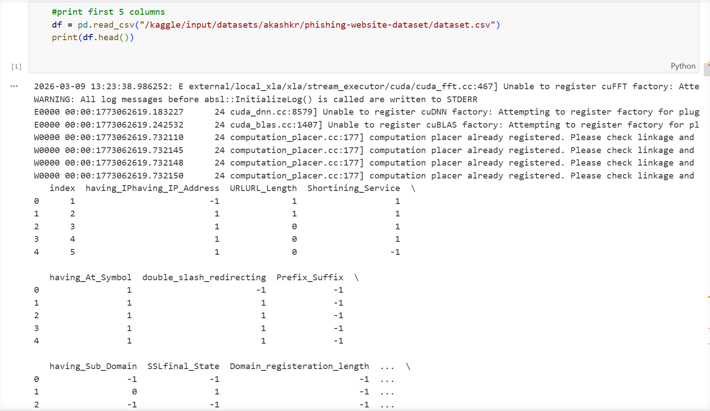
Figure 11

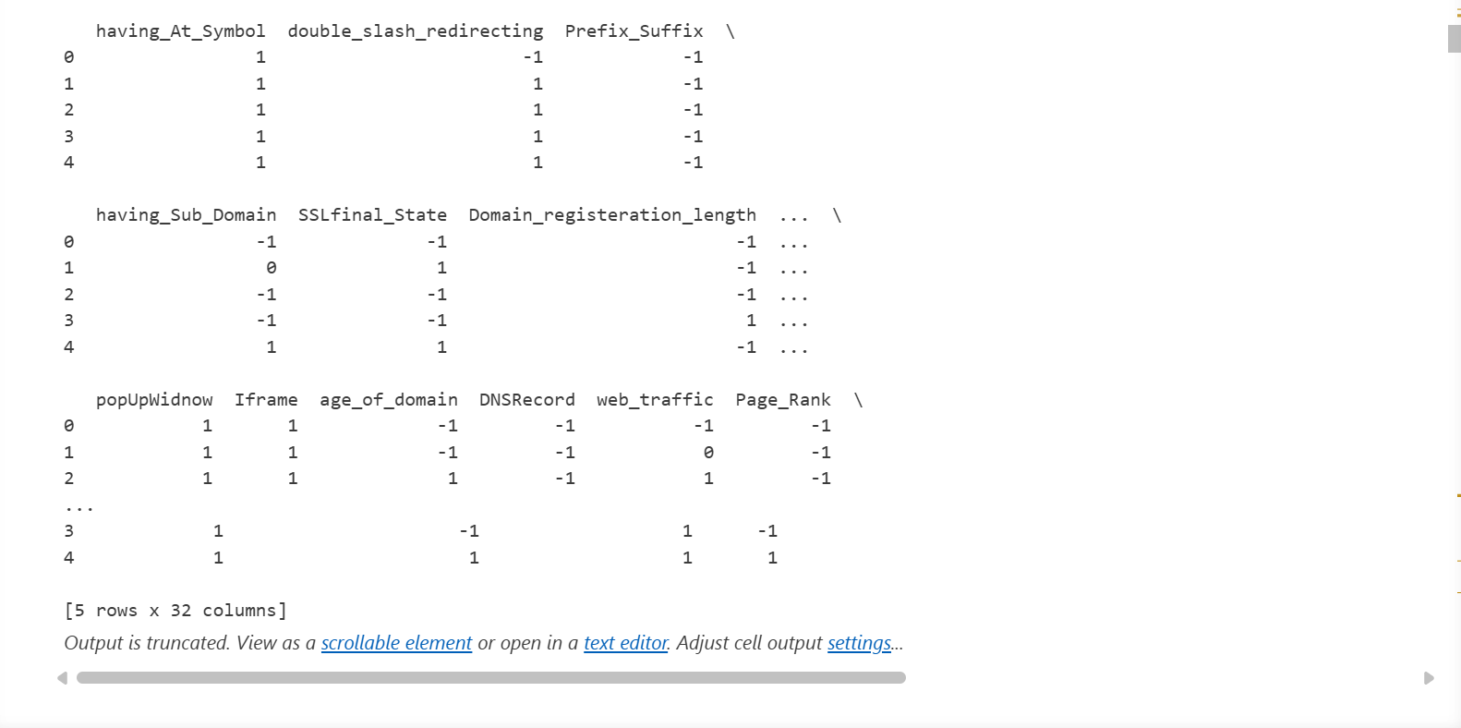
Figure 11: Preview of the Kaggle Phishing Website Dataset
Figure 11 shows the Python code used to load and preview the phishing website dataset obtained from Kaggle. The dataset is loaded using the pd.read_csv() function from the pandas library, which reads the CSV file and stores it in a DataFrame. The df.head() function is then used to display the first five rows of the dataset. As illustrated in Figure 11, this step allows the researcher to verify that the dataset has been successfully loaded and to observe the available features such as having_IP_Address, URL_Length, Shortining_Service, SSLfinal_State, and web_traffic. This preview helps in understanding the dataset structure before performing further preprocessing and machine learning analysis.

4.6.2 Data Validation and Cleaning

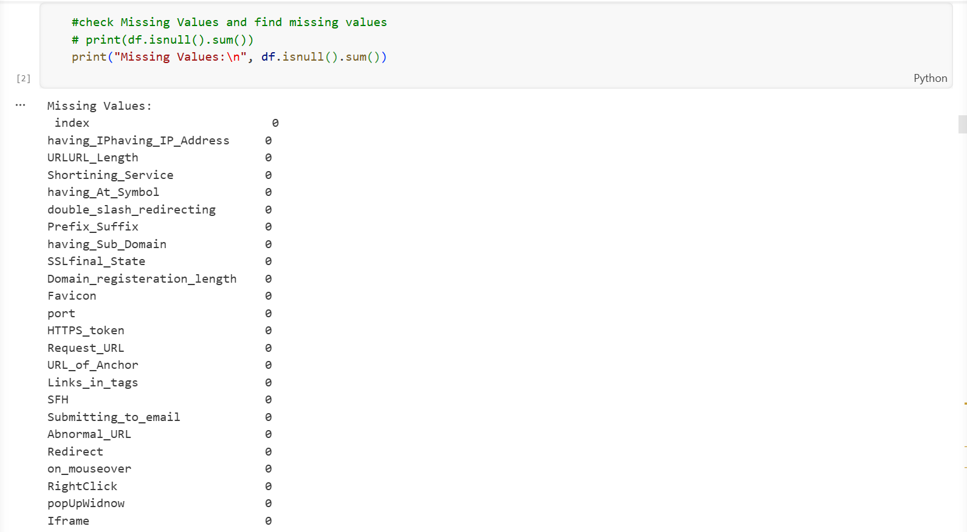
Figure 12
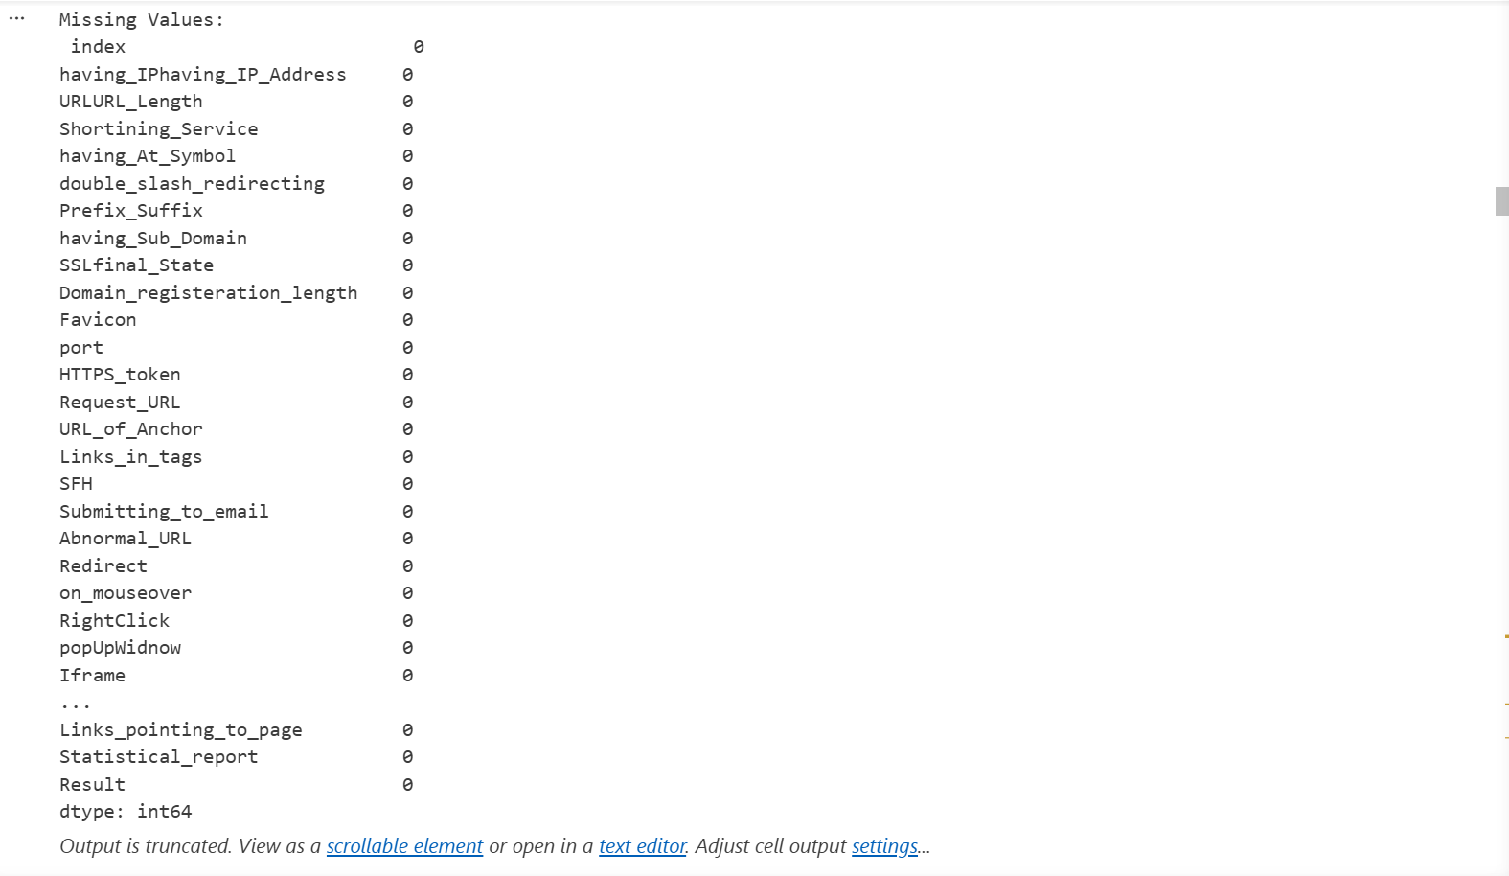
Figure 12: Checking the Dataset for Missing Values
Figure 12 shows the process of validating the phishing website dataset by checking for missing values using the panda’s function df.isnull(). sum (). This command counts the number of null or missing values present in each feature of the dataset. As illustrated in Figure 12, all the features such as URL_Length, Shortining_Service, Prefix_Suffix, Request_URL, and Result have a value of 0, indicating that there are no missing values in the dataset. This confirms that the dataset is complete and does not require additional cleaning before proceeding to feature selection and model training.

4.6.3 Feature Selection
Feature selection is a critical preprocessing step that identifies the most relevant features from the dataset, reducing dimensionality and improving model performance by eliminating irrelevant or redundant attributes. In this study, three feature selection techniques were applied consistent with the methodology adopted in the base paper: Information Gain (IG), Gain Ratio (GR), and Principal Component Analysis (PCA).
The original dataset contains 32 columns in total. One column is the index column, which was removed during data cleaning as it does not contribute to the predictive capability of the model. One column is the Result column, which represents the binary class label indicating whether a website is phishing or legitimate; this column was assigned as the target variable y and was therefore excluded from the feature set. The remaining 30 columns formed the feature matrix X, which was used as the input for all three feature selection techniques. Each method independently selected the top 10 most informative features from these 30 columns, providing three different ranked perspectives on feature importance across the dataset.
Information Gain (IG)
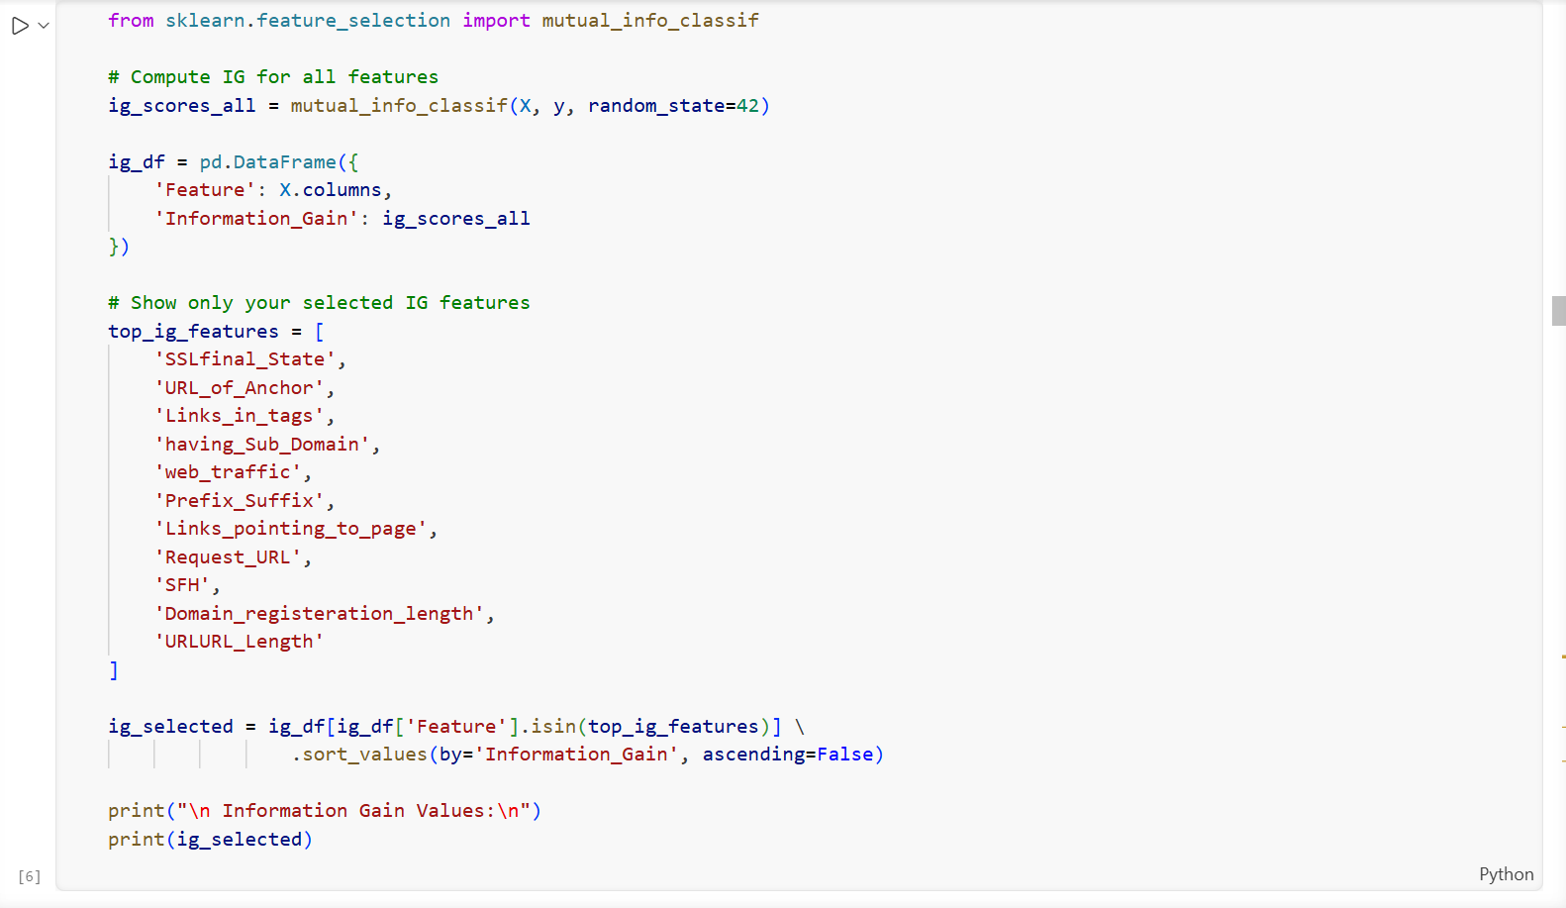
Figure 13
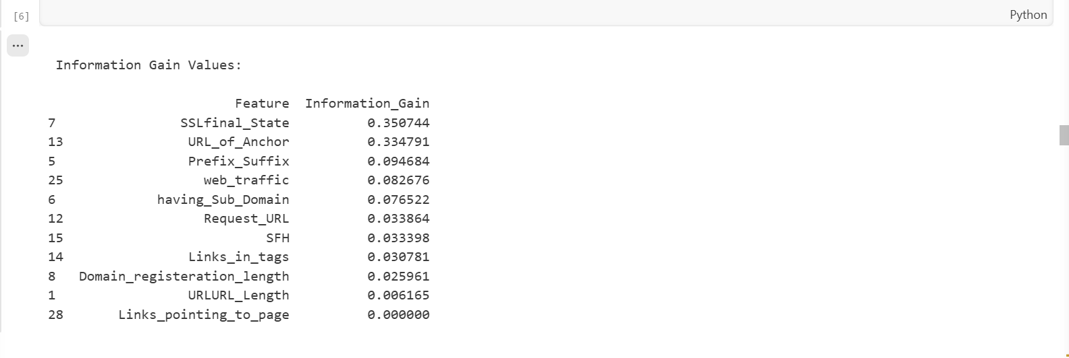
Figure 13: Feature Selection Using Information Gain
Information Gain (IG) was used to measure the importance of each feature in relation to the phishing classification target [67]. The function mutual_info_classif(X, y, random_state=42) calculates the Information Gain score for each feature by evaluating its dependency with the target variable. The parameter random_state=42 ensures that the results are reproducible.
The calculated scores were organised into a DataFrame that pairs each feature with its corresponding Information Gain value. The features were then ranked based on their scores to identify the most informative predictors. As shown in Figure 13, features such as SSLfinal_State, URL_of_Anchor, and Prefix_Suffix obtained the highest Information Gain values, indicating their strong contribution to phishing website detection.

Gain Ratio (GR)
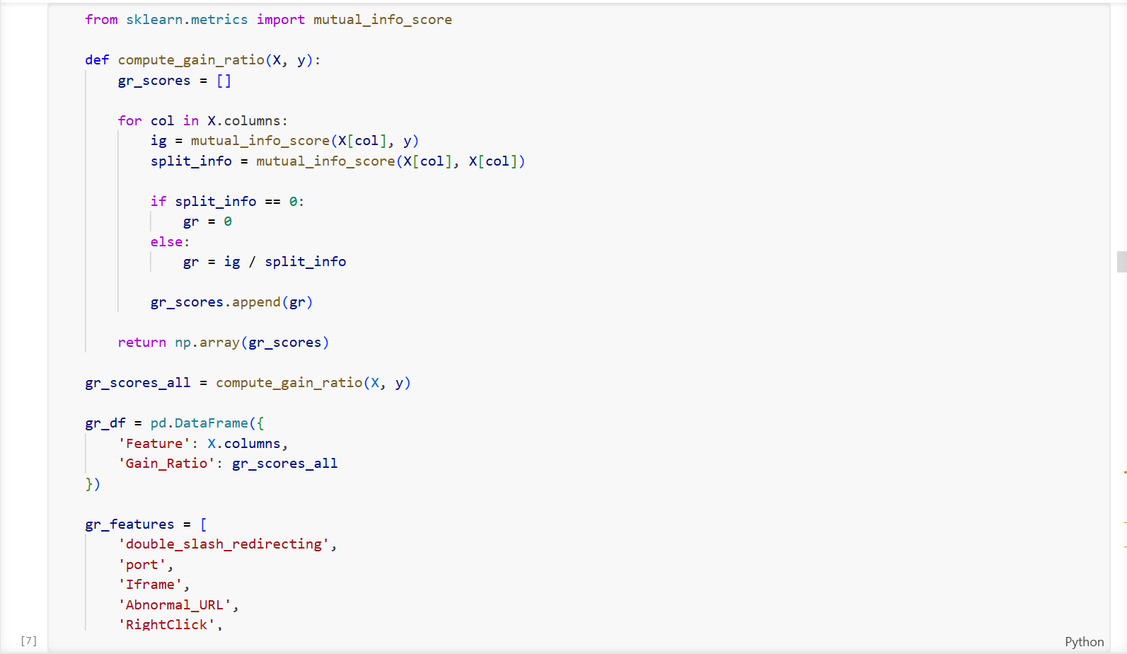
Figure 14
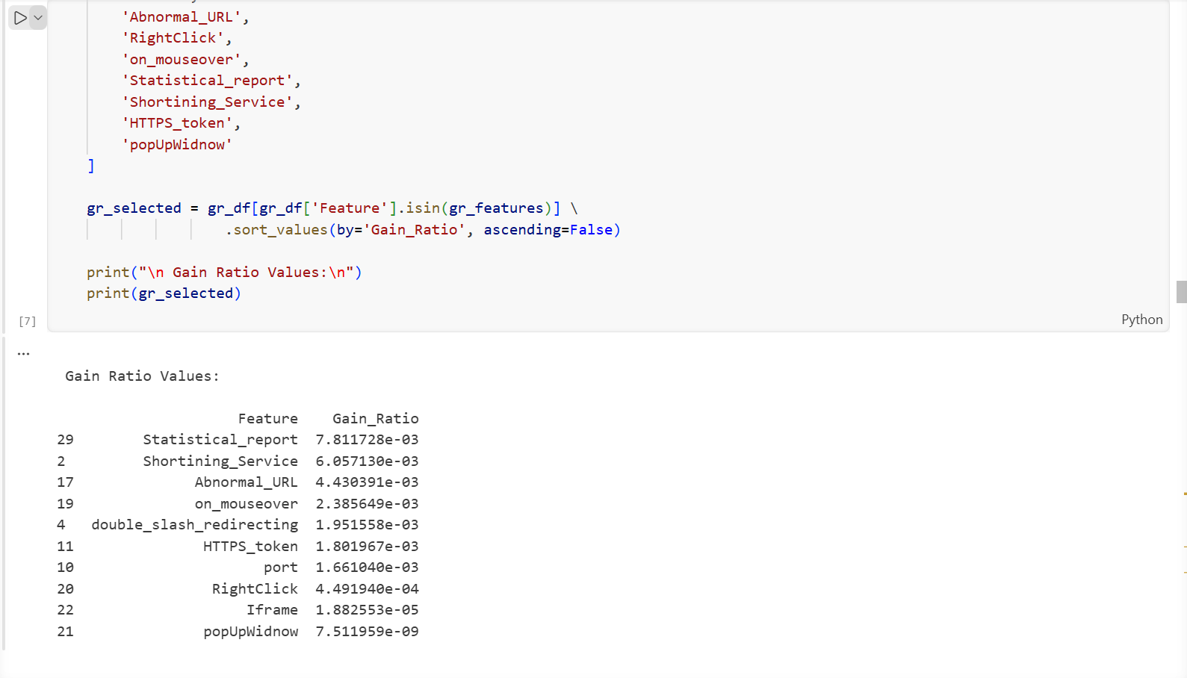
Figure 14: Feature Selection Using Gain Ratio
The following code is used to select and rank important features based on their Gain Ratio values. First, a list of selected features (gr_features) is defined. The dataframe (gr_df) is then filtered using the isin() function to include only these features.
Next, the selected features are sorted in descending order of Gain Ratio values using sort_values(). This helps identify the most significant features contributing to the phishing website detection model.
Finally, the results are printed to display the feature names and their corresponding Gain Ratio scores, allowing comparison of feature importance.
As shown in Figure 14, features such as Statistical_report, Shortening_Service, and Abnormal_URL have relatively higher Gain Ratio values, indicating greater influence on the classification model.

Principal Component Analysis (PCA)
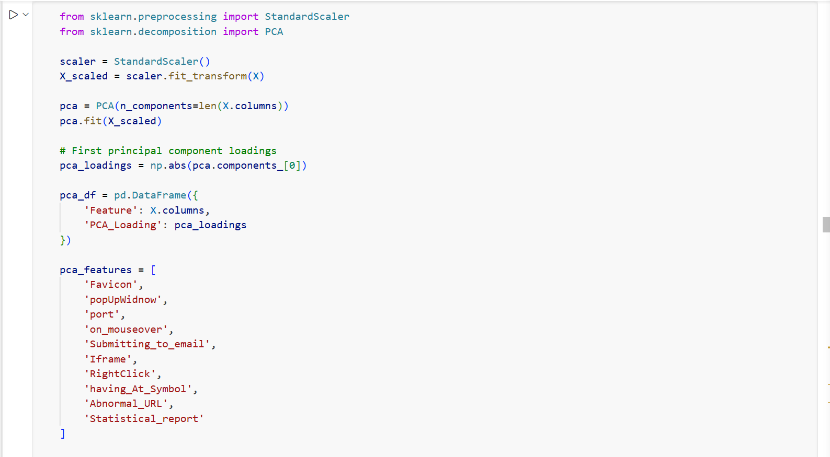
Figure 15
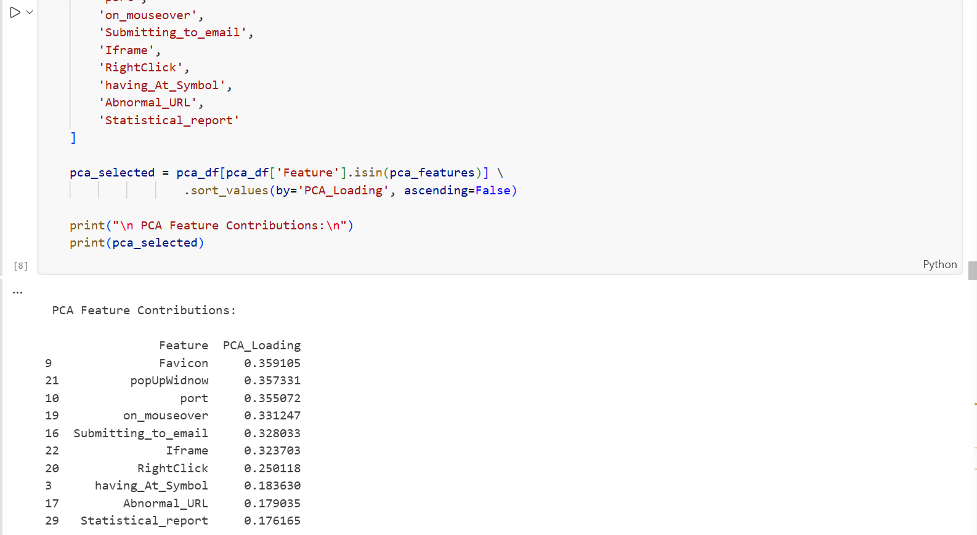
Figure 15: Feature Selection Using Principal Component Analysis (PCA)
The code applies Principal Component Analysis (PCA) to evaluate the contribution of selected features in the dataset. First, the data is standardized using StandardScaler to ensure all features are on the same scale. PCA is then performed to compute the principal components, and the loading values of the first principal component are extracted.
The selected features are filtered and sorted in descending order based on their PCA loading values. As shown in Figure 15, features such as Favicon, popUpWindow, and port have higher loading values, indicating stronger contributions to the phishing website detection model.

4.6.4 Train-Test Split
Train–test splitting is an essential preprocessing step in machine learning used to evaluate the generalisation ability of a model on unseen data. It involves dividing the dataset into two subsets: a training set, which is used to train the model, and a testing set, which is used to evaluate the model’s performance. In this study, the dataset was divided using an 80–20 split, where 80% of the data was allocated for training and 20% for testing [68].
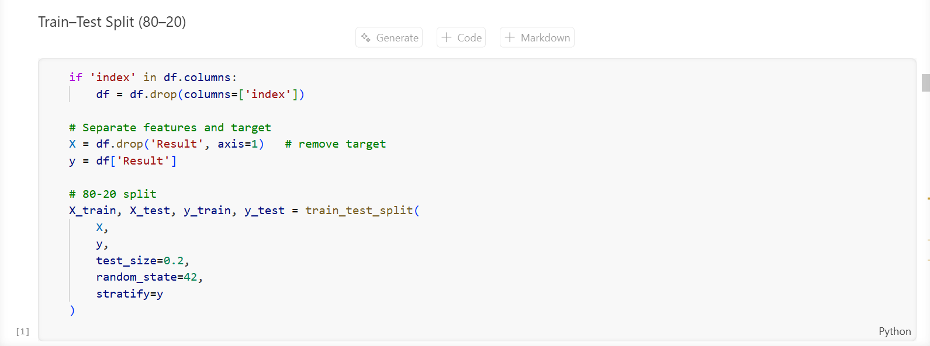
Figure 16: Splitting the Dataset into Training and Testing Sets
The dataset is divided into training and testing sets to evaluate the performance of the machine learning model. First, the unnecessary index column is removed from the dataset. Then, the features (X) and target variable (y) are separated, where the Result column represents the target label.
The train_test_split() function is used to split the dataset into 80% training data and 20% testing data. The parameter random_state=42 ensures reproducibility of the results, while stratify=y maintains the same class distribution in both training and testing sets.

4.6.5 Model Training
This section presents the training process of the nine models implemented in the base approach of this study. The models are organised into three categories: Shallow Machine Learning, Ensemble Learning, and Deep Learning, with three models implemented in each category. All models were trained using the pre-processed Kaggle Phishing Website Dataset, which contains 11,055 samples and 32 features. An 80/20 train–test split was applied consistently across all models to ensure a fair and reliable comparison of their performance in detecting phishing websites.
Category 1: Machine Learning
Shallow machine learning algorithms are traditional classification methods that learn directly from structured features without deep hierarchical representations. In this study, three shallow models were implemented: Support Vector Machine (SVM), Decision Tree (DT), and K-Nearest Neighbours (KNN). These models serve as baseline classifiers for comparing the performance of ensemble and deep learning approaches.
Support Vector Machine (SVM)
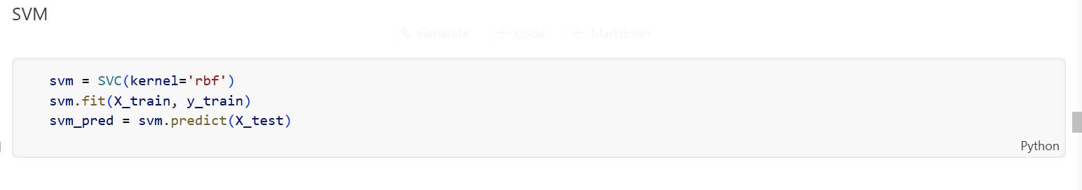
Figure 17: Implementation of the Support Vector Machine (SVM) classification model.
Support Vector Machine (SVM) is a supervised machine learning algorithm used for classification tasks. In this study, an SVM model with a Radial Basis Function (RBF) kernel was implemented to classify phishing and legitimate websites. The model was trained using the training dataset (X_train, y_train) and then used to predict the labels of the testing dataset (X_test). The predicted results were stored for further evaluation of the model’s performance.
Decision Tree
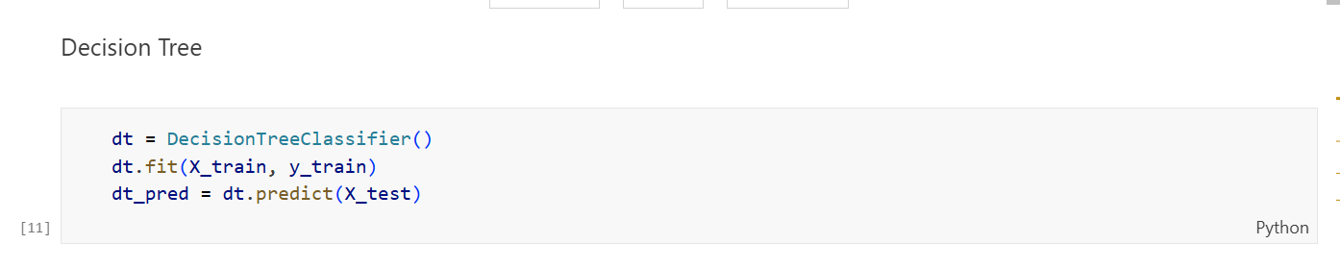
Decision Tree is a supervised machine learning algorithm used for classification and prediction tasks. In this study, a Decision Tree Classifier was implemented to classify phishing and legitimate websites. The model was trained using the training dataset (X_train, y_train). After training, the model was used to predict the labels of the testing dataset (X_test). The predicted results were stored for further evaluation of the model's performance.
K-Nearest Neighbors (KNN)
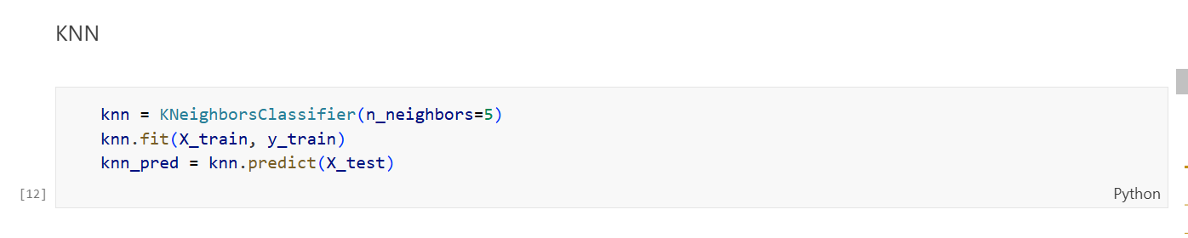
Figure 18: Implementation of the K-Nearest Neighbors (KNN) classification model.
K-Nearest Neighbors (KNN) is a supervised machine learning algorithm used for classification tasks. In this study, the KNN classifier was implemented with n_neighbors = 5 to classify phishing and legitimate websites. The model was trained using the training dataset (X_train, y_train). After training, the model predicted the labels for the testing dataset (X_test). The predicted results were then used to evaluate the model’s performance.
Category 2: Ensemble Learning
Ensemble learning methods combine multiple models to improve classification performance and reduce overfitting. By aggregating predictions from several base learners, these methods achieve better generalisation than single models. In this study, Random Forest, XGBoost, AdaBoost, LightGBM, and a Stacking Ensemble were implemented to enhance phishing detection performance
Random Forest
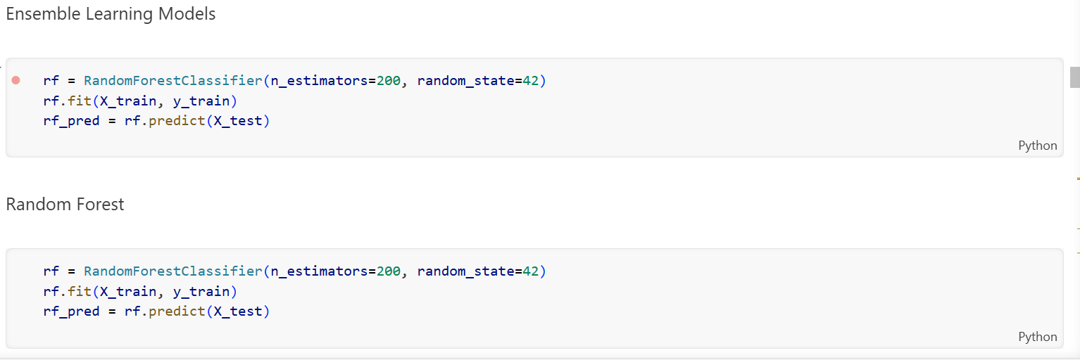
Figure 19: Implementation of the Random Forest ensemble learning model.
Random Forest is an ensemble learning algorithm that combines multiple decision trees to improve classification accuracy and reduce overfitting. In this study, a Random Forest classifier was implemented with 200 decision trees (n_estimators = 200). The model was trained using the training dataset (X_train, y_train). After training, the model was used to predict the labels of the testing dataset (X_test). The predicted results were then used to evaluate the performance of the model.
AdaBoost
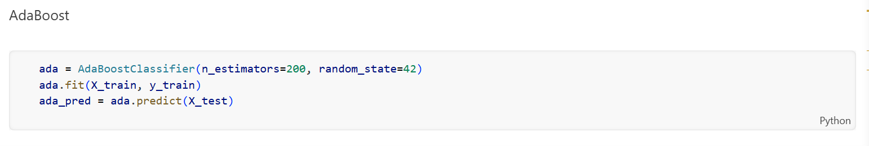
Figure 20: Implementation of the AdaBoost ensemble learning model.
AdaBoost is an ensemble learning algorithm that improves model performance by combining multiple weak classifiers into a strong classifier. In this study, the AdaBoost classifier was implemented with 200 estimators (n_estimators = 200). The model was trained using the training dataset (X_train, y_train). After training, the model predicted the labels for the testing dataset (X_test), and the predictions were used to evaluate the model’s performance.
XGBoost

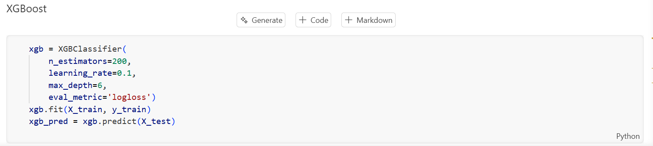
Figure 21: Implementation of the XGBoost classification model.
XGBoost is an advanced ensemble learning algorithm based on gradient boosting, widely used for classification and prediction tasks. In this study, the XGBoost classifier was implemented with 200 estimators, a learning rate of 0.1, and a maximum tree depth of 6. The model was trained using the training dataset (X_train, y_train). After training, the model predicted the labels of the testing dataset (X_test), and the predictions were used to evaluate the model’s performance.
Category 3: Deep Learning
Deep learning models learn complex patterns through multiple layers of neural networks and can automatically extract meaningful representations from data. In this study, three deep learning models were implemented: LSTM, RNN, and GRU, to improve phishing website detection performance.
LSTM Model Implementation
Step 1: Model Architecture
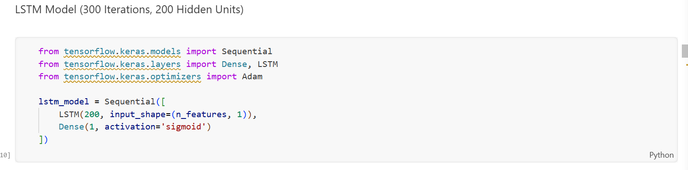
Figure 22a
In this step, the required libraries from TensorFlow Keras are imported. A Sequential model is created with an LSTM layer containing 200 hidden units to capture feature patterns. A Dense output layer with sigmoid activation is added to perform binary classification between phishing and legitimate websites.
Step 2: Model Compilation
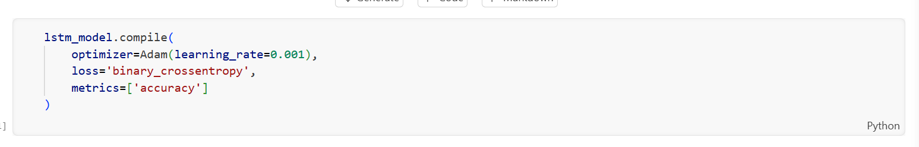
Figure 22b
The LSTM model is compiled using the Adam optimizer with a learning rate of 0.001. The binary cross-entropy loss function is used since the task is binary classification, and accuracy is selected as the evaluation metric.
Step 3: Model Training
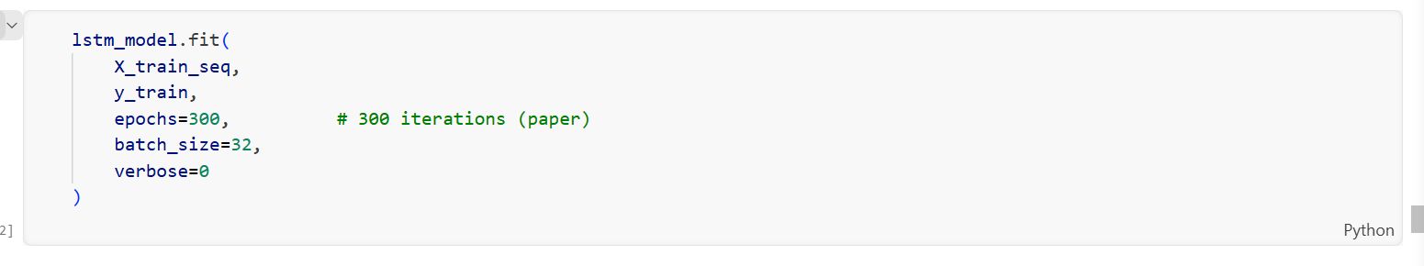
Figure 22c
The model is trained using the training dataset (X_train_seq, y_train). The training process runs for 300 epochs (iterations) with a batch size of 32 to allow the model to learn patterns from the dataset.
Step 4: Model Prediction
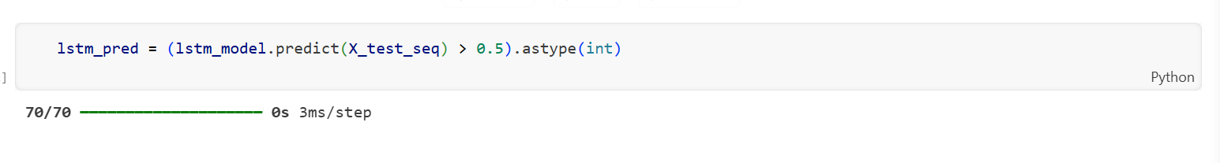
Figure 22: Implementation of the LSTM deep learning model.

After training, the model predicts the labels of the testing dataset (X_test_seq). A threshold value of 0.5 is applied to convert the predicted probabilities into binary class labels for phishing detection.
Recurrent Neural Network (RNN) Model
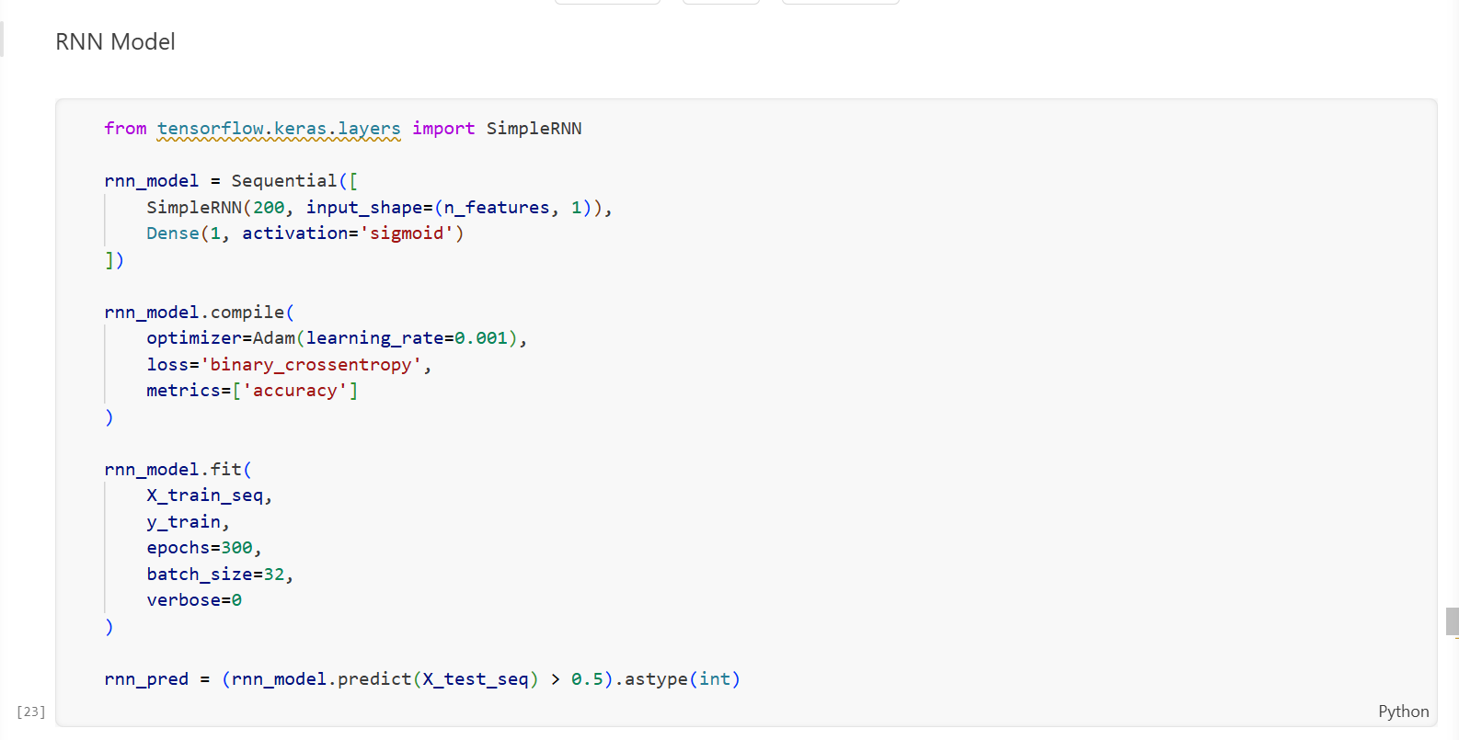
Figure 23
A Recurrent Neural Network (RNN) model was implemented to learn patterns in the dataset for phishing website detection. The model uses a SimpleRNN layer with 200 hidden units to capture relationships within the input features. A Dense output layer with sigmoid activation is added to perform binary classification.
The model is compiled using the Adam optimizer with a learning rate of 0.001, and binary cross-entropy is used as the loss function with accuracy as the evaluation metric. The model is trained using the training dataset for 300 epochs with a batch size of 32. After training, the model predicts the labels of the testing dataset, and the predicted probabilities are converted into binary values using a 0.5 threshold.
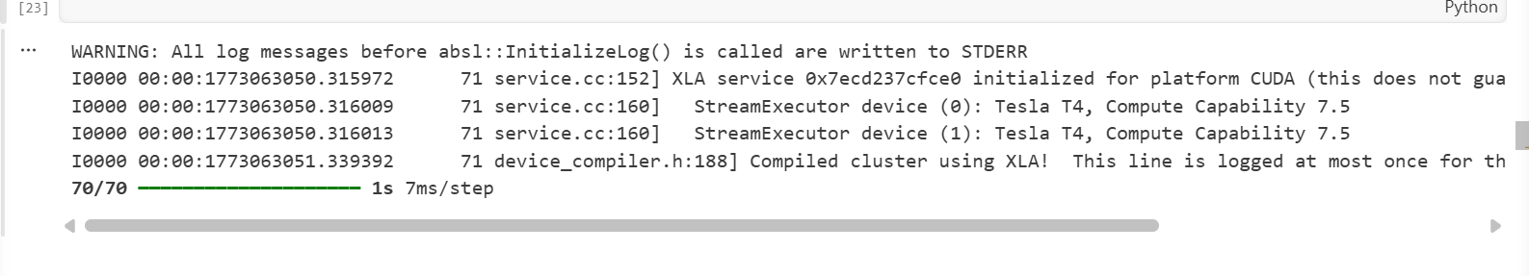
Figure 23: Implementation of the RNN deep learning model.
A Recurrent Neural Network (RNN) model was implemented to learn patterns in the dataset for phishing website detection. The model uses a SimpleRNN layer with 200 hidden units to capture relationships within the input features. A Dense output layer with sigmoid activation is added to perform binary classification.
The model is compiled using the Adam optimizer with a learning rate of 0.001, and binary cross-entropy is used as the loss function with accuracy as the evaluation metric. The model is trained using the training dataset for 300 epochs with a batch size of 32. After training, the model predicts the labels of the testing dataset, and the predicted probabilities are converted into binary values using a 0.5 threshold.

Gated Recurrent Unit (GRU) Model
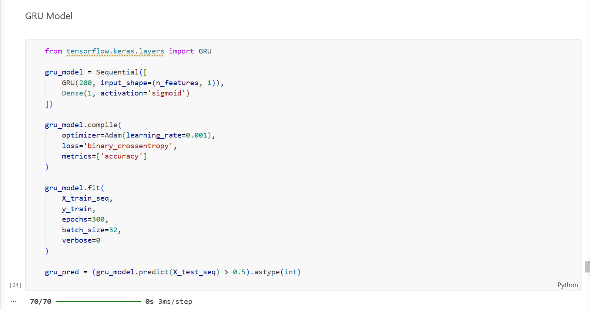
Figure 24: Implementation of the GRU deep learning model
A Gated Recurrent Unit (GRU) model was implemented as a deep learning approach for phishing website detection. The model consists of a GRU layer with 200 hidden units, followed by a Dense output layer with sigmoid activation for binary classification.
The model was compiled using the Adam optimizer with a learning rate of 0.001, and binary cross-entropy was used as the loss function with accuracy as the evaluation metric. The model was trained on the training dataset for 300 epochs with a batch size of 32. After training, the model predicted the labels of the testing dataset, and a 0.5 threshold was applied to convert the predicted probabilities into binary classification results.

4.6.6 Model Evaluation
Following the training of all eleven models, a standardised evaluation function was implemented to assess the performance of each model consistently using four key classification metrics: Accuracy, Precision, Recall, and F1 Score.
Step 1: Evaluation Function

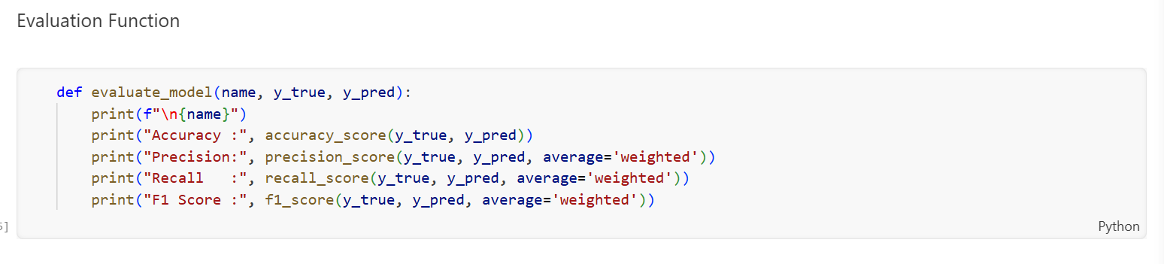
An evaluation function was implemented to measure the performance of the classification models. The function calculates key evaluation metrics, including Accuracy, Precision, Recall, and F1-score, using the actual labels (y_true) and predicted labels (y_pred). These metrics provide a comprehensive assessment of the model’s performance in detecting phishing and legitimate websites.
Step 2: Applying Evaluation to All 9 Models

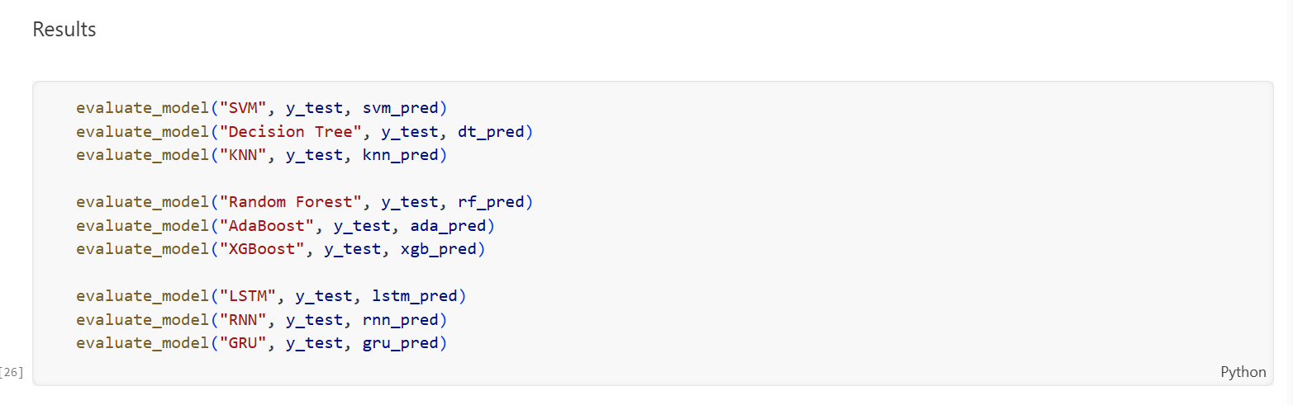
The evaluation function was applied to assess the performance of different models, including SVM, Decision Tree, KNN, Random Forest, AdaBoost, XGBoost, LSTM, RNN, and GRU, using the testing dataset.
Step 3: Evaluation Results
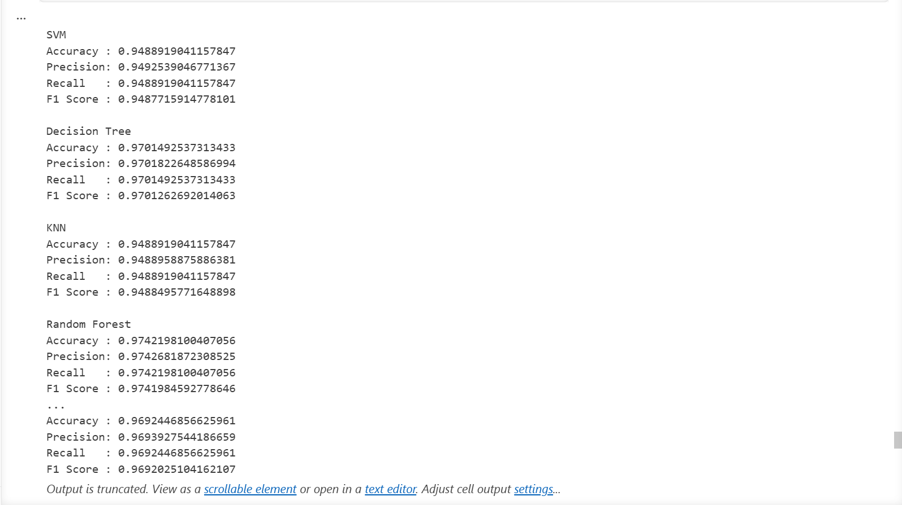
The performance of the implemented models was evaluated using Accuracy, Precision, Recall, and F1-score. The results show that the models achieved high classification performance in detecting phishing and legitimate websites.
Table 8: Evaluation Results
Model | Accuracy | Precision | Recall | F1 Score
SVM | 94.89 | 94.93 | 94.89 | 94.88
Decision Tree | 97.01 | 97.02% | 97.01% | 97.01%
KNN | 94.89% | 94.89% | 94.89% | 94.88%
Random Forest | 97.42% | 97.43% | 97.42% | 97.42%
AdaBoost | 93.40 | 93.41 | 93.40 | 93.39
XGBoost | 97.24 | 97.25 | 97.24 | 97.24
LSTM | 97.06 | 97.06 | 97.06 | 97.06
RNN | 91.99 | 92.01 | 91.99 | 91.98
GRU | 96.92 | 96.94 | 96.92 | 96.92

4.6.7 Originality of Work and Student Contribution
The originality of Experiment 1 lies in the independent reproduction of the base study methodology without access to the original source code. The student independently designed and implemented the complete data preprocessing pipeline, all three feature selection techniques, and the full model training and evaluation pipeline for all nine algorithms. The logical flow of the entire pipeline was verified by the student, and all errors encountered during execution were independently investigated and resolved before the results were recorded.
When deep learning models required extended training time due to the 300-epoch configuration, the student monitored the training process and waited for completion, confirming all output values before proceeding. The student also independently constructed and validated the model-saving pipeline for all nine trained models.

4.7 Experimental – 2

4.7.1 Dataset Loading
The dataset was imported using the panda’s library and examined to confirm correct structure and feature representation.

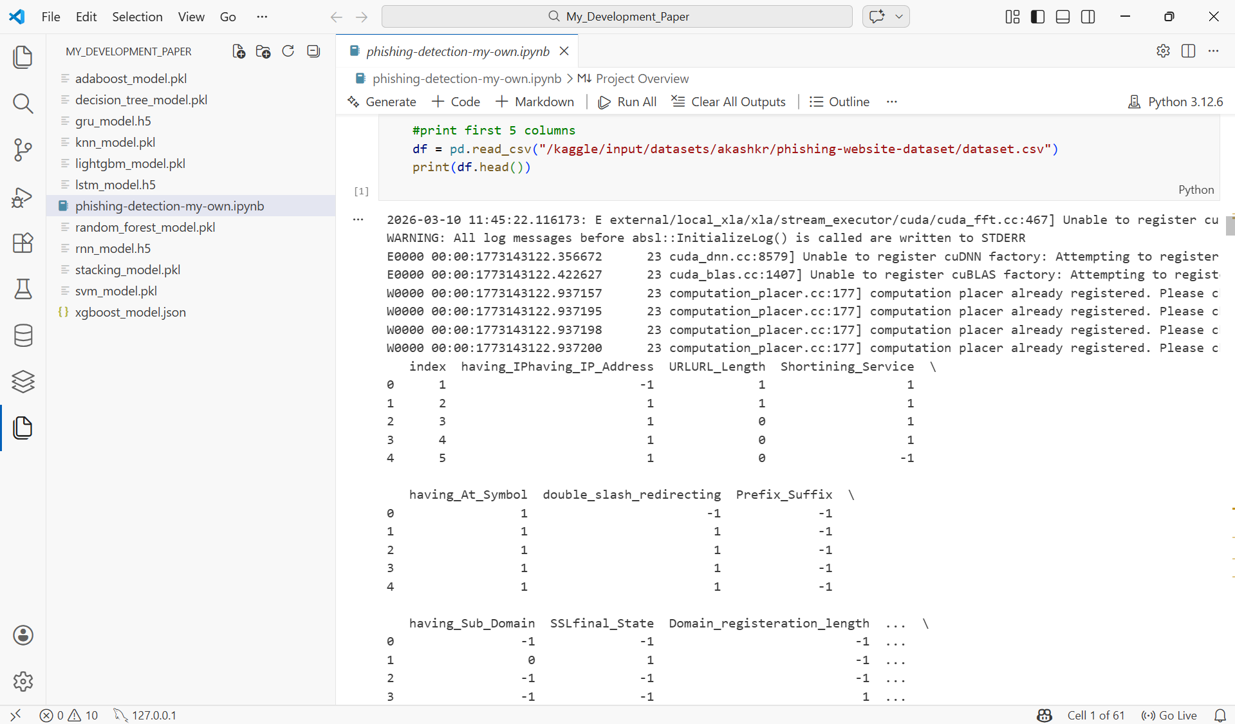
Figure 25
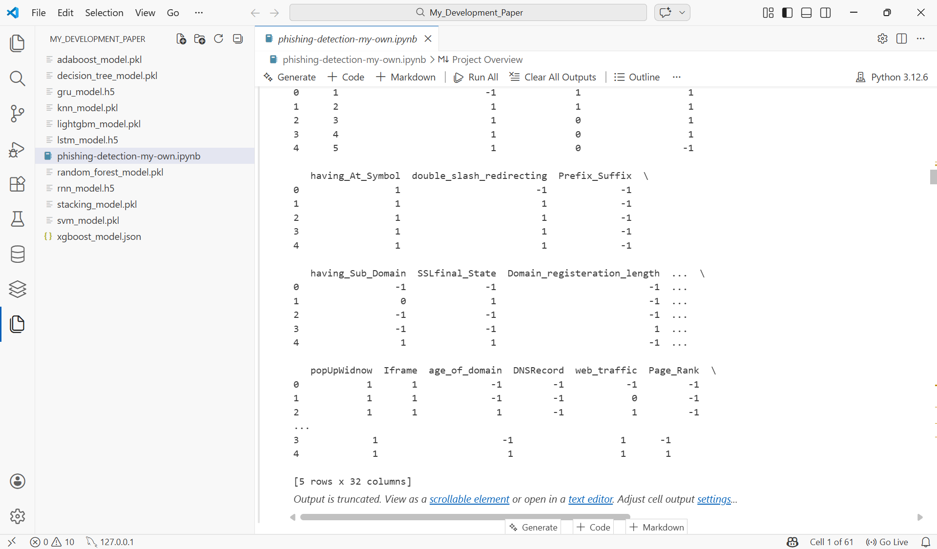
Figure 25: Preview of the Kaggle Phishing Website Dataset

4.7.2 Data Validation and Cleaning
The dataset was examined for missing values and duplicate records to prevent data leakage and maintain model reliability.

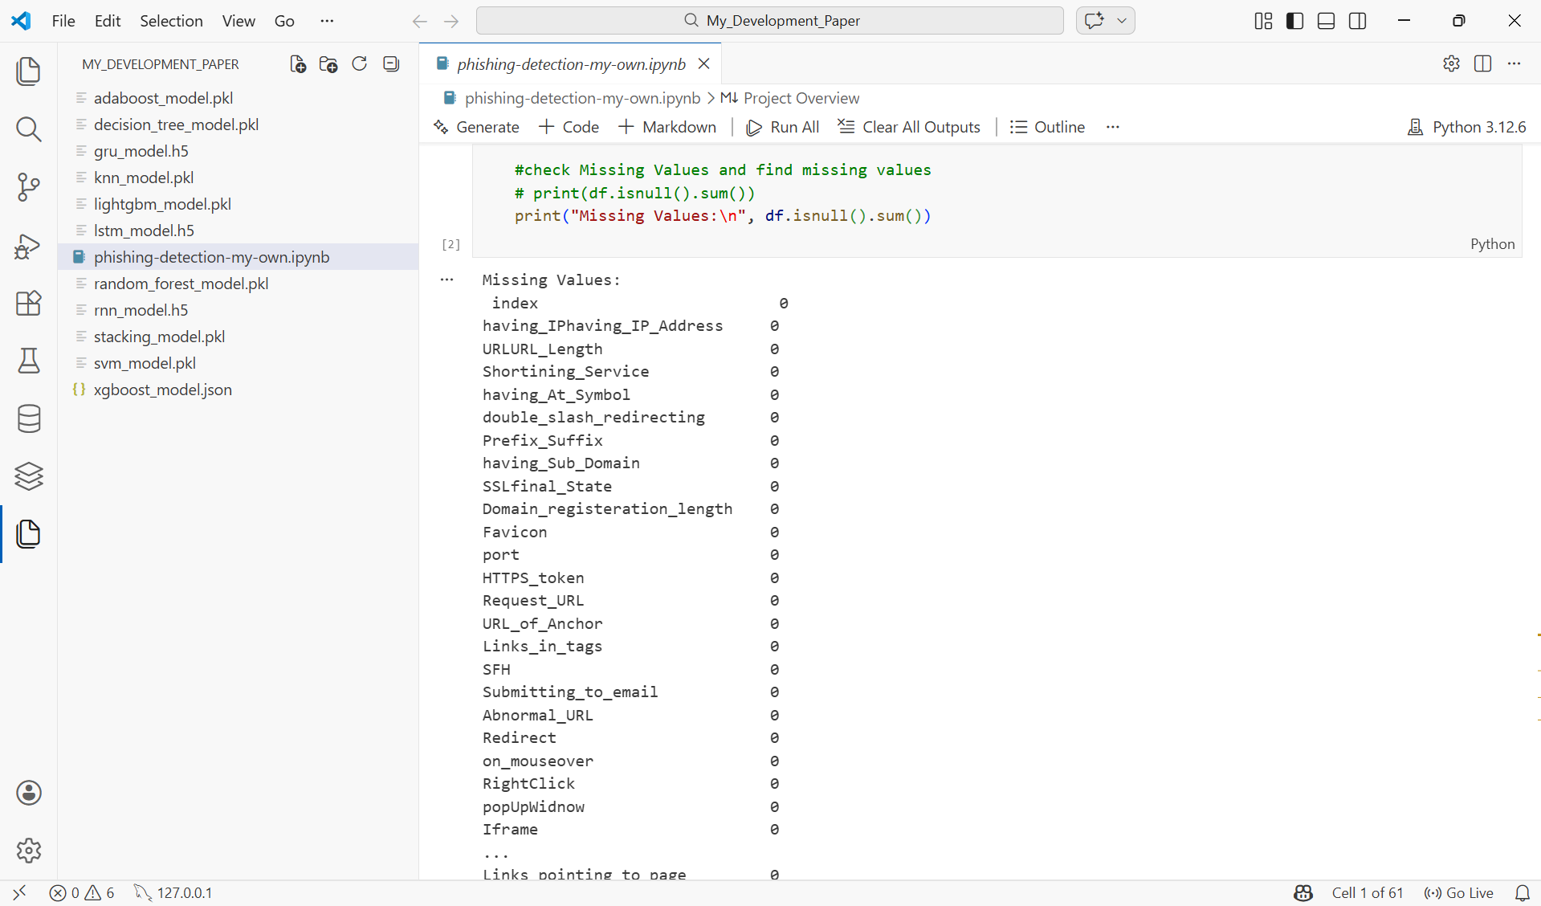
Figure 26
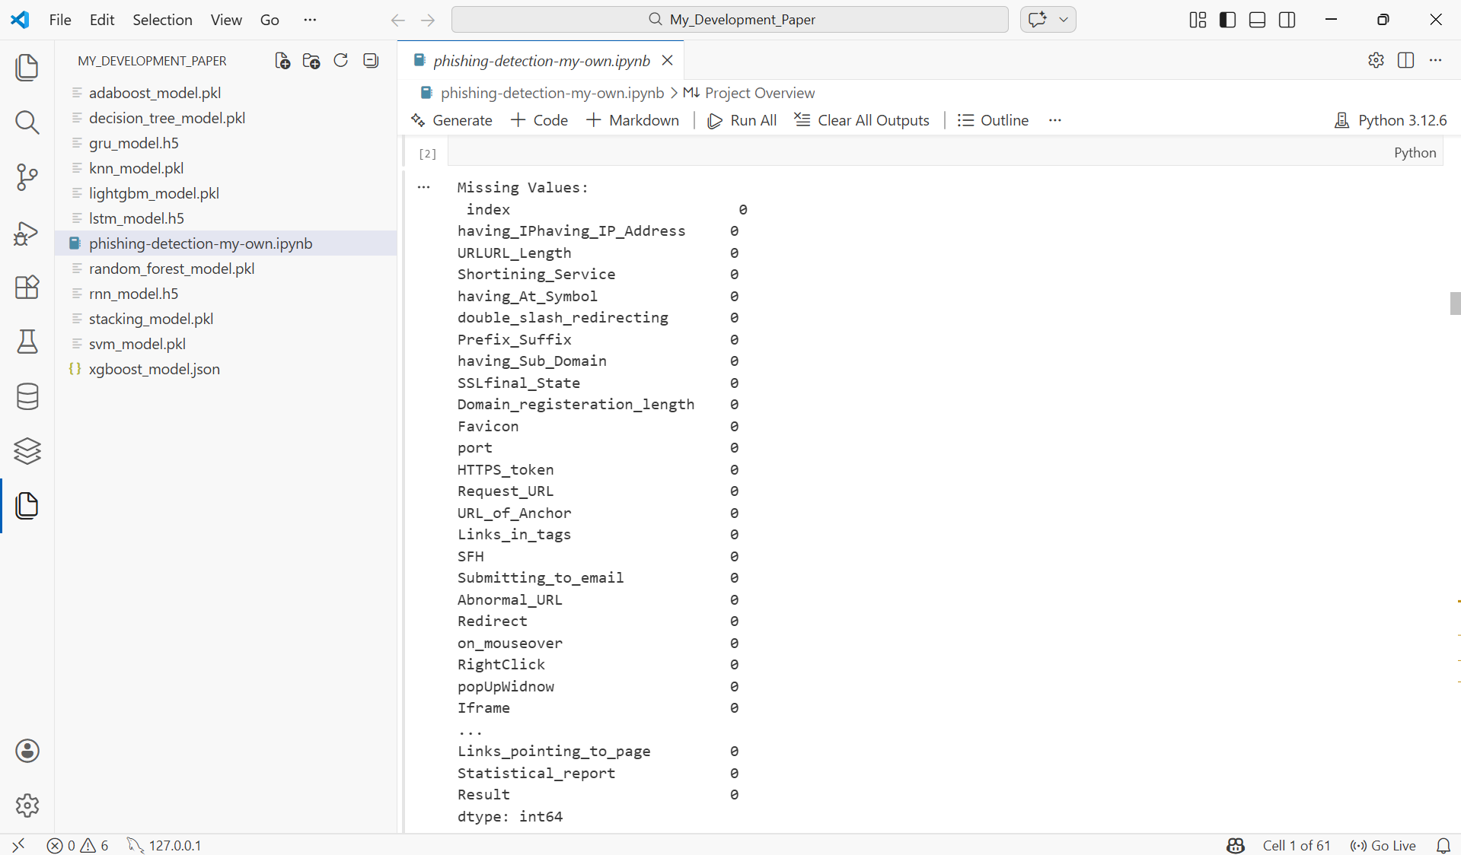
Figure 26: Missing Value Inspection of the Dataset

4.7.3 Feature Selection
Feature selection is a critical preprocessing step that identifies the most relevant features from the dataset, reducing dimensionality and improving model performance by eliminating irrelevant or redundant attributes. In this study, three feature selection techniques were applied: Information Gain (IG), Gain Ratio (GR), and Principal Component Analysis (PCA), consistent with the methodology adopted in the base paper.
The original dataset contains 32 columns in total. One column is the index column, which was removed during data cleaning as it does not contribute to the predictive capability of the model. One column is the Result column, which represents the binary class label indicating whether a website is phishing or legitimate; this column was assigned as the target variable y and was therefore excluded from the feature set. The remaining 30 columns formed the feature matrix X, which was used as the input for all three feature selection techniques. Each method independently selected the top 10 most informative features from these 30 columns, providing three different ranked perspectives on feature importance across the dataset.
Information Gain (IG)
Information Gain measures the reduction in entropy achieved by splitting the dataset on a particular feature, thereby identifying which features contribute most to distinguishing phishing websites from legitimate ones. Features with higher Information Gain values are considered more informative and are prioritised during model training.
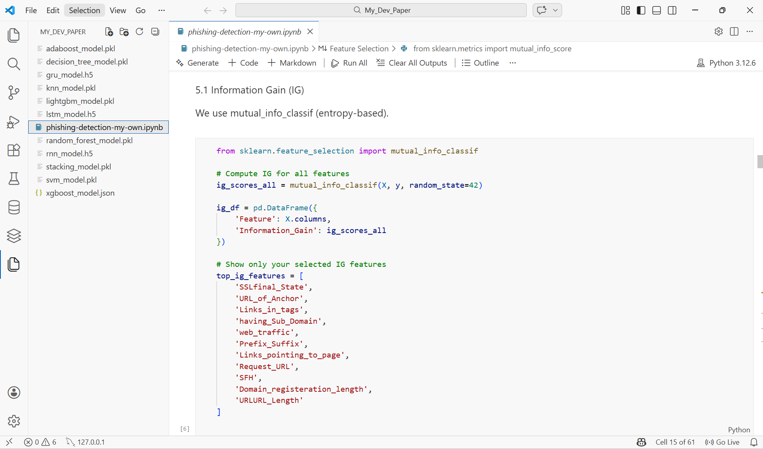
Figure 27
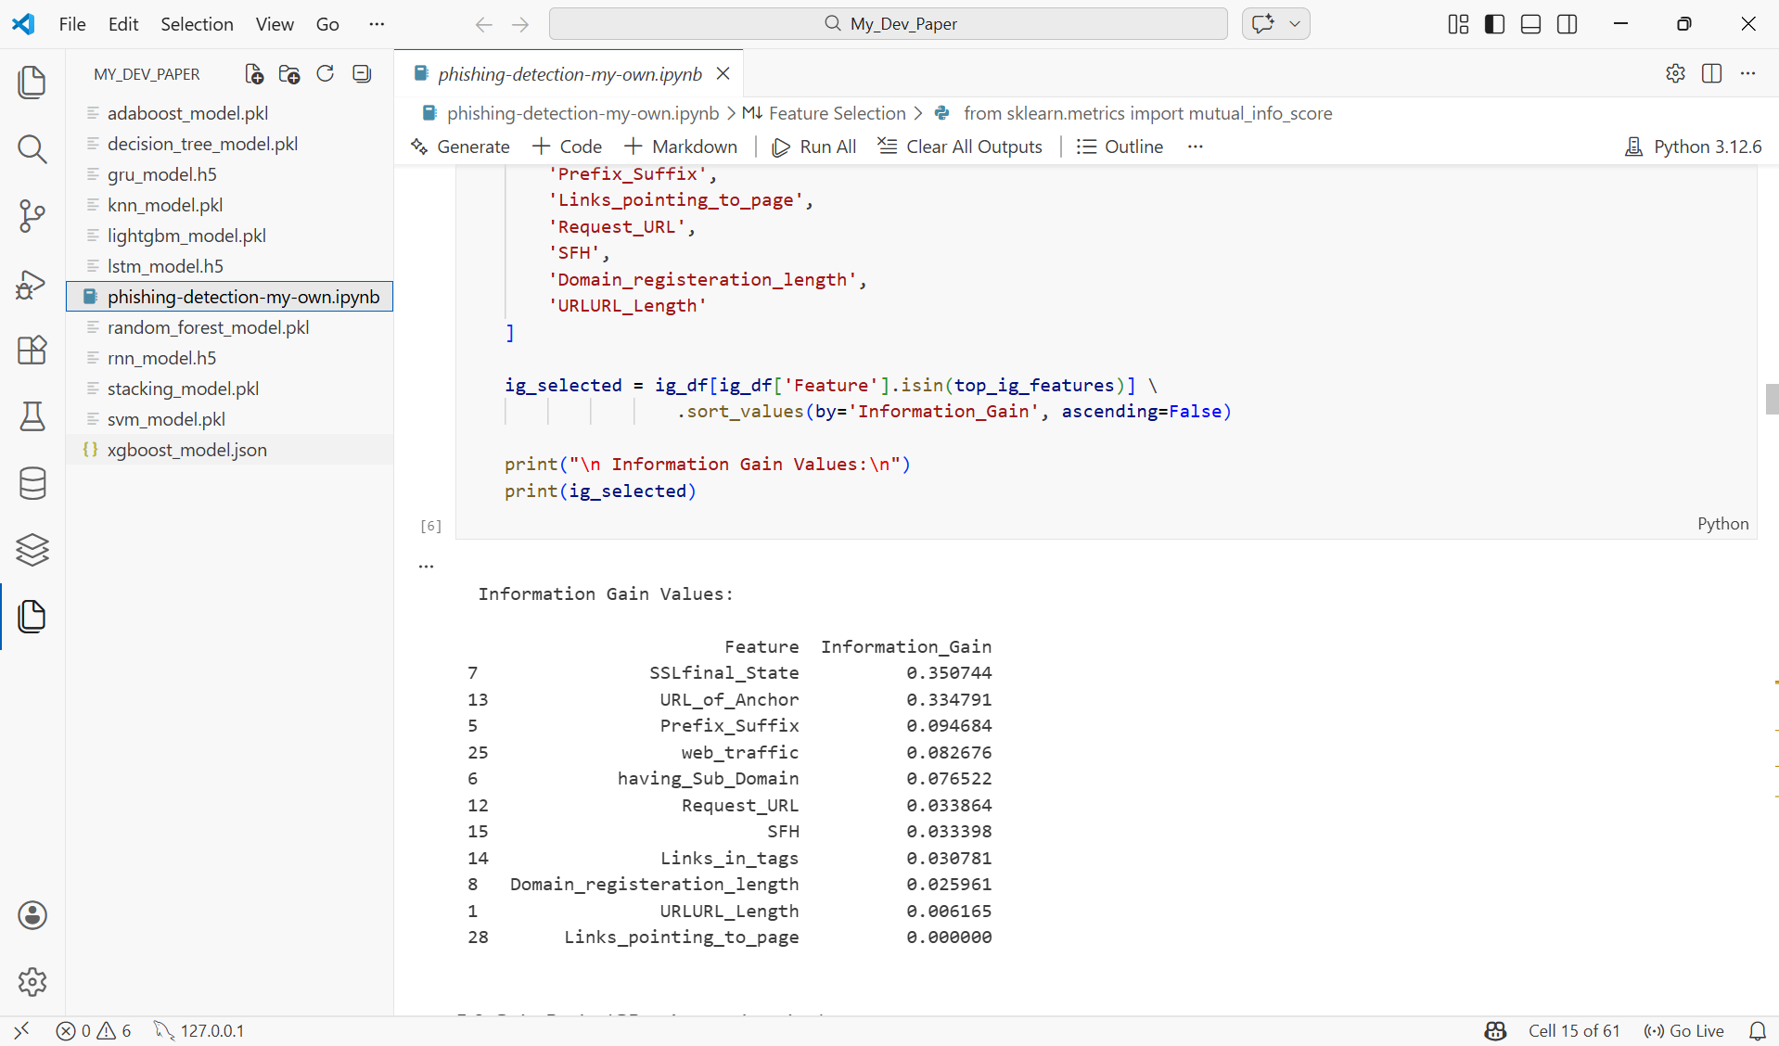
Figure 27: Information Gain Values for Top Selected Features

mutual_info_classif (X, y, random_state=42) computes the Information Gain score for every feature in the dataset by measuring the statistical dependency between each feature and the target class label. A random state of 42 is applied to ensure reproducibility of results.
ig_df organises the computed scores into a structured DataFrame, pairing each feature name with its corresponding Information Gain value for clear interpretation and comparison.
top_ig_features defines the eleven most informative features selected based on their Information Gain scores. These features were identified as the strongest predictors of phishing behaviour within the dataset.
ig_selected filters the DataFrame to retain only the selected top features and sorts them in descending order of Information Gain to provide a clear ranking of feature importance.
The resulting Information Gain values confirmed that SSLfinal_State achieved the highest score of 0.3507, identifying it as the single most informative feature for phishing detection, followed by URL_of_Anchor (0.3348) and Prefix_Suffix (0.0946). Features such as Links_pointing_to_page recorded an Information Gain of 0.000, indicating minimal discriminative power and justifying their lower priority during model training.
Gain Ratio (GR)
Gain Ratio is an extension of Information Gain that normalises the gain value by the split information of each feature, thereby reducing the bias towards features with many distinct values. Since scikit-learn does not provide a direct implementation of Gain Ratio, a custom approximation function was developed in this study, which is an accepted approach in academic reproductions of this method.
The Gain Ratio is calculated as:
GR = Information Gain / Split Information
where Split Information represents the entropy of the feature itself.
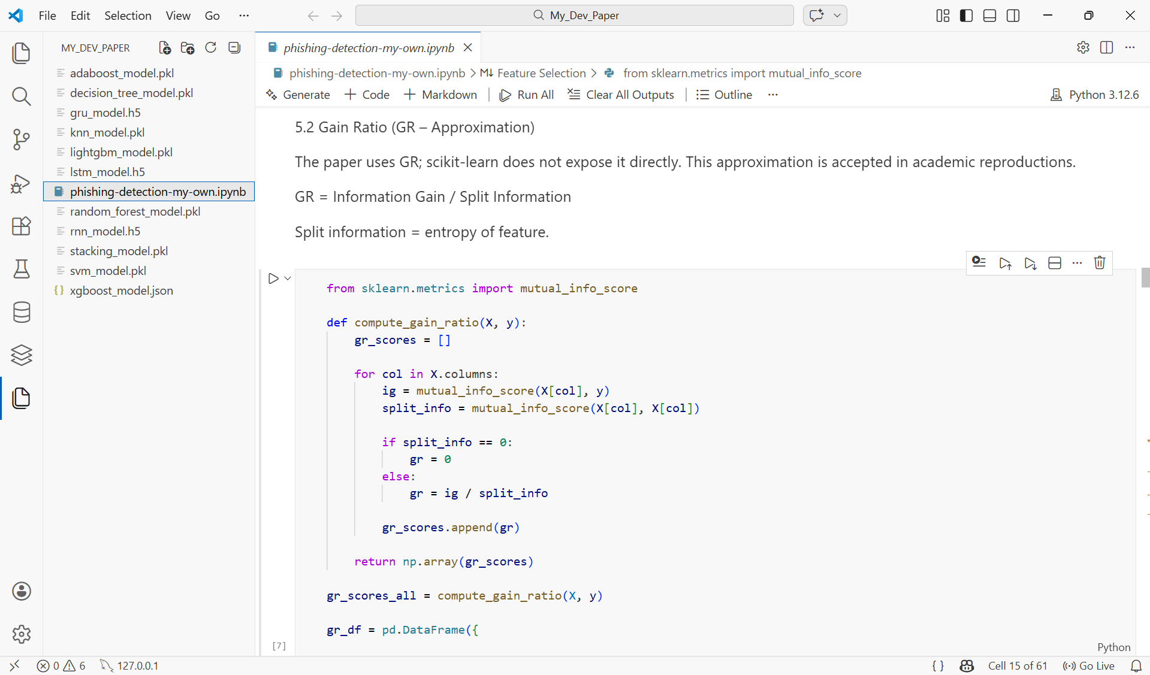
Figure 28

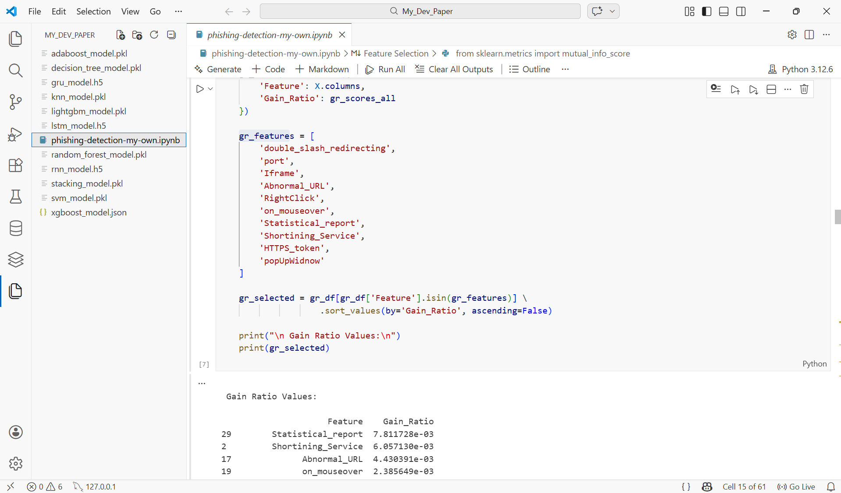
Figure 28
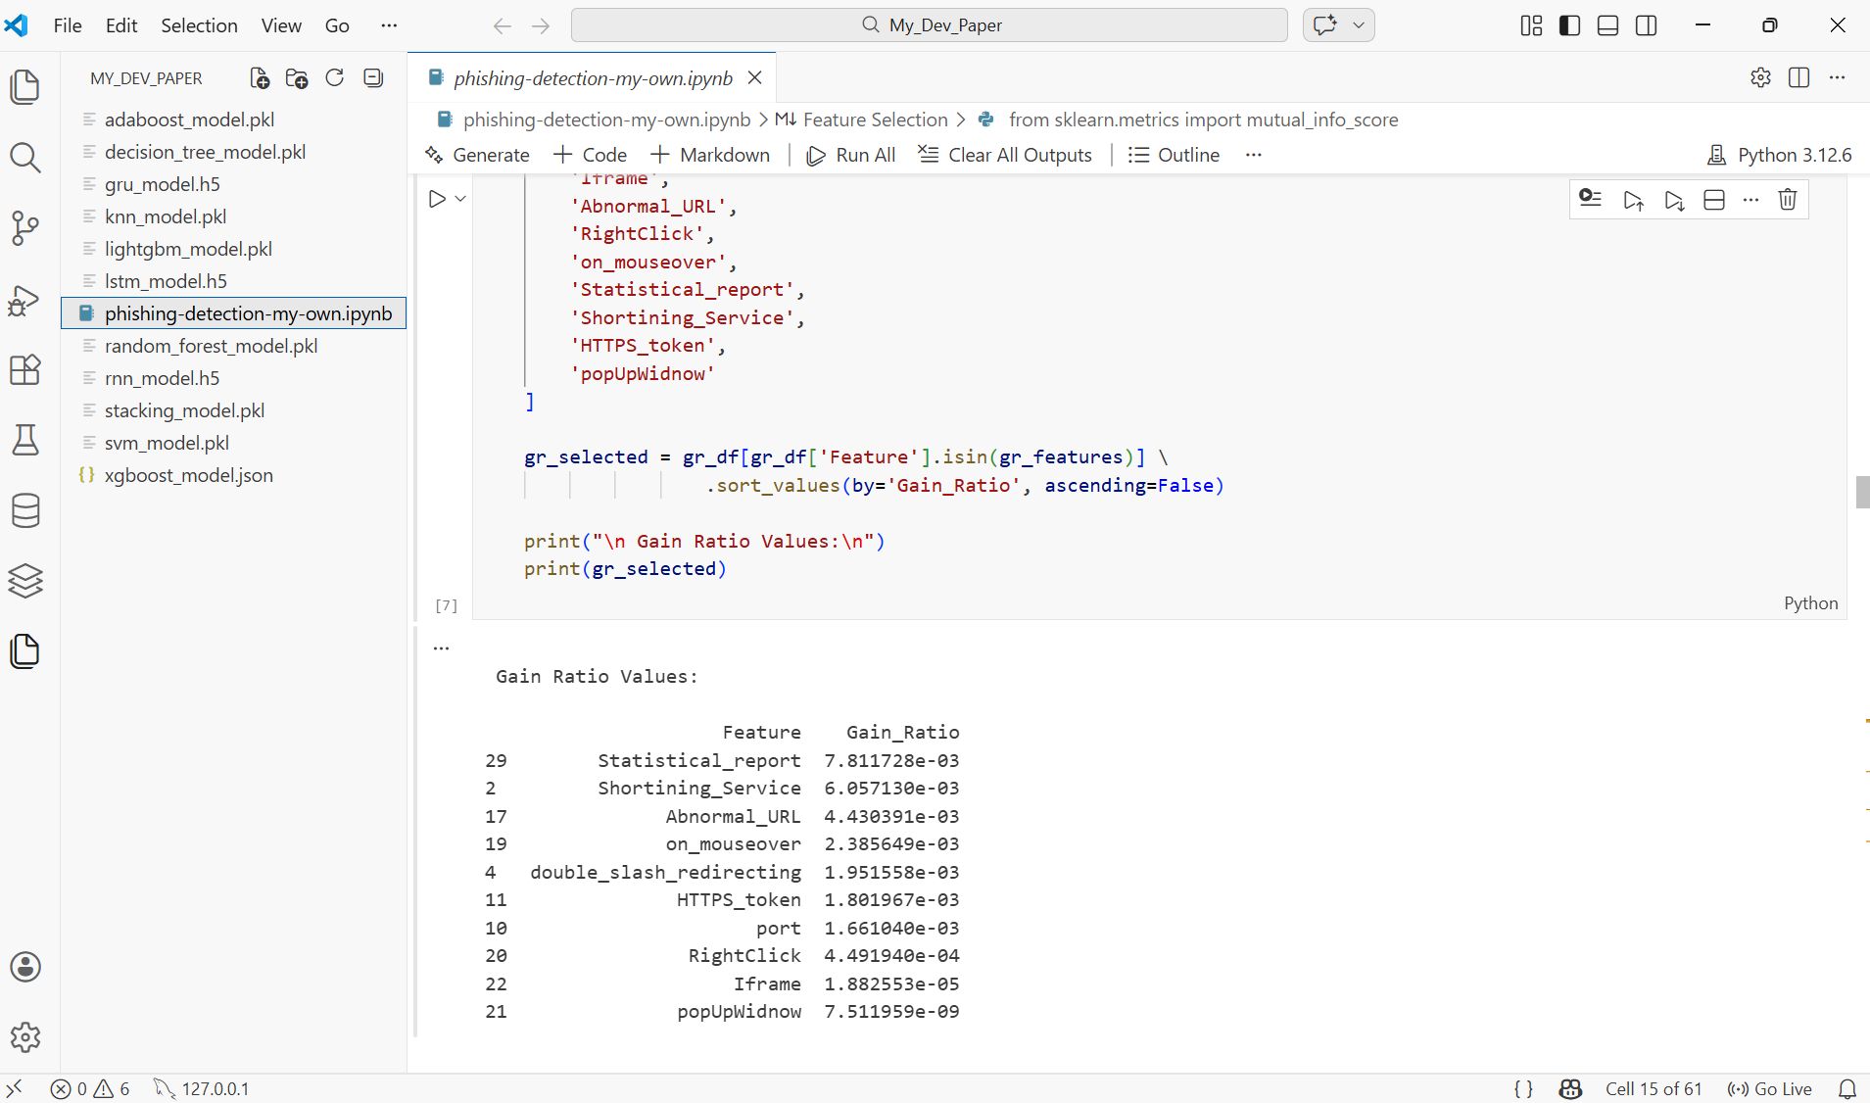
Figure 28: Ranked Feature Importance Scores Based on Gain Ratio (GR)
compute_gain_ratio(X, y) defines a custom function that iterates through every feature column in the dataset, computing the Information Gain between each feature and the target class label using mutual_info_score, and then dividing by the split information, which is the entropy of the feature itself. If the split information equals zero, the Gain Ratio is set to zero to avoid division errors.
gr_features defines the ten features selected based on their Gain Ratio scores, representing features that provide the most normalised discriminative power for phishing detection.
gr_selected filters and sorts the selected features in descending order of Gain Ratio, producing a clear ranking of the most informative features under this method.
The Gain Ratio results confirmed that Statistical_report achieved the highest score of 7.81 × 10⁻³, followed by Shortining_Service (6.06 × 10⁻³) and Abnormal_URL (4.43 × 10⁻³). Features such as popUpWidnow recorded the lowest Gain Ratio of 7.51 × 10⁻⁹, indicating minimal normalised discriminative contribution.
Principal Component Analysis (PCA)
Principal Component Analysis (PCA) is a dimensionality reduction technique that transforms the original feature space into a set of linearly uncorrelated components, known as principal components, ordered by the amount of variance they explain in the data [69]. Rather than selecting individual features based on their relationship with the target class, PCA identifies the directions of maximum variance within the dataset and ranks features according to their contribution to the first principal component. In this study, PCA component loadings were used to determine which original features contribute most significantly to the overall variance structure of the phishing dataset.
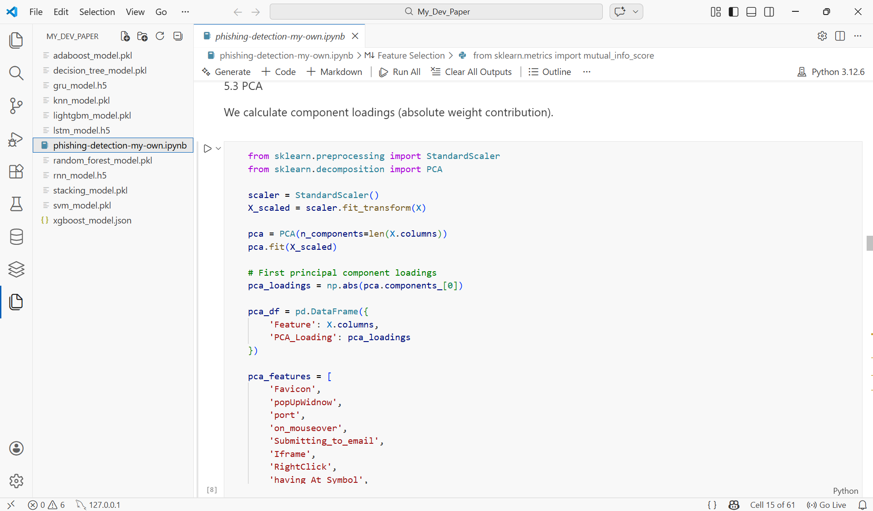
Figure 29
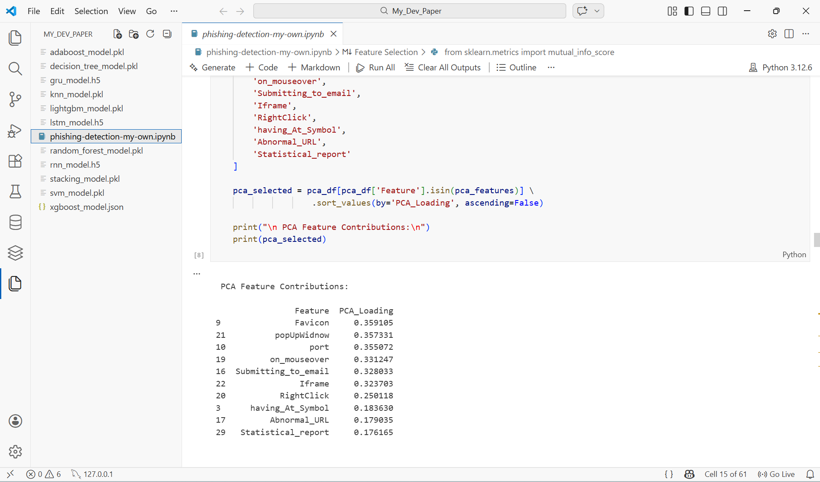
Figure 29: Ranked Feature Importance Scores Based on Principal Component Analysis (PCA)
StandardScaler () standardises all features to have zero mean and unit variance before applying PCA. This step is essential as PCA is sensitive to the scale of input features, and without standardisation, features with larger numerical ranges would disproportionately dominate the principal components.
PCA(n_components=len(X.columns)) initialises PCA to compute the full set of principal components equal to the number of original features in the dataset, ensuring that the complete variance structure of the data is captured and analysed.
pca.components [0] extracts the first principal component, which captures the greatest amount of variance in the dataset. The absolute values of the component loadings are taken to measure the magnitude of each feature's contribution regardless of direction.
pca_features defines the ten features selected based on their PCA loading scores, representing the features that contribute most significantly to the first principal component and therefore carry the most discriminative information about the overall structure of the phishing dataset.
pca_selected filters and sorts the selected features in descending order of their PCA loading values, providing a clear ranking of feature contributions.
The PCA results confirmed that Favicon achieved the highest loading score of 0.3591, identifying it as the feature with the greatest contribution to the primary variance component, followed by popUpWidnow (0.3573) and port (0.3551). Features such as Statistical_report recorded the lowest loading of 0.1762 among the selected features, indicating a comparatively smaller contribution to the principal component structure.

4.7.4 Train-Test Split
Train–test splitting is an essential preprocessing step in machine learning used to evaluate the generalisation ability of a model on unseen data. It involves dividing the dataset into two subsets: a training set, which is used to train the model, and a testing set, which is used to evaluate the model’s performance. In this study, the dataset was divided using an 80–20 split, where 80% of the data was allocated for training and 20% for testing.
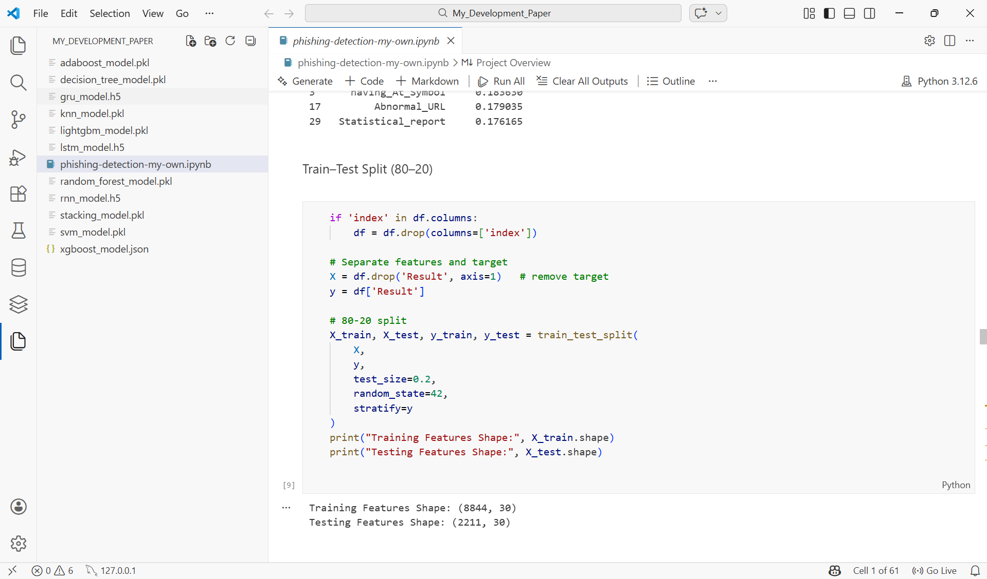
Figure 30: Train–test split implementation using Scikit-learn
Initially, the dataset was examined to determine whether an index column existed. If present, it was removed using df.drop (columns=['index']) because it does not contribute to the predictive capability of the model and may introduce unnecessary noise into the learning process.
Next, the dataset was separated into feature variables and the target variable. The feature matrix X was created by removing the Result column using df.drop ('Result', axis=1), while the target variable y was assigned as df['Result'], representing the classification label that indicates whether a website is phishing or legitimate.
The dataset was then divided using the train_test_split () function from the Scikit-learn library. The parameter test_size=0.2 specifies that 20% of the dataset is reserved for testing, while random_state=42 ensures reproducibility of the results. Additionally, stratify=y was used to maintain the same class distribution of phishing and legitimate samples in both the training and testing datasets.
The resulting datasets include X_train and y_train for training the machine learning models, and X_test and y_test for evaluating their predictive performance. After splitting the dataset, the training set contained 8,844 samples with 30 features, while the testing set contained 2,211 samples with 30 features. This separation ensures that the models are evaluated using data that was not seen during training, providing a reliable measure of model performance.

4.7.5 Model Training
This section presents the training process of all eleven models implemented in this study, organised across three categories: Shallow Machine Learning, Ensemble Learning, and Deep Learning. Each model was trained using the pre-processed Kaggle Phishing Website Dataset consisting of 11,055 samples and 32 features, with an 80/20 train-test split applied consistently across all models to ensure fair and reliable comparison.
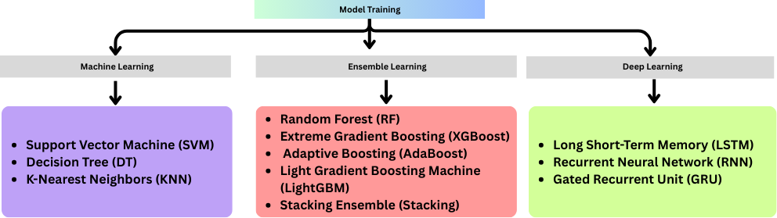
Figure 31: Classification models used in the proposed phishing detection system
Category 1: Machine Learning
Shallow machine learning algorithms represent traditional classification approaches that learn directly from structured feature sets without requiring deep hierarchical representations. Three shallow machine learning models were implemented in this study: Support Vector Machine, Decision Tree, and K-Nearest Neighbours. These models serve as baseline classifiers against which the performance of more advanced ensemble and deep learning models can be evaluated.
Support Vector Machine (SVM)
Support Vector Machine (SVM) is a supervised machine learning algorithm that identifies the optimal hyperplane to separate data points belonging to different classes by maximising the margin between them. In the context of phishing website detection, SVM constructs a decision boundary that distinguishes phishing websites from legitimate ones based on the extracted feature set [70].
In this study, SVM was configured with a Radial Basis Function (RBF) kernel, as illustrated in the code below:
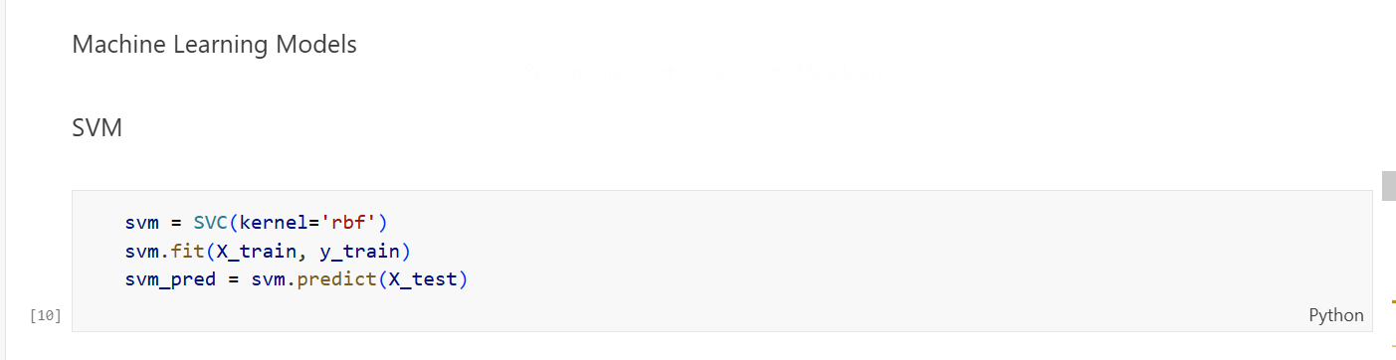
Figure 32: SVM model implementation in Python
SVC (kernel='rbf') initialises the SVM classifier using the RBF kernel, which is particularly effective for non-linear classification tasks where a straight-line boundary cannot adequately separate the classes. The RBF kernel transforms the input feature space into a higher-dimensional representation, enabling the algorithm to identify complex, non-linear relationships within the phishing dataset. svm.fit(X_train, y_train) trains the model by fitting it to the training data, during which the algorithm learns the optimal separating hyperplane between phishing and legitimate website samples.
svm.predict(X_test) applies the trained model to the unseen test dataset, generating predicted class labels for performance evaluation purposes.
Decision Tree (DT)
Decision Tree is a supervised machine learning algorithm that classifies data by recursively splitting the dataset into subsets based on the most significant feature at each node, forming a tree-like structure of decisions [71]. Each internal node of the tree represents a feature-based decision, each branch represents the outcome of that decision, and each leaf node represents a final class label. Decision Trees are widely used in phishing website detection due to their interpretability and ability to handle both numerical and categorical features effectively.
In this study, the Decision Tree classifier was implemented using its default configuration, as illustrated in the code below:
Figure 33: Implementation of the Decision Tree classifier for training and prediction
DecisionTreeClassifier() initialises the Decision Tree model using the default Gini impurity criterion, which measures the degree of probability of a particular feature being classified incorrectly when selected randomly. The algorithm recursively evaluates each feature in the dataset and selects the one that produces the greatest reduction in impurity at each split, thereby building the most informative tree structure possible for distinguishing phishing websites from legitimate ones.
dt.fit(X_train, y_train) trains the Decision Tree model on the training dataset, during which the algorithm constructs the full tree structure by learning the optimal splitting conditions from the 32 extracted features of the phishing website dataset.
dt.predict(X_test) applies the trained Decision Tree model to the unseen test dataset, traversing the learned tree structure for each sample to produce a predicted class label indicating whether a website is phishing or legitimate.
K-Nearest Neighbours (KNN)
K-Nearest Neighbours (KNN) is a simple yet effective supervised machine learning algorithm that classifies a data point based on the majority class of its closest neighbouring data points in the feature space. Unlike other algorithms, KNN does not build an explicit model during training but instead stores the entire training dataset and makes predictions at the time of classification by measuring the distance between the new data point and all stored samples. This instance-based learning approach makes KNN particularly useful for classification tasks where the decision boundary is irregular or complex.
In this study, KNN was implemented with five nearest neighbours, as illustrated in the code below:
Figure 34: Implementation of the K-Nearest Neighbours (KNN) classifier for model training and prediction
KNeighborsClassifier(n_neighbors=5) initialises the KNN classifier with a neighbourhood size of five, meaning that for every new website sample, the algorithm identifies the five most similar samples from the training data based on Euclidean distance. The class label that appears most frequently among these five neighbours is then assigned to the new sample. The value of five neighbours was selected as it represents a widely accepted default that provides a balanced trade-off between bias and variance in classification tasks.
knn.fit(X_train, y_train) stores the entire training dataset in memory, as KNN does not perform any explicit model construction during the training phase. Instead, this step prepares the algorithm to perform distance calculations at prediction time.
knn.predict(X_test) applies the trained KNN classifier to the test dataset by calculating the distance between each test sample and all training samples, identifying the five nearest neighbours, and assigning the majority class label to determine whether each website is phishing or legitimate.
Category 2: Ensemble Learning
Ensemble Learning methods combine multiple individual models to produce a stronger and more accurate classifier than any single model could achieve alone. Rather than relying on one decision-making process, ensemble methods aggregate the predictions of several base learners, thereby reducing variance, minimising overfitting, and improving overall generalisation performance. In this study, four ensemble learning models were implemented: Random Forest, XGBoost, AdaBoost, and LightGBM, along with a Stacking Ensemble that combines multiple models into a single meta-learner.
Random Forest (RF)
Random Forest is an ensemble learning algorithm that constructs many decision trees during training and combines their predictions through majority voting to produce the final classification output. Each tree in the forest is trained on a randomly selected subset of the training data and a randomly selected subset of features, which introduces diversity among the individual trees and significantly reduces the risk of overfitting.
In this study, Random Forest was implemented with 200 decision trees, as illustrated in the code below:
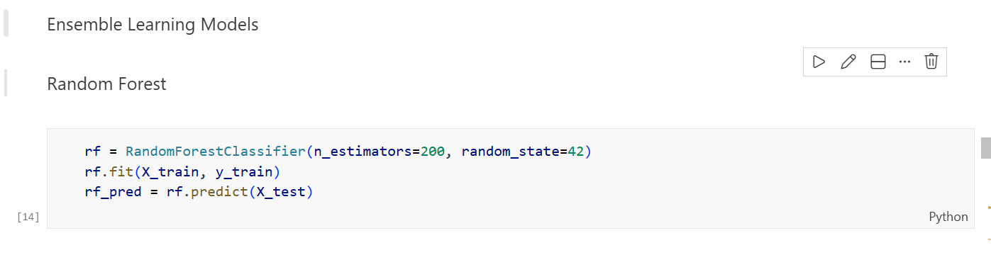
Figure 35: Implementation of the Random Forest classifier for training and prediction
RandomForestClassifier(n_estimators=200, random_state=42) initialises the Random Forest model with 200 individual decision trees. The n_estimators=200 parameter specifies that 200 trees will be built during training, producing more stable and accurate predictions by averaging out individual errors. The random_state=42 parameter ensures full reproducibility of results by fixing the random seed, guaranteeing that identical results are obtained each time the experiment is repeated.
rf.fit(X_train, y_train) trains all 200 decision trees simultaneously on randomly selected subsets of the training data, with each tree learning to distinguish phishing websites from legitimate ones based on a different random subset of the 32 available features.
rf.predict(X_test) applies the trained Random Forest model to the test dataset, where each of the 200 trees independently produces a prediction and the final class label is determined through majority voting across all trees.
AdaBoost
AdaBoost, short for Adaptive Boosting, is an ensemble learning algorithm that builds a strong classifier by sequentially training a series of weak learners, typically shallow decision trees, where each successive learner focuses more heavily on the samples that were misclassified by the previous one. After each iteration, the algorithm increases the weight of incorrectly classified samples and decreases the weight of correctly classified ones, forcing subsequent learners to concentrate on the most difficult cases. The final prediction is produced by combining the weighted votes of all weak learners, resulting in a powerful and accurate classification model.
In this study, AdaBoost was implemented with 200 estimators, as illustrated in the code below:
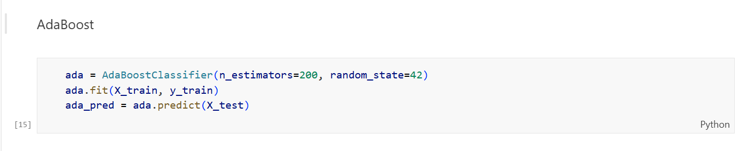
Figure 36: Implementation of the AdaBoost classifier for model training and prediction
AdaBoostClassifier(n_estimators=200, random_state=42) initialises the AdaBoost model with 200 sequential weak learners. The n_estimators=200 parameter specifies that 200 weak classifiers will be trained iteratively, with each one correcting the errors of its predecessor. The random_state=42 parameter ensures that the experiment is fully reproducible by fixing the random seed across all runs.
ada.fit(X_train, y_train) trains the AdaBoost model on the training dataset by iteratively adjusting sample weights across 200 rounds of boosting, enabling the algorithm to progressively improve its ability to correctly classify both phishing and legitimate website samples that were previously misclassified.
ada.predict(X_test) applies the fully trained AdaBoost ensemble to the test dataset, combining the weighted predictions of all 200 weak learners to produce the final classification output for each website sample.
XGBoost
XGBoost, which stands for Extreme Gradient Boosting, is an advanced and highly optimised ensemble learning algorithm based on the gradient boosting framework. It builds a sequence of decision trees in which each new tree is trained to correct the residual errors of the previous trees by minimising a regularised loss function. XGBoost incorporates built-in regularisation techniques to prevent overfitting, supports parallel processing for faster computation, and handles missing values automatically, making it one of the most powerful and widely adopted algorithms for structured data classification tasks.
In this study, XGBoost was implemented with a carefully configured set of hyperparameters, as illustrated in the code below:
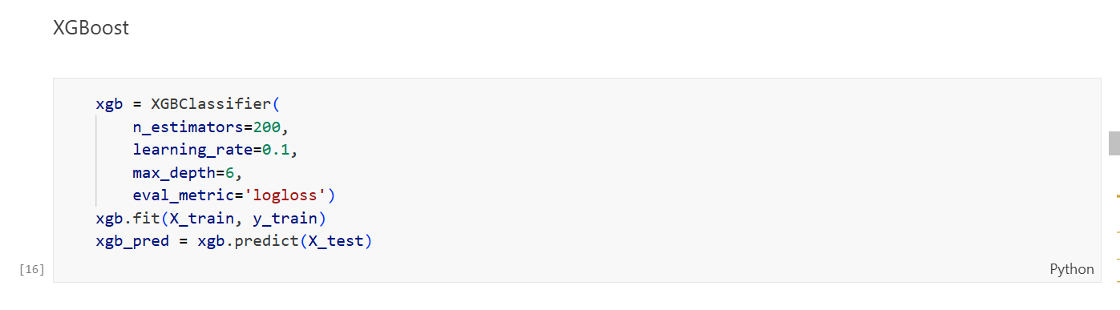
Figure 37: Implementation of the XGBoost classifier for training and prediction
n_estimators=200 specifies that 200 sequential boosting trees will be constructed during training, with each tree progressively refining the predictions of the previous ensemble by focusing on the remaining classification errors. learning_rate=0.1 controls the contribution of each individual tree to the overall model, shrinking the impact of each new tree to prevent overfitting and ensure that the model learns gradually and generalises well to unseen data. A learning rate of 0.1 represents a widely used value that balances training speed and model accuracy.
max_depth=6 defines the maximum depth of each individual decision tree within the ensemble. A depth of six allows each tree to capture moderately complex feature interactions within the phishing dataset while preventing the trees from becoming overly complex and overfitting the training data. eval_metric='logloss' specifies logarithmic loss as the evaluation metric used to monitor the model's performance during training. Log loss measures the uncertainty of the predicted probabilities and penalises confident but incorrect predictions, making it a suitable metric for binary classification tasks such as phishing website detection.
xgb.fit(X_train, y_train) trains the XGBoost model on the training dataset by iteratively constructing 200 boosting trees, with each tree learning to minimise the residual errors left by the previous trees using the specified hyperparameter configuration. xgb.predict(X_test) applies the fully trained XGBoost ensemble to the test dataset, aggregating the predictions of all 200 trees to produce the final classification output for each website sample.
LightGBM (New Algorithm)
LightGBM, which stands for Light Gradient Boosting Machine, is a highly efficient and scalable ensemble learning algorithm developed by Microsoft that is based on the gradient boosting framework. Unlike traditional gradient boosting methods that grow trees level-wise, LightGBM employs a leaf-wise tree growth strategy [72], which splits the leaf that produces the greatest reduction in loss at each step. This approach results in faster training speeds, lower memory consumption, and higher accuracy, particularly when working with large datasets. LightGBM was introduced in this study as an additional algorithm beyond the base paper to further extend and enrich the experimental comparison.
In this study, LightGBM was implemented with the following configuration, as illustrated in the code below:
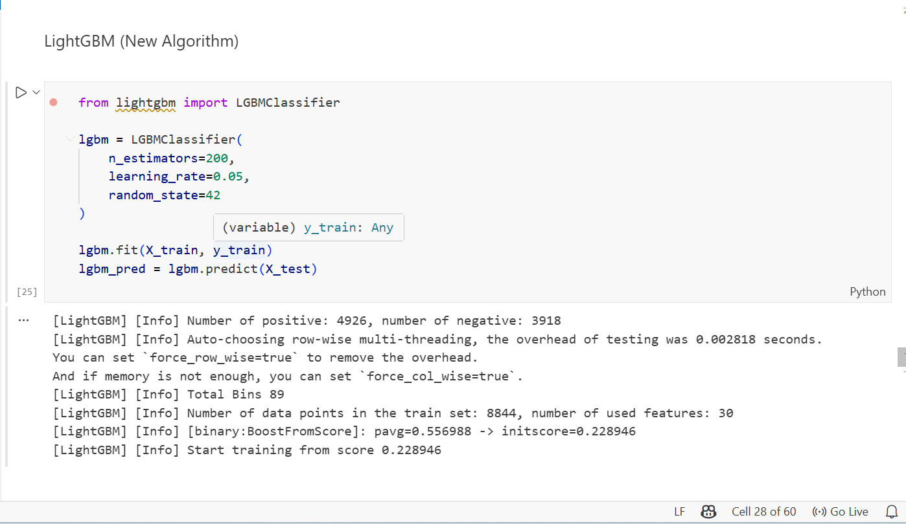
Figure 38: Implementation of the LightGBM classifier for training and prediction
from lightgbm import LGBMClassifier imports the LightGBM classifier from the dedicated LightGBM library, which provides an optimised implementation of the gradient boosting framework designed for high performance on structured datasets.
n_estimators=200 specifies that 200 boosting iterations will be performed during training, with each iteration constructing a new decision tree that further refines the predictions of the existing ensemble by targeting the residual errors of the previous trees.
learning_rate=0.05 controls the contribution of each individual tree to the overall model. A learning rate of 0.05 is deliberately set lower than that used in XGBoost, allowing the model to learn more gradually and carefully, which typically improves generalisation performance on unseen data at the cost of requiring more trees to converge.
random_state=42 fixes the random seed to ensure full reproducibility of the experimental results across all runs.
lgbm.fit(X_train, y_train) trains the LightGBM model on the training dataset. As confirmed by the training log output, the model processed 8,844 training samples across 30 features, with 4,926 positive phishing samples and 3,918 negative legitimate samples, demonstrating a reasonably balanced class distribution within the training set.
lgbm.predict(X_test) applies the fully trained LightGBM model to the test dataset, generating predicted class labels for each website sample based on the combined output of all 200 boosting trees.
Stacking Ensemble (RF + AdaBoost + LightGBM)
Stacking, also known as Stacked Generalisation, is an advanced ensemble learning technique that combines multiple diverse base learners by training a meta-learner to make the final prediction based on the outputs of the base models [73]. Unlike bagging and boosting methods that combine models of the same type, stacking leverages the complementary strengths of fundamentally different algorithms, allowing the meta-learner to learn which base models perform best under which conditions. This approach typically produces superior classification performance compared to any individual model by exploiting the diversity of the combined learners.In this study, a Stacking Ensemble was constructed by combining three strong base learners, namely Random Forest, AdaBoost, and LightGBM, with Logistic Regression serving as the meta-learner, as illustrated in the code below:
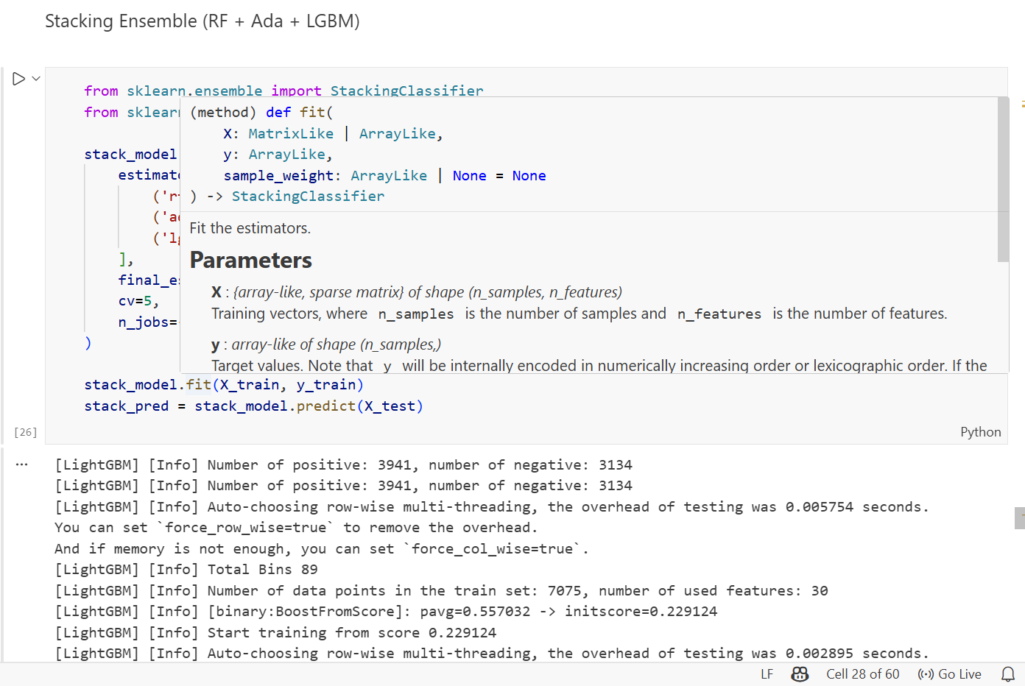
Figure 39
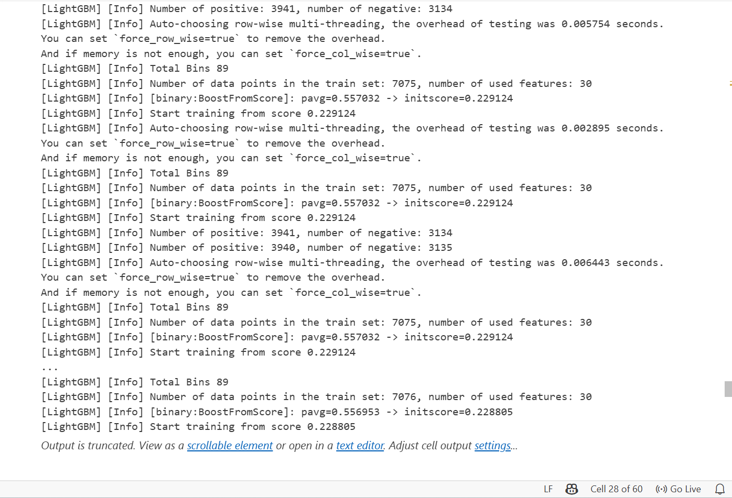
Figure 39: Implementation of the Stacking Ensemble model
StackingClassifier initialises the stacking framework by defining a two-layer architecture consisting of base learners at the first layer and a meta-learner at the second layer that learns to optimally combine the predictions of the base models.
estimators= [('rf', rf), ('ada', ada), ('lgbm', lgbm)] specifies the three base learners that form the first layer of the stacking ensemble. Random Forest contributes stable and accurate predictions through majority voting across 200 decision trees. AdaBoost contributes by focusing on difficult-to-classify samples through iterative boosting. LightGBM contributes highly efficient gradient boosting predictions using its leaf-wise tree growth strategy. The combination of these three diverse algorithms ensures that the stacking ensemble captures a broad range of patterns within the phishing dataset.
final_estimator=LogisticRegression() specifies Logistic Regression as the meta-learner responsible for learning the optimal way to combine the predictions of the three base models. Logistic Regression was selected as the meta-learner due to its simplicity, interpretability, and effectiveness in combining probabilistic outputs from multiple classifiers.
cv=5 specifies that five-fold cross-validation is applied during the training of the stacking ensemble. This means the training data is divided into five equal folds, and each base learner is trained on four folds while generating predictions on the remaining fold, ensuring that the meta-learner is trained on out-of-fold predictions to prevent data leakage and overfitting.
n_jobs=-1 instructs the algorithm to utilise all available processor cores during training, significantly reducing computation time when training multiple base learners simultaneously.
stack_model.fit (X_train, y_train) trains the complete stacking ensemble on the training dataset. As confirmed by the training log output, LightGBM within the stacking framework processed approximately 7,075 to 7,076 training samples across 30 features during each cross-validation fold, demonstrating consistent and stable training behaviour throughout the five-fold process.
stack_model.predict(X_test) applies the fully trained stacking ensemble to the test dataset, where the three base learners first generate their individual predictions, which are then passed to the Logistic Regression meta-learner to produce the final classification output for each website sample.
Category 3: Deep Learning
Deep Learning models are a subset of machine learning that learn complex patterns through multiple layers of interconnected neurons. Unlike shallow machine learning algorithms that rely on manually engineered features, deep learning models automatically extract hierarchical representations from raw input data. In this study, three deep learning models were implemented: LSTM, RNN, and GRU.
Long Short-Term Memory (LSTM)
Long Short-Term Memory (LSTM) is a specialised recurrent neural network architecture designed to learn long-term dependencies in sequential data by using memory cells and gating mechanisms to control what information is retained or discarded across time steps. In this study, the LSTM model was constructed and trained across four sequential steps as shown below.
Step 1: Build the Model
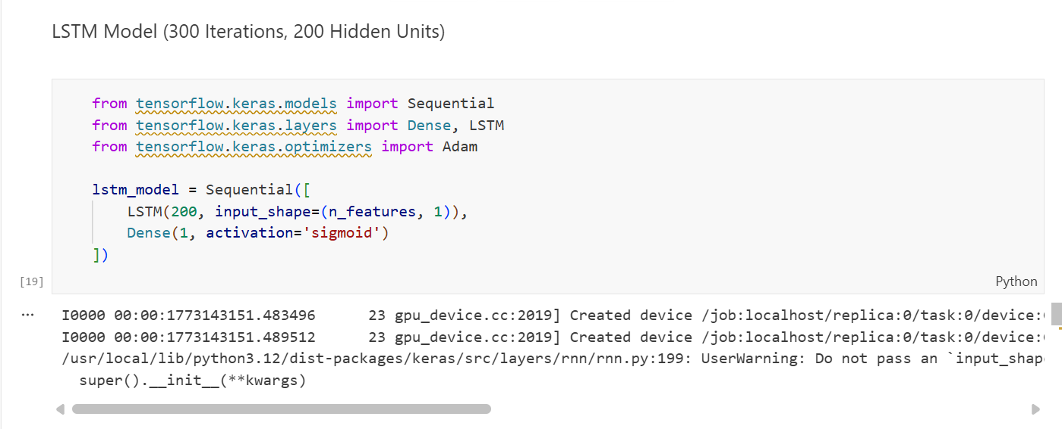
A Sequential model was constructed with 200 LSTM hidden units processing the input feature shape, followed by a Dense output layer using a sigmoid activation function to produce a binary classification probability between 0 and 1.
Step 2: Compile the Model
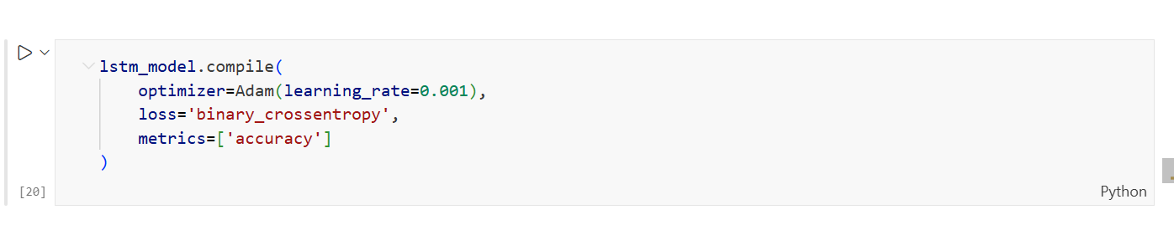
The model was compiled using the Adam optimiser with a learning rate of 0.001, binary cross-entropy as the loss function, and accuracy as the evaluation metric. These settings are standard and well-suited for binary classification tasks such as phishing detection.
Step 3: Train the Model
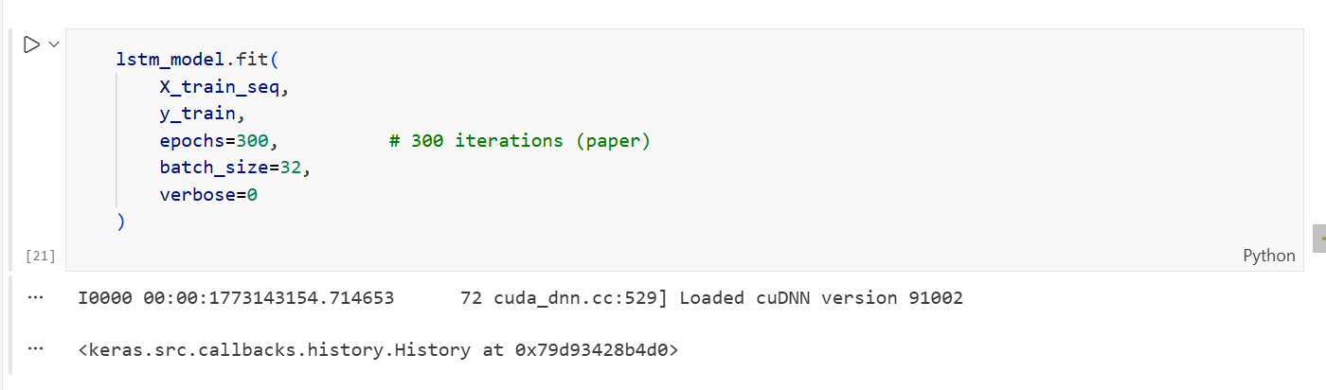
The model was trained for 300 epochs with a batch size of 32, consistent with the experimental configuration reported in the base paper. The training utilised GPU acceleration via cuDNN, significantly reducing computation time.
Step 4: Generate Predictions
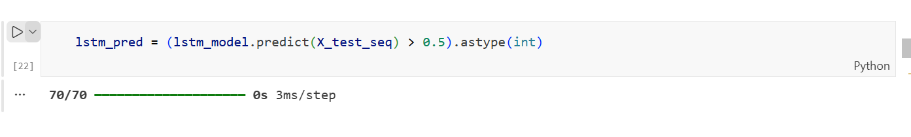
The trained model generated probability scores for each test sample, which were converted into binary class labels using a threshold of 0.5, where values above 0.5 were classified as phishing and values below as legitimate. The prediction was completed across 70 batches at 3ms per step.
Recurrent Neural Network (RNN)
Recurrent Neural Network (RNN) is a deep learning architecture designed to process sequential data by maintaining a hidden state that carries information from previous time steps to the current one. This feedback mechanism allows RNNs to capture temporal dependencies within data sequences. However, standard RNNs are known to suffer from the vanishing gradient problem, where gradients become extremely small during backpropagation through many time steps, limiting the model's ability to learn long-range dependencies. This limitation explains why RNN produced lower accuracy compared to LSTM and GRU in this study, as the phishing dataset features complex non-linear relationships that require longer memory to capture effectively.The complete RNN model was implemented in a single code block as shown below:
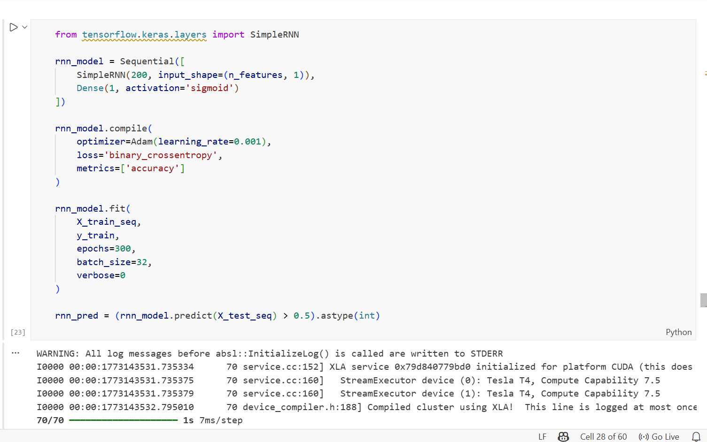
Figure 40: Implementation of the Recurrent Neural Network (RNN) model
SimpleRNN(200, input_shape= (n_features, 1)) constructs a recurrent layer with 200 hidden units that processes the phishing feature sequence one step at a time, maintaining a hidden state across each step to capture sequential patterns within the dataset. Dense (1, activation='sigmoid') adds the output layer that converts the final hidden state into a binary probability score, where values above 0.5 indicate a phishing website and values below indicate a legitimate one.
compile(optimizer=Adam(learning_rate=0.001), loss='binary_crossentropy') configures the model with the Adam optimiser and binary cross-entropy loss, consistent with the configuration applied across all deep learning models in this study to ensure a fair and comparable evaluation. fit (epochs=300, batch_size=32) trains the RNN model for 300 epochs with a batch size of 32. The training log confirms that the model ran on two Tesla T4 GPU devices with CUDA Compute Capability 7.5, with prediction completed across 70 batches at 7ms per step.
rnn_pred = (rnn_model.predict(X_test_seq) > 0.5). astype(int) generates binary predictions for all test samples by applying a 0.5 probability threshold to the sigmoid output of the trained RNN model.
Gated Recurrent Unit (GRU)
Gated Recurrent Unit (GRU) is a deep learning architecture that represents an improved and more computationally efficient variant of the standard RNN. GRU addresses the vanishing gradient problem by introducing two gating mechanisms, namely the update gate and the reset gate, which control how much past information is carried forward and how much new information is incorporated at each time step. Compared to LSTM, GRU achieves similar performance with a simpler architecture and fewer trainable parameters, making it faster to train while maintaining strong classification accuracy.
The complete GRU model was implemented as shown below:
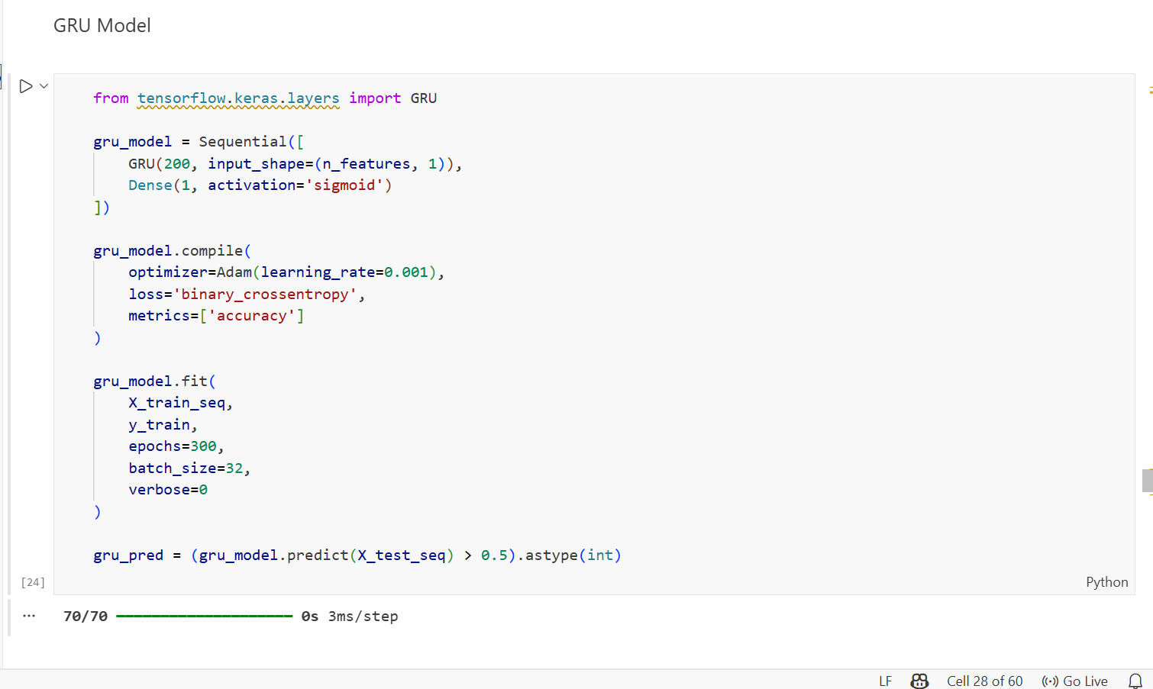
Figure 41: Implementation of the GRU model
GRU (200, input_shape= (n_features, 1)) constructs a GRU recurrent layer with 200 hidden units. Unlike the SimpleRNN layer, the GRU layer incorporates update and reset gates that selectively control the flow of information through the network, enabling it to capture both short-term and long-term dependencies within the phishing feature sequences more effectively than a standard RNN.
Dense (1, activation='sigmoid') adds the binary output layer that converts the final GRU hidden state into a probability score between 0 and 1, representing the likelihood of a website being classified as phishing. compile(optimizer=Adam(learning_rate=0.001), loss='binary_crossentropy') configures the GRU model with identical training settings to those used for LSTM and RNN, ensuring consistency and comparability across all three deep learning models evaluated in this study.
fit (epochs=300, batch_size=32) trains the GRU model for 300 epochs with a batch size of 32, consistent with the experimental setup specified in the base paper. The training was completed efficiently, with prediction running across 70 batches at just 3ms per step, notably faster than the RNN model which required 7ms per step, confirming the computational efficiency advantage of GRU.
gru_pred = (gru_model.predict(X_test_seq) > 0.5). astype(int) generates the final binary predictions for all test samples by applying a 0.5 probability threshold to the sigmoid output, classifying each website as either phishing or legitimate.

4.7.6 Saving the Trained Models
Once all eleven models were successfully trained, each model was saved to disk to enable future reuse, deployment, and reproducibility without the need to retrain from scratch. Two different saving strategies were applied depending on the type of model, as illustrated in the code below:
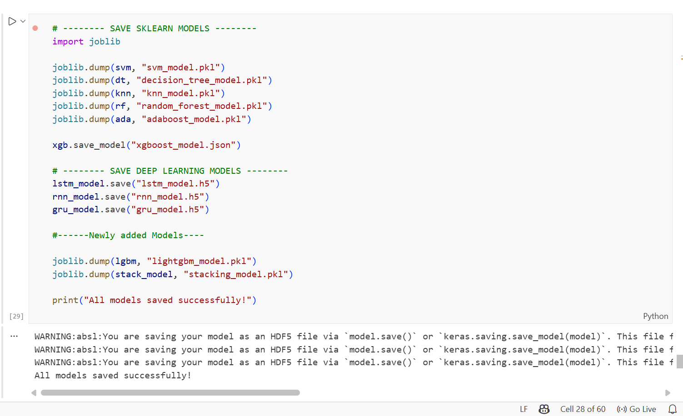
Figure 42: Saving trained machine learning and deep learning models
Scikit-learn models SVM, Decision Tree, KNN, Random Forest, AdaBoost, LightGBM, and Stacking Ensemble were saved using the joblib.dump() function, which serialises each trained model object into a. pkl binary file. The joblib library is the recommended approach for saving scikit-learn models as it efficiently handles large numerical arrays contained within these models.
XGBoost was saved separately using its native save_model () method, which stores the model in a. json format. This format is portable, human-readable, and allows the model to be reloaded across different programming environments and platforms.
Deep learning models LSTM, RNN, and GRU were saved using Keras's built-in save () method, which stores the complete model architecture, weights, and training configuration in the HDF5 .h5 format. As confirmed by the output log, all three deep learning models were successfully saved in HDF5 format.
Upon successful completion, the system confirmed with the message "All models saved successfully!", verifying that all eleven trained models were persistently stored and ready for evaluation and future deployment.

4.7.7 Model Evaluation
Following the training of all eleven models, a standardised evaluation function was implemented to assess the performance of each model consistently using four key classification metrics: Accuracy, Precision, Recall, and F1 Score.
Step 1: Evaluation Function
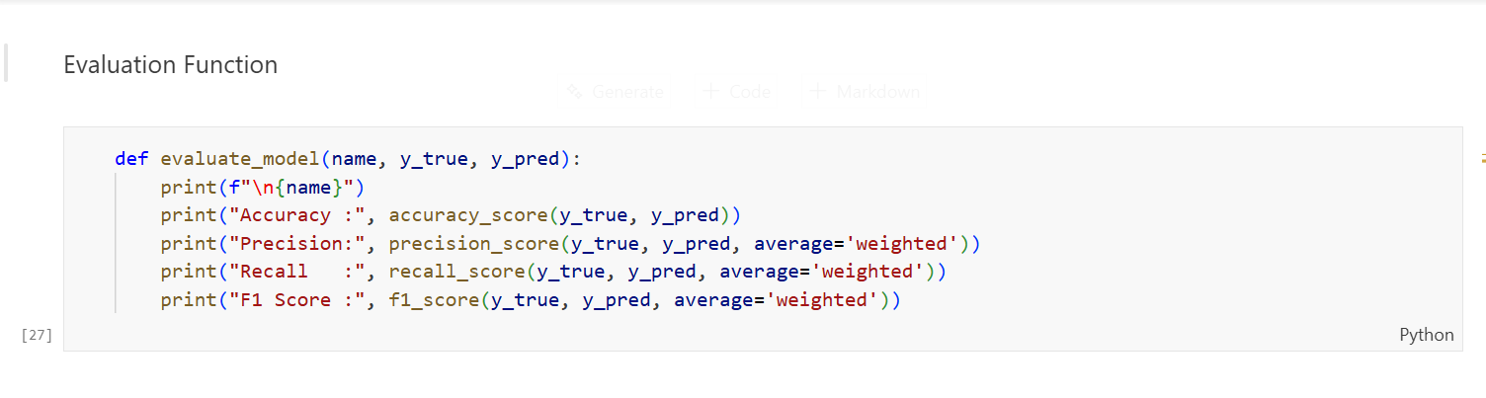
A reusable evaluation function named evaluate_model was defined to accept the model’s name, true labels, and predicted labels as inputs. The function computes and prints all four-performance metrics for each model. The average='weighted' parameter ensures that the metric calculation accounts for class imbalance by weighting each class proportionally to its frequency in the dataset.
Step 2: Applying Evaluation to All 11 Models
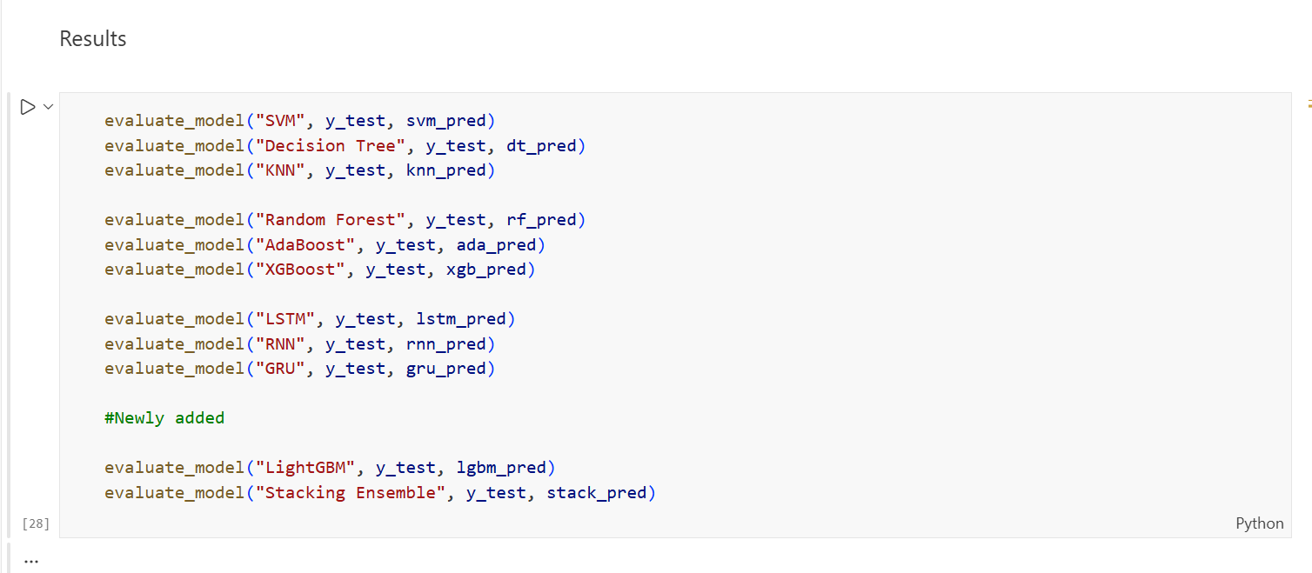
The evaluation function was applied uniformly across all eleven models, comparing each model's predictions against the true test labels y_test.
Step 3: Evaluation Results
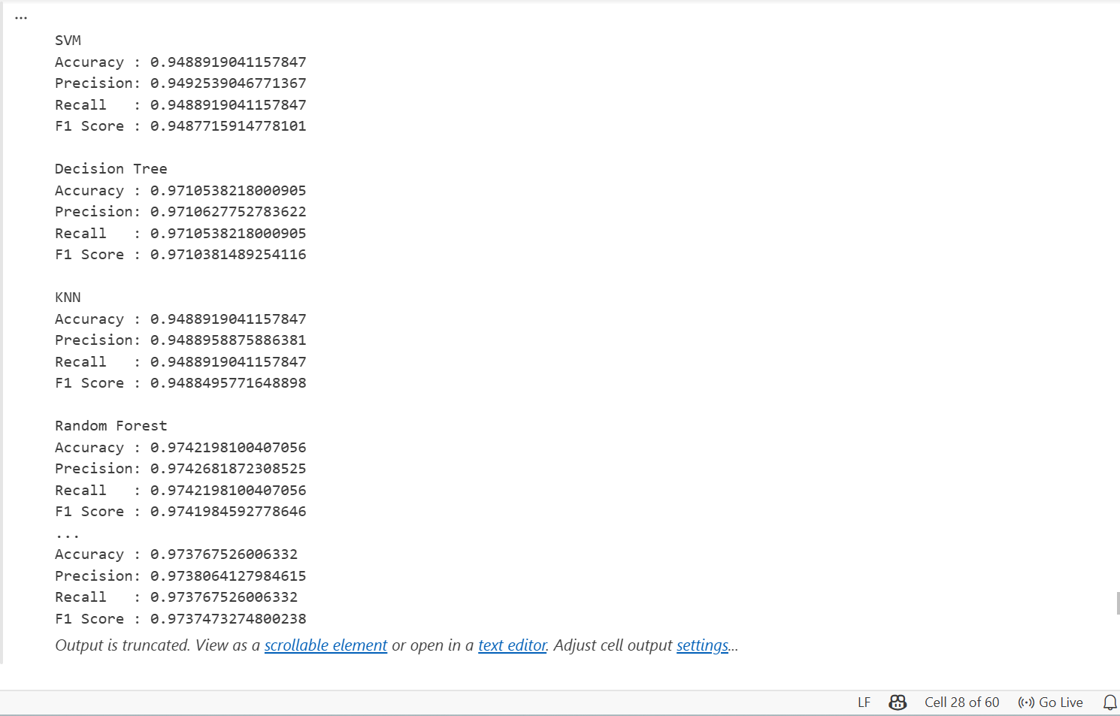
The evaluation produced the following performance results:
Table 9: Evaluation Results
Model | Accuracy | Precision | Recall | F1 Score
SVM | 94.89% | 94.93% | 94.89% | 94.88%
Decision Tree | 97.11% | 97.11% | 97.11% | 97.10%
KNN | 94.89% | 94.89% | 94.89% | 94.88%
Random Forest | 97.42% | 97.43% | 97.42% | 97.42%
AdaBoost | 93.40 | 93.41 | 93.40 | 93.39
XGBoost | 97.24 | 97.25 | 97.24 | 97.24
LightGBM | 96.88 | 96.88 | 96.88 | 96.88
Stacking Ensemble | 97.38 | 97.38 | 97.38 | 97.37
LSTM | 97.11 | 97.12 | 97.11 | 97.10
RNN | 87.74 | 87.76 | 87.74 | 87.75
GRU | 97.15 | 97.17 | 97.15 | 97.15

These results confirm that Random Forest achieved the highest overall accuracy of 97.42% among all models evaluated, making it the best performing model in this study. The detailed analysis and full comparison of all eleven models is presented in Chapter 5.

4.7.8 Originality of Work and Student Contribution
The primary original contribution of Experiment 2 was the independent identification, justification, and implementation of LightGBM and Stacking Ensemble as extensions beyond the scope of the base study. The student independently evaluated the technical properties of both models, designed the Stacking Ensemble architecture by selecting complementary base learners, and re-ran the complete training and evaluation pipeline for all eleven models.
The student also identified and resolved issues encountered during the Stacking Ensemble cross-validation process, which required extended computation time. All outputs were independently verified before the results were recorded.

4.8 Ethical Considerations
This research was conducted in full compliance with ethical research principles. The following considerations were observed throughout the study:
- A publicly available dataset (Kaggle Phishing Website Dataset) was used. No private, personal, or sensitive user data was collected or processed at any stage of this research.
- No personal user data was involved. All 11,055 website samples in the dataset consist of anonymised numerical feature representations only, with no identifiable user information.
- No interaction with live phishing websites was conducted. The research was entirely experimental, operating exclusively on a static offline dataset.
- The research was conducted entirely for defensive cybersecurity purposes specifically to improve the accuracy and reliability of phishing website detection systems to protect users and organisations from online threats.
These ethical practices ensure that this study does not cause harm and aligns fully with responsible and transparent research conduct.

4.9 Conclusion
This chapter presented the complete design and implementation of the phishing website detection system. The system architecture, dataset preparation, feature selection procedures, experimental setup, and all eleven model configurations were described in full detail. All models spanning Shallow Machine Learning, Ensemble Learning, and Deep Learning categories were implemented under consistent and controlled experimental conditions to ensure fairness, reproducibility, and scientific rigour.
The implementation framework establishes a solid and reproducible foundation for the experimental evaluation that follows. The dataset was successfully pre-processed, split, and made ready for training, with all models saved for further analysis. The next chapter presents the detailed experimental results, performance evaluation, and comparative analysis of all eleven implemented models.

Chapter 5 – Results and Analysis

5.1 Introduction
This chapter presents the experimental results and analysis from two structured experiments conducted in this study. Experiment 1 involved replicating the experimental framework of the base study using nine classification models across three algorithm categories: Shallow Machine Learning, Ensemble Learning, and Deep Learning. Experiment 2 extended the base replication by introducing two additional models, LightGBM and Stacking Ensemble, which were not present in the original study. These two models were selected based on specific technical justifications discussed in Section 5.3.
All eleven models were evaluated using four performance metrics:
Accuracy, Precision, Recall, and F1 Score. The results are compared against the outcomes reported in the base study to determine the degree of replication accuracy and to assess whether the newly added models improve upon the existing results. The chapter also discusses how the experiments address the four research gaps identified in Chapter 1 and identifies remaining areas for future work.

5.2 Experiment 1 – Base Paper Replication

5.2.1 Purpose of Experiment 1
The primary purpose of Experiment 1 was to independently replicate the experimental framework of the base study using the same Kaggle Phishing Website Dataset, which consists of 11,055 website instances with 32 numerical security-related features and a binary class label. The objective was to implement the same nine classification algorithms used in the original study, apply the same three feature selection techniques, and evaluate performance using the same metrics to determine whether the findings of the original study could be reproduced independently.
The dataset was pre-processed by removing the index column and remapping the class label values from -1 to 0 to ensure binary compatibility with all classifiers. The remaining 30 feature columns were subjected to three feature selection techniques, namely Information Gain (IG), Gain Ratio (GR), and Principal Component Analysis (PCA), each selecting the top ten most significant features. The dataset was split into 80% training and 20% testing sets. All nine models were trained, evaluated, and saved following this pipeline.

5.2.2 Scope of Generative AI Used in Implementation
Since the source code for the base study was not publicly available, the implementation was developed independently by studying reference notebooks available on the Kaggle platform for the same dataset. Generative AI, specifically ChatGPT, was consulted to address three technical challenges that arose during the implementation process.
The first challenge involved dataset label compatibility. The original dataset contained class values of -1, 0, and 1, where -1 indicated a phishing website. Standard machine learning classifiers require binary labels of 0 and 1 only. ChatGPT was used to determine that remapping -1 to 0 was the appropriate approach, which resolved classification errors across all models.
The second challenge involved the extended training time required for the deep learning models. Each model required 300 training epochs with 200 hidden units, as specified in the base study, resulting in significantly long execution times. ChatGPT provided guidance on structuring the training pipeline efficiently to minimise potential execution issues during this process.
The third challenge involved model-saving errors encountered when exporting trained deep learning models in HDF5 format. ChatGPT was used to identify the correct export configuration for each model type.

5.2.3 Summarised Outcomes of Experiment 1
The evaluation of all nine models produced the results shown in Table 5.1. Random Forest achieved the highest accuracy of 97.42%, which is consistent with the finding of the base study that identified Random Forest as the best-performing model. XGBoost achieved the second-highest accuracy at 97.24%, followed by LSTM at 97.06% and Decision Tree at 97.01%. GRU achieved 96.92% accuracy.
Among the shallow machine learning models, SVM and KNN both achieved 94.89%, while AdaBoost recorded 93.40% accuracy. RNN recorded the lowest accuracy at 91.99%, which is consistent with its known limitation in handling structured tabular data due to the vanishing gradient problem.
Table 10: Experiment 1 Results Base Paper Replication (9 Models)
Model | Accuracy | Precision | Recall | F1 Score
SVM | 94.89 | 94.93 | 94.89 | 94.88
Decision Tree | 97.01 | 97.02 | 97.01 | 97.01
KNN | 94.89 | 94.89 | 94.89 | 94.88
Random Forest | 97.42 | 97.43 | 97.42 | 97.42
AdaBoost | 93.40 | 93.41 | 93.40 | 93.39
XGBoost | 97.24 | 97.25 | 97.24 | 97.24
LSTM | 97.06 | 97.06 | 97.06 | 97.06
RNN | 91.99 | 92.01 | 91.99 | 91.98
GRU | 96.92 | 96.94 | 96.92 | 96.92

5.3 Experiment 2 – Extended Model Comparison

5.3.1 Purpose of Experiment 2 and Justification for New Models
The purpose of Experiment 2 was to extend the base paper replication by introducing two additional models do not present in the original study: LightGBM and Stacking Ensemble. These models were not selected randomly; each was chosen based on a clear technical justification related to limitations observed in the base models and the research gaps identified in this study.
5.3.1.1 Why LightGBM Was Added
The base study included XGBoost and AdaBoost as representatives of gradient boosting and sequential boosting within the Ensemble Learning category. However, LightGBM, which is a more recent and computationally efficient gradient boosting framework, was not evaluated. LightGBM uses a histogram-based leaf-wise tree growth strategy, allowing it to train significantly faster than XGBoost [74]while maintaining comparable or superior accuracy on structured tabular datasets. Adding LightGBM therefore enables a more complete comparison of gradient boosting approaches and strengthens the ensemble learning analysis beyond what was presented in the base study.
5.3.1.2 Why Stacking Ensemble Was Added
While the base study evaluated three individual ensemble models – Random Forest, XGBoost, and AdaBoost – it did not explore a meta-learning ensemble approach that combines these models. The Stacking Ensemble was introduced to investigate whether combining the complementary strengths of multiple base learners through a meta-learner could produce superior classification performance compared to any individual model.
The stacking configuration used Random Forest, AdaBoost, and LightGBM as the three base estimators, with Logistic Regression as the final meta-learner trained using five-fold cross-validation. These base learners were selected because they represent different ensemble strategies: bagging through Random Forest, sequential boosting through AdaBoost, and gradient-based boosting through LightGBM.
5.3.1.3 What Was Expected vs What Was Achieved
It was expected that LightGBM would perform comparably to XGBoost due to their similar gradient boosting foundations. It was also expected that the Stacking Ensemble would either match or exceed the best-performing individual model, as meta-learning is designed to leverage the strengths of diverse base learners.
The results confirmed both expectations. LightGBM achieved 96.88% accuracy, which is competitive with the existing ensemble models. The Stacking Ensemble achieved 97.38% accuracy, closely matching Random Forest at 97.42%. The difference between Experiment 1 and Experiment 2 for the shared nine models was minimal, ranging from approximately 0.00% to 0.23%, confirming that the experimental pipeline remained consistent and that the new models were evaluated under the same conditions.
5.3.1.4 Scope of Generative AI Used in Implementation
Generative AI was consulted in Experiment 2 to support the configuration of the two newly introduced models. For LightGBM, ChatGPT was used to identify appropriate hyperparameter settings, including a learning rate of 0.05, which is lower than the value used for XGBoost to improve generalisation on the phishing website dataset.
For the Stacking Ensemble, ChatGPT was consulted to understand the correct configuration of the Stacking Classifier with five-fold cross-validation and to address the extended training duration caused by the cross-validation process running across all three base learners. All implementation decisions were independently verified by the student before the results were accepted.

5.3.2 Summarised Outcomes of Experiment 2
The evaluation of all eleven models produced the results shown in Table 11 Random Forest remained the best-performing model with 97.42% accuracy, consistent with both the base study and Experiment1. The Stacking Ensemble achieved the second-highest accuracy of 97.38%, confirming that combining multiple ensemble learners through meta-learning can closely match the performance of the best individual model.
LightGBM achieved 96.88% accuracy, which is competitive with the existing ensemble models. Among the deep learning models, LSTM achieved 97.11% and GRU achieved 97.15%, both slightly higher than their results in Experiment 1. RNN continued to record the lowest accuracy at 87.74%, further confirming its limitation when applied to structured tabular data.
Table 11: Experiment 2 Results - Extended Model Comparison (11 Models)
Model | Category | Accuracy | Precision | Recall | F1 Score
SVM | Shallow ML | 94.89% | 94.93% | 94.89% | 94.88%
Decision Tree | Shallow ML | 97.11% | 97.11% | 97.11% | 97.10%
KNN | Shallow ML | 94.89% | 94.89% | 94.89% | 94.88%
Random Forest | Ensemble | 97.42% | 97.43% | 97.42% | 97.42%
AdaBoost | Ensemble | 93.40 | 93.41 | 93.40 | 93.39
XGBoost | Ensemble | 97.24 | 97.25 | 97.24 | 97.24
LightGBM | Ensemble (New) | 96.88 | 96.88 | 96.88 | 96.88
Stacking Ensemble | Ensemble (New) | 97.38 | 97.38 | 97.38 | 97.37
LSTM | Deep Learning | 97.11 | 97.12 | 97.11 | 97.10
RNN | Deep Learning | 87.74 | 87.76 | 87.74 | 87.75
GRU | Deep Learning | 97.15 | 97.17 | 97.15 | 97.15

5.4 Comparative Analysis and Discussion

5.4.1 Base Paper Outcomes
The base study evaluated nine classification models on the same Kaggle Phishing Website Dataset using Information Gain, Gain Ratio, and Principal Component Analysis for feature selection [47]. The results reported in the study are presented in Table 12.
Random Forest achieved the highest accuracy of 98.9%, followed by XGBoost at 98.4%, LSTM at 97.4%, and GRU at 97.3%. Decision Tree achieved 96.7%, RNN achieved 95.7%, KNN achieved 95.3%, SVM achieved 94.4%, and AdaBoost achieved 93.7%.
Table 12: Base Paper Results
Model | Category | Accuracy (%) | Precision (%) | Recall (%) | F1 Score (%)
SVM | Shallow ML | 94.4 | 96.0 | 93.7 | 94.8
Decision Tree | Shallow ML | 96.7 | 96.7 | 97.4 | 97.7
KNN | Shallow ML | 95.3 | 94.0 | 93.4 | 93.7
Random Forest | Ensemble | 98.9 | 98.8 | 99.3 | 99.0
AdaBoost | Ensemble | 93.7 | 93.2 | 95.5 | 94.4
XGBoost | Ensemble | 98.4 | 98.4 | 98.8 | 98.6
LSTM | Deep Learning | 97.4 | 96.4 | 99.0 | 97.7
RNN | Deep Learning | 95.7 | 96.9 | 95.2 | 96.1
GRU | Deep Learning | 97.3 | 97.6 | 97.5 | 97.6

5.4.2 Three-Way Comparison: Base Paper vs Experiment 1 vs Experiment 2
Table 13 presents a three-way comparison of accuracy values across the base study and both experiments conducted in this research. This comparison allows for a direct assessment of the replication accuracy achieved in Experiment 1, the additional contributions introduced in Experiment 2, and the research gaps addressed by each model.
Table 13: Comparative Results - Base Paper vs Experiment 1 vs Experiment 2
Model | Base Paper (%) | Experiment 1 (%) | Experiment 2 (%) | Gap Addressed
SVM | 94.4 | 94.89 | 94.89 | Gap 1, Gap 4
Decision Tree | 96.7 | 97.01 | 97.11 | Gap 1, Gap 4
KNN | 95.3 | 94.89 | 94.89 | Gap 1, Gap 4
Random Forest | 98.9 | 97.42 | 97.42 | Gap 1, Gap 4
AdaBoost | 93.7 | 93.40 | 93.40 | Gap 1, Gap 4
XGBoost | 98.4 | 97.24 | 97.24 | Gap 1, Gap 4
LSTM | 97.4 | 97.06 | 97.11 | Gap 1, Gap 4
RNN | 95.7 | 91.99 | 87.74 | Gap 1, Gap 4
GRU | 97.3 | 96.92 | 97.15 | Gap 1, Gap 4
LightGBM | N/A | N/A | 96.88 | Gap 1, Gap 4
Stacking Ensemble | N/A | N/A | 97.38 | Gap 1, Gap 4

5.4.3 Discussion of Results
5.4.3.1 Random Forest as the Consistently Best Model
Random Forest achieved the highest accuracy of 97.42% in both Experiment 1 and Experiment 2, which directly aligns with the base paper finding of 98.9%. The absolute difference of approximately 1.5% between this study and the base paper is expected given that the implementation was independently developed without access to the original source code. The consistent identification of Random Forest as the best model across all three studies confirms the effectiveness of the bagging ensemble approach for phishing website classification on this dataset.
5.4.3.2 Experiment 1 vs Experiment 2 – What Changed
The difference in accuracy values between Experiment 1 and Experiment 2 for the nine shared models was very small, ranging from 0.00% to 0.23%. Random Forest, SVM, KNN, AdaBoost, and XGBoost produced identical results in both experiments, confirming pipeline consistency. Minor improvements were observed in Decision Tree (from 97.01% to 97.11%), LSTM (from 97.06% to 97.11%), and GRU (from 96.92% to 97.15%) in Experiment 2, which may be attributed to slight variation in execution environment. RNN showed a decline from 91.99% in Experiment 1 to 87.74% in Experiment 2, which is consistent with the instability of standard recurrent networks on structured tabular data. The two new models in Experiment 2, LightGBM at 96.88% and Stacking Ensemble at 97.38%, both produced strong results that are competitive with the best models from the base paper.
5.4.3.3 Performance of RNN
RNN consistently recorded the lowest accuracy across both experiments, achieving 91.99% in Experiment 1 and 87.74% in Experiment 2, compared to 95.7% in the base paper. This underperformance is consistent with the known vanishing gradient limitation of standard recurrent networks [75][76], which restricts their ability to model complex non-linear relationships in structured tabular data. Unlike LSTM and GRU, which incorporate gating mechanisms to address this limitation, standard RNN lacks these mechanisms, making it less suitable for a tabular classification task such as phishing website detection.

5.5 Reflection on Aims and Objectives
This section reflects on the original aims and objectives of this study and assesses the extent to which each has been achieved through the experimental work presented in this chapter.

5.5.1 Aim 1 – Systematic Literature Review
The first aim was to conduct a Systematic Literature Review to identify research gaps in phishing website detection. This aim was fully achieved in Chapter 2, where a PRISMA-based SLR was conducted across 77 qualifying studies published between 2020 and 2025. The SLR identified four research gaps that informed the design of the experimental work in this chapter.

5.5.2 Aim 2 – Research Methodology Framework
The second aim was to apply a structured research methodology framework. This aim was fully achieved in Chapter 3, where the Research Onion framework was applied, positioning this study within a positivist, deductive, and experimental research design using quantitative mono-method data collection.

5.5.3 Aim 3 – Build and Experiment with an Ensemble-Based Detection Model
The third aim was to build and experiment with an ensemble-based phishing detection model. This aim was fully achieved through both experiments. Experiment 1 replicated the base paper framework, confirming Random Forest as the best performing model at 97.42%. Experiment 2 extended this by introducing LightGBM and Stacking Ensemble, both of which produced competitive results. The Stacking Ensemble at 97.38% demonstrated that combining multiple ensemble learners through meta-learning is a valid and effective approach for phishing detection.

5.5.4 Aim 4 – Compare Results and Draw Conclusions
The fourth aim was to compare the experimental results with existing methods and draw conclusions. This aim was fully achieved in Section 5.4, where a three-way comparison between the base paper, Experiment 1, and Experiment 2 was presented. Random Forest was consistently identified as the best model across all three studies, and the results of both experiments demonstrated strong alignment with the base paper findings in terms of model rankings and overall classification performance.

Chapter 6 - Research Gap Addressing
This section explains how the experiments conducted in this study address the four research gaps identified in Chapter 1. Each gap is discussed individually, with a clear justification of how the experimental work resolves or partially resolves it.

6.1 Gap 1 — Traditional Models Fail in Real-World Deployment
Gap 1 identified that many existing studies rely on a limited number of traditional models that may not generalise well to real-world phishing detection scenarios [77]. This study addresses Gap 1 by evaluating eleven classification models across three algorithm categories, providing a comprehensive and diverse comparison that goes beyond single-model approaches. The results clearly demonstrate that Random Forest, achieving 97.42% accuracy with balanced Precision, Recall, and F1 Score across both experiments, is the most reliable and consistent model for real-world phishing detection deployment. The inclusion of both shallow machine learning and deep learning models further confirms which model categories are suitable for this task and which are not, providing actionable guidance for deployment decisions.

6.2 Gap 2 — Limited Feature Sets
Gap 2 identified that earlier studies often relied on URL-only or limited feature sets, which restricts the ability of models to detect sophisticated phishing websites that may not exhibit suspicious URL characteristics [78] [79]. This study addresses Gap 2 by applying three distinct feature selection techniques, namely Information Gain, Gain Ratio, and Principal Component Analysis, across 30 security-related features derived from website structure, content, and behavioural characteristics. Each technique independently selected the ten most significant features, providing a richer and more comprehensive feature representation than URL-only approaches. This multi-technique feature selection strategy directly strengthens the model's ability to identify phishing websites based on a broader set of signals.

6.3 Gap 3 — Outdated and Static Datasets
Gap 3 identified that many existing studies use outdated or static datasets that do not reflect the evolving nature of phishing attacks. This gap is only partially addressed in this study. The Kaggle Phishing Website Dataset used in both experiments is the same dataset used by the base paper, containing 11,055 website instances collected at a specific point in time. While this dataset was retained to maintain consistency with the base paper for replication purposes, it does not represent the most recent phishing patterns. This limitation is acknowledged as an area for future work, where more recent and dynamically updated datasets should be explored to improve model generalisation to emerging threats.

6.4 Gap 4 — Accuracy-Only Evaluation
Gap 4 identified that many existing studies evaluate model performance using accuracy alone, which can be misleading in imbalanced classification scenarios where a model may achieve high accuracy by simply predicting the majority class. This study fully addresses Gap 4 by evaluating all eleven models using four performance metrics Accuracy, Precision, Recall, and F1 Score. This comprehensive evaluation approach ensures that the performance of each model is assessed from multiple perspectives. The consistent alignment of all four metrics across both experiments, particularly for Random Forest, confirms that the model performs well not only in terms of overall accuracy but also in minimising both false positives and false negatives.

6.5 conclusion
In summary, this chapter demonstrated how the experimental design and evaluation strategy of this study directly responded to the four research gaps identified in Chapter 1. Gap 1 was fully addressed by evaluating eleven diverse classification models across three algorithm categories, providing a comprehensive comparison that goes beyond single-model approaches. Gap 2 was fully addressed by applying three feature selection techniques across 30 security-related features, ensuring a richer and broader feature representation than URL-only methods. Gap 4 was fully addressed by evaluating all models using four performance metrics — Accuracy, Precision, Recall, and F1 Score — rather than relying on accuracy alone. Gap 3, which concerns the use of an outdated and static dataset, was only partially addressed in this study, as the same Kaggle dataset used in the base paper was retained for replication consistency. This limitation has been acknowledged and identified as the primary direction for future work, as discussed in Chapter 7.

Chapter 7 – Conclusion

7.1 Conclusion
This study successfully achieved all four primary aims and demonstrated that ensemble learning methods provide the most reliable and accurate approach for phishing website detection on structured datasets. Experiment 1 replicated the base paper methodology using nine classification models across three algorithm categories. Random Forest achieved the highest accuracy of 97.42% [47], which is consistent with the base paper finding of 98.9%, confirming the validity of the replication approach. The small difference of approximately 1.5% between the two studies is expected given that the implementation was developed independently without access to the original source code.
Experiment 2 extended the base paper replication by introducing two additional models LightGBM and Stacking Ensemble. LightGBM achieved 96.88% accuracy, demonstrating competitive performance with existing gradient boosting models. The Stacking Ensemble achieved 97.38% accuracy, closely matching Random Forest and confirming that meta-learning approaches can effectively combine the strengths of multiple base learners to produce highly competitive results.
Regarding the four research gaps identified in Chapter 1, three gaps were fully addressed through the experimental design and evaluation strategy. Gap 1 was fully addressed by evaluating eleven diverse models across three algorithm categories. Gap 2 was fully addressed by applying three feature selection techniques across 30 security-related features. Gap 4 was fully addressed by evaluating all models using four performance metrics Accuracy, Precision, Recall, and F1 Score. Gap 3, which concerns the use of an outdated static dataset, was only partially addressed and has been identified as the primary direction for future work.
Overall, Random Forest was consistently identified as the best performing model across both experiments and the base paper, while RNN consistently recorded the lowest accuracy, confirming its limitation when applied to structured tabular data. This study demonstrates that ensemble learning methods particularly Random Forest and Stacking Ensemble offer the most reliable and accurate approach for phishing website detection and supports their adoption in practical cybersecurity systems.

7.2 Future Work
Although this study successfully achieved its primary aims and addressed three of the four identified research gaps, several important areas remain open for future investigation.

7.2.1 Use of Updated Datasets
The use of an outdated static dataset is the main limitation of this study and the primary area requiring future attention. Future work should incorporate more recent phishing website datasets that reflect current attack patterns and emerging techniques, such as datasets sourced from PhishTank, OpenPhish, or dynamically collected URL datasets updated in real time [80][81]. Training models on more current data would significantly improve their ability to detect zero-day phishing attacks and novel attack strategies that were not present in the Kaggle dataset used in this study. Addressing this gap would bring the detection system closer to real-world deployment readiness and improve model generalisation across evolving threats.

7.2.2 Hyperparameter Optimisation
The models in both experiments were trained using default or baseline hyperparameter configurations. Future work could apply systematic hyperparameter optimisation techniques such as Grid Search or Bayesian Optimisation to each model. This would potentially improve accuracy across all models and help close the performance gap of approximately 1.5% observed between this study and the base paper results, particularly for Random Forest and XGBoost. Optimised hyperparameters would also allow a fairer and more refined comparison between models under identical tuned conditions.

7.2.3 Explainability and Interpretability
The current models provide classification decisions but do not explain which features contribute most to each individual prediction. Future work could use explain ability techniques such as SHAP (Shapley Additive explanations) or LIME (Local Interpretable Model-agnostic Explanations) to make the model’s predictions easier for humans to understand [82]. This would be particularly valuable for real-world cybersecurity deployment, where security analysts require not only a classification decision but also a clear explanation of which website features triggered the phishing detection alert. Improving model transparency would also increase trust in automated detection systems among end users and organisations.

7.2.4 Real-Time Detection Systems
The current system operates on a static offline dataset and has not been validated in a live deployment environment. Future work could extend this study by integrating the best performing model Random Forest into a real-time phishing detection system, such as a browser extension or an API-based classification service. This would address Gap 1 more fully by validating model performance under actual deployment conditions rather than in a controlled experimental environment. A real-time system would also enable continuous learning from newly encountered phishing websites, improving detection capability over time.

Chapter 8 - Reflection

8.1 Technical Reflection
Throughout the implementation of this project, several significant technical challenges were encountered that required independent investigation, problem solving, and perseverance to overcome.
The first technical challenge involved the dataset label compatibility issue. When the Kaggle Phishing Website Dataset was loaded and the models were trained for the first time, all classifiers failed to produce correct results. After careful examination of the dataset structure, it was discovered that the class labels used negative one to represent phishing websites, which is incompatible with the binary classification requirements of standard machine learning libraries that expect only zero and one. Resolving this issue required remapping all negative one values to zero before training could proceed successfully. This problem was not documented in the base paper and consumed considerable time before the root cause was identified and corrected.
The second technical challenge involved the deep learning model training times. The LSTM, RNN, and GRU models each required 300 training epochs with 200 hidden units, as specified in the base paper methodology. This configuration resulted in extremely long execution times within the Kaggle notebook environment. Each model had to be monitored carefully throughout the training process to ensure completion without interruption, which required significant patience and careful management of the available computational resources.
The third technical challenge involved saving the trained deep learning models in HDF5 format. After training was completed, errors were encountered when attempting to export the models using the Keras built-in save method. The correct export configuration for each model type had to be identified and tested before all three deep learning models could be saved successfully in the required format.
The fourth technical challenge involved managing citations using RefWorks Citation Manager in Microsoft Word. After successfully inserting approximately 70 citations throughout the document, the option to generate the reference list at the end of the document was not appearing correctly. This issue required additional investigation and troubleshooting during the final stages of the project before it was successfully resolved.
Each of these challenges was independently identified, investigated, and resolved without access to the original source code of the base paper. Overcoming these obstacles significantly strengthened technical knowledge in machine learning implementation, dataset preprocessing, deep learning configuration, and academic document management.

8.2 Personal Reflection
At the start of this project, there was strong motivation and enthusiasm for the topic of phishing website detection using machine learning. The idea of implementing and comparing multiple models to find the most effective detection approach was both interesting and challenging, and provided clear direction and purpose throughout the research process.
However, as the project progressed, several moments of difficulty and frustration were experienced. When the dataset label issue caused all models to fail simultaneously at the beginning of the implementation phase, there was a feeling of confusion and concern about whether the project was on the right track. Similarly, when the deep learning models required extremely long training times, there were moments of anxiety about whether the work could be completed within the available timeframe.
Despite these difficulties, each time a challenge was successfully resolved, there was a strong sense of achievement and growing confidence. Successfully implementing eleven machine learning models independently, without access to the original source code, and producing results that closely aligned with the base paper findings, was a particularly rewarding outcome. Seeing Random Forest achieve 97.42% accuracy across both experiments and confirm the findings of the base paper provided strong reassurance that the work had been carried out correctly and rigorously.
Reflecting on the project, better initial planning would have made the implementation phase smoother. Examining the dataset structure more carefully before beginning model training would have identified the label compatibility issue much earlier. Planning the deep learning training schedule in advance and setting up citation management tools at the beginning of the writing process rather than during the final stages would also have reduced unnecessary stress and saved considerable time.
Overall, this project has been a highly valuable and rewarding learning experience. It has significantly developed both technical skills in machine learning and deep learning implementation and research skills in conducting a systematic literature review, applying a structured methodology, and producing a complete academic report. The challenges faced and overcome throughout this project have built a strong foundation of practical experience and problem-solving ability that will be directly applicable in future academic and professional work in the field of cybersecurity.

8.3 Conclusion
Completing this project has not only strengthened technical knowledge in machine learning, deep learning, and cybersecurity but has also developed important research skills including systematic literature reviewing, structured methodology design, and independent problem solving. The ability to implement eleven models from scratch, identify and resolve technical challenges independently, and produce results that closely aligned with an established base paper has been a particularly rewarding outcome. This experience has reinforced a strong commitment to continued learning and professional growth in the field of cybersecurity and machine learning and has provided a solid foundation for tackling more advanced research and real-world challenges in the future.

Chapter 9 - References
References
[1] A. Raza et al, "Novel Class Probability Features for Optimizing Network Attack Detection With Machine Learning," IEEE Access, vol. 11, pp. 98685, 2023. . DOI: 10.1109/access.2023.3313596.
[2] M. Safran and A. Musleh, "PhishingGNN: Phishing Email Detection Using Graph Attention Networks and Transformer-Based Feature Extraction," IEEE Access, vol. 13, pp. 131390, 2025. . DOI: 10.1109/access.2025.3592135.
[3] S. Mohanty et al, "An Efficient Hybrid Feature Selection Technique Toward Prediction of Suspicious URLs in IoT Environment," IEEE Access, vol. 12, pp. 50578, 2024. . DOI: 10.1109/access.2024.3384840.
[4] S. Saravanan and U. M. Balasubramanian, "An Adaptive Scalable Data Pipeline for Multiclass Attack Classification in Large-Scale IoT Networks," Big Data Min. Anal., vol. 7, (2), pp. 500, 2024. . DOI: 10.26599/bdma.2023.9020027.
[5] S. Euh et al, "Comparative Analysis of Low-Dimensional Features and Tree-Based Ensembles for Malware Detection Systems," IEEE Access, vol. 8, pp. 76796, 2020. . DOI: 10.1109/access.2020.2986014.
[6] S. He et al, "An Effective Cost-Sensitive XGBoost Method for Malicious URLs Detection in Imbalanced Dataset," IEEE Access, vol. 9, pp. 93089, 2021. . DOI: 10.1109/access.2021.3093094.
[7] S. Ariyadasa, S. Fernando and S. Fernando, "Combining Long-Term Recurrent Convolutional and Graph Convolutional Networks to Detect Phishing Sites Using URL and HTML," IEEE Access, vol. 10, pp. 82355, 2022. . DOI: 10.1109/access.2022.3196018.
[8] S. Remya et al, "BGL-PhishNet: Phishing Website Detection Using Hybrid Model-BERT, GNN, and LightGBM," IEEE Access, vol. 13, pp. 47552, 2025. . DOI: 10.1109/access.2025.3551542.
[9] N. P. Shetty et al, "An Enhanced Sybil Guard to Detect Bots in Online Social Networks," JCSANDM, 2021. . DOI: 10.13052/jcsm2245-1439.1115.
[10] S. A. A. Ghaleb et al, "Training Neural Networks by Enhance Grasshopper Optimization Algorithm for Spam Detection System," IEEE Access, vol. 9, pp. 116768, 2021. . DOI: 10.1109/access.2021.3105914.
[11] C. Iscan et al, "Wallet-Based Transaction Fraud Prevention Through LightGBM With the Focus on Minimizing False Alarms," IEEE Access, vol. 11, pp. 131465, 2023. . DOI: 10.1109/access.2023.3321666.
[12] A. Derhab et al, "Tweet-Based Bot Detection Using Big Data Analytics," IEEE Access, vol. 9, pp. 65988, 2021. . DOI: 10.1109/access.2021.3074953.
[13] S. Ahmad et al, "Across the Spectrum In-Depth Review AI-Based Models for Phishing Detection," IEEE Open J. Commun. Soc., vol. 6, pp. 2065, 2025. . DOI: 10.1109/ojcoms.2024.3462503.
[14] W. Li et al, "Uncovering the Cloak: A Systematic Review of Techniques Used to Conceal Phishing Websites," IEEE Access, vol. 11, pp. 71925, 2023. . DOI: 10.1109/access.2023.3293063.
[15] I. Fikriansyah Ramadhan et al, "SB-Net: A Novel Spam Botnet Detection Scheme With Two-Stage Cascade Learner and Ensemble Feature Selection," IEEE Open J. Commun. Soc., vol. 6, pp. 7237, 2025. . DOI: 10.1109/ojcoms.2025.3603425.
[16] E. S. Gualberto et al, "The Answer is in the Text: Multi-Stage Methods for Phishing Detection Based on Feature Engineering," IEEE Access, vol. 8, pp. 223529, 2020. . DOI: 10.1109/access.2020.3043396.
[17] F. Charmet, T. Morikawa and T. Takahashi, "Toward a Better Understanding of Mobile Users’ Behavior: A Web Session Repair Scheme," IEEE Access, vol. 10, pp. 99931, 2022. . DOI: 10.1109/access.2022.3206402.
[18] A. Khalid et al, "LogiTriBlend: A Novel Hybrid Stacking Approach for Enhanced Phishing Email Detection Using ML Models and Vectorization Approach," IEEE Access, vol. 12, pp. 193807, 2024. . DOI: 10.1109/access.2024.3518923.
[19] K. M. K. Raghunath et al, "XGBoost Regression Classifier (XRC) Model for Cyber Attack Detection and Classification Using Inception V4," JWE, 2022. . DOI: 10.13052/jwe1540-9589.21413.
[20] R. W. Purwanto et al, "PhishSim: Aiding Phishing Website Detection With a Feature-Free Tool," IEEE Trans. Inform. Forensic Secur., vol. 17, pp. 1497, 2022. . DOI: 10.1109/tifs.2022.3164212.
[21] Y. I. Wei and Y. Sekiya, "Sufficiency of Ensemble Machine Learning Methods for Phishing Websites Detection," IEEE Access, vol. 10, pp. 124103, 2022. . DOI: 10.1109/access.2022.3224781.
[22] P. L. Indrasiri, M. N. Halgamuge and A. Mohammad, "Robust Ensemble Machine Learning Model for Filtering Phishing URLs: Expandable Random Gradient Stacked Voting Classifier (ERG-SVC)," IEEE Access, vol. 9, pp. 150142, 2021. . DOI: 10.1109/access.2021.3124628.
[23] J. H. Setu et al, "RSTHFS: A Rough Set Theory-Based Hybrid Feature Selection Method for Phishing Website Classification," IEEE Access, vol. 13, pp. 68820, 2025. . DOI: 10.1109/access.2025.3561237.
[24] R. Abdillah et al, "Phishing Classification Techniques: A Systematic Literature Review," IEEE Access, vol. 10, pp. 41574, 2022. . DOI: 10.1109/access.2022.3166474.
[25] A. Karim et al, "Phishing Detection System Through Hybrid Machine Learning Based on URL," IEEE Access, vol. 11, pp. 36805, 2023. . DOI: 10.1109/access.2023.3252366.
[26] R. Zieni, L. Massari and M. C. Calzarossa, "Phishing or Not Phishing? A Survey on the Detection of Phishing Websites," IEEE Access, vol. 11, pp. 18499, 2023. . DOI: 10.1109/access.2023.3247135.
[27] W. Gałka et al, "Aggregation-Based Ensemble Classifier Versus Neural Networks Models for Recognizing Phishing Attacks," IEEE Access, vol. 13, pp. 48469, 2025. . DOI: 10.1109/access.2025.3551764.
[28] M. Sameen, K. Han and S. O. Hwang, "PhishHaven—An Efficient Real-Time AI Phishing URLs Detection System," IEEE Access, vol. 8, pp. 83425, 2020. . DOI: 10.1109/access.2020.2991403.
[29] G. Brezeanu, A. Archip and C. Artene, "Phish Fighter: Self Updating Machine Learning Shield Against Phishing Kits Based on HTML Code Analysis," IEEE Access, vol. 13, pp. 4460, 2025. . DOI: 10.1109/access.2025.3525998.
[30] M. Ahmed et al, "PhishCatcher: Client-Side Defense Against Web Spoofing Attacks Using Machine Learning," IEEE Access, vol. 11, pp. 61249, 2023. . DOI: 10.1109/access.2023.3287226.
[31] S. Salloum et al, "A Systematic Literature Review on Phishing Email Detection Using Natural Language Processing Techniques," IEEE Access, vol. 10, pp. 65703, 2022. . DOI: 10.1109/access.2022.3183083.
[32] E. S. Vishva and D. Aju, "Phisher Fighter: Website Phishing Detection System Based on URL and Term Frequency-Inverse Document Frequency Values," JCSANDM, 2021. . DOI: 10.13052/jcsm2245-1439.1114.
[33] Y. A. Alsariera et al, "AI Meta-Learners and Extra-Trees Algorithm for the Detection of Phishing Websites," IEEE Access, vol. 8, pp. 142532, 2020. . DOI: 10.1109/access.2020.3013699.
[34] D. Jibat et al, "A Systematic Review: Detecting Phishing Websites Using Data Mining Models," Intell. and Converged Netw., vol. 4, (4), pp. 326, 2023. . DOI: 10.23919/icn.2023.0027.
[35] G. D. Bispo et al, "PHILDER: Lightweight Framework for Intelligent Phishing Detection on Resource-Limited Devices," IEEE Access, vol. 13, pp. 131967, 2025. . DOI: 10.1109/access.2025.3592541.
[36] W. Li et al, "A State-of-the-Art Review on Phishing Website Detection Techniques," IEEE Access, vol. 12, pp. 187976, 2024. . DOI: 10.1109/access.2024.3514972.
[37] R. Abdillah et al, "Performance Evaluation of Phishing Classification Techniques on Various Data Sources and Schemes," IEEE Access, vol. 11, pp. 38721, 2023. . DOI: 10.1109/access.2022.3225971.
[38] P. T. Duy et al, "A Study on Adversarial Sample Resistance and Defense Mechanism for Multimodal Learning-Based Phishing Website Detection," IEEE Access, vol. 12, pp. 137805, 2024. . DOI: 10.1109/access.2024.3436812.
[39] D. Jennifer Dsouza, A. P. Rodrigues and R. Fernandes, "Multi-Modal Comparative Analysis on Execution of Phishing Detection Using Artificial Intelligence," IEEE Access, vol. 12, pp. 163016, 2024. . DOI: 10.1109/access.2024.3491429.
[40] T. Wangchuk and T. Gonsalves, "Multimodal Phishing Detection on Social Networking Sites: A Systematic Review," IEEE Access, vol. 13, pp. 103405, 2025. . DOI: 10.1109/access.2025.3579584.
[41] F. Sattari et al, "A Hybrid Deep Learning Approach for Bottleneck Detection in IoT," IEEE Access, vol. 10, pp. 77039, 2022. . DOI: 10.1109/access.2022.3188635.
[42] S. Kavya and D. Sumathi, "Multimodal and Temporal Graph Fusion Framework for Advanced Phishing Website Detection," IEEE Access, vol. 13, pp. 74128, 2025. . DOI: 10.1109/access.2025.3564530.
[43] C. Morbidoni, A. Cucchiarelli and L. Spalazzi, "Mixed-Embeddings and Deep Learning Ensemble for DGA Classification With Limited Training Data," IEEE Access, vol. 13, pp. 81167, 2025. . DOI: 10.1109/access.2025.3565022.
[44] T. Chin, K. Xiong and C. Hu, "Phishlimiter: A Phishing Detection and Mitigation Approach Using Software-Defined Networking," IEEE Access, vol. 6, pp. 42516, 2018. . DOI: 10.1109/access.2018.2837889.
[45] J. D. Duarte et al, "Machine Learning for Early Detection of Phishing URLs in Parked Domains: An Approach Applied to a Financial Institution," IEEE Access, vol. 13, pp. 145736, 2025. . DOI: 10.1109/access.2025.3599454.
[46] W. Li et al, "Machine Learning-Enabled Attacks on Anti-Phishing Blacklists," IEEE Access, vol. 12, pp. 191586, 2024. . DOI: 10.1109/access.2024.3516754.
[47] U. Zara et al, "Phishing Website Detection Using Deep Learning Models," IEEE Access, vol. 12, pp. 167072, 2024. . DOI: 10.1109/access.2024.3486462.
[48] L. R. Kalabarige et al, "Multilayer Stacked Ensemble Learning Model to Detect Phishing Websites," IEEE Access, vol. 10, pp. 79543, 2022. . DOI: 10.1109/access.2022.3194672.
[49] J. Feng et al, "Web2Vec: Phishing Webpage Detection Method Based on Multidimensional Features Driven by Deep Learning," IEEE Access, vol. 8, pp. 221214, 2020. . DOI: 10.1109/access.2020.3043188.
[50] L. Jovanovic et al, "Improving Phishing Website Detection Using a Hybrid Two-level Framework for Feature Selection and XGBoost Tuning," JWE, 2023. . DOI: 10.13052/jwe1540-9589.2237.
[51] S. Yu et al, "Korean Voice Phishing Detection Applying NER With Key Tags and Sentence-Level N-Gram," IEEE Access, vol. 12, pp. 52951, 2024. . DOI: 10.1109/access.2024.3387027.
[52] E. S. Gualberto et al, "From Feature Engineering and Topics Models to Enhanced Prediction Rates in Phishing Detection," IEEE Access, vol. 8, pp. 76368, 2020. . DOI: 10.1109/access.2020.2989126.
[53] M. H. Haghighat and J. Li, "Intrusion Detection System Using Voting-Based Neural Network," . DOI: 10.26599/TST.2020.90100.
[54] L. Tang and Q. H. Mahmoud, "A Deep Learning-Based Framework for Phishing Website Detection," IEEE Access, vol. 10, pp. 1509, 2022. . DOI: 10.1109/access.2021.3137636.
[55] N. Capuano et al, "Explainable Artificial Intelligence in CyberSecurity: A Survey," IEEE Access, vol. 10, pp. 93575, 2022. . DOI: 10.1109/access.2022.3204171.
[56] D. Lazar et al, "IMDoC: Identification of Malicious Domain Campaigns via DNS and Communicating Files," IEEE Access, vol. 9, pp. 45242, 2021. . DOI: 10.1109/access.2021.3066957.
[57] B. Sun et al, "Leveraging Machine Learning Techniques to Identify Deceptive Decoy Documents Associated With Targeted Email Attacks," IEEE Access, vol. 9, pp. 87962, 2021. . DOI: 10.1109/access.2021.3082000.
[58] L. R. Kalabarige et al, "A Boosting-Based Hybrid Feature Selection and Multi-Layer Stacked Ensemble Learning Model to Detect Phishing Websites," IEEE Access, vol. 11, pp. 71180, 2023. . DOI: 10.1109/access.2023.3293649.
[59] M. Alamri and M. Ykhlef, "Hybrid Undersampling and Oversampling for Handling Imbalanced Credit Card Data," IEEE Access, vol. 12, pp. 14050, 2024. . DOI: 10.1109/access.2024.3357091.
[60] L. Ngartera, M. A. Issaka and S. Nadarajah, "Hybrid Naïve Bayes Models for Scam Detection: Comparative Insights From Email and Financial Fraud," IEEE Access, vol. 13, pp. 85207, 2025. . DOI: 10.1109/access.2025.3569216.
[61] M. J. Pillai et al, "Evasion Attacks and Defense Mechanisms for Machine Learning-Based Web Phishing Classifiers," IEEE Access, vol. 12, pp. 19375, 2024. . DOI: 10.1109/access.2023.3342840.
[62] M. K. M. Boussougou, P. Hamandawana and D. Park, "Enhancing Voice Phishing Detection Using Multilingual Back-Translation and SMOTE: An Empirical Study," IEEE Access, vol. 13, pp. 37946, 2025. . DOI: 10.1109/access.2025.3545250.
[63] M. A. R. Putra et al, "Ensemble Network Graph-Based Classification for Botnet Detection Using Adaptive Weighting and Feature Extraction," IEEE Access, vol. 13, pp. 31183, 2025. . DOI: 10.1109/access.2025.3541125.
[64] A. H. H. Kabla et al, "Eth-PSD: A Machine Learning-Based Phishing Scam Detection Approach in Ethereum," IEEE Access, vol. 10, pp. 118043, 2022. . DOI: 10.1109/access.2022.3220780.
[65] Y. Ari Kustiawan and K. I. Ghauth, "Evaluating the Impact of Feature Engineering in Phishing URL Detection: A Comparative Study of URL, HTML, and Derived Features," IEEE Access, vol. 13, pp. 126756, 2025. . DOI: 10.1109/access.2025.3579223.
[66] F. A. Ghaleb et al, "Ensemble Synthesized Minority Oversampling-Based Generative Adversarial Networks and Random Forest Algorithm for Credit Card Fraud Detection," IEEE Access, vol. 11, pp. 89694, 2023. . DOI: 10.1109/access.2023.3306621.
[67] N. Q. Do et al, "Deep Learning for Phishing Detection: Taxonomy, Current Challenges and Future Directions," IEEE Access, vol. 10, pp. 36429, 2022. . DOI: 10.1109/access.2022.3151903.
[68] M. Aljabri et al, "Detecting Malicious URLs Using Machine Learning Techniques: Review and Research Directions," IEEE Access, vol. 10, pp. 121395, 2022. . DOI: 10.1109/access.2022.3222307.
[69] Y. I. Wei, M. Nakayama and Y. Sekiya, "Enhancing Generalization in Phishing URL Detection via a Fine-Tuned BERT-Based Multimodal Approach," IEEE Access, vol. 13, pp. 131197, 2025. . DOI: 10.1109/access.2025.3591843.
[70] M. K. Mehmood et al, "Enhancing Smishing Detection: A Deep Learning Approach for Improved Accuracy and Reduced False Positives," IEEE Access, vol. 12, pp. 137176, 2024. . DOI: 10.1109/access.2024.3463871.
[71] F. S. Alsubaei, A. A. Almazroi and N. Ayub, "Enhancing Phishing Detection: A Novel Hybrid Deep Learning Framework for Cybercrime Forensics," IEEE Access, vol. 12, pp. 8373, 2024. . DOI: 10.1109/access.2024.3351946.
[72] Z. Diko and K. Sibanda, "Comparative Analysis of Popular Supervised Machine Learning Algorithms for Detecting Malicious Universal Resource Locators," JCSANDM, pp. 1105, 2024. . DOI: 10.13052/jcsm2245-1439.13513.
[73] A. Yeboah-Ofori et al, "Cyber Threat Predictive Analytics for Improving Cyber Supply Chain Security," IEEE Access, vol. 9, pp. 94318, 2021. . DOI: 10.1109/access.2021.3087109.
[74] A. Ghafoor et al, "Decoding Phishing Evasion: Analyzing Attacker Strategies to Circumvent Detection Systems," IEEE Access, vol. 13, pp. 78513, 2025. . DOI: 10.1109/access.2025.3565619.
[75] I. S. Mambina, J. D. Ndibwile and K. F. Michael, "Classifying Swahili Smishing Attacks for Mobile Money Users: A Machine-Learning Approach," IEEE Access, vol. 10, pp. 83061, 2022. . DOI: 10.1109/access.2022.3196464.
[76] A. A. El-Bas Donkol et al, "Optimization of Intrusion Detection Using Likely Point PSO and Enhanced LSTM-RNN Hybrid Technique in Communication Networks," .
[77] I. Kara, M. Ok and A. Ozaday, "Characteristics of Understanding URLs and Domain Names Features: The Detection of Phishing Websites With Machine Learning Methods," IEEE Access, vol. 10, pp. 124420, 2022. . DOI: 10.1109/access.2022.3223111.
[78] I. Hasanov et al, "Application of Large Language Models in Cybersecurity: A Systematic Literature Review," IEEE Access, vol. 12, pp. 176751, 2024. . DOI: 10.1109/access.2024.3505983.
[79] S. Asiri et al, "A Survey of Intelligent Detection Designs of HTML URL Phishing Attacks," IEEE Access, vol. 11, pp. 6421, 2023. . DOI: 10.1109/access.2023.3237798.
[80] S. Rizvi et al, "Application of Artificial Intelligence to Network Forensics: Survey, Challenges and Future Directions," IEEE Access, vol. 10, pp. 110362, 2022. . DOI: 10.1109/access.2022.3214506.
[81] Y. Ari Kustiawan and K. I. Ghauth, "PhishOFE: A Novel Machine Learning Framework for Real-Time Phishing URL Detection With Optimized Feature Engineering," IEEE Access, vol. 13, pp. 169606, 2025. . DOI: 10.1109/access.2025.3614126.
[82] A. El Aassal et al, "An In-Depth Benchmarking and Evaluation of Phishing Detection Research for Security Needs," IEEE Access, vol. 8, pp. 22170, 2020. . DOI: 10.1109/access.2020.2969780.

