Student name: Sandra Senenko
Student number: 1815103



Foreign Languages & Cultural Awareness (M5X01923_LON)

TABLE OF CONSENT:
Introduction………………………………………………………………………………………...3
List of international countries……………………………………………………….……..3
Hofstede cultural dimension………………………………………………………..…….3/4
United Kingdom………………………………………………………………………….………..4
United States………………………………………………………………………………….……5
Tanzania………………………………………………………………………………………………6
Brazil………………………………………………………………………………………………..….7
Japan………………………………………………………………………………………………..…..8
Does and Don’t for the hotel staff…………………………………………………….9/10
Guest experience…………………………………………………………………………………11
Reference……………………………………………………………………………….…………….12

Introduction
Cultural awareness is a very important component of hotel management. Hotels, in their quest for delivering high-quality services to their clients, need to have a better understanding of the culture for clients from different countries (Seo, 2012). Cultures, customs, and behaviors for people vary from one country to the other (Gonçalves, 2014). The focus of this paper is on cultural awareness as a tool that can be instrumental for the management of guest experiences in the hotel sector.

List of international countries
Below are some of the countries that will be assessed in terms of the cultures, customs, and behavior for the inhabitants.
- United Kingdom
- Tanzania
- Brazil
- Japan
- United States

Hofstede cultural dimension
The Hofstede cultural dimension can be used for the assessment of the cultural differences and customs for various countries around the world. The information from the Hofstede Cultural Dimension is important for the individual companies in the hotel sector in that it allows them to implement the right measures for meeting the needs of its customers. An organization’s ability to meet the requirements for customers from diverse cultural and ethnic backgrounds is important in that it contributes to an improvement in their financial performance. In this section of the Aide Memoire, the Hofstede Cultural Dimension will be used for the assessment of the key cultural differences, customs, and behavior for the people in the above-listed countries.

United Kingdom
- Power Distance: The power distance index for the United Kingdom stands at 35%. The low index implies that the country is keen on the promotion of equality in societies. All the people have to be treated equally irrespective of their race, age, gender, or disability.
- Individualism: The people from the UK are individualistic. From an early age, children across the UK are taught about the essence of leading independent lives. With a score of 89%, it is evident that persons from the UK value live that are not communal (Hofstede Insights, 2020). The social interactions for the people in this nation are limited and dependent on personality.
- Masculinity: At a score of 66%, the UK society is one that is masculine. The male gender holds the largest percentage of plum jobs. In as much as the UK has been at the forefront in the promotion of gender equality, the high masculinity score shows that the male gender still makes key decisions.
- Uncertainty avoidance: The UK has a low uncertainty avoidance score of 35%, and this implies that the people in the nation are comfortable with ambiguous situations. The people in the nation adhere to the rules and regulations that are implemented.
- Long-term orientation: The long-term orientation score for the UK stands at 51%. The score implies that people from the UK are not holding onto dominant British cultures (Hofstede Insights, 2020). Erosion of some of the cultures in the nation has been caused by issues such as immigration.
- Indulgence: The UK culture is one that is classified as an indulgence, and this is evident from the high score of 69%. The people possess a positive attitude and are willing to go to various extra miles in their quest to enjoy life. When it comes to purchasing decisions, the people in the UK focus more on product.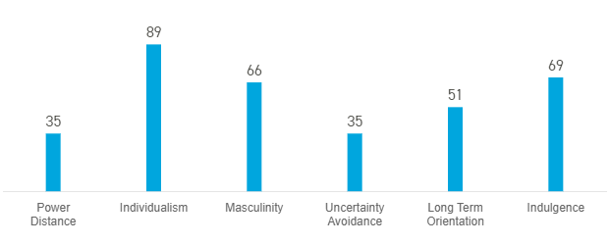

United states
- Power distance: The power distance for the U.S. stands at a score of 40%. The culture of the country is focused on the promotion of equality. People in the U.S. value equality in gender or race among other areas.
- Individualism: The level of independence is very high in the U.S. and this is evident from the score of 91%. The society is loosely knit in the country and this reveals that households prefer leading their independent and not communal lives.
- Masculinity: The masculinity score for the U.S. is 62% and this is a typical American behavioral pattern. Just like in the UK, masculinity is high at the workplace as well as communities. Men hold most of the plum jobs across the country (Hofstede Insights, 2020). Americans also hardly shy off when it comes to talking about their success.
- Uncertainty avoidance: The uncertainty avoidance score for the U.S. is below average and stands at 46%. The culture for the country hardly requires several rules and regulations. Americans adhere to the available rules in the nation. The Americans also have a fair acceptance of new ideas, creativity and innovations.
- Long-term orientation: The long-term orientation score for the country stands at 26% and this implies that Americans have minimal connection with their traditions and cultures. Additionally, the Americans are prone to the assessment of new information with the aim of assessing whether its true.
- Indulgence: The high score of 68% is a true reflection of the American indulgence culture. Americans love working hard and playing hard (Hofstede Insights, 2020). Party life is normal across the United States. Social vices such as racial discrimination, drug addiction and criminal activities are also reported in various parts of the country.
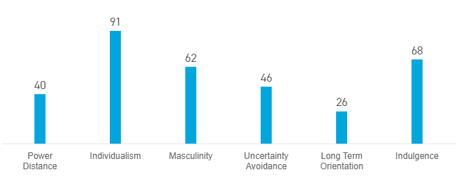

Tanzania
- Power distance: Tanzania’s Power Distance score stands at 70% and this implies that people in the country accept a hierarchical order where every person has a place in the society. The subordinates expect what to be told by those above them. Cases of gender inequality remain on the high with the female gender fallen victim to most of the discrimination.
- Individualism: The country, with a score 25% is a highly collective culture nation. A close long-term commitment of the members in a given community provide a clear picture of the collectivism in Tanzania. The people in the country are very friendly and welcoming (Hofstede Insights, 2020). At the workplace, promotions may also be based on the collectivism and management groups.
- Masculinity: Tanzania’s score of 40% shows that the country is considered to as feminism society. Women in the country are given the respect that they deserve. Conflicts are solved by either negotiations or compromise.
- Uncertainty avoidance: The uncertainty avoidance refers to the extent to which the members for a given society feel threatened by unknown situations. In the case of Tanzania, the score for uncertainty avoidance stands at 50% and this implies that there is no preference, when it comes to the country’s culture.
- Long-term orientation: Tanzania’s score for long-term orientation stands at 34% and this makes it a short-term oriented and normative culture. The societies in the country have low propensity to save, are concerned about achieving absolute truth and they exhibit strong respect for traditions. Children in various tribes across the country are taught about the traditions from an early age.
- Indulgence: Tanzania has a low score of 38%, an indication of restraint. Restraint societies hardly take most of their time engaging in various leisure events and have control gratification for their desires. The culture is characterized by persons spending most of the time visiting their relatives or spending time with their families.
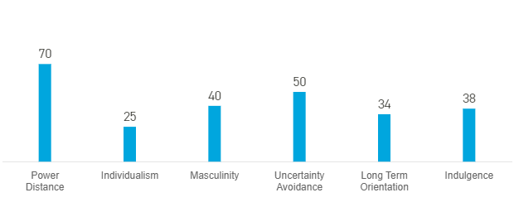

Brazil
- Power Distance: The power distance for Brazil stands at 69% and this implies that the culture for the country advocates for the respect of hierarchy. Inequality is also tolerated in the country. The holders of power in Brazil have more benefits compared to those that are less powerful in the societies. Power is the symbol for respect in most of the societies across the nation.
- Individualism: The individualism score for the country is 38% and this shows that from birth people in Brazil are integrated into strong groups. As a collective society, people in the country value social interactions and togetherness (Hofstede Insights, 2020). At the workplaces, teamwork is given utmost priority in the organizational cultures.
- Masculinity: Brazil’s 49% masculinity score paints a clear picture that balances between feminism and masculinity. Women, just like men, hold powerful job positions in companies and the governments. Both genders are friendly and support one another (Hofstede Insights, 2020).
- Uncertainty avoidance: The uncertainty avoidance for Brazil is very high (76%). The Brazilian society requires a strong legal framework and rules and regulations for the structuring of life in the country. The people from the country are very passionate and their emotions can easily be shown from their body language.
- Long-term orientation: Brazilians from most of the parts of the country value their traditions and Samba roots. At a score of 44%, it is evident that culture erosion is something that is currently being witnessed in the country and this is majorly linked to immigration.
- Indulgence: The people of Brazil possess a positive attitude and have a strong tendency towards optimism. With a score of 59%, it is evident that Brazil is an indulgence society (Hofstede Insights, 2020). The people in the country love enjoying life, spend money as they wish and have a very high degree of importance for leisure time.
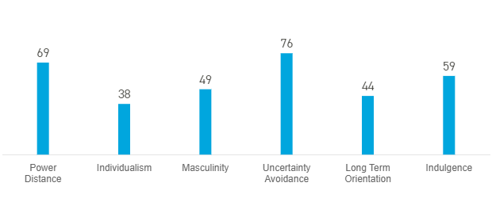

Japan
- Power Distance: The power distance for Japan is 54%, and this implies that Japanese are usually conscious of their hierarchical position in any societal setting. Equality is given priority in the Japanese educational system.
- Individualism: Japan is more of a collective society. With a score of 46%, it is evident that Japan has a more collective culture. Individuals in various societies are more than willing to support their relatives and friends. Companies in Japan value teamwork as part of their corporate culture (Hofstede Insights, 2020).
- Masculinity: At a score of 95%, Japan is one of the most masculine countries globally. Most of the top positions in companies are held by the men. The masculine culture ranges from sporting activities to chores in the various households.
- Uncertainty avoidance: Japan, with a score of 92% is the most uncertainty avoidance country in the world. Some of the factors behind the high score include natural disasters such as Tsunami and earthquakes and disasters such nuclear explosions (Hofstede Insights, 2020). The high UA score best explains the reasons why it is hard to make changes in Japan.
- Long-term orientation: Japanese value their traditions and cultures and this is evidenced by the high score of 88%. People in the country are guided by good values and morals that are installed to them in various stages of their lives.
- Indulgence: Japan is characterized as an indulgence society with high restraint. The low indulgence score of 42% is a proof that the people in nation exercise much restraint and have low preference for leisure time. Moreover, a pessimistic approach is evident in most of the communities across Japan. The people of Japan are friendly and value courtesy.
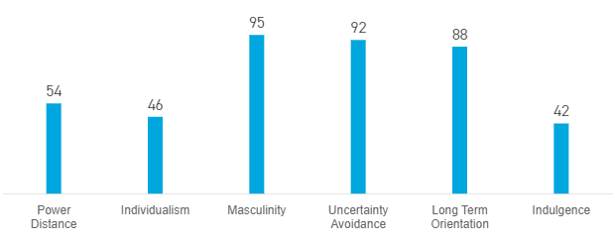

A table for Dos and Don’ts for the hotel staff
Below is a do’s and don’ts’ table for the hotel staff
Country | Do’s | Don’ts’s
United Kingdom | A firm handshake is a good gesture  Talking in low and acceptable tones  Listen to all the suggestions made by the client.  Serving them with their favorite dishes | Do not interrupt them when speaking  Treat both male and female genders equally and no favors per gender
United States | A firm handshake while looking directly into their eyes.  The right body language and excellent communication  Provide the client with any support that he or she requires.  Speaking in a respectful tone and apologizing where necessary | Poor communication and the lack of courtesy.  Shouting at the client or using disrespectful language.  Avoiding eye contact  Gender or racial discrimination
Tanzania | Showing the client respect/ courtesy.  Eye contact may not be necessary  Ensuring that all the needs for the client are met | Negative attitude when handling the client.  Lack of respect to the clients  Shouting at the client/ visitor  Discrimination based on gender or race
Japan | Eye contact is recommended  Bowing is a form of greetings for the Japanese  The men get more favors compared to the women  Respect the culture for the people  Serving them with their favorite traditional dishes. | Treatment that shows that men are lower than women.  Disrespecting the clients  The lack of respect to the Japanese culture
Brazil | Passionate conversation  Positive attitudes in the interactions  Respecting clients irrespective of their gender or age  Serving them with their favorite dishes and drinks | The lack of respect to the clients  Poor verbal and non-verbal communication that display negative attitudes  Discrimination of the clients based on their race.

Unforgettable experience to the clients
The primary objective for most of the hotels is to provide their clients an unforgettable experience (Ayeh, Au and Law, 2016). Having a better understanding of the cultures and customs for the clients is one of the strategies that hotels can embrace for improving the quality for their services. Customer needs in the hospitality sector will always vary from one country to the other (Mattila, 1999). Some of the factors pertaining to culture that hotel staff need to comprehend include types of foods and drinks, social interactions and greetings and approach to life/ indulgence (Mok and Armstrong, 1998).

REFERENCE
1.Ayeh, J., Au, N. and Law, R. (2016). Investigating cross-national heterogeneity in the adoption of online hotel reviews. International Journal of Hospitality Management, 55, pp.142-153.

2.Gonçalves, A. (2014). The Journey not the Arrival Matters: Developing Intercultural Awareness and Communication Skills in Tourism Education, ENCATC Journal of Cultural and Policy, 4(1) 2014/ISSN pp. 2224-2554.

3.Hofstede Insights (2020). Home - Hofstede Insights. [online] Hofstede Insights. Available at: https://www.hofstede-insights.com/ [Accessed 10 Jan. 2020].

4.Mattila, A. (1999). The Role of Culture in the Service Evaluation Process. Journal of Service Research, 1(3), pp.250-261.

5.Mok, C., and Armstrong, W. R. (1998). Expectations for Hotel Service Quality: Do they differ from Culture to Culture? Journal of VacationMarketing,4(4), pp.381–391.

6. Seo, Y. (2012). Cultural Impact on Customer Satisfaction and Service Quality Evaluation in Hotels. UNLV Theses, Dissertations, Professional Papers, and Capstones. 1370..

