University of Wales Trinity Saint David
London campus

3/24/2025
E-Portfolio Link: https://account.portfoliobox.com/pb4/admin/#/assignment-1-lde-all-doc
Module Name: Learning In the Digital Era
Module Code: ACCA 4025

Student Name: Ikechukwu Victor Osigwe
Student ID: 2530991
Group: 2

Lecturer’s Name: Koushik Modak

LDE Assignment 1
E-Portfolio
Table of Contents
Introduction 2
Main Body 2
Task 1: Essential Academic and Employment Skills for the future career Path 2
Task 1 (a): Report on Essential Academic and Employment Skills 2
Task 1 (b): Evaluation of Task 1 (a) based on Similarity report 2
Task 2: Collaborative Mind Map and Individual Poster 2
Mind Map (Collaborative) 2
Poster (Individual) 2
Task 3: Virtual Collaboration and RefWorks 2
Report on Virtual Collaboration 2
Step-by-step process of using RefWorks with visuals 2
Task 4: E-Portfolio Creation and Evaluation 2
Task 4 (a): E-Portfolio Creation 2
Task 4 (b): Illustrative Review of E-Portfolio tool Selection 2
Conclusion 2
References 2
Task 1 References: 2
Task 3 References: 2

Introduction

Main Body

Task 1: Essential Academic and Employment Skills for the future career Path

Task 1 (a): Report on Essential Academic and Employment Skills
Learning is the very best way for every student to study in any academic institution and could create fundamental Academic skills by their self to enable them to progress into the future about the career they choose. Furthermore, to explore the nature of Learning at University for a deep approach to knowledge and the ability to think critically and learn independently by becoming more aware of what we think learning is. What kind of Learning is required and how learning occurs. Everybody has the power to atter and develop how they learn and so doing increases their chances to become successful [1].

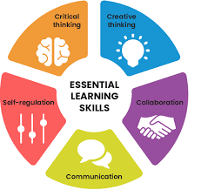

the content. But in some extrinsic factor (outside of the task) they may, for example be aiming just to pass to obtain employment or they may be studying because their parent expects it. As a result of lack of interest and motivation these students do not aim to understand the content but to reproduce it. They learn as if they were filling information in a computer. Each new file is given a name and place. However, the file is not linked. Such students also have a poor search function. while they can easily retrieve a particular file. They find it difficult or impossible to think about ideas that occur in different files
Some students consistently employ a surface approach in their learning However most student act in a much more strategic manner.

Task 1 (b): Evaluation of Task 1 (a) based on Similarity report

. Developing Transferable skills
. Making Use of Lectures and Seminars
. Using Libraries and the internet
. Note taking, essays, Seminars and Presentations
. Revision and Examinations

Task 2: Collaborative Mind Map and Individual Poster

Mind Map (Collaborative)
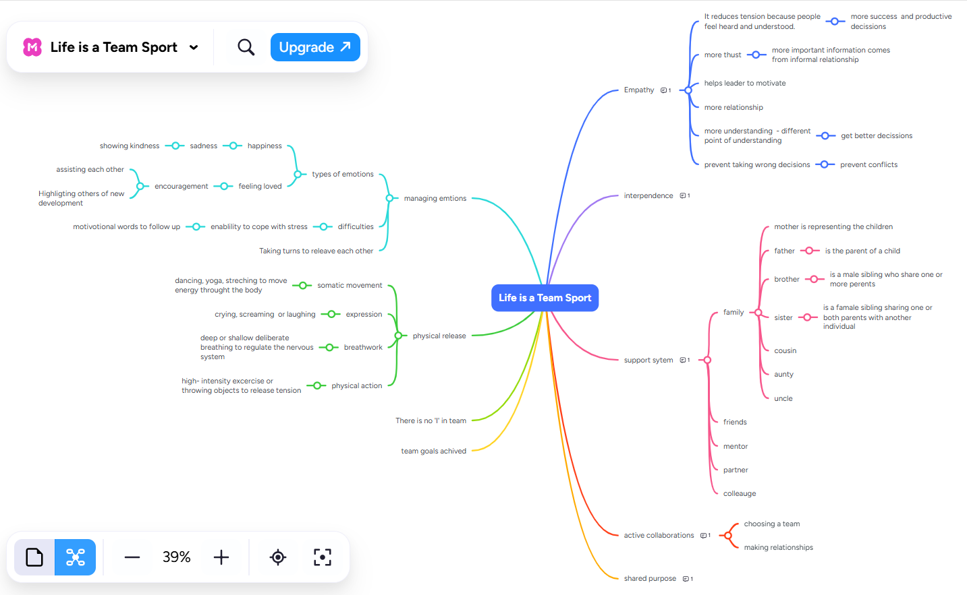

Poster (Individual)



Illustrated with some examples

Task 3: Virtual Collaboration and RefWorks

Report on Virtual Collaboration

. Developing Transferable skills
. Making use of Lectures and seminars
. Using Libraries and the internet
. Note-taking, essays, seminars and presentations
. Revision and Examinations

Step-by-step process of using RefWorks with visuals

Task 4: E-Portfolio Creation and Evaluation

Task 4 (a): E-Portfolio Creation

Task 4 (b): Illustrative Review of E-Portfolio tool Selection

Conclusion

References

Task 1 References: [1].

Task 3 References:

