Fanfare SVG: Events’ (FE) strategic direction to discover a new way forward for delivering innovative customer care ensuring future resilience and sustainable competitive advantage against a backdrop of a pandemic.

Module: Strategic Management
Module code: BMMB7013
Student ID: 2113847

Table of Contents
List of figures 3
Executive Summary 4
Introduction 6
Analysis 8
Formulation 21
Implementation 25
Evaluation 30
Conclusion & Recommendations 32
References 33
Appendices 37

List of Figures
Figure 1- Analysis, Formulation, and Implementation-AFI (adapted from Rothaermel 2012) 7
Figure 2- Strategic Management Process (David 2009) 8
Figure 3- Macro and micro environment relative to FE (adapted from Oxford College of Marketing 2018) 9
Figure 4- Fanfare SVG: Events and competitors relative to Porters five force (source) 13
Figure 5- Fanfare SVG: Events SWOT analysis 16
Figure 6- Fanfare SVG: Events tangible and intangible resources 17
Figure 7- Fanfare SVG: Events VRIO analysis 18
Figure 8- Fanfare SVG: Events strategic position on Ansoff’’s Matrix 21
Figure 9- Hiatt’s ADKAR change management model (source) 27

Executive Summary

FE, a major player in the events planning and management sector in SVG, recently underwent restructuring and as such must ensure that its focus aligns with the core business priorities. The rollout of COVID-19 vaccines has provide hope for hospitality operatives thus FE needs to take advantages of opportunities in the market while and mitigating threats ahead.
The report examines the macro and micro environmental factors that are currently affecting the business. The competitive environment analysis provided some insights as to how the business can position itself in the various niches. Its entrepreneurial outlook has enabled expansion but FE now needs to focus on utilizing its current capabilities to penetrate the present market which includes doing research on the millennials who are the most populous cohort getting married in SVG. This group has the affluence to afford a professional planner however FE needs to focus on strategically marketing to the aspirations of this group. Additionally, there is an opportunity for exploitation of the destination wedding niche but FE needs to create strategic alliances and packages to make it worthwhile. Though FE has strong brand integrity in SVG its online presence does little to attest to its capabilities as there are no public testimonies which will be crucial for potential customers outside the destination.
There is a real opportunity for FE to become the destination event planning and management guru however there are specific arears that need fine-tuning within the company. The strategy outline some key areas (more details on pg 32) inclusive of creating a vision and mission for the business with specific objectives for short term wins and long-term targets, syncing communication across all channels, focusing on updated customer service training, efficiently laying out the website and promoting online customer engagement. People are usually adverse to change thus the strategy incorporates the ADKAR change management theory which focuses on guiding the individual worker’s transition through the process from Awareness to Reinforcement. FE’s workers are integral to the strategy since they are the stewards of hospitality and if personalized customer care is to be realized the staff must understand, agree, accept and enact the changes outlined in the plan.
Introduction

Fanfare SVG: Events and Distribution (FED) is a major events management and planning company in St. Vincent and the Grenadines (SVG). Like many similar companies worldwide they have been hit hard by the current COVID-19 Pandemic. Most events have been canceled (Eckler, 2021), postponed or severely scaled back resulting in serious sector shrinkage. FED is an independent company that quickly saw the opportunity to adapt in its changing environment by including sanitization stations and necessary accessories in their rental products offerings. This led the company to capitalize on the opportunity for distributing quality sanitization and cleaning products. The company utilized the opportunity to rebrand, launch a distribution arm and develop a website (Searchlight, 2020).
With all the changes afoot the owner deemed it necessary to contract the author, a Strategic Business Advisor, to be the architect of creatively reshaping Fanfare SVG: Events’ (FE) strategic direction to discover a new way forward for delivering innovative customer care ensuring future resilience and sustainable competitive advantage against a backdrop of a pandemic.
Towards this end the consultant has identified four additional members of the organisation to work on realizing the new strategic direction for the business. The team members and their specified responsibilities are as follows:
- Owner- PR & Marketing
- Administrative Assistant- To identify training needs and seek training opportunities for support staff, keep track of budget
- Senior Event Coordinator/Planner- To compile database of strategic partners and maintain positive relationship.
- Website Maintenance Personnel- To effect the highlighted changes in the website’s layout
- Strategic Business Advisor- To assess and refocus the business’ strategy, identify gaps in customer care and make recommendations.
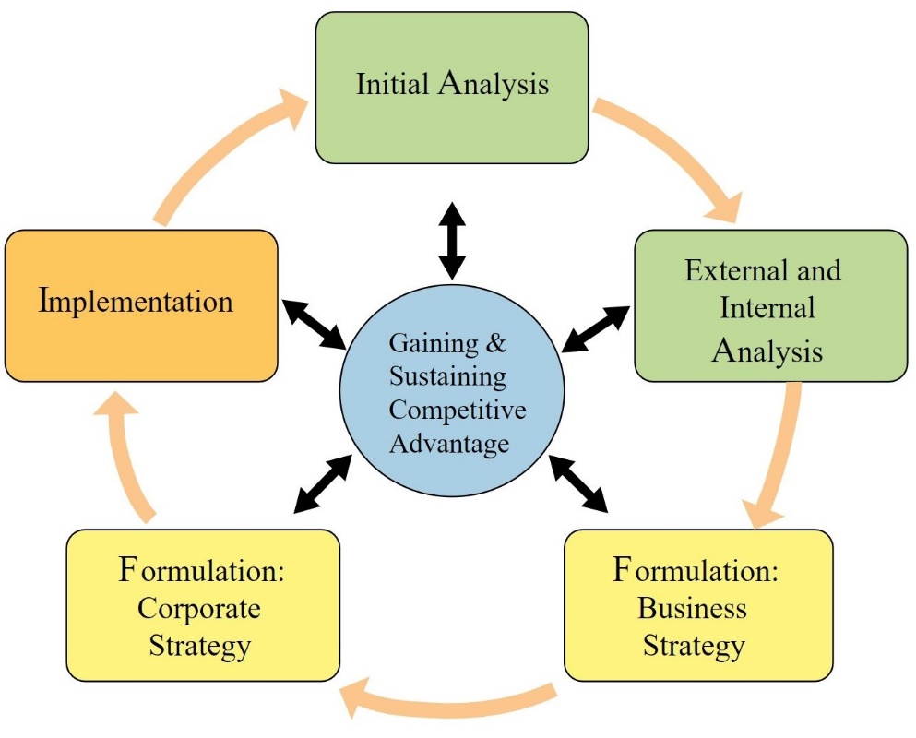
Figure 1- Analysis, Formulation, and Implementation-AFI (adapted from Rothaermel 2012)
This report was primarily guided by Rothaermel’s Analysis, Formulation, Implementation (AFI) model, see figure 1. AFI is suitable because it depicts the strategic management process as a continuous activity with a central focus on the business gaining and sustaining competitive advantage. Though the arrows depict a one way process this is not always realistic beacuse the firm may choose to reassess a previous stage instead of moving ahead. AFI also fails to include the monitoring phase which is a crucial step for evaluating formulated strategies.

1. Analysis
1.1 Initial Analysis
The 2020 FED rebranding process included a change of name, logo redesign (see Appendix 1 and 2), new products and office space expansion. Based on these steps it is fair to conclude that the focus is growth and as such there is need to ensure that strategies are in place to adequately guide the company. A company’s strategic management process begins with crafting relevant vision and mission statements for the business (David 2009).
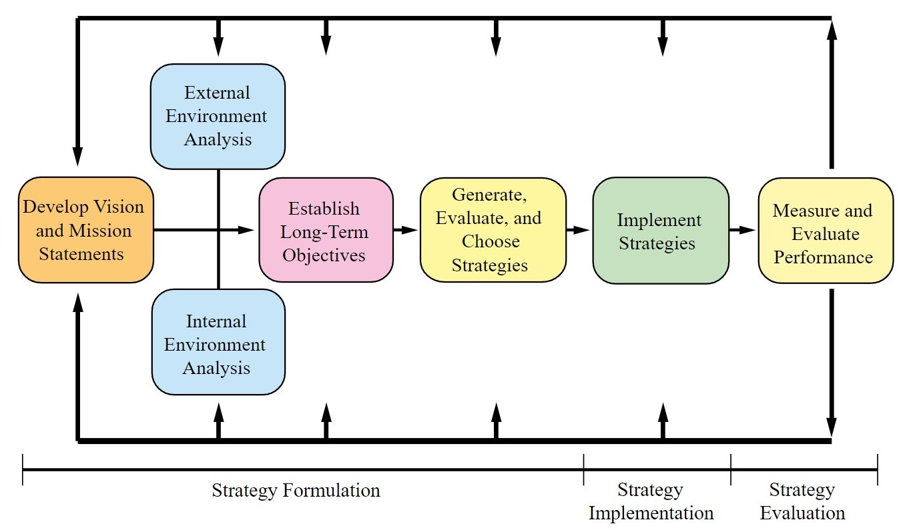
Figure 2- Strategic Management Process (David 2009)
At present there is notable absence of the aforementioned areas for FE. However, it publicly shares its tagline, promise, purpose and values (see Appendix 3). With David’s process, see figure 2, in mind the company must identify the type of business that it engages in, its mission and vision. A vision is necessary to guide the company’s future trajectory and help employees undertake tasks to stay the intended course. Additionally, the mission is one way to craft an internal and external image that speaks to the business’ products, services and customers.
1.2 External Analysis
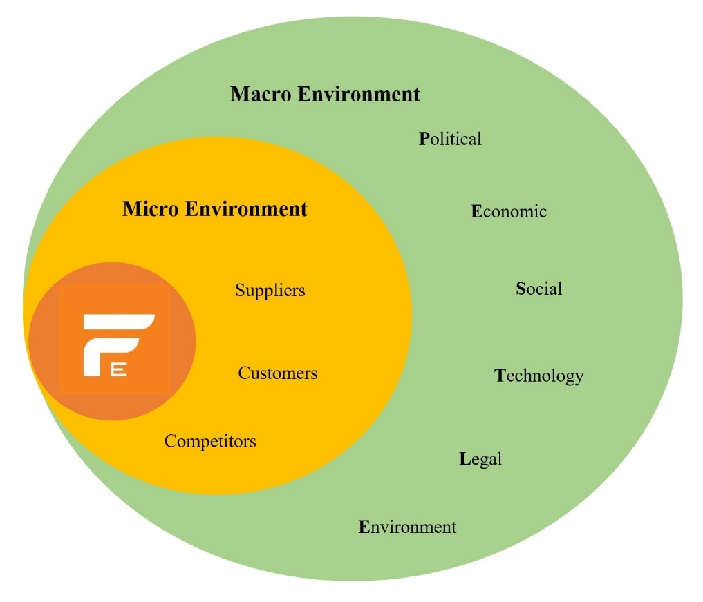
Figure 3- Macro and micro environment relative to FE (adapted from Oxford College of Marketing 2018)
The external environment analysis of the business is instrumental to its development mainly beacuse the modern environment is extremely dynamic, complex and uncertain (Shtal et al. 2018). This position is even more relevant against the backdrop of the current pandemic. Forces within the external environment can create threats and opportunities for a business (Rothaermel 2017). The survival and success of the business is related to how well it can adapt to this changing environment. Subsequently, the macro factors or PESTLE, see figure 3, must be examined to better position the business to take advantage of openings or thwart possible dangers.
1.2.1 Political-
SVG is a democratic and politically stable country (The Global Economy 2020). The government has acknowledge that the tourism and hospitality industry is an important avenue for economic development (World Bank 2020) and have actively encouraged major developments in the sector (Wong 2021). SVG is one of few countries that remained opened throughout 2020. It is believed that the delayed direct effects of the virus combined with misinformation contributed towards vaccine hesitancy resulting in the government legislating the COVID-19 vaccine for front line workers in critical industries (Gonsalves 2021). This has led to a dramatic polarization of SVG’ population. The hesitancy is depicted in the slow uptake of vaccines despite availability (Adams, 2021) and can potentially lead to more sustained travel advisories placed on the destination in its various source markets.
1.2.2 Economic-
Since 2020 there has been mass global shutdowns (Congressional Research Service 2021), lessened leisure travels and prevailing unemployment. Latin America and the Caribbean is the region most affected relative to hours worked and income (Maurizio et al. 2020, p.2). Businesses that have managed to stay afloat now have a larger labour force from which to choose employees thus opening up possibilities for cheaper skilled workers. Another side effect is the increased cost for sourcing materials for specialized events.
1.2.3 Social-
The last 20 years depicted growth in the number of Vincentians accessing university education more than any other period in the country’s history. High level of education often results in better jobs, higher income and higher spending on aspirational products/services. Local statistics indicate that millennials are marrying more than any other cohort. Since the pandemic began attitude towards health & safety improved due to the public awareness programs for reducing transmission of COVID-19.
1.2.4 Technology-
Options for online payments in SVG are lagging behind those of source markets for example locals can utilize PayPal to make payments globally but cannot receive payments for goods and services via the application. Social media has become more important for communication since the pandemic was declared. Companies that invest in ensuring their online presence is strategically aligned can have a greater impact on potential clients. The increase trends of virtual streaming is another example of adding value to events and can be offered as an option to the clients. Countless Applications are now available to assist professionals and DIYers to simplify and keeping track of the planning process.
1.2.5 Legal-
SVG’s current legal framework dictates that couples have residency for 24hrs minimum prior to appearing at the central registry in person with essential documentation for a marriage licence. This precludes same day visitors and is a hassle for those marrying on a Grenadine island. FE should lend its voice to lobby for pro-destination wedding legislations. As a further complication hospitality workers fall within the frontline category thus current and potential staff must submit proof of vaccination to employers.

1.2.6 Environment-
Hospitality consumers are becoming more environmentally conscious and are holding business’ accountable by choosing to purchase from those that demonstrate environmental sensitivity and activism. SIDS like SVG are at great risk for negative impacts of climate change which is primarily deemed as caused by larger developed nations. FE needs to be aware of the national environmental standards and regulations like the ban on single use plastics and Styrofoam products so that they can responsible align decisions regarding material type and sourcing for product and pricing strategy.

1.3 Competitive Analysis-
FE has three social media sites: Instagram, Facebook and twitter and according to their content the company caters mainly to the wedding market. The majority of their rental offerings also supports this observation. Thus its competitors for events are those that cater to the same target market and its primary competition would be those that are deemed as offering a comparable or superior product/service. The main competitors are: Exquisite EventSVG; Joche Moments and A Caribbean Wedding see Appendix.
As an independent company it is not required to publicly disclose sales and there is no data to accurately pinpoint market share. FE has won every best ‘Event Rentals’ 2017, 2018 and 2020 since inception of the national people’s choice awards- Best of SVG (Fanfare SVG: Events, 2021). The company was nominated for best Event Planner but lost the coveted tittle to main competitors thus far: Exquisite EventSVG in 2017, Joche moments in 2018 (searchlight 2018) and 2020 (The Best of SVG, 2020).

1.4 Porter’s five force
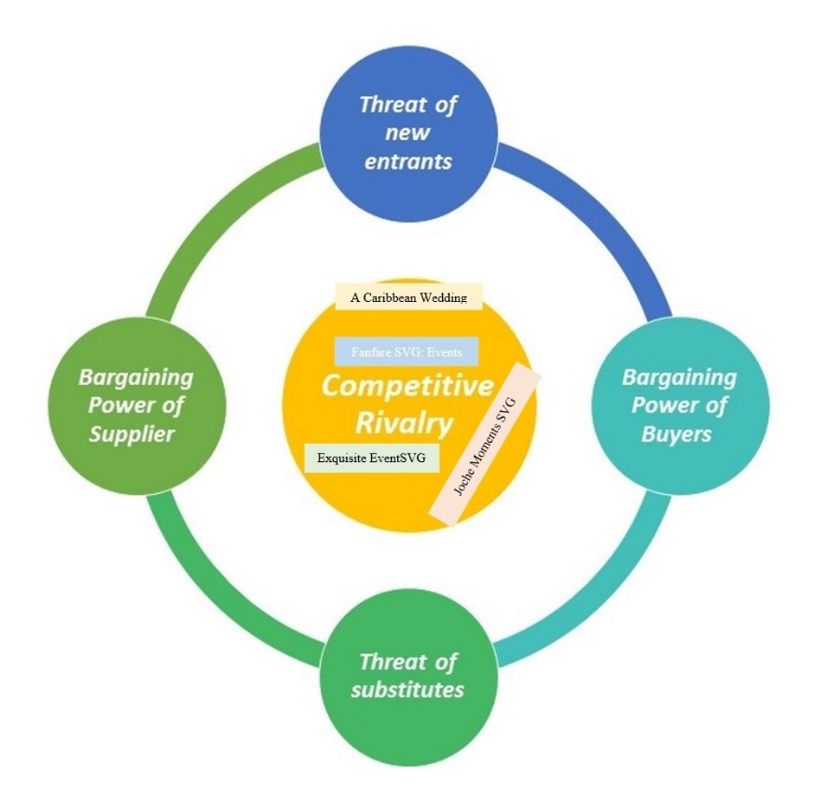
Figure 4- Fanfare SVG: Events and competitors relative to Porters five force (source)
Porter’s Five Forces is considered to be a useful starting point for strategic analysis (Johnson, Scholes & Whittington 2008, p.60). Porter’s theory identifies five forces, see figure 4, which determine the competitive intensity and attractiveness of a market. When a company is mindful of the forces it can secure competitive positioning (Porter, 1979). Supporters also argue that examining these forces can help firms to determine whether new products or services are potentially profitable. Thus helping the business to avoid mistakes, improve weaknesses and capitalize on strengths.
1.4.1 Threat of new entrant-
The threat of new entrants are high due to low barriers. However, the success of those new entrants are low because it takes time to gain traction and carve out market share in the local industry. The three main entities possess years of expertise, do quality work and enjoy good brand recognition.
1.4.2 Bargaining power of suppliers-
There are numerous suppliers which help to stabilize prices, however many are located overseas in China and the US. Even the local suppliers source their raw materials from the aforementioned countries. Timely transport of materials can be an issue for specialized and time sensitive events. This issue can be minimized by offering ‘green’ event concepts which includes materials sourced locally or within the Caribbean region.
1.4.3 Bargaining power of customers-
According to the national census the population has remain stable for the last two decades and so too has the number of couples getting married. Corporate events are mainly staff dinners and awards which are sometimes planned and managed in house. Prior to the pandemic there were increases in the number of large social events that necessitated a professional planner but local health protocols continue to restrict size.
1.4.5 Threat of substitute products-
There are numerous applications available online to assist with the planning of any event. However, without an in person professional to guide the process and deal with the many stresses that may arise the discerning client may find that these substitutes are inadequate.
1.4.6 Degree of competitive rivalry-
There is moderate rivalry among the main competitors for local clients and main firms are dominant in specific niches. Fanfare SVG dominates event rentals for social and corporate; Exquisite EventSVG prevails in the local wedding scene while the most rivalry exist between Fanfare SVG: Events and Joche Moments SVG for the other social (excludes Weddings) and corporate events. Outside of the resorts A Caribbean wedding is the only local event planner to specifically target visitors. Thus targeting this niche is an opportunity for exploitation by FE.

2.5 Internal Analysis

SWOT
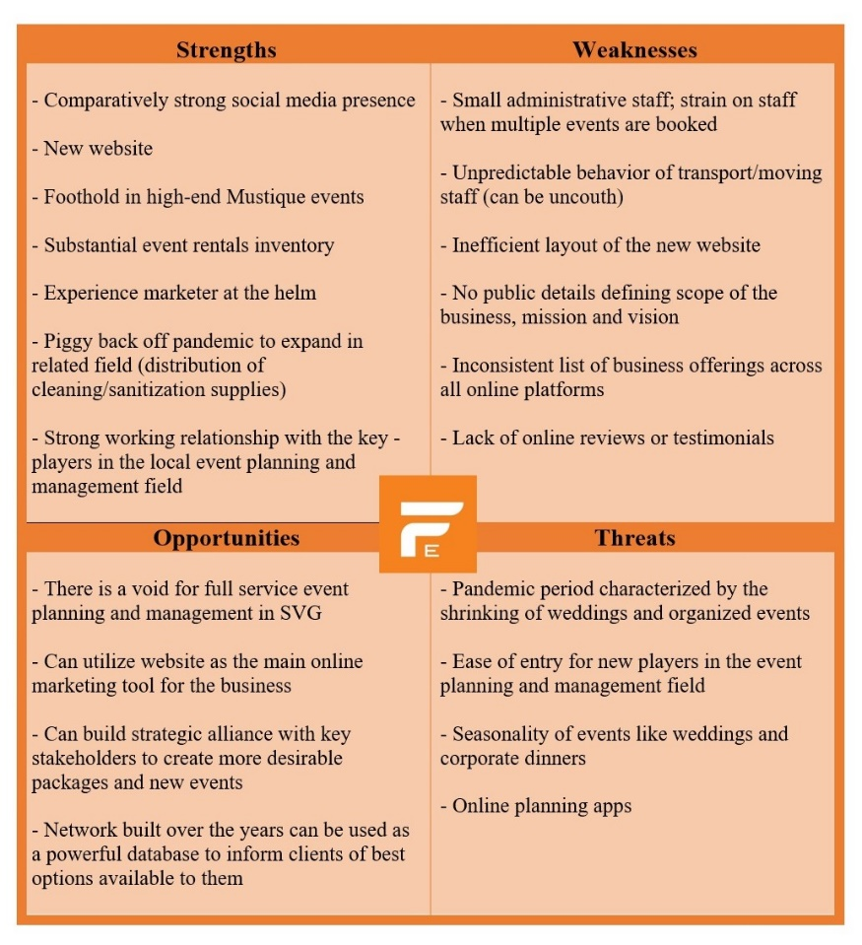
Figure 5- Fanfare SVG: Events SWOT analysis

A SWOT, see figure 5, is done to identify FE’s internal and external factors which can support achievements of its goals. The degree to which these factors are congruent can be termed as a business’ Strategic fit (pestleanalysis.com, 2015).
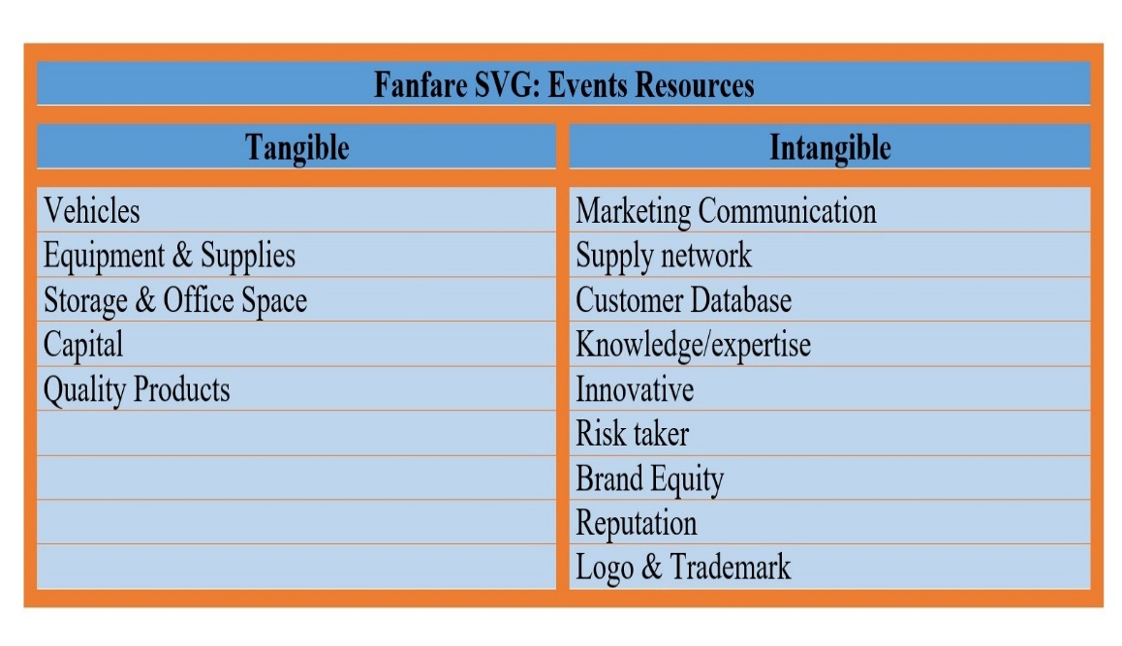

Figure 6- Fanfare SVG: Events tangible and intangible resources
Resource Based View (RBV)
To identify FE tangible and intangible resources which are integral to achieving superior performance the RBV model was used, see figure 6. It is argued that organizations must look internally to find the sources of competitive advantage instead of in the competitive environment. External opportunities can be exploited using the business’ existing resources in a new way instead of attempting to acquire new skills for each discovered opportunity.
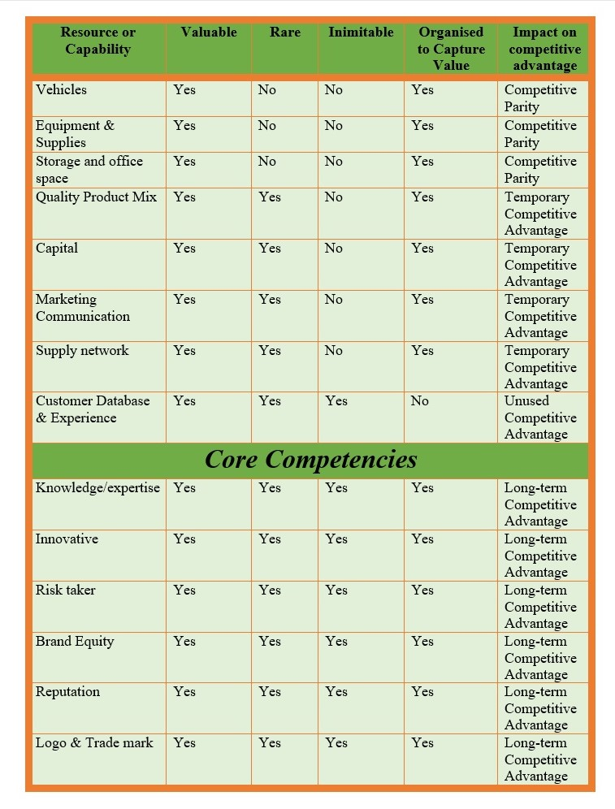
Figure 7- Fanfare SVG: Events VRIO analysis
Valuable Rare Inimitable Organised (VRIO)
FE can gain and sustain a competitive advantage when it has resources and capabilities that satisfy the VRIO criteria (Rothaermel 2012). Its core competencies were identified, refer to figure 7, and analysed. These are the factors that underscores FE’s capabilities, sets it apart from the main competitors and are central to the strategic process. They are rare, difficult for competitors to imitate and provide superior value for customers (Prahalad and Hamel 2015).
The main tangible assets: vehicles; equipment & supplies; storage and office space are all valuable to FE because they ensure that it can offer a hospitable environment to entertain clients for in person consultations, maintain product aesthetic due to proper storage and competitive pricing due to ownership of storage facilities and transports for delivery. Their competitive impact is one of parity since main competitors possess these resources in varying degrees.
On the other hand the high standard of the product quality and varying offerings are due to high reinvestment in the business. This allows FE to have better access to capital from its creditors. As a matter of fact its ability to raise capital enabled expansion during this time when similar business have been force to stand still or close. Thus allowing the business to enjoy temporary competitive advantage.
Marketing communication and supply network are two intangible assets that have secured a temporary competitive advantage as well. FE’s owner used his background in marketing to out maneuver rivals in the marketing arena thus ensuring his business is top of mind for event rentals. FE prides itself on the solid suppliers’ network which it developed over time and reinforced with the strength of the brand.
FE does both corporate and social events and have worked with a diverse clientele. Its longevity in the industry has enabled it to amass an envious database and if used strategically this intangible resource will secure a competitive advantage for the business. In a very visual and experience centric industry they are known for crating unique celebrations to the satisfaction of each client however there are no discernible public reviews or testimonies to attest. This shortcoming is also present among main competitors and is an opportunity for the FE to turn its clients’ experiences into positive brand engagement.

Core competencies
Throughout its years the company has proven its value to the local market and has demonstrated that it is an industry expert, possess great propensity for innovation and is unafraid to take risks. Its innovation is especially evident in its décor creations and marketing campaigns. The risk assessment function is robust and has serve the company well during this pandemic.
The company’s logo & trademark, brand equity and reputations are intangibles resources that can be further exploited to attain a sustained competitive advantage. FE’s brand is well known throughout the destination and has excellent integrity. This was developed over 12 years of consistent quality products, unique experiences and positive growth. Within recent years the brand has gain a reputation for working with top companies and high-end customers. This is demonstrated by its dominance in Mustique’s exclusive enclave.

Formulation

Business
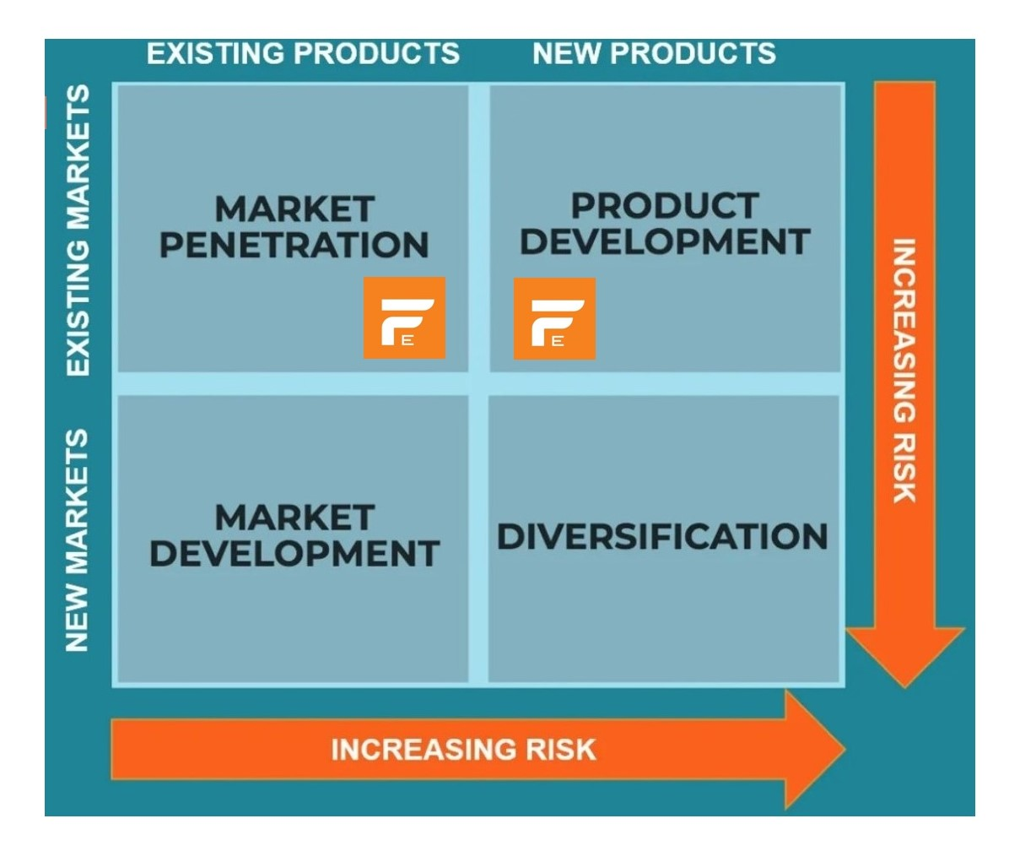
Figure 8- Fanfare SVG: Events strategic position on Ansoff’’s Matrix
The Ansoff’s Matrix is a relevant tool for FE to adopt as a means of focusing its strategic growth over the future, see figure 8. Market Penetration and Product development are key areas to focus on in the short term. The suggested method is to identify suitable target markets in the local population. For example (Stats.gov.vc. 2018) show that from 2016-2018 the age group 25-44 accounted for more than 60% of local marriages thus it would be wise for the company to do more research to tailor advertisements specific to this cohort. The grouping includes local millennials who benefitted from a thrust in the ‘education revolution’ -a government policy aimed at raising the standard in SVG’s education system since 2002 (Education.gov.vc. 2012). Data indicates that since 2001 thousands of Vincentians have accessed university education (Stats.gov.vc. 2018) arguable resulting in this grouping acquiring better jobs and improved incomes thus enabling them to afford aspirational products and services like professionally executed events.
By the first quarter of 2020 the FE acquired handwashing stations and partnered with Bank of St. Vincent and the Grenadines (BOSVG) to launch a ‘clean hands’ campaign (Searchlight 2020), other businesses would eventually join the campaign and John foresaw yet another opportunity. By mid-2020 there was an overhaul: the business became incorporated- Fanfare SVG Inc.; the logo was reimagined; a distribution arm was included for cleaning and sanitization supplies and they moved to a larger office space (Searchlight 2020).The incorporation was a strategic move to facilitate the additional new products which is complementary to the planning side of the business.
Further product development can be done via creating an annual signature event to be used as a showcase for the company’s creativity, product offering and specialized customer service opportunities. The 25-44 age group tend to be more sociable and is a good target market for such events. There is also the opportunity for developing packages which feature non-traditional wedding venues like Fort Charlotte, Arnos Vale Cricket ground, Victoria Park, and Dark View Falls. This can be a collaboration with worthwhile accommodation that lack the capability to utilize newer event management & planning techniques, products and services.
Market development can be adopted in the medium to long term scenario if post pandemic recovery conditions are encouraging. There are nearby regional islands that may be potential avenues for expansion but require in depth research and strategic partners to share risks
Corporate
FED’s corporate strategy must take into consideration the similarity and differences for FE and FD. Their complementarity must be fully integrated to gain the most competitive advantage. Each business should have its own vision and mission statements with pertinent goals to foster both individual and combined objectives. These goals are an indication of what the company as a whole is trying to achieve and to become (Tilles, 2014)
Vertical integration:
The owner utilized an expansion strategy in 2020 to incorporate the business and add FD. This is an example of forward vertical integration where a new but related products is marketed to current customers through established channels.
Strategic Alliances:
With the reopening of the world tourism economy on the horizon many tourism destinations are going to invest heavily in marketing endeavours that seek to encourage visitors to choose their country. The local events management and planning sector needs to be proactive by creating strategic partnership/alliance with venues and accommodation entities to devise competitive and alluring packages, create special events for relevant niche markets that complement the destination’s comparative advantage and share the cost of marketing to the targeted customers. Visitors are looking for stress free experiences and this is a prime way to create worthwhile options that take care of the A-Z of Event planning and management especially for the destination weddings niche

Implementation
There comes a point when strategy must be put to use because change comes through implementation and evaluation, not through the plan (David 2011). Implementation is the sum total of the activities and choices required for execution of a strategic plan (Wheelen and Hunger, 2012) though there is no agreed-upon, generally accepted and dominant framework in "strategy implementation" (Siddique and Shadbolt, 2016 cited in Hourani, M. 2017).
(David, 2011) identified 13 management issues that are central to the implementation process, 5 of these are key for FE:
Annual objectives:
Quality time should be designated to this endeavour and must involves key staff members. This tactic can influence staff to be committed sooner than if they were excluded from the process. Annual goals are crucial to establishing priorities, resource allocation, staff evaluation and pinpointing monitoring tools. FE’s annual objectives must be clear, specific measurable and reasonable. Areas to be address includes growth, target markets, market share, brand engagement, enhanced customer experience and profitability.
Policy:
Policy includes guidelines, methods, procedures, rules, forms, and administrative practices to support the business’ stated goals (David, 2011). It says something about how goals will be attained (Tilles, 2014), how the company is run and what clients can expect. Fanfare SVG: Events must devise clear policies to include expected behaviors for workers, specified roles, boundaries for the company-client relationship, contracts, and channels for addressing issues. Hosting events is a high stress profession (CareerCast.com, 2019) and if the company aims to create a personalized stress-free experience for clients it becomes a necessity to have detailed procedures for every phase.
Resource allocation:
The strategy involves maneuvering the business into the destination’s event planning and management Guru. Thus appropriate resource apportionment is vital. Human, technological and financial resources must be aligned to the website to ensure an efficient layout, add new pages, and timely updates as it is the company’s online base. Staff training should be given consideration immediately especially in COVID-19 protocols for hospitality staff and the new face of customer service in the pandemic era. Front line staff inclusive of the delivery team must be prioritized. If the FE is to properly exploit the destination wedding niche it needs to fill the Senior Event Planner/Coordinator post.

Change Management:
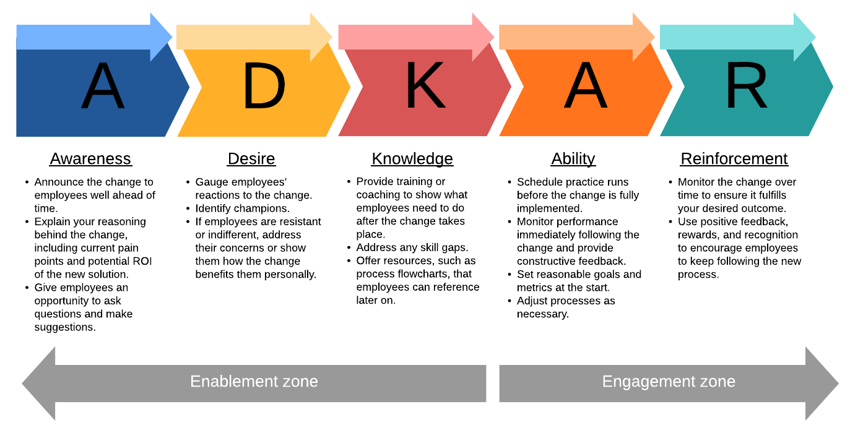
Figure 9- Hiatt’s ADKAR change management model (source)
Resistance to change can be considered the single greatest threat to successful strategy
Implementation (David, 2011) and is termed as the leading factor for why so many change transformations fail (Galbraith, 2018). A Change management model that is well suited to the smaller enterprise should be adopted to lessen resistance. It is argued that successful change is based on how to facilitate it at the individual level (Hiatt, J 2006). Hiatt’s ADKAR model, see figure 9, is a one that focuses on the organisation’s base up. Awareness and desire are needed to move employees out of the current state, where change is needed but has not started. Knowledge and ability occur during the transition phase, and reinforcement continues into the future. The focus on the base should increase, in theory, the rate of adoption to the changes.
The model is outcome-oriented which facilitates goal setting during the process. Individual team members must achieve each goal which means the collective may not be at the same goal at a given point. However, the model allows for change leaders to assist those that are stuck on a phase since its presumable easier to identify the resistance associated with each of the five stages.
ADKAR goals:
Create awareness of the need:
Communicate the need for the change, be mindful that in order for employees to be truly aware of its necessity they must both understand and agree with the reasoning for it. Provide clear explanations why the change is needed and focus on the benefits for the affected employees (Galbraith, 2018).
Foster desire for the change:
In order for staff to adopt the change, they must want it. Pinpoint change leaders who are able to relate to how daily routines will be affected so that they can provide specific support. Change leaders can foster desire for the change by promoting the benefits of the change for the staff.
Provide knowledge on how to change:
The transition phase underscores education and training. This will allow for the closing of gaps that may affect long-term objectives. FE’s staff will need to understand impacts on their tasks, skills and tools. Enabling knowledge that applies directly to the individual’s responsibilities is critical because all must reach each milestone separately.
Ensure that employees have the ability to make the change:
Having access to the information and the ability to use it are distinct. This stage requires people to act in a new way for the change to be realized (Creasey, n.d.). Utilising change leaders can provide coaching or facilitate hands on training for staff to simulate the new processes.
Reinforce the change:
If the change is to take root it must be reinforced well after implementation. Motivate employees by building enthusiasm throughout the process for example reward those who are making visible progress and those who exemplify the adopted changes.
Linking performance to rewards:
The range of options for incentivizing the organisations’s human resource to actively support strategy-implementation activities is vast (David, 2011). Bonuses tied to the business achieving its objectives, salary raises/ increments, award or recognition for service excellence etc.

Evaluation
Evaluation is critical to ensure that objectives are being achieved and should have both long and short-run focus. The process allows managers to determine if the attainment of the set goals are sustainable and whether the core strategies are suitable (Brown and McDonnell 1995 cited in Eldeeb and Halim, 2011). The holistic approach of the balance scorecard is adaptable to the small organisation and facilitates evaluation from four perspectives: financial performance, customer knowledge, internal business processes, and learning and growth (Kaplan and Norton, 1992). Below are some areas for FE to consider in the evaluation.
1. Financial:
- Employees incentives
- Profitability for specific niches
- Profitability of packages
2. Customer:
- Ease of communication
- Consistency of communication
- Customer engagement
- Client Satisfaction feedback
3. Internal Process:
- Creating Packages
- Strategic partnerships
- Vision, Mission & Objectives
- Mechanism for customer dissatisfaction
4. Learning & Growth:
- Employee initiative
- Employee training
- Staff Appraisal
- Employee turnover

Conclusion & Recommendations
FE’s entrepreneurial outlook has enabled the business to seize worthwhile opportunities to help it survive and grow as in the rebranding of 2020. This analysis offers FE key areas to develop so that it can reposition as the main source for all event planning and management resources in the destination. The new customer care paradigm is to anticipate the needs of its customer and have solutions on hand to create tailored experiences that are hassle free. FE has the expertise, the access to resources, brand integrity and network to dominate the sector however it must take the following into careful consideration:
-Create a vision and mission for FE
- Publically communicate the scope of the company with the clear vision and mission.
- Streamline communication across all channels (website, social media). They must be accurate and congruent.
- Actively encourage online engagement and feedback. Find ways to encourage testimonials from clients. Create surveys for client to share their honest perspective.
- Optimise website’s layout. Create content needed for SEO to make business more visible in destination searches. Create original content (this can be outsources) on a consistent basis for example monthly article about the planning experience or destination marketing piece. Include strategic partners’ links.
- Include a Resource page for tips on how to navigate planning for different types of event. Should be for both corporate and social especially weddings (destination, vow renewal), be current (share trending colours, style ideas,) and helpful (top free tools for creating budgets, tracking the planning process, creating websites, local marriage requirements).

- Join relevant local, regional and international associations within the industry. This will help with knowledge sharing, marketing and opportunities for up to date training.
- Approach worthwhile venues and accommodation entities with solid destination wedding package ideas for joint collaborations.
- Create at least one annual signature event to showcase FE’s capabilities
- Create tiered packages
- Facilitate staff training and periodically refresh customer service updates
- Create a senior wedding planner to coordinate all projects
- Devise a comprehensive policy to deal with every phase of the planning and management process, involve staff and ensure they are knowledgeable about the processes.

References
Adams, R. (2021). Misinformation fueling Vaccine Hesitancy. [online] searchlight.vc. Available at: https://searchlight.vc/health-wise/2021/08/17/misinformation-fueling-vaccine-hesitancy/ [Accessed 13 Dec. 2021].
CareerCast.com (2019). 2019 Most Stressful Jobs. [online] CareerCast.com. Available at: https://www.careercast.com/jobs-rated/most-stressful-jobs-2019?page=5.
COMMERCESTUDYGUIDE. (2017). MICHEAL PORTER’S FIVE FORCE MODEL. [online] Available at: https://commercestudyguide.com/micheal-porters-five-force-model/ [Accessed 14 Dec. 2021].
Creasey, T. (n.d.). Applying the ADKAR Model to New Change Management Work. [online] blog.prosci.com. Available at: https://blog.prosci.com/applying-adkar-to-new-change-management.
Eckler, B. (2021). Opportunity Knocks: The Future of the Event Industry. [online] Jwu.edu. Available at: https://www.jwu.edu/news/2021/04/the-future-of-events-industry.html [Accessed 13 Dec. 2021].
Eldeeb, M.S. and Halim, Y.T. (2011). A Balanced Scorecard Model to Align Performance Evaluation of Egyptian Hospitality Organizations. [online] papers.ssrn.com. Available at: https://papers.ssrn.com/sol3/papers.cfm?abstract_id=1874932 [Accessed 17 Dec. 2021].
Galbraith, M. (2018). Don’t Just Tell Employees Organizational Changes Are Coming — Explain Why. [online] Harvard Business Review. Available at: https://hbr.org/2018/10/dont-just-tell-employees-organizational-changes-are-coming-explain-why.
Government of SVG Statistical Office. (2018). 179. [online] Available at: https://stats.gov.vc/wp-content/uploads/2021/11/Digest-of-Statistics-2019.pdf [Accessed 1 Dec. 2021].
Kaplan, R.S. and Norton, D.P. (1992). The Balanced Scorecard—Measures that Drive Performance. [online] Harvard Business Review. Available at: https://hbr.org/1992/01/the-balanced-scorecard-measures-that-drive-performance-2.
Maurizio, R. (2020). Impact on the labour market and income in Latin America and the Caribbean. [online] www.ilo.org, p.2. Available at: https://www.ilo.org/wcmsp5/groups/public/---americas/---ro-lima/documents/publication/wcms_756697.pdf [Accessed 1 Dec. 2021]. ILO Technical Note.
Oxford College Of Marketing (2018). Micro and Macro Environment Factors | Oxford College of Marketing Blog. [online] Oxford College of Marketing Blog. Available at: https://blog.oxfordcollegeofmarketing.com/2014/11/04/the-impact-of-micro-and-macro-environment-factors-on-marketing/.
Searchlight (2018). Best of SVG win opens more doors for event planning company. [online] searchlight.vc. Available at: https://searchlight.vc/local-vibes/2018/11/30/best-of-svg-win-opens-more-doors-for-event-planning-company/ [Accessed 14 Dec. 2021].
Searchlight (2021). Fanfare SVG launches sleek new website. [online] Searchlight. Available at: https://searchlight.vc/features/2021/09/24/fanfare-svg-launches-sleek-new-website/ [Accessed 9 Dec. 2021].
The Global Economy. (2020). Saint Vincent and the Grenadines Political stability - data, chart. [online] Available at: https://www.theglobaleconomy.com/Saint-Vincent-and-the-Grenadines/wb_political_stability/ [Accessed 13 Dec. 2021].
Tilles, S. (2014). How to Evaluate Corporate Strategy. [online] Harvard Business Review. Available at: https://hbr.org/1963/07/how-to-evaluate-corporate-strategy.
Wong, M. (2021). SVG to expand its hotel room stock ahead of 2025. [online] Loop News. Available at: https://caribbean.loopnews.com/content/svg-add-1000-hotel-rooms-ahead-2025 [Accessed 13 Dec. 2021].
World Bank. (2020). Building a Sustainable and Resilient Economy in St. Vincent and the Grenadines. [online] Available at: https://www.worldbank.org/en/results/2020/10/26/building-a-sustainable-and-resilient-economy-in-st-vincent-and-the-grenadines.

Appendices

Appendix 1- FE new logo


Appendix 2- FE old logo


Appendix 3- FE’s promise, purpose & Values


