

MODULE CODE/ COD Y MODIWL: ACCC5006
RESEARCH METHODS

Shopping in small hospitality shop using Android Smartphone

Student: Sonya Kyuchukova
ID 1818665
B.Sc Cloud Computing

Lecturer: Renuga Jayakumar

Table of Contents

1.Abstract………………………………………………………………………... 3
2.Introduction…………………………………………………………………… 3
3. Application development process…………………………………………… 4
4. Literature Study……………………………………………………………… 5
5. Proposed Work……………………………………………………………….. 5
5.1 Web Service………………………………………………………….. 6
5.2. Database……………………………………………………………... 7
6. Android………………………………………………….................................... 9
7.Methodology……………………………………………………………………. 10
8.Implementation…………………………………………………………………. 10
8.1 Application Features…………………………………………………. 10
8.2 Technologies Used……………………………………………………. 11
9.Conclusion………………………………………………………………………. 14
10.References……………………………………………………………………… 15
11.Apendix…………………………………………………………………………15

1.Abstract

I am developing a method for shopping in a small cafeteria, where the customer will be able to choose a product by barcode provided in the menu, quantity, method of payment, will receive information about current promotions. This method of shopping saves the customer the long wait for queues, and for the restaurant provides work with fewer staff at the tills and more staff in preparing the query. This is a good investment for future business development

2.Introduction

Almost everyone nowadays uses a smartphone that is turned as a small home office. In this paper I rely on the idea that the largest part in the use of operating systems for mobile applications is on Android, so the application is developed for Android.

Fig. 1: Usage of OS
It turned out that many people prefer to use their phones to make purchases, even in small stores. In a hurry sometimes the customer has the opportunity to place the order and just go to get it.
For companies this is good opportunity for advertising their activities and effective use of the resource provided by the mobile application, using the company logo, announcing promotions, collecting points for discounts and in the feedback form monitors the demand for a particular product.
Another aspect of this type of shopping is cashless payment, which is a very current issue today.
This paper is ride at a time when traditional ways of shopping hide the risks of queuing and cash payment, but this will be a good basis for shopping in the future.
3. Application development process
BUSINESS PLANNING
Gathering information about the market and competition opportunities and needs of the industry
PROJECT MANAGEMENT
Organizing an action plan, determining the scope of the project, stages and deadlines
DEVELOPMENT
Following the preliminary plan, development improvement of functionality and navigation
QUALITY CHECK
Load testing and security of the mobile application functionality analysis
SUPPORT
Continuous cooperation and assistance from our experienced specialists

Fig. 2: Application development process

4. Literature Study

Benny Skogberg, Android application development, School of Technology Malmö University SE820506 Malmö Sweden.
I got acquainted with the literature, according to which the functional capabilities of the Android system allow to obtain maximum benefits to help the merchant and a number of benefits for the customer.
Dr.Gagandeep Nagra, Dr.R.Gopal, “An study of Factors Affecting on Online Shopping Behavior of Consumer”,International journal of scientific and research publications, Volume3,issue 6,June 2013,ISSN:2250-3153
Completely online shopping in small shops is not suitable because there are no options for direct contact.

5. Proposed Work
The mobile application is a tool that the company will use. It must be built in the context of the organization and the external environment in which it operates. For the initial analysis I consulted with specialists from the marketing and finance departments of the respective stores. Survey was conducted at three shops.
Burger King -Waterloo
Pasty Shop – Waterloo
Chiken King /country Bulgaria/

The problems at the moment:
- Waiting in line
- The need for one or more staff to be employed at the cash register, and a shortage of staff preparing the request
- Scan a barcode for each product, which takes time
- The problem with the use of cache and return money back is eliminated
The user has the ability to scan the product he wants to purchase with the help of a scanner provided by the application from the menu of the restaurant, placed in a suitable place.
After scanning the item, a web service is called which creates a connection to the store's database.
When the connection is made, the user syncs with database by receiving information related to this element.
It is necessary for this purpose:
The store has a Wi-Fi facility
The user has installed the application

5.1 Web Service
The software which can connect any device that is active in the internet to another and establish communication between them is the WEB service. It uses HTTP as common communication protocol. Web service is required to establish communication between Android device and Shop’s database to exchange information.
The Shopping application uses Representational State Transfer protocol. It is a set of guidelines for creating web services. REST is a style of software architecture for the implementation of web services. The basic idea is to define a system resource that changes as a result of the interaction between the service provider and the user. The REST architectural model includes server-client interactions that occur during data transfer. The architectural properties of REST are:
• Client-server
• Stateless
• Manipulation of the resources
• Self-descriptive messages
• Resource identification

5.2. Database
The database is designed to use MYSQL. It provides an interface to designe any database easily .The database contains six tables:
• Inventory system- It provides information about the availability of the items, unique id, product id
• Item table- It provides detailed information of each item from its manufacturing date, price, weight,
• Client details- It provides the customer’s information - the address and phone number that will be used at the time of online payment
• Client session- It provides information about the log in time after scanning the shop’s barcode till the successful payment completion.
• Store details- It provides detail information about the shop’s name, its branch and unique id (barcode) that will be retrieved at the time of scanning of the shop’s barcode.
• Final order table- This table maintains customer information about the purchases, total cost, session id and all the information, required to generate a final bill

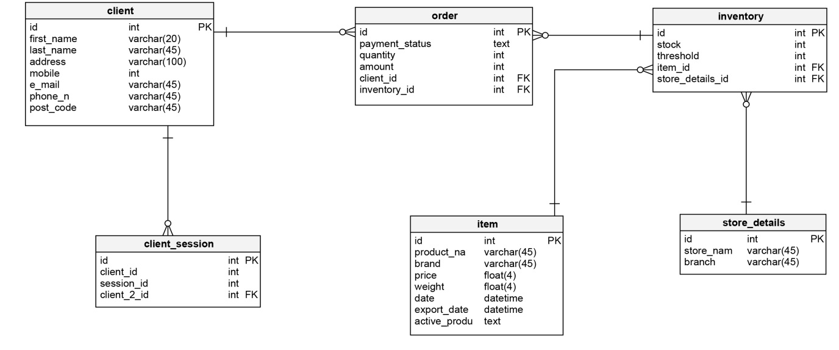

Fig. 3: ER Diagram

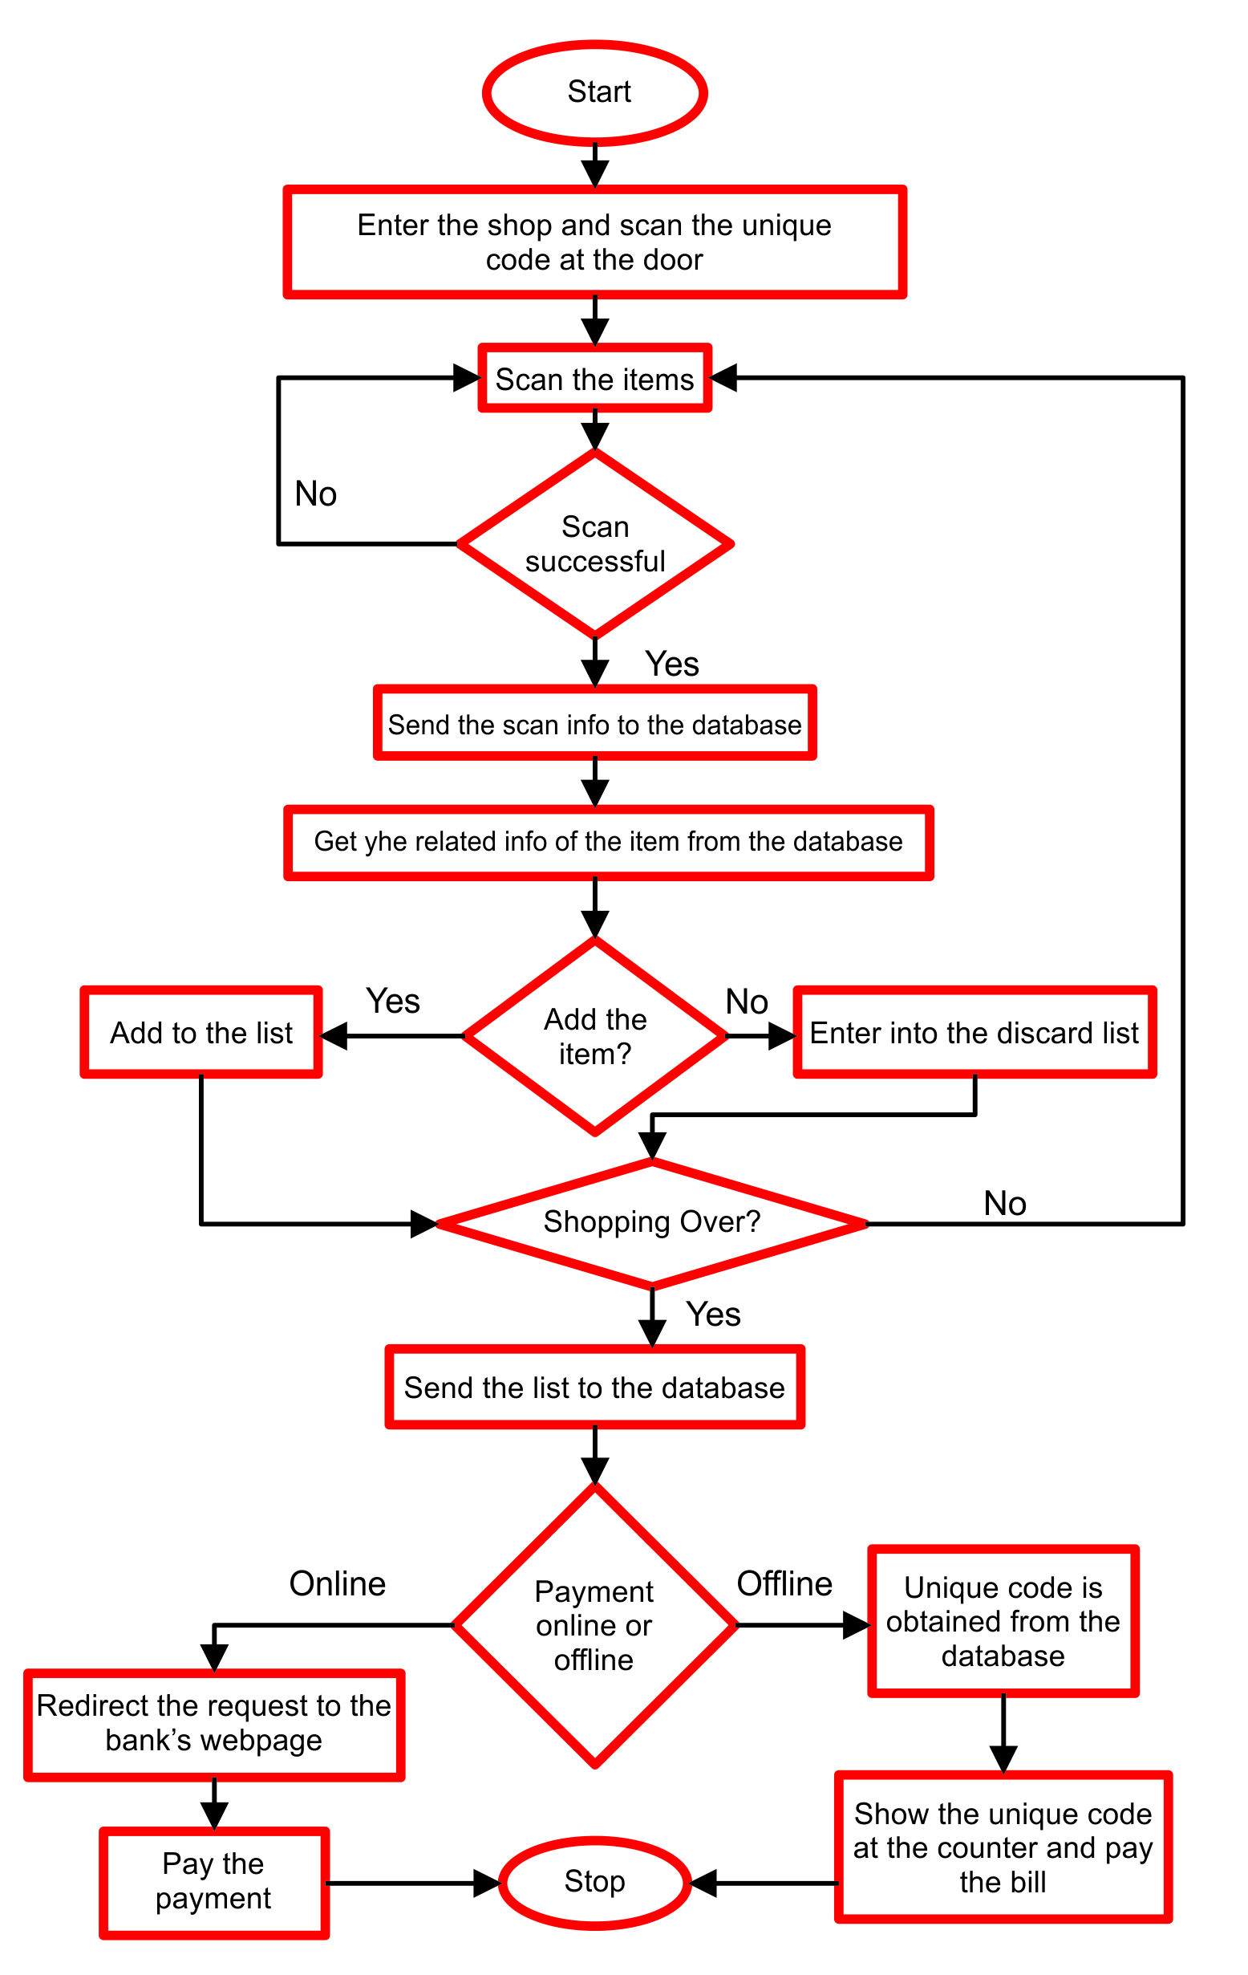
Fig. 4: Flow Graph
6. Android

"Android is based on Linux kernel and uses Dalvik Virtual Machine (DVM) for executing Java byte code .Absence of GNU C Library and some functions differentiate it from being Pure Linux. Android's source code is released by Google under open source licenses."[1]
The Android operating system is established itself as dominant operating system in the mobile device market. The advantages of Android are combining architectural solutions and open source and ability to cover an ever-expanding variety of devices and platforms, and related hardware extensions. The trends in the future of development of this operating system make this system suitable for the development of specialized system software for mass mobile computer-based devices.

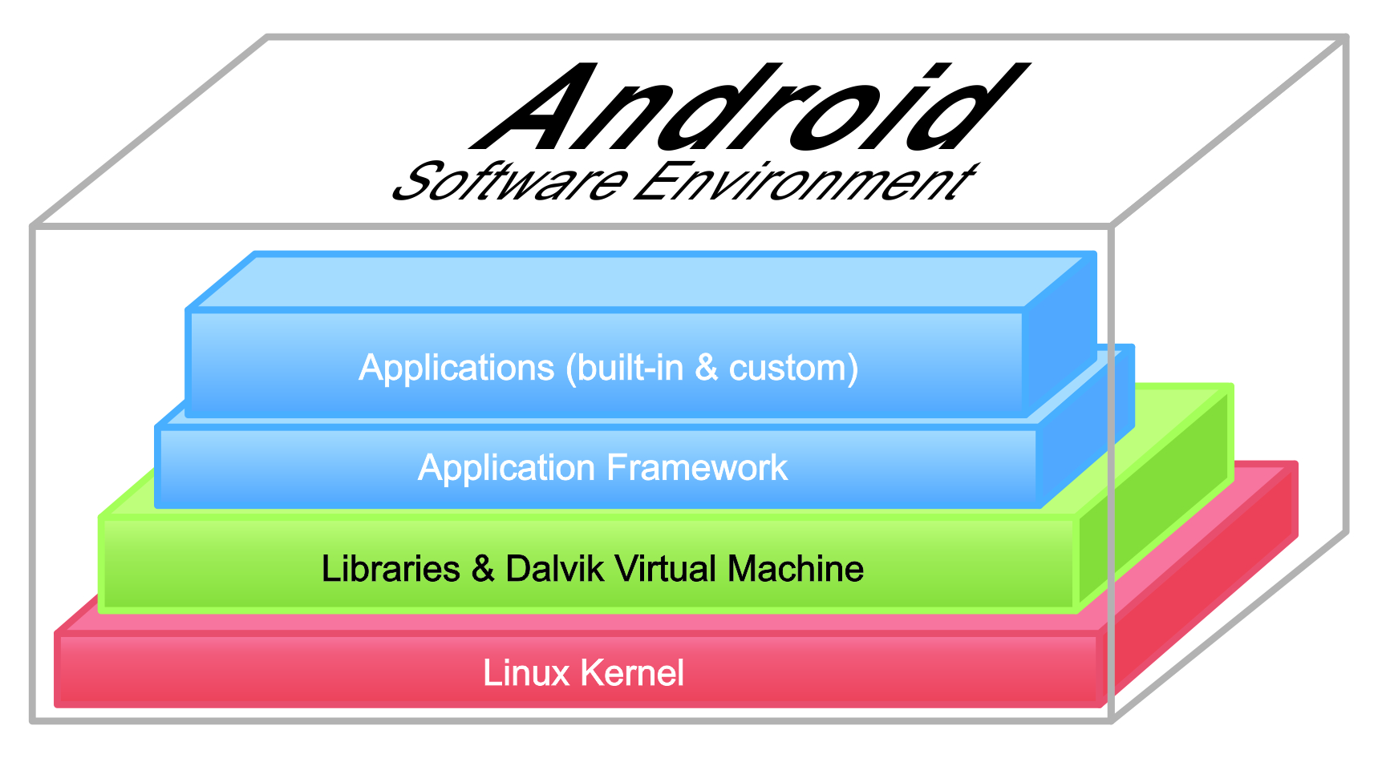
Fig. 5: Android Software Environment

The work is based on native mobile applications
These are applications for smartphones and tablets that are designed specifically for a particular mobile operating system
Main advantages of native applications
Excellent performance - Because native applications are designed specifically for a particular operating system, according to the relevant instructions, they are faster and finer compared. This makes them ideal for business development, media promotion and game development.
They provide direct access to the functionality of mobile devices

7.Methodology
I use Qualitative data - flow diagram, RE diagram, with which to present the information needed to create the application which data are organized in tables. The data are nominal categorical variables which does not allow us to perform any mathematical operations and strictly quantitative data. The methodology I follow is step by step to explore the stages that are needed to create for the shop application. This research is descriptive which aim is exploratory research is to understand the problems and behavior of users of a particular coffee shop or small food kiosk.
I use secondary data necessary for the development of the application, but to formulate the problem of this type of kiosks I examine their hygiene requirements. These data are primary. I formulated the problem that it is necessary for different staff to service the cash register and prepare the order. There are many applications for online trading, but the problem they solve is customer convenience, while in this application the problem is of a hygienic point of view. The research in the mentioned sites aims to assess the non-cash charging and how it will contribute to solving their main problem, for which purpose I received the necessary information such as the products which they offer
The main goal is to analyze the methods by which to develop the application, to analyze the necessary means to achieve this and to design an application that scans the bar code of the selected product, summarizing purchases, payment and printing a receipt.
The target population is several small shops - kiosks. They are selected in terms of belonging to the company I work for. I will focus my development on one of them - Chicken King due to the fact that they are ready with digital materials at the moment.

8.Implementation
8.1 Application Features
• Reduces scanning time
• Personalization of items
• Maintains History of purchased products
• Provides information regarding Discounts and Offers

8.2 Technologies Used
• Android SDK
• ADT (Android Development Tool)
• ZXing
• MySQL 5.6
• Maven
• REST web service

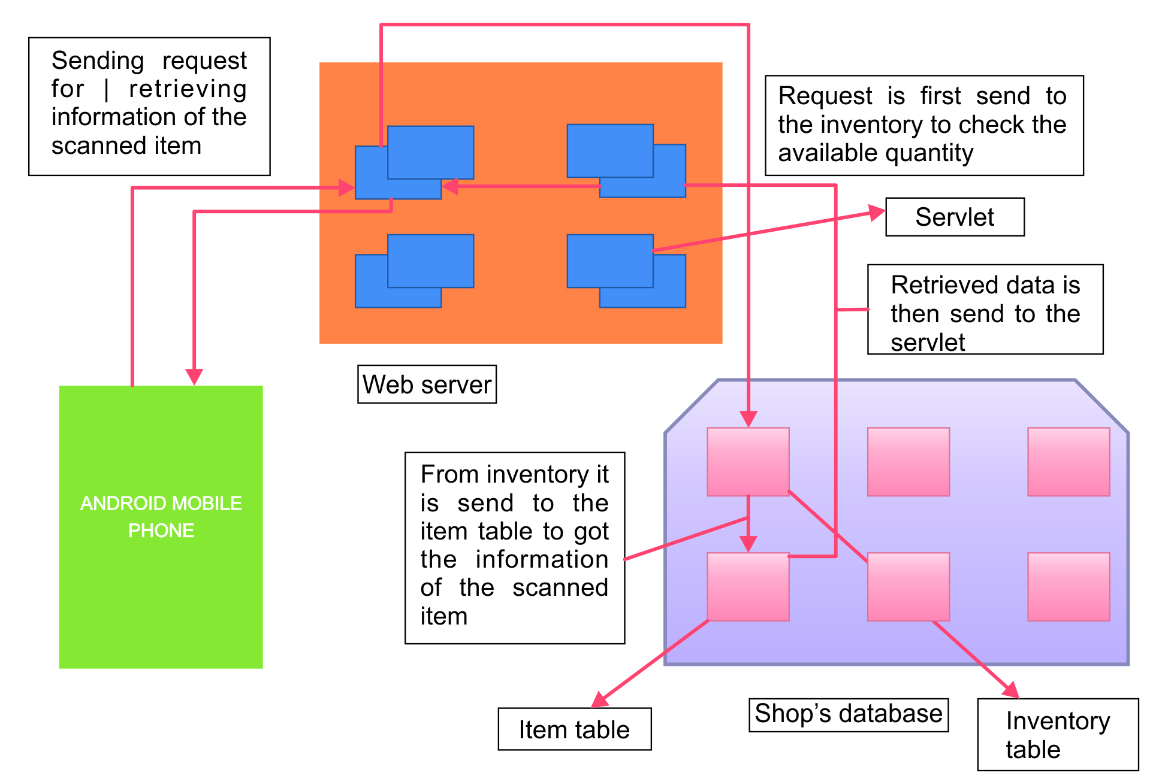
Fig. 6: Working of the app

Android SDK
It is the software development kit used for developing android apps. This kit includes:
• Debugger
• Libraries
• Quick emulator
• Documentation
• Sample code
• Tutorials
Android virtual device is used to get a view of an app. This SDK will be included in the android in the bundle called as ADT bundle. This ADT bundle is then extracted to get the above facilities.

Android Development Tool
It is the plugin for the eclipse with the help of which following tasks can be performed-
• Set up new Android projects
• Creating a new application UI
In total it provides an environment in which the android projects can be imported, build and run successfully.
ZXing - is the library which is used for scanning purpose and
used in this app for scanning the items to be purchased.
The following are the barcodes that can be read using ZXing:
• EAN-13
• EAN-8
• UPC-A
• UPC-E
• Code 39, Code 93 and Code 128
• QR Code
With this library, the barcode will be read and decoded and then converted into any specific number that will be unique for every product. This library can also be used for generating barcodes.
Maven
It is an automation tool which proves helpful in the building the java projects. It alone can provide various features like:
• Source code generation as well as compilation
• Packaging the source code into jar files and zip files
If any necessary plugins are required then they are downloaded from the repositories. The important thing for the maven is the POM file. POM file is the project object model file which is read by the maven every time when the code gets executed.

MYSQL
MYSQL is a RDBMS that supports:
• Multiple administrative tools
• Programs and libraries
• Application programming interfaces
It can run on different platforms like windows, MACOS and Linux. It is designed with the help of languages like C and C++ and uses kernel threads for most of its operation. Use of kernel threads allows MYSQL to use multiple CPU’S. In order to increase the execution speed MYSQL uses thread based memory allocation and optimized nested loop joins.

REST web service
As only the basic operations are to performed like CRUD (Create, Retrieve, Update, Delete) in this app, a lightweight web service was in need. This can be easily found in the REST web service. It is lightweight because it makes use of HTML and their basic commands like GET, POST, DELETE, etc.
The app uses following concepts for the UI-
• Fragment
• Navigation drawer
• ZXing
• Shared preference
A fragment is a portion of the user interface in an activity of an android. Navigation drawer is the facility in which there is a transition from the left edge. In this app, it shows all the app’s main options for the navigation.

9.Conclusion
The application described in this way is a prototype in which the basic principles and models are laid down. The starting point for future work is to follow the feedback from customers, and after this study more features will be added. There is a lot to be done to improve the way of shopping, protection of transactions, loading bonus points .It is necessary to complete the database software as well as to populate the database. I need to think about the design of custom screens for each type of activity.
Security features
Online transactions, as well as user’s personal data, must be as secure as possible. Some of the main tools to achieve this include:
- SSL certificate - It establishes a secure connection between the web server receiving the data and the web browser on which it is entered.
- Double verification - Here the user usually enters an additional code or password. An example is the passwords used when shopping online with debit and credit cards, which are part of the Verified by VISA and MasterCard Secure Code security systems.
- Privacy Policy - It should be posted on its own page in the online store and explain precisely and clearly how the data provided by customers is used and protected.
Greeting the customer will be the company logo, which is a type of advertising.

10.References

1. Benny Skogberg, Android application development, School of Technology Malmö University SE820506 Malmö Sweden.
2. Dr.Gagandeep Nagra, Dr.R.Gopal, “An study of Factors Affecting on Online Shopping Behavior of Consumer”,International journal of scientific and research publications, Volume3,issue 6,June 2013,ISSN:2250-3153
3. Constantinides, E., (2004), “Influencing the online consumer’s behaviour: The web experiences”, Internet Research, vol. 14, no. 2, pp.111-126
4.Falessi, D., Cantone, G., Kazman, R., Krutchen: Decision-making Techniques for Software Architecture Design: A Comparative Survey. ACM Computing Surveys 43(4) (2011)

11.Apendix

-- Table: client
CREATE TABLE client (
id int NOT NULL,
first_name varchar(20) NOT NULL,
last_name varchar(45) NOT NULL,
address varchar(100) NOT NULL,
mobile int NOT NULL,
e_mail varchar(45) NOT NULL,
phone_n varchar(45) NOT NULL,
post_code varchar(45) NOT NULL,
CONSTRAINT Group_student_id PRIMARY KEY (id)
);

-- Table: client_session
CREATE TABLE client_session (
id int NOT NULL,
client_id int NOT NULL,
session_id int NOT NULL,
client_2_id int NOT NULL,
CONSTRAINT client_session_pk PRIMARY KEY (id)
);

-- Table: inventory
CREATE TABLE inventory (
id int NOT NULL,
stock int NOT NULL,
threshold int NOT NULL,
item_id int NOT NULL,
store_details_id int NOT NULL,
CONSTRAINT Group_Day_pk PRIMARY KEY (id)
);

-- Table: item
CREATE TABLE item (
id int NOT NULL,
product_name varchar(45) NOT NULL,
brand varchar(45) NOT NULL,
price float(4) NOT NULL,
weight float(4) NOT NULL,
date datetime NOT NULL,
export_date datetime NOT NULL,
active_product text NOT NULL,
CONSTRAINT item_pk PRIMARY KEY (id)
);

-- Table: order
CREATE TABLE "order" (
id int NOT NULL,
payment_status text NOT NULL,
quantity int NOT NULL,
amount int NOT NULL,
client_id int NOT NULL,
inventory_id int NOT NULL,
CONSTRAINT order_pk PRIMARY KEY (id)
);

-- Table: store_details
CREATE TABLE store_details (
id int NOT NULL,
store_name varchar(45) NOT NULL,
branch varchar(45) NOT NULL,
CONSTRAINT store_details_pk PRIMARY KEY (id)
);

-- foreign keys
-- Reference: client_session_client (table: client_session)
ALTER TABLE client_session ADD CONSTRAINT client_session_client
FOREIGN KEY (client_2_id)
REFERENCES client (id);

-- Reference: inventory_item (table: inventory)
ALTER TABLE inventory ADD CONSTRAINT inventory_item
FOREIGN KEY (item_id)
REFERENCES item (id);

-- Reference: inventory_store_details (table: inventory)
ALTER TABLE inventory ADD CONSTRAINT inventory_store_details
FOREIGN KEY (store_details_id)
REFERENCES store_details (id);

-- Reference: order_client (table: order)
ALTER TABLE "order" ADD CONSTRAINT order_client
FOREIGN KEY (client_id)
REFERENCES client (id);

-- Reference: order_inventory (table: order)
ALTER TABLE "order" ADD CONSTRAINT order_inventory
FOREIGN KEY (inventory_id)
REFERENCES inventory (id);

