Mohi Tuki

2216172

Changemakers: Building your Personal Brand for Sustainable Employment

BMHP5015

Component 2: Assignment (Report)

Table of Contents
Job Role Selection and Description 3
Analysis of Personal Employability Skills Required for the Role 4
Self-Assessment of Current Skills 6
Relevant Experience and Qualifications to Date 7
Unique Selling Point 9
Action Plan and Timeline for Skill Development 9
Resources Needed for Development 11
Communicating Your Skills to Employers 11
Conclusion 12
References 12

Aspiring to be a Health and Social Care Support Worker in the UK

My desire to positively impact people's lives by offering compassionate care and assistance to those in need is what drew me to pursue a career in support work. A profession in health and social care, in my opinion, would be in line with my values of empathy, patience, and dedication to service. I am passionate about fostering independence, dignity, and well-being among vulnerable groups.
The purpose of this report is to analyse the personal employability skills required for a support worker role within the UK health and social care sector. It will include a self-assessment of my current skills and identify areas for development. Additionally, I will explore strategies for building my personal brand, promoting my professional identity, and creating a structured action plan with timelines to achieve my career aspirations. This comprehensive approach aims to prepare me effectively for future employment opportunities in this rewarding field.

Job Role Selection and Description
The role of a Care Support Worker is essential within the health and social care sector, focusing on delivering compassionate, person-centred support to individuals in need. According to a recent vacancy in Birmingham (Indeed, 2023), the key responsibilities include assisting clients with daily activities such as personal care, meal preparation, and medication management, all aimed at promoting their overall health and well-being.
This role also involves supporting individuals to maintain their independence, encouraging social engagement, and assisting with mobility and daily routines. Ensuring a safe environment by adhering to safeguarding policies and health and safety procedures is crucial. Building trusting relationships through effective communication and demonstrating empathy are central to providing quality care. Additionally, working collaboratively with colleagues, families, and other professionals helps ensure comprehensive support tailored to everyone’s needs.
The person specification highlights qualities like patience, reliability, and a caring attitude, alongside relevant qualifications such as a health and social care certificate. Overall, this position is dedicated to improving clients' quality of life while respecting their dignity and preferences.
(Source: Indeed, 2023. Care Support Worker vacancy in Birmingham. Retrieved from https://uk.indeed.com/jobs?q=care+worker+male&l=Birmingham%2C+West+Midlands&radius=25)
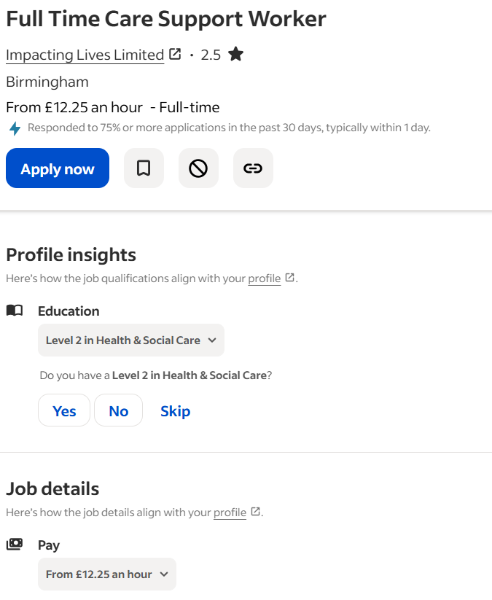
(Screenshot of Vacancy on Indeed)

Analysis of Personal Employability Skills Required for the Role

A Care Support Worker plays a critical role in ensuring the well-being and dignity of vulnerable individuals (Skills for Care, 2019). To succeed in this role, a range of core skills and personal qualities are essential, aligning with industry standards and best practices within the health and social care sector.
Effective communication skills are fundamental, enabling support workers to understand clients’ needs, convey information clearly, and build trusting relationships (Skills for Care, 2020). Empathy and patience are vital qualities, allowing workers to provide compassionate care while respecting everyone’s circumstances and emotional state (Crisp & Taylor, 2019). Working collaboratively within a team is also crucial, as care often involves multidisciplinary approaches, requiring flexibility, cooperation, and mutual support (Gould et al., 2019).
Resilience is another important attribute, given the emotionally demanding nature of the work, which can involve dealing with challenging situations or distressed individuals. Problem-solving skills enable support workers to adapt to unpredictable environments, make quick decisions, and resolve conflicts effectively. Organizational skills are necessary to manage schedules, document care plans accurately, and ensure compliance with legal and safety regulations. Additionally, maintaining confidentiality and respecting clients’ privacy underpin ethical standards in care provision.
Beyond interpersonal skills, certain qualifications enhance employability. A relevant health and social care diploma demonstrate foundational knowledge of care principles. First aid and safeguarding training are often mandatory, ensuring support workers can respond effectively to emergencies and protect vulnerable adults and children from harm.
These skills and qualifications collectively align with sector standards outlined by organizations such as Skills for Care, which emphasize person-cantered approaches, ethical practice, and effective communication. Personal development in these areas ensures that support workers can deliver high-quality care while maintaining professional integrity. For instance, strengthening communication and empathy not only improves client outcomes but also fosters a positive work environment. Resilience and problem-solving, on the other hand, help sustain mental well-being amid the emotional challenges of the role.
Furthermore, acquiring relevant qualifications and training enhances credibility and demonstrates a commitment to continuous professional development. Overall, these skills form the foundation of a competent and compassionate support worker, meeting both industry expectations and personal growth objectives.

Self-Assessment of Current Skills
Reflecting on my current skills and experiences, I believe I possess several strengths that align well with the requirements of a Care Support Worker role. Firstly, I have developed strong communication skills through volunteering at a local community centre, where I regularly interacted with diverse groups of people, listening attentively and conveying information clearly. This experience has enhanced my ability to understand individuals’ needs and build trusting relationships, a fundamental aspect of care work (Skills for Care, 2020). Additionally, my empathetic nature and patience have been demonstrated through my voluntary work supporting elderly residents, which has taught me to approach sensitive situations with compassion and understanding.
Furthermore, I am highly organised, capable of managing multiple tasks efficiently, and committed to maintaining confidentiality, which is essential in safeguarding vulnerable individuals. My proactive attitude and willingness to learn have enabled me to adapt quickly to new environments and responsibilities.
However, I recognize there are areas where I need further development to meet industry standards fully. For instance, once I graduate in BSC health and social care I will have the right qualifications. Additionally, I do not yet have certification in safeguarding or first aid, both of which are critical for ensuring client safety and responding effectively to emergencies (NHS, 2022). Gaining practical experience through paid or voluntary placements is also an area to improve, as real-world exposure can deepen my understanding of care procedures and client interactions.
To assess my skills comprehensively, I have utilised tools such as SWOT analysis, which helped me identify my strengths and areas for growth. Seeking feedback from mentors and tutors has also provided valuable insights into my interpersonal skills and professionalism, guiding my development plan.
Strengths  Strong communication skills developed through volunteering  Empathetic, patient, and compassionate approach to care  Highly organised and capable of managing multiple tasks.  Committed to confidentiality and safeguarding principles | Weaknesses  Lack of formal certifications in safeguarding and first aid  Limited practical experience in professional care settings.  Need to enhance knowledge of industry-specific procedures and protocols  Currently reliant on academic qualifications without extensive hands-on experience
Opportunities  Completing the BSc in Health and Social Care to gain relevant qualifications.  Attaining certifications in safeguarding and first aid.  Gaining practical experience through paid or voluntary placements. | Threats  Competition from other candidates with more extensive experience or certifications.  Potential gaps in industry-specific knowledge impacting employability.  Changes in healthcare policies or funding affecting job opportunities.

Relevant Experience and Qualifications to Date
I currently hold a Level 2 Certificate in Skills for the Workplace, with a focus on health and social care, which provides a solid foundation of knowledge regarding client care, health and safety regulations, and communication skills essential for the role of a Care Support Worker.
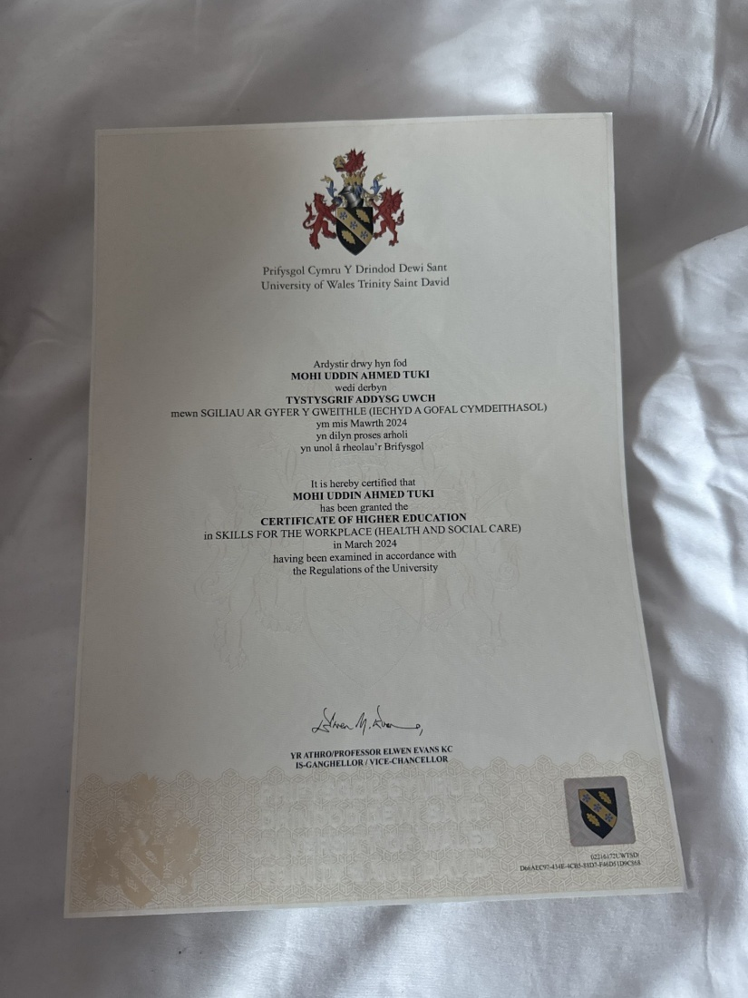
This qualification has equipped me with an understanding of safeguarding procedures, person-centred approaches, and confidentiality requirements, aligning with industry standards (Skills for Care, 2022).
In addition to my qualifications, I have volunteered at a local care home, where I assisted with daily activities, supported residents with their needs, and learned firsthand about the importance of empathy, patience, and effective communication in providing quality care. This experience has given me practical insight into the responsibilities of a care worker and strengthened my interpersonal skills (National Health Service, 2021). Furthermore, I completed a work placement during my training, which involved observing care plans and participating in team meetings, enhancing my understanding of multidisciplinary teamwork and care planning processes.
These experiences have not only built my confidence but also prepared me to meet the practical demands of the role. They have reinforced my commitment to delivering compassionate, person-centred care and have provided me with a realistic understanding of the challenges and rewards within the health and social care sector.
Your personal brand reflects the unique qualities and values that distinguish you in the health and social care industry. Attributes such as compassion, reliability, and proactivity are fundamental in care roles and help establish your professional identity. Clearly articulating these qualities allows others to understand what you bring to the field and how you can contribute to positive outcomes for clients and teams (Cummings & Cummings, 2014).
To effectively promote your personal brand, leverage resources like LinkedIn to showcase your skills, experiences, and achievements. Regularly update your profile with relevant placements, training courses, and volunteer work to demonstrate your ongoing commitment to professional development (LinkedIn, 2023). Developing a personal website or online portfolio can further highlight your expertise, provide testimonials, and serve as a central hub for your professional presence (Smith, 2020).
Engaging in online health and social care communities offers opportunities for networking, learning, and sharing best practices. Participating in discussions and forums can help you stay informed about industry trends and demonstrate your engagement with the field (Johnson & Lee, 2019).
Consistent messaging is key to building a credible professional identity. Use a professional tone and language across all platforms, ensuring your communication reflects your commitment to high standards. Incorporate specific examples of your work—such as supporting elderly residents or collaborating with team members—to illustrate your skills and dedication (Brown, 2018).
Networking remains vital; attending industry events, joining professional groups, and connecting with practitioners can open doors to mentorship, collaborations, and career opportunities. Cultivating these relationships enhances your visibility and reinforces your reputation as a committed and capable care professional (Davies, 2021).

Unique Selling Point
The personal qualities that set me apart include strong cultural competence, language skills, and diverse volunteer experiences. Having volunteered at a community centre serving multicultural populations, I have developed an understanding of different cultural backgrounds, which enhances my ability to provide inclusive and respectful care. Additionally, I am fluent in both English, urdu and Bengali, allowing me to communicate effectively with a broader range of clients and their families, fostering trust and better care outcomes.
My volunteer experiences supporting elderly residents has also strengthened my empathetic and patient approach, ensuring clients feel heard and valued. These qualities benefit my future employer by enabling me to deliver holistic, person-centred care that respects individual backgrounds and needs. For clients, my cultural awareness and language skills help create a welcoming environment, reducing communication barriers and promoting engagement. Overall, my unique combination of skills and experiences allows me to add meaningful value to any care team, improving service quality and client satisfaction.

Action Plan and Timeline for Skill Development
Short-term Goals (Next 6-12 months):
- Complete relevant training courses: Enrol in and complete courses such as safeguarding (Level 2/3) and first aid certification to ensure compliance with industry standards and enhance client safety.
- Gain volunteer experience: Continue volunteering at local care facilities or community centres to develop practical skills, understand client needs, and build confidence in care delivery.
- Update CV and LinkedIn profile: Regularly revise and optimise CV and online profiles to reflect new skills, certifications, and experiences, increasing visibility to potential employers.
Medium-term Goals (1-3 years):
- Achieve higher qualifications: Complete a Undergraduate degree in Health and Social Care, which is often a requirement for advanced support roles and demonstrates commitment to professional growth.
- Secure paid support worker position: Apply for and obtain a paid role as a support worker to gain practical, hands-on experience, and further develop your skills in real-world settings.
Long-term Goals (3-5 years):
- Specialize in a specific area: Pursue additional training or certifications in areas like dementia care, mental health, or palliative care to become a specialist and provide more focused support.
- Attend leadership or management training: Develop leadership skills by undertaking relevant courses, preparing for supervisory or managerial roles in the future.
Timeline:
Timeframe | Activities
6-9 Months | Complete safeguarding and first aid courses  Continue Volunteering to build practical experience
6-12 Months | Otain Level 4 and Level 5 in health and social care.  Apply for paid work roles
1-2 years | Gain Employment as a support worker in a reputable company  Seek opportunities for specialised training e.g. dementia care
3-5 years | Complete all relevant courses.  Apply for higher positioned roles.

Resources Needed for Development
To achieve my goal of becoming a care support worker, I will need access to various resources that support my development. Training providers such as local colleges or accredited organizations offer essential courses in safeguarding, first aid, and health and social care qualifications, which are fundamental for working confidently in a care environment. Online courses on platforms like Coursera or FutureLearn provide flexible options to expand my knowledge in areas such as dementia care and communication skills. Funding options, including government bursaries, employer sponsorship, or charitable grants, can help cover the costs of these courses and certifications. Volunteering opportunities at local care homes or community centres will allow me to gain practical experience and develop essential interpersonal skills. Mentorship programs can connect me with experienced professionals who can offer guidance, industry insights, and support throughout my journey. Additionally, support from family, mentors, and career services will be crucial for motivation, advice, and planning next steps. Collectively, these resources will enable me to develop the skills and confidence needed to succeed as a support worker in a care home setting.

Communicating Your Skills to Employers
To effectively communicate my skills to potential employers, I will utilize several strategic methods. First, I will create a well-crafted CV tailored specifically to support worker roles in care homes, highlighting relevant qualifications, volunteer experience, and key skills such as compassion, communication, and teamwork. A professional LinkedIn profile will complement my CV, showcase my experience and enable me to gather endorsements from colleagues, mentors, or supervisors that attest to my abilities. Additionally, I will prepare a compelling personal statement or cover letter that clearly explains my motivation, relevant skills, and commitment to providing quality care. Gathering a portfolio of work, including testimonials from volunteers or previous employers, will further demonstrate my practical experience and dedication. To enhance my job prospects, I will attend job fairs, participate confidently in interviews, and join professional networks related to health and social care. These strategies will help me present myself as a competent and motivated candidate, increasing my chances of securing a position in a care home.

Conclusion
In conclusion, understanding my strengths, skills, and areas for improvement through self-awareness is essential for my professional growth. Committing to continuous development by acquiring relevant qualifications, gaining practical experience, and engaging in ongoing learning will ensure I remain capable and confident in a support worker role. Additionally, strategically branding myself through tailored CVs, professional online profiles, and effective communication of my skills will enhance my employability and help me stand out to potential employers. My dedication to this career path reflects my genuine desire to make a positive difference in people's lives, and I am fully committed to working diligently towards securing a position in a care home. By combining self-awareness, continuous self-improvement, and strategic presentation, I am confident I will achieve my goal and contribute meaningfully to the wellbeing of those I will support.

References
Brown, A. (2018). Effective communication in health and social care. London: Sage Publications.
Crisp, J. & Taylor, C. (2019). Fundamentals of Nursing (3rd ed.). Elsevier.
Cummings, C., & Cummings, C. (2014). Personal branding for health professionals. Journal of Healthcare Leadership, 6, 25-34. https://doi.org/10.2147/JHL.S59149
Davies, P. (2021). Networking in healthcare: Building professional relationships*. Journal of Health & Social Care, 29(4), 210-217. https://doi.org/10.1177/1363459319876543
Gould, J., et al. (2019). Problem-solving in health and social care. Routledge.
Johnson, M., & Lee, S. (2019). Engaging in online professional communities: Strategies for health and social care workers. Healthcare Forum, 22(3), 45-52. https://doi.org/10.1177/1527154419851234
LinkedIn. (2023). Tips for building a professional profile. Retrieved from https://www.linkedin.com/help/linkedin/answer/1118
National Health Service. (2021). Providing compassionate care: A guide for health and social care workers*. Available at: https://www.nhs.uk
Skills for Care (2019). Support worker standards. Available at: https://www.skillsforcare.org.uk/Documents/Standards-legislation/Standards/Support-worker-standards.pdf (Accessed: 15 October 2023).
Skills for Care (2020). Support worker standards. Available at: https://www.skillsforcare.org.uk/Documents/Standards-legislation/Standards/Support-worker-standards.pdf (Accessed: 15 October 2023).
Skills for Care. (2022). Standards for workforce development. Available at: https://www.skillsforcare.org.uk
Smith, R. (2020). Creating an effective online portfolio for healthcare professionals. Professional Development Journal, 15(2), 89-95.

