

Data Security, Governance and Compliance

Programme Name: MSc Cybersecurity & Digital Forensics
Module Name: Ethical Hacking
Module code: ACCA7033
Lecturer: Dr. Mohamed Ghanem
Student Name: Ashthaben Girishbhai Babariya
Student ID: 2507706

Abstract
This report is a design/implementation/verification of an Active Directory Domain Services (AD DS) environment (through the use of virtualization technology). The main aim of the practical was to create a working client server network that allows centralized user and computer authentication and control. It was implemented in a controlled laboratory setting with the virtualization platform being Oracle VirtualBox.
The Microsoft Windows Server 2019 was used as a Domain Controller with the Server Core mode of installation to represent the highest level of deployment practices. Active Directory domain service and DNS were installed and configured in order to create a new domain called cpc.local. Now Windows client system was installed and successfully connected to the domain through configuration of relevant network and DNS settings. The server and client communication were tested using connectivity tests, domain log in validation tests, and identity validation commands.
The report outlines the requirements of the system, network design, implementation methodology, testing procedures and troubleshooting procedures applied in the practical. A number of obstacles were faced, such as administration by command line only, DNS misconfiguration, and display problem in virtualization among others. The positive outcome of the practical proves the efficiency of the Active Directory to achieve the centralized authentication and management. The work is a practical guide to the enterprise network administration and emphasizes the need to plan, configure, and troubleshoot all of the network environments based on the directory.
Table of Contents
Introduction 5
Objectives of the Practical 6
Background Study 6
System Requirements and Tools 8
Network Design and Architecture 9
Methodology and Implementation 10
Creating a Virtual machine 11
Server Installation and Configuration 12
Active Directory Domain Services configuration 14
Client Installation and Set-up 15
Domain Join Process 15
Testing and Verification 16
Problems encountered and troubleshooting 18
Results and Observations 19
Conclusion 20
Future Scope 21
References 23
Appendix 25

List of Figures
Figure 1 : Logical network architecture of CPC domain environment implemented using Oracle VirtualBox 9
Figure 2: Virtual machines created in Oracle VirtualBox 11
Figure 3 : Windows Server Core management using SConfig utility with access to PowerShell for advanced configuration 12
Figure 4 : Network configuration using SConfig utility on Windows Server Core 13
Figure 5 : Client connectivity verification and domain join attempt output 14
Figure 6 : Confirmation message showing successful password configuration for the domain user Employee in Active Directory Domain Services. 16
Figure 7: Server Manager view confirming successful deployment and online status of Active Directory Domain Services (AD DS) on CPC-SERVER. 17
Figure 8 : Successful DNS resolution and network connectivity test using ping cpc.local 19
Figure 9 :Network configuration of Domain Controller (CPC-Server) 20

Introduction
Handling a huge amount of computers, users, resources in a modern organization is inefficient and prone to errors. In order to beat this problem, there is a wide usage of centralized directory services. Active Directory (AD) is a Microsoft-based system of directory service, which allows the centralized management of users, computers, permissions, and security policies in a network (Hughes, 2022). It is significant in enterprise set ups as it facilitates authentication, authorization as well as administration of resources in a well-organized and safe form.
Active Directory is based on a client-server model with a central server referred to as a Domain Controller (DC) that has a database of all network objects including user, group, computer and policies. Domain Controller authenticates the users when providing them with access and implements security policies within the domain. With the help of Active Directory, administrators may now control the whole network at one location, instead of establishing each system separately (Omotunde and Ahmed, 2023). This will go a long way in minimizing administrative overhead and enhancing security and consistency.
A centralized management is one of the most important advantages of Active Directory. It enables the administrators to create users, assign permissions, issue Group Policies, and centrally manage resources. As an example password policies, access rights and software restrictions can be applied to all domain-joined computers uniformly. This guarantees the control, the security and simplifies the maintenance of IT infrastructure.
Virtualization is widely applied in order to safely experiment with and implement such enterprise level technologies. Virtualization allows several operating systems to be run on one physical machine by the use of virtual machines (VMs) (Johnson, 2025). In this practical, windows server (Domain Controller) and windows client systems were deployed in isolated virtual environments with the help of the Oracle VirtualBox. This will remove the physical hardware requirements, cost is minimized and can be easily tested, configured and recovered.
This practical will involve the installation and configuration of Windows Server 2019, Active Directory Domain Services (AD DS), creating a new domain, configuring the DNS, and adding a Windows client system to the new domain. The practical is also aimed at being able to learn the idea of the client-server communication, domain authentication, and the problem solving of typical issues during the implementation. This exercise will provide practical application of theory on real-world concepts of network administration, and will equip learners with enterprise IT settings.

Objectives of the Practical
The main goal of this practice is to learn and apply Active Directory Domain Services (AD DS) on a managed virtual setting. It entails installation of a Windows Server as a Domain Controller, a new domain and centralization of authentication and authorization. The practical is designed to illustrate the manner in which centralized user and computer control can be done in an enterprise network by use of technology of the Active Directory.
The secondary goals will be to get actual experience in working with virtualization through Oracle VirtualBox, to install and arrange the work of Windows Server 2019 and Windows client operating systems, to learn how the server and client computers interact in a domain-based network. The other valuable goal is to ensure that the necessary services are set up to guarantee effective communication between the server and the client systems like DNS, network settings, and membership of a domain.
Moreover, this practical will instruct the students in the use of GUI-based administration tools and command-line-based (CLI) administration tools (Server Manager, PowerShell, and Server Core) as well. Another important goal is to trouble-shoot common problems like failure to join a domain, network misconfiguration and service requirements.
The anticipated learning objectives will be a clear conception of client server architecture, Domain Controller role, centralized security management and practical system administration. This practice exposes the students to the management of the windows based enterprise network.

Background Study
Active Directory Domain Services (AD DS) refers to centralized directory service created by Microsoft to control the users, computers and resources of a network based on windows. It has been greatly embraced in corporate settings because it has the capability to offer secure authentication, authorization and centralized administration. AD DS is a database system that holds the information about the objects of the network in a structured form and helps the administrators regulate access to the resources through the predetermined policies (Francis, 2021). Microsoft documentation reveals that Active Directory makes the administration of the network easier since it facilitates single sign-on, centralized security enforcement, and scalable administration of the infrastructure of large enterprises.
One of the fundamental elements of the Active Directory is a Domain Controller (DC). The Domain Controller contains the Active Directory database and has a role of authenticating the users and computers in the domain. Once a user wants to log in, the Domain Controller verifies the request and only accepted credentials are used. This technology can be used to improve network security because it prevents unauthorized access and administrators can impose passwords, account controls and access control centrally. To achieve fault tolerance and redundancy, a number of Domain Controllers can be deployed in the enterprise setting.
The next key service that is closely integrated with the Active Directory is the Domain Name System (DNS). DNS can do the task of converting domain names into IP addresses enabling clients to find Domain Controllers and other network services. Active Directory cannot operate properly without the use of DNS because the domain join operation, the authentication process and the service discovery process all rely on correct DNS resolution. The Domain Controller can serve as the DNS server in an AD environment, and it has service (SRV) records where clients can find authentication and directory services (Fernandez, 2023). The failure of Active Directory working will occur without proper DNS configuration, as domain joining and user authentication will fail.
Windows server may be installed as a server core or desktop experience (gui) mode. Server core is a simple installation option that does not provide a graphical user interface and has a smaller system resource usage and attack surface. It is also popular in corporate settings where security, performance and minimized maintenance are the concern. Desktop Experiences, in contrast, offer a complete graphical interface, which is easier to administer by novice users and any situation that may need GUI based tools to be used. Although both alternatives are useful with the support of Active Directory, Server Core is usually chosen in the production setups because it offers more security and efficiency.
Active Directory is based on a client server architecture, with the server (Domain Controller) offering authentication services and directory services, and the clients requesting access to the services. To enjoy the management through centralization, client machines need to be attached to the domain. Clients will then authenticate to the Domain Controller as opposed to the local accounts once they are joined. This architecture allows centralization of users, consistent application of policies and effective sharing of resources; characteristics that are vital in enterprise networks.
Active Directory is used in practice to administer thousands of users and devices in departments and locations of a real enterprise. It provides logical structuring of organizational units (OUs), group policies to implement security settings, and group-based access control to control the permissions effectively. AD is generally combined with file servers, email solutions, and cloud solutions to offer an integrated identity solution. Active Directory continues to be an underpinning technology in the current IT infrastructure as it is scalable, reliable, and secure.

System Requirements and Tools
This practical application involved a set of proper hardware facilities in combination with software programs to implement a client-server environment based on Active Directory at a successful level. The system requirements were chosen to provide stable operation in the state of running several virtual machines at the same time.
Hardware wise, it required a host system that has a minimum of 8 GB RAM, a 64-bit processor with virtualization features (Intel VT-x or AMD-V), and a minimum of 100 GB of free disk space (Mettrick, 2022). It was necessary to have adequate memory and CPU resources to operate the Windows Server and Windows Client virtual machines at the same time without compromising performance. Virtualization support had been enabled in the system BIOS in order to enable the Oracle virtualbox to work properly.
Oracle VirtualBox was the main virtualization software that was applied. VirtualBox was selected as the open-source software is free to use and has been greatly used in academia and professional settings (Borislav Đorđević, Nenad Kraljević and Kuk, 2024). It is compatible with many operating systems, it offers flexible network connectivity and it is easy to create a virtual machine and delete or recover them. These characteristics render VirtualBox an appropriate tool that can be used to simulate enterprise network environments in a safe manner without the requirement of physical servers.
In the case of the server operating system, windows server 2019 was chosen. Windows server 2019 stabilizes support on Active directory domain services (AD DS), DNS and other essential services to an enterprise. The Server Core installation option was selected to minimise overheads of the system and enhance security by ensuring that the attack surface is minimal as it represents the actual practices related to enterprise deployment.
The operating system employed by the client was Windows 10 / Windows 11. A client OS is mandatory to present an end-user system, which is capable of being a member of an Active Directory domain. Windows client operating systems are fully integrated with Active Directory and can be used with domain authentication, centralized policy enforcement, and network resources access.
Combining these tools and system requirements offered a solid and realistic platform on how to implement and test the Active Directory Domain Services on a virtualized environment.

Network Design and Architecture
The network architecture applied in this practical is client-server architecture that is commonly applied in the enterprise. Architecture It is a centralized Domain Controller (CPC-Server) and a domain-joined client machine (CPC-Client). Both systems are rented as the virtual machines in the Oracle VirtualBox where all the network can be deployed in the isolated and controlled environment.
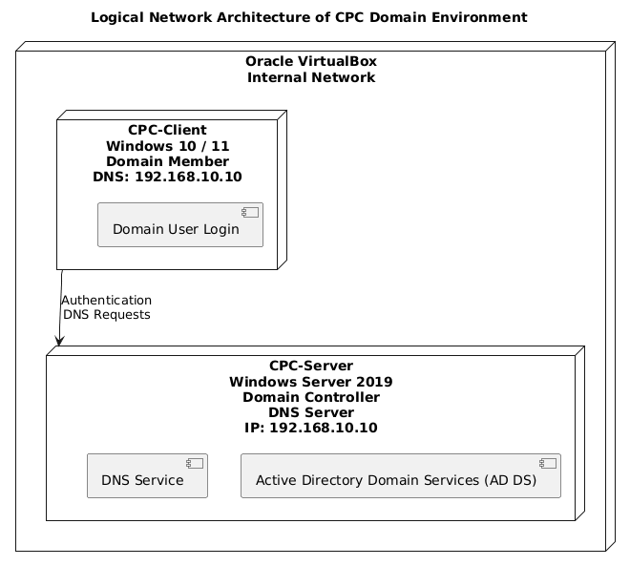
Figure 1 : Logical network architecture of CPC domain environment implemented using Oracle VirtualBox
The logical network design is purposely basic in order to concentrate on the essential Active Directory functionality. Active Directory Domain Services (AD DS) and Domain Name System (DNS) are provided on a single domain controller (Smirnov, 2024). Client machine depends on the server to provide authentication services, name resolution services and domain-related services. This design is representative of a small scale network of enterprise where only one domain controller is used to administer users and devices.
The server-client authentication and management is centralized. The Domain Controller provides a directory database of user accounts, computer accounts and security policies. In case the client tries to log in with domain credentials, the authentication requests are sent to the Domain Controller. This guarantees that security is enforced consistently and there is no necessity of managing the local account of individual machines.
Network stability is realized with the help of a structured IP addressing scheme. The Domain Controller is set to have a static IP address that will make it accessible at all times. The importance of the static addressing is due to the fact that Active Directory and DNS services rely on a stable network identity. The client computer gains network access on a dynamic basis, but it is configured specifically to use the IP address of the Domain Controller as its primary DNS server (Fernandez, 2023b). This makes sure that there is reliability between client and server.
Active Directory architecture relies on the reliance on DNS. DNS allows the client to acquire the Domain Controller by means of service (SRV) records in the DNS database. This is because domain joining, user authentication and policy retrieval operations are based on proper DNS resolution. Active Directory services are incomplete without an appropriate DNS setup.
The network is carried out to be secure and isolated and is implemented in a VirtualBox internal network. This setup will not expose the virtual machines to the host network or external systems but will only allow communication among the virtual machines. Internal networking provides a secure testing environment and a reasonable simulating of an enterprise LAN without jeopardizing any interference with actual networks.

Methodology and Implementation
This section outlines the step-wise procedure used to design, implement and verify an Active Directory Domain Services (AD DS) environment with the help of a virtualization. This was implemented in a controlled laboratory setting to model a real world enterprise network. The methodology includes the creation of the virtual machine, the installation of the servers and clients, the setup of the Active Directory and domain join process.

Creating a Virtual machine
The implementation was divided into the initial step, which was the development of the necessary virtual machines with the help of Oracle VirtualBox. Virtualization has been selected because it was considered as a safe way of simulating an enterprise network without necessarily using physical hardware (Johnson, 2025b). Two major virtual machines were developed with one acting as the Domain Controller (CPC-Server) and the other as the client workstation (CPC-Client).
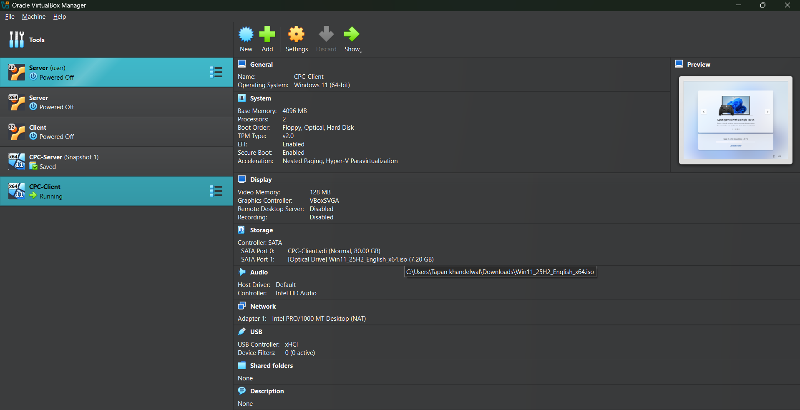
Figure 2: Virtual machines created in Oracle VirtualBox
The virtual machine server, CPC-Server was developed using Microsoft windows server. In the process of creation, proper resources had been given to maintain a stable performance. The server was allocated enough RAM and CPU resources to be able to provide Active Directory and DNS services. A dynamically growing virtual disk was used to assign disk storage in order to optimize the usage of storage of host system. Virtual machine was set up with one network adapter that was linked to an isolated virtual network to enable it to communicate with client machine but not be exposed to the outside world.
CPC-Client virtual machine was developed independently, on Windows client operating system. This system is a workstation on end user platform in an enterprise. The client received fewer resources than the server, which is realistic when deploying enterprise services in which the server is configured with more specifications than the user devices. The server was affiliated to the same virtual network as the client so that communication could be done with the client to facilitate domain authentication.
One aspect that was considered in this stage was resource allocation. Not enough memory or CPU service might cause a decrease in performance, failure to install or an unstable service. Thus, memory and processor allocation were the same according to the capacity of the host system. The default settings of VirtualBox have been changed where it is required to allow both machines to run efficiently at the same time. This phase laid the background to the whole implementation of Active Directory.

Server Installation and Configuration
Once the server virtual machine was created, windows server 2019 was installed in CPC-Server. Server Core is the type of installation that was chosen and offers a barebones installation with no graphical user interface. The choice of Server Core was due to the real world enterprise behavior in which minimized attack surface, enhanced performance, and minimized maintenance load are significant.
The installation of the operating system was done during the installation process in which a bootable ISO file was attached to the virtual machine (Saeed, Hassan and Qader, 2017). The steps involved in the installation were the selection of correct edition of the server, setting of regional settings and strong Administrator password. This password is very crucial because it is needed to promote domains as well as to continue accessing the administration.
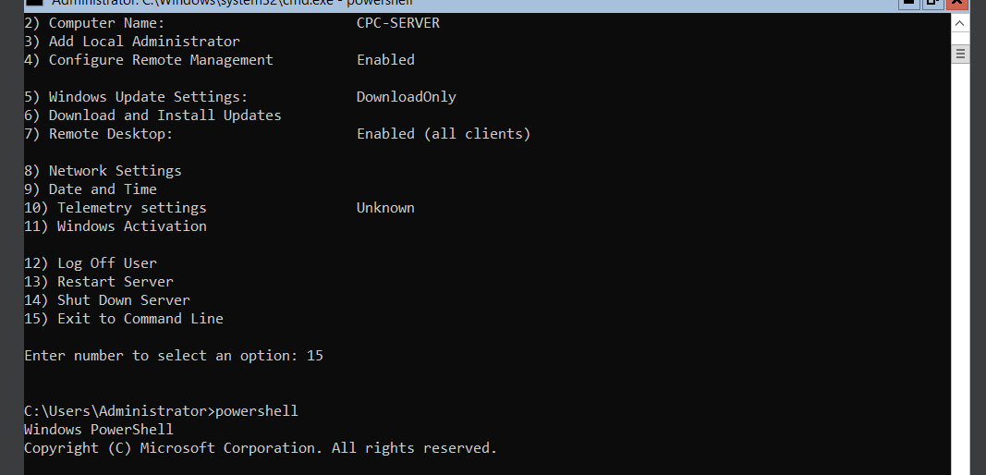
Figure 3 : Windows Server Core management using SConfig utility with access to PowerShell for advanced configuration
After installation was done, preliminary server configuration work was done. This server was renamed CPC-Server so that it can be easily defined as a part of the network. The domain environments should be named properly to prevent confusion and allow the same management. The changes were then implemented by restarting the server.
Another important step in preparation of server was network configuration. A Domain Controller was provided with a fixed IP address so that identity could be maintained in the network. Active Directory and DNS services are based on fixed addressing; hence, DHCP may be used on the server, which results in authentication and name resolution failure. The DNS setting of the server was also configured to reference itself as well as the static IP so that it would answer queries related to domain names on its own.
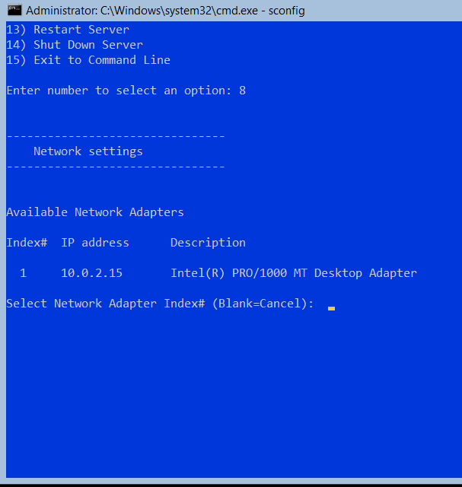
Figure 4 : Network configuration using SConfig utility on Windows Server Core
Administrative tasks were performed by the Server Core configuration utility (sconfig) as well as using the PowerShell. These tools enabled one to manage the settings of the systems effectively without the need to use a graphical interface. This phase allowed to make certain that the server was properly installed, properly set up, and awaiting Active Directory Domain Services deployment.

Active Directory Domain Services configuration
The second step was to install and configure Active Directory Domain services (AD DS) on the server. The fundamental service is AD DS which permits central authentication, authorization and directory management of a Windows domain condition.
PowerShell commands that are appropriate in server core environments were used to install the AD DS role (Margaret and Alice, 2021). This role also had the tools and dependencies needed to be installed like DNS services. Active Directory cannot be completed without DNS integration since it will enable clients to find Domain Controllers by following service records in the DNS database.
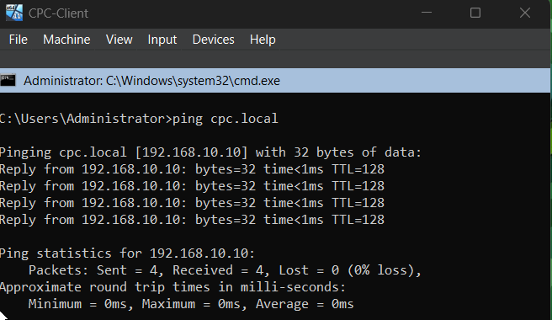
Figure 5 : Client connectivity verification and domain join attempt output
Once the AD DS role has been successfully installed, the server was advanced to a Domain Controller. In the process, a new forest and domain were formed having the domain name cpc.local. The creation of a new forest creates the basis of the Active Directory structure and offers a security perimeter to the organization. The naming of the domain was based on the internal enterprise naming rules and to prevent conflicts with the public domains.
A Directory services restore mode (DSRM) password was set as a part of the promotional process (Zavala, 2024). This is a very important security measure where recovery operations cannot be made without this password. After all the prerequisite checks were successfully done, the promotion process was done and the server automatically rebooted.
When the server was restarted it became a Domain Controller. Active directory database, DNS zones and authentication services were operational. The creation of the domain was checked with the help of command-line tools to make sure that the domain was created successfully and that the services of Active Directory were functioning properly. At this point, the server could handle users, computers as well as authentication requests within the domain.

Client Installation and Set-up
After the successful installation of the Domain Controller, the CPC-Client virtual machine was ready. The Windows client is a Windows operating system (Windows 10 or Windows 11), which was installed in a typical installation process with a graphical interface (Arshad et al., 2021). The local user account was created in the course of the installation because membership to the domain is set when the operating system has been set up.
After the installation was done, the client machine was renamed to CPC-Client to ensure it was in line with the enterprise naming conventions. Changes were then started by restarting the system. Correct naming will ensure that the client would be easily identified in the active directory when it is joined to the domain.
The client configuration of networks was an important process. DNS configuration was performed manually, in which the client was programmed to refer to the IP address of the Domain Controller. This is also a required step since Active Directory uses DNS to find authentication services. Lack of proper DNS set up would result in the failure of the client to find the domain or even finish domain join process.
There were some simple connectivity tests done to make sure that there is communication between the client and server. Effective name resolution and network connectivity were used to prove that the client was properly configured and available to be added to the domain.

Domain Join Process
The last implementation process was to connect CPC-Client to the cpc.local domain. In this process, the client is incorporated into the Active Directory space where the authentication and management can be handled centrally.
The domain join operation was done through PowerShell commands, because the operation is sure and applicable in a GUI and non-GUI environment (Kavousi et al., 2021). It was also given Domain Administrator credentials, which were required to add the client to the domain. When the authentication was successful, the system added the announcement that the client was added to the domain.
Once the domain join operation had taken place, the client was restarted. Reboot is necessary to make domain membership changes and boot up domain-based security policies. After the client restarted, the users could use domain credentials rather than local ones to log in.
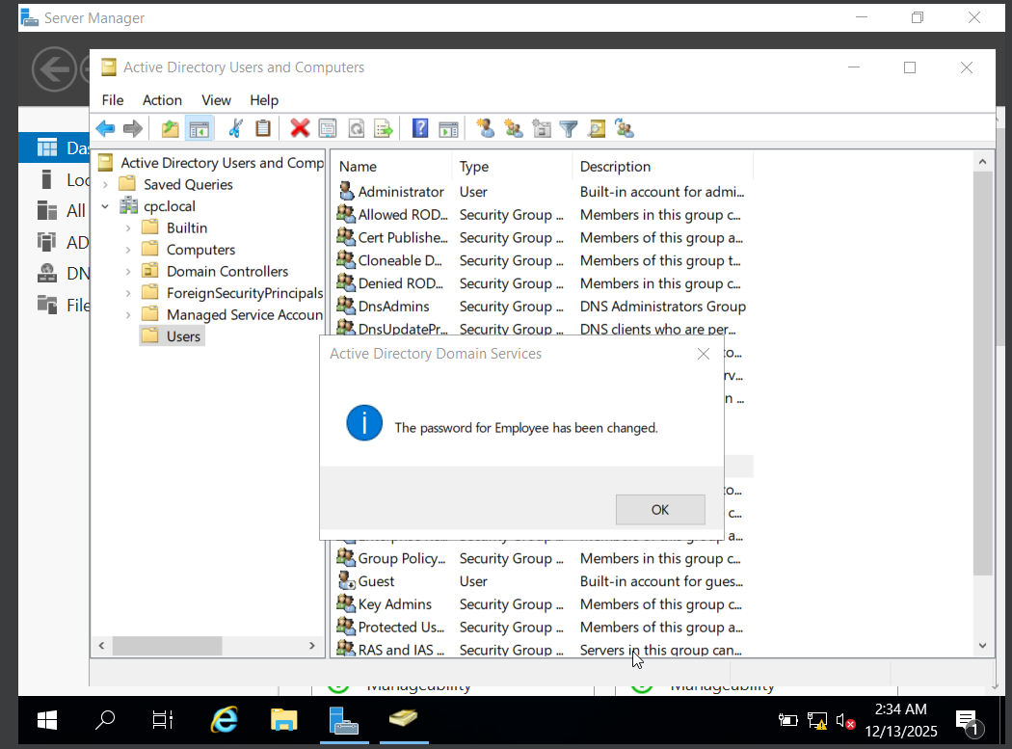
Figure 6 : Confirmation message showing successful password configuration for the domain user Employee in Active Directory Domain Services.
To verify this, the user made use of the domain account and ran commands of identity verification to verify domain authentication. The successful login and authentication was an indication that the client-server communication was working as expected and the Active Directory environment was operational to the fullest.

Testing and Verification
The testing and verification were to be performed so as to ascertain that the Active Directory Domain Services (AD DS) environment was properly set up and functional. These tests were on network connectivity, domain name resolution and authentication and identity checking between the server and client systems.
The initial verification measure was to check network connectivity and DNS resolution of the client machine. A command ping cpc.local was run on the client machine to ensure that the domain name was resolvable to the IP address of the Domain Controller. The replies were successful, and it proved that the DNS service was operating properly, and the client could find the Domain Controller by the domain name. Active Directory also makes high use of DNS to discover services, so this test was important to ensure that the basic network setup is correct.
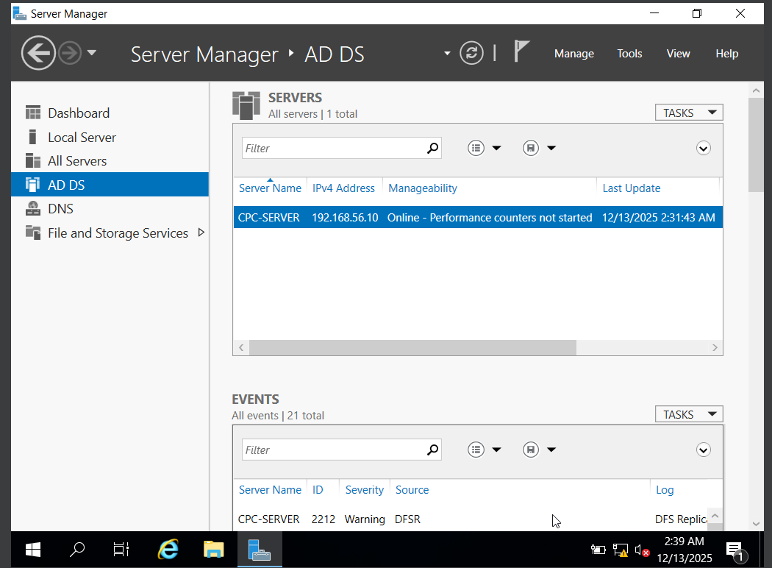
Figure 7: Server Manager view confirming successful deployment and online status of Active Directory Domain Services (AD DS) on CPC-SERVER.
Then, the domain login test was carried out. The system was restarted after it was added to the domain of the client machine. Local user credentials were not used at the login screen; rather, the use of domain credentials was done. When the domain administrator account was used to log in, it was verified that the client was logged in successfully by the Domain Controller (Motero et al., 2021). This showed that, centralized authentication was operating on basis and the client was duly incorporated into the domain setting.
In order to further confirm authentication, the identity verification was done on the client system by use of the whoami command. The output contained the domain-qualified username, which verified that the user who was logged-in was not authenticated with a local account but through Active Directory. This test was a definite indication that domain-based authentication was in action and functional.
Additional testing was done on DNS configuration in the client machine. The ipconfig /all was also used to ensure that the DNS server of the client was configured to the IP address of the Domain Controller. This guaranteed that any query relating to domains was sent to the appropriate DNS service.
All these testing steps revealed that domain creation was successful, DNS resolution was correct, client-server communication was reliable, and the centralized authentication worked. The findings confirmed the fact that the Active Directory environment was correctly deployed and achieved the goals of the practical.

Problems encountered and troubleshooting
In the process of implementing the Active Directory environment, a number of problems were experienced. These difficulties gave great learning experiences as well as problem solving ability through systematic badgering.
Among the most serious issues was the work in a CLI-only Server Core environment. Server core unlike the Desktop Experience does not offer a graphical interface, something that made configuration tasks initially more complicated. This problem was overcome with the help of in-built software like sconfig and PowerShell commands that permitted full configuration of the server with no GUI.
The second problem that was experienced was the appearance of a black screen on the client virtual machine upon restart. VirtualBox display configuration and compatibility with graphics driver caused this problem. The problem was solved through the VirtualBox display options, such as the graphics controller setting and the 3D acceleration option. These changes succeeded in booting the client system.
There was also a problem of DNS misconfiguration in the process of domain joining. In the first case, the client could not find the domain because of wrong DNS configurations. This was sorted out by hand configuration of the DNS server of the client to address the static IP address of the Domain Controller. After that, domain name resolution and authentication were successful.
The other major problem was the wrong choice of operating system. The client machine had a Windows Server operating system installed into it wrongly hence the system was upgraded to a Domain Controller. This discouraged domain joining. The problem was solved by reinstallation of client using appropriate windows client operating system.
Every problem was solved with the help of thorough analysis, diagnostic using command lines and further consultation of official documents. These troubleshooting experiments enhanced knowledge in Active Directory dependencies and enterprise network set up.

Results and Observations
The introduction of the Active Directory Domain Services environment took place successfully, and all the goals of the practical were reached. A complete Domain Controller was set up and a windows client system was also added to the domain successfully.
The deployment of the cpc.local domain was an indication of a fruitful implementation of the Active Directory services, and the integration of DNS and a centralized authentication. The Domain Controller could verify the user and control the access by the clients. The client machine was registered to be in the domain successfully and it could communicate with the server error-free.
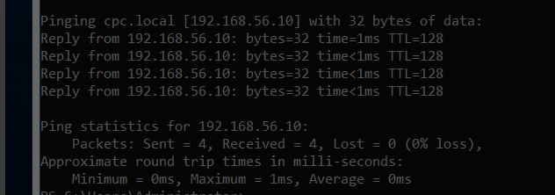
Figure 8 : Successful DNS resolution and network connectivity test using ping cpc.local
A major observation was that the setting up of DNS is vital in an active directory setup. Proper DNS settings were found to be very important in domain joining, authentication, and service discovery. Any faulty setting led to instant failures and this underscores the fact that DNS is a core part of Active Directory.
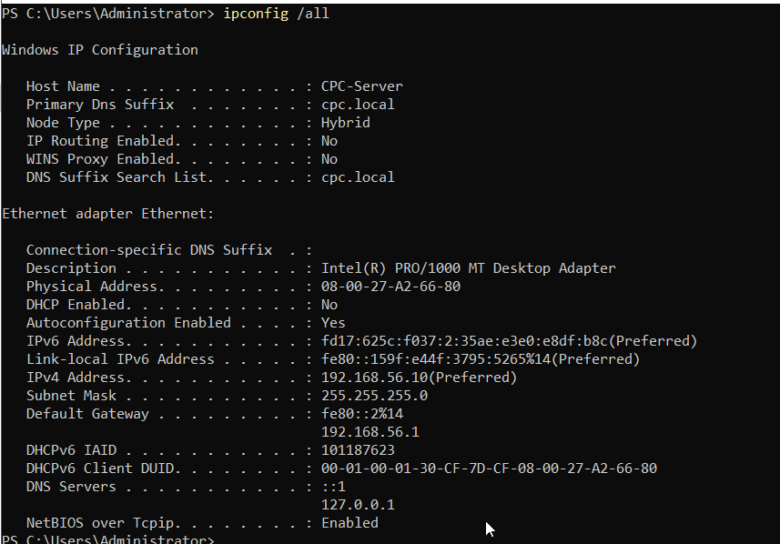
Figure 9 :Network configuration of Domain Controller (CPC-Server)
Centralized authentication was also observed to be effective. After the client was added to the domain, the user was able to use domain credentials to log in, thus the management of local accounts was not necessary. This showed how Active Directory provides ease in administration and enhances a consistent security.
Virtualization was very effective in the simulated practice of enterprise environments. VirtualBox was permitting safe testing, easy recovery on mistakes and effective use of resources. In general, the findings confirmed that the adopted setup is more or less similar to an actual enterprise network and can operate efficiently in an ordinary operating environment (Jacob and Aleburu, 2023).

Conclusion
This practice was able to illustrate how to implement and run an Active Directory Domain Services environment with a virtualized environment. This project met the main objective of setting up a Domain Controller, setting up a domain and adding one client system so that it can be centrally authenticated and managed.
This practical helped to realize the significance of Active Directory in the current enterprise networks. Active Directory offers an ordered and safeguarded system of user, computer and resource administration in a centralized location. With a Domain Controller, organizations are able to impose uniform security policies, achieve effective management of access and reduce administrative overheads.
The implementation also brought out the importance of supporting services like DNS and appropriate network configuration. This reliance of Active Directory on DNS highlighted the importance of proper planning and proper implementation. Also, the experience of using Server core environments exposed me to command line administration which is commonly used in professional IT settings.
The implementation also had a number of technical issues such as CLI-only administration, problems with display in virtualization and DNS misconfigurations. The ability to solve these problems successfully contributed to improving the skills of troubleshooting and strengthening theoretical knowledge with the help of the practical one.
Generally, this practical gave me a good practical experience in the administration of an enterprise network. It enhanced the knowledge of client server architecture, domain level authentication and centralized administration of the system. Wisdom and competencies acquired in this implementation can be applied directly to the real-life IT setting, where this practical ground can be a powerful base of additional learning and professional advancement in the field of work of network and system administration.

Future Scope
Active Directory environment applied in this practical can be enriched to reflect the more complex enterprise scenario. The introduction of Group Policy Objects (GPO) in order to implement security policies, password policies, and desktop policies across all computers in the domain is one of the possible improvements (Laasonen, 2025).
The other area that can be enhanced in the future is the introduction of several client systems into the domain. This would enable scaling and management of a broader network to be tested. The establishment of Organizational Unit (OUs) of various departments may also show organized management.
Configuring a file server with Active Directory would also extend the environment in that controlled access to shared resources, based on user and group permissions, can be made. As well, dynamic network hosting configuration protocol (DHCP) would be used, so that the IP addresses are automatically assigned, and the network management is made easier (R et al., 2023).
Such advanced security measures as account lockout policies, auditing, and role-based access control might be implemented too. These extensions would give a better insight into the enterprise security practice and extend the knowledge about the possibilities of the Active Directory in the real-life network.

References
Arshad, M.R., Hussain, M., Tahir, H., Qadir, S., Ahmed Memon, F.I. and Javed, Y. (2021). Forensic Analysis of Tor Browser on Windows 10 and Android 10 Operating Systems. IEEE Access, 9, pp.141273–141294. doi:https://doi.org/10.1109/access.2021.3119724.
Borislav Đorđević, Nenad Kraljević and Kuk, K. (2024). Impact of Different Hypervisor Versions on the File System Performance: Case Study with VirtualBox. doi:https://doi.org/10.1109/infoteh60418.2024.10495992.
Fernandez, S. (2023a). DNS as a Source of Trust and Information in the Modern Internet. Hal.science. [online] doi:https://theses.hal.science/tel-04618246.
Fernandez, S. (2023b). DNS as a Source of Trust and Information in the Modern Internet. Hal.science. [online] doi:https://theses.hal.science/tel-04618246.
Francis, D. (2021). Mastering Active Directory. Packt Publishing Ltd.
Hughes, L.E. (2022). Pro Active Directory Certificate Services. Apress eBooks. doi:https://doi.org/10.1007/978-1-4842-7486-6.
Jacob, J. and Aleburu, J. (2023). Enhancing Virtualization Security in Oracle VirtualBox: Investigating VM Escape Vulnerabilities and Mitigations MSc Research Project MSc Cybersecurity. [online] Available at: https://norma.ncirl.ie/7124/1/joshuachakkojacob.pdf.
Johnson, R. (2025a). KVM Virtualization Essentials. HiTeX Press.
Johnson, R. (2025b). QEMU Virtualization Essentials. HiTeX Press.
Kavousi, M., Yang, R., Ma, S. and Chen, Y. (2021). SemFlow: Accurate Semantic Identification from Low-Level System Data. Lecture Notes of the Institute for Computer Sciences, Social Informatics and Telecommunications Engineering, pp.513–535. doi:https://doi.org/10.1007/978-3-030-90019-9_26.
Laasonen, J. (2025). Securing PAM Admins : protecting the new keys to the kingdom. Theseus.fi. [online] doi:https://www.theseus.fi/handle/10024/886878.
Margaret, A. and Alice, M. (2021). Automating Windows Server Administration with PowerShell and Desired State Configuration (DSC) - Repository Universitas Muhammadiyah Sidoarjo. Umsida.ac.id. [online] doi:http://eprints.umsida.ac.id/16124/1/231%20Automating%20Windows%20Server%20Administration%20with%20PowerShell%20and%20Desired%20State%20Configuration%20%28DSC%29.pdf.
Mettrick, D. (2022). Virtual machine detection through Central Processing Unit (CPU) detail anomalies. [online] Scholaris.ca. Available at: https://ontariotechu.scholaris.ca/items/42f2c770-3983-463c-8e1a-6623ac0474de [Accessed 14 Dec. 2025].
Motero, C.D., Higuera, J.R.B., Higuera, J.B., Montalvo, J.A.S. and Gomez, N.G. (2021). On Attacking Kerberos Authentication Protocol in Windows Active Directory Services: A Practical Survey. IEEE Access, 9, pp.109289–109319. doi:https://doi.org/10.1109/access.2021.3101446.
Omotunde, H. and Ahmed, M. (2023). A comprehensive review of security measures in database systems: Assessing authentication, access control, and beyond. Mesopotamian Journal of CyberSecurity, [online] 2023(2), pp.115–133. doi:https://doi.org/10.58496/MJCSC/2023/016.
R, S.P., R, R., Narayanan, J., Balaji, D. and S, K. (2023). A DHCP Based Approach To IP Address Management And Allocation In A Network Using VLSM. [online] IEEE Xplore. doi:https://doi.org/10.1109/ICACCS57279.2023.10112844.
Saeed, M.H.R., Hassan, B.A. and Qader, S.M. (2017). An Optimized Framework to Adopt Computer Laboratory Administrations for Operating System and Application Installations. Kurdistan Journal of Applied Research, [online] 2(3), pp.92–97. doi:https://doi.org/10.24017/science.2017.3.8.
Smirnov, E. (2024). Building Modern Active Directory. Berkeley, CA: Apress. doi:https://doi.org/10.1007/979-8-8688-0941-5.
Zavala, Á. (2024). Application for Secure Password Self-Service Management in Local Active Directory (AD) Environments. [online] pp.1–6. doi:https://doi.org/10.1109/andescon61840.2024.10755863.

Appendix
System Logs and Troubleshooting Evidence


