Derrick Dabur (1805318)
University of Wales Trinity Saint David [Company address]
how has social MEDIA AFFECTED higher education

Table of Contents
Section 1: Introduction 2
Section 2: Social Media and its Use in Higher Education 3
2:1 Using Facebook to Improve Independent learning in Higher Education 3
2:2 Using an App (Rescue Time) to improve Time management via WhatsApp in Higher Education 4
2:3 Social media can be used a useful tool for Motivation to improve learning in Higher Education 5
2:4 Events Interactions to Improve Social Engagement in Higher Education 6
2:4:1 Using (Forest App) to Improve Communication skills in Higher Education 7
2:4:2 Improving Confidence in Higher Education 9
2:4:3 Building Empathy in Higher Education 9
2:5 Using WhatsApp as a Link to conduct research surveys and Polls in Higher Education 10
2:6 Using Visme cloud based social network tool share for group Presentation to improve public speaking. 11
Section 3: Influence of Social Media on Higher Education 12
3:1 Findings and Visions for the future 12
3:2 Social media will help students adapt and Improve Higher Education Learning 13
3:3 How social Media has changed the way student learn in higher education 13
3:4 Social media lets students communicate effectively and efficiently 14
Section 4: Conclusions 15
Bibliography 16

Section 1: Introduction
Social media can be beneficial to academic learning by creating an interaction between the lecturers and the students. Lecturers or teachers can connect with the students thereby incorporating the use of social media into their lessons. In the last 10 years, social networks have been part and parcel of the daily lives of most young people it has become an important means of communication. The most common social network sites that used today include Facebook, WhatsApp and Instagram to name a few, with face book being the dominant worldwide. According to business insider thirteen years into its existence “Facebook runs four of the five most used social network and messaging services in the world” (Insider, 2017), as can .be seen from the chart below.
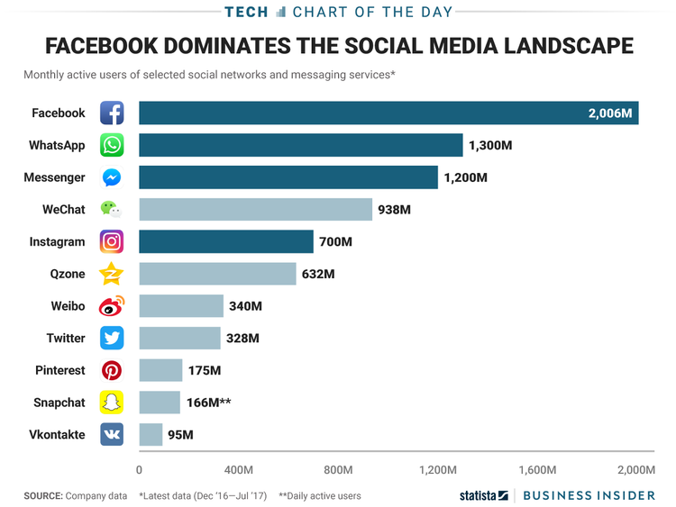
Figure: 1 showing the most used social network and messaging services
It is hard to imagine living in today world without the use of social media. In today’s world, social media is used for different reasons or different purposes. For instance, people use social media like twitter and Instagram to follow their models or celebrities and people also use social media to make new friends. The (The Guardian , 2019) states that “Social media can be hugely beneficial for making friends” and that social media can also be a good starting point to connect with people, for example apps certain apps such Bumble FF and Meetup enable users to connect based on different purposes like dating and local activities and events in a community. Social media enable loyal customers to keep up with their favourite brands. In today’s world of social media, individuals are now able to personally express their thoughts and feelings to their audience. Again, the most common form of this is the use of Snapchat or Instagram. It is very important to take note of newer social media plat forms like snapchat and Instagram as they have “found their way to an ever increasing number of teenagers” (The Guardian , 2019). That is mostly because this social media platform’s allows young people to communicate to a larger extent by using pictures, this type of development has a great influence on how people can express their thoughts and feelings and also communicate differently from traditional methods (CFDP, 2019). Social media has also help people to stay in contact with friends and family especially the ones that live far away from home. With some of the social media tools free to use people now prefer to use that means of communication to stay connected to their loved ones instead of the traditional methods that sometime cost money like using a telephone. According to (Pew Research, 2011)“Roughly two thirds (67%) of social media users say that staying in touch with current friends and family members”, before this type of communication method being able to stay in touch with friends and family over a long distance was not easy and very costly for those who could afford it. (Nah, 2014) States that “the Idea of blogging started in the 1990s”, but was mostly used as a way of communication where people simply wrote about personal things and would only share with close family members in the 90s. Then it was later overtaken by social media the earlier version being Facebook and with later ones mainly Instagram, however the main purpose of social media is and has remained to Connect and share with people. That aspect of connection and sharing is what this essay seek to explain its use in improving higher education learning.

Section 2: Social Media and its Use in Higher Education

2:1 Using Facebook to Improve Independent learning in Higher Education
In today’s higher academic environment teaching impart knowledge and information to students. Teachers are looked upon by students to guide them when attempting to gain an education. However, independent learning contributes to a large extent to an education of a student than complete direct teaching. Some research suggests that a lot of the activities that take place in the classroom simply do little in developing a student academically. Some activities that have been designed to impact on students only take up valuable time in the name of engagement and that “Often, these approaches not only have limited impact on student learning but can have a hugely detrimental impact on teacher workload and wellbeing” (The Guardian, 2017). This means the activities in the classroom matter when it comes to learning but also does independent learning. That is why teachers tend to fundamentally “encourage independent thought, independent enquiry and ultimately independent learning” according to (Guardian, 2013). Independent learning can be defined as a process of involving “significant or experiential learning a quality of personal involvement-the whole person in both his feeling and cognitive aspects being in the learning event” (Henderson, 1984). Student who do independent learning often engage in research, in higher education one of the research tools available for students is google scholar. Google scholar is a web search engine that can be accessed for free for scholarly literatures. Google scholar platform has features in which using social media can be used to improve independent learning. For example, if an article or subject is of interest to student they can use the function ‘create alert’ on the left hand corner of the page and google scholar will send a reminder alert to the account holders email address which with the right setting can be automatically forwarded to holder’s email account. This notification can be transformed into short messaging service (SMS) which can be sent off to the student’s mobile device. Again the good news is Facebook “adopted SMS to allow users to receive and respond to notifications they receive through status updates, comments, private messages or changes with a profile in real-time” (Anon., 2017). This notification can be configured so that student conducting independent research can stay updated when there is new article available on google scholar. On average teenagers spend 8 hours, a day on Facebook according to (The Telegragh, 2018) but by connecting Facebook to google, scholar students can improve independent learning through their Facebook account.

2:2 Using an App (Rescue Time) to improve Time management via WhatsApp in Higher Education
One of the things people learn in higher education is time management. How students use their time in organising their workload can gravely affect their studies both positively and negatively. Time is said to be a precious and valuable resource that everyone needs to completely do everything in life with it (Hamermesh, 2019) says, “Time is now worth more – it is more valuable – and increasingly scarcer than the incomes we use to buy things”. It cannot be added or subtracted in a day, but it can be managed properly to archive great results, poor time management takes different forms for example personal distractions can lead to poor time management and can cause delay in school projects or even taking longer to complete than they should take. In higher education, students sometimes perform badly academically due to poor time management. According to an article by (The New Times, 2017), the author argues that “Time management is the art of arranging, organising, scheduling and budgeting one’s time for the purpose of generating more effectiveness and productivity,”. The author goes on to state that how students allocate time to themselves from the competing demands that each day brings is important and can affect their grades in school given that time and its availability in any given day is 24 hours and can neither be increased nor decreased therefore managing time in school can improve academic performance. The good news is that in this tech age there are apps and tools available to help students with the management of time so they can be more productive. For example, an app called ‘rescue time’ is one of many time management apps, which is available to install in any operating system, the app is designed to monitor its users online time-spending (Calbay, et al., 2015). This app is good for people in higher education because by the end of the day of every activity, the app gives a display on its user’s dashboard on everything that a user might have spent their time of the day doing. The app can be configured to reflect individual needs depending on what can be seen as productive by different individuals. Rescue time has a premium feature that allows its users to get real-time notification about time spent on social networking, when it is set as ‘not productive’ under its settings (Calbay, et al., 2015). Another option that rescue time software application has is called ‘integration’. This feature allows a user to be able to connect with their google account in which they can connect to google calendar from there a summary of your logged in time will be posted to your google calendar. Once in google calendar the tool offers different functionalities that can be used like tasks or reminders. Its user and the time to be reminded, there is an edit button that also let its user to add a location in case they are on the go, can use the reminder on google calendar to set a reminder for an activity. Tasks can also be used as a reminder, once rescue time has been linked to google calendar, task in google calendar has no time associated with it but has date associated with it. The features can be used simultaneously i.e. both reminder and tasks. The most useful part of this tool is how it can be shared to a regular social media app like WhatsApp. The process simply involves setting the reminder on the calendar to send a notification to the student email, like a Gmail account then configuring that email into a (Short Messaging Service) SMS to be sent to the user’s mobile which can be seen anytime anywhere (Miller, 2013).

2:3 Social media can be used a useful tool for Motivation to improve learning in Higher Education
Motivation is very important when it comes to student’s success in learning, any learning that last must have persistence motivation. There is usually a challenge of trying to identify what students might find to be important educational experiences, when a student is motivated then they have the desire to participate in a process of learning they enjoy (Tileston, 2010). Students are self-motivated to learn in school by various reasons. According to a journal the ‘Research in Educational Journal’, there are serval theories attempting to explain human motivation, but no single theory seems to be able to adequately do that. Human needs and desires are very complex hence studying human beings and students particularly in other to understand their motivation can be difficult. For students “very little if any learning can occur unless students are motivated on a consistent basis” (Williams & Williams., 2011). In this day and age of technology and social media, in particular there are several ways in which social media can be used to motivate students to improve learning in higher education. Social media has an impact on student’s motivation in higher education, especially when the right tools are used, social media can enhance students motivation in a creative way because young people are very active in information sharing and social media is simply about connecting. Social media can be an effective way of learning with the right tools it can become a suitable and interesting technique to be used for motivating students and improving higher education learning process. An example of using social media to motivate students come from social media influencers like Instagram. Instagram Influencers are basically people who are inspiring to their audience (Abidin, 2018).

2:4 Events Interactions to Improve Social Engagement in Higher Education
Facebook is used to share pictures of an event with the user’s audience, Facebook can be used to improve students experience in higher education. For instance, when a student hosts an event then he decides to take pictures of the event and post them on Facebook afterwards, the pictures can be made easily to find especially when the pictures are tagged with the friend’s names on it (Treadaway & Smith, 2010). The user’s audience will be to see such school event. There are different types of tools that are also used to raise awareness for school events such as google ads, emails and videos. Using these types of platforms in other to advertise or share an event with friends can be too straight forward for instance sending emails to individual persons once at a time will not reach out to many people. However, using social media can offer the user a variety of networking platform to first choose from and secondly connect with their audience and many others so they can raise awareness about it and more students can attend. Students can also decide to use the different social media tools available to “build an event marketing social media plan that’s optimized on all the options” (Treadaway & Smith, 2010). An event that has been set-up can be optimised using Facebook to reach out to friends, firstly the user sends an invite notification to all friends, about their different types of events anniversaries and birthdays etc. Using Facebook to manage events in higher education to help students engage in higher education with social activities can improve social engagement a vital skill needed in life after college. As not everyone may have a Facebook account the good news is that the process allows a way to attract potential attendees as (Treadaway & Smith, 2010) .. puts it “Facebook events are controlled by the host, but also allow attendees to comment and ask questions within the event page. This makes it an ideal way to engage with potential attendees, provide more information, and address any concerns”. LinkedIn is mostly used as a professional networking platform, founded in 2002, it is mostly an employment oriented service platform but there is a way this social media platform can be used to engage students in there school events. Although it is business oriented, LinkedIn “groups are made to provide a place for conversation, questions, and ongoing engagement with a group of people” (Anon., 2019). As stated above, that social media is all about being able to connect and share with people, an event that is set up in LinkedIn can be set up such that students who wish to attend can connect and those that are already on the group can simply join in and continue with the conversation. LinkedIn enables its users to be able reach out to other connections that may have similar interest in the type of event that a student may be hosting. The way in which the student can reach out is by posting a video to the other group and explaining to them what he or she may be planning to do next, in other to get them interested in it (Anon., 2019). When groups are formed in any social media platform one of the ways to keep the student engaged is by posting frequently depending on the size of the group.
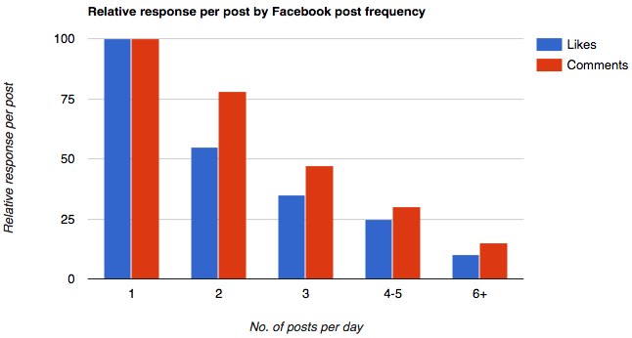
Fig 1 showing Facebook post frequency & response per post (Social Report, 2018)
The image above shows the relationship between the number of post on Facebook and the relative response per post. A research by Hobspot suggest that if you have more than 10,000 followers on Facebook you should post 1-2 post per day and more if you have more than 10,000 followers (Social Report, 2018). The evidence from that research can beneficial and replicated in LinkedIn groups by students. Social media enable students to share campus events among themselves easily keeping everyone engaged and aware of any activities. This is a good way in which students can improve their social engagement skills via social media.

2:4:1 Using (Forest App) to Improve Communication skills in Higher Education
Effective communication is one of the essential skills students learn in higher education. Communication is defined as “a process of transmitting ideas, information, attitudes (images which we have formulated for ourselves) by the use of symbols, words, pictures, figures from the source (who is the originator of the message) to a receiver, for the purpose of influencing with intent” (Youssef, 2005). From the definition it can gathered that effective communication comes from developing certain skills such listening, confidence, empathy, friendliness and being respectful. These are attitudes and attributes that everyone possesses naturally but in higher education, they can be improved. In today’s world social media and hi tech are part of everyday life, listening is an important skill set that is useful in every situation for example conflict resolution between two parties it is also important for reducing errors and improving accuracy According to (Forbes, 2012) listening “helps develop resourceful, self-reliant kids who can solve their own problems. Listening builds friendships and careers. It saves money and marriages”. In other words, is an essential skill to have or develop where there is the need to do so. The same author goes on to say that in other to improve one listening abilities first they should endeavour to maintain eye contacts in any given communications. Social media has improved how maintaining eye contact while listening to a conversation is done. For example video conferencing tools and app like Skype. Skype is a “telecommunications application that specializes in providing video chat and voice calls between computers, tablets, mobile devices, the Xbox One console, and smartwatches via the Internet” (Max & Ray, 2006). Skype is an application that also offers instant messaging services. Using this application for a group project in higher education is very common, even among students maintaining eye contacts among colleague gives the impression that such student is interested in the video conversation and serious because looking away during a video conferencing might mean different things to different people as (Forbes, 2012) explains that in the western world not maintaining eye contact may mean “Shyness, uncertainty, shame, guilt, or other emotions, along with cultural taboos” (Forbes, 2012). Being relaxed and paying attention is another way to improve listening skills meaning to attend to another person. ‘Attend’ means to pay attention therefore by blocking out mind distractions and other background noise and activities a student will be improving the listening skills. An app called ‘forest’ is available to help students with attentiveness, especially people on a research program. The forest app allows the user to set their timer upon clicking go the app locks your mobile. It is a fact that social media can be beneficial but it can also be a source of distraction to students in higher education. According to some studies, “76 per cent of students are distracted by the internet to a significant or worrying degree” (Forge Press, 2014). No doubt, social media being a benefit can also be a challenge to use responsibly, which is why the app Forest is useful in this regard. The distraction that many students face many times in university is that when they student for a few minutes then they go onto a social networking site where they spend a lot of time doing unproductive work and sometimes after that they start to procrastinate whether to stop for the day. Forest locks the user’s mobile device so they cannot do that. The apps have an interesting feature when installed on a mobile device that looks like a tree, and the idea is when the user starts their study timer it plants a tree, depending on how long the timer is set the tree starts to grow, the idea is when the user leaves their phone when the tree has been plated then the app kills the tree. However, if the user does not leave the app all the way through then the user gets a notification saying the tree has grown, then the app plants the tree in a field or a forest plot (Vastaranta, et al., 2015). So for each plot of work that a student complete at the end of the day they can look at how many plot they have done and it is usually represented by a tree they can also see how many plot of work they have failed at with a visually impacting image. This app does at least two things it helps students to improve their motivation because they try to keep the tree alive and they are able to see how many times they got distracted through the day (Vastaranta, et al., 2015). Using an app like Forest can help student improve their attentive skills, which is part of an effective communication skill. Being able to keep on open mind is a great communication skill without indulging in judgemental bemusement of other people. This is listening and not jumping to conclusion or interrupting unnecessary. Forest App is also abled to be linked to any social networking platform like WhatsApp especially when the user is on the move.

2:4:2 Improving Confidence in Higher Education
How you relate in terms of communication can go a long way in making a big difference in everything you do in life. The academic environment is not different from business environment or any other professional setting when interactions take place, every is bound to come across certain individuals with big egos, and in such interactions it takes confidence for someone to able to share their views. In (Bhardwa, 2017) survey student pointed out that building confidence was one of the reasons they attended higher education. In a communication situation where to or more people are present confidence is important, when a group of people are interacting in a verbal and non-verbal way. School assignments or projects involves a group of students participating in a conversation and sometimes in these type of situations, some students may find it hard to speak due to lack of confidence. Or they may even speak less when they are involved in what (Kelly & Watson, 1986) Calls a “dyadic situation” meaning information is exchanged on rapid scale and individuals “who bring different experiences, interests, knowledge, goals and general background to the situation and all of whom are influencing one another” (Kelly & Watson, 1986). ‘Think up’ is an app designed to helps its users improve their confidence, and lead a fulfilling life. Students in a higher education require confidence as a communication skill to grow their leadership skills in their various areas of discipline. An individual may be have a leadership title but actually lack the confidence to lead others for example they may a title that lets them coach or mentor others yet if they fail to believe in themselves or lack confidence in themselves then it’s pointless As Francisco Dao says, “Self-confidence is the fundamental basis from which leadership grows. Trying to teach leadership without first building confidence is like building a house on a foundation of sand. It may have a nice coat of paint, but it is ultimately shaky at best.” (Peter Barron Stark, 2017). Therefore, students can derive a lot of benefits from self-confidence when it is improved like being contend with themselves and performance is improved. They are able deal with school life and achieve results more than those with self-confidence achieve better grades (Murtagh, 2019).

2:4:3 Building Empathy in Higher Education
Empathy is a skill set that student develop and improve in higher education which they need when they get on to their various professional fields in life, empathy is defined “as an emotional response that stems from another’s emotional state or condition and that is congruent with the others emotional state or situation” (Eisenberg & Strayer, 1987). Having empathy enables one to see the world from someone else’s point of view, it enables one to put themselves in other people’s shoes. By having this communication skill set an individual is able to feel what someone else is feeling. People generally become students of higher education for several reasons and one of them is certainly to find and grow their passion and achieve their goals in life. As people, empathy is one of the greatest needs that we have as human beings. Some experts in this field are behavioural scientist and some studies suggest that we all have different and varied abilities to empathise with others. Social media is all about connecting and sharing, social media has provided the opportunity for people to really express themselves more than ever before.

2:5 Using WhatsApp as a Link to conduct research surveys and Polls in Higher Education
WhatsApp is one of the major mobile apps used for communication. WhatsApp has contributed to the advancement of mobile technology. WhatsApp currently has over 1 billion users it is a messenger app for smart phones. Once the app is downloaded to your smartphone the internet is required before messages can be sent, videos images and voice notes can be shared (Constine, 2018).
Google forms is used to create surveys as opposed to using traditional methods of hard copy forms. Google forms allows you to create forms that can be sent out via emails or links. (Graham, 2013). Google forms is a part of google suite or G – Suites “(comprising Gmail, Hangouts, Calendar, and Google+ for communication; while Drive for storage; include: Docs, Sheets, Slides, Forms, and Sites for collaboration)” these suites of applications google allows students to work with by syncing information in unison with either google drive (Patricia, et al., 2019). The google form allows students to be able to create pre designed questionnaire forms or a new form google forms “data can also be easier to extract” (Walloth, et al., 2016). The new form has a titled page, description and question to be entered. There different types of questions to choose from the drop-down menu where students are able to choose from a number of different types of question for example short answer types of question, paragraph types of questions, check boxes and dropdown types of questions, according to (Tech Republic, 2012) “Google Forms provide a fast way to create an online survey, with responses collected in an online spreadsheet”.
The additional symbol on the platform allows one to add another question. A question can be designed on the form in many ways and interchangeably for example, a there can be a mixture of multiple question and linear scale question (Tech Republic, 2012).
There are options provided to drag and drop if a question needs to be deleted or duplicated. The questions can be moved around with the options being moved around too, unlike the traditional methods of hard copy forms which people can skip questions google forms proved an options called required, that when checked makes that question a compulsory question to answer, this very feature makes online and digital reading more effective than paper based google form feature that makes it compulsory to answer a question can produce a more reliable data, there are other “accessibility options that are impossible in print they are potentially beneficial for those with impairments, such as dyslexia”. (Thomson, et al., 2013) An option that allows imaging to be added to the form is also available to enable one add an image to the form and also video. When someone is done completing a survey or poll using the form then they need to submit. WhatsApp can be used to easily send forms out to audiences so they can complete. On the upper right hand corner of the forms, brings up a pop-up window which provides a feature that can be used to send to individuals emails by typing email addresses directly or using the link icon to alternatively it can be sent directly from google drive to WhatsApp contacts by clicking on the WhatsApp contact and attaching the document from google form, that will allow the contact on your WhatsApp to fill the form. According to (Tech Express, 2019). WhatsApp now support documents sharing users are “able to send documents from iOS to Android and Android to Android, etc. The document sharing option is also available for groups on WhatsApp as well” (Tech Express, 2019)

2:6 Using Visme cloud based social network tool share for group Presentation to improve public speaking.
Microsoft PowerPoint are mostly used for presentation but its prevalence has made presentation too regular. Therefore, the add-ons can create an impact on how audiences are engaged. A cloud based presentation tool called “Visme”, lets student to create a highly visual presentation that engage viewers and communicate ideas. The contains methods for creating presentation contents with drag and drop functions as easy features. There are different versions provided standard, the complete business version of the programme is able to prioritize brand, which can be colour, text or image so that when student or indeed anyone creates a presentation, the already stored in brand is able to be reused promoting consistency in the process. “Visme also offers a built-in analytics system, so you can see who has viewed your presentation and who finished it” (Business News Daily, 2018). Visme is a complete visual communication tool which allows people to “create everything from print flyers all the way down to scatter plots and graphs” (Tech Republic, 2012) the notion that you can and are able to immediately create an online content for easy interaction with audience is important for visual communication that is interesting.

Section 3: Influence of Social Media on Higher Education

3:1 Findings and Visions for the future
The biggest social network site are Facebook, YouTube and Instagram these network sites have the largest user base worldwide according to pew research centre.
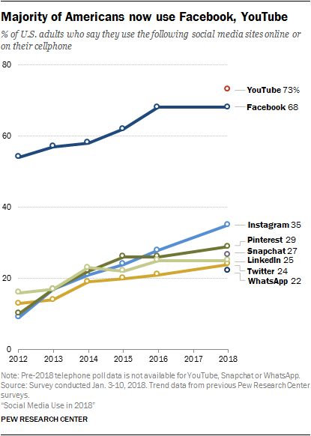
There is a long-standing tradition in the social media space and also an emerging trend that is popping up based on a new pew research centre survey of adults in the United States of America. The discovery noted that social media network such as YouTube and Facebook continue to lead as the most preferred social networking site as can be seen from the chart above (Anderson & Jiang, 2018).
More than 60 percent of students in the United States mostly have a social media account or profile if Instagram, YouTube, or Facebook.
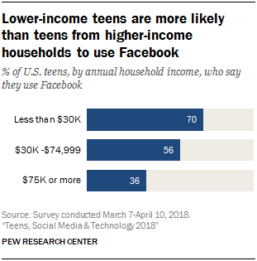

In the United Kingdom, the statistics suggests similar trend and Facebook is also on the top list in terms of being the most popular social networks for either educational or personal purposes. The time spent on social networking sites by students vary, but some studies suggest that on average they spend about 60 minutes (Anderson & Jiang, 2018).

3:2 Social media will help students adapt and Improve Higher Education Learning

The reason students attend students attend higher education is to get high quality teaching and learning experience. According to a survey by the times higher the top five reason why student chose to go to university included high quality teaching, scholarship, ranking and its prestigious brand with students choosing ‘high quality teaching’ first (Bhardwa, 2017).
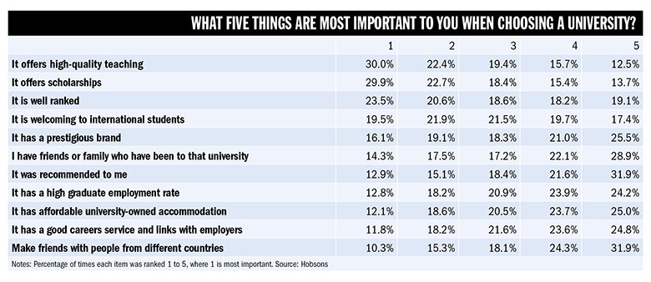
The other reasons people to choose to go to university may be to continue their learning and development. Some people choose to go to university to learn very important and essential life skills required for day-to-day tasks, or to earn more money in their future careers. What eve the reason may be as explain above social media will play an important role in improving different areas of higher education learning.

3:3 Social Media will changed the way student learn in higher education
There are numerous impact social media has on higher educational institution, such as interactions between students and lecturers, and academic performance. The notion of formal or informal learning has changed over the years with the use and incorporation of social networks. According to (Nijhof, et al., 2002) formal learning is defined as “learning that occurs within an organised and structured context (formal education, in-company training etc.), and that is designed as learning”. This type formal learning creates an interaction in the process between the parties whether lecturers or students. Formal education is the most common form of educational setting in higher education. Most educational systems have a formal hierarchical formal setting for education running from primary to university level. Although viewed as a source of distraction and hindrance to better performance in school, social media can be beneficial in terms of learning and can enhance a student’s learning experience or journey. It can also make teaching more comprehensive and easy to connect between teachers and pupils. Social media platforms such as Facebook and Instagram present its users with the platform to exchange and share contents. Social Networking sites such as Facebook also provide the capability for its user to connect with more people and post contents for academic purposes.

3:4 Social media will enable students communicate effectively and efficiently
As technology advances the way in which students communicates have evolved and changed dramatically, new methods of communications have emerged in the field of academics. In the past traditional forms of media contributed mostly to knowledge spread. In the past learning and teaching was done using traditional media this form of learning or teaching and ensured everyone benefited. According to (Patrut & Patrut, 2013) “traditional media proved to be a powerful tool in the process of making learning and teaching more effective, interesting and more simple to ensure everyone benefits to the maximum”. The characteristics of social media is a two-way communication rather than a static massaging platform that simply displays information on the web. Examples of social networking sites include Facebook, twitter and LinkedIn and the post that are associated with these sites are also able to include pictures and video in their post. Social media enables effective communication because a user is able to post content a large broader audience. Facebook provides many opportunities for communications aside from using your own account, there is the opportunity to set up groups which provides a small space for a group of people. People can post in the group though publicly visible, in other to participate in the group such as to make a comment they would need to register to join that group (Patrut & Patrut, 2013).

Section 4: Conclusions
In conclusion, social media improves independent learning this means the activities in the classroom matter when it comes to learning but also does independent learning. That is why teachers tend encourage their students to practise independent learning. Independent learning helps students improve their grades in school, it is known that Facebook can be really distracting but at the same time, it can be used to improve learning via SMS received from the email notification. The Academic performance of students in higher education can be improved with time management “Time management is the art of arranging, organising, scheduling and budgeting one’s time for the purpose of generating more effectiveness and productivity” using an application called rescue time, time management is a useful skill to have in higher education. Social media can enhance student’s motivation in a creative way because young people are very active in information sharing and social media is simply about connecting people. Students use social media platforms to share their motivating stories to their friends and also share tips on how to self-motivate to improve academic learning in higher education. Social media platform one of the ways to keep the student engaged in groups of study and social engagement. Social engagement leads to improvement of communication skills. With an app called ‘forest’ which is available to help students with attentiveness, especially people on a research program. The forest app allows the user to set their timer upon clicking go the app locks your mobile. It is a fact that social media can be beneficial but it can also be a source of distraction to students in higher education. However, according to some studies with the right tools in place social media can be useful way of enhancing students learning experience. Confidence is pre-requisite that any leader needs to be successful in any field. “Self-confidence is the fundamental basis from which leadership grows. Trying to teach leadership without first building confidence is like building a house on a foundation of sand. It may have a nice coat of paint, but it is ultimately shaky at best.” There are social media tools that can build self-confidence. Social media enables students to conduct research via WhatsApp. Google forms is the most common online forms used for creating questionnaires. The questionnaire can then be sent to participant via link through WhatsApp making the process more convenient for students in higher education. According to pew research, Facebook and YouTube are most desired form of social networking platform.

Bibliography
Abidin, C., 2018. Internet Celebrity: Understanding Fame Online. 1st ed. Bingley: by Emerald Publishing Limited.
Anderson, M. & Jiang, J., 2018. Social Media Use in 2018, Washington, DC: Pew Research Center Internet and Technology.
Anon., 2017. What Does SMS Mean on Facebook?. [Online]
Available at: https://itstillworks.com/sms-mean-facebook-18872.html
[Accessed 06 May 2019].
Anon., 2019. How to Use Social Media for Event Marketing. [Online]
Available at: https://www.business2community.com/social-media/how-to-use-social-media-for-event-marketing-02160013
[Accessed 10 May 2019].
Bhardwa, S., 2017. Why do students go to university and how do they choose which one?, London: Times Higher Education.
Business News Daily, 2018. Beyond PowerPoint: Presentation Tools for Small Businesses. [Online]
Available at: https://www.businessnewsdaily.com/6525-business-presentation-tools.html
[Accessed 4 May 2019].
Calbay, R., Leon, M. d. & Lising, P., 2015. Cyberpreneur Philippines: Online Business Start-up Guide. 1st ed. Taguig: by PageJump Editorial.
CFDP, 2019. Social media teach young people to express their feelings in new ways. [Online]
Available at: https://cfdp.dk/social-media-teach-young-people-to-express-their-feelings-in-new-ways/
[Accessed 06 May 2019].
Constine, J., 2018. WhatsApp hits 1.5 billion monthly users. 19 billion dollars? Not so bad.. [Online]
Available at: https://techcrunch.com/2018/01/31/whatsapp-hits-1-5-billion-monthly-users-19b-not-so-bad/?guccounter=1&guce_referrer_us=aHR0cHM6Ly93d3cuZ29vZ2xlLmNvLnVrLw&guce_referrer_cs=GdMAFFIxuUxJS5tMGCOhWQ
[Accessed 12 May 2019].
Eisenberg, N. & Strayer, J., 1987. Empathy and Its Development. 1st ed. New York, NY: by Cambridge University Press .
Forbes, 2012. 10 Steps To Effective Listening. [Online]
Available at: https://www.forbes.com/sites/womensmedia/2012/11/09/10-steps-to-effective-listening/#275c35463891
[Accessed 10 May 2019].
Forge Press, 2014. Study shows students most distracted by social media, NY, USA: by Forge Press.
Graham, M. J., 2013. Google Apps meet common core. 1st ed. London: by Sage Publication Limited..
Guardian, T., 2013. Why new technologies could never replace great teaching. [Online]
Available at: https://www.theguardian.com/teacher-network/teacher-blog/2013/jun/20/technology-not-replace-teaching-learning
[Accessed 06 May 2019].
Hamermesh, D. S., 2019. Spending Time: The Most Valuable Resource. 1st ed. Oxford, UK: by Oxford University Press.
Henderson, E. S., 1984. Independent Learning in Higher Education. 1st ed. Eaglewood Cliffs, New Jersey: by Education Technology Publications, Inc..
Insider, B., 2017. Facebook totally dominates the list of most popular social media apps. [Online]
Available at: https://www.businessinsider.com/facebook-dominates-most-popular-social-media-apps-chart-2017-7?r=US&IR=T
[Accessed 14 April 2019].
Kelly, L. & Watson, A. K., 1986. Speaking with Confidence and Skill. 2nd ed. New York, USA: by University Press of America, Inc..
Max, H. & Ray, T., 2006. Skype: The Definitive Guide. 1st ed. Indiana, USA: by QUE Limited.
Miller, M., 2013. My Google Chromebook: My Google Chromebook _p2. 2nd ed. Indianapolis, Indiana USA.: by Pearson Education, Inc..
Murtagh, T., 2019. Why Confidence Is Important for Achieving Better Grades, Connecticut Avenue, NW: by The Honor Society Magazine.
Nah, F. F.-H., 2014. HCI in Business: First International Conference, HCIB 2014, Held as Part of HCL International 2014. 1st ed. Roller, MO: by Springer International Publishing Switzerland.
Nijhof, W., Heikkinen, A. & Nieuwenhuis, L. F., 2002. Shaping Flexibility in Vocational Education and Training.. 1st ed. AH Dordrecht, The Netherlands: by Kluwer Academic Publisher.
Patricia, O. d. P., D., L. M., Xi, Z. & Tai., C. K., 2019. Opening Up Education for Inclusivity Across Digital Economies and Societies. 1st ed. Hershey, PA.: by IGI Global.
Patrut, M. & Patrut, B., 2013. Social Media in Higher Education: Teaching in Web 2.0. 1st ed. Hershey, PA: by Information Science Reference (an Inprint of IGI Global).
Peter Barron Stark, 2017. The Role Confidence Plays in Leadership. [Online]
Available at: https://peterstark.com/role-confidence-leadership/
[Accessed 10 May 2019].
Pew Research, 2011. Using Social Media to Keep in Touch. [Online]
Available at: https://www.pewresearch.org/fact-tank/2011/12/22/using-social-media-to-keep-in-touch/
[Accessed 06 May 2019].
Social Report, 2018. How Often Should You Post On Social Media?. [Online]
Available at: https://www.socialreport.com/insights/article/115003574046-How-Often-Should-You-Post-On-Social-Media-
[Accessed 10 May 2019].
Tech Express, 2019. WhatsApp now supports document sharing: Here’s how to use. [Online]
Available at: https://indianexpress.com/article/technology/mobile-tabs/whatsapp-document-share-option-how-to-use/
[Accessed 04 May 2019].
Tech Republic, 2012. Use Google Forms to create a survey. [Online]
Available at: https://www.techrepublic.com/blog/google-in-the-enterprise/use-google-forms-to-create-a-survey/
[Accessed 04 May 2019].
The Guardian , 2019. Seven ways to make new friends. [Online]
Available at: https://www.theguardian.com/lifeandstyle/2019/feb/11/seven-ways-to-make-new-friends
[Accessed 06 May 2019].
The Guardian, 2017. Teachers: your guide to learning strategies that really work. [Online]
Available at: https://www.theguardian.com/teacher-network/2017/oct/27/teachers-your-guide-to-learning-strategies-that-really-work
[Accessed 06 May 2019].
The New Times, 2017. How poor time management affects grades. [Online]
Available at: https://www.newtimes.co.rw/section/read/224043
[Accessed 06 May 2019].
The Telegragh, 2018. Thousands of teenagers spending more than eight hours a day online at weekends, Ofcom figures show. [Online]
Available at: https://www.telegraph.co.uk/news/2018/07/12/thousands-teenagers-spending-eight-hours-day-online-weekends/
[Accessed 06 May 2019].
Thomson, J. M., Chen, C., Sonnert, G. & Pomplun, M., 2013. E-Readers Are More Effective than Paper for Some with Dyslexia. [Online]
Available at: https://journals.plos.org/plosone/article?id=10.1371/journal.pone.0075634#ack
[Accessed 04 May 2019].
Tileston, D. W., 2010. What Every Teacher Should Know About Student Motivation. 2nd ed. Oaks California, USA: by SAGE Ltd.
Treadaway, C. & Smith, M., 2010. Facebook Marketing: An Hour a Day. 1st ed. Indian, USA: by Wiley Publishing, Inc..
Vastaranta, M. et al., 2015. Evaluation of a Smartphone App for Forest Sample. [Online]
Available at: file:///C:/Users/daburd/Documents/Downloads/forests-06-01179.pdf
[Accessed 12 May 2019].
Walloth, C., Gebetsroither-Geringer, E., Atun, F. & Werner, L. C., 2016. Understanding Complex Urban Systems: Integrating Multidisciplinary Data in. 2nd ed. Switzerland: by Spinger International Publishing Switzerland.
Williams, K. C. & Williams., C. C., 2011. Five key ingredients for improving student motivation. Research in Higher Education Journal, I(12), p. 1.
Youssef, I. M. A., 2005. Communication Skills. 1st ed. Cairo, Egypt.: by Centre for Advancement of Postgraduate Studies and Reseach in Engineering Sciences Faculty of Engineering..

