Royal 14 B V: Membrane 4 and 5 Rollo and his descendants
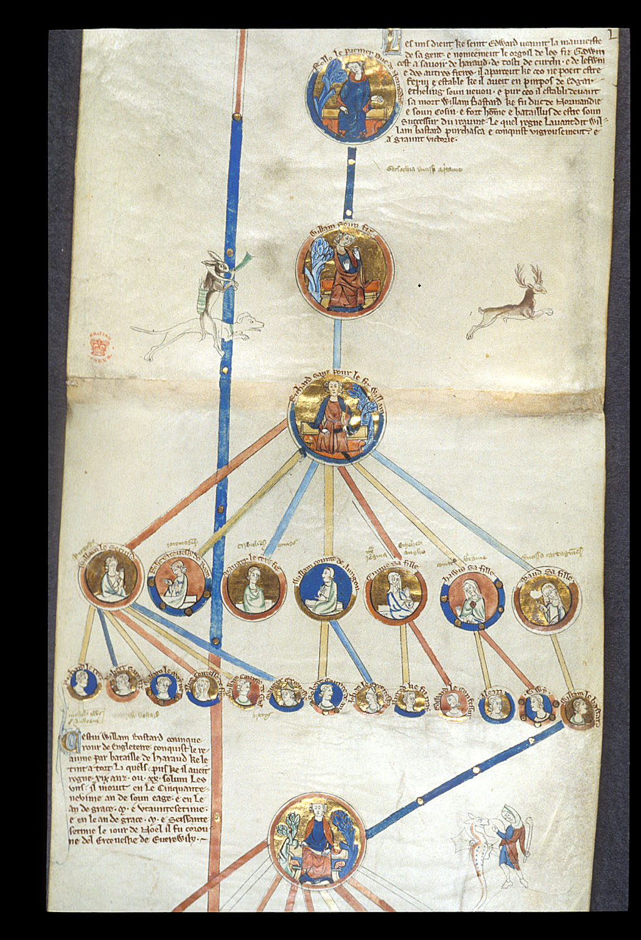

This is an image of a small extract from a manuscript which contains small round intricate paintings of Rollo’s family tree. Rollo, who was also called ‘Rolf’ or ‘Rou’, was born in the year 860. He was originally from Scandinavia, but he journeyed to Normandy, where he later established himself as the Duke of Normandy. According to historic writings, Rollo made himself independent from the king of Norway, and he spent much of his life sailing to other foreign lands, such as Scotland, England and France. Rollo became a significant figure when he invaded France with his Danish army. But he was defeated by Charles II the Simple of France. After the defeat, Charles II the Simple negotiated a treaty between himself and Rollo, the treaty of Saint-Clair-sur-Ente, where Charles gave Rollo a part of Neustria, which became known as Normandy. In 927, Rollo’s son, William I Longsword, was given the title of Duke before Rollo’s death in 932. Rollo was baptised before his death, but many say that Rollo died as a pagan.
In Membrane 4, which is the extract image from the manuscript in which I am commentating on, it includes, ‘the royal genealogy of Cnut, with Edward the Confessor and Harold Godwinson, and the line of the Norman ancestors of William the Conqueror: Rollo, William, and Richard I the Fearless. and also, membrane 5 in which the genealogy from Richard I the Fearless, Duke of Normandy, to Henry II and his descendants’. According to the description of this image on the digitalised manuscripts page, it is a ‘roll chronicle containing the genealogy of the kings of England from the Heptarchy to Edward I as a king (1272-1307), but without portraits of his children’.
This manuscript roll contains all the kings of England, and their descendants all on this piece of manuscript. The script is considered to be gothic according to the digitalised manuscript page. This manuscript is an example of an illuminated manuscript, which means the paintings within the manuscript substitute the words, not including names. Illuminated manuscripts were called this since gold or silver were incorporated into the manuscript itself. ‘Illumination comes from the Latin word illuminare, meaning “light up,” and when one sees one of these brilliant manuscripts in person, the term makes sense.’.
Regarding the portraits on the manuscript, small round paintings of the kings of England and their descendants; all of them are interlinked with one another by a line. It was painted by the illuminator who was commissioned to do works such as these. At the end of the manuscript, there is a note in red, partly destroyed by time, which contains excuses by the illuminator of the manuscript, who seems to state that they were ‘pressed for time’.
The illuminator of the manuscript has incorporated many vibrant colours into the manuscript. Red is considered to be a colour which symbolises assertation, romance, strength, excitement, ambition, impulse and, most importantly in this context, physical prowess. But it can also mean ‘danger or threat’. Yellow is also included in the manuscript, and it can be associated with a feeling of hope, happiness and ‘denoting wisdom’.
Orange is ‘flamboyant, lively and cheerful’. It can symbolise youth, of being fearless, spontaneous and assertive. But darker orange can mean ‘deceit and distrust’’ while an orange closer to red could mean aggression, domination and the ‘thirst for action’, which would link well with the history that we know of Rollo. The illuminator uses blue to paint the lines linking the portraits to one another. Blue is a colour which is ‘often used to show a kind of expansiveness similar to skies and oceans’. It is a very regal and formal colour and its darker shades have been linked to royalty. It is a colour which is often linked with the feeling of melancholy. This is very interesting, as some of the family members are linked with this colour, therefore there could be an underlining message.
Gold is one of main colours which is used in this manuscript extract. The colour Gold held a symbolic meaning in the middle ages. It was thought that the divine light was gold. Gold was a very expensive commodity, therefore only wealthy people were able to buy it, and since this manuscript contains gold in the boarders and also in the small round paintings, then it is a surety that Rollo and his descendants were very wealthy. It also meant that you had a place in society. It was a sign of royalty. It sent out a message of spiritual illumination, which meant in some cases, a connection to the divine; God. In some manuscripts, ’Halos were golden most of the time’.
The small round painting of the family members on the manuscript are so small and intricate that to a person looking at it, you would have to have a magnifying glass in order to look at it in closer depth to appreciate it to its full extent. In most of the paintings, gold, red and blue seem to be the main colours being used, and this is due to the fact that it was the three colours that showed others their wealth and status to others in a sort of silent message that was known and acknowledged by everyone, and also was a sort of warning, as the colour red told everyone that they were not to crossed or angered, or there would be a reckoning to be had.
The images that surround the extract from the manuscript are peculiar. According to Christian Heck and Rémy Cordonnier, ‘animals were a constant — and delightful — presence in illuminated manuscripts throughout the Middle Ages’. A deer, or more precisely, a stag is present in the extract from the manuscript, and in the middle ages, a stag hunt was considered to symbolise the ‘trials of life’. A hunting dog is perceived to be chasing the stag, and this could mean both that the family were of noble birth, but also that they were adept at hunting game. But also, in the manuscript piece, there seems to be a hare riding the hunting hound, whilst blowing the hunting horn. There are seems to be a woman at the bottom right corner facing, what I think is a dragon. Although I have searched for sources in regard to this, I have found no explanation on why there seems to be a dragon depicted here.
Therefore, in conclusion, this extract seems to be a very intricate piece of art, and the images themselves seems to be so intricate, but also small that you would need a magnifying glass in order to see them in detail. The images have been painted by an illuminator to the highest calibre, and this extract from the manuscript is ideal in telling us, as historians, the timeline of Rollo and his descendants, but also of Rollo’s ascendants. This source tells us that the Normans wanted to know their history, and they also seem to want to broadcast their wealth and their status. After this commentary, I have learnt that there seems to be some secret messages in this extract, in the way that some lines are in blue to perhaps to tell us that there is a hint melancholy to that family member. This image has opened my eyes to the ways that the illuminators painted their manuscripts, and how they spread the silent messages in the middle ages.

Bibliography

Artelisa, Symbolism of Color, Medieval: Red, Blue, White and Gold History of Color # 4 (Sunday, March 25, 2012) <http://artelisaart.blogspot.com/2012/03/history-of-color-4-symbolism-of-color.html> [accessed 4 November 2018].
Boehm, Barbara Drake, and Holcomb, Melanie, Animals in Medieval Art. In Heilbrunn Timeline of Art History. New York: The Metropolitan Museum of Art, 2000–. http://www.metmuseum.org/toah/hd/best/hd_best.htm (originally published October 2001, last revised January 2012)
British Library: Digitalised Manuscripts, Genealogical Chronicle of the English Kings (2018) <http://www.bl.uk/manuscripts/FullDisplay.aspx?ref=Royal_MS_14_b_v> [accessed 4 November 2018].
Heck, Christian, Cordonnier, Rémy, The Grand Medieval Bestiary: Animals in Illuminated Manuscripts (2012) <https://www.amazon.co.uk/Grand-Medieval-Bestiary-Illuminated-Manuscripts/dp/0789211270> [accessed 4 November 2018].
Illuminated Page, The Illuminated Page: History (2002) <http://www.illuminatedpage.com/history.html> [accessed 4 November 2018].
Kokuyo, Camlin, The Hidden Meaning of Colours, In Art (June 21, 2018) <https://www.kokuyocamlin.com/blog/the-hidden-meaning-of-colours-in-art.html> [accessed 4 November 2018].
Kyoto National Museum, Use of Gold in Paintings (2018) <https://artsandculture.google.com/exhibit/fALy7oXz0ilaLw> [accessed 4 November 2018].
The Editors of Encyclopaedia Britannica, Rollo Duke of Normandy (2018) <https://www.britannica.com/biography/Rollo-duke-of-Normandy> [accessed 29 October 2018].

The Editors of Encyclopaedia Britannica, Rollo Duke of Normandy (2018) <https://www.britannica.com/biography/Rollo-duke-of-Normandy> [accessed 29 October 2018].
Rollo Duke of Normandy (2018) [accessed 29 October 2018].
Rollo Duke of Normandy (2018) [accessed 29 October 2018].
Rollo Duke of Normandy (2018) [accessed 29 October 2018].
Rollo Duke of Normandy (2018) [accessed 29 October 2018].
British Library: Digitalised Manuscripts, Genealogical Chronicle of the English Kings (2018) <http://www.bl.uk/manuscripts/FullDisplay.aspx?ref=Royal_MS_14_b_v> [accessed 4 November 2018].
Digitalised Manuscripts, Genealogical Chronicle of the English Kings (2018) [accessed 4 November 2018].
Digitalised Manuscripts, Genealogical Chronicle of the English Kings (2018) [accessed 4 November 2018].
Digitalised Manuscripts, Genealogical Chronicle of the English Kings (2018) [accessed 4 November 2018].
Digitalised Manuscripts, Genealogical Chronicle of the English Kings (2018) [accessed 4 November 2018].
Camlin Kokuyo, The Hidden Meaning of Colours, In Art (June 21, 2018) <https://www.kokuyocamlin.com/blog/the-hidden-meaning-of-colours-in-art.html> [accessed 4 November 2018].
Camlin Kokuyo, The Hidden Meaning of Colours, In Art (June 21, 2018) [accessed 4 November 2018].
Camlin Kokuyo, The Hidden Meaning of Colours, In Art (June 21, 2018) [accessed 4 November 2018].
Camlin Kokuyo, The Hidden Meaning of Colours, In Art (June 21, 2018) [accessed 4 November 2018].
Camlin Kokuyo, The Hidden Meaning of Colours, In Art (June 21, 2018) [accessed 4 November 2018].
Camlin Kokuyo, The Hidden Meaning of Colours, In Art (June 21, 2018) [accessed 4 November 2018].
Artelisa, Symbolism of Color, Medieval: Red, Blue, White and Gold History of Color # 4 (Sunday, March 25, 2012) <http://artelisaart.blogspot.com/2012/03/history-of-color-4-symbolism-of-color.html> [accessed 4 November 2018].
Christian Heck, Rémy Cordonnier , The Grand Medieval Bestiary: Animals in Illuminated Manuscripts (2012) <https://www.amazon.co.uk/Grand-Medieval-Bestiary-Illuminated-Manuscripts/dp/0789211270> [accessed 4 November 2018].
Barbara Drake Boehm, and Melanie Holcomb. Animals in Medieval Art. In Heilbrunn Timeline of Art History. New York: The Metropolitan Museum of Art, 2000–. http://www.metmuseum.org/toah/hd/best/hd_best.htm (originally published October 2001, last revised January 2012)

