module:

Digital Skills and Research Methods
assignment 2:

group task
bmsk4003

Student: Abdul Islam 1806293

Website page
In the module managing enterprise in the 21st century we were tasked to create a business. We were then allocated into groups, my group consits of five members:
Abdul Islam 1806293
Mamasir Miah 1805953
Shahidur Rhaman 1805953
Sanu Miah 180689
Katarzyna kolowrocka 1805961

My login details for the web page:

Gmail: 1806293@gmail.com
Password: uwtsd123

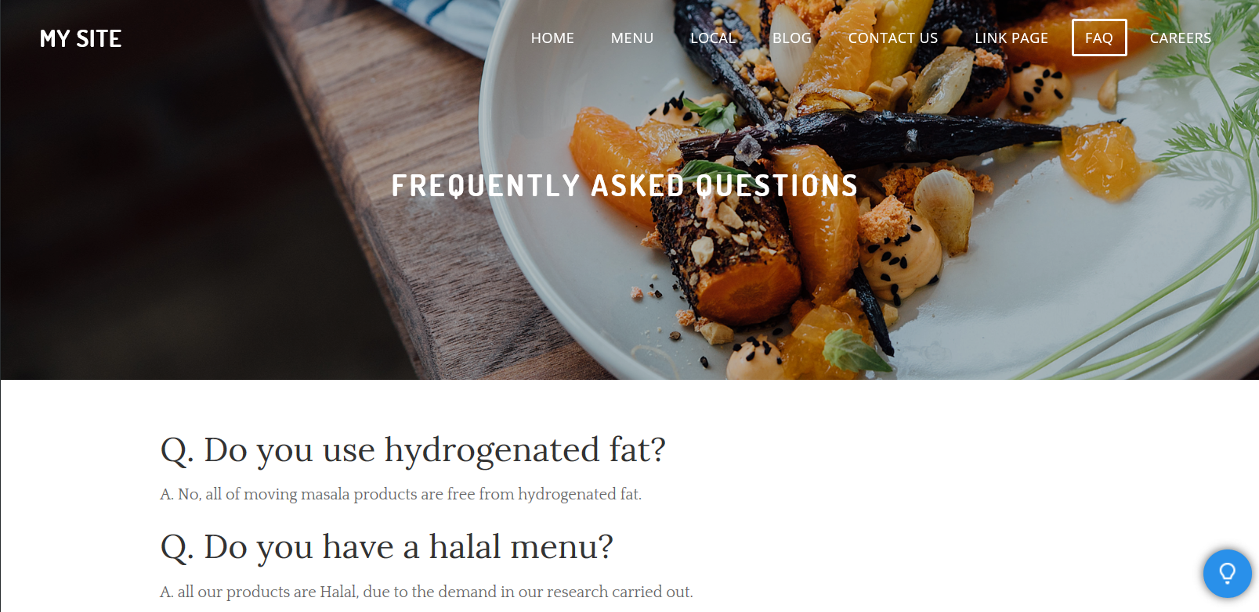
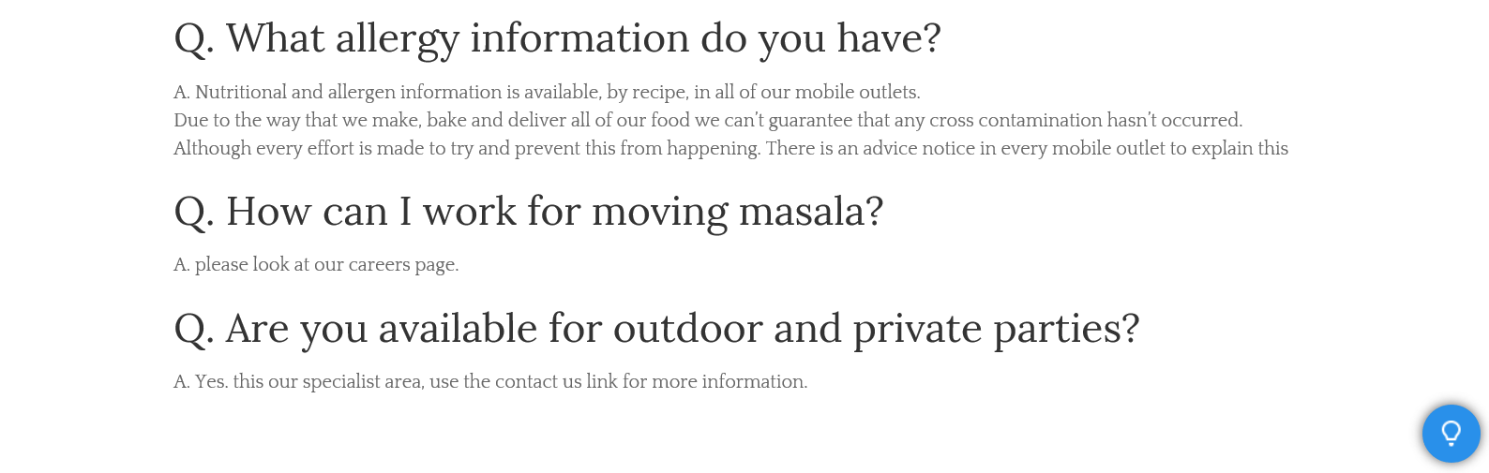

As a group we have designed a website using weebly.
Each of us had our own page to design my page was the FAQs page.

The reason for the FAQs page is that no matter how clear and well-organized a website is, users with questions probably have to browse through a few pages looking for the right answer, which can be annoying for a visitor that just wants a quick answer to an easy question. By compiling answers to common questions on certain topics related to our business, an FAQ page gives visitors a central place to find the answers they need.

I have chosen five questions which I think will be the most commonly asked:

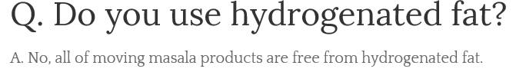

With a very health concise society these days I think that people would like to know what we cook our food with. This promotes our brand in way of being health concise and not cutting corners to maximise profits.

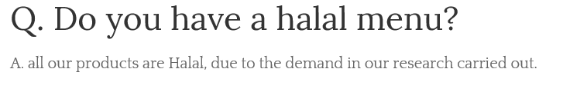

To cater for all faiths and beliefs we intend to be clear about products and appeal to as many potential customers. The halal food market is huge and ever-growing big company’s such as Nando’s and KFC have outlets that cater for halal requirements.

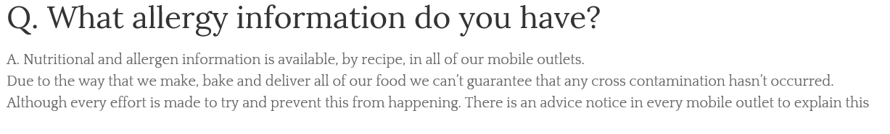

Allergy information is very important that’s why I have included this question and answer there are a lot of people with allergies and we must be very clear as any incidents could be very dangerous.

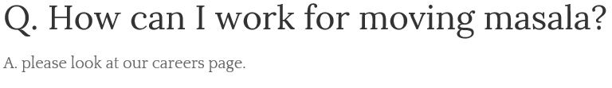

I included this question for information purposes also away of free recruitment advertising.

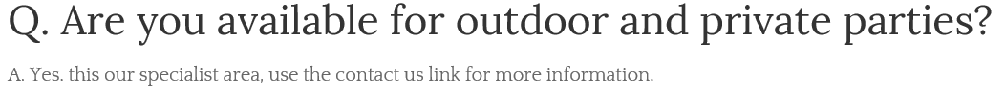
I included this question in order to promote our services.

