Alexander Ford (2501109)

Fundamentals of construction technology
Rhyd y car Terrace

Contents
Introduction 2
Overview of Period Changes (1805-1985) 3
Windows and Doors 4
Wall Coverings 5
Roof Coverings 6
Eaves Details & Rainwater Goods 7
Floor Coverings 8
Conclusion 9
Sketches 10
Reference List 13

Introduction
The Rhyd-Y-Car Terrace is a small row of houses that were originally built in 1795 by Richard Crawshay, to provide accommodation for his iron workers. However, this is no longer the case as the terrace was renovated in 1987 to display the changing standards of working-class Welsh houses throughout nearly two centuries. (Amgueddfa Cymru 2024) This essay aims to outline how houses in Wales have developed over the years, it will compare different building features in each period and explore how features such as the wall coverings, windows and doors and roof coverings have developed over time and why such changes have taken place. These changes reflect wider developments in society, including rising living standards and new building methods.

Overview of Period Changes (1805-1985)

To understand how the Rhyd-Y-Car houses differ from each other, it is important to outline the main changes that occurred between the two centuries. Over the six periods the Rhyd-Y-Car houses demonstrate a clear progression in living standards. This is presented in several ways. Firstly, the house in 1805 is a very basic early industrial house with no sanitation, limited furniture, one room with a fireplace for cooking and heating and it was also constructed using simple materials such as timber frame windows, limewashed walls and a slate roof. By 1855 some small improvements were made, such as more furniture which reflects a slightly bigger focus on comfort and the increase in manufactured goods for the time, however there was still no sanitation in the house and there were only slightly better finishes on interior. The 1895 house shows strong Victorian influence, with an improved iron range for heating, mass produced household goods and a rise of furniture compared to previous homes. For example, companies such as Elliots, who operated a steam powered joinery works in the late 19th century, demonstrate the growing availability of mass-produced household items. (BIAG n.d.) The 1925 house reflects changes in public health and hygiene, with cleaner wall and floor finishes such as decorative wallpaper and carpets. Some limited electricity is also present in this house. The 1955 house displays significant post war improvements, with electricity, running water, concrete floors and more standardised kitchens and bathrooms becoming common features. Finally, the 1985 house incorporates modern standards such as carpets, electric heating and double glazing which all demonstrates a shift towards comfort and an increased concern for energy efficiency. All these changes throughout the houses reveal how working-class housing evolved from basic industrial housing to near modern domestic homes. These developments can be viewed through the Angyeddfa Cymru virtual tour. (Angyeddfa Cymru- Museum Wales n.d.)

Windows and Doors
One of the clearest indicators of the change in housing standards across the Rhyd-Y-Car Terrace is the development of windows and doors. Beginning with the earliest house the 1805 house reveals how basic window and door construction was during the early industrial period. The doors were wooden and thin, this meant that there was no insulation and it also offered little security. As well as this, the windows were made from handmade simple timber frames with multiple thin glass panes. This is because the technology was not advanced enough in 1805 to produce large sheets of glass. As in 1805 crown glass was the most preferred choice for window glass. (IHBC 2024) This resulted in a lot of draught throughout the building and very poor heat retention.
By 1855, the windows and doors in the housing had undergone marginal changes, the windows were still timber framed with small panes of glass as there hadn’t been any major development in the production of large panes of glass. The doors also had minimal improvement as they were still wooden and thin, however small improvements in the joinery quality can be seen, this reflects developments in tools.
In 1895, influence from the Victorian era can be seen in the windows and doors. Due to industrialisation glass became cheaper and clearer. While they were still timber framed the frames were larger and thicker than the ones used in 1855. These changes were made mainly due to accommodate Victorian tastes. Doors were also improved as they were heavier, this allowed for more privacy and less heat loss in the home.
By 1925, the windows had improved from 1855 due to post war developments. While the windows stayed timber framed there are larger panes resulting in less panes on the windows and there were improved putty seals for weather protection. Doors remained mostly the same, although there were sturdier fittings due to better frames, this helped reduce heat loss.
In 1955, Britain saw a housing boom post-WW2, this saw an increased focus on cheap standardised housing. The house in Rhyd-Y-Car reflects this as the windows are factory made timber casement with improved sealant and easier opening. Although the windows were still single glazed as double glazing began to be widely adopted from the 1980s onwards. (Department of Energy & Climate Change 2011)
By 1985 the windows had improved a lot with sealed double glazing which significantly improved insulation, reduced condensation and cut heat loss. The door also became more aesthetically pleasing with polished wood and shaped glass.

Wall Coverings
Another way in which development in the Rhyd-Y-Car Terrace is shown is through the internal and external wall coverings. The earliest house in 1805 had rubble stone walls with a lime plaster, this limewash helped with preventing damp, improving sanitation and giving a uniform finish. (SPAB n.d) The internal walls were rough stone walls with very minimal lime plaster.
The 1855 and 1895 house had very little changes to the wall coverings, the internal walls were still a lime plaster, although it was spread more evenly. The same can be said for the external walls.
By 1925 slight improvements had been made, wallpaper was being mass produced on a large scale and post war public health concerns meant that decorative wallpaper became the fashion as rooms had to be easier to clean, also the mass production of printed wallpaper made them more affordable for the working class. The external walls still used limewash, but the house had a smoother render giving a neater finish.
The 1955 houses had a new development as post war; houses had to be constructed fast. Over 2 million houses were built in the 1950s. (Maxine Lester 2025) This meant that the internal walls were plastered with gypsum not lime, as gypsums fast setting time made it ideal for post war construction. (Logic Plastering 2024) The external walls also had developments as a cement render was used as it was cheap, quick to apply and weather resistant.
The 1985 house used plasterboard on the walls instead of solid plaster, this allowed for faster construction and lower maintenance. The external walls have a smooth sand and cement render and painted pink with masonry paint.

Roof Coverings
Roof coverings also have had a lot of developments across the Rhyd-Y-Car terrace. The 1805 house has a traditional slate tile roof likely sourced from North Wales in the Penrhyn Quarry (History Points), which is very common for this period. Slate was used as there was large quantities of it in Wales which made it cheap at the time. As well as this, slate has excellent durability and water resistance.
By 1855 there was no development in the type of material used as it was still Welsh slate, but slight improvements were made with the way it was fitted due to developments in splitting techniques this allowed for a more consistent pattern on the roof. The same can be said for the 1895 house, it still had a slate roof, but it was thinner and better fitted due to more advanced production. Around this time decorative ridge tiles were sometimes used in Victorian Houses.
By 1925 the house in Rhyd-Y-Car shows some improvement in roof construction. While slate was still the primary roof covering, bituminous felt underlay was increasingly being introduced across the UK. This is because it provides a weather barrier and reduces draughts. (Roofclad Systems n.d.) The 1955 house continued to use slate for the roof covering, but they were fitted with machine made nails. This reflects the post war push for rapid construction and advancements in manufacturing.
By 1985, the roof covering reflects modern building practices. Instead of using traditional slate, the house uses interlocking concrete roof tiles, which had become common around the 60s due to their low cost, durability and ease of installation. (BMI Group n.d)

Eaves Details & Rainwater Goods
Eaves and rainwater goods are an often-overlooked feature of a house, but they affect weather protection and durability. This makes them a clear indicator of developments in housing. The 1805 house has very minimal eaves and during the time likely no formal guttering. This means that rainwater directly ran off the slate roof causing several issues such as damp walls. There were no eaves or guttering due to early industrial housing focused primarily on cost.
The 1855 house had minor developments while it still had shallow eaves, simple timber gutters were introduced although this did help water flow the timber gutters were prone to rot and required frequent maintenance. But wooden guttering was preferred as cast iron was still very expensive during this time. By 1895 cast iron guttering was introduced but it was still expensive, so it wasn’t the standard yet.
By 1925 there was clear improvements in the guttering and eaves. Cast iron guttering was the standard across the UK, this allowed for better water control, and they were also a lot more durable. (HJA) This development reflects the industrial mass production and public health concerns.
The 1955 house also used cast iron guttering although they were easier to replace, due to standardisation of equipment and installation techniques which became common in the post-war period. As well as this, the eaves were more clearly defined and had much wider projection than previous houses. This protected the walls from rain so helped reduce damp and provided shading to windows which helped to maintain comfortable internal conditions. (Designing Buildings Wiki 2020)
The 1985 house had a major development as it was using plastic (uPVC) guttering, which was introduced in the 1960s and became popular in the 1980s. This was beneficial because it is cheap, lightweight, low maintenance and has a good resistance to rot. (Drainage Central n.d.)

Floor Coverings
Floor coverings are a clear indicator of changes across the Rhyd-Y-Car terrace, as they affect hygiene, comfort and temperature within the homes. The 1805 house had a stone flag floor on the ground level, and timber floorboards upstairs. This was a very basic design due to it being the cheapest way of construction this affected performance as the stone flooring was extremely cold and had damp issues. The 1855 & 1895 house also had flagged stone floors and timber floorboards while there was no improvement in the materials used there was developments in the way it was laid and it was bedded more consistently in lime mortar rather than straight onto the earth, this improved stability, durability and cleanliness.
By 1925 the house was still using stone flooring, but they had carpets on the floor, although they weren’t fitted into the floor and were loose laid rugs, they drastically improved comfort throughout the house.
By 1955, the ground floor was constructed using a concrete slab and was finished with vinyl flooring, during this time it was very common as it was invented in the 1930s and was widely popular due to it being cheap, durable and easy to clean. (Designing Buildings Wiki)
By 1985, the house reflects modern domestic standards, as it had fitted carpet throughout the ground floor of the house. This shift to fully fitted carpets reflects comfort and thermal efficiency as carpets provide insulation, reduce draughts and improve the comfort within the home.

Conclusion
To conclude, the Rhyd-Y-Car Terrace is a valuable insight into the development of working-class housing in South Wales across nearly two centuries. By comparing the two houses from 1805 to 1985 clear improvements can be seen in building performance, comfort and hygiene standards. The earlier houses were constructed using basic materials and simple construction methods, this resulted in poor insulation and little protection from damp causing housing to be uncomfortable and pose health issues. However, overtime advancements in building technology, material availability and public health concerns led to improved roof coverings, better rainwater goods, more comfortable floor coverings, and developments in the windows and doors. These changes reflect developments in the manufacturing industry, different tastes amongst society and post-war construction. By the late twentieth century the houses demonstrate more modern domestic standards with an increased focus on thermal efficiency, comfort and durability. Overall, the evolution of the Rhyd-Y-Car terrace highlights how technology progress in building techniques and materials have influenced the design and performance of residential buildings in Wales.

Sketches
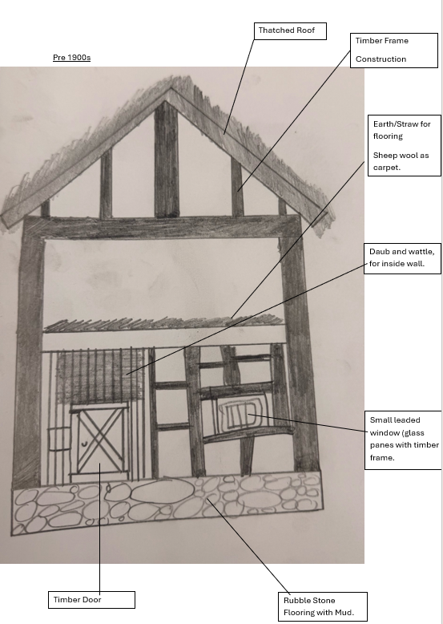

1950s
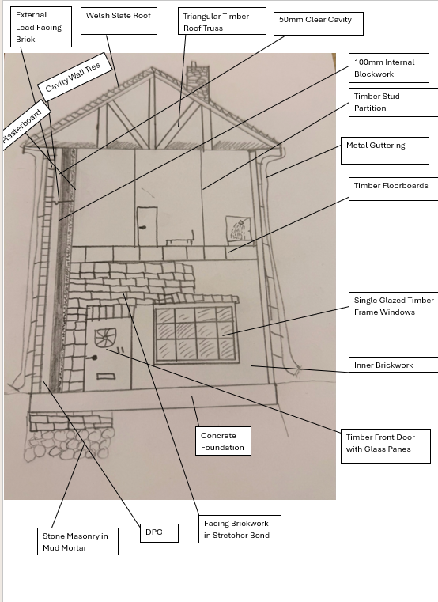
Post 2000
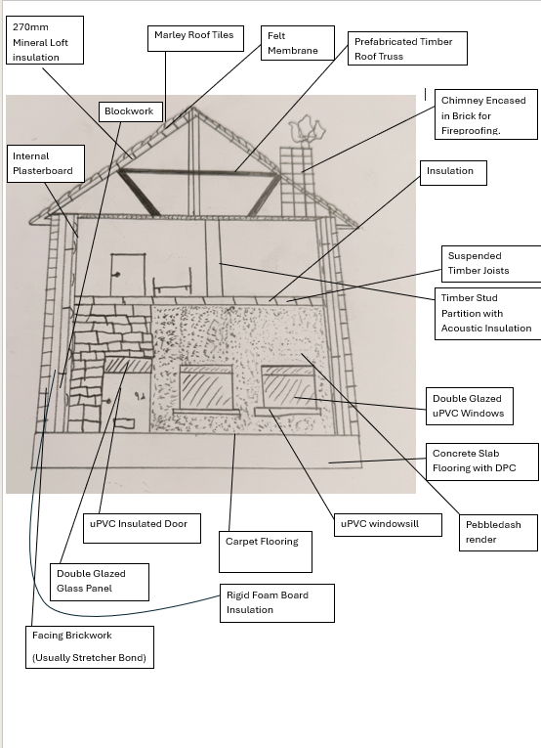

Reference List
Amgueddfa Cymru- Museum Wales (2024) Rhyd-y-car Terrace. Available at: https://museum.wales/collections/historic-buildings/29/Rhyd-y-car-Terrace/ (Accessed:1 November 2025)
Amgueddfa Cymru-Museum Wales (n.d.) Virtual tour of Rhyd-y-car homes through time. Available at: https://museum.wales/learning/activity/401/Virtual-Tour-of-Rhyd-y-car-Homes-through-Time-/ (Accessed:3 November 2025)
BIAG- Berkshire Industrial Archaeology Group (n.d.) Elliotts. Available at: https://biag.org.uk/elliotts/ (Accessed: 2 November 2025)
BMI Group (n.d.) Concrete tile history and heritage. Available at: https://www.bmigroup.com/uk/bmi-from-the-rooftop-blog/concrete-tile-history-and-heritage/ (Accessed: 11 November 2025)
Department of Energy & Climate Change (2011) Great Britains housing energy fact file 2011. Available at: https://assets.publishing.service.gov.uk/media/5a78a9ef40f0b62b22cbbcbf/3224-great-britains-housing-energy-fact-file-2011.pdf (Accessed: 5 November 2025)
Designing Buildings Wiki (n.d.) Eaves. Available at:https://www.designingbuildings.co.uk/wiki/Eaves#Purposes_of_eaves (Accessed: 13 November 2025)
Designing Buildings Wiki (n.d.) Vinyl flooring. Available at: https://www.designingbuildings.co.uk/wiki/Vinyl_flooring (Accessed: 15 November 2025)
Drainage Centre (n.d.) The evolution of domestic guttering- from cast iron to PVC. Available at: https://www.drainagecentral.co.uk/Article-The-Evolution-of-Domestic-Guttering--From-Cast-Iron-to-PVC (Accessed: 14 November 2025)
HJA Fabrications (n.d.) The history of guttering. Available at: https://hjafabrications.co.uk/news/the-history-of-guttering/ (Accessed: 12 November 2025)
HistoryPoints (n.d.) Penrhyn slate quarry. Available at: https://historypoints.org/index.php?page=penrhyn-slate-quarry (Accessed: 9 November 2025)
IHBC- Institute of Historic Building Conservation (2024) The history of glass in the UK and Ireland. Available at: https://www.designingbuildings.co.uk/wiki/The_history_of_glass_in_the_UK_and_Ireland (Accessed: 4 November 2025)
Logic Plastering Services (2024) Gypsum vs lime plaster- what’s the difference? Available at: https://logicplasteringservices.co.uk/gypsum-vs-lime-plaster/#:~:text=Gypsum%20plaster%2C%20also%20known%20as,cost%2Deffective%20option%20for%20homeowners. (Accessed: 8 November 2025)
Maxine Lester Residential Lettings (2023) The housing market 1948-2023. Available at: https://www.maxinelester.co.uk/news/the-housing-market-1948-to-2023#:~:text=Social%20housing%20was%20born%20after,not%20move%20from%20their%20prefabs (Accessed: 7 November 2025)
Roofclad Systems (n.d.) Everything you need to know about roofing felt. Available at: https://www.roofcladsystems.co.uk/blog/everything-you-need-to-know-about-roofing-felt/ (Accessed: 10 November 2025)
Society for the Protection of Ancient Buildings (SPAB) (n.d.) Limewash advice. Available at: https://www.spab.org.uk/advice/limewash#:~:text=Importantly%20for%20old%20buildings%2C%20limewash,comprise%20a%20series%20of%20layers. (Accessed: 6 November 2025)

