Viva Questions and Answers

Question One
Do you expect to get power losses from changes of direction of inertias over a complete 720 degree cycle at constant RPM. Please discuss.

Response
It is expected to see the power stay the same, the effect which I can see is that the work done which has been lost over the 720 degrees, has been reduced and therefore using less torque to change direction of the heaver reciprocating assembly, allowing for more torque to be used to accelerate the vehicle. I am unsure entirely but from 1st principles, it is understood that the power required to change the direction of the piston and reciprocating assembly is less due to Newton’s First Law, F=ma. If (M) mass is lower, and RPM is constant, then the force exerted on the wheel is less therefore meaning less power consumed, so fewer power losses when using the Ti-based alloy.

Question Two
On page 13 you state that load increases to third power of RPM. Is this correct?

Response
This is incorrect as proven by the following screenshot graph:

Question Three
Do you think there will be any separation between rod and cap at normal operating conditions to jeopardise FEA results?

Response
Yes, I believe there will be some separation between the rod and cap. It is apparent from the FEA results and images included within the report that the FE model could have been set-up with higher accuracy in terms of the fitment of the connecting rod to the crankpin to allow for the true interaction of the parts. For example, the rod separation would have caused less stress in the places shown in the FEA results due to the bolts stretching and taking a lot of the load during the cases where the cap and rod would have separated. These inaccuracies meant a higher safety factor was used to take this into consideration. However, a way to prevent rod and cap separation in a real life scenario is to fracture split the rod to create an uneven surface which from research provides a bond which is not so easily separated, thus reducing bolt stress which could be excessive and also providing more accurate FEA results. Fracture splitting the connecting rod is not easily done with Titanium due to its low young’s modulus, Super TIX 51-AF was formed to have a slightly higher young’s modulus therefore allowing for fracture splitting. Below is a screenshot of the closeup rod and cap separation from FEA results:
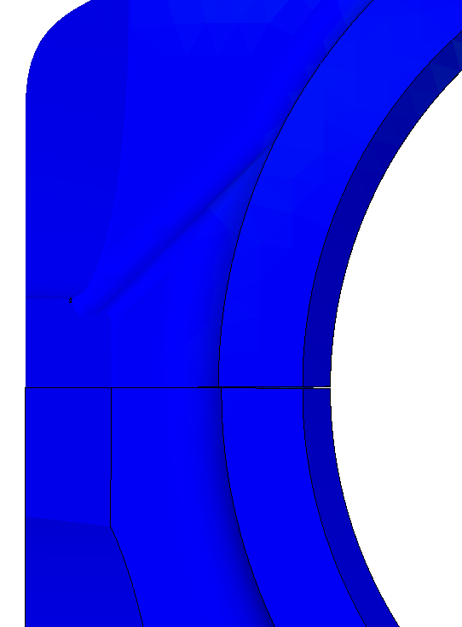

Question Four
Do you think that your achieved reduction in rod mass is sufficient to reduce the crank moment of inertia by 63%? Please check and discuss.

Response
This is a mistake. The crank moment of inertia does not change however the crank mechanism assembly including the reciprocating and rotating connecting rod and piston assembly moment of inertia has reduced but not by the stated 63%, this value was taken from Solidworks as the entire model moment of inertia and is not correct after looking at this again. If the rod mass has been reduced by 30%, this logically looking at the problem will reduce the entire crank mechanism assembly moment of inertia 30% lower, therefore it has not reduced by 63% but 30%.

Question Five
Is the acceleration simulation model in report your own personal Excel development?

Response
Yes, the acceleration model in the report is my own which has been developed further from a lap-time simulation I created previously. The principles for recti-linear motorcycle motion were from Vittore Cossalter’s book. It was seen as the final way to quantify any type of improvement considering the fact the motorcycle is a prototype race machine and the primary goal for racing is to complete a lap in as little time as possible. An assumption was made that the reduced mass of the bike changed with the reduction in crank assembly moment of inertia therefore technically making the bike seem heavier or lighter, but marginally to replicate the equivalent mass reduction. A full lap simulation of the effect would have been desired but there was simply not enough time and maybe time planning could have been slightly better. The moment of inertia used for the crankshaft was not the 63% used in the report but the 30% difference between the steel rod and titanium counterpart. Therefore, the error has not been carried forward and the acceleration improvement is still as it stands in the report.
As something which can be a useful tool for checking the impact on the lap-time or time to accelerate the motorcycle, it has been successful. However, knowing myself it can all change as soon as the rider gets on the bike it can be a bad impact on how the power is delivered or can have had a good impact, only a real test could decide this.

