BUSINESS INTELLIGENCE AND WAYS OF DATA MANAGING
ANCA VASILE
ID UWTSD-2018716

Executive Summary
In the overall report, with arranging a survey with 200 high school students, the most liked
An ice cream flavor related idea has been incorporated in this study. Through the survey it can be stated that the most liked ice cream flavor is vanilla and the rate of gender those like the vanilla flavored ice cream has also been incorporated in this study. It is necessary to highlight those 109 female genders like this flavored ice cream more than the males. Apart from that disadvantages including advantages of SPSS including Excel have been stated in this study effectively.

Table of Contents
Introduction 3
Part 1 3
Findings and discussions 3
Analysis of Pivot Table 4
Analysis of Lookup 7
Part 2 10
Evaluation of choice of Ice cream flavor of students 10
Interpretation of gender of students 11
Illustration of Mean and Median of participants 13
Most basic text mining technique including data mining technique 14
Disadvantageous including advantages of SPSS including Excel 14
Conclusion 15
Reference List 16

Introduction
Business intelligence can be referred to as the procedural including technical infrastructure that stores data that analyzes several data that have been produced through the activities of an organization. This BI can be considered as the vast term that helps in encompassing the data mining, analysis of procedure, descriptive analysis including performance benchmarking. This BI reflects becoming more intelligent regarding the business and for the business related factors BI is the most effective. In this study, utilizing the crime data set that has been given, critically helps in determining the rate of the crime. On the other hand, evaluation of the utilization of excels mainly for analyzing, pre-processing including visualizing the accurate data. Utilizing the two functions of excel that are Lookup including that Pivot Tables crime rate in the region would be analyzed in this study. In the part 2 through using the SPSS software mean median and other questions would be analyzed.

Part 1

Findings and discussions
Data handling can be considered as the procedure of assuring that the research data has been stored, disposes including that archived off into some kind of safer place including security related manner. This also comprised the evolution of some policies including procedure towards managing data handled effectively including that by non electronic related means (Du et al. 2020). Data preprocessing can be considered as the raw data that has been converted into some of the understandable formatting of data. In addition to this, the raw data contains missing data, noisy data including some errors and several of the issues would be resolved through utilizing data processing related techniques in excel.
On the other hand, in order to analyze the data this excel can be recognized as the suitable option as this supports in analyzing several of the data in the worksheet in case that it helps in getting a better business related analyzation. As per views of Becker et al. (2019),This excel can support through recommendations including automatically making the Pivot Tables, which can be recognized as the major path to analyze, summarize, present or else explore the overall data. The main tools that are mainly in excel that might support summarizing including visualizing the data and major types of data visualization in excel can be recognized as pie charts, histograms including bar charts. It is easier to display this data analysis focused reports in a numerous of paths in Excel. On the contrary, in case the results of data analysis might be visualized mainly as charts that help in showcasing the significant pointing in the data. As opined by Astuti and Bhakti (2018), Microsoft Excel can be considered as the most utilized data analysis related programs including the build in some of the Pivot tables that is recently recognized as the most familiar analytic tool. This can be considered as the major reason towards examining including interpreting the data in some types of paths and this type of information might come through several unique places.

Analysis of Pivot Table
It can be stated that this Pivot Table can be considered as an interactive path towards rapidly summarizing massive estimation of data. Through the Pivot Table it will be easier to scrutinize some of the numerical data more in-depth including that answering unanticipated questions regarding the data. The Pivot Table mainly has been designed regarding querying massive estimation of data in several user friendly paths. As opined by Jelen (2022), the main reason behind selecting the utilization of the Pivot Table is that summarizing data in an instant process with the support of Pivot Table. In addition to that, this table helps in managing the data in a more simple process with containing some user friendly attributes. Apart from that, this Pivot Table function in excel supports any researcher to effectively summarize the overall data without encountering any type effective insights instead of encountering hassle. In this study, the Pivot Table including graphs have been used in terms of significantly evaluating the lofty estimation of crime rate between the regions including population.

Crime Rate | (All)
Values
Max of Youth | 177
Max of Region | 1
Max of Education | 15.1
Max of ExpenditureYear0 | 166
Max of Labor Force | 641
Max of Males | 1071
Max of More Males | 1
Max of State Size | 168
Max of Youth Unemployment | 142
Max of Mature Unemployment | 58
Max of High Youth Unemployed | 1
Max of Wage | 689
Max of Below Wage | 276
Table 1: Pivot Table
(Source: MS-Excel)
In the aforementioned table it can be stated that the maximum estimation of crime is happening among the Southern side. 15.1% of literate people are extremely interlinked with this crime rate. The above interpreted table has illustrated that a maximum estimation of 177 youth have been effectively accused of this issue of crime rate. In the Southern state the maximum estimation of males are extremely committed towards the crime that has forced a pessimistic format of effect upon the Southern region of performance.
It is necessary to state that depending upon the previous analysis it can be stated that the rate of unemployment has put a massive effect upon the enhancing ratio of crime in the area of Southern (Gupta et al. 2022). It can be estimated that during the interpretation of the findings of this Pivot table that this youth employment rate is putting a major effect upon the enhancing crime rate in comparison towards the donation of enhancing crime related employment rate. According to Pashazadeh and Navimipour, (2018), major findings of this study critically evaluated that the staff with less wages in the Southern area are majorly inclined towards committing crime to foster their regular necessities.
In order to get better knowledge a graph has been provided below that would provide a better allowance to the researcher. This is for getting a beneficial knowledge regarding the attributes including components of Southern that are playing a major role in the enhanced crime rate related factors. Through the above interpretation, it is important to showcase that several of the employees who are having low incoming rates are more inclined towards committing the crime to effectively foster their necessities on a regular basis (He and Zheng, 2021). It is also important to get a clear understanding about the graph that has been attached in the below as this would provide a better allowance to several researchers. Some diversity mainly in those daily wages focused systems is also containing the effective effect upon the daily enhancing crime related rate in the area of Southern.
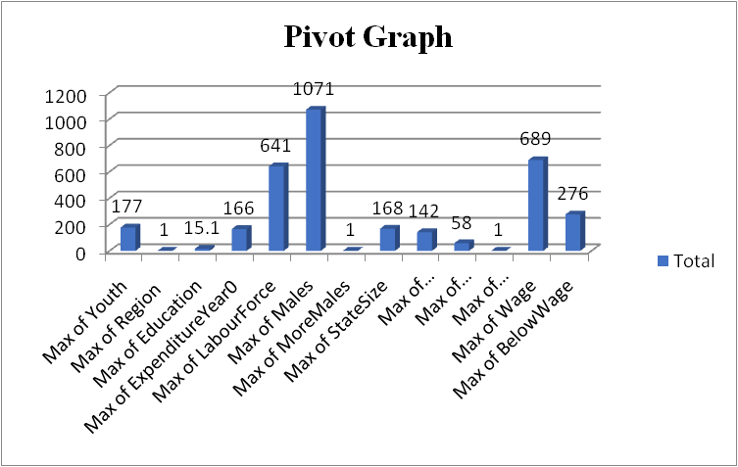
Figure 1: Pivot Graph
(Source: MS-Excel)

With the support of the aforementioned figure that this Southern side is having the lofty estimation of crime rates. This place has a lofty percentage of criminals that are males that has had some crucial impact upon the performance of Southern. In addition, with comprising 641 public maximum workforces including that 166% enhancement in expenditures, the rates of crime have increased tremendously. On the other hand, a maximum of minors rate of 177 have been effectively charged with this accusation of crime, as per considering the data. The percentage of 15.1% of literate people is having a straightforward correlation between the rates of the crime. It can be stated that the lofty incidence of this unemployment of youth will be having a tremendous impact upon the place’s increasing rate of crime (Tillyer et al. 2021). The findings of the pivot table is reflecting that the unemployment rate of youth is having a major effect upon increasing the rate of crime rather than this unemployment rate between the ancient criminal focused population. As opined by McCutcheon (2021), the enhancing prevalence of the crime rate in the Southern side is also effectively being encouraged through the vast range of several incomes in the Southern. In the end it can be explained that some of the low earning workers in the Southern region are deeply getting engaged in some different patterns of criminal activities. The overall findings critically reflect that the lesser incoming workers in this Southern region are more towards getting engaged in some drastic criminal activities.

Analysis of Lookup
VLOOKUP can be considered as the most crucial portion of this MS Excel as this might be undertaken into consideration regarding effectively outlining the data’s potentiality in a succinct manner. In addition to this, VLOOKUP might be used particularly for saving the timing depending upon the estimation that would encounter an individual towards opting for beneficial steps to measure the result of this study. In the below part the VLOOKUP related findings including discussion has been effectively highlighted in this study.
VLOOKUP | 0

Figure 2: VLOOKUP score
(Source: MS-Excel)
The score of this VLOOKUP particularly of this study has been as 0 and this score is reflecting that the Northern side is not that much committing crime than the Southern region. From the overall interpretation it has been clearly stated that this Southern region is trying to fulfill their needs that is the reason they are more engaged in crime. On the other hand, it is necessary to state that the Northern region is not that much into the crime related issues, therefore, on that note that VLOOKUP score has got as 0. Utilization of VLOOKUP at the time the researcher needs towards finding the accurate things in a single table or else some range through the support of row (LaPolla, 2020).
As an example, it can be stated that this looks up some type of price about an automotive portion through the part number or else finding several students related information depending upon various things. As per views of Jelen, (2019), the main reason behind utilizing VLOOKUP to gain the crime data related factors is that this function supports looking at the data automatically rather than any public having towards doing it manually. Therefore, saving time can be recognized as the most significant advantage that springs towards the mind. Through utilizing this VLOOKUP can support the researcher to get the accurate score regarding the crime range in the specific range. At the time someone has the necessity towards searching the information into a vast spreadsheet or else the researcher is searching all the time regarding the equal timing of information through supporting the VLOOKUP function. In the end, it can be stated that the overall interpretation of both of the function VLOOOKUP and Pivot Table are authentic and valid in this study.

Part 2

Evaluation of choice of Ice cream flavor of students
Being a data analyst and doing the work of assisting the local business company, it is necessary to critically analyze the survey about the most desired flavor of ice cream between several students. The survey has proceeded with collecting the data of approximately 200 high school students including some of their scores upon several tests along with these video games including puzzles. As opined by Ain et al. (2019), it is necessary for the business organization to critically get an understanding about the right flavor of ice cream for the several of the students. In order to critically highlight the liking rate of vanilla, chocolate including strawberry pie, a chart has been attached in this study. In addition to this, getting a detailed understanding about the most desired flavor of ice cream can support the business organization to get more business profit including some other benefits.
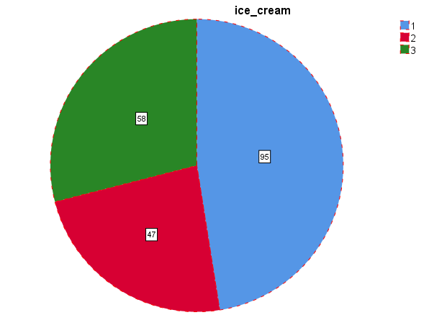
Figure 3: Rate of ice-cream flavor
(Source: SPSS)
In the above figure it has been highlighted that exact rate of flavor that has been liked by most of the students. It can be stated that in terms of knowing the most liked flavor of ice cream the support of SPSS software has been taken to get the exact and authentic amount of rate about the flavor (Rode and Ringel, 2019). Through the above figure it is necessary to highlight that mostly 95 people have liked the vanilla flavor, 47 people have liked chocolate flavor including that 58 people have liked strawberry flavor.

ice-cream
 |  | Frequency | Percent | Valid Percent | Cumulative Percent
Valid | 1 | 95 | 47.5 | 47.5 | 47.5
Valid | 2 | 47 | 23.5 | 23.5 | 71.0
Valid | 3 | 58 | 29.0 | 29.0 | 100.0
Valid | Total | 200 | 100.0 | 100.0
Table 2: Rate of Ice Cream flavor
(Source: MS-Excel)
Through the support of the above table it can be stated that this result that has been undertaken is almost valid. However, it has been mentioned in the previous interpretation that the frequency of 95 is for the vanilla flavor of ice cream. Apart from that, it is important to state that this vanilla flavor is mainly preferred by 47.5% of people and 23.5% of people are favoring chocolate flavor. In addition, 29.0% of people prefer strawberry flavor, this can be stated as the ultimate result of the survey.

Interpretation of gender of students

Estimation of females and males
 |  | Frequency | Percent | Valid Percent | Cumulative Percent
Valid | 0 | 91 | 45.5 | 45.5 | 45.5
Valid | 1 | 109 | 54.5 | 54.5 | 100.0
Valid | Total | 200 | 100.0 | 100.0
Table 3: Gender rate
(Source: SPSS)
From the aforementioned table it can be viewed as the accurate rate of male including females in the survey that has taken place. The rate of the people who have liked the ice cream flavor their rate are in that the exact females and male’s rate have been identified in this section. Through the table it can be highlighted that 91 are males and on the other hand, 109 are females. As opined by Chen et al. (2018), it has been seen that most of the time females generally prefer the vanilla flavor. The above table is reflecting that 45.5% is the accurate percentage of the males that are associated with the liking of vanilla flavor. On the other hand, the percentage of females can be recognized as 54.5. Therefore, from the above interpretation it can be highlighted that the business organization needs to prefer the female gender rather than the males.

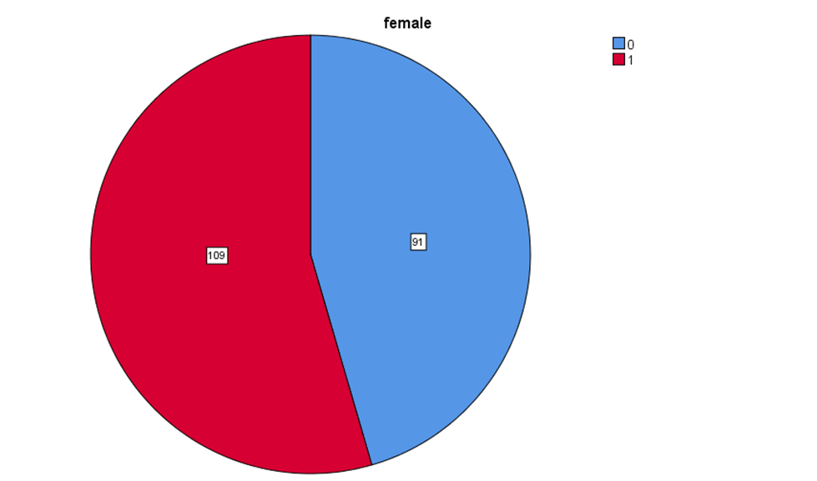
Figure 4: Rate of males and females
(Source: SPSS)
In terms of getting an in -depth knowledge about the right estimation of males of females range that are liking the ice cream flavor, the pie chart has been provided. However, it has been stated earlier still this pie chart is showing that the rate of females is higher than other males. It is not unknown that vanilla flavor has been liked by most females in the past several decades. It is necessary to highlight that in case the business organization is putting more concentration upon the female students in terms of enhancing the growth then it would be beneficial for them.

Illustration of Mean and Median of participants

Descriptive Statistics
 | N | Minimum | Maximum | Mean | Std. Deviation
ice_cream | 200 | 1 | 3 | 1.82 | .857
Valid N (listwise) | 200
Table 4: Descriptive analysis
(Source: SPSS)
From the above table it can be stated that there are some Mean and Median of some of the participants who on the other hand like chocolate including strawberry flavor rather than the vanilla flavor. In the previous data it can be seen that the data value’s mean value is noticed as 1.82, on the contrary, the minimum including maximum related value can be recognized as 3 including that the other one is 1. In addition to this, it has been seen that the research work related data has been gained through the vast volume of participants.

Most basic text mining technique including data mining technique
It can be highlighted that there are numerous critical data mining methods towards effectively considering at the time accessing the data area, however, few of the most basic and precise methods comprise data cleaning, clustering, data warehousing, prediction, association and classification (Ali et al. 2019). However, there are several data mining techniques still the most basic data mining technique can be mentioned as Prediction.
This prediction can be stated as the most suitable data mining process, from the time this has been utilized towards projecting the patterns of data that can be seen in the future. Apart from that, the most basic text mining technique can be recognized as clustering (Pejić Bach et al. 2019). It is necessary to mention that clustering is the most critical method of text mining. This helps in seeking towards getting a better understanding about intrinsic structures mainly in textual information including that organizing these into precise subgroups or else clusters regarding to do further analysis in future.

Disadvantageous including advantages of SPSS including Excel
The major disadvantage of SPSS is that this might not be utilized towards analyzing a massive data set. The main advantage of SPSS can be recognized as that it is comprehensive statistical focused software. Apart from that, the advantage of MS-Excel can be recognized as it helps in transforming including cleaning the data, better path towards storing several of the data, and this helps in printing the reports in a more simple way (Jelen, 2020). On the other hand, the major disadvantage of Excel is that it lacks control including security, and complexity in managing advanced costing related rules.
Excel can be recognized as the most complex towards troubleshooting including for the test related factors. The other major issues of using the Excel is that this is susceptible towards the errors of the human and this is vulnerable towards the corruption and utilizing this might be caused several data privacy related issues (Juwairiah et al. 2021). However, Excel has more benefits than disadvantages, therefore, in the end it can be stated that both Excel including SPSS are effective to use for data analysis.

Conclusion
Throughout the overall report the gender rate of those liking the vanilla flavor can be started from the aforementioned interpretation that the flavor ice cream is mostly liked by females. In the study, through using the SPSS software the Mean along with that Median has been undertaken. From the interpretation it can be stated that, the most liked flavored ice cream of students is vanilla flavor, then strawberry and after that chocolate is less liked by the students. In addition, disadvantages including advantages of SPSS along with Excel have been incorporated in this study.

Reference List
Ain, N., Vaia, G., DeLone, W.H. and Waheed, M., 2019. Two decades of research on business intelligence system adoption, utilization and success–A systematic literature review. Decision Support Systems, 125, p.113113.
Ali, H., Salleh, M.N.M., Saedudin, R., Hussain, K. and Mushtaq, M.F., 2019. Imbalance class problems in data mining: A review. Indonesian Journal of Electrical Engineering and Computer Science, 14(3), pp.1560-1571.
Astuti, I.A.D. and Bhakti, Y.B., 2018. Interactive learning multimedia based Microsoft excel on the temperature and heat. Unnes Science Education Journal, 7(1).
Becker, L.T. and Gould, E.M., 2019. Microsoft power BI: extending excel to manipulate, analyze, and visualize diverse data. Serials Review, 45(3), pp.184-188.
Chen, C., Chen, H., He, Y. and Xia, R., 2018. TBtools, a toolkit for biologists integrating various biological data handling tools with a user-friendly interface. BioRxiv, 289660(10.1101), p.289660.
Du, P., Bai, X., Tan, K., Xue, Z., Samat, A., Xia, J., Li, E., Su, H. and Liu, W., 2020. Advances of four machine learning methods for spatial data handling: A review. Journal of Geovisualization and Spatial Analysis, 4(1), pp.1-25.
Gupta, V.K., Shukla, S.K. and Rawat, R.S., 2022. Crime tracking system and people’s safety in India using machine learning approaches. International Journal of Modern Research, 2(1), pp.1-7.
He, J. and Zheng, H., 2021. Prediction of crime rate in urban neighborhoods based on machine learning. Engineering Applications of Artificial Intelligence, 106, p.104460.
Jelen, B., 2019. Excel: WILDCARDS IN VLOOKUP AND SUMIFS. Strategic Finance, 100(11), pp.62-63.
Jelen, B., 2022. Excel: COMPARE TWO ITEMS IN A PIVOT TABLE. Strategic Finance, 103(10), pp.60-61.
Juwairiah, J., Indarwanta, D. and Kodong, F.R., 2021, November. Evaluation of Oil and Gas Economy using Economics Profit Indicators and Prototype Macro VBA Excel. In RSF Conference Series: Engineering and Technology (Vol. 1, No. 1, pp. 549-558).
LaPolla, F.W.Z., 2020. Excel for data visualization in academic health sciences libraries: a qualitative case study. Journal of the Medical Library Association: JMLA, 108(1), p.67.
McCutcheon, J.C., 2021. The impact of the interstate on violent crime in three southern states: do drugs play a role?. Criminal Justice Studies, 34(2), pp.156-172.
Pashazadeh, A. and Navimipour, N.J., 2018. Big data handling mechanisms in the healthcare applications: a comprehensive and systematic literature review. Journal of biomedical informatics, 82, pp.47-62.
Pejić Bach, M., Krstić, Ž., Seljan, S. and Turulja, L., 2019. Text mining for big data analysis in financial sector: A literature review. Sustainability, 11(5), p.1277.
Rode, J.B. and Ringel, M.M., 2019. Statistical software output in the classroom: A comparison of R and SPSS. Teaching of Psychology, 46(4), pp.319-327.
Tillyer, M.S., Wilcox, P. and Walter, R.J., 2021. Crime generators in context: examining ‘place in neighborhood’propositions. Journal of Quantitative Criminology, 37(2), pp.517-546.

