Performing An Energy Audit



Student name: Joseph Blackmore (1702858)

Programme: BEng Energy & Environmental Engineering

Module: Energy Management & Efficiency

Module Code: M6X01197

Contents

- Introduction
1.1 Energy Audits
- Background of Berry Global
- Types of energy and where it is used
  - Electricity Usage At The Facility
  - Electrical Distribution Drawings
  - Calculation of Total Capacity
- Assessment of the current situation
- Calculations of the amount of energy used
- Potential energy savings
6.1 Potential savings by replacing compressors with VSD units
- Recommendations
- References

Introduction
In this report an overview of the energy consumption of a thermoplastics manufacturing facility operated by Berry Global in Kenfig, Bridgend, will be analysed. By reviewing the energy usage of the operation, an understanding of where potential energy savings can be obtained can be established. As energy consumption is often a significant portion of a manufacturing businesses financial outlay, effectively managing energy consumption and improving the overall efficiency of the manufacturing process and associated energy consuming activities is an important method of improving the profitability of a business such as Berry Global. There are a variety of factors that can cause the actual energy usage over a given period to vary quite significantly compared to the estimated energy usage. When completing the energy audit a variety of assumptions will be required in order to gain some calculations, the projected energy usage and actual energy usage can be compared.

1.1 Energy Audits
An energy audit is an inspection survey of energy usage within a building or facility. Audits can be carried out across an entire industrial facility or carried out in more detail across a particular manufacturing process. Energy audits aid industrial companies and facilities in measuring how much energy is being used, what form of energy is being consumed and where energy is being consumed within the facilities. A well-produced energy audit will allow the company to understand how efficiently their operation is running and highlight to engineers areas of possible improvement. For example, by evaluating how much energy is being used by an air compressor, this information can compared against a possible alternative that may be more efficient, collating this data can inform the auditor on what recommendations can be made to improve efficiency moving forwards. Alternatively a periodic increase in energy usage could highlight the necessity for maintenance or replacement of components, by closely monitoring energy usage a cost-benefit analysis can be made to determine whether investment in new equipment is financially viable.
The type of energy audit applied will depend on the purpose of the audit, the type of industry it is concerned with and the potential magnitude for energy savings. Industrial energy audits can be seperated into two categories;
- Preliminary (walk-through) audit-
This type of audit utilises readily available energy usage information such as the power ratings of machinery and utilities in order to highlight common opportunities for energy saving. This opportunity can also be taken to carry out visual inspections in order to highlight poor maintenance or outdated and inefficient equipment. This form of audit takes a relatively short amount of time and the economic analysis is typically limited to a basic payback period
- Detailed (Diagnostic) audit-
For diagnostic audits more detailed data is required, data inventory is usually collated for individual processes and energy systems. Detailed energy usage is usually collected over a period of time for a specific system, such as a pump fan or heating element, in detail. This type of audit is typically far more time invasive but produces a more detailed picture of the performance of specific operations, hence allows for more specific energy saving recommendations.
(Hasenbeigi & Lynn, 2010)

The auditing process should identify ways to enhance an organisations operating efficiency and decrease maintenance costs. All potential areas for increasing efficiency must be considered, however in many cases it may be considered impractical or not economically feasible for much of the methods initially considered. For every recommendation that is made by an energy auditor, possible health and safety implications must always be considered.

The auditing process is a continual process through which new areas for efficiency improvements can always be targeted. Monetary savings from carrying out no-cost and low-cost activities can be used in order to fund higher cost and more long term investments in improving operational efficiency. The diagram below represents how energy auditing can be considered a continual process;

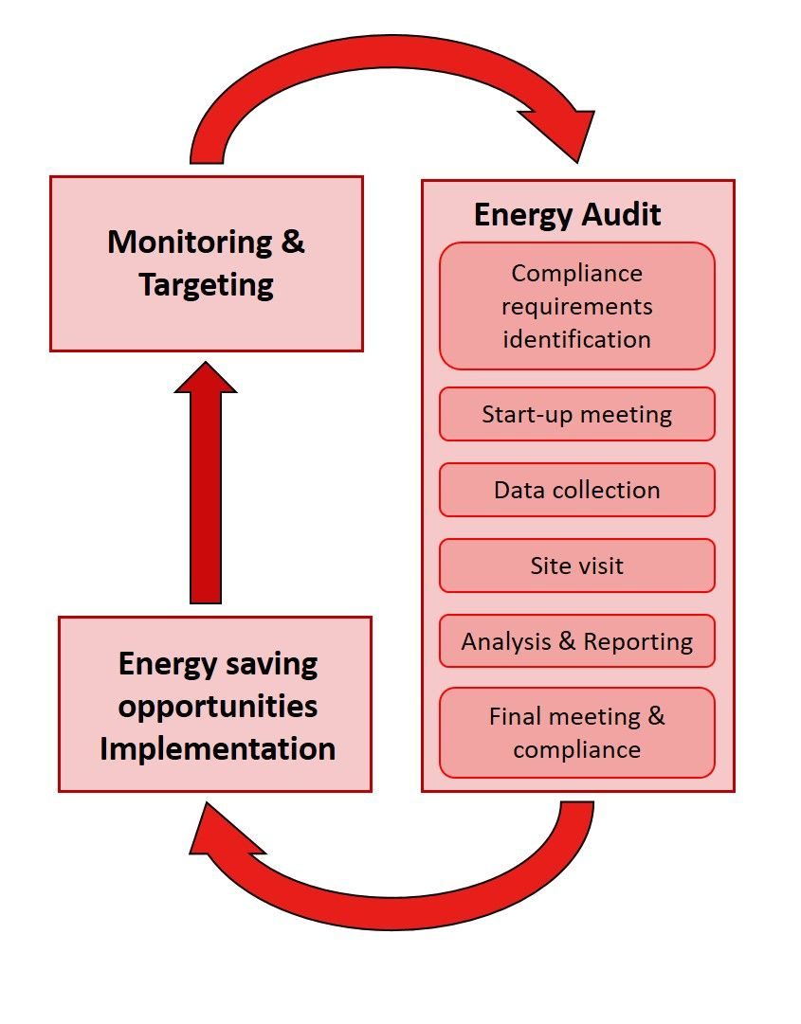

(Figure 1) (R2M Solutions, n.d.)

Background of Berry Global

Berry Global is an international manufacturer of plastic packaging products based in Indiana, USA, their Kenfig plant manufactures recyclable plastic vending cups and coffee machine capsules. The Kenfig plant operates two separate manufacturing processes over 10 lines called Omni and Bellaform.
There are four Bellaform and Omni lines with one Bellaform grinder and one Omni grinder.
The two separate types of manufacturing line represent different manufacturing processes and therefore different amounts of energy usage.
Polystyrene Office style water cups and Klix vending cups are produced using a 2 layer process on the Bellaform lines. Polypropylene products such as the coffee capsules and green Klix cups are manufactured using a 5 layer process on the Omni lines. The Omni lines account for more energy usage as the polypropylene requires reheating along the manufacturing process as the material begins to harden as it cools down along the production line.




(Figure 2, products produced by Omni lines) (Figure 3, products produced by Bellaform lines)

Site Fundamentals

Type Of Business | Thermoforming
Annual Production Tonnage | 8021 Tonnes
Energy consumed in a year | 34,017,877 kWh
Permanent staff | 82 people
Working Hours | Direct Staff  Bellaform Section - 3 shift rota/5 days per week  1. Mornings 6am to 2pm  2. Afternoons 2pm to 10pm  3. Nights 10pm to 6am  Omni Section - 2 shift rota/7 days per week  1. Days 7am to 7pm  2. Nights 7pm to 7am  Indirect Staff  9am to 5pm - 5 days per week

Working hours are particularly important in regards to energy auditing as in order for energy usage calculations to be made, the amount of time that specific energy consuming activities are estimated to take place needs to be understood. Omni lines are run continuously 7 days a week with production only stopping due to machine breakdowns and planned maintenance. Bellaform production lines are run continuously from Monday to Friday with maintenance taking place on weekends. Office staff are present at the facility from Monday to Friday between the hours 9am to 5pm. The facility is operational for all but 2 days of the year over Christmas and boxing day.

Types of Energy & Where It Is Used At The Facility

Three forms of energy are consumed at the facility in the form of gas, LPG, and electricity.
Electricity is by far the form of energy consumed the most at this site as it is the primary form of energy used to run the manufacturing process. According to the companies report for the fiscal year 2017, when converted into kWh equivalent the total usage of gas, LPG and electricity are as follows;

- Electricity= 26,213,572 kWh
- LPG= 127,244 kWh
- Gas= 59,403kWh

As electricity is clearly the largest form of energy consumption, monitoring how and where electricity is being consumed at this facility will offer the greatest opportunity to highlight potential areas for reducing energy consumption. Gas and LPG are used for heating purposes in the offices and foyer, whereas the equipment used on the factory floor solely uses electricity.
Between these 4 main areas, over 90% of the entire facilities energy consumption can be accounted for
Areas Of Significant energy Usage
- Bellaform Thermoformers
- Omni Thermoforming
- Air Compressors
- Chillers, Pumps And Cooling Equipment

Electricity Usage At The Facility

The electrical supply coming into the factory is split into three separate meters as follows;
 | 1st Supply (Main) | Submeter No.
 | Compressor 1 Feed 1 (L250) | PAC003
 | Compressor 1 Feed 2 (L250) | PAC003
 | Compressor 2 (L160) | PAC004
 | Adiabatic Cooling Tower | PAC011
 | Adiabatic Cooling Pump 1 | PAC012
 | Adiabatic Cooling Pump 2 | PAC013
 | Office Lighting and Power
 | Production Area Lighting and Power (Bellaform)
 | Heat Exchangers/Dryers | PAC008
 | Bellaform Line 1 | PAC016
 | Bellaform Line 2 | PAC018
 | Bellaform Line 3
 | OMNI Grinder 1 | PAC001
 | OMNI Grinder 2 | PAC002
 | OMNI 6 | PAC017
 | OMNI 6 Hot Air Supply

2nd Supply | Submeter No.
Roof Fans and Chilled Water Pumps
Chiller | PAC’s not yet set up
OMNI 7
OMNI 7 Hot Air Supply
OMNI 8
OMNI 8 Hot Air Supply
OMNI 9
OMNI 9 Hot Air Supply
Chiller 1 (Montair)
Chiller 2 (Hitema 320 kW)

3rd Supply | Submeter No.
Compressor 3 (VSD 55 kW) | PAC005
Compressor 4 (55 kW) | PAC006
Compressor 5 (ML132) | PAC007
Bellaform Grinder 1 | PAC014
Bellaform Grinder 2 | PAC015
New Workshop
Dryer | PAC010
Bellaform Line 4

In order to gain an estimated value for the total electrical energy demand for the production area of the factory when all equipment is operational, the power demand for each piece of equipment must be established. Some machinery will display power ratings in kW’s, however for some machines, pieces of equipment and lighting, the power consumption needs to be determined by the auditor. For some pieces of equipment the capacity was determined using the programmable automated controllers (PAC).

3.2 Electrical Distribution Drawings From The 3 Supplies

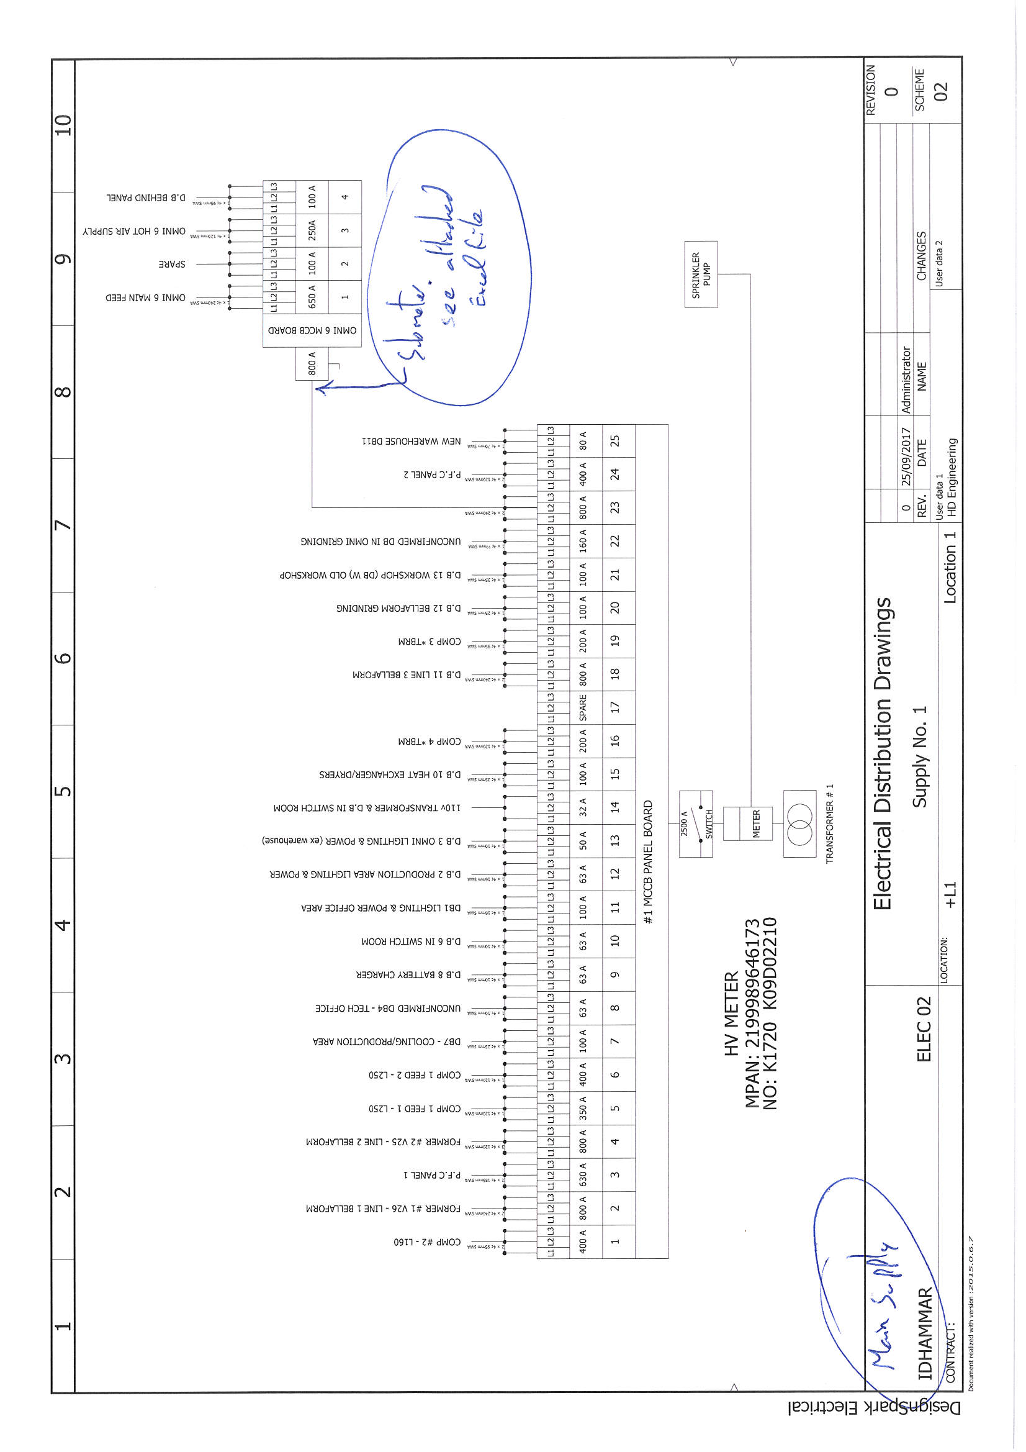

(Figure 4)

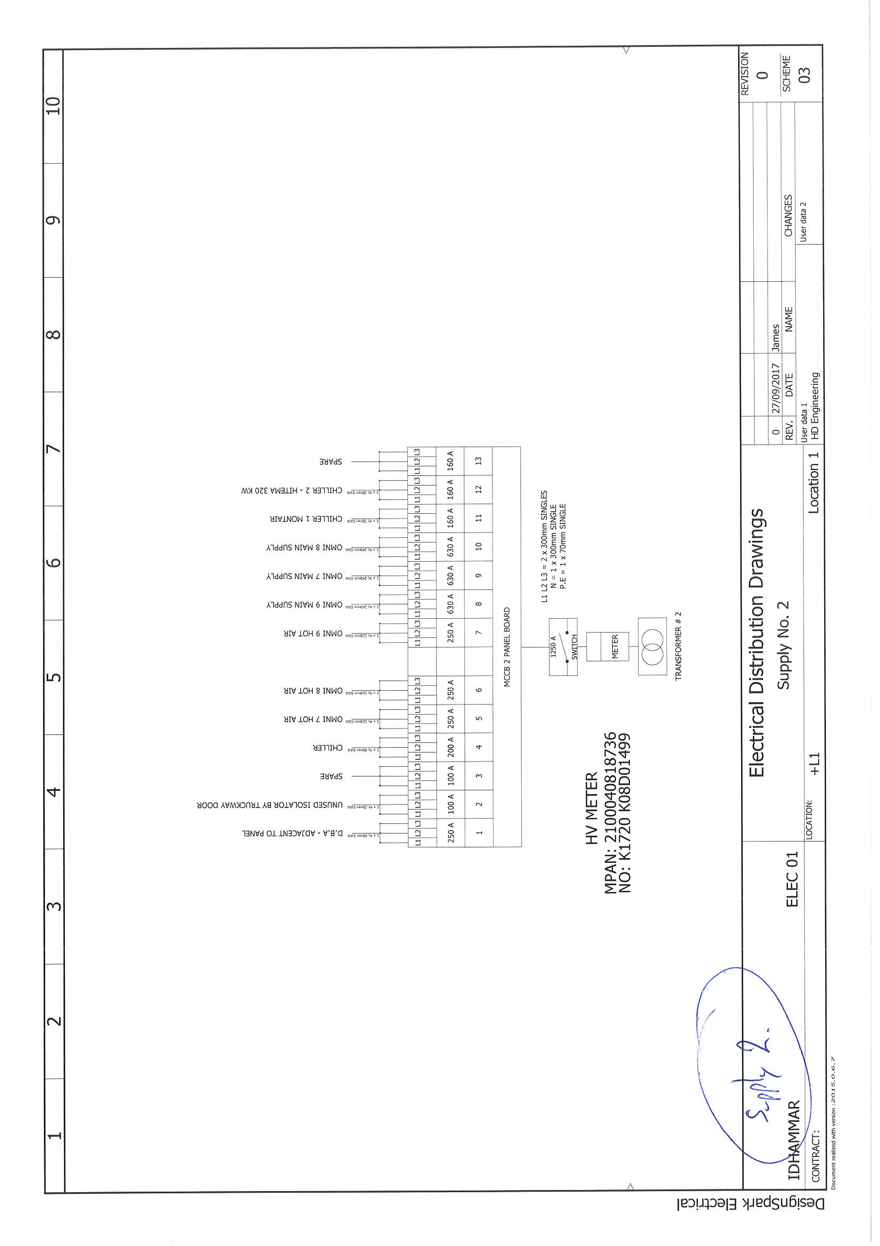

(Figure 5)

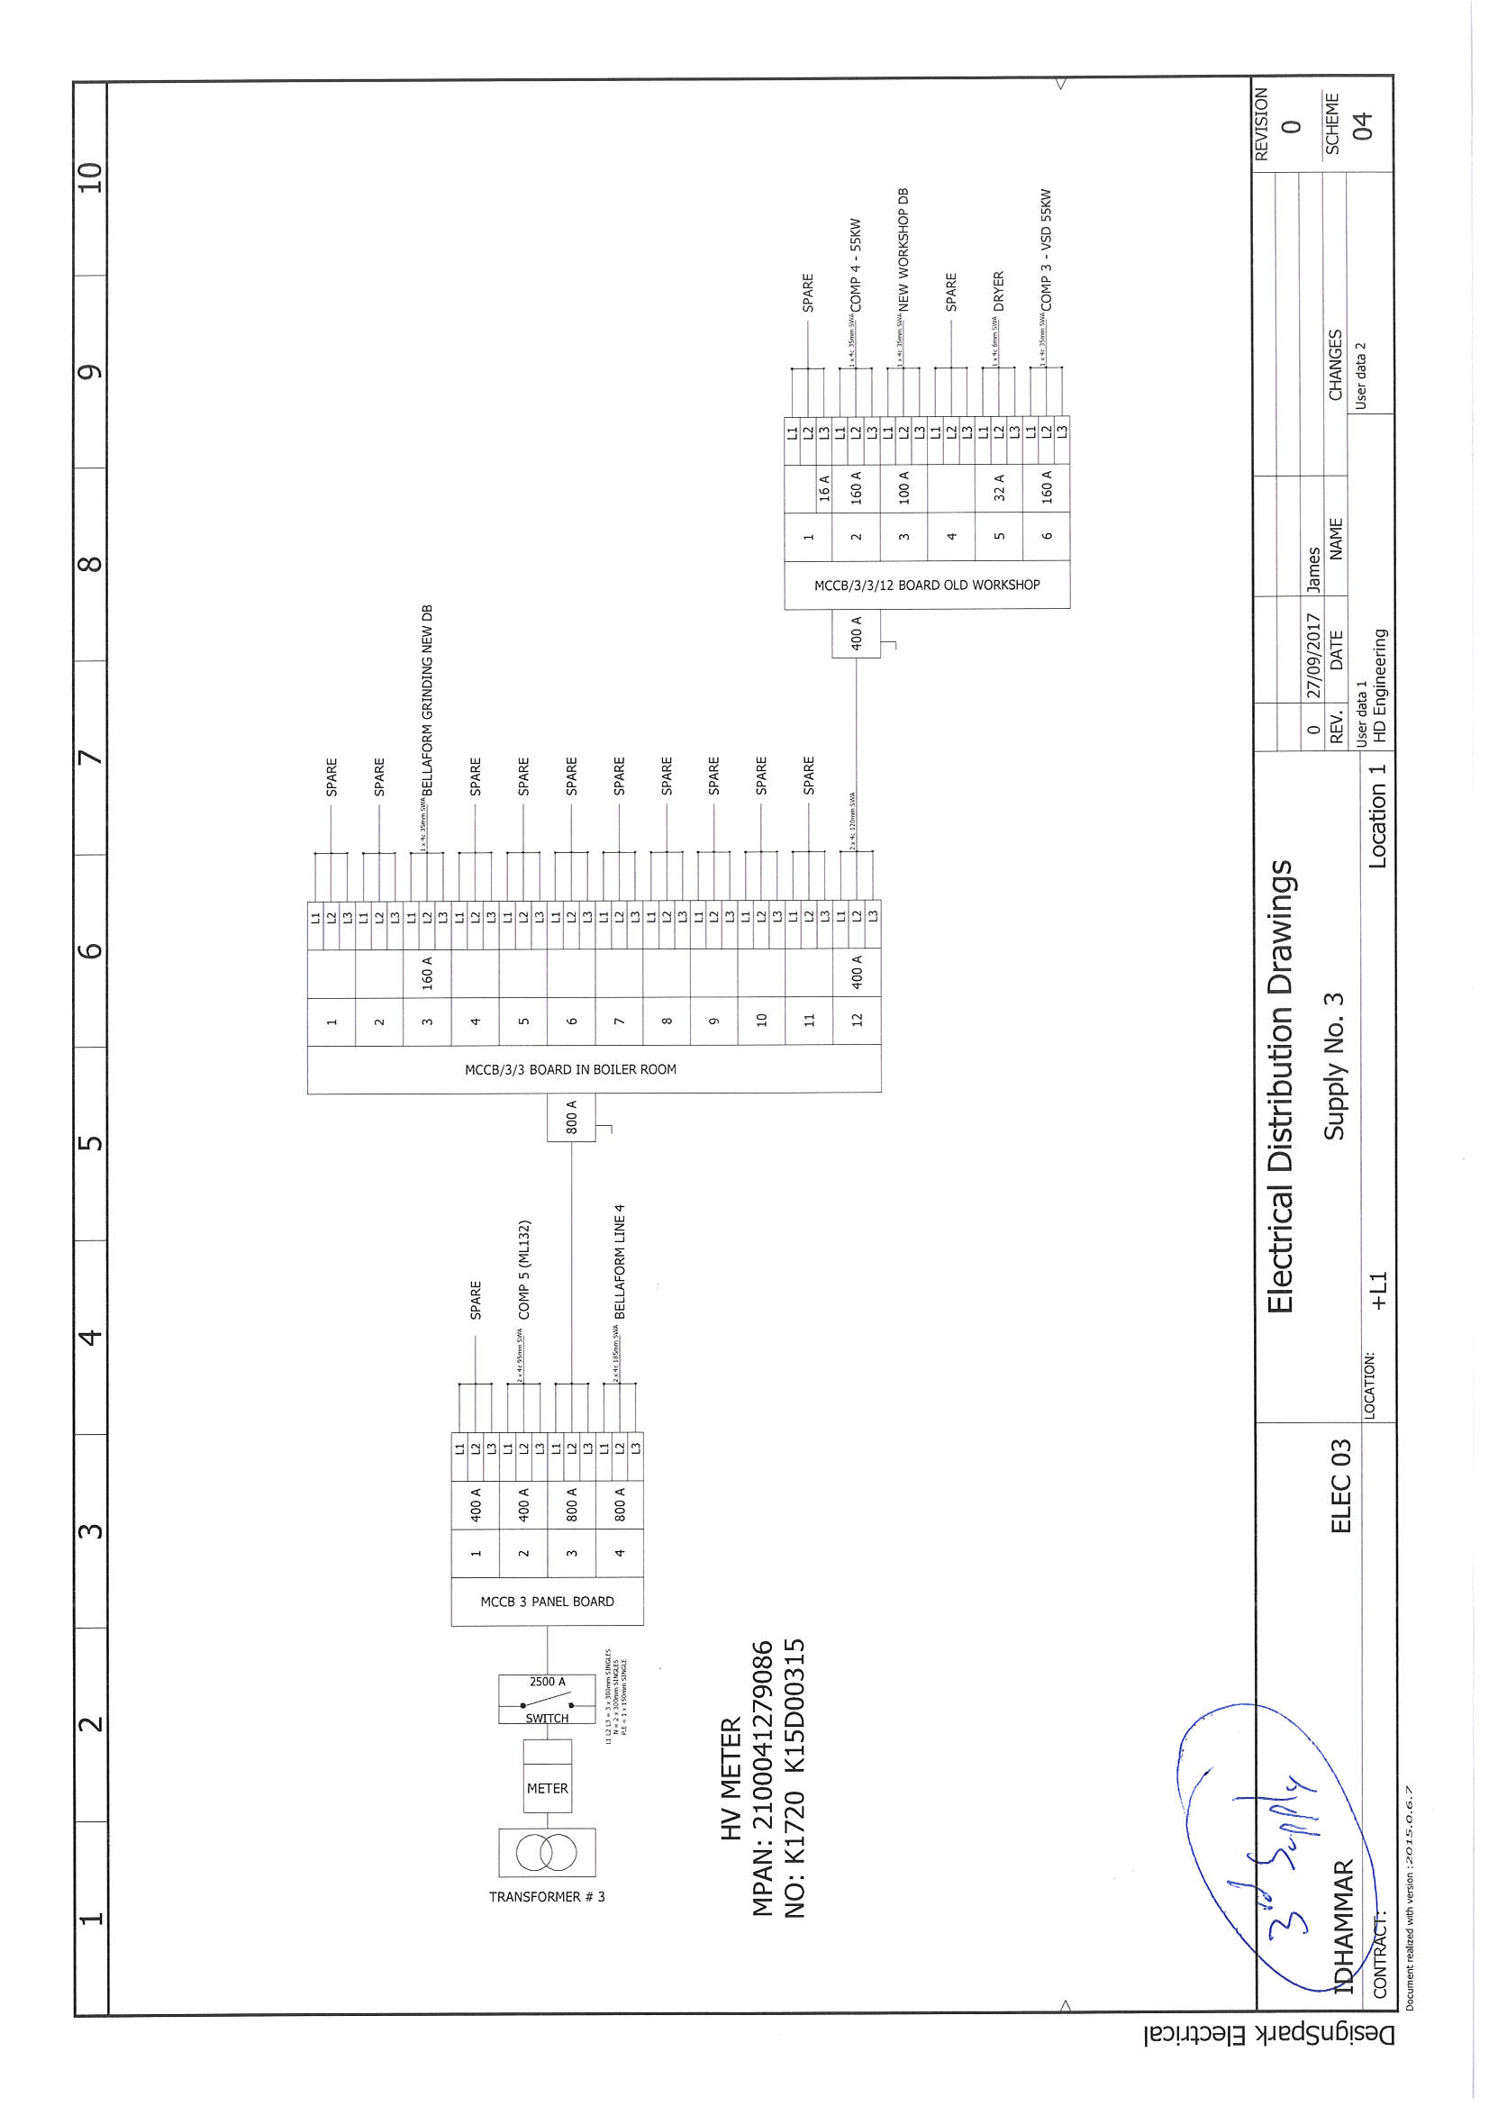

(Figure 6)

Calculation of total capacity

ENERGY CONSUMPTION BY MACHINE (Data is in unconverted kW)

ENERGY Kw

Compressor 1 250 *

Compressor 2 160*

Compressor 3 55*

Compressor 4 55*

Compressor 5 132* (Standby compressor, so not included in total)

Chiller 1 (Hitema) 320*

Adiabatic Cooler 525 *

Omni 6 489 **

Omni 7 489 **

Omni 8 489 **

Omni 9 489 **

Omni Grinder 1 14.5 **

Omni Grinder 1 14.5**

Bellaform Line 1 210 **

Bellaform Line 2 210 **

Bellaform Line 3 210 **
KEY

* Rated

** Measured using PAC readings

Bellaform Line 4 210 **

Bellaform Grinder 1 30 *

Bellaform Grinder 2 30*

Production Lighting 400 *

TOTAL = 4650 kW
The measured ratings are calculated using PAC monitors. The energy demand for each component of the Omni lines was noted and summated in order to gain a figure for the line as a whole. The factory is currently in the process of installing PAC’s on all of the equipment used in the production area. At this stage the monitors can only be used to monitor and control some of the equipment. On the equipment where PAC’s are in place the exact energy demand for the equipment can be accurately recorded, in addition to this PAC’s can be utilised to automatically shut down equipment that is not being used during maintenance periods or malfunctions.
 | Drive | Heating
 | KW | KW
Extruder K70
Screen changer
Melt pump
Feed Pipe to Feed Block | 93
7-Layer feed block
Die connection
Die DB 100F
Screen changer KL45 *4 |  | 11.6
Extruder K45-24D (CMG) | 12
Extruder K45-24D (CMG) | 12
Extruder K45-30D (CMG) | 18
Extruder K45-30D (CMG) | 18
Polishing haul-off GA1/900
Air knife
Heating and cooling unit | 12
Flat sheet haul-offBA1/900
Aspirations K70 | 5.5
Aspirations K45 (Ext 2,3,4,5) | 5.5
RDM 75K illig | 86
PLS 75B illig
Heating and cooling unit RDM75K | 1.5 | 7.5
Heating and cooling unit PLS 75B | 1.5 | 7.5
Grinder | 12
Aspirations punching hole | 12
Aspirations punching hole | 3
Amax (Packing Machine) | 5
Air Compressor | 93
Water cooling | 72
 | 462 | 26.6
Total KW | 488.6

(Example of how data logged by PAC meter is used to calculate capacity of one of the Omni lines.)

Assessment of current Situation

Currently there are a number of areas within the action plan that show promise for improving the overall efficiency of the factory. Installation of PAC monitors has not been fully completed, once this project is completed a more specific understanding of overall energy use in the production area and more effective control of individual machines will be available. A plan is already in place to replace production lighting with LED fittings. The air compressors currently in use are fixed drive units, installing variable speed compressors would improve efficiency as during maintenance and breakdowns the speed of the compressors could be adjusted to match the reduced air pressure demand. All air compressors and grinders are run at full capacity, even when some of the production lines are down. The main air compressors are placed outside of the factory in order to increase operating efficiency and allow for more room in the production space. For every 4 degree centigrade drop in intake temperature, a 1% increase in efficiency can be expected due to denser intake air. Due to the location of the air compressor units, utilising a heat recovery system to heat the office areas at the facility would not be feasible due to the distance between the air compressors and office spaces. A heat exchanger system has been put in place in order to provide space heating for the work shop area that is situated adjacent to the production area however.

Workshop Heat exchanger system;
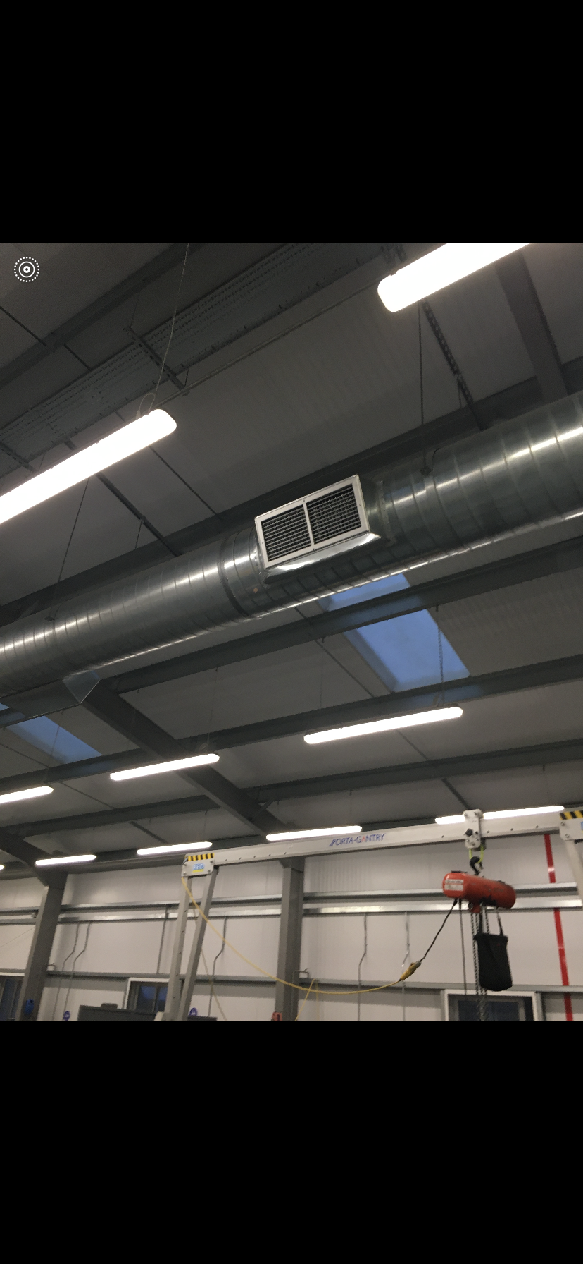
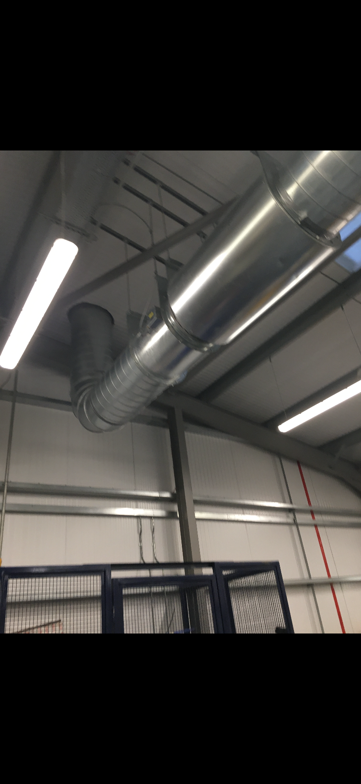

(Figures 7 & 8)

Annual Energy Usage Estimation

Production area is operated for 363 days per year, 8712 hours

Bellaform Section - 3 shift rota/5 days per week
1. Mornings 6am to 2pm
2. Afternoons 2pm to 10pm
3. Nights 10pm to 6am

Omni Section - 2 shift rota/7 days per week
1. Days 7am to 7pm
2. Nights 7pm to 7am

The following assumptions were made to gain an annual estimation for electricity usage;

Omni section is operated for 8712 hours/year
Bellaform section is operated for 6216 hours/year

The following equipment is running continuously through the working year;

- Compressor 1 (250 kW)
- Compressor 2 (160 kW)
- Compressor 3 (55 kW) 250+160+55+55+320+525+400+60+29= 1854 kW
- Compressor 4 (55 kW)
- Chiller 1 (Hitema) (320 kW) 1854 kW x 8712 hours= 16,152,048 kWh
- Adiabatic Cooler (525 kW)
- Production Lighting (400 kW)
- Bellaform Grinders (60 kW)
- Omni Grinders (29 kW)

Bellaform and Omni lines and grinders will not be consuming energy continuously through the
year as they are shut off during planned maintenance and to fix breakdowns. Total down times including planned maintenance and breakdowns from January 1st 2019 to January 1st 2020 have been calculated for each line using data from the Idhammar CMMS (computerised Maintenance Management System).

Down time; Running hours over the year; kWh;
Bellaform line 1 (210 kW) 3866 hours 6216-3866= 2350 210x2350= 493500
Bellaform line 2 (210 kW) 3534 hours 6216-3534= 2682 210x2682= 563220
Bellaform line 3 (210 kW) 2898 hours 6216-2898= 3318 210x3318= 696780
Bellaform line 4 (210 kW) 1681 hours 6216-1681= 4535 210x4535= 952350

Omni 6 (489 kW) 6428 hours 8712-6428= 2284 489x2284= 1116876
Omni 7 (489 kW) 2900 hours 8712-2900= 5812 489x5812= 2842068
Omni 8 (489 kW) 1786 hours 8712-1786= 6926 489x6926= 3386814
Omni 9 (489 kW) 2116 hours 8712-2116= 6596 489x6596= 3223977

Total = 12,768,685 kWh

By adding the estimated energy usage from the lines and continuously operated equipment, the total estimation for annual electricity consumption in the production area of the facility is as follows;

Total estimated annual electricity usage= 28,920,733 kWh

Potential energy savings

Variable speed air compressors are typically considered around 30% more efficient, considering around 80% of the cost of an air compressor in its lifetime is due to its running costs, this is a worthwhile long term investment. Instead of controlling inlet or exhaust valves to regulate the output of the compressor whilst it still runs at full speed, a variable drive unit will reduce the speed of the compressor to meet the output demand. VSD retrofit should not be considered on centrifugal machines as they usually run above the first critical speed and serious damage can occur if the speed is changed. (Carbon Trust , 2018) The Compressors used at Berry are centrifugal so retrofitting would not be applicable.

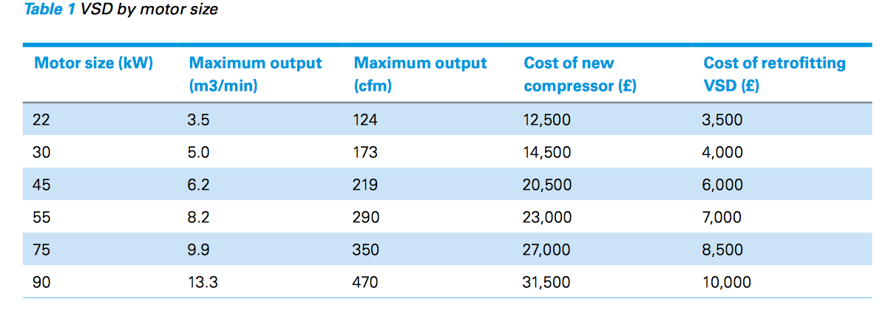

(Figure 9)

To improve efficiency the smaller compressors at the plant could be replaced by VSD units with the two largest compressors operating at full capacity to supply the base load required.
Compressors 3&4 could be replaced with two 55kW VSD units offering the following potential savings;

Assumptions made: VSD units use 30% less electricity, new units cost £23,000 each

Potential savings by using VSD compressors

Compressors 3&4 operate for 8712 hours per year, consuming;

55kW x 8712= 479160 kWh per year each.

If VSD units are 30% more efficient VSD units will consume 70% x 479160 kWh

VSD units consume 335412 kWh per year each.

Each 55 kW VSD compressor can save approximately 143748 kWh of consumption per year.
Taking cost of electricity to be 8p per kWh, this equates to a saving of £11500 per year each.

Taking the price of a new VSD 55kW air compressor to be £23000 the pay-back time is as follows;

£23000/£11500 = 2 year payback period for replacing the 55kW compressors for variable speed units.

Recommendations

Short term- Completing the installation of the programmable automated controllers should be an immediate priority in the energy management plan. When this system is brought online energy savings can be made immediately by shutting down the grinders automatically when any of the lines are down for maintenance and repairs. Implementing a clear energy management strategy to employees at all levels can encourage a culture of energy usage awareness and encourage vigilance in highlighting areas where energy is potentially wasted.

Long term- Investment in more efficient variable speed drive air compressors would provide an opportunity to achieve significant energy consumption reductions with a reasonable payback period. The current practice of continually running all compressors at full capacity is inefficient and should be altered. Replacing the production area lighting with LEDs as planned in the energy management plan should be taken forward as there is the potential for significant energy savings in this area.

References
Berry Global, 2019. How are we creating a more sustainable future?. [Online]
Available at: https://sustainability.berryglobal.com
Carbon Trust , 2018. How to utilise variable speed drives with air compressors. [Online]
Available at: https://www.carbontrust.com/media/147017/ctl167_variable_speed_motor_driven_air_compressors.pdf
[Accessed 31 January 2020].
Hasenbeigi, A. & Lynn, P., 2010. Industrial Energy Audit Guidebook: Guidelines for Conducting an Energy Audit in Industrial Facilities, Berkeley : Lawrence Berkeley National Laboratory .
Moynihan, G. P. & Barringer, F. L., 2017. In: Energy Efficiency in Manufacturing Facilities: Assessment, Analysis and Implementation. s.l.:IntechOpen.
R2M Solutions, n.d. Energy Audits & Efficiency Measures. [Online]
Available at: https://www.r2msolution.com/energy-sustainability/energy-audits-efficiency-measures/
[Accessed 31 January 2020].
SKM Enviros & BRE, n.d. Guidebook for Energy Auditing in Industry. [Online]
Available at: http://eemo.govmu.org/English/Documents/Final-Audit-Guidebook-Industry.pdf

