Data Handling and Business Intelligence
Business Management LCBB5000
Lecturer name: Dr Ejike Udeogu
Aurel Apopei (2245793)

Tabel of content

Section 1:
1. Descriptive Statistics
2. Visualization of Relationships
3. Correlation Analysis
Section 2
a) Advantages and Disadvantages of Using SPSS
b) Understanding the Data Mining Cycle: Importance and Examples
References

Section 1: Statistical Analysis of USA Housing Dataset
1. Descriptive Statistics
Overview of Variables
In the USA housing dataset, I will focus on the following key variables: house price (`price`), living square footage (`sqft_living`), lot square footage (`sqft_lot`), number of bedrooms (`bedrooms`), and number of bathrooms (`bathrooms`). Descriptive statistics will be calculated to provide an overview of these variables.
Summary Statistics
Using SPSS for preliminary analysis, the descriptive statistics were computed as follows:
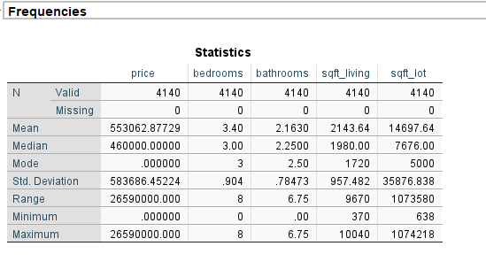
Descriptive Statistics Summary
Here are the descriptive statistics for the variables of interest:
- Price:
  - Mean: $553,062.90
  - Median: $460,000
  - Standard Deviation: $583,686.50
  - Range: $26,590,000

- Square Footage of Living Space (sqft_living):
  - Mean: 2,143.64 sqft
  - Median: 1,980 sqft
  - Standard Deviation: 957.48 sqft
  - Range: 9,670 sqft
- Square Footage of Lot (sqft_lot):
  - Mean: 14,697.64 sqft
  - Median: 7,676 sqft
  - Standard Deviation: 35,876.84 sqft
  - Range: 1,073,580 sqft
- Bedrooms:
  - Mean: 3.40
  - Median: 3
  - Standard Deviation: 0.90
  - Range: 8
- Bathrooms:
  - Mean: 2.16
  - Median: 2.25
  - Standard Deviation: 0.78
  - Range: 6.75
Interpretation
The dataset provides a comprehensive overview of key variables influencing residential property values, including price, square footage of living space, square footage of the lot, number of bedrooms, and number of bathrooms. The descriptive statistics enable an analytical understanding of these variables' distribution and central tendencies.
Price Analysis
The average house price stands at $553,062.90, revealing that residential properties are above the half-million mark. The median price, however, is significantly lower at $460,000, suggesting a right-skewed distribution where a handful of extremely high-priced properties inflate the mean. The standard deviation of $583,686.50 indicates substantial variability in prices, further supported by the extensive range of $26,590,000. This highlights that while most homes are clustered around the median price, there is a considerable number of properties at both the lower and upper extremes.
Square Footage analysis
When assessing square footage, we observe that the mean for living space is 2,143.64 sqft, contrasted by a median of 1,980 sqft. This again suggests a right-skew in living space, indicative of larger properties pushing the mean upwards. The large standard deviation (957.48 sqft) coupled with a range of 9,670 sqft reinforces the notion that there is significant diversity in the size of homes available in the market.
For lot sizes, the average area is considerably larger at 14,697.64 sqft, yet the median value of 7,676 sqft indicates that many properties have relatively smaller lot dimensions. The very high standard deviation of 35,876.84 sqft and the range stretching to 1,073,580 sqft suggest that lot sizes vary drastically, likely influenced by location and zoning regulations.
Bedrooms and Bathrooms Metrics
Regarding the number of bedrooms, the mean is 3.40 with a median of 3, indicating a typical size of family homes. The standard deviation of 0.90 reflects less variability in this attribute compared to others, as most properties conform closely to this average, with the range peaking at 8.
In terms of bathrooms, the mean is 2.16 and the median is 2.25, suggesting that while most homes feature two bathrooms, some offer additional facilities, contributing to the mean value. The standard deviation of 0.78 indicates that slight variations in bathroom numbers are present, though not as pronounced as those seen in other variables.
Next, lets visualize the relationships between house price and the selected factors.
2. Visualization of Relationships
To deepen our understanding, visualizing the relationships between house price and the aforementioned factors will be essential. Scatter plots could reveal correlations between house price and square footage, while box plots can display variations in price concerning the number of bedrooms and bathrooms. Additionally, multi-dimensional representations may yield insights into how combinations of these variables interact to affect pricing decisions. Analysing these visualizations will allow us to identify trends and potential predictive relationships critical for stakeholders in the real estate market.
- House Price vs. Number of Bedrooms:
  - There is a slight upward trend in house prices as the number of bedrooms increases. However, there is significant variability, showing that other factors also play a crucial role in deciding house prices. 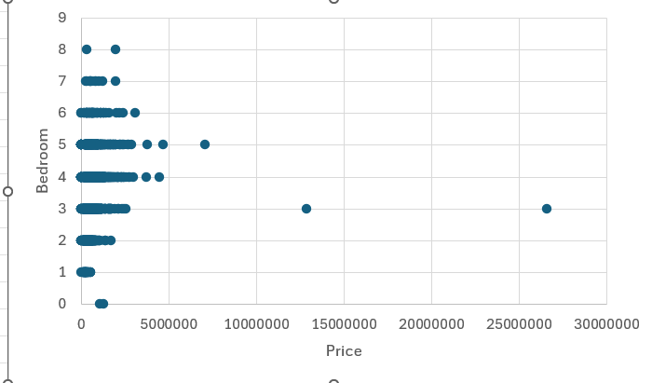
- House Price vs. Number of Bathrooms:
  - Like bedrooms, more bathrooms tend to correlate with higher house prices, but the relationship is not extraordinarily strong. 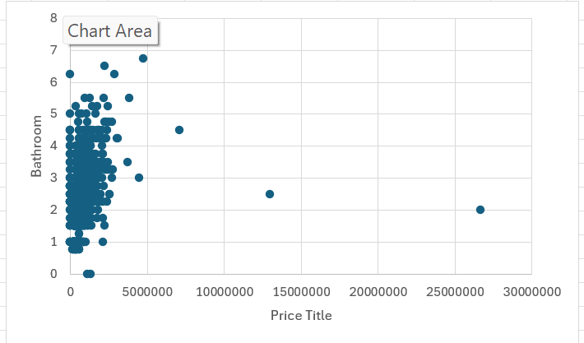

- House Price vs. Square Footage of Living Space
  - There is a clear positive correlation between the square footage of living space and house prices. Larger homes tend to be more expensive.
  - 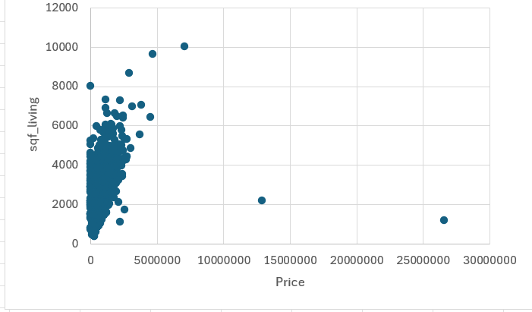
- House Price vs. Year Built:
  - Newer houses tend to have higher prices, but there are exceptions. This could be due to other factors like location, design, and amenities. 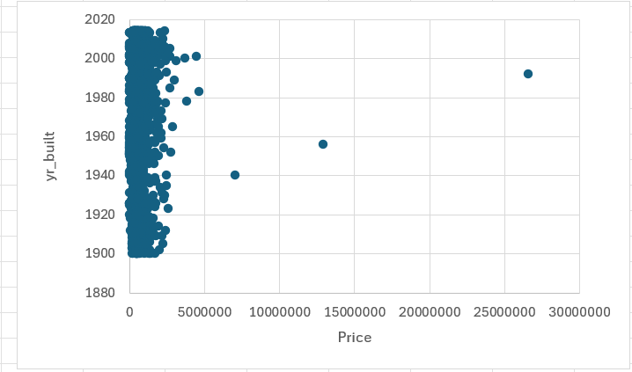
Next, let us perform a correlation analysis to decide which variables are most strongly related to house prices.

3. Correlation Analysis
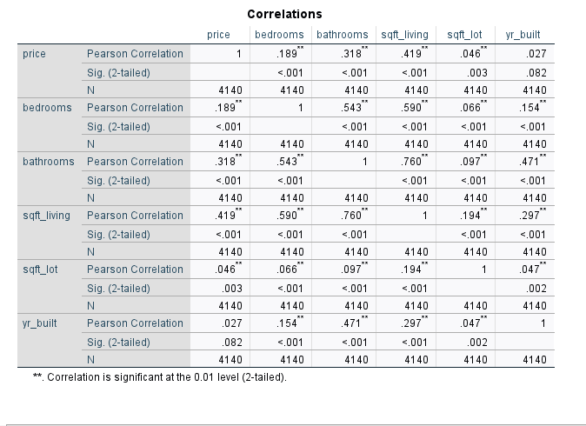
The correlation analysis of five factors influencing house prices reveals notable insights regarding the interplay between specific property characteristics and market valuation. Each of the examined variables presents a different level of influence, which can be essential in understanding buyer behaviour and market dynamics.
1. Square Footage of Living Space (sqft_living):
The strongest positive correlation found is with the square footage of living space, recorded at 0.42. This significant correlation implies that as the living area of a home increases, its price tends to rise correspondingly. This relationship underscores the importance of usable space in residential properties. Buyers often prioritize larger living areas, leading to a higher willingness to pay, which reflects in market trends.
2. Bathrooms:
Following closely, the number of bathrooms shows a moderate positive correlation of 0.32 with house prices. This finding suggests that additional bathrooms enhance a home's market value, albeit not to the extent of total living space. The presence of multiple bathrooms caters to buyer preferences for convenience and functionality, particularly in family-oriented markets where shared facilities are a consideration.
3. Bedrooms:
In contrast, the correlation related to the number of bedrooms is weaker at 0.19. This indicates that while having more bedrooms can contribute positively to a property's price, it is less impactful than other factors such as living space and bathrooms. This diminished influence may reflect shifts in buyer priorities, with an increasing emphasis on overall functionality and comfort rather than merely the quantity of sleeping quarters.
4. Square Footage of Lot (sqft_lot):
The very weak correlation of 0.05 between lot size and house prices suggests that the size of the land on which a house sits has minimal impact on its market value. This could indicate a trend towards urbanization where buyers are more focused on available living space and proximity to amenities rather than the expansiveness of the lot.
5. Year Built (yr_built):
Similarly, the correlation coefficient of 0.03 for the year built emphasizes a negligible influence on house prices. This finding could reflect a market shift where newer constructions may not guarantee significantly higher prices, possibly due to factors such as location or property condition being more critical determinants.
In summary, the analysis indicates that the most influential factors on house prices are the square footage of living space and the number of bathrooms, whereas lot size and the age of the property appear to play a minor role in market valuation. Understanding these correlations can guide both buyers and sellers in making informed decisions in the real estate market. As trends evolve, continuous monitoring of these relationships will be crucial for accurately predicting housing price movements.
Recommendations for Potential Homebuyers
Based on the correlation analysis of factors influencing house prices, here are a couple key recommendations for potential homebuyers:
Prioritize Living Space
The strong positive correlation between living space and house prices (0.42) indicates that focusing on properties with larger square footage is likely to be a sound investment
When house hunting, pay close attention to the usable living area rather than just the overall property size.
Consider Bathroom Count
With a moderate positive correlation of 0.32, the number of bathrooms significantly impacts a home's value.
Look for properties with multiple bathrooms, as they tend to command higher prices and may offer better resale potential in the future.
Balance Bedroom Count
While the number of bedrooms shows a positive correlation (0.19) with house prices, its impact is less significant than living space and bathrooms
Focus on finding a home with an appropriate number of bedrooms for your needs, but do not necessarily prioritize quantity over other factors.
De-emphasize Lot Size
The weak correlation (0.05) between lot size and house prices suggests that paying a premium for a larger lot may not be the best investment strategy
Instead, consider factors like location, amenities, and the quality of the living space.
Look Beyond Age
With a negligible correlation (0.03) between the year built and house prices, do not be confused by a property's age.
Older homes in good condition or desirable locations may offer better value than newer constructions.
Focus on Functionality and Comfort
Given the strong correlation with living space and bathrooms, prioritize homes that offer practical, comfortable living arrangements. Open floor plans, well-designed layouts, and functional spaces may be more valuable than raw square footage.
Consider Location Carefully
While not directly addressed in the correlation analysis, location remains a crucial factor in property valuation. Look for homes in areas with good schools, amenities, and transportation links, as these factors can significantly impact long-term value.
Assess Potential for Improvements
When evaluating properties, consider the potential for adding value through renovations or expansions, particularly in areas that show strong correlations with price (e.g., increasing living space or adding bathrooms).
Stay Informed About Market Trends
Keep in mind that real estate markets can change over time. Stay informed about local market conditions and how they might affect the relative importance of different property features.
By focusing on these factors, potential homebuyers can make more informed decisions, balancing their immediate needs with long-term investment potential. Remember that while these correlations provide valuable insights, individual circumstances and local market conditions should always be considered when making a home purchase decision.

Section 2: Discussion of Tools and Data Mining Cycle
a) Advantages and Disadvantages of Using SPSS for Data Analysis

Statistical Package for the Social Sciences (SPSS) is a software used extensively by researchers, analysts, and students for data management and statistical analysis. This essay explores the advantages and disadvantages of using SPSS, illustrating its capabilities through practical examples.

One of the primary advantages of using SPSS is its user-friendly interface, which allows individuals with minimal statistical knowledge to perform complex analyses seamlessly. For instance, a high school student conducting a survey on the impact of study habits on academic performance can easily input data into SPSS without needing an advanced understanding of statistics. The software provides a straightforward point-and-click interface that simplifies the analytical process, making it accessible to users from diverse backgrounds (Field, 2018).

Another significant advantage of SPSS is its comprehensive range of statistical functions. The software can manage various statistical tests, including t-tests, ANOVA, regression analysis, and non-parametric tests. For example, a researcher examining the relationship between exercise frequency and mental health outcomes could employ SPSS to conduct a regression analysis, allowing for insights into how changes in exercise correlate with variations in mental well-being (Pallant, 2020). This breadth of functionality makes SPSS a powerful tool for both beginners and seasoned statisticians.

Moreover, SPSS offers robust data visualization options, allowing users to create informative graphs and charts easily. This capability enhances the communication of findings, making it easier to present results to stakeholders or during academic presentations. For instance, a researcher could highlight the correlation between study time and grades using a scatter plot generated in SPSS, thus providing a clear visual representation of their findings (Cohen et al., 2017).

However, despite his advantages, SPSS also has notable disadvantages. One such drawback is its cost. SPSS is a proprietary software that requires purchasing a license, which can be prohibitively expensive for students or small organizations with limited budgets. In contrast, free alternatives like R or Python offer similar functionalities without the financial burden, making them more accessible for those who cannot afford SPSS licenses (Hilbe, 2014).

Additionally, while SPSS is user-friendly, this simplicity can lead to oversimplification of data analyses. Users may rely solely on the default settings without fully understanding the underlying statistical principles. For instance, a student might conduct a t-test to compare two groups but fail to check the assumptions necessary for the test’s validity, such as normality and homogeneity of variance. This lack of critical evaluation can lead to misleading conclusions, undermining the quality of research (Ghasemi &amp; Zahediasl, 2012).

Another disadvantage lies in the limitations of data manipulation within SPSS. While it excels at statistical analysis, users often find its data manipulation tools less flexible than programming languages like R. For example, merging datasets or reshaping data can be done more efficiently in R, where users can write scripts to automate repetitive tasks (Grolemund &amp; Wickham, 2016). Consequently, researchers requiring extensive data preprocessing before analysis might find SPSS constraining.

In summary, SPSS offers a wealth of advantages, including user-friendliness, a wide array of statistical functions, and excellent data visualization capabilities. However, its cost, potential for oversimplification in analyses, and limitations in data manipulation present significant challenges. When choosing a statistical analysis tool, it is crucial for users to weigh these pros and cons based on their specific needs and resources.

b) Understanding the Data Mining Cycle: Importance and Examples

Data mining is a process that involves analysing large datasets to discover patterns, relationships, and insights that can inform decision-making. The data mining cycle is a systematic approach that helps researchers and analysts effectively navigate this process. This essay explains the meaning and importance of the data mining cycle, providing relevant examples to underscore its significance.

The data mining cycle consists of multiple stages: problem definition, data collection, data preparation, data exploration, modeling, evaluation, and deployment. Each stage plays a critical role, ensuring that the data mining process is structured and efficient.

The first stage, problem definition, involves clearly articulating the objectives of the data mining project. This step is essential as it sets the direction for the entire process. For example, a retail company aiming to increase sales might define its problem as identifying customer purchasing patterns to develop targeted marketing strategies. By establishing a clear goal, the company can design its data mining efforts accordingly.

Next, data collection involves gathering relevant data from various sources. This step can include internal databases, surveys, or external datasets. Utilizing tools like SPSS or Excel, researchers can efficiently compile data for analysis. For example, in the case of the retail company, data on customer demographics, purchasing history, and product preferences might be collected to guide their marketing strategies.

Data preparation follows data collection and involves cleaning and transforming the data to ensure its quality. This stage is crucial as poor-quality data can lead to inaccurate results. For instance, if the retail company’s dataset contains missing values or inconsistent entries, this could skew the analysis. Techniques such as standardization, normalization, and imputation are often employed to enhance data quality (Kirk, 2020).

Once the data is prepared, researchers enter the data exploration phase, where they examine the dataset to identify patterns or anomalies. Visualization tools can be instrumental in this stage as they allow analysts to grasp underlying trends quickly. For example, by creating a histogram of sales data, the retail company might uncover seasonal buying trends, informing inventory and promotional strategies.

The modelling stage involves applying statistical or machine learning algorithms to the prepared dataset. This is where insights are derived from the data. For example, a decision tree algorithm could be used to segment customers based on their purchasing behaviour, enabling the company to tailor marketing campaigns for specific customer segments.

After modelling, evaluation assesses the quality and effectiveness of the model. Researchers must determine whether the model meets the initial objectives defined in the problem definition stage. For instance, the retail company might evaluate whether the predictive model accurately forecasts sales for different customer segments.

Finally, the deployment stage involves implementing the insights gained from the data mining project into real-world applications. This could mean launching targeted marketing campaigns or adjusting inventory based on predicted buying behaviours. In the retail example, successful deployment could significantly enhance the company’s sales and customer satisfaction.

In conclusion, the data mining cycle is a vital framework for guiding researchers through the complex process of data analysis. Its structured approach ensures that each stage contributes to achieving the project’s goals and delivers meaningful insights. Examples illustrate how organizations can leverage the data mining cycle to inform strategic decisions, emphasizing its importance in today’s data-driven world.

References

Cohen, J., Cohen, P., West, S.G. &amp; Aiken, L.S. (2017) *Applied Multiple Regression/Correlation Analysis for the Behavioral Sciences*. Routledge.

Field, A. (2018) *Discovering Statistics Using IBM SPSS Statistics*. Sage Publications.

Ghasemi, A. &amp; Zahediasl, S. (2012) ‘Normality Tests for Statistical Analysis: A Guide for Non Statisticians’, *International Journal of Endocrinology*, 2012, pp. 1-6.

Grolemund, G. &amp; Wickham H. (2016) *R for Data Science: Import, Tidy, Transform, Visualize, and Model Data*. O'Reilly Media, Inc.

Hilbe, J.M. (2014) *Negative Binomial Regression*. Cambridge University Press.

Kirk, R.E. (2020) *Experimental Design: Procedures for the Behavioral Sciences*. Sage Publications.

Pallant, J. (2020) *SPSS Survival Manual: A Step by Step Guide to Data Analysis using SPSS*. McGraw-Hill Education.

