Student name: Masuma Begum
Student ID number:1915403
Programme: BSc Health and Social Care Module:
Changemakers: Creativity and Value Creation Module code: BMHP5014_BIRM Contribution to Overall Module
Lecturer: Dr Azora Hurd

Contents:

Contents: 2
Introduction 3
ARTEFACT TASK 3- Create an elevator style pitch: 4
ARTEFACT TASK 4- Flyer/ Leaflet: 6
ARTEFACT TASK 4. Create a single-sided flyer-explained: 7
References 9
_Toc107145525

Introduction
For my E portfolio I have chosen artefact task 3 and artefact task 4, and option 2, I have designed an elevator style pitch to deliver at a postnatal session, I will be advocating and raising awareness for postpartum depression, or pregnant women’s and new mums, on behalf of an existing organisation, Mums Aid, I have decided to demonstrate my active leadership role to support the project to a potential new audience within my local area for an existing local project. My aim is to raise awareness for mental health illness relating to postpartum depression, and to inform them about the new Mms Power support group session. The leaflet will be available to my audience at the pitch.

ARTEFACT TASK 3- Create an elevator style pitch:
Good morning, my name is Masuma Begum, thank you so much for joining me today, I would like to congratulate you all on the birth of your new baby on behalf of Mums Aid. I have come here to represent and inform you about the support that is available to pregnant women’s and new mums, and I would like to invite you to our new Mum’s Power support group club at the family community centre, 110 Golden hillock road, small heath, which is open every Wednesday between 12pm-2pm.
Let me tell you a little bit about who we are and what we do, Mums Aid was founded in 2012 because we believe passionately that pregnancy and new motherhood can be an exciting, but also challenging a time, and that the right support can make a difference, not just to mothers but to the healthy emotional development of their babies, and the broader well-being of their families and communities. We are here to support you through, pregnancy, birth and the early infant years, the services we supply include counselling and psychotherapy, befriending support by trained peer volunteers, training for frontline staff in postpartum depression awareness, clinical supervision, and an active social media presence aimed at supplying support to mothers and raising awareness. (1. Mums Aid, 2022).
Becoming a new parent can be overwhelming and sometimes induce Postpartum depression. Mums Aid would like to encourage you to look out for the symptoms that lead to postpartum depression which can affect your mental health. According to the NHS, occasionally new mums can feel very anxious in the first week after giving birth, which may cause them to feel a bit down and tearful, these symptoms are a sign of Postpartum depression, these symptoms can start any time within the first year of giving birth. (2.NHS, 2018).
At Mums Aid we understand having a new baby means you have very little time on hand to socialise, which can affect your mental health, therefore at Mums Aid we have decided to run a social support group every week on Wednesday, where you enjoy a nutritional lunch and refreshments and enjoy social interaction with other mums, which will be beneficial and healing for your mental health.
A donation of £2.50 every week from each mum, will help us to run the mums power support group, and if we can have some volunteers to help us with the lunch service at the community centre would be amazing, you are welcome to bring along your partners or another family member or friend to support you. I would like to encourage you all to fill out the admission form and pick up a leaflet from my desk, the leaflet explains what postpartum depression is and symptoms. I look forward to seeing you all at the community centre next Wednesday, please feel free to visit our website for more information, which is, www.mums-aid.org. Thank you so much for having me today.



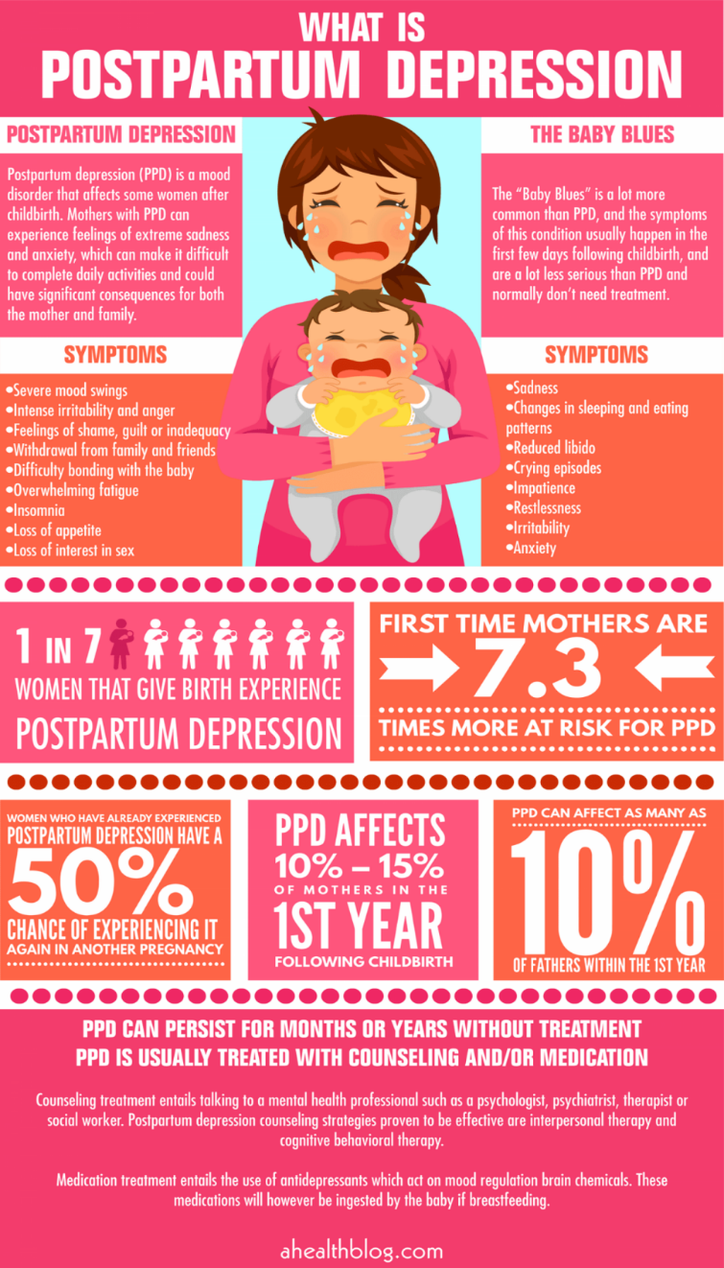
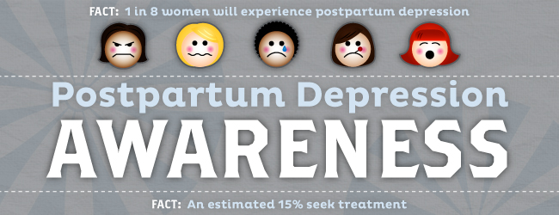


E: info@mums-aid.org, T: 07758763908 Mums Aid 184-186 Westcombe Hill, Blackheath, SE3 7DH.
(3. Pelsaert, 2020)
Struggling with a new baby or toddler? Pregnant and worried? At Mums Aid we know that the early years of parenthood can be the hardest. That is why we supply free specialist counselling and emotional support
(4. Mums Aid, 2022)
(5. Mums Aid, 2022)
(6. Bing image, 2022)
Mum’s Power Support group now open every Wednesday 12pm-2pm
@ Family community centre, 110 golden hillock road, small Heath, B10 1AR,
Lunch and Refreshments will be provided.
*£2.50 donation contribution from each mum, will make a real difference.

(7. Village Mums – Community | Support | Assistance, 2022)
(10. Bing images, 2022)
COME AND JOIN US

Medication
Treatments:
Therapy
Selfcare
Family support
Social interaction
counselling
Emotional/ physical support
Nutrition


(9. Bing images, 2022)

For more info please visit, www.mums-aid.org

ARTEFACT TASK 4. Create a single-sided flyer-explained:
The leaflet will be available to my audience at the elevator pitch, and at their doctor’s surgery. The concept of the leaflet is to inform and raise awareness of early detection of symptoms related to postpartum depression, the aim to inform pregnant women’s and mums, about a new campaign launched by Mums Aid, ‘Mums Power session’, will run every Wednesday between 12pm-2pm. I have chosen this idea is because, social interaction and support is crucial for pregnant women’s and new mums, which is why I have developed this idea. We will be supplying a nutritional lunch and refreshments for the mums their family/ friends/ partners at the session, because to treat postpartum depression eating a nutritional meal is important, and to feel better social interaction is particularly important.
The leaflet explains the term postpartum depression, and the symptoms to the audience. I have chosen 2 images for the leaflet to reflect cultural diversity in the community, one of them is the multi-ethnic group of babies, and the other image represents 2 families of different ethnic group. I have experienced these symptoms, and I understand without the emotional support I wouldn’t be where I am today, it is crucial for people to understand the importance of seeking the emotional support, and many women hesitate to seek help. Postpartum depression has a negative impact in our lives, and life could be challenging without support and counselling. my intention is to encourage mums not to ignore these symptoms, due to many cultural stigmas in our society women refuse to ask for help, I want them to brake the stigma and improve their health and wellbeing, mental illness also affects the people around them and loved ones. The logo on the leaflet for Mums Aid has been extracted from the original organisation’s webpage for authenticity. Contact information and the venue address is clearly visible on the leaflet so users can easily navigate. The leaflet reflects the intention, which is to raise postpartum depression awareness, and to inform my audience about new social support group. In the leaflet it mentions, “£2.50 in donations from each mum, will make a real difference” I have added this information so that the audience is aware we need this contribution to help us run the sessions, I have used the term donations, is to encourage the audience to get involved with the campaign, it also includes a list of available treatments. Overall, I feel the leaflet is a great marketing strategy for the campaign.
Thomas Insel, on TED talk has emphasized the importance and need of primitive identification and prevention for treating mental illness, he has said that 95% of suicide is related to mental illness. (8. Insel. T, 2013), this shows the importance of early detection and raising awareness, if we can encourage people suffering from postpartum depression, to approach us for help and support, we can help to avoid developing long term health conditions, and health inequalities and mortality due to mental illness.

References
- Bing image, 2022. raising awareness for postnatal depression quotes - Bing. [online] Bing.com. Available at: <https://www.bing.com/images/search?view=detailV2&ccid=c4TxIBaW&id=0099C8CA0273C1EE14F8D63FA94379FE047BBA0C&thid=OIP.c4TxIBaW-Dlzg5SZkntkTQHaC2&mediaurl, [Accessed 20 June 2022].6.
- Bing.com. 2022. Cute New-born Babies Group - Bing images. [online] Available at: <https://www.bing.com/images/search?q=Cute+Newborn+Babies+Group&mmreqh=wipPY9m0qyk98Cg9g5TnZ%2bMJ7%2fpOnBv5S9AfnI%2bVADg%3d&form=INLIRS&first=1&tsc=ImageHoverTitle> [Accessed 26 June 2022].9, [Accessed 26 June 2022]10.
- Insel, T., 2013. Thomas Insel: Toward a new understanding of mental illness. [online] Youtube.com. Available at: <https://www.youtube.com/watch?v=PeZ-U0pj9LI> [Accessed 20 June 2022].8.
- Mums Aid, 2022. Home - Mums Aid. [online] Mums Aid. Available at: <https://www.mums-aid.org/> [Accessed 17 June 2022].1, [Accessed 20 June 2022].4, /> [Accessed 20 June 2022].5.
- NHS, 2018. Overview - Postnatal depression. [online] nhs.uk. Available at: <https://www.nhs.uk/mental-health/conditions/post-natal-depression/overview/> [Accessed 17 June 2022].2.
- . Pelsaert, S., 2020. Postpartum Depression. [image] Available at: <https://sampelsaert.blogspot.com/2020/12/postpartum-celebrity-moms-share.html> [Accessed 20 June 2022].3.
- Villagemums.com.au. 2022. Village Mums – Community | Support | Assistance. [online] Available at: <https://villagemums.com.au/> [Accessed 20 June 2022].7.

