Name: Josh Jones

Student Number: 2501946

WORKSHEET 2 – TESTING (Tiles)

- Original code:

import math
print("Enter wall width in cm:")
width = float(input())
while width <= 0:
width = float(input("Invalid. Enter a positive number: "))

print("Enter wall height in cm:")
height = float(input())
while height <= 0:
height = float(input("Invalid. Enter a positive number: "))

tile_size = 20

tiles_across = math.ceil(width / tile_size)
tiles_down = math.ceil(height / tile_size)

total_tiles = tiles_across * tiles_down

print("You need", total_tiles, "tiles.")

- Code Testing

For each test below (i – vii), run your code and enter the values provided. Present a screenshot of the of what happened when the programme ran. Did the programme behave correctly or did it do something unexpected, and if so, why?

Input:

- Enter dimensions of wall: Width 40 Length 45
- Enter dimensions of wall: Width 100000 Length 200000
- Enter dimensions of wall: Width -16 Length -20

Logic:
- Enter dimensions of wall: Width 80 Length 80. The result should be 16 tiles
- Enter dimension of wall: Width 40 Length 45. The result should be 6 tiles
- Enter dimensions of wall: Width 85 Length 90. The result should be 25 tiles.
- Enter dimensions of wall: Width 15 Length 15. The result should be 1 tile.

Note: If you decided to include logic within your program to allow a tile to be cut such that 2 pieces can be used from the same tile where possible (therefore reducing the total number of tiles required), your results may differ from the above. In this case, explain your logic as part of your answer. If you did not, consider adding this logic to your final code.

Fill in a box for each test above. You should present 7 separate boxes, 1 for each test. (Note: the first box is provided as a template)

Test i:
Input i. - Enter dimensions: Width 40 Length 45

Screenshot(s) of output:
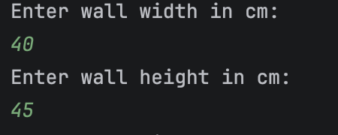
Result: Did the programme behave as expected ie syntactically and logically correct?
YES
If NO, what went wrong?
If YES, comment on what happened

The programme didn’t crash. It accepted the input ’40’ and ‘45’ since the input followed the validation rules as the width and height was more than and equal to 0.

Continue the rest of the tests below. (Copy and paste a box for each one)

Test ii:
Input ii. - Enter dimensions: Width 100000 Length 100000

Screenshot(s) of output:
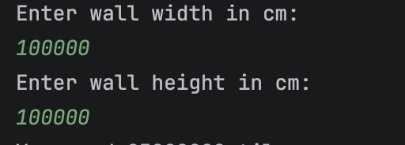
Result: Did the programme behave as expected ie syntactically and logically correct?
NO
If NO, what went wrong?
If YES, comment on what happened

The programme didn’t crash. It accepted the input ‘100000’ for both and since it followed the initial validation checks, it just moved on to the next question instead of rejecting it and asking for the width and height again as there should be a validation check for the width and height to be more than or equal to 15 cm and less than or equal to 200 cm. For the initial code, the validation checks for the width and height were too difficult to fit within the time frame to complete it.

Test iii:
Input iii - Enter dimensions: Width -16 Length -20

Screenshot(s) of output:
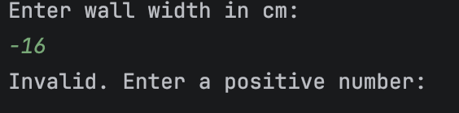
Result: Did the programme behave as expected ie syntactically and logically correct?
YES
If NO, what went wrong?
If YES, comment on what happened

The programme didn’t crash. It didn’t accept the input ‘-16’ for the width and since the input didn’t follow the validation checks since the width was less than 0, it asked the user to input their width again and until the user inputs a correct width (more than or equal to 0), it will continue to ask to enter their width again. The same applies to the length. But, if they enter a correct width, it will go onto to ask for their length.

Test iv:
Logic iv - Enter dimensions of wall: Width 80 Length 80. The result should be 16 tiles

Screenshot(s) of output:
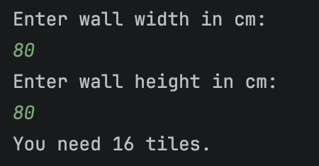
Result: Did the programme behave as expected ie syntactically and logically correct?
YES
If NO, what went wrong?
If YES, comment on what happened

The programme didn’t crash. It accepted the input ‘80’ and ’80’ since the input followed the validation rules as the width and height was more than and equal to 0. It also calculated how many tiles the user would need correctly which is 16 tiles.

Test v:
Logic v - Enter dimension of wall: Width 40 Length 45. The result should be 6 tiles

Screenshot(s) of output:
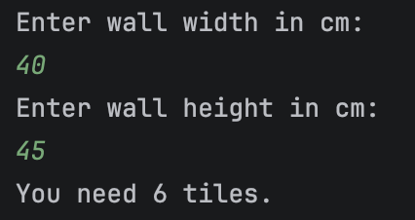
Result: Did the programme behave as expected ie syntactically and logically correct?
YES
If NO, what went wrong?
If YES, comment on what happened

The programme didn’t crash. It accepted the input ‘40’ and ‘45’ since the input followed the validation rules as the width and height was more than and equal to 0. It also calculated how many tiles the user would need correctly which is 6 tiles.

Test vi:
Logic vi - Enter dimensions of wall: Width 85 Length 90. The result should be 25 tiles.

Screenshot(s) of output:
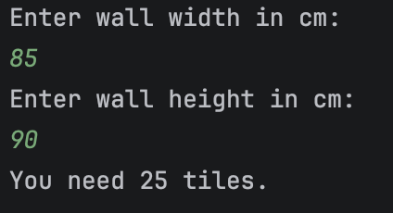
Result: Did the programme behave as expected ie syntactically and logically correct?
YES
If NO, what went wrong?
If YES, comment on what happened

The programme didn’t crash. It accepted the input ‘85’ and ‘90’ since the input followed the validation rules as the width and height was more than and equal to 0. It also calculated how many tiles the user would need correctly which is 25 tiles.

Test vii:
Logic vii - Enter dimensions of wall: Width 15 Length 15. The result should be 1 tile.

Screenshot(s) of output:
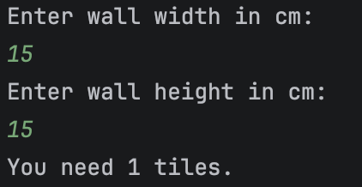
Result: Did the programme behave as expected ie syntactically and logically correct?
YES
If NO, what went wrong?
If YES, comment on what happened

The programme didn’t crash. It accepted the input ‘15’ and ‘15’ since the input followed the validation rules as the width and height was more than and equal to 0. It also calculated how many tiles the user would need correctly which is 1 tile.

- Consider the results of the above tests and revisit your code in order to solve any problems discovered at the testing phase. (Note: you may not be able to solve all of them, but solve as many as you can.)

Paste your revised code here:

import math
while True:
try:
width = float(input("Enter wall width in cm: "))
if width < 15 or width > 200:
print("Invalid. Enter a value between 15 and 200:")
else:
break
except ValueError:
print("Invalid input. Please enter a number.")
while True:
try:
height = float(input("Enter wall height in cm: "))
if height < 15 or height > 200:
print("Invalid. Enter a value between 15 and 200:")
else:
break
except ValueError:
print("Invalid input. Please enter a number.")
tile_size = 20
tiles_across = math.ceil(width / tile_size)
tiles_down = math.ceil(height / tile_size)
total_tiles = tiles_across * tiles_down
print("You need", total_tiles, "tiles.")

