CERTIFICATE OF HIGHER EDUCATION IN SKILLS FOR THE WORKPLACE
HEALTH AND SOCIAL CARE

Coursework: Effective Team Working and Communication

Module No: BMSW4002
Tutor: Lloyd Beharry

Submitted by: Mirela Olaru

ID No:1914862

LEVEL 4 Semester 1 of 3

Table of Contents
Introduction 3
1.Communication 3
2. Models of communication 3
Types of communication: 7
1.1. Verbal or oral communication 7
1.2 . Nonverbal communication 7
3.Conclusion 8
References: 10
Appendix 11

Introduction
1.Communication is the process of interaction between people, groups, as a relationship mediate by word, image, gesture, symbol or sign. Through it inviduals share their knowledge, experiences, interest, attitudes, feelings, opinions, ideas. (www.univath.ro 10 April).
Good communication skills are elemental and can be acquired through trainings and courses. In any organization communication is an essential to exchange information to accomplish the task and the objectives. Also, communication is the fundamental element that manage the coordinating functions.
The competent employee does not communicate at random or at his pleasure but according to a certain strategy, both in terms of the communication act itself and the strategy existing at the level of the organization. Administrative communication may be a frame of interpersonal communication, an essential device of the administrator with which can work out administrative obligations as: arranging, organizing, propelling preparing, planning, controlling assessing and accomplish the proposed destinations. (Anderson,2006).
The scope of this report is to examine the significance of communication in work environment, how to transfer information from one person to another, the barriers to communicate and how to improve communication effectively.
Communication can be made successfully in a business association: by inform flow between managers and subordinates; to implement a viable communication system like smartphone. In this case employees can be informed about any changes through the phone, texting messages or using social media; training and encouraging the employees to use properly the communication system.
A good communication helps a business organization to coordinate their activities, to achieve common goals, to make decisions, solve problems or conflicts and carry out changes at management level.
At the university students learn about different types of models of communication.
2. Models of communication are models to clarify the human communication prepare. There are three models of communication learned at university.
2.1 Shannon and Weaver Model in (1949). Shannon was an American mathematician, electronic engineer and Weaver was an American scientist, both of them join together to write an editorial in ‘’Bell System Tehical Journal ‘’called ‘’A Mathematical Theory of Communication’’ also called as ‘’Shannon and Weaver Model of Communication’’. (communicationtheory.org 12 April). The basic concept was to send and to get message or date from one person to another, from sender to receiver. This model act with different concept like data source, transmitter, commotion, channel, message, recipient, channel, data goal, encode and interpret. (communicationtheory.org 12 April).
In this model of communication there is no feedback and the message could be interfered by noise. The messages are exchanged from encoder to decoder through channel, the message can be affected or distracted by physical noise like thunder; horn sound or encoded signals which can distract the channel during the transmission process, and this can affect the communication.
For example, is a case study that we have done in class was about a telephone conversation between Maria and Pedro. Maria called Pedro and ask him to buy a chicken when will come home. Pedro works in a building side where is a lot of noise, because of the noise Pedro din not understood well what Maria asked him and when Pedro went home din not bought the chicken, instead he was waiting Maria in the kitchen as he understood at the phone. The message send by Maria to Pedro was interfered by the noise.


https://www.businesstopia.net/

2.2 Schramm’s Model (Wilber Schramm in 1954). This is the single model who expect to receive feedback. The encoder sends the message, then will be interpreted and after that the message will be send to the encoder to confirm that the message is understood. Concurring to Schramm he accepts that a person’s information, encounter and social foundation play a critical part in communication. People from distinctive societies, religion or who do not talk the same dialect tend to interpret the message in numerous ways. (managementstudyguide.com 2015,12 April). Schram’s model of communication explain that this situation could be avoided by sending a feedback to the sender. The case study that I reported above could be avoided if Pedro called Maria and ask her again what to buy or to send her a text message.

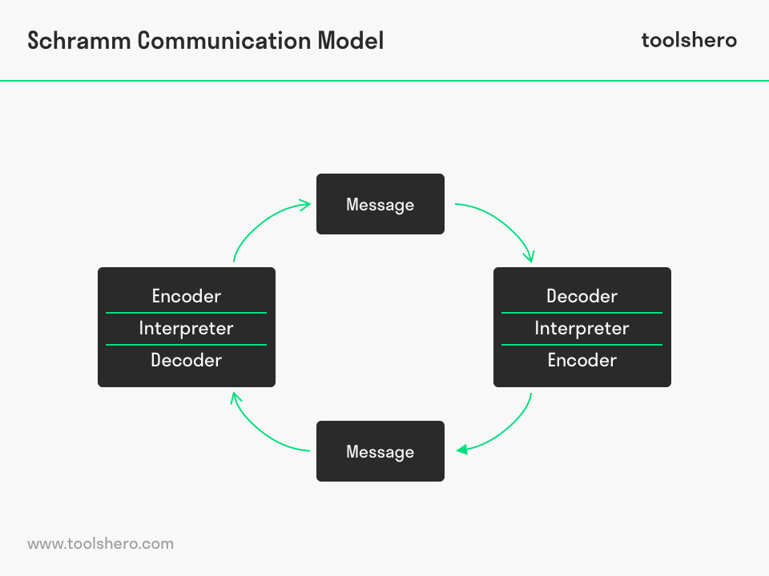

2.3David Berlo’s Model of communication in (1960) created: Sender-Message-Channel-Receiver. This message could be interfered by the noise too, but at the end the message will be completely send to the receiver. Berlo’s model believe that for compelling communication to require put the source and the collector ought to be on the same level. (communicationtheory.org 12 April). According to Berlo a person must have excellent communication skills to make the communication efficient and to create attention for listeners. A person must know how to use tone of voice, the accent when to repeat the sentence, the attitude, a person with great attitude create a good impression to the listeners.

https://www.communicationtheory.org/
For example, the case study that we have done in the class, is about a professor that moved to a village with people less educated than him. One night the professor’s house was on fire and he screamed for help. However, because the professor did not used typical or regular words, but instead rare and unusual vocabulary, the villagers did not understand him. Therefore, the villagers could not help him.
Communication plays a fundamental role in all facet of organization. No organization or group can exist without communication. When I was working as a volunteer in a care home communication was vital. Good communication between nurse, patients and carers is essential to help develop each patient care plan. Practicing at the elderly home, I have learned how to communicate with ill people, how to understand them, to help the patients with special needs, with disabilities, demonstrating courtesy, kindness and sincerity. I have tried all the time to be honest with the patients to tell them the true about their disease, but at the same time I encouraged them to fight the disease, to follow the treatment to recover fast. Communication also means listening, which is extremely important, because as a nurse you have to listen all the problems of the patients, to observe and encourage them to find solutions, to feel safe. There were many situations when the patients could not speak properly because of the disease, or angry, or aggressive and the duty of the nurse is to make the patient trust you by communicating with them. Nurse must communicate all the time with the patient’s family, with the doctors to give the information about the patient’s condition and to do that you need to have good communication skills.
More than half of the communication is expressed by body language and gestures. Through this accommodation process, good communication is essential because it contributes in ensuring a safe and efficient medical care that the patient needs by providing quality service. Also, by performing the appropriate procedures. Good communication reduces the stress, helps the patient to gain confidence in the medical staff they come in contact with and make them feel safe. Communication must be sincere and direct. Discussion with patient should not leave room for doubt, suspicion and misunderstanding. Each patient has his own specific way of communication, the nurse has to learn to understand the patient’s needs.

Types of communication:

1.1. Verbal or oral communication

. Nonverbal communication

Oral or verbal communication are the most common forms of communication. Every person is using words verbally to inform or to provide information. Verbal messages are created through languages. Verbal communication is the capacity to conversation, to require portion in a discussion between two or more individuals.
Nonverbal communication incorporates all the ways to communicate without words. A more technical definition for nonverbal communication is “communication other than written or spoken language that creates meaning for someone “(Ivy and Wahl,2014, p.5). Also, nonverbal communication is when a message is transmitted through signs, body languages, eye contact, facial expression, gestures, posture, tone of voice. Written communication is used to send documents, text, emails, essay, reports, memo and other types. Body language is the communication without words. Eye contact smile and the position of the body can send message to the people.
At workplace sometime the nurse used written communication with the family’s patient by texting message with the new scheme of treatment asking the family to bring the pills recommended by doctor. Communication barriers existed in my workplace working as a volunteer in a nursing home there was a situation with a dumb patient who could not communicate, and we had to talk through signs to find out what are his needs.
It is essential to always remember the importance of communication in any organization, to increase the productivity and to achieve the goals. Communication between administration and employees is one of the big factors of a successful business, and can be improved by making weekly team meetings, to get to know employees better, to listen their questions, to give the opportunity to every team member to talk about their ideas, to motivate them. Managers should be accessible to listen the rest of the team, to create a group to be like a family, to be a leader for the team to know how to use the tone of voice.
Communication is the key in any relationship. Communication effectively and transparently with the employees allows managers to understand their needs and desire. Communication is essential for active teams. It creates efficiencies by motivating employees, encouraging open dialogue give rewards when is the case. (Sandler System, 2010, 12 April).
The role of management is to accomplish the goals of an organization. To do this manager create a plan that define what needs to be done, when it will be done, and how will be done. Managers established reports and collaborations and keep the team informed of events and actions that can affect the organizations. A good communication helps the people to feel that they make part of that organization and support the organization. Effective organization create commitments and support. By allowing employees to come with suggestions, to input their work will be more engaged and motivated. (courses.lumenlearning.com 12 April).
There are many barriers to communication, and this may occur at any stage in communication process. One of the most common barriers is the language differences in understanding unfamiliar accents, the use of words with different meanings. Communication blockages can be so intense that there are visible differences between the transmitted information and the perceived message. The foremost common obstruction of communication is the need of clarity, which is essential at any working environment, to assist convey a clear message, to achieve all the task on time. The second barriers are language differences because organization use different expression like jargon and people are not familiar with those expressions.

3.Conclusion
Communication plays an important role in society, business, education, family and in every person’s life. Each person should have good communication skills, to know how to give an information and how to receive it.
Communication in not about word, it is a mixture of tones, gestures and body language.
Communication is the method of sending data common understanding from one individual to another. It is absolutely necessary to communicate with people, to listening before speaking to understand the message. The benefits of a good communication increase self of steam, create better relationships, increase productivity. The probability of success is higher when we have an efficient communication.

References:

- Albrecht, S. (1996). Crisis management for corporate self-
- Albrecht, S. (1996). Crisis management for corporate self-
Anderson, P. V., 2011. Workplace scenarios to integrate communication skills and content: a case study. Is integration of communication and technical instruction across the SE curriculum a viable strategy for improving the real-world communication abilities of software engineering graduates?, pp. 525-529.

Anon., n.d. [Online].
Antos, G. (2011). Handbook of interpersonal communication. The Hague, The Netherlands: Mouton De Gruyter.

Asani MR (2009.Patient physician communication. West Indian Med J 58-(4):357-61

- defense. New York: Amaco
- defense. New York: Amacom.
Ivy Diane K, W. S. T., 2009. Nonverbal Communication for a Lifetime. 1st Edition ed. U.S.A: Allyn & Bacon.

lumen, N Y. Introduction to communication. [Online]
Available at: https://courses.lumenlearning.com/introductiontocommunication/chapter/defining-nonverbal-communication/
[Accessed 12 04 2020].

Models of communication (Shannon and Weaver, Berlo and Schram’s) available at www.communicationtheory.org (accessed on12 April)

Raya A, Nursing of man as a unique person Nosileftiki.2006;45(1);19 -24{google scholar}

training, s., 2020. improve communication. [Online]
Available at: https://www.sandler.com/blog/enhance-communication-with-your-customers/
[Accessed April 12 2020].

Appendix



