
Tensile Test
Callum Clement

Semester 1

Engineering Science
Abi Penny

2400570

Contents Page
Introduction 2
Experimental Procedure 3
Results 4
Analysis 8
Conclusion 9
Evaluation 10
Further Work 11
References 12

Introduction

This report will cover an experiment on tensile strength, testing different materials and analysing the results gathered from the test. The data will be laid out into graphs and spreadsheets displaying the data. Towards the end there a conclusion will be laid out by comparing the experimental results against researched results followed by an evaluation of the experiment and how errors were eliminated. Finally the report will cover the possibility of bettering the experiment if there was unlimited time and resources.

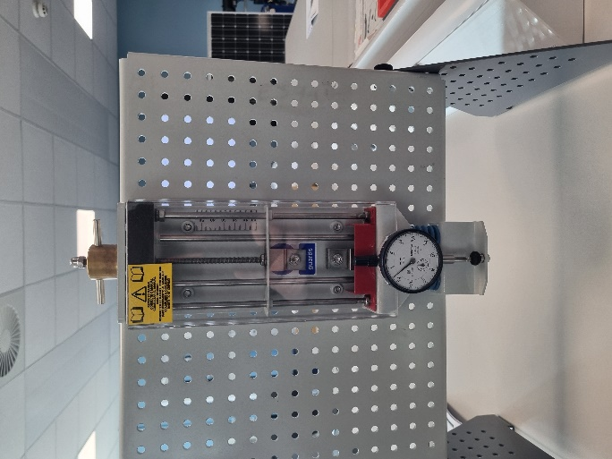
Figure 1

Experimental Procedure

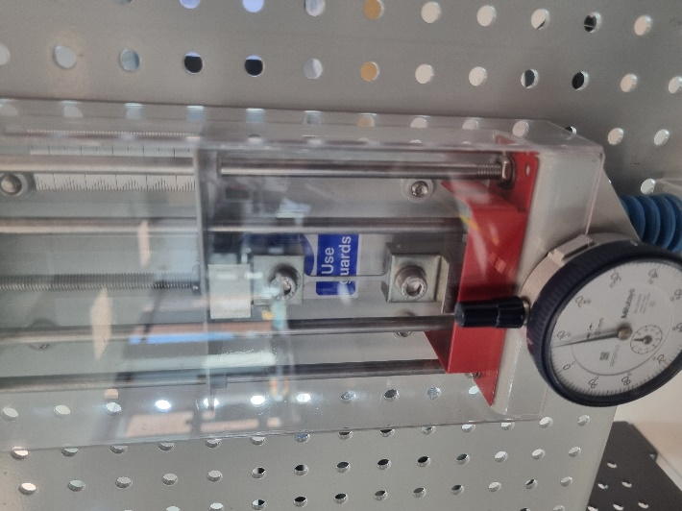
When conducting this experiment, a tensile tester is required and needs to be setup as shown in figure 1 placed onto a panel securely. For each test on each material the next step is repeated the same, each material has the original length measured and the cross-sectional area by measuring its width and thickness. It is then secured as shown in figure 2.
Figure 2

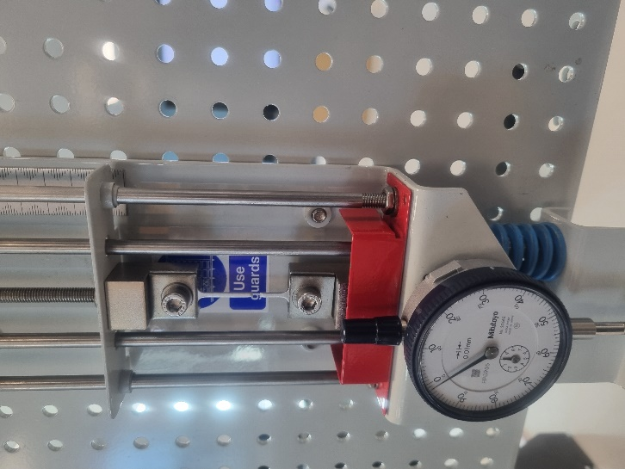
During the test the material has a load placed on it, this is done by rotating the load nut. Initially the load is increased in small increments. At the top by the load nut there is a scale of 10 notches and each time it is rotated 2 notches moving the top chuck by 0.2mm. This is then repeated until the material either breaks or until it has been moved 5mm and then it is moved 1mm at a time until it reaches 10mm in total and then it is rotated 10 full turns at a time until it fails as shown in figure 3.
Figure 3

When the material breaks it is then removed and needs to be measured. To measure it the broken ends are pressed back together, and the new length is then measured to find the elongation of the material.

This process is repeated for the other materials and may be repeated for additional tests.

Results
Specimen material: Steel
Original cross-sectional area (mm2): 1.8mm2
Original Length (mm): 31mm
Load Nut Movement (mm) | Dial Indicator (mm) | Force (N) | Extension (mm) | Stress N/m² | Nominal Strain
0 | 0 | 0 | 0 | 0 | 0
0.2 | 0.18 | 18 | 0.02 | 10000000 | 0.000645161
0.4 | 0.37 | 37 | 0.03 | 20555555.56 | 0.000967742
0.6 | 0.56 | 56 | 0.04 | 31111111.11 | 0.001290323
0.8 | 0.74 | 74 | 0.06 | 41111111.11 | 0.001935484
1 | 0.93 | 93 | 0.07 | 51666666.67 | 0.002258065
1.2 | 1.12 | 112 | 0.08 | 62222222.22 | 0.002580645
1.4 | 1.31 | 131 | 0.09 | 72777777.78 | 0.002903226
1.6 | 1.5 | 150 | 0.1 | 83333333.33 | 0.003225806
1.8 | 1.68 | 168 | 0.12 | 93333333.33 | 0.003870968
2 | 1.86 | 186 | 0.14 | 103333333.3 | 0.004516129
2.2 | 2.04 | 204 | 0.16 | 113333333.3 | 0.00516129
2.4 | 2.23 | 223 | 0.17 | 123888888.9 | 0.005483871
2.6 | 2.41 | 241 | 0.19 | 133888888.9 | 0.006129032
2.8 | 2.59 | 259 | 0.21 | 143888888.9 | 0.006774194
3 | 2.75 | 275 | 0.25 | 152777777.8 | 0.008064516
3.2 | 2.9 | 290 | 0.3 | 161111111.1 | 0.009677419
3.4 | 3.04 | 304 | 0.36 | 168888888.9 | 0.011612903
3.6 | 3.17 | 317 | 0.43 | 176111111.1 | 0.013870968
3.8 | 3.3 | 330 | 0.5 | 183333333.3 | 0.016129032
4 | 3.42 | 342 | 0.58 | 190000000 | 0.018709677
4.2 | 3.55 | 355 | 0.65 | 197222222.2 | 0.020967742
4.4 | 3.67 | 367 | 0.73 | 203888888.9 | 0.023548387
4.6 | 3.77 | 377 | 0.83 | 209444444.4 | 0.026774194
4.8 | 3.89 | 389 | 0.91 | 216111111.1 | 0.029354839
5 | 4 | 400 | 1 | 222222222.2 | 0.032258065
6 | 4.47 | 447 | 1.53 | 248333333.3 | 0.049354839
7 | 4.83 | 483 | 2.17 | 268333333.3 | 0.07
8 | 5.05 | 505 | 2.95 | 280555555.6 | 0.09516129
9 | 5.18 | 518 | 3.82 | 287777777.8 | 0.123225806
10 | 5.25 | 525 | 4.75 | 291666666.7 | 0.153225806
20 | Failure |  | 6
30
40
Tensile Strength (N/m²): 2.91*10⁸
Yield Stress (N/m2): 2.22*10⁸
%Elongation: 19.4%
Specimen material: Aluminium
Original cross-sectional area (mm2): 1.71mm2
Original Length (mm): 31mm
Load Nut Movement (mm) | Dial Indicator (mm) | Force (N) | Extension (mm) | Stress N/m² | Nominal Strain
0 | 0 | 0 | 0 | 0 | 0
0.2 | 0.11 | 11 | 0.09 | 6432748.54 | 0.002903
0.4 | 0.26 | 26 | 0.14 | 15204678.4 | 0.004516
0.6 | 0.44 | 44 | 0.16 | 25730994.2 | 0.005161
0.8 | 0.63 | 63 | 0.17 | 36842105.3 | 0.005484
1 | 0.81 | 81 | 0.19 | 47368421.1 | 0.006129
1.2 | 1 | 100 | 0.2 | 58479532.2 | 0.006452
1.4 | 1.18 | 118 | 0.22 | 69005848 | 0.007097
1.6 | 1.36 | 136 | 0.24 | 79532163.7 | 0.007742
1.8 | 1.54 | 154 | 0.26 | 90058479.5 | 0.008387
2 | 1.72 | 172 | 0.28 | 100584795 | 0.009032
2.2 | 1.89 | 189 | 0.31 | 110526316 | 0.01
2.4 | 2.05 | 205 | 0.35 | 119883041 | 0.01129
2.6 | 2.18 | 218 | 0.42 | 127485380 | 0.013548
2.8 | 2.28 | 228 | 0.52 | 133333333 | 0.016774
3 | 2.4 | 240 | 0.6 | 140350877 | 0.019355
3.2 | 2.46 | 246 | 0.74 | 143859649 | 0.023871
3.4 | 2.57 | 257 | 0.83 | 150292398 | 0.026774
3.6 | 2.61 | 261 | 0.99 | 152631579 | 0.031935
3.8 | 2.71 | 271 | 1.09 | 158479532 | 0.035161
4 | 2.75 | 275 | 1.25 | 160818713 | 0.040323
4.2 | 2.79 | 279 | 1.41 | 163157895 | 0.045484
4.4 | 2.83 | 283 | 1.57 | 165497076 | 0.050645
4.6 | 2.84 | 284 | 1.76 | 166081871 | 0.056774
4.8 | 2.88 | 288 | 1.92 | 168421053 | 0.061935
5 | 2.88 | 288 | 2.12 | 168421053 | 0.068387
6 | Failure |  | 2.2
7
8
9
10
20
30
40
Tensile Strength (N/m²): 1.68*10^8
Yield Stress (N/m2): 1.44*10^8
%Elongation: 7.10%

Specimen material: Duralumin
Original cross-sectional area (mm2): 1.8mm2
Original Length (mm): 31mm
Load Nut Movement (mm) | Dial Indicator (mm) | Force (N) | Extension (mm) | Stress N/m² | Nominal Strain
0 | 0 | 0 | 0 | 0 | 0
0.2 | 0.15 | 15 | 0.05 | 8333333.33 | 0.0016129
0.4 | 0.32 | 32 | 0.08 | 17777777.8 | 0.00258065
0.6 | 0.5 | 50 | 0.1 | 27777777.8 | 0.00322581
0.8 | 0.68 | 68 | 0.12 | 37777777.8 | 0.00387097
1 | 0.87 | 87 | 0.13 | 48333333.3 | 0.00419355
1.2 | 1.05 | 105 | 0.15 | 58333333.3 | 0.00483871
1.4 | 1.23 | 123 | 0.17 | 68333333.3 | 0.00548387
1.6 | 1.42 | 142 | 0.18 | 78888888.9 | 0.00580645
1.8 | 1.6 | 160 | 0.2 | 88888888.9 | 0.00645161
2 | 1.79 | 179 | 0.21 | 99444444.4 | 0.00677419
2.2 | 1.97 | 197 | 0.23 | 109444444 | 0.00741935
2.4 | 2.16 | 216 | 0.24 | 120000000 | 0.00774194
2.6 | 2.34 | 234 | 0.26 | 130000000 | 0.0083871
2.8 | 2.54 | 254 | 0.26 | 141111111 | 0.0083871
3 | 2.71 | 271 | 0.29 | 150555556 | 0.00935484
3.2 | 2.88 | 288 | 0.32 | 160000000 | 0.01032258
3.4 | 3.07 | 307 | 0.33 | 170555556 | 0.01064516
3.6 | 3.25 | 325 | 0.35 | 180555556 | 0.01129032
3.8 | 3.43 | 343 | 0.37 | 190555556 | 0.01193548
4 | 3.61 | 361 | 0.39 | 200555556 | 0.01258065
4.2 | 3.79 | 379 | 0.41 | 210555556 | 0.01322581
4.4 | 3.98 | 398 | 0.42 | 221111111 | 0.01354839
4.6 | 4.14 | 414 | 0.46 | 230000000 | 0.01483871
4.8 | 4.22 | 422 | 0.58 | 234444444 | 0.01870968
5 | 4.49 | 449 | 0.51 | 249444444 | 0.01645161
6 | 5.05 | 505 | 0.95 | 280555556 | 0.03064516
7 | 5.28 | 528 | 1.72 | 293333333 | 0.05548387
8 | Failure |  | 2
9
10
20
30
40
Tensile Strength (N/m²): 2.93*10^8
Yield Stress (N/m2): 2.34*10^8
%Elongation: 6.45%

Specimen material: PVC
Original cross-sectional area (mm2): 2mm2
Original Length (mm): 31mm
Load Nut Movement (mm) | Dial Indicator (mm) | Force (N) | Extension (mm) | Stress N/m² | Nominal Strain
0 | 0 | 0 | 0 | 0 | 0
0.2 | 0.07 | 7 | 0.13 | 3500000 | 0.004194
0.4 | 0.13 | 13 | 0.27 | 6500000 | 0.00871
0.6 | 0.2 | 20 | 0.4 | 10000000 | 0.012903
0.8 | 0.24 | 24 | 0.56 | 12000000 | 0.018065
1 | 0.25 | 25 | 0.75 | 12500000 | 0.024194
1.2 | 0.24 | 24 | 0.96 | 12000000 | 0.030968
1.4 | 0.22 | 22 | 1.18 | 11000000 | 0.038065
1.6 | 0.2 | 20 | 1.4 | 10000000 | 0.045161
1.8 | 0.18 | 18 | 1.62 | 9000000 | 0.052258
2 | 0.16 | 16 | 1.84 | 8000000 | 0.059355
2.2 | 0.16 | 16 | 2.04 | 8000000 | 0.065806
2.4 | 0.16 | 16 | 2.24 | 8000000 | 0.072258
2.6 | 0.15 | 15 | 2.45 | 7500000 | 0.079032
2.8 | 0.13 | 13 | 2.67 | 6500000 | 0.086129
3 | 0.13 | 13 | 2.87 | 6500000 | 0.092581
3.2 | 0.12 | 12 | 3.08 | 6000000 | 0.099355
3.4 | 0.12 | 12 | 3.28 | 6000000 | 0.105806
3.6 | 0.12 | 12 | 3.48 | 6000000 | 0.112258
3.8 | 0.12 | 12 | 3.68 | 6000000 | 0.11871
4 | 0.12 | 12 | 3.88 | 6000000 | 0.125161
4.2 | 0.11 | 11 | 4.09 | 5500000 | 0.131935
4.4 | 0.11 | 11 | 4.29 | 5500000 | 0.138387
4.6 | 0.11 | 11 | 4.49 | 5500000 | 0.144839
4.8 | 0.1 | 10 | 4.7 | 5000000 | 0.151613
5 | 0.1 | 10 | 4.9 | 5000000 | 0.158065
6 | 0.1 | 10 | 5.9 | 5000000 | 0.190323
7 | 0.09 | 9 | 6.91 | 4500000 | 0.222903
8 | 0.08 | 8 | 7.92 | 4000000 | 0.255484
9 | 0.08 | 8 | 8.92 | 4000000 | 0.287742
10 | 0.08 | 8 | 9.92 | 4000000 | 0.32
20 | 0.08 | 8 | 19.92 | 4000000 | 0.642581
30 | Failure |  | 21
40
Tensile Strength (N/m²): 4*10^6
Yield Stress (N/m2): 1.25*10^7
%Elongation: 67.7%

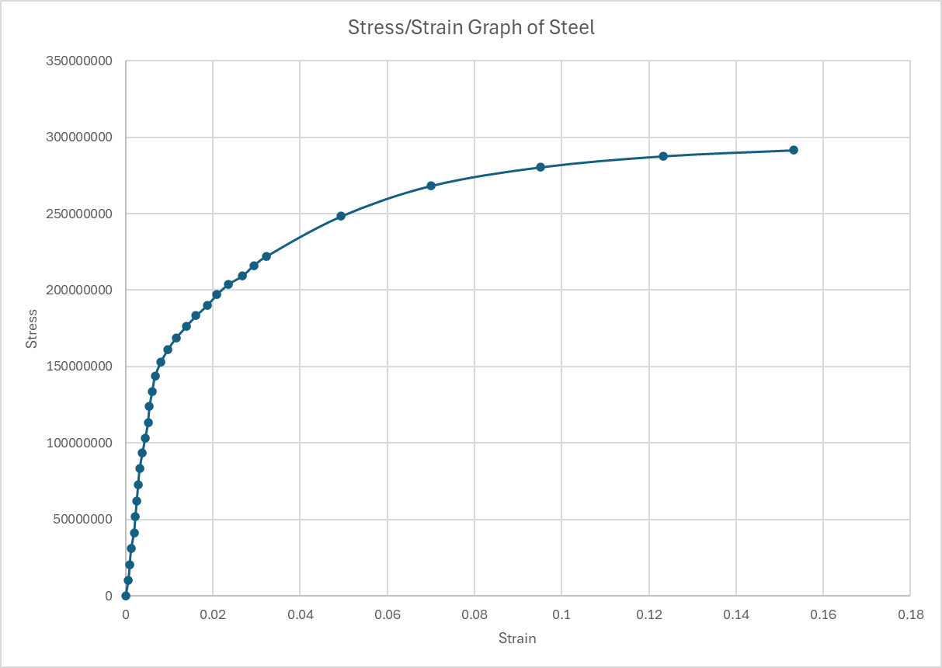

Analysis

After gathering the experimental data for the 4 specimen materials, the results provide enough data to calculate the extension and the stress and strain of the material.

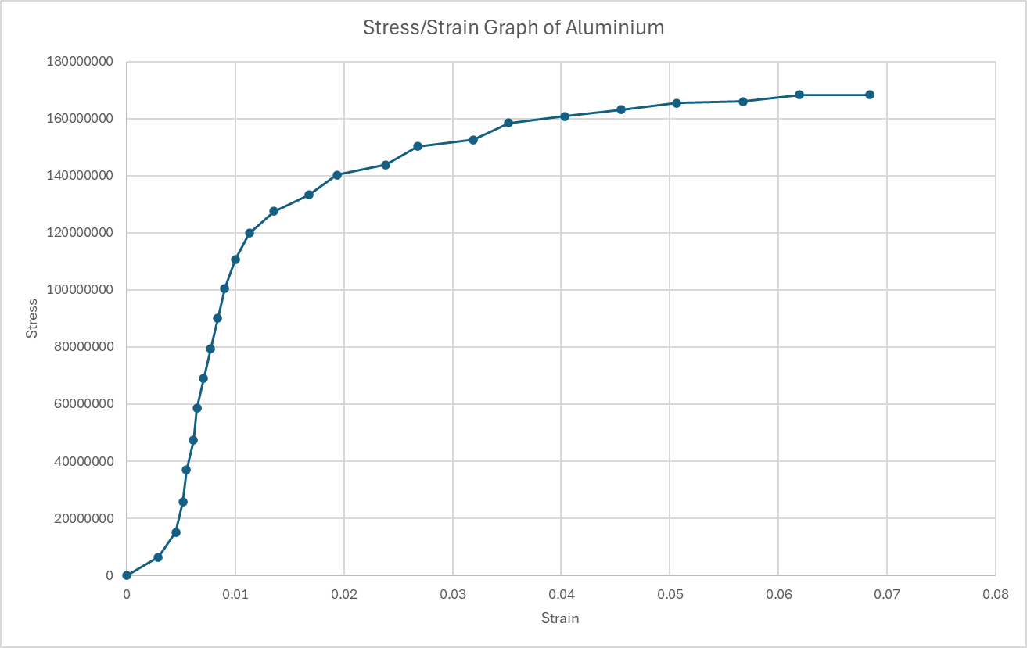
Using the stress and strain values a stress/strain curve can be produce as a graph for each material.
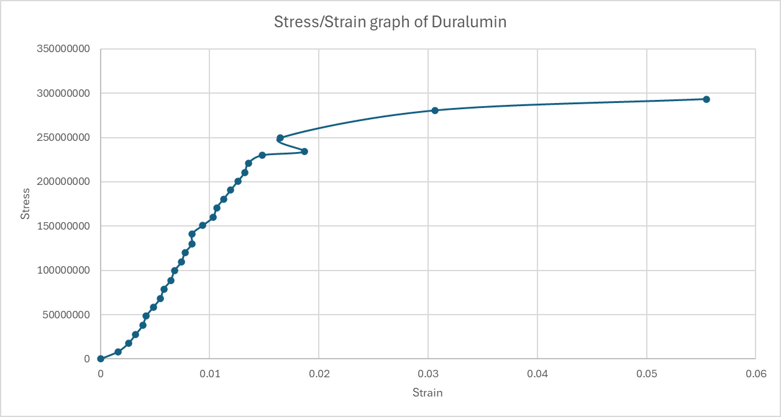
With the results gathered the graphs represent a curve with no issues apart from the duralumin specimen where there appears to be an area where the strain decreases where the stress is increasing producing an unexpected appearing graph.
The graph for PVC produces a very familiar looking graph showing the yield stress followed by a decrease in the stress throughout the graph.

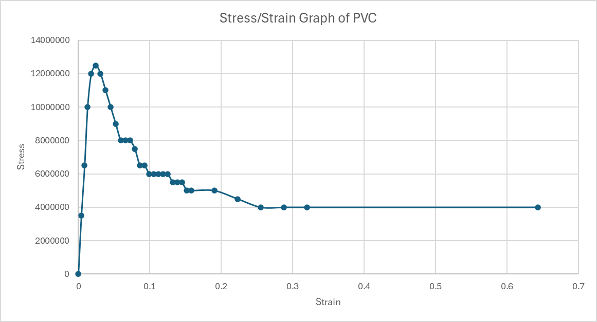
These results are heavily impacted by the environmental conditions and results may vary when conducting the experiment with different room temperatures where the PVC may be more brittle at a colder temperature and fail earlier.

Conclusion

The experiment conducted of 4 materials. Specimen 1 was mild steel a basic steel alloy. Specimen 2 was a basic aluminium alloy very similar to specimen 3 duralumin which is a high spec aluminium alloy which has a higher tensile strength than aluminium alone. Specimen 4 was PVC which is a common thermoplastic used for things such as piping, doors, wire insulation etc.

Tensile strength varies across different materials. It is stated that mild steel has a tensile strength of around 5.5x10⁸ N/m², whereas with the experimental data there was a recorded tensile strength of 2.91x10⁸ N/m^{2.} This trend continues throughout the experimental results with the greatest difference being with PVC where PVC can have a tensile strength of 1.6x10⁷ N/m² and the recorded results were 4x10⁶ N/m². The tensile for aluminium alloy varies between alloys from 8x10⁷ N/m² up to much higher numbers but it can be expected that the aluminium alloy used had a tensile strength of around 1.8x10⁸ N/m² as the experiment provided results of 1.68x10⁸ N/m². Duralumin has a tensile strength of around 4.5x10⁸ N/m² and the experiment displayed a result of 2.93x10⁸ N/m² .

The difference in the results can be down to human error but also a big impact is the environmental factors where the materials were more pliable than they would be in a controlled environment and deformed easier due to a higher temperature within the room.

Evaluation

During the investigation errors were attempted to be eliminated in many ways. It was ensured that the DTI was zeroed before starting an experiment on each specimen, the same person was applying the force to every specimen to ensure there was no discrepancies with force applied and was even across all materials.
Each reading was double checked, and it was ensured that the reading was correct and noted at the time.
The specimens were measured and double checked to ensure it was correct so that all workings were correct.

An area that could have been improved was the person taking the measurements should have remained the same person so there was a lower chance of the readings being different from person to person.

Further Work

If I had an unlimited budget and unlimited time, I would alter the experiment slightly. I would control the temperature within the room to ensure that all experiments were completed under the same conditions so there were minimal differences under the experiments. I would also repeat each specimen at least 3 times to produce an average out of the results and to use that average as my final number. It would be a much more time-consuming process and would be more difficult to complete but would produce more exact results. I would also replace the manual tensile strength tester with a machine operated version which ensures the same force is applied and is even across each specimen providing a much fairer and more accurate test.

References

MatWeb Accessed at 08/12/2024:
https://www.matweb.com/search/datasheet_print.aspx?matguid=69642362cb864d25b8f6eb9d02092ecf

AZO Materials Accessed at 08/12/2024;
https://www.azom.com/article.aspx?ArticleID=8073

AZO Materials Accessed at 08/12/2024:
https://www.azom.com/article.aspx?ArticleID=2863

Metals4U Accessed at 08/12/2024:
https://www.metals4u.co.uk/blog/mild-steel-in-depth-guide

Metals4U
Matweb
AZO Materials
AZO Materials

