5ADCM Contributing to Coaching and Mentoring

Name: Laura Daniel

CIPD Membership Number: 42646234

Date: 7th July 2021

Wordcount
Lo1 = 1801
Lo2 = 1819

By signing below, I confirm that the work/evidence presented is my own, unaided work. I understand the regulations pertaining to candidate malpractice and the action that may be taken as a result.

Signed: 
Date: 03.07.2021

Contents
Page 1 Front Cover
Page 2 Contents
Page 3 -6 Evidence Matrix
Page 7 Introduction
Page 8-10 LO1 Q 1.1
Page 10-11 LO1 Q 1.2
Page 11-12 LO1 Q 1.3
Page 13-14 LO1 Q 1.4
Page 15-20 LO1 Evidence
Page 21 LO2 Q 2.1
Page 22-23 LO2 Q 2.2
Page 23-24 LO2 Q 2.3
Page 24-25 LO2 Q 2.4
Page 25 LO2 Q 2.5
Page 26-47 LO2 Evidence
Page 48 Conclusion
Page 48-49 Recommendations
Page 49-53 References

CIPD Candidate Evidence Matrix
Candidate name: Laura Daniel |  |  |  |  | CIPD Membership/registration No.:  42646234
Qualification title: CIPD Level 5 |  |  |  |  | Unique Learner No. (ULN):
Unit code | Unit title |  | Assessment criteria no. | Evidence description | Evidence reference number |  | Assessor  initials | I/V initials if sampled
5ADCM | Contributing to Coaching and Mentoring |  | 1.1 | Supervisors Induction Form | EV1
5ADCM | Contributing to Coaching and Mentoring |  | 1.1 | Training and Development Policy | EV2
5ADCM | Contributing to Coaching and Mentoring |  | 1.1 | Letter of Probation | EV3
5ADCM | Contributing to Coaching and Mentoring |  | 1.1 | Work Instructions | EV4
5ADCM | Contributing to Coaching and Mentoring |  | 1.2 | Organisational Chart | EV5
5ADCM | Contributing to Coaching and Mentoring |  | 1.2 | Supervisors Training (Modern Slavery) | EV6
5ADCM | Contributing to Coaching and Mentoring |  | 1.2 | Code of Conduct | EV7
5ADCM | Contributing to Coaching and Mentoring |  | 1.2 | Statement of Core Principles | EV8
5ADCM | Contributing to Coaching and Mentoring |  | 1.2 | Handbook front page | EV9
5ADCM | Contributing to Coaching and Mentoring |  | 1.2 | Handbook principles | EV10
5ADCM | Contributing to Coaching and Mentoring |  | 1.2 | E-mail plan for new employees | EV11
5ADCM | Contributing to Coaching and Mentoring |  | 1.2 | HR Induction form | EV12
5ADCM | Contributing to Coaching and Mentoring |  | 1.2 | Departmental Induction | EV13
5ADCM | Contributing to Coaching and Mentoring |  | 1.3 | Organisational Chart | EV14
5ADCM | Contributing to Coaching and Mentoring |  | 1.3 | SWOT Analysis | EV15
5ADCM | Contributing to Coaching and Mentoring |  | 1.3 | COVID Policy | EV16
5ADCM | Contributing to Coaching and Mentoring |  | 2.2 | Notes of Meeting with Managing Director | EV17
5ADCM | Contributing to Coaching and Mentoring |  | 2.2 | College Apprentice E-mail | EV18
5ADCM | Contributing to Coaching and Mentoring |  | 2.2 + 2.5 | Induction Policy | EV19
5ADCM | Contributing to Coaching and Mentoring |  | 2.2 | ACAS Training | EV20
5ADCM | Contributing to Coaching and Mentoring |  | 2.2 | Appraisal Form | EV21
5ADCM | Contributing to Coaching and Mentoring |  | 2.2 | Appraisal Techniques | EV22
5ADCM | Contributing to Coaching and Mentoring |  | 2.1, 2.2, 2.3, 2.4 | Draft PowerPoint Presentation on Coaching and Mentoring | EV23
5ADCM | Contributing to Coaching and Mentoring |  | 2.1 | Draft Poster | EV24
5ADCM | Contributing to Coaching and Mentoring |  | 2.5 | Development Review Form | EV25
5ADCM | Contributing to Coaching and Mentoring |  | 2.5 | Apprentice/Trainee Form | EV26
5ADCM | Contributing to Coaching and Mentoring |  | 2.5 | Individual Learning Plan | EV27
5ADCM | Contributing to Coaching and Mentoring |  | 2.5 | E-mail Evidence, Warehouse and Engineering Manager | EV28
5ADCM | Contributing to Coaching and Mentoring |  | 2.5 | E-mail Evidence, Managing Director and Finance Director | EV29
Candidate declaration:
- I confirm that the work/evidence presented for assessment is my own unaided work.
- I have read the assessment regulations and understand that if I am found to have ‘copied’ from published work without acknowledgement, or from other candidate’s work, this may be regarded as plagiarism which is an offence against the assessment regulations and leads to failure in the relevant unit and formal disciplinary action.
- I agree to this work being subjected to scrutiny by textual analysis software if required.
- I understand that my work may be used for future academic/quality assurance purposes in accordance with the provisions of the Data Protection Act 1998.
- I understand that the work/evidence submitted for assessment may not be returned to me and that I have retained a copy for my records.
- I understand that until such time as the assessment grade has been ratified through internal and external quality assurance processes it is not final.
Signature: |  |  |  |  |  | Date: | 03.07.2021

Introduction
Coaching and mentoring are practices carried out within organisations and can provide many benefits, some of which “provide employees with a way to connect, learn and grow within the company and along their own career paths giving them higher job satisfaction which leads to increased productivity and reduced turnover” (Mundy 2021).
To be effective, coaching/mentoring require specific skillsets such as:
- Listening skills
- Empathy
- Questioning
- Goal setting
- The ability to give feedback.
- Honesty
- Self-awareness
Both time and effort must be given to the mentee/trainee for it to work and if practiced correctly, can benefit the organisation in ways such as succession planning, employee motivation and possibly more contentment throughout the workforce.
Successful coaching/mentoring will give managers more time to manage the business strategically, instead of being caught up in day-to-day operational tasks, hence freeing up time for higher level activities. It is a management style, where some organisations struggle to find time or to understand its importance. Company “X” can put itself in this category.
The Company I will be discussing within this project will be called Company “X”, here I have been working for 4 years as the HR Manager. Company “X” is a manufacturing Company with 100 employees, 9 of whom work off-site, travelling around the UK and the remainder working on-site. There is very little coaching/mentoring carried out at site and not a topic that is talked about very often by the higher management team.
The main stakeholders at Company “X” are the employees (including mentees/coaches), Supervisors/managers (coaches/mentors), the organisation, its customers and suppliers.

Lo1 – 1.1 Investigate the extent to which coaching and mentoring take place within an organisation.
Coaching and mentoring can take place in many forms. There are informal ways as described by N Muruga (2017) as a “check-in or a catch up”, where conversations are often light in structure such as a supervisor talking with a member of staff in a one-off conversation, or through feedback. Conversations can take place in public areas e.g. corridors or even on the factory floor. Company “X” carries out coaching/mentoring mostly informally. Many one-off conversations are carried out via the manager and employee where they are being guided through their work tasks and offering feedback; there are no notes of these conversations.
There are more formal ways for coaching/mentoring such as according to McGuinness (2008) “scheduled appointments” with structure and purpose, often relating to workplace goals. Formal coaching/mentoring usually takes place in private and are confidential for the purpose of gaining trust with the coach/mentor. Coaches/mentors can creatively apply techniques which may include one-to-one training, counselling & networking (S Atkins 2021), this can often take place during review meetings/appraisals. There is no formal coaching/mentoring structure within Company “X”, however new inductees shadow a colleague for at least a week, then gradually work on their own. Company “X” doesn’t have an induction policy currently to reinforce onboarding and help new recruits understand the process. Some managers are currently resistant to coaching/mentoring and give reasons such as time and resource. There is 1 department currently where coaching/mentoring is slightly more structured, but unfortunately no documented evidence of this can be found.
Quite often formal and informal coaching/mentoring can complement each other. Mark McGuiness (2008) states that “In-house workplace coaching lies on a continuum from the formal structured workplace coaching at one end to the informal, on-the-run workplace coaching at the other – what you might call corridor coaching: the few minutes snatched in the corridor in the midst of a busy project”. Many managers use both styles in complementary ways, known as a hybrid approach (Clutterbuck 2019), however this type of approach doesn’t exist within Company “X”.
Types of coaching/mentoring within organisations include:
Performance Coaching | Helps individuals to succeed in their roles, identifying any gaps in performance and to make improvements.
Executive coaching | Coaching with a senior person within an organisation.
Peer/group Coaching | Coaches working with groups/peers
Line Manager/Supervisor Coaching | Carried out by the coachees line-manager/supervisor
On-line Mentoring | Especially during the Coronavirus pandemic, this is being carried out more via organisations as employees are working from home
1:1 Mentoring | One mentor and mentee, the mentor is usually someone more senior to provide guidance, support and encouragement
Reverse Mentoring | When more junior employees have a different set of skills where they can mentor their own managers and co-workers
Traditional Mentoring | Carried out one-on-one and face-to-face where the mentor can give their full attention whilst encouraging individuals

Company “X”, will concentrate on Supervisor coaching/mentoring and in some cases 1:1 mentoring for newer employees. Supervisors have an induction form that they follow for new recruits but no formal mentoring programme (EV1). Supervisors are not taken out of their work environment for the induction so cannot always give mentees their full attention.
“Organisational policies and procedures can have an impact on how coaching/mentoring is carried out” (R Stephens 2016). Company policies set out what is expected from employees and what they can expect from the company. In some cases, there is a disconnect between what the policies say and what is being carried out (S Atkins 2021).
Company “X” has a Training and development Policy (EV2), but no coaching/mentoring policy. The Training policy requires updating and states “It’s a manager’s responsibility to coach their teams and identify employee development needs”. This unfortunately isn’t being adhered to by most departments, which has caused a disconnect between some management who believe that coaching/mentoring is important. This is causing a negative culture with regards to coaching/mentoring for both employees and some management positions.
Coaching should be open to all employees and chosen fairly. Every employee should be treated equally throughout the process (Harvard Business Review 2017). However, as coaching/mentoring only exists within 1 department within Company “X”, fairness is not consistent throughout the business.
Performance reviews are sometimes seen as a way of coaching on annual goals, however, according to Keller (2021), “the two are dramatically different”. Reviews are formal sessions designed to let employees know how they are doing, whereas coaching is usually more interactive to engage and support employees.
Performance reviews can be positive for the employer as it reinforces expectations and provides information to support decision-making e.g. performance rewards. Annual reviews are not carried out within Company “X”, it was abolished approximately 10 years ago due to management feeling they were just a tick box exercise and there wasn’t enough time to complete them.
Since working for Company “X” I have introduced feedback meetings on completion of employees 3 months’ probation. This is held by the supervisor and HR, it is used as 2-way feedback for an understanding on how the first 3 months of employment has been, there is no template used, however a letter is issued to employees (EV3). HR have informally been encouraging supervisors/managers with feedback on their teams, which is being resisted by some but embraced by others.
A Directive Approach is currently being utilised by those within Company “X” who are embracing coaching/mentoring, this is a show, tell, do approach where supervisors are instructing their teams and showing them how to complete the task, (CIPD 2021). The evidence of this is work instructions (EV4).

  - Evaluate how current coaching and mentoring activity supports achievement of individual, team and organisational objectives.
CIPD (2021) mention that coaching/mentoring within an organisation helps to clarify organisational objectives and goals whilst improving performance of individuals and their teams and can be carried out by those who are able to direct employees correctly. Within Company “X”, this would usually be the supervisors/managers as they are best placed to analyse the performance of the coachee/mentee and plan what actions to take to improve, support and motivate.
“One of the most valuable roles that any coach fills are that of crisis management” (ILM 2021). Coaching/mentoring can assist in different ways such as when downsizing departments, a merger or addressing behavioural/performance issues. Whatever the reason, there must be support from top management and in turn be filtered down throughout the workforce.
Organisations are made up of different elements e.g. departments/people/goals, “changes in one of the parts create changes in one or more of the others” (Wolinski 2010). EV5 shows an Organisational Chart of Company “X”. These departments must align to work effectively. To do this, “Systemic coaching is sometimes used as an approach to align individuals and the teams they work into their organisation” (Coacharya 2021). Ideally, for a systemic approach, individuals should be coached so they understand its organisations policies/objectives/values and strategy to achieve the Companies goals. If objectives become aligned, then the company and its employees are more likely to succeed. Within Company “X”, it is only during employee inductions that policies and strategy are discussed. However, HR has regular training with Supervisors and managers to discuss policies and certain training (EV6).
A company Mission Statement can help to clarify its goals and define its culture. It is “an action-based statement that declares the purpose of an organisation and how they serve their customers” (E Nelson 2020). Companies should work towards their mission statement.
Company “X” doesn’t have a mission statement, however, Company “Z” (its mother company) has a statement of core principles and Code of Conduct, which outlines how it drives its policies. Employees are issued with these (EV7, EV8). These Core Principles are signed for during employee induction and give an overall vision of the company.
At Company “X” employees are issued with a Company handbook (EV9). Within the handbook are key principles (EV10). People development isn’t mentioned within its principles or company policy, which could make its employees feel it is not important.
Before an employee starts within Company “X” a plan is circulated for them to spend a few hours with key people on site to get acquainted. This usually happens after their HR induction (EV11). Inductees spend the first morning with HR going through policies/procedures and the Company handbook whilst following an induction sheet (EV12). Once the HR induction is complete, the employee spends the rest of the first day meeting employees and receives a departmental induction (EV13).

  - Assess factors in the organisation including other learning strategies which could impact on the further development of coaching and mentoring.
As can be seen (EV14), Company “X” is flat and lean in structure, with 2 directors sitting at the top and most managers having several different job titles. The culture is currently that of low trust from managers who typically have been with the company for 25+ years and find organisational change difficult. According to CIPD (2020), the Denison Culture Index states that Employee Involvement often relies “on employees to make decisions by empowering them and developing them”. As Company “X” doesn’t develop its employees, this can make a negative culture within the organisation.
Due to the lean structure, the resource for employees to act as coaches/mentors is very difficult to manage. There is vast potential and capability of mentors within Company “X” due to the skilled workforce, however, they do not utilise this potential as it means taking employees off their job. Company “X” will however, be recruiting over the next few months as key positions within the business will be retiring and hence leaving gaps within the workforce. This is going to force the organisation to utilise its resources or to recruit more resources to coach/mentor these new recruits and change its current systems and approach. Coaching/mentoring will have to play a big part with the new recruits and support by management is required to become more proactive in this area. Company “X” is going to have to change its existing culture as explained by CIPD (2020) as “movement from the current known state to a potentially unknown state”. This will have to start with its management team.
Possible financial implications here could include:
- Recruiting Temps to carry out production roles, hence freeing up time for those to coach/mentor.
- Overtime costs
- Salary increases for those acting as coaches/mentors.
- Training courses to upskill those identified as coaches/mentors.
Ideally, internal coaches/mentors will be used as employees know their roles very well and will be more cost effective, however as there isn’t a coaching/mentoring culture, identifying coaches/mentors may initially be difficult. Those identified, may not have the capability, so in this instance, external companies will have to be used to help gain the skills, knowledge and confidence required to coach/mentor effectively. Supervisors and employees themselves are best placed to coach/mentor within Company “X”, as Managers sometimes have other roles to do.
All stakeholders will need to buy into coaching/mentoring i.e. employees, supervisors and managers. Due to coaching/mentoring fitting in with the companies L&D strategy (CIPD 2020), HR is best placed to assist with this change in culture along with the Managing Director who will be the person making it happen. Coaching/mentoring must now become a company objective, or these skill gaps could bring challenges to the business such as lack of production in the future.
Within the wider Group of companies, Company “X” is lagging when it comes to coaching/mentoring and not as proactive as its sister companies, this is mainly down to a lean workforce. Details on the Groups approach have been requested in the hope that this can help Company “X” with its approach and the wider HR strategy.
A SWOT Analysis can be used to assess the factors affecting Coaching/mentoring within any business, one has been produced for Company “X” (EV15). SWOT can assist a business to identify what changes are required and helps businesses improve operations (CIPD 2020).
The Coronavirus pandemic has affected Coaching/mentoring and made companies rethink their strategy, values, policies and training and forced organisations to find new ways of working e.g. from home/online and hence update their strategies and mission statements. Working from home is quickly becoming the new trend which is being forced due to the Coronavirus. Deloitte (2021 p 4) states that companies have had to “rethink outdated views and establish a new set of truths”, which has been awkward for many companies. Many workers have been asked to re-skill and change their roles.
Company “X” has been working throughout the pandemic. Employees have not been coached throughout, apart from Coaching by HR on Coronavirus and keeping the business and employees safe (EV16). It has therefore been more of a learn as you go approach, some employees have taken on more work due to sickness and this has caused burnout, loss of motivation and on a few occasions’ resignation. Since the Coronavirus, Company “X” has only carried out coaching/mentoring for new starters.
  - Make justified recommendations for how coaching and mentoring activity can be developed to benefit the organisation.
According to Mundy (2021), when coaching/mentoring in an efficient and productive manner “coaching and mentoring provides employees a way to connect, learn and grow within the company and along their own career paths”. This will give higher job satisfaction and often lead to increased productivity and reduced turnover.
The below table shows further justifications and benefits to Company “X”, along with recommendations on developing coaching/mentoring to get the best out of its employees and managers:

BENEFIT TO COMPANY “X” | Recommendation
“Enhance an individual’s skills, knowledge or work performance” (CIPD 2020). | Supervisors and Managers to attend a coaching/mentoring course to gain the skills required to coach/mentor their own teams. There would be cost implications to this external training
Sharing learning, which leads to enhanced knowledge of Company “X” and the way it works. This could lead to better working relationships. | Supervisors and managers to identify who within their teams are interested and would be committed in coaching/mentoring to impart their own knowledge to their teams
Increased employee engagement | Ask team members who would be interested in coaching/mentoring (involve everyone)
“Building better personal awareness! (Knight 2021), | Reinvigorate teams and individuals, let them coach others, this will often give employees a lift and positive outlook at work.
Achieving both individual and organisational goals and supporting specific skill development (Michael 2008) | Senior management to think about the company goals with regards to coaching/mentoring and cascade these goals through the workforce so employees are working together.
challenge and help individuals to change limited beliefs (CIMA 2008). Helps with bringing change to the organisation and enhancing working partnerships between managers and employees. | For those managers who feel that it is a waste of time to coach/mentor and for those who are resistant to change, they require educating as to the reasons why Company “X” need to change. This will have to come from senior management meetings.
Plan and take advantage of potential new opportunities. If new recruits know there is a good training/mentoring/coaching package within the business, this could in-turn attract new talent and give Company “X” an edge over their competitors. | A better induction process needs to be put into place to help with new recruits. Supervisors must be allowed to take time out of their days to coach/mentor individuals. This could be done by deputy supervisors taking over the supervisor’s role for a short time whilst coaching/mentoring takes place.

The table below shows best practice examples of coaching/mentoring as described by Birkbeck University of London (2014):
Best Practice | How to Carry it Out
Understand the mentees needs and expectations | Company “X” must be open with what they want to get from coaching/mentoring and its objectives.
Be clear on how much time is to be given to coaching/mentoring to both the coach/coachee and mentor/mentee. | Enough time must be given by Company “X” for it to be effective
Coaches/mentors must avoid being judgemental and be respectful with the time given. | Coaches/mentors must build good relationships with their mentees/coachees and not judge on what is being said
Confidentiality is important and both mentors/mentees must understand the importance of this | Trust must be important for the relationship to work.

LO1 Evidence
(EV1 – Employee Induction)
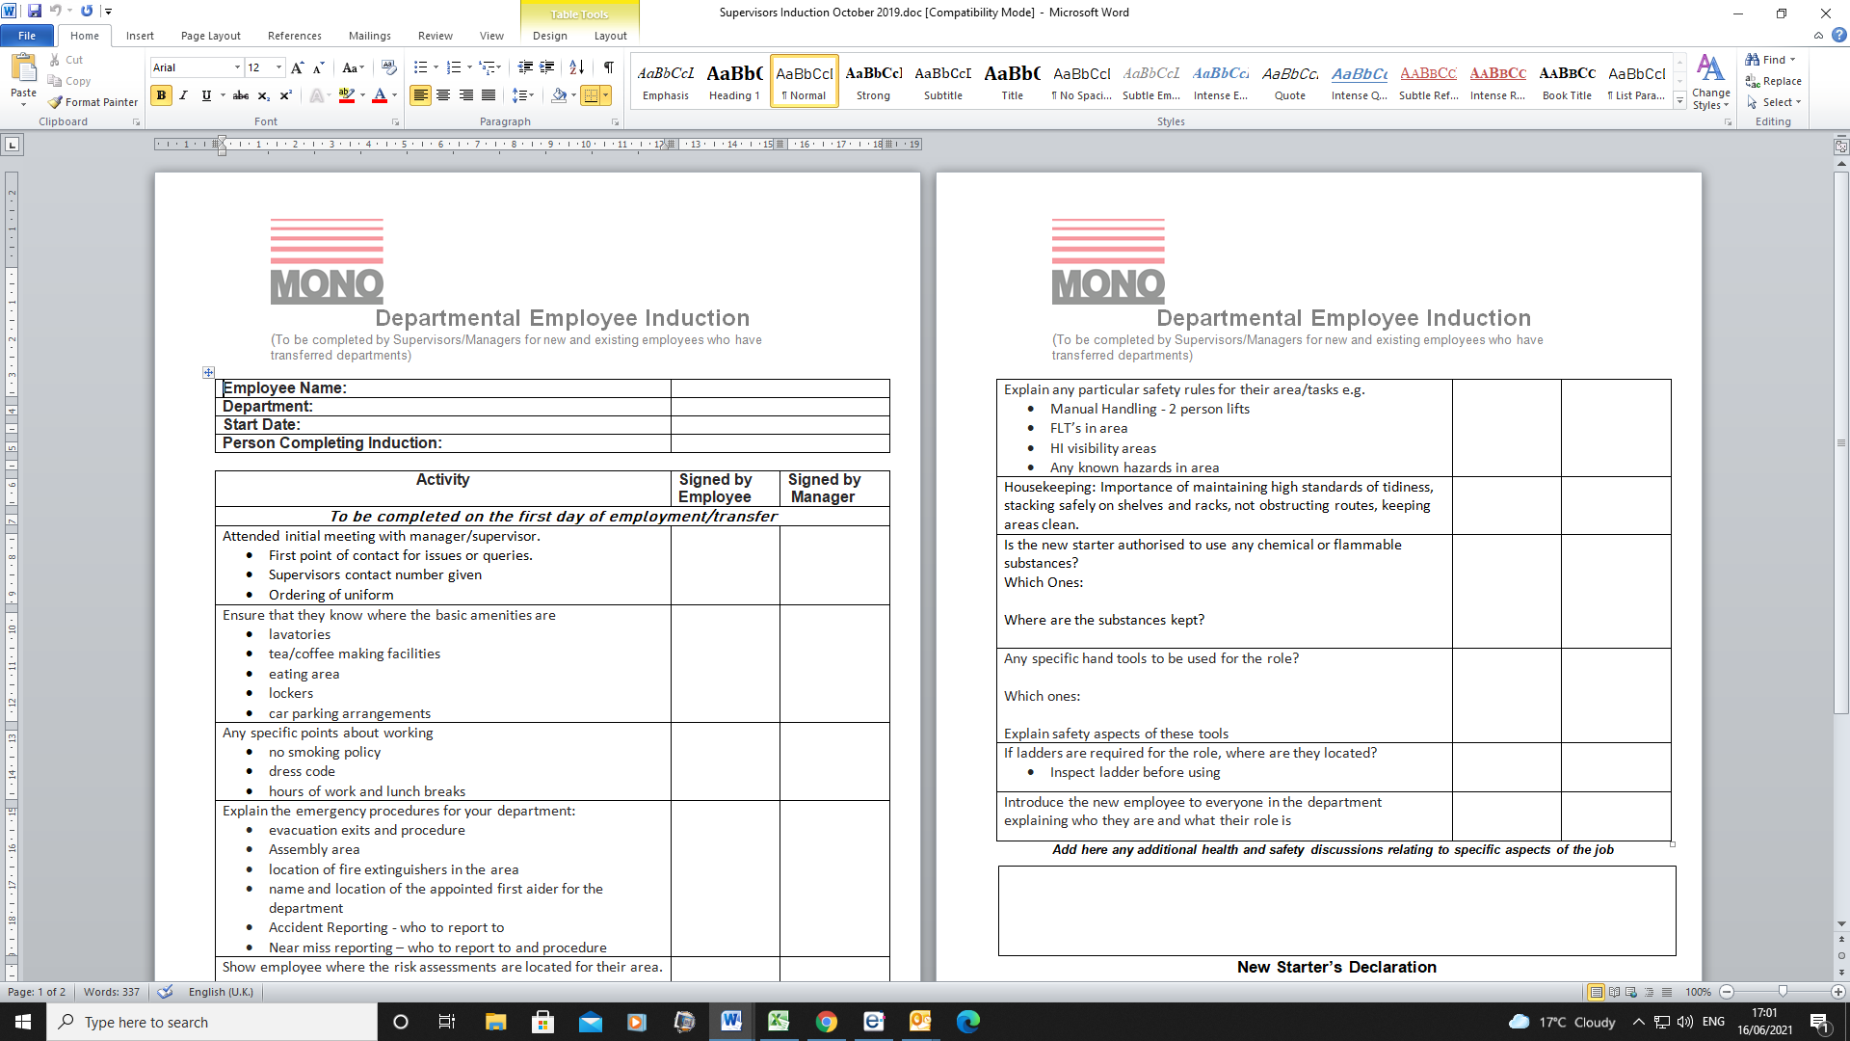
(EV2 – Training Development Policy)
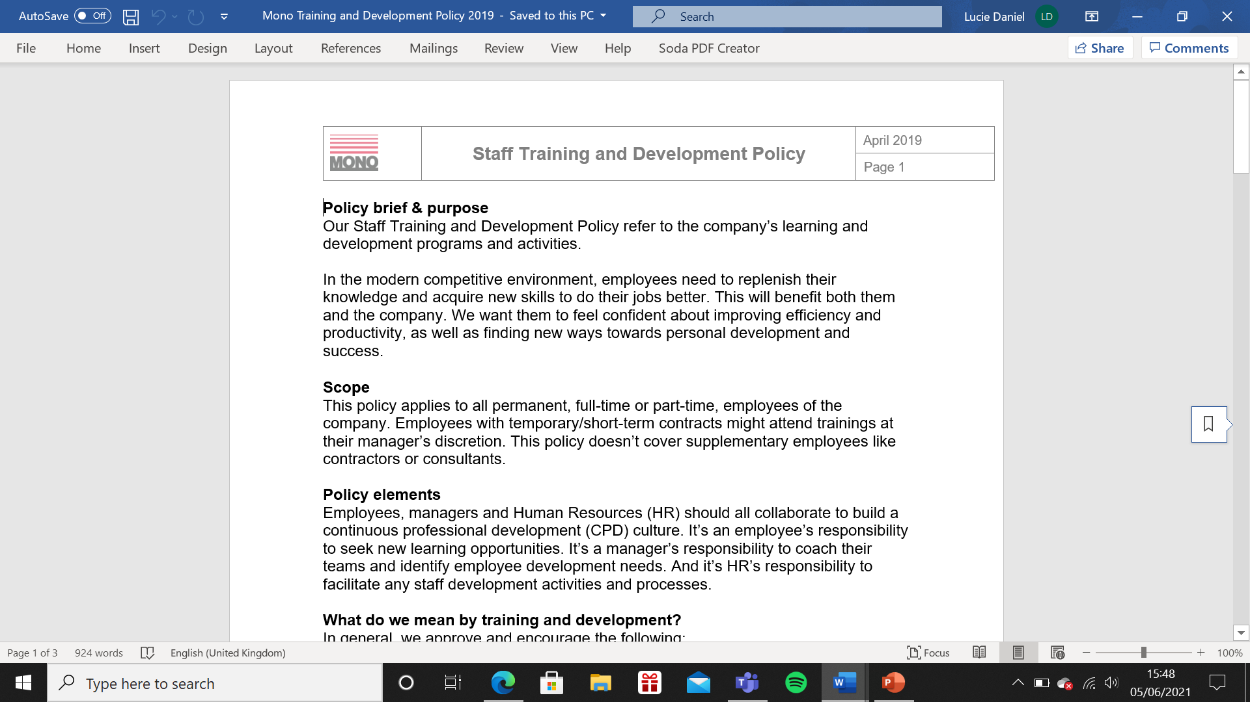
(EV3 – Probation Period letter)

(EV4 – Work Instruction)
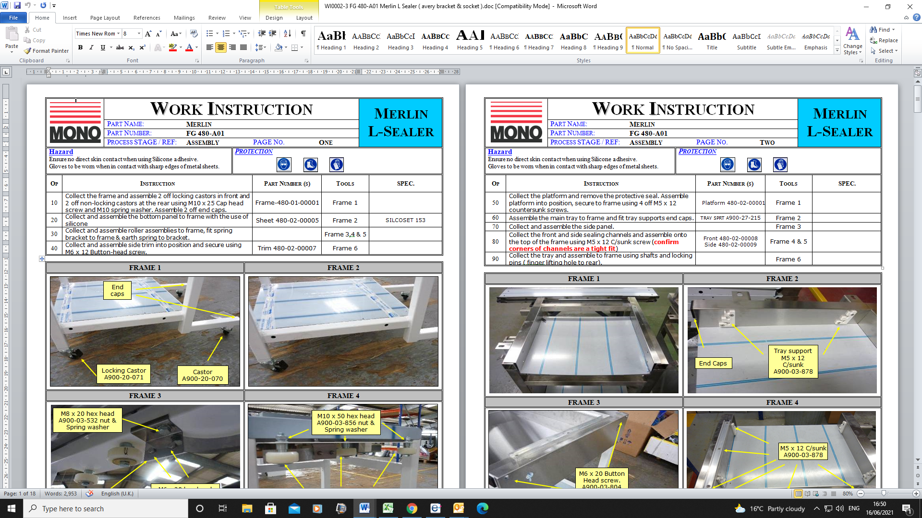
(EV5 – Organisational Chart)
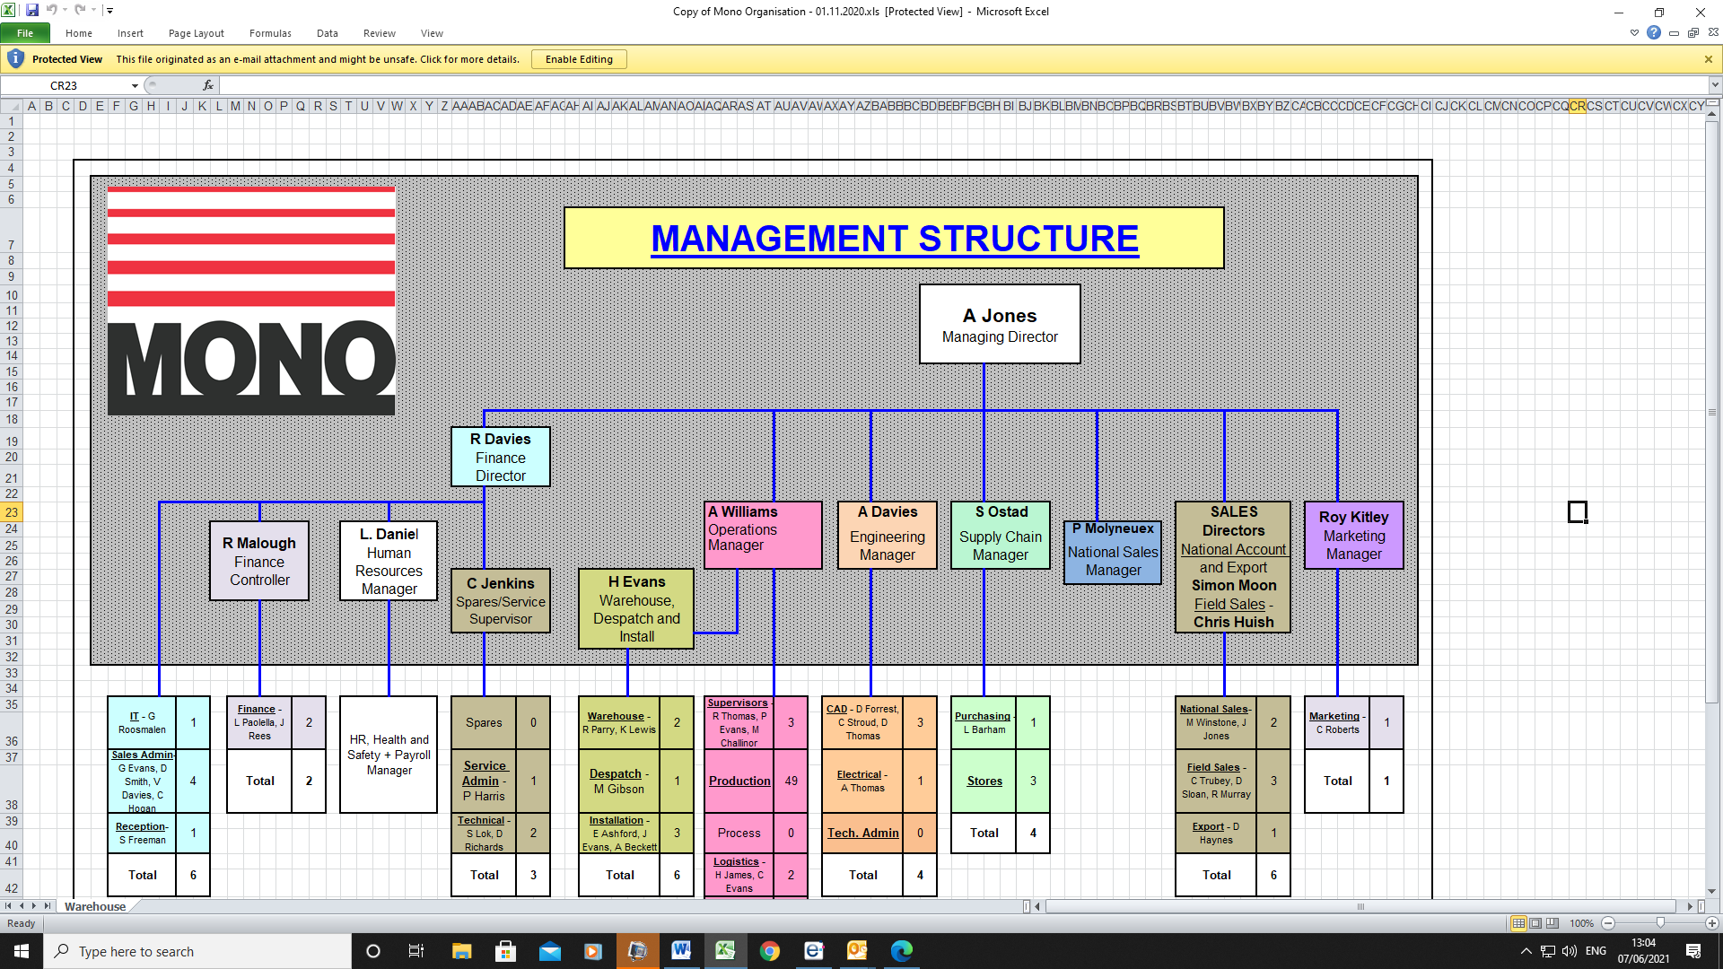
(EV6 – Supervisors Training e-mail)
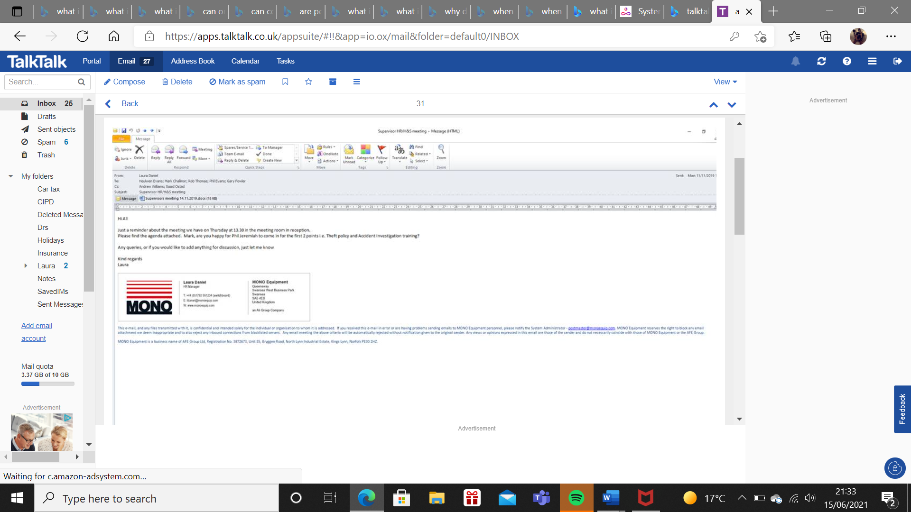

(EV7 – Statement of Core Principles)
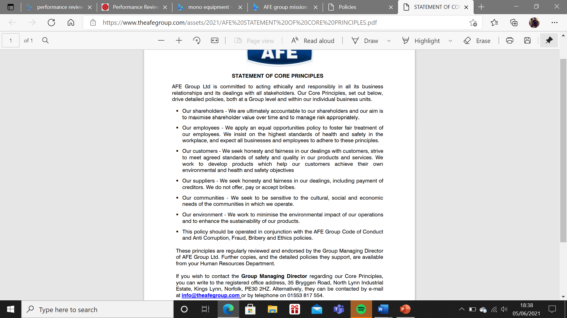
(EV8 – Code of Conduct)
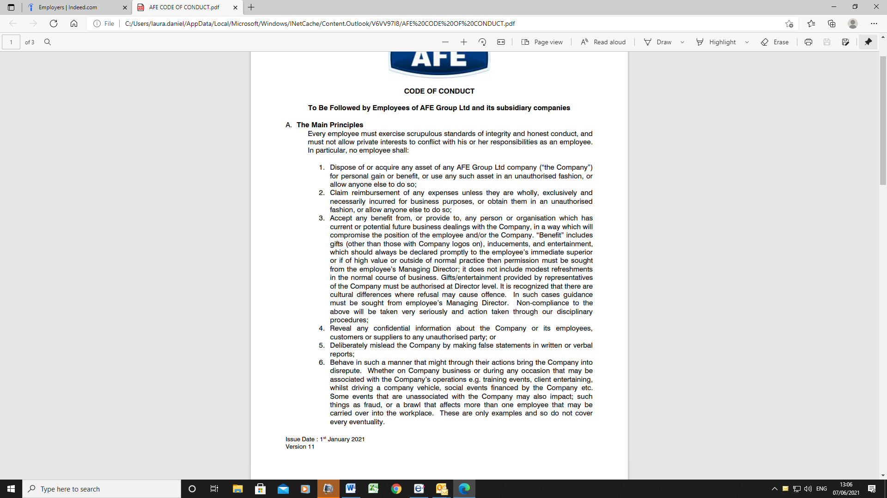
(EV9 – Company Handbook)


(EV10 - Principles)
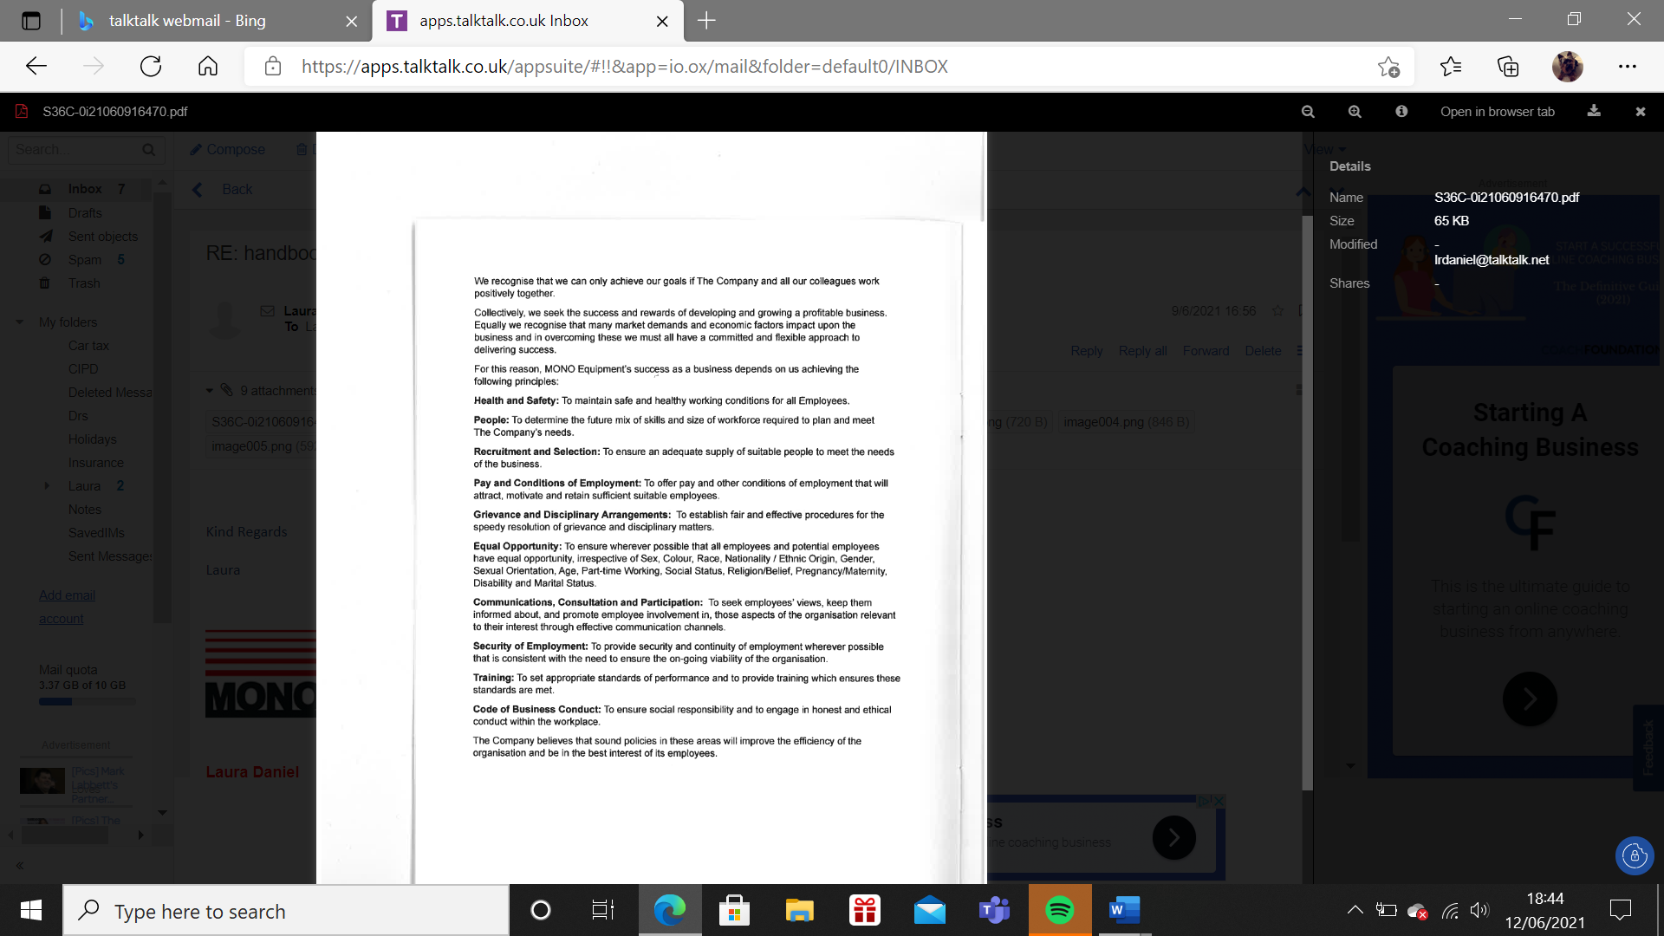
(EV11 – HR e-mailed plan for new employees)
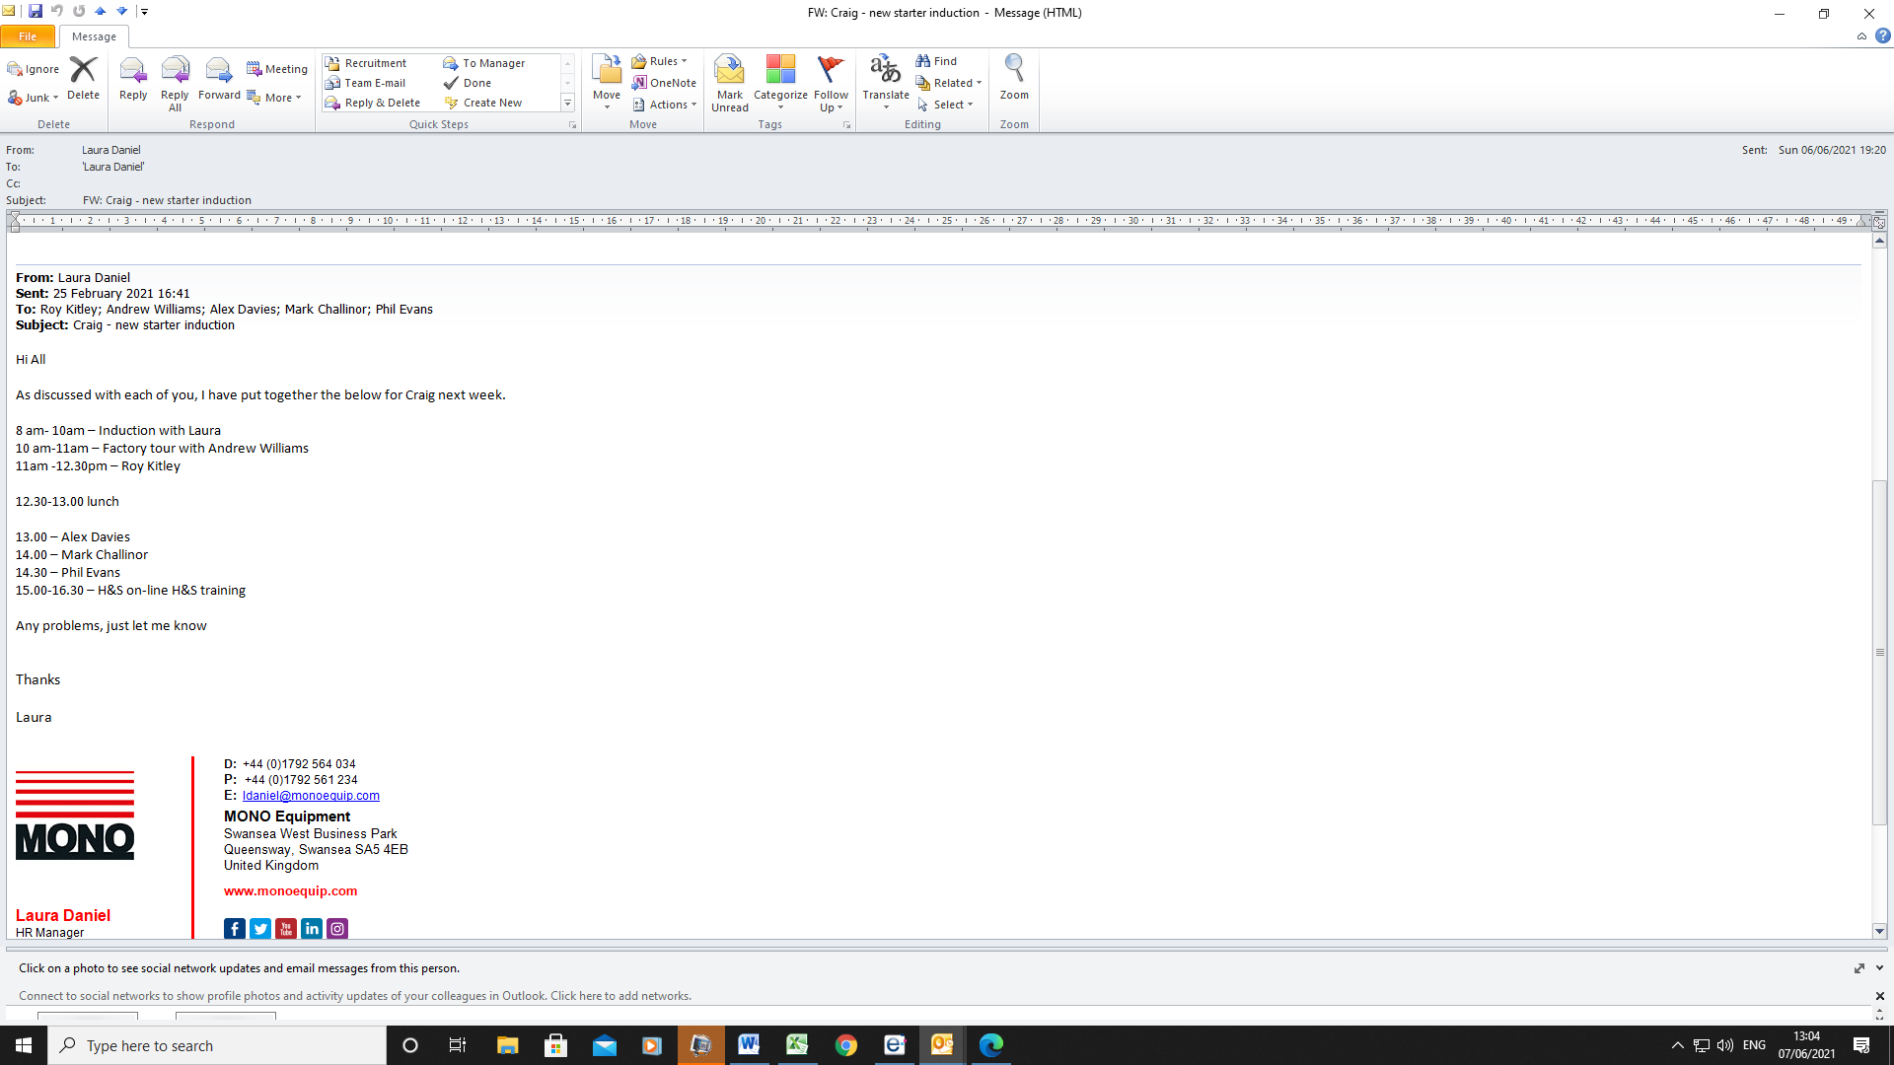
(EV12 – Induction Pack)
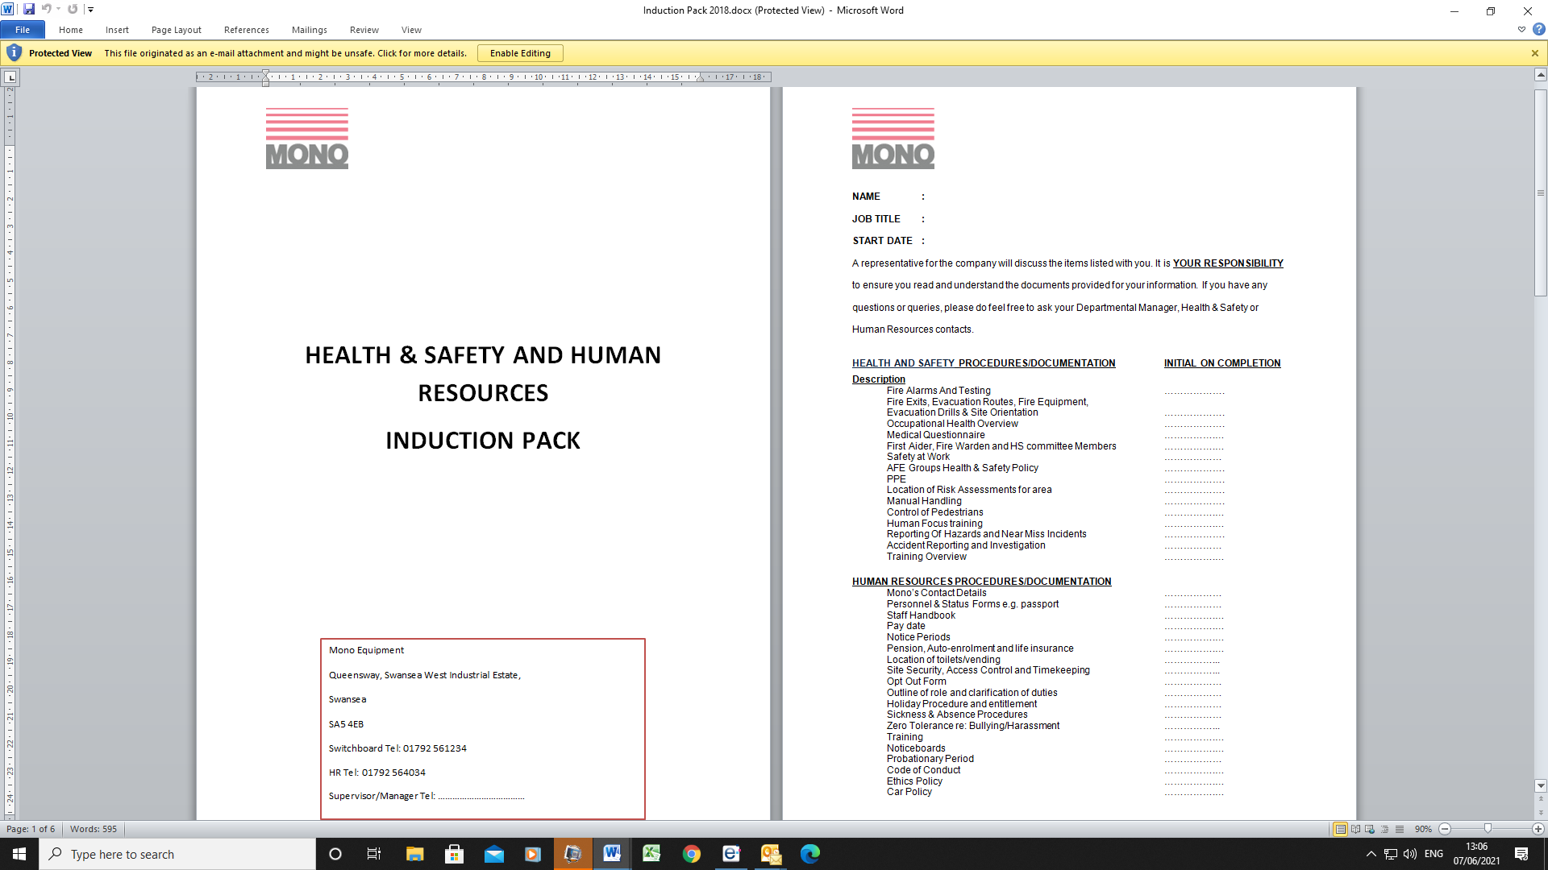

(EV13 – Departmental Induction)
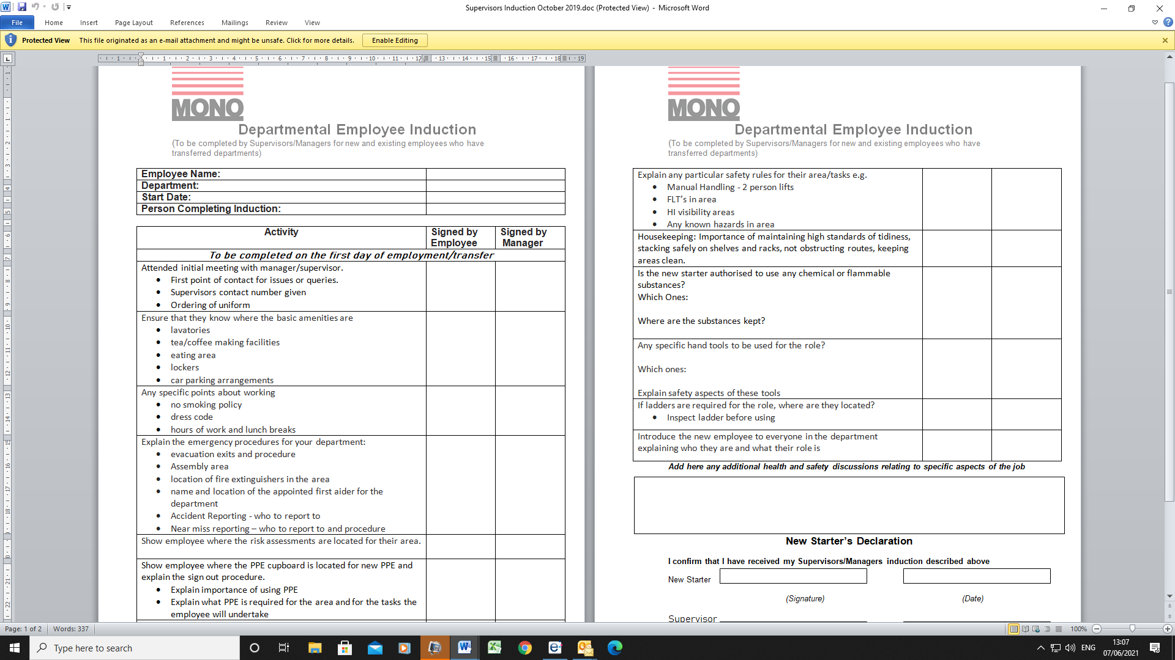
(EV14 – Organisational Chart)
(EV15 – SWOT Analysis)
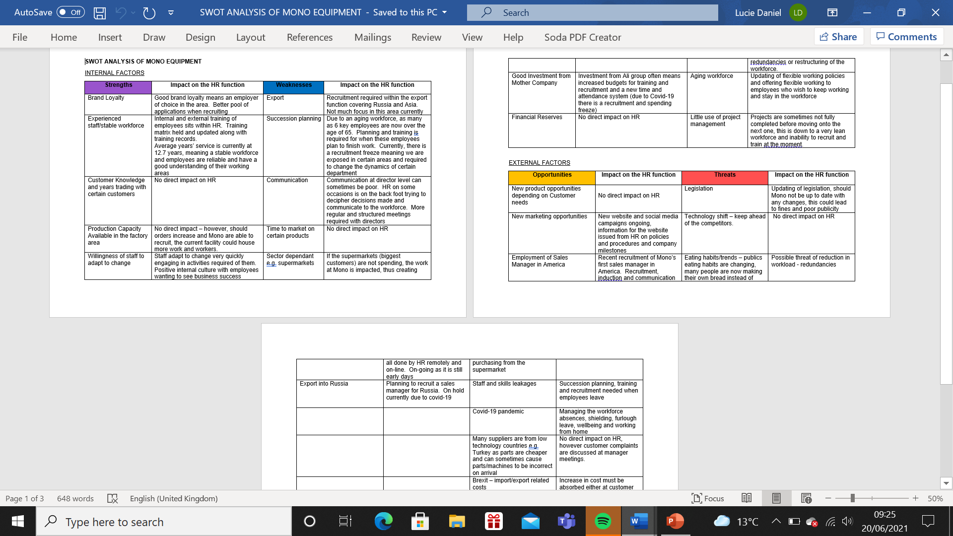

(EV16 – Coronavirus Policy)
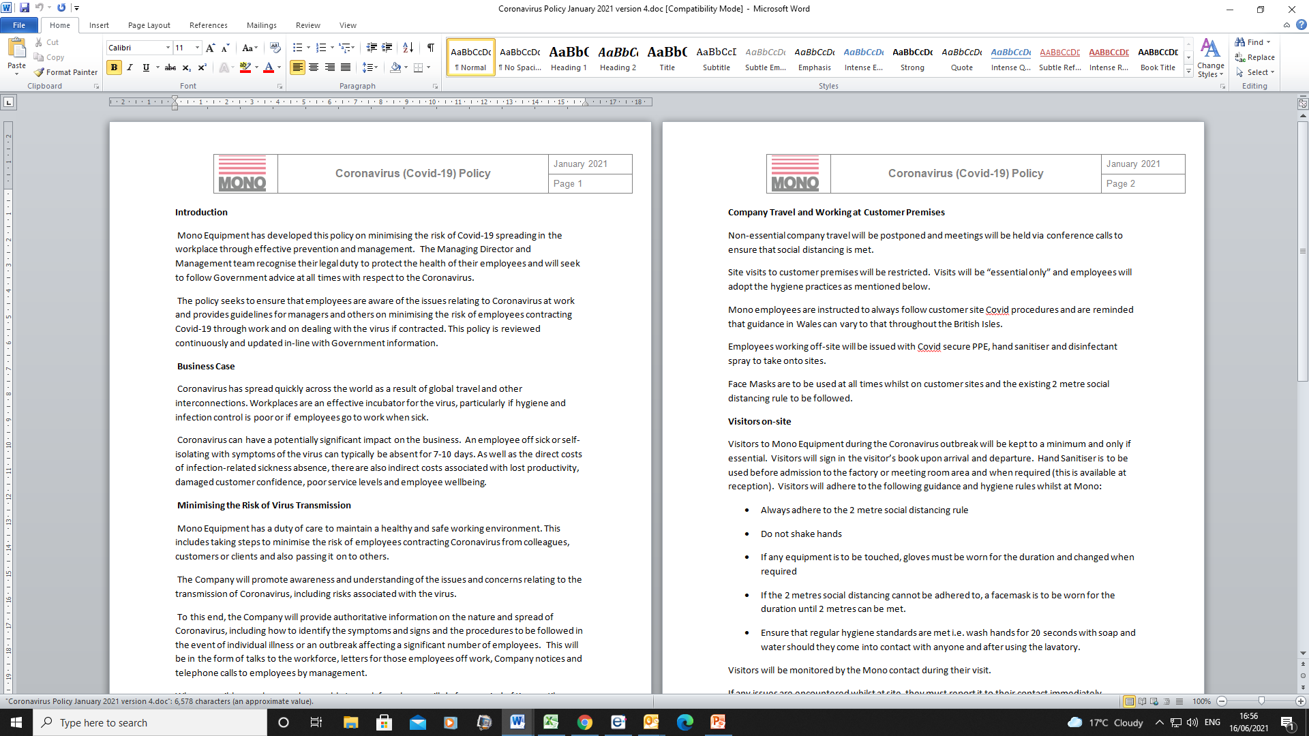

LO2 - 2.1 Promote the benefits of coaching/mentoring within the organisation, recognising and addressing the potential barriers.
According to BrightHR (2021), by developing and enhancing employee skills through coaching/mentoring makes employees more valuable to the company. When employers are interested in the growth of its employees, it shows that the business care about their progress which can increase their loyalty and engagement. Company “X” doesn’t promote coaching/mentoring, however with the increased need to change the existing culture and become an employer of choice, the company needs to recognise that it needs to change. Faragher (2012) says many HR professionals are now asking coaching providers to “kick-start” a programme that creates that organisational shift towards a coaching culture, however with the cost implications of this, it may not be feasible for Company “X” and internal coaching/mentoring may be more suitable.
To raise awareness within Company “X”, internal notifications and marketing bulletins could go out to employees explaining the positive effects it will have on both the organisation and its employees. This communication can be put on noticeboards requesting those interested in becoming a coach/mentor to employees to inform their supervisor (a draft poster can be seen in EV25). This is cost effective and gives all employees the choice to put their names forward instead of the supervisors/managers choosing who to get involved. A barrier however could be that not everyone reads the notice boards, so a copy of the communication will also be given with payslips. Managers and supervisors can also communicate this information to their teams to promote coaching/mentoring even further.
A draft PowerPoint training presentation has been drawn up for supervisors and managers to promote coaching/mentoring within Company “X”. The presentation will highlight the skills, knowledge and behaviours required, along with the benefits to coachees/coaches/managers and the organisation and touch upon elements that may help coachees/mentees be more prepared to engage in C&M in the future (EV24). A barrier that could be faced with this training is getting everyone together in a room (Coronavirus and time constraints are the issues), however the presentation can be sent to all managers via e-mail for them to review or a zoom session can be held.

2.2 Contribute to the development of organisational coaching/mentoring processes.
The aim of changing the current culture within Company “X” is so that employees become more engaged in coaching/mentoring. Conversations and changes are currently underway on improving coaching/mentoring within the business. I took the opportunity to speak to the Managing Director (MD) about making some changes and improvements on Friday 7th May 2021. Rough notes were taken of the conversation (EV17). During the meeting, I attempted to justify my reasons for change, giving reasons on how the Company could benefit and have a better culture as a result (information from the table in question 1.4 was discussed). It was agreed that I would assist with training our supervisors and managers on why coaching and mentoring is important and to put a PowerPoint presentation together (EV24).
According to Knolskape (2021), it is important to educate managers on the “why” i.e. show them the purpose of coaching/mentoring”. When managers and leaders coach or mentor with a clear purpose, they may be able to better see the collateral benefits of coaching/mentoring.
A new training room will be made available to assist with sessions of coaching/mentoring in a more professional manner. I will assist the supervisors/managers in selecting the coachees/mentees to ensure that there is no favouritism and that selection in fair.
We also discussed how to drive improvements through the business. The MD will be assisting with brainstorming ideas on how to utilise coaching/mentoring for the company and talk to the senior team on how to make this happen. The MD agrees that Company “X” needs to make changes to create better working partnerships between employees, change the current culture and hopefully help to make the organisation a Company of Choice in the future.
Last month, HR carried out a review on current skills within the business, identifying that over the next few years, key employees are going to be leaving and hence with no succession planning in place, this will be leaving skills gaps and issues that the company must address immediately. This is a good starting point for coaching/mentoring within Company “x” and has made the management team re-think their coaching/mentoring approach and meetings are already taking place to establish the best way to do this. Several ideas have been discussed with HR and others such as:
• HR have contacted local colleges on recruiting apprentices (EV19).
• The induction process will become more structured, with supervisors taking the lead on organising their teams. A new induction policy and timetable will be drawn up by HR for new recruits to follow, to assist in enhancing their coaching/mentoring experience (a draft version has been written up, however will vary depending on the department EV20).
• Supervisors and managers are to complete Equality, diversity and inclusion, managing people and performance training through the ACAS website to understand its importance and why employees should be treated equally. This has already started (EV21).
• An appraisal system is to be brought in at the end of the year, currently the forms are being circulated by HR (EV22) and managers are to be trained on how to complete them, ensuring that 2-way feedback takes place and training is discussed. Appraisal techniques have been drawn up to help with training on how to complete appraisals (EV23).
• A group HR meeting is taking place next month. During a telephone call with the chair of the meeting, I have asked that coaching and mentoring is added to the agenda in the hope that policies and approaches from other companies can be shared and discussed.

  - Support coaches/mentors to build and develop the knowledge, skills and behaviours required for the role.
Coaches/mentors, develop skills such as listening skills whilst supporting the coachee/mentee. This helps to advance their ability on questioning. Star (2011), says there are 4 types of listening, Cosmetic Listening, Conversational Listening, Active Listening and Deep Listening as shown below:
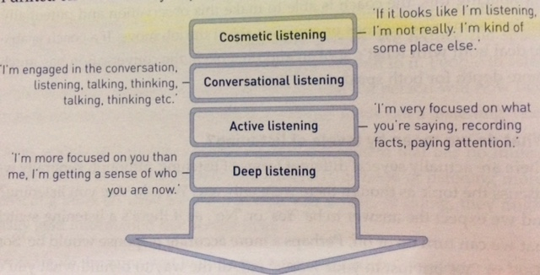
The mentee can bring new ideas to the coach/mentor and hence give them a new lease of life in the process. However, according to Forbes (2018) “Coaches or mentors not experienced with guiding new or young hires may accidentally impede improvement while trying to help”. It is therefore important for Line managers to have the skills and knowledge to carry out this task or the business and its employees will suffer. As already mentioned, a draft PowerPoint presentation has been created to help with this (EV24, slides with notes are included) and will be rolled out once agreed.
According to Haill (2015) “Coaching/mentoring creates and builds confidence, creative-thinking, responsibility and commitment for the coach/mentor”. They will also see improved working relationships amongst others and according to Institute of Coaching (2020), “their own performance benefits”.
Coaches/mentors may see satisfaction in their own roles. It is said by Zahid (2019), that some organisations are struggling with poor performance by managers. Therefore, for managers to be proactive and have improved performance, “coaching and mentoring is a cost-effective intervention, helping them develop ideas and discuss decisions” (Zahid 2019). Very often, coach/mentors have insights into workplace issues and sometimes personal issues. It is very important that the coach/mentor understands about confidentiality and any consequences if trust is breached. According to Robbins (2019) “a certain level of trust is a non-negotiable requirement for any kind of coaching to work”, hence why it has been agreed for managers/supervisors to use the ACAS courses in confidentiality to assist with this.
Whilst running the PowerPoint training, HR will incorporate a YouTube video on How to Coach and Mentor in the workplace by the Pathway Group (2014) (the link will be included on the PowerPoint slides). To assist coaches/mentors, HR will run support meetings, ensuring that any issues are being dealt with and for some feedback.

  - Assist potential coachees/ mentees to understand and participate fully in coaching/mentoring programmes.
Coaching/mentoring is an important part of continuous performance management. “When managers maximise employee potential and surround employees with supporting talent, they put their teams in a position to grow and help the organisation succeed” (Strange 2001). Both parties require the right mindset to engage in these activities and can assist each other throughout the process.
There can however, be several challenges when managing a mentoring programme, one of the main ones being participation of the coachee/mentee. Lack of participation could be due to a lack of understanding of what coaching/mentoring is, not understanding the reasons why it is being carried out or its benefits, also it needs to be considered if is it the right style for them (not one size fits all).
Elements that may assist coachees/mentees be more prepared for the coaching/mentoring process can include:
- Understanding why they are there, what do they want to achieve out of the process? Be prepared for the mentor to ask these questions.
- Have goals in mind, what direction they would like to go within the business so the coach/mentor can map out a plan (Lim 2019).
- Research a little about who the mentor/coach is before starting e.g. employment history, this will help coachees/mentees to know how to utilise their time.
- Be prepared to give feedback on how the coaching/mentoring sessions are going, are they getting what they want out of it?
Feedback is important for the coachee/mentee, this can be in the form of conversations during meetings, 360 feedback or a questionnaire. This helps with evaluating on how the sessions are going and where any improvements can be made.
Currently, there are no feedback forums that exist within Company “X”, no employee surveys or appraisal systems to help with the coaching/mentoring process. However, is a recommendation for the company going forward.
The following which is based on Kirkpatricks Evaluation Method (1959), can also assist with evaluating the process:
- Reaction of the student – How do they feel about the process?
- Learning – Is there an increase of knowledge because of the process?
- Behaviour – What is their behaviour like during the process, are they engaged?
- Results – Are there any positive or negative effects on the organisation resulting from the coachees/mentees performance?
With clear workable goals and visible improvements from coaching/mentoring, employee motivation and job satisfaction ramp up along with self-confidence and appreciation (Backlaw 2019). Once in place, Company “X” must ensure that these improvements continue, and both the Company and employee do not go back to their old ways.

2.5 Support the on-going evaluation and continuous improvement of the organisation’s coaching/mentoring programmes.
There is not much evaluation within Company “X”, this could be due to time constraints or perhaps because Managers are not trained in how to carry it out. There are a few evaluation forms that already exist within Company “X” around training, however, are very rarely used and will need to be adapted for coaching/mentoring (Ev26, shows a development review form. EV27 shows an Apprentice/Trainee review form and EV28 shows an Individual Learning Plan). The Individual Learning Plan has recently been adapted for 2 departments and was e-mailed to the Warehouse and Engineering Manager for suitability and for feedback. Their responses are within EV29, both were happy to start using the form once they had been trained on its use.
I am currently co-ordinating coaching/mentoring sessions with the Warehouse Manager (I will be carrying these out myself), evidence can also be seen within these e-mails for training sessions.
I have been discussing my plans for coaching/mentoring within the organisation with the Managing Director (Andrew Jones) and my manager (Rob Davies). Both have agreed that there is lots to do in this area and have shared ideas with the wider management team. To start the coaching/mentoring process, I created an induction policy as this is where the whole process starts. I sent a draft copy of the policy to both managers (EV20) who have endorsed the process, their feedback is attached (EV30).

EVIDENCE LO2
(EV17 notes of meeting with MD)
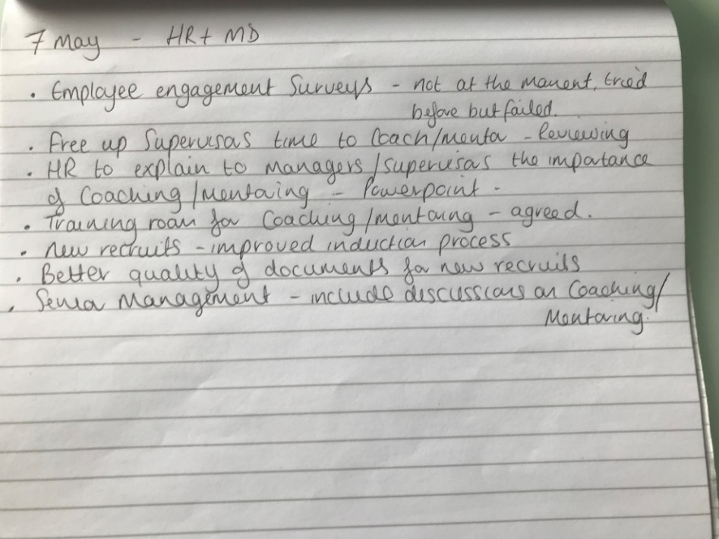
(EV18 – E-mail to the college requesting an apprentice)
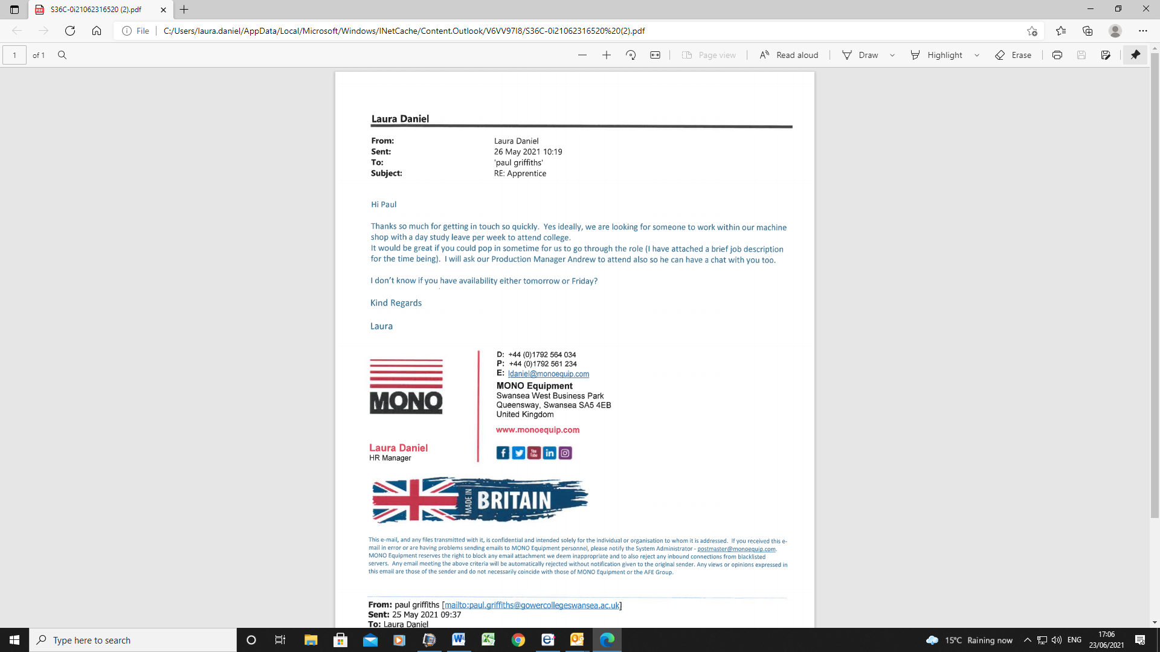
(Evidence 19 – Induction Policy and Checklist)
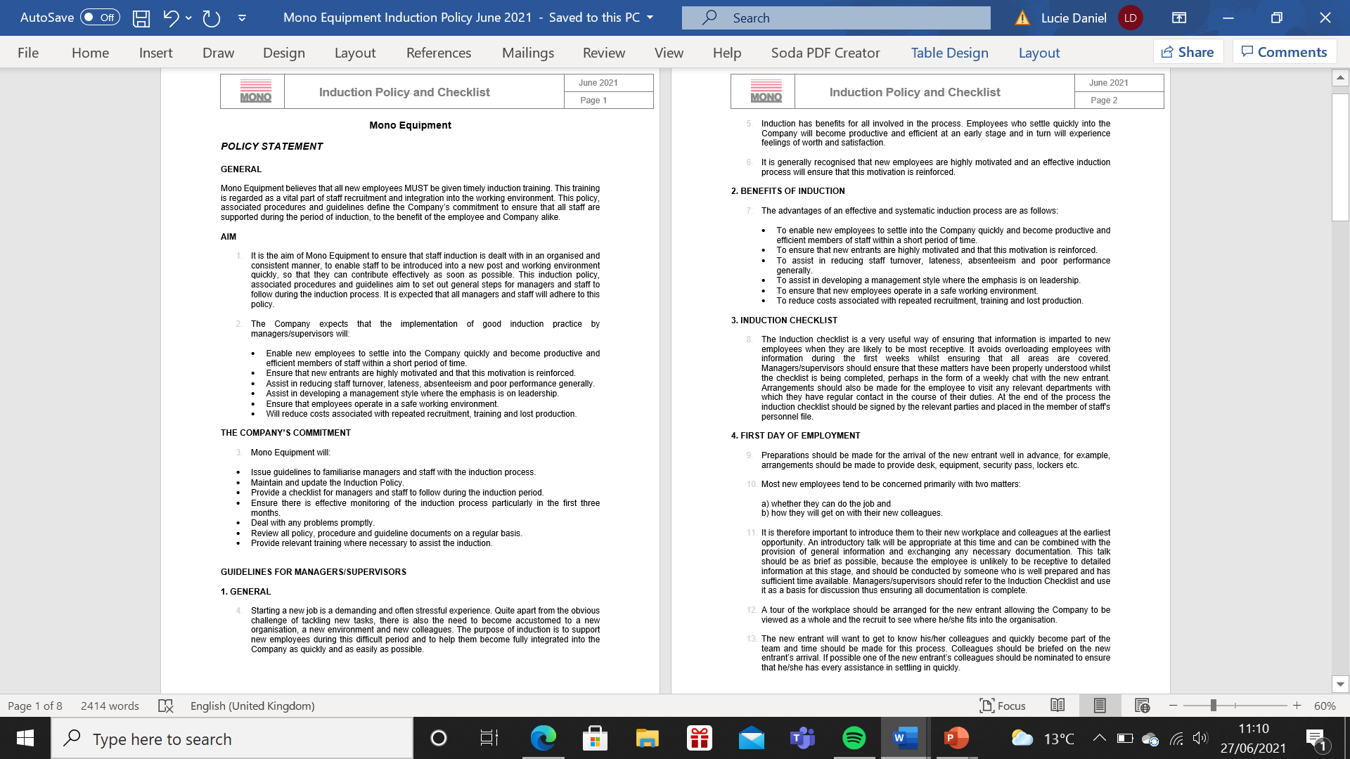
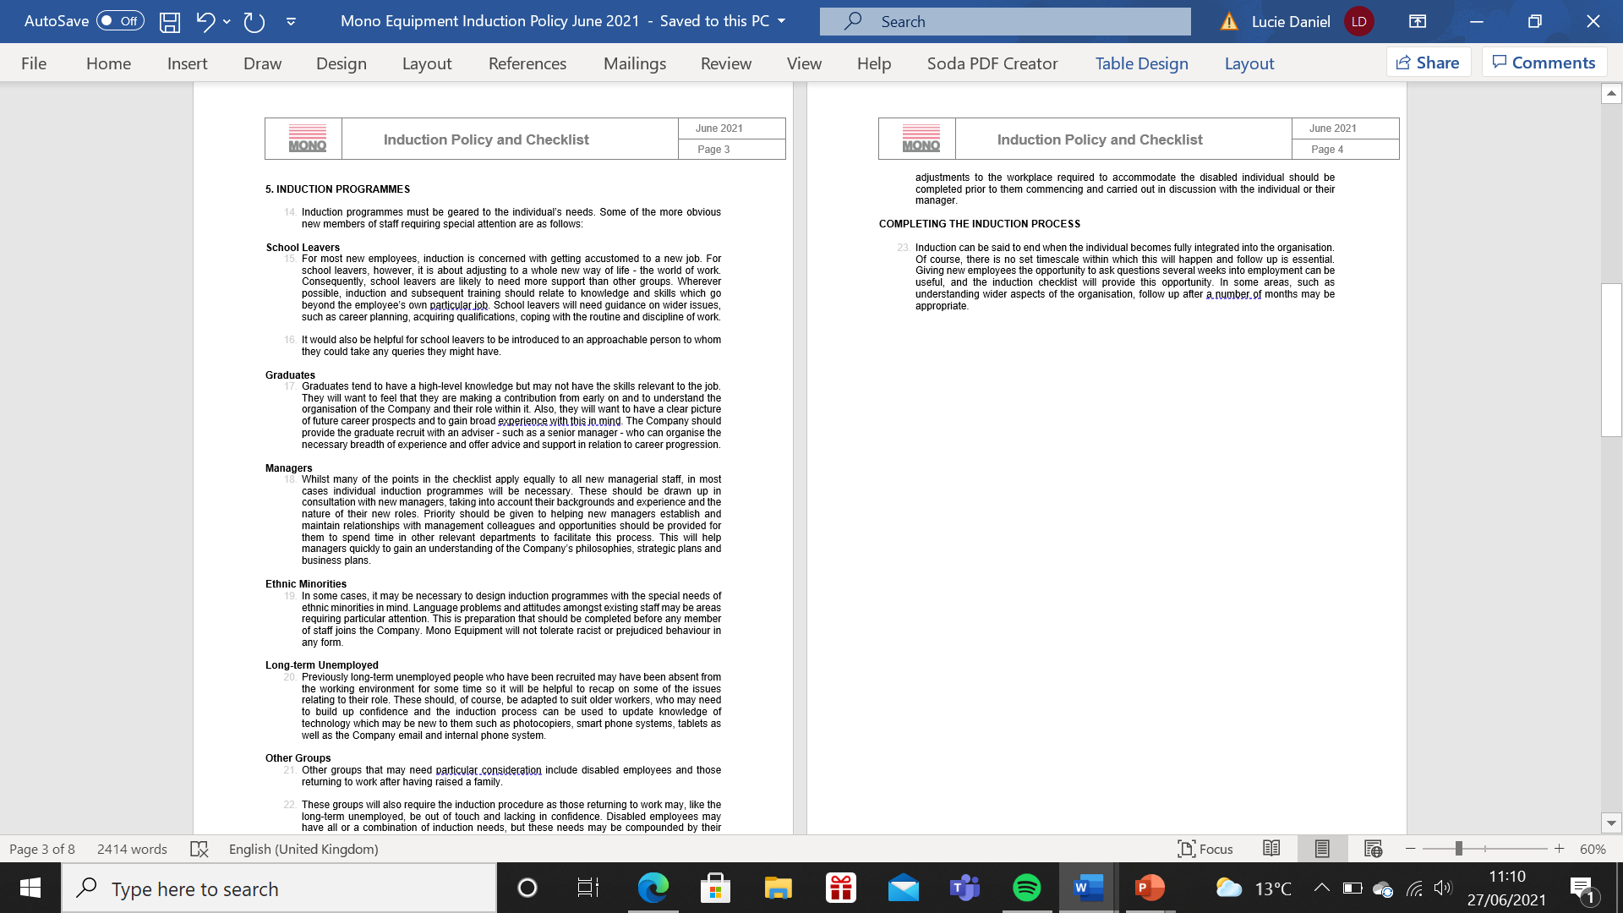
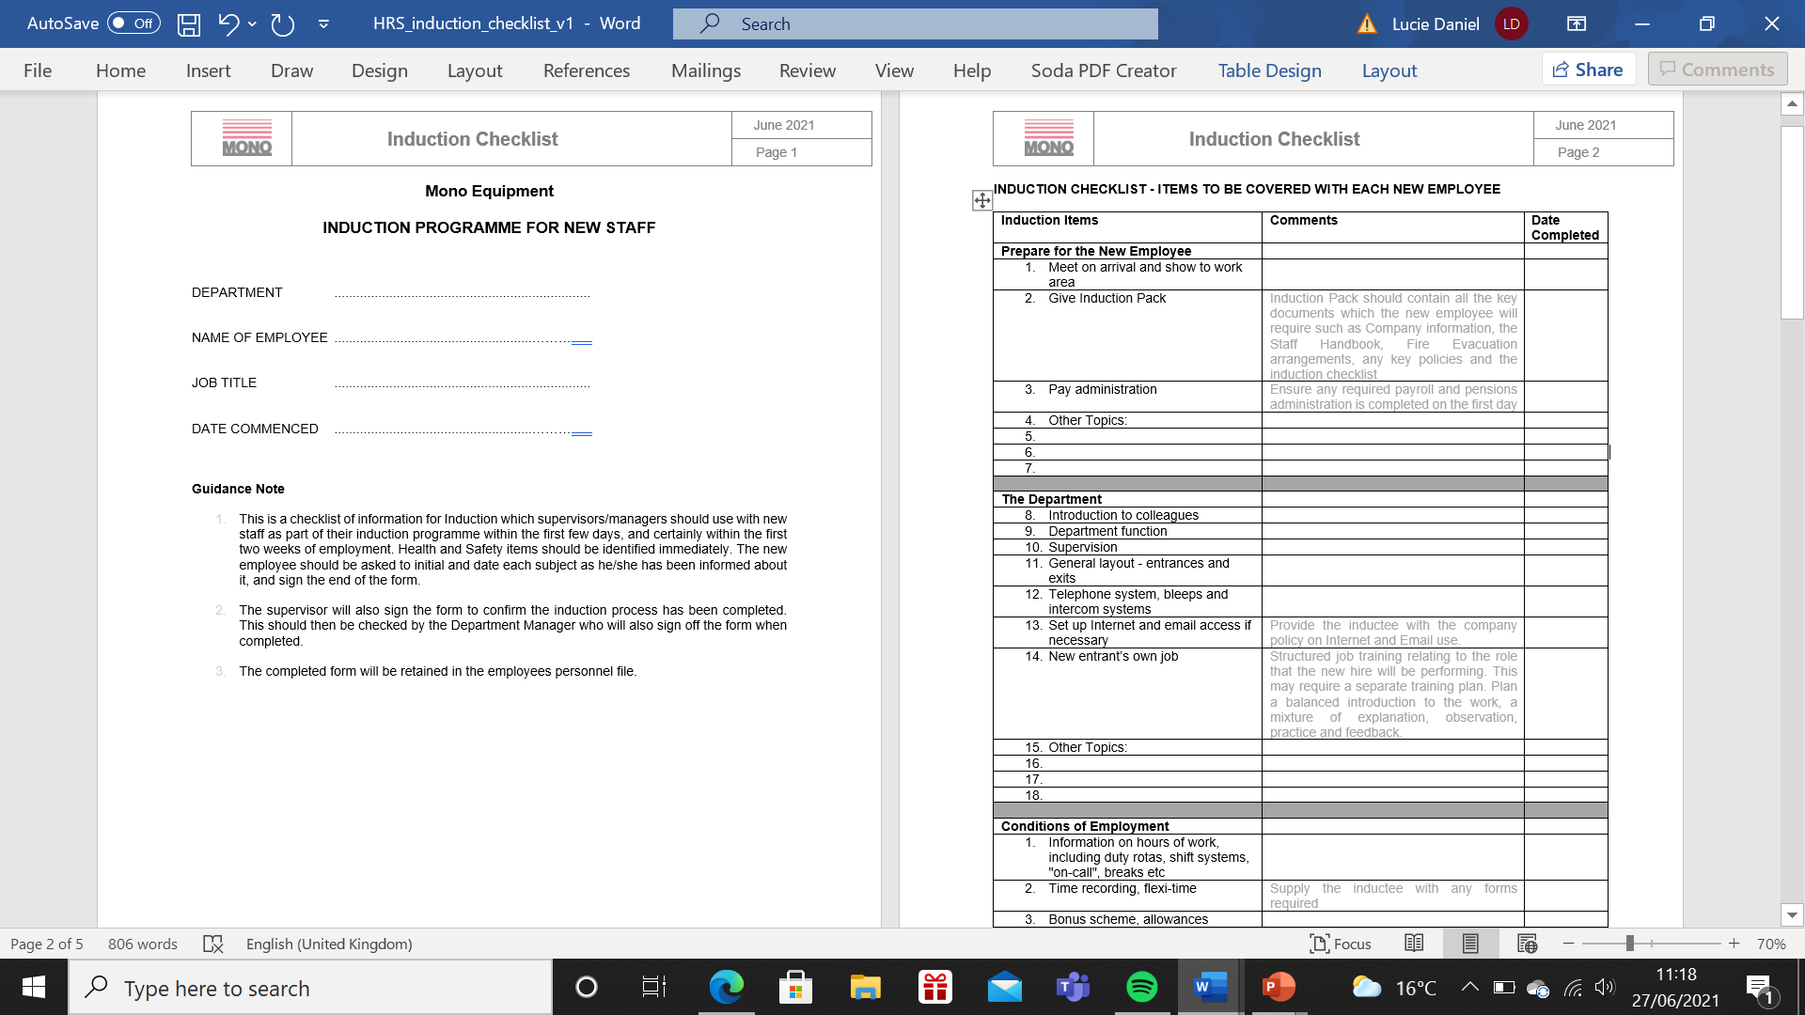
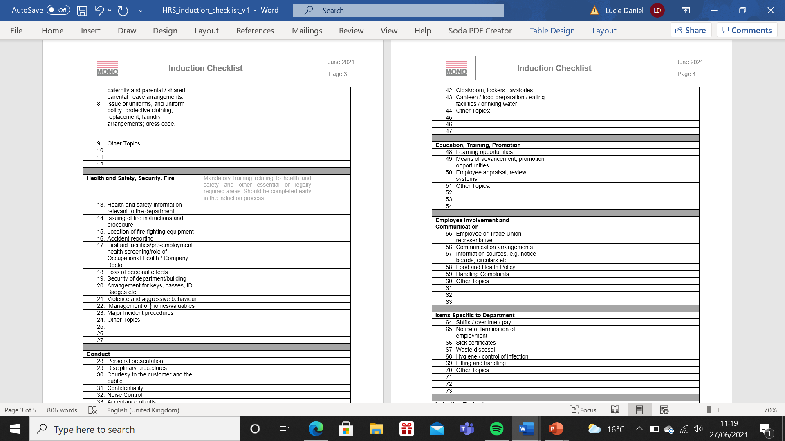

(EV20 ACAS Training)

(EV21– Staff appraisal form)
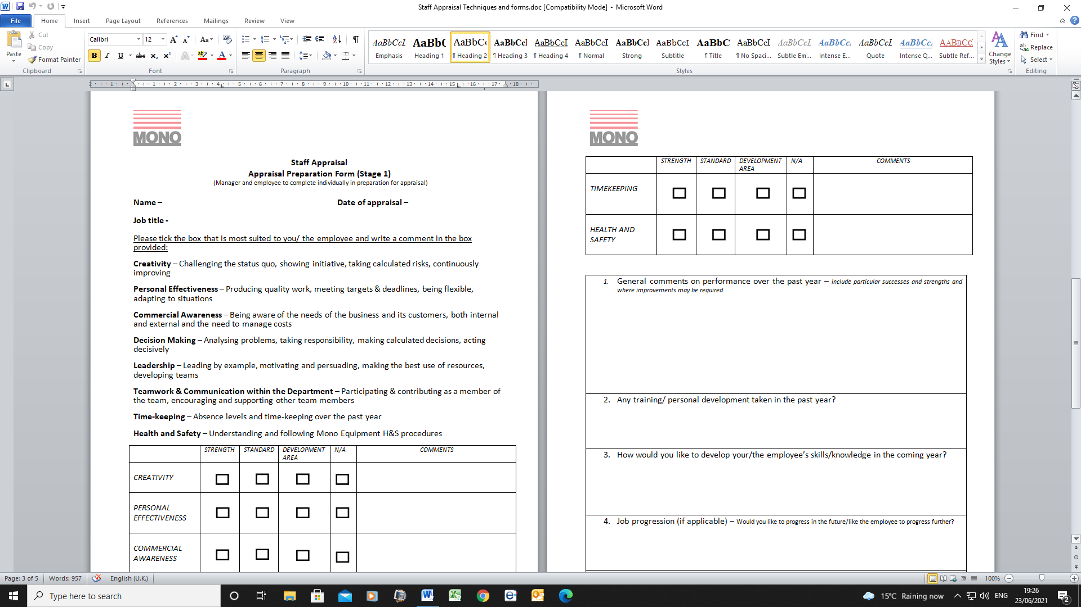
(EV22 – Staff appraisal techniques/training)
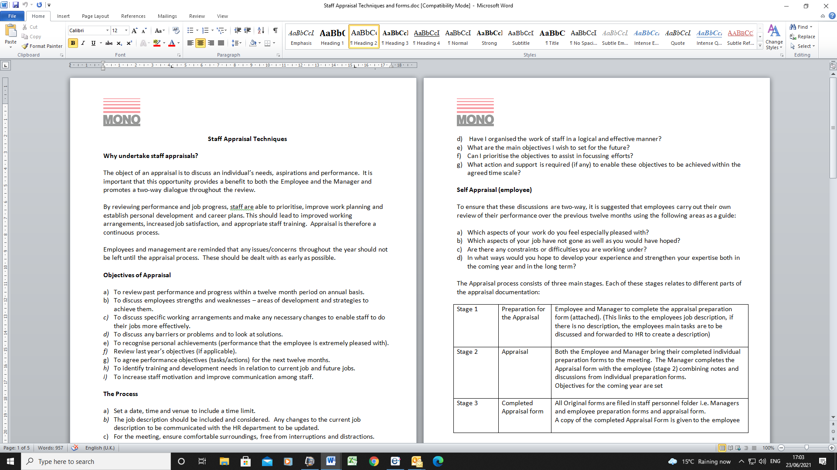

(EV23 – PowerPoint training)
Slide 1
Slide 2

A mentor in the workplace is “a relationship in which a more experienced colleague shares their greater knowledge to support the development of an inexperienced member of staff” (CIPD factsheet 2020).

Coaching is” A process by which the coach, through direct discussion and guided activity, helps an individual to solve a problem, or do a task better than would otherwise have been the case”.
Clutterbuck, D. and Megginson, D. and Bajer, A. (2016) Building and Sustaining a Coaching Culture. London: Chartered Institute of Personnel and Development

- Coaching can be very short sharp mini sessions, it can be coaching language encouraged throughout the day, or it can be several hours of introspective analysis.
- Mentoring tends to be more informal and can be a catch up in the corridor, Coaching is generally more structured and meetings are scheduled in on a regular basis.

Slide 3

Chapter 15 of the Tao of Coaching, Landsberg - talks about how people become defensive and threatened when confronted with a new way of doing things and we often resist. However, by a coach asking a coachee a question, the brain becomes engaged in a process of exploration rather than one of defence.

As a Company, we should be wanting to progress with Coaching/mentoring for the following reasons:

- individual development and focus on morale, productivity and motivation.
- good rapport between both parties.
- “Observe, listen and ask questions to understand the individual’s situation” (S Atkins 2021)
- support individuals and give advice, whilst being non-judgemental.
- can be incorporated into L&D programs.
- Creatively apply techniques which may include one-to-one training, counselling & networking (S Atkins 2021).
- Job-specific guidance and direction
- The ability to learn from senior employees (S Bahu 2021)
- The opportunity to hone skills and learn from mistakes.

Slide 4

Very often, coach/mentors have insights into workplace issues and sometimes personal issues. It is very important that the coach/mentor understands about confidentiality and any consequences if trust is breached. According to Robbins (2019) “a certain level of trust is a non-negotiable requirement for any kind of coaching to work”.

Some skills such as empathy, curiosity and intuiting are natural abilities or will increase with your experience and practice as a coach (Schuy 2020).

The following skills are useful when coaching/mentoring:
Goal setting – Build well defined and achievable goals.
Actively Listen - Listen to what the coachee/mentee is saying, gathering information
Building Rapport – Such as non-verbal body language (S Atkins 2021)
Questioning -Funnell technique This technique involves starting with general questions, and then drilling down to a more specific point in each (Open, Probing, Closed) (S Atkins 2021)
Observing - read the gestures, take in the emotions and thoughts and read between the lines (Schuy 2020)
Provide structure - The session is used to find new solutions, inspiration, impulses and to think about the action steps to take before they achieve their goals.
Feedback -It should be clear, relevant, constructive, solution-focused, positive and motivating.
Regular check ins - This helps both coach/coachee to recognise their progress and success since the last session and ensures the understanding of each other. It’s also a perfect way to check if the coachee/mentee is happy with the coaching (Schuy 2020)
Patience – Coaches should show patience with coachees/mentees and keep calm, helping them to learn.
Pause – Let the coachee/mentee have time to answer questions.
Communicate – According to CIPD (2021) – The listeners impression is based on 55% Body Language, 38% tone and 7 % words.

Slide 5

Behaviour - The way in which someone acts or conducts their self, especially towards others or in response to a situation or stimulus (S Atkins 2021)

The Betari Box, seen above is a simple model that can help us to understand the impact that our attitudes and behaviours have on the attitudes and behaviours of the people around us. Showing self-awareness to break these cycles and re-frame (S Atkins 2021)

Slide 6
The diagram above shows the knowledge, skills and behaviours required by coaches/mentors. “By defining coaching through behaviours, we can present clearly what great coaching looks like through the eyes of the participant. Behaviours also provide a connection to the knowledge and skills required to help enhance a person’s experience or performance” (The Coaching Team 2019).

Communication – listening, questioning, demonstrating, explaining, prioritising information and working out the best way to communicate with others. A behaviour is thinking about when to communicate and how to communicate.
Relationships – Building a rapport and finding a connection with the individual. Being able to connect and be positive and respectful to the coachee/mentee.
Planning – Session planning while maintaining safety and identifying any risks involved.
Reviewing – Offering feedback to individuals, whilst identifying any opportunities that present themselves. A behaviour could be reflecting on your own experience and coaching practice.
Collaborative – Opening and support networks you may have and identifying when the coachee/mentee requires additional support. As a coach/mentor, you should be able to offer support and that of others when required.

Slide 7
There are numerous possible reasons why Mono do not carry out coaching/mentoring such as:
- Busy work schedules, not having enough time to invest in it.
- Not understanding the benefits of coaching/mentoring. More education required.
- Lack of skills within the workforce to carry out coaching/mentoring.
- Employees not wanting to take part, possible reason include coaching/mentoring being new to employees (not everyone likes change) or employees not understanding the importance of it.
- A negative culture around training/coaching and mentoring – managers thinking it’s not important has a negative effect of others.
- Reward – We cannot always offer a monetary reward for employees taking part. We can, however, think of other possible ways such as changing their job role or just a thankyou from a director.

Slide 8

workplace coaching and training, mentoring and coaching in the workplace - Bing video.

The above link gives additional information on coaching/mentoring and what benefits it can offer your departments.

Clutterbuck et al (2018), mention benefits to individuals and the Company for carrying out coaching/mentoring such as:
- An increase in confidence for the mentee/coachee as they are finding out more from others about the company, the feeling of empowerment.
- New ideas from the coachee/mentee, they can sometimes see things differently.
- Closure of skills gaps – more employees to do more roles.
- Engaged employees.
- Progression for individuals wanting to enhance their career prospects.

Slide 9
When promoting the scheme to potential mentors and mentees you will need to provide an outline of the scheme’s benefits, requirements and expectations (University of Sussex 2021).

To get the best suitors, it is useful to ask people to provide some information about their mentoring expectations, requirements and skills when they register their interest in the scheme.

When Employees are given the opportunity to develop, they are more likely to engage in the process and the organisation (Insala 2019)

Slide 10
According to Haill (2015) “Coaching/mentoring creates and builds confidence, creative-thinking, responsibility and commitment for the coach/mentor”.

They will also see improved working relationships amongst others and according to Institute of Coaching (2020), “their own performance benefits”.

Slide 11
Coaching/mentoring benefits the organisation. According to Jones & Gorell (2014) “where coaching happens at every level, it adds to the bottom-line performance. Gallup (2019) also states “Coaches empower workers to take on challenges and use their strengths, which engages workers”.
In addition to the above, there are other benefits of coaching/mentoring to the organisation such as:
•Increased skills, creativity and knowledge of employees
•Loyal and committed employees – Job Satisfaction, making the time to develop team members will enhance the morale and loyalty to the company. Employees will feel more valued within the company (Hattie 2020).
•A positive change in culture and employee relations - As senior- and junior-level employees interact more frequently, they’ll grow more comfortable around each other. They’ll cultivate a deeper trust in each other and create stronger bonds of unity (Bahu 2021)
•Customer satisfaction – Not so many errors on orders as more skills within the workforce
•Improves morale and engagement - Increasing morale and loyalty will mean that you are improving employee retention
•Increased productivity and retention - Bringing individuals up to speed with company processes will allow them to work efficiently. They will be able support their other colleagues when needed (Hattie 2020).
•Improved communication and relationships

There are however some drawbacks to coaching/mentoring; According to Forbes (2017), the coaching industry has “failed to consistently and comprehensively calculate coaching value”. Other drawbacks include employees wanting to leave the company once mentoring has ceased to progress their own careers elsewhere. In some cases, there could be a creation of false expectations for the employee. Quite often once coaching and mentoring is complete, the employee goes back to their old ways. Employees may require a pay increase, which some organisations cannot agree to. In some instances, there may be an incorrect matching of mentor/mentee which could cause issues such as the coachee/mentee not listening or misbehaving.

Slide 12
- Employees want constructive feedback from their managers, but don’t always get it. Employees want to know how their performance is viewed, what they’re doing well, and what they need to improve. Feedback shouldn’t just come from the manager. Employees should be encouraged to provide feedback to each other and to you, their manager (Stange 2021)
- Employee listening is an essential part of coaching. It opens you to different concepts you hadn’t previously thought of, and it makes employees feel heard.
- No two employees are exactly alike. They come from different backgrounds and have varying personalities, strengths, and weaknesses. Connecting employees with their peers opens new possibilities and creates a more connected workplace.
- When an employee succeeds or goes over the top, let them know that you noticed (Stange 2021)

Slide 13

According to Downey 2003, the role of the line manager can be divided into 3; Leadership, Mentoring and Coaching, each overlap as shown.

“As a line manager, one of your principal responsibilities is to develop your direct reports” (Clutterbuck 2018)

A Line Manager is best placed to coach/mentor employees within a business for the following reasons:
- They are leaders, having regular conversations with their teams on its procedures, values and how to achieve goals.
- They are role models.
- Can inspire and motivate their teams.
- Give feedback on their team’s performance. Be specific, descriptive but not judgemental, making sure it is your own feedback (Atkins 2021)
- Able to train team members on the job.
- Give Appraisals
- Set goals for their teams.
- Attend interviews and disciplinary meetings.
- Plan and organise their team’s workloads.

Slide 14
There are several types of coaching/mentoring, here are a few to look at:
- Traditional Mentoring – Carried out one-on-one and face-to-face where the mentor can give their full attention whilst encouraging individuals. This type of mentoring can be tailored to individual needs and provides a low stress environment.
- Reverse Mentoring – When more junior employees have a different set of skills where they can mentor their own managers and co-workers. This can often assist with knowledge sharing throughout the business.
- 1:1 Mentoring – One mentor and mentee, the mentor is usually someone more senior to provide guidance, support and encouragement. Concentrating on building relationships and the mentees skill level over a period.
- Performance Coaching – Helps individuals to succeed in their roles, identifying any gaps in performance and to make improvements. Coaches work to develop targets and plans for individuals. The GROW Model can be used here to assist with improving performance.
- Executive coaching – Coaching with a senior person within an organisation. The coach helps identify how the executive is perceived by others, understand their own competencies and identify goals on how to reach them. The OSCAR Model (explained below) could be used here; instead of focussing on the problem, it focusses on finding a solution.
- Peer/group Coaching – Coaches working with groups/peers. There can be different focusses e.g. team building or developing and managing your career. Benefits include more people to give ideas and to learn from peers’ experiences whilst learning in a group environment. Peer coaching can be a good way of promoting self-belief by observing others. The GROW model can also be used here as it embeds a change in behaviour and awareness whilst helping with support and reflection.

Slide 15
Coaching models assist in providing a framework for coaches to follow during discussions with their coachee, they do not have to be used rigidly, however can be used to steer conversation. Sir John Whitmore (1937-2017) created the GROW Model as a process of implementing coaching/mentoring and used this model as you would plan a journey.

For Coaches to be more effective, different approaches may be useful e.g. adapting models. Further models that can be used are the ACHIEVE Model, Egan’s Skilled Helper or the OSCAR Model to structure a coaching session:
O - Outcome i.e. what do you want at the end of the training?
S - Situation i.e. what is impacting you now?
C - Choices and Consequences i.e. what is stopping you form achieving, what are your actions?
A - Actions i.e. What are you going to do for your next steps?
R - Review i.e. How will you measure your progress?
The above OSCAR Model emphasises how to overcome barriers when training and helps individuals to think on how to review their actions.
It’s important to choose a model that works best for you, the common themes of questioning, listening, clarifying and reframing are typical of many of them (S Atkins 2021)

Slide 16
Directive coaching is about explaining and demonstrating, following a process of show, tell and do, whilst non-directive is where the coachee is encouraged to find their own answers. However, both styles can be used.

- According to CIPD (2021), Asking is more empowering – telling is more controlling.

- On a sliding scale from 1 – 5 (with 1 being the first thing to try)
- Ask questions and paraphrase.
- Make suggestions.
- Demonstrate
- Give advice.
- Tell what and how.

Slide 17
Further information and guidance can be given by your manager or HR.
There are also several good articles on the internet and video clips on YouTube as mentioned earlier in the presentation.

(EV24 – Draft Poster)

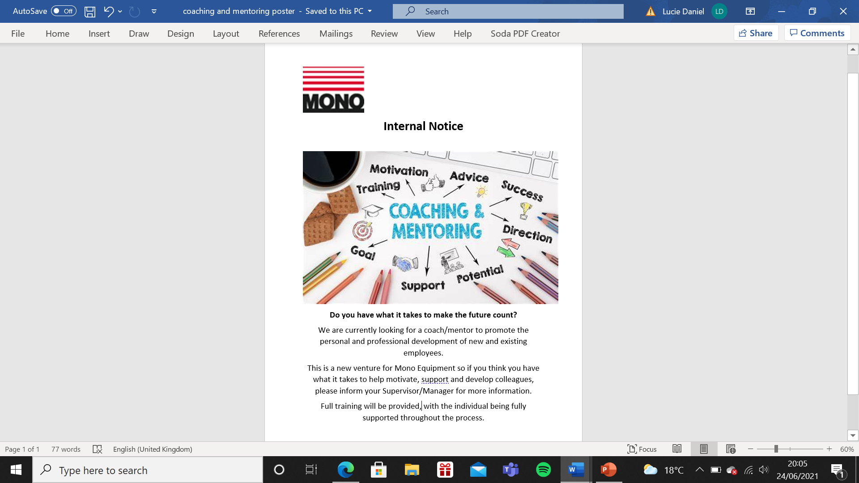
(EV25 – Development Review Form)
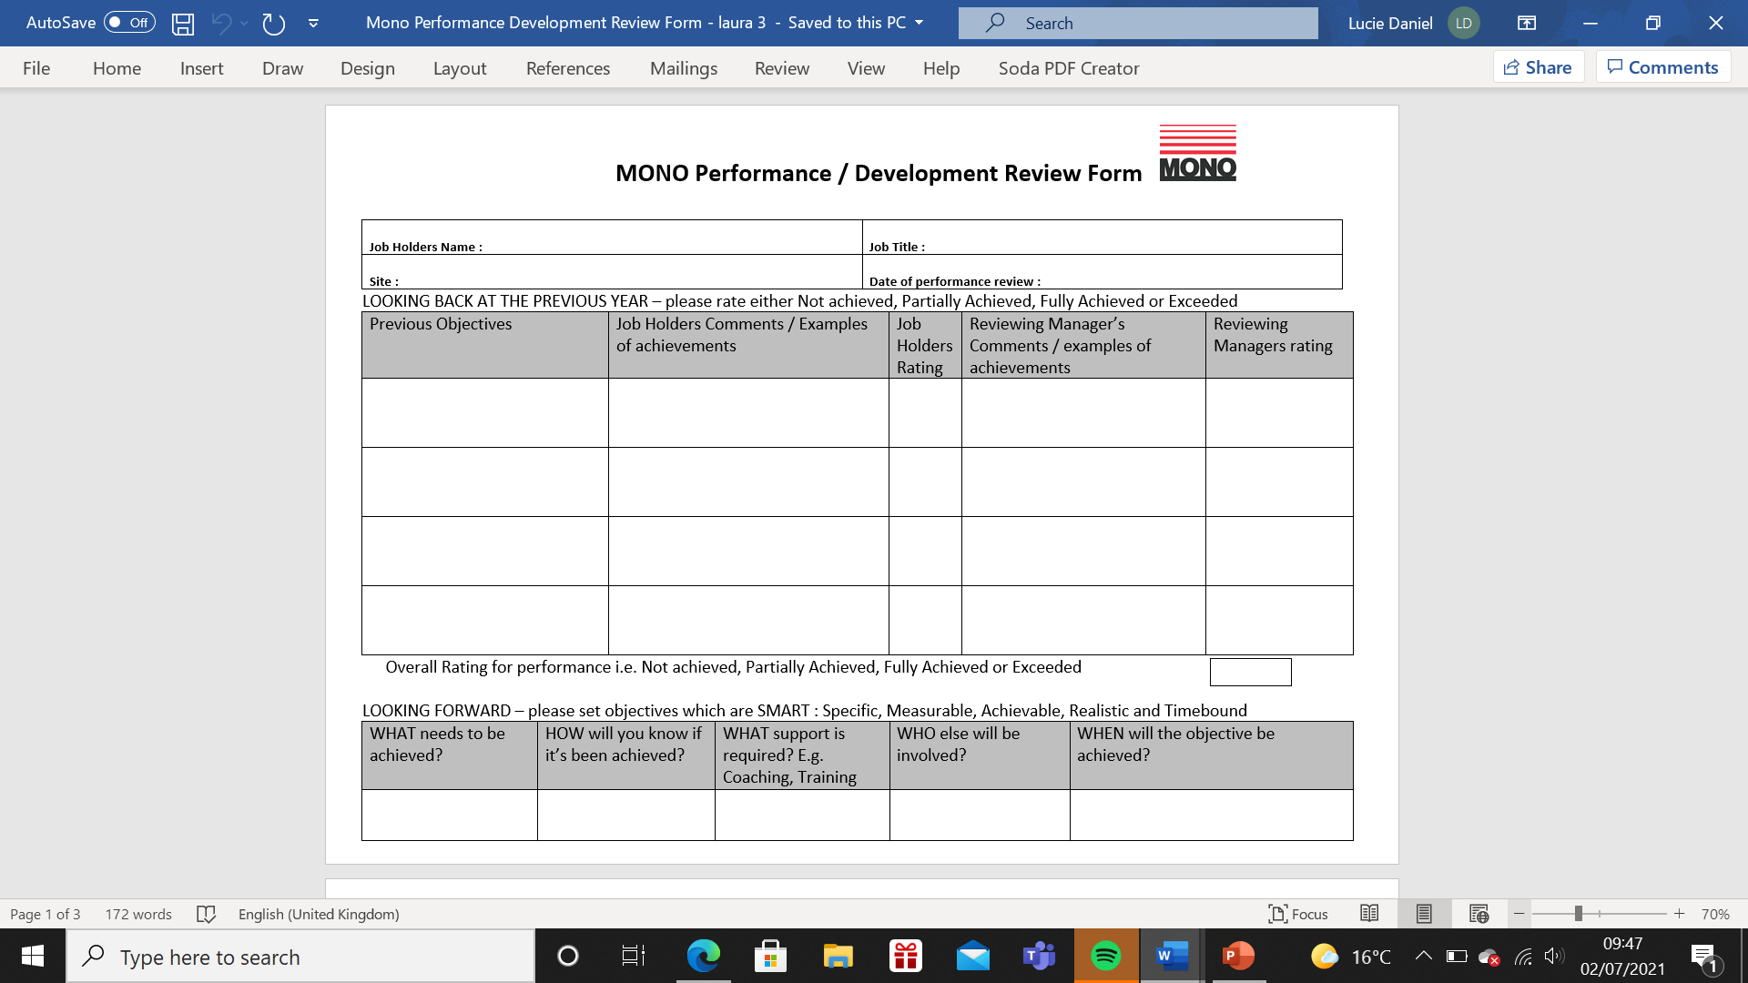
(EV26 – Apprentice/Trainee review form)
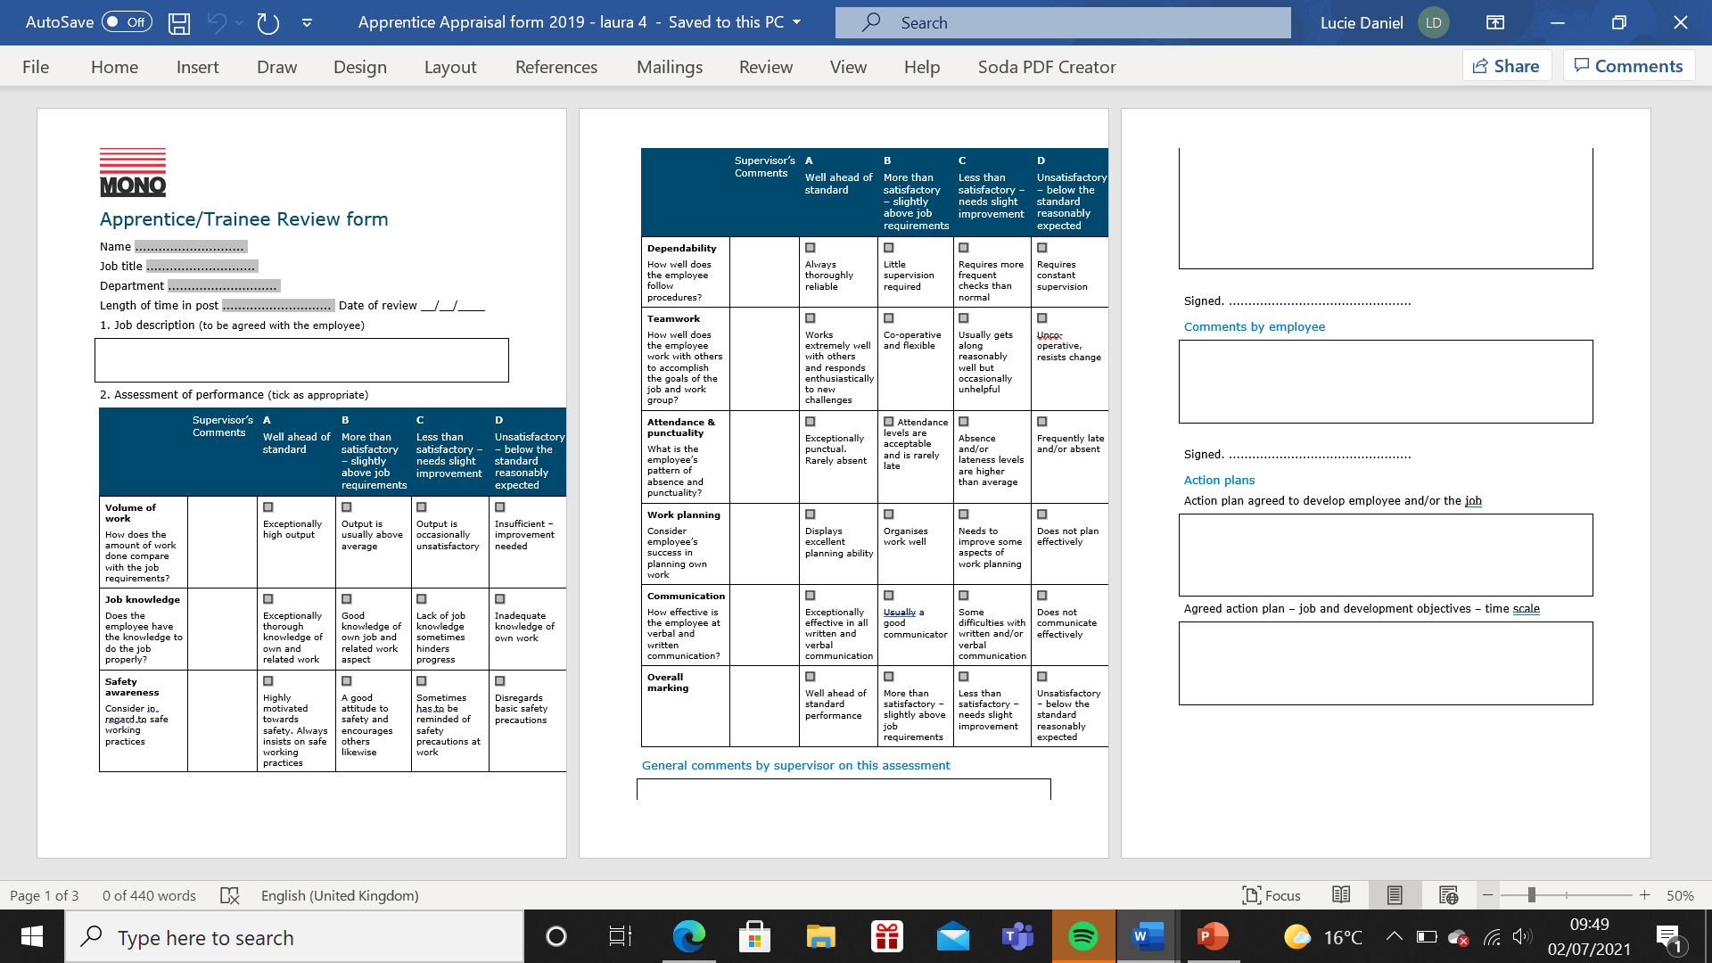
(EV27 – Individual Training Plan)
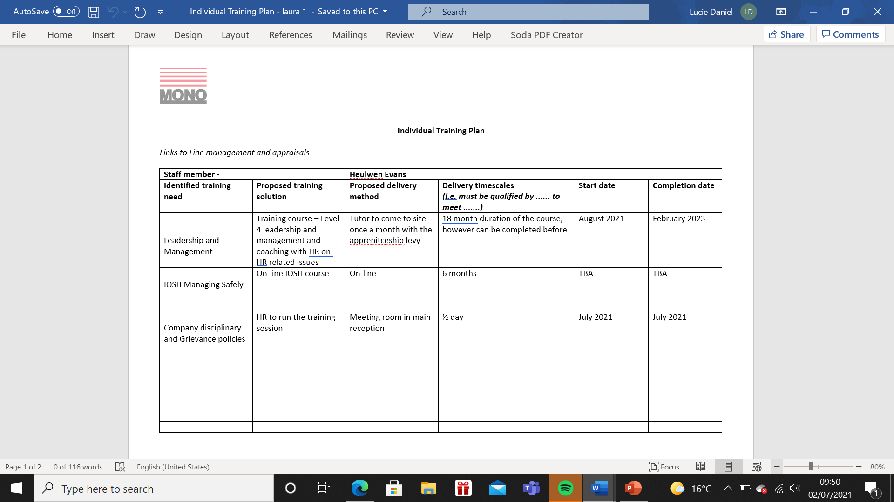
(EV28 – e-mails form Managers regarding use of Individual Training Form)
From: Laura Daniel
Sent: 30 June 2021 10:55
To: Heulwen Evans
Subject: Training

Morning Heulwen,

As mentioned, to assist you with your on-going leaning for your role of Warehouse Manager, I have looked into some courses that will hopefully help you going forward with managing your team. As you have already completed Level 3 in leadership and management, I recommend that you now look at completing level 4.
This will benefit you in so many ways and give you confidence when dealing with more difficult aspects with your team. I will arrange for the tutor to come to site and talk to you in more detail on what is involved. As with your previous learning, I will be available to assist you with the activities and guide you through areas where more experience may be required.

I also include a training plan on further courses I think would benefit your management training.

As already discussed, I will arrange for us to have a training session on our internal disciplinary and grievance policy and on coaching and mentoring the warehouse team.

Please let me know your thoughts.

Kind Regards

Laura

  Laura Daniel  HR Manager
  D: +44 (0)1792 564 034
  P: +44 (0)1792 561 234
  E: ldaniel@monoequip.com
  MONO Equipment
  Swansea West Business Park
  Queensway, Swansea SA5 4EB
  United Kingdom
  www.monoequip.com


This e-mail, and any files transmitted with it, is confidential and intended solely for the individual or organisation to whom it is addressed. If you received this e-mail in error or are having problems sending emails to MONO Equipment personnel, please notify the System Administrator - postmaster@monoequip.com. MONO Equipment reserves the right to block any email attachment we deem inappropriate and to also reject any inbound connections from blacklisted servers. Any email meeting the above criteria will be automatically rejected without notification given to the original sender. Any views or opinions expressed in this email are those of the sender and do not necessarily coincide with those of MONO Equipment or the AFE Group.

From: Heulwen Evans
Sent: 30 June 2021 13:26
To: Laura Daniel
Subject: RE: Training

Thanks very much for the information, the level 4 course is definitely what I am looking for at the moment to help me lead the team. I will have a look at the training plan, can I use this template for my team going forward?
I am available next week for the coaching and mentoring session, Friday suits best as it is quieter for us here if that's ok? Probably the week after would be best for the disciplinary training.
Thanks again for your help on this.
Heulwen

  Heulwen Evans  Installation / Warehouse Manager
  D: +44 (0)1792 564 011
  M: +44 (0)7717 581 902
  P: +44 (0)1792 561 234
  E: hevans@monoequip.com
  MONO Equipment
  Swansea West Business Park
  Queensway, Swansea SA5 4EB
  United Kingdom
  www.monoequip.com
  

This e-mail, and any files transmitted with it, is confidential and intended solely for the individual or organisation to whom it is addressed. If you received this e-mail in error or are having problems sending emails to MONO Equipment personnel, please notify the System Administrator - postmaster@monoequip.com. MONO Equipment reserves the right to block any email attachment we deem inappropriate and to also reject any inbound connections from blacklisted servers. Any email meeting the above criteria will be automatically rejected without notification given to the original sender. Any views or opinions expressed in this email are those of the sender and do not necessarily coincide with those of MONO Equipment or the AFE Group.
From: Laura Daniel
Sent: 30 June 2021 12:21
To: Alex Davies
Subject: Training Plan for Daniel

Hi Alex

I know we have had a few conversations lately regarding Daniel and his Graduate training, coaching and mentoring him etc.
I have put together a quick template that we can use for his future training. This hopefully will help us with planning for his future and for him to see that we do want to invest in him long term.

It would be worth sitting down with Daniel over the next few weeks to discuss this with him, I can join in the meeting if you want and get some input from him, where does he see the role going as well as us? (He isn’t always going to be a graduate, we don’t want him to leave after a year when he has his experience, so really need to focus on some structure for him).

We can also use this template for his internal training? Please let me know your thoughts and if you think this is a good idea to move forward with.

Kind Regards

Laura

Laura Daniel  HR Manager
  D: +44 (0)1792 564 034
  P: +44 (0)1792 561 234
  E: ldaniel@monoequip.com
  MONO Equipment
  Swansea West Business Park
  Queensway, Swansea SA5 4EB
  United Kingdom
  www.monoequip.com

This e-mail, and any files transmitted with it, is confidential and intended solely for the individual or organisation to whom it is addressed. If you received this e-mail in error or are having problems sending emails to MONO Equipment personnel, please notify the System Administrator - postmaster@monoequip.com. MONO Equipment reserves the right to block any email attachment we deem inappropriate and to also reject any inbound connections from blacklisted servers. Any email meeting the above criteria will be automatically rejected without notification given to the original sender. Any views or opinions expressed in this email are those of the sender and do not necessarily coincide with those of MONO Equipment or the AFE Group.

From: Alex Davies
Sent: 30 June 2021 12:27
To: Laura Daniel
Subject: RE: Training Plan for Daniel

Ye, good idea

I would rather if you were present during the sit-down discussions regarding his future etc, and whether enrolling him on courses allows us to tie him down for a certain amount of time after.

Alex

(EV29 – Evidence of endorsement of Induction Policy from Directors)
From: Laura Daniel
Sent: 30 June 2021 17:05
To: Andrew Jones; Rob Davies
Subject: Induction policy

Hi Andrew/Rob

With the amount of new starters we have had recently and also more to come, I thought I would put together an induction policy and revamp the current induction forms.
I know it has been mentioned many times that we need to on-board new employees differently especially those new to employment, who perhaps require more structure.

Can you please have a look at the attached and let me know if you are happy for me to forward this onto managers so they can understand the importance of on-boarding, I will also spend time with those managers to go into it in more depth.
I am working with both Heulwen and Alex at the moment, putting a training plan together for each new recruit. I will hopefully be rolling this out to everyone to make the experience a bit less daunting and for each person to know that we have a plan and some sort of structure for them.
If you could let me know your thoughts, that would be great.
Thanks

Laura

  Laura Daniel  HR Manager
  D: +44 (0)1792 564 034
  P: +44 (0)1792 561 234
  E: ldaniel@monoequip.com
  MONO Equipment
  Swansea West Business Park
  Queensway, Swansea SA5 4EB
  United Kingdom
  www.monoequip.com
  

This e-mail, and any files transmitted with it, is confidential and intended solely for the individual or organisation to whom it is addressed. If you received this e-mail in error or are having problems sending emails to MONO Equipment personnel, please notify the System Administrator - postmaster@monoequip.com. MONO Equipment reserves the right to block any email attachment we deem inappropriate and to also reject any inbound connections from blacklisted servers. Any email meeting the above criteria will be automatically rejected without notification given to the original sender. Any views or opinions expressed in this email are those of the sender and do not necessarily coincide with those of MONO Equipment or the AFE Group.

From: Andrew Jones
Sent: 01 July 2021 09:28
To: Laura Daniel; Rob Davies
Subject: RE: Induction policy
Yes looks good.
Please issue...

From: Rob Davies
Sent: 01 July 2021 08:26
To: Laura Daniel; Andrew Jones
Subject: RE: Induction policy

Looks fine to me…………..very relevant to stress the importance that the relevant Manager has everything in place when the new person starts – i.e. chair, desk, e-mail address, PC etc……………it is also important that Graham has plenty of notice to set up PC’s, ERP system, E-Mail addresses etc. He cannot be informed on a Friday that someone is starting on the Monday.

I would also add that the introduction to staff especially Senior Managers should be phased – I see little benefit of people meeting everyone on their first day when they have no idea of what is going on.
Conclusion
A coaching culture helps people at all levels improve employee engagement, empowers people to excel at their tasks, emphasises the importance of personal and professional development, rewards creativity, and helps people take pride in their responsibilities (Mattone 2018). A coaching/mentoring leadership style builds personal and team morale where employees feel they are contributing to the success of the organisation.
A coaching/mentoring culture is not an environment where everyone always gets along, and no one is ever unhappy. It is a culture in which employees at all levels have space to grow, receive honest, helpful feedback, and pursue professional goals (Miller 2021).
Getting both managers and employees to change their perspective on coaching/mentoring is becoming increasingly important for the rapidly changing environment within Company “X”. Although management have started making changes to coaching/mentoring, there is clearly still lots to do to contribute to the success of the organisation and to become the “Employer of Choice” that they are striving to become.

Recommendations
The following recommendations are based on reflection of the current processes of coaching/mentoring within Company “X”.
Reflection is important according to the Open University (2021), as it helps to develop your own skills and to review their effectiveness. It positively challenges the way we may have been doing things for several years by helping us to see if it can be done better. It also means that “we are consistently learning from our experiences and applying what we have learnt” (S Atkins 2021).
Gibbs Reflective Cycle (1998), can help with this by helping to understand what coaches/mentors are doing well and what they can do to improve in the future:
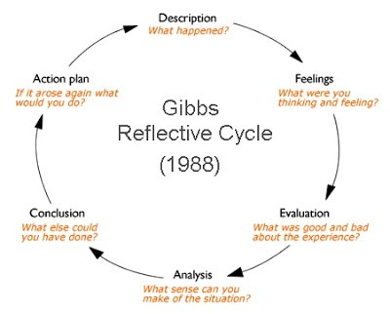
The below recommendations are based on the way that Company “X” currently view and carry out coaching/mentoring. These recommendations would build on some of the already mentioned ideas and include:
- (Based on the Gibbs Cycle) The Training of Managers/Supervisors on coaching/mentoring (description). Currently they haven’t been trained, which impacts the company in many ways such as employee retention (feelings). This is giving both employees and managers a bad experience (evaluation). Managers/supervisors need to attend a training course, my PowerPoint presentation has been put together for this (analysis). If the training/coaching/mentoring culture were different, this wouldn’t be such a problem (conclusion). Company “X” will invest in training asap (action plan).
- Now the Induction policy has been written and agreed, I will forward it to all managers/supervisors and carry out internal training on the process to re-enforce the importance of on-boarding employees. The induction policy will show employees and those joining the organisation that we invest in our people and there is clear instruction of how we do this.
- I will strive for HR to have more of an influence on the decision-making regarding coaching/mentoring within the organisation and keep the Managing Director up to date with its feedback.
- Create Feedback forums e.g. employee forum or an ideas box/suggestion box, appraisal systems.
- Change the culture of the Company.
Hopefully by implementing some if not all the above, will impact the coaching/mentoring culture positively.

References
Atkins S (2021) slides CIPD Understanding Coaching and Mentoring in the workplace. CIPD Diploma in Applied HR.
Backlaw A (2019). The Effect of Coaching and Mentoring on Team Development and Effectiveness. Found at: https://www.civilservicecollege.org.uk/news-the-effects-of-coaching-and-mentoring-on-team-development-and-effectiveness-217 Accessed 20.06.2021)
Bahu S (2021) What are the Benefits of Coaching and Mentoring in the Workplace? Found at https://unboxedtechnology.com/blog/benefits-of-coaching-and-mentoring-in-the-workplace/ Accessed (27.06.2021)
Bigrock Coaching (2021) Coaching Styles; Directive VS Non-Directive. Found At: https://www.bigrockhq.com/the-effectiveness-of-different-coaching-styles/#:~:text=There%20are%20two%20coaching%20models%20we%20use%20and,the%20discussion%20by%20asking%20about%20the%20coachee%E2%80%99s%20goals (accessed 19.06.2021)
Birkbeck University of London (2014) Mentoring Handbook of Good Practice. Found at http://www7.bbk.ac.uk/trigger/docs/Mentoring_Handbook_of_Best_Practice-Web.pdf. Accessed (20.06.2021)
Businessballs (2020) Kirkpatrick Evaluation Method. Found at: https://www.businessballs.com/facilitation-workshops-and-training/kirkpatrick-evaluation-method/ Accessed (02.07.2021)
Bright HR (2021). What are the Benefits of Coaching and Mentoring in the Workplace? Found at: https://www.brighthr.com/articles/training/coaching-mentoring/benefits-of-coaching-and-mentoring-in-the-workplace/#:~:text=Coaching%20and%20mentoring%20an%20employee%20makes%20them%20more,showing%20them%20that%20you%20care%20about%20their%20progress. (Accessed 20.06.2021)
Coaching Team (2019) Coaching Behaviours. Found at https://www.ukcoaching.org/resources/topics/guides/coaching-behaviours (Accessed 27.06.2021)
Clutterbuck D (2019). What every HR Director Should Know about Coaching and Mentoring Strategy. Found at: https://davidclutterbuckpartnership.com/what-every-hr-director-should-know-about-coaching-and-mentoring-strategy/ (accessed 08.05.2021)
CIMA (August 2008). Mentoring and Coaching. Found at: https://www.cimaglobal.com/Documents/ImportedDocuments/cid_tg_mentoring_coaching_Aug08.pdf.pdf (Accessed 20.06.2021)
CIPD (August 2020) Coaching and Mentoring. Available at: https://www.cipd.co.uk/knowledge/fundamentals/people/development/coaching-mentoring-factsheet. Accessed (05/06/2021)
CIPD (October 2020). Organisational Culture and Cultural Change. Found at: https://www.cipd.co.uk/knowledge/culture/working-environment/organisation-culture-change-factsheet (Accessed 19.06.2021)
CIPD (November 2020). SWOT Analysis. Found at https://www.cipd.co.uk/knowledge/strategy/organisational-development/swot-analysis-factsheet (Accessed 20.06.2021)
Creighton K (2018). HR Daily Advisor 6 Types of Effective Mentorship Programmes and when to use them. Found at: https://hrdailyadvisor.blr.com/2018/04/16/6-types-effective-mentorship-programs-use/ (accessed 05.06.2021)
Deloitte (2021) file:///D:/College/Level%205%20CIPD/Unit%207%20coaching%20and%20mentoring%20portfolio/deloitte_human-capital-trends.pdf
Faragher J (2012). Personnel Today: The Benefits of Embedding Coaching into your Organisation. Found at: https://www.personneltoday.com/hr/the-benefits-of-embedding-coaching-into-your-organisation/ (Accessed 20.06.2021)
Forbes Human Resources Council (2018) 15 Effective Coaching Strategies to Use with New Hires. Found via: https://www.forbes.com/sites/forbeshumanresourcescouncil/2018/10/12/15-effective- coaching-strategies-to-use-with-new-hires/?sh=77176c9555f2 (accessed 8.05.2021)
Harvard Business Review (2017) Choose your Mentee Carefully Found at: https://hbr.org/tip/2017/08/choose-your-mentee-carefully (Accessed 14.06.2021)
ILM (2021) Coaching and Mentoring for Better Performance. Found at: https://www.distancelearningcollege.co.uk/2021/06/10/coaching-mentoring-for-better-performance/ (Accessed 15.06.2021)
Insala (2019) Increasing Employee Engagement Through Coaching. Found at https://www.insala.com/blog/how-to-increase-employee-engagement-through-coaching (Accessed 28.06.2021)
Keller C (2021) Performance Reviews V Coaching. Centre for Management & Organization Effectiveness. Found at: https://cmoe.com/blog/performance-reviews-vs-coaching/ (Accessed 05.06.2021)
Knight K (2021) How can Coaching and Mentoring help your Organisation to Thrive? Found at: https://www.youhrconsultancy.co.uk/how-can-coaching-mentoring-help-your-organisation-thrive/#:~:text=When%20conducted%20in%20an%20efficient%20and%20productive%20manner%2C,which%20leads%20to%20increased%20productivity%20and%20reduced%20turnover. (Accessed 20.06.2021)
Knolskape (2021) How-To-Guide: How Do Coaching and Mentoring Contribute to Leadership and Development? Found at: https://www.knolskape.com/coaching-and-mentoring-contribute-to-leadership-development/ (accessed 21.06.2021)
Lim M (2019). How to Prepare for Mentoring: A Mentees Guide. Found at https://hertalis.com/how-to-prepare-for-mentoring/. (Accessed 02.07.2021)
Mattone J (2018) The Importance of a Coaching Culture in the Workplace. Nourish your Mind Ignite Your Soul Blog. Found at https://johnmattone.com/blog/the-importance-of-a-coaching-culture-in-the-workplace/ (Accessed 01.07.2021)
Miller K (2021) 20 Proven Benefits of Life Coaching and Mentoring. Found at: https://positivepsychology.com/benefits-life-coaching-mentoring/#:~:text=Simpson%20%282010%29%20found%20that%20coachees%20in%20leadership%20positions,career%20planning%206%20increased%20confidence%207%20enhanced%20self-awareness. (Accessed 21.06.2021)
Mundy I (2021) How can Coaching and Mentoring help your organisation thrive? You HR Consultancy. Found at https://www.youhrconsultancy.co.uk/how-can-coaching-mentoring-help-your-organisation-thrive/ (accessed 22.05.2021)
Muruga M (2017) Informal Coaching – A must Have skill for Managers. Found at: https://www.linkedin.com/pulse/informal-coaching-every-managers-must-have-navin-muruga. Accessed (15.06.2021)
M McGuinness (2008) Formal and Informal Coaching. Found at https://www.wishfulthinking.co.uk/2008/01/28/formal-and-informal-coaching/ (accessed 02.06.2021)
Pathway Group (2014) YouTube clip Workplace Coaching and Training, Mentoring and Coaching in the Workplace. Found at: https://www.bing.com/videos/search?q=how+to+coach+and+mentor+in+the+workplace&&view=detail&mid=B792CA0E45A7FEB268DAB792CA0E45A7FEB268DA&&FORM=VRDGAR&ru=%2Fvideos%2Fsearch%3Fq%3Dhow%2Bto%2Bcoach%2Band%2Bmentor%2Bin%2Bthe%2Bworkplace%26FORM%3DHDRSC4. Accessed (27.06.2021)
Robbins J (2019). Why is Confidentiality Important in Coaching? Found At: https://www.performancecoachuniversity.com/why-is-confidentiality-important-in-coaching/#:~:text=There%20is%20an%20%28often%20unspoken%29%20assumption%20that%20confidentiality,mean%20that%20it%20is%20an%20entirely%20reactive%20process. (Accessed 21.06.2021)
Stange J (2021). Coaching to Engage: 12 Rules to Effective, Ongoing Coaching. Found at: https://www.quantumworkplace.com/future-of-work/12-rules-for-effective-employee-coaching (Accessed 27.06.2021)
Stephens S (2016) 5 Ways Training on your Compliance Policies Can Protect Your Organisation. Found at https://www.navexglobal.com/blog/article/5-ways-training-your-compliance-policies-can-protect-your-organization/ (Accessed 15.06.2021)
Strange J (2021). Coaching to Engage: 12 Rules to Effective, Ongoing Employee Coaching. Found at: https://www.quantumworkplace.com/future-of-work/12-rules-for-effective-employee-coaching. Accessed on (23.06.2021)
University of Sussex (2021) Organisational Development – Recruiting and Matching Mentors and Mentees. Found at: https://www.sussex.ac.uk/organisational-development/mentoring/guidance-for-coordinators/mentors-and-mentees Accessed (28.06.2021)
Wolinski S (2010) Coaching Leaders, A Systems Approach. Leadership Blog. Found at https://managementhelp.org/blogs/leadership/2010/06/20/coaching-leaders-a-systems-approach/ (accessed 06.06.2021)
Zahid A (2019) Benefits of Coaching & Mentoring for different Stakeholders in organisations. Found at: https://www.linkedin.com/pulse/benefits-coaching-mentoring-different-stakeholders-arsalan (accessed 09.05.2021)
Zentis N (2016) Institute of Organizational Development. The 15 Types of Coaching. Found at: https://instituteod.com/15-types-coaching/ (accessed 05.06.2021)

Bibliography

https://coacharya.com/systemic-coaching/

