A critical evaluation and the identification of next teaching and learning steps focusing on a case study of an individual learner or a group of learners, based on an observed critical incident

Introduction
Teachers face numerous problems and scenarios in the classroom that no amount of studying or listening to experts can fully prepare them for, especially during their first few years as a teacher (Farrell & Baecher, 2017). Using critical incidents to reflect on practice can be a useful tool to assess these scenarios and evaluate how the situation was handled.

Tripp (2012) states a critical incident is produced by the way an observer looks at a situation. They are occurrences which result in the interpretation of events where an observer gives them meaning (Tripp, 2012). A critical incident can also be viewed as an event where a teacher’s actions have impacted the learning of a pupil (Woodburn et al., 2021), and can have either a positive or negative impact on learning.

Reflection is a treasured instrument that enables teachers to develop a deeper understanding of their practices, to experience change and to allow corrective intervention of their methods (Voulgari & Koutrouba, 2021). It can allow educators to grow, evaluate and improve in their teaching and to develop their problem solving and analytical skills.

A case study which includes the observation of a critical incident will be used in this essay to aid my evaluation of teaching and learning. I will reflect on what I saw, then discuss how I plan to use what I learned as a developing student-teacher in the section titled ‘Evaluation and Next Steps’.

The Role of Critical Reflection

Reflective practice among teachers has altered from being a desirable disposition to a compulsory activity that has been standardised throughout educational systems around the world (Brandenburg et al., 2017). This is due to the encouragement from experts in teacher education to include reflection in practice (Baxter et al., 2021). The term ‘reflection’ can be used to describe the thought applied to a belief or source of knowledge along with evidence that supports it and the conclusions it cultivates (Voulgari & Koutrouba, 2021).

Critical reflection is not just a summary of what happened and not every observation or judgement is critical (Kubok, 2018). Critical reflection involves reflective thinking which, for a teacher, would involve an analysis of classroom events and circumstances (Shandomo, 2010). Professionals are able to influence and are, in turn, influenced by their colleagues, the organisations they work with and the environment they’re in through being critically reflective (Baxter et al., 2021). Critical reflection can be used to support the development of a professional by evaluating decisions, leading to improved practice and offers a way for teachers to gain an awareness and understanding of their own professionalism (Smith, 2011). The role of critical reflection in a teachers’ professional development has been given much consideration in scholarly literature, especially in recent years, with much debate around its importance in determining the quality of a teachers’ work (Saric & Steh, 2017).

In 2017, the Welsh Government revised the professional standards for teaching and leadership for a new, ambitious curriculum (James et al., 2021). It was designed around five professional standards which support professional growth and explains the skills, knowledge and attributes shown by excellent teachers. One of which is ‘professional learning’ and reflection is a key factor in the development of this to progressively improve pedagogy (Welsh Government, 2019). This demonstrates the importance of reflection and how it is relevant for any new or aspiring teacher to improve their growth as a professional by familiarising themselves with the process of critical reflection.

Borton’s Model for Critical Reflection

Some models for critical reflection are specifically designed for the use in educational settings, for example Terry Borton’s model (Skinner & Mitchell 2016). The phases of the model originally consisted of ‘having an experience’, ‘trying to understand the experience’ and ‘applying what was learned to new situations’ (Snyder, 2019). Abraham and Suresh (2018) describe how this strategy now requires the practitioner to evaluate a situation by asking themselves three questions:
- What?
- So What?
- Now what?

For the ‘what?’ stage it is important to remain objective while remembering what happened. The experience is analysed during the ‘so what?’ stage, thinking about what was important, what concepts it links to and what the researcher has learned. The final stage ‘now what?’ is about applying what has been leaned and thinking about ways the researcher has grown from the experience (Rolfe & freshwater, 2020).

Observation School
Anonymity is a priority in this research and the British educational research association (BERA) guidelines will be followed throughout to ensure this. BERA guidelines (2018) state that “the confidential and anonymous treatment of participants’ data is considered the norm for the conduct of research” meaning everybody involved with the research including staff, pupils and the school will be strictly anonymous.

The observation occurred in a mixed-gender Welsh medium ‘3-16’ school in Withybush, near Haverfordwest in the local authority of Pembrokeshire County Council. There are 705 pupils who attend this school. The ages of the pupils range from 3 to 16 since the school also has a nursery and secondary section. The school consists of 22 classrooms, meaning each year group at primary level has 2 classes. The classrooms are organised by randomly within year groups, meaning they aren’t separated by ability. Only 5% of the pupils who attend the school speak welsh as a first language.
According to school records at the time, 16.5% of the pupils have additional learning needs, which is lower than the national percentage of 21% (Estyn, 2019). Since the school opened, the number of children eligible for free school meals has averaged at 10.07% which is much lower than the reported average for Wales in 2018, which was 19% (Estyn, 2019). The school is looking forward to future, with senior staff showing great enthusiasm for the new curriculum and implementing the four purposes.

The Critical Incident

Classroom Context
The incident occurred after the children were brought in from their lunch break. It was 1:30PM on Thursday, 23rd of September. The setting consisted of thirty children from a reception classroom of children aged between four and five years old. Many children were wandering around the classroom; taking off their coats and washing their hands. Teacher 1 had planned an afternoon of mathematics and numeracy, where they were going to learn about number patterns for the first time and therefore required everybody’s full attention to ensure participation, engagement, understanding and learning. The room was noisy and it appeared that it would be a challenge to get the children to sit down and concentrate.

The Incident
When it became clear that the children were not focusing, Teacher 1 started a game of ‘Simon Says’ to gain their attention. This quickly changed the atmosphere in the classroom and the majority of the children were eager to listen and play the game. Pupil 1, who had suspected learning difficulties, did not engage and he continued to play with a toy he’d kept from the playground. It looked as though he was trying to gain the attention of the teacher or his peers. His friends, Pupil 2 and Pupil 3 were initially interested in the toy he had, before participating in the ‘Simon Says’ game. Teacher 1 noticed this, and individually praised Pupil 2 and Pupil 3 for their correct attitude and responses. It then appeared that Pupil 1 wanted the same approval as his peers and began to cooperate.

Once Teacher 1 had the attention of every pupil, she began a short mindfulness session which included breathing exercises and yoga poses specifically designed for young children. Everyone was listening carefully and were replicating Teacher 1’s actions and instructions. Within the space of around 10 minutes the classroom had shifted from a loud, chaotic environment to a quiet and calm setting.

Link to one of the Four Purposes
The new curriculum framework in Wales aims to enable each learner to develop towards the four purposes, which should be the aspiration of every schools’ curriculum design (Welsh Government, 2020). The Welsh Government (2020) lists the four purposes of education to allow its learners to be:

- Ambitious, capable learners
- Enterprising, creative contributors
- Healthy, confident individuals
- Ethical, informed citizens

The benefits to mental health, obesity and attentiveness attained from yoga and mindfulness sessions have a direct link to ‘healthy, confident individuals’ as studies have demonstrated how yoga can be used to lower obesity rates, increase the success rates of task completion and resulted in calmer, more attentive children (Telles et al., 2019). Yoga has also been shown to have a positive effect on psychological wellbeing, including improvements in symptoms of depression and anxiety (James-Palmer et al., 2020).

Literature Review

Using Mindfulness to Improve Behaviour
Classroom discipline is often an issue for teachers, schools and parents due to its complexity and ineffective methods (Lopes & Oliveira, 2017). Traditional punishments for challenging behaviour or lack of concentration in schools have created a lack of equity within classrooms, with many school discipline methods having an undesirable effect on pupil academic growth (Potter et al., 2017). Positive relationships and mutual respect are of great importance for classroom management, since problems usually arise when a pupil is struggling academically, socially, or emotionally (Berger et al., 2021). Effective teachers use good techniques and routines, but techniques and routines alone do not produce good teaching or management (Tripp, 1993).

An underappreciated and under-utilised method of behavioural management is ‘changing the stimulus conditions’ or the setting of the classroom to influence behaviour (Wheldall, 2017). One method of accomplishing this is through mindfulness. Mindfulness can be described as “current awareness of present moment sensory and perceptual experiences” and “the willingness to stay present with your experiences without trying to alter them” (Hoffman & Geisler, 2020). Mindfulness activities such as breathing exercises and yoga can positively alter the environment and have been shown to improve children’s’ self-regulation and reduce hyperactivity (Viglas & Perlman, 2018). Mindfulness based interventions are becoming increasingly common in the classroom to tackle behavioural problems (Dunning et al., 2019), and activities such as yoga have been proven to reduce difficulty with learning for children, decrease levels of stress and improve physical health and cognitive ability (Narasingharao et al., 2017).

The benefits of mindfulness on managing poor behaviour is huge, and it has been proven to reduce unacceptable behaviours and help children better manage their emotions. Wearne (2021) states that practicing mindfulness reduces aggression, hostility and symptoms of attention deficit hyperactivity disorder (ADHD). Mindfulness in this instance helped Pupil 1 concentrate and focus on his progress and his learning.
Shapiro & Carlson (2009) believe that through practicing mindfulness, children develop a greater awareness, understanding and connection that enhances their wellbeing. It has been recognised that a child requires the experience of being nurtured and developing a bond with a caring adult, and this has been proved to affect all aspects of behaviour and development (Hubbuck, 2009).

As children mature, it is natural for them to test the boundaries of their own decision-making and once they begin to mature, they can become defiant and unwilling to engage (Benn et al, 2012). Evidence suggests that children engage better with mindfulness when they have good relationships with their teacher and their parents (Shorey & Debby, 2021). This is important to consider and is another reason why having positive relationships with pupils are important. In order for children with behavioural problems to engage, mindfulness sessions need to be lively with definitive boundaries. Also, sessions that are created outdoors show more benefit and effectiveness in achieving the intended outcomes (Wearne et al, 2021).

Yoga can be used to change the setting for the whole classrooms and can benefit every participant. Behavioural management of this manner can also regulate a misbehaving pupil’s behaviour without directly confronting the individual, for example, when Pupil 1 was not initially cooperating. Allowing the activity to continue, tackled the problem with equity as described by Potter et al., (2017) since the children who were listening and cooperating were not losing out on valuable lesson time and learning.

Since yoga is an ancient practice estimated to have originated in India thousands of years ago and was originally used to relieve disease and suffering (Kamradt, 2017), its effects have been well documented in Asian literature for thousands of years. Although the application to education has been utilised more recently in western civilisation, there is not an abundance of information or studies conducted in the United Kingdom regarding the ways it effects school children. Because of this, some of the information used in this essay has been based off studies from Asia to ensure there is sufficient material to discuss and connect to what was observed in the critical incident.

The effects of using mindfulness for behavioural management were witnessed during the critical incident when Teacher 1 utilised it to gain the attention of Pupil 1. Before beginning the mindfulness session, Pupil 1 was distracting Pupil 2 and Pupil 3. A few minutes later, all three pupils were concentrating and this was done without negativity, confrontation or wasting any time for the rest of the class. Managing the learning environment is one of the professional standards and it is important for this to be used to promote positive learning habits and behaviours to meet the four purposes (Welsh Government, 2019).

Using Mindfulness for Mental health
Since the start of the Covid-19 pandemic, the number of children who demonstrate symptoms of anxiety has doubled, taking the total up to an approximated 25% of children (Racine et al., 2021). Out of all children who suffer from poor mental health, only one in four receive sessions of therapy outside of school (Hubbard, 2017). This makes school the exclusive provider of mental health support for most of the children who require it.

Some of the risks associated with anxiety include a negative impact on academic performance, weaker social skills, and poorer mental and physical health (Creswell et al., 2020). Increased screen time from digital technology and social media were having a negative impact on anxiety and depression levels among children for years (Hoge et al., 2017), and this worsened over the lockdown periods in 2020 and 2021 (Newlove-Delgado et al., 2021).

Studies show that activities such as yoga can noticeably improve children’s mental health (Miller et al., 2020), making it a fantastic activity for teachers to use in the classroom to help with children who are anxious or suffering with depression. Since problems with mental health such as increased levels of anxiety are becoming more prevalent among children and can negatively affect social and academic performance (Shreve et al., 2021), yoga is an excellent activity to combat low self-esteem and lack of confidence.

Mindfulness in the school setting is a simple, inclusive, equitable yet effective way to improve children’s mental health due to its diverse, low-tech, relatively cheap and generally very safe nature (Stephens, 2017). With pupil 1 it improved his self-esteem and the activity, although short, had a profound effect on the class. Following the activity, the children were ready to face the afternoon of learning, calmly and relaxed. Wearne (2021) suggests that mindfulness improves resilience, optimism, connectedness and happiness. Mindfulness is a safe activity that can be utilised to improve and support a number of social and emotional targets. It is something that can be easily combined and included as a daily part of school life (Vollestad et al, 2012). A 2015 Canadian study showed that children who practice mindfulness in schools reported fewer depressive symptoms and improvements in sociality, with significant growth observed in sharing, trustworthiness, helpfulness and taking other children’s perspective into consideration, whilst supporting their holistic growth (Schonert-Reichl et al, 2015).

There are additional positive outcomes for teachers who practice mindfulness, which include improved wellbeing, improved self-care, reduced mental health problems and an improvement in teacher effectiveness (Weare et al, 2021). It is also suggested that teachers who engage in mindfulness relate better to children in class and show more empathy and presence. Teachers are also shown to have a calmer and more focused classroom (Bilmez
& Aral, 2020) which gives children who are less physically capable the opportunity to participate, increasing accessibility and creating equity and inclusion among pupils. The harmony between mind, body and emotions has the ability to eliminate negative feelings and improve mood, therefore increasing happiness (Bilmez & Aral, 2020).

The science and research behind using mindfulness in schools is relatively new, but is being explored at an accelerating rate due to studies showing an improvement in children’s executive functions such as inhibition, working memory and shifting (Geronimi et al., 2020).
Despite there being many reports on the benefits on the mental health of adults through mindfulness exercises, research on the effects of mindfulness on children and young people is far less common, especially when focusing on cognitive processes (Geronimi et al., 2020). Although effects may be similar for children and adults, it cannot be assumed results are identical and interchangeable.
Providing pupils with a heightened sense of wellbeing through mindfulness relates to one of the professional standards, ‘learning outcomes and wellbeing’ (Welsh Government, 2019). This demonstrates the importance of high-quality education and how positive mindset and experiences can enhance learning. This was demonstrated in a classroom setting during the critical incident, when Teacher 1 acknowledged the atmosphere was not suitable for an introduction to a new mathematics topic as it could potentially be stressful for the pupils.
The mindfulness session conducted in response to this affected the pupils in the same positive way the research suggested it would. If Teacher 1 had began the new topic immediately after the children had come in from their lunch break, I do not think the mathematics lesson would have been as successful as it was.

Evaluation and Next Steps
Smith (2011) describes how critical reflection helps teachers evaluate the choices they make which lead to better performance and outcomes for their pupils. Had I been in charge of the class, it would not have occurred to me to get the class to settle by doing a quickfire round of ‘Simon Says’ and move onto mindfulness. I assumed this was a ‘tickbox’ exercise with little value or benefit for the children. On reflection, I am confident to say that without the mindfulness, the mathematics lesson would not have been as rewarding.

Following observation of the incident, I have recognised that classroom management is an area I woud like to develop in my practice. The response from the pupils demonstrated the effectiveness of the proper utilisation of mindfulness and I will research this further to ensure that I will practice this correctly to benefit the children, by relieving their stress and increasing their concentration. I would like to further my knowledge in this field and incorporate mindfulness into lessons effectively by the end of my first placement, which will be February half-term. I hope to feel confident to take this skill into my next placement and continue to develop it throughout my career. To achieve this, I will observe experienced teachers to understand how they use mindfulness for behaviour management and wellbeing. Exploring different methods to see what works best for myself and the pupils will be a valuable technique to develop a successful intervention as part of their routine.
There are numerous resources such as books and articles available to teachers which I will use to continue my professional development and learning, and my mentor will be fundamental to ensure I have the correct approach to my lesson planning.

I will determine whether this has been a success or not by the outcomes and responses to my teaching sessions. I am hopeful that I will become a more proficient and effective teacher that children will trust and relate to. These goals are based on the studies carried out by theorists and other relevant authors who have expanded my knowledge and understanding. Regular meetings with my mentor to obtain feedback will help me check that I have successfully achieved my targets. I will also maintain a personal reflective diary and note feedback from pupils to monitor how effective the mindfulness exercises have been. Tripp (2012) states that reflective teaching is fundamental in supporting teachers to review and evaluate choices they have made during a teaching session and that it helps them to look at ways to progess in their professional development. Using Borton’s model of reflection suited me as I found the model simple yet effective when applying to my critical incident. Jasper (2013) states that novices can use this model through to skilled practitioners.

Teacher 1 has a responsibility to the whole class and although the incident ended well, it could have easily escalated and affected the whole class and interupted their learning. Wells (2020) states that all children have a fundamental need to feel significant and belong and if they feel neglected they can misbehave to get attention.

Theorists Vygotsky and Chomsky, viewed learning as a process requiring environmental input and social interaction (Barnes 2001). The most important development for Pupil 1 is language, and whilst observing, it became apparent that Pupil 1 wanted to particiapte and wanted to please the teacher. This shows that positive reinforcement reflects on a child’s behaviour, which supports Cooley’s argument that children need praise and encouragement and that it is important to provide opportunities for children to reflect (Blake and Pope 2008). Positive reinforcement, praise and encouragement are three attributes that I would aspire to distriube which I hope will support my personal and professional developmement.

Conclusion
Reflection should become a daily practice and by doing this I hope to become a better teacher and gain confidence. This will be a continuous process that requires me to be dedicated and committed. I am keen to develop my classroom management, by doing this I will gain confidence in building strong relationships with the teachers and the children.
The best textbook techniques can be used, but an understanding of the pupil’s requirements is necessary for somebody to be a good teacher (Tripp, 1993). Tripp's strategy for analysing professional experiences can help teachers understand different approaches, which in turn encourages them to broaden their professional awareness.

My attitude and behaviour have altered following this experience, as historically I did not feel that mindfulness was an activity that I would engage in, however the outcome was so positive. It became clear that the children became concentrated and paid more attention whilst focusing on their breathing and filtering out other stimuli. Observing this session demonstrated to me that children gained skills in understanding their emotions and how to best work with them to their advantage. I witnessed Teacher 1 demonstrating her knowledge of numerous professional standards, this improved my understanding of pedagogy and professional learning. I will be required to understand and demonstrate the ability to work to all standards, however I believe I learned a great amount in the two days I spent in a classroom for this assessment.

I have considered how I would like to teach; I have ideas around writing classroom rules with the children as a preventative measure which may contribute to a positive environment from the start. I would like to do a ‘check in’ with the children in the morning to quickly assess how they are feeling and incorporate what my expectations are for the day. I would also like to be identified as a teacher that reinforces positive behaviour. By gaining the children’s trust, I feel I will get the best out of them. Critical reflection has increased my knowledge and I feel it is great preparation to strengthen my professional practice.

Appendices 1
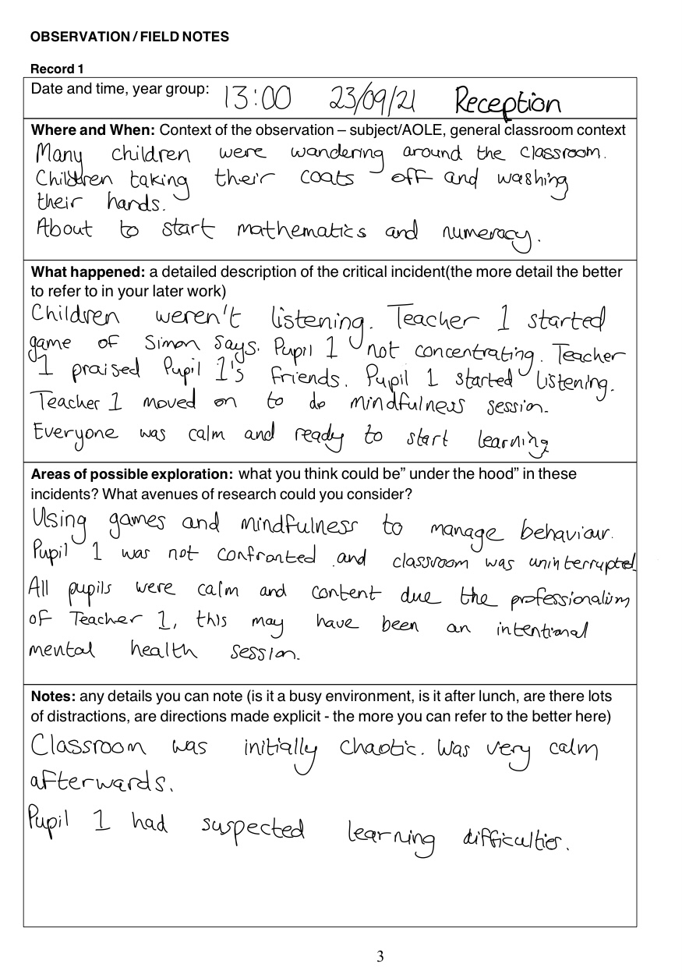

Appendices 2

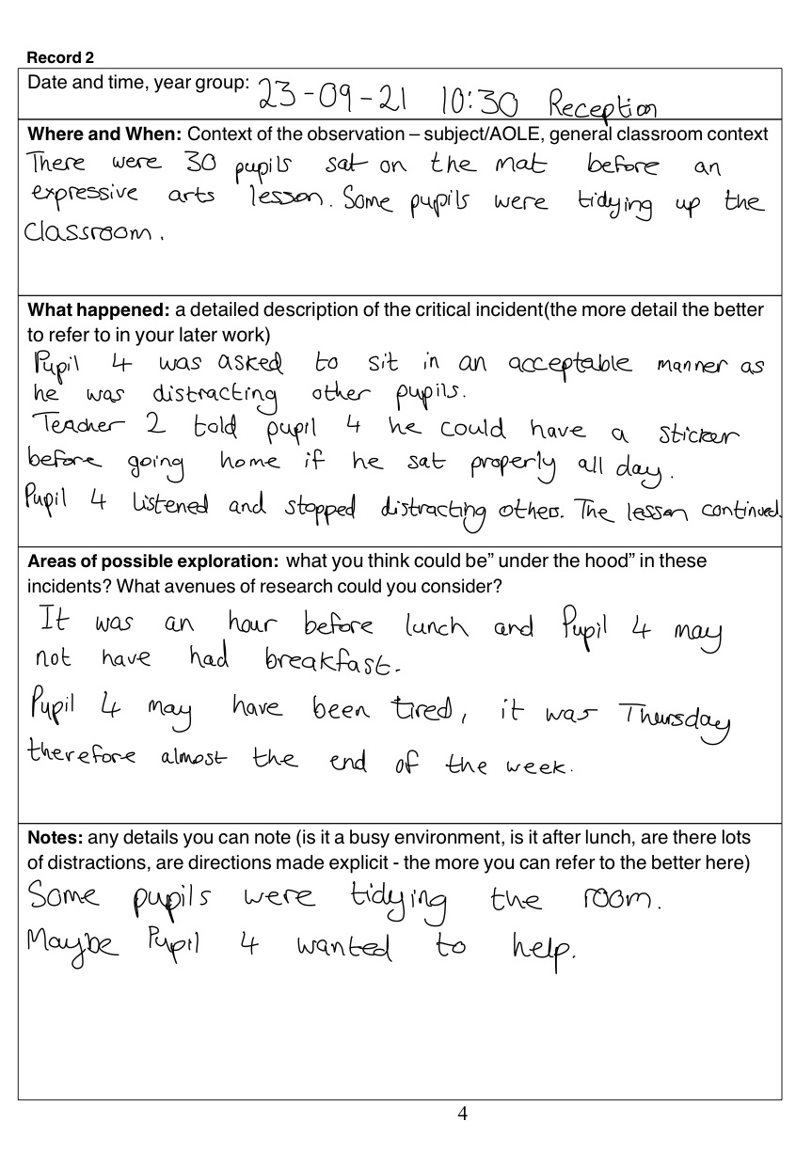

Appendices 3
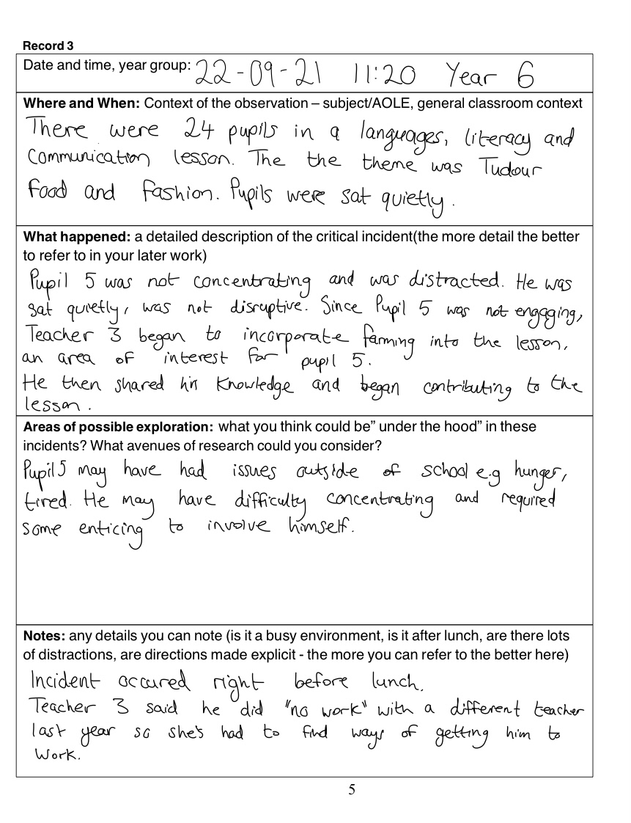

References:
Abraham, P. and Suresh, K.P. (2018) Reflective practice: A key to language education. educational extracts, p.79.

Barnes, P (2001) Personal, social and emotional development of children. London. Blackwell Publishers.

Blake, B, Pope, T (2008) Developmental Psychology: Incorporating Piaget and Vygotsky’s Theories in classrooms. Journal of Cross-Disciplinary Perspectives in Education.Vol.1, No. 1.

Baxter, L.P., Southall, A.E. and Gardner, F. (2021) Trialling critical reflection in education: the benefits for school leaders and teachers. Reflective Practice, pp.1-14.

Benn, R., Akiva T., Arel S. & Roeser R. W. (2012) Mindfulness training effects for parents and educators of children with special needs. Developmental Psychology 48, 1476.

Berger, R., Strasser, D. and Woodfin, L. (2021) Management in the active classroom. EL Education., p.4.

Bilmez, B. and Aral, N. (2020) Yoga for babies and children: Introduction, definition and importance of yoga, benefits of yoga, yoga in education. In Handbook of Research on Prenatal, Postnatal, and Early Childhood Development (pp. 386-397). IGI Global.

Brandenburg, R., Glasswell, K., Jones, M. and Ryan, J. (2017) Reflective Theory and Practice in Teacher Education. Self-Study of Teaching and Teacher Education Practices, 17, p.1.

British Educational Research Association (BERA) (2018) Ethical guidelines for educational research. 4th edn. Available at: https://www.bera.ac.uk/researchers-resources/publications/ethical-guidelines-for-educational-research-2018 (Accessed: 30 September 2021).

Creswell, C., Waite, P. and Hudson, J. (2020) Practitioner Review: Anxiety disorders in children and young people–assessment and treatment. Journal of Child Psychology and Psychiatry, 61(6), pp.628-643.

Dunning, D.L., Griffiths, K., Kuyken, W., Crane, C., Foulkes, L., Parker, J. and Dalgleish, T., (2019) Research Review: The effects of mindfulness‐based interventions on cognition and mental health in children and adolescents–a meta‐analysis of randomized controlled trials. Journal of Child Psychology and Psychiatry, 60(3), pp.244-258.

Estyn, (2019) A report on Puncheston CP School Haverfordwest Pembrokeshire. [online] Estyn.gov.wales. Available at: <https://www.estyn.gov.wales/system/files/2020-08/Puncheston%2520CP%2520School%2520en.pdf> [Accessed 26 October 2021].

Farrell, T.S. and Baecher, L. (2017) Reflecting on critical incidents in language education: 40 dilemmas for novice TESOL professionals. Bloomsbury Publishing.

Geronimi, E.M., Arellano, B. and Woodruff-Borden, J. (2020) Relating mindfulness and executive function in children. Clinical child psychology and psychiatry, 25(2), pp.435-445.

Hoffmann, C.F. and Geisler, F.C. (2020) Accept what you observe: A conditional process model linking mindfulness facets, threat appraisal, and perceived stress in German college students. Personality and Individual Differences, 156, p.109752.

Hubbard, A. (2017) Yoga as a School-Based Mental Health Intervention. Communique, 46(1), p.35.

Hubbuck, C (2009) Play for sick children. Play specialists in hospital and beyond. London. Jessica Kingsley Publishers.

James, D., Morgan, A., Milton, E., Bryant, A., Clement, J., Kneen, J. and Beauchamp, G., (2021) Assessment and initial teacher education in Wales at a time of change: Adapting and learning. Profession, 18, p.19.

James-Palmer, A., Anderson, E.Z., Zucker, L., Kofman, Y. and Daneault, J.F. (2020) Yoga as an intervention for the reduction of symptoms of anxiety and depression in children and adolescents: a systematic review. Frontiers in pediatrics, 8, p.78.

Jasper M. (2013) Beginning Reflective Practice. Andover: Cengage Learning

Kamradt, J. (2017) Integrating yoga into psychotherapy: The ethics of moving from the mind to the mat. Complementary therapies in clinical practice, 27, pp.27-30.

Kubok, D. (2018) Thinking Critically: What Does It Mean?. 1st ed. Walter de Gruyter GmbH, p.2.

Lopes, J.A. and Oliveira, C. (2017) Classroom discipline: Theory and practice. Nova Science Publishers., p.1.

Narasingharao, K., Pradhan, B. and Navaneetham, J. (2017) Efficacy of structured yoga intervention for sleep, gastrointestinal and behaviour problems of ASD children: An exploratory study. Journal of clinical and diagnostic research: JCDR, 11(3), p.VC01.

Newlove-Delgado, T., McManus, S., Sadler, K., Thandi, S., Vizard, T., Cartwright, C. and Ford, T. (2021) Child mental health in England before and during the COVID-19 lockdown. The Lancet Psychiatry, 8(5), pp.353-354.

Papatheodorou, T, Luff, P, Gill, J (2012). Kindle ed. Child Observation for Learning and Research. New York. Pearson Educational Limited.

Potter, H., Boggs, B. and Dunbar, C. (2017) Discipline and punishment: How schools are building the school-to-prison pipeline. In The school to prison pipeline: The role of culture and discipline in school. Emerald Publishing Limited.

Racine, N., McArthur, B.A., Cooke, J.E., Eirich, R., Zhu, J. and Madigan, S. (2021) Global prevalence of depressive and anxiety symptoms in children and adolescents during COVID-19: A meta-analysis. JAMA pediatrics.

Rolfe, G. and Freshwater, D. (2020) Critical reflection in practice: generating knowledge for care. Bloomsbury Publishing., p.44.

Saric, M. and Steh, B. (2017) Critical reflection in the professional development of teachers: Challenges and possibilities. CEPS journal, 7(3), pp.67-85.

Schonert-Reichl KA, Oberle E, Lawlor MS, Abbott D, Thomson K, Oberlander TF, Diamond A (2015) Enhancing cognitive and social-emotional development through a simple-to-administer mindfulness-based school program for elementary school children: a randomized controlled trial. Dev Psychol. 2015 Jan;51(1):52-66. doi: 10.1037/a0038454. PMID: 25546595; PMCID: PMC4323355.

Shapiro, S. L., & Carlson, L. E. (2009). The Art and Science of Mindfulness: Integrating Mindfulness into Psychology and the Helping Professions. Washington DC: American Psychological Association. http://dx.doi.org/10.1037/11885-000

Shandomo, H.M. (2010) The role of critical reflection in teacher education. School-University Partnerships, 4(1), pp.101-113.

Shorey, S & Debby, E (2021) The efficacy of mindful parenting interventions: A systematic review and meta-analysis. International Journal of Nursing Studies 121, pages 103996.

Shreve, M., Scott, A., McNeill, C. and Washburn, L. (2021) Using Yoga to Reduce Anxiety in Children: Exploring School-Based Yoga Among Rural Third-and Fourth-Grade Students. Journal of Pediatric Health Care, 35(1), pp.42-52.

Skinner, M. and Mitchell, D. (2016) “What? So What? Now What?” Applying Borton and Rolfe’s Models of Reflexive Practice in Healthcare Contexts. Health and Social Care Chaplaincy, 4(1), pp.10-19.

Smith, E. (2011) Teaching critical reflection. Teaching in higher education, 16(2), pp.211-223.

Snyder, M.M. (2019) Designing socially-mediated reflection in online discussions. FDLA Journal, 4(1), p.3.

Stephens, I. (2017) Medical yoga therapy. Children, 4(2), p.12.

Telles, S., Gupta, R.K., Gandharva, K., Vishwakarma, B., Kala, N. and Balkrishna, A. (2019) Immediate effect of a yoga breathing practice on attention and anxiety in pre-teen children. Children, 6(7), p.84.

Tripp, D (1993) Critical Incidents in Teaching: Developing Professional Judgement. Psychology Press.

Tripp, D., (2012) Critical Incidents in Teaching (Classic Edition). Hoboken: Taylor & amp.

Viglas, M. and Perlman, M. (2018) Effects of a mindfulness-based program on young children’s self-regulation, prosocial behavior and hyperactivity. Journal of Child and Family Studies, 27(4), pp.1150-1161.

Vollestad, J, Nielsen, MB and Nielsen, GH (2012) Mindfulness- and acceptance-based interventions for anxiety disorders: A systematic review and meta-analysis

Voulgari, R. and Koutrouba, K. (2021) Examining the depth of primary schoolteachers’ reflection through the critical incident technique. Educational Studies, pp.1-19.

Weare, K, Bethune, A, Bristow, J (2021) Implementing Mindfulness in Schools: An Evidence-Based Guide. The Mindfulness Initiative

Wells, J (2020) Positive Discipline for Kids. Wryting ltd

Welsh Government (2019) Professional standards for teaching and leadership. [online] Hwb.gov.wales. Available at: <https://hwb.gov.wales/api/storage/19bc948b-8a3f-41e0-944a-7bf2cadf7d18/professional-standards-for-teaching-and-leadership-interactive-pdf-for-pc.pdf> [Accessed 12 October 2021].

Welsh Government (2020) Introduction to Curriculum for Wales guidance. [online] Hwb.gov.wales. Available at: <https://hwb.gov.wales/curriculum-for-wales/introduction#:~:text=The%20Curriculum%20for%20Wales%20guidance%20is%20a%20clear,and%20misinformation%2C%20and%20encourage%20critical%20and%20civic%20engagement.> [Accessed 11 October 2021].

Wheldall, K. (2017) A positive approach to classroom discipline. Psychological Aspects of Learning and Teaching (pp. 10-37). Routledge.

Woodburn, A., Allison-Abaunza, A., Couture-Légaré, J. and Thompson, M. (2021) Mentor requirements in the student-coach practicum: an analysis using the critical incident technique. Sports Coaching Review.

