

Recognition of ship image based on deep learning

by
Yulei Bai
Supervisor: Tim Bashford

Project submitted as part of the requirements for the award of
MSc Software Engineering

November 2021

DECLARATION

I, Yulei Bai FULL NAME Yulei Bai declare that I am the sole author of this Project; that all references cited have been consulted; that I have conducted all work of which this is a record, and that the finished work lies within the prescribed word limits.

This work has not previously been accepted as part of any other degree submission.

Signed : Yulei Bai

Date : 2021/11/11

FORM OF CONSENT

I Yulei Bai FULL NAME Yulei Bai hereby consent that my Project, submitted in candidature for the M.Sc. Applied Computing degree, if successful, may be made available for inter-library loan or photocopying (subject to the law of copyright), and that the title and abstract may be made available to outside organisations.

Signed : Yulei Bai

Date : 2021/11/11

Abstract
For students majoring in shipbuilding,traditional teaching uses the book method, but this does not allow students to absorb knowledge well. Based on this problem, this paper builds a ship information visualization system to simulate the actual process of ship navigation, and enhances learning through virtual reality joint learning. Efficiency and verify its feasibility.
The information visualization system in this article is a system based on virtual environment simulation. It mainly uses Unity3D technology to simulate actual navigation scenes in a virtual environment. The system displays the basic information of ship operation and surrounding environment information to users in an immersive manner, making the visualization of navigation status data more intuitive, allowing students to experience the actual sailing situation firsthand and improving the learning efficiency.
The main work of the thesis is as follows:
(1) Model and analyze the simulation required for the ship scene and import it into the scene. At the same time, the cruise ship motion model is modeled to simulate the water body and the interaction between the cruise ship and the water surface.
(2) Analyze the relationship between the latitude and longitude and the world coordinates in Unity3D, establish a target equation, and simulate the conversion of 3D coordinates into latitude and longitude.
(3) Complete the overall design and scene construction of the ship information visualization system through the Unity3D virtual engine, build the sea, sky and weather systems, and write scripts to realize the user's scene roaming in virtual reality and the main interface for ship information visualization.
(4) Complete the docking of the visualization system and the virtual reality hardware HTC Vive headset. Arranged 20 users to complete the application experience and analyzed the user's questionnaire data.
Keywords: Unity3D technology; virtual reality; visualization; ship navigation data

Table of Contents
Abstract ii
1 Introduction 1
1.1 Aim 2
1.2 Objectives 2
1.3 Structure of the Report 2
2 Literature review 4
2.1 The development of Virtual Reality Technology 5
2.1.1 Virtual reality technology 1.0 5
2.1.2 Virtual reality technology 2.0 5
2.1.3 Virtual reality technology 3.0 5
2.1.4 Virtual reality technology 4.0 6
2.2 Key Technologies of Virtual reality 6
2.2.1 Three-Dimensional Modeling Technology 7
2.2.2 3D Reality Technology 7
2.2.3 Three-dimensional audio technology 7
2.2.4 Somatosensory interaction technology 8
2.3 The composition of the virtual reality system 8
2.3.1 Hardware composition 9
2.3.2 Software composition 9
2.4 Fields of virtual reality technology 10
2.4.1 National defense military 10
2.4.2Education and training 10
2.4.3 Industrial Manufacturing 11
2.4.4 Ship 11
2.4.5 City Information 12
2.4.6 Medicine 12
2.5 Unity and Virtual Reality 12
2.6 UI interaction in virtual reality 13
2.7 The choice of virtual reality hardware equipment 14
2.8 Virtual Reality and QOE 14
2.9 Conclusion 15
3: RESEARCH AND/OR DEVELOPMENT METHODOLOGY 16
3.1 Research overview 16
3.1.1 Research process 16
3.1.2 Research philosophy 17
3.1.3 Research Methodologies 17
3.1.4 Research Design 18
3.2 Development methodology 19
3.3 Development Preparation 20
3.3.1 Software Selection 20
3.3.2 Hardware Selection 21
4 DESIGN AND IMPLEMENTATION 22
4.1 Design Positioning 22

4.1.1 System Category Positioning 22
4.1.2 The overall Positioning of the System 23
4.1.3 System Function Positioning 23
4.1.4 System Design Object Positioning 23
4.2 Design Concept 23
4.3 Establish Plan 24
4.4 The key technology of system development 26
4.4.1 Modeling Method 27
4.4.2 Construction of Cruise Ship Motion Model 29
4.4.3 Realization of transforming coordinates into latitude and longitude 36
4.5 Development of Virtual Ship Information Visualization System 41
4.5.1 Construction of Basic Scenarios for Ship Information Visualization 41
4.5.2 Virtual scene roaming 48
4.5.3 Human-computer interaction and realization of the system 51
4.5.4 Cruise Ship Movement Simulation Development 55
4.6 Summary of this chapter 56
5 Results and Analysis 57
5.1 Design of the QoE framework of the ship information visualization system 58
6 Conclution and Outlook 64
6.1 Summary 64
6.2 Outlook 65
7 REFLECTION 67
References 69
Appendices 73

Table of Figures
Figure 1 Composition diagram of virtual reality system . 8
Figure 2 Development process of virtual ship information visualization system 26
Figure 3 The texture of the air conditioner 30
Figure 4 SHIP FORCE ANALYSIS 31
Figure 5 Inertial coordinate system and attached coordinate system 33
Figure 6 Design of Fluid Script Frame 33
Figure 7 GENERATE TURBULENCE SCRIPT 34
Figure 8 BUOYANCY CODE EXPRESSION 35
Figure 9 TURBULENCE JUDGMENT FUNCTION 35
Figure 10 SHIP FORCE ALGORITHM 35
Figure 11 THE LOGIC FLOW CHART OF ALGORITHM 36
Figure 12 COMPLICATED OBJECT CALCULATION BUOYANCY 36
Figure 13 LATITUDE AND LONGITUDE MAP 39
Figure 14 LONGITUDE AND LATITUDE SPACE SPHERIACAL COORDINATE PROJECTION 40
Figure 15 ALGORITHM OF GPS CONVERSION TO WORLD COORDINATES 41
Figure 16 CONVERT WORLD COORDINATES TO GPS 41
Figure 17 HIGH PRECISION 2D AND 3D DATE STRUCTURE 42
Figure 18 THE DESIGN FRAMEWORK OF THE SCENE 43
Figure 19 THE DISPLAY AFTER CLICKING THE MODEL 44
Figure 20 AFTER IMPORTING THE MATERIAL 44
Figure 21 CONSOLE 3D MODEL 45
Figure 22 MODEL AFTER TEXTURE 45
Figure 23 TEST BOX MODEL 46
Figure 24 SKYBOX 46
Figure 25 WATER SURFACE RENDING 47
Figure 26 OCEAN TOPOGRAPHIC MAP 48
Figure 27 SNOW SCENE 49
Figure 28 ARCHITECTURE OF THE OVERALL DEVELOPMENT PROCESS OF ROAMING EXPERIENCE 50

Figure 29 TELPORTPOINT 51
Figure 30 TELEPORTAREABU CORE CODE 51
Figure 31 PLACEMENT OF THE TELOPOTER 52
Figure 32 INTERACTIVE PROMPT 52
Figure 33 CODE CORE 53
Figure 34 MAIN INTERFACE 54
Figure 35 SHIP INFO INTERFACE 54
Figure 36 SPEED PANEL 54
Figure 37 WEATHER PANEL 55
Figure 38 SET UP STATIC OBJECTS 56
Figure 39 BAKING PARAMETERS 56
Figure 40 BAKED GRID 56
Figure 41 TRADITIONAL SHIP TEACHING MODE 58
Figure 42 THE DESIGN PLAN OF THE FUTURE SHIP INFORMATION 59
Figure 43 THE QOE FRAMEWORK OF SHIP INFORMATION VISUALIZATION SYSTEM EVALUATION 62
Figure 44 USER QOE VALUE GRAPH 63
Figure 45 SCORE STATISTICS CHART 63

1 Introduction
Since the reform and opening up, social productivity has been continuously improved, and the shipping industry has also been gradually developing. Many schools have opened ship-related majors. Most of the students learn ship-related knowledge through PPT and textbooks in the classroom, but the efficiency of student learning is not high, and the cost of learning on real ships It is also very high, which will hinder development to a certain extent. The display of a real ship can realize the visualization of ship information, but it needs to be on a real ship. Not all schools can provide such conditions, and the opportunities for ship use are also limited. The real ship is often very large, and the most important thing is that a ship driver can only drive a ship after training and obtaining a driver’s license. With the joint development of computer technology and virtual reality technology, product virtualization development has the advantages of improving work efficiency, supporting design innovation, and reducing costs. It is gradually being recognized and developed by schools. Virtual reality technology has two major advantages for our shipbuilding industry: First, designers and users can experience product performance through virtual simulation products during the product design stage; second, designers can experience product performance through the design process and visually simulate the manufacturing process in advance Perform analysis and evaluation. Virtual reality can achieve the effect of crew training through the simulation of ships and operations, so as to achieve the same effect as traditional training at a lower cost. With the use of virtual reality helmets, data gloves and other sensing devices, virtual reality can create a realistic experience with immersion and interaction. In the virtual reality environment, students can apply the knowledge they learn in the classroom to the virtual scene, verify the knowledge they have learned, and at the same time learn how to deal with emergencies, which is unmatched in the real world Yes, because it only needs a very low cost for the simulation of emergencies, and there is no danger at the same time.

1.1 Aim
The main purpose of this topic is to simulate the scene of ship sailing in the VR environment, to simulate the weather conditions that the ship may encounter while sailing and the measures that should be taken when encountering special situations, and to improve through the experience of different personnel and questionnaires. Related functions and interactions. Verify the convenience and cheaper cost of simulating ship navigation in a virtual scene compared to learning in a real ship.

1.2 Objectives
- Learn and collect information about virtual reality and ship information. Explain the research value of this topic and the application prospects of virtual reality in shipbuilding, machinery manufacturing and many other industries.
- By downloading from professional websites and building models by yourself, you can obtain the relevant models and data needed in the scene.
- Set up the layout scene, realize the construction of the ship information display system, and simulate the construction of the weather system and the ship motion system.
- The built system program will be tested in the virtual reality device for hardware, and relevant personnel will be invited to experience it and fill out the questionnaire to improve the function and interaction.

1.3 Structure of the Report
This project consists of three parts. The first part is a literature review, that is, to understand the application of learning virtual reality in some scenarios and some technologies that combine virtual reality and unity to provide theoretical and technical basis for the project.
The second part introduces in detail how to design and build the simulation of the entire ship scene, and explains in detail how each system implements its functions. The third part is to test on the hardware side of htc, and let users fill out relevant questionnaires after experience, and modify functions and interactions on this basis to verify the feasibility of visualizing ship information in a virtual environment.
Chapter one provides a basic overview of the subject, expounding the research purpose, objectives and structure of the subject.
Chapter two analyzes the current development of virtual reality technology and its application fields in combination with literature, and summarizes some technical requirements for the development of VR systems
Chapter three describes the research process, research types and research methods of this topic.
Chapter four introduces the development and design of this project in detail, and explains how to build a ship information visualization system
Chapter five in the basic steps of establishing a ship simulation system, steamVR is introduced for interactive adjustment and hardware debugging, and at the same time, people are invited to experience and fill in the questionnaire.
Chapter six Make some functional adjustments based on the questionnaire to verify the feasibility of the project
Chapter Seven outlines and explains the areas that can be improved or references to other aspects of this topic.
Chapter eight Reflections on the research of this topic and explanation of the difficulties

2 Literature review
The development of VR technology makes more and more people pay attention to it. At the same time, due to the development of hardware technologies such as chips, the price of VR equipment has dropped to a range that ordinary people can afford. Various industries and companies are beginning to apply it to their own technical fields. The threshold of virtual reality technology is gradually lowering, and its shapeability is gradually increasing. In the future, VR technology will become a technology that every household can experience.
The development of virtual reality technology benefits from the development of computer graphics. Virtual reality uses locators to track the movements of the user's body and head, and updates in real time in the virtual reality world, creating a very real experience. With the help of the sensor of the handle, the user can interact with objects in the virtual world in the virtual world, such as throwing a stone, just like doing the same thing in the real world [1].
The core of the virtual reality system is the sense of immersion, the high integration of the sense of interaction and the sense of existence. Based on the user-centered perspective, tracking and feedback of users' actions in a 3D environment, with the help of software and hardware devices, users are completely immersed in it. Specifically, the degree of immersion is related to the amount of sensory stimulation and is affected by the similarity between the simulated environment and reality. The sense of interaction emphasizes the smooth human-computer interaction between the user and the virtual environment, and simulates the natural feedback of the user's sense of hearing, vision, and touch as much as possible. Slater and SA Wilbur defined the sense of presence as the subjective psychological sensation of being in a virtual environment [2]. DA Bowman and RP McMahan agreed with this statement, saying that users may have different degrees of presence in the same three-dimensional computer-generated environment. .

2.1 The development of Virtual Reality Technology

2.1.1 Virtual reality technology 1.0
The emergence of the concept of VR technology can be traced back to 1930. There was a science fiction novel at that time, which was a science fiction short story published in 1935 by novelist SG Weinbaum. The protagonist Pygmalion enters a magical world by using a goggles. In 1968, IESutherland, a pioneer in computer graphics, first developed a head-mounted display connected to a virtual environment. It is called the "Sword of Damocles" because of its similar appearance [3]. The disadvantage is that it cannot support the user to interact with the virtual environment.

2.1.2 Virtual reality technology 2.0
With the simultaneous development of optical technology and other tactile devices, users can also move and interact in a virtual environment. "VIDEOPLACE" developed by M. W. Krueger in 1975 was the first interactive virtual reality platform. The experience in these virtual worlds has led to some novel concepts, but the concept of "virtual reality" has not been mentioned yet [4]. It was not until 1987 that the term was first proposed[5]. As the founder of the Visual Programming Lab, he has been focusing on researching VR-related hardware devices such as virtual helmets. He brought VR equipment into everyone's sight, turned the theory into reality, and was recognized by the industry.

2.1.3 Virtual reality technology 3.0
The breakthrough progress of virtual reality technology was from the 1990s to 2010. J. Waldern first demonstrated the virtual reality arcade "Virtuality" at the International Computer Graphics Conference in London in 1990. The user gets a strong experience in the virtual environment. In 1992, C. Cruz-Neira and others used the technology available at the time to construct the virtual environment CAVE, and solved the problem that the user's perspective is not the center [6]. After entering the 21st century, thanks to breakthroughs in graphics processing, motion capture and other related technologies, virtual reality technology has developed faster and faster. In 2007, Google opened the map street view function, fusing street images with maps, allowing users to directly view higher-precision images [7]. In order to facilitate user navigation, Google launched a 3D stereoscopic street view image in 2010. At this stage, related technologies have developed rapidly, and various theories have emerged one after another.

2.1.4 Virtual reality technology 4.0
Since 2012, the industrialization of virtual reality technology has entered a new stage. The maturity of virtual reality technology makes industrialization possible. In 2012, Google launched the virtual reality glasses device "Google Glass", and Oculus released the virtual reality head-mounted display "Oculus Rift". The two companies started fierce competition and promoted the prosperity and development of the entire industry. From then to 2016, HTC began to sell HTC Vive, and Sony launched PlayStationVR. Various products that shocked the industry began to appear in the entire industry, and the technology has been greatly improved. Therefore, 2016 is also regarded as a critical year for the development of virtual reality technology. In 2018, Wal-Mart began to try to use virtual reality technology for employee training. It selected 10 pilot stores and will invest 17,000 Oculus headsets in the future to make virtual reality training a standard for all units[8].This decision is to promote the application of virtual reality technology. Reached a new height.

2.2 Key Technologies of Virtual reality
In a virtual reality environment. The user gains a sense of immersion, being in a computer-generated world and interacting with it. An effective virtual realization experience will make users unaware of the real environment and focus on the existence of objects in the virtual environment. The use of key virtual reality technologies can help improve the effectiveness of the virtual reality experience and achieve system goals.

2.2.1 Three-Dimensional Modeling Technology
The primary task of virtual reality is to simulate the real world. Three-dimensional modeling not only requires the similarity between the model and the real world, but also emphasizes the interaction with objects in the scene. The focus and methods of modeling technologies in different fields are also different. You know that at the beginning of the 21st century, image-based 3D modeling is still the most commonly used method. The key is to create a 3D model after establishing key control points from the 2D image. In 2019, A. Mahrous and GB Schneider proposed to introduce 3D modeling technology into dental education and treatment, which can not only enhance the visual learning effect of dental students, but also allow patients to intuitively understand the treatment methods and results[9].

2.2.2 3D Reality Technology
Traditional reality technology can only display two-dimensional information and lacks in-depth information. With the development of optics and other technologies, three-dimensional display has been developed. The current three-dimensional display technology is mainly divided into four categories: 3D film, holography, holographic projection and stereoscopic three-dimensional display. J. Geng believes that 3D display is the core part of the scene, and the authenticity of the scene largely depends on the authenticity of the 3D objects in the scene [24].

2.2.3 Three-dimensional audio technology
In order to enhance the user's immersion, the user must be allowed to perceive the location of the sound source anywhere in the three-dimensional space. At the IEEE Games, Entertainment, and Media (GEM) conference held in 2018, J.Broderick and others emphasized the importance of 3D virtual audio to users in a virtual environment, and high-quality audio can improve the user's virtual experience [11]. The article believes that good spatial audio can make users more deeply immersed in the virtual environment, and the fidelity of the sound is the basic element of the virtual reality experience.

2.2.4 Somatosensory interaction technology
Non-contact interaction with the virtual environment through natural interaction with the body such as actions, sounds or expressions is a somatosensory interaction technology.The most representative somatosensory interactive device is the "Kinect" released by Microsoft in 2010.It has functions such as motion capture, gesture and facial recognition, and can be used in courses, entertainment, virtual dressing and other fields. Y. Mengüç et al. The soft motion sensing device used to measure the joint motion of the lower limbs can effectively improve the mobility and wear resistance of the existing technology [12].The research of somatosensory interaction technology focuses on recognition accuracy and versatility, and increase sensory stimulation Can enhance the user's sense of existence."

2.3 The composition of the virtual reality system
The virtual reality system consists of two important parts: software and hardware. As shown in Figure1,the software mainly includes two-dimensional graphics software, three-dimensional modeling software, virtual reality open platform, virtual reality engine, etc.; hardware can be divided into input and output devices. Comprehensive use of software and hardware to construct a three-dimensional virtual environment to enhance user immersion and interaction.
Figure 1 Composition diagram of virtual reality system

2.3.1 Hardware composition
Virtual reality hardware components include input devices and output devices. The input device connects the user and the computer and is a bridge between the two parties. Common input devices include joysticks, data gloves, and motion trackers. The output device presents the virtual environment to the user and gives feedback. Common output devices include glasses, earphones, and head-mounted displays. The computer driver processes the input information and generates appropriate feedback, and the output device delivers the feedback to the user. Scholars such as J.Ahn are committed to improving the user experience of virtual reality devices, suggesting that future virtual reality devices must consider the multi-user virtual reality environment and wireless connection issues. [13] They studied in detail the feasibility of virtual reality on wireless local area networks, and proposed an efficient wireless multi-user virtual reality communication scheme. Wireless non-contact virtual reality devices are the future technology development direction.
In recent years, virtual reality technology has advanced rapidly, equipment costs have been reduced, and the market for virtual reality hardware equipment has developed rapidly.

2.3.2 Software composition
There are various types of virtual reality system software, of which three are the most important: three-dimensional modeling software, virtual reality open platform and engine. Virtual reality modeling is based on two-dimensional drawing software. 3DS Max, AutoCAD, Softimage 3D and Maya are commonly used three-dimensional modeling software. The School of Art and Design of Lanzhou Jiaotong University did not rely on traditional professional 3D modeling to build ships. It uses solidwoks3D design software to develop, and uses microsor files for storage and visual basic for programming. It has studied some problems of ship structure 3D modeling[14 ]. There are virtual reality software development kits available in the virtual reality open platform, referred to as VR SDK. Both Oculus and SteamVR provide a constantly updated SDK for creating prototypes and allowing everyone to participate in the application development process. The virtual reality engine is a software framework, the core function is the 3D model rendering engine, interactive behavior and collision detection physics engine.

2.4 Fields of virtual reality technology
From the above analysis of the development of virtual reality, we have learned the history of the development of VR technology, which has grown from a concept to the current technological maturity. It is currently used in many industries, and then we will make a series of statements and analyses on its application.

2.4.1 National defense military
National defense has always been combined with the latest technology, technology can bring about the improvement of national defense, so virtual reality technology has also been applied to national defense. Familiarize yourself with dangerous operations through virtual reality simulation technology to avoid damaging expensive equipment. In 2007, the Liteye military funded by the US Department of Defense developed a custom HMD with see-through display function. The equipment can withstand some extreme weather and environmental conditions. An author used virtual reality technology to help soldiers wounded in the center of the war ask for negative emotions and treat their illnesses [15].

2.4.2Education and training
Different from studying on books, virtual reality technology can help us deepen our understanding and impression of knowledge in the process of our study. V.S.Pantelidis analyzed the application of virtual reality in the education industry this year, and combined the analysis to design a method to match the timing of the use of VR technology[16]. A. Brown and T. Green analyzed the possibility of using this equipment in teaching from the perspective of school expenses and users’personal expenses, and concluded that cheap equipment can be used in teaching on a large scale. The experimental method research of scholars such as P.Hodgson in 2019 is the latest research result.They used the courses of "Pharmacology and Therapeutics" and "Understanding Ecotourism" as experimental subjects[17].The combination of virtual reality teaching and traditional teaching can improve students’s interest in learning.

2.4.3 Industrial Manufacturing
There are also many applications of virtual reality technology in industry, which can help factories experience their products in advance and improve production efficiency. LPBerg and JMVance are concerned about the impact of this technology on the industry. In 2017, through a survey of manufacturing companies, they found that virtual reality technology can help companies obtain very high returns, and the investment in technology is not worth mentioning compared to the return [18]. In 2019, R. Dobrescu and others further discovered that traditional product manufacturing can use VR technology to achieve an update and iteration. At the same time, they also personally developed the platform to help the factory better manufacturing system [19]. It is believed that in the near future, the manufacturing industry will work with VR technology to create a good ecosystem.

2.4.4 Ship
Hongru Cao etal proposed a webGL-based ship virtual visual simulation display platform construction method to solve some problems encountered in the industry, such as traditional technology can not meet the three-dimensional level of ship virtual simulation. To this end, they also designed a combination of server and browser mode. Evangelos Markopoulos and his friends developed a simulation system to help seafarers conduct safety training. The difference between the system and other simulation systems is that it has better portability. Users can use it in a variety of scenarios. The author also uses MarSEVR technology to verify the key role of VR technology in the marine field, and explains the huge demand for related training [22].

2.4.5 City Information
With the increase in the scale and dimensions of large-scale heterogeneous data in recent years, traditional browser-based two-dimensional visualization has become more and more difficult to meet the demand because they cannot describe high-latitude information well. Virtual reality technology can make up for these shortcomings. The author merged a subset of the external data sources of the existing network platform into the virtual reality application, and at the same time evaluated the three existing network platforms and virtual reality systems in the way of user research. The results It shows that virtual reality is significantly lower in perceived frustration, and significantly higher in data intuition and immersion [21].

2.4.6 Medicine
Intubation of the trachea is a challenging operation. The doctor needs a tube through the mouth to enter the organ to maintain an open airway and promote artificial respiration. The current doctors' learning in this area are all training on mannequins and cadavers, which has some limitations. Pavithra Rajeswaran et al. demonstrated a virtual reality-based simulator for intubation training. Use this platform to achieve two goals, one is to help novices learn intubation, and the other is to use this technology to prepare doctors for surgery in advance [23].

Above we have analyzed and discussed the development of virtual reality and its application fields. Below we will analyze and discuss related technologies one by one.

2.5 Unity and Virtual Reality
In response to the public's demand for VR games, Juan Wu et al. developed a first-person shooter game based on the unity3D engine to achieve a series of interactive roaming functions and users to attack enemies. The article roughly describes the development process of VR games, from material model preparation to construction of scenes and architecture design, then programming and finally running tests. It provides a specific process reference for the ship information visualization system in this article [24].
In the development of ship systems, it is particularly important to develop an environmental system for a real simulation environment. Based on GIS, Hsuan Hsu and others developed a geographic information visualization program using Unity. The system provides a lot of geographic information visualization, such as forest coverage. The geographic information data downloaded from the cloud database is obtained in advance or through http request in real time. At the same time, several different geographic information visualization programs are tested and compared, and it is analyzed that geographic information can be obtained by directly importing data files or entering legal URLs [25].

2.6 UI interaction in virtual reality
Regardless of the software, the user interface has always been very important, especially for the software based on virtual reality, the user experience must be improved when designing the user interface. Tanja Kojic and others developed a small game in which they combined ergometer and rowing in a virtual environment to quantify the strength of rowing through the user interface. They also designed four sets of control conditions to analyze the impact of the user interface on the readability of the content [26]. An article studies the impact of user interface perspective on user experience. They set a few areas, and by changing the distance and angle between the UI and the user, they got the best angle and the best distance [34]. When designing virtual reality applications, we naturally look at the user interface as unimportant. Game design is important, but the user interface experience will also be mapped to the players’ direct experience [35]. Llanos and Jrgensen further analyze the UI problems in the game from various angles [36]. The performance of a beautifully designed interface in a virtual environment is often contrary to everyone's expectations. The interface in the game is actually difficult to adapt to the VR environment, so it should be simpler to design the interface in the virtual environment.

2.7 The choice of virtual reality hardware equipment
The article compares two virtual reality helmets currently on the market [27]. They used the same virtual reality application to test two devices. The test is mainly from two aspects, one is the objective factor and the other is the subjective factor. The objective is mainly based on the evaluation of the frame rate when the application is running, the sensitivity of the handle and the response speed of the device. Subjective factors are evaluated based on the user's perception of completing the same task. Taken together, HTC is better than Oculus.

2.8 Virtual Reality and QOE
The research on user quality experience (Quality of Experience, QoE) plays an important role in various augmented reality applications. It usually describes the overall user satisfaction and reflects the degree of satisfaction or boredom of users using (multimedia) systems, services or applications. The International Telecommunication Union defines QoE as: the subjective acceptance of the entire application or service as a whole by the end user, and QoE is defined as: the user experiences the overall performance of a system. The QoE measurement system involves different types of technical and non-technical factors, service preparation, delivery and presentation, and there is a huge challenge for QoE to maintain an acceptable level with the increasing demand for mobile video services. Although the performance of holographic augmented reality multimedia devices can be measured with traditional quality of service parameters, the experience quality model can better evaluate the device from the user's perspective. Since there is currently no recognized model to measure the experience quality of holographic augmented reality multimedia devices, Abdulmotaleb El Saddik et al. proposed a quality framework and modeled it with a fuzzy inference system to quantitatively evaluate the device. The article proposes a QoE framework with three levels of influence parameters, and uses Fuzzy Inference System (FIS) to model it to quantitatively evaluate ARSGs. The QoE framework and the details of the FIS model are described, and the model is verified and analyzed. Based on the special attributes of augmented reality devices, the paper proposes the concept of QOE framework for holographic augmented reality multimedia device evaluation. The framework is mainly composed of four high-level (first-level) parameters: content quality, hardware quality, environment understanding and user interaction. Use the low-level (second and third) aspects of each high-level parameter to extend the framework at the same time. The QoE parameters in the framework are obtained through user questionnaires, and an FIS evaluation model is constructed based on the theory of fuzzy inference system design. The article takes the obtained parameters as input, defines the module subset of each variable, the fuzzy subset is divided into five levels, and a part of all the subsets is taken out as the system evaluation result level, that is, the rule of de-fuzzy, for a given Based on fuzzy rules, the FIS model can generate corresponding output[28]。

2.9 Conclusion
This part expounds important historical research results from three aspects of literature research and review. The first is to explain a development history of virtual reality technology. Through the update and iteration of virtual reality technology, the composition of virtual reality systems and the field of virtual reality applications, it has been introduced in many fields such as education, industry, and so on. As the technology has become more and more mature, the project is worthy of research and development. The second aspect is to analyze the relevant literature from the aspects of the system application. It mainly introduces the cooperation between unity and virtual reality technology, the simulation of virtual reality to the environment system, the design of UI interaction in virtual reality, and the design of QOE in virtual reality, combined with the basic framework of virtual reality system in the literature, to get the final system design.
Reading literature is helpful for experimental exploration and development and design, and lays a good foundation for the main purpose and objectives of the research. Finally, on the basis of consulting the literature, through the learned technology and architecture, build your own ship information visualization system.

3: RESEARCH AND/OR DEVELOPMENT METHODOLOGY

3.1 Research overview
The research phase of the thesis is mainly divided into four parts, namely research process, research ideas, methods and research design

3.1.1 Research process
There are basically six steps from drafting the topic to completing the writing of a paper:
1 Consider and determine the topic of the paper:
The birth of a topic first needs to set a general direction. This direction may come from a meticulous observation in ordinary times; it may come from a field that I often contact; it may be a solution from a project; it may also come from a universal existence in academia. Of the unresolved problems, but they are all inseparable from a lot of thinking in a certain direction.
2 Summarize the literature:
Read a lot of literature related to the topic, analyze the design framework and problem-solving ideas of other people's papers, and summarize them by category.
3. Formation of the framework:
On the basis of a large amount of literature, extract the useful parts of the topic, analyze the general implementation steps of the system, and design the framework of your own system according to the concept of the framework design of the relevant papers and your own system requirements.
4. Determine the method and collect data:
According to the determined framework, determine the development method used in each part of the framework, and collect some data needed for development
5. Analyze the results and draw conclusions:
Design experiments according to the previously determined framework and methods, and analyze the results of the research to determine whether it can meet the needs and whether it has practical significance, and further deepen the understanding of the research results.
6. Writing of the paper:
Summarize and organize the relevant results obtained in the whole process, and write a paper in a unified, suitable and standard language

3.1.2 Research philosophy
This topic aims at the traditional ship education based on the boring nature of textbooks and the high cost of learning on real ships, and proposes a research on the visualization of ship information based on virtual display. Virtual display can not only improve the immersion of experience, but also reduce the cost of learning. Based on this problem, this research has developed a ship information visualization system, which simulates the relevant information data of the ship when it is sailing at sea.

3.1.3 Research Methodologies
The research methods used in this topic include:
1) Literature research method: In order to have a more comprehensive and detailed understanding of the history, background, current situation and prospects of the research topic, it is necessary to read a lot of literature according to the research content.
2) Research project analysis method: After collecting and analyzing theories, analyze and design according to the overall system of existing research projects to realize the combination of theory and practice, so that the theory is reasonable and the design is more reasonable.
3) Simulation method: Create a model in a virtual environment based on the main characteristics of the ship's model. Here we use physical simulation and use modeling software such as 3dmax to build the model required by the ship's information visualization system.
4) Survey method: Use questionnaire survey method to collect users' experience and experience of the system, and then collect the results, make statistics and research, and verify the feasibility of the system in the field of marine vessels.

3.1.4 Research Design
By consulting the literature, it is clear that the research purpose of this subject is to develop a ship information visualization system. Therefore, we need to understand the relevant knowledge of ships, and reserve the relevant knowledge necessary to achieve this goal to study and implement this system. In the early stage, I was familiar with the related concepts of virtual reality, learned about the tools that ship simulation can use, learned to build the models that I need, set up simulation scenarios, and understand the key factors that need to be paid attention to in the design and implementation of the system. This part adopts the literature research method.
The overall framework is to first build the required model, then build the scene (including sea, sky, island, and weather), and then start to build the ship's motion system, the environmental weather system, the UI system for information visualization, and the interactive system under the virtual environment. This part adopts the research project analysis method.
After the entire system is set up, use HTC VIVE hardware to test, and determine the final function and interaction mode according to the user experience questionnaire.

3.2 Development methodology
Common software development methods include structured development methods, object-oriented software development methods and problem analysis methods. Each of them has its own characteristics. For the structured development method, its characteristic is based on the principle of functional decomposition; extending from the upper layer to the lower layer, its advantage is that it is simple to implement and practical[31]. However, the user's functions are frequently changed, which will inevitably lead to the instability of the system's framework. For the object-oriented development method, the basic structure of the software is divided into three. The sorting is sequence, selection and repetition. The three data structures can be combined to form a complex structure system. This method starts with the input and output data structure of the target system, derives the program frame structure, and adds other details to obtain a complete program structure diagram. Applying the object-oriented principle can help our system to be modified and reused more conveniently. For the development of the ship information visualization system for this topic, we adopt the object-oriented principle on the one hand because the programming language we use is an object-oriented development The language itself contains the characteristics of encapsulation, inheritance and polymorphism, combined with object-oriented thinking will make the program easier to stabilize. On the other hand, because our system needs to be changed and expanded in the future, object-oriented programming can help us achieve this goal. The only disadvantage of the object-oriented development method is that it is more difficult to design, because the interface and abstract classes need to be abstracted for the functions required by the system, and the framework design requires us to use more abstract ideas to extract the parent class.

3.3 Development Preparation

3.3.1 Software Selection
1 Unity2019 and VS2019
2 C# programming foundation
3 install and configure SteamVR SDK
There are many options for the popular virtual reality development software on the market. At present, Unity3D and Unreal Engine are more commonly used in the production of 3d games on the market. There are several basic principles for selecting an engine: 1 What is the target user of the software service and what is the target platform; 2 Is it better for image quality or adaptability? ; 3 Are there any special technical requirements?
The following will make a comparison from several aspects. First, the graphics module. Graphics is a very important part of the engine. Art resources directly determine the content of the game world. The two engines are very similar in terms of rendering pipelines. In terms of terrain, Unreal is more powerful than U3D. U3D supports terrain but has weak functions. In terms of weather, both engines need to be implemented by themselves, but Unreal is relatively easy. In terms of particle effects, Unity is simple and easy to use. U3D has a UGUI system in terms of UI, which is easier to get started than another engine.
Excluding the graphics module from other considerations, U3D uses the c# programming language, which is easier to learn than the c++ used by Unreal. In terms of physical calculations, both implement basic core functions, such as cloth physics, ray casting, complex collisions, etc., but Unreal is more comprehensive and easier to expand. In terms of pathfinding, the two engines are very similar and can basically meet our needs. For our system, we need a good community that can provide us with solutions to problems. The U3D community has many experienced developers. U3D is compatible with hardware devices. Steam officially provides an SDK that can be easily adapted to HTC VIVE. Because it is not a game with a very delicate picture, it is not very demanding in terms of graphics. The programming language also needs a relatively short learning cycle. Compared with c++, c# is easier to learn, and the difficulty of learning is less. So combining some of the above aspects, we decided to use U3D as our development software
After determining the engine, because the engine officially supports the c# programming language, we use c# as our development language. In addition, because of the particularity of virtual reality, we need to test our scene in the VR glasses, so in order to adapt to the glasses, we need to import the SteamVR SDK. It is a necessary plug-in for unity to develop HTC-VIVE and other hardware, encapsulating a lot The function of the hardware.

3.3.2 Hardware Selection
In addition to a laptop, we also need a virtual reality hardware device. In recent years, virtual reality technology has advanced rapidly, equipment costs have been reduced, and the market for virtual reality hardware devices has developed rapidly. HTC Vive and Oculus Rift are both head-mounted displays, which use an operating handle. Many foreign scholars compare the two from multiple angles. Scholars such as J. Egger listed objective and subjective measurement criteria to compare HTC Vive and Oculus Rift. They found that HTC Vive performs slightly better in test selection and location tasks. In Oculus Rift[29]. So this time we choose HTC VIVE as our hardware device.

4 DESIGN AND IMPLEMENTATION
Before embarking on the development of the virtual ship information visualization system, we must first design the overall development plan of the system. In the following, how to develop a virtual ship information visualization system will be explained in detail from the aspects of design positioning, design conception, establishment plan and evaluation plan.

4.1 Design Positioning
Based on the research on the virtual ship design and application and the analysis of the project requirements of this subject, a clear design positioning of the system requirements is obtained.

4.1.1 System Category Positioning
The virtual ship information visualization system designed and developed is a virtual simulation education platform for teaching learning and training. The most important development object in the system is a virtual simulation cruise ship. To meet the needs of teaching and research, it must be consistent with the actual ship, not only the structure is consistent, but also the function. In order to achieve the goal of simulation, two aspects are mainly explored: one is the fine production of the outer structure of the ship, and the other is the detailed simulation of the important cabins of the ship. In addition, there are ship motion simulation and weather simulation, as well as the realization of functions in the cabin, and so on.

4.1.2 The overall Positioning of the System
The overall positioning of this virtual ship simulation system is to develop a system project based on the Unity 3d virtual reality platform.
It focuses on how to use the Unity 3d platform to build scenes, dynamic simulations and virtual roaming. Through the practice of virtual ship simulation system, we can develop a better and more suitable virtual simulation teaching and research platform.

4.1.3 System Function Positioning
The function of the virtual ship simulation system should meet the teaching requirements of basic marine and shipping colleges and training institutions. In order to meet these needs, the following functions have been developed: virtual simulation ship and simulation cabin, more realistic ship navigation, and first-person virtual roaming in the cabin. On the basis of real simulation, it also needs to have good interactive functions, such as a clear and friendly user interface (UI), rich and colorful human-computer interaction functions and a smooth and brief user experience.

4.1.4 System Design Object Positioning
The system uses 3d Max three-dimensional model software to make a large cruise ship. The cruise ship is a relatively complex model. It has a lot of indoor cabins and a very complicated structure. Taking the cruise ship as the practical object for the development of this simulation simulation system has a certain representativeness.

4.2 Design Concept
To design a set of virtual ship simulation system, it must be able to meet the objective needs of teaching and scientific research at the same time. In view of the lack of training ships in the actual teaching and scientific research process, virtual reality technology is used to simulate real ships to liberate the teaching and research work from the distressed reality. By using the virtual ship simulation training platform, trainees can combine the theoretical knowledge learned in books with the actual situation of the ship. Combining theory with practice does not allow the knowledge learned to be out of touch with the actual production and life. When the trainees actually go on board for internship in the future, the time for retraining and adapting to the post will be reduced, and the training efficiency will be improved.
The design of virtual ship simulation system includes simulated ship, user interface and virtual roaming [40]. The virtual simulation of the ship should take into account the interface layout and color matching; the design of the user interface should be clear and concise and easy to use; the virtual roaming of the scene should be consistent with the real boarding visit, reflecting the consistency of the virtual simulated ship and the real ship, and It satisfies the interaction between the user and the system during virtual roaming. Therefore, in order to ensure the integrity of the virtual simulation system, important parts such as deck, superstructure, cockpit, etc. will be simulated in the virtual ship training platform.

4.3 Establish Plan
After the project requirements and project positioning are clarified, the realization of the project can be started. In addition to the initial capital
In addition to the review of materials, the reading of documents and the collection of data, the focus of the realization of the entire system lies in the production of models and the construction of scenes. The model in this project is made using 3d Max three-dimensional software, and each system scene and interactive practical functions are implemented in the Unity 3d virtual reality platform. The development process of the virtual ship simulation system is shown in Figure2.

Figure 2 Development process of virtual ship information visualization system
(1) Use 3d Max to make models
Currently there are countless excellent modeling software on the market, the commonly used ones are 3Ds MAX, Maya, Sketch Up,
Rhino and Cinema 4D etc. This topic chooses 3d Max modeling not only because it is powerful but also easy to use. Beginners can find many instructional videos on the Internet, and they can also download many functional plug-ins to help modeling. Modeling basically follows the basic process of "model→material→light→rendering". The modeling method, material selection, lighting and photography settings, and the final rendering process are a very complicated process. This research does not intend to elaborate on every process and detail of modeling, and only some key contents are explained in the follow-up content.
(2) Use Unity 3d virtual reality platform for system development
Unity 3d stands out among many virtual reality platforms and game development engines, relying on its powerful capabilities
Performance and excellent cross-platform features. After a development, Unity can finally be released on the PC side (including Windows
And Mac OS system), mobile terminal (Android and IOS) and host platforms are repeatedly launched online, which is conducive to the cross-platform release and use of the system.
Unity system development is the establishment of game scenes. Similarly, in the development of the virtual ship simulation platform, various
The establishment and coordination of the virtual scene can achieve the desired development effect. Importing the model made in 3d Max into Unity to add functional components, writing scripts to control its actions, designing the user interface (UI) to interact with users is all the content of this system development.
(3) Debug and release
After the system development is completed, we need to debug the system on the hardware, find out the problem and modify the error is the key to the system development. Then collect the questionnaires filled out by users, and modify the functions and interactions according to the feedback messages. This is a complete project development process based on the Unity platform.

4.4 The key technology of system development
Various development techniques have been used to develop the virtual ship simulation system. This is mainly from model making and system integration
The two aspects specify the relevant development technology to prepare for the next step to develop the system.
The key to 3d Max 3D software modeling
The development of the virtual ship simulation system requires the use of many three-dimensional models. These models are due to design needs.
Can only be produced using software. There are a lot of problems when using 3d Max models. Here are some key points for analysis, so that you can build more excellent three-dimensional models more quickly in subsequent operations.

4.4.1 Modeling Method

4.4.1.1 Common Modeling Methods
Common modeling methods in 3d Max include: built-in geometric modeling, mesh modeling, polygon modeling, conforming object modeling, two-dimensional graphics modeling, patch modeling and NURBS modeling. In fact, the modeling method should not have a fixed classification but should be used interactively with different methods.
Built-in geometry modeling is to use the basic model that comes with 3dMax for modeling; composite object modeling uses some special modeling methods to merge two or more models into one object; two-dimensional graphics modeling is to use two-dimensional lines The process of creating a three-dimensional model with graphics; mesh modeling transforms the model into an editable mesh, which can be edited and modeled from five objects of "vertex", "edge", "face", "polyline" and "element"[32].

4.1.1.2 Polygonal Modeling
Polygonal modeling is more flexible in editing and has low hardware requirements. Unlike mesh modeling, it does not require the number of faces of the editing model, and is more suitable for the production of complex models.
All polygon objects are converted (collapsed) from the existing model. Convert objects to polygons
There are 4 methods:
(1) Select the object and click the "Polygon Modeling" button in the "Modeling" option in the upper left corner of the interface.
The transformed polygon will lose all creation parameters.
(2) Right-click the selected object and select "Convert to → Convert to Editable Polygon", all the converted polygon creation parameters will be lost.
(3) Select the object in the modifier stack and click the "editable polygon" command to create the transformed polygon
The built parameters will also be lost.
(4) Load the "Edit Poly Modifier" for the object, this method will make the converted polygon creation parameter preservation
stay.
The five levels of vertices, edges, boundaries, polygons and elements are the sub-object classifications of the editing model, that is, they can never
Edit a basic object at the same level to make it the complex object model we need.

4.1.1.3 Comprehensive Application of Lighting, Material and Rendering
Materials and textures
(1) The use of materials
The color, texture, texture, transparency and luster of the object can all be expressed by material, in the creation of a
The use of materials when creating an object model can make it look almost the same as the real object. Similar material effects can be reproduced by collecting real pictures of the model and using the material editor in 3d Max.
(2) Selection of stickers
The texture of the surface of the object material can be represented by a map. If the engine performs real-time shader calculation, the performance requirements are very high. In order to save resources, textures are usually used to make the required effects in advance, such as UV textures. Through uv textures, each point on the image is accurately mapped to the surface of the model object, as shown in Figure3. The position of the gap between the points is smoothly interpolated by the software. In order to make the model more realistic and more complete in detail, using the texture function can help us create a more realistic virtual environment
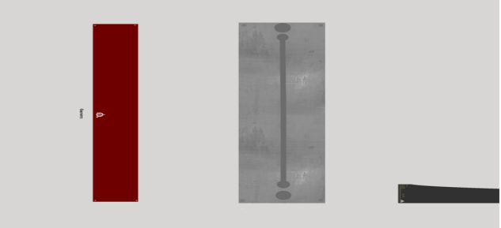
Figure 3 The texture of the air conditioner

4.1.1.4 Rendering
When using 3d Max to model, generally follow the basic steps of "modeling→lighting→material→rendering", and rendering is generally the last process. Render can also be translated as shading, so rendering is for the scene
Coloring. There are various rendering tools. 3d Max includes iray renderer, mental ray renderer, Quicksilver hardware renderer, VUE file renderer and default scanline renderer. Each type of renderer has its advantages and disadvantages. In actual operation, choose the appropriate rendering tool according to the needs.

4.4.2 Construction of Cruise Ship Motion Model
In order to realistically simulate the seawater environment and the influence of buoyancy on the ship, it is necessary to analyze the possible force situation of the real ship at sea. In the course of virtual yacht navigation in U3D, the mathematical model of yacht motion determines the state of ship motion, and its accuracy will directly affect the degree of simulation of ship driving and manipulation.
The ship will continue to be interfered by various external forces in the process of actual movement, as shown in Figure 4.3.

Figure 4 Ship force analysis

This article studies and discusses the movement of cruise ships. Due to the complexity of external environmental interference, cruise ships will continue to be subjected to environmental interference forces such as wind, waves and currents when sailing at sea. In order to simplify the movement of cruise ships, the forces experienced by the ship are simplified as driving Power and buoyancy. After determining the force of the cruise ship, the cruise ship can be determined as a movement in six degrees of freedom. As shown in the table below.

Degree of freedom Position value Linear velocity force
1 Linear motion along the x axis x u X
2 Linear movement along the Y axis y v Y
3 Linear movement along the Z axis z w Z
4 Rotation centered on the X axis φ p K
5 Rotation centered on Y axis θ q M
6 Rotation centered on Z axis ψ r N

As shown in the above table, in the six-degree-of-freedom motion coordinate system:
Longitudinal speed u, lateral speed v, and vertical speed w are the speed of the ship on the three coordinate axes respectively;
The heel angular velocity p, the trim angular velocity q, and the yaw angular velocity r are the angular velocities of the ship around the three coordinate axes respectively;
Longitudinal force X, lateral force Y, and vertical force Z are the external forces acting on the three coordinate axes of the cruise ship;
The heeling moment K, the pitching moment M, and the bowing moment N are the moments of the acting force on the three coordinate axes, respectively.
The direction of the above speed and force is positive when the positive direction of the coordinate axis is the same, and the judgment of the positive or negative of the angular velocity and the moment follows the right-hand rule.

4.4.2.1 Establishment of Coordinate System
Firstly, the coordinate system is established. In this paper, two commonly used coordinate systems for the analysis of ship maneuvering motion are adopted: the inertial coordinate system and the appendage coordinate system, as shown in Figure5.
Figure 5 Inertial coordinate system and attached coordinate system
Ο₁-X₁Y₁Z₁coordinate system is an inertial coordinate system fixed on the surface of the earth. It is used as a reference system.It is stipulated that the Ο₁X₁axis points to true north, the Ο₁Y₁axis points to the true east, and the Ο₁Z₁axis points to the center of the earth. The Ο-XYZcoordinate system is attached to the ship. The origin of the coordinates is at any point on the ship. It is stipulated that the ΟXaxis points to the bow, the ΟYaxis points to the starboard side, and the ΟZaxis points to the keel of the ship[30].

4.4.2.2 Cruise ship water degree of freedom motion simulation
Based on the above principles, the specific realization idea is to realize the simulation of water physics on the basis of the collider. The design of this article is to construct a fluid interactor base class and two extended classes, as shown in Figure 6.

Figure 6 Design of Fluid Script Frame

First of all, any plane can be simulated as a horizontal plane. By adding a collider and Fluid, a plane can have the density and tension of the water surface. For an object subject to surface buoyancy, a basic fluid interactor is constructed for it, which is the parent class of all interactors. BaseFluidInteractor defines the basic settings inherited by all interactors. Custom volume: used to set a custom volume. When his value is 0, it means that the collider will be used to calculate the volume. Damping factor: The damping applied to the object. Simulate water turbulence: add random interference forces generated by Berlin noise. Turbulence intensity: The intensity of the applied force. Floating strength: Use it to change the buoyancy without changing the mass. The core of this class is the simulation of turbulence. The simulation method in this article is to use Perlin noise, which is an algorithm that naturally generates noise. A noise function is basically a seed random generator. It requires an integer as a parameter, and then returns a random number based on this parameter. If the same parameter is passed in both times, it will generate the same number twice. The core idea of simulation is to use Time.fixedDeltaTime (set to 0.02 in U3D) as the accumulation of time count,
And set a random time offset, so that using the characteristics of Perlin Noise to get a continuous and smoothly changing random value. As shown in Figure 7

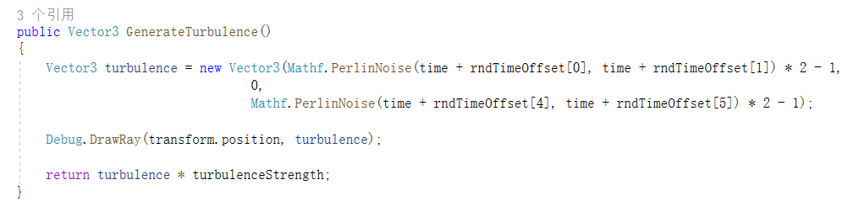
Figure 7 Generate turbulence script

In order to deal with objects in different situations, two interactors are designed in this paper, one is BasicFluidInteractor and the other is ComplexFluidInteractor. In the BasicFluidInteractor class, the abstract function FudUpadate of the base class is rewritten. The basic step of the algorithm is to judge the difference between the height of the current object and the height of the fluid. If it is less than the height of the fluid, it means that the object has been in contact with water at this time, and the algorithm is executed. , According to the buoyancy calculation formula, a buoyancy calculation expression can be obtained, as shown in Figure 8.

Figure 8 Buoyancy code expression

Then judge whether there is turbulence in the fluid at this time. If there is turbulence, the buoyancy should also be added to the effect of turbulence. This force will have a rotating effect on the object. The performance in the code is shown in Figure 9.
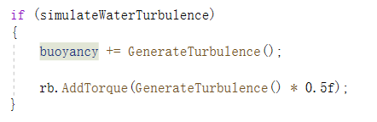
Figure 9 Turbulence judgment function
Finally, if the object has a basic speed, then it not only receives the basic buoyancy and gravity, but also receives a resistance from the water. The algorithm uses the AddForceAtPosition method of the rigid body to apply a buoyancy and resistance to the object, thereby changing the position of the object. Finally, the complete algorithm code and logic flow chart are shown in Figures 10 and 11.
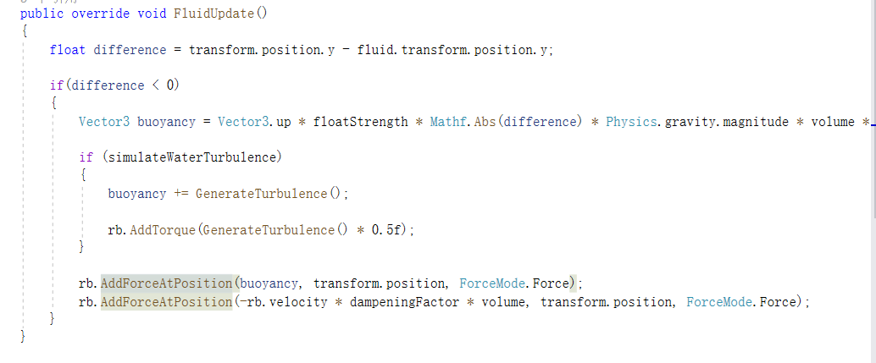
Figure 10 Ship force algorithm
Figure 11 The logic flow chart of the algorithm
But because it calculates everything from the center of the object, this may cause strange behavior on more stretched objects, such as wooden boards. So it is very suitable for smaller objects, background props, cuboids and spheres.
For the ComplexFluidInteractor class, it can deal with more complex situations, similar to BasicFluidInteractor. In this class, the FluidUpdate method is also rewritten. The difference from BasicFluidInteractor is that a layer of random points is added to the core of the algorithm, which is not a calculation for large objects. The buoyancy at the center of the object instead calculates the buoyancy of multiple points that can be placed on the object. Those "floating objects" calculate their buoyancy based on their sinking, and then apply it to the main rigid body at the corresponding position, as shown in Figure 12.
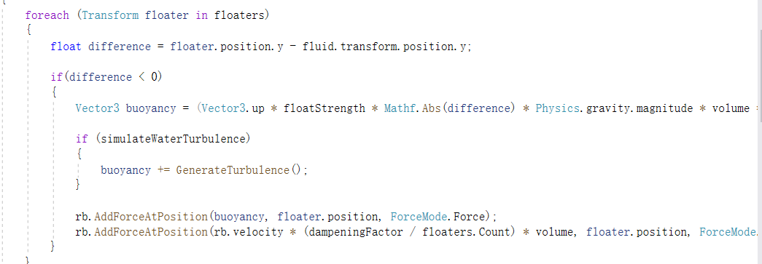
Figure12 Complicated object calculation buoyancy
At the same time, the function of automatically assigning floating points is realized, and the floating points are distributed by a quantitative offset from the center of the ship, as shown in the following figure
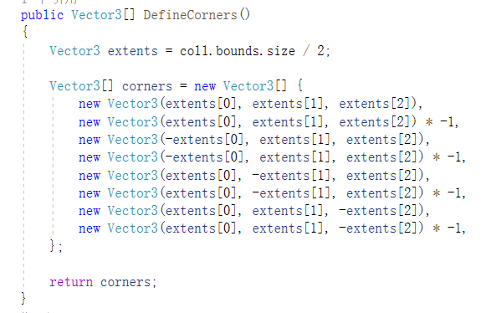
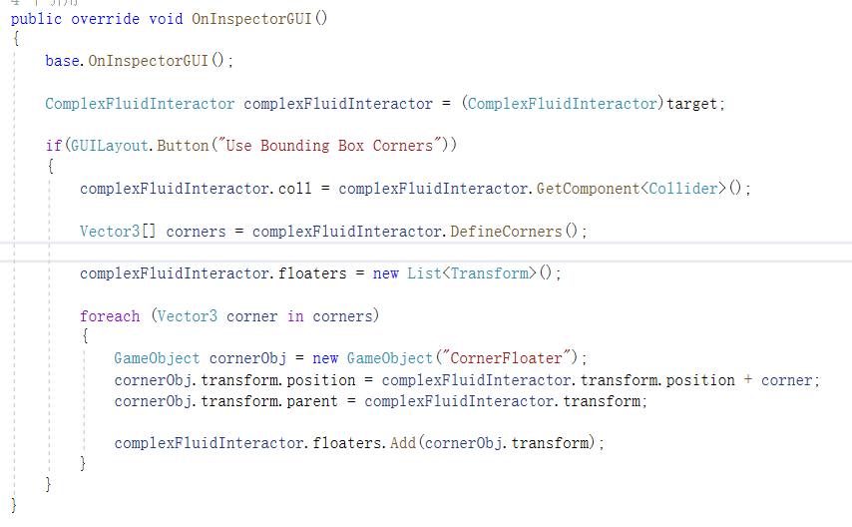

4.4.3 Realization of transforming coordinates into latitude and longitude
The same as in reality, the latitude and longitude of the ship at this time also need to be obtained in the virtual scene. One of the core contents of the ship information visualization system during the conversion of latitude and longitude. When operating in a real cruise ship, various information of the ship, including the latitude and longitude, needs to be mastered in real time. In the real world, GPS can directly obtain the coordinate information of an object at this time, but in the virtual world, it is necessary to implement a function similar to GPS and use it to help update the longitude and latitude information of the ship when sailing in the virtual environment.

4.4.3.1 World coordinates in Unity
The 3D coordinate system is a basic concept in 3D game development and VR development. Generally speaking, the 3D coordinate system uses the Cartesian coordinate system to describe the coordinate information of the object. The Cartesian coordinate system is divided into a left-handed coordinate system and a right-handed coordinate system.
Unity uses a left-handed coordinate system. The X axis represents the horizontal direction, the Y axis represents the vertical direction, and the Z axis represents the depth. Vector3(x,y,z) Classification of coordinate systems in Unity: word Space (world coordinate system), local Space (local coordinate system), Screen Space (screen coordinate system), viewport (viewport coordinate), GUI interface coordinate system [32].
The world coordinate is an absolute coordinate system defined according to the Cartesian coordinate system. The following coordinate systems are all based on the world coordinates. We know that any point in a two-dimensional plane can be represented by two-dimensional coordinates (x, y). If this concept is extended to three-dimensional space, then any point in three-dimensional space can be represented by three-dimensional coordinates (x, y, z). )To represent. Unity3D uses a left-handed coordinate system. In the world coordinate system, the objects created in the Unity scene all use the coordinate origin (0, 0, 0) in the global coordinate system to determine their positions. In Unity3D, we can use transform.position to get the world coordinates of an object in the scene. Normally, the Inspector window in the editor describes the position of a 3D object in world coordinates, unless there is a parent object for a 3D object At that time, it will describe its position in relative coordinates.

4.4.3.2 Latitude and Longitude
Latitude and longitude are the combined name of longitude and latitude to form a coordinate system called geographic coordinate system. It is a spherical coordinate system that uses the spherical surface of three-degree space to define the space on the earth. It can mark any position on the earth, such as As shown in Figure 13
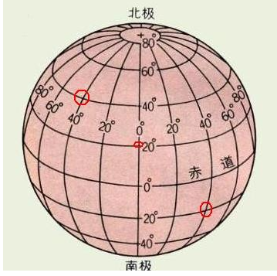
Figure 13 Latitude and longitude map( come from baidu.com)
Longitude is the number of degrees east or west from the prime meridian. Longitude is divided into 360°and every 15°is divided into a time zone, and then each time zone to the west is different by one hour, and so on to the east, the opposite goes all the way to the prime meridian.
Latitude refers to the line-face angle formed by the line between a point and the center of the earth and the earth’s equatorial plane. The value is between 0 and 90°. The latitude of a point located north of the equator is called north latitude and is denoted as N. The point latitude becomes the south latitude and is denoted as S.

4.4.3.3 The realization of the conversion between latitude and longitude and world coordinates
First draw a schematic diagram of the latitude and longitude space projection, as shown in Figure 14

R

O’

Z

B’’
θ

B
O
B’
C

Y
A

X

Figure14 Longitude and Latitude Space Spherical Coordinate Projection
From the figure above, it can be found that O is the center of the sphere, O′ is the theoretical north pole, A is the zero point of latitude and longitude, C is a point of any longitude at the same latitude as A, point B is on ⌒O′C, and OB is Radius, ⌒AC is an arc on the equator, assuming point B is the coordinates of the target latitude and longitude, B″ is the projection of point B on the plane xz, OC is the projection of O'C on the plane xy in the negative direction of the z axis, then B'is on OC, so ∠AOB' is the longitude and ∠B'OB is the latitude. From this we can get Lon=∠AOB', Lat=∠B'OB, R=OB, and the coordinates of point B are (X, Y, Z)

It is known that latitude represents the angle with the equatorial plane: in the northern hemisphere, as the angle increases, the circle of latitude gets closer to the North Pole; the larger the z value, the shorter the radius of the circle of latitude. Coordinate z value = length of minor axis * sin(a) longitude circle radius = length of major axis * cos(a), the same is true for longitude, considering that the actual distance corresponding to each degree of different longitude or different latitude is different , So we need to obtain the latitude function after the Fourier cosine series calculation when we calculate it. According to WGS84 coordinates, some basic parameters can be obtained, such as m1=111132.95255, m2=-559.84957 and so on. From this we get the length value of each degree
For each unit of latitude, it corresponds to the sum of projections of m1, m2, and m3. The formula is as follows
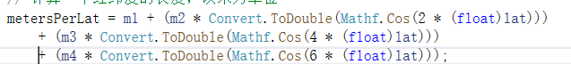
In the same way, the unit length of longitude can be obtained
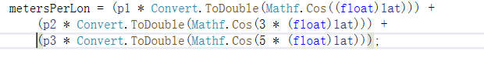
The next step is to use the unit length to realize the mutual conversion between world coordinates and longitude and latitude. For the conversion of world coordinates to longitude and latitude, first set an initial value of the world, and then calculate the current longitude and latitude using the unit latitude length and the unit longitude length, the main realization The idea is to multiply the unit length by the offset of the current latitude and longitude relative to the initial value, as shown in Figure 15.
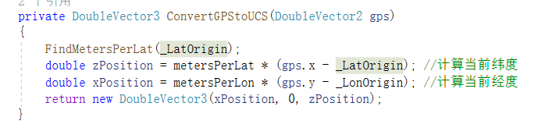
Figure 15 Algorithm of GPS conversion to world coordinates

In the same way, we can get the algorithm for converting world coordinates to latitude and longitude.
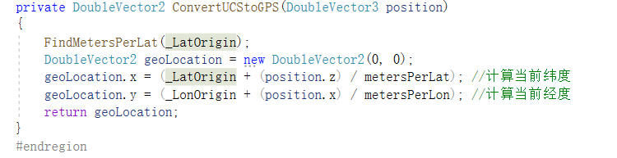
Figure 16 Convert world coordinates to GPS
In order to improve the accuracy requirements, two structures, DoubleVector3 and DoubleVector2, are specially encapsulated in the implementation. They are the same as Vector2 and Vector3, except that double-precision floating-point data must be used here.The specific design is shown in Figure 17
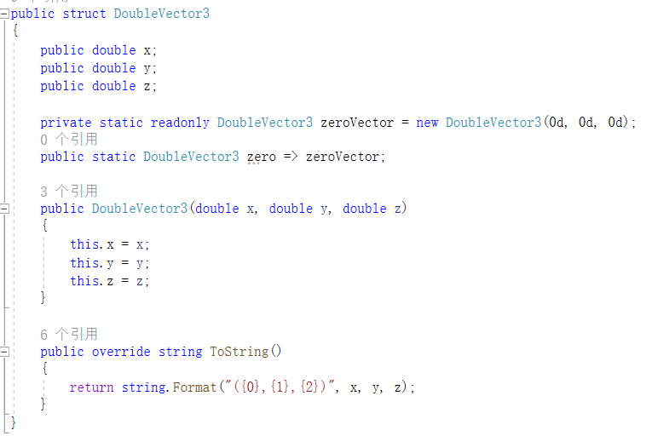
Figure 17 High-precision 2D and 3D data structure

4.5 Development of Virtual Ship Information Visualization System
This part conducts the overall development of the ship information visualization system, analyzes the basic process of developing virtual simulation software, and refers to the overall software development process of the company’s software engineers from the beginning of the project to the final delivery of the project; combined with the specific function planning of the virtual platform, the platform functions Compile and implement; finally complete the construction of the yacht virtual experience platform.

4.5.1 Construction of Basic Scenarios for Ship Information Visualization
3D virtual scene visual simulation modeling includes 3D space scene construction, basic environment construction, ship 3D
Modeling, the scene of the cruise ship traveling at sea in this system is the background, relying on professional design schemes to build a virtual yacht experience platform. When creating the physical model of the virtual system, it is necessary to ensure that the collected physical model has accurate data to ensure the accuracy of the model. This not only refers to the accuracy of the data of a single model, but also to ensure the data of the whole object and the surrounding environment. The proportional relationship is accurate.

4.5.1.2 Design Ideas for Scene Building
For the simulation system of navigation data visualization, the geographical environment of navigation needs to be simulated, which is very important to simulate the real environment during navigation. In this design, in order to achieve the effect of observing different positions, a model of the sky, terrain, ship model, and a certain cabin is required. The overall design of the design scene is shown in the Figure18

Figure 18 The design framework of the scene
Scene
Sailing scene
Observation model
water
Multiple terrain
Weather system
Ship model
cabin

4.5.1.3 Ship Model and Cabin Model
After downloading the ship model from the Internet, open it with 3DMAX, export it as an FBX file, and copy it to the Models folder in the Unity project, thus importing the model into Unity. But at this time, the color of the ship is gray. At this time, you need to complete the mapping operation in Unity.
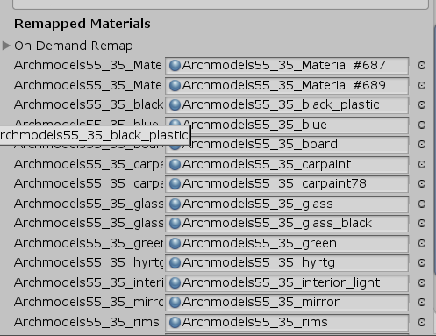
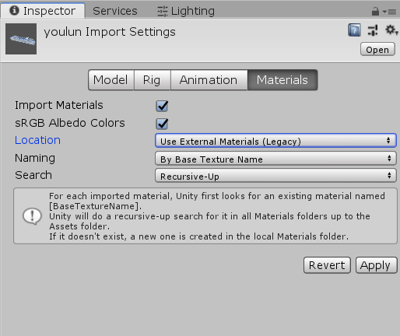
First click on the model in the model folder, as shown in Figure 19, select the location as "Use External
Figure 19 The display after clicking the model
Figure 20 After importing the material
At this time, the interface shown in Figure 20 will appear, and the materials in Remapped Materials have corresponding materials. Click apply again.
The cabin part is divided into a cockpit and an environmental parameter collection room. For the cockpit part, this article models the central control computer, rudder and air conditioner, taking the central console as an example.
According to the requirements of the ship's virtual experience platform, collect photos related to the center console of the cruise ship, and model it 1:1 with reference to the real console to ensure the authenticity of the control room. First, construct the frame and complete the modeling of the ship console with reference to real photos.
After completing the overall creation and optimization of the yacht model, it is necessary to create a partial model of the detailed part of the model. Adjust the model structure by selecting points, lines, and facing the model structure to make the model structure conform to the real model. For models with arcs and curved surfaces, it is difficult to use polygonal and geometric modeling methods to create, so NURBS modeling methods must be used to modify each polygonal model. However, for sharp angles that are difficult to modify, other methods need to be modified, modified and cut, combined with multi-surface control for the establishment of complex and detailed models, and finally the establishment of a three-dimensional model of the ship console, as shown in the figure.

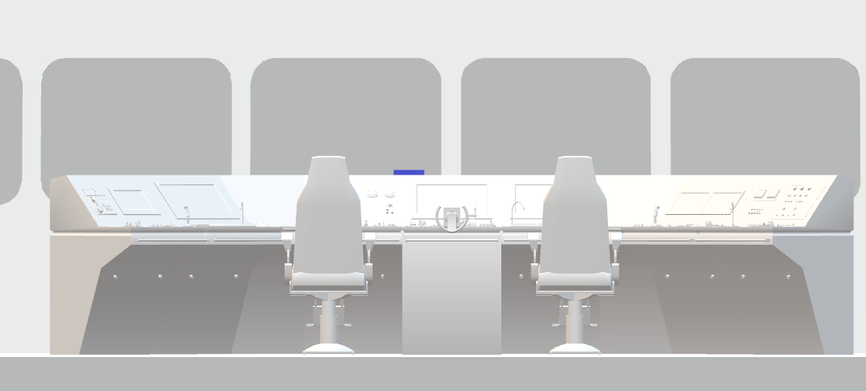
Figure 21 Console 3D model
The preliminarily constructed three-dimensional model of the yacht only has the outline of the yacht, and there is no material on the surface of the hull. Use the material mapping function to fill the yacht with materials. Then use U3D to build a three-dimensional virtual scene, and set the ambient light baking settings, and finally, import the rendered model into U3D, and the rendered effect is shown in the Figure.22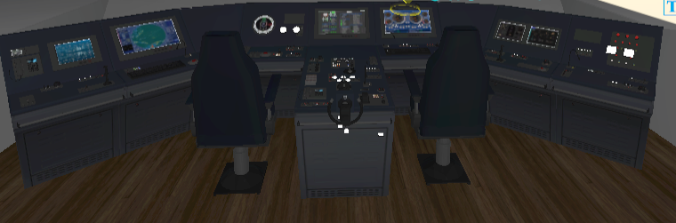
Figure 22 Model after texture
The construction of the model of the environmental parameter collection room is basically similar to the above construction method. The difference is that many models are assembled and spliced through smaller models, such as one of the data collection boxes, through the use of small glass, wooden boards, and pipes. The parts construct a complete test box, as shown in the Figure 23
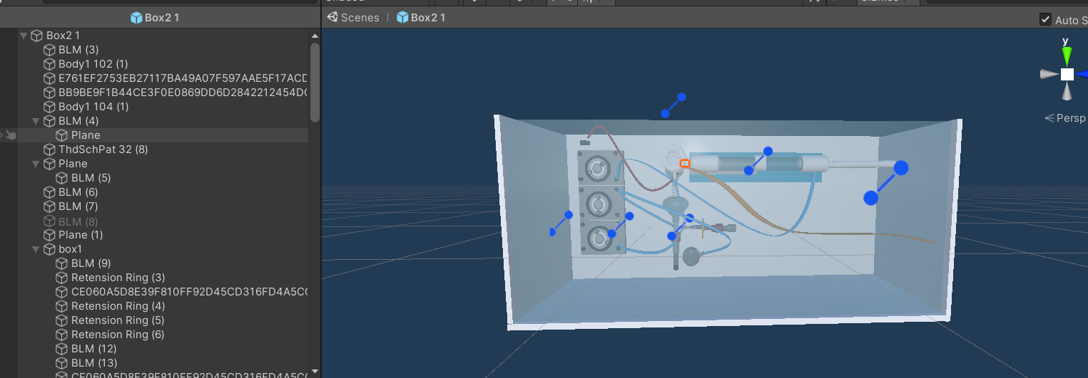
Figure 23 Test box model

4.5.1.4 Sky, ocean and terrain scene construction
When constructing a yacht virtual experience platform, for the overall virtual environment that needs to be constructed, the construction of the sky, ocean and terrain visual environment is the most basic and most important. The construction of the virtual simulation of the sky and the virtual simulation of the ocean will make the constructed overall virtual environment closer to the real environment.
Customize the method of creating a sky scene: first create your own project through U3D, and build your own scene.
Put the required sky box resources into the created project, and then add the sky box to the scene to get the effect as shown in the figure 24.
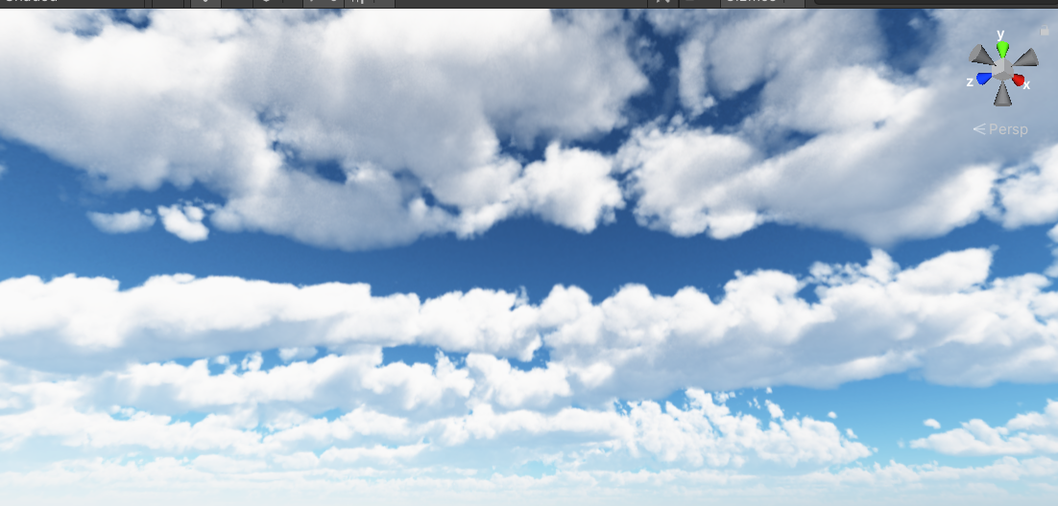
Figure 24 Skybox
Creation of the marine environment: 3D
The development engine comes with a water resource package. If it is used to create a water environment, there will be many unreasonable places in the water environment created, and it is not easy to adjust the basic parameters, so it does not use its own water resources system. This article adds a special Water Specular material to it by constructing a plane. The shader sets the influence on the water surface material from six aspects: ALBEDO,NORMALMAP, MICROWAVE, PARALLAX, REFLECTION, MIRROR and FOAM, and finally gets the water surface effect as shown in the Figure 25
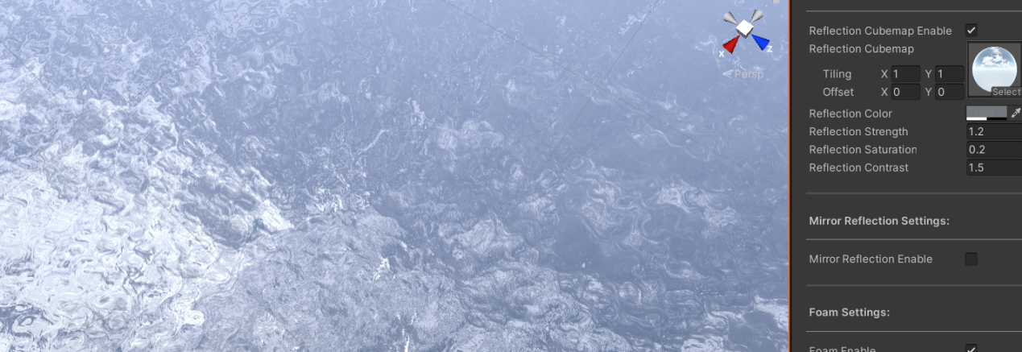
Figure 25 Water surface rendering
The transparency of the water surface and surface ripples can be changed by adjusting the transparency value and normal map.

Terrain creation: Terrain construction can be completed directly in the Unity scene. Create Terrain. There are Transform, Terrain and Terrain Collider components in the inspector column of the terrain. However, this article adopts the method of autonomous modeling to realize it. Firstly, the mountain grid is constructed, and the height and slope of the mountain are adjusted based on the terrain of others. Finally, the mountain grid model as shown in the figure is obtained.
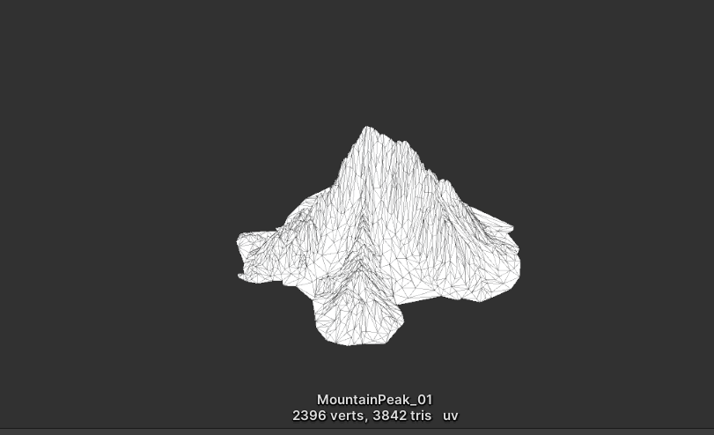

Based on a mountain model, the terrain is generated iteratively, and their positions are adjusted to obtain the final ocean terrain.As shown in Figure 26
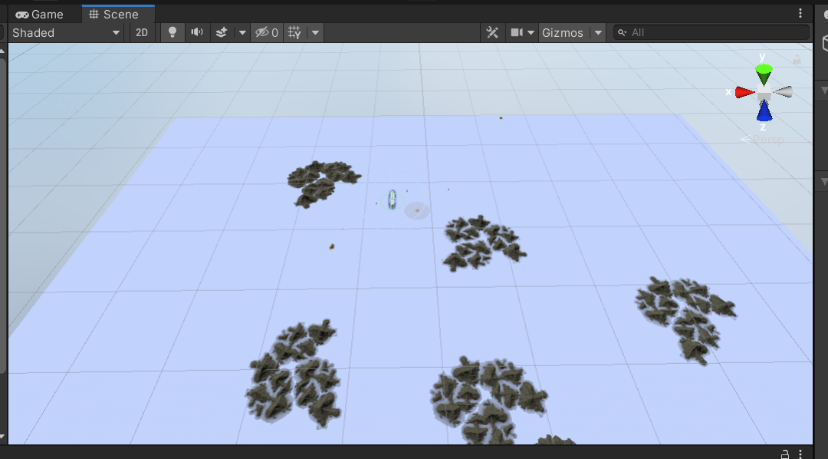
Figure 26 Ocean topographic map

4.5.1.5 Creation of weather system
Weather simulation refers to the weather conditions encountered when the yacht is sailing or berthing. The real environment cannot be sunny every day. In order to be closer to the real environment more realistically, different weather environments need to be simulated. Our idea is to build a weather box to simulate various weathers in the weather box. We have built several scripts to control time, weather, and sky respectively. Time is a simulation of real-world time. It can represent each month and a certain day of the month. When the time is January, the weather module will select the weather according to the season. , The corresponding weather in January is snow. The realization of all kinds of weather is realized through Unity's own particle effect adjustment parameters, and three weathers such as normal daytime, rain and snow are designed for your own choice. The weather changes automatically following the seasons, it is connected with the control interface of the control room, and the control panel will reflect the current weather conditions in real time.
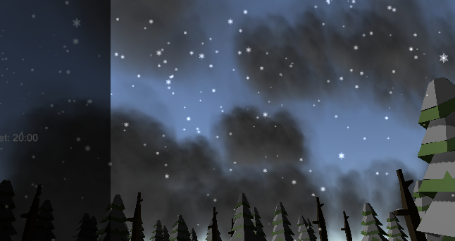
Figure 27 Snow scene

4.5.2 Virtual scene roaming
The cruise virtual tour experience is the virtualization of the real scene. Users can move and exchange in the virtualized scene, and can observe at any position and angle in the virtual space. Based on the principle of this roaming characteristic, the structure of the roaming experience development process for the yacht virtual experience platform is shown in the figure 28.

Figure 28 Architecture diagram of the overall development process of roaming experience
The roaming in the scene can be realized by using steam VR. Steam VR integrates many convenient functions, one of which is its transmission mechanism. Unlike the previous version of SteamVR1.0, SteamVR2.0 comes with a player prefab, which is the first person in a virtual reality scene. It combines a VR camera with two handles as shown in the figure below.
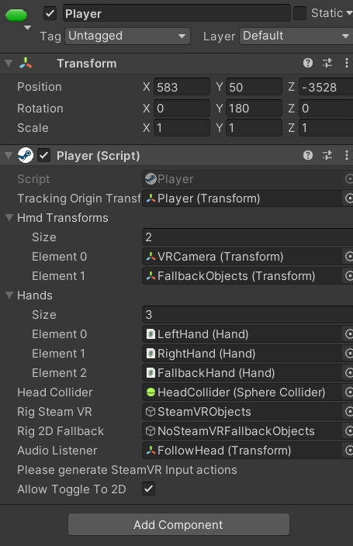
Immediately after adding Teloporting and TeleportPoint components to the scene, Teleporting is responsible for turning on the transmission function. Press and hold the disc of the handle to emit a Bezier curve, and TeleportPoint is the transmission point, which can be directly dragged into the scene, as shown in Figure 29.

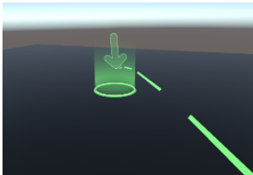
Figure 29 TeleportPoint

At the same time, add TeleportArea script to it by creating a plane arbitrarily, then this area will become a teleportable area. The main code of the TeleportAreabu part of the script is shown in the following figure 30
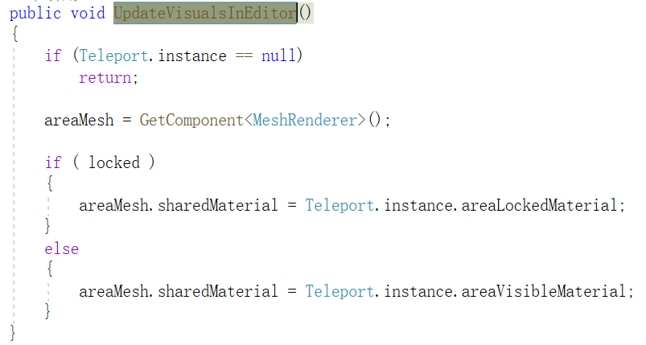
Figure 30 TeleportAreabu core code

The system places transmission points on the deck and cabin of the cruise ship to realize the observation of various positions. Eventually get the transfer point arrangement as shown in the figure 31
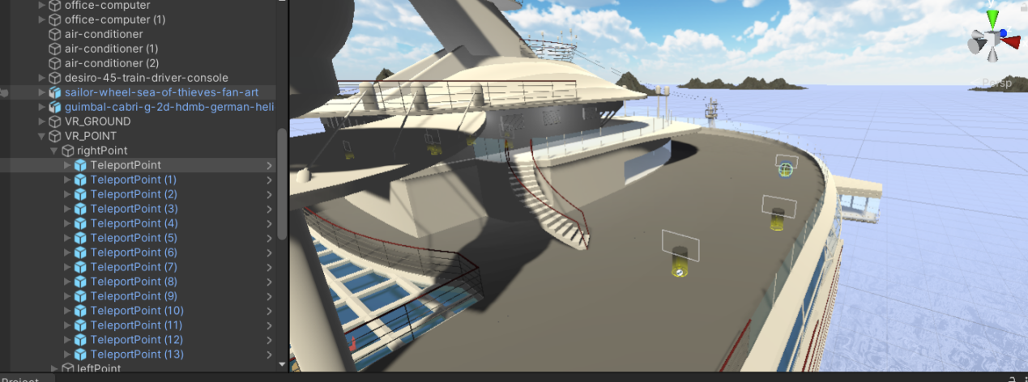
Figure 31 Placement of the teleporter

4.5.3 Human-computer interaction and realization of the system
The design and implementation of human-computer interaction is an important factor affecting software user experience, which includes two-dimensional interface interaction and three-dimensional interaction. Various interactive methods are connected to each other. The user inputs information through the device and then gets the feedback from the device to the information, forming an intricate interactive network. This section mainly describes the implementation of menu interactive design and operation interactive design.
The bridge information interaction adopts the fusion of multiple interactive methods. When the virtual character moves to certain designated points, an interactive prompt will be triggered. The interactive prompt is shown in Figure 32:
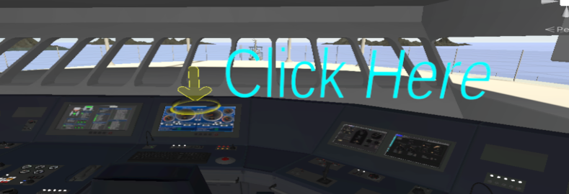
Figure 32 Interactive prompt

The main interface can be opened by clicking the prompt part. The function of this part is to use the ray of the control handle to touch a collider placed on the console screen. In order not to affect the screen, uncheck the messrender of the collider. It won't be rendered, it only has a collision function. To this end, construct a cube button group, place the cube at the position of each object that needs to display information, and add a script. Part of the core code of the script is shown in Figure 33:
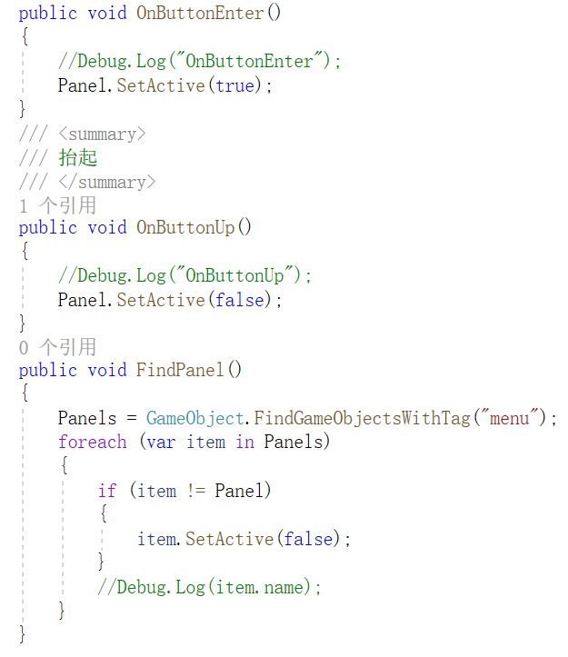
Figure 33 Core code

The core idea of the code is to display the relevant information of the object when the ray hits the object, and then when the ray leaves the range of the colliding body, the display of the information panel will be closed.
The main interface part uses the unity UI system. In the virtual environment, the Canvas of the UI needs to be set to world space mode, but after setting to the world mode, in order to solve the problem of not being able to click the button, you need to add UIelement components and Interactable scripts to the button , Through the Interactable script, the click interaction of the button in the virtual reality environment can be realized. The entire UI system is roughly divided into three levels. The first level is part of the main interface. The main interface contains several buttons of the secondary interface, as shown in Figure 34.
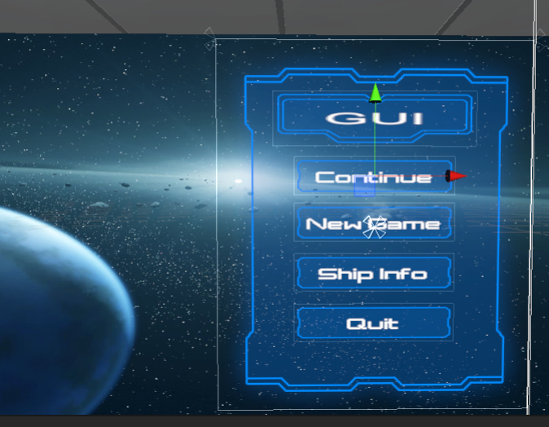
Figure 34 Main interface
When the user clicks the Ship Info button, the interface will switch to the ship information interface, as shown in Figure 35.
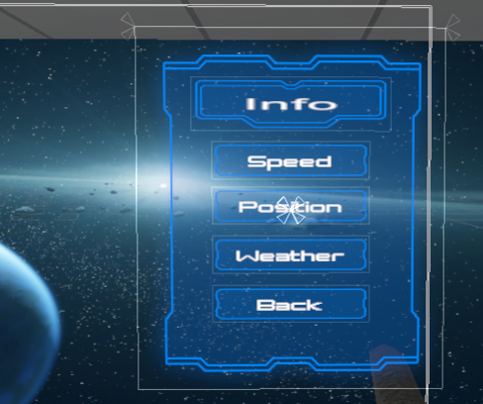
Figure 35 Ship Info Information
The ship information interface contains four buttons, namely speed, location, weather and return. By clicking the speed menu button, the speed-related information interface will pop up, as shown in the figure 36.
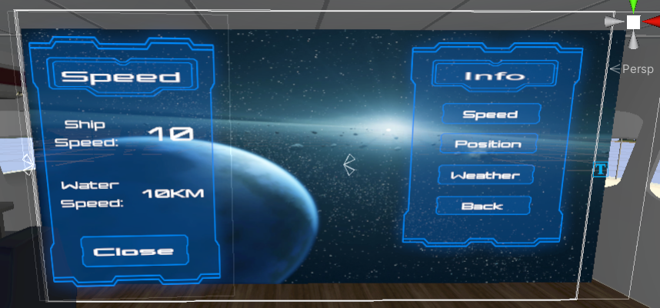
Figure 36 Speed Panel
The speed information panel is mainly responsible for displaying the running speed of the ship and the speed of the water flow. The speed information is the real-time collection of the speed value of the ship when it is running. The Weather menu button corresponds to the weather interface, as shown in the figure 37
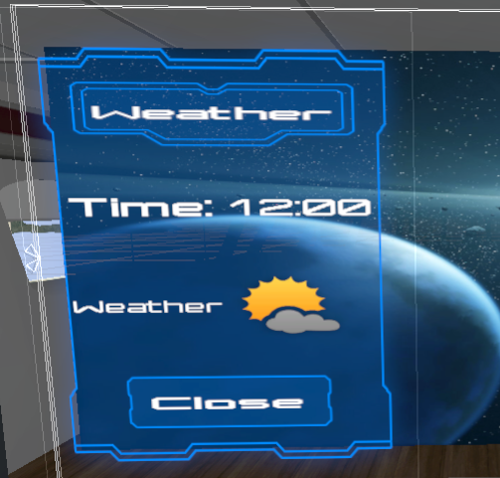
Figure 37 Weather Panel

The Time column displays the current time. The system does not use the real time of the world but a time simulation. The Weather column information is displayed according to the weather conditions at this time, for example, the external weather at this time is sunny. . All select menu keys are implemented by calling the functions of the PanelManager script. There are several main methods in the PanelManager script. The first is an initialization method, which is used to convert the default animation to a hash value. The core part of the script is the OpenPanel and CloseCurrent methods. The code is shown below
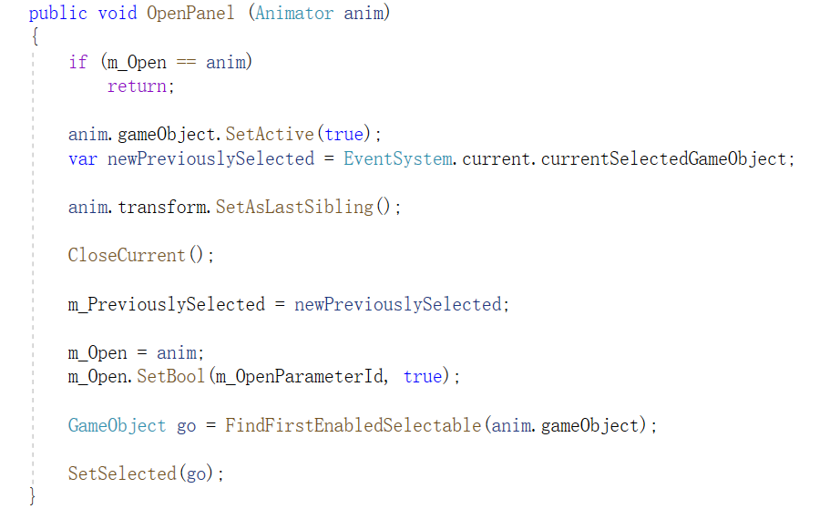

4.5.4 Cruise Ship Movement Simulation Development
In the movement of ships, this article mainly uses unity's navigation system. The principle of navigation is the pathfinding algorithm, which is a high-latitude improvement based on the A* algorithm. The entire pathfinding process is mainly divided into two parts: Navigation mesh construction and pathfinding algorithm. The navigation grid is roughly equivalent to baking in Unity. First, you need to set the sea and islands to static in the scene as shown in the figur 38

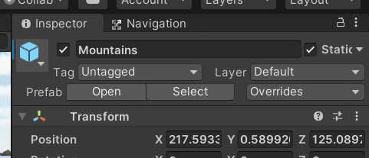
Figure 38 Set up static objects
Then adjust the baking parameters in the Navigation panel as shown in the figure 39
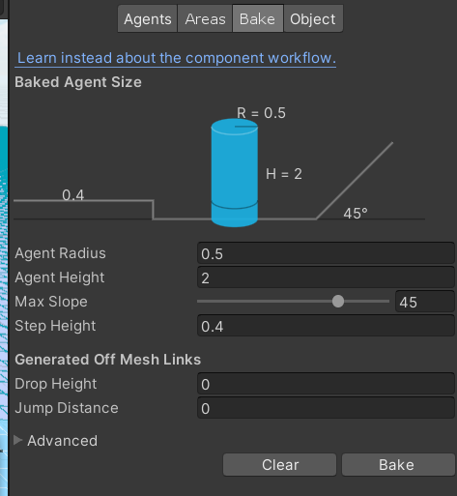
Figure 39 Baking parameters
In the above settings, Agent Radius defines how close the center of the agent is to the wall or ledge, height defines the low degree of space the agent can reach, and Max Slope defines the steepness of the agent's climb up the ramp. After clicking Bake, the engine starts to calculate and construct NavMesh for static objects, and the result is shown in Figure 40:
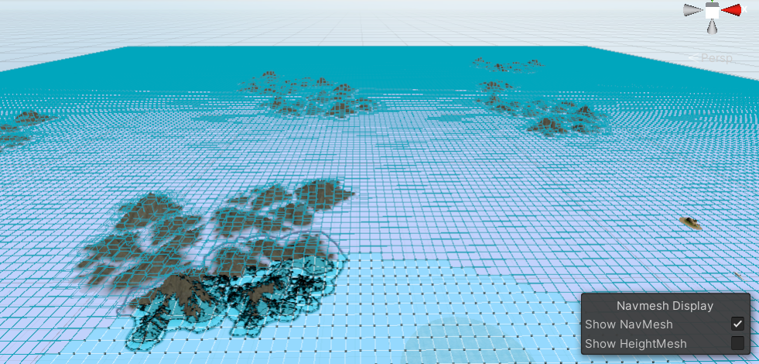
Figure 40 Baked grid

Then add the NavMeshAgen component on the cruise ship, and then add a NavShip script to control the cruise ship to automatically navigate to the designated location. Since the Agent Size in the NavMeshAgen component is a cylindrical collider by default, this will cause the range of the collider to be much larger than the actual size of the cruise ship. Therefore, place a cylinder on the top of the cruise ship whose diameter is equal to the width of the cruise ship. The effect of pathfinding can avoid the problem of too large collision body.

4.6 Summary of this chapter
This chapter firstly models and renders cruise ships, cabins, mountains and sea water respectively. Through the sky and ocean models created by U3D, the weather environment and scene special effects are designed through the particle system to realize the construction of virtual visual environment. Write function scripts according to the functions to be realized by the cruise ship, and complete the human-computer interaction function according to the scripts. Based on the establishment of the visual scene, the human-computer interaction interface of the system is designed to complete the development of ship navigation and roaming experience. After the cruise virtual experience platform is developed, the platform will be released and run independently from the development engine.

5 Results and Analysis
This chapter mainly elaborates the design of questionnaires based on the basic functions of the system, collects the questionnaires filled by users to analyze data and information, and refines suggestions for improvement, so as to realize a single theoretical teaching model in traditional classrooms and the transformation to a virtual reality information-based ship information visualization teaching model. Possibility.
Traditional Chinese ship teaching usually adopts the "single-line" teaching mode of offline "theory teaching + site visit teaching". After the students complete the theoretical study in the classroom, they will go offline to visit the ship together under the organization of the teacher, and the students will submit a report after the visit is completed. The teaching mode of traditional ships is shown in Figure 41.
Figure 41 Traditional ship teaching mode

In the future, Internet technology can be used to realize data transmission between the cloud classroom and the ship information visualization virtual experience platform, so that users can more conveniently obtain the virtual ship information visualization system, and realize the information exchange between the cloud classroom and the virtual experience platform. Figure 42 shows the design ideas of the future ship information visualization experience platform teaching system
Figure 42 The design plan of the future ship information visualization teaching platform

5.1 Design of the QoE framework of the ship information visualization system

Quality of Experience refers to the user's subjective perception of the quality and performance of equipment, networks and systems, applications or services. QoE refers to how easy it is for users to complete the entire process.
The creation of QoE is a concept designed by operators to improve the end user experience. QoE can now be applied to the evaluation of equipment, networks and systems in various scenarios. QoE is based on questionnaires and is filled out after user experience. Questionnaires are used to obtain relevant parameters. Since QoE indicators vary from system to system, it is necessary to design corresponding questionnaires for specific systems and their own needs. This paper proposes a QoE framework with two levels of influence parameters [28].
Based on the particularity of virtual reality and the functionality of the system, we propose a conceptual QoE framework for the evaluation of ship information visualization systems. The framework is mainly composed of three high-level parameters: content quality, environmental realism and user interaction. In order to clear the description framework, I further explore the low-level aspects of each high-level parameter to expand the system's framework. Figure 43 shows the entire QoE framework for the evaluation of the ship information visualization system.

Figure 43 The QoE framework of ship information visualization system evaluation

Content quality
Content quality is the core of a virtual reality application. In terms of content quality, we have attributed two important factors, one is the richness of the content, and the other is the authenticity of the information. For players in virtual reality, the amount of content must be sufficient. For ship information visualization systems, there must be simulations of ships, oceans, and some important cabins in ships. Another point is the authenticity of information. Virtual reality requires vivid content to fully immerse users in the virtual world. Therefore, the system's simulation of weather, ocean and ships needs to satisfy its authenticity as much as possible, and imitate navigation in the ocean to the greatest extent. The cruise scene enhances the user’s sense of immersion.
Hardware quality
As users usually need to move around while wearing an VR device to interact with the aug-mented contents and the surrounding environ-ment, VR hardware quality can greatly influence the user experience. It needs to be connected to external computer equipment, which limits the user's experience to a certain extent. At the same time, it also requires hardware equipment that can provide various degrees of freedom of observation. Another evaluation criterion is the comfort when wearing a virtual reality device, because the user's head needs to always support the weight of the device. Therefore, the overall quality and materials of the device will closely affect the user experience.
User Interaction
User interaction is different from simply displaying images or playing movies. VR applications require a lot of user interaction. Therefore, evaluating user interaction is also an important part of evaluating the QoE framework. The first part is the naturalness of the interaction, which is to fit the actual operation method as much as possible, and not be too rigid in the interaction of some functions. In our framework, the interactions defined in this way are summarized as commonly used methods, such as clicking the handle, waving the handle, and so on. Another unavoidable factor is the accuracy and speed of the system's response to user interaction. If an interaction takes too long, it will lead to a decrease in user experience.

Based on the design of this framework, we designed a questionnaire to collect users’ satisfaction with the ship information visualization system. The questionnaire sets up a series of questions based on the three parameters of the QoE framework. The questionnaire is divided into four parts. The first part is about the user's understanding of virtual reality and whether they have experienced virtual reality-related software. The next three parts are related to the three advanced parameters. For example, for user quality, the questionnaire designed three questions: "what extent did the device provide realistic visual information.", "what extent did the device provide realistic audio information." and "how rich is the content of the app." At the same time, scores are set for these questions. Users will score each question according to their own feelings. The scores range from one to five. These scores will be used for evaluation. An input, in order to unify the final scoring criteria, we convert all input answers Iin ranging from 1 to 5 into a percentage value Ip ranging from 0 to 100, as shown below:
Where N represents the number of answer options, which is 5 in the questionnaire. Therefore, the original input data is divided into five groups: 1→0,
2→25, 3→50, 4→75, and 5→100. For obtaining data, it is necessary to define the membership degree corresponding to a score according to the fuzzy set theory. Since each question about advanced parameters in the questionnaire we designed has 5 answers (1-5) to choose from, we use part of the input as the criterion for judging. For example, if the user considers content quality, hardware quality, and user interaction And the overall ratings are respectively rated as 75, 50, 75, and 75, these values can then be interpreted as good, fair, good, and good, and the following fuzzy rules can be derived: if the content quality is good, and the hardware quality is fair, and If the user interaction is good, the overall rating is good. At the same time, we define that if the number of users with a good overall rating exceeds 75% of the total number of users, the system is considered to basically meet the requirements.

Experiment Setup
The user study was performed in a room. A total of 20 subjects (15 males and 5 females) participated in the test, of which 18 subjects were between 20-29 years old, and two subjects were aged Between 30-39 years old. In addition, 10 users have never used VR-related applications. They all experienced the virtual reality ship information visualization system of this article.
Participants have ten minutes to get acquainted with the HTC VIVE headset, using simple interactions such as moving the head, displaying and canceling the menu, and operating the handle to click and shake. After the participants became familiar with the VR equipment, I provided more detailed instructions for the selected applications and performed tests. Finally, the participants completed the questionnaire. In addition, a laptop computer is used to connect to the device. Used ASUS laptop, 15.6" screen with 1920×1080 resolution, and a Windows 10 64-bit operating system.

Experimental results
We use 10 of the 20 users as the standard of the rule, and the data of the remaining 10 users are used to judge the final rating based on this standard. The final data is shown in Figure 44.

Figure 44 User QoE value graph

From the data in the figure above, we can get the number of different interval scores by doing a statistics. As shown in Figure 45

Figure 45 Score statistics chart

Combining the above data, we obtained the following data analysis table from the average, median, standard deviation of user QoE and the proportion of user experience scores greater than 75 points.

Testing  Application | QoE(Mean) | QoE(Median) | Standard deviation | System satisfaction (greater than 75%)
Ship System | 78.5 | 80 | 7.5 | 80%

It can be seen from the table that the average QoE value is 77.75, and the median of user experience data is 80. The standard deviation is further calculated to focus on the degree of dispersion of the data. As shown in the table, the standard deviation is 7.5, and the distribution of the data is relatively scattered.The degree of discretization is relatively large, which can reflect that the ship information visualization system has a relatively large difference in user experience, but the system’s satisfaction exceeds 75%. It can be determined that the system basically meets the user’s satisfaction. Spend.

6 Conclution and Outlook

6.1 Summary
This paper takes ship information visualization as the research object, carries out modeling and simulation research on ships, and applies the simulation data to the visualization process of ship information. Taking a large cruise ship as an example, the model and virtual ocean scene of the cruise ship and cabin are established, the Unity3D virtual reality engine is used to complete the visualization application of its data, and it is connected with the virtual reality hardware HTC VIVE. The specific research content of this article is summarized as follows:
(1) A detailed introduction to the research background and topic significance of ship information visualization, and an overview of the development and application of virtual reality
(2) Model and analyze the simulation required for the ship scene, and import it into the scene. At the same time, the cruise ship motion model is modeled to simulate the water body and the interaction between the cruise ship and the water surface.
(3) Analyze the relationship between latitude and longitude and the world coordinates in Unity3D, establish a target equation, and simulate the conversion of 3D coordinates into latitude and longitude.
(4) Complete the overall design and scene construction of the ship information visualization system through the Unity3D virtual engine, build the sea, sky, and weather systems, and write scripts to realize the user's scene roaming in virtual reality and the main interface for ship information visualization.
(5) Complete the docking of the visualization system and the virtual reality hardware HTC Vive headset. Arranged 20 users to complete the application experience and analyzed the user's questionnaire data.

Based on the visualization of cruise ships, the thesis analyzes the movement model of the ship and the conversion between latitude and longitude and world coordinates, and applies it to the ship information visualization system to make it more realistic. At the same time, the use of virtual reality equipment to run the ship information visualization system enables trainees to integrate into the scene of ship navigation, thereby enhancing trainees' cognition of some knowledge of ship navigation and making up for the lack of learning in the classroom.

6.2 Outlook
This paper has done relevant research on the application of ship information visualization, and used the most widely used virtual reality engine Unity3D as the development platform to complete the construction of the ship information visualization system, and finally docked with the virtual reality hardware HTC Vive. The open test feedback results showed that the visualization system Can enable the operator to get a deeper sense of immersion. This article has achieved certain results in the visualization and experience of ship information, but due to the limitations of personal energy and research conditions, this article still has a lot of content that deserves more in-depth research, including the following aspects:

(1) This article only conducts modeling and analysis on cruise ships, cabins, some islands, and sea water, and establishes a visualization system. However, some interactive animations are not added to the rudder and other models in the control room, and the movement of the ship is not actually connected to the control of the rudder. In the future, the ship can be controlled to control the movement of the ship, which can better simulate the actual driving of a cruise ship. Some situations.
(2) There are not many prompt interactions in the system. Because it is an automatic navigation mode, dangerous situations are eliminated. Some dangerous scenes can be added later, so that users can learn how to deal with emergencies in dangerous situations. At the same time add some answering systems so that users can learn some knowledge.
(3) During the open test of the visualization system in this article, some students reflected the stuttering phenomenon in the scene. This is because the amount of data loaded in the system is relatively large and real-time calculations are relatively large, and subsequent rendering in the scene can be optimized and the physical model can be optimized.

7 REFLECTION
After several months of research and work, the research and experiment on this subject have finally been completed. In the process of writing the paper, I gained a lot. From setting the topic to consulting the literature, to achieving the research goal, and finally completing the article, every step here is sweat and effort, trial and hard work. In this process, I benefited a lot and gained a lot of insights. Under the guidance of Professor Tim, I started to consult relevant materials and books recommended by the teacher from the state that unity-related learning was not enough to make the vague probability gradually clear, and the success of each experiment would give me a sense of accomplishment.
At the beginning, I just had an idea but didn’t clear up the real meaning, because I was doing ship information visualization. The teacher said that my idea was very good, but compared with the real ship’s monitor, I quickly clarified myself. The goal is to apply the idea to the teaching of ships, and realize a value direction of virtual reality ship information visualization by combining with traditional teaching. Start learning unity, virtual reality and related knowledge according to the teacher's recommendation. In order to realize this system, you must understand the knowledge of ships. The first problem encountered in development was encountered during modeling, because there was no modeling experience and some difficulties in implementing specific details were encountered in the process of implementing the model. In the end, a solution was found through various learning methods. The second is the realization of the system function module, because in VR we use the VR handle to click the button, but the button cannot be clicked in the world space mode. Later, the problem was solved by adding UIelement components and scripts, but it still exists Clicking has no effect, so we came up with a plan to implement a collision box function by placing an object of similar size on the object and canceling its grid rendering, and achieve the corresponding effect through the collision detection between the ray and the collision box Function.
Finally, through the development of this system, I learned about unity, ships, and virtual reality. At the same time, I also had a deep understanding of such issues and successfully completed the development of this system.

References
- Weiss, P. L., Jessel, A. S. 'Virtual Reality Application to Work'[J]. Work, 1998, 11(3): 277-293.
- Slater, M., Wilbur, S. A. 'Framework for Immersive Virtual Environments (FIVE): Speculations on the Role of Presence in Virtual Environments'[J]. Presence: Teleoperators & Virtual Environments, 1997, 6(6): 603-616.
- Sutherland, I. E. 'A Head-mounted Three Dimensional Display'[A], ACM (Ed.) 1968 Fall Joint Computer Conference[C], New York: ACM Press, 1968, 757-764.
- Krueger, M. W., Gionfriddo, T., Hinrichsen, K. 'VIDEOPLACE—An Artificial Reality'[J]. ACM SIGCHI Bulletin, 1977, 16(4): 35-40.
- Lanier, J. 'Virtual Reality: The Promise of the Future'[J]. Interactive Learning International, 1992, 8(4): 275-279.
- Cruz-Neira, C., Sandin, D. J, DeFanti, T. A. 'The Cave: Audio Visual Experience Automatic Virtual Environment'[J]. Communications of the ACM, 1992, 35(6): 64-73.
- Vincent, L. 'Taking Online Maps Down to Street Level'[J]. Computer, 2007, 40(12): 118-120
- ARPost.'Key News and Events in the Augmented and Virtual Reality Technology World-September2018'[EB/OL].https://arpost.co/2018/09/28/key-news-and-eventsin-the-augmented-and-virtual-reality-technology-worldseptember-2018/. 2019-04-14.
- Jafari, B., Khaloo, A., Lattanzi, D. 'Deformation Tracking in 3D Point Clouds Via Statistical Sampling of Direct Cloud-to-Cloud Distances'[J]. Journal of Nondestructive Evaluation, 2017, 36(4): 1-65
- Mahrous, A., Schneider, G. B. 'Enhancing Student Learning of Removable Prosthodontics Using the Latest Advancements in Virtual 3D Modeling'[J]. Journal of Prosthodontics, 2019, 28(4): 471-472.
- Broderick, J., Duggan, J., Redfern, S. 'The Importance of Spatial Audio in Modern Games and Virtual Environments'[A], IEEE (Ed.) 2018 IEEE Games, Entertainment, Media Conference (GEM)[C], Piscataway: IEEE Press, 2018, 1-9
- Mengüç, Y., Park, Y. L., Martinez-Villalpando, E. 'Soft Wearable Motion Sensing Suit for Lower Limb Biomechanics Measurements'[A], IEEE (Ed.) 2013 IEEE International Conference on Robotics and Automation[C], Piscataway: IEEE Press, 2013, 5309-5316.
- Ahn, J., Kim, Y., Kim, R. 'Virtual Reality-wireless Local Area Network: Wireless Connection-oriented Virtual Reality Architecture for Next-generation Virtual Reality Devices'[J]. Applied Sciences, 2018, 8(1): 43.
- Zhang, Jian (School of Art and Design, Lanzhou Jiaotong University, Lanzhou; Gansu, China); Wang, Ying Source: Advances in Intelligent Systems and Computing, v 1385 AIST, p 11-18, 2021, Application of Intelligent Systems in Multi-modal Information Analytics - 2021 International Conference on Multi-modal Information Analytics, MMIA 2021
- ]Loucks, L., Yasinski, C., Norrholm, S. D. 'You Can Do That?: Feasibility of Virtual Reality Exposure Therapy in the Treatment of PTSD due to Military Sexual Trauma'[J]. Journal of Anxiety Disorders, 2019, 61(1): 55-63.
- Pantelidis, V. S. 'Reasons to Use Virtual Reality in Education and Training Courses and a Model to Determine When to Use Virtual Reality'[J]. Themes in Science and Technology Education, 2010, 2(1-2): 59-70.
- Hodgson, P., Lee, V. W. Y., Chan, J. C. S. Immersive Virtual Reality (IVR) in Higher Education: Development and Implementation[M]. Augmented Reality and Virtual Reality. Springer, Cham, 2019, 161-173
- Berg, L. P., Vance, J. M. 'Industry Use of Virtual Reality in Product Design and Manufacturing: A Survey'[J]. Virtual Reality, 2017, 21(1): 1-17.
- Dobrescu, R., Merezeanu, D., Mocanu, S. 'Process Simulation Platform for Virtual Manufacturing Systems Evaluation'[J]. Computers in Industry, 2019, 104(1): 131- 140.
- H. Cao, X. Hou and Y. Feng, WebGL-Based Research on Virtual Visualization Simulation Display Platform of Ship.[J] IEEE Advanced Information Management,Communicates,Electronic and Automation Control Conference (IMCEC), 2018, pp. 895-899,
- S. V. Broucke and N. Deligiannis, Visualization of Real-Time Heterogeneous Smart City Data Using Virtual Reality.[J]. IEEE International Smart Cities Conference (ISC2), Casablanca, Morocco, 2019, pp. 685-690.
- E. Markopoulos, J. Lauronen, M. Luimula, P. Lehto and S. Laukkanen, Maritime Safety Education with VR Technology (MarSEVR).[J]. 10th IEEE International Conference on Cognitive Infocommunications (CogInfoCom), Naples, Italy, 2019, pp. 283-288.
- P. Rajeswaran, T. Kesavadas, P. Jani and P. Kumar, "AirwayVR: Virtual Reality Trainer for Endotracheal Intubation-Design Considerations and Challenges," 2019 IEEE Conference on Virtual Reality and 3D User Interfaces (VR), Osaka, Japan, 2019, pp. 1130-1131.
- J. Wu, "Research on roaming and interaction in VR game based on Unity 3D," 2020 International Conference on Computer Vision, Image and Deep Learning (CVIDL), Chongqing, China, 2020, pp. 592-595.
- I. Hsu, X. Zhang and F. Shyu, "An application for geovisualization with virtual reality built on Unity3D," 2018 IEEE International Conference on Applied System Invention (ICASI), Chiba, Japan, 2018, pp. 1082-1085.
- T. Kojic, U. Sirotina, S. Möller and J. Voigt-Antons, "Influence of UI Complexity and Positioning on User Experience During VR Exergames," 2019 Eleventh International Conference on Quality of Multimedia Experience (QoMEX), Berlin, Germany, 2019, pp. 1-6.
- M.Suznjevic, M. Mandurov and M. Matijasevic, "Performance and QoE assessment of HTC Vive and Oculus Rift for pick-and-place tasks in VR," 2017 Ninth International Conference on Quality of Multimedia Experience (QoMEX), Erfurt, Germany, 2017, pp. 1-3.
- L. Zhang, H. Dong and A. E. Saddik, Towards a QoE Model to Evaluate Holographic Augmented Reality Devices.[J]. IEEE MultiMedia, vol.26, no. 2, pp. 21-32, 1 April-June 2019,
- Egger, J., Gall, M., Wallner, J. 'HTC Vive MeVisLab Integration via OpenVR for Medical Applications'[J]. PloS One, 2017, 12(3): e0173972.
- Jiang Fangchao. Development and Application of Yacht Virtual Experience Platform Based on VR[D]. Shandong Jiaotong University, 2019.
- Xiao Rui, Cui Xuewei, Ai Hua, Pan Ya, Zhang Juan. Java object-oriented program development and actual combat[M]. People's Posts and Telecommunications Publishing House: Big Data Development Actual Combat Series, 201801.209.
- Wu Yafeng, Yu Fuxing, Suo Yina. Unity3D game development standard tutorial [M]. People's Posts and Telecommunications Publishing House: Mobile Development Talent Training Series, 201606.353.
- Gong Mingyu. 3DSMAX 6 brand new experience [N]. Computer News, 2003-11-10 (C09).
- M.Alger, “Visual design methods for virtual reality,"Ravensbourne. http://aperturesciencellc.com/vr/VisualDesignMethodsforVR MikeAlger . pdf, 2015.
- L. A. Shaw, B. C. Wünsche, C. Lutteroth, S. Marks, and R. Callies,“Challenges in virtual reality exergame design," 2015.
- S. C. Llanos and K. Jørgensen, “Do players prefer integrated userinterfaces? a qualitative study of game ui design issues," in Proceedings of DiGRA 2011 Conference: Think Design Play, 2011.

Appendices
Weather Controller:
private Season[] GetSeasons() {
GameObject[] s = GameObject.FindGameObjectsWithTag("Season");
Season[] result = new Season[s.Length];
for (int i = 0; i < s.Length; i++) {
Season season = s[i].GetComponent<Season>();
if (season == null) {
Debug.LogError("GameObject " + s[i].name + " is tagged as Season, but it does not have a component with the Season script");
Debug.Break();
} else {
result[season.GetIndex()] = season;
}
}
return result;
}
GPS:
public sealed class GPSEncoder
{
public static DoubleVector2 USCToGPS(DoubleVector3 position)
{
return GetInstance().ConvertUCStoGPS(position);
}
/// </returns>
/// <param name='gps'>
/// (Lat, Lon) 转 Vector2
/// </param>
public static DoubleVector3 GPSToUCS(DoubleVector2 gps)
{
return GetInstance().ConvertGPStoUCS(gps);
}
public static DoubleVector3 GPSToUCS(double latitude, double longitude)
{
return GetInstance().ConvertGPStoUCS(new DoubleVector2(latitude, longitude));
}
public static void SetLocalOrigin(DoubleVector2 localOrigin)
{
GetInstance()._localOrigin = localOrigin;
}
#region 单例
private static GPSEncoder _singleton;
private GPSEncoder()
{
}
private static GPSEncoder GetInstance()
{
if (_singleton == null)
{
_singleton = new GPSEncoder();
}
return _singleton;
}
#endregion
#region 实例变量
private DoubleVector2 _localOrigin = DoubleVector2.zero;
private double _LatOrigin { get { return _localOrigin.x; } }
private double _LonOrigin { get { return _localOrigin.y; } }
private double metersPerLat;
private double metersPerLon;
#endregion
#region 实例函数
/// <summary>
/// 计算度长度
/// </summary>
/// <param name="lat"></param>
private void FindMetersPerLat(double lat)
{
// Set up "Constants"
double m1 = 111132.92d;
double m2 = -559.82d;
double m3 = 1.175d;
double m4 = -0.0023d;
double p1 = 111412.84d;
double p2 = -93.5d;
double p3 = 0.118d;
lat *= Mathf.Deg2Rad;
metersPerLat = m1 + (m2 * Convert.ToDouble(Mathf.Cos(2 * (float)lat)))
+ (m3 * Convert.ToDouble(Mathf.Cos(4 * (float)lat)))
+ (m4 * Convert.ToDouble(Mathf.Cos(6 * (float)lat)));
metersPerLon = (p1 * Convert.ToDouble(Mathf.Cos((float)lat))) +
(p2 * Convert.ToDouble(Mathf.Cos(3 * (float)lat))) +
(p3 * Convert.ToDouble(Mathf.Cos(5 * (float)lat)));
}
private DoubleVector3 ConvertGPStoUCS(DoubleVector2 gps)
{
FindMetersPerLat(_LatOrigin);
double zPosition = metersPerLat * (gps.x - _LatOrigin);
double xPosition = metersPerLon * (gps.y - _LonOrigin);
return new DoubleVector3(xPosition, 0, zPosition);
}
private DoubleVector2 ConvertUCStoGPS(DoubleVector3 position)
{
FindMetersPerLat(_LatOrigin);
DoubleVector2 geoLocation = new DoubleVector2(0, 0);
geoLocation.x = (_LatOrigin + (position.z) / metersPerLat);
geoLocation.y = (_LonOrigin + (position.x) / metersPerLon);
return geoLocation;
}
#endregion
}
public struct DoubleVector3
{
public double x;
public double y;
public double z;
private static readonly DoubleVector3 zeroVector = new DoubleVector3(0d, 0d, 0d);
public static DoubleVector3 zero => zeroVector;
public DoubleVector3(double x, double y, double z)
{
this.x = x;
this.y = y;
this.z = z;
}
public override string ToString()
{
return string.Format("({0},{1},{2})", x, y, z);
}
}
public struct DoubleVector2
{
public double x;
public double y;
private static readonly DoubleVector2 zeroVector = new DoubleVector2(0d, 0d);
public static DoubleVector2 zero => zeroVector;
public DoubleVector2(double x, double y)
{
this.x = x;
this.y = y;
}
public override string ToString()
{
return string.Format("({0},{1})", x, y);
}
}

