

Module: Managing Hotel Administration
Module Code: BMIH6004
Assessment 1

Student Name: Mirela Mihaela Motohoi
Student ID: 2206811

Table of Contents
1.0 Introduction 3
2.0 Reflection on Experience and Personal Development 5
3.0 Critical Analysis of Work-Based Skills and Technical Knowledge 7
4.0 Reflection on Organisational Issues 8
5.0 Conclusion and Action Plan 10
References 12

1.0 Introduction
Newport’s Coldra Court Hotel sets the benchmark in hospitality management, as per Coldra Court Hotel (2025), with the Human Resource (HR) department acting as a driving force in maintaining relations with recruitment, employees, adherence to laws and staff training as per ASET (2017) and QAA (2018). HR is at the centre of preserving operational effectiveness and service excellence per industry best practice, as Bardi (2010) cited.
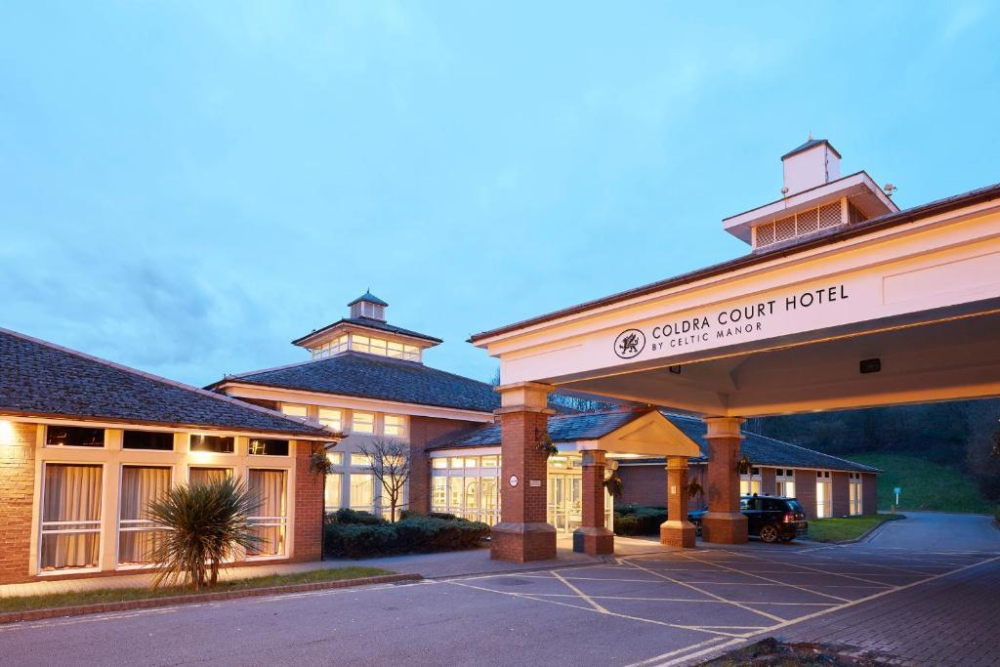
Figure 1: Coldra Court Hotel
(Source: Booking.com, 2025)
The work experience, in accordance with Najlae (2024), is designed around the following learning outcomes:
- Familiarity with Recruitment Procedures
- Improving Staff Relations
- Understanding Payroll Handling and HR Policies
- Creating Strategic Communication and Team Working Skills
Gibbs’ Reflective Model, as in Figure 2, will direct systematic reflection against work-based practice encouraging extended consideration of the contributions and functions of HR activities, according to Johnston, Clark and Shulver (2012). The reflective analysis employs widely accepted academic and industry paradigms to exhaustively evaluate practical HR strategy execution within Coldra Court Hotel.
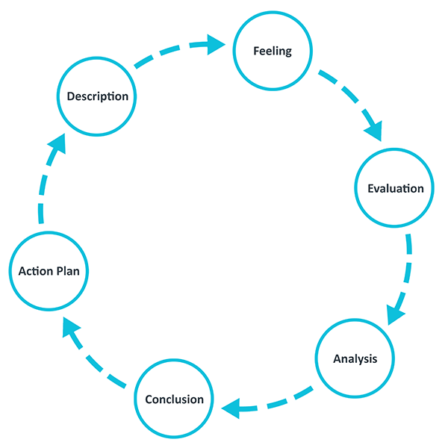
Figure 2: Gibb’s Reflective Model
(Source: The University of Edinburgh, 2025)

2.0 Reflection on Experience and Personal Development
Description
My observation of the supervisory work in the Human Resources section in Coldra Court Hotel offered in-depth understanding into the administrative practices required for premium guest service quality. The activity involved the monitoring of performance assessment, recruitment processes, scheduling employees and disputes. My experience gained in state-of-the-art HR systems and technological processes revealed ways in which the success of entire operations is delivered through efficient administration, as per Tewan (2009).
Feelings
My first experience of the supervisory function brought forth both excitement and fear. The setting required an acute awareness of procedural nuances and rapid decision-making creating a respectful awe of the intricacies of Human Resource management. This mix of excitement and guarded observation emphasised the importance of technical proficiency and transparent communication in a fast-paced work environment, according to Hagg (2013).
Evaluation
My field experience established that effective teamwork, communication and task management are essential for successful HR functions. Good examples involved problem-solving through teamwork and effective information sharing among employees. Infrequent instances of administrative inefficiencies, however, pointed out areas where improved task management and coordination linking can contribute further to the enhancement of service delivery, as also agreed by Rughubalan (2009).
Analysis
Hands-on experience complemented me with scholarly learning by demonstrating theoretical concepts in practice. Salem et al. (2023) stated that precise academic preparation in organisational behaviour and organisational theories can lay a solid groundwork for me that was substantiated through my observation, as shown in Figure 3. The experience proved that a combination of scholarly understanding and technical implementation is crucial to guaranteeing operational effectiveness in HR functions. Contemporary HR technologies became indispensable instruments in simplifying processes and improving guest service standards harmonising with formulated hospitality management concepts, as cited by Casado (2012) and Wood (2013). Moreover, these insights justify my constant improvement of competencies required in efficient administration of HR.
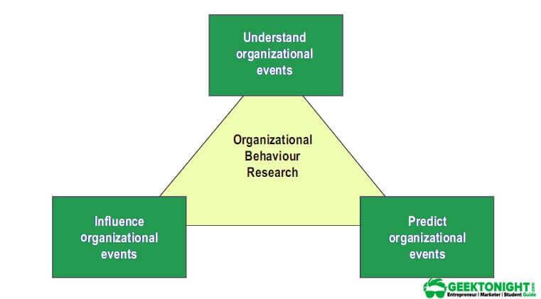
Figure 3: Theory of Organisational Behaviour
(Source: Geektonight, 2023)
Conclusion
My shadowing exercise greatly enhanced the comprehension of work-related skills and technical competencies in hotel management. Experiential insights reiterated the value of continuous vocational growth and the necessity for continued improvement in communication, team-working as well as task coordination skills to facilitate high-quality guest service (Bates, 2024). The reflections become a catalyst for my future career growth and enhanced HR practices.

3.0 Critical Analysis of Work-Based Skills and Technical Knowledge
Description
During the placement within the Human Resources unit of Coldra Court Hotel I practically monitored and experienced various work-related competencies and technical equipment needed in efficient hotel administration. For instance, I saw with my own eyes how sophisticated HR packages were being applied for monitoring employee performance, staff planning and enforcing company policy and thereby greatly eased admin work. The experience exposed me to transferring theory into practical implications in real practice.
Evaluation
I believe that a good balance of technical skills and interpersonal competencies is essential to ensuring operational excellence. Observation showed that the effective use of technology, good communication and even collaboration had a direct impact on guest service quality as well as staff performance (Musheke and Phiri, 2021). As also proposed by Fallon and Rutherford (2010), experience underscored the necessity to balance academic knowledge with the dynamic nature of hotel settings.
Analysis
Moreover, with respect to experience I acknowledge technical expertise in HR administration that minimises mistakes and enhances workflow. As an example, the electronic scheduling system not only made effective management of staff possible but also provided for timely, coordinated assistance to the guests’ needs. Effective communication and co-working became essential competencies making operations more effective overall, according to Vallen, Valen and Jerome (2014). My assessment of the experience made me observe that these skills have a direct influence on guest satisfaction and internal effectiveness, as evidenced by the quick resolution of administrative issues.
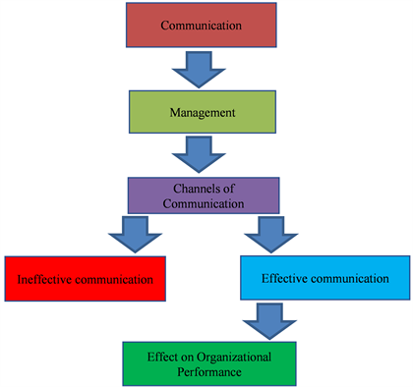
Figure 4: Effective Communication for Organisational Performance
(Source: Musheke and Phiri, 2021)

Conclusion
My experience asserted that balancing the skills acquired within the workplace with technical knowledge remains the key to effective hotel management. I am encouraged to build on these strengths further in my pursuit of advancement in hospitality management.

4.0 Reflection on Organisational Issues
Description
During the work experience with the Human Resources team of Coldra Court Hotel, I experienced a malfunctioning problem in communication channels of the department and also in those of HR in comparison with other parts of the operations of the hotel. It had taken place while transmitting changes of policies and the workers’ feedback to the corresponding authority had caused delays in the process of making decisions as well as disruptions of workflow.
Feelings
I was frustrated and worried as the communication lag not only hit internal staff morale but also extended to overall guest service. The lag in taking care of staff matters introduced tension and uncertainty affecting operational effectiveness.
Evaluation
Communication inefficiency reduced departmental performance to slower response times to employee inquiries and eventually, poor guest service (Sharbaji, 2021). Critical feedback got lost or was delayed slowing corrective action.
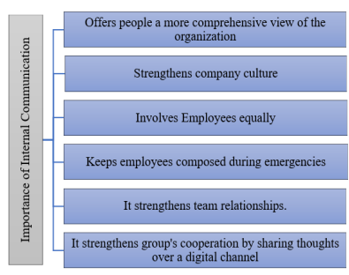
Figure 5: Importance of Internal Communication
(Source: Sharbaji, 2021)
Analysis
Looking back, I realise that effective communication is critical in coordinating efforts among different administrative functions, as per Figure 5. The problem can be traced to the lack of organised communication procedures and poor technology implementation both of which are critical in facilitating timely flow of information. Lack of explicit delegation and organised follow-up also added to the problem.
Conclusion and Recommendation
Therefore, to overcome this challenge, Leung (2022) proposed utilising combined digital communication systems and constant inter-departmental conferences to create openness and instant information availability. Additionally, having transparent communication strategies and educating employees fully about such systems should help in achieving better efficiency. Enacting such strategies will not only benefit the performance of the HR but will also advance total guest service as well as working harmony.

5.0 Conclusion and Action Plan
Conclusion
Shadowing exercise in the Human Resources Management of Coldra Court Hotel revealed the critical importance of work-specific skills and technical knowledge in effective hotel management. Practical experience of using performance monitoring, digital scheduling and official communication significantly enhanced operational efficiency and guest service. The experience itself combined with Gibbs’ Reflective Model and main theories of hotel management highlighted the imperative to connect theory and practice. It emphasised constant vocational development in ensuring excellence in service quality and competitiveness within the hospitality industry.
Future Action Plan
Therefore, to further boost expertise and professional development the following are suggested strategies, according to Suksutdhi (2024):
- Undertaking advanced HR management and digital systems training.
- Taking strategic communication and leadership workshops for better improvements.
- Pursuing hotel administration and operations certifications further.
- Practicing regular reflective practice and industry trends review can increase efficiency.
- Development of networking with industry players can enable to exchange best practices.
Application of the strategies will be anticipated to enhance technical skills and interpersonal skills, thus driving career progression in the ever-changing hospitality industry.

References
ASET (2017) Good Practice Guide for Work Based and Placement Learning in Higher Education. Sheffield: ASET.
Bardi, J. (2010) Hotel Front Office Management. London: Wiley.
Bates, C.A., (2024). Increasing Employment Outcomes for Culturally Diverse Students Through Experiential Learning in Higher Education (Doctoral dissertation, Northeastern University).
Booking.com, (2025). Newport: 130 properties found. [Online] Available at: https://www.booking.com/searchresults.html?aid=356980&label=gog235jc-1DCAsoUEISY29sZHJhLWNvdXJ0LWhvdGVsSDNYA2hsiAEBmAExuAEXyAEM2AED6AEB-AECiAIBqAIDuAKp_Yq-BsACAdICJGM4OGYxOTIyLWU1NzktNDU0Ny1hOTU0LWRlYjQ2NGEwOTgwOdgCBOACAQ&highlighted_hotels=38101&redirected=1&city=-2604041&hlrd=user_sh&source=hotel&expand_sb=1&keep_landing=1&sid=4b692bf0ae618fdc21ed3640294e722f [Accessed on 1st March 2025]
Casado, M. (2012) Housekeeping Management. London: Wiley.
Coldra Court Hotel, (2025). Search for accommodation. [Online] Available at: https://www.coldra-court.com/ [Accessed on 1st March 2025]
Fallon, M. & Rutherford, D. (2010) Hotel Management and Operations. London: Wiley.
Geektonight, (2023). What is Organizational Behavior? [Online] Available at: https://www.geektonight.com/organizational-behavior/ [Accessed on 1st March 2025]
Hagg, E. (2013) Internship Guide: Work Placements Step by Step. 5th Ed. The Hague: Eleven International Publishing.
Johnston, R., Clark, G. & Shulver, M. (2012) Service Operations Management: Improving Service Delivery. 5th Ed. London: Pearson.
Leung, R., (2022). Development of information and communication technology: from e-tourism to smart tourism. Handbook of e-Tourism, pp.23-55.
Musheke, M.M. and Phiri, J., (2021). The effects of effective communication on organizational performance based on the systems theory. Open Journal of Business and Management, 9(2), pp.659-671.
Najlae, I.E.B., (2024). Recruitement policy and company's strategy: how to optimize recruitment policy to better align with strategic objectives?.
QAA (2018) UK Quality Code, Advice and Guidance: Work-based Learning. London: QAA.
Rughubalan, G. (2009) Hotel Housekeeping: Operations and Management. Oxford: Higher Education Press.
Salem, M.H., Selem, K.M., Khalid, R., Raza, M. and Valeri, M., (2023). Humorous leadership, upward voice and resistance to change in the hotel context: from affective events theory perspective. European Business Review, 35(5), pp.737-762.
Sharbaji, Y., (2021). Role and impact of internal communication among employees within an organization in the digital communication era. Digikogu. Taltech. Ee.
Suksutdhi, T., 2024. Innovation model of human resources training and development for the hotel industry from the asean standard framework: A case in Nakhon Ratchasima Province, Thailand. GeoJournal of Tourism and Geosites, 52(1), pp.267-275.
Tewan, J. (2009) Hotel Front Office: Operations and Management. Oxford: Higher Education Press.
The University of Edinburgh, (2025). Reflection Toolkit. [Online] Available at: https://reflection.ed.ac.uk/reflectors-toolkit/reflecting-on-experience/gibbs-reflective-cycle [Accessed on 1st March 2025]
Vallen, G.K. & Valen, Jerome J. (2014) Check-In Check-Out: Managing Hotel Operations. 9th Ed. Harlow: Pearson Education Limited.
Wood, R.C. (2013) Key Concepts in Hospitality Management. London: SAGE Publications Ltd.

