

Postgraduate/Distance Learning
Assignment coversheet & feedback form

THIS SHEET MUST BE THE FIRST PAGE OF THE ASSIGNMENT YOU ARE SUBMITTING (DO NOT SEND AS A SEPARATE FILE)

For completion by the student:
Student Name: Anne Louise Day-Jones

Student University Email: 1704596@student.uwtsd.ac.uk
Module code: (AHAN7008)  Module title: HEAVENLY DISCOURSES | Student ID number: 1704596 |  |  | Educational support needs:  No

Assignment title: Compare and contrast the expression or representation of the sky in two works of film, music, art, architecture, celestial cartography or literature in their expression or representation of the sky.
.

Assignment due date: 31 May, 2019
This assignment is for the 1st 2nd 3rd 4 5th 6th x module of the degree
I confirm that this is my original work and that I have adhered to the University policy on plagiarism.
Signed ……………Anne Louise Day-Jones………………………………………………
Email submission:if you are submitting this form via email, please tick this box
(as a substitute for your signature) to confirm that you agree to the above declaration.
Assignment Mark
1st Marker’s Provisional mark
2nd Marker’s/Moderator’s provisional mark
External Examiner’s mark (if relevant)
Final Mark

NB. All marks are provisional until confirmed by the Final Examination Board.

For completion by Marker 1 :
Comments:

Marker’s signature: |  |  | Date:
For completion by Marker 2/Moderator:

Comments:

Marker’s Signature: |  | Date:
External Examiner’s comments (if relevant)

External Examiner’s Signature: |  | Date:

Essay 1 HPCA7008 HEAVENLY DISCOURSES
Compare and contrast the expression or representation of the sky in two works of film, music, art, architecture, celestial cartography or literature

This essay will compare and contrast the expression of sky in two buildings: The Globe Theatre (or Shakespeare’s Globe) London, UK, and the Scrovegni Chapel (or Arena Chapel) in Padua, Italy. It will begin with a brief introduction to the architectural structures themselves, and will then consider the sky’s expression within them, focusing on the sky’s role in orientating the observer, and as a potent medium within the spaces.

Introduction
The Scrovegni Chapel was commissioned by Enrico Scrovegni in 1303-05. It was decorated entirely by Giotto di Bondone (1266-1337) whom Giordana Mariani Canova describes as ‘the greatest painter of the Middle Ages.’ Giotto also participated in the chapel’s design. Two fresco cycles cover the side walls, narrating the life of Christ and of the Virgin Mary. On the entrance wall is a Last Judgement. The vaulted ceiling is painted a deep blue - with stars, and roundels depicting Mary and Jesus, Jesus, and various prophets (see Figure 1).
Shakespeare’s Globe, completed in 1997, is a faithful reconstruction of the original Globe Theatre (built in 1599, and then re-built, after a fire, in 1634) even down to the type of wood used. Inside, three tiers of seating surround a central ‘pit’, which is open to the sky, as shown in Figure 2. The stage is partially covered; sky images decorate this overhang (see Figure 3). Other sky images are painted on the walls behind the seating areas (not shown).

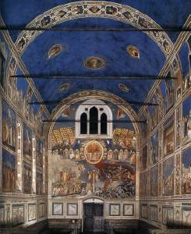

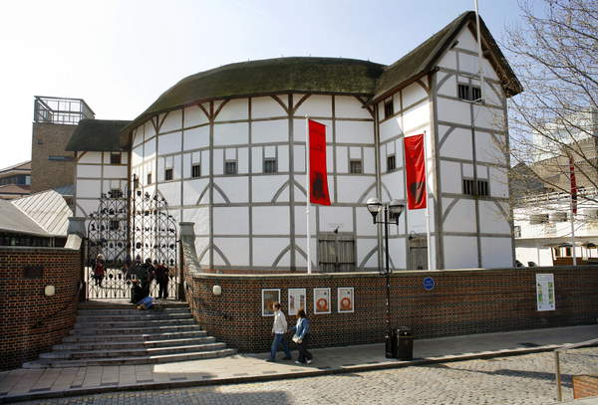

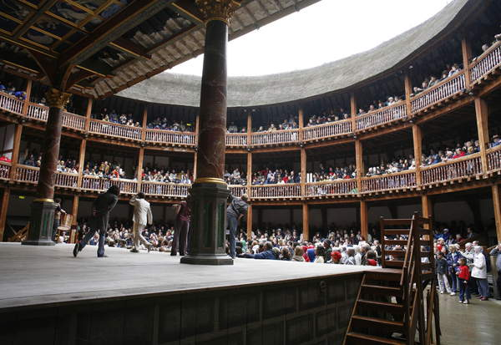

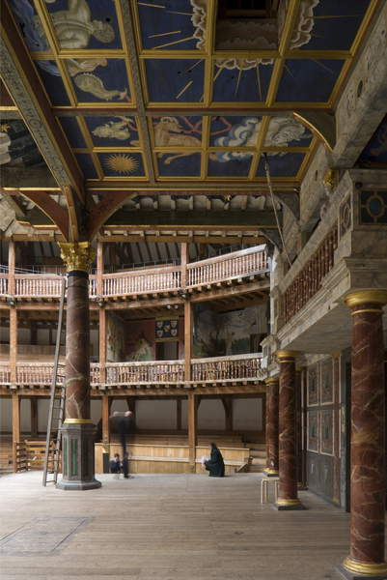

The sky as locator
Darrelyn Gunzburg notes the sky’s crucial role in humanity’s ability to judge time and to locate ‘ourselves externally and internally, physically and symbolically.’ This essay will begin with this focus, looking at where and when the respective skies locate the viewer.

The Arena Chapel
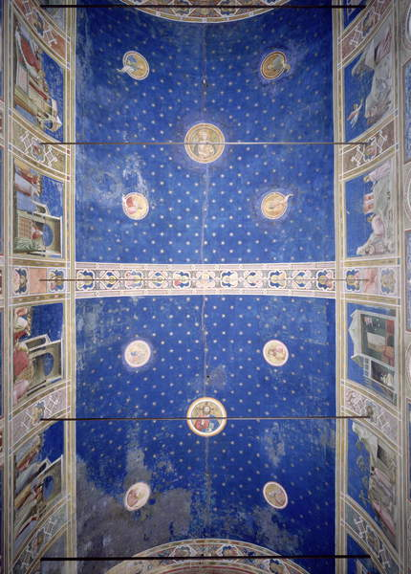
Fig 1. Vault
Shows stars are regularly arranged across the vault, against a deep blue background, which spreads down the walls and enters many of the fresco episodes.

The Arena Chapel
Giotto was praised for the realism he brought to art, by contemporaries such as Pietro d’Abano (1257-1315); Anne Derbes and Mark Sandona write of ‘the startling freshness of his observations.’ Yet the painted vault is not a realistic depiction of an observed night sky - it is a deliberately ‘unnatural’. Canova describes it thus: ‘above us in a starry azure vault, eternity looks down on the productions of time’. Instead of constellations, the stars are arranged in perfect geometric patterns, and instead of planets, we have the planet-like roundels of Christ, the Virgin, and saints. That Giotto was at pains to make this Christian sky nonetheless sensual and immediate to the viewer is spoken to in particular by the ‘plethora of candlelight’ effects, which Jacobus notes were built into the design of the chapel itself. Candlelight, for example, would have highlighted all the gold-painted elements of the sky, especially the stars, which were so painted as to ‘maximize glitter’. Angels would have appeared to float off the walls. Thus, with this sky, Giotto has located the viewer ‘externally and internally, physically and symbolically’ in the Christian Universe, which he has depicted – particularly under the effect of candelight – not as distant, but as alive and sensually present in the world of the viewer.
The themes of time and place are continued in the Last Judgement (Fig ?). At the top of the fresco, angels roll up the sky – which is revealed as a mere painting. Jacobus notes that this ‘peeling’ back of the sky happens on either side of a window, through which the ‘real’ mundane sky can be seen. (as in fig ) Here, then, two different skies are brought together, between them locating the viewer in relation to the sacred and the mundane, the fleeting and Eternal – as well as in relation to two different, specific times - now and Judgement Day.

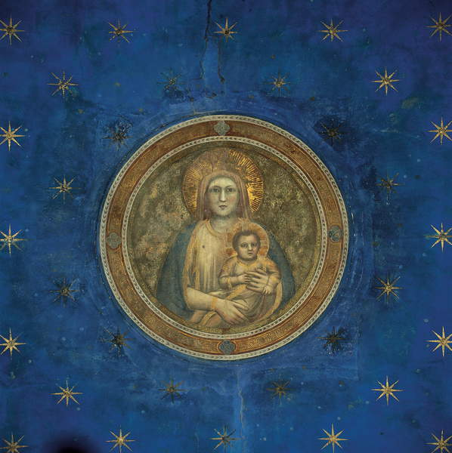

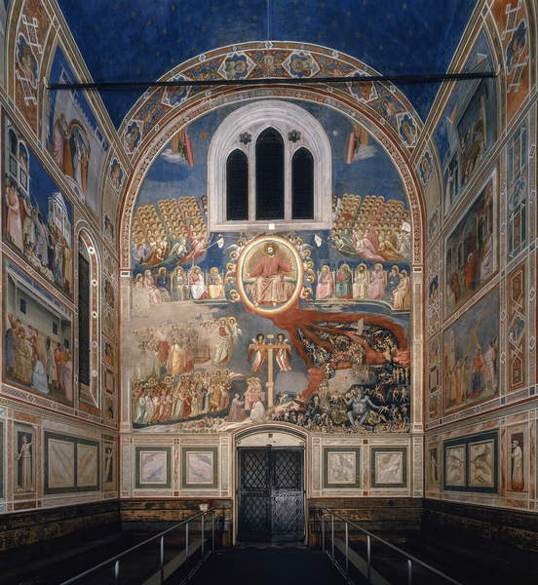

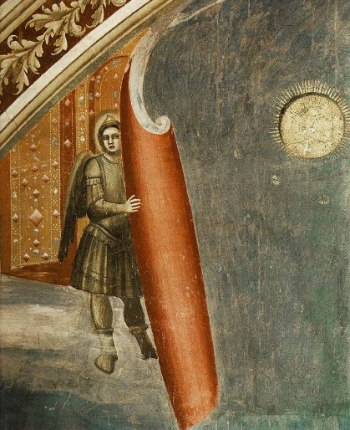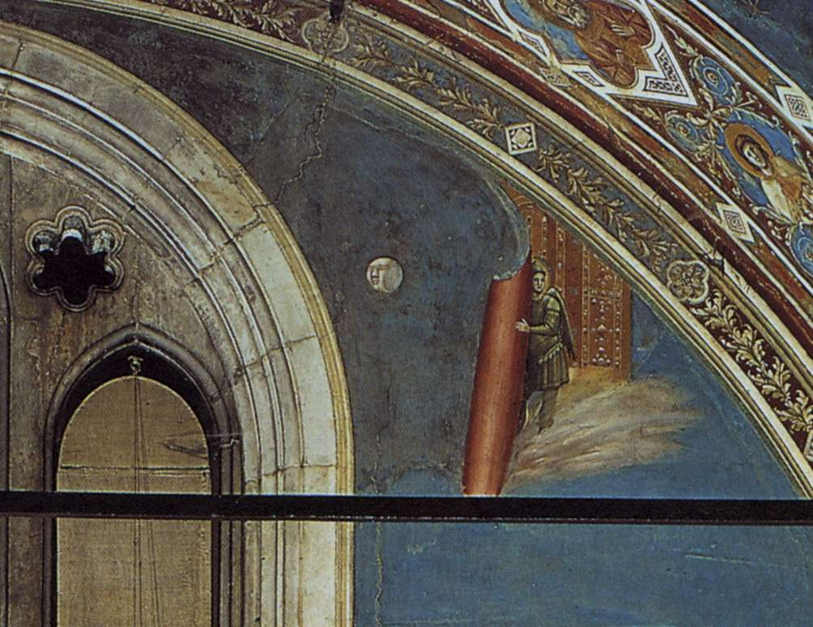

Shakespeare’s Globe
On a cloudless day, the open sky of Shakespeare’s Globe might also seem to be the unchanging, eternal sky, but it is not, it is, what Ingold calls ‘sky-in-formation, never the same from one moment to the next.’

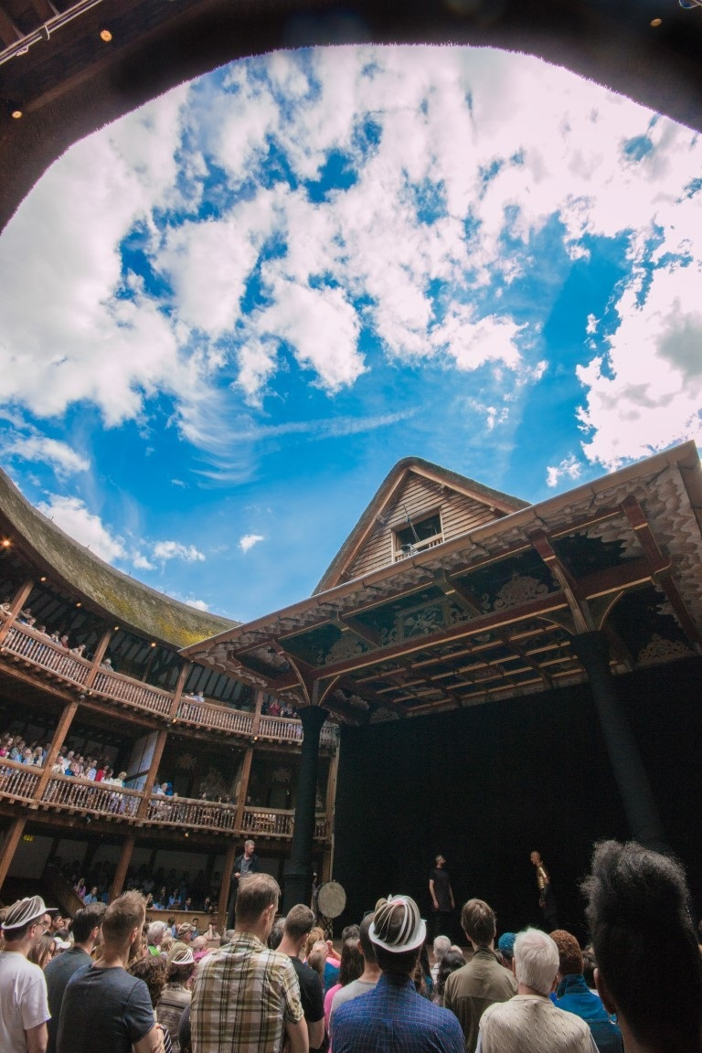

This moment-by-moment ‘sky-in-formation’ brings those under it into a keen sense of the present moment – especially when it is hot, cold, or wet. Francis Edwards has written that such an exposure, unfamiliar to modernity, was normal for a medieval people, who experienced ‘complete vulnerability … to the natural elements.’ The Globe box office speaks to this difference between past and present when they warn the public that:
The Globe is a reconstruction of an open air theatre designed in 1599 and cannot satisfy all 20th-century expectations of comfort and convenience …The theatre is open to the elements and performances continue whatever the weather.
Thus, there is a potential tension between being under a modern sky, yet having, perhaps, a historical experience of that sky. This effect can be heightened by the decoration of the Globe. Mulryne has noted that:
The decoration of the playhouse, which many will find over-elaborate, even gaudy, accords with Elizabethan taste and visual habits rather than modern … indeed, almost every aspect of the rebuilt playhouse will speak boldly of the distance between today’s theatre and the theatre of Elizabethan London.
Mulryne speaks of a distance between present and past. A letter from a child, posted on the Globe theatre website, speaks of being simultaneously in both worlds, under two skies:
‘when I stepped foot in the globe it was time shifting. I stared at the sky and thought I was staring at the same sky William Shakespeare would’ve 400 or so years ago….’
The Globe’s sky therefore locates the viewer both in the present, and in the past, especially, perhaps, when that sky exposes them to weather conditions which a modern public, unlike an Elizabethan public, is used to being sheltered from.
Thus sky, in both the Arena Chapel and the Globe, is expressed as a dialogue between two different skies - the mundane, ‘real’ sky, and another sky. In the Arena Chapel, this ‘other’ sky is the Christian sky of eternity; in the Globe, it is the sky of 400 years ago.

Sky as a potent medium

Sky as actor and unifier at Shakespeare’s Globe
Weather is, according to Harris, ‘one of the most powerful threads holding us together: it is what we share with everyone else who is in it, or under it.’ This essay has already looked at ways in which the Globe’s sky-as-weather links those under it to the past, but there are other ways in which it ‘holds us together’ in the present. Thomas Pettit, for example, states that his ‘most lasting’ memory at the Globe was of watching a play under steady rain. Under this rain, the performance was ‘effectively reduced to the basics of just keeping going and getting through, with the cooperation and encouragement of the audience a decisive element’. He relates how, at the end of the play, both audience and actors ‘applauded each other.’ In this way the sky is a medium which binds audience and actors together, and also an agent, that speeds up the performance, and turns the audience into an active participant in the play. Kiernan too has spoken of this in his discussion of the roof’s architecture:
If the roof had been tiled and with a substantial gutter, there would be little danger of the playgoers in the yard getting soaked, but less chance of discovering how the presence of the groundlings in the rain speeded up performance time and gave performances a different dynamic from those played in the dry.’
Yet even on a dry day, the common lighting that the Globe sky brings unites actor and audience and changes performance. (See Fig)
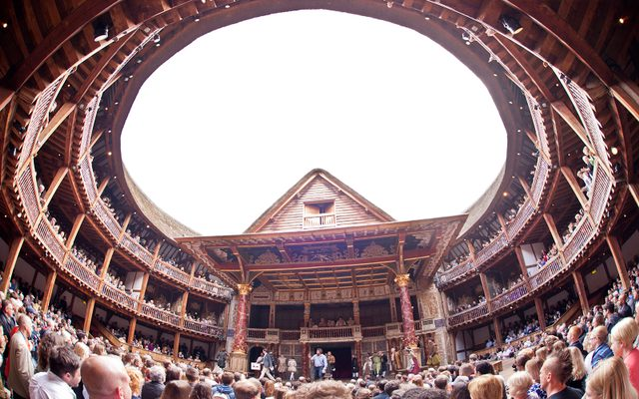

Giotto’s blue
If the sky in the Globe is a potent, weather-filled medium that acts to connect people beneath and within it, then the medium of Giotto’s sky in the colour blue itself. Heidegger writes that: ‘Blue is not an image to indicate the sense of the holy. Blueness itself is the holy, in virtue of its gathering depth which shines forth only as it veils itself’
Serena Romano writes of the abundance of blue in the chapel, as seen in figs – it fills not only the vault, but spills down into the frescoes below, mounting again in the Last Judgement on the entrance wall. A BBC documentary recounts that in Giotto’s hands, blue ‘was elevated to divine status’, that for Giotto ‘heaven was blue.’ The effect of this blue has been remarked upon by academics and bloggers alike. Romano calls the effect of the blue in the Arena Chapel ‘rasserenante e salutifero’ – that is, calming, serene-making, healthful. In a blog entitled ’50 shades of blue in Padua’ a travel writer enthuses ‘You have to see the blue – the Giotto blue, as I like to call it – which this chapel is filled with. It’s simply mesmerizing.
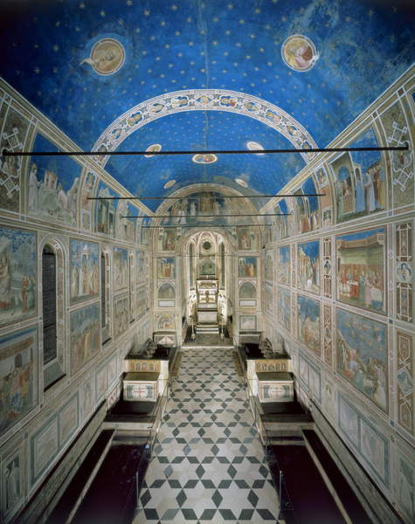
Thus Giotto’s blue sky not only represents the divine, it may be felt to share in the divine, however that is understood by the onlooker. Potent, like the Globe’s sky, it links that onlooker to a felt sense of that divine – whether that be through a sense of wonder, beauty, serenity, or simply a sense of health.

Conclusion
This essay has considered the expression of sky in the Arena Chapel and Shakespeare’s Globe. It found that in both cases, two skies are juxtaposed: Giotto’s sky of eternity, with the mundane sky, and the open sky of Shakespeare’s Globe, which while clearly connecting the viewer to present-day London, also – through decorative elements and through the sheer unfamiliarity of being exposed to the weather – in some ways brings the viewer simultaneously to a sense of being under a 16th century sky. The expression of sky in both buildings is powerful – in the Globe, the experience of being in the changing medium of a shared light and weather can unite actor and spectator. In the Arena Chapel, this uniting is in a sense a union with something ‘holy’ – however that is perceived, achieved through Giotto’s powerful use of blue.

Michael Viktor Schwarz, ‘Padua, its Arena and the Arena Chapel: A Liturgical Ensemble’, Journal of the Warburg and Courtauld Institutes, Vol. 73 (2010), 39-64, (47); Riccobaldo Ferrarese, quoted in Muarray 1953: 59-60, trans. Gunzburg), in Darrelyn Gunzburg, ‘Giotto’s Sky’ in The Imagined Sky, ed. by Darrelyn Gunzburg; Giordana Mariana Canova, ‘Padua and the Stars: Medieval Painting and Illuminated Manuscripts’, The Inspiration of Astronomical Phenomena VI, ASP Conference Series, Vol. 441, ed. by Enrico Maria Corsini, (San Francisco: Astronomical Society of the Pacific, 2011), (112).
Giordana Mariana Canova, ‘Padua and the Stars: Medieval Painting and Illuminated Manuscripts’, The Inspiration of Astronomical Phenomena VI, ASP Conference Series, Vol. 441, ed. by Enrico Maria Corsini, (San Francisco: Astronomical Society of the Pacific, 2011), (112).
Laura Jacobus, ‘Giotto’s Annunciation in the Arena Chapel, Padua,’ The Art Bulletin, Vol. 81, No. 1 (Mar., 1999), 93-107, (104).
Globe documentary, published by Gro Video Limited, Dec., 22, 2011) https://www.youtube.com/watch?v=b9uDK3xsLYk [accessed May 28, 2019].
Darrelyn Gunzburg, introduction to The Imagined Sky, ed. by Darrelyn Gunzburg (Sheffield: Equinox Publications, 2016), pp. ix-xvii, (ix).
J. Thomann, ‘Pietro d’Abano on Giotto’, Journal of the Warburg and Courtauld Institutes, 54 (1991), 238-244, in Canova, ‘Padua and the Stars’, 114.
Anne Derbes and Mark Sandona (2004:2) in Darrelyn Gunzburg ‘Giotto’s Sky’ in
Anne Derbes and Mark Sandona, ‘Barren Metal and the Fruitful Womb: The Program of Giotto’s Arena Chapel in Padua’, The Art Bulletin, Vol. 80, No. 2 (Jun., 1998), 274-291, (274).
Canova, ‘Padua and the Stars’, 114.
Jacobus
Jacobus, ‘Giotto’s Annunciation’, 104.
Tim Ingold, ‘Earth, Sky, Wind, and Weather’, The Journal of the Royal Anthropological Institute, Vol. 13, Wind, Life, Health: Anthropological and Historical Perspectives (2007), S19-S38, (S28).
Francis Edwards, Ritual and Drama: The Mediaeval Theatre (Guildford and London: Lutterworth Press, 1976), p.14.
https://www.shakespearesglobe.com/visit/faqs/#is-the-theatre-air-conditioned-or-heated
Thomas Pettitt ‘New Britain’s Dome’, author’s final draft of an article published in Anglo-Files. No. 122 (December 2001), 35-47, Danish Association of Teachers of English, page 9, available at academia.edu
Mulryne, Shakespeare's Globe, p. 16.
Globe website
Weatherland, p. 14.
Thomas Pettit, ‘New Britain’s Dome and England’s New Globe: Shakespearean Circulations’, author’s final draft (with a few technical corrections, 2014) of an article published in Anglo-Files. No. 122 (Dec., 2001), 35-47, (47).
Pauline Kiernan, Staging Shakespeare at the New Globe, (Houndmills, Basingstoke, Hampshire, and London: Macmillan Press Ltd, 1999) p. 5.
Kiernan, Staging Shakespeare, 5.
Heidegger, On the way to language, p. 166, in James Hillman, ‘The Azure vault: The Caelum as Experience’, in Sky and Psyche, ed. by Nicholas Campion and Patrick Curry (Edinburgh: Floris Books, 2006), pp. 37-54, p. 43.
Serena Romano
Blue: A History of Art in Three Colours, BBC4, James Fox and Matthew Hill, (BBC:2011).
Serena Romano, ‘Giotto e la nuova pittura’ in Il Secolo di Giotto nel Veneto, ed. by Giovanna Valenzano and Federica Toniolo (Venezia: IVSLA, 20007) p 8.
’50 shades of blue in Padua’, < https://www.trustandtravel.com/blog/scrovegni-chapel-padua/> [accessed May 28, 2019]

