Introduction
In this article it will analyses and evaluate the links between the principles and ethos of Education for Sustainable Development (ESD) and early childhood theory and pedagogy. There will be a critical analysis of Education for Sustainable Development and Global Citizenship (ESDGC) action in Wales in context of early childhood theory and pedagogy. I will look at the challenges and opportunities of developing early childhood practice which supports ESD/ESDGC.
According to Department for Natural Resources (2015) within the Well-being of Future Generations (Wales) Act, there are public bodies, such as Welsh Ministers, Local Authorities and Local Health Boards. These public bodies think about the future and how they can improve the ‘social, economic, environmental and cultural well-being of Wales’. ‘Working with people and communities and each other, looking how to prevent problems and taking a joined up approach’ to help Wales long term. Doing all these things will help look after the Wales we live in now and for the future generations. Following this act is important as we all need to work together, to help look after our world for us and the future. Here are the Well- being Goals from the Well – being of Future Generation (Wales) Act.
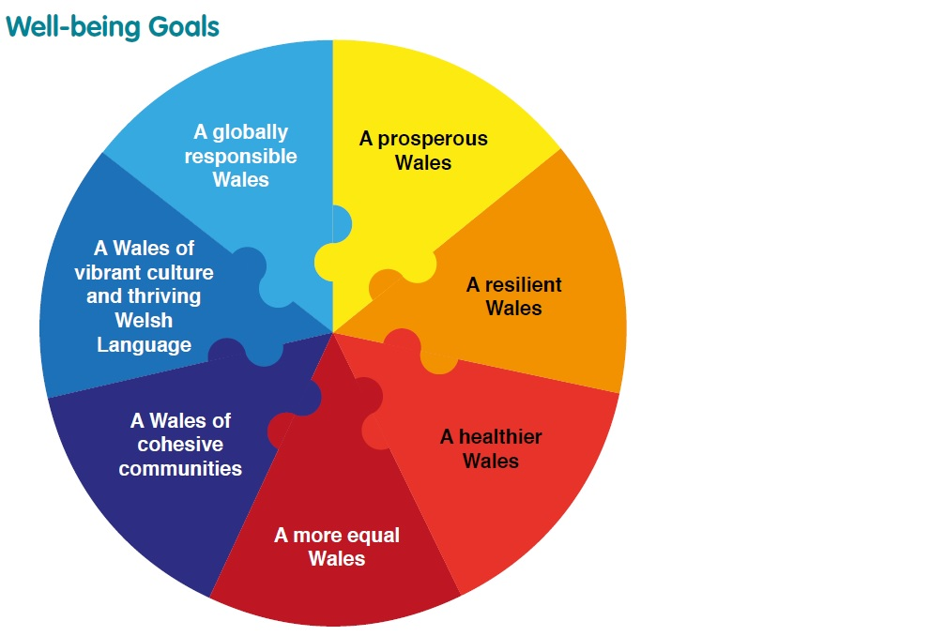

(Source: Department for Natural Resources, 2015)
According to López-Alcarria et al. (2016) Environmental Education (EE) is very important to teach to children because they are the future, and they need to learn about the environment and how they can help change what is happening to it. It is important that the learners understand and learn about the knowledge, values, skills, experience and determination which prepare them to act. Åhlberg (cited in Härkönen, nodate: 2) proposes that with in the Environmental Education, there are three strands, which include learning about the environment, learning in the environment and learning for the environment.
What is ESD/ESDGC?
According to Department for Children, Education, lifelong Learning and Skills (2008) Education for Sustainable Development and Global Citizenship (ESDGC) is the things we do in everyday life. ‘It is about the big issues in the world, which include climate change, trade, resource and environmental depletion, human rights, conflict and democracy’. ESDGC is how we treat the earth and each other, no matter which country we live. It is about how we prepare for the future and everyone in the world has a part to play.
As DCELLS (2008) states ESDGC is built around 7 themes, which is shown in the photograph below. The themes are:
- the natural environment
- consumption and waste
- climate change
- wealth and poverty
- identity and culture
- choices and decisions
- Health

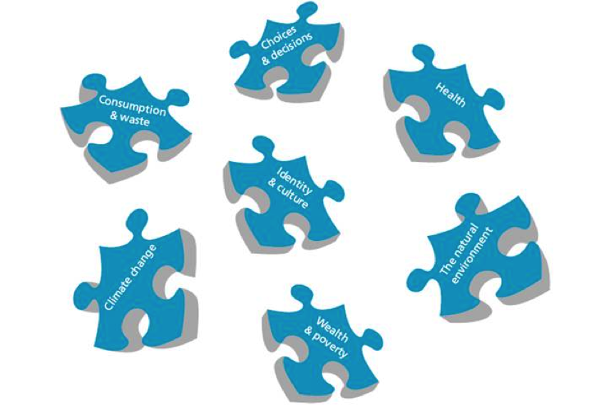

(Source: DCELLS, 2008)
Holistic approach
According to DCELLS (2008) ESDGC is an integrating theme with the curriculum in Wales. The ESDGC emphasises that there is a holistic approach to the education to learners. These should include allow learners prepare for challenges such as climate change and international competition for resources that will be in witness in their future. Allow learners understand the ‘complex, interrelated nature of their world’. Allow learners build and understand skills that will ‘enable them to think critically, laterally, link ideas and concepts’. ESDGC stresses that these ideas should be performed across the whole school. ESDGC should be holistic and realistic for the children, teachers, parents and community.
According to Nandish V (2003) Learning is one of human’s rights, it is a need that all humans express and do that in different ways, stages and societies. Being a holistic learner, they want to achieve the highest they can. The holistic teacher wants to help the learner develop as ‘critical, confident, independent learners’. They will also provide the learner with facilities that enable the learner to enable them in the real world. The holistic approach is defined as the ‘social process of allowing critical learners to claim ownership of the knowledge’.
According to Attfield and Wood (2005) Frobel saw children as individuals and as part of ‘the family and community’. He believed in the holistic approach and that learning should involve ‘the children, other adults and wider community’. Childrens natural goodness needed to be centred by encouragement and this could be done through educational practice. Steiner also believed in the Holistic Approach and through curriculum activities such as play, music, imagination and movement, the child develops.
Hands on experiences
According to DCELLS (2008) ESDGC emphasises the importance of experiential learning and hands on experiences. These activities are important to be done both indoors and outdoors and allowing the children to develop an ‘awareness of the environment and the diversity of the people who live there’. As Attfield and Wood (2005) states Frobel believed that childhood was a stage and not just being prepared for adulthood. Play, first hand experiences, child led activities and motivation all help children develop and learn about the environment. According to DCELLS (2007) the connection children have with the environment and the experiences children have in it, determine their attitudes and values. It has a positive effect on first hand experiences and that’s how children gain the most understanding of their natural environment. Within the picture below, it shows children out in their natural environment having first hands experience.
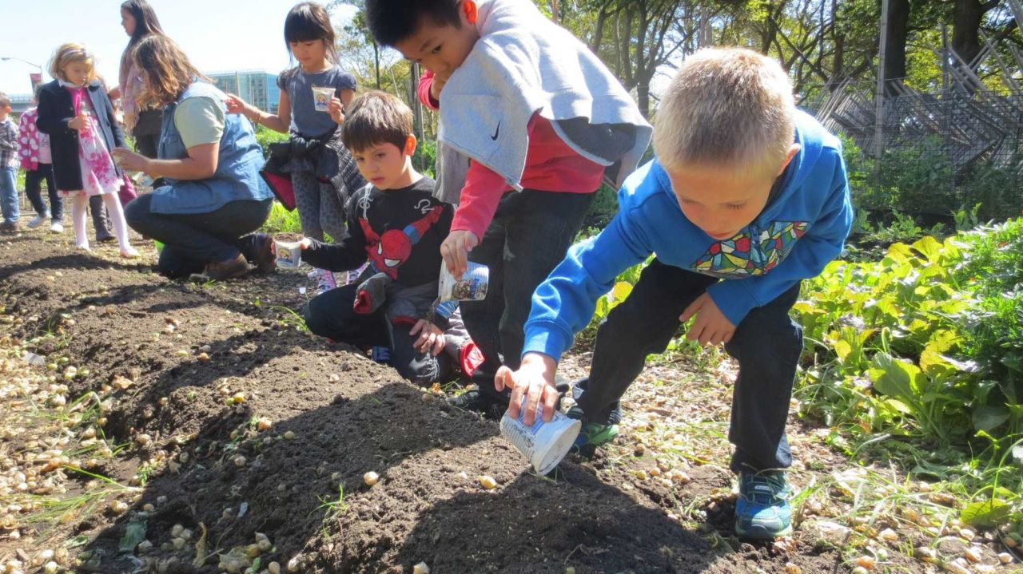
(Source: Holter, 2014)

Interdisciplinary
As Davis (2015) states that early child hood education have been incorporating holistic and integrated curriculum. For practitioner to take on an interdisciplinary approach, they must maximise the learning environments they have available for children, they can do this by exploring sustainability issues with young children that concern both them and the environment. These experiences are enriched when ‘family’s cultural and local knowledge’ is used to help with exploration of the issues, the children discussed. From engaging an interdisciplinary approach, it allows children to be creative, encourages sharing learning experiences, allows children solve issues using different ideas and knowledge, creates opportunities for families and the community to share their knowledge and experiences and values practise and childrens learning strengths and interests.
Student led and teacher as facilitator
According to Davis (2015) ‘relationships with adults are a cornerstone of early childhood pedagogy’. Adults are known as co-learners, interpreters, facilitators and role models. Carson (1959 cited in Davies, 2015:47) urges practitioners to be the significant adult to promote childrens connections with nature and the environment. It is also important for practitioners to create these learning environments for children to benefit children and all other living things. As Attfield and Wood (2005) point out Frobel thought that the adult should be facilitators and to just support the child rather than lead. Steiner also believed that the role of the adult was extremely important for children to develop and that the teacher should facilitate. Dewey emphasised that children should be ‘co-constructers of their learning’ and they should be active in decision making which relate to their learning environments and experiences. As Muirhead (2017) states Reggio Emilia parents are huge influencers in their learning on a daily basis. There are plenty of opportunities for families and communities to get involved with childrens development. Reggio Emilia approach allows children with a student led environment and defines roles of all the partners. They believe children are collaborators and communicators, teachers are guides and researchers and parents are partners. They also promote that the environment is a third teacher. Reggio Emilia believe parents provide the ultimate welfare of students and they are the Childs first teacher.
Challenges and Opportunities
As Davis (2005) states there are not many early years education centres that demonstrate environmental education practice. Also there are only a few of research publication that focus on early childhood education for sustainability. There is also a lack of studies that show how early childhood should be incorporating sustainability in to their everyday curriculum practices. So the question is why do all school not follow ESDGC or combine it within their curriculum? According to Davis (2015) within early childhood education there is still big gabs to take on the ESD principles, theories and approaches. Early childhood settings may think that they are under – prepared, under – resourced and under – researched, this may be why not all early years’ settings haven’t yet embedded ESD within in their day to day curriculum. As DCELLS (2007) practitioners feel that they are hampered from facilitating exploration of the environment within formal education. The practitioners feel like they are ‘pressured by the curriculum, there are health and safety concerns, lack of confidence and restricted budgets’.
According to Davis (1998) environment education is not a subject or a add on to current curriculum, it is not an option either. It is the way we think and the way we put that in to practice. Early environment education allow strong relationships to grow between people and between people and the earth. Practitioners understand childrens attitudes and values towards numeracy, social interactions, creativity and literacy, as practitioners believe that parents and teachers roles are important to shaping these attitudes and values. However practitioners ignore how important it is to shape childrens attitudes and values towards environmental education. As Davis (1998) points out Pestalozzi, Froebel, Montessori and Dewey believed greatly in childrens learning and development enhanced through environment experiences, using natural materials. They also emphasised that early childhood programmes should continue to support children having these opportunities. There are already strong links between environmental education and early childhood curriculum, these are:
- They both build sustainable relationships
- They both emphasise on the idea of wholism and the connection with the world
- They both focus on the childrens learning, attitudes, values and skills
- And they recognise how important of empowerment for learners, parents and practitioners.
As Davis (1998) argues it is surprising to still find how many early childhood settings that do not focus upon ESDGC. ‘Children can learn sustainable practices through gardening, composting, adopting water use minimisation strategies and through repairing soil erosion’. Practitioners can ask different questions to include environment education in to their curriculum, and engaging in efficiency practices. It is aware that there is a challenge to ‘incorporate environmental education into current teacher education programmes’. Teacher networking is a useful way for practitioners to build on knowledge, views and interest and to expand on it.
Even though expanding awareness and understanding of environmental education will not be easy, especially with the diversity of services, settings and qualifications within the early childhood sector, networking actually reinforces the non-hierarchical, democratic, collaborative ways of working that are the hallmarks of both early childhood and environmental education. In the end, this may prove to be the most effective way of building momentum for environmental education and ensuring that it is no longer left off the mainstream early childhood agenda.
(Davis, 1998:12)
According to Davis (2015) Bronfenbrenner believed in the ecological system theory, shown below in the picture, shows how his theory works. He believed that the child is a living system, which embedded and influenced boarder systems. There are different layers within his theories, such as, Microsystems, Mesosystems, Exosystems and Macrosystem. As Paquette and Ryan (2001) states The Microsystems is the closest layer to the child and has direct contact. It included people like teachers, parents and the community, this is when the Mesosystem comes in and connects the teachers with the Childs parents and with the community. The Exosystems involves the Childs development but do not involve the child directly, then lastly the Macrosystem which is ‘comprised of cultural values, customs, and laws’. As Davis (2015) states this theory recognises the child’s place within the ecosystem and the influence the child has on it too. According to Paquette and Ryan (2001) Within schools, it is important for teachers to gain a strong and stable long term relationship with the children however, Bronfenbrenner believes that the main relationship the child has with someone need to be the one who provides care that is meant to be forever. Schools and teachers, do provide an important role, but to Bronfenbrenner it is seen as secondary. Schools and teachers, should do their utter most to support and influence the primary relationship for the child.
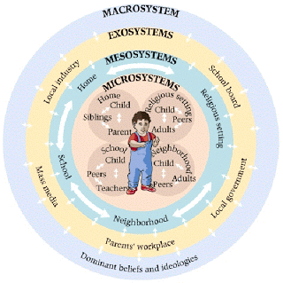
(Source: Learningneverstops, 2013)

ESDGC action in Wales
According to Tinney and Merriman (nodate) the Welsh government has been promoting sustainable development and encouraging early childhood education settings to promote it to children, within all age groups. As Tinney and Merriman (nodate) states that many authors point out that children learn about sustainable development through education. Welsh government suggest that ESDGC should be approached through the whole setting and interconnect the seven areas of ESDGC, within the curriculum. There are concerns that young children may feel overwhelmed by issues such as climate change and poverty. However, within the United Nations Convention on the Rights of the Child (UNCRC) point out that Article 29, states that ‘education should encourage children to respect others, human rights and cultures. It should also help a child to learn to live peacefully, protect the environment and respect other people’. As UNICEF (2010) point out The United Nations Convention on the Rights of the Child states that in Article 12 ‘Every child has the right to express their views, feelings and wishes in all matters affecting them, and to have their views considered and taken seriously’. As Tinney and Merriman (nodate) states the links between ESDGC and early years may be problematic, as many practitioners felt that it was adding an extra subject to the national curriculum and also would be too difficult for children to participate.
According to Tinney and Merriman (nodate) ‘early childhood play based and experimental learning naturally is important for children to engage in sustainability education. Practitioners could introduce it within activities such as, gardening, cooking and building, as these promote the seven themes of ESDGC, within the seven different areas of the Foundation Phase. This means the ESDGC is not an add on, just simply embedding the ESDGC framework with the curriculum. Tinney and Merriman (nodate) suggest that ESDGC values that ‘children being kind, willing to share and looking after one another and all living things, are encouraging them towards empathy, respect and responsibility’.

Example
One activity children could get involved with which covers both The Foundation Phase and ESDGC is gardening. This activity covers both the seven themes from ESDGC and the seven areas of learning from The Foundation Phase. Firstly, from children doing an gardening activity, they follow the Foundation Phase curriculum by counting flowers and seed, measuring water, measuring how deep to put the seeds and how tall the plant grows. This links with the Mathematical development, which is one of the seven areas of learning, from the Foundation Phase framework. Next is adding the Welsh language, the practitioners could be asking questions in Welsh, learning the Welsh names of plants and flowers. Then, the practitioner could be asking questions to the children for them to learning about the knowledge and understating of the world they live in, they could ask ‘where does water come from?’ or ‘where is this plant originated from?’. By doing gardening children cover the physical development, as they are using fine and gross motor skills, carrying and digging. Allowing children to plant the seeds where they want too, choosing the plant pots and what plants they want to see in their garden, shows their creative development. Children communicating with eachother and the practitioner, asking questions and writing out plans, shows they are covering the language, literacy and communication area. The personal and social development, well-being and cultural diversity area, can be covered by children learning where the plants come from, or where they would be found in the world. Children learning what other counties plant or grow such as coffee beans and bananas. (Department for Education and Skills, 2015)
To then embed the seven themes of ESDGC within this activity, children just need to be asked the correct questions. For children to cover Health, children need to be made aware of washing hands after gardening, if they are planning vegetables or fruit, understanding they are healthy. For children to cover choices and decisions, they get to choose what to grow, where the seeds are brought and how everyone will work together. Children need to understand where soil comes from, can we recycle the rubbish and not using too much water, covers Consumption and Waste. Children being asked where the seeds come from, did they come along way and where does the plant come from? Covers Climate Change. For children to include Natural Environment, children need to be asked, could growing these plants have benefits on our community? How will the children get rid of waste and not to damage any natural environment when gardening. Covering Identity and Culture, children need to discuss where the seed or plants come from? Visit a seed shop and discuss what could be made with the vegetable or fruit when it has grown. For children to include Wealth and Poverty they need to, discuss what type of life the children have, growing the plant where it comes from have. (DELLS, 2008)
Conclusion
To conclude on this article, there are many challenges and opportunities of

