
Student Name: Mihai-Daniel Mihalcea
Student ID: 2244870
Module: Sustainable Hospitality & Tourism Management (BMIH 5006)
Word count: 2159
Tutor: Daniel Payne
Module Lead: Lisa Knight

Al Acknowledgement:
I acknowledge the use of Copilot (https://copilot.microsoft.com/) on March 5, 2025, to check my work using the prompt(s):
1. Please check the following text for readability, grammar and syntax. I confirm that I have not presented any AI generated text as my own work. I confirm I have copies of my drafts, notes, and other resources I used before, and after the use of AI tools which I may be asked to provide in evidence.

Executive Summary
This paper aims to assess the bus transport means, especially within the context of sustainable tourism within the hospitality business. The project addresses four key resources: Time because buses take time to fill up as compared to refuelling vehicles, Energy in terms of fuel used in the vehicles, Health whereby traditional diesel buses lead to pollution and the last natural resource is the Environment due to the polluting nature of traditional diesel buses. One of the outcomes of the change to electrical and hydrogen buses is discussed in the technological, operational, and policy aspects (Gov.UK, 2022). The changes include battery efficiency for electric and hydrogen buses, implementation of necessary infrastructures as well as government policies. London and Oslo set up incentives promoting the usage, as well as charging facilities that lower emissions and enhance the quality of the air in urban areas (Transport for London, 2024). Therefore, the report has highlighted the following measures for increasing sustainability such as emission reduction technologies, integration of renewable energy, improved operation procedures and positive government policies. The information on the UK experience and other world cities is provided in the form of case studies, which describe the best practices in the sphere of sustainable transport. Overall, the results presented in the paper imply a need for more financial incentives, Public-Private Partnerships, as well as attitude change to promote the use of environmentally friendly buses. When employed, the above recommendations could help to easily cut carbon footprints, enhance the mobility of cities, and hence lead to a green hospitality sector.
Table of Contents
Executive Summary 2
Introduction 4
Main Findings 5
1. Environmental Impact 5
2. Sustainability initiatives 7
3. Possible Solutions 9
Conclusion 12
Recommendations 13
References 14

Introduction
Transportation in the hospitality industry is a significant aspect of sustainable tourism since it enables tourists to travel between accommodation facilities and travel destinations. Hospitality transport refers to the transportation services of guests within or around facilities in the hospitality industry. It is not just about cars; it is about mobility in comfort and style, and quite often in luxury. Others are hotel transportation, airport transportation, limousine services for occasions, and leisure transportation for entertainment among others. The use of buses has been accepted globally because they are cheaper and could have reduced effects on the environment as compared to single-occupied vehicles (Statista, 2023). To understand the idea of sustainability regarding the extensive use of buses in urban and rural tourism, this report aims to focus on buses. It also discusses risks and potential solutions of environmentalism within the hospitality industry.

Main Findings
Buses form a significant part of the public transport infrastructure within the UK and because of their costs and flexibility, it is an important means of transport to the people within the UK both locals and tourists. Nevertheless, their operation has created some environmental issues about sustainable development within the hospitality and tourism business.

Environmental Impact
Emissions and Pollution: Traditional diesel buses release large quantities of Carbon Dioxide (CO₂) and nitrogen dioxide (NOx) contaminating the environment and worsening climate change. The domestic transport emissions of the UK in 2022 were 112.5 million metric tons of CO₂ and contributed to 26% of the overall emissions by the country (Department for Transport, 2024). Buses on the other hand emit much less greenhouse gases than private cars on the road in urban areas. The Public Transportation Sustainability Indicator List (PTSIL) is designed to take into account such impacts by presenting indicators in several environmental fields combined with economic and social aspects (Irsfeld, 2022). It considers environmental, economic and social footprint to evaluate the degree of sustainability in transport systems. Potential positives for UK buses include convenience and accessibility. Nevertheless, drawbacks include high emissions (environmental), especially from old vehicles and the possibility of traffic congestion effects (social/economic).
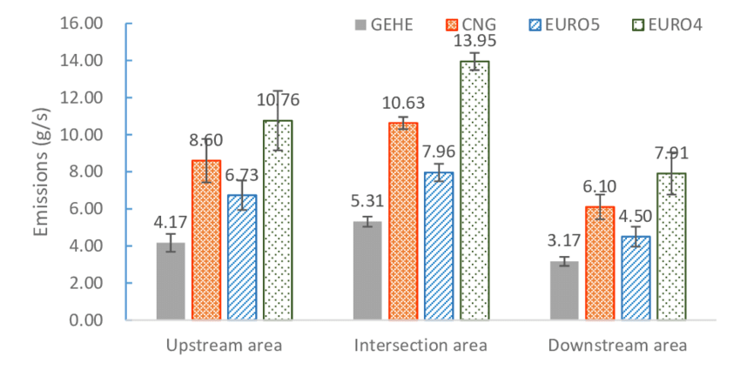
Figure 1: CO₂ and NOx Emissions Comparison (Gov.UK, 2022)
The following graph compares emissions in different areas such as Upstream, Intersection, and Downstream from various bus types: GEHE, CNG, EURO5, and EURO4. CNG bus emissions are the highest at intersections (13.95 g/s) and the lowest emissions are of GEHE in all sectors (Gov.UK, 2022). EURO4 consistently emits more than EURO5. These statistics demonstrate the energy-related unsustainability of various types of buses and stress the imperativeness of the greener form of transport to boost sustainability in the hotel industry.
Resource Consumption: There is a high dependence on non-renewable fossil sources of energy. The use of fuels for extraction, refining, and consumption not only reduces the availability of these resources but also affects the environment (Jauhari, 2021). According to the Sustainable Transport Planning Index, switching to electric buses requires the creation of a charging network and additional energy consumption, and energy sources must be produced sustainably (Broniewicz and Ogrodnik, 2021). Extending the use of electric buses in the UK requires charging infrastructure such as those being implemented in London. More energy is required in the current world and the development of renewable sources like offshore wind farms becomes essential. Without it, the environmental gains are lost, and pollution might simply be displaced.
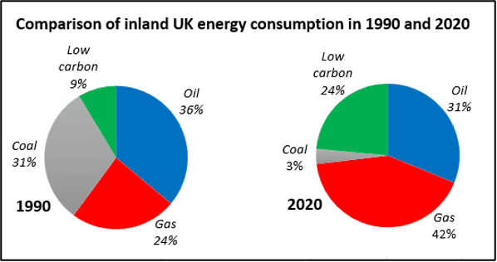
Figure 2: Fossil Fuel Dependency (Gov.UK, 2022)
The British energy use by source in the years 1990 and 2020 revealed that coal usage was reduced from 31% to 3% whereas low-carbon energy sources increased from 9% to 24% (Gov.UK, 2022). The amount of gas used had risen from 24% to 42% mainly because of an inclination to shift to clean energy (Gov.UK, 2022). This transition is essential for lowering the emission profile of public transportation while also considering the issues of sustainability within the hotel business and better utilisation of cleaner resources.
Community Disruption: Diesel buses cause noise pollution, and traffic congestion which negatively affect communities and tourists. According to Lowe et al. (2022), The Sustainable planning Index considers social improvement by reducing these disruptions. For example, in today's complex traffic environment, the average speed of buses in big cities such as London has reduced to 6.6 mph which is even slower than walking speed (Transport for London, 2024). It negatively impacts public transport systems. The diesel bus noise and traffic affect the quality of life of inhabitants and tourists interrupting their stay such as London's bus speeds which are slower than that of walking (Transport for London, 2024). Some of the measures are bus priorities, tolls, and smart signals to organize bus movement to give priority, clear congestion and make its services faster.

Sustainability initiatives
Therefore, the actualisation of electric buses in the UK brings about sustainability issues in the operational, technology, policy, and consumer spectra.
Operational Barriers and Technological Constraints: Electric buses and their underlying systems are capital-intensive since they need a large sum at the outset. For example, VEV is to install high-powered DC charging infrastructures for more than 150 electric buses in 4 depots in Leamington and Nuneaton and integrate solar power systems with charging stations (VEV, 2024). This project reduces carbon footprints despite the costs.
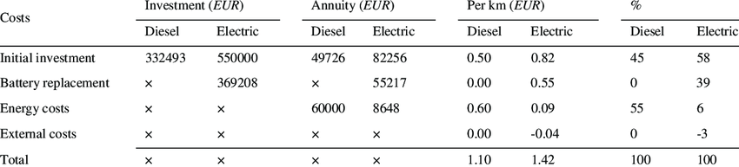
Figure 3: Cost Analysis of Electric vs. Diesel Buses (Statista, 2023)
The graph shows that electric buses require more capital investment (€550,000) and battery replacement expenses (€369,208) as compared to diesel (Statista, 2023). On the downside, operational costs contain high initial costs and demand for infrastructures. Thus, electric fleets also present operational challenges, especially with batteries, which are their health issue such as cold weather vulnerability and proper disposal such as battery discharge and failures (BBC, 2025). That’s why electric buses in Glasgow struggle in subzero temperatures, causing battery failures to be an essential issue. Also, a limited charging network worsens the problem. So, expanding infrastructure across urban and rural areas is key to improving services.
Policy and Regulatory Issues: The UK has provided a fair and unrealistic support system such that the regulatory system sometimes fails to offer adequate support to green public transport projects (BBC, 2024). For instance, this is a threat to local manufacturers such as Alexander Dennis as international producers pose a threat due to subsidy laws and hence can't be favoured. So, concerns about job losses show the need for balanced environmental and economic policies.
Consumer Behaviour: According to behaviour change theory, efforts to promote a change from private car usage to public buses are still not easy (Hauslbauer et al., 2022). This is consequently discouraging to potential passengers through perception of inconvenience, for instance in terms of routes or the number or frequency of services provided. In this context, more reliable and better-covered public transport needs to become consumers' first choice to shift their patterns.

Possible Solutions
The advancement of sustainable transport in the context of hospitality depends on type, feasibility and adoption based on the Tripple Bottom Line concept. As electric buses have fewer emissions (Planet), the high costs of adopting this form of public transportation are its drawbacks (Profit) (Ali et al., 2023). So, Incentives need to be employed to help alter consumer patterns (People) in favour of sustainable Public transport solutions.
Emission Reduction Technologies: One of the key measures aimed at reducing emissions in public transport involves using electric and hydrogen fuel cell buses. FirstGroup, Britain’s largest transport operator has recently set the goal of having a non-emitting fleet by the middle of this decade (First Group, 2023). Regarding this goal, they have pledged large-scale commitments towards electric and hydrogen buses to cut down greenhouse emissions drastically. Hybrid engines combining fuel combustion and electric power offer an interim solution (Senol et al., 2023). Such vehicles can reduce emissions during the process of conversion to electric or fully electric buses when these are still being developed. For instance, FirstGroup has a detailed environmental management plan to replace all of its bus fleet with zero-emitting ones (Firstgroupplc.com, 2024). This not only tackles the environmental issue but also serves as a model for the public transport sector showing that cleaner technologies are viable and should be embraced. This entails working with manufacturers to source the latest generation of vehicles and building the requisite demand and infrastructure.
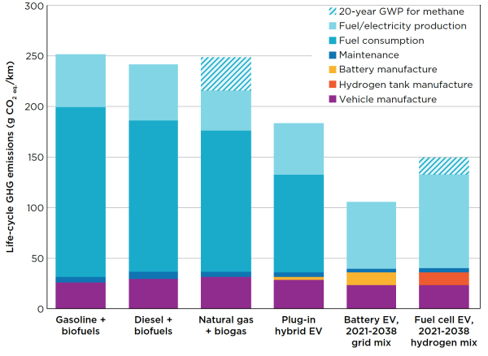
Figure 4: Emission Reduction Potential by Technology (Senol et al., 2023)
The following figure compares life-cycle greenhouse gas (GHG) emissions (g CO₂-eq/km) of different vehicle types. The highest ratio is represented by gasoline vehicles (250), followed by diesel (230), and natural gas (260); however, battery electrical vehicles (80) and fuel cell Electrical Vehicles (EVs) (100) reduce the emissions to a large extent reflecting the role of low-emissions technologies. This reflects light on the cut-emission advantages of EVs, using cleaner energy type; less usage of fuel and showing the potential eco-technologies for a better environment.
Renewable Energy Integration: Charging buses at these central go through renewable sources like solar and wind is thus the way to make electric transport green (Chen et al., 2022). The use of renewable energy has been an excellent way of lowering the reliance on fossil fuels and consequently frustrates emissions concentration. It is further added that this approach also helps in achieving environmental goals as well as enhancing energy security and may eventually result in cost optimisation. For instance, Derby has become a leader in sustainable tourism as it is well-connected with transport facilities to other beautiful places in this region (Marsh, 2021). This reveals an eco-friendly approach by promoting bus transport for tourists and improving the city’s environment. It reduces vehicle usage time cuts emissions and offers visitors the most convenient route to attractions.
Sustainable Operational Practices: Making effective changes in the route planning process and the eco-driving technique can lead to less fuel consumption and pollution outcomes (Sadrani et al., 2022). Reducing the travel distances and time spent at terminal points helps in the improvement of the overall efficiency of the buses. Other factors which could be enhanced to reduce fuel consumption include the training of drivers in inefficient driving practices including the sensitivity of the gas pedal and brake (Magazine, 2024). But the following factors play a very important role in vehicle efficiency and durability, which enhances the sustainability goal such as timely servicing of vehicles. For instance, in the case of Transport for Wales, there is the Walker Visit Wales pass that allows for free bus travel throughout the country (GOV.WALES, 2024). This initiative encourages tourists to use public transport, reducing the use of private transportation and emissions. It ensures affordable convenient tourism and highlights integrated transport benefits.
Policy Recommendations: Shaterabadi et al., reveal in their study (2022) there is a need for government interventions through incentives, tax credits and subsidies to promote the formation of green fleets. These are also helpful for setting up the actual expenses to operate electric and hydrogen buses since it becomes easier for operators to embrace innovation. Higher emission standards and strict regulations on public transport foster a continuous improvement of environmental friendliness in the field (Kwilinski et al., 2024). Transport operators must be supported by increased funding and tax incentives in an attempt to bring forward the transition to zero-emission fleets. Partnerships between government agencies and transport providers will be crucial for developing a responsible public transport system (Henna Sundqvist and Tuominen, 2023). For instance, according to Transport Scotland (2024), the Scottish government offers free bus passes for senior citizens hence boosting the uptake of public transport for this category of people. This policy does not only enhance social inclusion but also fosters environmental conservation through enhancing the use of public transport.

Conclusion
In this study, an analysis was made of the environmental effects of using buses as a mode of transportation in the hospitality sub-sector, including sustainability issues and measures. Buses are of great importance in the provision of sustainable tourism since they encourage the discouragement of the use of personal cars, thus reducing gas emissions and traffic congestion. Inefficiencies such as high operating costs, poor technology, and inadequate policies act as barriers to the green buses transition. However, the adoption of emission reduction technologies, integration of renewable energy and favourable policies can improve the sustainability and operations of Public Transport in the future.

Recommendations
To improve the sustainability of buses in the hospitality business, the following measures can be implemented. Firstly, governments' involvement should be enhanced due to the high fixed costs involved in the undertaking. The UK has invested £525 million in zero-emission buses (Nalina Hamsaiyni Venkatesh and Laurencas Raslavičius, 2024). However, these policies, taxes and grants can reduce financial barriers. Secondly, there are additional possibilities to expand the charging infrastructure through Public-Private Partnerships (Kou et al., 2024). Such arrangements are not mutually exclusive and they show how other transport operations, such as First Bus have invested in smart charging solutions with Hitachi adequately. Thirdly, the prompting of hotels to use public transport can lead to a change in consumer behaviour. Some of them are Iconic Luxury Hotels which provide rail incentives and Green Pearls 'guest tickets supporting public transport (Green Pearls GmbH, 2024). This way, the hospitality sector is capable of cutting down its ecological impact while improving the mobility of tourists and sustainability factors.

References
- Ali, N., Nakayama, S. and Yamaguchi, H. (2023) 'Using the extensions of the theory of planned behaviour (TPB) for behavioural intentions to use public transport (PT) in Kanazawa, Japan', Transportation Research Interdisciplinary Perspectives, 17, p. 100742. Available at: https://doi.org/10.1016/j.trip.2022.100742.
- BBC (2024) ‘Bus manufacturer Alexander Dennis warns of 160 jobs at risk’, BBC News, 12 September. Available at: https://www.bbc.com/news/articles/cx292n5d4qlo (Accessed: 22 February 2025).
- BBC (2025) 'Glasgow electric buses were withdrawn over 'technical failures'', BBC News, 8 January. Available at: https://www.bbc.com/news/articles/cx2w2nd5g17o (Accessed: 22 February 2025).
- Broniewicz, E. and Ogrodnik, K. (2021) ‘A comparative evaluation of multi-criteria analysis methods for sustainable transport’, Energies, 14(16), p. 5100. Available at: https://doi.org/10.3390/en14165100.
- Chen, H. et al. (2022) ‘Towards renewable public transport: Mining the performance of electric buses using solar-radiation as an auxiliary power source’, Applied Energy, 325, p. 119863. Available at: https://doi.org/10.1016/j.apenergy.2022.119863.
- Department for Transport (2024) Greenhouse gas emissions from transport in 2022. Available at: https://www.gov.uk/government/statistics/transport-and-environment-statistics-2024/greenhouse-gas-emissions-from-transport-in-2022 (Accessed: 22 February 2025).
- First Group (2023) 'FirstGroup becomes first UK public transport operator to commit to ambitious net zero targets'. Available at: https://www.firstgroupplc.com/news-and-media/latest-news/2021/15-04-21a.aspx (Accessed: 22 February 2025).
- First Group (2024) ‘Zero Carbon’. Available at: https://www.firstgroupplc.com/sustainability/low-emission-transport/zero-carbon.aspx (Accessed: 22 February 2025).
- Gov.UK (2022) Low Emission Bus Scheme monitoring programme: Final report. Available at: https://assets.publishing.service.gov.uk/media/646f304c24315700136f4228/lebs-monitoring-report.pdf (Accessed: 22 February 2025).
- GOV.WALES (2024) Free bus and train travel advice for refugees. Available at: https://www.gov.wales/free-bus-and-train-travel-advice-refugees (Accessed: 22 February 2025).
- Green Pearls GmbH (2024) ‘Guest Cards: An incentive for more sustainable tourism?’. Available at: https://www.greenpearls.com/newsroom/en/travel-sustainably-with-a-guest-ticket-guest-cards-with-mobility-and-additional-functions-promote-sustainable-tourism/ (Accessed: 22 February 2025).
- Hauslbauer, A.L. et al. (2022) 'Extending the theory of planned behaviour to predict and nudge toward the subscription to a public transport ticket', European Transport Research Review, 14(1). Available at: https://doi.org/10.1186/s12544-022-00528-3.
- Henna Sundqvist and Tuominen, A. (2023) ‘Intermediaries and intermediation in building local transformative capacity for active and sustainable transport’, Ambio, 53(1), pp. 156–167. Available at: https://doi.org/10.1007/s13280-023-01912-6.
- Irsfeld, B. (2022) Public transportation and social sustainability: Investigating the use of indicators to evaluate social sustainability in public transportation systems. Available at: https://scholarsbank.uoregon.edu/xmlui/bitstream/1794/27914/1/irsfeld_exit_project_paper_2022.pdf (Accessed: 22 February 2025).
- Jauhari, V. (2021) Managing sustainability in the hospitality and tourism industry: paradigms and directions for the future. Oakville, Ontario: Apple Academic Press.
- Kou, G. et al. (2024) ‘Innovative solution suggestions for financing electric vehicle charging infrastructure investments with a novel artificial intelligence-based fuzzy decision-making modelling’, Artificial Intelligence Review, 58(1). Available at: https://doi.org/10.1007/s10462-024-11012-w.
- Kwilinski, A., Lyulyov, O. and Pimonenko, T. (2024) ‘Reducing transport sector CO2 emissions patterns: Environmental technologies and renewable energy’, Journal of Open Innovation: Technology, Market, and Complexity, 10(1), p. 100217. Available at: https://doi.org/10.1016/j.joitmc.2024.100217.
- Lowe, M. et al. (2022) ‘City planning policies to support health and sustainability: an international comparison of policy indicators for 25 cities’, The Lancet Global Health, 10(6), pp. e882–e894. Available at: https://doi.org/10.1016/S2214-109X(22)00069-9.
- Magazine, RouteOne (2024) ‘Key advancements and challenges for electric bus tech in 2024’, Euro Bus Expo. Available at: https://eurobusxpo.com/key-advancements-and-challenges-for-electric-bus-tech-in-2024/ (Accessed: 22 February 2025).
- Marsh, J. (2021) 'Local leaders shine a spotlight on sustainable transport for English Tourism Week', Destination Chesterfield. Available at: https://www.chesterfield.co.uk/2021/05/local-leaders-shine-spotlight-on-sustainable-transport-for-english-tourism-week/ (Accessed: 22 February 2025).
- Nalina Hamsaiyni Venkatesh and Laurencas Raslavičius (2024) ‘A national innovation system concept-based analysis of autonomous vehicles’ potential in reaching zero-emission fleets’, Technologies, 12(2), p. 26. Available at: https://doi.org/10.3390/technologies12020026.
- Sadrani, M., Tirachini, A. and Antoniou, C. (2022) ‘Vehicle dispatching plan for minimising passenger waiting time in a corridor with buses of different sizes: Model formulation and solution approaches’, European Journal of Operational Research, 299(1), pp. 263–282. Available at: https://doi.org/10.1016/j.ejor.2021.07.054.
- Senol, M., Bayram, I.S., Naderi, Y. and Galloway, S. (2023) ‘Electric Vehicles Under Low Temperatures: A Review on Battery Performance, Charging Needs, and Power Grid Impacts’, IEEE Access, 11, pp.39879–39912. Available at: https://doi.org/10.1109/access.2023.3268615.
- Shaterabadi, M., Jirdehi, M.A. and Amiri, N. (2022) ‘Impact of fuel price increasing policies on fuel smuggling and acceptance of green cars: A case study of Iran’, The Journal of Engineering. Available at: https://doi.org/10.1049/tje2.12181.
- Statista (2023) Electric bus global market size forecast 2027. Available at: https://www.statista.com/statistics/1264411/electric-bus-global-market-sise-forecast/ (Accessed 20 Feb. 2025).
- Transport for London (2024) Buses performance data. Available at: https://tfl.gov.uk/corporate/publications-and-reports/buses-performance-data (Accessed: 21 February 2025).
- Transport Scotland (2024) Transport Scotland. Available at: https://www.transport.gov.scot/concessionary-travel/60plus-or-disabled-free-bus-travel/ (Accessed: 22 February 2025).
- VEV (2024) ‘VEV supports Stagecoach’s bus electrification with high-power charging, solar power & control platform’, VEV. Available at: https://www.vev.com/pressrelease/vev-supports-stagecoachs-bus-electrification-with-high-power-charging-solar-power-control-platform/ (Accessed: 22 February 2025).

