React Bitcoin Dashboard

Name: - Sai Harsha Jangili
Student ID: - 1908692

Table of Content
Introduction
Application Development Concept
- Requirement
Design and Implementation
-Implementation
Evaluation

Introduction
Bitcoin, the prominent digital money that will replace conventional fiat cash later on - state cyypto fans.
All things considered, that is a reality as It is getting a greater amount of fiction, extraordinarily after a year ago, when Bitcoin costs ascended cosmically to conceivably hit the $20,000 mark. While the whole world has been seeking after Bitcoin to rise and balance out, as general rule the money has fallen and stays unsteady. As all exchanging entries and online sites screen bitcoin value variances, it's essential to screen these ongoing changes during exchanging of bitcoin and other digital forms of money. Bitcoin utilizes distributed (P2P) innovation, and it works with no confided in outsider power that may show up as a bank, a Chartered Accountant (CA), a legal official, or some other unified help. Specifically, a client has full power over its bitcoins, and she could spend them whenever and anyplace without including any unified position. Bitcoin configuration is open-source and no one possesses or controls it.
The undertaking gives a bit by bit control on the most proficient method to make this scaled down dashboard, utilizing the Bitcoin API. The project is created in React, a JS library for building UIs, Bitcoin Price Index API. In Bitcoin, a client can have different locations by producing various open keys and these addresses could be related with at least one of her wallets. The private key of the client is required to spend the claimed bitcoins as carefully marked exchanges. Utilizing the hash of people in general key as an accepting location gives the clients a specific level of namelessness, and it is prescribed the training to utilize diverse Bitcoin address for each getting exchange.

Application Development Concept
On that note, We have constructed a continuous bitcoin Monitor dashboard in React. This undertaking gives a bit by bit control on the most proficient method to make this scaled down dashboard, utilizing the Bitcoin API. The project is created in React, a JS library for building UIs, Bitcoin Price Index API, that gives one of a kind volume of cryptographic money trade rates information conveyed in simple to-incorporate JSON organization, a JavaScript based diagramming library for information representation.
As a matter of course, the BPI will be appeared for USD, GBP, and EUR. Alternatively, one can choose ones claim cash to show notwithstanding the 3 previously mentioned monetary standards.
Requirement
- Visual Studio Code - A source code editor developed by Microsoft for Windows, Linux and macOS. It includes support for debugging, embedded Git control, syntax highlighting, intelligent code completion, snippets, and code refactoring.
- Node.js - Node.js is a stage based on Chrome's JavaScript runtime for effectively fabricating quick and versatile system applications. Node.js utilizes an occasion driven, non-blocking I/O model that makes it lightweight and productive, ideal for information concentrated ongoing applications that stumble into appropriated gadgets. Javascript runtime
- React - A javascript library for building user interfaces
- Babel - Babel is a JavaScript compiler that incorporates the capacity to assemble JSX into customary JavaScript. ... Babel 's npm module's name is babel-center
- Webpack - Webpack gives you authority over how to treat various resources it experiences. For instance, you can choose to inline advantages for your JavaScript packs to maintain a strategic distance from demands. Webpack additionally enables you to utilize procedures like CSS Modules to couple styling with segments, and to keep away from issues of standard CSS styling.
- SCSS - CSS metalanguage
- Bootstrap 4 - Bootstrap is a structure to assist you with planning sites quicker and simpler. It incorporates HTML and CSS based structure layouts for typography, structures, catches, tables, route, modals, picture merry go rounds, and so on. It likewise gives you support for JavaScript modules.
- Axios - Axios is a promised based HTTP client that works both in the program and in a node.js environment. It fundamentally gives a solitary API to managing XMLHttpRequest interface. Other than that, it wraps the solicitations utilizing a polyfill for ES6 new's guarantee grammar.
- CoinDesk Bitcoin Price Index API - CoinDesk gives a straightforward API to make its Bitcoin Price Index (BPI) information automatically accessible to others.The choice to apply a basic normal, rather than a volume-weighted normal, for the CoinDesk XBP was made in light of the fact that the bitcoin showcase presently needs adequate profundity and local liquidity. CoinDesk information is made accessible through various HTTP assets, and information is returned in JSON design.
This project also demonstrates:
- React project structure
- babel setup
- webpack setup
- eslint setup
- integration of CoinDesk Bitcoin Price Index API

Design and Implementation
The application is made out of the accompanying parts:
• Header - A heading that presentations application title
• BitcoinMonitor - The essential (root) segment that oversees state for itself and every hidden component. It is likewise liable for associating with BitcoinService to recover Bitcoin Price Index information.
• Display - Displays the Bitcoin Price Index information for USD, GBP, and EUR as a default. Likewise enables one to choose a money as a fourth cost to screen.
• Indicator - Used by the Display part, it shows a marker that shows if the present value is up or down from past cost.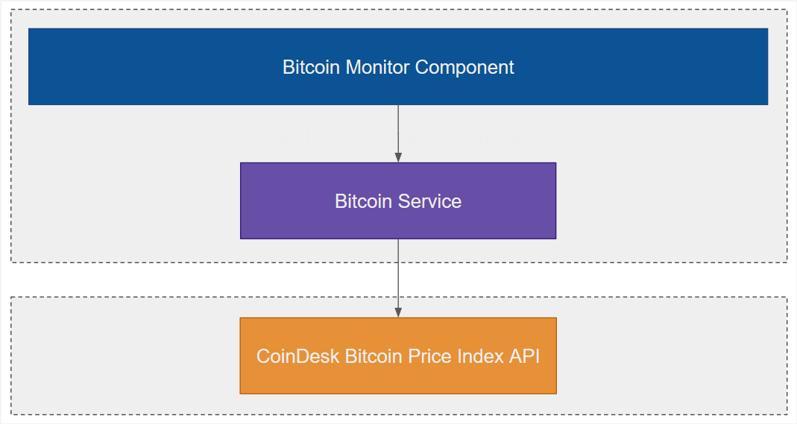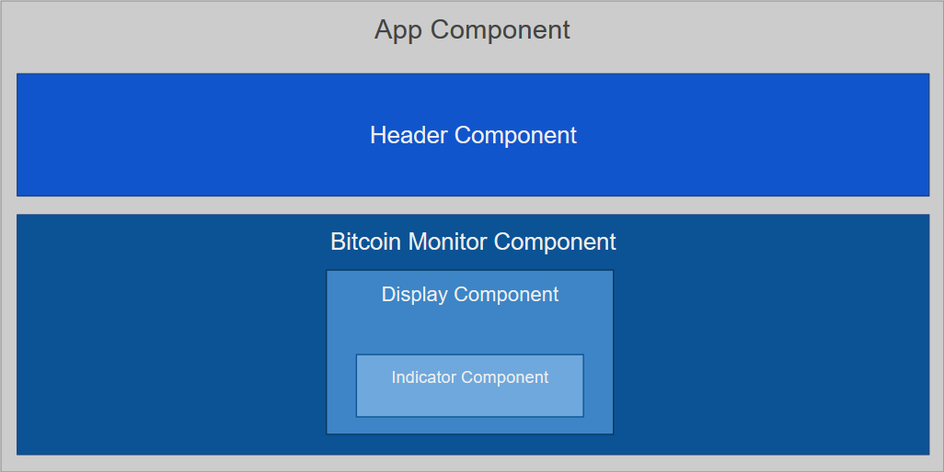
Implementation
Utilizing Create React App is a standout amongst other approach to set up the advancement condition. This gives the most recent JavaScript highlights, upgrades the designer experience and improves the application for generation.There are various approaches to introduce FusionCharts, for general directions you can look at Fusion Charts Documentation Page.
Fusion-Chart Direct Download: You can legitimately download JS documents from site, utilizing this connection and remember them for your application utilizing <script> tag in/open/index.html of our dashboard application.
The CoinDesk Bitcoin Price Index API information source is characterized at the highest point of the content tag. The API restores a JSON dump, which we have changed over as the JavaScript object "information" (gave to this capacity as a contention).
Given beneath is the API URL, this will bring the ongoing information for the Bitcoin Ticker: https://api.cryptonator.com/programming interface/ticker/btc-usd
Explore to the mentioned URL, and the qualities returned ought to be unmistakable in the browser. Moreover, remove btc-usd with the cash codes like eth-usd, ltc-usd to bring the estimations of Ethereum and Litecoin. I have utilized Bootstrap 4 here to fabricate this responsive dashboard. With new parts, responsive structures and styles, it is a predictable system that supports larger part all things considered and CSS similarity fixes.
To make the Navigation bar, we will utilize the navbar part of Bootstrap. The header is encased inside compartment and {branding} holds the content for the Header. Here's what Header.js looks like:
import React from "react";
const Header = props => {
const { branding } = props;
return (
<nav className="navbar mb-3 pt-3 pb-3 py-0 text-sm-center text-md-left">
<div className="container">
<a href="/" className="navbar-brand">
{branding}
</a>
<ul className="navbar-nav mr-auto-right" alt="fireSpot">
<ul class="navbar-nav mr-auto">
<li class="nav-item active">
<img src={"fclogo.svg"} width="145" alt="" />
</li>
</ul>
</ul>
</div>
</nav>
);
};
Header.defaultProps = {
branding: "Real-Time Cryptocurrency Dashboard"
};
export default Header;
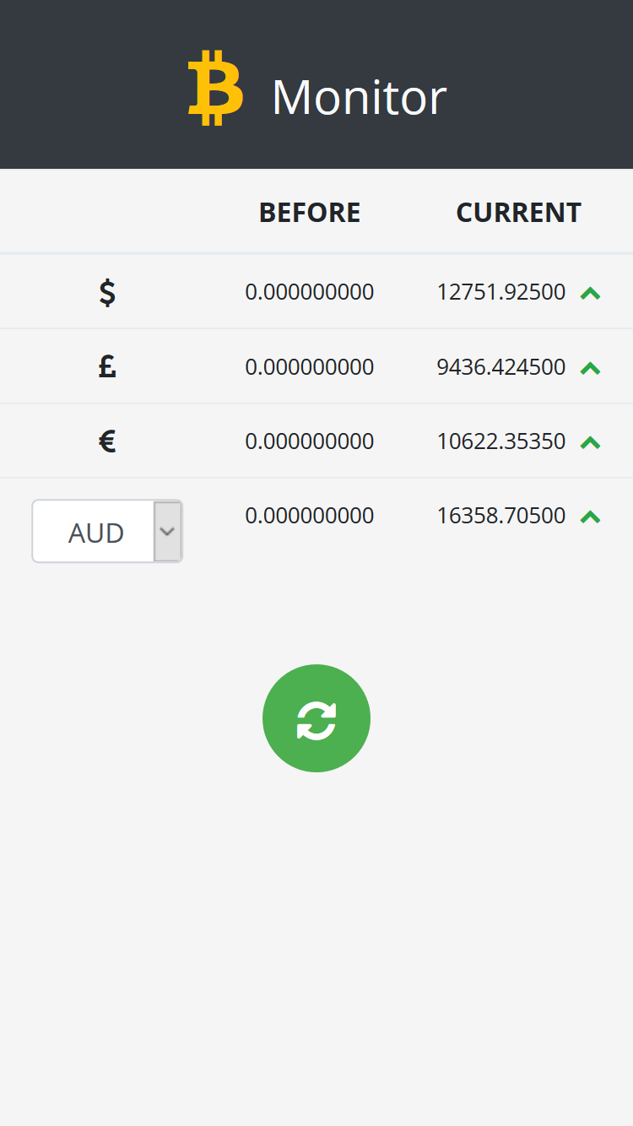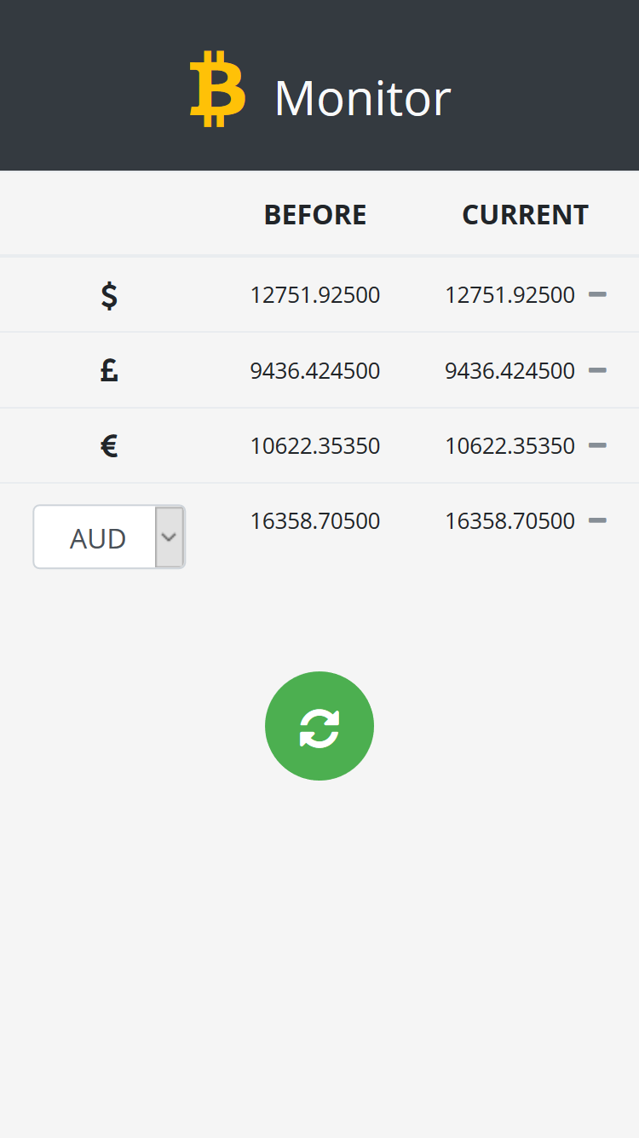
The KPI esteems are gotten by sending GET method to Bitcoin Price Index API and securing the information in JSON design. We have used getDataFor() work for getting the digital money esteems.
The componentDidMount() strategy for the kid segments is summoned before that of parent segments.
The Base URL + conversion(btc-usd/eth-usd/ltc-usd) brings the Cryptonator API and d.ticker.price restores the cost of the digital money.
For Bitcoin, the ticker is plotted against Local Time in the x-hub versus Price in USD in the Y-pivot. To acquire the timestamp, the capacity clientDateTime() is utilized. This profits the present time and the diagram gets refreshed at an interim of 2 seconds.
The capacity startUpdatingData() includes refreshing the graph with the dynamic qualities. feedData() strategy gave by FusionCharts is utilized to bolster information into the graph. Likewise, feedData deals with any postpone that happens during auto invigorate or on page load.
class Body extends React.Component {
// ...
componentDidMount() {
this.getDataFor("btc-usd", "btcusd");
this.getDataFor("ltc-usd", "ltcusd");
this.getDataFor("eth-usd", "ethusd");
}
startUpdatingData() {
setInterval(() => {
fetch(this.BASE_URL + "btc-usd")
.then(res => res.json())
.then(d => {
let x_axis = this.clientDateTime();
let y_axis = d.ticker.price;
this.chartRef.feedData("&label=" + x_axis + "&value=" + y_axis);
});
}, 2000);
}
getDataFor(conversion, prop) {
fetch(this.BASE_URL + conversion, {
mode: "cors"
})
.then(res => res.json())
.then(d => {
if (prop === "btcusd") {
const dataSource = this.state.dataSource;
dataSource.chart.yAxisMaxValue = parseInt(d.ticker.price) + 5;
dataSource.chart.yAxisMinValue = parseInt(d.ticker.price) - 5;
console.log(JSON.stringify(dataSource));
dataSource.dataset[0]["data"][0].value = d.ticker.price;
this.setState(
{
showChart: true,
dataSource: dataSource,
initValue: d.ticker.price
},
() => {
this.startUpdatingData();
}
);
}
this.setState({
[prop]: d.ticker.price
});
});
}
static addLeadingZero(num) {
return num <= 9 ? "0" + num : num;
}
clientDateTime() {
var date_time = new Date();
var curr_hour = date_time.getHours();
var zero_added_curr_hour = Body.addLeadingZero(curr_hour);
var curr_min = date_time.getMinutes();
var curr_sec = date_time.getSeconds();
var curr_time = zero_added_curr_hour + ":" + curr_min + ":" + curr_sec;
return curr_time;
}
getChartRef(chart) {
this.chartRef = chart;
}
render() {
return (
<div className="row mt-5 mt-xs-4">
<div className="col-12 mb-3">
<div className="card-deck custom-card-deck">
<PriceCard
header="Bitcoin(BTC)"
src={"/bitcoin.png"}
alt="fireSpot"
label="(Price in USD)"
value={this.state.btcusd}
/>
<PriceCard
header="Litecoin(LTC)"
src={"/litecoin.png"}
alt="fireSpot"
label="(Price in USD)"
value={this.state.ltcusd}
/>
<PriceCard
header="Ethereum(ETH)"
src={"/ethereum.png"}
alt="fireSpot"
label="(Price in USD)"
value={this.state.ethusd}
/>
</div>
</div>
<div className="col-12">
<div className="card custom-card mb-5 mb-xs-4">
<div className="card-body">
{this.state.showChart ? (
<ReactFC
{...this.chartConfigs}
dataSource={this.state.dataSource}
onRender={this.getChartRef.bind(this)}
/>
) : null}
</div>
</div>
</div>
</div>
);
}
}
export default Body;

Installation:
  - The accompanying software is required to be introduced on your framework:
npm 8.x
Npm 3.x
  - Type the following commands in the terminal to check your npm and npm versions:
npm - v
npm - v
  - Install cd react-bitcoin-monitor
  - npm install
  - npm run build: Build application and start watching for changes.
  - This command will also run ESLint as part of build process.
npm run build:watch
  - Run ESlint: Lint project using ESLint
  - Run start: This will run the 'serve' npm task
  - npm start
  - Run webpack dev server: npm run serve:dev
On the other hand: run live-server
npm run serve
After the effective execution of the code, the page is stacked with the dashboard header, digital currency esteems and the bitcoin ticker.
The Bitcoin, Litecoin and Ethereum costs (in USD) are shown just beneath the dashboard header. This Bitcoin Ticker gets refreshed at a fixed interim of 2 seconds. Floating on hold outline, at each tooltip the cost of bitcoin at that specific timestamp can be watched. The y-hub is designed powerfully so that even with any extraordinary change in value, the hub of the diagram gets adjusted as needs be.

Evaluation
There is a wide range of segment testing procedures. They go from a "smoke test" checking that a segment renders without tossing, to shallow rendering and testing a portion of the yield, to full rendering and testing segment lifecycle and state changes.
Various ventures pick distinctive testing tradeoffs dependent on how frequently parts change, and how much rationale they contain. On the off chance that you haven't settled on a testing technique yet, we prescribe that you start with making straightforward smoke tests for your segments:
import React from 'react';
import ReactDOM from 'react-dom';
import App from './App';
it('renders without crashing', () => {
const div = document.createElement('div');
ReactDOM.render(<App />, div);
});
This test mounts a segment and ensures that it didn't toss during rendering. Tests like this furnish a ton esteem with next to no exertion so they are extraordinary as a beginning stage, and this is the test you will discover in src/App.test.js.
import { configure } from 'enzyme';
import Adapter from 'enzyme-adapter-react-16';
configure({ adapter: new Adapter() });
Now you can write a smoke test with it:
import React from 'react';
import { shallow } from 'enzyme';
import App from './App';
it('renders without crashing', () => {
shallow(<App />);
});
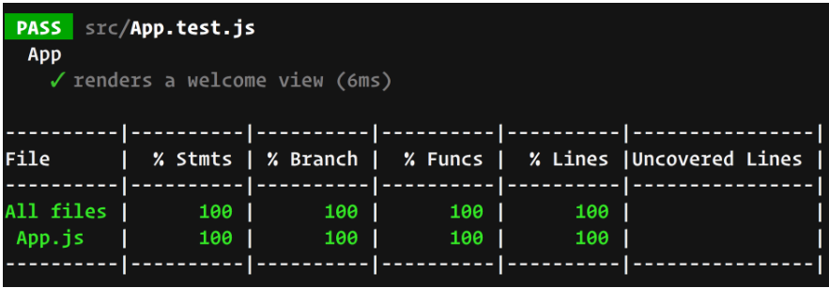
Snapshot testing is an element of Jest that consequently produces content depictions of your segments and spares them on the circle so if the UI yield transforms, you get told without physically composing any statements on the segment yield.
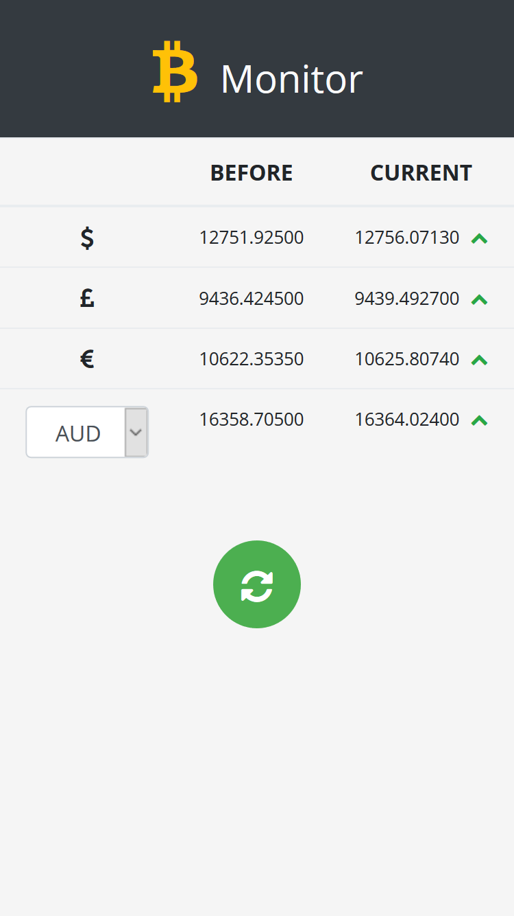
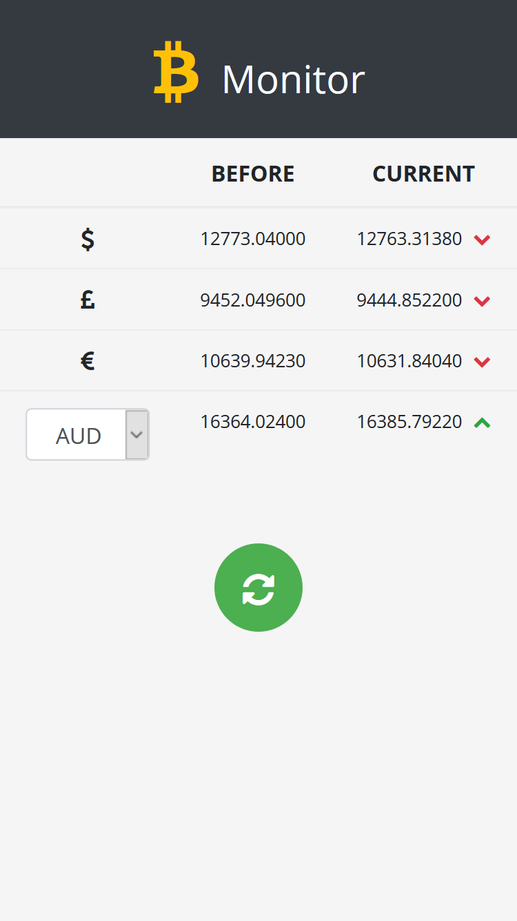

The cutting-edge bitcoin spot advertise is both essentially littler and altogether more proficient than generally comprehended. It is a market that exchanges at remarkably tight spreads, with amazingly compelling exchange keeping costs in lockstep among every single critical trade. It is a market that is bolstered by progressively compelling guideline at the spot bitcoin trade level, backstopped by a critical and becoming managed bitcoin fates showcase. It is a market looked out for by a portion of the most refined institutional market creators on the planet, who entered the market to serve the inexorably institutional client base that is keen on putting resources into bitcoin.
With the expansion in information assortment and total, organizations currently feel the requirement for better information perception to take progressively educated choices. Fusion-Chart has been fruitful in picturing information sources crosswise over various industry use-cases with 28,000 clients and love from more than 750,000 designers around the world. Get familiar with Fusion-Chart and it is new items like Data-Stories, Dashboards, Export items and the sky is the limit from there.

