University of Wales Trinity Saint David

LCBB5004
Managing People

ASSESSMENT 2

Student name: Oana Balaban
Student ID: 1911819

Lecturer: Dr Olusoyi Richard Ashaye
4th January 2022
2235 words

Executive Summary

This report describes the different elements and the impacts of the employee engagement in the organisation. Maintaining the resources have an positively relation associated with organizational engagement climate, which help to maintain substantial contribute in insight. In addition, the zinger model is applied to portray the effects of the employee engagement in an organisation and effects of their tools. This report also includes the ways of measuring the employee engagement and substantial role of it on employee wellbeing. Furthermore, several ways of measuring the employee value proposition is also depicted in this report.

Table of Contents
Introduction 4
Concept and Drivers of Employee Engagement 4
Enhancing well-being 5
Enliven energy 5
Making meaning 5
Leverage strengths 6
Building relationships 6
Foster recognition 6
Master moments 6
Maximising performance 7
Marking progress 7
Evaluates Diagnostic Tools to Measure Engagement 8
Conducting surveys: 8
HR Tools: 8
Social media: 9
Exit interviews: 9
Employee Value Proposition from the Ideas and Analysis Which Are Previously Covered and Raising Employee Engagement 9
Broadcasting the efforts of the employees for the organisation: 10
Offering in-person thanks: 10
Encouraging employees for improving skills: 10
Providing additional rewards: 11
Conclusion and recommendation 11
Reference list: 13

Introduction
Employee engagement in an organisation is an important element to keep the work culture and ambience stable. Employee engagement is the concept belonging to human resource management. This particular term refers to the dedication of the workers in the workplace. The proper dedication of the employees at the workplace affects their performance positively by motivating them to apply extra effort to their tasks. In addition, with the increment of employee engagement, the employee starts to care for the company. Analysing from this perspective the employee engagement can be marked as the dedication and the enthusiasm of the employee for their workplace. Employee engagement is the attachment of the employee with the aim, mission and vision of the company. The attachment of the employee with the vision and mission of the company helps to achieve the organisational goals effectively by motivating them to put all the effort into completing the tasks. In order to measure employee engagement, surveys can be conducted in the company to collect their feedback of them. However, in order to effectively measure employee engagement the survey needs to be done, which stakeholders can understand their needs.

Concept and Drivers of Employee Engagement
The concept of employee engagement is related to the continuous development of an organisation. The development of the organisation takes place with the positive efforts of the employees of the organisation. In order to portray the concept of employee engagement, the Zinger Model is critically analysed. The Zinger Model focuses on the needs and the importance of the employees to help implement employee engagement. This particular model for employee engagement follows a structure of the pyramid. Every stage of the pyramid refers to the different needs of human beings and employees. The bottom row describes the necessities of human beings.

Figure 1: Drivers of employee engagement
(Source: Self-Developed)

Enhancing well-being
The base of the pyramid focuses on the enhancement of the well-being of the human being. Good mental and physical health is most essential for effective effort at the workplace. Maintaining the work and personal life balance, providing sick leaves, vacation time can help to enhance human well-being.

Enliven energy
The main goal of these criteria is to make the work environment productive and friendly to the employees. A creative and comfortable environment for work helps the employees to utilise their full potential to complete the task (Ramakumar and Priyadarshini, 2021).

Making meaning
Effective employment demands a meaning of the efforts which they are providing for the betterment of the company. The leadership skills of the management body can help the employee to understand the meaning of the efforts.

Leverage strengths
The environment of the workplace needs to allow the employees to grow with their strengths and also get help in working on their weaknesses. The application of the strength leads to organisational development (Suyanti and Absah, 2019).
The second row of the pyramid focuses on uniting the company.

Building relationships
The leaders of an organisation most importantly focus on building the relationship with the other employees. The relationship-building of the organisation positively contributes to the achievement of the employees by motivating them to complete tasks.

Foster recognition
This particular parameter of the second stage of the Zinger Model refers to the systematic promotion and rewards to the employees of an organisation. In addition, the main goal of this stage is to search for opportunities for both the employees and management (Sinha, 2021).

Master moments
In order to stay engaged the employees to need to focus on the tasks. Specifically, the mental presence is also required with the physical presence at the workplace. The management body can conduct daily interactions with the employees for enhancing connections.
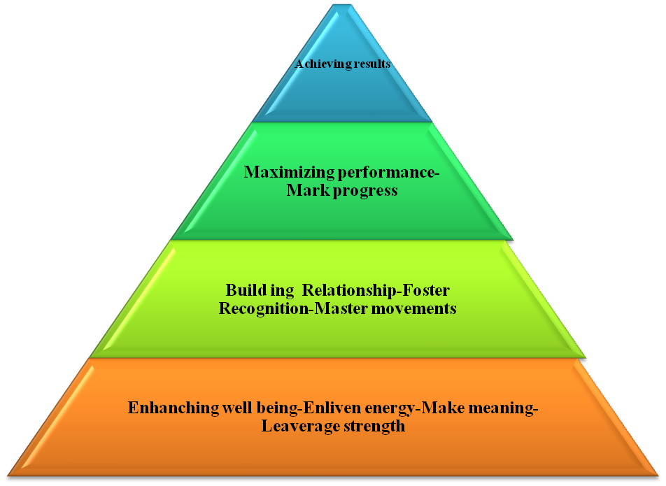
Figure 2: Employee engagement pyramid with Zinger Model
(Source: ALimam, 2017)

The third row of the pyramid is boosting performance which focuses on increasing the productivity of the employees.

Maximising performance
The employees sometimes feel frustrated when their way of completing tasks gets obstacles by certain decisions or activities of management. The improper communication of the tasks is also a reason for the employees to feel frustrated. Maximising the performance needs proper communication of the goals of the tasks.

Marking progress
The achievement of success is a long process, the organisation must communicate with the employees during the time of persuasion of tasks and achieving goals. The continuous interaction of the organisation with the employees helps them to stay engaged by preventing communication gaps.
The top stage of the pyramid is achieving results.
The whole process of employee engagement leads to achieving results, clear communication, focusing on the betterment of the employees and strategic engagement with the customer makes a productive work environment that helps the employees to achieve results by applying their full potential for completing tasks.

Evaluates Diagnostic Tools to Measure Engagement
The engagement of the employees needs to be measured from time to time to continue the flow of organisational improvement. There are certain diagnostic tools used for measuring the employee engagement of the company:

Conducting surveys:
The most effective way to kn0w the feedback of the employees towards their engagement with the company is to conduct surveys. For example, Zoom communication has used this process to know the statement of the employees about working in the company (Cnbc, 2021). HSBC bank is another organisation that has used the survey process to collect the data of employee engagement from 100 employees (Salesforce, 2021). The survey is the most effective way to collect the statements of the employees. The organisations can focus on different methods of conducting surveys. The digitization and the effectiveness of the internet, allows the organisations to conduct online surveys to know the statement of the employees. In addition, the organisation can outsource the survey to be conducted by any firm.

HR Tools:
The era of Marketing 4.0 has allowed organisations to apply HR tools for collecting data about employee engagement. The software provides real-time data on employee engagement which helps the organisations to act within time to increase employee engagement. In addition, the software can store the data of multiple employees at the same time. The software uses cloud technology to strengthen the dada and this reduces the threat of losing the data. Conducting online surveys can help the organisations in collecting the star ratings for the offerings on behalf of the company (Baykal, 2021). The electrical collection of the data not only helps to use a lesser workforce but is also a time-saving process for collecting feedback.

Social media
Global technological advancement has increased the number of users of social media. Social media is not limited to two or three platforms like Facebook, Twitter or Instagram. There are certain platforms that collect the feedback of the employees, Glassdoor is a particular platform that collects the data related to the organisation and their work culture. The collected data is showcased on the websites to be available to show the details to the website visitor (Rasheed et al. 2021). In addition, there are internal social media networks used by the organisation which is better known as Intranet.

Exit interviews
The exit interviews are the other most creative strategy used by the companies in collecting the employee engagements. An employee enters into an organisation after clearing the interview. However, most of the companies do not use the strategy to conduct the exit interviews to know their statement about why they are leaving the company. In addition, the exit interviews also help to retain the employees. According to Borden, (2021) the exit interview is the most effective tool for the betterment of the organisation. Analysing from this perspective, it can be stated that through the information collected by exit interviews an organisation can make effective development in the future.

Employee Value Proposition from the Ideas and Analysis Which Are Previously Covered and Raising Employee Engagement
The employee value proposition is the offerings and rewards which one individual receives from the side of the company as a token for motivation. There are different components for implementing the employee value proposition. The company offers compensation, work-life balance, and respect to the employees. Generally, the organisation offers the value proposition to the employees according to the terms of their achievement.
The organisation uses different strategies to provide the employee value proposition

Offerings | Description
Compensation | Promotion of designation, hike in salary.
Benefits | Holidays, Retirement plans
Career | Career development programs, skill development workshops
Work environment | Work-life and personal life balance, equality at the workplace
Table 1: Elements of EVP
(Source: Kumar et al. 2021)

Broadcasting the efforts of the employees for the organisation
The efforts of the employees are the primary component for the future development of the organisation. On the other hand, the organisation needs to focus on cheering the employees by announcing their contribution to the organisation on an open platform. The public platform can be the social media handles, or the newspapers and magazines. The broadcasting done by the organisation will encourage the employees to do further betterment for the organisation (Couser, 2021).

Offering in-person thanks
The public posting of the employees and their efforts is not the only thing that one organisation can offer. Besides, organising a formal lunch with the management body can also be considered as a token of thanksgiving. In addition during the course of the meal, the manager can ask some questions that will reflect the opinion of the employee for the organisation. Moreover, all these offerings contribute to the effective motivation for the employees. In addition, the organisation may offer personal tours to the employees to take a break from the hectic work life (Cvenkel, 2021).

Encouraging employees for improving skills
Employee motivation works as the most effective component for the continuous development of an organisation. In addition, the organisations including strategies to raise levels of engagement may offer encouragement to the employees for developing further skills by attending seminars or joining courses. The continuous learning and development of an employee can also contribute to the betterment of the organisation. In order to fulfil this purpose, the organisations may provide a monetary offering to the employees. In addition, the organisation can organise certain seminars or merge with certain skill development platforms for the skill development of the employees (ALİ, 2020).

Providing additional rewards
The organisation can provide additional rewards like cash back or digital perks to encourage the employees to maintain enhance their work abilities. The cashback can be used in the stores that accept digital payments from the customers, which can be a great reward. This particular strategy will include the thanksgiving of the organisation and also will allow the employee to save a little amount from salary. In addition, the organisation may provide a one-time payment to the employees as a reward for staying in the company or doing good work (Mathew, 2021).

Conclusion and recommendation

This particularly focuses on the development of employee engagement and the elements related to this are also analysed. Employee engagement requires the involvement of various processes related to employee motivation and retention. This report sheds light on the fact that 'employee motivation' depicts an important key role in the development of an organisation. A healthy environment of the organisation can help productivity to grow from an organisational perspective. This report describes that there are certain steps that work as an element for the engagement. The term engagement refers to the relation of the organisation with the employees. The continuous betterment of the relation with the employees contributes to the future development of the organisation.
This report is developed on the basis of a secondary research method, analysing the collected data has produced certain recommendations for the future development of the organisations.
- The organisation should hire eligible and efficient candidates as an employee.
- Offering better experience among employees could be done by the organisation.
- Training and development programs and tools implementation should be an effective process to enhance talent.
- The organisation must ensure the proper training and tests before joining the organisation.
- Should focus on the training and efficiency of the managers to implement effective management in the workplace.
- The management should focus on expressing the importance to the employees.
- Should encourage the politeness and the approachability of the management body.

Reference list:
ALİ, M.O., 2020. Organizational Culture and Its Impact In Improving The Performance of Employees. The International New Issues in Social Sciences, 8(1), pp.63-92.
ALimam, O.M.A., 2017. Employee engagement and its effect on facilitating business performance.

Baykal, E., 2022. Digitalization of human resources: E-HR. In Research Anthology on Human Resource Practices for the Modern Workforce (pp. 200-218). IGI Global.

Boden, W.E., 2021. RESPONSE: The Exit Interview—of a Professional Lifetime. Journal of the American College of Cardiology, 77(17), pp.2256-2257.

Cnbc, 2021. [online] Available at: <https://www.cnbc.com/2020/11/03/zoom-has-the-happiest-employees-of-2020heres-why.html> [Accessed 28 December 2021].

Couser, G.P., Nation, J.L. and Hyde, M.A., 2021. Employee assistance program response and evolution in light of covid-19 pandemic. Journal of Workplace Behavioral Health, 36(3), pp.197-212.

Cvenkel, N., 2021. Work-Life Balance and Well-Being at Work: Employees’ Perspective to Promote a Psychologically Healthy Workplace. The Palgrave Handbook of Corporate Social Responsibility, pp.429-451.

Kumar, A., Devadas, U.M. and Dhammika, K.A.S., 2021. Impact of Employee Value Proposition on Employee Retention. INTERNATIONAL JOURNAL OF ECONOMICS, BUSINESS AND HUMAN BEHAVIOUR, 2(3), pp.19-33.

Mathew, M.B.M., 2021. A Study on Job Satisfaction of Employees in Star Category Hotels in Mysuru. Design Engineering, pp.15927-15935.
Ramakumar, K. and Priyadarshini, R.G., 2021. Employee Engagement during Organizational Crisis–with special reference to the COVID Scenario. PURUSHARTHA-A journal of Management, Ethics and Spirituality, 14(1), pp.105-115.

Rasheed, M.A., Hookmani, A.A., Waleed, S., Fatima, H.S., Siddiqui, S., Khurram, M. and Hasan, B.S., 2021. Implementation and Evaluation of a Social Media-Based Communication Strategy to Enhance Employee Engagement: Experiences From a Children's Hospital, Pakistan. Frontiers in public health, 9, p.55.
Salesforce, 2021. [online] Salesforce.com. Available at: <https://www.salesforce.com/content/dam/web/en_gb/www/pdf/form/pdf/hsbc-ee-v03.pdf> [Accessed 30 December 2021].

Sinha, B.C., 2021. Employee Engagement,“Myth or Reality”?: A Critical Analysis of the Entrepreneur and Employee Relationship in the Recession Phase of the Business Cycle. In Sustainable and Responsible Entrepreneurship and Key Drivers of Performance (pp. 136-146). IGI Global.

Suyanti, H.N. and Absah, Y., 2019. Effective employee engagement using SWOT analysis. Advances in Economics, Business and Management Research, 100.

