Sheron Ahmed 2117695 Personnel Resourcing and Development BMIH5005 Emma Roberts

What are the current challenges that the industry is facing that is affecting employee recruitment and retention.

Table of Contents
Introduction 2
Background of Hilton and the proposed study 2
Discussion 3
Challenges faced by the Hospitality industry and selected hotel 3,4
Pestle analysis………………………………………...………………………….……...4,5,6
Swot analysis……………………...…………………………………….………………....6,7
Potential Solutions and Lifecycle development…………………………………..…..7,8,9
Evaluation…………………………………………………………….………………………9,10
Conclusion 10
References 11,12,13,14

Introduction
The hospitality sector has faced serious challenges from the global outbreak of Covid-19. Maintaining commercial operations is particularly challenging considering the frequent lockdowns and safety precautions that compelled them to close all of the hotels and hospitality operations. According to the report of UNWTO, the global hospitality industry faced a loss of US$ 1.3 trillion in revenues put more than 100 million jobs at risk (UNWTO, 2021). Considering hospitality and tourism restrictions, several hotels let go of their employees and had their administrative personnel to work from home. These actions weakened the working atmosphere and caused job instability (PwC, 2020). Accordingly, the issues of employee engagement and retention has become one of the primary issues for the human resource and their team due to the furloughs, uncertainty and reduced wages. Thus, this report will examine the challenges which the hospitality industry is facing and affecting employee recruitment and retention. In order to conduct the research, the Hilton hotel has been selected, focussing on The Waldorf Hilton London.

Background of Hilton and the proposed study
The Waldorf Hilton London is a part of the Hilton Worldwide Holdings Inc., which is located near the Covent Garden in London. It is 0.60 miles away from the Buckingham Palace, London Eye, and 1 mile from the British Museum. The hotel offers all possible modern amenities with the heritage of Edwardian grandeur (Hilton, 2023).
Hilton is renowned for emphasising the value of excellent staff care. A culture like this is prone to ensuring job stability and retention. Nevertheless, due to serious financial concerns brought on by Covid-19, hotels were forced to lay off hundreds of employees (Hilton, 2020). The Covid-19 pandemic has severely disrupted the business due to the travel restrictions. The management of the hotels including Waldorf Hilton London had to take appropriate actions to protect the business. As a mitigation strategy, Hilton had to furlough a substantial number of staff throughout all levels for at least 90 days (Hilton, 2020). Wages for corporate managers, executives and employees were temporarily reduced by 20%, and the salary for the Hilton CEO was eliminated through 2020 (Hilton, 2020). These issues had increased job uncertainty, as well as lower employee engagement in the hotel.

Discussion

Challenges faced by the Hospitality industry and Hilton hotel
Given the Covid19 pandemic and Brexit, Hilton has had to make some challenging considerations about its staff during 2020 (Hilton, 2020). The hotel executives concluded to have some staff members laid off, others introduced to the furlough programme, and a significant subset of the personnel working from home to perform a limited percentage of organisational responsibilities as the first lockdown was implemented in March 2020 and hotel chains had to shut and stop operating (Hilton, 2020). When the restrictions were lifted in 2021, Hilton was confronted with the issue of increasing the staff numbers to a point where the operation could run smoothly once more.
Brexit had imposed a serious issue on the hospitality sector in the UK, more than 120,000 EU workers in the hospitality sector in the UK has left since 2019 (McAllister, 2022). The issue got worse by the outbreak of Covid-19, which caused 90,000 EU staff to leave the UK hospitality sector (McAllister, 2022). London is one of the mostly affected regions by the loss of the EU staff members. The pre-pandemic proportion of the EU workers in London was 75%. Hence, after reopening the hospitality sector, vacancies have increased by 342% (Wadhera, 2021), which indicates issues of staff shortage and effects of decision-making regarding employee recruitment and retention (Jones, 2021). The executives have concluded that the EU workers remains as the indispensable part of the hospitality success factors, and the government should make policies to ease the process of returning the EU workers.
Businesses are taking additional measures to attract the best talent from a stagnating applicant pool. Hotels must create an effective plan and prepare for employee recruitment and retention in order to mitigate this barrier by being an employer of choice. A desirable employer provides numerous benefits to its employees. Most obvious point is competitive pay and benefits, while beneficial, should only be one component of a hospitality overall business of human resource's retention strategy. Other considerations to include:
- Performance incentives
- High levels of team member engagement and culture
- Opportunities for career growth and advancement.
- Community engagement and social performance
Referral and performance incentives, as well as attractive benefits such as provided lunches, free accommodation, English as a Second Language courses, flexible work schedules, and employee and family activities, go quite a long way towards exemplifying respect and appreciation for employees. When employees are engaged and enjoy their job, both businesses and guests benefit (Manley, 2019).
Considering the employee lifecycle and the recovery from the impacts of Covid-19 and Brexit, Hilton hotel HRM should consider the changed environments, adopt appropriate employee lifecycles in the new and post Covid-19 situations. In order to evaluate the conditions, a PESTEL analysis is required:
Political: The political factor that affects the Hilton workforce lifecycle are extensive and exert a significant influence. The primary political element impacting Hilton hotels is Brexit as well as the ensuing outflow of EU professionals from London. Due to Brexit, firms are now required to confirm that all workers are authorised to operate in the UK, lengthening and complicating the hiring process for both business and candidates (Jones, 2021). Hilton needs to concentrate on luring employees with a competitive advantage and pay structure, a dynamic perspective to employment schedules, and by providing retraining and capacity building for those who are new to the hospitality industry.
Economic: Due to a shortage of trade in most industries during the Covid-19 pandemic, the UK economy entered a stagnation. According to estimates, the Brexit or Covid-19 pandemics has had a significant negative impact on 69% of the country's economy (TETLOW and POPE, 2020). The hospitality sector has been impacted twice: once by firms shutting for more than a year, and again by changes made to immigrant policy following Brexit, which led to a staffing shortage (Jones, 2021).
Social: The Covid-19 pandemic has impacted social as well as cultural standards. Required face coverings and social distance were maintained in many settings during the pandemic outbreak (Hilton, 2020). The HR division at the Waldorf Hilton London must collaborate extensively with team executives throughout the onboarding, engagement, and retention phases in order to effectively convey updates on Covid-19 policies and advice and ensure that workers feel comfortable in their workplace (Hilton, 2020).
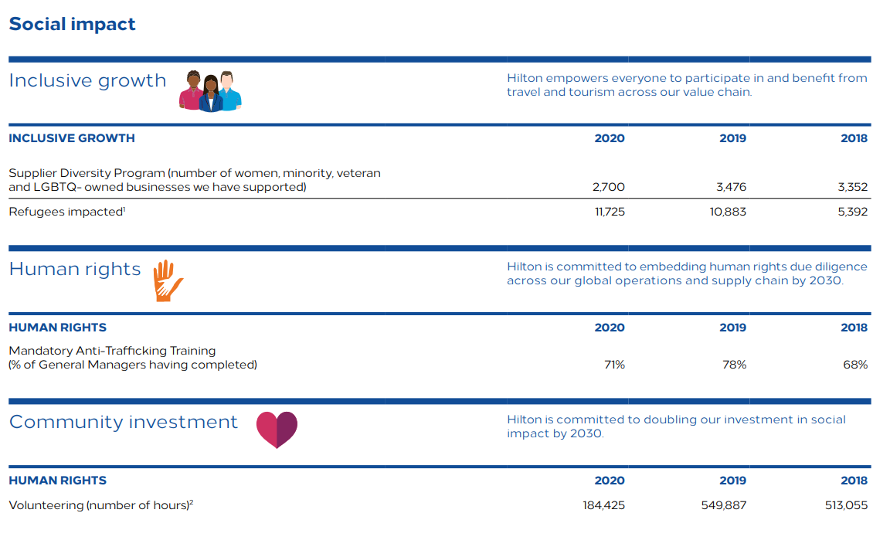
Figure 1: Social impact of Hilton employee engagement
(Source: Hilton, 2020)
Technology: The Covid-19 outbreak has resulted in a rapid advancement in technology due to the great requirement for the new employment conditions. Workers profit from internal systems that allow them to view their schedules, connect with their employers and co-workers about matters relating to their jobs, and voice concerns while utilising modern technology (Hilton, 2021).
Environmental: As the hospitality sector moves towards a net-zero economy, Hilton has committed to reducing carbon output by 61% by 2030 (Hilton ESG, 2023). Hilton takes pride in being the first large hotel chain to establish scientific based (SBTi) carbon reduction goals that are in line with the Paris Climate Agreement and the field of climate research. In order to meet the energy targets, which would lower electricity expenses and greenhouse emission. Hilton has pledged to create 20 context-based water management pilot projects in high-risk water locations and reduce its water consumption severity by 50% by 2030 (Hilton ESG, 2023).
Legal: All workers are now required by the revised post-Brexit immigration rules to certify their ability to be employed in the UK, lengthening, and complicating the hiring procedure (GOV.UK, 2020). Hilton provides tailored legal advice on the rights to engage in the UK while upholding an inclusive hiring procedure for both potential recruits and existing workforce.
Considering the new changes, policies and requirements, Waldorf Hilton London should consider changes in its internal policies. However, in order to initiate change in the internal environment, the organisational strength and weaknesses must be evaluated. Thus, a SWOT analysis of the business is required.
Internal Factors
Strengths  - Huge Brand image and brand presence is one of the key strengths of Hilton. The business has more than 7000 properties, 1.1 million rooms in 123 nations around the world. Hilton provides top class hospitality though its 19 brands around the globe (Hilton, 2023).  - Exceptional employee benefits are another valuable aspect of Hilton. Even during the pandemic and furloughs, the company continued to provide its furloughed employees with health and wellbeing requirements (Hilton, 2020).  - The updated technical developments that potentially enhance the visitor experience have generally been quickly accepted and implemented by Hilton (Hilton, 2021). | Weaknesses  - The major weakness of Hilton is its limited market share in the UK, compared to the US market presence.  - Another major weakness was recorded before the pandemic. The data breach in 2015 two data breaches through its UK based systems has caused US$ 700,000 fine (Roberts, 2022). The incidents have raised concerns among the global customer base and questioned the security system of the company.
External Factors
Opportunities  - The rapidly emerging technology and communication systems such as social media platforms provide a huge opportunity for marketing for the products and services offered by Hilton.  - Multiple branding of Hilton allows to pursue a diverse range of marketplaces (Hilton, 2023). In a post-Covid era, the UK government has offered additional support through several schemes for the hospitality industry (Gov.UK, 2021). | Threats  - Recession is the key threat to all the business sectors including hospitality. Increasing cost for staffing may hinder recruitment and increase layoffs.  - Increasing competition is a substantial threat to the hospitality sector. Some of the main competitors of Hilton are Marriott, Hyatt Hotels and Holiday Inn.

Potential Solutions and Lifecycle development
Looking at the above evaluation, it can be said that the sustainability and efficacy of Hilton hotels could be improved by retaining an engaged team of staff. Employee engagement improves the organisational culture, develops productive communications, increases job efficacy, and increase the overall productivity. Hence, the managers should recruit and retain the employees for long-term success. This can be accomplished with the six-stage employee lifecycle development:
Attraction: In the initial phase of employee lifecycle, Hilton should develop new strategies to attract new employees. The hotel should promote more brand awareness, employee benefits, flexibility, and employee wellbeing (Alduayj and Smith, 2019).
Recruitment: Recruiting is the second stage, in which the HR department should select appropriate candidates according to the job requirements (Cattermole, 2019). In Hilton, implementation of online interview through video conferencing in the post-Covid times have significantly reduced the time in recruitment cycle (Bersin et al., 2017). Hilton recruited approximately 4000 employees in UK and Ireland in 2021 (Pegden, 2022).
Onboarding: Onboarding refers to start working with inclusive training and agendas. In this aspect, Hilton has introduced LightStay program, which is a comprehensive platform under the Environmental, Social and Governance (ESG) strategy of Hilton. The managers, employees and new staff are trained through this program (Hilton, 2020).
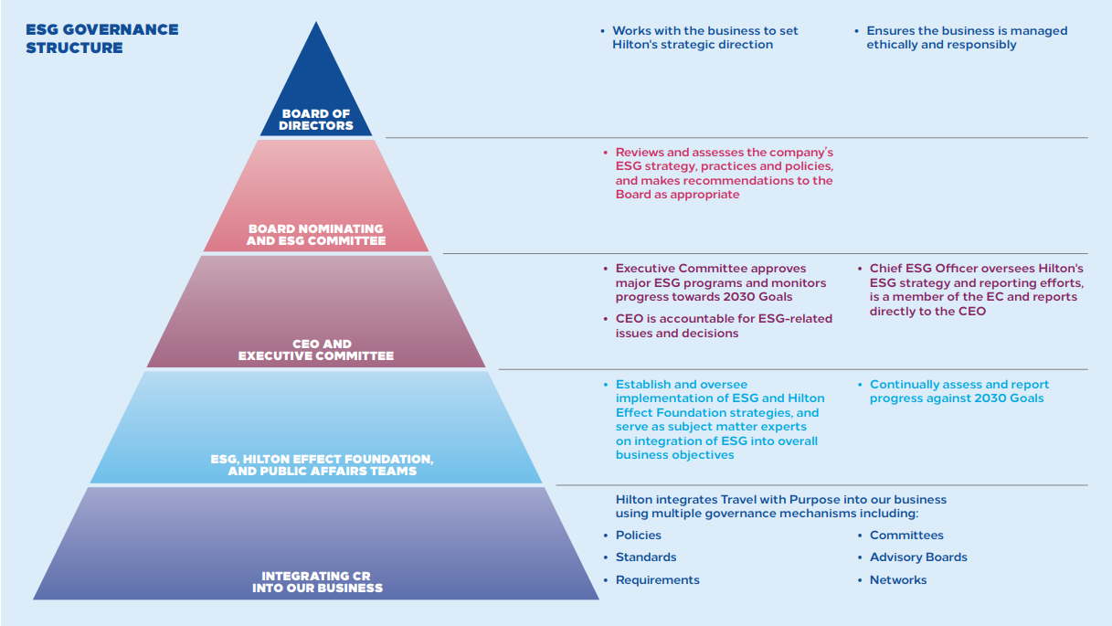
Figure 2: ESG Programme in Hilton Hotels
(Source: Hilton, 2020)
Development: Employers should provide the opportunities for employee growth and development. Hilton offers substantial development opportunities through its Immersion Experience programme (Brownlee, 2019). Hilton also delivers career development through Hilton University and online learning through eCornell (Hilton, 2020).
Retention: The management in the hotels should maintain transparency to develop an inclusive and trustworthy environment. This will deliver maximum flexibility and ensure retention. The Immersion Experience programme has helped to maintain high employee morale in Hilton hotels (Brownlee, 2019). The retention rate is excellent in Hilton, as voluntary turnover reduced from 19% in 2019 to 11.7% in 2020 (Hilton, 2020).
Separation: The HR executives also support the decisions taken by an employee, such as leave, retiring or leaving the company. Thus, the management should arrange exit interviews for the processes (Cattermole, 2019).

Evaluation
Analysing the above Pestle and Swot analysis, it can be noted that both internal and external environments and the associated factors have an impact on the employee lifecycle. Thus, the factors determine the success of recruitment and rates of retention. The political, economic, and social issues after Covid-19 and Brexit have impacted the business most, reducing the opportunities to hire talents from the EU regions. Additionally, the new safety, health, and wellbeing issues have become prevalent. The business of Hilton is largely impacted by the global recession caused by the Covid-19 pandemic. Hence, the management is facing challenges to bring the operations back to normal. However, the strong brand presence, huge business footprint and flexible management practices have allowed Hilton to reduce the adverse impacts and recover the business.
Successful HRM practises should enable employees to perform at the top of their abilities and with moral integrity at job, which is an indication of fulfilment. Employee engagement is supported by HRM both at the individual and organisational levels. Highly skilled employees seek employment more frequently in situations with challenges, chances for professional progression, and engaging work cultures (Aybas and Acar, 2017). For instance, the HR department in the Hilton hotel chains launched a three-day programme entitled the Hilton Immersion Experience. Company directors and management officials perform front-line tasks including visitor check-in, baggage carrying, addressing grievances, and room maintenance in this programme. This helped the subordinate employees to engage more and increased overall employee retention rate, significantly improving employee morale, and eliminating turnovers (Brownlee, 2019).

Conclusion
The research has aimed to explore the challenges faced by the hospitality industry that affect recruitment and employee retention. Hilton hotel has been chosen for this report. As a HR manager, it is beneficial to develop the key issues include prolonged lockdown and economic recession caused by Covid-19 pandemic, travel restrictions, huge furloughs, layoffs to save the businesses, and Brexit imposed issues, such as restrictions on immigration, and huge turnover of EU employees during Covid-19 has adversely impacted the hospitality industry. The staffing, recruitment and retention are disrupted due to the issues raised by Covid-19 and Brexit together. Thus, to cope with the impacts and recover the businesses, effective policy making, team engagement and recruitment is required. Accordingly, a PESTEL and SWOT analysis has been conducted to understand the new changes and needs for policy making. Thus, it can be concluded that active participation is a prerequisite for the hospitality industry since it promotes performance, reliability, and retention. There are, however, several challenges that must be overcome. The HRM must consistently be cognisant that gaining a strategic benefit relies mostly on its staff. They must therefore deploy adaptable practices to promote interaction and attract new skills.

References
Alduayj, S.S. and Smith, P., (2019), May. Sentiment classification and prediction of job interview performance. In 2019 2nd International Conference on Computer Applications & Information Security (ICCAIS) (pp. 1-6). IEEE [Accessed 28 Feb 2023].
Aybas, M. and Acar, A.C., (2017). The effect of human resource management practices on employees’ work engagement and the mediating and moderating role of positive psychological capital. International Review of Management and Marketing, 7(1), pp.363-372 [Accessed 28 February 2023].
Bersin, J., McDowell, T., Rahnema, A. and van Durme, Y. (2017). Rewriting the rules for the digital age 2017 Deloitte Global Human Capital Trends. [online] Available at: https://www2.deloitte.com/content/dam/Deloitte/global/Documents/AboutDeloitte/central-europe/ce-global-human-capital-trends.pdf. [Accessed 28 Feb 2023].
Brownlee, D. (2019). How The ‘Best Companies To Work For’ Engage Employees And Retain Top Talent. [online] Forbes. Available at: https://www.forbes.com/sites/danabrownlee/2019/09/04/how-the-best-companies-to-work-for-engage-employees-and-retain-top-talent/?sh=7f264bcc1eca [Accessed 28 Feb. 2023].
Cattermole, G., 2019. Developing the employee lifecycle to keep top talent. Strategic HR review, 18(6), pp.258-262. [Accessed 28 Feb 2023].
GOV.UK (2020). New Immigration System: What You Need to Know. [online] GOV.UK. Available at: https://www.gov.uk/guidance/new-immigration-system-what-you-need-to-know [Accessed 27 Feb. 2023].
Gov.UK (2021). Hospitality Strategy: Reopening, Recovery, Resilience. [online] GOV.UK. Available at: https://assets.publishing.service.gov.uk/government/uploads/system/uploads/attachment_data/file/1003059/1200-APS-CCS0621819592-002-BEIS-Accessible2.pdf [Accessed 27 Feb. 2023].
Hilton (2020). HILTON 2020 ENVIRONMENTAL, SOCIAL AND GOVERNANCE (ESG) REPORT CONRAD MALDIVES RANGALI ISLAND. [online] Available at: https://cr.hilton.com/wp-content/uploads/2021/04/Hilton-2020-ESG-Report.pdf [Accessed 26 Feb. 2023].
Hilton (2020). Hilton Corporate Response to COVID-19. [online] Stories From Hilton. Available at: https://stories.hilton.com/releases/hilton-corporate-response-to-covid19 [Accessed 26 Feb. 2023].
Hilton (2020). TEAM MEMBER ENGAGEMENT: We are in the business of people serving people. [online] Hilton. Available at: https://cr.hilton.com/wp-content/uploads/2020/04/Hilton-Team-Member-Engagement.pdf [Accessed 26 Feb. 2023].
Hilton (2021). Hilton Debuts Industry Leading Tech Enhancements. [online] Stories From Hilton. Available at: https://stories.hilton.com/releases/hilton-debuts-industry-leading-tech-enhancements [Accessed 27 Feb. 2023].
Hilton (2023). Hilton Brands | Global Hospitality Company. [online] www.hilton.com. Available at: https://www.hilton.com/en/corporate/#:~:text=Hilton%20Honors [Accessed 26 Feb. 2023].
Hilton (2023). Hotels in Covent Garden - The Waldorf Hilton London - UK. [online] Hilton. Available at: https://www.hilton.com/en/hotels/lonwahi-the-waldorf-hilton-london/ [Accessed 26 Feb. 2023].
Hilton ESG (2023). Environment. [online] Hilton. Available at: https://esg.hilton.com/environment/ [Accessed 27 Feb. 2023].
Jones, A. (2021). Thousands of EU workers have left hospitality jobs in the past year – report. [online] www.standard.co.uk. Available at: https://www.standard.co.uk/news/uk/brexit-government-london-greater-manchester-b949235.html [Accessed 26 Feb. 2023].
Manley, C. (2019) Human Resources 6 strategies to help recruit, retain hotel employees https://www.hotelmanagement.net/human-resources/recruiting-retaining-employees-while-unemployment-hits-a-49-year-low [Accessed 27 Feb 2023].
McAllister, J. (2022). Number of international workers in UK hospitality sector shrinks by nearly 200,000. [online] bighospitality.co.uk. Available at: https://www.bighospitality.co.uk/Article/2022/08/17/number-of-international-workers-in-uk-hospitality-sector-shrinks-by-200-000-since-covid-19-coronavirus-pandemic-brexit-eu-worker-decline [Accessed 26 Feb. 2023].
Pegden, T. (2022). Hilton hotels taking on 1,000 new starters in UK and Ireland. [online] Business Live. Available at: https://www.business-live.co.uk/retail-consumer/hilton-hotels-taking-1000-new-22963065 [Accessed 28 Feb. 2023].
PwC (2020). UK Hotels Forecast 2019-2020 - PwC UK. [online] PwC. Available at: https://www.pwc.co.uk/industries/hospitality-leisure/insights/uk-hotels-forecast.html [Accessed 26 Feb. 2023].
Roberts, P. (2022). Hilton Was Fined $700K for a Data Breach. Under GDPR It Would Be $420M. [online] Digital Guardian. Available at: https://www.digitalguardian.com/blog/hilton-was-fined-700k-data-breach-under-gdpr-it-would-be-420m [Accessed 27 Feb. 2023].
TETLOW, G. and POPE, T. (2020). Brexit and coronavirus: economic impacts and policy response. [online] Institute for Government. Available at: https://www.instituteforgovernment.org.uk/publication/report/brexit-and-coronavirus-economic-impacts-and-policy-respons [Accessed 27 Feb. 2023].
UNWTO (2021). 2020: Worst Year in Tourism History with 1 Billion Fewer International Arrivals. [online] www.unwto.org. Available at: https://www.unwto.org/news/2020-worst-year-in-tourism-history-with-1-billion-fewer-international-arrivals [Accessed 26 Feb. 2023].

Wadhera, C. (2021). Brexit: Thousands of EU workers have left hospitality jobs in the past year, report says. [online] The Independent. Available at: https://www.independent.co.uk/news/uk/home-news/eu-workers-jobs-employment-brexit-covid-b1897002.htm [Accessed 26 Feb. 2023].

