Business Report – Comparison of Mandarin Oriental Hotel Group and Premier Inn

Module: Financial Management for the Hotel Industry BMIH5007

Name: Viktoria Benko

Student ID Number: 2130343

Lecturer: Tristan Hawkins

Contents
Executive Summary 3
Introduction 3
1. Total Revenue 3
2. Market Position 6
3. Growth Potential 8
4. Financial Commitment to CSR (Corporate Social Responsibility) 10
Recommandations 12
Conclusion 12
References: 13

Executive Summary
Business Report comparing Mandarin Oriental Hotel Group and Premier Inn showing in-depth analysis, comparison and evaluation of two prominent players in the hospitality also showing impact of their financial performance and sustainability.

Introduction
2022 has been a year of changeover after two years in which the worldwide hospitality industry was badly hit by Covid 19. Travel limitation in Europe, the Middle East and America made the situation worse. Hospitality groups like Mandarin Oriental member of the Jardine Matheson group has 27 hotels in Asia, and Premium Inn, one of the biggest hotel chains in United Kingdom and Europe, with a very strong market position in the budget hotel segment and familiar for providing fair price and comfortable accommodation to both leisure and business visitors positioning itself as a convenient and good choice for customers try to find a value-for-money place. Also where customers get their money back if they don’t get a good night had a poor start at the beginning of 2019. Their total revenues, market positions, growth potential and financial commitment to Corporate Social Responsibility fell by 20%. Had to revise their financial management strategies and practise in order to adapt.

1. Total Revenue
Although Mandarin also had a difficult start of 2019. Their place as a luxury hotel brand in worldwide market seem to have improved. They continue to provide clear accommodation, unusual service and world -class amenities to guests. With its emphasis on luxury and attention to element Mandarin Oriental aims to serve to affluent travellers seeking a high-end hospitality experience. The performance of the Mandarin Oriental Hotel Group recovered powerfully in the year, with mixed total revenue of hotels under leadership of US$ 1.6 billion in 2022, increase from 2021 and 18% above 2019.

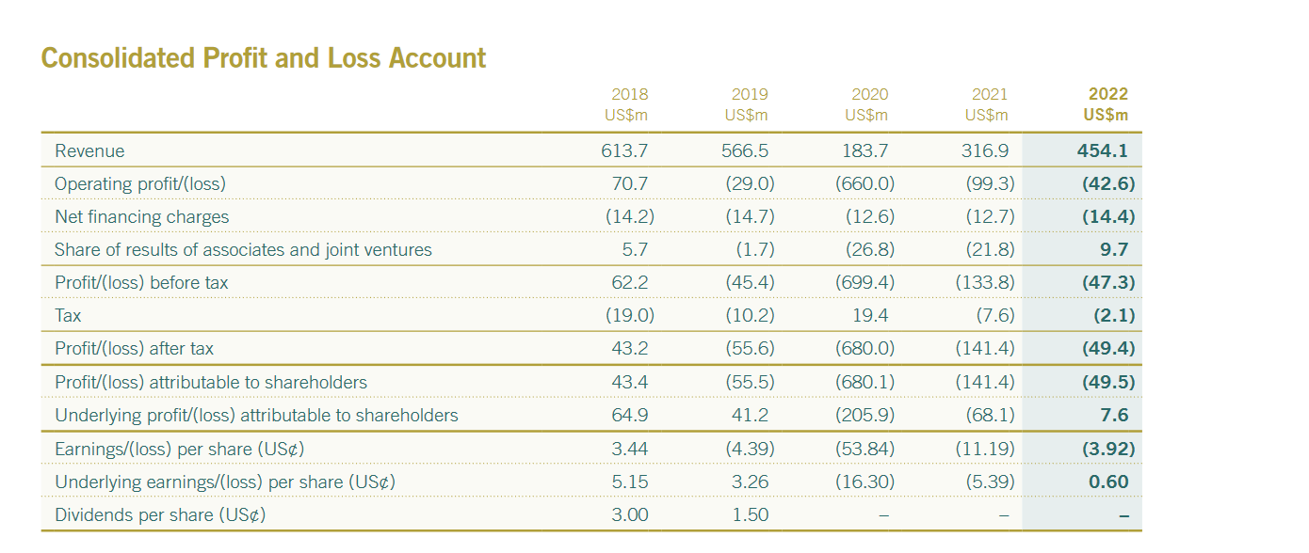
Figure 1:Consolidated Profit and Loss Account
Source: Internet

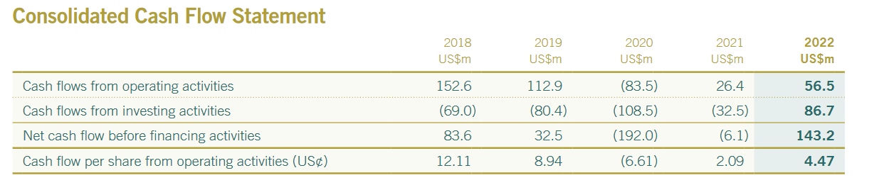
Figure 2:Consolidated Cash Flow Statement
Source: Internet
The brand separate itself some various factors:
- Exceptional service: celebrated for their personalized and intuitive service, make sure that guests has a memorable and bespoke experience.
- Iconic locations: many properties are located in prime cities around the world ,with stunning views and popular attractions.
- Luxurious Ambiance: Mandarin Oriental providing very elegant and exquisite designed interiors, blend modern comforts with elements of local culture and heritage.
- Culinary Excellence: The brand is known for its five -star dining options, often present multi-award-winning restaurants command by famous chefs.
- Spa and Wellness Offerings: Mandarin Oriental hotels offering outstanding luxurious spa facilities, a range of wellness treatments and experiences for guests.
Mandarin oriental explore to be an innovative leader in luxury hospitality with the aim to increase profitability and long -term shareholder value. To provide enduring value improve revenues they are convert strategies in line with the world’s shift toward carbon neutrality.
Lead movement that they are taking include:
- Progressing with sustainability in mind by apply our Product Standards & Guidelines for Responsible Hotel Development.
- Handle energy modelling in the design stage to do greater gauge energy use and recognize energy efficiency chance.
- Environmental Targets for energy, GHG emissions, water and waste build on the special circumstances and priorities of each and every mandarin oriental hotel group property and its location.
- Present supportable risk assessments and variation action plans across the company.
- Testing and scrutinize Business Continuity Plans regularly. Expanding investments in reduction measures ,including a strong insurance coverage.
- Let engage staff and consumers for feedback to make better sustainability program and sustainable offerings.
- Encourage green transportation modes ,involving the use of Electric Vehicles in transport fleets and providing of EV charging site.
- Acquiring goods and services sustainably ,such as using only sustainably licenced paper products.
- Recognizing and harnessing chance to tap on sustainable finance in the suggestion of our sustainability strategy, such as efficiency projects.
- Evaluate emerging ESG reporting level and requirements and range disclosures to best market practice.
Strong recovery as travel situations back to normal. The hotel groups performed powerfully in regions where there was full freedom of movement. Underlying profit reach for the first time since 2019.Net debt was lower by 27%. Liquidity and support position remains strong. Two hotel and two residences opened in 2022,representing 7% growth in the portfolio.
Premier Inn owner Whitbread also had a difficult start of 2019 but has been announce statutory revenue of £2.6b in its latest financial results 27% ahead of pre -pandemic levels. Total UK place sales were 37% on of pre-pandemic and as a result ,the group saw legal profit before tax of £375m ,34% ahead of similar chains like Whitbread’s 2020 financial year. Evaluating Premier Inn’s financial performance such as revenue gain, profitability, and get back good returns on investment was essential. (Weetman, 2019)
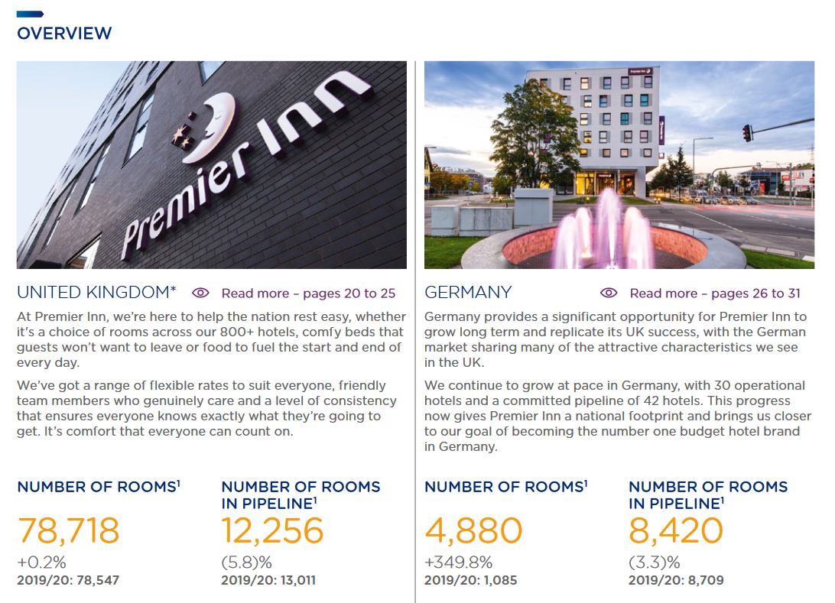
Figure 3:Premium Inn showing Rooms in UK and German
Source: Internet
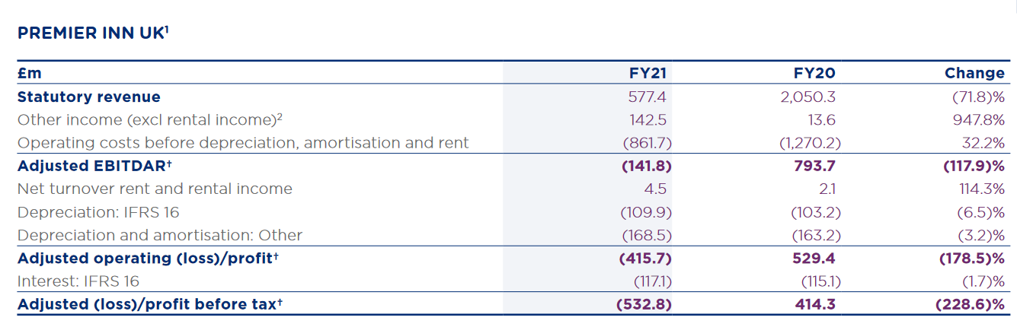
Figure 4: Premium Inn revenue
Source : Internet

2. Market Position
Mandarin Oriental Hotel Group, which has 27 hotels in Asia, North-America and Europe, receive the top overall score in the tier as well as top marks for organize group travel, meeting facilities, business amenities. Mandarin Oriental Hotel Group aim to improve their opportunities over the countries in which they operate by positioning itself as a convenient and good choice for customers trying to find a value-for-money place. They offer consistent quality standards across their hotels.
In order to improve their brand image, Mandarin Oriental group has a Fan Campaign based on top-level celebrities endorsing the brand. Charming celebrities who are attractive have higher chance of enhancing the memory of the brand that they endorse depending on target audience. (Graham J. Hooley, 2020) For example:
- Physical aspect, intellectual ability and lifestyle. Admirable celebrities endorsements act as an visible cue that enable customers to shift through the huge brand clutter in the market, the credibility aspect of the celebrity highly influences the cooperation with customers. Success of the brand-celebrity partnership heavily rely on the compatibility between the brand and the celebrity in terms of personality, place in the market and way of life. When a brand signs on a celebrity, these are some of the compatibility part that have to exist for the brand to support the maximum from that collaboration.

- Premier Inn hotels has located in key cities, towns and popular tourist destinations, ensuring to find a various attractions and transportations. This allows them to provide to a base consumer base both domestic and international travellers. Besides Premier Inn emphasizes consumer comfort and has implemented initiatives such as the “good night guarantee”, where guests can get their money back if they don’t have a good night sleep. This good focus customer service and value has contributed to their strong market position in the budget hotel segment.

Overall, the hotel group is a trusted and affordable choice for travellers who are looking for comfortable place. Premier Inn has been regularly growing not only UK but also in international markets, shown particular interest in the German market, work towards to become one of the country’s main budget hotel.
Premier Inn has established a very strong market position in the budget hotel segment, offering affordable hotel rooms with quality service.
- Premier Inn has a pleasure to providing excellent customer satisfaction. Premier Inn regularly operates in United Kingdom but there is a possibility for international market. By entering new markets the group can tap into the growing worldwide travel industry.
- Premier Inn has chance to focus on business travellers as many companies look for affordable accommodations for their employees and offering reliable and comfortable stays at a fair price the group can capture a significant share of the corporate travel industry.
- Embracing online booking platforms, mobile apps, and personalized guests commitment can help them to stay competitive and attract tech-savvy travellers.

3. Growth Potential
Mandarin Oriental Hotel Group does not specifically align with a particular Bowman’s strategy, as it is a luxury hotel brand known for its extraordinary service and exclusive offerings.
- Differentiation strategy: The hotel group focuses on offering their consumers a distinctive and high-end experience through its deluxe accommodations ,custom-made services, and attention to detail. It’s a goal to create a unique and memorable visit for all consumers, setting itself apart from others through its exceptional level of service and refined hospitality. (Albert Ziegler, 2021)
- Quality Enhancement Strategy: Mandarin Oriental seek to provide the highest level of standard in every aspect of its operations. From the design and atmosphere of all properties to the skills of staff ,the group aims to consistently exceed consumer expectations. By continuing and enhancing its quality levels, Mandarin Oriental seeks to attract discerning travellers who value excellence in their hotel experience. (Elsevier Ltd, 2020)
- Customer Intimacy Strategy: Mandarin Oriental places a powerful emphasis on create a long-term relationship with consumers. The brand focus to anticipate and fulfil the individual’s needs. By understanding and catering to their customers desires Mandarin Oriental focus to generate a loyal customer base that will return and recommended the brand to others. (J Walker, 2020)

Premier Inn has been expanding both domestically and internationally. Analysing the company's growth strategy could involve assessing its ability to enter new markets successfully and the impact of brand recognition on guest acquisition. (Lee, 2009)
Premier Inn be in control of thorough market research to recognize potential locations for expansion including analysing factors such as population tally, tourism trends and the current competition in the target market. (Nawaz, 2017)
- Premier Inn put in central focus choosing a strategic locations that align with its target viewers and brand positioning. This may include select high-demand areas, like city centre major transport point or popular tourist destinations.
- The hotel group may pursue new build projects and changing opportunities. The new builds include constructing hotels from the ground up, while changing involve renovate buildings.
- Premier Inn may looking partnership or investment to accelerate its expansion. This could include entering into joint ventures with local hospitality businesses or come by smaller hotel chains that align with Premier Inn strategy.
- Premier Inn has a powerful commitment to sustainability. As part of its expansion plan ,it incorporates eco-friendly practices into a hotel project and operations to minimize environmental concussion.

Both Mandarin Oriental Hotels and Premier Inn seem to have Modernized Diversity & Inclusion Policy meaning fostering a diverse and inclusive working environment, fair Human Resources operations and career support for colleagues. Averse to modern captivity and human trafficking and human rights policy help to understanding of these key topic among our suppliers. Businesses are more likely to buy from distributors or suppliers who follow these guidelines outlining target to work with instituted supplier code of conduct, procurement standards and who take general sustainability operation seriously.

4. Financial Commitment to CSR (Corporate Social Responsibility)
Mandarin Oriental Hotel Group, has allocated significant financial commitments to corporate social responsibility (CSR) initiatives.
- The group has prioritized sustainability, environmental stewardship and invested in numerous initiatives to reduce their environmental footprint and implementing and promoted sustainable practices. (Rimmel, 2020) For example, Mandarin Oriental has implemented energy-efficient technologies in their properties and aims to reduce their carbon emissions.

- They have also partnered with organizations focused on marine conservation to reduce water consumption.
- Furthermore, the hotel group is committed to supporting local communities and empowering their employees ensuring professional growth by continuing to train and educate. (Mike Bourne, 2011)

Through their financial commitment to CSR, the group sets an example for the hospitality industry and demonstrates the importance of integrating social and environmental responsibilities into business operations hence they seem to have grown steadily backed good by financial credits. (Rui Coelho, 2023)

Whereas Premier Inn, as a leading hotel group, has made a significant financial commitment to corporate social responsibility (CSR) initiatives. The group recognizes the importance of operating in a way that positively impacts the environment, local communities, and stakeholders. Here are some of the key areas where Premier Inn has demonstrated its financial commitment to CSR:
Some of these measures include:
- Environmental Initiatives:
Premier Inn has included energy saving measures for example waste reduction programs, increased use of renewable energy resources and eco-friendly building designs to try to reduce its carbon footprint.
- Community Engagement: Premier Inn is providing skills and training to individuals from disadvantaged backgrounds, charitable partnerships and sponsoring volunteer groups to help business support to communities.
- Employee well-being: The company also provides support to those who have mental health issues by conducting surgeries.
- Ethical Sourcing: Premier Inn's financial commitment to CSR includes investing in supply chains that prioritize responsible sourcing and ethical practices. This not only benefit society but also contribute to long term success as a sustainable hotel group. (David Jobber, 2016)

Recommandations
Although businesses need to try to follow guidelines when researching for financial management strategies and practices example political, economic, social, technical, legal. Overall the Mandarin Oriental Hotel Group is a highly recommended for its luxurious accommodations, exceptional service stunning locations and commitments to sustainability. Premier Inn a recommended choice for many individuals who looking for an affordable accommodation with a convenience location. If hotels do not follow guidelines they may end up find by authorities or lose potential business leading to losses.

Conclusion
Overall both Mandarin Oriental Hotel and Premium seem to follow guidelines however a lot still needs to be done in terms of putting more into practise. They are also implementing strategies that are allowing companies to simultaneously make incremental improvements to their existing products and/or services, while investing in the development of breakthrough and significant inventions.

References:

Albert Ziegler, ‎. S. ‎. V. ·., 2021. Advanced Learning. Lausanne: Frontiers Media SA.
David Jobber, F. E.-C., 2016. EBOOK: Principles and Practice of Marketing. New York: McGraw-Hill Education.
Elsevier Ltd, 2020. Inducing manufacturer’s quality enhancement via retailer’s acquisition strategy. Quality Enhancement Strategy, Volume Vol.93, p.102032, Article 102032.
Graham J. Hooley, P. G. H. B. N. J. R. N. L., 2020. Marketing Strategy and Competitive Positioning, 7th Edition. 7th Edition ed. s.l.:s.n.
J Walker, J. T. W., 2020. Introduction to Hospitality. 8th edition ed. Florida: Pearson.
Lee, J., 2009. Marketing. p. p.19.
Mike Bourne, P. B., 2011. Handbook of Corporate Performance Management. Hoboken, New York: Wiley.
Nawaz, S., 2017. The Authority Guide to Profitable Pricing. s.l.:SRA Books.
Rimmel, G., 2020. Accounting for Sustainability. Milton Park: Taylor and Francis.
Rui Coelho, S. J. J. J. F., 2023. The impact of social responsibility on corporate financial performance: A systematic literature review. New Jearsey: John Wiley and Son.
Weetman, P., 2019. Financial and Management Accounting. s.l.:Pearson.
https://cdn.whitbread.co.uk/media/2021/05/05141427/23076_Whitbread_AR2020_web.pdf
https://www.whitbread.co.uk/governance/reports-policies/
https://photos.mandarinoriental.com/is/content/MandarinOriental/corporate-22arMOIL
https://www.annualreports.com/HostedData/AnnualReports/PDF/LSE_WTB_2022.pdf
https://www.jardines.com/en/our-businesses/hotels
https://markets.ft.com/data/equities/tearsheet/summary?s=M04:SES

