Contents Page

Page number | Contents
1-14 | Assignment Response
15-17 | Appendices 1-4
18-21 | Bibliography

Based on evidence from current research and policy as well as data gathered from a group questionnaire, critically discuss an inclusive approach to supporting the needs of a particular group of pupils. Focus on one specific learning difficulty, disability or additional need for you discussion.

It is vitally important that educators adopt a fully inclusive approach to enable every learner to access the curriculum and reach their full potential regardless of any Additional Learning Needs (ALN), learning difficulty or disability (Welsh Government, 2018a). One area of learners with potential learning difficulties, which may be at a disadvantage when compared to their peers, is learners with English as an Additional Language (EAL). Welsh Government (2018a, p.60) define learners with EAL as when their L1 language ‘which is, or has been, spoken at home’ is other than English. Welsh government data (Welsh Government, 2018b) reports there are 34,540 learners with EAL currently in education in Wales. This figure is 7.5% of the total number of children in education in Wales and the number of learners requiring EAL support has ‘remained fairly constant’ over the past five years (Welsh Government 2015a, p.3). Furthermore, recent data highlights that learners with EAL are not evenly distributed within Wales with higher levels of concentration present within Swansea, Cardiff and Newport local authorities (Welsh Government, 2018b). However, as there are learners with EAL in every county in Wales, it remains statistically likely that all teachers will encounter a learner with EAL during their careers (Welsh Government, 2015a). Therefore, it is vitally important that all practitioners have an excellent level of understanding of the differing needs and challenges that learners with EAL may experience compared to their peers and are aware of the strategies that can be utilised to support them. QTS standard S1.1 (Welsh Government, 2009, p.5) supports this view stating trainee teachers should ‘understand the diverse learning needs of learners’ ‘to enable them to provide the best possible education whatever their ‘personal circumstances, cultural, linguistic, religious or ethnic backgrounds’.

Learners with EAL are a diverse and heterogeneous group. They may have differing L1 home language/s and levels of literacy; exposure to the English language; exposure to education as well as differing cultures and life experiences (Mistry and Sood, 2015). The Welsh Government measure learners’ progress in English language acquisition using a ‘best-fit basis’ approach within a 5 stage model (Welsh Government, 2018c, p.4). The model begins at stage A where the learner is new to English and needs a considerable amount of EAL support and progresses to stage E when the learner is fluent and able to access all areas of the curriculum equivalent to a first language L1 English learner ‘without any EAL support’ (ESTYN, 2009; Welsh Government, 2018c). Collier (1989) states competent L2 language acquisition thus attaining Stage E can take between 5-10 years; however, she highlighted the rate can be dependent on many variables such as; age and language exposure. ESTYN (2014, p.51) highlights learners with EAL in Wales are ‘vulnerable to underachievement’ if they do not understand English. However, if learners with EAL develop ‘some degree of competence or fluency in English’ they generally achieve well, compared to their peers, at the ‘end of primary and secondary school’ (ESTYN, 2014, p.52).

The Draft ALN Code (Welsh Government, 2018a, p.60) states whilst learners with EAL ‘might need extra support to achieve their potential’ they do not ‘necessarily have ALN’ and are not automatically included on the ALN register. Identifying ALN in learners with EAL can be challenging as it may be unclear whether difficulties arise from learning EAL or a wider issue/s (Welsh Government, 2018a). UNCRC (Unicef, 2018, p.8) states education must develop every ‘child’s personality, talent and mental and physical’ ability. Learners with EAL have a legal right to equal opportunities and a full education to help them reach their full potential (Welsh Government, 2016; WCVA, 2017).

As a group, we collated secondary research from a wide-range of sources within the field of learners with EAL. Our research informed our choice of focus topics for our primary research. Our primary research was in the form of an online questionnaire accompanied by a covering letter. When designing the questionnaire and covering letter we were considerate of potential confidentiality and ethical issues surrounding gathering data. We carefully selected our questions to obtain a balance of open and closed questions to achieve both quantitative and qualitative data. Furthermore, we utilised the branching function to ensure questions were tailored towards the staff members’ role/level in the school. A draft questionnaire was piloted prior to distribution to ensure it was fully functional, to gain feedback and test response time. Thomas (2013, p.207) highlights the number of questionnaire respondents ‘will decrease in proportion to its length’. The group felt the questionnaire should be as succinct as possible to ensure a high response rate.

Schools of interest were identified by their percentage of learners with EAL through data collated from ESTYN reports and individual school websites. It was proposed to target schools with a varying quantity of learners with EAL to gain a wide range of perspectives. The group hand-delivered the questionnaires to our Personal Teaching Experience (PTE) placement schools whilst the remaining schools were sent a personally addressed email. This approach would be supported by Green (2002) who highlights a personal element to a questionnaire can help improve return rates.

The questionnaire was distributed to 48 schools within Local Authorities in South Wales with a response rate of 19%. All respondents gave their consent for their data to be used in our research project. Department of Education (2018b) highlights many teachers have an unmanageable workload and it is thought this low response rate could be attributed to a lack of available time to complete as schools may have also received questionnaires from other students. Additionally, Welsh Government (2015b) highlight teachers have a responsibility to safeguard pupils and data surrounding learners with EAL could potentially be sensitive or confidential. Whilst our questionnaire and covering letter mentioned ethics and confidentiality considerations and responses were anonymous, individual school policy or teacher/school concerns may have prevented participation. Lastly, some teachers may not have had any experience of learners with EAL which reduced their confidence or ability to take part. Whilst the response rate was relatively low at 19%, the responses received can be used alongside findings from secondary research to discuss an inclusive approach to supporting learners with EAL.

The questionnaire was distributed to schools with seven local authorities (LAs). Our secondary research indicated LAs had differing provisions to support practitioners and learners with EAL and we were interested in collating a range of data. However, we only received responses from practitioners within Swansea, Carmarthenshire and Neath Port Talbot LAs (Figure 1). This will limit data interpretation as we do not have data from a wide-range of local authorities.

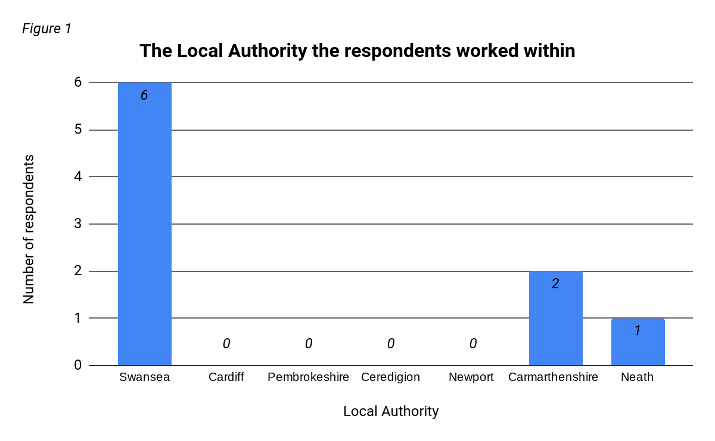
In our covering letter, we stated we were interested in gaining the perspective of a wide-range of school staff with experience of learners with EAL. However, we only received responses from class teachers and teaching assistants (Figure 2). As a group, we decided to branch questions 4 and 5 dependent on role and as we did not receive leadership responses, we have no data for question 4. If we were to extend the study, an interview or questionnaire response/s from a headteacher or deputy head would provide different perspectives on the study. Whilst the responses gained will give us a good classroom perspective, it does not give us a whole school leadership approach. However, 78% of these responses are from an individual with five or more years experience supporting learner with EAL and can provide an experienced, informative insight when analysed alongside support from secondary research and Personal Teaching Experience (PTE) to critically discuss an inclusive approach to supporting the needs of learners with EAL.

All respondents had learners with EAL in their current class. This may be because the questionnaire was forwarded to them by the headteacher as they knew they had EAL. We did not receive any responses from teachers with previous experience with learners with EAL but had none in their current class. On one hand, this means all the respondents are giving us current, up-to-date information. However, on the other hand we may have missed an interesting viewpoint from teachers who do not currently have learners with EAL in their class.

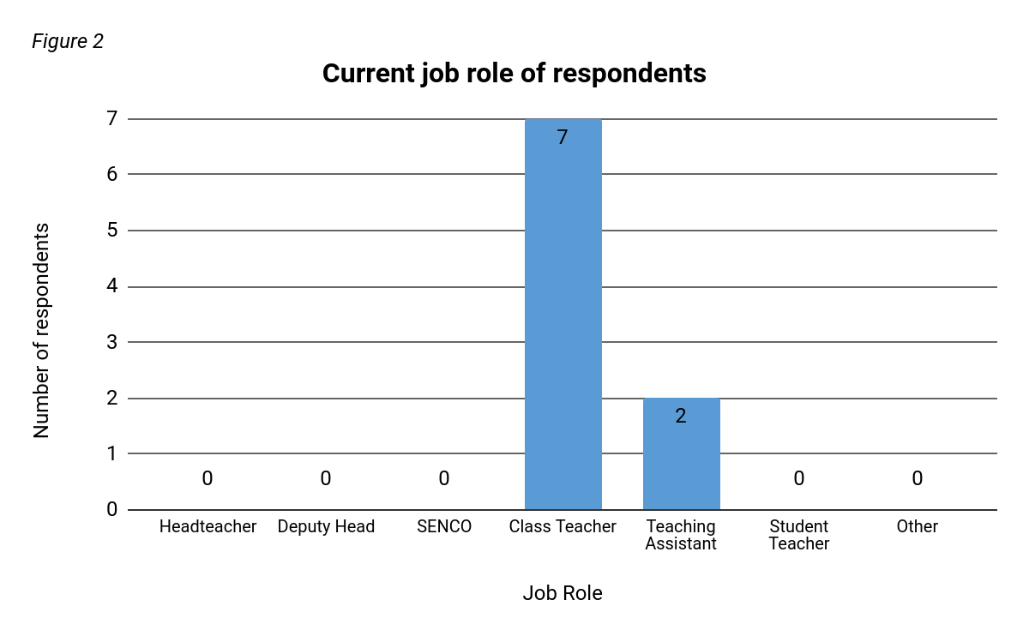

When learners with EAL are starting a new school, ESTYN (2018, p.1) best practice highlights the benefits of assessing new learners with EAL ‘before they start’. The SEN code of practice for Wales (2004, p.45) further builds upon this view recommending it is ‘necessary to consider the child within the context of his or her home, culture and community’ when assessing learners with EAL. Furthermore, Mistry and Sood (2005) note a pre-assessment would support the child's transition into the new setting by providing the opportunity for the learner, parents or guardians to ask any questions. The information gathered can be valuable in the creation of an Individual Education Plan (IEP), if required, to create ‘targets, strategies and review dates’ to support the learners’ development (Grigg, 2010, p.273). Our primary research indicated 66% of respondents, 6 individuals in total, currently use or have used an initial assessment to support learners with EAL and 78% of respondents, 7 individuals in total, indicated they use or have used an IEP approach to support new learners with EAL during transitional periods (Figure 3). Our primary research indicated these were the most commonly used strategies that respondents used to support new learners with EAL during transitional periods. EAL summer schools can also be used to develop English literacy levels of learners with EAL prior to starting school. ESTYN (2018, p.2) highlight the benefits of such a scheme as learners ‘make strong progress’ and they help close the attainment gap faster with their peers. However, from our primary research, no respondents indicated any such programme was available or utilised. There is no provision for EAL summer schools available in these areas (Swansea Council, 2017; Carmarthenshire County Council, 2018; Neath Port Talbot Council, 2018; ESTYN, 2014). The introduction of EAL summer schools to these areas could potentially support the transition of learners with EAL when starting school and help close attainment gaps faster.

ESTYN (2016; 2018) highlight the useful role of pupil buddies or ambassadors to support the transition and inclusion of new learners with EAL when they start school. Buddies can provide a ‘strong role model’ to support new pupils with EAL with school routines and activities (ESTYN, 2016, p.3). When selecting a buddy for a learner with EAL it is important to select a child who is helpful and friendly as well as a good oracy role model to allow children to have ample opportunity to practise their new language skills (Mistry and Sood, 2015; ESTYN, 2014). Vygotsky’s (Bates, 2016) ‘More knowledge other’ (MKO) theory would support this approach. However, despite encouragement and guidance much of the buddy child’s language may be outside of the learner with EAL’s zone of proximal development at first. In our primary research, 33% of respondents, 3 individuals in total, indicated they used a pupil buddy or ambassador when learners with EAL first started in their school. It would appear this effective and easily-organised strategy is being under utilised in schools although our data does not give us a reason for why it is not being more commonly used. If we were to repeat the study, it would be useful to follow question 10 with an open question to gain qualitative data to further analyse the reasons.

Thomas (2013, p208) states ‘prestige bias’ can affect questionnaire responses. It should be considered that the multiple choice question format may have prompted respondents to select multiple options that they do not use, as respondents may want to appear more ethical and inclusive to learners with EAL when they start school (Thomas, 2013). It is a possibility that our results have been affected by prestige bias despite stating all responses are confidential. In substitute, we could have used an open question, however, it is likely this would have made it more difficult to analyse the data due to the qualitative nature (Thomas, 2013).
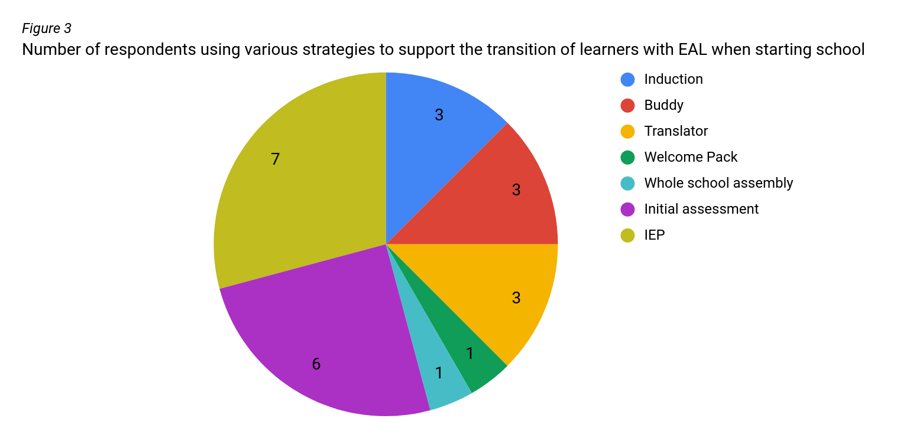

Firstly, to promote the inclusion of learners with EAL, schools can choose to include learners with EAL within their school ethos. Murphy (TES, 2018a, p.1) highlights EAL can be viewed as a ‘negative attribute’ or used to indicate a deficit and schools should strive to include learners with EAL positively. The inclusion of learners with EAL positively within a school’s ethos can help create an ‘inclusive and welcoming’ environment for learners (Mistry and Sood, 2015, p.19). In our primary research, 78% of respondents, 7 individuals in total, indicated EAL was mentioned within their school’s ethos and their school had an EAL policy (Figure 4). Additionally, during PTE I saw many school and classroom wall displays that supported the school’s inclusive ethos (Appendix 2). Many of the displays had been created by the children and this helped the children gain and develop an inclusive attitude to learners with EAL. Welsh Government (2016) stated children should be taught about inclusion and diversity in school and activities such as these provide an enjoyable, engaging opportunity for children to learn. Our primary research indicated 44% of respondents, 4 individuals in total, indicated their school also has displays promoting the inclusion of learners with EAL.

Secondly, it would appear an area to further develop the inclusion of learners with EAL as a whole school is school assemblies. In our primary research only 11% of respondents, 1 individual in total, indicated whole school assemblies are used as a method to promote the inclusion of learners with EAL in their school (Figure 4). ESTYN (2018, p.1) states by schools promoting ‘high levels of pupil inclusion’ through whole school activities such as assemblies it helps learners with EAL to integrate. Parker (TES, 2018b, p.1) reports school assemblies that involve, celebrate and promote the inclusion of learners with EAL can help to bridge the gap between communities and promote ‘cultural exchange’. Furthermore, it is not just learners with EAL that benefit from such experiences; English and monolingual learners will potentially benefit from experiencing different cultures, arts and music (TES, 2018b).
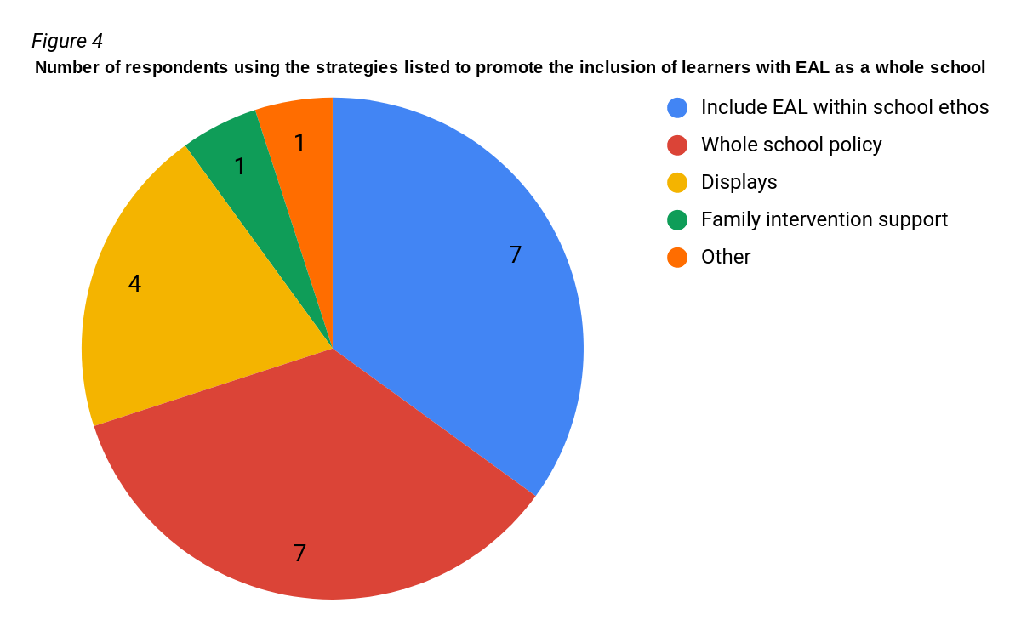

The inclusion of learners with EAL during lessons can be supported through the use of bilingual support assistants. ESTYN (2013, p.3) highlighted the benefits of bilingual staff on improving ‘communication between pupils, their peers, parents and staff’. During Personal Teaching Experience (PTE), I observed learners with EAL whilst they were supported by bilingual teaching assistants. The bilingual support assistants were able to translate the work for the children and I observed engagement was much higher, and work quality and quantity was improved. Our primary research indicated 33% of respondents, 3 individuals in total, use or have used bilingual staff to support learners with EAL. Murphy (TES, 2018a) highlights the benefits of translanguaging where knowledge is drawn from the child’s home language to support new English language learning. Vygotsky (Bates, 2016) would support this approach as the learners with EAL L1 language and knowledge within that language would scaffold the learning of English enabling a better understanding of the context and content (ESTYN, 2014). This approach would also support the continued development of their home language whilst developing learners with EAL independence; a key principle of EAL learning (Naldic, 2019). Furthermore, by teachers differentiating work for learners of EAL through the inclusion of a L1 translation, learners with EAL may be able to access more challenging work (Mistry and Dood, 2015) . 33% of respondents, 3 individuals in total, stated they continued to support learners with EAL first or home language. Respondents detailed this was achieved in a variety of ways including using L1 phases within the classroom routine and the use of a bilingual teaching assistant (appendix 4). However, these methods require bilingual staff or the class teacher to have a level of fluency in their home language to be successful (Conteh, 2006). It was unclear from our questionnaire why the remaining two thirds of respondents do not use or have used a bilingual member of staff. It is possible their learners with EAL English language skills were of a level that did not require bilingual staff. On the other hand, it may be lack of funding that prevents the employment of bilingual support staff. 88% of respondents indicated that they did not have any funding or were unsure if they had funding to support learners with EAL. Whilst this may indicate a lack of funding, this data would have been improved if we had more senior leadership responses. If funding is not available, some schools may opt to use English-speaking teaching assistants to support learners with EAL, language barriers may affect staff to student communication. Respondents indicated they used electronic translators to communicate with parents effectively; however, these strategies were not identified as in use with the pupils (figure 5). The use of electronic translators by English-speaking staff could be utilised to communicate more effectively with learners of EAL in the classroom.
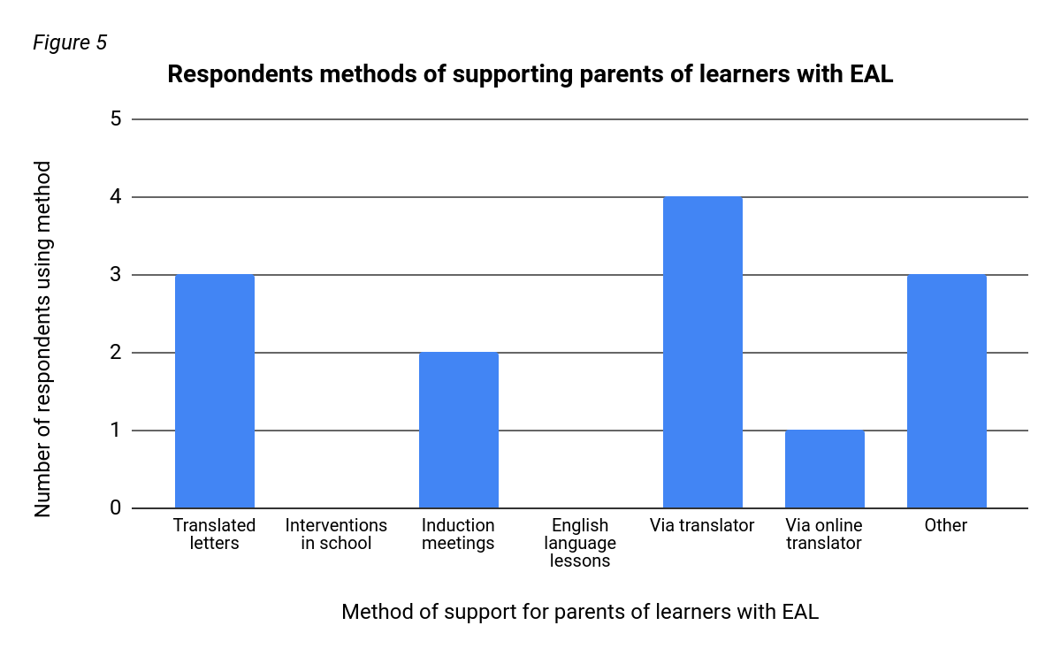
Gaining parental support and having effective parental communication is ‘clearly to the advantage’ of children’s education and development (Grigg, 2010, p.72). QTS standard S1.4 (Welsh Government, 2009, p.5) highlights ‘the importance of’ teachers ‘communicating information and expectations clearly and sensitively to parents and guardians‘ and ‘fostering positive relationships between home and school’. Our primary research indicated 44% of respondents, 4 individuals in total, were neither confident or unconfident communicating with parents or guardians of learners with EAL (Figure 6). However, no respondents indicated they were very confident. This lack of confidence may affect the learners with EAL as vital information may not be communicated which may adversely affect the child. However, communicating effectively with the parents or guardians of learners with EAL can be challenging for schools and practitioners as their first language may not be English and they may not speak English at all. ESTYN (2013) reports the benefits of using bilingual letters, key documents and bilingual staff support to ensure parents are involved in their child’s education. Our primary research indicated 33% of respondents, 3 individuals in total, translate letters for parents and 56% of respondents, 5 individuals in total, use a form of translator to communicate with parents. Furthermore, ESTYN (2013) best practice reports offering English classes to parents has helped improve parental communication. Our primary research indicated that no respondents indicated their school offered or has offered English language lessons for parents (Figure 5). However, during PTE I observed parental school-based English language lessons, the school staff reported the parents found them very useful and they were well-attended. The introduction of English-language classes within schools would help parents and guardians of learners with EAL to improve teacher communication levels.

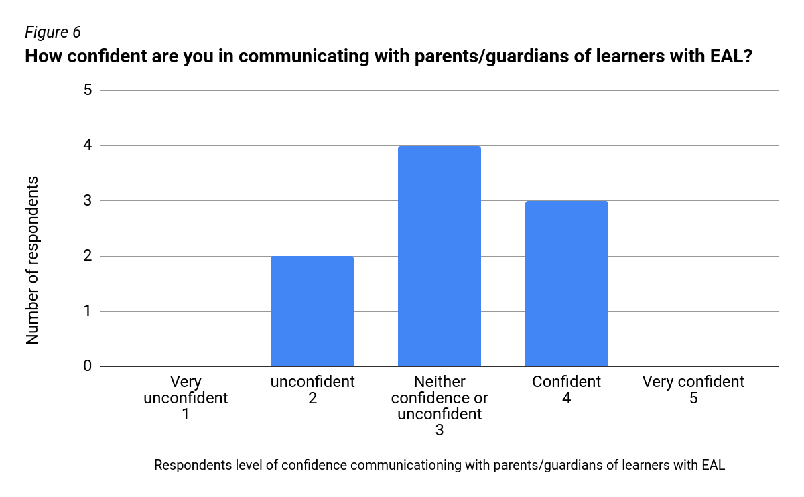

Class Teacher confidence is important when supporting learners with EAL. Our primary research utilised the likert scale to gather responses about the confidence level of teaching learners with EAL (Figure 7). Upon analysis of the results, only 11% of respondents, 1 individual in total, reported they were very confident when teaching learners with EAL..
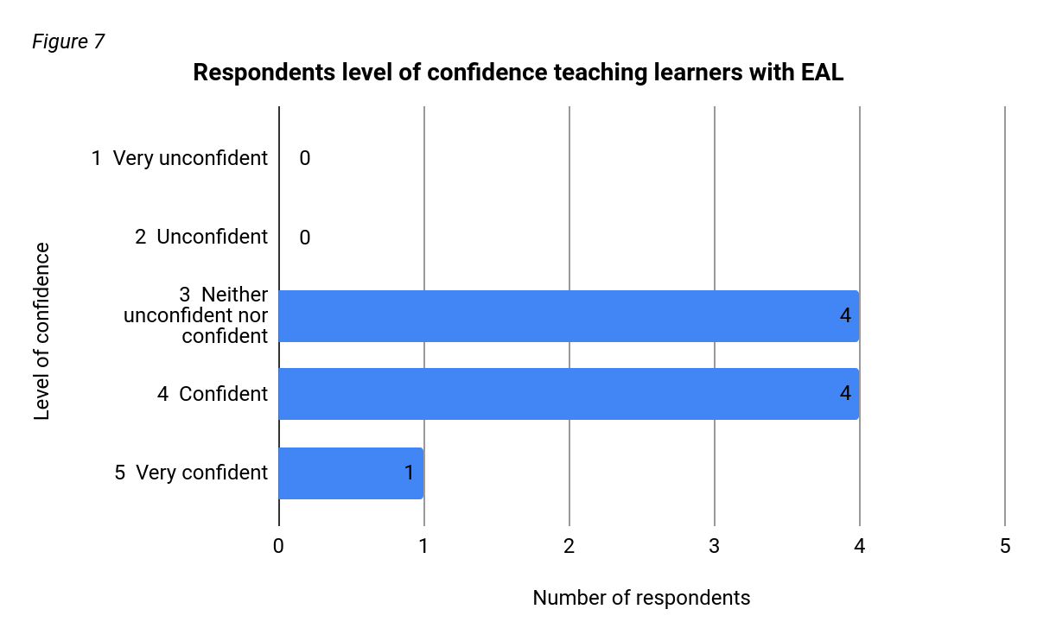
During our secondary research we identified several external companies that provide staff training for learners with EAL such as the Bell Foundation (Bell Foundation, 2019). Our primary research indicated respondents thought their training was provided by the LA however the LA might outsource training to external companies. 22% of respondents, 2 individuals in total, indicated they have had no formal training whilst 22% of respondents, 2 individuals in total, indicated they have had training provided by the school. Staff training will support teachers’ adaptation of the curriculum, competence and confidence with supporting learners with EAL in schools (Grigg, 2010). Our primary research used the likert scale questioning approach to gain quantitative data to assess respondents’ attitudes towards their satisfaction levels with their training on supporting learners with EAL (Thomas, 2013) (Figure 8). 44% of respondents, 4 individuals in total, indicated they were neither satisfied or dissatisfied with their training. Thomas (2013, p.213) highlights there is a tendency for respondents to ‘over-choose’ the middle option’. The removal of the middle option would have achieved more opinionated results. No respondents said they were very satisfied with their training and 22% of respondents, 2 individuals in total, indicated they were very unsatisfied with their training. The respondents who indicated they were very dissatisfied or dissatisfied worked within a range of LAs so it would not appear to be an issue with training in a particular LA. The NQT national survey 2017 (Department for Education, 2018a) reports 63% of primary school newly qualified teachers (NQTs) rated their training to prepare them to teach learners with EAL less than 7 out of 10. This suggests teacher training does not currently give students the skills or knowledge to adequately teach and support learners with EAL. Our research suggests these skills do not continue to be developed to an adequate level once qualified. A focus upon improving student and staff training by trainers and schools would improve competence and confidence and would support learners with EAL more effectively.

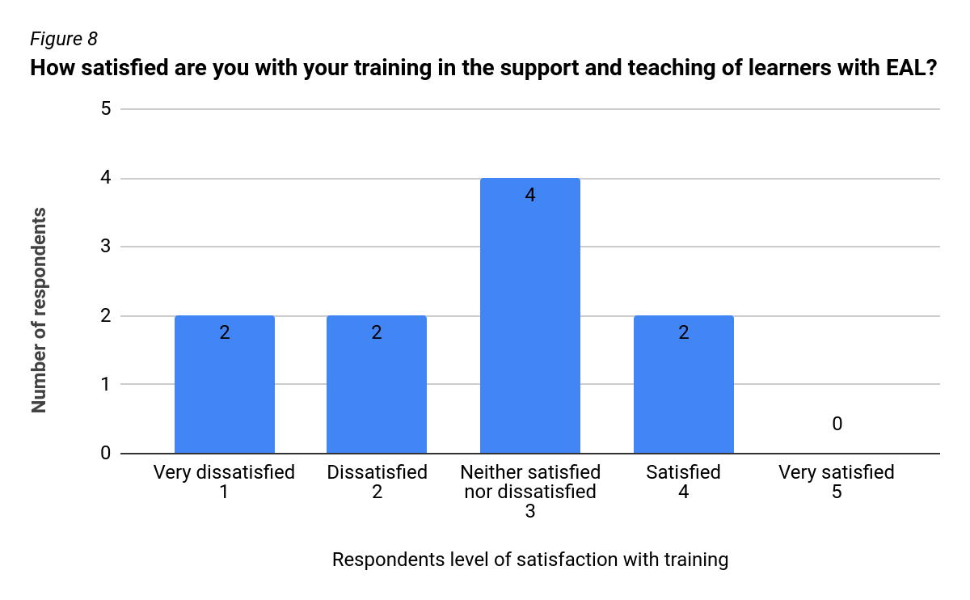

Myers (GL assessment, 2013, p.4) has identified whilst learners often experience high levels of motivation in stages A and B of the five-stage model, ‘there is often a dip in motivation’ at Stage C. The majority of learners with EAL in Wales are currently at Stage C (Welsh Government, 2018b). Stage C is when learners are developing confidence and ‘superficially fluent’ but do not have the ‘academic language proficiency to fully access the curriculum (GL assessment, 2013, p.4; Welsh Government, 2018c). Cummin’s (1980) iceberg model of language development (Figure 9) would support this viewpoint; however, he further reports cognitive and academic language proficiency skills can be improved and developed through practise and exposure.
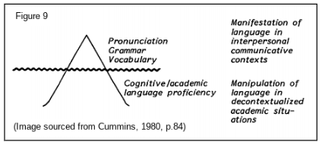
Teachers should be aware and mindful of this and use teaching and assessment for learning strategies to raise and maintain motivation levels. ESTYN (2016, p.1) highlight the benefits of the use of a ‘broad range of strategies and teaching methods’ coupled with first hand experiences to adapt the curriculum and support and engage learners with EAL. The foundation phase framework (WAG, 2015) would support this teaching approach as it would enhance the development of all learners. Our primary research utilised Fleming's VARK Model (Bates, 2016) to assess which teaching and learning styles are being used to differentiate and adapt the curriculum for learners of EAL. Respondents indicated 78%, 7 individuals in total, were currently using visual strategies with the remaining 22%, 2 individuals in total, using audio-based strategies to support learners with EAL (Figure 10). All of the respondents who indicated the use of visual resources, used images accompanied with text to support their teaching (appendix 3). Cook (2008, p57) supports this audio-visual differentiation approach to teaching language, highlighting this method can help organise new vocabulary and link it to ‘existing information in the mind’. However, no respondents indicated the use of reading or kinaesthetic learning style approaches. Bates (2016, p.121) highlights learners should be exposed to a range of learning styles to prevent hindering learning and to ‘develop learners’ weaker styles’. By utilising a wider-range of learning style approaches in their differentiation and adaptation of the curriculum, it will benefit all learners in the class as well as just learners with EAL.

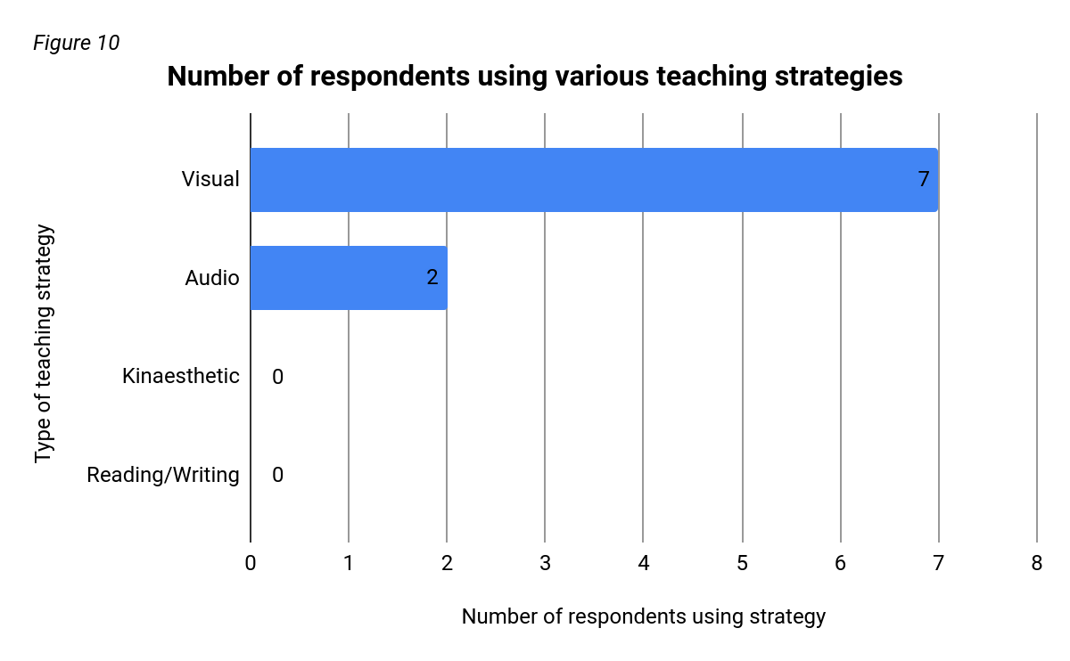

To conclude, whilst learners with EAL are a diverse and heterogeneous group, many of the strategies that teachers use with monolingual learners will also be effective and benefit learners with EAL. Furthermore, by the teacher smiling, being friendly and learning how to pronounce their name correctly, whilst modelling this positive behaviour for the other students, learners with EAL will begin to feel included and welcome in the class. It is important for a teacher to ask learners about their culture, family and celebrations and promote high levels of inclusion in all activities and school events, if appropriate (ESTYN, 2013). Overall, it's important to treat them with equality wherever possible. Moreover, by developing their English language skills, learners with EAL will work towards achieving one of Donaldson’s (2015, p.30) four purposes of the curriculum by becoming ‘ambitious, capable learners’ that are able to ‘communicate effectively in different forms and settings’ using English.

The primary research gave a good level of quantitative data surrounding teaching and support strategies, support and confidence with parents and guardians, whole school approaches and particularly teacher confidence supporting learners with EAL. However, at times it lacked depth and the analysis would have been improved with more qualitative, open questions to achieve a greater insight into respondents’ answers. To achieve this, I would have to continue to be mindful of response time and may have to reduce the amounts of topic in the research to maintain a reasonable response time. Furthermore, my analysis of the inclusion of learners with EAL, would have been improved further by the inclusion of question/s on high rates of pupil mobility and how respondents assess learners with EAL.

The ‘Microsoft forms’ questionnaire format appeared easy to use for respondents and the results were presented in an accessible format for analysis. We were mindful of respondents’ rights by allowing withdrawal from the research and by portraying responses accurately. Data was kept successfully in line with university guidelines and all responses were already anonymised. Green (2002, p.75) highlights the importance of using data ethically and sensitively as otherwise ‘it could cause considerable distress to participants’. However, we were disappointed with the functionality of the questionnaire as the format did not allow a ranking style question with several options. We changed the format, which we were initially happy with however, in my opinion this did not produce as useful, insightful data. A multiple ranking option may be available on other platforms such as survey monkey and we could have trialled using that platform to improve questionnaire functionality.

I have observed few learners with EAL whilst on PTE and would benefit from further observation and practice. I have arranged a placement in a school with a high percentage of learners with EAL in the coming months for my own personal development and to widen my knowledge of supporting a diverse range of learners with EAL further.

Word count: 4351 words

Appendices

Appendix 1
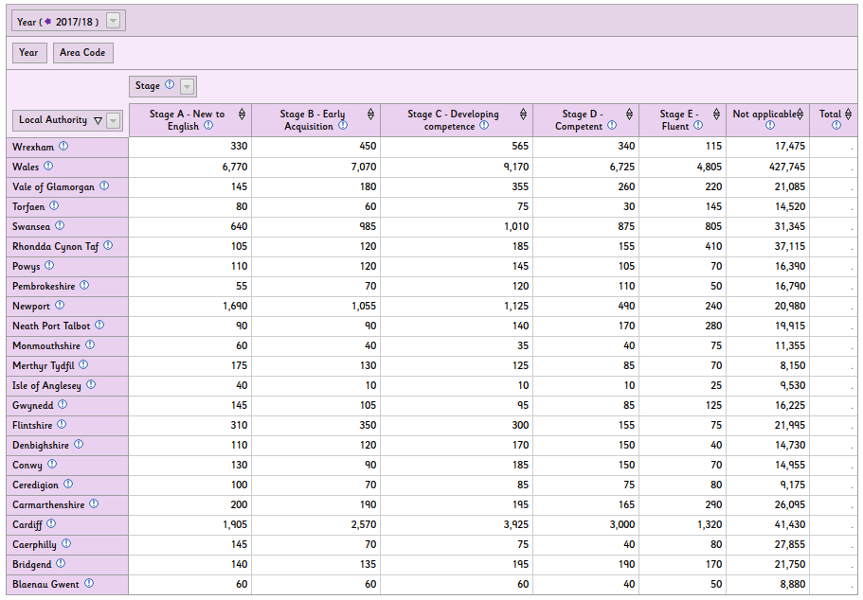
Welsh Government (2018b) Pupils in nursery, primary, middle and secondary schools acquiring English as an additional language by local authority and stage of development. Available at:https://statswales.gov.wales/Catalogue/Education-and-Skills/Schools-and-Teachers/Schools-Census/Pupil-Level-Annual-School-Census/Ethnicity-National-Identity-and-Language/pupilsacquiringenglishasadditionallanguage-by-localauthorityregion-stagedevelopment (Accessed: 9th April 2019).

Appendix 2

Collage of inclusive wall display examples
Created from images from Pinterest.co.uk. Available at: https://www.pinterest.co.uk/pin/398146423305126350/
https://www.pinterest.co.uk/pin/1477812348984938/
https://www.pinterest.co.uk/pin/181129216237009155/
(Accessed: 9th April 2019).

Appendix 3

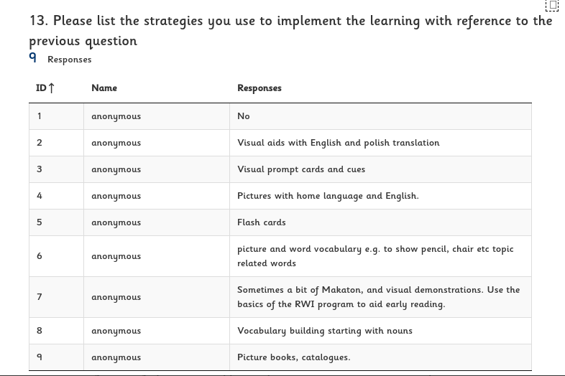

Questionnaire responses for question 13

Appendix 4
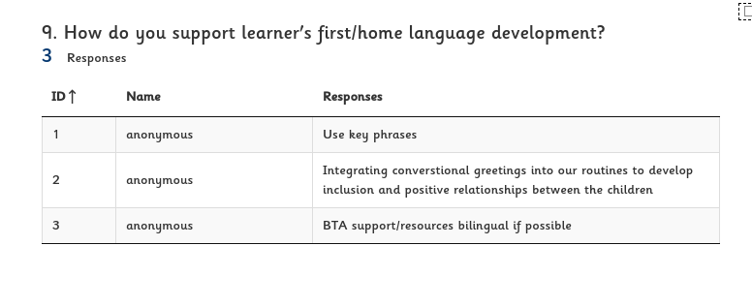Questionnaire responses for Question 9

Bibliography

Bates, B. (2016) Learning theories. London: Sage Publications.

Bell Foundation (2019) Training courses to support teachers working with EAL learners. Available at: https://www.bell-foundation.org.uk/news/training-courses-support-teachers-working-eal-learners/ (Accessed: 9th April 2019).

British Council (2015) Identifying challenges and good practices in preparing trainee teachers in Wales to meet the needs of additional language learners. Available at: https://ealresources.bell-foundation.org.uk/sites/default/files/document-files/British%20Council%20EAL%20Nexus%20ITT%20and%20EAL%20WAL%20in%20Wales%20Short%20Report%20in%20English.docx (Accessed: 11th April 2019).

BTC Education (2013) What is scaffolding for EAL learners [video].Available at: https://www.youtube.com/watch?v=aZMicmGkFIM (Accessed: 10th April 2019).

Carmarthenshire County Council (2018) Support for Learners. Available at: https://www.carmarthenshire.gov.wales/home/council-services/education-schools/support-for-learners/ (Accessed: 9th April 2019).

Children in Wales (2014) ‘Rights’. Available at: http://www.childreninwales.org.uk/our-work/rights/ (Accessed: 19th April 2019).

Collier, V. (1989) ‘How long? A synthesis of research on academic achievement in a second language’, TESOL Quarterly, 23(3), pp. 509-531. Available at:
http://www.thomasandcollier.com/assets/how-long.pdf (Accessed: 15th April 2019).

Conteh, J. (2006) Promoting Learning for bilingual pupils 3-11: opening doors to success. Sage: London.

Cook, V. (2008) Second Language Learning and Language Teaching. 4th Ed. London: Hodder Education.

Cummins, J. (1980) The construct of language proficiency in bilingual education, Georgetown university round table on languages and linguistics 1980, unknown, pp. 81-103
Available at: https://repository.library.georgetown.edu/bitstream/handle/10822/555473/GURT_1980.pdf?sequence=1#page=93 (Accessed: 9th April 2019).

Department for Education (2018a) Newly qualified Teachers: annual survey 2017. Available at: https://assets.publishing.service.gov.uk/government/uploads/system/uploads/attachment_data/file/738037/NQT_2017_survey.pdf (Accessed: 10th April 2019).

Department for Education (2018b) Exploring teacher workload: Quantitative research. Available at: https://assets.publishing.service.gov.uk/government/uploads/system/uploads/attachment_data/file/686734/Exploring_teacher_workload.pdf (Accessed: 9th April 2019).

Donaldson (2015) Successful futures. Available at: https://gweddill.gov.wales/docs/dcells/publications/150225-successful-futures-en.pdf (Accessed: 9th April 2019).

Edchat (2013) Teachers TV: Engaging pupils with EAL [video]. Available at: https://www.youtube.com/watch?v=l4a70A88DS0 Accessed: 20th April 2019.

ESTYN (2009) How effective is provision for learners aged 16 to 19 years with English language acquisition needs? Available at: https://www.estyn.gov.wales/thematic-reports/how-effective-provision-learners-aged-16-19-years-language-acquisition-needs-july (Accessed: 7th April 2019).

ESTYN (2013a) Effective partnerships help to break down language barrier. Available at: https://www.estyn.gov.wales/effective-practice/effective-partnerships-help-break-down-language-barriers (Accessed: 19th April 2019).

ESTYN (2013b) Supporting vulnerable groups of pupils. Available at: https://www.estyn.gov.wales/effective-practice/supporting-vulnerable-groups-pupils
(Accessed: 16th April 2019).

ESTYN (2014) The annual report of her majesty's chief inspector of training and education in Wales. Available at: https://www.estyn.gov.wales/sites/default/files/documents/The_Annual_Report_of_Her_Majestys_Chief_Inspector_of_Education_and_Training_in_Wales_2013-2014.pdf (Accessed: 9th April 2019).

ESTYN (2016) Taking every opportunity to increase literacy. Available at : https://www.estyn.gov.wales/effective-practice/taking-every-opportunity-increase-literacy
(Accessed: 9th April 2019).

ESTYN (2017) A flexible curriculum that responds to the needs of individual learners. Available at: https://www.estyn.gov.wales/effective-practice/flexible-curriculum-responds-needs-individual-learners (Accessed: 15th April 2019).

ESTYN (2018) Supporting pupils with English as an additional language to help them integrate. Available at: https://www.estyn.gov.wales/effective-practice/supporting-pupils-english-additional-language-help-them-integrate (Accessed: 9th April 2019).

GL Assessment (2013) ‘Understanding the attitudes of ethnic minority students’, GL Assessment newsletter, 8th September. Available at: https://www.gl-assessment.co.uk/sites/gl/files/images/Files/GL-Assessment-Newsletter_Assessment-Matters_UK-edition-Issue-8_September-2013.pdf (Accessed: 3rd April 2019).

Green, S. (2002) Research Methods in health, social and early years. Stanley Thornes Publishers: Cheltenham.

Grigg, R. (2010) Becoming an outstanding primary school teacher. Essex: Pearson.

Mistry, M. and Sood, K. (2015) English as an additional language in the early years: linking theory to practice. London: Routledge

Naldic (2019) ‘Teaching and learning’. Available at: https://naldic.org.uk/teaching-learning/primary/ (Accessed: 7th April 2019).

Neath Port Talbot Council (2018) Schools, education and youth. Available at: https://www.npt.gov.uk/1347 (Accessed: 19th April 2019).

Northampton University (2014) TAs supporting English language as an additional language [video]. Available at: https://www.youtube.com/watch?v=IPYxNDwos34
(Accessed: 10th April 2019)

Swansea Council (2017) Childcare and education plans and policies. Available at:https://www.swansea.gov.uk/educationplans (Accessed: 9th April 2019).

TES (2018a) Why using the term EAL can be ‘reckless. Available at: https://www.tes.com/news/why-using-term-eal-can-be-reckless
(Accessed: 8th April 2019).

TES (2018b) Polish to English: how one school is bridging the gap. Available at:
https://www.tes.com/news/polish-english-how-one-school-bridging-gap (Accessed: 11th April 2019).

TES (2019) 7 ways to support EAL learning in primary. Available at: https://www.tes.com/news/7-ways-support-eal-learning-primary (Accessed: 9th April 2019).

Thomas, G. (2013) How to do your research project: A guide for students in Education and Applied Social Sciences. 2nd Ed. Sage: London.

UNICEF (2018) Convention on the rights of the child. Available at: https://downloads.unicef.org.uk/wp-content/uploads/2010/05/UNCRC_united_nations_convention_on_the_rights_of_the_child.pdf?_ga=2.114131909.352654264.1556380276-2028968373.1556206536 (Accessed: 11th April 2019).

WAG (2003) The achievement of ethnic minority pupils in Wales. Available at: https://learning.gov.wales/docs/learningwales/publications/121119ethnicminoritypupilsen.pdf (Accessed: 9th April 2019).

WAG (2004) Special Educational Needs Code of Practice for Wales. Available at: https://learning.gov.wales/docs/learningwales/publications/131016-sen-code-of-practice-for-wales-en.pdf (Accessed: 10th April 2019).

WAG (2015) Foundation Phase Framework. Available at: https://beta.gov.wales/sites/default/files/publications/2018-02/foundation-phase-framework-revised-2015.pdf (Accessed: 12th April 2019).

WCVA (2017) The goals of the wellbeing of future generations (Wales) act 2015. Available at: https://www.wcva.org.uk/media/5636168/the_goals_of_the_wellbeing_of_future_generations__wales__act_2015.pdf (Accessed: 12th April 2019).

Welsh Government (2009) The Qualified Teacher Status Standards Wales 2009. Available at: https://gweddill.gov.wales/legislation/subordinate/nonsi/educationwales/2009/3220099/?lang=en (Accessed: 9th April 2019).

Welsh Government (2014) Rewriting the future: raising ambition and attainment in Welsh schools. Available at: https://gov.wales/sites/default/files/publications/2018-03/rewriting-the-future-raising-ambition-and-attainment-in-welsh-schools.pdf (Accessed: 5th April 2019).

Welsh Government (2015) Evaluation report on capacity building approaches to support the delivery of English as an additional language in Wales. Available at:
https://learning.gov.wales/docs/learningwales/publications/151001-capacity-building-en.pdf (Accessed: 9th April 2019).

Welsh Government (2015b) Keeping learners safe. Available at: https://gov.wales/sites/default/files/publications/2018-11/keeping-learners-safe-the-role-of-local-authorities-governing-bodies-and-proprietors-of-independent-schools-under-the-education-act-2002.pdf (Accessed: 9th April 2019).

Welsh Government (2016) Inclusion and pupil support. Available at https://gov.wales/sites/default/files/publications/2018-05/guidance-inclusion-and-pupil-support_0.pdf (Accessed: 13th April 2019).

Welsh Government (2018a) Draft Additional Learning Needs Code for Wales. Available at: https://gov.wales/sites/default/files/consultations/2018-12/draft-additional-learning-needs-code-for-wales_0.pdf (Accessed: 9th April 2019).

Welsh Government (2018b) Pupils in nursery, primary, middle and secondary schools acquiring English as an additional language by local authority and stage of development. Available at: https://statswales.gov.wales/Catalogue/Education-and-Skills/Schools-and-Teachers/Schools-Census/Pupil-Level-Annual-School-Census/Ethnicity-National-Identity-and-Language/pupilsacquiringenglishasadditionallanguage-by-localauthorityregion-stagedevelopment (Accessed: 12th April 2019).

Welsh Government (2018c) Academic Achievement by Pupil Characteristics, 2018 Key Quality Information. Available at: https://gov.wales/sites/default/files/statistics-and-research/2019-01/academic-achievement-by-pupil-characteristics-2018-key-quality-information.pdf (Accessed: 8th April 2019).

