Project Management

Project Management and Research Methods

Dr Mabrouka Abuhmida

Scott Howells
Student P Number – 1701604
Dr Kemi Ademoye – Security in Web Applications

Table of Contents
Introduction 2
Introduction / Background to the Proposed Research 3
Research and Development Methods 6
Resources and Planning 11
Bibliography 15
References 15

Table of Figures
Figure 1: The Research Onion 7
Figure 2: The Waterfall Model 9
Figure 3: Prototype Methodology 10
Figure 4: Gantt Chart 12
Figure 5: Calendar view of Gantt Chart (1) 13
Figure 6: Calendar view of Gantt Chart (2) 13
Figure 7: Calendar view of Gantt Chart (3) 14
3Figure 8: Resource Sheet………………………..……………………………………………………………………….14

Introduction
The following report has been conducted in order to display a vast range of research and planning that must be attributed in order to identify an area of study that is relevant to the degree that is currently being undertaken. The report will highlight key methods into the research taken for the final year research project. This report will be portrayed as a project proposal in which the chosen research will be introduced and justified.

Introduction / Background to the Proposed Research
Introduction and working title
This section of the report will contain an in-depth consideration into the project and the methods of implementation that will be undertaken in order to set the project into motion. There will also be a brief consideration into the current literature and research pertaining to the project and the inclusion of the aims and objectives that is hoped to achieve and displayed with the completion of the project.
The chosen topic area of the proposed research document for the final year project is called ‘Security in Web Applications’. This project will investigate the different types of security within web application development. The project has the potential to expand in many ways which is another benefit to the chosen topic area of study. The project can discuss the most prevalent and dangerous threats within the world and its ability to affect web security. The project will also investigate the approach to securing a web application following guidelines and validating the implementation against the framework. However, this project has a large scope in which can be investigated and has room for many external topics of conversation which is linked with the chosen project title.
Web applications refer to the application program that can be stored on a remote server. Client-server software applications will run in a web browser. Web applications can also be built for specific purposes such as a cross-platform app development service.
‘Multiple mobile platforms impel to build & maintain mobile apps for each possible platform. Developing the native apps means a cumulative cost. Cross platform apps make a way for the companies to invest in a framework that reduces efforts. For the time & cost-effective solutions, developers go with the cross platform mobile app’ [1].
In today’s current technology it is easier for programmers to develop cross-platform apps. Some approaches to cross-platform development include:
- Hybrid mobile app development - developers write the core of the application as an HTML5 or JavaScript mobile app and then place a native device wrapper around it.
- Rapid mobile app development (RMAD) - developers use code-free programming tools. RMAD offers business users the ability to quickly build and manage “good-enough” internal apps to address specific business issues.
- Windows universal apps - one codebase for all Windows devices. The goal is to enable the same app to run on a Windows PC, tablet, smartphone, smartwatch or Xbox.
- Progressive web apps (PWAs) - websites that look and behave as if they are mobile apps. PWAs are built to take advantage of native mobile device features, without requiring the end user to visit an app store, make a purchase and download software locally. [2]
There is also evidence to support that some web applications may contain the elements of both native and web apps. Users can utilize any application from any computer through the internet connectivity. There are pros and cons to web application, as briefly listed below the pros are:
- Cost effective development
- Anytime Access
- Customization
- Supports Various Devices
The cons are considered:
- Overhead and Increased Size
- Restrictions for Client Side [3].
Security in web applications have been introduced as it is ‘crucial because attacks against internet-exposed web apps are the top cause of data breaches’ [4]. As Stephen Gates has stated within his blog, security within web applications are extremely important as many malicious attacks can be as a direct result of a lack of security on the web applications. He states that ‘77 percent of web applications have at least one security vulnerability’ [5], in today’s current situation that is extremely high with the amount of web applications that are used on a daily basis. This project will aim to research all the areas that is associated with web application security and discuss and portray all the appropriate and relevant information with recommendations to the project.
The recent ‘advancements in web applications have also attracted malicious hackers and scammers’ [6], this is due to the opportunity to gain money despite it being extremely illegal. The need for further research into security on web applications is a definite must. Innocent people with valuable information are proceeding to lose their valuable information due to hackers and scammers. Valuable information such as personal acknowledgement of the location of residency, banking information and many more are being stolen. The need for further protection from security on web applications is highly requested and the need for others to learn and understand the key components of security and how it must be established effectively and implemented throughout web applications is also required in order for the current and the next generation of web applications to succeed and withstand the negative effects of the hackers and scammers. Therefore, the research being made towards this project will help incline many others in order to establish a greater security thought towards web applications.
Provide the reader with an understanding of the field in which the studies lie and an idea of where and how the study fits into this field
The aim of the project will be to investigate security within web applications and portray the findings within a well-documented report with its main outline to educate others on the subject matter. The document will focus on all the techniques associated with security within web applications as well as the inclusion of relatable topics that work hand in hand with the project. The intensive research that will be undertaken for the purpose of this project will be justified as the research will benefit the outcome of the report as well as those whom read the report. The report will contain many sources that is linked to the topic, this topic is very controversial as it can (if not implemented effectively) affect many web applications and the users assigned to them. Despite this topic being well known, there are still areas that can be investigated. This is due to the fact that security is constantly under threat and multiple sources indicate that malicious activity continues to proceed on most web applications in today’s climate. As well as conducting research into the types of malicious activity that has gripped the world with relation to web applications, the report will also contain the types of procedures conducted into keeping a web application secure.
Will there be any industry/organisation/context that will be investigated?
There will be multiple investigations into organisations that have experienced faults within their security when it comes to security in web applications. There will also be an investigation into the types of security used within organisations and the most prolific ways organisations combat and implement security.
Define one overarching aim of the study (the research purpose). Construct a series of objectives that specify what you will do to achieve the aim (typically 3 or 4 objectives)
The aim of the study is to provide a detailed and well descriptive study into the Security of Web Applications. This study will ultimately be used as a report and will be used to educate others on the Security of Web Applications. In order to achieve this aim, the following objectives will need to be achieved:
- Investigate what Security in Web Application is and what is required when considering it
- Analyze and evaluate the Security of vast amounts of Web Applications
- Explore the possibility of creating a suitable security method within a web application as well as documenting other different types
- Produce recommendations into how Web Applications should take care in securing their products as well as the reasons as to why

Expected outcomes and/or deliverables
At the end of the project it is expected that all areas of Security in Web Applications will be covered, and the report will cover all the basis regarding how to secure web applications and the correct methods and procedures to take.
To accompany the report there will be detailed sections that outline the best interests of how to implement security on web applications. The report is expected to deliver informative and educational aspects towards security in web applications.
Extensive research and planning will be involved in order to meet the aims and objectives that have been stated above.
Conclusion
In this section, there has been a clear incentive into the amount of research that will be undertaken as well as what is needed to be researched throughout this topic. There has been a clear understanding with the background of the topic and the potential of what will be the outcome when completed. In relation to this research, the aim is to produce a successful report with the correct understanding of all aspect towards security in web application.
The next section of the report will contain the research and development methods.

Research and Development Methods
This section of the report will consider the research methodology that will be followed and the development method that will be implemented. The ethical and legal issues that are connected to the project will be considered as well as potential risks or limitations that may arise during the project and what action will be taken in order to prevent them. Finally, this section will also consider how at the end of the project the aims and objectives will be evaluated and if they have been achieved.
Philosophies
Preliminary to conducting the research, an appropriate research philosophy must be implemented. A research philosophy ‘refers to the set of beliefs concerning the nature of the reality being investigated’ [7]. The research philosophy can be used to explain any assumptions made within the research process and how it will be associated with the methodology being used. A popular way to identify the different philosophies, approaches, strategies, time and techniques is to use the ‘Research Onion’. The research onion was developed by Saunders [8] and it illustrates the stages that must be covered when developing a research strategy. The research onion provides an effective progression through what research methodology can be designed. Below is an illustration of the ‘Research Onion’:
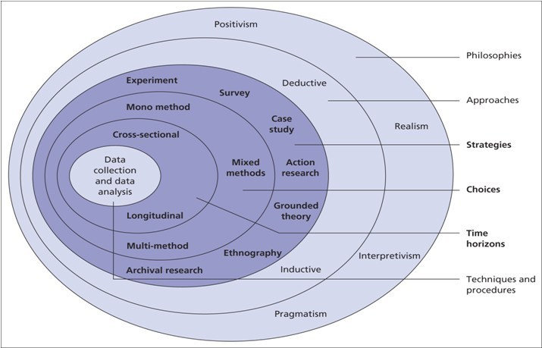
Figure 1: The Research Onion [9]
The research for this project which is about considering all aspects of security in web applications and develop strategies into using security in web applications means that the best philosophy to follow will be positivism. Positivism will create research questions and hypotheses that can be tested. Positivism allows for the explanation measuring the knowledge of the topic. Alternatively, phenomenography understands the behaviors of humans and people’s perceptions of interpretation on their experiences.
After choosing an appropriate philosophy, there are two research approaches that can be chosen. These two methods are inductive and deductive. Inductive focuses on the working title of the theory, it means not to give a thought to an existing theory. The structure of the research that has been conducted can change as the research is developed. This approach works hand in hand with phenomenography. Deduction is the aim to find the answer to the question that is at the beginning of the research. The objective of this approach is to give a definitive answer of yes or no in response to the research question. This process is to gather data and either confirm or reject the questions being asked. This approach is structured and allows the process to be replicated, this means the data that is being produced is valid and facts identified are quantitively measured.
Strategies
There are multiple research strategies that can be used for this project. Case Study has been issued as the most appropriate research strategy in order to conduct research. A case study helps study one or more studies. When conducting research on multiple studies it will allow for a clearer conclusion when completing the project. Action research is also another alternative as it allows for research into an organization and the process can be to have an objective, find an issue and make a list of problems. This strategy can also be used when studying security in web applications.
The final strategy that will be taken will be longitudinal rather than cross-section. This method allows for the use of qualitive and quantitative research methods. This method will study behavior and events with focus over a long period of time.
The study population
The study population of this project will be the users of web applications. When creating a successful web application, it is important to include suitable and strong security. Software Engineers and Web Developers are some of the study population that will required to acknowledge security within web applications. Multiple organisations will also be studied as they have web applications that are available for the public and the security will be assessed as well as previous faults in some organsiations web application security.
Data collection methods
Data collection is very important when it comes to conducting research. If data that has been collected is inaccurate then it can impact the results of the study and has the potential to affect the study in a negative way.
Quantitative and qualitative methods will be used in order to collect the data. Quantitative is used to quantify the problem by developing usable statistics. This type of method will formulate facts and uncover patterns in research. Qualitative is used to gain an understanding and provides an insight into the problem, it is also a helpful way to develop ideas and hypotheses for the research. This method is also used to uncover trends and dive deeper within a problem [10]. Both methods will be used in order to collect relevant data as both are appropriate.
In order to identify the requirements needed to produce a suitable security system within a web application, extensive amount of research will be made in order to gain enough knowledge of all areas that is associated with the security within web applications. The potential to use questionnaires and interview for some of the people whom create web applications could be useful as they must create security for the web applications. Furthermore, there will be research conducted and documented on security in web applications. The data gathered would be on the importance of security when creating a web application. The knowledge gained from this will be used to correctly document the project as well as attempt to implement security within a web application.
Reliability and validity
Reliability refers to the consistency. An example of this would be a thermometer is reliable as it would measure the correct temperature each time it is used, and it is consistent. Validity is the concern that the resulting data is accurately portrayed what is happening. An example of this would be the history and method of testing may not be accurate.
As discussed above, using mixed methods of introducing both quantitative and qualitative data collection will ensure that the possibility of including false information will be limited.
If relevant, identify and justify any development methods and techniques that will be used as part of systems development. Consider an evaluative framework (such as Avison and Fitzgerald) to compare methods or to justify the selection.
When choosing the software development method, it was important to garner the pros and cons for using each method. The methods that have been identified as successful to use regarding this project are the waterfall method and prototype methodology. The waterfall model will clarify the process that is required to be followed. Figure 2 will demonstrate the waterfall model. Prototype methodology is a software development procedure that initiates developers into making the sample of the software in order to validate its functionality before creating and finishing the changes that are required to be made in order to allow it for general use. This is suitable as it will allow for the concentration on security within web applications. Figure 3 is an illustration of prototype methodology.

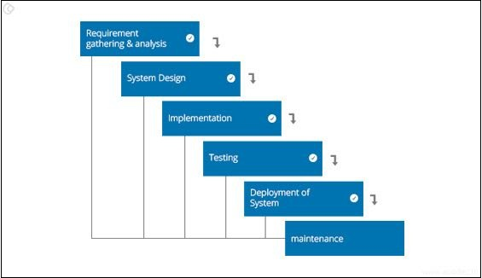
Figure 2: The Waterfall Model [11]
The pros to using the waterfall model and avoiding any problems are:
- It is easy to understand
- Simple design to follow
- Saves significant time
- Allows for easy testing and analyzing

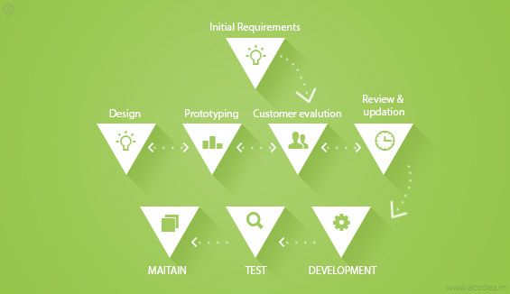
Figure 3: Prototype Methodology [11]
The pros to using the prototype methodology and avoiding any problems are:
- Gives a clear idea about the functional process
- Reduces the risk of failure
- Assists with the requirement gathering and overall analysis
Identify risks/limitations/ethical/legal issues and ways to deal with the risks.
When in the beginning stages of developing a project, it is always important to identify potential issues rather than them unexpectedly occurring during the creation of the project. There are several risks that have been identified, these risks are:
- Not being able to achieve all the requirements set as unrealistic goals were implemented
- Poor time management
- Not enough time to construct the software
- Implementing using the incorrect software
- Loss of data (keep backups)
- The questionnaires not being completed fully
The main tool that will be utilized in order to plan the project effectively will be the Gantt chart with the PERT analysis as they have proved in previous studies to be effective. Using a Gantt chart will allow for a clear path to follow with set instructions to follow within deadlines. As previously discovered there will be no fixed amount of work required to be completed as other work constraints may play a factor in the progress.
The legal and ethical issues that have currently been identified (note there may be more that appear later) is that many organisations will not want to publicly disclose their security when it comes to their web applications. If enough critical research has been made, then weak security could be targeted. This will not be acceptable to include as organisations would rather certain information will not be available to the public.
The final note to consider regarding the limitations for the project will be the lack of ability to effectively construct a secure security system for a web application. Through the use of self-teaching and help from gaining the skills by attending classes on security in web applications only then will there be sufficient knowledge in order to develop a functioning security system. This is the reason why a prototype will be created rather than a fully functioning web application as there may not be suitable time scales to impact the learning.
How will the data be analysed, and the results evaluated?
The evaluation of the completed report and the potential completion of a security method within a web application will be carried out in multiple methods. The first type of analysis will be to compare the security with others in the field of web applications. A test will be carried out in order to assess the security of the web application. The report will be proof read in order to ensure that the report is of high standard.
Conclusion
In this section, there has been a fruitful discussion and a justification on the specific research and development methods that will be used when constructing this project. Risks, limitations, ethical and legal issues have been considered, despite the possibility of more identifiable later in the project.

Resources and Planning
This final section will consider the resources required and the planning that the project needs for it to become successful.
Identify any resources required
In order to complete the project, resources are required and will be utilized in order to enhance the project into becoming successful. The following resources have been identified and will be required in the creation of the project (note that further resources may be identified later in the process of completing the project):
- Laptop/Desktop – to be used for creating the report as well as the potential of building the security system
- Microsoft Word
- Visual Studio
- The Internet – for the research
- Books – for the research

Construct a Gantt chart that demonstrates evidence of project planning and management. Identify the timescales for each component of the study.
When planning and managing the project, a Gantt chart was identified in order to follow a plan successfully allows for the project to be completed in a professional and appropriate manner. Each task implemented within the Gantt chart has been constructed in order to complete the project with success, the success from completing each task will enhance the project into finalizing into a professional final year project. The use of Program Evaluation Review Technique (PERT) [12] will allow for a more realistic task completion date.

Figure 4: Gantt Chart


Figure 5: Calendar view of Gantt Chart (1)

Figure 6: Calendar view of Gantt Chart (2)

Figure 7: Calendar view of Gantt Chart (3)

Figure 8: Resource Sheet
Conclusion
As stated above, there is always a possibility that the resources that have been identified may not be enough and further resources are required to be utilized. The potential of including more resources during the completion of the project may hinder the project. However, with the project planning of the Gantt chart and managing the project efficiently there should be no room for error if resources are missing as there will be a contingence plan in place. In this current moment the times attributed to completing each task are only hypothetical as there is no fixed timescale.

Bibliography
Research Onion - https://www.allassignmenthelp.co.uk/blog/research-onion-made-easy-to-understand-and-follow/
Data Collection Methods - https://people.uwec.edu/piercech/researchmethods/data%20collection%20methods/data%20collection%20methods.htm
How to Use Gantt Chart to Kickstart a Project Like a Boss - https://www.proofhub.com/articles/uses-of-gantt-chart

References

[1] | “Cross Platform Mobile App Development Company,” iMOBDEVTECH, [Online]. Available: https://www.imobdevtech.com/Services/Cross-Platform-Development. [Accessed 3 April 2019].
[2] | M. Rouse, “cross-platform mobile development,” searchmobilecomputing, May 2018. [Online]. Available: https://searchmobilecomputing.techtarget.com/definition/cross-platform-mobile-development. [Accessed 3 April 2019].
[3] | B. Parmar, “What is a web app? Pros & Cons of using them,” iMOBDEVTECH, 1 July 2016. [Online]. Available: https://www.imobdevtech.com/Blog/what-is-a-web-app-pros-cons. [Accessed 3 April 2019].
[4] | S. Gates, “Why Web Application Security is Important,” dyn.com, 8 August 2018. [Online]. Available: https://dyn.com/blog/why-web-application-security-is-important/. [Accessed 3 April 2019].
[5] | S. Gates, “Why Web Application Security is Important,” dyn.com, 8 August 2018. [Online]. Available: https://dyn.com/blog/why-web-application-security-is-important/. [Accessed 3 April 2019].
[6] | netsparker, “Getting Started with Web Application Security,” netsparker, [Online]. Available: https://www.netsparker.com/blog/web-security/getting-started-web-application-security/. [Accessed 3 April 2019].
[7] | A. Bryman, Social Research Methods (5th Edition), Oxford: Oxford University Press, 2012.
[8] | P. L. A. T. Mark Saunders, Research Methods for Business Students (4th Edition), Edinburgh Gate, Harlow: Financial Times Prentice Hall, 2007.
[9] | AllAssignmentHelpUK, “Research Onion – Made easy to understand and follow,” 14 July 2017. [Online]. Available: https://www.allassignmenthelp.co.uk/blog/research-onion-made-easy-to-understand-and-follow/. [Accessed 3 April 2019].
[10] | S. E.DeFranzo, “What’s the difference between qualitative and quantitative research?,” Snap Surveys, 16 September 2011. [Online]. Available: https://www.snapsurveys.com/blog/qualitative-vs-quantitative-research/. [Accessed 3 April 2019].
[11] | “12 BEST SOFTWARE DEVELOPMENT METHODOLOGIES WITH PROS AND CONS,” Acodez, 14 June 2018. [Online]. Available: https://acodez.in/12-best-software-development-methodologies-pros-cons/. [Accessed 3 April 2019].
[12] | M. Rouse, “PERT chart (Program Evaluation Review Technique),” SearchSoftwareQuality, May 2007. [Online]. Available: https://searchsoftwarequality.techtarget.com/definition/PERT-chart. [Accessed 4 April 2019].

