LERANING IN DIGITAL ERA
Assessment 1 Evidence of learning (E-portfolio)
Module: BMSW4010
Name: Ruth Tulu
Student number: 2126246
Date submitted: 25/11/22
Word count: 1360



Contents page
Introduction ....................................................................... 2
Main finding ....................................................................... 2
Task 2 Academic writing …................................................ 3
Task 3 Critical analysis …................................................... 5
Task 4 sense of place video ….......................................... 6
Conclusion …..................................................................... 6
Reference list …................................................................ 7

Introduction
An academic report introduction is the first part of the document, following the abstract. Answering "why" is one of the introduction's most crucial tasks: why was the study conducted, and why is it interesting and/or significant? The introduction, which comes first in the paper, also helps to inform the reader of the importance of reading the remainder of it and to set the stage for them to comprehend the significance and consequences of the findings. Additionally, since this section should be devoted mostly to describing why the study was conducted, rather than how it was conducted, the introduction is typically not the greatest place to highlight the methodology utilised in your study. (Catmouse, 2020).
Main finding
where you actually will do the work is in the paper's main body. In main finding It is where you present your case, offer your supporting details, or outline your study's findings. If we are writing an essay the essay's primary body will present and discuss the issues, then expand on them with details and examples. We can use paragraphs with precise definitions. You must take into account the essay's structure and make sure you have a clear path from the introduction to the conclusion. If you have a plan, your essay will already have a direction. (Bets, 2021)

Task 2
Academic writing
Academic writing is a formal style of writing mostly used in colleges and universities to help present ideas, write essay, reports, research paper etc... It helps to communicate ideas, information, and research to the wider academic community. There is student academic writing type and expert academic writing. In order to prepare students for university study, academic writing is utilised as a type of assessment in both schools and universities. A piece of expert academic writing is one that is meant to be published in a book or academic journal. Both types of academic writing are expected to adhere to the same standard. (Brown, 2020).
Key characteristics of academic writing
Structured, evidenced, critical, balanced, precise, objective, and formal. (Smith,2022).
Structured
It have a clear structure. For instance, the format of a report will include an introduction with the goal, a technique section, a discussion section, and so on. An essay will begin with a clear introduction, follow it up with concise body paragraphs that each feature a topic phrase.
Evidenced
In academic writing opinions and arguments should be supported by evidence. The writing will be based on information. It will be important to reference the information appropriately.
Critical
To build sufficient understanding for critical writing, a lot of research is necessary. As an academic writer you need to analyse and evaluate the information you are writing about.
Balanced
It should be balanced by considering all sides of the issue.
Precise
To make sure the reader understands the content, the language used should be clear and accurate.
Objective
In this part the aim is to make an objective argument using evidence.
Formal
Slang do not belong in this type of writing

Why is academic writing important?
Academic writing is important to help people have a research skill, it increases your knowledge, it helps to grow intellectually, to improve their formal style of writing, develop their language skills and better understanding, it improves critical thinking skill, independent research, improve learning development et cetera... (Archer, 2019).

Report template document
I was asked to write the definition of academic writing and why academic writing is important. I was asked to write this because it can improve of my understanding and knowledge about academic writing while I was researching and writing about it. Which really develops my academic writing skills by knowing how to write academic writing and understanding the key characters in academic writing and what they require each character, what the aim is, how they should be, what I should use and what is important et Cetera.... special for students it helps them to write a better-quality assessment. (William, 2020)

Screen shot of my similarity check
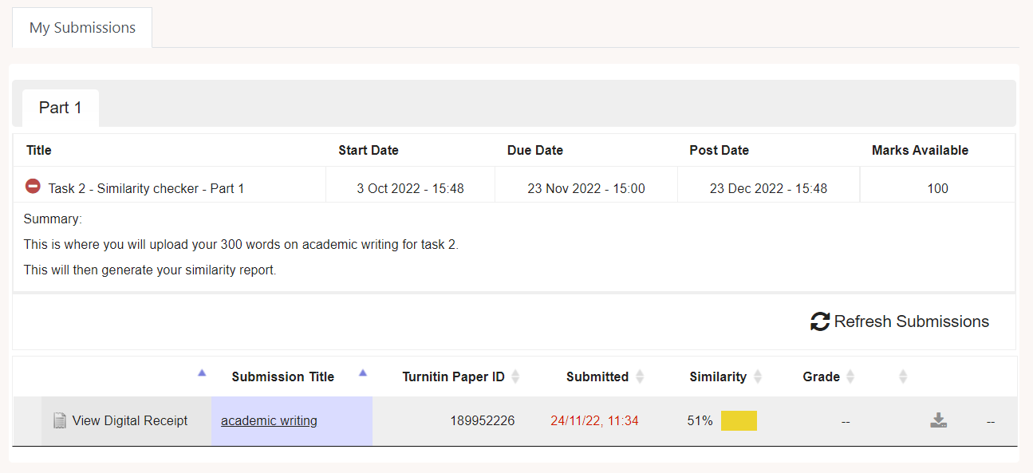
Similarity check is a way to figuring out who has done the research and written the required paper and who has not is easy with the help of a free report from a similarity checker. Tools like this one are crucial for teachers as anti-plagiarism rules are being developed by an increasing number of universities and colleges. (Jodlowski,2022). I believe this will help students to improve their writing skill and how to explain words in their own word. My similarity check is 51% which is not good enough because the maximum present was 30% and mine was 21% more so I need to improve this by paraphrasing again most of my work to improve my similarity.

Task 3
Critical Analysis
Critical thinking is self-directed, self-disciplined thinking that aspires to the most significant standard of fair-minded reasoning. Critical thinkers continually strive to live rationally, sensibly, and compassionately. (The foundation of Critical thinking,2019). Furthermore, it is the process of rationally and logically deconstructing what students read, write, and listen to. (Saint Mary’s University,2018) However, Critical analysis goes beyond describing or paraphrasing an author's work. In completing this process, the material offered in employment must be carefully examined, along with its significance, presentation, relationship to other concepts, and potential implications for different viewpoints or other pieces of writing. (Saint Mary’University,2018).

The University of Wollongong, Australia (2022) states that critical thinking is crucial for success in college because it enables students to comprehend and evaluate the arguments, theories, and assertions related to their particular study area. Students can understand situations and information more clearly by using critical analysis. Reflection, discussion, and concept improvement are constants in academic areas. Thus, a critical examination is essential to the continued existence and development of all academic disciplines. (Jane et al.,2017). Critical analysis has several benefits, such as letting people decide by themselves, improved problem-solving abilities, such as the ability to recognise areas for improvement and assess potential solutions, I will give people to be confident when they speak, the potential to view the world differently through using awareness and ability to perform various tasks with higher accuracy and precision. (Cottrell,2017). Critical analysis enables employees to make connections between concepts, assess claims, identify mistakes, and resolve challenging problems. There are several circumstances at work that call for teams and individuals to approach complex challenges and solve them using new and original methods. Employees with these skills are more likely to succeed because they can build rapport with co-workers, make action plans, and resolve problems. (HR Profiling solutions,2021).
In this portfolio, I write the definition of critical analysis and the purpose of critical thinking in the workplace and higher education. The reason the teacher asked me to write about critical analysis believe that the teacher wants me to get a better understanding of critical analysis. Furthermore, while dining the research about critical analysis, I learned that critical analysis is the best way to see things from a different point of view and my communication skill. Wale and Bishaw(2020) believe that In order to improve students' problem-solving, decision-making, and communication abilities, critical thinking skills in higher education, particularly in academic writing, must be incorporated into the teaching and learning process.

Task 4 sense of place video
Recording-20221125_021224.webm

Conclusion
Conclusion will always be the last part. we summarise the main results of our report in the conclusions. (Consider that we must condense everything we have learned into just five or six phrases.) There should be no new added information in this part. Reiterating your introduction's aims and objectives, as well as commenting on how effectively they have been achieved, might be useful. The conclusion may also include Suggest additional research and give a summary statement. The conclusion leaves the most impression on your readers, making it the part of your writing that your audience will remember the most. (konya, 2022)

Reference list
Archer, S. (2019) why do we write? The importance of academic writing research, Available at Why do we write? The importance of academic writing in research - Jan - University of Derby (Accessed 15 November 2022).
Bets, A. (2021) writing the main body paragraphs of an essay, Available at: Writing the Main Body Paragraphs of an Essay - Research Prospect (Accessed 25 November 2022)
Brown, L. (2020) what is academic writing? - A complete guide, Available at: What is Academic Writing? - A Complete Guide - Crowd Writer (Accessed 15 November 2022).
Catmouse, M. (2020) what is an introduction in academic writing? Available at: What is an Introduction in Academic Writing? - PensacolaVoice Magazine 2022 (Accessed 15 November 2022)
Cottrell,S. (2017) Critical Thinking skill: Effective Analysis , Argument and Reflection. 3th edn. London: Bloomsbury study skills ser.
Jagannath, T. (2018) what is sense of place? Available at: What is Sense of Place?. A sense of place is when people feel a… | by Thejas Jagannath | Interviews and Articles on Art & Public Spaces | Medium (Accessed 24 November 2022)
Jane,L. Reynolds,E. , Jude,B. and Jones,P. (2017) Critical thinking skills for education student. 2th edn. London : SAGE.
Jodlowski, P. (2022) what is a similarity check, Available at: Similarity check and what to do – Codility (Accessed 15 November 2022)
Konya, K. (2022) how to write a conclusion for an essay, Available at: How to Write a Conclusion for an Essay | Grammarly (Accessed 24 November 2022)
Saint Mary’s University(2018) Critical Analysis And Critique. Available at : https://studio.smu.ca/ac-resources/critical-analysis-critique (Assessed 10 November).
Smith, s. (2022) academic writing, Available at: What is Academic Writing? (eapfoundation.com)
(Accessed 15 November 2022).
University Of Wollongong Australia (2022)Critical analysis : What is critical analysis. Available at : https://www.uow.edu.au/student/learning-co-op/assessments/critical-analysis/ (Accessed 8 November).
Waston, C. (2016) place identity, Available at: PLACE IDENTITY | research-project (charlottefwatson.wixsite.com) (Accessed 24 November 2022)
William, N. (2020) how does academic writing help students for the future? ,Available at: How Does Academic Writing Help Students for the Future? (nathanwilliamkress.wixsite.com) (Accessed 15 November 2022).

