Engineering Problem

Engineering Design (ACHA4001)
Daniel Gooch
2404008
University of Wales Trinity Saint David
Motorsport Engineering
Submission Date: 04/04/2025

Contents

Introduction and Interpretation of Brief 3
Legislation 4
Specification 5
Time Plan 6
Research 7
Sketches 8
CAD Modelling 9
Technical Drawing and Material Choices 10
Manufacturing Proces 11
Justification 12
Conclusion 13
References 14

Introduction and Interpretation of Brief

This report will cover all the steps required in a product design cycle to improve the current cover for multiple anodization tanks. This will include research into how long the process is expected to take, previous design ideas, multiple sketches and designs that will be refined into a final model for a product which will improve the safety and ease of operation.
The brief describes the need for an improved cover for the tank which makes the process of opening and closing it easier and safer. It must be openable by one person and keep clearance from above the vat. This means the lid must not be heavy or difficult to move, nor require any risk of falling into the tank and causing injury. The design mustn’t change the tanks size or materials however it can be modified to accommodate the new tank lid. The lid must also be able to be mass manufactured as it will be needed on all the companies’ tanks including those at other factories.

Legislation

The health and safety of the workers using the equipment is one of the key demands for the design of this product. As the health and safety act 1974 states, it is the duty of all employers to ensure the safety and welfare of their employees to its most reasonable extent. It is also necessary to ensure that whatever the employee must use, clean or set is always safe without any risk to health (Health and Safety at Work etc. Act 1974).
This means that the design for this product must not only ne safe itself (i.e. no sharp edges or being too heavy to lift), but also safe to maintain on the job. This means the lid must be easily accessed to be maintained or inspected and, if it is heavy, must be easy to move or lift. This may require a mechanical system to aid in the lifting of the product.

Specification

Type | Description
Time | The process for making the new lid mustn’t take any longer than 3 months. This time is needed as multiple parts may need to be manufactured/brought in. There will also need to be time for design and testing.
Target Market | This product is to be made for the automotive equipment manufacturer to fit over anodising tanks.
Function | The lid must cover the tanks securely, be removable by one person and be safe and easy to do so.
Constraints | The lid must not interfere largely with the space above the tanks as material will have to be lowered in. The tank itself cannot be changed in material or inner volume, though it can be added to.
Size | The size of the lid must fit over a size of 1770mm by 1020mm. It should also not intrude too much to the space around the tank.
Aesthetics | The visual aspect of this product isn’t too important as it is on a factory floor, however the colour should match the rest of the tanks and factory products.
Durability | This product should at least last 5 years as it will need to securely cover each tank. Mechanical wearing parts may have to be replaced during this time however the lid itself should be durable.
Material | The material for the cover will have to be corrosion resistant and should be decently strong and waterproof. This means something like stainless steel may be useful for the main part of the lid.
Safety | The product must cover the tank and be safe to remove by one person. The corners and sides must also not cause risk.
Cost | The product doesn’t need to compete pricewise with competitors however shouldn’t be overly expensive due to being high quantity.
Enivronmental | Not too high of a concern. Avoidance of non-recyclable plastics.
Manufacture | Parts may have to be brought in, and other parts designed and sent off to be manufactured elsewhere.
Testing | The product must be tested to make sure it effectively covers the tanks while also making it easy to remove.

Time Plan

 | Week 1 | Week 2 | Week 3 | Week 4 | Week 5 | Week 6 | Week 7 | Week 8
Specification
Research
Adaption to Spec
Sketching
CAD Modelling
Testing of Model
Development
Manufacture
Sourcing of parts
Construction
Inspection
Review
Any Final Actions
 | Week 9 | Week 10 | Week 11 | Week 12 | Week 13 | Week 14 | Week 15 | Week 16
Specification
Research
Adaption to Spec
Sketching
CAD Modelling
Testing of Model
Development
Manufacture
Sourcing of parts
Construction
Inspection
Review
Any Final Actions

Research

To get a good idea of what the new design could look like, it is important to see what other lids have been used. This is to find where problems are with designs and what can be improved for the design made for these tanks.
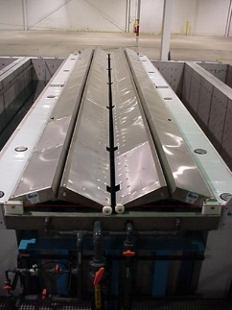
(Products Finishing, 2011)
This tank uses a system where the lid to the tank is rotated at one end causing the other end to lift which pulls the centre with the wheels across. Covers like this cause a reduction in heat loss and reduces fume emissions from chemical tanks which not only keeps the tank safe and easy to open but also saves the company money on energy (Products Finishing, 2011)
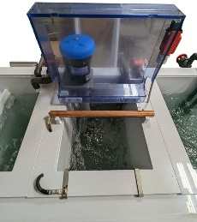
(Best Technology, 2024)
The design for this one is for a smaller tank than the one needing to be covered, however the design shows an effective cover which is on a hinge. This makes it easier to remove as it doesn’t have to be removed from the vat completely. Despite this upside, this would likely not be feasible for the tank being used as it would be larger and heavier to lift off the tank.
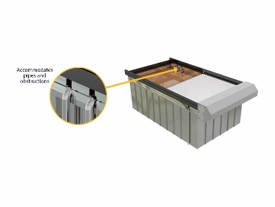
(Dynatect, 2024)
This design has a cover roll out across the tank from one end where an electric motor turns to retract and extend the cover. This method is less intrusive than the first tank cover and easier to use than the lifted cover.

Sketches
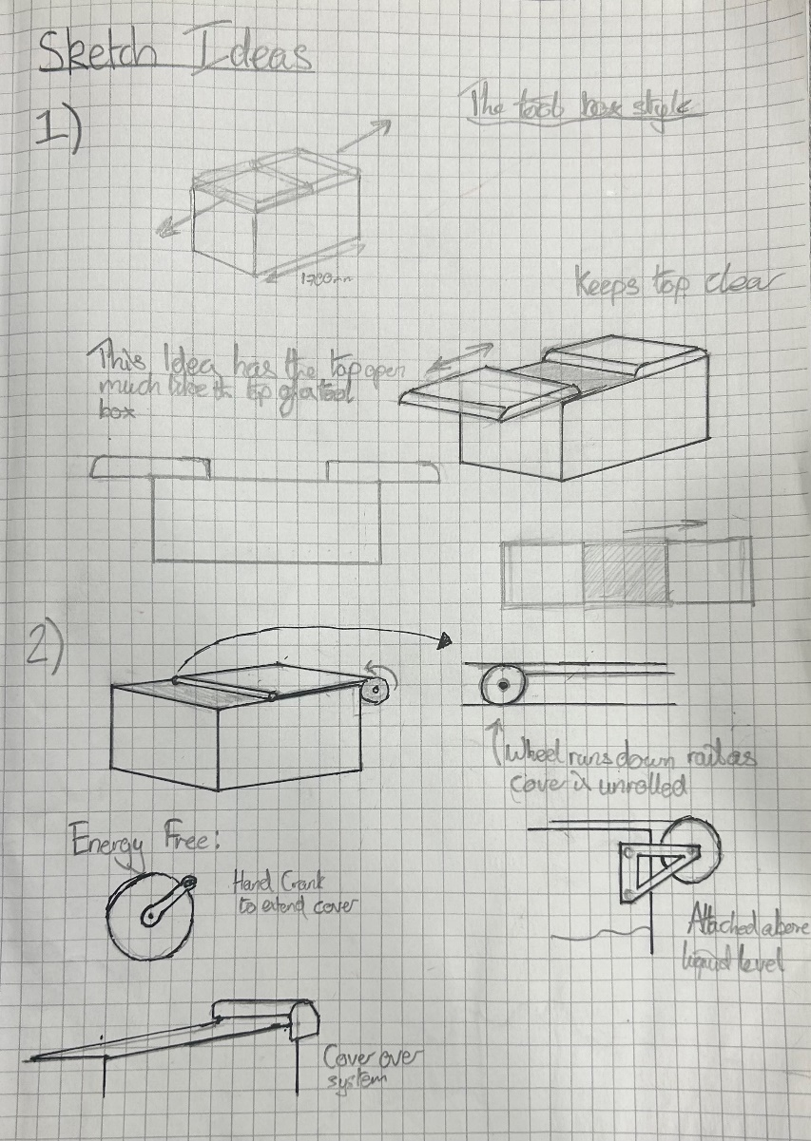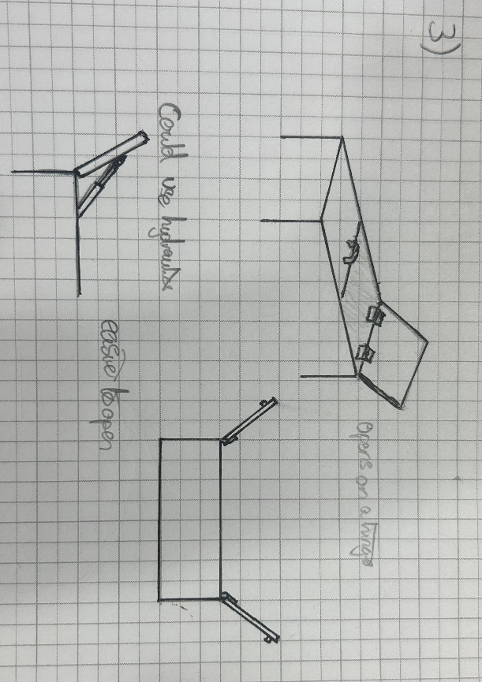

The images above show a few design ideas I have come up with for how the tank should be covered. The first design shows a lid which would function in the same way as a toolbox. This would have the cover split down the middle and extend off either way. The cover would be able to be locked from the centre much like a toolbox and would be easy and safe to operate.
The next design is like the Dynatect design from my research; however, it would be powered by hand crank. This would save energy usage while still being a far easier, one-man job.
The final design shown has the lid open on a hinge on either side. This is helped using hydraulics like those found on car boots to make opening the lids easy.
Out of these designs I have chosen to go with the second design. The reason for discounting the first choice is due to the space occupied either side of the tank by the sliding lid. This would make the design inefficient space wise and may be difficult to attach to 100s of tanks across the companies’ sites. The third design was removed as an option as the area above the tank is heavily impacted. This would make it more difficult to lower the metal sheets into the tanks so would not be a viable option.
The reason for why I believe option two is best is due to it being unintrusive, safe to operate and relatively easy to set up. The sheet will roll out across the top of the tank and stop at the end to create a cover which will help maintain temperature and keep fumes in. The design is also easily applied to multiple bins as it only requires being assembled and bolted onto the tank. Most of the parts could be easily mass produced or bought in from supplies of parts like bearings and bolts.

CAD Modelling
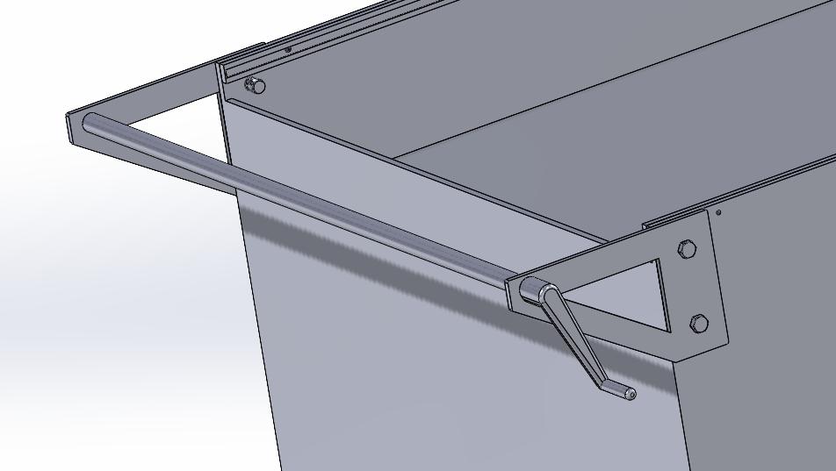
For the mount attached on the back there is a simple frame attached significantly above the marked liquid line and keeps the roll off the back of the tank when retracted. This is operated by a simple handle at the back which is spun to extend and retract the cover.
It is attached via 4 nuts and bolts on the frame to provide support for the weight which be applied on the bar. The plates themselves have been rounded off on the corners to make them safe in case of someone slipping and falling onto the frame.
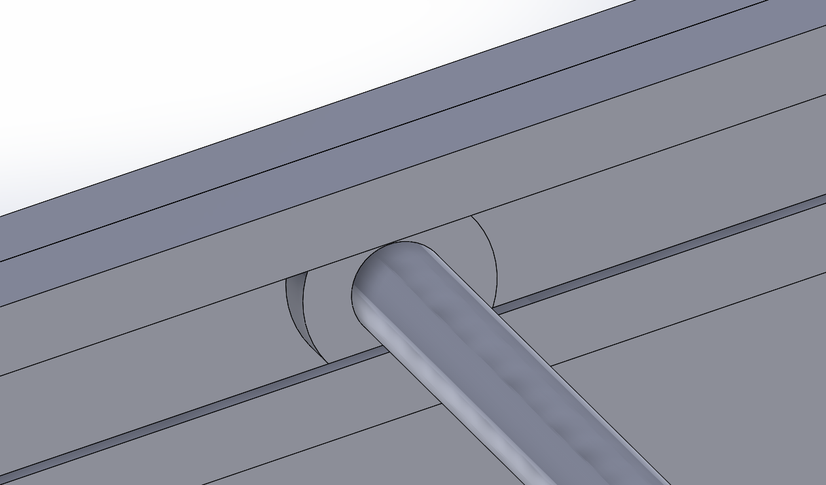
The part which is extended ends with a bar attached to a wheel which rolls in a grove along the length of the tank. This allows for easy movement of the cover with the rod being attached by a ball bearing to stop itself from spinning and causing the cover to roll up at the end.
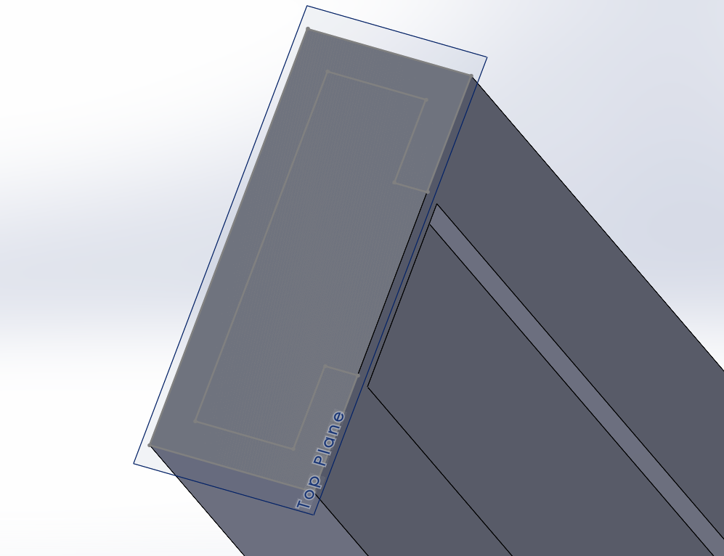
The roller rolls down This track attached to the side of the tank. The bolts would be attached on the inside with the point being sunken so as not to obstruct the roller. The thickness of this part would have to be adapted depending on what bolt would be applicable to hold it in place.
The sides of this would also provide support to the sheet being pulled across the tank which would stop it from bowing at all.
A problem found in the CAD design is that it wasn’t possible to model the cover being drawn across the tank, however it was still possible to get the end bar to move across as it would be able to.

Technical Drawing and Material Choices
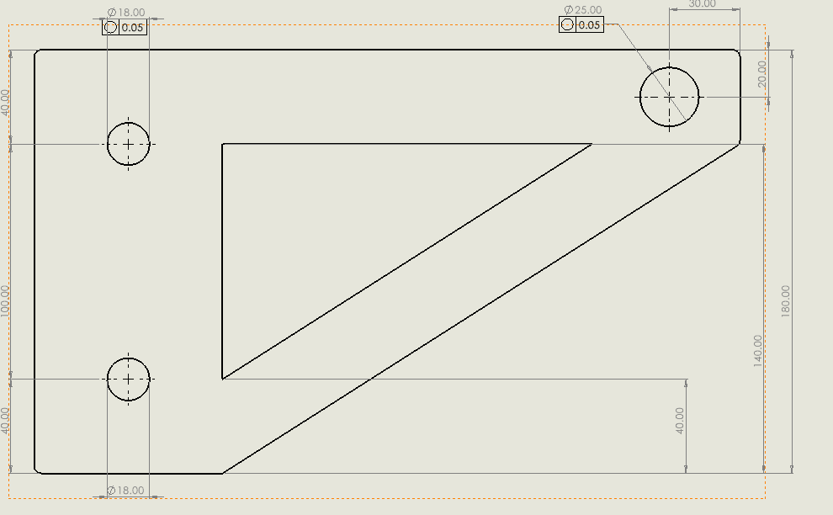
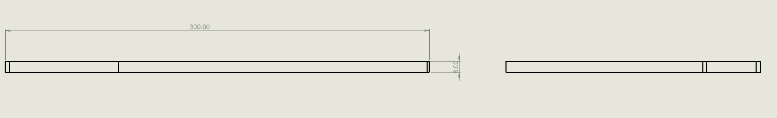
For the side plate there is a tight tolerance for the holes as it has to lien up very well with that of the tank. The chosen material for this part is stainless steel as it needs to be resistant to the conditions and needs to be strong enough to hold the weight of the cover without breaking.
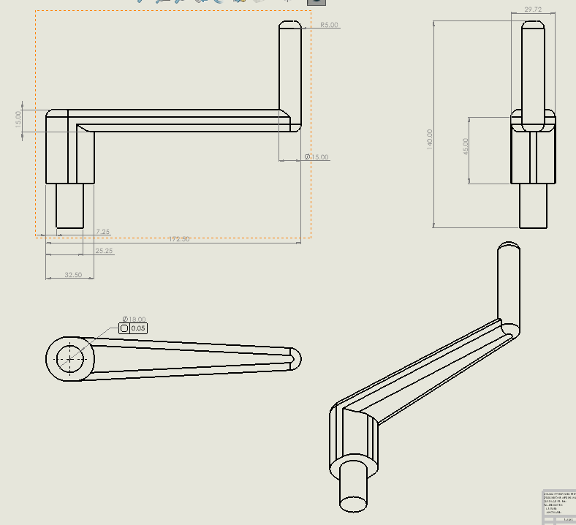
For the handle, there is one tight tolerance for where it attaches to the bar while the cover is attached to. This part may have to be 3D printed from ABS as this material is strong enough to not snap under load, but it’s also usable in a 3D printer to make this complex shape.
For the cover itself, the material will need to be a PVC sheet as it is corrosion resistant, light enough and can be made into a sheet.
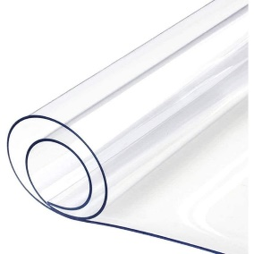
(I Want Fabric, 2022)

Manufacturing Processes

For all bolts, nuts, bearings and cylindrical bars, these parts would be brought in to save time especially as most of these would be widely available for purchase. The same can be said for the PVC sheet to cover the tank as the correct width can be bought and then cut to the desired length.
For the side plate, it would be appropriate to use a CNC milling machine to create the product as this would result in the most accurate finish. The screw holes would be created by a pillar drill after having been milled to the correct size.
The handle would be made using a 3D printer as this would result in a single, detailed part which would make assembly much easier. The material of choice for which would be ABS.
The rail on which the bearing wheel runs would be made from a 2mm metal sheet. This would then be line bent into the correct shape. The holes for the bolts would be pillar drilled into the sheet before being bent to make the process easier.
Assuming the company does not own any of the above equipment, all these processes would be outsourced to companies which would make these parts.

Justification

The side plate must be milled as it is necessary to make the complex shape required for the part. This will result in a high precision finish however it may require a post process to remove burr from the part which would make it safer for use.
The handle must be 3D printed to make the desired shape in a cost-effective way. This may result in a longer time for manufacture however it is not shown that time is a restraint in the design brief.

Conclusion

References

Health and Safety at Work Act 1974, c. 6. Available at: https://www.legislation.gov.uk/ukpga/1974/37/section/6 (Accessed: 01/04/2025)
Products Finishing (2011) Putting a Lid on Tanks. Available at: https://www.pfonline.com/articles/putting-a-lid-on-tanks (Accessed: 02/04/2025)
Best Technology (2024) Titanium Anodizing Equipment Line. Available at: https://www.besttechnologyinc.com/surface-finishing/titanium-anodizing-equipment-line/ (Accessed: 02/04/2025)
Dynatect (2024) ChemTank Covers. Available at: https://dynatect.com/product/chemtank-covers/ (Accessed: 02/04/2025)
I Want Fabric (2022) Clear PVC Sheeting Plastic Vinyl Fabric 0.75mm. Available at: https://www.iwantfabric.com/0-75mm-thick-clear-plastic-pvc-fabric.html (Accessed 04/04/2025)

