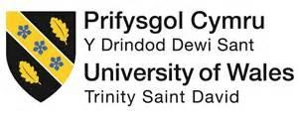
University of Wales Trinity Saint David
Swansea College of Arts

Business Start-Up
Professional Promotion
ADAD6002

Ffion Weston, Karen Lacey-Freeman, Kiara Sullivan
1706523, 1701729, 1701519

21st January 2020

Distinction of our applied business’ brand
CWR’
Welcome to our collaborative company! We are Cwr’. Cwr’ stands for ‘Community, Wellbeing and Resilience’. The translation for Cwr’ is ‘to meet’ in the welsh language. We decided to use a welsh word for our company as we all identify as being Welsh, the name gives a personal feel and stands us apart from other companies in South Wales that may offer similar experiences.
We are a collective, non-profit organisation that uses participatory activities to improve the community’s wellbeing. ‘To explore, engage and empower communities to develop positive Health and Wellbeing for all’. As our mission statement, this provides an insight into the experiences we offer as a collaborative and what we strive to achieve within the community.
Our Aims:
- To engage with a range of diverse community groups and people within the wider community. (Swansea, Carmarthen, Neath, Port Talbot)
- To empower the people we work with in the community to build resilience together.
- To offer participatory activities to everyone we can.
Our Values:
- To give everyone a voice,
- To be professional,
- To be respectful of each other and the space that we work in,
- To look after each other along with each other’s wellbeing,
- To treat everyone as equals, to look past differences to create positive experiences,
- Be aware of boundaries within different groups,
- To make every experience authentic,
- Be supportive of one another,
- To build trusting relationships that will last,
- Be flexible,
- Work to the pace of the group,
- To keep a personal approach,
- To be aware of the impact that our work has on the environment (carpool, to be energy efficient and recycle).
Our Vision:
- We want to create a safe environment for various members of the community to allow them to feel that they belong.
- To have a thriving community space,
- For Cwr’ to have an identity within the wider community,
- To encourage community engagement;
- To create unlikely friendships,
- To improve wellbeing and resilience within the wider community.
With our mission statement, aims, values and vision, we will encompass all of our different skill sets to reach the core of our company. The core of our company is to reach anyone and everyone within the wider community, to bring everyone together to create a resilient community along with creating a healthy wellbeing in everyone. This will be accomplished through providing a safe environment where people can be themselves, creating a creative space where the various needs of the different groups can exist with the overarching aim where people that would not normally come together have a space to do so.
Design of Logo
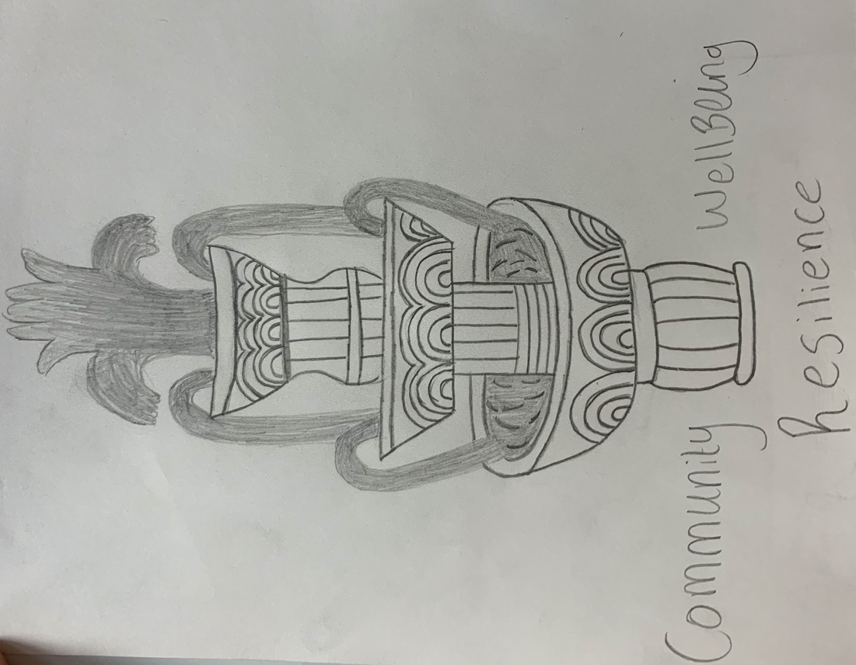
We discussed many forms of what a relevant logo is, we came to a conclusion that trees and fountains resonate well with the topic of wellbeing. When looking online, schools and many different organisations that have wellbeing at the core, use these images. While we want our company to stand out, we also need it resonate the right feeling and emotions that people have towards wellbeing. These successful organisations and popular schools indicate that people engage with this type of advertisement best.
Figure 1: Design of Logo (Weston, F. 2020)
The logo would be on every advertisement we create, along with where the workshops take place, the time they happen and dates of when people can attend.

Structure of the Company
The structure of our company is that we are a private limited by guarantee set up business. This means we have a volunteer Board of Directors. The benefit of this is we get to choose who we want on that board, this giving us the ability to choose who we know, trust and respect that will help enable our vision.

We can still therefore, employ people to work within our company along with bringing volunteers on board. The negative connation’s of this style of company is that we have to consult the board on every decision we make, we are not our own boss, we do not own the company and we have to live on a limited wage until the company starts to make a profit so we can then pay ourselves. This normally happens within the third year of the business. Taking all this into consideration, we still feel as though this is the best option for us at the moment.

We will apply for funding from the Arts Council of Wales, Big Lottery Funding and the local councils to be able to run our projects within the wider community. These funding’s would allow us to rent out a space, cover travel costs, materials for any of the workshops and the general costs of running a company. We would save money by delegating specific roles to the right people who have the experiences within the company i.e. Karen would be in charge of the finance within the company as she has experience in this avenue.

Setting up a small business- Meet the Team

Artistic Director- Kiara Sullivan
Through volunteering and participating in many practitioner and artist led events, I have a varied skill set that has been built up from great practitioners. With this vast experience, I have created my own way of working and have already facilitated and co-facilitated some thought provoking projects within the community. I am always eager to work with any group no matter what they are experiencing or going through. I am constantly being inspired by the young people throughout the different communities I work with and always look forward to new opportunities that come my way.

Finance Manager- Karen Lacey-Freeman
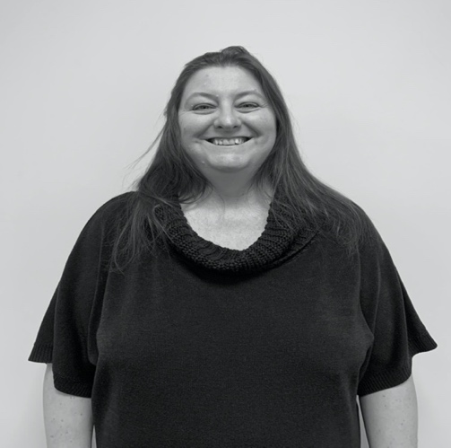
In my capacity as a reminiscence storyteller I have gathered a wealth of interesting and original props to include in my workshops, to involve people living with dementia to tell their story. I feel that this can be applied to many situations and engage the community to share stories with each other. I run an easy going, relaxed style of workshop for everyone to enjoy and take part in without any pressure. I also bring my knowledge of accounts to the business; therefore, I could prepare the companies accounts and tax returns.

Advertising Manager- Ffion Weston
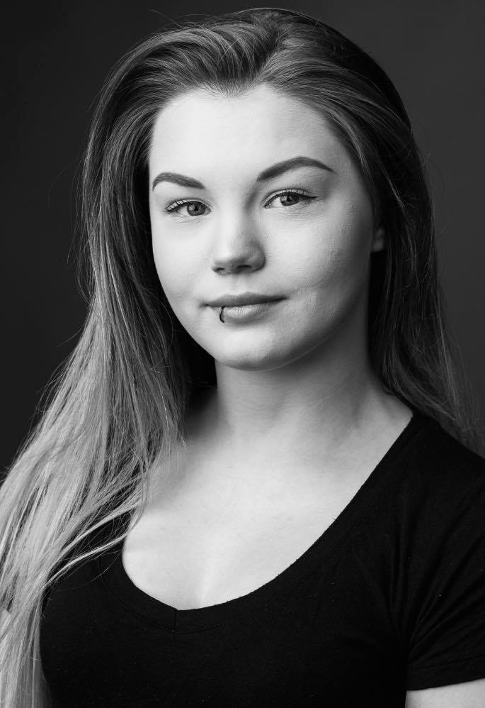
I have a vast knowledge of Autism and ADHD. This is due to the fact that I have previously worked with children with Autism on emotional literacy through the form of drama workshops. This includes using storytelling and techniques from the drama practitioner Augusto Boal as a form of exploring emotions and emotional situations that some autistic children may find difficult. I will be bringing these drama workshops to the community which will make them more accessible, as there is currently not much outside of what specialist schools provide as support for those who have autism and struggle with emotional literacy.

Location of Cwr’
On initial discussion of where we would like to set up our company base, we decided that we would like an office along with a permanent workshop space for our ‘Sharing Saturday’ and if we bring in groups, we would need a space. We would like to have a shared office which includes having facilities such as a toilet and kitchen. We would like our office to be in a friendly location that is accessible and easy to get too with plenty of available parking. For our workshop space, we would need a spacious room with a relaxing atmosphere for large numbers of people.

On further discussion of locations, we have shortlisted some good places that our office would thrive in. These locations are based in and around Swansea. Places that have a good reputation are: Princess Way, Uplands, Kingsway, St James, Mumbles, SA1, Fforest Fach and Port Tennant. We are aware that some of these places rent offices at a higher price and in further discussions we would evaluate where the best place and best price would be that would benefit us. We decided against setting up an office in the High Street, Sandfields and Port Talbot. The reasons for this are we want our future participants and prospective employees to feel safe in travelling to the office and associate a good reputation with where we are based, and we feel like these places would not benefit our reputation.

Promotion Video

Kiara Sullivan’s Curriculum Vitae

Name: Kiara Barbara Sullivan
Date of Birth: 26.03.1999
Age: 20 years old
Home Address: 15 Troed Y Rhiw Road, Mount Pleasant, Porth, R.C.T, CF39 0DP
University Living Address: 103 Rhondda Street, Mount Pleasant, Swansea, West Glamorgan, SA1 6ET
Contact Numbers: 07473994445 (Mobile) 01443 688455 (Home)
Email Address: kiarasullivan16@aol.co.uk

Current Studies (September 2017- July 2020)
Bachelor of Arts (Hons) Applied Drama, University of Wales Trinity St David, Swansea Campus
First Year Modules (Level 4) 2017-2018
- Play and Creativity (20 Credits)
- Reflective and Academic Skills (20 Credits)
- Voice and Body (20 Credits)
- Digital Arts in Performance (20 Credits)
- Introduction to Applied Drama (20 Credits)
Second Year Modules (Level 5) 2018-2019
- Drama and Theatre in Education (20 Credits)
- Practice as Research (20 Credits)
- Drama, Health and Well Being (30 Credits)
- Performing Cultures (20 Credits)
- Participatory Performance (30 Credits)
Third Year Modules (Level 6) 2019-2020
- Applied Practice in Action (20 Credits)
- Investigating Performance (20 Credits)
- Professional Promotion (20 Credits)
- The Advanced Practitioner (30 Credits)
- Independent Project (30 Credits)

Coleg Y Cymoedd- Rhondda Campus (September 2010- July 2015)
- BTEC 90-Credit Diploma in Performing Arts (QCF)- DM (Distinction Merit)
- BTEC Extended Diploma in Performing Arts (QCF)- DDM (Distinction, Distinction Merit)
- Welsh Baccalaureate Advanced Skills Challenge Certificate- Pass

Tonypandy Community College (September 2010- July 2015)
- 8 GCSE (A-C)
- A in Health and Social Care
- B in English, Health and Social Care, Geography, Religious Studies and Additional Applied Science
- C in Mathematics and Welsh Second Language
- Applied Science (QCF)- Pass
- Essential Skills Wales Qualification- All Passed
- Welsh Baccalaureate Intermediate Diploma- Pass

Skills
- First language is English
- General knowledge of the Welsh language
- DBS Enhanced Certificate
- Fluent on all Microsoft Office applications on Apple products and Window machines
- Proficient on all social media platforms
- Intermediate knowledge of all email software
- Competent with using the internet
- Independent
- Works well within a group
- Strong communicator and listener
- Very organised
Experience
Inside Out Cymru (Newport and Swansea) 16th October 2019- 16th January 2020
Forum Theatre performance toured to Inside Out Cymru mental health groups.
Well Iawn Project (Ffairfach, Carmarthenshire) 15th October- 16th December 2019
Co-facilitated a wellbeing project run with Mess Up the Mess and Ysgol Bro Dinefwr.
Drama Therapy Conference (Swansea) 22nd November 2019
Attended and volunteered at the Drama Therapy Conference- Creatively exploring the spaces between the personal and the professional.
National Youth Theatre of Wales Residency (Mold, North Wales) 17th August- 24th August 2019
Part took in a residency at Theatr Clwyd to develop performance skills and to explore the different career pathways within the theatre industry.
Casgliad (Swansea) 15th June 2019
Attended and volunteered at Casgliad- Youth Arts and Youth Workers were invited to come together to re-energise, connect and get creative with a rich programme of speakers, workshops and talks.
The Women Who Changed the World (Penclawdd School and Pencoed School) 15th + 20th May 2019
Participatory Performance about inspiring women was toured with a co-facilitated workshop to two schools to year six girls with the hope to inspire them.
Rawffest Gwylgrai (Wales Millennium Centre) 25th April- 28th April 2019
Attended a Youth Arts festival for Wales and took part in fun, innovative and surprising workshops.
TroyBoyz Workshop (Cardigan) 30th January 2019
Facilitated a workshop with a group of NEETs’ to encourage confidence, team building and trust building within the group.
Drama in Education Workshop (Penclawdd School) 6th November 2018
Co-facilitated a Diwali inspired workshop to year three students.
Life Hack Event (Porth) 21st October 2018
Facilitated a university themed workshop to inform and have conversations about university with young people.
Artist Hub (Penygraig) 11th August- 17th August 2018
Volunteered with Sparc who worked with WMC Creative Learning Team and artist Bethan Marlow to run Artist Hub as part of the Together Stronger Partnership- included lyric writing, circus, drama and film workshops, interactive tasks and creative installations.
Casgliad (Wales Millennium Centre) 28th April 2018
Youth Arts Workers, emerging artists and students come together to share and collaborate in a wide range of inviting and interesting workshops.
Rawffest Gwylgrai (Llandudno) 17th- 20th August 2017
Facilitated the ‘Fun Fair’ workshop at the second Rawffest event with Penygraig Youth Theatre.
Tate Modern Exchange (London) 12th April- 15th April 2017
Created a ‘Fun Fair’ event which looked into what we as a group think of politics, the differences between classes within society and to have fun more often.
Rawffest Gwylgrai (Newport) 18th August- 20th August 2016
Attended many different workshops and performed in the first ever Rawffest event. This event is the first of its kind for young people in Wales.
The Factory (Porth) 7th April- 11th April 2014
Work Experience with Sparc for school.
Superheroes are Coming (Poland) 27th July- 3rd August 2013
International Exchange Programme with 30 young people from Georgia, Poland and the United Kingdom.
In amongst all this, I have also volunteered on many devised shows that Sparc have put on. I have built set, designed and created costumes, made props, found music for the productions, helped the participants learn their lines, been backstage manager and moved set on and off stage.
Interest and Hobbies
- Drama
- Dancing
- Music
- Live Concert
- Live Performances

References

Alison Franks- Lecturer of Applied Drama at UWTSD
University of Wales Trinity Saint David
Alexandra Road
Swansea
SA1 5DU
01570 422351
E-mail: alison.franks@uwtsd.ac.uk

Miranda Ballin- Artistic Director of Sparc
The Factory
Jenkin Street
Porth
CF39 9PP
01443 303032
E-mail: miranda@valleyskids.biz

Karen Lacey-Freeman’s Curriculum Vitae
Karen Lacey-Freeman
77 Weig Fach Lane, Fforest-Fach, Swansea, SA5 5AD
Email: 1701729@student.uwtsd.ac.uk. Mobile: 07510062648

Personal Profile
I am currently in my third year as an Applied Drama student at UWTSD Swansea. I have gained confidence through mixing with a variety of people and learning new skills to help me adapt my practice to suit all different situations. I am used to working in group environments and can be flexible as well as contribute ideas to make specified goals. I am open minded and motivated to ensure that I can achieve high standards as well as making sure that projects still have a personal touch.
Education and Qualifications
University of Wales Trinity Saint David
BA Applied Drama (2017- Ongoing)
As part of this course I have completed various modules exploring applied drama and contemporary performance practically and theoretically. I have recently completed a module where I had to present and run my own project in the community. The project was centred around ladies living with dementia in a care home environment and facilitating visual workshops around food. Also, I incorporated young students from a local school which made some of the workshops intergenerational.
Chase Cross Comprehensive School
O-Level
English Literature- B
Geography- C
RSA
Secretarial Studies- Distinction
CSE
Maths- 1
English- 1
Geography- 1
French- 4
Textiles and Fashion- 3
German Level One Certificate- Pass
Work
Annie-tiques Collectable and Antique Business
2003-2005 - Self Employed- Joint partner
Daily running of a business, accounting and balancing books, sourcing out stock at antique and collectable auctions. Selling at local antique fairs and centres in cabinets and stalls and making contacts within the business.
I now do my husband’s bookkeeping and research on various items but not as a paid employee.
National Westminster Bank Plc (Clerkenwell Road London & High Street Southend-on-Sea)
1986 – 1991 Junior Clerk- Counter Staff- Acting Chief Cashier.
All the posts at the bank required a high level of communication and diplomacy especially with other staff members. I am used working in pressurised situations where all money must be accounted for.
Southend United Football Club
1993-1996 - Assistant in Accounts Department
This job involved the daily accounts of the football club from invoicing local businesses and processing the football players wages to balancing money from match gates and the catering department.
1996 - Manager of Boots and Laces – Football Club training ground
I was promoted to this post which involved the daily running of the training ground, including invoicing, ordering in supplies, and dealing with training sessions with the players.

Volunteering Projects
2019
November-December - PeopleSpeakUp & My Food for Thoughts and Cilymaenllwyd Tea Party Workshops
I volunteered for the first two workshops as Carys Phillips was the facilitator and then I facilitated a further four workshops for my project Food for Thoughts.
September- Birth Café – PeopleSpeakUp in collaboration with Dr Tracy Breathnach (Evans)
I helped Tracy set up a relaxing space in the Ffwrnes Theatre Llanelli for the participants, made tea and coffee, also taking part in the workshop.
August & September -Theatr na nÓg- The Butterfly Hunter
Professional performance at the Dylan Thomas Theatre followed by workshops in the local museums. I facilitated workshops in the local museums dressed as a Victorian lady for primary school children.
July & August -PeopleSpeakUp- Llanelli Voices Project
Intergenerational spoken word and visual arts project throughout the summer, involving many practitioners and facilitators, in different forms of art and storytelling.
June - Swansea Waterfront Museum - Storytelling in Health Conference
I was a steward on Friday 28th June, directing participants to the right areas and helping practitioners with their presentations. I also participated in workshops on Saturday 29th June.
April- PeopleSpeakUp- Swansea Voices Project
Intergenerational project with storytellers Eleanor Shaw and Phil Okwedy involving the Pontarddulais Comprehensive School and the Hollies care home. This involved a series of life story workshops to create a better understanding between younger and older people.

Workshops Co-Facilitated
May 2019- The Women Who Changed the World- Penclawdd School and Pencoed School
Participatory performance and workshop performed in two schools about historical women that could inspire young girls. This was performed and co-facilitated by my year group at university.
November 2019- Theatre -in -Education Diwali workshop- Penclawdd School
Diwali inspired workshop co-facilitated with a fellow student to third year primary pupils.
Workshop Participation
Re-Live- life story theatre work, Jonny Cotsen- deaf performer and Theatre maker, Casgliad 2019, birth café with Dr Tracy Breathnach (Evans), Dramatherapy Conference 2019.

Skills and Qualities
- Good communication skills
- Very organised
- Bookkeeping
- Work within a team
- Flexible and adaptable
- Punctual and good timekeeper
- Self-Motivated

References
Eleanor Shaw- Artistic Director of People Speak Up
Ffwrnes Fach
Ffwrnes Theatre
Llanelli
SA15 3YE
07972 651920
Email: Eleanorshaw10@gmail.com

Alison Franks- Lecturer of Applied Drama at UWTSD
University of Wales Trinity Saint David
Alexandra Road
Swansea
SA1 5DU
01570 422351
E-mail: alison.franks@uwtsd.ac.uk

Ffion Weston’s Curriculum Vitae

Ffion Weston
116 Rhondda Street,
Swansea, SA1 6EU
07815588587
1706523@student.uwtsd.ac.uk

I am an applied drama practitioner with an extensive knowledge of autism and ADHD. I enjoy reading and learning about neurological disorders, in order to create drama workshops to support those who have neurological disorders or family members who live with people with neurological disorders. I also excel in facilitating storytelling for children and adults that want to escape the pressures of everyday life.

Key skills
- Energetic
- Creative
- Strong communication skills
- Problem solving
- Adaptability
- Time management

Experience

2019

Ysgol Hendrefelin, Bryncoch, Neath - Drama Practitioner
During my time at Ysgol Hendrefelin, I used a variety of drama techniques in order to explore emotional literacy and difficult situations that the autistic children may find difficult. For example, we used storytelling and roleplay to explore what emotions are felt in different types of situations.

All women's Asylum Seekers group, UWTSD, Swansea - Drama Practitioner
During this workshop, I co-facilitated a confidence building workshop in preparation for an upcoming fashion show. I used drama techniques such as still images to empower the women to feel confident within themselves.

Penclawdd Primary School, Swansea – Co-Facilitator
I have visited this school on a few occasions during my time at university, bringing different workshops each time. One being a performance followed by a workshop based on the topic of empowering young girls to be themselves and to not change themselves in order to be what a social media- crazed society wants them to be. I also co-facilitated a storytelling workshop aimed at a younger age group, with the theme of self-acceptance. We used different techniques such conscience alley, roleplay and hot seating in order to explore the theme of self-acceptance.

Education

2015- 2017

Neath Port Talbot College, Neath - Level 3 Diploma in Performing Arts
During my time at college I participated in many musicals and dance performances which are listed below;
- Scrooge the pantomime
- We Will Rock You
- 9 to 5
- Guys and Dolls
- Neverland Christmas dance performance
- Lift dance company performance.

2017- current

University of Wales Trinity Saint David - BA Applied Drama
During my time at university I have planned and created, facilitated and co-facilitated many workshops. These workshops range from working with autistic children, to working with people who suffer from anxiety and stress. We have studied and created workshops using many practitioners and their techniques such as Augusto Boal and his Theatre of the Oppressed and Dorothy Heathcote and her Mantle of the Expert techniques.
Market Research
CWR have various competitors in the following areas that are listed below, however, we feel as a collective that we can offer a different and wider range of workshops and facilities for the wider community to improve wellbeing. We have done a SWOT analysis of some of the companies and some events we have attended to determine how we can use their weaknesses to benefit our company.
Cardiff
Re-Live
An award-winning charity based in Chapter in Cardiff that produces “Life Story Theatre Work” (Re-live, 2020). They mainly work with the elderly and armed forces through their work, concentrating on people living with dementia and post-traumatic stress disorder.
Hijinx
This company make theatre with learning disabled and autistic people mainly through their academies. They do work with the community but most of their participants are chosen through an interview process.
Fio
This theatre company “focus on those who are currently under-represented or misrepresented in society” (Fio, 2020). Even though they are based in Cardiff they do work all over the United Kingdom.
Wales Millennium Centre
Located in Cardiff Bay, the centre offers opportunities to the young people through workshops and courses this includes hosting various youth festivals.
Llanelli
PeopleSpeakUp
This is a “social arts and wellbeing enterprise” (PeopleSpeakUp, 2020) located in the Zion Chapel Llanelli with facilities also in the Ffwrnes Theatre. PeopleSpeakUp offer storytelling, spoken word events, workshops on site and around the Carmarthenshire area.
Carmarthen
Arts Care Gofal Celf
Located in West Carmarthen “Arts Care Gofal Celf is a professional arts organisation” (Arts Care Gofal Celf, 2017) who has a wide range of participants coming together in the form of workshops and projects.
All these companies and charitable organisations offer a range of workshops and participation in various forms. This includes theatre productions, spoken word, art, workshops and projects. We feel that most of these are tailored to specific audiences, therefore will only be open to certain demographics in the community. Also, some of the companies have only one permanent facilitator and must hire extra facilitators if needed. Whereas, with CWR there are three facilitators with a wide skillset and workshop experience, these skills focus on different needs and therefore, we can be adaptable within the community base.
One of the weaknesses in CWR is that as we are an all-female collaboration and that we have no male facilitators. On completion of market research into whether we will need a male facilitator for the company on a flexible or part time basis we have three contacts: Matthew Rosolemos, Cameron Hester and James Jones. These facilitators are all graduates of the UWTSD BA Applied Drama course and have facilitated workshops in the wider community.
We have also recognised that between the ages of twenty-five to fifty, we are lacking beneficial opportunities. We are therefore working together to offer workshops and activities in the following areas in the community.
- Parents with young children, to tackle loneliness and isolation.
- Couples.
- Men, to improve communication and confidence.
- Working companies- offer training through drama for:
Confidence.
Self-Esteem.
Team building.
Table 1: SWOT Analysis (Weston, Lacey-Freeman, Sullivan, 2020).
Company/Event | Strengths | Weaknesses | Opportunities | Threats
Hijinx | Reach many autistic actors and young adults who have learning difficulties.  They have a unique ethos which makes them stand out.  Have accessible use of the WMC. | They do not reach a usual theatre audience.  They do not offer their academies to everyone-there is an interview process. | Their productions travel internationally.  They cover broad areas in Wales. | Competition with what Ffion wants to offer to the community.
Volcano | Cheap rent for the location- Swansea High Street.  Location is accessible due to bus station and train station being near.  Receive funding from Arts Council of Wales. | Not a very inviting space.  Unclear of what the building is used for when looking straight on.  The facilities have hazards- holes in walls, exposed cables. | They participate in Edinburgh Fringe Festival. | As a company they have a longevity.  Competition to contemporary performers.
Arts Care | Company has a long Gevity and great location being in the centre of Carmarthen town. | Even though being in town it is easily missed due to being poor signed. | On their freelance register of practitioners, there are not any drama facilitators. | We do not see them as a threat to us as we offer what they do not.
PeopleSpeakUp | Community based- in Llanelli.  Great location being next to town centre.  Welcoming and safe space.  Run by a Board of Governors (Volunteers) | Most projects are very specific (based around storytelling).  Does not have a wide base due to being Llanelli orientated. | Offers intergenerational projects.  Volunteering opportunities for anyone.  Employs various outside facilitators.  Offers intern opportunities.  Has links with Coleg Sir Gar. | Offer a range of workshops.  Receives funding from various sources.
Drama Therapy Conference | A very specific community of people.  Can be liberating and sometimes relatable. | A very specific community of people.  Can be self-indulgent. | Drama therapy exercises can be adaptable to a different group of people.  Small community- is room to join if you’re a therapist. | We do not see them being a threat to us as we offer something completely different to what they do.
YANC | A network that builds a community for students and practitioners.  Volunteer committee board. | Not publicly active all year. | You can join the network easily.  Able to connect with various students, practitioners, freelancers and artists.  They offer advice when you seek it. | We do not see them as a threat as we are not a network.

Strategic Plan
Our Specialities
Karen
Karen has an extensive knowledge of reminiscence theatre and storytelling using a variety of props that range from photographs to food. While working with many elderly people and over fifty groups such as the stroke association and many different care homes. Karen’s work creates a safe space for the elderly to tell stories, reconnect with family and other members of the group and gives them an opportunity to form bonds with the younger generation.
Karen contacts various charity organisations to collect information on what services are within the community and if they would be interested in what she has to offer. She also visits hospitals, doctors and other health services to advertise her posters on their pin boards where they have “what is happening in the area”. She also visits nearby care homes to have conversations with the appropriate staff to arrange taster workshops to hopefully continue a full programme of workshops with the residents.
Kiara
Kiara has worked with many different young people from disadvantaged areas/backgrounds, young adults with learning difficulties and young people within schools. Along with growing up in a disadvantaged area herself, she found that drama was the right outlet, and this inspires her to pass on what she has learnt first-hand. This has allowed her to gain a vast knowledge of the struggles these young people go through. She has experienced from a young age how many other drama practitioners work. This led her to be professionally trained in drama techniques such as improvisation, forum theatre, imagery and many other drama techniques. Kiara encourages young people to use their voice in a creative and safe environment were self-expression is accepted.
Kiara has many links with youth groups and different theatre organisations which lends a hand when coming to marketing her workshops. She visits different youth groups and runs taster workshops with young people to find out if they would like a full programme of workshops. Kiara can also work to a school curriculum to explore the topics through drama.
Ffion
Ffion has a broad knowledge of autism and ADHD, due to herself having ADHD and having siblings with autism. Ffion has seen and experienced first-hand the positive impact drama has had on those who have neurological disorders and hopes to pass on her experiences to help them discover their full potential.
Ffion has also seen the impact that living with someone with a neurological disorder has on a person, knowing this she aims to create a safe space for people affected by neurological disorders to escape reality for a time to better their mental health. Ffion has a passion to support those affected by different neurological disorders and has worked with specialist autistic schools using drama to explore emotional literacy.
Due to the fact that our practitioners all trained together, they therefore, know each other’s styles of work and have also trained in the same practices. Even though they are all trained in the same techniques, they have developed their own individual style when coming to facilitate these. This creates a great opportunity for co-facilitation when a workshop or project requires more than one practitioner.
As a collective we have outlined our working week below, to expand on this we decided that Monday would be our preparation day where we would all come together to discuss the week. This includes our own individual workshops and discussing them as a whole to make sure that everything is in place for the coming week.
The week’s plan
Monday- Preparation day
Tuesday- Ffion’s workshop
For example, Ffion might visit two schools that have an autism unit in a day to deliver two different emotional literacy workshops that last an hour and a half.
Wednesday- Karen’s workshop
For example, Karen might have a tea and cake storytelling hour in two different care homes that require her to transport a lot of props to and from the care homes.
Thursday- Kiara’s workshop
For example, Kiara might visit a school to run a two-hour workshop on a particular theme or topic the school has asked for. Then in the evening she would visit a youth group to deliver a two- and half-hour workshop.
Friday- Paper day
A day to catch up on any funding applications, workshops documentation and answer any emails, phone calls and queries the company may have had throughout the week.
Saturday- Sharing Saturday
Our Sharing Saturday aims to bring together everyone that attends the different workshops throughout the week, in order to create a stronger and more resilient community. The Saturday workshops will not be heavily drama based and instead will provide participatory activities that everyone of all ages can enjoy.
Sunday- Rest day
Advertising ourselves
We would like a one-off marketing event where we could open the space to the community and invite them to come along and have an informal look at the space and have a chat with us about what we have to offer. There would be free refreshments and people would be free to come and go as they please without any pressure of staying for a workshop. We will also have a sealed suggestion box so that anyone could suggest an idea or something we could be lacking in support for a particular group. This will be invaluable as we are then receiving first-hand ideas from the community.

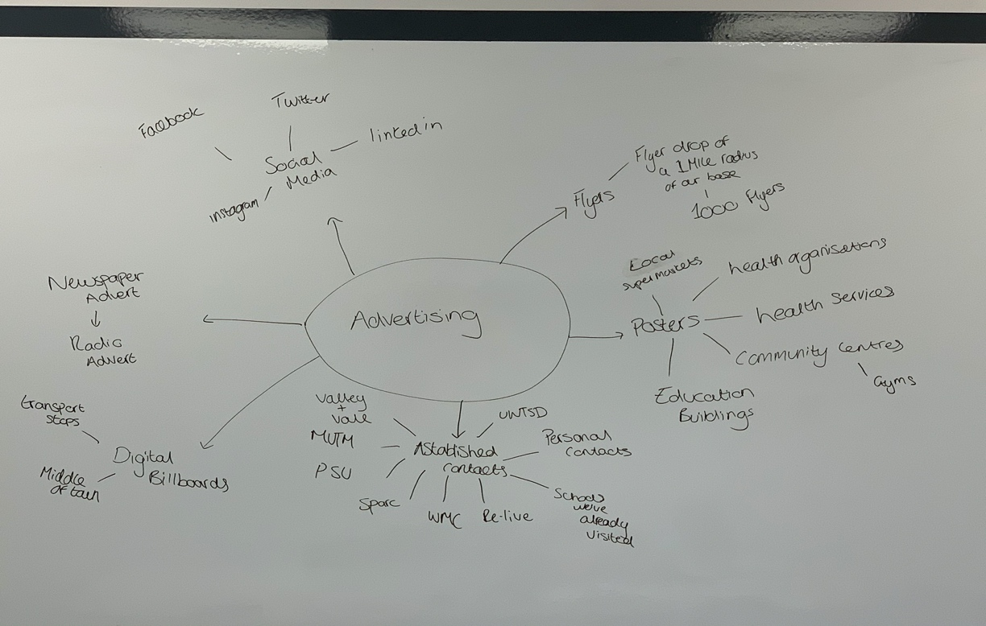
Other ways of advertising ourselves
Figure 2: Discussion on Advertising (Weston, Lacey-Freeman, Sullivan, 2020).

On discussion of how to advertise our company, we all decided that there are a few initial modes of advertising that would benefit us. Social media can be used to interact and promote to the younger generation along with any community pages that are set up for particular groups. We discussed that newspaper advertisement would be best for the older generation, as on reflection, this is the type of communication they use on a more regular basis. As a general way of promoting our company, we would post flyers through doors of a one-mile radius of where our base location is. Along with pinning posters in local health organisations, services and community centres. As we all have personal connections with many different companies/organisations, we would also encourage these to promote our company. Within time of our company growing, we would then hope to branch out to promote ourselves on digital billboards, radio adverts and possibly local tv stations (S4C).
Independent Reflection
Setting up Cwr has been a challenging and valuable insight into running a business in the world of drama, theatre making and facilitating. Personally, I have enjoyed being in a group to start a business and have seen first-hand how building a company with two other facilitators that I have worked alongside has many benefits. As we have known each other for three years, we are comfortable in forming the company and have trust in what each member can provide to Cwr. Because we all have individual skills that we can bring to the company, we will not need to employ other people to do certain jobs. Ffion has experience in social media, so she is competent at advertising and marketing us on these platforms. Kiara offers her extensive knowledge of Sparc and Valleys Kids, in which she participated in from a young age, which incorporates experiencing the daily running of a community-based drama company. I myself have experience in accounting and banking and can be comfortable in the role of financial manager.
The company name Cwr was adopted from the welsh translation of the verb “to meet”. This reflects our own ethos of bringing members of the community together to meet. Additionally, as we all come from different backgrounds and areas, we would never have met if we had not participated on the Applied Drama course. This not only makes us diverse in what we can offer but strong together as we have a tight bond and respect for each other.
Not only have I drawn influence from my two company members on forming our company, but also have had many discussions with other members of drama and theatre-based companies in South Wales. The most influential person that I have spoken to is Eleanor Shaw, who is the Artistic Director of PeopleSpeakUp “a social arts and wellbeing enterprise” (PeopleSpeakUp, 2020) based in Llanelli. Despite this being a new enterprise, having been formed on the 3rd May 2017, Eleanor already has a wealth of contacts and knowledge of running this style of business. Her company is a private company limited by guarantee without share capital. After a clear explanation from Eleanor about how this type of business is set up, we felt this suited us as a company, because we can choose the board of directors and employ outside facilitators and staff when needed. I also gained knowledge of Eleanor’s various jobs throughout her working life and can see how long it has taken her to build up contacts and her knowledge of how to be a storyteller and facilitator in the community. It has made me realise that, on a personal level, I have a lot more to learn to find my place as a competent facilitator in the community. However, it has inspired me to move forward and be a part of a company.
Having no capital for a business was a major concern for me, as I only have myself to put into the company and nothing in the way of finances. However, Eleanor explained that you did not need a lot of money to set up a business, as she did not have any starting capital when she formed PeopleSpeakUp. She also explained what funding she has applied for in the past and has offered to help us with any difficulties we have in this area. This has given me confidence in applying for funding, because filling out these forms correctly could be the difference to whether we receive funding or not. Even though other organisations we spoke to receive funding, Eleanor was the only person to offer us guidance and help.
The space in which PeopleSpeakUp work from is a tranquil chapel that has calming qualities. I have facilitated two workshops in this space and have experienced first-hand that it omits a positive atmosphere. Therefore, the space in which our company uses needs to have a similar presence, to help the participants feel at ease straight away. I strongly believe that comfort is one of the most important factors when choosing a location because participants need to feel relaxed and comfortable to participate fully. I feel like Volcano Theatre space in High Street Swansea does not provide this due to hazardous areas such as loose wires and holes in the building. It is also uncomfortable as it is cold, and the seats are very hard.
I have spoken about Volcano Theatre space briefly, comparing it with the chapel at PeopleSpeakUp. My conclusion of Volcano Theatre’s facilities was concreted after meeting Claudine Conway, the communications manager at the theatre. I found her very easy to talk to and she had a lot of information about the theatre to pass onto us. However, despite liking her and her positive portrayal of the company, I found the opportunities offered by Volcano were not as varied as they could be and were predominately based on contemporary styles. It gave me the impression of a very cold and edgy theatre company that was not very community friendly, even though it had run some projects with a local school. Through the conversation, I discovered that the artistic director is not open minded in who he works with and is not very flexible. I know that sometimes it is difficult to engage with everyone, but as a facilitator you do have to try involving your company with as many various parts of the community as you can. Volcano does have a place in the world of theatre making but mostly all I drew from them was negativity and felt that I would not want to collaborate with them or use their space.
On the other hand, on participating in a workshop and speaking to Jon Dafydd-Kidd who is head of participation at Hijinx, I felt energised. The style of workshop was diverse and enjoyable giving encouragement to all who participated. It made me feel like I wanted to be a part of Hijinx, and this is how I want my participants to feel when I facilitate a workshop. Jon had a very friendly personality and was passionate about the academies he oversees, as well as the outside projects that he has been part of. Although he could not give advice about the general running of a company, he came with an energy and likeability. This gave me confidence with my facilitating, and how I could incorporate some of his ideas into my workshops.
Going forward I have drawn influence from these three people the most and have taken on board their advice, help and guidance. Starting Cwr would have been much more difficult without their input. Even though we all bring many different qualities into the community we can still learn from each other and benefit by working together.

Bibliography for Reflection

Companies House (2020) PeopleSpeakUp Ltd. Available at: https://beta.companieshouse.gov.uk/company/10752538 (Accessed: 11th January 2020).
Hijinx (2020) Staff. Available at: http://www.hijinx.org.uk/staff/ (Accessed: 11th January 2020).
PeopleSpeakUpLtd. (2017) Business Plan 2017. Available at: file:///C:/Users/staples/Downloads/People%20Speak%20Up%20-%20Business%20Plan%202019.pdf (Accessed: 11th January 2020).
PeopleSpeakUpLtd (2020) Home. Available at: https://peoplespeakup.co.uk/ (Accessed: 11th January 2020).
Valleys Kids (2014) What we do. Available at: https://valleyskids.org/home/what-we-do/ (Accessed: 18th January 2020).
Volcano (2019) About Us. Available at: http://www.volcanotheatre.co.uk/about-us (Accessed: 18th January 2020).

Bibliography
Arts Care Gofal Celf (2017) Home. Available at: http://www.acgc.co.uk/wordpress/?lang=en (Accessed: 14th January 2020).
British Association for Music Therapy (2017) Dramatherapy Wales Conference 2019. Available at: https://www.bamt.org/DB/events/dramatherapy-wales-conference-2019.html (Accessed: 14th January 2020).
Hijinx (2020) We are Hijinx. Available at: http://www.hijinx.org.uk/about-us/ (Accessed: 14th January 2020).
nwzhg (2018) Category: Festival of Wellbeing 2018 [blog]. 22 March. Available at: https://blogs.hazlegrove.co.uk/category/festival-of-wellbeing-2018/ (Accessed: 11th January 2020).
PeopleSpeakUp (2020) What we do. Available at: https://peoplespeakup.co.uk/what-we-do.html (Accessed: 14th January 2020).
Re-Live (2020) Home. Available at: http://www.re-live.org.uk/ (Accessed: 14th January 2020).
The Pilgrim School (2019) Well-being Support. Available at: https://www.pilgrim.lincs.sch.uk/Well-being_Support (Accessed: 11th January 2020).
Volcano (2019) About Us. Available at: http://www.volcanotheatre.co.uk/about-us (Accessed: 14th January 2020).
Wales Millennium Centre (2019) What We Do. Available at: https://www.wmc.org.uk/en/what-we-do/ (Accessed: 14th January 2020).
Wearefio (2020) About. Available at: https://www.wearefio.co.uk/about (Accessed: 14th January 2020).
Youth Arts Network Cymru (2019) About YANC. Available at: https://yanc.co.uk/about/ (Accessed: 14th January 2020).
Figures
Weston, F. (2020) Design of Logo, Group Meeting Two. Swansea: UWTSD.
Weston, F, Lacey-Freeman, Sullivan, K. (2020) Discussion on Logo, Group Meeting Two. Swansea: UWTSD.
Weston, F, Lacey-Freeman, K, Sullivan, K. (2020) Group Meeting. Swansea: UWTSD.
Weston, F, Lacey-Freeman, K, Sullivan, K. (2020) SWOT Analysis, Class Discussion. Swansea: UWTSD.

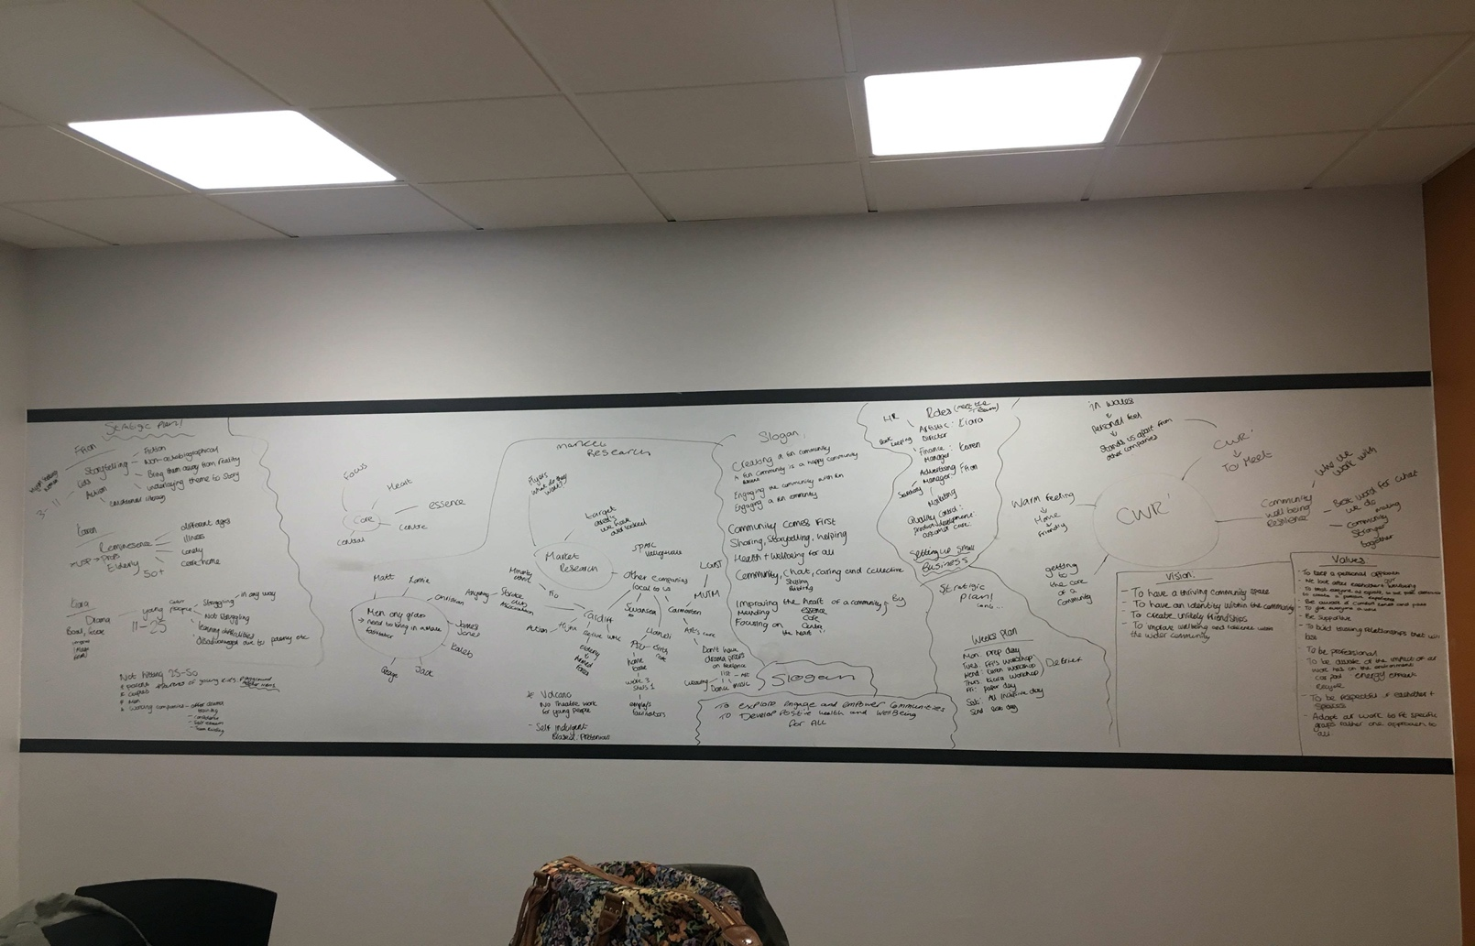
Appendix
Figure 3: Group Meeting (Weston, Lacey-Freeman, Sullivan, 2020).

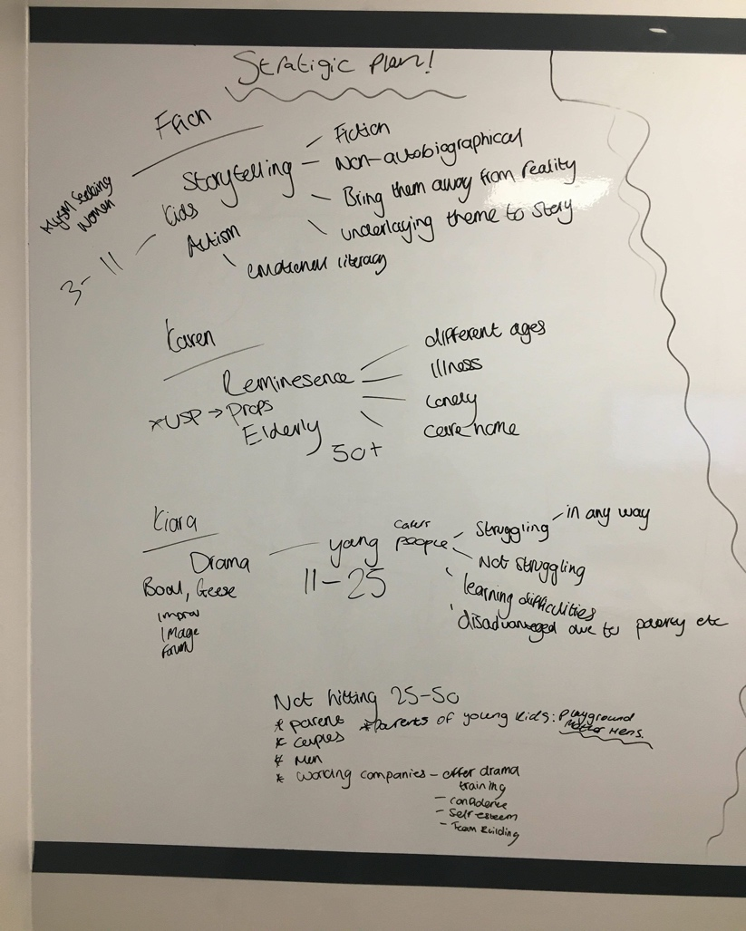

Figure 4: Group Meeting (Weston, Lacey-Freeman, Sullivan, 2020).

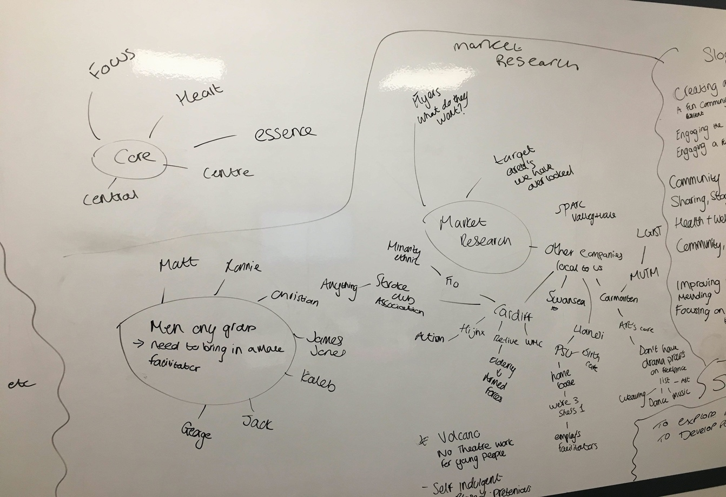
Figure 5: Group Meeting (Weston, Lacey-Freeman, Sullivan, 2020).
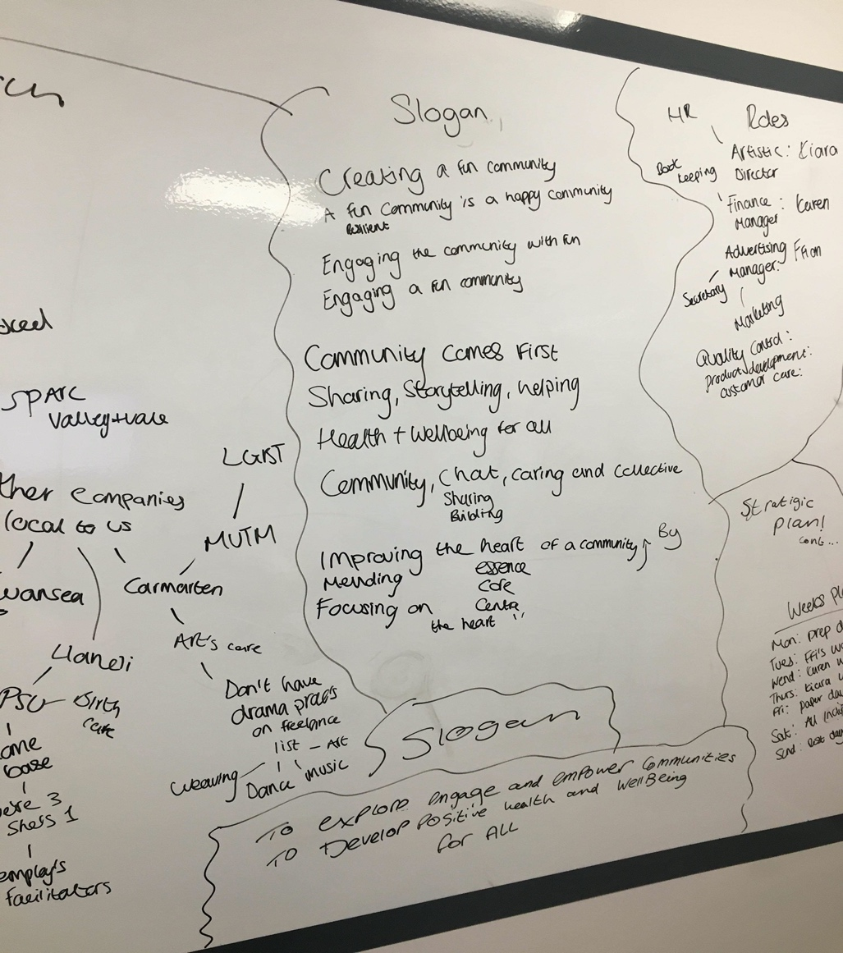
Figure 6: Group Meeting (Weston, Lacey-Freeman, Sullivan, 2020).

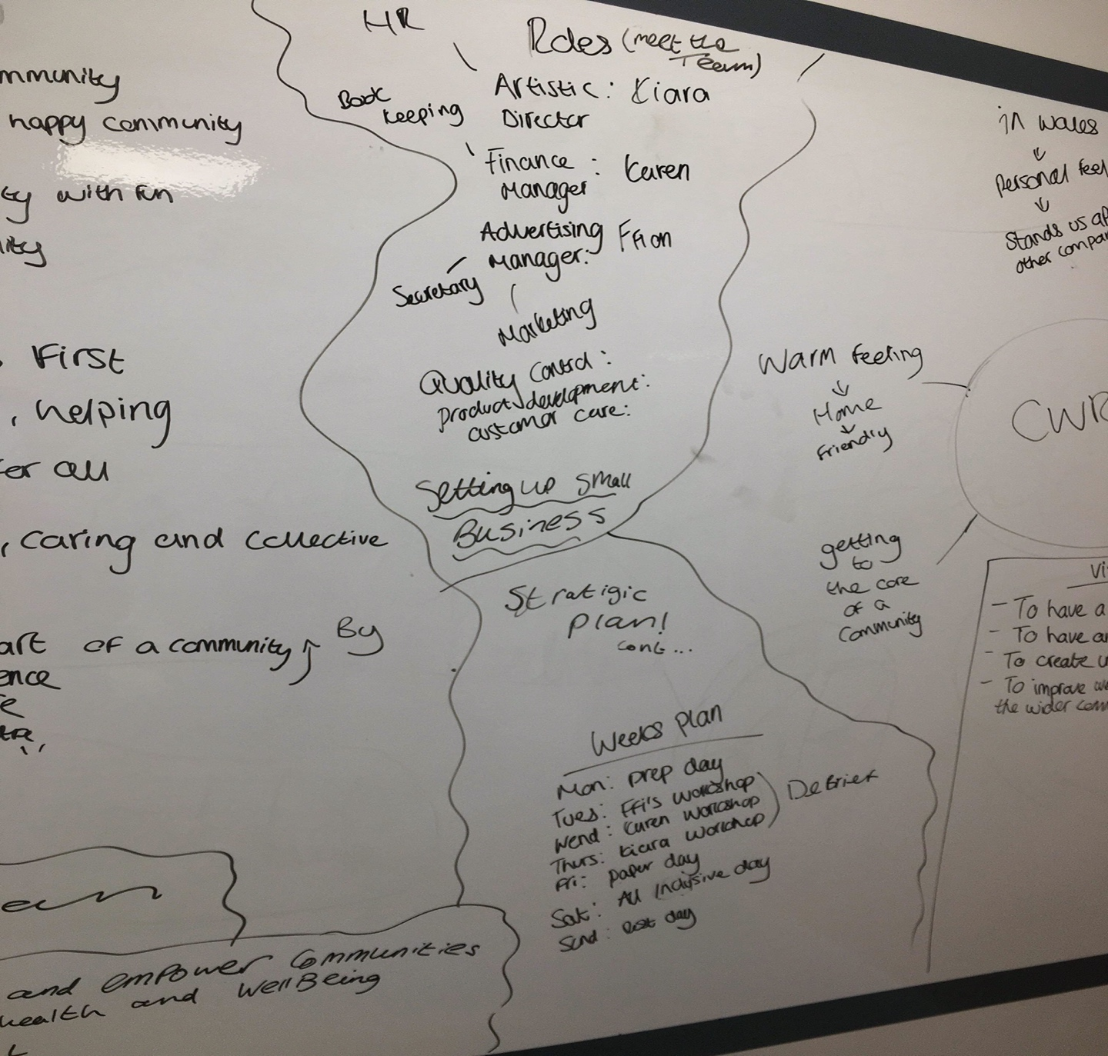
Figure 7: Group Meeting (Weston, Lacey-Freeman, Sullivan, 2020).

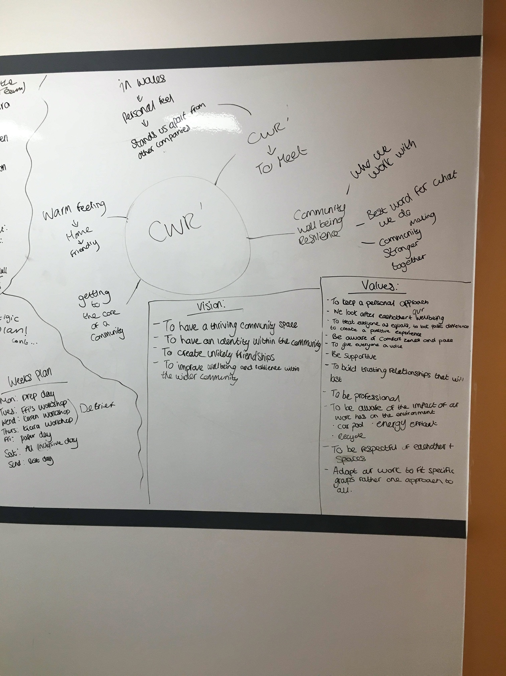
Figure 8: Group Meeting (Weston, Lacey-Freeman, Sullivan, 2020).

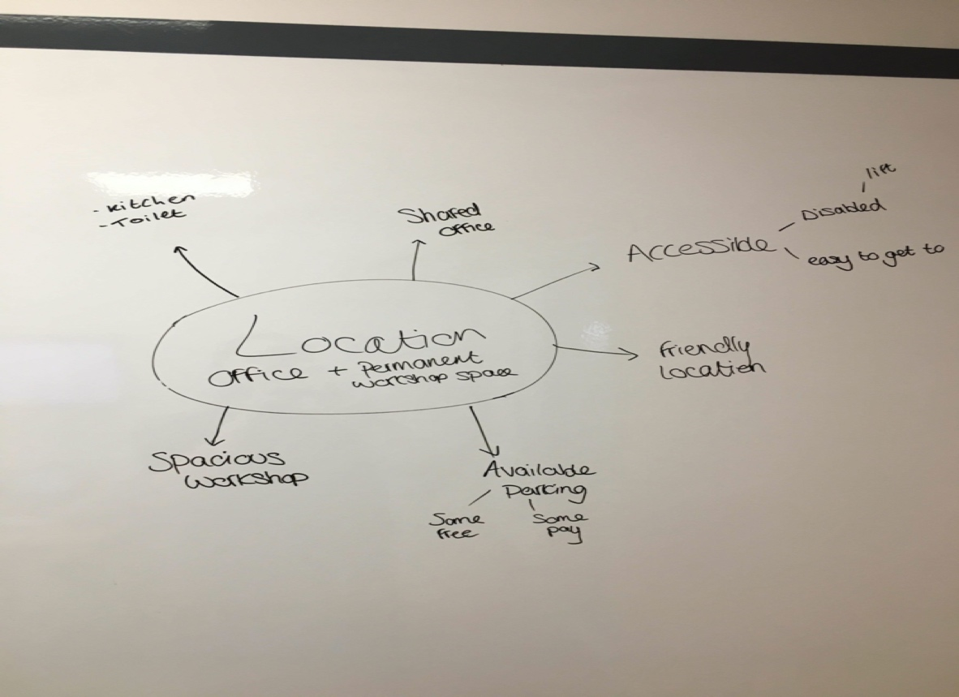
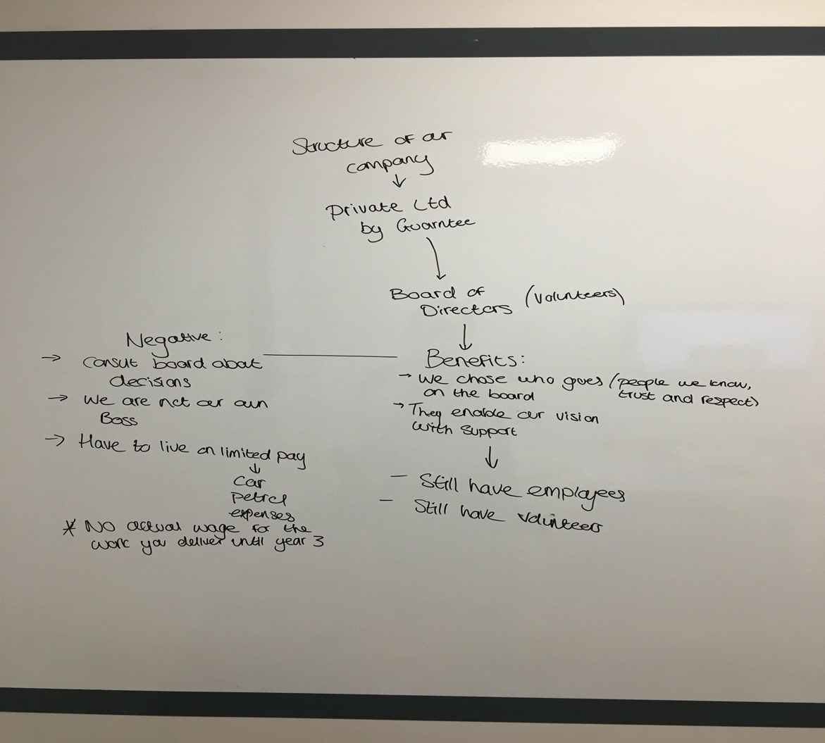
Figure 10: Group Meeting (Weston, Lacey-Freeman, Sullivan, 2020).
Figure 9: Group Meeting (Weston, Lacey-Freeman, Sullivan, 2020).
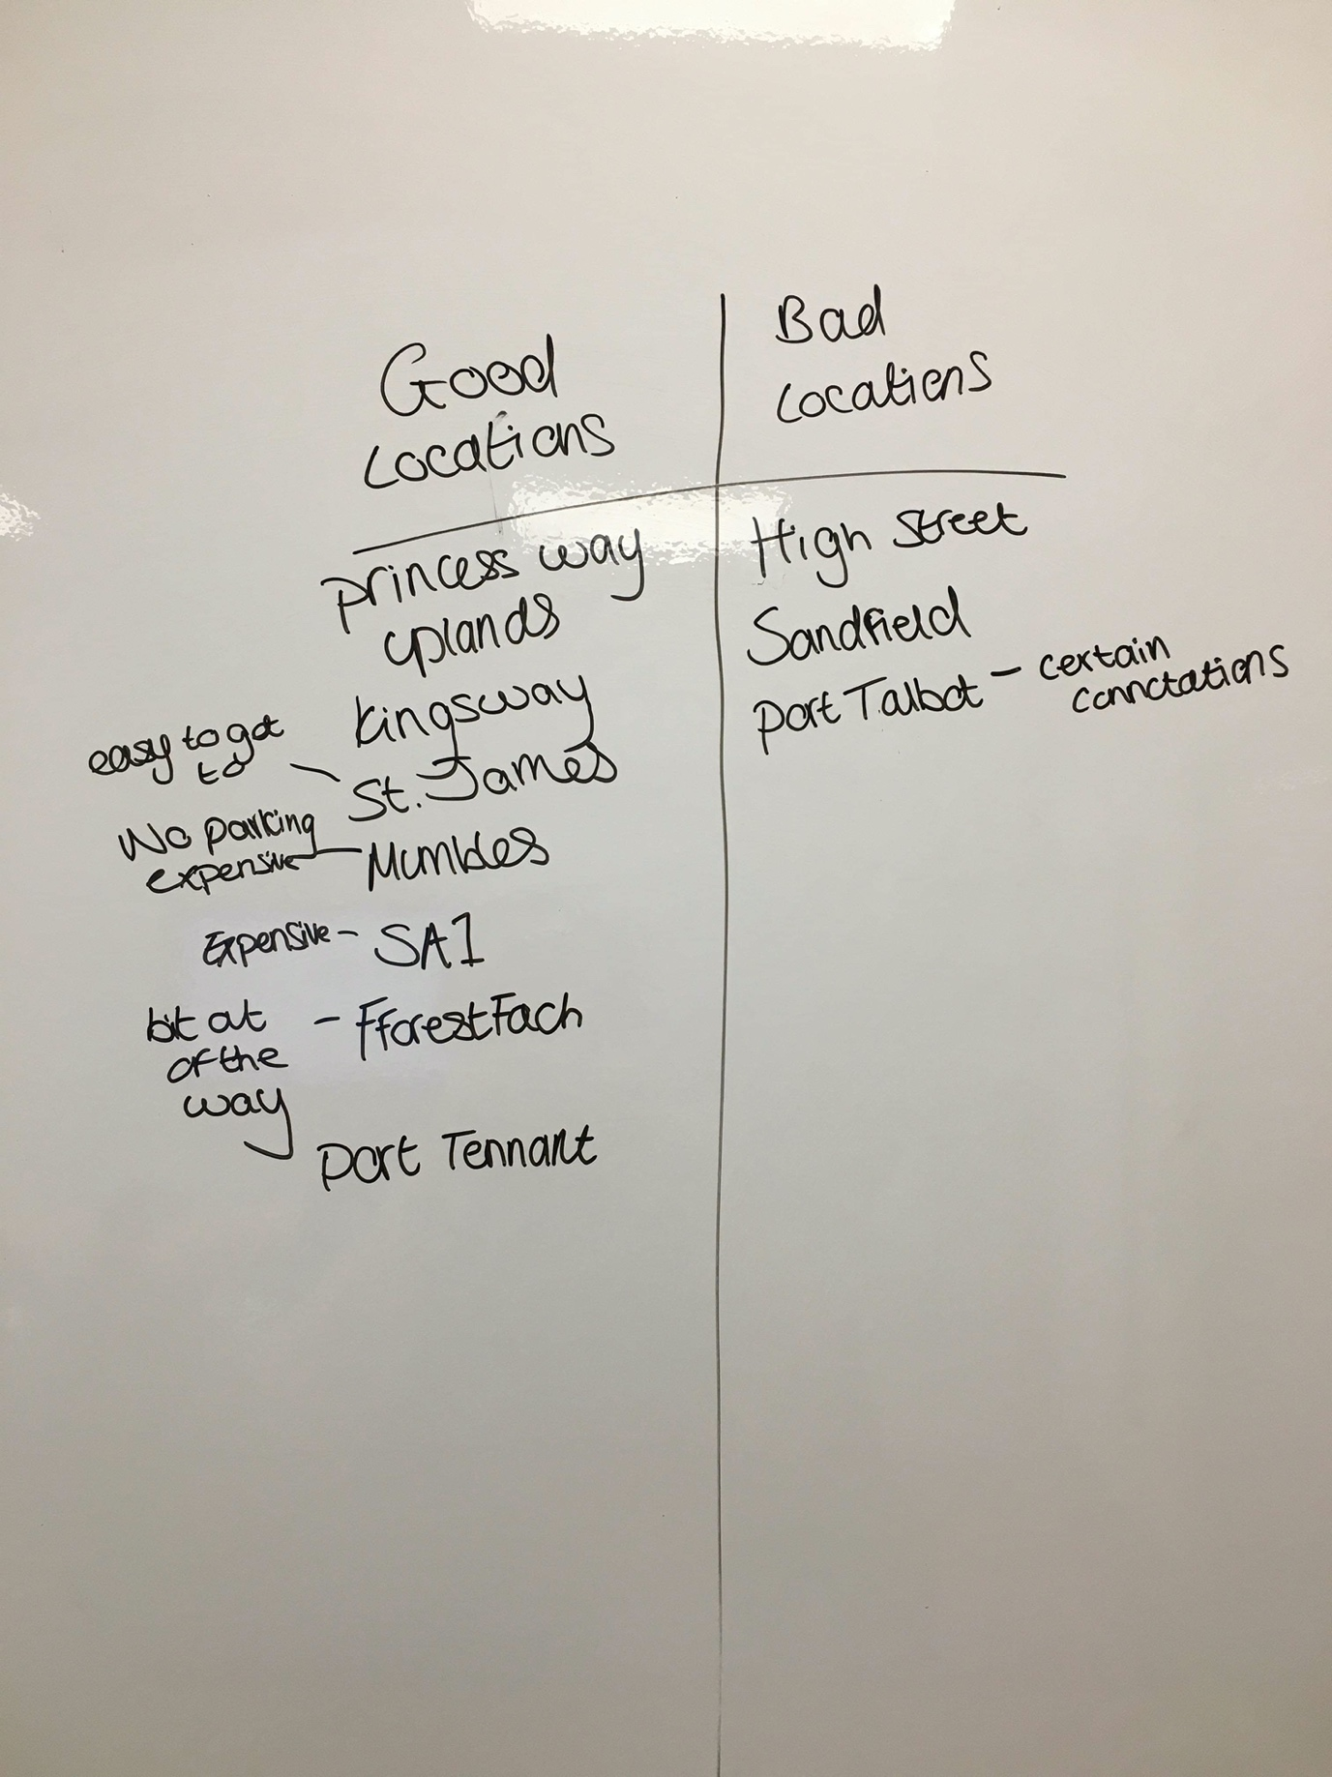
Figure 11: Group Meeting (Weston, Lacey-Freeman, Sullivan, 2020).
Initial Design of Logo
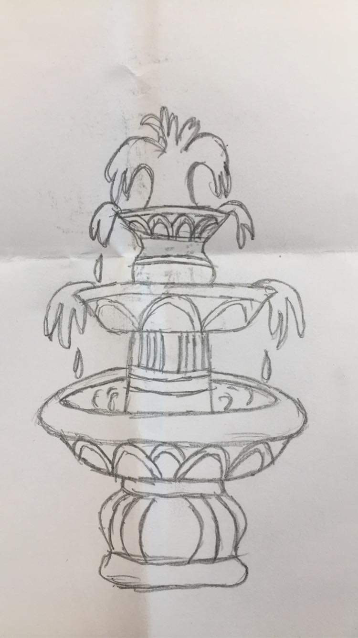
Figure 12: Initial Design (Weston, 2020).
Initial Market Research
CWR have various competitors in the following areas that are listed below, however, we feel as a collective that we can offer a different and wider range of workshops and facilities for the wider community to improve wellbeing.
Cardiff Area
Re-live
An award-winning charity based in Chapter in Cardiff that produces “Life Story Theatre Work” (Re-live, 2020). They mainly work with the elderly and armed forces through their work, concentrating on people living with dementia and post-traumatic stress disorder.
Hijinx
This company make theatre with learning disabled and autistic people mainly through their academies. They do work with the community but most of their participants are chosen through an interview process.
Fio
This theatre company “focus on those who are currently under-represented or misrepresented in society” (Fio, 2020). Even though they are based in Cardiff the do work all over the United Kingdom.
Wales Millennium Centre
Located on the Bay in Cardiff, the centre offers opportunities to the young people through workshops and courses this includes hosting various youth festivals.
Llanelli Area
PeopleSpeakUp
This is a “social arts and wellbeing enterprise” (PeopleSpeakUp, 2020) located in the Zion Chapel Llanelli with facilities also in the Ffwrnes theatre. PeopleSpeakUp offer storytelling, spoken word events, workshops on site and around the Carmarthenshire area.
Carmarthen
Arts Care Gofal Celf
Located in West Carmarthen “Arts Care Gofal Celf is a professional arts organisation” (Arts Care Gofal Celf, 2017) who has a wide range of participants coming together in the form of workshops and projects.
All these companies and charitable organisations offer a range of workshops and participation in various forms. This includes theatre productions, spoken word, art, workshops and projects. We feel that most of these are tailored to specific audiences, therefore will only be open to certain demographics in the community. Also, some of the companies have only one permanent facilitator and must hire extra facilitators if needed. Whereas, with CWR there are three facilitators with a wide skillset and workshop experience, these skills focus on different needs and therefore, we can be adaptable within the community base.
One of the weaknesses in CWR is that as we are an all-female collaboration and that we have no male facilitators. On completion of market research into whether we will need a male facilitator for the company on a flexible or part time basis we have three contacts: Matthew Rosolemos, Cameron Hester and James Jones. These facilitators are all graduates of the UWTSD and have facilitated workshops in the wider community.
We have also recognised that between the ages of 25-50 we are lacking beneficial opportunities. We are therefore working together to offer workshops and activities in the following areas in the community.
- Parents with young children, to tackle loneliness and isolation.
- Couples.
- Men, to improve communication and confidence.
- Working companies- offer training through drama for:
Confidence.
Self-Esteem.
Team building.

Initial Strategic Plan
Our Specialities
Karen
Karen has an extensive knowledge of reminiscence theatre and storytelling, working with many elderly people and over 50 groups such as the stroke association and many different care homes. Karen’s work creates a safe space for the elderly to tell stories which are important to them.
Kiara
Kiara has worked with many different young people from disadvantaged areas and young carers groups and has a vast knowledge of the struggles these young people go through. Using techniques such as improvisation, forum theatre and imagery, Kiara’s work creates a space for self-expression and trust.
Ffion
Ffion has a broad knowledge of autism and ADHD. Ffion has a passion to support those affected by different neurological disorders and has worked with specialist autistic schools using drama to explore emotional literacy. Ffion’s workshops create a space for support for those affected by or have neurological disorders.
Due to the fact that our facilitators all trained together as a class, they therefore know each other’s styles of facilitation and have also learned the same techniques through their university years. This creates a great opportunity for co-facilitation when a workshop of project requires that.
The week’s plan
Monday- Preparation day
Tuesday- Ffion’s workshop
Wednesday- Karen’s workshop
Thursday- Kiara’s workshop
Friday- Paper day
Saturday- All-inclusive day
Sunday- Rest day

Our all-inclusive day aims to bring together everyone that attends the different workshops throughout the week, in order to create a stronger and more resilient community. The Saturday workshops will not be heavily drama based and instead will provide participatory activities that everyone of all ages can enjoy.
Open day

Scripts for Video

Hello, we are Cwr’! A collective non-profit company who offer participatory activities to the wider community. Cwr’ stands for community, wellbeing and resilience and translates in welsh ‘to meet’. We would love to meet with you to be creative and build lasting friendships.

Hi, I am Kiara and I am the Artistic Director of Cwr’. I use my unique set of skills to interact with young people aged 11-25 to build confidence and encourage them to use their voice as it matters. I have worked with diverse age groups and I am constantly inspired and challenged by whoever I work with and that excites me to continue offering new opportunities to the wider community.

Hi, my name is Karen and I am one part of CWR, my passion is reminiscence storytelling using photographs, food and lots of other interesting objects. I feel that this can be applied to many situations and engage the community to share stories with each other. My workshops are in a relaxed atmosphere with no pressure. It is fantastic that we have the opportunity to reach out to people from the community to come together and benefit from each other’s experiences, engaging and empowering to improve wellbeing.

Hi, my name is Ffion and I am the Advertising Manager. I also have ADHD. My passion is to help people with neurological disorders and support them through the use of drama. This is because drama helped me, and I want to help others with it as well! My workshop aims to create a safe place and support network for those affected by neurological disorders and those living with neurological disorders.

