4. Chapter Four: Data analysis

4.1 Introduction
The previous chapter identified the methods and methodology of this research. This chapter aims to achieve the third objective of this dissertation:

“To analyse the results obtained from primary research and to explore young people’s cognition of e-sports and their attitudes towards the future development of e-sports.”

This chapter will introduce and analyse the data collected in the questionnaire survey. The study finally collected questionnaires from 215 respondents, which surveyed young people's views on e-sports, especially their attitudes towards the future development of e-sports.

4.2 Data Analysis
Data analysis is a process in which researchers use appropriate statistical analysis methods to summarize (Collis and Hussey, 2014). In this case, the visualization results can be used to maximize the development of data functions. The data was analyzed by using WJX (wjx.cn) online SPSS and the IBM SPSS statistics 26.0 software. Data analysis provides descriptive analysis and Chi-Square test of association. Secondly, the data analysis use T-test (Independent sample T test) to study the relationship between categorical variables and continuous variables (Prabhaker, et al., 2019). Finally, the analysis use ANOVA multi-factor analysis of variance to analyze the ratio of between-group variance and within-group variance (Rouder, et al., 2016).

4.3 Methods
Since the research is to explore the views of young people over 18 and under 30 on e-sports, it has screened and excluded respondents who do not meet the age requirements. The 215 interviewees who were able to perform data analysis were able to meet the data analysis requirements of the research.

4.4 Demographics and Descriptive Statistics
The study recruited 191 respondents through online platforms (e.g., social media and emails). All interviewees were 18 years of age or older and volunteered to participate.

There are the basic information (Question 2-5) and more questions results figures in the appendix 6.

From the data in the appendix 6, it can be seen that more than 60% of the age samples choose "18-22 years old ". The proportion of "male" selected in the sample was 52.56%. There are also 47.44% of the samples for women. More than 80% of the highest academic qualifications choose "undergraduate (including undergraduate)". From the work type, there are relatively many "students" in the sample, the proportion is 67.91%.

4.5 Chi-Square Analysis

4.5.1 Chi-Square Analysis for Gender Associations
The analysis performed nine Chi-Square analyses to check whether the results showed a statistical association between male and female responses. Due to the limitations of Chi-Square analysis, this operation is only done for questions involving nominal data (questions that are not answered using the Likert scale). Therefore, a Chi-Square analysis was performed on questions 6, 7, 9, 11, 13, 14, 15, 17, 19. For ease, the list of questions in the Appendix 3.

Figure 4.1, 4.2 and 4.3 shows significant associations between male and female answers to question 6,11 and 15.
Table 4.1 shows the non-significant associations between gender and responses to question 7, 9, 13, 14, 17 and 19 (See Appendix 3 for figures).
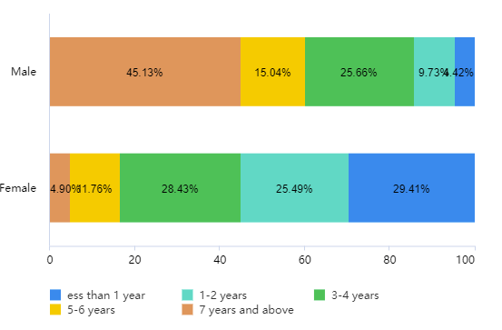
Figure 4.0.1 Showing a significant association between gender and response to, “How long have you playing E-sports games (any platform)?” (p=.000), in question 6.

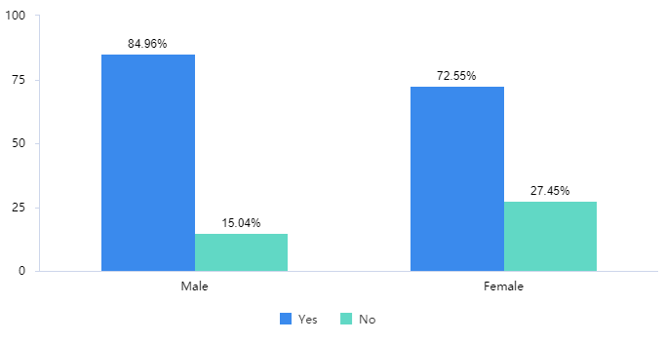
Figure 4.0.2 Showing a significant association between gender and response to, “Do you think e-sports can be used as a major in the university?” (p=.026), in question 11.

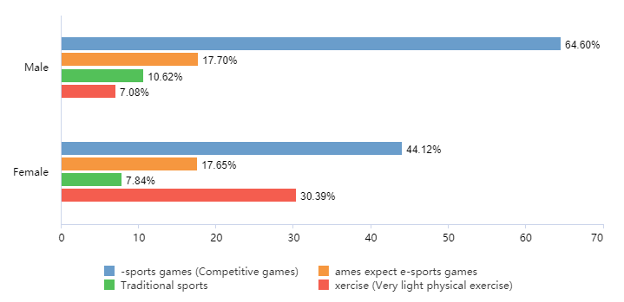
Figure 4.0.3 Showing a significant association between gender and response to, “Which option you spend more time every year?” (p=.000), in question 15.

Table 4.1 Showing non-significant associations between gender and questions 9,13,14,17 and 19.
Question Number | Question | Significance (p-value)
7 | Do you think e-sports is a sport? | .051
9 | Do you think e-sports should be institutionalized like traditional sports? | .461
13 | Which one do you think is more popular with young people? | .238
14 | Which one do you think has more potential for development? | .553
17 | Do you think e-sports can be sustainable in the future? | .629
19 | Do you think the Institutionalization of e-sports will help it stand the same position with traditional sports? | .125

4.5.2 Chi-Square Analysis for Age Associations
The analysis performed nine Chi-Square analyses to check whether the results showed a statistical association between responses of age 18-22, 23-26 and 27-30. Due to the limitations of Chi-Square analysis, this operation is only done for questions involving nominal data (questions that are not answered using the Likert scale). Therefore, a Chi-Square analysis was performed on questions 6, 7, 9, 11, 13, 14, 15, 17, 19. For ease, the list of questions in the Appendix 3.

Figure 4.4 shows significant associations between age 18-22, 23-26 and 27-30 answers to question 6.
Table 4.2 shows the non-significant associations between gender and responses to question 7, 9, 11, 13, 14, 15, 17and 19 (See Appendix 3 for figures).
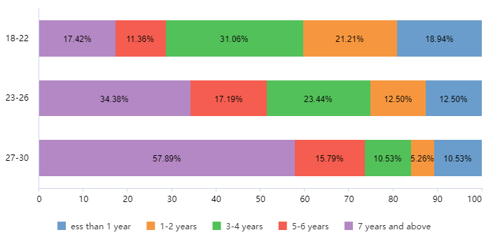
Figure 4.0.4 Showing a significant association between age and response to, “How long have you playing E-sports games (any platform)?” (p=.005), in question 6.

Table 4.2 Showing non-significant associations between age and questions 7, 9, 11, 13, 14, 15, 17and 19.
Question Number | Question | Significance (p-value)
7 | Do you think e-sports is a sport? | .121
9 | Do you think e-sports should be institutionalized like traditional sports? | .346
11 | Do you think e-sports can be used as a major in the university? | .096
13 | Which one do you think is more popular with young people? | .634
14 | Which one do you think has more potential for development? | .099
15 | Which option you spend more time every year? | .297
17 | Do you think e-sports can be sustainable in the future? | .787
19 | Do you think the Institutionalization of e-sports will help it stand the same position with traditional sports? | .324

4. 6 Independent T Test
This analysis performed twelve T test analyses to check whether the results showed a significant difference between males and females. Due to the limitations of T test analysis, this is completed by the questions which had Likert scale responses. Therefore, a T test analysis was performed on question 10, 12 and 18.

Figure 4.5 shows a significant difference between males and females to the question section, “The life cycle of e-sports is too short, and ordinary events cannot survive for a few years, while traditional sports usually do not happen.”
Table 4.3 shows a non-significant difference between males and females to the remaining questions (See Appendix 4).

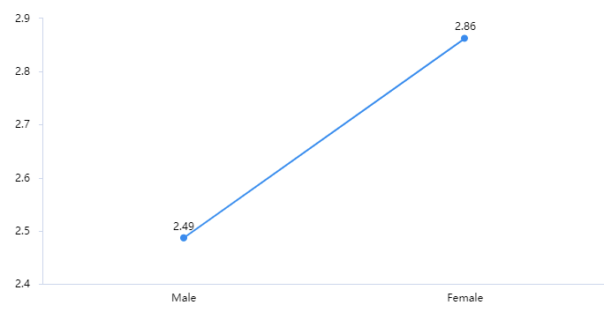
Figure 4.5 showing a significant difference between males and females and response to, “The life cycle of e-sports is too short, and ordinary events cannot survive for a few years, while traditional sports usually do not happen.” (p=.007), in question 10.

Table 4.3 showing a non-significant difference between males and females and response to the remaining questions.
Question Number | Question section | Significance (p-value)
10 | The playability of the game itself | .281
10 | Capital investment | .764
10 | Institutionalization of e-sports | .300
10 | Society needs recognition of e-sports | .318
12 | E-sports is not recognized like traditional sports as a sport. | .916
12 | E-sports is a commercial activity, not the same as sports. | .399
12 | Society has prejudices against e-sports | .118
18 | The playability of the game itself | .275
18 | Capital investment | .524
18 | Institutionalization of e-sports | .292
18 | Society needs recognition of e-sports | .525

4.7 ANOVA analysis
This analysis uses the ANOVA (Analysis of Variance) to investigate the difference of age on the view of e-sports, the analysis shows (See in the Appendix 5):

The age showed a significant level of 0.01(F=8.897, pF=0.000) for the duration of playing e-sports games, and the specific contrast difference showed that the group average score with obvious difference was "23-26 years old >18-22 years old ,27-30 years old >18-22 years old ".

The results of the difference of the views of the highest education on e-sports showed the highest education level is 0.05(F=3.110, pF=0.027).
The highest education is a commercial activity for e-sports, which shows a significant 0.05 level (F=2.817, pF=0.040), and the specific contrast difference shows that the group average score with obvious difference is " Junior college (including college enrollment) > Undergraduate (including undergraduate students) > Postgraduate or above ".
For the differences of e-sports views, the specific analysis shows:
The highest education showed a significant 0.05 level (F=3.166, pF=0.025) for social prejudice against e-sports, and the specific contrast difference showed that the group average score with obvious difference was " Undergraduate (including undergraduate students) > Postgraduate or above> Junior college (including college enrollment)".

The result of the difference of work type's views on e-sports showed the work type shows 0.01 level significance for playing e-sports games (F=.4.004, pF=.0. The comparative results of group average scores with significant differences are "students > institutions/staff/government staff; freelancers > students of professional and technical personnel (teachers, doctors, engineers, writers, etc.); general or corporate staff > students; self-employed > students; freelancers and students ".

4.8 Discussion
This research aimed to investigate young people’s views on e-sports and its sustainable development. According to the previous research (e.g., ESCHER，2020; Guttman，1994; Wallechinsky，2004; Wooyoung and Byon, 2019; Arin，2020; Brock，2017; Seo and Jung, 2016; Witkowski, 2012; Ahmet and Engin, 2020; Boluk and LeMieux, 2017), this research found the development potential of e-sports is greater than that of traditional sports.

The unique aspect of this study is that it investigates the influence of young people's age, gender and education level on the perception of e-sports. In the research of analysis figures, there are some significant associations between males and females to the specific questions and it shows that males have a strong understanding and extend of love on e-sports than females. With association of age, age between 23 and 26 years old have a better understanding of e-sports and they are more optimistic about the sustainable development of e-sports. For the highest education level in the participants, it shows that undergraduate and the people who have a bachelor degree are the main force of e-sports.

In the analysis of the questionnaire questions, question 7 and question 16 show that respondents generally believe that e-sports is a sport and its future development trend is good. This confirms the previous research (Marko and Dino, 2019; Witkowski, 2012; Ahmet and Engin, 2020; Boluk and LeMieux, 2017; Jin, 2010; Anita, et al., 2017) that the status quo of e-sports in recent years is in a stage of rapid development. It also has a great change from the perception of e-sports among the Chinese public in the early days (Lin, Wang and Qi, 2019; Lou, 2018; Xue, 2016).

In accordance with previous research, this research is more concern with the degree of similarity and relevance between e-sports and traditional sports. Although the previous research is optimistic about the future development trend of e-sports, there are some scholars and institutions believe that the future development of e-sports needs to learn from the institutionalization of traditional sports in order to develop further (Guttman, 1994; Abanazir，2018; Summerley, 2019; Candela and Jakee，2018; Zhihu, 2019). The fact is that there are still gaps between e-sports and traditional sports. Through the analysis of question 12 and 18 of this research, it can be seen that participants generally agree that gaps between e-sports and traditional sports. But through the views of participants, nearly all the participants are optimistic about the sustainable development of e-sports and e-sports are more popular with young people’s group.

In accordance with previous research, this research found that the institutionalization of e-sports is not a significant factor affect the sustainable development comparing to the playability of the game itself, capital investment and society needs recognition of e-sports. There are small group of participants thought institutionalization of e-sports will not help it stand the same position with traditional sports.

4.9 Conclusion
This chapter achieved the third objective:

“To analyse the results obtained from primary research and to explore young people’s cognition of e-sports and their attitudes towards the future development of e-sports.”

In conclusion, this research is basically consistent with the previous research. They all show that the development of e-sports in the current environment is becoming increasingly important, and both show the feasibility of the sustainable development of e-sports in the future. To further support the previous literature, this research found the development potential of e-sports is greater than that of traditional sports, but the institutionalization of e-sports is not the key factor affect the sustainable development of e-sports. The playability of the game itself (Zhou，2018; Li，2019; Sohu, 2020), capital investment (Ahmet and Engin, 2020; Amadeus, 2020; Fang, 2017) and society needs recognition of e-sports (Lin, Wang and Qi, 2019; Lou, 2018) have a deep influence for the sustainable development of e-sports.

This chapter has successfully analyzed data and explored young people’s cognition of e-sports and their attitudes towards the future development of e-sports. The last chapter will achieve the final objective of the dissertation, which are understanding the implications and limitations, making the recommendations and considering for the further research.

References
Rouder, J.N., et al. (2016). Model comparison in ANOVA. Psychonomic Bulletin and Review, 23(6), pp.1779-1786.
Prabhaker, M., et al. (2019). Application of student's t-test, analysis of variance, and covariance. Annals of Cardiac Anaesthesia, 22(4), pp.407–411.

