
Applied Computing
Wales Institute of Science and Art (WISA)

Digital Forensics (ACCA7031)

Investigative Process - Imaging

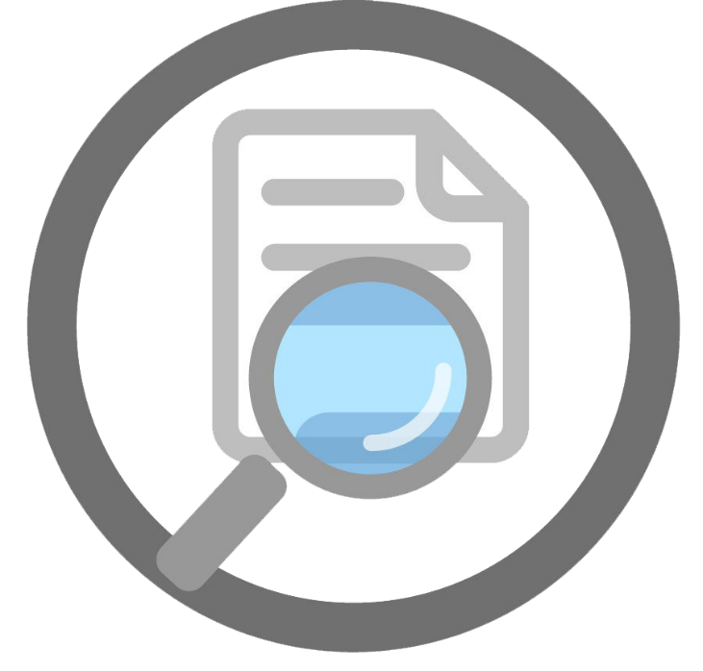
This Photo by Unknown Author is licensed under CC BY-NC

Lab Activities are based on
TryHackMe, EC Council – CHFI, and other Industry Digital Forensic Curriculum

Objectives
In continuation to our lectures, this hands-on Activity helps in providing you an overview of digital forensic investigation process.
ETHICAL STATEMENT
As discussed during our lectures, it is very important to adhere to Personal Ethics, Professional Ethics, Computer Ethics and Business Ethics.
We, the participants and stakeholders in the digital forensics laboratory, recognize the significance of ethical conduct when using digital forensics tools and processes for academic purposes. Our commitment to ethical standards is grounded in the principles of integrity, privacy, and responsible handling of digital data.
The tools and techniques you are exposed to’ in this lab is to work only on a virtual machine environment and the purpose is entirely to demonstrate various digital forensic activities. Experimentation with these tools, techniques, and resources is at the discretion of the instructor and institution. If you as a student consider using these tools for educational purposes on an outside environment, you should contact your lecturer prior to any experimentation.
Note: Unauthorized access to data, computer, and network systems is a crime in many jurisdictions and often is accompanied by severe consequences, regardless of the perpetrator’s motivations. It is the learner’s responsibility, as the user of this material, to be cognizant of and compliant with computer use laws.
Task 1: Image Acquisition
Task 2: Image Acquisition (Alternative Methods)

Task 1: Image Acquistion
(Team Activity)
Team Size: 2-3
- Your team is part of an digital forensic investigation. The investigation scene is pictured below.
  - Document the steps you need to do as part of digital forensic process. (Refer to the lecture: The process is to prepare, gather, Process and Present. Address each step)
- Let’s focus on the Preparation process. As a team, discuss and research various acquisition tools that are available for the following requirements. It is an open book activity. Feel free to use Internet, Books or any other resources to identify the tools. List out 5 tools (including open source and licensed tools). Include Vendor Name, Tool Name, Latest Version and the features of the tool. Make all assumptions. (Like OS etc)
- Task: As a Team
  - Create a Folder, and few files (Try to put in encrypted files (create one if you can to challenge your classmates).
  - Use any appropriate tools to acquire the image of the folder.

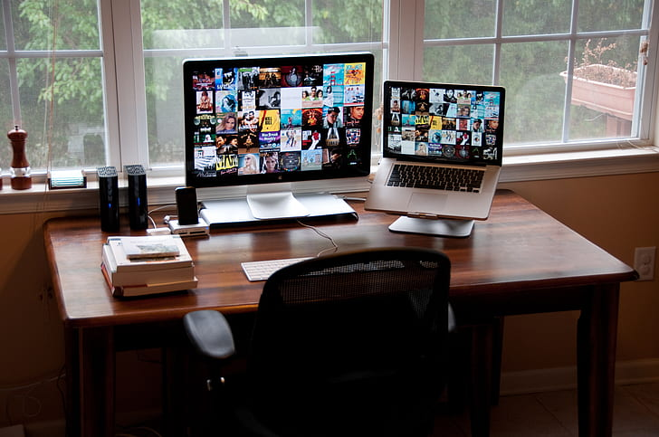
- Discuss in the class about your experience in acquiring the image.

- During acquiring the images, you might have come across different file formats. A brief discussion about file formats like E01, RAW was done during the Lecture session with your Lecturer. Based on your activity and understanding, discuss with your classmates/ team about those available file formats and their purposes.
- Based on the research done earlier about the tools for acquiring the image, discuss briefly the pros and cons of the tools you identified.
- Did you reach a point where FTK Imager (If you used FTK Imager or any other Imaging Tools) verified the image/ results?
  - Discuss the importance/ key aspects of that verification with your classmates/ team. (Note: If you have not done this, I strongly recommend you to complete this activity before continuing this).
  - Submit the image acquired and a brief note on the list of files inside the image, keys (if encrypted) in the shared folder. Naming conventions are very important.

Task 2: Image Acquistion (Alternative Methods)

- Try to acquire image with a Command Line Tool
  - What are the possible tool options to acquire image using CLI? Did you come across tools during your Handson Activity 1 research?
  - Lets try dd tool from chrysocome.net. Have a overview of the tool in the given website and download it. Make sure you download the correct version.
    - Download DD (Appropriate version)
    - Open Command Prompt and change directory to the current path where DD is stored. (cd Desktop)
    - Use dd –list to check the mounted devices
    - Image a small folder/ file to a specific destination. (I would possibly recommend to connect a flash drive with minimal data to get more information)
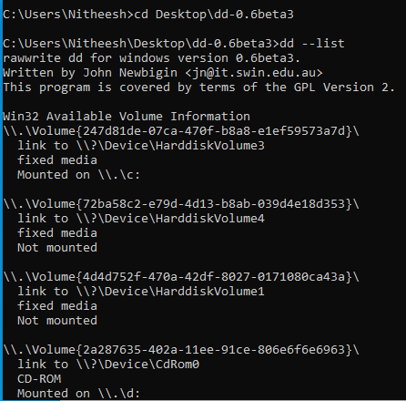
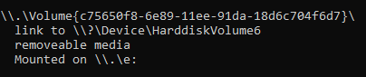

    - Create the image specifying the source and the destination.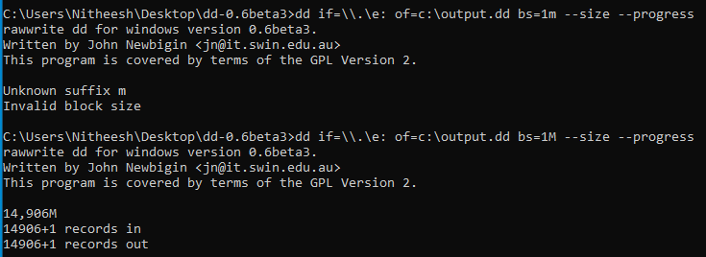
    - Check the dd image file.
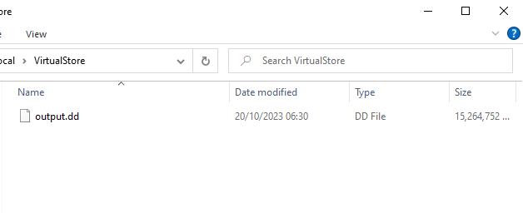
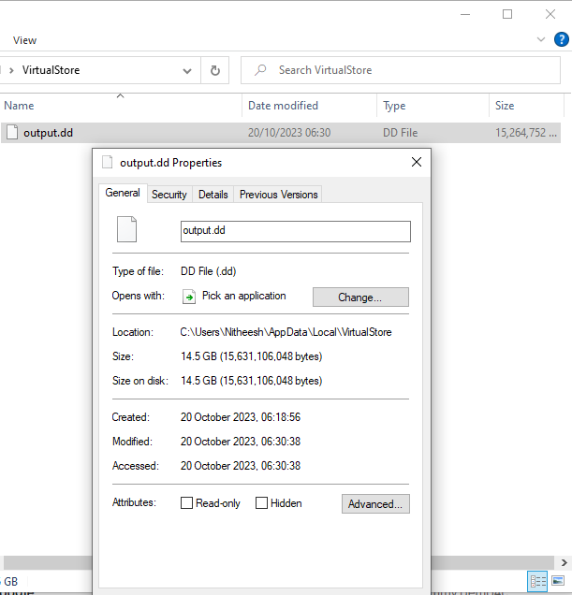

    - Try to implement Filter options and acquire the image and document the outcome.
    - Build your Virtual Topology. Use DD Tool or other relavent tool to create a Forensic image over the network using file share.

Acquired Images:
- Folder with Files (EO1/RAW)
- Folder with Files (DD)
Overall Reflection
- Understanding on the concepts discussed in the lecture and its relation to the activity done.
- Understanding about various tools used and various frameworks available for DF Investigations.
- Rate yourself: Understanding of Preparation – DF Investigation
-------------------------------------------End of Activity--------------------------------------------

