

A Cheap and Affordable Device for Monitoring Noise Levels in Home Studio Environments to Warn Users of Exposure Duration Based Hearing Damage

by
James Frew

Supervisor: Nik Whitehead
Second Marker: Nathan Morgan

Project submitted as part of the requirements for the award of
BSc (Hons) Computing (Software Engineering)

April 2025

DECLARATION

I, James Frew declare that I am the sole author of this Project; that all references cited have been consulted; that I have conducted all work of which this is a record, and that the finished work lies within the prescribed word limits.

This work has not previously been accepted as part of any other degree submission.

Date : 29/04/2025

FORM OF CONSENT

I James Frew hereby consent that my Project, submitted in candidature for the B.Sc. (Hons) Computing (Software Engineering) degree, if successful, may be made available for inter-library loan or photocopying (subject to the law of copyright), and that the title and abstract may be made available to outside organisations.

Date : 29/04/2025

Abstract
This project documents the research into, and creation of a low-cost, compact device designed to monitor environmental noise levels within home studio settings. Its purpose is to help prevent duration-based hearing damage among musicians and audio producers primarily in home studios. Extensive research is performed, looking into sound fundamentals, the human ear, weighted sound levels, noise pollution, recommended exposure limits, home studios, current noise monitoring technologies, digital signal processing, sound calculation algorithms, standards for noise monitoring devices, and future developments in noise monitoring technologies. An affordable MEMS microphone and ESP32 microcontroller are combined with custom-developed software, and a custom-modelled 3D printed casing. The system measures real-time sound levels, calculating safe exposure durations, and providing visual and auditory alerts when users exceed NIOSH recommended sound guidelines. The device is successfully created at an affordable price (less than £20) and sits compactly at 71 x 64 x 51mm. The system’s ease of use and accurate noise monitoring are confirmed through rigorous testing and ample user feedback. This feedback is performed using the System Usability Scale, with the device receiving a very high score of 89.5. Future developments such as miniaturisation, wearable options, and mobile integration are reflected on with user suggested amendments assessed for their viability. The report also briefly addresses the device’s possible future commercialisation.
Table of Contents
Chapter 1 - Introduction 11
1.1 Introduction 11
Chapter 2 - Research and Review of Literature 12
2.1 Literature Review 12
2.2 Sound Fundamentals 12
2.2.1 Longitudinal Waves 12
2.2.2 Sound Pressure and Sound Pressure Levels 12
2.3 The Human Ear 13
2.3.1 Human Ear Sensitivity 14
2.4 Calculating and Interpreting Average dB Levels 14
2.4.1 The Concept of Equivalent Continuous Sound Levels (Leq) 14
2.4.2 Weighted Sound Levels (dBA, dBC) 14
2.4.3 Challenges in Calculating Averages for Fluctuating Sound Levels 15
2.5 Noise Pollution 16
2.5.1 Residential Settings 16
2.5.2 Health Impacts of Excessive Noise Exposure 16
2.6 Recommended Exposure Limits 16
2.7 Home Studios 18
2.7.1 Rise of affordable audio production tools 18
2.7.2 Non-Standard Acoustic Environments 19
2.8 Noise Monitoring Technologies 19
2.8.1 Microphones 19
2.8.2 Wearable Devices and Consumer Electronics 20
2.9 Digital Signal Processing 21
2.9.1 In Noise Monitoring 21
2.9.2 Real-Time Analysis of sound 21
2.9.3 Fast Fourier Transform for Frequency Analysis 21
2.10 Algorithms for calculating equivalent continuous sound levels (Leq) 21
2.11 Standards and Guidelines for Noise Monitoring Devices 23
2.11.1 International Electrotechnical Commission (IEC) 23
2.11.2 International Organization of Legal Metrology 24
2.12 Future Developments in Noise Monitoring Technology and Artificial Intelligence 24
2.12.1 Microelectromechanical systems (MEMS) 24
2.12.2 AI and Machine Learning for Sound Analysis 25
2.13 Literature Conclusion 25
Chapter 3 - Methodology 26
3.1 Research Methodology 26
3.1.1 Philosophy 26
3.1.2 Approach 26
3.1.3 Strategies 26
3.1.4 Risks and Limitations 27
3.1.5 Ethical Issues 27
3.1.6 Validity, Reliability, and Generalisability 28
3.1.7 Data Collection and Evaluation 28
3.2 Development Methodology 29
3.2.1 Software Development 29
3.3 Resources 29
3.3.1 Human Resources 29
Chapter 4 - Design, Implementation and Analysis 30
4.1 Project Requirements 30
4.1.1 MoSCoW Requirements 30
4.1.2 Determination of Requirements 31
4.1.3 Requirement Evolution 31
4.2 System Design Decisions 31
4.2.1 Computer-Based System 31
4.2.2 Affordability 31
4.2.3 Size 32
4.2.4 Hardware and Software Choices 32
4.2.5 Alternative Designs 32
4.2.6 Accuracy, Reliability, and Ease of Use 33
4.3 System Models and Interfaces 33
4.3.1 Use Case Diagrams 33
4.3.2 Block Diagram 34
4.3.3 Flowchart 34
4.3.4 Wireframe and Interface Design 35
4.3.5 Digital Model 37
4.4 Implementation Details 39
4.4.1 Technologies Used 39
4.5 Software Development 39
4.5.1 Development and Coding Challenges 39
4.6 Testing Strategy 44
4.6.1 Testing Goals 44
4.6.2 Unit Testing 45
4.6.3 Integration Testing 45
4.6.4 Acceptance Testing 46
Chapter 5 - Testing 47
5.1 Project Testing 47
5.1.1 Calibration Testing 47
5.1.2 Longevity Testing 48
5.1.3 Rapid Change Testing 48
5.2 User Testing 48
5.2.1 Test Protocol 48
5.2.2 Testing Observations 49
5.2.3 User Feedback 49
5.2.4 Additional User Feedback 51
Chapter 6 - Conclusions and Recommendations 53
6.1 Discussion and Conclusion 53
6.1.1 Overview 53
6.1.2 Successes 53
6.1.3 Problems 54
6.1.4 Future Development 54
6.1.5 Commercialisation 56
6.1.6 AI Usage 56
6.1.7 Final Conclusion 57
Chapter 7 - Reflection 58
7.1 Personal Reflection 58
Chapter 8 - References 60
Chapter 9 - Appendices 66
9.1 Use Case Diagrams 66
9.1.1 Run Application 66
9.1.2 Alerts 67
9.1.3 Calibration 68
9.2 Wire Frames 69
9.2.1 Legal Disclaimer Design 69
9.2.2 Calibration Design 70
9.2.3 Warning Design 71
9.3 Digital Model 72
9.3.1 Original Open 72
9.3.2 Original Shut 72
9.4 Printed Casing 73
9.4.1 Original Casing 73
9.4.2 Original Base 73
9.4.3 Original Lid 74
9.5 User Feedback 75
9.5.1 Feedback Questions 75
9.5.2 Feedback Results 76
9.6 Consent Form 77

Table of Figures
Figure 1 Compression and Rarefaction Diagram [5] 12
Figure 2 Diagram of the human ear [8] 13
Figure 3 Cochlea Diagram [9] 14
Figure 4 NIOSH Safe Exposure Levels [32] 17
Figure 5 London Ear Lab’s Safe Exposure Durations [33] 18
Figure 6 Schematic of a condenser microphone [39] 19
Figure 7 Cross-Section of Dynamic Microphone [41] 20
Figure 8 Block Diagram 34
Figure 9 Flowchart 35
Figure 10 Main Wireframe 36
Figure 11 Final Main Screen 37
Figure 12 Final Open Design 38
Figure 13 Final Closed Design 38
Figure 14 Final Casing Closed 39
Figure 15 Final Casing Open 39
Figure 16 Broken Piece 40
Figure 17 Raw PCM Audio Graph 41
Figure 18 ReadFromESP Connection Code 41
Figure 19 Finding the COM port 41
Figure 20 ESP32 Code for sending marker and data 42
Figure 21 Bytes read and connection 42
Figure 22 Thread Sample Reading 43
Figure 23 A-Weighting Calculation 43
Figure 24 Leq Decay 44
Figure 25 dBA Algorithm 44
Figure 26 Sound Alerts 45
Figure 27 60 dBA Lower Limit 46
Figure 28 System Usability Scale [61] 50
Figure 29 Average Score Per Question 51
Figure 30 Average Score Per User 52

Table of Tables
Table 1 Acceptable frequency limits for class 1 and 2 Sound level meters IEC [50] 23
Table 2 Resources 29
Table 3 MoSCoW Requirements 30
Table 4 Initial Decibel Test 48
Table 5 Final Decibel Test 48

Table of Equations
Equation 1 Equation for Equivalent Continuous Sound Pressure Level (Leq) 21
Equation 2 Equation for A-Weighted Equivalent Continuous Sound Pressure Level (LAeq) 21
Equation 3 Parseval’s Theorem (Time-Frequency Energy Relation) 21
Equation 4 A-Weighting Equation 21
Equation 5 Modified A-Weighting Equation (Resource-Constrained Approximation) [48] 22
Equation 6 Modified Parseval’s Relation for A-Weighted Frequency Components [48] 22
Equation 7 Frequency Index to Frequency Conversion Formula 22
Equation 8 Frequency Resolution 22
Equation 9 FFT Length (Relation Between Sampling Frequency and Window Time) 22
Equation 10 Domain Filtering Equation 22
Equation 11 Time-Domain Power Approximation Equation 22
Equation 12 Approximate A-weighted SPL Equation (Power-Based Form) 22

Introduction

Introduction
Home music production has become more popular and accessible in recent years, with many people using their bedrooms or small home studios to create and mix music. Spending large amounts of time in environments like this can expose individuals to long durations of noise, potentially at very high volumes. These loud noises and long-duration exposures can lead to hearing damage. Most people are unaware of the risks of duration-based exposure and don’t have access to equipment that can alert them to the dangers of their environment. This project aims to address that issue by creating a simple and affordable noise monitoring device designed specifically for home studio users.
The goal is to create a device to raise awareness of how long users can safely stay in noisy environments by providing real-time feedback on sound levels and exposure times. The device will sit on a desk, measure the surrounding noise, showing the user how loud it is, how long they’ve been exposed to it, and if it’s still safe for them. If sound levels become dangerous, the system will alert the user and recommend taking a break.
The main aim of this project is to develop an affordable and compact device that monitors noise levels in home studios and alerts users when sound exposure becomes dangerous.
To achieve this, the project will:
- Research safe listening levels and how to measure noise exposure
- Build a compact device using a microphone and microcontroller
- Develop a desktop application to show live sound data and calculate safe exposure time, alerting users when sound levels become harmful
- Include a calibration option to improve accuracy and allow adjustments for specific user needs
- Test the system in real home studio environments and collect user feedback
The following chapters will cover the background research and existing technologies, the design and development process, testing and evaluation of the system, and final conclusions and reflections on the project.

Research and Review of Literature

Literature Review
This literature review explores the key concepts and technologies related to sound monitoring, particularly for home studio environments, and the long-term noise exposure risks. It covers sound production and perception, noise measurement techniques such as sound pressure levels (SPL) and equivalent continuous sound levels (Leq), and the challenges of capturing fluctuating noise data. Emerging technologies such as MEMS microphones and digital signal processing (DSP) are also discussed.

Sound Fundamentals
Rumsey and McCormick [1] explain that sound is generated when an object vibrates and causes the air surrounding it to move, creating pressure waves. Lloyd [2] explains that decibels (dB) are a logarithmic measure of sound intensity, where a 3 dB increase doubles the energy. Science Learning Hub [3] defines frequency as the number of waves passing a point per second measured in hertz (Hz).

Longitudinal Waves
Hamilton and Blackstock [4] describe sound as longitudinal waves of alternating compressions (higher pressure) and rarefactions (lower pressure) as seen in Figure 1. This variance causes the sensation of sound, which is measured in Sound Pressure Levels (SPL).
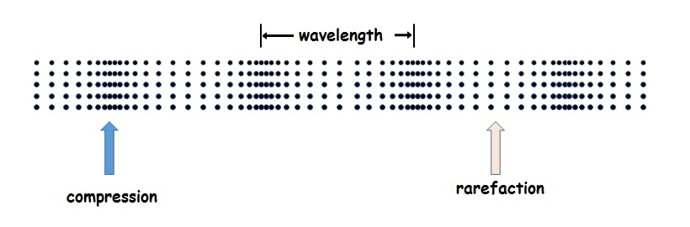
Figure 1 Compression and Rarefaction Diagram [5]

Sound Pressure and Sound Pressure Levels
As explained by Švec and Granqvist [6] sound pressure levels (SPL) quantify the perceived loudness of a sound and help estimate its acoustic energy. While sound pressure can be measured in Pascals (Pa), it is more commonly referenced in decibels. When sound pressure reaches 1 Pa, the SPL is approximately 94 dB because of the logarithmic relationship.

The Human Ear
Brownell and Alford [7] outline that the human ear detects pressure waves in the air, which vary in frequency and intensity. The outer ear collects sound and directs it to the eardrum, modifying the amplitude for better localisation. The middle ear amplifies sounds mechanically using the ossicles to transfer energy to the fluid-filled cochlea of the inner ear (Figure 2), where vibrations are converted into electrical signals by sensory hair cells.
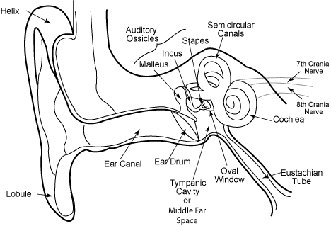
Figure 2 Diagram of the human ear [8]
The cochlea maps frequencies distributed along its length, with high-pitched sounds detected near the base (outer ear) and low-pitched sounds near the apex (inner ear), as shown in Figure 3.

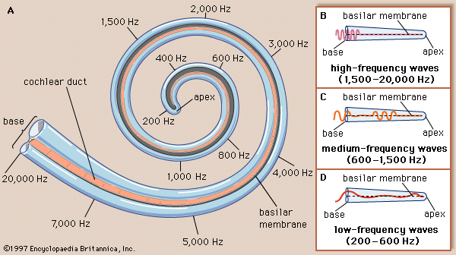
Figure 3 Cochlea Diagram [9]

Human Ear Sensitivity
The human hearing range, as specified by Pilhofer and Day in [10], spans roughly 16 Hz to 16 kHz. Dobie and Hemel [11] explain that the auditory system is most sensitive between 500 and 4000 Hz, and that natural age-related hearing loss affects higher frequencies first.

Calculating and Interpreting Average dB Levels

The Concept of Equivalent Continuous Sound Levels (Leq)
Equivalent continuous sound levels (Leq) are defined by Majidi et al. [12] as a “stable, uniform sound for a given period in a specific location with the same energy level as a non-uniform sound.” Leq represents the logarithmic average of sound pressure levels measured over time, combining varying sound levels into a single equivalent dB value that reflects total sound energy during that period.

Weighted Sound Levels (dBA, dBC)
According to Meyer-Bisch [13], frequencies below 500 Hz and above 6000 Hz are less likely to cause hearing damage. To account for this, A-weighted sound levels (dBA) apply a selective frequency curve during measurement. Another curve, C-weighting (dBC), is used for more moderate noise levels.

Challenges in Calculating Averages for Fluctuating Sound Levels

Sampling Intervals
Sampling intervals determine how often sound is recorded from the environment. Dewey et al. [14] compare sparse and continuous sampling. They note that continuous sampling captures short-lived changes more accurately, while sparse sampling risks missing sudden noise events. However, continuous sampling increases computational, and data processing demands, whereas sparse sampling is less demanding on system resources.

Data Buffering
Two main buffering methods are relevant to this project: circular buffering and double buffering. Rong et al. [15] describe circular buffering as a looped storage mechanism where data is written and read sequentially, with memory resetting automatically when full. This approach uses memory efficiently without needing manual clearing.
In [16], Sun and Yao discuss double buffering, which uses two alternating Direct Memory Access (DMA) buffers with one receiving new data while the other transfers to a FIFO queue. Once full, the buffers swap roles. This method reduces CPU load, lowers latency, and minimises packet loss by processing smaller data batches.
In this project, double buffering will be used on the microcontroller for incoming data handling, while circular buffering will support data storage within the software.

Windowing
Windowing, as described by Rasel et al. [17], involves dividing datasets into smaller, overlapping or non-overlapping sections to better identify patterns or trends. Window size determines how much data each section includes. In normal rectangular windowing, a window moves across the dataset, using the last value as the prediction label.
Flatten windowing simplifies datasets by removing all data points between the beginning and end of a window, followed by adjusting all values relative to the most recently known value. This acts as the base for each dimension, making the data easier for machine learning analysis. De-flattening restores the original range. Flatten windowing will likely be used during the FFT calculations in this project.

Time management
Bouma et al. [18] suggest that system timestamps can be used to construct file timelines. This concept applies to noise monitoring by recording the start time when sound is detected, allowing calculation of the active noise duration.

Noise Pollution
Deepak [19] classifies noise pollution as any excessive noise that harms or disrupts human activity. The Center for Hearing and Communication [20] lists normal conversation levels at around 60 dB.

Residential Settings
As noted by Drug and Gavat [21], residential noise pollution is mainly caused by cars and heavy vehicles.

Urban noise pollution
In [22], Danilevičius et al. explain that dense urban environments suffer major noise pollution from sources like power units, suspension systems, airflow-related noise, and especially tyre-road interactions, which dominate at speeds between 35 km/h and 120 km/h (~ 20-75 mph).

Sound levels in homes
Qzar [23] observed that household noise mainly comes from people and appliances, with living rooms experiencing the highest levels. Indoor noise also varies seasonally, averaging around 60 dB in summer due to appliances like air conditioners, and about 54 dB in winter.

Health Impacts of Excessive Noise Exposure

Hearing Loss and Safe Listening Levels
Hearing damage from noise exposure is cumulative and often goes unnoticed until it becomes advanced, as explained by Gilliver and Beach [24]. Shehabi et al. [25] add that excessive noise can also cause tinnitus and hyperacusis. Merijanti [26] identified that hearing loss most commonly affects the 3, 4, and 6 kHz frequency ranges.

Non-Auditory Health Effects
Excessive noise exposure can also lead to mental health problems such as anxiety, depression, anger, and agitation, as noted by Moroe and Mabaso [27]. In [28], Sarker et al. discovered that sleep disturbances could be caused by stress responses to noise. This was further supported by Pugh et al. [29] with potential cardiovascular issues leading to heightened discomfort.
Additionally, Kumari et al. [30] found that chronic noise exposure reduces productivity due to higher levels of annoyance, fatigue, and stress.

Recommended Exposure Limits
The World Health Organization (WHO) [31] recommends weekly limits such as 80 dB for 40 hours, 90 dB for 4 hours, and 100 dB for 20 minutes. As a reference, 100 dB is comparable to the volume of a hairdryer, meaning it should not be used for more than 20 minutes per week without hearing protection.
The National Institute for Occupational Safety and Health (NIOSH) [32] provides safe exposure durations based on an eight-hour workday, focusing on A-weighted noise exposure (dBA). Their guidelines, shown in Figure 4, indicate that for every 3 dB increase above 85 dB, the safe exposure time halves. This relates back to the logarithmic nature of SPL discussed in section “2.2.2 Sound Pressure and Sound Pressure Levels”.
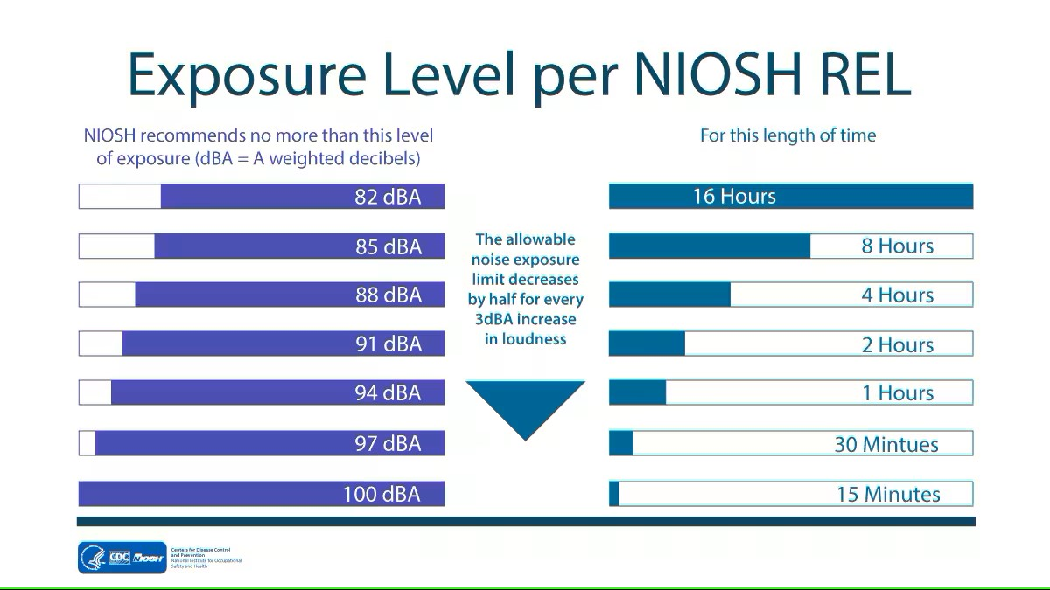
Figure 4 NIOSH Safe Exposure Levels [32]

Figure 5 shows London Ear Lab’s Safe Exposure Durations
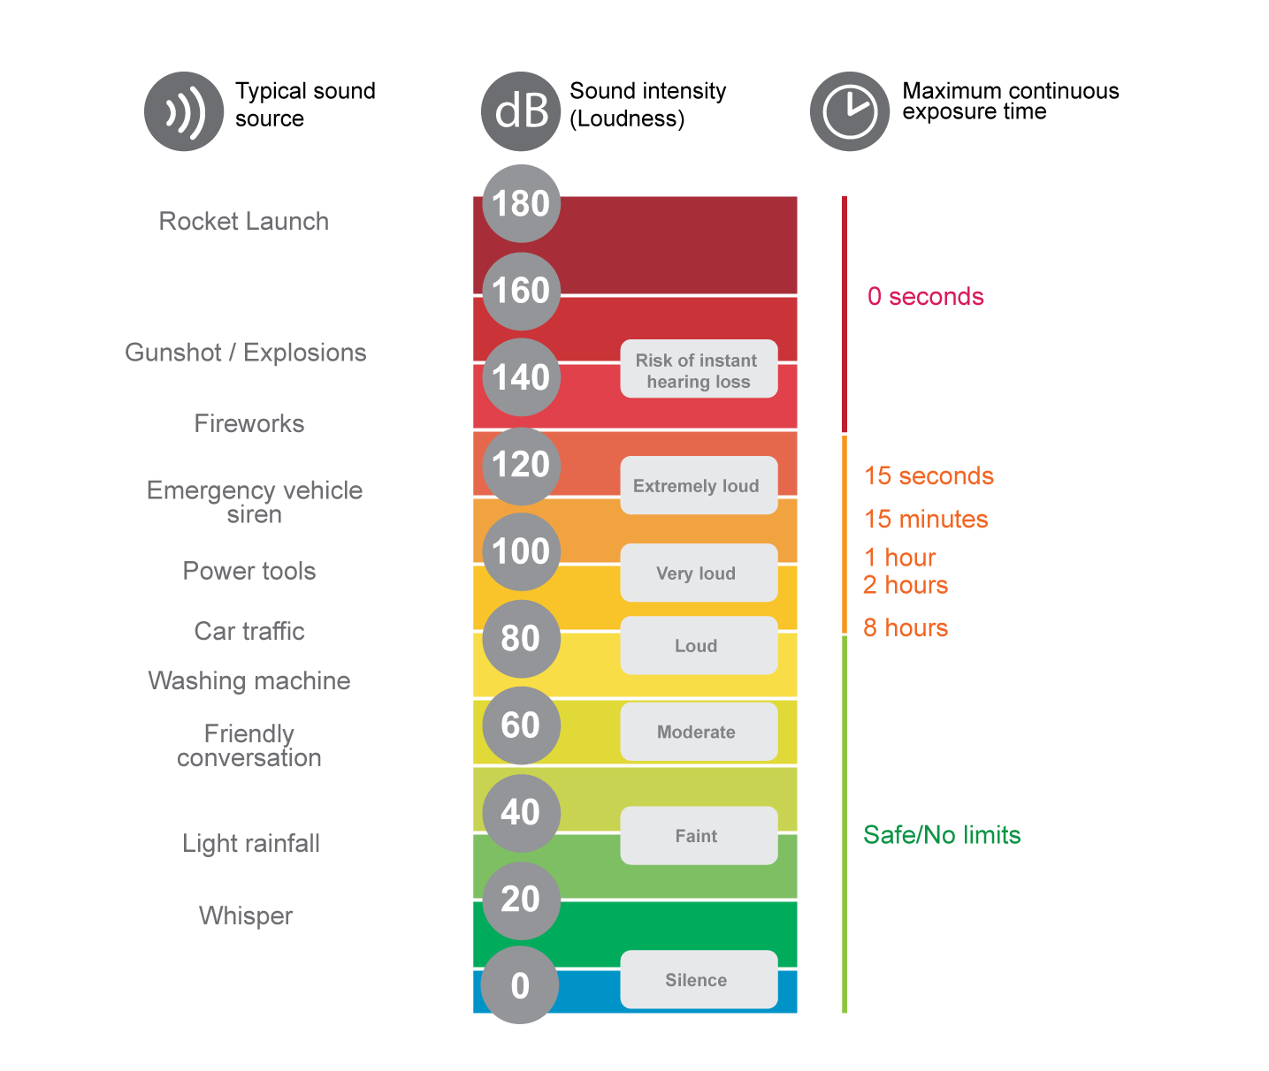
Figure 5 London Ear Lab’s Safe Exposure Durations [33]

Home Studios
Home studios have become increasingly popular. Carvalho [34] notes that personal computers with Digital Audio Workstation (DAW) software now offer individuals an affordable way to record music.

Rise of affordable audio production tools
According to Polk in [35], professional studios dominated music production before DAWs emerged in the 1970s, due to the high cost of recording equipment. While cheaper gear existed, it was often viewed as unprofessional. As technology improved, more accessible and cost-effective options became available. A major limitation of early systems was the inability to record tracks separately – studios had to capture all instruments simultaneously. DAWs introduced asynchronous multitracking, allowing users to record each instrument individually. As a result, large recording spaces were no longer necessary, enabling users to record music in small rooms – often bedrooms – using affordable gear such as computers and audio interfaces.

Non-Standard Acoustic Environments
Accurate noise monitoring can be difficult in untreated environments. However, this project’s device bypasses that issue by operating like body-worn monitors [36] [37], effectively collocating the user and monitor.

Noise Monitoring Technologies
Noise monitoring technologies measure environmental sound levels to assess hearing risks and ensure compliance with safety standards.

Microphones
Microphones and SPL meters convert acoustic signals into electrical signals, enabling accurate sound level analysis across different environments.

Condenser Microphones
In [38], Zawawi et al. explain that condenser microphones, also known as capacitive microphones, use a change in capacitance between fixed and movable plates to capture sound waves as seen in Figure 6. This process requires a bias voltage. Electret microphones – a common type of condenser microphone – maintain a permanent bias using electret materials. Their simple manufacturing, strong performance, and low cost have made electret microphones highly popular.
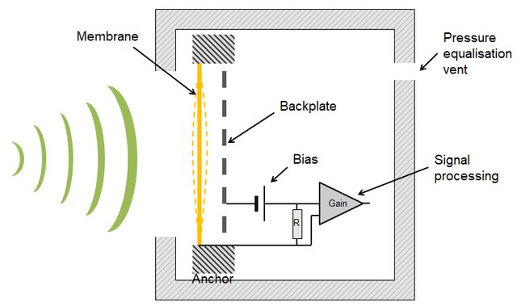
Figure 6 Schematic of a condenser microphone [39]

Dynamic microphones
Dynamic microphones, according to Huang and Shiu [40], use a diaphragm and coil within a magnetic field to generate voltage from sound vibrations. As shown in Figure 7, higher acoustic pressure is needed to move the coil, making dynamic microphones less effective for low-volume sounds but highly durable for louder or harsher environments.
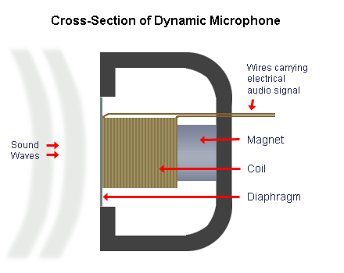
Figure 7 Cross-Section of Dynamic Microphone [41]

Wearable Devices and Consumer Electronics

Smartphones
Padilla‑Ortiz et al. [42] explored the potential of smartphones as noise monitoring tools. Many apps for iOS and Android can measure environmental noise levels, with most offering recalibration options. When correctly calibrated in controlled environments, the best-performing apps measured within 1 dBA of reference standards. However, achieving this level of accuracy without experts in a controlled setting remains challenging for most users.

Smartwatches
Smartwatches are capable of monitoring environmental noise levels, although Fischer et al. [43] observed that they typically underestimate readings by about 0.5 dBA – an acceptable margin for ambient conditions. Across 13 tested environments (ranging from 35 to 110 dBA), accuracy dropped slightly below 70 dBA and again at higher volumes around 90 dBA, though deviations remained minor and did not significantly affect overall averages.

Digital Signal Processing
Analogue Devices [44] explain Digital Signal Processing (DSP) converts real-world analogue inputs (audio, temperature, etc.) into digital signals, manipulating them mathematically through operations such as addition, subtraction, multiplication, and division.

In Noise Monitoring
Tan et al. [45] state that DSP in noise monitoring can be used to apply weighting (A, C, etc.) to the digital signals. This uses floating-point to improve system performance.

Real-Time Analysis of sound
In [46], Seitzer et al. explain that DSP involves processing audio signals with high-speed computations to evaluate spectral and psychoacoustic properties. DSP enables real-time calculation of masking thresholds, error analysis, and Noise to Mask Ratio (NMR) values.

Fast Fourier Transform for Frequency Analysis
Fast Fourier Transform (FFT) is a computational tool for analysing signals such as power spectra and filter simulations. Cochran et al. [47] describe FFT as an algorithm that calculates the Discrete Fourier Transform (DFT) faster and more efficiently by using iterative methods.

Algorithms for calculating equivalent continuous sound levels (Leq)
$$L_{eq,T}={10log}_{10}\left(\frac{1}{T}\int_{0}^{T}{\frac{{p(t)}^{2}}{p_{0}^{2}}}dt\right)$$
Equation 1 Equation for Equivalent Continuous Sound Pressure Level (Leq)
$$L_{Aeq,T}={10log}_{10}\left(\frac{1}{T}\int_{0}^{T}{\frac{{p_{A}(t)}^{2}}{p_{0}^{2}}}dt\right)$$
Equation 2 Equation for A-Weighted Equivalent Continuous Sound Pressure Level (LAeq)
$$ε_{x}=\sum_{n=0}^{N-1}{{|x\left[n\right]|}^{2}}=\frac{1}{N}\sum_{k=0}^{N-1}{{|X\left[k\right]|}^{2}}$$
Equation 3 Parseval’s Theorem (Time-Frequency Energy Relation)
$$R_{A}(f)=\frac{{12194}^{2}f^{4}}{\left(f^{2}+{20.6}^{2}\right)\sqrt{\left(f^{2}+{107.7}^{2}\right)\left(f^{2}+{737.9}^{2}\right)}(f^{2}+{12194}^{2})}$$
Equation 4 A-Weighting Equation
$$R_{A}(f)=\frac{{12200}^{2}f^{4}}{\left(f^{2}+{20.6}^{2}\right)\sqrt{\left(f^{2}+{107.7}^{2}\right)\left(f^{2}+{737.9}^{2}\right)}(f^{2}+{12220}^{2})}$$
Equation 5 Modified A-Weighting Equation (Resource-Constrained Approximation) [48]
$${\tilde{ε}}_{x}≈\frac{2}{N∙∆t}\sum_{k=0}^{N/2}{{|X_{A}\left[k\right]|}^{2}}$$
Equation 6 Modified Parseval’s Relation for A-Weighted Frequency Components [48]

Mariscal-Ramirez et al. [48] propose a frequency-domain-based algorithm that begins by sampling acoustic signals and converting them into digital form. FFT is used to extract the signal’s frequency components, with the Leq calculated as an initial step (1). A-Weighting is then applied, using the more efficient approximation (5) instead of the standard A-Weighting formula (4) to reduce processing demands. Rather than using traditional Parseval’s relation (3), the algorithm applies a modified version (6), optimised for devices with limited computational resources. Finally, the filtered frequency-domain data is converted into the A-weighted equivalent continuous sound pressure level (LAeq) (2) in dBA format.
$$f\left(k\right)=\frac{f_{s}∙k}{N}$$
Equation 7 Frequency Index to Frequency Conversion Formula
$$∆f=\frac{f_{s}}{N}$$
Equation 8 Frequency Resolution
$$N=f_{s}∙T_{w}$$
Equation 9 FFT Length (Relation Between Sampling Frequency and Window Time)
$$X_{A}\left[k\right]=A(∆f∙k)∙X[k]$$
Equation 10 Domain Filtering Equation
$$P_{x}≈\frac{ε_{x}}{T_{w}}$$
Equation 11 Time-Domain Power Approximation Equation
$$SPL\left(dBA\right)=10∙\log_{10}\left(P_{x}\right)+C$$
Equation 12 Approximate A-weighted SPL Equation (Power-Based Form)

In [49], Fernandez-Prieto et al. proposed another algorithm for resource-constrained devices. The process begins by applying the FFT (9) to convert sampled signals from the time domain into the frequency domain. Frequencies for each sample are calculated using (7), with frequency resolution determined by (8). An A-weighting filter (5) is applied to adjust the frequency components according to human hearing sensitivity. The total energy of the weighted components is then found using the modified Parseval’s relation (6), similar to the method used by Mariscal-Ramirez et al. [48]. The signal’s instantaneous average power is then calculated using (11), and finally, the dBA is obtained using (12).

Standards and Guidelines for Noise Monitoring Devices

International Electrotechnical Commission (IEC)
The International Electrotechnical Commission (IEC) [50] defines guidelines in 61672-1:2013 for sound monitoring devices. Devices are classified into three categories: Time-weighting, Integrating-averaging, and Integrating sound level meters. They must measure sounds within the human hearing range and be categorised as either Class 1 (higher precision) or Class 2 (lower precision) – seen in Table 1.
Nominal Frequency | Acceptable limits (dB)
Nominal Frequency | Class 1 | Class 2
16Hz | +2.5, -4.5 | +5.5, -∞
20Hz | ±2.5 | ±3.5
1kHz | ±1.1 | ±1.4
10kHz | +2.6, -3.6 | +5.6, -∞
16kHz | +3.5, -17.0 | +6.0, -∞
Table 1 Acceptable frequency limits for class 1 and 2 Sound level meters IEC [50]
Devices may be handheld or modular with analogue or digital processing and may include:
- Computers
- Recorders
- Printer
- Other components
They may function with or without an operator for continuous monitoring.

International Organization of Legal Metrology
The International Organization of Legal Metrology (OIML) provides two key recommendations: R 58 [51] for instantaneous sound pressure meters and R 88 [52] for average sound level meters (LAeq). R 58 requires compliance with IEC 651 for Class 1 and 2 monitors, covering maximum permissible errors (MPEs) and material quality. Devices must display:
- Manufacturer’s name or trademark
- Model designation and serial number
- Reference to IEC 651 indicated by the marking “IEC 651” (or an equivalent national standard)
- Class (1 or 2)
Instruction manuals must follow IEC 651, subclause 11.2, and non-user-accessible parts must be sealed. Devices must also allow for the attachment of verification marks. R 88 mirrors these requirements but references IEC 804 for average sound level meters, while still applying IEC 651 standards where relevant.

Future Developments in Noise Monitoring Technology and Artificial Intelligence
Emerging MEMS microphones and AI technologies are enabling smarter, real-time noise monitoring.

Microelectromechanical systems (MEMS)
The future of MEMS microphones is quite positive.
Griffin [53] explains that MEMS can be mass-produced at low unit costs ($5-$50) due to their manufacturing being the same as semiconductors, making large-scale system integration on a single chip feasible. Their small size and low cost allow for advanced measurement, control, and communication strategies that were previously impractical. MEMS merges sensing, actuation, computation, and communication into compact systems. Future MEMS devices are expected to monitor and respond to environmental conditions autonomously, potentially embedded within smart materials for real-time tracking of damage, strain, and noise exposure. In home studio or health contexts, this can extend to intelligent environments that track and respond to noise exposure in real-time.
Griffin [53] also notes the possible development for energy-harvesting MEMS, powered by vibrations, temperature, or light from their own environment. This development is crucial for creating wearable or passive monitoring devices. As wireless sensing grows, wireless MEMS systems are expected to improve in reliability and precision, enabling remote noise exposure tracking without user intervention.

AI and Machine Learning for Sound Analysis
Artificial Intelligence and Machine Learning could potentially be used for sound analysis in the future.

AI in Sound Monitoring
Artificial intelligence (AI) has seen increasing use in sound monitoring, particularly in recognising patterns in audio signals. According to García-Vega et al. [54], AI methods such as support vector machines (SVMs), neural networks (NNs), and random forests have been applied in classifying respiratory sounds for early disease detection which offers a non-invasive, cost-effective, and automated solution. While García-Vega et al. [54] focused on medical applications, similar techniques could be adapted to home studio environments to extract features from user audio exposure patterns and issue more accurate noise warnings.

Real-Time Sound Analysis
Jose and Mayan [55] demonstrate real-time sound analysis using AI to detect bird vocalisations in agricultural settings. Their system employs a Long Short-Term Memory (LSTM) neural network trained on Mel-Frequency Cepstral Coefficients (MFCC) and Mel spectrogram features, which were extracted from audio recordings. Incoming audio is pre-processed similarly to the training phase before passing through the LSTM to detect parakeet calls. If a detection exceeds a set threshold, the system automatically triggers a deterrent sound. The approach achieved an accuracy of 84.38%, even in noisy outdoor environments, showing the potential for machine learning in autonomous real-time sound response systems.

Literature Conclusion
This literature review highlights the complexity of accurately measuring and interpreting sound, especially in non-standard acoustic environments. Metrics like SPL and Leq are essential for quantifying noise exposure, but capturing real-time fluctuations demands advanced methods like continuous sampling, buffering strategies, and FFT analysis. The integration of AI and machine learning for real-time sound detection shows promise in automated monitoring systems. With the rise of accessible recording technology and MEMS microphones, as well as growing concern over the health impacts of noise pollution, there is a clear need for intelligent, efficient, and context-aware noise monitoring tools. These insights will guide the development of a system capable of raising awareness of harmful noise exposure in home studio environments.

Methodology

Research Methodology
This chapter outlines the planning, development, and evaluation methods used to create the noise monitoring system. It includes the philosophical approach, research strategy, potential risks and limitations, ethical considerations, and methods used to ensure the system’s reliability, validity, and effectiveness.

Philosophy
The project follows a positivist philosophy, as it relies on objective, quantifiable data – specifically environmental sound levels and exposure durations. This allows for direct comparison to established health standards (WHO, NIOSH, etc.). A secondary interpretivist element is included through user feedback on design and usability, ensuring that the device meets real-world needs.

Approach
A mixed-methods approach is used. The deductive method draws from known standards for safe noise exposure to guide hardware and software design. To address user-centred concerns, inductive reasoning is also applied through qualitative feedback, ensuring usability is considered alongside technical performance.

Strategies
Three core strategies guide the project:

Literature Review
The literature review guided the system’s requirements, covering:
- Safe exposure durations and hearing damage thresholds
- Existing sound monitoring devices
- Component specification selection
- Sound calibration and data handling

Software Development
The core aspect of software development focuses on:
- Writing microcontroller code to capture and transfer sound data.
- Building the Python-based desktop application to process and display this data
- Creating the user interface to show real-time noise levels and alerts.

Case Study
A real-world evaluation in home studios will assess system performance and usability, checking:
- Accurate decibel readings against known references
- Correct alert triggering when exposure thresholds are exceeded
- How effectively users are informed about noise exposure risks

Risks and Limitations

Risks
- Hardware failure (microphone/microcontroller/etc.) may delay development. Mitigated by early assembly and pre-emptive spare parts to avoid shipping delays.
- Time constraints may affect progress. Managed through staged planning and frequent testing.
- Inaccurate readings could compromise results. Prevented by comparing against a calibrated sound level meter and implementing a user-accessible calibration feature.

Limitations
- Optimised for small-scale home studios but not intended for industrial use.
- Dependent on computer with no standalone or mobile use – an intentional simplification.
- Targeted but limited number of testing users due to time constraints, with focus on musicians and home studio users.

Ethical Issues
No personal data will be collected, and users will not be asked to expose themselves to harmful sound levels beyond normal usage. However, developer safety during testing is a concern. To reduce risk, the developer will:
- Limit exposure time at high volumes
- Use hearing protection
- Maintain safe testing distances
- Follow the same safety standards promoted by the system
By adhering to these precautions, ethical risks during development are minimised.

Validity, Reliability, and Generalisability

Validity
The device directly addresses the project aim – measuring sound levels and alerting users when exposure becomes dangerous. It will be affordable, compact, and aligned with real-world safety standards.

Reliability
Consistency is ensured through the use of readily available hardware and reproducible code. Each software feature is tested individually using Feature-Driven Development before integration.

Generalisability
While designed for home studios, the device can also function in similar small-scale environments like music classrooms or podcasting rooms. Results may vary slightly, but the system allows calibration to account for different conditions.

Data Collection and Evaluation

Data Collection
Quantitative data will include:
- Real-time noise levels from the microphone
- Average noise exposure and remaining safe duration
- Comparison to a professional decibel meter
Qualitative data will be gathered via the System Usability Scale (SUS) to assess user satisfaction and ease of use. A small number of testers will complete this as part of the case study.

Data Evaluation
- Sound level accuracy will be verified against a calibrated reader.
- Calculated safe exposure durations will be compared to limits set by WHO, NIOSH, etc.
- SUS scores will be used to evaluate usability – showing strengths and areas for improvement.
- If hardware data cannot be collected, simulated data will be used to test the system’s calculations and feedback features.

Development Methodology

Software Development
A Feature-Driven Development approach will be used, where each feature is developed and tested individually before progressing to the next stage. This ensures stability and consistent progress throughout development.

Resources
The hardware and software resources are listed in Table 2:
Category | Resources
Hardware Resource | ESP32 Microcontroller  INMP441 Microphone Module  Computer (Windows OS)  Soldering equipment  USB cable  Breadboard and jumper wires
Software Resource | Arduino IDE version 2.3.4 (latest)  Python version 3.13.2  PyQt6  PySerial  NumPy  INNO Setup Compiler  Board managers in Arduino  - Arduino AVR Boards by Arduino  - ESP32 Boards by Espressif Systems  Board model specific board managers [56] [57]
Table 2 Resources

Human Resources
Five users will test the device’s usability by completing a short feedback form based on the System Usability Scale.

Design, Implementation and Analysis

Project Requirements
This chapter presents the design decisions, system architecture, and implementation process of the noise monitoring device. It outlines how system requirements were established, the reasoning behind design choices, and how the software and hardware were developed. It details the models, diagrams, and interface concepts that guided development.

MoSCoW Requirements
The project was guided by a combination of functional and non-functional requirements, established through the initial literature research and personal insight into the needs of musicians and home studio users. These can be seen in Table 3:
Priority | Features
Must Have | Accurate Real-time noise measurement  Safe exposure alerts  Average noise level tracking  Legal disclaimer display  Compact size  Affordable price
Should Have | Display of:  - Current noise levels  - Average noise levels  - Safe remaining duration  - Session duration  Visual and audio alerts  Microphone calibration feature  Easy computer setup  User-friendly interface
Could Have | Adjustable thresholds for hearing protection  Customisable notifications  Noise exposure logging
Won’t Have | Standalone notification functionality  Integration with external apps  Compensation for acoustic treatment  Tracking individual noise sources  Visual danger indicators (LEDs)  Multiple mounting options  Haptic feedback or wearable alerts
Table 3 MoSCoW Requirements

Determination of Requirements
Requirements were identified based on the safe noise exposure levels research and existing sound-monitoring tools. The goal for the device’s creation was to create a functional and compact solution for musicians and home studio users.

Requirement Evolution
The core requirements remained consistent throughout the project. Minor refinements were made to improve clarity or feasibility, but the overall vision and functionality did not change significantly over time.

System Design Decisions
This section outlines the main design choices made during development, along with justifications and reflections on possible alternative solutions. Decisions were based on the goals of affordability, simplicity, monitoring accuracy, and usability within a home studio environment.

Computer-Based System
The system was designed to deliver all notifications via the user’s computer, keeping the physical device extremely simple – limited to a microphone and microcontroller – avoiding the need for additional components like screens, speakers, or buzzers. Reducing hardware complexity helped minimise both cost and size.
As home studios require a computer for music recording, it made sense to use this computer for notifications. These alerts would be played through studio speakers, making them more noticeable than a sound generated directly by the device – which could be masked by background music. Although notification sounds might occasionally interfere with recording, this could be addressed in future versions by allowing users to toggle the sound alert on or off.

Affordability
Many sound-monitoring solutions are expensive and bulky, making them inaccessible to smaller studios or independent musicians. Devices like the SoundEar II Noise Activated Warning Sign [58] can be upwards of £450. Prioritising affordability ensures the device can reach a wider audience and protect more users’ hearing. A device is more likely to remain in regular use if it takes up less space.

The cost of creating the device came in at £17.97:
- Casing - £1.63
- Six wires - £0.35
  - £6.99 for a pack of 120
- Mic - £4.99
- Controller - £11.00

Size
The device must be of minimal size. The final design had dimensions of 71 x 64 x 51mm – compact enough to sit on a user’s desk.

Hardware and Software Choices
The INMP441 MEMS microphone was selected for its small size, low power consumption, and low cost. As the device only needs to measure dB levels, a high-end mic was unnecessary. A microcontroller with built-in I2S, ESP32 support, and USB communication was required, and a low-cost ESP32-based board met all project needs.
The Arduino IDE was chosen for microcontroller programming due to its strong community support and compatibility. Python was used for the computer software due to its ease of development, and suitability for a GUI-based system. Complex languages like C++ were unnecessary and would have increased development time.

Alternative Designs

Other Notification Methods
Sound-based alerts from the device were avoided for the same reason computer-based alerts were preferred – sounds from the device might be drowned out by studio music. LED indicators were considered but were omitted to keep the prototype simple. A screen on the device was ruled out due to cost, size, and development time. Mobile app integration was considered but was impractical at this stage due to requiring additional resources for testing mobile applications, and the redundancy of the target environment already having a computer present.

Alternative Microphones
Other MEMS microphones were considered but typically proved to be larger or more expensive without offering meaningful advantages.

Wireless vs. Wired Connection
Wireless connections like Bluetooth were avoided to simplify development and prevent compatibility issues. Bluetooth risks conflicting with users’ Bluetooth speakers or other studio equipment. A USB cable handles power and communication, eliminating the need for batteries and reducing system cost and complexity.

Accuracy, Reliability, and Ease of Use

Accuracy
Microphone readings were compared against a dedicated decibel meter to calibrate the device resulting in a +3.5 dB adjustment. Teachman [59] also found an INMP441 they used to be ± 3 dB, so this is not uncommon. This extra 0.5 dB variance might be due to the device casing – which likely blocks some level of sound from entering the microphone. The software includes a manual calibration setting, allowing users to adjust the dB offset as needed.

Reliability
Reliability is supported by minimising system complexity. Fewer components and direct USB communication reduced potential points of failure. Keeping processing tasks computer-based allowed for easier debugging, updates, and future maintenance.

Ease of Use
The system is designed to be plug-and-play, requiring only calibration after the initial software installation and CH340 driver. The application was compiled into the installer executable using INNO Setup, with a note for users to install CH340 drivers for USB communication. This simplifies installation and usage for users, increasing ease of use. The software interface is simple, clearly presenting all key information without overwhelming the user. By avoiding unnecessary features, the system remains intuitive and focused on its primary function.

System Models and Interfaces
To support the design and development of the system, several models and interface sketches were created. These models helped to visualise functionality, structure the system, and ensure that both user and technical requirements were met throughout the development process.

Use Case Diagrams
These were used to identify and define user interaction with the system.
The main use cases include:
- Starting the program
- Reading real-time noise levels
- Receiving alerts when safe duration is exceeded
- Viewing the legal disclaimer
- Adjusting calibration settings
These diagrams helped clarify system scope and ensure all essential user interactions were captured. See Appendix 9.1 for use case diagrams.

Block Diagram
The block diagram (Figure 8) shows the relationship between the microphone, microcontroller, computer, and software interface. It illustrates data flow through the system, from sound input to the computer-based display and notification.
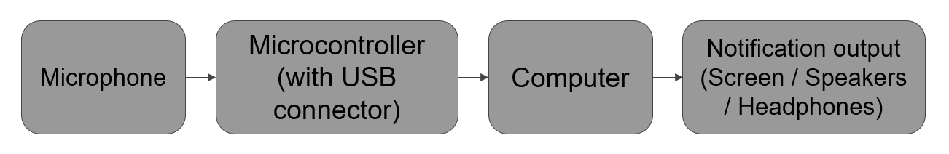
Figure 8 Block Diagram

Flowchart
A flowchart (Figure 9) was created to map the system’s logic, especially data processing and alerts. It shows how the program displays the legal disclaimer, captures live input, displays noise levels, checks against exposure limits, and triggers alerts. This helped define the software’s internal logic during development.
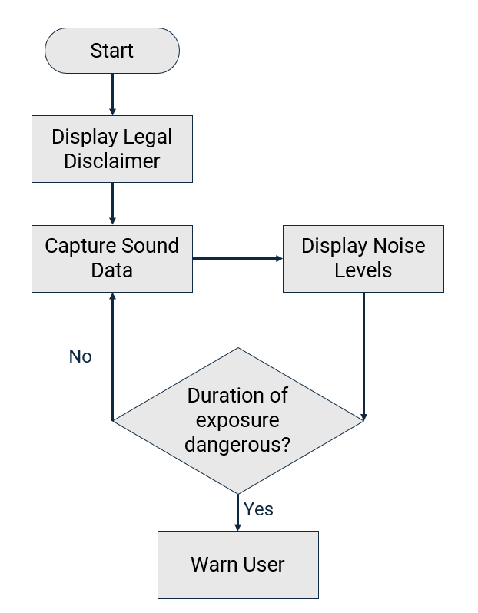
Figure 9 Flowchart

Wireframe and Interface Design
A wireframe was made to plan the user interface layout before development. It focused on simplicity and clarity, reflecting the goal of intuitive and user-friendly software.
The layout includes the:
- Legal Disclaimer shown at the start
- Current noise level
- Average noise level since program start
- Time since monitoring began
- Remaining safe duration at current levels
- Calibration button/menu
The wireframes helped ensure the interface remained focused on the most relevant and useful information. The main display wireframe can be seen in Figure 10 with the final outcome in Figure 11. The other wireframes can be found in Appendix 9.2.
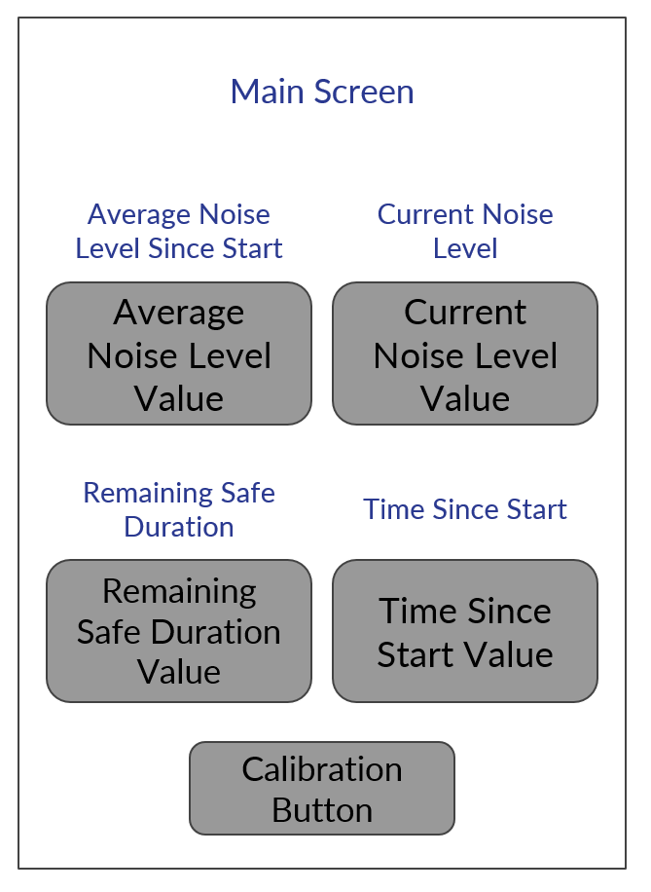
Figure 10 Main Wireframe
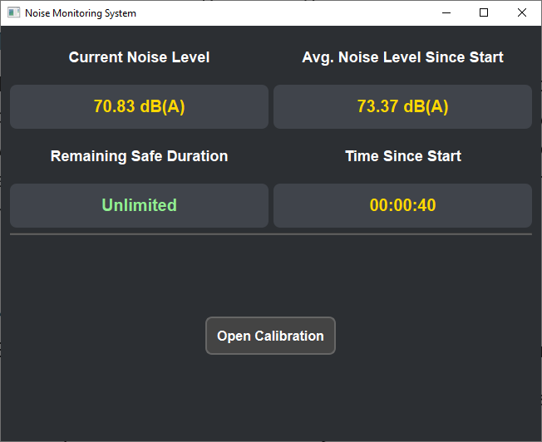
Figure 11 Final Main Screen

Digital Model
Digital models of the device were created to explore form factor and usability. These helped confirm that the device would be compact and unobtrusive, suitable for a home studio desk. Modelling also helped determine optimal microphone placement and enclosure design. Two models were created for the device’s casing. The original design seen in Appendix 9.3, was overly complicated, and didn’t properly account for the small size of some casing parts. This caused issues during 3D printing – removing supports damaged critical sections. This led to the redesign seen in Figure 12 and Figure 13, which functioned better than the original with fewer small pieces, and a more efficient sound entry path.
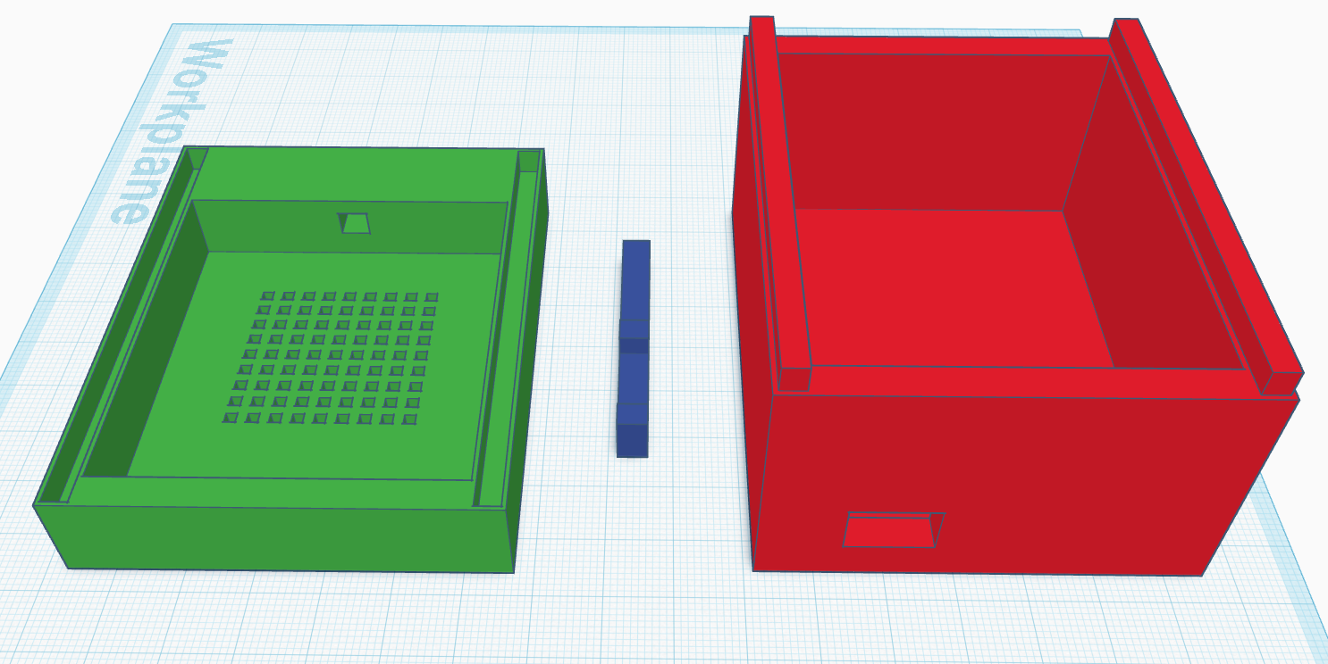
Figure 12 Final Open Design
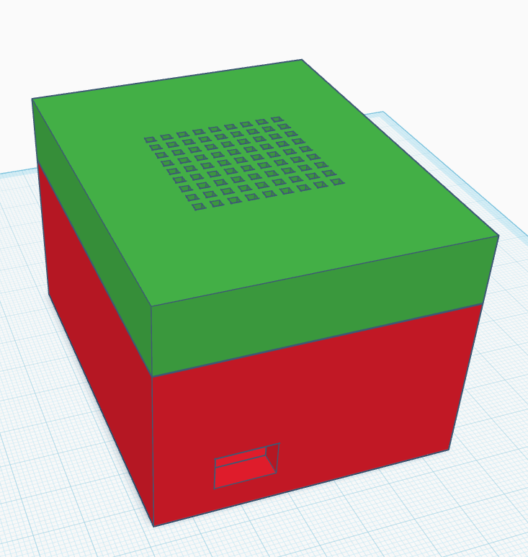
Figure 13 Final Closed Design
The final, printed model can be seen in Figure 14 and Figure 15, with the first, discarded model seen in Appendix 9.4.
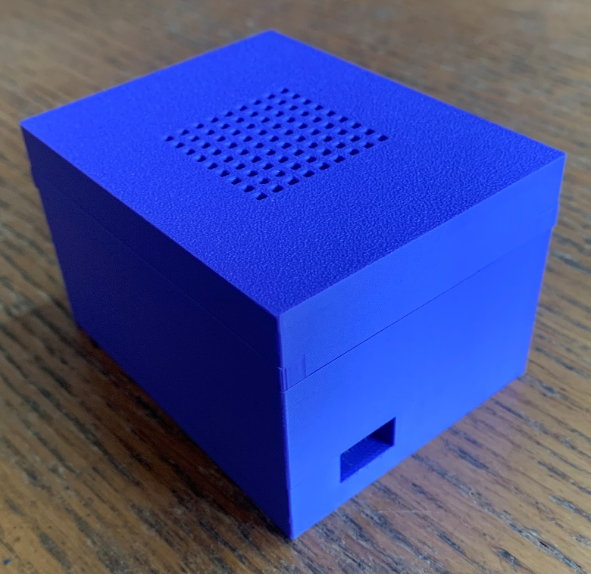
Figure 14 Final Casing Closed
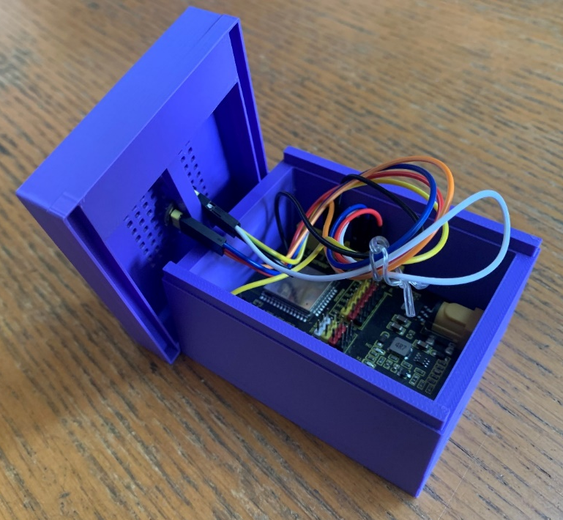
Figure 15 Final Casing Open

Figure 16 shows damage to one of the first design’s parts. This issue is what sparked the need for a redesign.
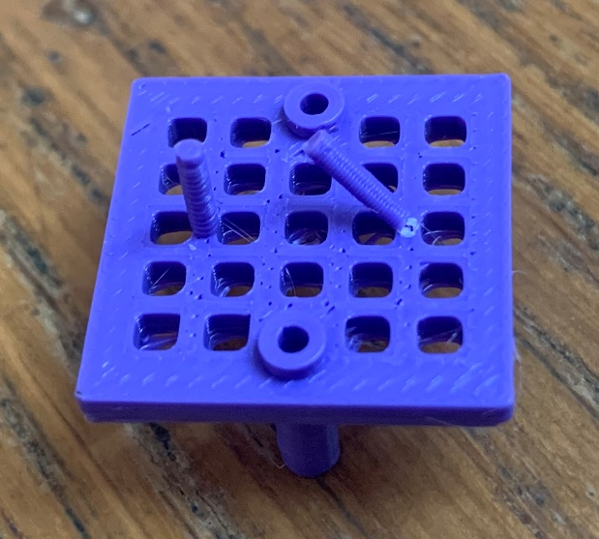
Figure 16 Broken Piece

Implementation Details
This section describes how the system was implemented, including the technologies used, chosen development methodology, and the main challenges encountered during the development process.

Technologies Used
The technologies used for the project are outlined in section “3.3 Resources”.

Software Development
The project followed a Feature-Driven Development approach. Features were implemented incrementally – small sections of code were written and verified before moving to the next task. Development began with hardware setup and testing, followed by progressively building the software in Python to receive, process, and display the incoming sound data.

Development and Coding Challenges

Hardware Setup
A major early issue occurred with the microphone failing to produce valid data. Multiple components (microphones, breadboards, and wires) were tested without success. It was ultimately discovered with help from lecturer Stephen Mosey that MEMS microphones require full soldering to function properly – a critical insight that resolved the problem.

Data Handling and Serial Communication
Early testing involved storing received data to a .csv file rather than viewing it live. The recorded sound data was then plotted into Figure 17, allowing basic verification that louder sounds registered higher values than quieter sounds, even though specific dB accuracy was not yet tested.
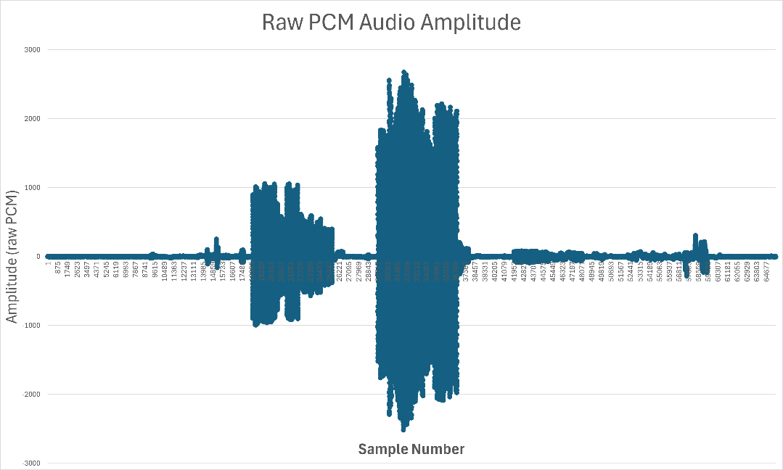
Figure 17 Raw PCM Audio Graph
A key issue arose when the Arduino IDE and PyCharm both attempted to access the same COM port (COM5) simultaneously. This conflict prevented the latest program from accessing the port. This issue was resolved by ensuring that only one application was running at a time. Another issue involving occupancy of the COM port arose – different classes within the same python application were also unable to access the port simultaneously. This was resolved in Figure 18 by ensuring only the ReadFromESP class could access the port.
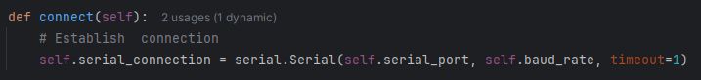
Figure 18 ReadFromESP Connection Code
Additionally, COM port numbers changed depending on which USB port was used. To address this, code was implemented (Figure 19) to automatically detect and use the port labelled as “Arduino”, “CH340”, or “ESP32”, defaulting to COM5 if no match was found.
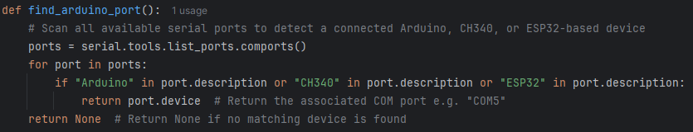
Figure 19 Finding the COM port

UI Performance and Data Sync
The GUI initially failed to update frequently enough, so the update interval was shortened for better responsiveness.
Crashes sometimes occurred due to invalid or misaligned data. After debugging, it was found that the code read 2048 bytes expecting both data and marker, when the correct total was 2050 bytes (2048 data + 2-byte marker). The program was then set to read a chunk of 4096 bytes per attempt and look for the sync marker (b’\xCD\xAB’) seen in Figure 20 within that chunk to align the sound data correctly.
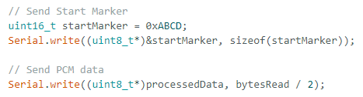
Figure 20 ESP32 Code for sending marker and data
Figure 21 shows the system retries until a valid connection is made.
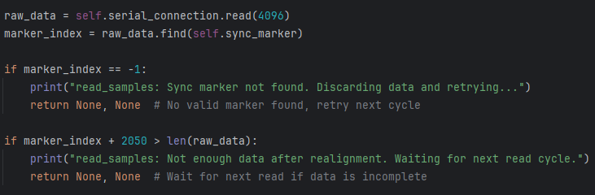
Figure 21 Bytes read and connection

Cross-System Compatibility
During testing on a laptop, the program initially failed to run. It was initially thought to be due to the variance in baud rate between different ports (the laptop USB ports being a lower spec than the PC). After rechecking to ensure that all packages were installed, it was found that Python’s pyserial package had encountered an issue when being installed on the laptop and the issue was resolved by reinstalling the package.

Threading and Frequency Analysis
FFT and frequency analysis caused GUI thread conflicts which resulted in the program crashing whilst trying to display or compute frequency data. The solution (Figure 22) was to offload sample reading to a separate thread and use QTimer for safe, scheduled GUI updates, preventing crashes caused by unhandled while True loops.
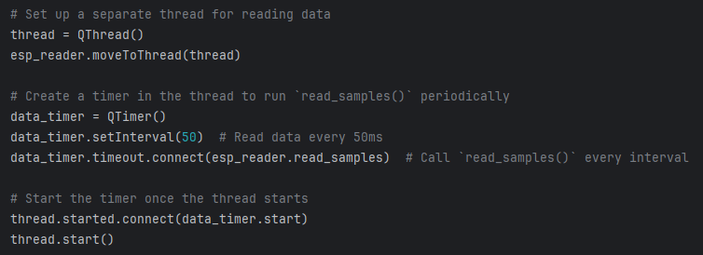
Figure 22 Thread Sample Reading

A-Weighting Adjustments
A-weighting was implemented with adjustments to Parseval’s theorem [48], which used a simplified calculation and offset calibration to a different calculation. This change seen in Figure 23, was necessary as the original calculation was causing incorrect dB readings, with values being over 100 dB higher than expected.

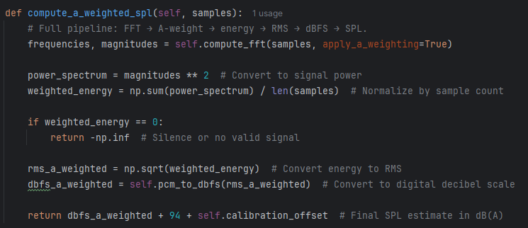
Figure 23 A-Weighting Calculation

Leq Averaging and Responsiveness
Rolling Leq averaging was implemented to make average dB values more responsive to real-time change. Leq decay was set at 0.998 ensuring the most recent sound levels had a higher weighting than earlier ones, as seen in Figure 24.
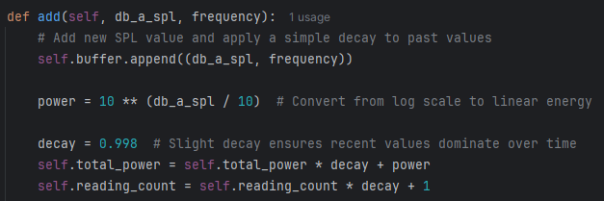
Figure 24 Leq Decay

Exposure Duration Algorithm
Following NIOSH guidelines [32], the algorithm in Figure 25 was created to calculate safe exposure durations based on dBA increments, starting from a base of 85 dBA and adjusting for every 3 dB increase.
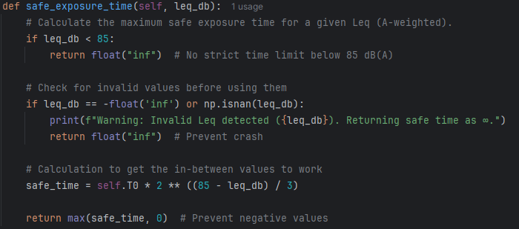
Figure 25 dBA Algorithm

Sound Alerts
Sound alerts were implemented (Figure 26) successfully after correctly assigning file paths relative to the code location, allowing alert sounds to be triggered when thresholds were crossed. 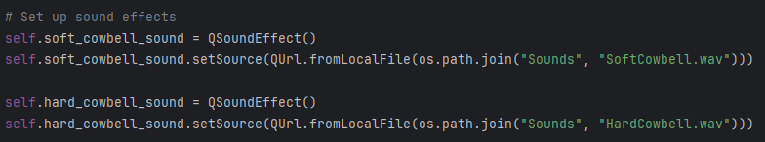
Figure 26 Sound Alerts

Testing Strategy
Testing was a critical part of this project which ensured the system was accurate, reliable, and usable in a real-world home studio environment. The system was tested incrementally as each component was developed, with more comprehensive testing carried out after.

Testing Goals
Testing was carried out to verify the accuracy of the microphone’s readings and the transmitted data. It confirmed that the alert system functioned correctly when safe duration limits were exceeded and that the interface was clear, responsive, and displayed the correct information. It also evaluated how the system performed in realistic home and studio environments.

Unit Testing
Each major system component was tested independently during development:
- Microphone readings: Data from the INMP441 was written to a CSV file and plotted to confirm expected behaviour.
- ESP32 to PC communication: Connection and transmission were confirmed by logging data to a file and visualising it, as shown previously in Figure 17.
- Application data reception: Live readings were displayed in the console to confirm incoming data integrity.
- Temporary data storage: Data buffers were checked by outputting stored values to the console.
- Average calculation: Values were monitored to ensure that the average increased/decreased as expected with time.
- User Interface: Each element (noise levels, session timer, etc.) was confirmed to update in real-time, displaying accurate values.

Integration Testing
The full system was tested as a complete package – from sound input through to visual and audio alerts. Components such as microphone accuracy, serial communication, data processing, and UI updates were initially tested in isolation, then the fully integrated system was tested through realistic scenarios.
One major test involved extended high-volume usage with the goal to observe how the device performed in consistently loud environments and with prolonged use. The test was conducted during a live 90-minute rehearsal with a four-piece metal band in a small studio environment, with average volumes reaching approximately 100 dBA. The band played intermittently simulating dynamic changes in real-world studio noise levels.
During this test, it was observed that the system reported an unlimited safe remaining duration, despite the clearly loud environment. This indicated that the average dB level was being significantly underestimated by the system.
To diagnose the issue, the system was re-tested in quieter environments and compared again against a calibrated decibel reader. It was discovered that ambient room levels had not been properly verified during initial testing; previous calibration had only included active noise readings at 70 dBA and above. In a quiet room (~55-60 dBA), the device reported unrealistically low values (25-30 dBA), which significantly skewed the average calculation observed during the session.
Upon reviewing the INMP441 microphone documentation, it was found that the mic had a high signal-to-noise ratio (SNR) of 61 dBA, meaning it could not reliably measure sounds below 60 dBA due to internal noise. To compensate, the software was updated to mark any readings below 60 dBA as 59 dBA (Figure 27). This approach ensures that the average is not disproportionately affected by artificially low input values.
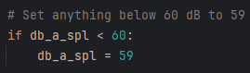
Figure 27 60 dBA Lower Limit
A follow-up test under the same high-noise conditions showed that the device now more accurately calculated safe exposure times. While this solution may slightly underestimate the safe duration in very quiet environments, it was judged that this outcome is preferable to the alternative of overestimating and failing to provide necessary warnings. This limitation could likely be addressed with a more expensive and higher quality microphone.

Acceptance Testing
Final acceptance testing verified that the project met all core functional and non-functional requirements outlined in section “4.1.1 MoSCoW Requirements”. Testing was conducted in both home studio and professional studio environments, with the system passing all targeted outcomes.

Testing

Project Testing
This chapter outlines the methods used to plan, develop, and evaluate the noise monitoring system. It covers the research approach, project strategies, potential risks, limitations, and ethical considerations. It also details how data was collected and evaluated to determine system effectiveness.

Calibration Testing
Calibration testing compared the device’s sound measurements to an official sound level meter. The initial offset of +3.5db was calculated before the hardware was installed into the casing, so further testing was needed to check for any impact from the enclosure. Tests were performed at a frequency of 2000hz, and the results can be seen in Table 4:
Sound Level Meter | This Device | Adjustment Needed
60 | <60 | Unknown
70 | 68 | +2
80 | 78 | +2
90 | 89 | +1
100 | 98 | +2
Table 4 Initial Decibel Test
This shows an average underestimation of around 1.6 dB for the device. Therefore, the casing has reduced the incoming sound by roughly 1.5 dB. The software was adjusted to increase the initial +3.5 dB offset to +5 dB to balance this out. After increasing the offset, the test was re-performed, and the results can be seen in Table 5:
Sound Level Meter (dB) | This Device (dB) | Adjustment Needed (dB)
60 | <60 | Unknown
70 | 70 | 0
80 | 79 | +1
90 | 90 | 0
100 | 100 | 0
Table 5 Final Decibel Test
The remaining variance was small enough that no further calibration changes were necessary.

Longevity Testing
To check stability over long sessions, the device was left running for over two hours. During this time the device functioned correctly without crashes or errors, confirming the system is reliable for extended use.

Rapid Change Testing
A test was conducted to assess the device’s responsiveness to rapid changes in sound levels. Ten claps were performed at random intervals near the device in an environment under 60 dBA, ensuring the clap would be clearly audible. Out of these Ten claps, only four appeared to be registering on the device – showing an increase in current noise level.
This suggests one of two possibilities; either the device isn’t transmitting data frequently enough to the computer for the sound to be logged, or the sound is happening between update ticks to the user interface. It is more likely that the issue is with the update frequency of the UI, rather than the frequency of data capture. If so, reducing the time between UI updates could improve responsiveness.
If the data reading frequency is the cause, several changes could be explored:
- Increasing the amount of data transmitted per send
- Implementing multiple threads to handle data receiving, reading, and storage
- Researching baud and other transmission rates across USB devices to determine if faster methods of data transfer are possible
- Offloading some data processing to the ESP32, pre-sanitising it before transmission
Further testing would need to be performed, researching and trialling these methods to discover a potential fix. However, this issue does not appear to affect the average noise level, which is the more significant value – either because missed sounds are too brief to affect the average, or because the issue is the UI update frequency.

User Testing
User testing was carried out to assess the usability of the device.

Test Protocol
After verifying sound level accuracy, testing progressed to user trials. Five users were given the device and software installer and asked to use it independently, while the researcher observed. Each user signed a consent form seen in Appendix 9.6 describing the purpose of the study, the voluntary nature of participation, the absence of personal data collection, and that they should not expose themselves to noise levels beyond what they would normally encounter. Users were instructed to use the device naturally, without guidance of placement.

Testing Observations
Several key observations were made during testing. One tester placed the device in front of their desk speakers and played music. The volume registered next to the speaker was noted at around 85 dBA. The tester questioned whether desk vibrations were affecting readings, so a folded towel was placed under the device and measurements were repeated. No noticeable difference was observed.
The tester then compared readings by moving the device closer to their ear, where sound levels dropped by approximately 20 dBA (around 65 dBA compared to 85 dBA on the desk). This significant difference highlighted how distance affects sound readings.
To address this, research would need to be carried out to determine how distance from a source affects sound levels detected. The device would need to be configured so that the user inputs the distance they are from the device in order to apply an automatic dBA offset. This would better represent the sound exposure at the user’s actual position.

User Feedback
To analyse user feedback, the System Usability Scale (SUS) was used. Each user answered the same ten questions, rating them from “Strongly Disagree” to “Strongly Agree”. Each user was scored in line with the SUS method and the total averaged to provide a score of 89.5. This score reflects very positively on the system, being over the 80.3 industry standard [60] for an “A” grade. Figure 28 shows the SUS score boundaries indicating the device’s score puts it just below the “Excellent” category.
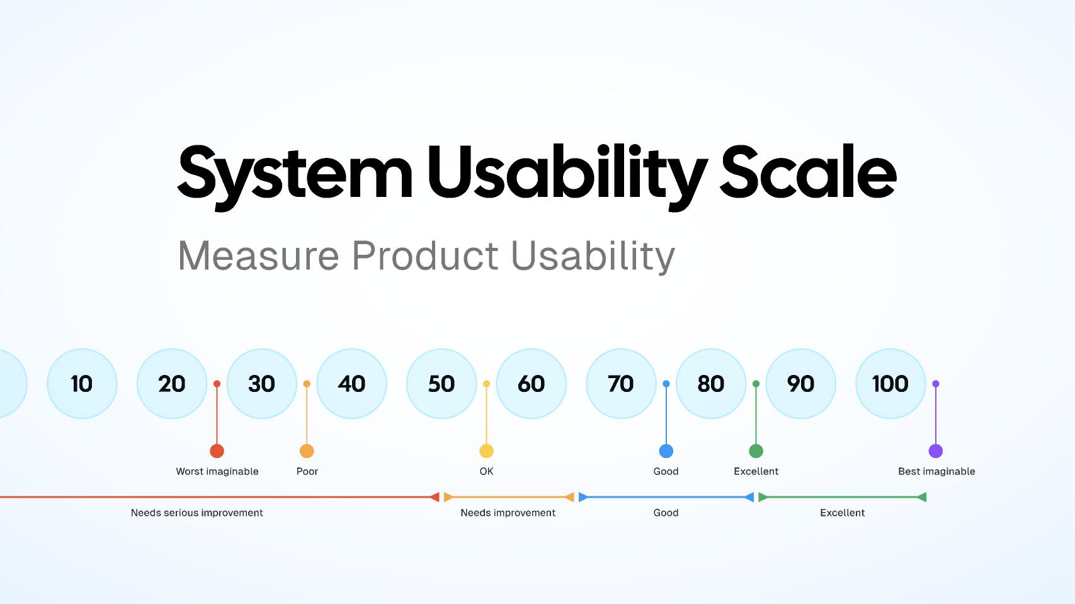
Figure 28 System Usability Scale [61]
The highest average scoring SUS questions were:
- Question 3 – “I though the system was easy to use”
- Question 5 – “I found the various functions in this system were well integrated”
Both received scores of 3.8.
The lowest average scoring question was:
- Question 1 – “I think that I would like to use this system frequently”
Question 1 scored an average of 3.2.
These results can be seen in Figure 29.
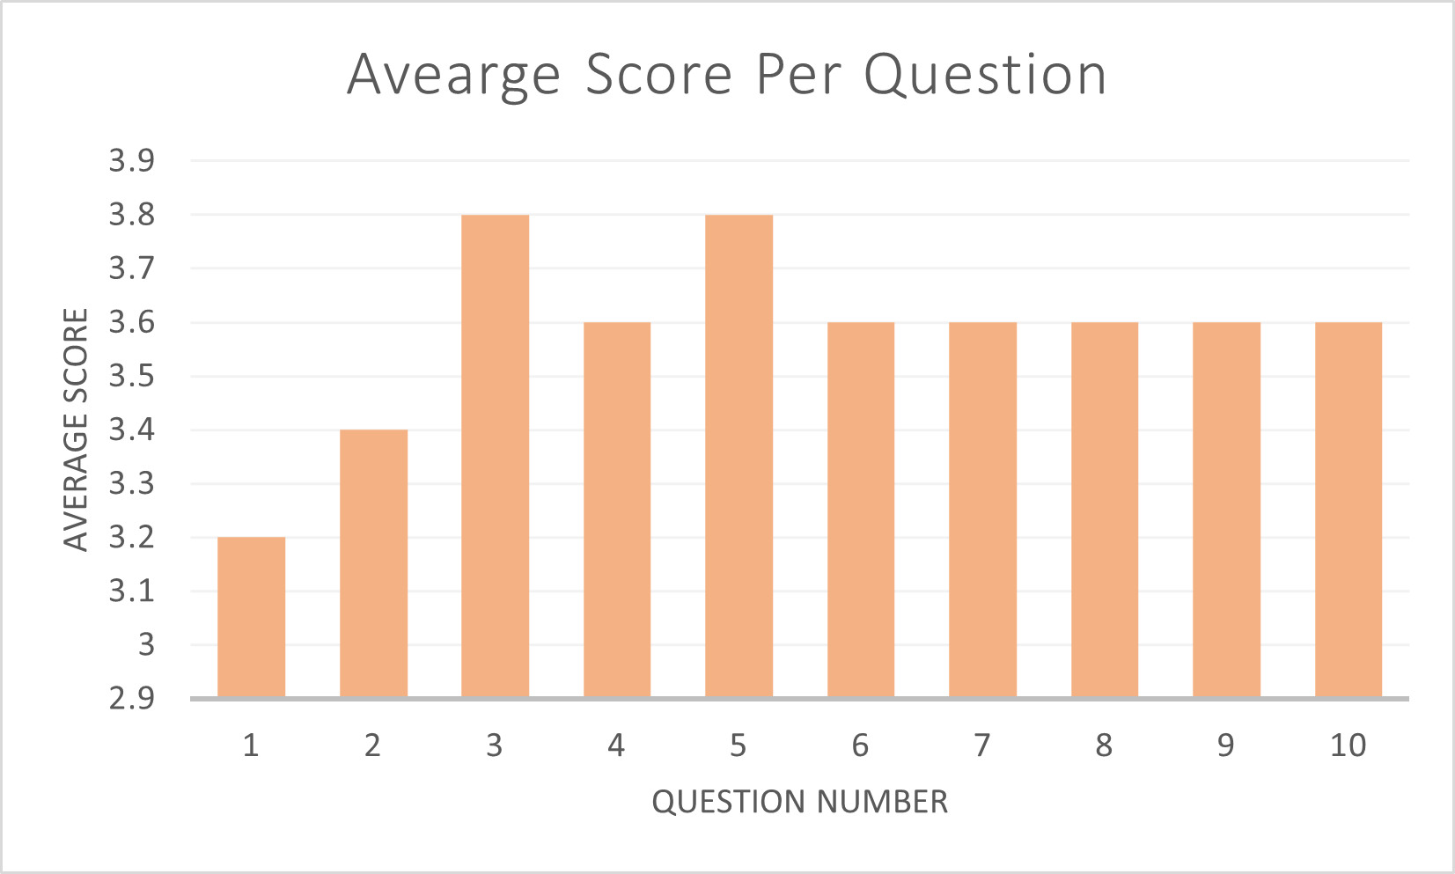
Figure 29 Average Score Per Question
This suggests that users found the system highly usable, but not all users felt they would need to use the device frequently. This is positive for the system and implies that lower scores were likely due to individual needs rather than system design flaws. The individual user average scores can be seen in Figure 30.

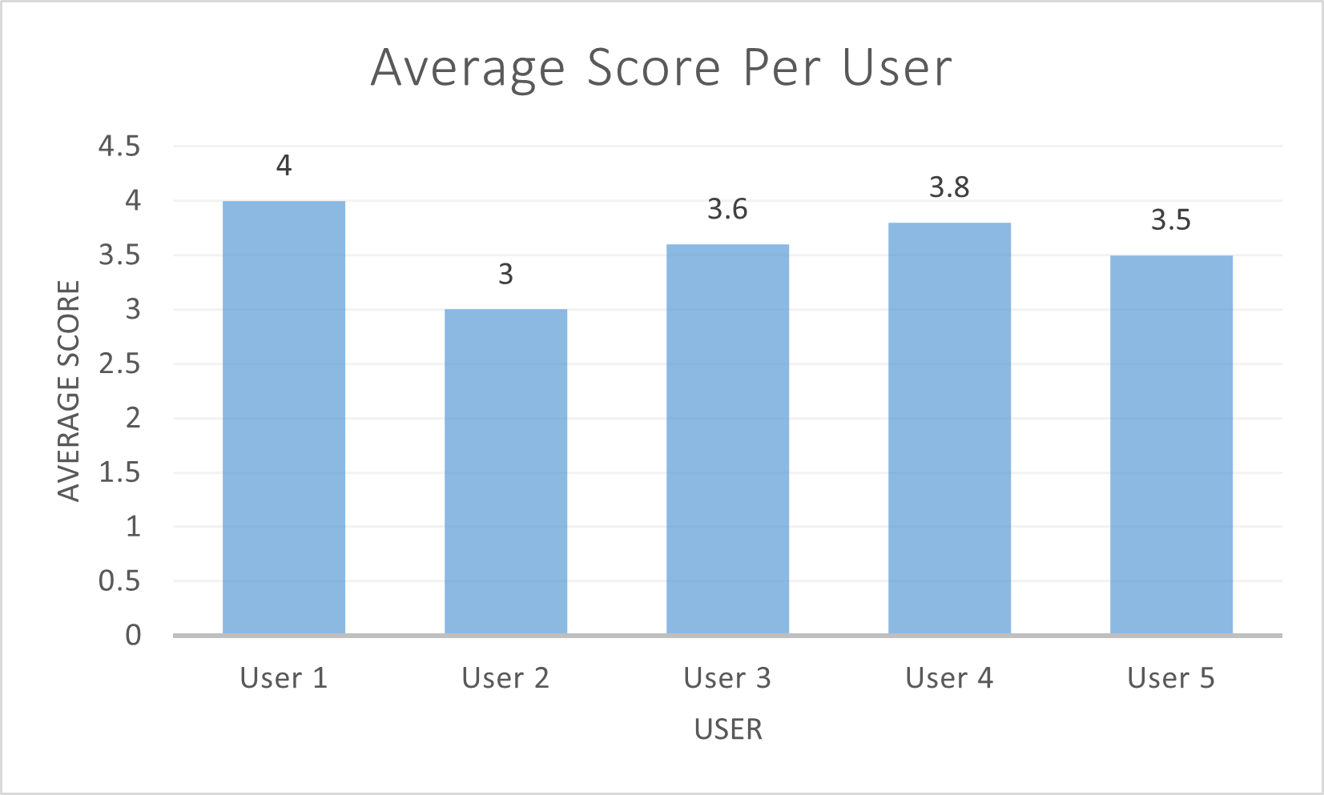
Figure 30 Average Score Per User
A copy of the SUS questions and raw results can be found in Appendix 9.5 User Feedback.

Additional User Feedback
In addition to the SUS scores, users were asked to provide open feedback on the device and its potential usage. Users generally identified home studios and live rehearsal spaces as ideal settings, aligning with the project’s intended purpose. Additional uses such as when playing video games or when at home playing their own individual instruments were suggested.

Personalisation
Several amendments were put forward by testers. Device personalisation was a common request – either by allowing the user to purchase a specific colour casing, or to change the UI colours. Additionally, a band could create a personalised version for use at concerts, using the logo/name/etc. For this, the device would need to be made into some form of wearable so that it could be visible, portable, and possibly allow for live interaction with bands changing the lighting or colours similar to how light up wrist bands are used to garner crowd engagement. This idea should be explored in the future, with the device being controlled by the user’s phone or similar, handheld/pocketable device.

VST/AU Integration
Users recommended developing the software as a VST (Virtual Studio Technology) or AU (Audio Unit) plugin, allowing it to integrate directly into their DAW (Digital Audio Workstation). This would allow the user to include the VST in their usual template so it could be applied to all projects when they were mixing music.

Headphone Integration
Users outlined that they frequently use headphones when mixing their music, expressing interest in an in-line version that could be integrated into headphones. This concept might not be feasible as a permanent add-on device to headphones. It might be possible to create an inline device which connects the headphones and the audio interface, but this would require extended research. Methods of calibration should be researched so that any headphone can be used, rather than requiring certain models that have been pre-calibrated.

Usability and UI Feedback
One user, describing themselves as “non-technical”, found the user interface confusing. They had to be told what each field represented, not understanding the labels corresponded to the values below them. Although they appreciated the installation guide, they expressed desire for a tutorial or manual explaining what each value on the UI represented. This should be added in future versions to improve accessibility.
Another user noted that the device would be particularly helpful when playing in groups, especially for musicians who are accustomed to practicing quieter instruments alone. They suggested that some of the user interface needed tweaking to enhance the user experience. This includes allowing the “Enter” key to be used instead of having to click “ok” for different parts of the interface and dynamically changing the size of text in respect to the window size. Both of these changes could be easily implemented for future iterations.

Hardware and Installation Feedback
Feedback on the casing noted that it should have more “curves” to make it more visually appealing and recognisable as a sound-related device, similar to the rounded design of microphones. This could be implemented in future models by redesigning the casing to give a rounder appearance.
In regard to the installation process, it was mentioned that it would be ideal if the CH340 driver didn’t require visiting a Chinese-language webpage to download it. The feasibility of this depends on the legality of distributing the driver. This is why it was omitted from the software installer, as future research into the legality and copyright of including the CH340 driver would need to be investigated. If there are no legal barriers, then the driver should be included for future iterations of the software.

Conclusions and Recommendations

Discussion and Conclusion
This chapter reviews the outcomes of the project and evaluates its success in meeting the original objectives. It reflects on the system’s strengths and limitations, summarises key findings, and outlines possible areas for future development. It also explores commercial opportunities, the role of AI during the project, and presents final conclusions and recommendations for how the system could be taken forward.

Overview
The project set out to design and build a compact, affordable device that helps users in home studio environments monitor noise levels and manage their sound exposure safely. The goal was to raise awareness of duration-based hearing damage through real-time feedback and visual alerts. The system combined an MEMS microphone, ESP32 microcontroller, and Python-based desktop application to track live sound levels, calculate safe exposure durations, and provide alerts when thresholds were exceeded. The final device was achieved cheaply and compactly – two major requirements in calculating the devices success.

Successes
The project succeeded in all of its major requirements. Real-time noise measurement was successful with the UI showing the current noise level detected by the device, alerting the user when the safe duration has 10 minutes remaining, and when expired. The GUI functionality was successful – most users understood it, and all found navigation easy. The configurable calibration offset worked fine without issues during implementation.
Tester SUS scores gave a result of 89.5 (grade A), showing how user friendly it is.
The feedback provided valuable suggestions for future versions and improvements to the device. Most testers found it functioned well, with an easy-to-understand UI, and indicated that it would be used in its intended setting by its target users – home studio users and musicians.
The device was successfully created with its software, compact casing, and affordable price. The system tests showed that the calibrated device was able to accurately measure the sound levels around it, compared to the dedicated sound level reader.

Problems
Several non-critical issues were identified during the project. The INMP441 microphone showed unreliable accuracy at lower dB levels, struggling to measure sounds below 60 dB. This likely results in underestimating the safe remaining time by inflating the calculated average – a safer outcome than overestimating exposure limits. The device does not accurately display short sound spikes, although further research is needed to determine whether this impacts the average noise level, which is the system’s primary function.
User feedback highlighted minor clarity issues with the UI, particularly among less technical users, who sometimes struggled to understand certain sections. Testers also suggested small usability improvements, such as enabling the “Enter” key to confirm inputs.

Future Development
Although the project was successful and met its core goals, there are several ways the system could be improved in the future.
Further testing should assess if desk vibrations affect the sound detected by the device. A large speaker system should be used alongside a suspension method to minimise vibration interference. If testing shows that vibrations do impact accuracy, internal suspension or padding solutions should be explored.
The most significant potential improvement is developing a small, wearable version of the device that could sit closer to the user’s ear, providing sound readings more representative of the user’s actual experience. This wearable version would ideally contain both the microphone and controller but would need to be significantly small than the current model. It would likely use either Bluetooth or Wi-Fi for connectivity, enabling pairing with mobile devices as well as PCs.
A smaller, wearable version of the device would be well-suited for use outside of home studios due to its reduced size. This wearable version could serve as the warning mechanism, while a mobile phone, smartwatch, or similar device could function as the microphone as demonstrated in the research section “2.8.2 Wearable Devices and Consumer Electronics”. The wearable could be designed as a badge or pin worn on clothing, featuring LEDs that change based on the remaining safe duration. These badges could be sold at music events – such as festivals and concerts – and offer a high degree of customisation, including band or venue branding.
Although wireless connectivity would be essential for wearable versions, options such as Wi-Fi and Bluetooth should also be considered for future desk-based models. A mobile application could be developed to control the device, replacing the desktop software.
Future versions of the device, regardless of platform, should feature a tutorial explaining the software’s functions and interface. The lack of tutorial after installation was an oversight in the current version but was unavoidable given the project’s time constraints.
To enhance the user experience, future versions of the device should allow users to customise both the casing and the software interface, including options for different casing and UI colours. Additionally, the casing design should be updated to feature a more curved, modern, visually appealing shape. Research and testing would be required to assess if the new shape impacts noise detection. The UI tweaks that were mentioned in section “5.2.4.4 Usability and UI Feedback” should also be addressed to enhance usability.
A future version could be developed as a fully standalone device with an integrated screen, enabling configuration without requiring a computer. Although this could complicate user settings, onboard memory could be implemented to store preferences. Ideally, a standalone device would also include a battery to eliminate the need for a constant connection to external power. Research would be needed to determine the most suitable battery type, and whether rechargeable or replaceable.
Various LEDs could be added to the casing to indicate device status – PC connection (computer-based devices), power state, charging level (standalone models), and the danger level of the current sound environment.
Future versions should also include a higher quality, more powerful microphone capable of accurately detecting sound levels below 60 dB, improving the precision of average sound level calculations.
All future versions of the device should address the spiking volume issue previously identified. This would require assessing the cause – the UI update frequency, or data read/write/calculation times. If the issue is the latter, it might be necessary to move to a faster programming language such as C++ and utilise more multithreading.
A potential upgrade for future desktop versions could be converting the application into a VST or AU plugin for integration within a user’s DAW. However, this would be a low priority, as demand is likely to be limited.
The device could be expanded into areas of mental health and wellbeing by shifting focus from volume levels to total noise exposure. Rather than aiming solely to prevent hearing loss, the device could support focus, stress management, and mental wellbeing. Significant research and user testing would be required to explore how best to adapt the system to support individuals, particularly those with neurodiversity.

Commercialisation
The natural progression of this project is to commercialise the device and sell it. Target markets would include studios, home studios, musicians, parents of young musicians, producers, and (with future versions) festivals and bands.
As discussed, the device is substantially cheaper than most alternatives currently available online, and bulk purchasing of components and printing would further reduce the unit cost.
Several sales avenues could be explored – a dedicated website, major online platforms such as Amazon and eBay, and specialist music retailers like Gear4Music, Thomann, and independent music stores. Selling directly to bands and venues could also open a large additional market.

AI Usage
Throughout this project, ChatGPT was used as an assistant for troubleshooting software and hardware problems. It proved invaluable for saving time debugging and generating simple lines of code. Its usage mainly involved the developer explaining specific problems and requesting possible solutions. ChatGPT would suggest several approaches, from which the developer would select one as the chosen solution. While ChatGPT was highly effective for quickly producing small code snippets (especially to speed up typing and recalling Python syntax), it often struggled with more complex logic and required guidance on how to approach tasks. Based on its performance during development, it is unlikely that ChatGPT alone would be capable of independently producing the fully functioning software from the project. It also struggled with hardware troubleshooting, failing to identify the need for microphone soldering to create valid input signals. Nevertheless, ChatGPT significantly accelerated development by supporting problem-solving and improving workflow, although it could not replace the developer’s role in system creation.
ChatGPT was also used as a writing assistant for this report. It was NOT used to blindly generate text or for research purposes. It was purely used as an assistant in condensing the projects wording to fit within the required word count. An original paragraph of text was given to ChatGPT, and it was asked to provide a condensed version. Its suggestion was taken and reworded to fit the writing style of the researcher, and that reworded paragraph replaced the original, longer version. The core meaning of each paragraph was deliberately checked and ensured by the researcher, as ChatGPT would often remove key sections of text, or create unnatural sentences/phrasing in its efforts to condense the wording. This use of AI allowed this extensive project to keep all of its original detail whilst maintaining the word limit and allowing for a smoother reading experience.

Final Conclusion
This project successfully created a compact, low-cost device for monitoring noise levels and safe exposure time in home studios. It met all core objectives and received strong user feedback, with a SUS score of 89.5. While some minor issues were found with low-volume accuracy and UI clarity, the system proved overall effective and usable. Future improvements include wearable designs, mobile integration, and better microphones. The device shows strong potential for real-world use and future commercialisation.

Reflection

Personal Reflection
I have learnt a lot from this project. I’ve learnt how the human ear works, and how sound works – sound pressure, weighted sounded levels, Leq, and the effects noise has on the human body (physically, mentally, and emotionally).
I found the hardest technical part of the project was the electronics – I wasn’t as familiar with them as I thought I was, hence, why the microphone soldering issue took so long to fix (around 2-3 weeks of testing different mics and boards). If I was repeating the project, I would allocate a section of the literature review to circuitry and electronics so that I would be more aware of the soldering issue and save myself a lot of time. From this I’ve learnt both that microphones need to be soldered, and that I’d need to spend more time researching electronics if I carried out a future project involving circuitry.
I enjoyed working alongside AI. It sped up development and allowed me to bounce ideas off of it – similar to the developer’s rubber duck. There were moments when I didn’t know which direction to go with a section and its advice really helped me, both in terms of what route to take, and in terms of momentum and motivation. If I had needed to spend hours of time, searching online on forums for other people’s code, my motivation, and therefore rate of progression with the project would have dropped substantially. This could possibly have resulted in some features having to be dropped, creating a worse end product. Working alongside the AI has actually encouraged me in my software development interests as it removes the horribly mundane aspect of memorising or researching syntax for a specific language and allows me to get results at a much faster rate.
In regard to my degree, I think the most useful modules were “Software Development”, “Advanced Software Development”, and “Software Engineering Principles and Testing” – all of which were relevant to the project. Although an AI and Machine Learning module was part of my degree, I think I would have fared better if this module (or an additional module) focused on how to use generative AI alongside software development, not just how AI functions.
Time management and more importantly time prioritisation were skills I further developed and refined during the project. Time management is something that naturally improves when you have weekly deadlines of tasks to complete, but time prioritisation took more work. A lot of my time during the final few months of the project were very busy for me, with a lot of time spent doing work as a Student Ambassador for the university. It reached a point during a particularly difficult moment in development that I realised I needed to prioritise the project and turn down work that was offered to me as an ambassador. I believe that (at least a part of me) is a people pleaser and I hated having to repeatedly turn people down when they asked me if I could work events. Having to do this has strengthened my own resolve in saying no, and putting my prioritises in the correct order. This will be an incredibly valuable skill going forward in life, both in work, and in my personal life, so I’m grateful that the project enhanced it.

References

[1] | F. Rumsey and T. McCormick, Sound and Recording: An Introduction, Oxford: Elsevier, 2006.
[2] | L. S. Lloyd, “What Are Decibels?,” The Musical Times, vol. 93, no. 1307, pp. 18-19, 1952.
[3] | Science Learning Hub – Pokapū Akoranga Pūtaiao, “Measuring sound,” Science Learning Hub – Pokapū Akoranga Pūtaiao, 10 May 2011. [Online]. Available: https://www.sciencelearn.org.nz/resources/573-measuring-sound. [Accessed 227 December 2024].
[4] | M. F. Hamilton and D. T. Blackstock, Nonlinear Acoustics, 3 ed., Gewerbestrasse, Cham: Springer Cham, 2024.
[5] | D. Abbott, Anatomy of a longitudinal wave.
[6] | J. G. Švec and S. Granqvist, “Tutorial and Guidelines on Measurement of Sound Pressure Level in Voice and Speech,” Journal of Speech, Language, and Hearing Research, vol. 61, no. 3, pp. 441-461, 2018.
[7] | W. E. Brownell and B. R. Alford, “HOW THE EAR WORKS - NATURE’S SOLUTIONS FOR LISTENING,” National Institutes of Health, vol. 99, no. 5, p. 9–28, 1997.
[8] | Otorhinolaryngology – Head & Neck Surgery , “Ear Anatomy Schematics,” McGovern Medical School, [Online]. Available: https://med.uth.edu/orl/online-ear-disease-photo-book/chapter-3-ear-anatomy/ear-anatomy-schematics/. [Accessed 30 December 2024].
[9] | J. E. Hawkins, “Human ear,” Encyclopedia Britannica, 21 November 2024. [Online]. Available: https://www.britannica.com/science/ear. [Accessed 30 December 2024].
[10] | M. Pilhofer and H. Day, Music Theory for Dummies, Indianapolis: Wiley Publishing, Inc., 2007.
[11] | R. A. Dobie and S. V. Hemel, Hearing Loss: Determining Eligibility for Social, Washington, DC: National Research Council of the National Academies, 2004.
[12] | F. Majidi, Y. Khosravi and K.-D. Abedi, “Determination of the Equivalent Continuous Sound Level (Leq) in Industrial Indoor Space Using GIS-based Noise Mapping,” Journal of Human, Environment, and Health Promotion, vol. 5, no. 2, pp. 50-55, 2019.
[13] | C. Meyer-Bisch, “Les Chiffres Du Bruit,” Med Sci (Paris), vol. 21, no. 5, pp. 546-550, 2005.
[14] | R. S. Dewey, D. A. Hall, C. J. Plack and S. T. Francis, “Comparison of continuous sampling with active noise cancelation and sparse sampling for cortical and subcortical auditory functional MRI,” Magnetic Resonance in Medicine, vol. 86, pp. 2577-2588, 2021.
[15] | J. Rong, W. Zhang, Q. Qiu and Y. Zhang, “A Circular Buffer Mode Design Based on BU-61580,” in 2009 International Conference on Computational Intelligence and Software Engineerin, Wuhan, 2009.
[16] | J. Sun and X. Yao, “A Fast Double-Buffering Strategy for Electrophysiological Data Transmission,” in 2019 International Conference on Machine Learning, Big Data and Business Intelligence (MLBDBI), Taiyuan, 2019.
[17] | R. I. Rasel, N. Sultana and P. Meesad, “An efficient modelling approach for forecasting financial time series data using support vector regression and windowing operators,” International Journal of Computational Intelligence Studies , vol. 4, no. 2, pp. 134-150, 2015.
[18] | J. Bouma, H. Jonker, V. V. D. Meer and E. V. D. Aker, “Reconstructing Timelines: From NTFS Timestamps to File Histories,” in ARES '23: Proceedings of the 18th International Conference on Availability, Reliability and Security, Benevento, 2023.
[19] | D. Jhanwar, “Noise Pollution: A Review,” Journal of Environment Pollution and Human Health, vol. 4, no. 3, pp. 72-77, 2016.
[20] | Center for Hearing and Communication , “Common noise levels - how loud is too loud?,” Center for Hearing and Communication , [Online]. Available: https://noiseawareness.org/info-center/common-noise-levels/. [Accessed 28 December 2024].
[21] | G. Drug and V. Gavat, “SOUND POLLUTION IN EVERYDAY LIFE: SOURCES, UNITS OF MEASUREMENT, METHODS OF DETERMINATION,” 2010.
[22] | A. DANILEVIČIUS, M. KARPENKO and V. KŘIVÁNEK, “RESEARCH ON THE NOISE POLLUTION FROM DIFFERENT VEHICLE CATEGORIES IN THE URBAN AREA,” Transport, vol. 38, no. 1, pp. 1-11, 2023.
[23] | I. Qzar, “Noise Pollution Monitoring at Some Indoor Environments in Basrah City, Iraq,” Biological and Applied Environmental Research, vol. 6, no. 1, pp. 24-34, 2022.
[24] | M. Gilliver and E. F. Beach, ““Know Your Noise” Helps Young People Understand Risks Associated with Recreational Noise Exposure and Take Action to Prevent Hearing Damage,” Journal of Consumer Health on the Internet, vol. 25, no. 4, p. 350–365, 2021.
[25] | A. M. Shehabi, G. Prendergast, H. Guest and C. J. Plack, “Noise Exposure in Palestinian Workers Without a Diagnosis of Hearing Impairment: Relations to Speech-Perception-in-Noise Difficulties, Tinnitus, and Hyperacusis,” Journal of Speech, Language, and Hearing Research, vol. 66, no. 3, pp. 1085-1109, 2023.
[26] | L. T. Merijanti, “Noise Exposure and Hearing Health in the Workplace,” JURNAL BIOMEDIKA DAN KESEHATAN, vol. 5, no. 3, pp. 132-135, 2022.
[27] | N. Moroe and P. Mabaso, “Quantifying traffic noise pollution levels: a cross-sectional survey in South Africa,” Scientific Reports, vol. 12, no. 3454, pp. 1-11, 2022.
[28] | P. C. Sarker, N.-E.-A. Siddique and S. Sultana, “A Review of Environmental Noise Pollution and Impacts on Human Health in Rajshahi City, Bangladesh,” Indonesian Journal of Environmental Management and Sustainability, vol. 7, no. 3, pp. 80-87, 2023.
[29] | R. Pugh, C. Jones and R. D. Griffiths, “The Impact of Noise in the Intensive Care Unit,” in Intensive Care Medicine, Berlin, Springer, 2007, pp. 942-949.
[30] | S. Kumari, A. Sharma and A. K. Ghosh, “Noise pollution and associated health impacts at Ganeshpeth Bus Terminus in Nagpur, India,” Noise Mapping, vol. 10, no. 20220168, pp. 1-13, 2023.
[31] | “Deafness and hearing loss: Safe listening,” World Health Organization, 29 May 2024. [Online]. Available: https://www.who.int/news-room/questions-and-answers/item/deafness-and-hearing-loss-safe-listening. [Accessed 20 November 2024].
[32] | “Noise and Hearing Loss,” National Instutute for Occupational Safety and Health (NIOSH), 30 January 2024. [Online]. Available: https://www.cdc.gov/niosh/noise/about/noise.html. [Accessed 20 November 2024].
[33] | London Ear Lab, “Safe exposure times,” London Ear Lab, [Online]. Available: https://londonearlab.com/sound-lab-en/safe-exposure-times/?cookies_accepted=Y. [Accessed 27 December 2024].
[34] | A. T. D. Carvalho, The Discourse of Home Recording: Authority of “Pros” and the Sovereignty of the Big Studios, Montréal: Université de Montréal, 2011.
[35] | D. M. Polk, Home Studio Owners' Strategies to Compete in the Recording Industry, Minneapolis: Walden University, 2019.
[36] | Pulsar Instruments Plc, “NoisePen Dosemeter – Personal Sound Exposure Meter,” Pulsar Instruments Plc, [Online]. Available: https://pulsarinstruments.com/products/noisepen-dosemeter-personal-sound-exposure-meter/. [Accessed 30 December 2024].
[37] | Svantek, “Noise Dosimeter SV 104,” Svantek, [Online]. Available: https://svantek.com/products/sv-104-personal-noise-dosimeter/. [Accessed 30 December 2024].
[38] | S. A. Zawawi, A. A. Hamzah, B. Y. Majlis and F. Mohd-Yasin, “A Review of MEMS Capacitive Microphones,” Micromachines, vol. 11, no. 484, pp. 2-26, 2020.
[39] | M. Duquesnoy, Tuning forks in photoacoustic spectroscopy : Comparative study and new developments, Paris-Saclay University, 2021.
[40] | Z.-G. Huang and S.-J. Shiu, “Design and analysis of diaphragms in dynamic microphones,” Advances in Mechanical Engineering, vol. 7, no. 7, pp. 1-13, 2015.
[41] | MediaCollege.com, “Dynamic Microphones,” MediaCollege.com, [Online]. Available: https://www.mediacollege.com/audio/microphones/dynamic.html. [Accessed 28 December 2024].
[42] | A. L. Padilla-Ortiz, F. A. Machuca-Tzili and D. Ibarra-Zarate, “Smartphones, a tool for noise monitoring and noise mapping: an overview,” International Journal of Environmental Science and Technology, vol. 20, no. 2023, pp. 3521-3536, 2022.
[43] | T. Fischer, S. Schraivogel, M. Caversaccio and W. Wimmer, “Are Smartwatches a Suitable Tool to Monitor Noise Exposure for Public Health Awareness and Otoprotection?,” Frontiers in Neurology, vol. 13, no. 856219, pp. 1-8, 2022.
[44] | Analog Devices, “A Beginner's Guide to Digital Signal Processing (DSP),” Analog Devices, [Online]. Available: https://www.analog.com/en/lp/001/beginners-guide-to-dsp.html. [Accessed 16 April 2025].
[45] | Q. Tan, X. Liu, X. Chen and D. Yu, “Digital Environmental Noise Monitoring System Based on B/S Architecture and Floating-Point DSP,” in 2009 2nd International Congress on Image and Signal Processing, Tianjin, 2009.
[46] | D. Seitzer, K.-H. Brandenburg, R. Kappust, E. Eberlein, H. Gerhauser, S. Krageloh and H. Schott, “DSP based real time implementation of an advanced analysis tool for audio channels,” in International Conference on Acoustics, Speech, and Signal Processing, Glasgow, 1989.
[47] | W. T. Cochran, J. W. Cooley, D. L. Favin, H. D. Helms, R. A. Kaenel, W. W. Lang, G. C. Maling, Jr, D. E. Nelson, C. M. Rader and P. D. Welch, “What is the fast Fourier transform?,” Proceedings of the IEEE, vol. 55, no. 10, pp. 1664-1674, 1967.
[48] | A. J. Mariscal-Ramirez, A. J. Fernandez-Prieto, J. Canada-Bago and M. A. Gadeo-Martos, “A new algorithm to monitor noise pollution adapted to resource-constrained devices,” Multimedia Tools and Applications, vol. 74, no. 1, p. 9175–9189, 2014.
[49] | J.-A. Fernandez-Prieto , J. Cañada-Bago and M.-A. Gadeo-Martos, “Wireless Acoustic Sensor Nodes for Noise Monitoring in the City of Linares (Jaén),” Smart Wireless Acoustic Sensor Network Design for Noise Monitoring in Smart Cities, vol. 20, no. 124, pp. 1-23, 2019.
[50] | B. Scott, “Sound level meter – What is the difference between a Class 1 & Class 2?,” Pulsar Instruments Plc, 1 October 2018. [Online]. Available: https://pulsarinstruments.com/news/difference-between-class-1-and-class-2-sound-level-meters/. [Accessed 27 December 2024].
[51] | International Organization of Legal Metrology, OIML R 58: Sound level meters, 1 ed., Paris: Bureau International de Métrologie Légale, 1998.
[52] | International Organization of Legal Metrology, OIML R 88: Integrating-averaging sound level meters, 1 ed., Paris: Bureau International de Métrologie Légale, 1998.
[53] | R. G. Griffin, Jr., “The Future of MEMS Microelectromechanical Systems in Transportation Engineering,” Transportation Research Board of the National Academies, Washington DC, 2003.
[54] | D. Garc´ıa-Vega, S. Gonz´alez-Castillo, F. D. Gonz´alez-Mart´ınez, J. Garc´ıa-Mart´ınez, E. F. Combarro, F. J. Ca˜nadas-Quesada and J. Ranilla, “Exploring Hybrid Quantum-Classical Machine Learning for Respiratory Sound Analysis,” in 2024 IEEE 22nd Mediterranean Electrotechnical Conference (MELECON), Porto, 2024.
[55] | T. Jose and J. A. Mayan, “Real-Time Sound Detection of Rose-Ringed Parakeet Using LSTM Network with MFCC and Mel Spectrogram,” in IEEE, Kanjirapally, 2023.
[56] | Espressif Systems, “esp32 version 1.0.6,” [Online]. Available: https://dl.espressif.com/dl/package_esp32_index.json. [Accessed 4 April 2025].
[57] | Espressif Systems, “esp32 version 3.2.0,” [Online]. Available: https://raw.githubusercontent.com/espressif/arduino-esp32/gh-pages/package_esp32_index.json. [Accessed 4 April 2025].
[58] | “SoundEar II Noise Activated Warning Sign,” NoiseMeters Limited, [Online]. Available: https://www.noisemeters.co.uk/product/soundear/se2ear/. [Accessed 4 April 2025].
[59] | M. Teachman, “Measuring Audible Noise in Real-Time,” Hackaday.io, 11 November 2019. [Online]. Available: https://hackaday.io/project/162059-street-sense/log/170825-measuring-audible-noise-in-real-time. [Accessed 4 April 2025].
[60] | N. Thomas, “How To Use The System Usability Scale (SUS) To Evaluate The Usability Of Your Website,” [Online]. Available: https://usabilitygeek.com/how-to-use-the-system-usability-scale-sus-to-evaluate-the-usability-of-your-website/. [Accessed 10 April 2025].
[61] | Harness, “System Usability Scale Toolkit,” Harness, 2024.

Appendices

Use Case Diagrams

Run Application
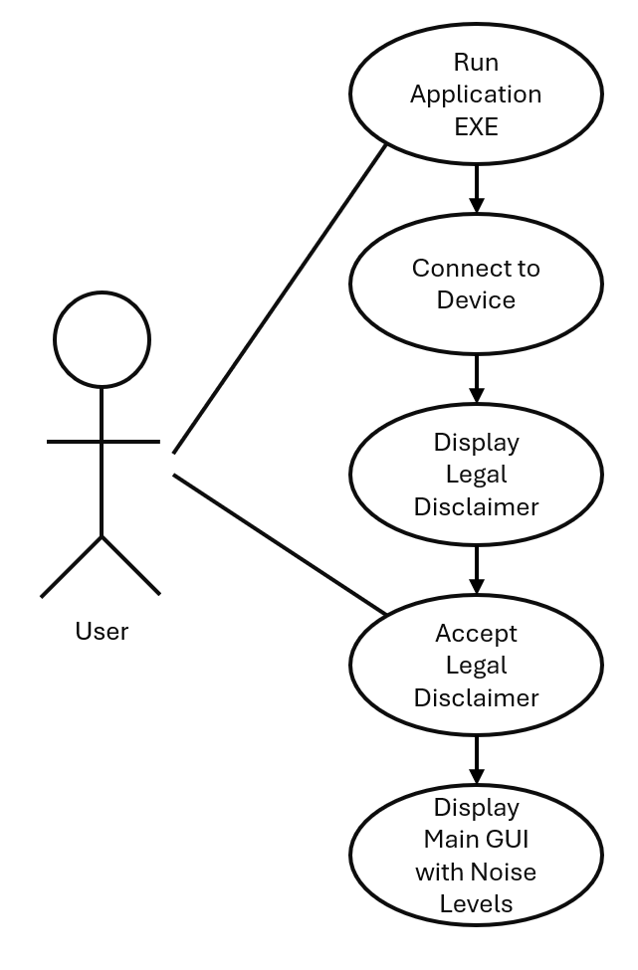

Alerts
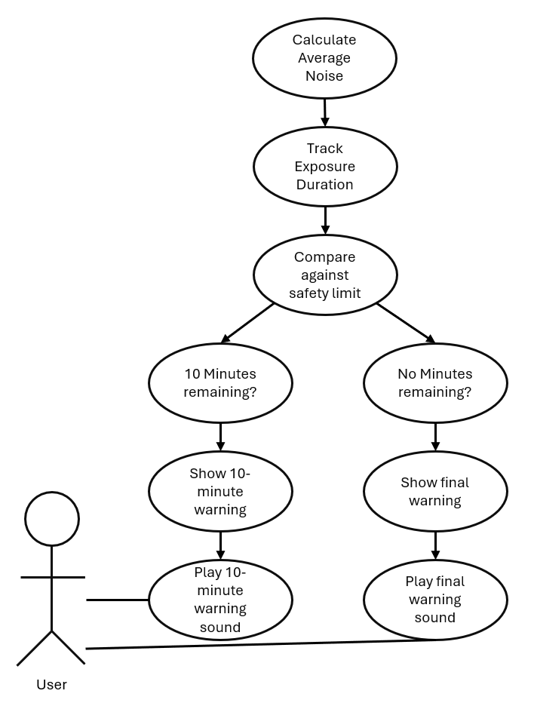

Calibration
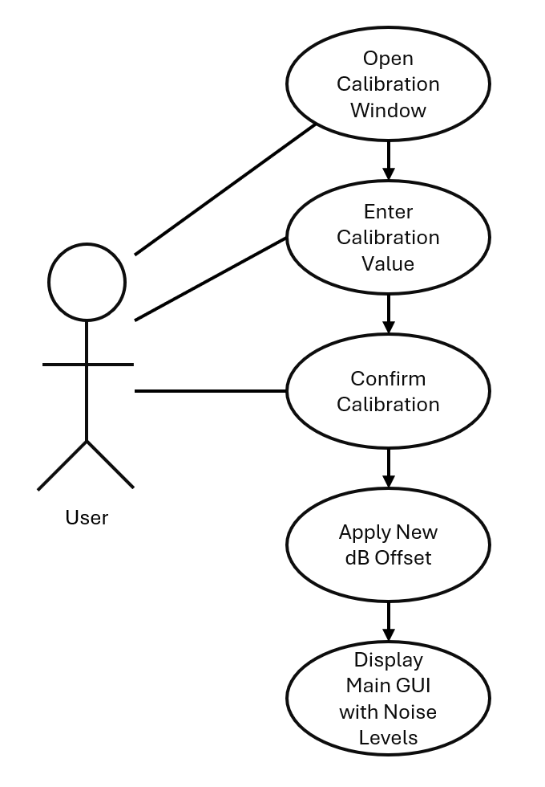

Wire Frames

Legal Disclaimer Design
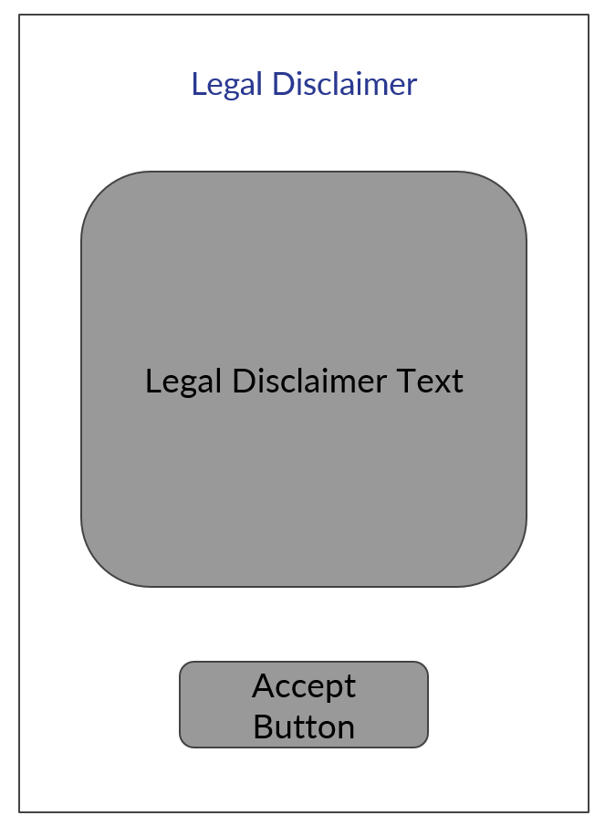

Calibration Design
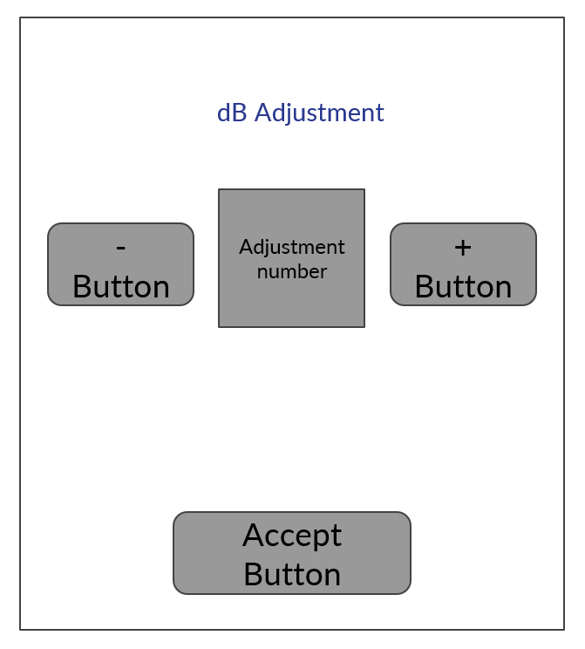

Warning Design
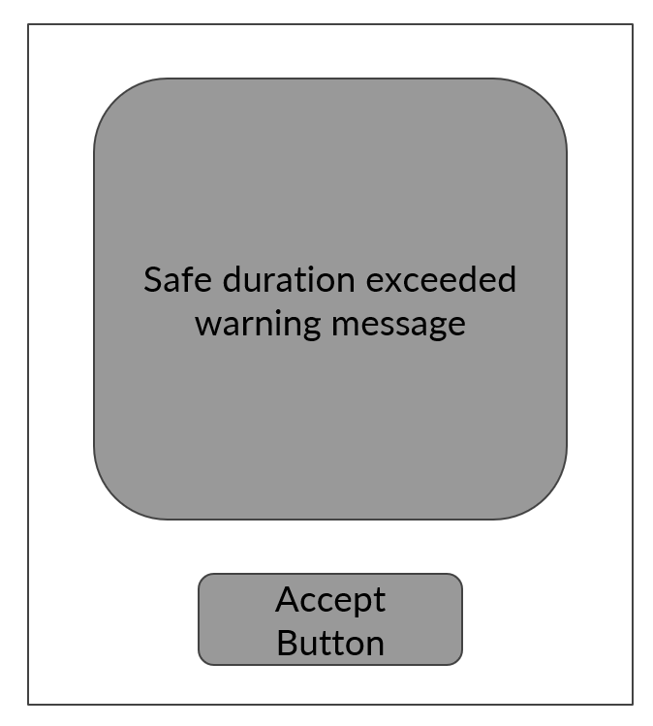

Digital Model

Original Open
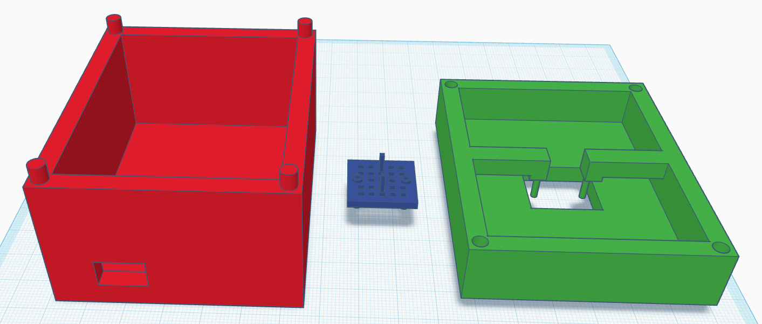

Original Shut
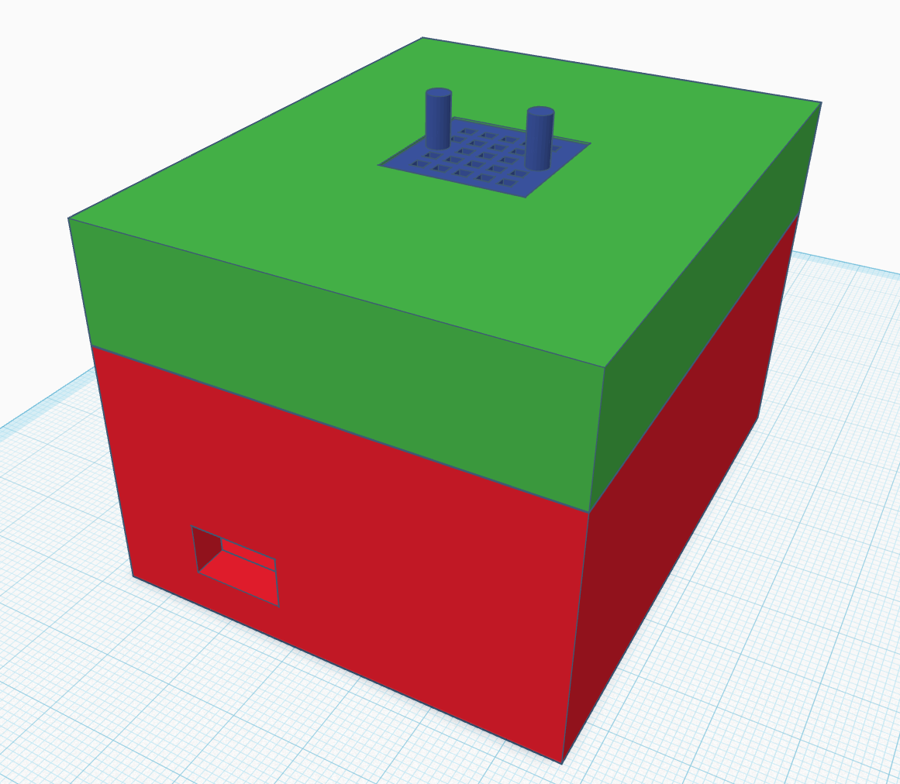

Printed Casing

Original Casing
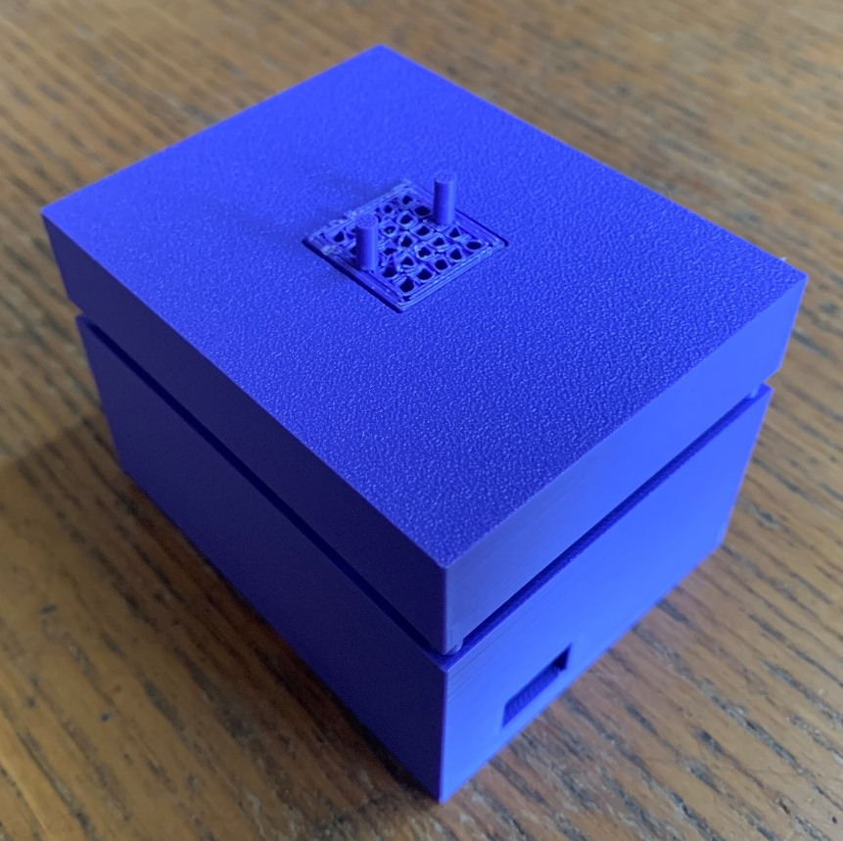

Original Base
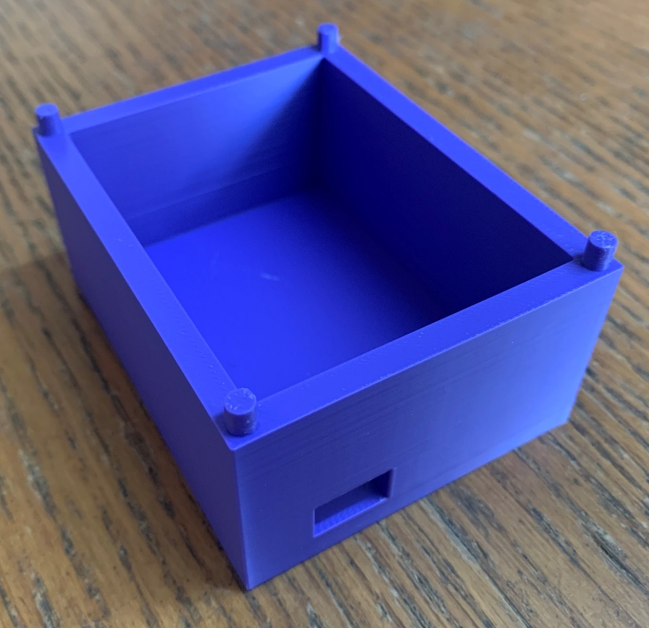

Original Lid
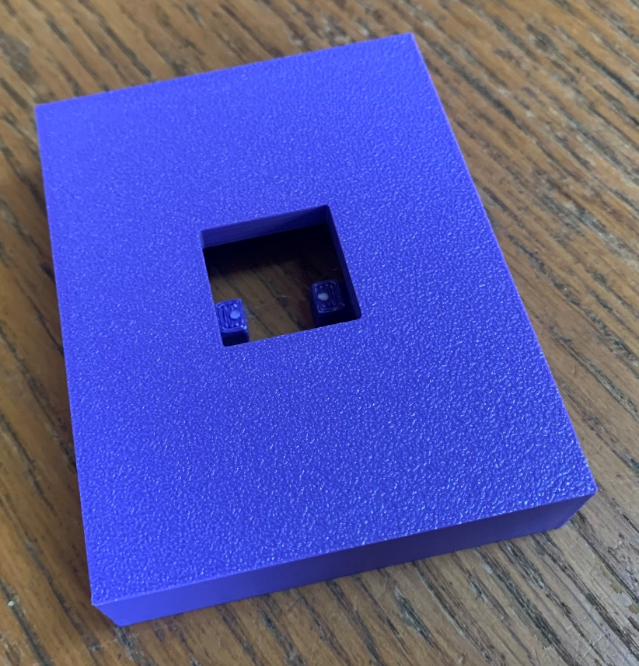

User Feedback

Feedback Questions
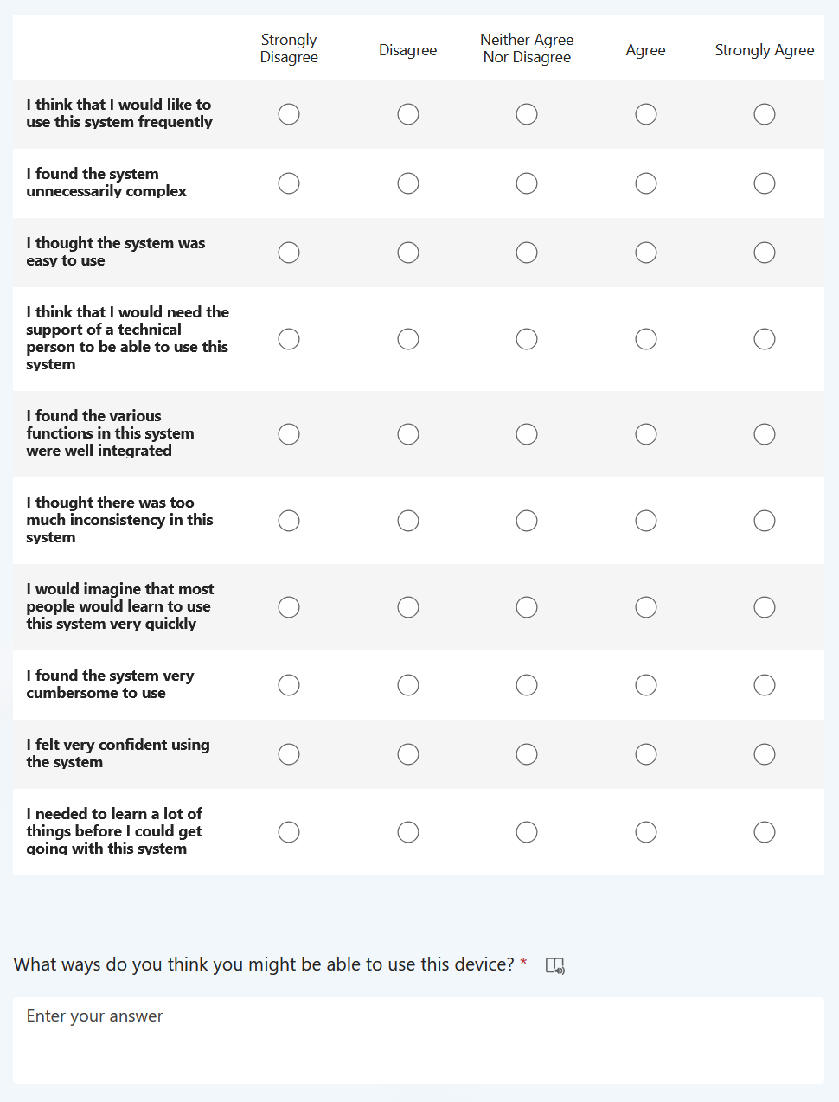

Feedback Results
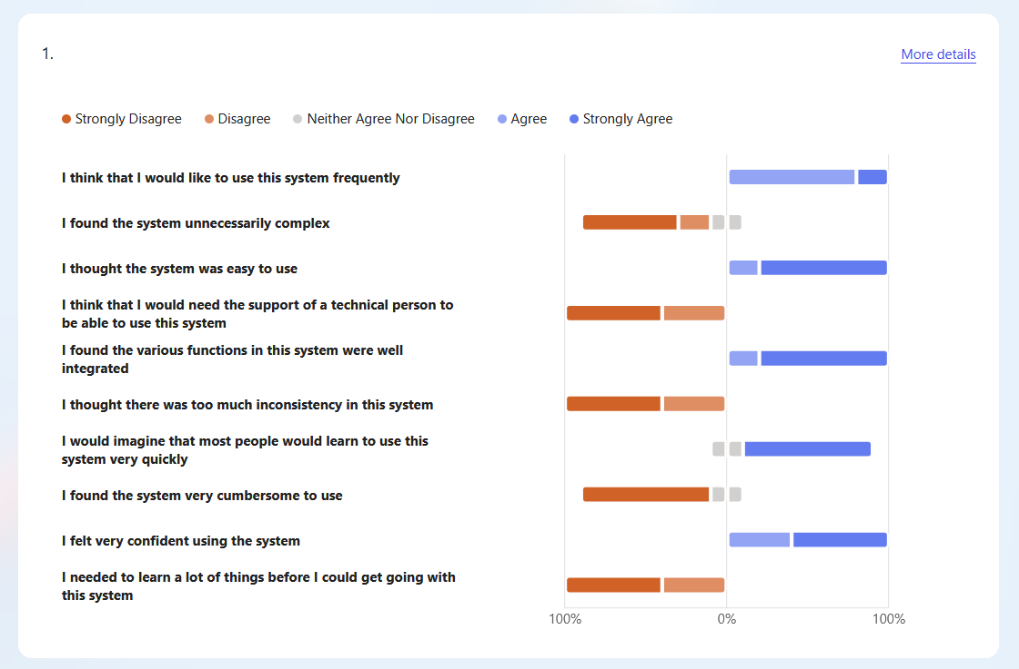

Consent Form


