EAT STREET LTD
South east Asian street food
“In south east Asia the real taste of food can be enjoyed not in the showroom classed posh restaurant but can be order and eaten right down the street” (Aquino,2019)
Business plan –
“A business plan is a guide of the operational and financial objectives of a business with detail planning and budgeting about how to progress in that route. It’s a route direction towards the direction of the business” (Ward,2018)
In getting the business plans ready the business should first have a business tag line or mission statement that define the nature of the business.
“A mission statement is a reason that tell why the business is there, identify the product and service it produces and also describe the geographical position, background of the business” (Entrepreneur, 2019)

Eat street mission statement- Quality matter rather than quantity, authentic homecooked street food with authentic flavour

“An aim or objective is a goal of what a business is trying to achieve over the next period of set time” (bbc,2019)
The business can set itself the kinds of targets like
Survival, increased profit, growth and increasing market share
The main aims of the business is reach to the customers by authentic, fresh home cook street food.
The inspiration to start the business came from “jay fa”-
A 72 old years chef who won the prestigious Michelin star for her cooking. The idea is if she can why can’t we also can do it .
Eat street was created then by four of friends – Raj /Faruk/Angur and Ashik.
Eat Street – Homestyle cook street food, unique in taste, affordable, fresh and local produce supporting
The business will be a privet limited company to reduce the risk factor. “limited company confers life in the business as a separate legal entity , all debts and obligation ,profit and losses are the company’s .Despite the resignation , death ,bankruptcy the business will continue and it also give a very good chance of outsider joining the company ,hence it can expands further”(Clayton ,2008)
To describe our product which can be easily explained by example from the menu and the price

Pani puri
Indian popular street snacks, also known as gol gappe
crispy wheat ball filled with feelings & with tamarind & mint water £4.15
samosa chaat (v)
pastry filled with vegetables layered with spicy chickpeas, yoghurt, mint /coriander/tamarind chutneys £5.15
Tteokbokki
korean style stir fried vegetarian & rice cake with egg in chilly paste £4.50
Salt & pepper chicken bites
battered chicken wings, vegetable & pepper sauce £5.25
“ingredient cost is the main in calculating food cost. The quantity should be taken in consideration while calculating the food cost. The ingredient cost needs to be added up and then the final food cost can be calculated” (study.com.2019)
This is the example of the of the recipe calculator
The perfect recipe costing will give us the perfect profit we expect from each dish. our aim is to hit 70% profit margin
To explain
Gross profit
100% - food cost % = Gross profit %
Example
100% -26.4% = 73.6% Gross Profit%
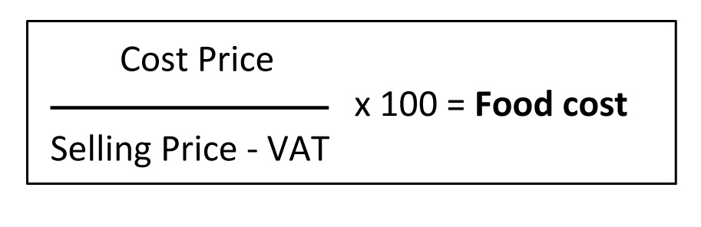

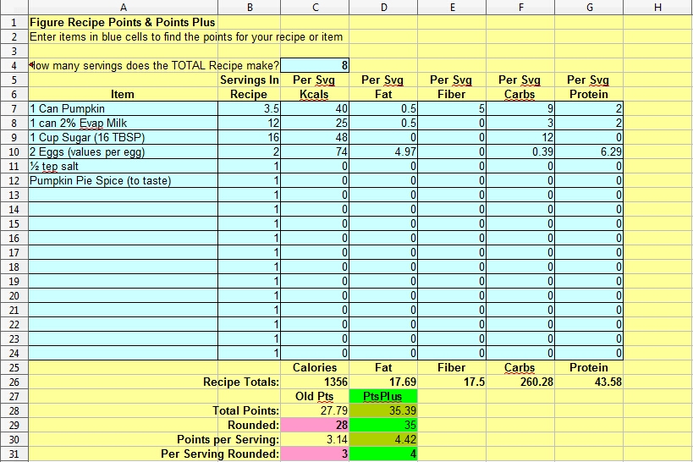

To make a conclusion to business proposal –
Swot is the key to a business success so to explain the swot “SWOT Analysis is a useful technique to find the strength and weakness and to find out the opportunity after recognizing the strength of the business” (mindtools,2019)

When we do swot on our business it really opens up new ways to look about for the approach towards our business
EAT STREET SWOT

STRENGHTH  - Cheaper price.  - Focus on quality  - Improvement is the key with every step  - Experienced food-oriented knowledge partner | WEAKNESS  - Other competitors  - Totally new concept in Swansea  - Rise in product price due to Brexit  - Capital investment is limited , budget oriented
OPORTUNITY  - New field to endeavour  - Good customer rotation as we are first & fresh food  - Could work with the local community, supporting the local suppliers | THREAT  - Our food style can be copied with similar ideas  - Unknown arena of Brexit  - Competitors having stronger relationship with retailors.  - Competition with established business

After we done the SWOT of eat street, now it is important to make an actin plan so that we know what direction we are heading

That’s the reason it is very important to have a smart plan in position at the start of the business

“The action plan describes how the business will operate, a guided track to build the business. It also takes in account how the back-office activity goes, though it is not directly related to the customers service” (Kluwer,2019)

EAT STREET BUSINESS ACTION PLAN USING SMART TARGETS

jobs to do | Research, identify, action required | Responsibility | Target date
Physical resources | Construction price | Angur, raj, Faruk | 6 weeks
Marketing plan | Social media and leaflet | Angur, raj, Faruk | 8 weeks
Finance | Cash flow, budget, sales forecast | Angur, raj, Faruk | 10weeks
IT works | E pos, security camera, etc | Angur | 8weeks
Website | Designing the website | Angur, Raj, Faruk | 3 weeks
Survey, questioner | Initial Feedback from customer | Angur, raj, Faruk | 4 weeks
Risk survey | Finding out probable risk | Angur, raj, Faruk | Full period

“A Gantt chart is time schedule chart useful for planning and scheduling of projects of all sizes, complex project can be simplified through Gantt chart” (apm.2019)

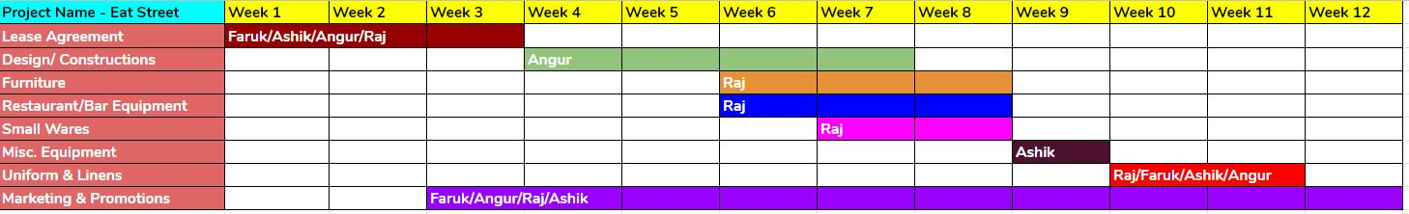

As a chef prospective i would also try to help in the product marketing of eat street by putting the photographs of various dishes of eat street in social media regularly. This will certainly help us to grow as well as attract customers attraction towards our product which is different. “Marketing is the way to promote, selling product or service that’s include a proper research of the market and the advertising” (Forsey,2019)
We hope that our serious effort will help us to reach to make us to grow in future.

REFERENCE LIST

Aquino. (2019).(online) Available at: https://www.tripsavvy.com>destination>asia (accessed 1 jul.2019)

Apm, (2019). (online) Available at: https://www.apmm.org.uk/resources/find-a-resource/gannt-chart (Accessed 29 Jun. 2019).

BBC, (2019). (online) Available at: https://www.bbc.com/bitesize/guide/z9gcd2p/revision/1 (Accessed 1 Jul. 2019)

Clayton, P. (2008). Forming a limited company. London : Kogan Page.p.1

Entrepreneur. (2019). Mission Statement Definition - Entrepreneur Small Business Encyclopaedia. (online) Available at: https://www.entrepreneur.com/encyclopedia/mission-statement (Accessed 1 Jul. 2019).

Forsey, c. (2019). what is marketing? (FAQ). (online)Blog.hubspot.com.Available at: https://blog.hubspot.com/marketing/what-is-marketing(Accessed 1 Jul. 2019)

Kluwer, w. (2019). (online) Available at: http://www.bizfilings.com/business/planning/creating-action-plan-for-yours-business (Accessed 2 Jul. 2019).

Mindtools, (2019). [online] Available at: https://wwwmindtools.com/pages/article/newTMC_05.htm [Accessed 2 Jul. 2019].

Study.com. (2019). (online) Available at: https://study.com/acadamy/lesson/how-to-calculate-food-cost-for-a recipe.html (Accessed 2 Jul. 2019).

Ward, s. (2018). (online) Available at: https://www.balancesmb.com>...>small business >Business plans (Accessed 1 Jul. 2019).

