Marketing Plan Report
House Party Event

Elijah Thomas
Student Number: 2313487

Introduction

The purpose of this written report is to provide a workable and realistic marketing plan to promote and sell tickets to Swansea Arenas new event called house party. It is being prepared for Swansea Arena to identify a target audience and be able to market effectively, to create a memorable event and be able to make a profit and expand their scope and scale across all Wales. Frameworks that will be used are SOSTAC (Situation, Objectives, Strategy, Tactics, Action, and Control) To form the main body Aswell as the 4p's of marketing and Ansoff’s matrix , Race, and the communications mix.

Situation Analysis

Company: Swansea Arena is known for being well reputable and active across Swansea and Wales. They host 200 performances yearly (www.swansea-arena.co.uk, n.d.),

In summary the key issues are that the city of Swansea has a bad reputation for being an ugly location and it may not appeal to students outside of Swansea, However the biggest strength is the funding and resources the Arena must advertise the event. An opportunity could be partnering with bigger organisations as well as advertise and create work that will make sales and create interaction. However, the biggest threat is the event has small bands these may not be appealing to work with for bigger venues.
(Refer A)

Customer: From researching Similarweb, (SimilarWeb, 2023). I have come to build customer profiles based off competitor analysis, The competitor I have chosen to use is Utilita Arena in Cardiff. Due to more statistics and information on the target audience

(Refer D)
From the information off similar web, we can determine 2 different customer profiles.

- Male-Female United Kingdom
Aged 18-24 Student
Primary social media: Facebook
Main interests: social media and Technology (Based on their search’s)

- Male United Kingdom
Aged 25-34
Primary social media: Facebook
Main interests: News, Technology

Looking at these 2 customer profiles. The most feasible will be targeting towards students with the event. As the house party event will appeal most to them most with the rock and garage style music.

Competitors:
(Refer C)
Notable competitors on the map are Swansea Bunkhouse, Aswell as Cardiff Stadium, and castle both being somewhat close and affordable. Cardiff Stadium/Utilita Is the biggest threat in terms of location, publicity and event quality and will need to be marketed against effectively.

Collaborators: Swansea Arena has collaborators, some of their corporate partners and business to business relations are Swansea Council and University of Wales TSD. Furthermore, Swansea Arena has some franchises it works with publicly in the hotel industry, Like Delta Hotels. The roles these competitors play is to help Swansea arena expand and grow. UWTSD working for experience helping the arena. Whereas delta hotels are business to business both working together on events for money and publicity (www.swansea-arena.co.uk, n.d.).

Climate:
(Refer B)
The biggest factors that affect the climate of the event are the music industry suffering from technology killing the music industry and making it less desirable, Cost of living economically limiting disposable income for sales and products on top of the positive technological factor e tickets positively creating flexibility for customers to buy tickets and attend.

Value Proposition: House party – A chance to be the first witness to the future of Wales.
This value proposition provides visitors with a sense of urgency to experience new bands being one of the first which most events don’t provide. Getting to see something almost unseen before now. Which hasn’t been done by any of its competitors in Wales across Cardiff and Newport. Creating a unique experience

Objectives

The aim is to sell 2,000 tickets to university students in Swansea and around Wales before February 2024. The objective is to hit the target audience and to push involvement in students helping publicise and advertising the event. Which will benefit the arena due the arena being able to expand.

Strategy

The marketing strategy going forward will be diversification. I have chosen this strategy to develop new opportunities and products for students to enjoy. Such as getting involved in the event with selling it and being the face of the concert going public, I have chosen diversification as my strategy because it will create opportunities for the event to market out and reach students across Wales. But also, other target audiences who will want to engage (IONOS Startup Guide, 2023), An example of diversification for the arena could be selling unusual merchandise. (Glowstick toppers, Torches with bands names) This will overall make the event more unique and appealing to younger people. Drive is what will influence customers to respond to a need or want, in this case it would be to try new products and see the new unseen bands in the spotlight (Blythe, 2013)

This framework is from the 4p’s founded by Jerome Mcarthy 1960. (Coursea, 2023) The marketing mix is effective when it comes to the event, The event appeals to the target market showing the product are effective, young bands in Swansea will appeal to students sparking curiosity. Swansea is close and accessible making the place effective for the target market. Likewise, the promotion itself is also effective. Reaching through social media and direct marketing to the target audience I believe that the product is the most effective in attracting students due to the events purpose and goal of rock and garage music , “The product is the beginning in the developing marketing” (Bowie and Buttle, 2011) however, to market effectively the key change should be the price. For price lowering it for students and making it cheaper if they have an e ticket. Statistics show from 2019 53% of 16–24-year-olds the target age range bought a ticket online for events in the UK (Chevalier, 2023). Making e ticket discounts an effective strategy in creating sales. One last change I would make to the marketing mix is the promotion. With promotion it would be beneficial to market to students in more direct methods along with social media. Direct methods used will be marketing through email and text, along with leaflets to promote the city and Arena. This change to the promotion will help achieve a personal level of marketing with students across Swansea. Making more charity money from ticket sales

However, the marketing mix extends further than this. Booms and Bitners Modelled an extension to the marketing mix. In 1981 they theorised that the process of service relies on three more concepts being Process, People and Physical Evidence. (ToolsHero, 2018). Which all apply to the success of the house party event. People refers to the parties and staff that work on putting the event, The process is the steps involved in delivering the product and service and the physical evidence applies to the customer experience in the actual layout and structure of the event. These are all successful when it comes to the event as the arena has the staff and resources to layout the event factors such as these well. They are well resourced with staff and the event is laid out with standing areas and seats to accommodate enough people. Satisfying the customers and providing physical evidence of success

Tactics

To reach and finalise my plan the strategies will be used from the framework race and the communications mix. internet/direct marketing with interactive content using act . For my direct marketing strategy, the plan will be to create posts on social media such as TikTok, Instagram and YouTube towards students personalized physical leaflets. On these products there will be interactive competitions and rewards for engagement and sharing, for example getting 50% off drinks for sharing with 5 people. This will incentivise an action from students creating sales and interaction with the event from students, I have chosen this approach as direct marketing is effective “testable and trackable when done correctly”. (Geller, 2002).

Addressing the issues in the situational analysis. I will introduce social media campaigns focusing on improving the bands publicity. This will be done through social media campaigns on Instagram and YouTube advertising the band’s music and adding incentives to engage such as share with 10 people and get a free meet up with the band members. According to Similarweb (SimilarWeb, 2023) between 18-24% of the TikTok, YouTube and Instagram audience are 18-24 . This shows that marketing the event and bands will be successful on social media for students (Refer G) Overall, this will lead to fixing the issue of the event not being unappealing. Creating publicity for the bands to possibly create new partnerships. Meaning more sales and interaction from the target audience to meet the objective.

This links back my customer profiles as they use social media the most to date. When identifying these profiles, the biggest interest of the customer profiles was technology. This shows using social media campaigns and allowing students to engage in their distribution will be imperative in creating sales and engagement.

Looking at the Arenas similar web results and their social media profiles, the biggest issue seems to be that there is engagement through twitter as a platform but not on the other social media where they advertise the event. (Refer E), Their strategy seems to be advertising reels of the bands on tickets on Instagram. The reels and strategy focus on the bands is good however Instagram has a smaller following compared to twitter and YouTube. So, a step that will be introduced is the same content being posted across twitter along with the promotion of the Instagram page and YouTube channel.

Action
(Refer H)
The reason I have used this marketing schedule is to moderate and control the information customers digest and save money when marketing. In terms of marketing towards the target audience this will achieve customers engaging more and being satisfied due to a refined marketing schedule. Customers will get angry with spam or too much action and engagement. For example, in this Gantt chart there are sections that have breaks of distribution. Aswell as marketing channels that don’t start until later months. Which informed me to make a steady digest that will allow customers to act and engage at their own pace making them more likely to buy tickets and further their objective.

Control

For my key performance indicators, I am going to use is social media interactions and gaining customer feedback through emails and texts. Gaining qualitative data on how successful the plan is going being more detailed. Allowing me to refine and adjust the marketing plan. I will also be measuring metrics through social media and ticket sales, The number of likes, comments, and shares on a campaign and charity money raised, Helping achieve quantitative data that can be easily and quickly analysed to measure success. Through graphs and statistics success can be measured along with the changes overtime. Finally, the last control factor will come from customers directly, measuring off the new customer’s we get, how much of the target audience we reach and their attitudes towards the event. This will achieve an understanding on how the marketing plan reached out to the right audience and how much satisfaction was provided.

Conclusion

Overall, this marketing plan has a variety of challenges to overcome, the first is that it is hard to fully pinpoint a niche when marketing you can only really assume which can be a big risk as the product and service might not fully appeal to students making the plan unsuccessful, second another challenge is the overall cost of the plan. Marketing is expensive with short budgets. Meaning marketing channels can be limited Finally, one recommendation I would have for the Arena is to promote as much on social media as possible to students being the target audience. Being effective in reaching and allowing customers to engage. This will further and allow to complete the objective of the marketing plan.

//////////////////////////////////
Word count: 1952 Words

Appendices
A:
Strength | Weakness | Threats | Opportunities
Swansea Arena is well reputable across Wales with a large following and a sizable income off events being able to capacitate and market to at least 3500 people (darcawards.com, 2022), This means they will have the resources and following to be able to market to students as a niche and increase sale tickets. | A weakness of Swansea Arena however is that the city of Swansea has a competitive disadvantage to other big Arenas due to the city being named one of the ugliest (Kelly, 2023) . This means that people may be more incentivised to visit other big arenas such as Cardiff /Utilita or London 02 Arena | The opportunity Swansea Arena has however is to extend their reach and partner with different and larger event venues to gain recognition and get a wider range of customers interested, some examples being Utilita Arena and Swansea Stadium. Giving the opportunity expand their market and hit more of their target market | The big threat to this however is that the Swansea Arena event being put on is that the bands in the event are small with followings on social media ranging between 100-500 which is quite low , this means that they may not be recognised and be appealing for larger venues to work with or advertise. Limiting their scope of how many venues and businesses they may be willing to work with
Swot analysis developed by Albert Humphrey 1960-70: (Lucidchart, n.d.)

B:
Political | Swansea council have set a speed limit to 20 mph, (Swansea, 2023) This influences how people can get to the event at what time. The target audience might use public transport meaning they may miss key aspects of the event. Killing interest in the event
Economical | With the cost of living rising, this has influenced how much disposable income the target audience Aswell as others may have. “A 69% increase in the number of people experiencing food insecurity” (www.proquest.com, 2023) Meaning they can’t contribute to the event much in terms of expense towards the event or maybe not even be able to buy a ticket and attend, effecting how much custom the Arena gets
Social | With the chance of rail strikes returning, this effect threatens how many people can access the event from other big cities e.g., Cardiff/Newport. On the 21st of June 2023 “Less than 10% Of services were not running as normal” (Rail strikes: Wales hit by biggest rail strike in 30 years, 2022) Showing that if this were to happen again near the time of the arena event, there would be heavy disruption to the number of attendees showing up to enjoy the concert. Only being able to get people to come from Swansea and a lot lower in other areas due to reliance of public transport, heavily decreasing revenue made and the overall viability and interest of the event to potential audiences. Another important factor to consider is the music industry becoming less and less popular and engaged with in the modern day. This is due to technology development and the rise of social media where people can listen to music for free. This has a detrimental impact on the event because it means that the audience, they are trying to market towards may not have an incentive to go and see live music because of this, heavily decreasing revenue and sales and overall money the event raises for charity (Khadejah, 2021)
Technological | With the trend of E tickets rising, this has allowed for easier ticket purchases and the loss of tickets and potential loss of people due to lost tickets being a lot lower, Due to tickets being on mobile devices guests have access to them 24/7. This means that Arena can retain their guests and not have to worry about the potential loss of people due to external factors out of their control. E tickets have created “Faster recognition” And “Increased Reliability” (Softjourn Inc, 2023)
Legislation | With the law in place for under 18s not being allowed alcohol in the UK, meaning they may not be able to contribute as much money to event or may not be interested, Also a high chance of it impacting sales and profit produced due to a key audience being restricted, Also a high chance -18 visitors may breach the rule and break the 2005 licensing act and the event may not be able to distribute alcohol. Effecting revenue and the reliability of the event . Finally, the breach of alcohol licensing and selling to minors can result in “Unlimited fine as well as 6 months in prison” (Poppleston Allen, 2022) Making it a big risk for the arena to make an error on serving minors
Environmental | With the chance of an extreme weathers such as rains or storms, This may impact how many people are able to access or want to attend the event as it’s a danger to travel, Impacting ticket sales and overall audience number, According to BBC news Wales has experienced rapid increases in storms and floods over the years (Storm Dennis: Review of Wales’ floods of past two years, 2022). If extreme weather were to occur it would affect public transport and travel across Swansea and other areas of Wales decreasing visitors and ticket sales.
Pestle Analysis: Founded by Francis Aguilar (Vaidya, 2022)
C:
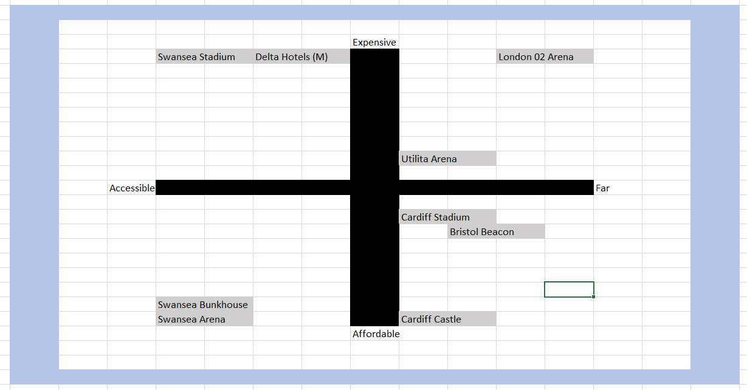
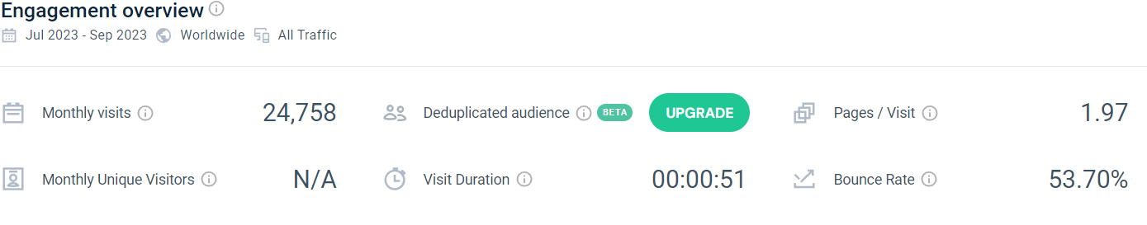

D:

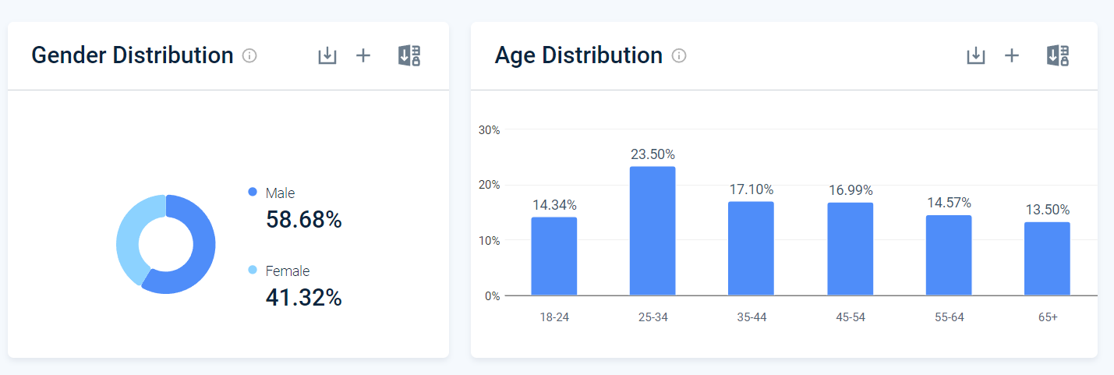
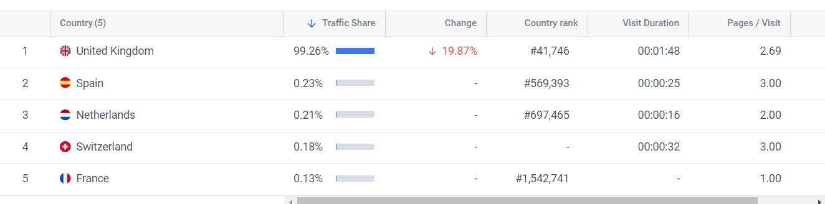
Cardiff Arena (Utilita) (www.utilitaarenacardiff.co.uk, n.d.)
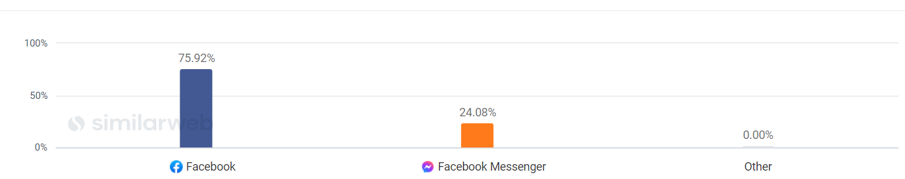
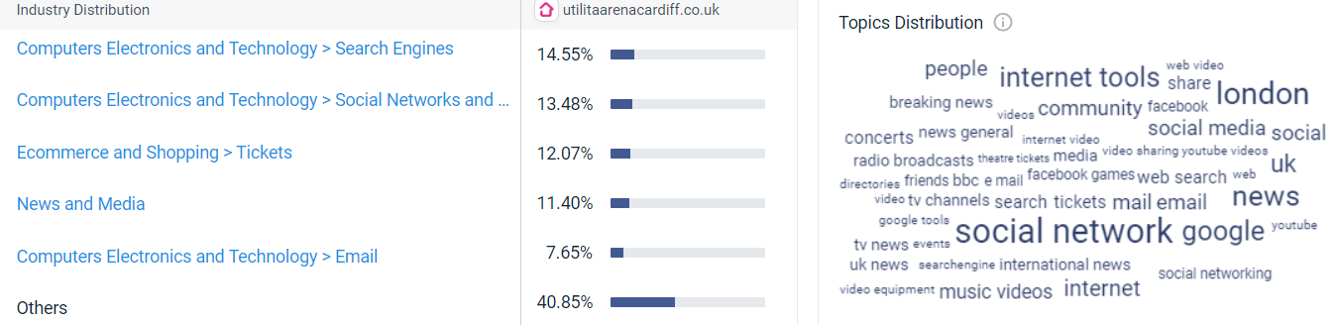

E:
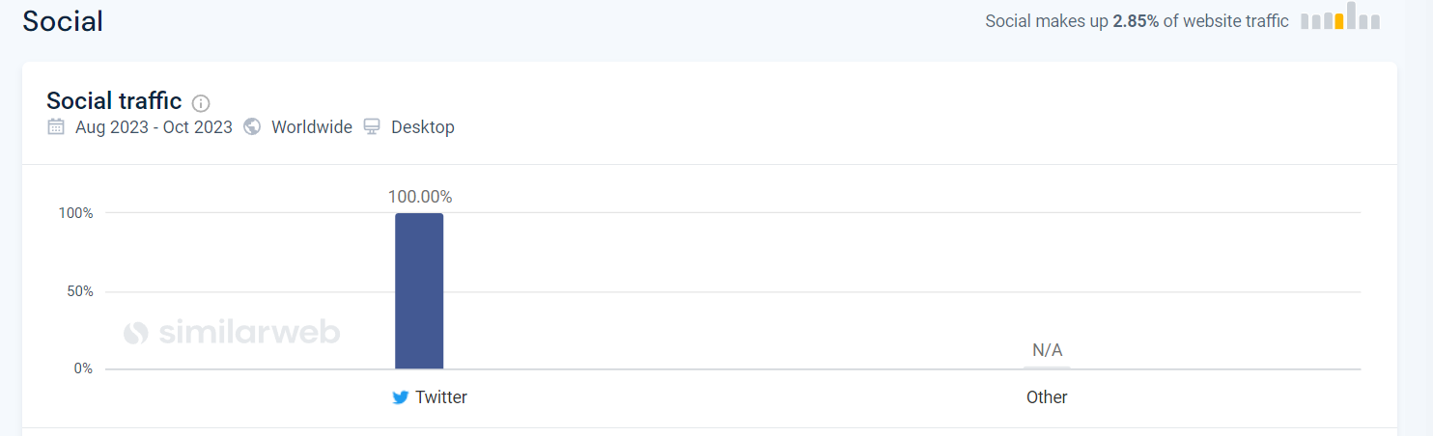

F:
Reach | Act | Convert | Engage
The reach technique involves a business making a name for itself and using communication methods and direct strategies to get the attention of a target audience. This can be through promotion online or direct marketing, using social media contests is a prime example. This applies to the house party event as being able to make students aware of the event will Aline and achieve the goals and objectives to help raise money for charity and create sales for the arena making it an effect strategy in RACE | The use of act in race involves getting a customer into interact or be a part in a certain activity. This can be through online competitions or allowing them tools to search through a social media site or website where they are able to navigate and choose what topics they want to investigate. This applies to house party as customers interacting with the event can provide a lot of benefits down the road. With them being able to win rewards that they can choose from and use at the event. Persuading them to go more as well as encourage ticket sales. Benefitting the event and objective in raising money and making sales | The use of convert in race involves pushing customers to take an action or persuading them to take a next step in a product or service. This can be through providing tangible evidence of the success of an event to persuade or through more subtle methods like good experiences and reviews through word of mouth. This applies to house party but not to a high extent. This is because the event has not happened yet meaning it may be hard to convert based off merit alone, however through word of mouth it could achieve a high amount of action from students. This can Aline with the arenas goals and objectives to make sales and raise money for charity however may not be as effective as other methods | The use of engage in race involves building relationships and communicating directly to them. This can involve putting out surveys for feedback that can be talked about and valued by the arena creating relationships as well as rewards for buying tickets online to give customers a sense of care and relationship for their business. This applies to house party as engaging and interacting with students will be beneficial in the arena creating relationships with customers. Making them happy and more likely to spread the event, this will help the arena achieve its objectives through increased customer sales and raising money for charity.

Race Model by Dave Chaffey (Cuofano, 2023)
G:
YouTube –
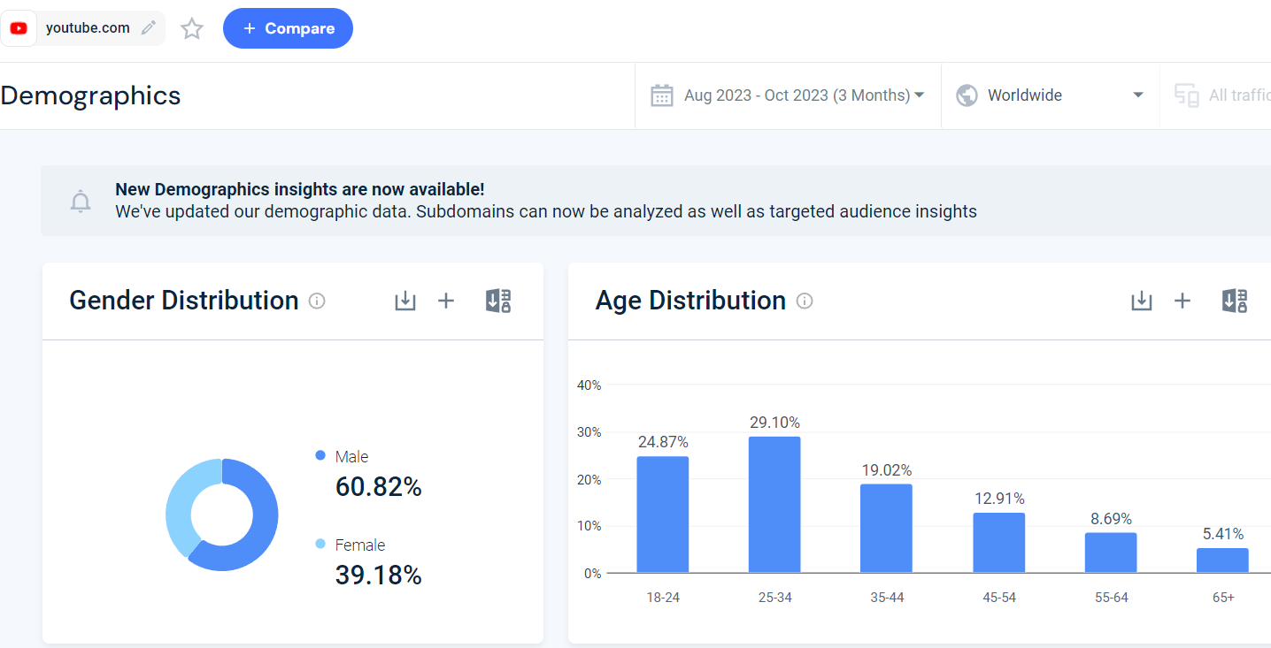
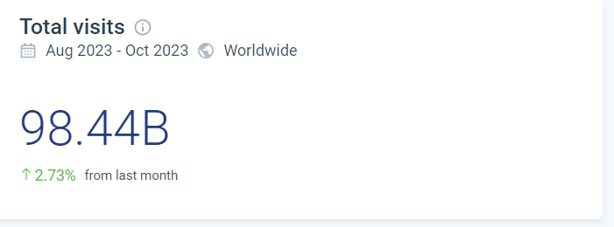
Instagram –
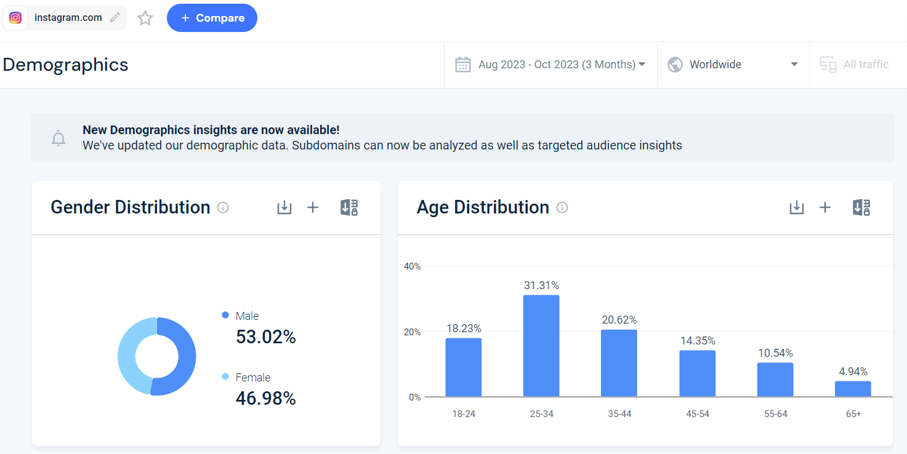
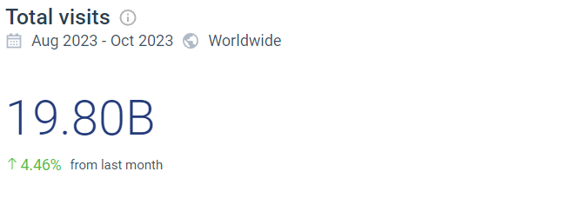
TikTok –
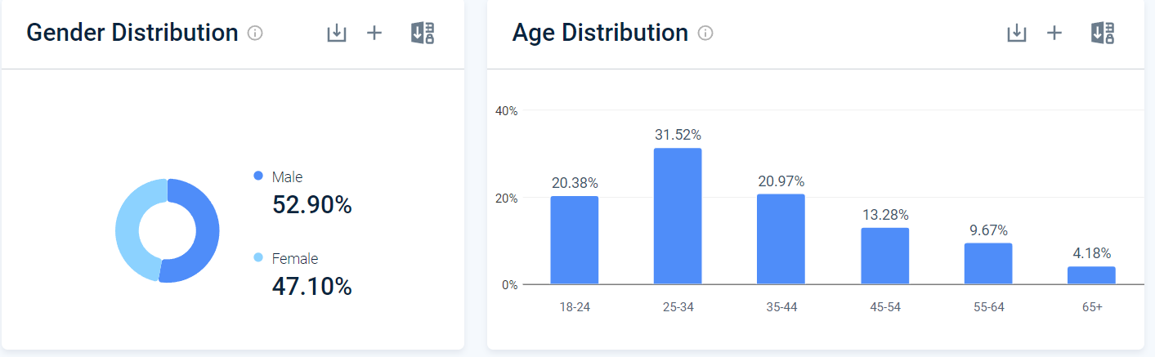
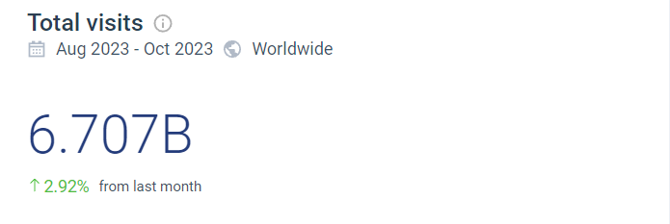

H:
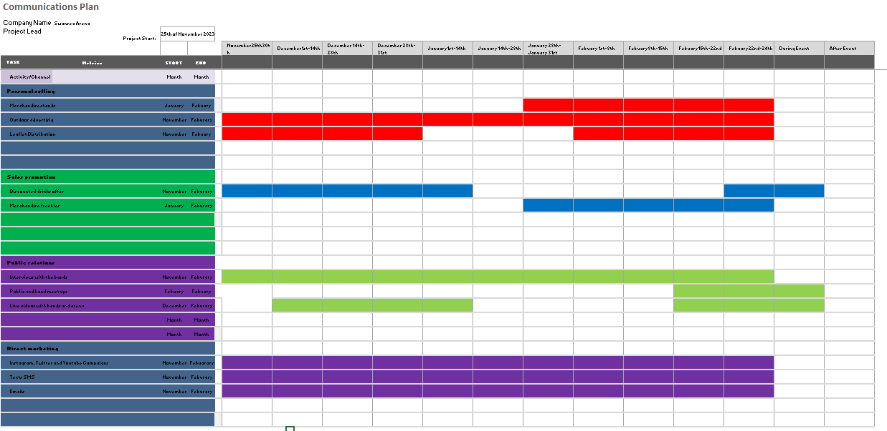

I:

References

Reference list
Blythe, J. (2013). Principles and Practice of Marketing. [online] Google Books. SAGE. Available at: https://books.google.co.uk/books?id=1IhIAwAAQBAJ&printsec=frontcover#v=onepage&q&f=false [Accessed 24 Nov. 2023].
Bowie, D. and Buttle, F. (2011). Hospitality Marketing (Developing the offer). [online] TaylorFrancis.com. Available at: https://www.taylorfrancis.com/chapters/mono/10.4324/9780080967929-13/developing-offer-david-bowie-francis-buttle?context=ubx.
Chaffey, D. (2022). SOSTAC Marketing Planning Model Guide. [online] Smart Insights. Available at: https://www.smartinsights.com/digital-marketing-strategy/sostac-model/.
Chevalier, S. (2023). Online ticket purchasing by demographic UK 2019. [online] Statista. Available at: https://www.statista.com/statistics/286113/event-tickets-online-purchasing-in-great-britain-by-demographic/.
Coursea (2023). The 4 Ps of Marketing: What They Are and How to Use Them. [online] Coursera. Available at: https://www.coursera.org/gb/articles/4-ps-of-marketing.
Cuofano, G. (2023). What is the RACE model? [online] FourWeekMBA. Available at: https://fourweekmba.com/race-model/#:~:text=The%20RACE%20model%20was%20created%20in%202010%20by [Accessed 21 Nov. 2023].
darcawards.com. (2022). Swansea Arena, UK – darc awards. [online] Available at: https://darcawards.com/portfolio/swansea-arena-uk/ [Accessed 8 Nov. 2023].
Geller, L.K. (2002). Response. [online] Lois K. Gellar. doi:https://doi.org/10.1093/acprof:oso/9780195158694.001.0001.
IONOS Startup Guide. (2023). Ansoff Matrix – what actually is it? [online] Available at: https://www.ionos.co.uk/startupguide/productivity/ansoff-matrix/#:~:text=Diversification%20also%20helps%20to%20spread%20the%20risk%3A%20instead [Accessed 20 Nov. 2023].
Kelly, L. (2023). Can you guess which UK city has been named one of the ugliest places in the world? [online] Time Out United Kingdom. Available at: https://www.timeout.com/uk/news/can-you-guess-which-uk-city-has-been-named-one-of-the-ugliest-places-in-the-world-110623 [Accessed 6 Nov. 2023].
Khadejah (2021). The Music Industry Today is Dead Because of This One Thing. [online] ILLUMINATION’S MIRROR. Available at: https://medium.com/illuminations-mirror/the-music-industry-today-is-dead-because-of-this-one-thing-ad22e35f558d.
Lucidchart. (n.d.). What is a SWOT Analysis. [online] Available at: https://www.lucidchart.com/pages/what-is-swot-analysis#:~:text=Humphrey%20and%20his%20research%20team [Accessed 6 Nov. 2023].
Mind Tools (2022). SWOT Analysis. [online] Mindtools. Available at: https://www.mindtools.com/amtbj63/swot-analysis.
Parry, A. (2023). The Swansea Arena House Party: Uniting for music with Music Venue Trust. [online] Eventindustrynews.com. Available at: https://www.eventindustrynews.com/news/uk-and-europe/the-swansea-arena-house-party-uniting-for-music-with-music-venue-trust [Accessed 26 Oct. 2023].
Poppleston Allen. (2022). Breaching your licence. [online] Available at: https://www.popall.co.uk/expertise/licencescertificates/breaching-your-licence [Accessed 8 Nov. 2023].
Rail strikes: Wales hit by biggest rail strike in 30 years. (2022). BBC News. [online] 20 Jun. Available at: https://www.bbc.co.uk/news/uk-wales-61867135 [Accessed 8 Nov. 2023].
SimilarWeb (2023). SimilarWeb Identity. [online] secure.similarweb.com. Available at: https://pro.similarweb.com/#/digitalsuite/websiteanalysis/audience-geography/.
Softjourn Inc. (2023). Top 6 Ticketing Industry Trends to Keep an Eye on in 2022 | Softjourn. [online] Available at: https://softjourn.com/insights/top-event-ticketing-industry-trends.
Statista (2021). Reach of leading social networking sites used by those aged 15 to 25 in the United Kingdom (UK) as of 3rd quarter 2020. [online] Statista. Available at: https://www.statista.com/statistics/1059462/social-media-usage-uk-age/.
Storm Dennis: Review of Wales’ floods of past two years. (2022). BBC News. [online] 17 May. Available at: https://www.bbc.co.uk/news/uk-wales-politics-61483819 [Accessed 8 Nov. 2023].
Swansea. (2023). Introduction of 20mph speed limit. [online] Available at: https://www.swansea.gov.uk/article/20765/Introduction-of-20mph-speed-limit#:~:text=The%20Welsh%20Government%20passed%20a [Accessed 7 Nov. 2023].
ToolsHero (2018). Service Marketing mix, the 7 P’s by Booms and Bitner | ToolsHero. [online] ToolsHero. Available at: https://www.toolshero.com/marketing/service-marketing-mix-7ps/.
Vaidya, D. (2022). PESTLE Analysis. [online] WallStreetMojo. Available at: https://www.wallstreetmojo.com/pestle-analysis/.
www.proquest.com. (2023). Wales: THE COST OF LIVING CRISIS – AN URGENT - ProQuest. [online] Available at: https://www.proquest.com/docview/2763215394?parentSessionId=Wq4difiLKH9D5U4KDV051TvGuS8tX95neYKQZotHMg4%3D&pq-origsite=primo&accountid=130472 [Accessed 8 Nov. 2023].
www.swansea-arena.co.uk. (n.d.). Partners | Swansea Arena. [online] Available at: https://www.swansea-arena.co.uk/about-us/partners [Accessed 5 Nov. 2023].
www.swansea-arena.co.uk. (n.d.). Swansea Arena | About Us. [online] Available at: https://www.swansea-arena.co.uk/about.
www.swansea-arena.co.uk. (n.d.). Swansea Arena | The Swansea Arena House Party. [online] Available at: https://www.swansea-arena.co.uk/shows/the-swansea-arena-house-party [Accessed 26 Oct. 2023].
www.utilitaarenacardiff.co.uk. (n.d.). Home | Utilita Arena Cardiff. [online] Available at: https://www.utilitaarenacardiff.co.uk/ [Accessed 20 Nov. 2023].

