Tanya Gue Ferreira Amaro
2209539
Sustainable Hospitality & Tourism ManagementBMIH5006
Lisa-Marie Bassler, Giulia Chifari, Lisa Knight

Executive Summary
This paper seeks to understand the concept of the greener practice in hospitality industry, more so Hilton Hotels. Environmentally friendly practices like wastage minimization, use of renewable power and water conservation form the central strategies to reduce the impacts of climate change, and work more efficiently to ensure enhanced brand image. The green practice is defined as the organization’s zero waste plan which focuses on the elimination of waste and the effective management of the emission of carbon through recycling and composting plan for Hilton.
Its findings have shed light on many positive values of the zero-waste program reducing the levels of methane emissions derived from landfill, the preservation of natural resources, energy savagery, and enhanced customer satisfaction. It also incurred one-off capital costs and, over time, it helped reduce costs of operations within the hotel. Yet, some barriers are out there which includes the financial implication, training for the staff, and the fact that there may be disruptions when the program will just be starting up.
For Hilton, important recommendations that should be implemented are staff training and ensure proper working with waste management partners and application of the zero-waste system step by step for all Hilton facilities. However, constant review and flexibility of the program implementation is crucial in sustaining the program and making sure that it counts toward the company’s larger sustainability missions and vision. This action also contributes to the environmental goals of the Hilton hotel business as well as to the strengthening of its position in the context of the sustainable development of the hospitality sector.

Table of Contents
Introduction 3
Main Findings 4
Greener Practice Initiative 4
Benefits of Renewable Energy Integration 4
Challenges of Implementation 5
Addressing the Gap in Current Practices 6
Environmental Impact of the Proposed Solution 8
Conclusion and Recommendations 9
Reference 11

Introduction
In order to have less of an effect on the environment and still provide good service, tourism and hotel businesses use "greener" methods. Using water resources more efficiently, cutting down on waste, and getting power from renewable sources are some of these priorities. As people become more environmentally conscious and rules become stricter, there is a huge demand for eco-friendly travel (Kuo et al., 2022). This makes greener practices very important in the hospitality business. Sustainable operations not only save money, but they also help build a brand's image and attract travellers who care about the environment, giving the business an edge over its competitors.
The Hilton Hotels name is known all over the world, and it is a great example of how to use environmentally friendly methods in the hospitality industry. Hilton has more than 7,000 hotels in 123 countries, making it a star in both high-end and budget hotels. The chain has tough plans for being environmentally friendly, for example, the Travel with Purpose program aims to cut carbon pollution by 61% and increase investments in social causes by two times by 2030. The chain has started using technologies that use less energy, strategies to cut down on waste, and long-lasting supply lines (Sharpley and Telfer, 2023). This kind of work by the hotel is shown off by its flagship buildings, like the Hilton London Bankside and the Hilton Hawaiian Village.
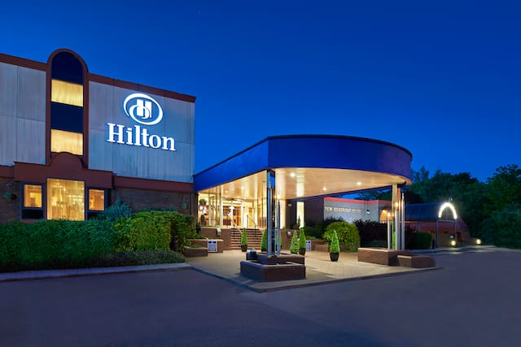

Main Findings

Greener Practice Initiative
Over the years, Hilton Hotels has also embarked on several measures to check its environmental footprint, of which utilisation of renewable energy is a best practice. Renewable energy is the utilisation of clean power with a focus on solar, wind and geothermal energy as an option to relying on fossil energies which leads to emission of greenhouse gases (Jones, 2023). This practice is in line with the Hilton’s Travel with Purpose strategy which is a drive to reduce the company’s carbon footprint by 61% in the year 2030. For instance, Hilton Fort Lauderdale Beach Resort uses solar panel to produce power thus minimizing energy acquired conventionally. Likewise, some hotels in the Hilton group established in Europe have incorporated wind energy systems as their source of energy. This way Hilton guarantees that the energy it uses during its operation is sustainable and that the firm is shielded from volatility emanating from energy supply shocks.
This is even true at Hilton as it indicates timely and efficient utility of the renewable energy sources in the hospitality industry (Mondok, 2023). For example, Marriott International has installed rooftop solar projects at different facilities; most of them produce significant RE and slash CO2 emissions by hundreds of tons per year. Likewise, Geothermal energy has also been adopted at the Hyatt hotels and with this energy company, they have drastically reduced their energy usage. These examples show that renewable energy management practices can indeed be integrated into hotel functioning effectively.

Benefits of Renewable Energy Integration
Use of green energy can help save resources and make buildings more energy efficient, among other benefits. Hilton can use less of this resource by switching from fossil fuels that run out to long-lasting options like solar and wind power (Chatterjee, and Karmakar, 2023). The Hilton Garden Inn Dubai Mall of the Emirates and other places that have solar panels have not only cut down on energy use and operating costs, but they have also shown how easy it is to make everyday activities more resource-efficient. Hilton cares about protecting environmental resources for future generations, as shown by these projects.
The other major benefit is that pollution and the company’s carbon footprint are lowered. The conversion to renewable energy effective reduces emission of greenhouse gases and so assists Hilton to manage its responsibilities to the environment appropriately (Dasgupta and Jamader, 2024). For instance, those industries that have incorporated power efficient technologies including light emitting diode (LED) lighting together with enhanced heating systems have recorded reduced emissions. These are important measures in ways of fighting climate change a challenge that is real to the global community and the tourism and hospitality industry in particular.
Therefore, renewable energy has positive side at the operational efficiency and this also reduce the cost of running the organisation. The costs of solar panels, wind turbines or geothermal systems are high at first but the return generated by them after sometimes is much higher. Some organisations who have installed solar power for instance Hilton Orlando Convention Center have enjoyed low electricity bills thus enabling the firm direct its resources elsewhere in the business. Energy efficiency can also mean improvements in operation dependability since renewable energy systems have a lesser tendency of supply chain interruption than conventional power.
The use of renewable energy increases the company’s brand value by improving its image to satisfy customers. The population of today’s travelers is becoming more and more eco-conscious as many guests explicitly look for sustainable hotels (Avasiloaei, 2022). Renewable energy initiatives that Hilton has embarked upon not only satisfy this segment but also help create Hilton as a market leader in sustainable operations. Research data suggest that environmental or ‘green’ consumers are significantly more likely to engage in word-of-mouth communication and return patronage to hotels that have clear environmental management and operating undertakings, providing further support to the business case for adopting such sustainability initiatives.

Challenges of Implementation
As much as the integration of renewable energy systems has numerous advantages, their implementation entails certain difficulties mainly focal to financial issues and more so cost. This is due to broadly defined initial costs for installation of solar panels or wind turbines are significantly high and could be out of reach for smaller Hiltons or franchisees (Marneros et al., 2023). For example, solar power installation for a mid-sized hotel can range from $200,000 to $500,000; an expense which can be off-putting to some properties. The initial costs, on the other hand, are expensive, and long-term costs savings are usually the components that make up for the costs.
From this perspective, staff training and staff engagement presents another challenge. Renewable energy systems call for changes in technology and practices that may not be easy for the employees to accept. These systems are however only effective if implemented with right training and support in place. Hilton needs to guarantee that the specialists working for the company have essential knowledge about renewable energy systems and their operation, which may need more money for training and development.
The implementation phase also entails certain activities that interrupt the normal functioning of a hotel (Atmaca Çetin et al.,2022). For instance, putting a solar system in a property or erecting a wind mill could mean that part of the property must be closed or some facilities off limits most of the time. A few of these disruptions may affect the revenues and guests’ experience, especially when serving markets with numerous competitors. The effect may be managed, which in turn makes implementation procedural and can be even more challenging.
Managing renewable energy systems with time is also a challenge, it is for this reason that maintenance is crucial and those systems need to be updated every now and then. While the individualistic aspects of management can be somewhat marginalised, insufficient attention to these factors can result in a drop of productivity and a lack of a high-quality financial outcome (Smith and Stewart, 2024). Assessing the key success factors also present Hilton with the following challenges Durban: Hilton must also incorporate sound maintenance policies regarding renewable energy and become committed to allocating adequate funding to support such endeavors in the long run.

Addressing the Gap in Current Practices
It should be noted that Hilton has improved over the years with regards with renewable energy utilisation but it is still lacking in its waste management. Recycling remains a big issue at Hilton and many other properties due to the absence of adequate recycling solutions that would support the goal of sustainability (Ruiz Molina et al., 2022). Effective separation and recycling of waste have been indications of a decrease in landfill burden and environmental pollutive role; however, these Shannon practices are not uniformly implemented in Hilton households.
Therefor Hilton could create a zero-waste program which includes; proper waste classification, treatment of the waste, partnering with waste management companies such as recycling companies. In this case, under this program, hotels would commission type and source separation where waste would be classified into those that are bio-degradable, those that can be recycled or those that cannot be recycled. Biodegradable waste can be collected and acted using anaerobic digestion plants, where the waste transforms to biogas and compost While hard and non-recyclable waste can be collected and taken to recycle centres (Buratto, 2024). Waste which cannot be recycled could also be reduced by ensuring that waste was changed to energy hence reducing the amount of waste that was dumped back into the environment.
The peculiarity of this solution is that is rather easily scalable and its cost will not be too high. There would be an initial outlay for purchasing waste segregation bins, notices and training of workers which are minimal when compared to long term benefits of lower waste disposal expenses (Whitfield et al., 2022). Such a program would complement the existing sustainable program of Hilton, thereby improving its effectiveness in the achievement of the environment objectives.
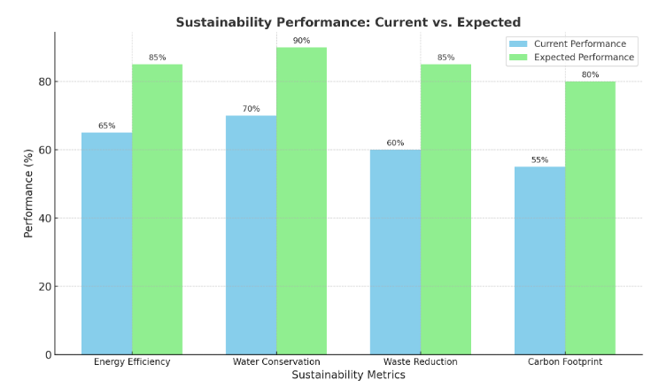

Environmental Impact of the Proposed Solution
The detailed zero waste expansion plan presented below would have massive chronic positive environmental impacts especially in the areas of exhaust emission and resource management. Reducing landfilling would reduce methane emission since it is a flammable greenhouse gas and encourages global warming (John Morrison et al., 2022). Again, paper products, plastics and metals when recycled would help to conserve the natural resources and the energy used to obtain them from raw form. Moreover, conversion of organic waste into biogas and compost would produce other useful end products such as energy for use and nutrient for enrichment of soil respectively, enhancing sustainability.
It can be pointed out that this program correlates well with the UN Sustainable Development Goals which include the 12th and the 13th Goals that are dedicated to the responsible consumption and production, as well as actions aimed at climate change. When Hilton takes the zero-waste approach, it would not only improve its environmentally sustainability agenda but would also support the worldwide campaign against climate change.
The zero-waste program would also supplement Hilton’s attempts at deploying renewable energy which would make it a one stop shop in terms of sustainability awareness (Kishore, 2022). Altogether, all these practices would help the company in its endeveour to minimize on its emission of carbon, optimum utilisation of resources and optimisation of its operations. This complementarity establishes the need for using a number of approaches towards enhancing sustainability as a way of attaining effective environmental gains.
Despite the proven record of Hilton in advances of renewable energy utilisation, the company needs to improve waste management. Through addressing this gap, the company has the opportunity to improve its environmental performance and corroborate the company’s environmental policies of the zero-waste program (McGregor et al., 2024). These effects also help Hilton to build a better reputation and improve its operation and customer satisfaction thus can help Hilton to create a sustainable development in an era of growing environmental concern.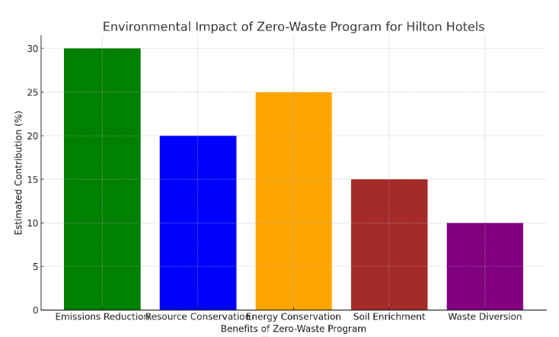

Conclusion and Recommendations
Therefore, sustainability has reshaped Hilton Hotels business by integrating renewable energy and other greener measures that leads to the conservation of resource, reduction of carbon emission and increased brand equity. The proposed zero-waste program helps to fill an important gap in Hilton’s current practices, which concerns waste segregation, recycling, and the utilisation of more sophisticated waste- to- energy technologies. This initiative has a good potential to provide significant environmental impacts such as decreasing methane emissions and resource use, and the integration of this project with the UN SDGs.
To avoid any problems of weak adoption of the proposed zero-waste program in Hiltons, the following suggestions should be provided: Hilton should roll out the proposed program gradually across different properties through a phased approach to ensure the targeted properties are among those with high traffic to help the company to gain maximum returns with the program. Staff involvement and brief the guests on the program is crucial in order to improve the program. The hotel should also work with local recycling organisations and also embrace technologies such as the anaerobic digesters. All these indicate that the sustainable practices need an ongoing evaluation and flexibility. Audits for efficiency, feedback from its guests.

Reference
Atmaca Çetin, H., Uz, F. and Tuna Ultav, Z., 2022. After İstanbul Hilton: Turkey’s local-global dichotomy in the 1950s interiors of Divan Hotel and Çınar Hotel. Interiors, 12(1), pp.19-49.
Avasiloaei, D., 2022. Reinventing the Business Model in the Tourism Industry based on Sustainable Circular Economy and Innovation. ENTRENOVA-ENTerprise REsearch InNOVAtion, 8(1), pp.435-448.
Buratto, A., 2024. How can we encourage more sustainable food consumption choices? (Doctoral dissertation, UCL (University College London)).
Chatterjee, P. and Karmakar, R., 2023. Role of sustainable development goal and digitalization in hospitality industry: A systematic literature review. Fostering Sustainable Businesses in Emerging Economies: The Impact of Technology, pp.223-245.
Dasgupta, D.S. and Jamader, A.R., 2024. Revolutionizing Tourism and Hospitality: Harnessing AI for Sustainable Transformation. Available at SSRN 4896697.
John Morrison, R. and Aalbersberg, W.G.L., 2022. Anthropogenic Environmental Impacts on Coral Reefs in the Western and South-Western Pacific Ocean. In Coral Reefs of the Western Pacific Ocean in a Changing Anthropocene (pp. 7-24). Cham: Springer International Publishing.
Jones, P., 2023. Towards Net-Zero Emissions in the Global Tourism Industry. Athens Journal of Tourism, 10(2), pp.125-136.
Kishore, V., 2022. Integrating Eco-design Thinking in Redesigning of a Communication Device: Eco-design strategies for sustainable product design and development.
Kuo, F.I., Fang, W.T. and LePage, B.A., 2022. Proactive environmental strategies in the hotel industry: Eco-innovation, green competitive advantage, and green core competence. Journal of Sustainable Tourism, 30(6), pp.1240-1261.
Marneros, S., Papageorgiou, G. and Efstathiades, A., 2023, May. Evaluating Strategies for Sustainability and Business Performance in the Hotel Industry of Cyprus. In International Conference on Tourism Research (Vol. 6, No. 1, pp. 177-185).
McGregor, K., Becken, S., Vada, S. and Mackey, B., 2024. Enhancing compliance assessment through regenerative transformations–A food waste perspective. Journal of Sustainable Tourism, pp.1-20.
Mondok, A., 2023. Reducing Costs and Creating Value in the Hotel Industry-Forced Good Practices. Multidiszciplináris kihívások, sokszínű válaszok-Gazdálkodás-és Szervezéstudományi folyóirat, (3), pp.132-167.
Ruiz Molina, M.E., Belda-Miquel, S., Hytti, A. and Gil-Saura, I., 2022. Addressing sustainable food management in hotels: proposing a framework and examining hotel groups. British Food Journal, 124(2), pp.462-492.
Sharpley, R. and Telfer, D.J., 2023. Tourism supply in a growth-based economy. In Rethinking Tourism and Development (pp. 102-129). Edward Elgar Publishing.
Smith, K. and Stewart, E., 2024. Under attack? Public accounts of health inequalities and the social determinants of health in Scotland. Journal of Critical Public Health, 1(2), pp.1-74.
Whitfield, J., Svobodova, P. and Webber, D.J., 2022. How Can We Reduce Conference Venues''Use of Single-use Plastics?. Event Management, 26(7), pp.1577-1590.

