History and Theory 2
Essay - Critical Analysis of Architecture Post 1945
There are many remarkable examples of post 1945 architecture. However, an outstanding piece of architecture post 1945 is the MAXXI museum. Both the architect and the purpose, as well as the design of this building were equally as interesting and have played a vital role in why the museum has the reputation it has today. This essay will explore the research with a critical analysis on all of the aspects of the museum. This building resides in one of the most architecturally rich cities in the world, and this essay will aim to analyse if the buildings design and purpose equates to its surrounding wealth. Like most, this project has not been without its troubles to overcome in its day to day life, which will be critically analysed to identify the impact (if any) these have had to the building.
The architect responsible for this piece of architecture is Zaha Hadid. Hadid was assisted by Patrik Schumacher in the main design with more than 50 additional people combined between the competition and design team. However, she was classed as the lead designer and had the biggest impact on the design of the iconic building (Zaha Hadid Architects , 2009). This 30,000m² building required a design team of 20 architects and designers to reach its completion in 2009 (Zaha Hadid Architects , 2009). The amount of work and development completed by the MAXXI museum team is showcased in the final building which is a staple of modern architecture. However, contradictory to its modern status, the MAXXI museum was designed with a very non-environmentally friendly material, difficult in achieving that modern naturalist look. Hadid had an extremely influential career where her architecture broke through boundaries which had previously been in place for female architects. The MAXXI museum holds a great influence in just how significant Hadid was in the field of architecture for women. An example proving just how great she was for the development of women in construction was when Hadid won the Stirling Prize for the MAXXI centre in 2010 (Zukowsky (2023) was a useful source of information). Hadid also won in 2011 for her work on the Evelyn Grace Academy (Frearson (2011) was an interesting source). For these and many other examples of her designs, she became the first women in the history of the RIBA Gold Medal to be named as a solo winner. Meaning she was the first solo female architect to win the Gold Medal in the 167 years from its creation in 1848 (Zaha Hadid receives the 2016 Royal Gold Medal (RIBA, 2016). This building is not only special because of its architecture but also of what it represents in the history of architecture.
The client that this remarkable project was produced for is the Italian Ministry of Culture, and its purpose is to house arts of the 21st century. The Italian Ministry of Culture, previously known as the Ministry of Culture and Environmental Heritage prior to 2013, is responsible for the protection, enhancement and promotion of Italian cultural heritage. This ranges from archaeological to architectural heritage, archival and library goods, as well as cinema entertainment and tourism, and to what the MAXXI is an example of, the care of the collections of museums and places of state culture (Directorate General for Archaeology, Fine Arts and landscape Ministry of Culture (Ministero Della Cultura (2022)
The MAXXI museum is located in the northern part of central Rome, specifically Via Guido Reni 4A in Roma, (MAXXI – National Museum of the 21st century arts (arcVision Prize, 2010) and sits a short distance from buildings of major historical significance. Some of these include the Colosseum and Pantheon amongst many others. With the MAXXI building being in such a historical location, the client and designers had to ensure that the architecture reflected and respected its surroundings. Its success or failure to do this will be discussed later in this essay.
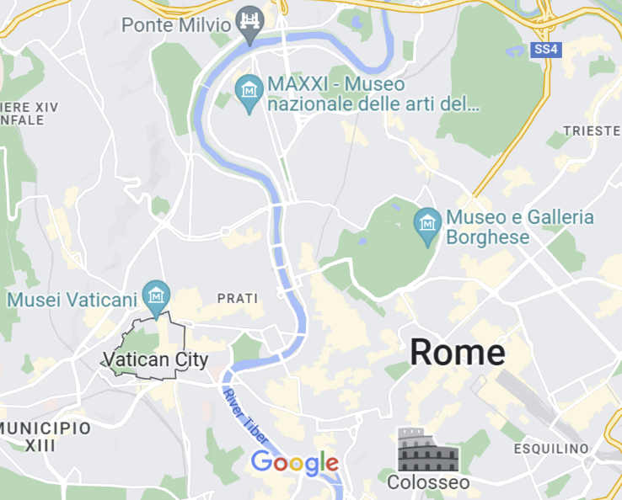
Figure 1
The location of the MAXXI Museum (Google Maps, 2023)

The short life of the MAXXI building has been extremely eventful. From the highs of winning awards and being a part of Hadid’s legacy, to being faced with closure, the museum has had its fair share of hurdles to overcome since its completion in 2009. Although the building was completed in 2009 the project was started all the way back in 1998, with competition submissions from 273 designers. Fifteen finalist were chosen and of these, Zaha Hadid was awarded the contract. The aim of the project was described as the refurbishment of a former military zone of the Flamino district (MAXXI – National Museum of the 21st century arts (arcVision Prize, 2010). The construction of the MAXXI, comprised of 6,700 tonnes of steel and 50,000m³ of site cast concrete which took 6 years to complete. Figure 2 shows the vast supports for the pouring of concrete and installation of steel in the construction of the museum. Due to the cavernous amount of concrete used in the construction the supplier, Calcestruzzi, installed a plant on site to speed up the construction timeline (MAXXI – National Museum of the 21st century arts (arcVision Prize, 2010).
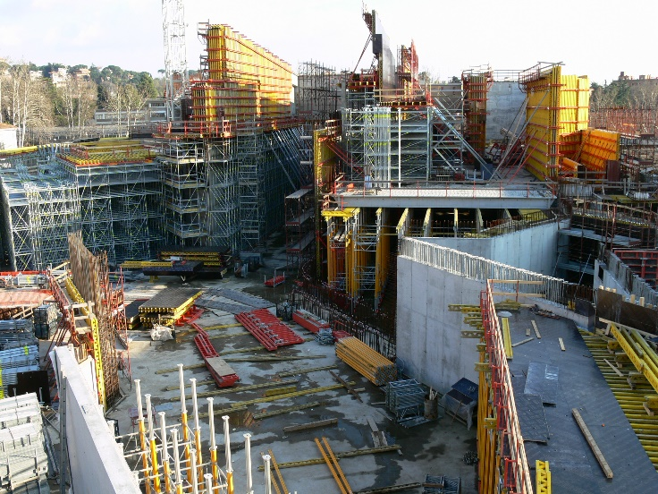
Figure 2
Construction phase image of the MAXXI Museum (arcVision, 2010)

The materials used in this building (steel, concrete, and glass) could be described as some of the most environmental damaging and carbon intensive materials which could be used, especially in the volumes in this project. But has this been justified and what solutions and justifications are being implemented to improve the overall impact of the building?
In the February of 2022, the MAXXI Museum released a competition for an environmental and sustainable upgrade to the building and introduction of a new research and development building as well as outdoor green spaces for exhibitions (Mitchell (2022) was a useful source of information). The upgrade to the MAXXI could be described as an entire overhaul to the sustainable profile of the building. To do this ‘the MAXXI Hub’ will include conservation laboratories for contemporary art as well as training spaces and innovative storage facilities. Another aspect to the project which will bring the museum into the current day, known as ‘Project Green’, and will include the previously mentioned green areas, which will be designed by artists and agronomists with outdoor exhibits, environmental workshops and gardens which can be used to harvest and grow vegetables. The upgrade to the museum is described by the author of the article as a “Laboratory of the future” (Geraci (2022) was an interesting source of information).
The overall masterplan will improve the sustainability of the MAXXI museum. To reduce the MAXXI’s greenhouse gas emissions they will install solar panels to the roof, methane gas boilers will be disinvested, and all lights in the building will be removed and replaced with LED technology (Mitchell (2022) was a useful source of information). These improvements show great significance in the awareness and consideration of the environmental impact of the MAXXI for the future. The President of the MAXXI museum Giovanna Melandri said that the masterplan
“will enable us to confront the ‘new world’ that must arise from the syndemic, environmental, social and health crisis and become even more a laboratory of the future” (Mitchell (2022) was a useful source of information).
The plans for the upgrade are due to be completed by 2026, and bring the building into the ‘New World’ of sustainability. The brief for the competition is described as a
“confrontation of the challenges represented by further innovation, being marked by sustainability and the state of the art technologies which be showcased in the upgraded and renovated museum” (Hickman (2022) was an important piece of information).
However, it could be argued why were these upgrades not considered when the building was originally built. Even though the building was completed 14 years ago, technologies like solar panels have been used long before 2009. Even if you take the original design submission date of 1998, solar panels had been in existence for many years prior to this, even if not as efficient as current technologies. It could also be argued that the materials used in the construction of the MAXXI museum should have been offset which sustainable technologies, or even that sustainable technologies should have been integrated in to the initial design and construction of the building. As it is the first institution in Italy dedicated to contemporary art and architecture (Crook (2022) was a useful source of information), measures like sustainably sourced energy and the overall impact of the building should have been investigated and implemented in the first instance.
Although there are upgrades and additions being completed to the museum, nothing can be taken away from the significance of the architecture of the MAXXI museum. The museum which is devoted to contemporary creativity, art and architecture, resembles exactly what its purpose is. The MAXXI is an example of a creative, artistic marvel of architecture. The weaving, overlapping design by Hadid and her extensive team had a number of theories and aims behind them which led to the success of the MAXXI. Hadid, has used her architectural skills to compliment the MAXXI with its neighbouring historical buildings. The MAXXI has no fixed boundaries, and like its surrounding structures, the MAXXI has a constant of intersecting planes, which create a combination of indoor and outdoor spaces. The MAXXI occupies its location so well due to how it interprets the existing urban grids to create its own complex form of weaving and overlapping lines shown in Figure 3.

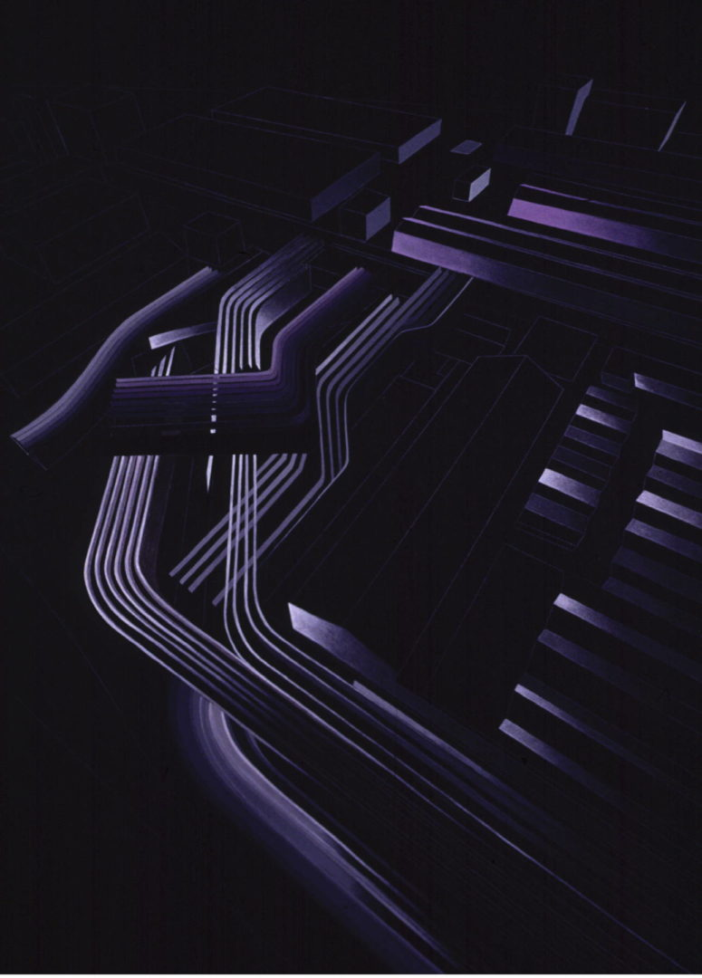
Figure 3
A painting showing the overlapping planes of form in the MAXXI Centre. (Hadid, no date)

Every single component of the MAXXI is accessible from a large high reaching lobby, from the galleries to auditoria, cafeteria, shops and services. The users movement form the lobby is then dictated via pedestrian walkways which mirror the contours of the building, and provide a link from the building to the existing urban environment which have been obscured for over a century (Zaha Hadid Architects, 2009). As previously discussed, the small amount of materials used in the building only consisted of steel, cement and glass. These combined resulted in a fluid, simple and yet complex design which sits centrally amongst a mix of residential and commercial buildings (shown in Figure 4). The buildings form and materiality contrasts everything of which it has been built amongst. Although it does not resemble any of its surroundings, its design does affect the surrounding historical beauties. The elongated elevation creates an interesting street picture and although it contrasts, it does something far from overpowering the image that you see. As shown in Figure 4, on the east side of the image the building pokes through but sits back and leads you.

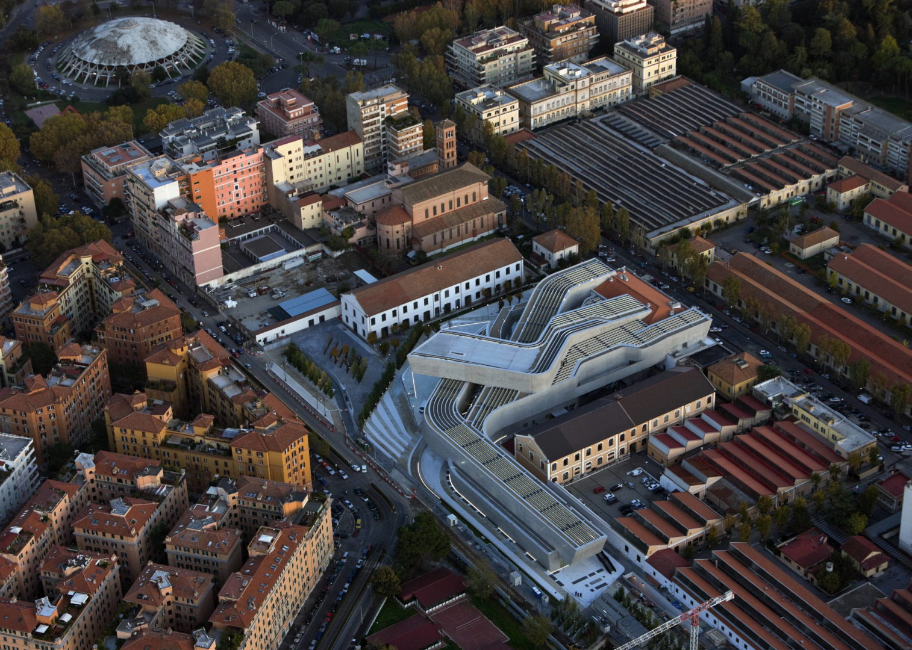

Figure 4
A picture showing the MAXXI in context (Zaha Hadid Architects ,2009)

Just two years after the opening of the MAXXI museum it was faced with possible closure. With the MAXXI being such a large project with a total construction cost of £128 million, the museum would have to maintain a constant flow of income to maintain and justify its scale, cost and place in the centre of Rome (MAXXI: museum of XXI century arts (AJ Buildings Library, 2009). The main reason for these threats was due to the pressure which was being put on by the economic crisis, which caused a squeeze on cultural funding which also resulted in much reduced funding for the arts. In April 2012 the museum was informed that its budget of 11 million Euros would fall drastically to 2 million Euros. As the officials were unable to put forward a budget for 2013, the government reportedly started proceedings to put the high profile (and rather new museum) into administration (Rosenfield (2012) was an interesting source of information). These problems arose when an 800,000 Euro hole was found in the MAXXI’s accounts, even though the museum stated that this had been offset by profit in the early years. Although this did not change the Italian government’s plans to hand the museum over to administrators with the projected losses summing 11 million Euros for the next three years. However, with 450,000 visitors a year, Hadid has described the museums success as “remarkable” as it built its reputation in the field of contemporary art (Rosenfield (2012) was an interesting source of information).
To conclude, the MAXXI museum has been through the toughest of times, these included a financial crisis and most recently a global pandemic. With the MAXXI museum having been able to progress and push through these difficult times, the road into the future only looks towards even more progression and development. In the future, this building will play a pivotal role in showcasing the best of Italy’s twenty first century arts and design. And as it is a marker for the incredible career of Zaha Hadid, it will play a role in her story as part of one of the most influential architects in recent history, for years to come. The modern sweeping design both contrasts and respects everything in its immediate surroundings to reflect its meaning and purpose for why it was built. Therefore, it can be concluded from the research that has been critically analysed today that the MAXXI museum has been revolutionary for architecture and design, through its struggles and triumphs. It could therefore be argued that the MAXXI museum will help pave the way for more natural and environmentally friendly designs and works of art to be created, updated and completed, especially as the MAXXI museum was considered extremely harmful in its production, but is moving towards a more positive light in twenty-first century architecture.
References
AJ Buildings Library (2009) MAXXI. Available at: MAXXI: Museum of XXI Century Arts | AJ Buildings Library (Accessed: 22nd March).
arcVision Prize (2010) MAXXI National Museum. Available at : MAXXI - National Museum of the 21st Century Arts - arcVision.org (Accessed: 18th March).
Crook, L (2022) Competition launched to extend MAXXI museum by Zaha Hadid Architects. Available at : Competition launched to extend MAXXI museum by Zaha Hadid Architects (dezeen.com) (Accessed: 20th March).
Frearson, A. (2011) Stirling Prize Shortlist. Available at: Stirling Prize shortlist 2011 | Dezeen (Accessed: 16th March).
Figure 1 – Google Maps (2023) Location of the MAXXI. Available at: Google Maps (Accessed: 18th March).
Figure 2 – arcVision (2010) Construction phase image of the MAXXI Museum. Available at: MAXXI - National Museum of the 21st Century Arts - arcVision.org. (Accessed: 18th March).
Figure 3 : Hadid, Z (No Date) A painted representation of the MAXXI’s overlapping planes. Available at : MAXXI: Museum of XXI Century Arts – Zaha Hadid Architects (zaha-hadid.com) ( Accessed: 21st March).
Figure 4 : Zaha Hadid Architects (2009) A picture showing the MAXXI in context. Available at : MAXXI: Museum of XXI Century Arts – Zaha Hadid Architects (zaha-hadid.com) (Accessed : 16th March).
Geraci, G, M. (2022) MAXXI Museum Masterplan. Available at : 'Laboratory of the future': Rome's Maxxi museum unveils plans for new R&D centre, green spaces and solar energy (theartnewspaper.com) (Accessed: 20th March).
Hickman, M. (2022) The ZHA – Designed MAXXI museum launches an environmental upgrade competition. Available at: The ZHA-designed MAXXI museum launches an environmental upgrade competition (archpaper.com) (Accessed: 20th March).
Ministero Della Cultura (2022) Directorate General for Archaeology, Fine Arts and landscape ministry of culture. Available at: Home - DGABAP (cultura.gov.it) ( Accessed: 17th March).
Mitchell, B. (2022) Rome’s MAXXI Museum reveals plans for new building and green spaces. Available at : Maxxi museum reveals plans for new building, green spaces | blooloop. (Accessed: 19th March).
RIBA (2016) Zaha Hadid receives royal gold medal. Available at: Zaha Hadid receives the 2016 Royal Gold Medal (architecture.com) (Accessed: 17th March)
Rosenfield, K. (2012) Zaha Hadid’s MAXXI museum faces closure. Available at: Zaha Hadid’s Maxxi Museum faces Closure | ArchDaily (Accessed: 23rd March).
Zaha Hadid Architects (2009) MAXXI. Available at MAXXI: Museum of XXI Century Arts – Zaha Hadid Architects (zaha-hadid.com) (Accessed: 14th March).
Zukowsky, J (2023) Zaha Hadid. Available at: Zaha Hadid | Biography, Buildings, Architecture, Death, & Facts | Britannica (Accessed: 16th March).

