
Master of Business Administration (MBA)
Module: International Marketing: Principles and Practices
Module code: LCMB7026

Analysis of IKEA’s International Marketing Strategies in India and the UK

Lecturer: Tushara Balendran

Student Name: Shifat Hossain
Student ID: 2436037

Word count: 5489
Date of Submission: 24 April 2026

Table of Contents
1. Introduction 2
2. Company Background: IKEA 2
3. PESTLE Analysis: UK vs India 3
Political Factors 3
Economic Factors 3
Social & Cultural Factors 4
Cultural Analysis Using Hofstede’s Model 4
Technological Factors 6
Environmental Factors 6
Legal Factors 7
Comparative Summary 7
4. Segmentation, Targeting, and Positioning (STP) (≈500 words) 7
Market Segmentation 8
Targeting 9
Positioning 9
Perceptual Mapping 10
Critical Evaluation 10
5. Marketing Mix Analysis (7Ps) 11
Product 11
Price 11
Place 12
Promotion 12
People 13
Process 13
Physical Evidence 13
Similarities and Differences of 7Ps 14
6. Directional Development Strategy 14
7. Ethical Issues in IKEA’s Marketing Mix 15
8. Recommendations 16
9. Conclusion 17
10. Reflective Account (Kolb Reflective Cycle) 17
Concrete Experience 18
Reflective Observation 18
Abstract Conceptualisation 18
Active Experimentation 19
Conclusion 19
Reference 21
Appendix 24

1. Introduction
IKEA is a Swedish multinational corporation and has cost-effective flat-packed furniture. It has transformed the furnishing of homes by providing low-cost, effective designs all over the world. The operations of the company cover many countries, and its products are also adjusted to suit different consumer tastes. India and the UK are two different markets for IKEA, where India provides a picture of a fast-growing economy with varied consumer behaviour, whereas the UK has an advanced, competitive retail market (Sageder and Durstmüller, 2019). Price sensitivity in India is the opposite of the demand for premium products in the UK, and hence, it is a special comparative analysis. In the case of an international manager like IKEA, international marketing is a necessity. Nonetheless, recent standardisation theories such as the Globalisation of Markets by Levitt might not work well with IKEA (IKEA, 2025). The idea of one-size-fits-all approaches is challenged by cultural and economic differences, e.g. in India, most products are preferred in a personalised and localised environment. The report will also compare the marketing strategies of IKEA in India and the UK through PESTLE and STP, in addition to the 7Ps and give a comparative analysis with recommendations on how the company can further grow. A reflective account of the report will be provided using Kolb’s Reflective Cycle.

2. Company Background: IKEA
Ingvar Kamprad started IKEA in 1943 in Aalmhult, Sweden. It started as a small mail-order company but expanded at a very fast rate to become a leader in low-cost home furnishings (IKEA, 2025). Kamprad had an idea to design functional designs with low prices, so that they could be affordable to many. IKEA started expanding its operations to foreign countries in the 1970s, and its earliest store was established in Switzerland. By the 90s, IKEA had penetrated the US and many other countries in Europe, Asia and the Middle East (IKEA, 2026). Although the standardisation model used in IKEA, which consists of producing centrally and designing all its stores in the same format, benefited the company by allowing it to increase its presence, this strategy has not been without its challenges. As an illustration, sometimes it needs more flexibility than the standardisation strategy that IKEA has implemented to adjust to local tastes and cultural preferences. The mission of IKEA is to innovate a better everyday life for many people. It has a vision of providing a broad selection of affordable, functional, and sustainable home furnishing products (IKEA, 2025). Nevertheless, labour practices and impact on the environment, particularly in emerging markets, are often the subject of criticism in the company due to its cost-efficiency strategy. IKEA entered the UK market in 1987, exploiting the need of the mature market to have furniture that was affordable and stylish (IKEA, 2026). Its UK strategy entailed a combination of standardisation and localisation, both iconic products and localisation. Conversely, IKEA experienced difficulties in entering India in 2018, which was mainly caused by price sensitivity and complicated regulations as well as a heterogeneous consumer base (IKEA, 2025). Although IKEA's low-price model is at the core of its success in the UK, the market in India required greater customisation, which was constrained by the conventional global strategy of IKEA.

3. PESTLE Analysis: UK vs India
A PESTEL analysis is a strategic framework commonly used to evaluate the business environment in which a firm operates. Traditionally, the framework was referred to as a PEST analysis, which was an acronym for Political, Economic, Social, and Technological; in more recent history, the framework was extended to include Environmental and Legal factors as well (Hanaysha, Al Shaikh and Alzoubi, 2021).
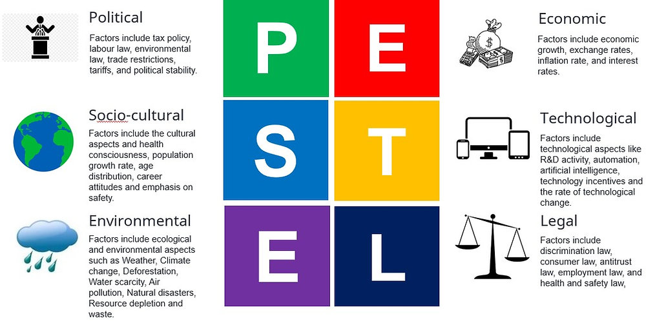
Figure 1: PESTLE Analysis
Source: (Hanaysha, Al Shaikh and Alzoubi, 2021)

Political Factors
The political environment in the UK is stable, and this is favourable to international companies such as IKEA. IKEA has an opportunity to grow with minimal regulation because the laws governing franchising in the country are clearly defined, and the country promotes free trade (IKEA, 2025). Nonetheless, after Brexit, doubts about trade tariffs and labour regulations may upset future operations of IKEA.
However, India is a more complicated political environment. The bureaucracy and regulatory challenges in the country make it very challenging to enter the market. In 2018, IKEA encountered issues like problems with land acquisition and the prohibition of multi-brand shops (Hanaysha, Al Shaikh and Alzoubi, 2021). Although the government of India has made efforts to promote foreign investment by providing initiatives such as the Make in India, the regulatory environment is not predictable for the foreign brand.

Economic Factors
The UK is a well-established economy with a GDP of 2.85 trillion in 2020 and high purchasing power, which is advantageous to the value-based pricing strategy of IKEA. IKEA can retain stable pricing strategies since the inflation rate is relatively low (1.5% in 2020) in the country (Inter IKEA Group, 2025). Nevertheless, the sensitivity of price after Brexit is also rising, and it can threaten the profitability of IKEA.
India, however, has a fast-paced economy and a GDP of $2.87 trillion (2020), yet income inequality is also a problem (Inter IKEA Group, 2025). The middle class is growing; however, most of the population remains sensitive to price. IKEA needs to change its pricing strategy to be affordable, particularly in lower-income areas, because its GDP per capita is low, and the inflation rate is 6.6% in 2020 (Inter IKEA Group, 2025).

Social Factors
Customers in the UK are more concerned with convenience, sustainability and value money. The IKEA flat pack furniture is compatible with the British consumer patterns, particularly the youth professionals and families (Hanaysha, Al Shaikh and Alzoubi, 2021). Nevertheless, the trend towards green products is increasing, and IKEA's sustainable product line should also be developed.
Family-oriented lifestyle, traditional preference to wooden furniture, and religious restrictions on what to eat are cultural issues in India that affect consumer behaviour greatly. IKEA would have to localise its products to meet local tastes, including launching more wooden and vegetarian products (Altay, Okumuş and Adıgüzel Mercangöz, 2022). The younger and urban population in India is more inclined towards adopting the modern design of IKEA, although price sensitivity is also a very crucial factor.

Cultural Analysis Using Hofstede’s Model
Hofstede’s Cultural Dimensions provide valuable insights into the differences between the UK and India. Below is a comparison of key cultural dimensions:
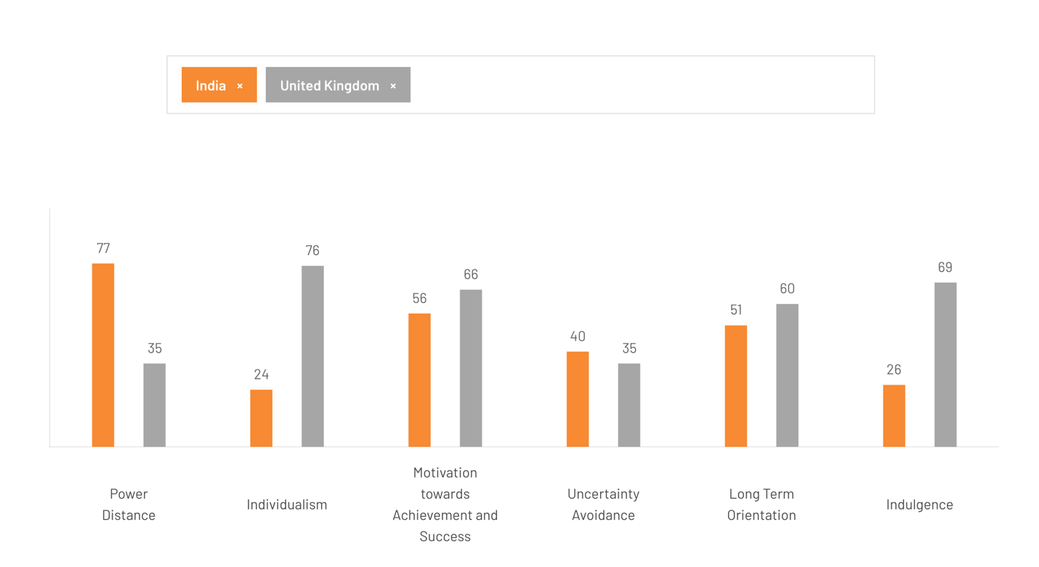
Figure 2: Cultural Analysis Using Hofstede’s Model
Source: (Hofstede Insights, 2025)
Cultural Dimension | UK | India
1. Power Distance | 35 (Low) | 77 (High)
2. Individualism | 76 (Individualistic) | 24 (Collectivist)
3. Motivation Towards Achievement And Success | 66 (Feminine) | 56 (Masculine)
4. Uncertainty Avoidance | 35 (Low) | 40 (High)
5. Long-Term Orientation | 60 (Long-Term) | 51 (Short-Term)
6. Indulgence | 69 (high) | 26 (low)
Table 1: Cultural Analysis Using Hofstede’s Model (Made By Author)
Cultural Dimensions provided by Hofstede can help to understand the cultural differences between the UK and India. The UK has a low power distance (35) and is more egalitarian, whereas India has a higher score (77), implying that it is more accepting of hierarchies. The UK is highly individualistic (76), unlike India, which is highly collectivist (24), meaning that it places more emphasis on family and community (Hofstede Insights, 2025). Both countries have ambivalent preferences in terms of masculinity and femininity, with India being more masculine (56) and the UK more feminine (66). The attitudes to planning and perseverance differ as the UK has a long-term orientation (60), whereas India has a short-term orientation (51). Such cultural differences indicate that IKEA will have to change its strategies accordingly (Hofstede Insights, 2025). Individualism and DIY acceptance in the UK imply that culture is again more favourable to IKEA. While in India, it is less and requires localisation to the country. Because collectivism and limited preferences dictate the local culture.

Advantages and Disadvantages of the Hofstede Model
Advantages:
The Hofstede-constructed model can be useful in unveiling the key differences between various country cultures to allow companies like IKEA be able to adapt their marketing orientation to the locals of the new country (Hanaysha, Al Shaikh and Alzoubi, 2021). It provides a methodical platform to compare markets (e.g. UK vs India), and helps in a decision-making framework to go global and simplifies the intricate behaviour of cultures into dimensions that can be effortlessly measured, and thus it is easy to examine business at that level.
Disadvantages:
The model has been widely criticised for being old-fashioned and highly abstracted in that the national cultures are considered to be homogeneous and stable. It fails to consider both the geographical, age-based, and individual differences in nations like India (Hanaysha, Al Shaikh and Alzoubi, 2021). Also, it can simplify the reality of the culture, and might not be entirely true to the present globalised consumer behaviour, and so may not capture the present changes in the marketing environment.

Technological Factors
The UK boasts a strong technological base, and the internet penetration is large (94% in 2020) (Inter IKEA Group, 2025). This enables high e-commerce and mobile ordering systems at IKEA. Nonetheless, the local e-commerce competition, such as Amazon, means that IKEA has to constantly innovate in the digital arena.
The technological environment in India is fast changing, and the number of internet users is 624 million (46% penetration in 2020) (Inter IKEA Group, 2025). E-commerce is on the increase, yet the rural section of the population is still limited in its access to the internet. To be competitive, IKEA needs to improve its mobile platforms, and logistics should be adjusted to suit these areas (Franco, 2021). There is also the opportunity of IKEA going online due to the move by the Indian government towards digital payments.

Environmental Factors
The UK is under pressure to become more sustainable, and IKEA wants to be a fully circular company by 2030 (Franco, 2021). Environmental issues of packaging wastes and carbon footprints are critical challenges to the operations of IKEA.
India is, however, still on a lower level of dealing with environmental sustainability. The existing weak waste management facilities and environmental laws in the country have an impact on IKEA’s strategy of environmentally friendly packaging and product design (Chaudhuri, Vrontis and Chatterjee, 2024). IKEA should also cooperate with the local governments and organisations to make sure that local standards and sustainability objectives are followed.

Legal Factors
IKEA in the UK is covered by strict food safety, advertising and labour laws. The adherence to these regulations in the company facilitates the smooth running of the company. Nevertheless, new legal issues can emerge due to post-Brexit regulatory changes (Khan et al., 2020).
India is a complicated legal environment with strict labour laws and uneven application of intellectual property rights. IKEA experiences difficulty in obtaining materials locally without violating these labour laws (Chaudhuri, Vrontis and Chatterjee, 2024). The protection of intellectual property is also an issue since the presence of fake products in India influences the market share of the IKEA company.

Comparative Summary
Similarities: The UK and India offer great growth prospects to IKEA as they have large consumer populations and are experiencing an increasing number of middle-income citizens. The growing sustainability need in both nations is in line with the vision of IKEA in providing affordable and environmentally friendly products (Khan et al., 2020). Also, the two nations are undergoing a transition to e-commerce, which gives IKEA a chance to expand its online visibility.
Differences: The UK presents a stable, developed market with high buying power and with low regulatory risks and this makes it an ideal market for IKEA’s standardised products. Nevertheless, the increased price sensitivity of the UK, particularly post-Brexit, is problematic (Tanveer et al., 2021). The market in India, conversely, needs more localisation given its cultural differences, price sensitivity, and economic differences. IKEA’s performance in India will rely on how it customises its product and pricing in accordance with the capabilities of a wider and more varied consumer market.

4. Segmentation, Targeting, and Positioning (STP)
Segmentation, Targeting, and Positioning (STP) is a marketing strategy model that enables IKEA to determine a particular market segment, identify the right target groups, and position its brand competently (Tanveer et al., 2021).
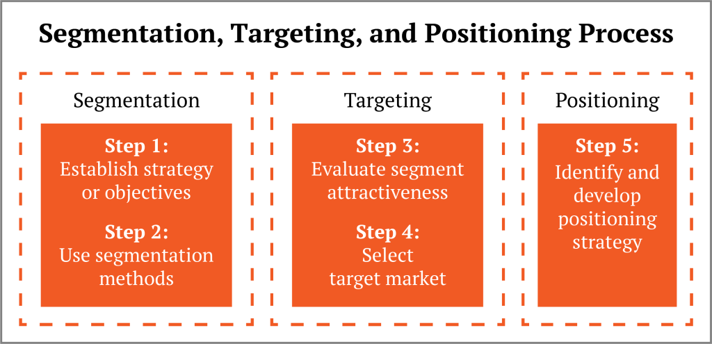
Figure 3: Segmentation, Targeting, and Positioning (STP)
Source: (Tanveer et al., 2021)

Market Segmentation
Demographic Segmentation: In the UK, IKEA is mainly focused on middle-income families and young professionals, as the average household income is 30000 pounds. These consumers want cheap but practical furniture in contemporary homes (Venaik and Midgley, 2019). In India, IKEA works with the emerging urban middle class of 28 years of age, with a median age of 28, targeting young families and young professionals (Inter IKEA Group, 2025). Affordability is, however, a factor in the price of products in India due to the income disparity in India.
Geographic: in the UK, IKEA stores are strategically positioned within the urban areas. As 94% of the population in the UK lives in urban areas (Inter IKEA Group, 2025). However, in India, IKEA concentrates primarily on metro cities such as Delhi and Mumbai, and not on tier-2 cities. The high rural population of India and logistical difficulties limit the geographical expansion of IKEA.
Psychographic: IKEA serves customers in the UK who appreciate sustainability, simplicity, and contemporary design. Statista (2020) indicates that 55% of consumers in the UK are interested in environmentally friendly products, which is in line with the sustainable product range offered by IKEA (Inter IKEA Group, 2025). In India, family-oriented values and practicality affect psychographic segmentation. Customers are more focused on long-lasting, practical goods, although at a cheaper cost, and not so focused on environmental sustainability as in the UK (Venaik and Midgley, 2019).
Behavioural: In the UK, the target consumers of IKEA are in the category of convenience seekers and frequent purchasers, who also like self-assembly and low prices. Technologically-advanced consumers who favour online shopping are also among the behavioural segmentation (Venaik and Midgley, 2019). Behavioural segmentation in India focuses on price-sensitive families and young people seeking affordable and durable furniture. The emergence of e-commerce in India has affected the buying behaviour, yet the physical shopping at the stores is still a major factor..

Targeting
In the UK, IKEA uses a differentiated targeting approach. IKEA targets middle-income families, young professionals and urban residents in the UK who are interested in cheap but stylish furniture. The purchasing power of the UK market is high, and this gives IKEA the ability to serve customers who value convenience and the cost factor (Kano and Verbeke, 2018). The widespread use of online shop platforms and well-structured supply chain management is an effort by IKEA to meet the needs of consumers who enjoy the convenience of shopping at the comfort of their homes.
The targeting strategy in India is designed to support the requirements of the urban middle classes, particularly in cities such as Delhi and Mumbai. IKEA lays more stress on affordability, considering the high number of price-sensitive consumers in India (Kano and Verbeke, 2018). Although the urban middle classes have been expanding, the pricing and product provisions provided by IKEA require further adjustment in order to support the rural markets.

Positioning
The UK market positioning of IKEA is founded on affordability, modern design, and sustainability. The company is viewed as an affordable, but fashionable option of cost-saving customers (Lee and Jin, 2019). Nevertheless, the growing threat posed by local and online furniture brands in the UK is an issue that the company may face in its quest to retain its competitive advantage.
IKEA in India is positioned as a low-cost and quality furniture company. Its focus is to provide products that meet the demands of small households, and especially those products that are family-friendly and durable (Lee and Jin, 2019). Nevertheless, the market in India is price-sensitive, and IKEA’s standard pricing strategy will, in many situations, need to be adjusted to fit the local expectations.

Perceptual Mapping
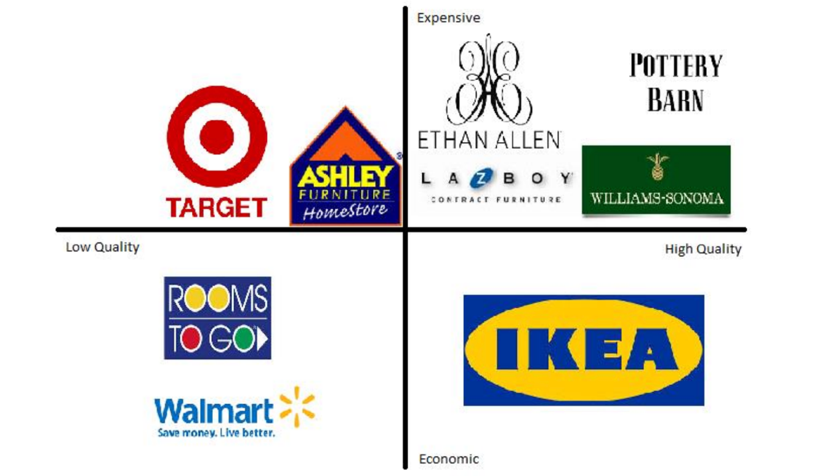
Figure 4: Perceptual Mapping
Source: (Yeğin and Ikram, 2022)
The perceptual map positions IKEA as a mid-range brand, one that balances between price and quality. It competes with such brands as Argos and B&Q in the UK and with the local furniture brands such as Godrej and online retailers such as Pepperfry in India (Yeğin and Ikram, 2022). The affordability and the eco-friendly nature of IKEA make it stand out in the UK, and in India, the company continues to grapple with competition on price at the local level.

Critical Evaluation
Similarities: The UK and India have huge urban populations, who constitute the central target market of IKEA. Both markets target cost-effective, functional furniture and the value-based pricing strategy at IKEA appeals to the middle-income segments (Vieira et al., 2019). Both markets are also considering sustainability, and IKEA’s eco-friendly efforts are increasingly attractive to environmentally conscious consumers in the two locations.
Differences: The UK market is more mature, having more purchasing power and preference towards premium products, whereas India is price sensitive and more localised products are needed (Vieira et al., 2019). The global model of IKEA can be applied more easily in the UK, whereas in India, it will need more cultural and economic adjustment.

5. Marketing Mix Analysis (7Ps)
The 7Ps of marketing are product, price, place, promotion, people, process and physical evidence. These seven elements provide a framework for planning and evaluating marketing strategies, and help ensure alignment between marketing strategies and customer expectations (Yang, 2018).
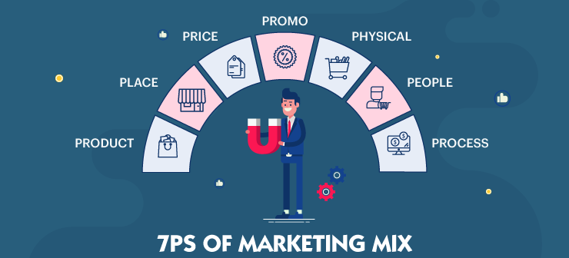
Figure 5: Marketing Mix Analysis
Source: (Yang, 2018)

Product
There is standardisation of products in IKEA UK, and minor modifications are made to meet the preferences. Which is like smaller, modern furniture (Yang, 2018). The concept of flat-pack, which has become popular with IKEA, makes the company easy to transport and affordable. Nevertheless, this strategy is not fully consistent with the growing demand for sustainable, environmentally friendly products, which are becoming more and more popular among competitors. Brand extension can be smart home solutions, sustainable product lines, modular storage systems, and home services.
India IKEA’s product design is determined by bigger families, the tastes of a region, and cultural practices (Yang, 2018). Also, IKEA is able to provide smaller-sized furniture to match the normally small-sized urban houses in India. Although the need to make local adaptations is paramount, IKEA's global standardisation strategy, in some instances, closely limits the ability to make additional customisation to suit India, with its varied regional tastes. In the appendix, the pictures of the product in both countries are available. Brand extension into affordable compact furniture, kitchen solutions, home décor, and services tailored to urban families.

Depth and Width of the Product
In the UK, it has a wide product width (furniture, kitchenware, decor, storage) and wide product depth with great variations of design, size and colour of each category of products.
In India, Product width is also broad, albeit in a more advanced manner, as compared to the product depth, which is narrow with fewer choices, and it is focused on the price advantage, utilisation of compact designs and local tastes.

Price
IKEA, in terms of the UK, has a value-based pricing policy of providing products to the middle-income bracket at a low price, but fashionable. The mid-price is 100-300 pounds, and it suits a product such as a sofa's quality and price (Inter IKEA Group, 2025). Post-Brexit inflation changes the prices of IKEA.
IKEA has employed a lower-cost strategy in India to serve the cost-conscious Indian market. IKEA has also reduced its prices to match the GDP per capita of India, of 2,000 dollars, in order to ensure its competitiveness despite its international pricing model. Prices of products such as chairs and tables range between ₹1,000 and ₹7,000, making it affordable to consumers in the lower middle classes (Inter IKEA Group, 2025). But this is a strategy that curtails IKEA's capacity to provide premium products in India in a market where other players, such as Godrej, are taking market share.

Place
IKEA has opened 22 stores in the UK; the majority of its stores are located in urban and suburban locations. Its omnichannel strategy allows it to have a strong presence in the online platform and deliver home (Chaudhuri, Vrontis and Chatterjee, 2024). The developed retail system in the UK enables IKEA to place much emphasis on store-based and online sales.
IKEA first concentrated on stores in metro centres like Delhi and Mumbai in India. Today, IKEA has 3 operational sites and is to be expanded (Kano and Verbeke, 2018). The company has a smaller presence online because of logistical issues and a less well-developed e-commerce infrastructure in India. In the appendix, the pictures of the stores in both countries are available.

Promotion
In the UK, Integrated Marketing Communication (IMC) are known as a concerted effort of advertising, digital media, PR and in-store promotion to deliver an in-store promotion that delivers a consistent brand of cheapness, designs, and sustainability (Altay, Okumuş and Adıgüzel Mercangöz, 2022). It is oriented towards sustainability, with frequently eco-friendly product lines appearing in advertising. The campaigns of IKEA are value-based with a sustainability emphasis to its brand image.
In India, Integrated Marketing Communications (IMC) is a combination of traditional advertising, online marketing, local advertising and influencer marketing to deliver the same but culturally adjusted brand message that is sensitive to the issue of affordability and family life (Franco, 2021). Nevertheless, the brand encounters difficulties using its global sustainability messages to fit the price-driven consumer base in India.

People
IKEA UK has 11,728 employees (Inter IKEA Group, 2025). The employee in IKEA in the UK is trained to set the standard of service to the customers consistently throughout the stores. The company focuses on effectiveness and consumer satisfaction (Lee and Jin, 2019).
IKEA India publicly states about 45,000 direct employees through its 48 suppliers in India (Inter IKEA Group, 2025). IKEA pays attention to cultural sensitivity and local training, in particular, when dealing with big families (Lee and Jin, 2019).

Process
In the UK, customers can complain at the in-store service desks, online customer support and helplines. The IKEA operational strategies in the UK are anchored on the effective supply chain and simple online ordering mechanism (Yang, 2018). It centres on getting them delivered on time and delivering the customer experience.
In India, customer complaints are made via store support, call centres and online avenues. But it can be resolved via third party logical and, thus, the process is comparatively slower than that in the UK (Yang, 2018). The challenge of the inadequate infrastructure of rural areas makes operational strategies difficult in India.

Physical Evidence
In the UK, the store designs of IKEA are standard from sleek and minimalist layouts. All stores have similar branding, and this adds strength to the IKEA brand (Inter IKEA Group, 2025). The contemporary, neat store design is correlated to the fact that the UK market prefers modern, utilitarian home furnishings.
Store design in India is designed with things that are close to local cultural aesthetics, like using wood, and also large layouts that are family-friendly (Vieira et al., 2019). It is branded so that it would attract the Indian clientele, yet the need to adopt the same level of design in several regions is still a challenge. In the appendix, the pictures of the website in both countries are available.

Similarities and Differences of 7Ps
Similarities: The UK and India markets are both characterised by great emphasis on affordability and functional design. The value-designated pricing, convenience, and sustainability are recurrent between IKEA in both of the countries (Khan et al., 2020). Another strategy that the company employs in the two regions is the omnichannel marketing strategy, where it uses both physical stores and online stores to reach a diverse market.
Differences: The retail environment is more established in the UK market, which enables IKEA to have a premium brand positioning but prices below. In its turn, the diversity of the culture and regions requires both more localisation of the product and a less expensive pricing policy (Tanveer et al., 2021). Also, the logistical issues in India and the dependence on brick-and-mortar stores restrict the effort by IKEA to reproduce the efficiency of its activities in the UK completely.

6. Directional Development Strategy
The Ansoff Matrix is a strategic instrument that assists businesses in evaluating growth opportunities by concentrating on product development and market development. The matrix comprises four strategies, which are Market Penetration, Market Development, Product Development, and Diversification (Hanaysha, Al Shaikh and Alzoubi, 2021). These approaches can be founded on the desire of a firm to increase its market share, venture into new markets, or work with the existing markets.
Strategic Application to India: In India, the growth strategy that IKEA has adopted could be best analysed in the Adsoff Matrix with regards to Market Development and Product Development. Market Development is the foremost consideration given that IKEA has only entered the Indian market in 2018. The introduction of its international brand into a new market, whose population is more than 1.3 billion people, was targeted by the company (Venaik and Midgley, 2019). Although IKEA was forced to tailor its products to suit the requirements of the price-sensitive and family-based consumer market in India, the business concept still stayed the same.
Nevertheless, Product Development is also imperative in India because the tastes are local. IKEA, as an example, launched bigger wooden furniture, compact room designs and low-cost prices that were specific to the Indian households. These are the local adaptations that enable IKEA to penetrate the Indian market in a better way (Venaik and Midgley, 2019). Nevertheless, this standardised line of products is a weakness of IKEA since the regional diversities with respect to tastes and expectations may demand new personalisation. Notwithstanding the success, the Market Penetration (expansion of IKEA in the existing markets) in India has not been smooth. The price sensitivity in India is more among mature markets such as the UK, and thus the company can not replicate the environmental success of Western markets (Yeğin and Ikram, 2022). Although the value-driven model of IKEA would be functional in the urban environment, it fails in the rural environment, where affordability is a more acute issue.

7. Ethical Issues in IKEA’s Marketing Mix
The marketing mix of the company (IKEA) in the UK and India has several ethical implications, especially those concerning labour practice, sustainability and consumer rights (Kano and Verbeke, 2018). IKEA focuses on cheap and utilitarian products in both markets; however, ethical issues surrounding the production and marketing of the products remain.
One of the ethical practices in the UK is IKEA’s sustainability. The company has gone a long way in utilising renewable energy in its activities and it has decided to make its products fully out of environmentally friendly or recycled products by the year 2030 (Inter IKEA Group, 2025). This is in accord with the increasing power of eco-friendly products in the UK where one in five consumers believes in sustainability and determines the choice of purchases (Yeğin and Ikram, 2022). Nevertheless, there is still an immoral aspect in the use of flat-pack furniture by IKEA, as it, though being cost-effective, produces a lot of waste in packaging. This waste is gaining more and more criticism in the UK as rival brands are driving towards more sustainable alternatives.
One of the ethical practices in India is IKEA's ability to deliver low-end home furnishing to the rising urban middle classes. IKEA's low-cost model will exclude high-end products and offer stylish furniture to many people with an annual income of around ₹1.5 lakh ₹(150,000) in the urban regions and social inclusivity (IKEA, 2026). There is, however, an unethical issue in India due to the labour practices within its local supply chains. However, even though IKEA puts its ethical labour policies on record, it is noted that there are cases where workers are subjected to poor working conditions and low wages in certain factories. Also, waste packaging is still a problem, particularly in a country that has limited recycling facilities.

8. Recommendations
New STP Strategies: IKEA will need to further decentralise the Indian market on the basis of socio-economic aspects to maximise market penetration by targeting different income groups with its products. IKEA can appeal to eco-conscious millennials in the UK, who are more interested in sustainability and less in prices. Paying attention to these segments, IKEA has the possibility to increase its market shares and make them more centered on the preferences of consumers (Hanaysha, Al Shaikh and Alzoubi, 2021). Nevertheless, consumer bases in both countries are quite varied, and that is why it is hard to apply the strategy of one size fits all successfully.
Innovations in the Marketing Mix: IKEA ought to be more creative in its products to make them more appealing to the local tastes in the two nations. IKEA can come up with furniture that is more region-specific in India, such as size, materials and design that would feel close to the Indian consumer (Franco, 2021). Although already adopting IKEA functional designs, the UK requires greater customisation in the high-end segment. By providing high-quality products that are more customised, one can win a market niche at a higher level. Such innovations need to take into account local culture, and IKEA cannot afford to stick to normalisation as experienced in previous problems in India.
Ethical Improvements: IKEA needs to increase its responsibility towards sustainability in both markets, especially by minimising packaging waste and increasing recycling activities. IKEA in India should also consider its labour issues through its suppliers by paying good wages and providing safe working environments. The opportunities that IKEA has to enhance its ethical image are to publish transparent reports regarding the activities in the supply chain and sustainability (Lee and Jin, 2019). The company also needs to focus more on the superior waste management solutions, especially in India, whose infrastructure is yet to be developed. Unless these issues are tackled, the efforts of IKEA as a company in terms of sustainability can be viewed as insufficient and threatening to its brand loyalty. The objectives of these strategic recommendations are to fit the marketing strategies of IKEA to suit both markets and improve its ethical practices, growth, and respond to emerging consumer expectations.

9. Conclusion
In this report, the international marketing strategies used by IKEA in both the UK and India were examined with an emphasis on the PESTLE analysis, STP strategies, and 7Ps of the company. Notable aspects of IKEA relate to its ability to adapt to the market requirements in the UK; however, in India, the apparent diversity of the market, in terms of both affordability and cultural orientations, has been identified as a challenge (Tanveer et al., 2021). IKEA developed sustainability and labour practices dealing with important ethical issues in the two markets. In the UK, IKEA has a very strong strategy, but in India, its strategy of standardisation suffers. IKEA needs to upgrade its products, go more localised, and become more ethical, especially in worker conditions and sustainability, to boost development.

10. Reflective Account (Kolb Reflective Cycle)
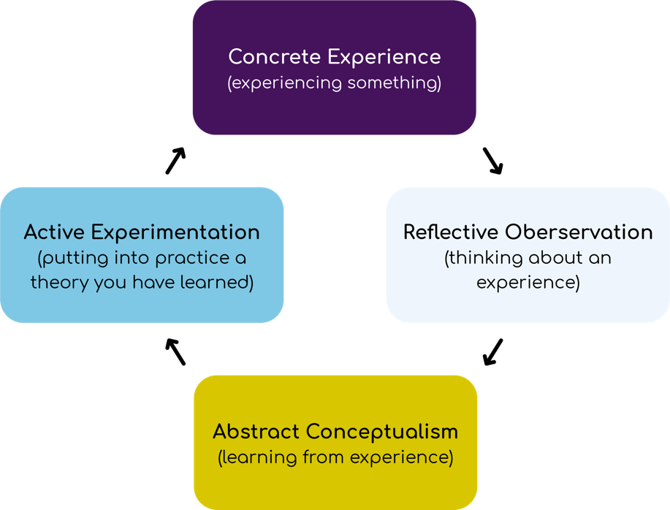
Figure 6: Kolb Reflective Cycle
Source: (Meijer et al., 2022)

Concrete Experience
The process of research included the analysis of marketing strategies of IKEA in the UK and India with emphasis on the 7Ps, the STP model, and the PESTLE analysis. At the beginning, I struggled to balance the richness of analysis and the need to write succinctly and powerfully. The two different markets of the UK and India posed different challenges, especially in the ways that IKEA differentiates its products and its marketing strategy to each (Meijer et al., 2022). My previous knowledge about marketing approaches was rather good ground but more critical thinking and flexibility were needed to apply these theories to the cultural and economic backgrounds of both nations.

Reflective Observation
My strengths include the fact that I was able to use theoretical frameworks such as PESTLE and the STP model. They assisted in structuring my research and had an organisational scheme to examine the international strategies of IKEA (Barker, Lencucha and Anderson, 2016). My analysis was supported with the help of statistical data, such as the average income levels in both countries to get a better understanding of the ways of how IKEA modifies its pricing and targeting strategies.
Nonetheless, I experienced the challenges in dealing with the constraints of standardisation throughout the IKEA global strategy. The theories that I originally applied did not adequately reflect the issues IKEA encounters in India, especially the theories concerning standardisation in international marketing (Meijer et al., 2022). The Indian socio-economic setting, with a strong income inequality and geographical dispersion, made me question the IKEA one-size-fits-all strategy. Sometimes I was limiting myself by using these theories that were not entirely applicable to such a diverse and intricate market as India. This missing theoretical fit left a gap in my analysis, especially on how the market penetration strategy used by IKEA can be made to work better in India.

Abstract Conceptualisation
This process has taught me to be highly critical in how I assess the theoretical model and the weaknesses linked to it when addressing real-world scenarios. To illustrate, with the STP framework being helpful in the division of markets, it fails to capture the depth of the culture and economic variations between countries such as India (Barker, Lencucha and Anderson, 2016). The insight into the possibility of models like the 7ps having to be modified to local environments instead of being applied equally across markets was an essential one.
Another thing I had discovered is that the sustainability work done by IKEA, though admirable, should be made more open (Morris, 2020). This was more evident when considering the ethical issues of labour practices and packaging waste. The ethical marketing theories helped to clarify the aspects of the brand image that IKEA could do better, with the emphasis on its supply chain activities.

Active Experimentation
To continue with my future academic or professional practice, I intend to be more adaptable in my approaches to theoretical frameworks. I will proceed with the STP model and PESTLE analysis, still I will approach all situations personally, taking into consideration local cultural peculiarities, maturity of the market and socio-economic complications, among other factors. This will enable me to come up with more realistic and more customised strategies, particularly when evaluating multinational companies that exist in varied market fields (Meijer et al., 2022). An example is using the Ansoff Matrix, as it has been applied to IKEA growth strategy in India, I was able to understand how crucial product development and market diversification can be and more significant than a standardised approach related to market development.
In addition, I will also explore the problem of ethical marketing more thoroughly, particularly the issues of labor and environmental sustainability (Morris, 2020). In the future, I will make sure that my analyses are based on both the performance of the business as well as the ethical aspects, which is in line with the consumer expectations and corporate responsibility. This approach will be effective in the professional practice environment to create holistic, socially responsible marketing strategies that are sensitive to profitability and ethical issues.

Conclusion
The given assignment helped me learn more about international marketing and its challenges related to applying the standard models to various markets, such as India. It emphasised flexibility, local studies, and ethics, in particular, sustainability (Meijer et al., 2022). The activity supported my academic competence and made me ready to face the marketing challenges in real life.

Reference
Altay, B.C., Okumuş, A. and Adıgüzel Mercangöz, B. (2022) ‘An intelligent approach for analyzing the impacts of the COVID-19 pandemic on marketing mix elements (7Ps) of the on-demand grocery delivery service’, Complex & Intelligent Systems, 8(1), pp. 129–140. Available at: https://doi.org/10.1007/s40747-021-00358-1.
Barker, D.J., Lencucha, J. and Anderson, R. (2016) ‘Kolb’s learning cycle as a framework for early fieldwork learning’, World Federation of Occupational Therapists Bulletin, 72(1), pp. 28–34. Available at: https://doi.org/10.1080/14473828.2016.1162373.
Chaudhuri, R., Vrontis, D. and Chatterjee, S. (2024) ‘External environment and internal dynamics of “born global”: strategic and operational firm performance’, Management Decision, 62(1), pp. 274–300. Available at: https://doi.org/10.1108/md-02-2023-0168.
Franco, S. (2021) ‘The influence of the external and internal environments of multinational enterprises on the sustainability commitment of their subsidiaries: A cluster analysis’, Journal of Cleaner Production, 297, p. 126654. Available at: https://doi.org/10.1016/j.jclepro.2021.126654.
Hanaysha, J.R., Al Shaikh, M.E. and Alzoubi, H.M. (2021) ‘Importance of Marketing Mix Elements in Determining Consumer Purchase Decision in the Retail Market’, International Journal of Service Science, Management, Engineering, and Technology, 12(6), pp. 56–72. Available at: https://www.igi-global.com/article/importance-of-marketing-mix-elements-in-determining-consumer-purchase-decision-in-the-retail-market/289416.
Hofstede Insights (2025) Country Comparison Tool, Theculturefactor.com. Available at: https://www.theculturefactor.com/country-comparison-tool?countries=india%2Cunited+kingdom (Accessed: 13 March 2026).
IKEA (2025) Page Restricted, Ikea.com. Available at: https://www.ikea.com/global/en/our-business/how-we-work/year-in-review-fy25/ (Accessed: 28 March 2026).
IKEA (2026) Get new perspectives on IKEA and life at home - IKEA Museum, https://ikeamuseum.com/en/. Available at: https://ikeamuseum.com/en/explore/the-story-of-ikea/ (Accessed: 17 March 2026).
Inter IKEA Group (2025) Inter IKEA Holding B.V. Annual Report FY25. https://www.inter.ikea.com. Available at: https://www.inter.ikea.com/-/media/interikea/igi/financial-reports/fy25-financial-reports/inter-ikea-holding-bv-annual-report-fy25-final.pdf?rev=10c81cc96c064789932e13ebf6229492&sc_lang=en (Accessed: 24 March 2026).
Kano, L. and Verbeke, A. (2018) ‘Theories of the multinational firm: A microfoundational perspective’, Global Strategy Journal, 9(1), pp. 117–147. Available at: https://doi.org/10.1002/gsj.1332.
Khan, E.A. et al. (2020) ‘The Impact of Enviropreneurial Orientation on Small Firms’ Business Performance: The Mediation of Green Marketing Mix and Eco-Labeling Strategies’, Sustainability, 12(1), p. 221. Available at: https://doi.org/10.3390/su12010221.
Lee, J.Y. and Jin, C.H. (2019) ‘The Role of Ethical Marketing Issues in Consumer-Brand Relationship’, Sustainability, 11(23), p. 6536. Available at: https://doi.org/10.3390/su11236536.
Meijer, M.W. et al. (2022) ‘Implementing Kolb´s Experiential Learning Cycle by Linking Real Experience, Case-Based Discussion and Simulation’, Journal of Medical Education and Curricular Development, 9, pp. 1–5. Available at: https://journals.sagepub.com/doi/full/10.1177/23821205221091511.
Morris, T.H. (2020) ‘Experiential Learning - a Systematic Review and Revision of Kolb’s Model’, Interactive Learning Environments, 28(8), pp. 1064–1077. Available at: https://doi.org/10.1080/10494820.2019.1570279.
Sageder, M. and Durstmüller, B.F. (2019) ‘Management control in multinational companies: a systematic literature review’, Review of Managerial Science, 13(5), pp. 875–918. Available at: https://doi.org/10.1007/s11846-018-0276-1.
Tanveer, M. et al. (2021) ‘Role of Ethical Marketing in Driving Consumer Brand Relationships and Brand Loyalty: a Sustainable Marketing Approach’, Sustainability, 13(12), p. 6839. Available at: https://doi.org/10.3390/su13126839.
Venaik, S. and Midgley, D.F. (2019) ‘Archetypes of marketing mix standardization-adaptation in MNC subsidiaries’, European Journal of Marketing, 53(2), pp. 366–399. Available at: https://doi.org/10.1108/EJM-11-2017-0861
Vieira, V.A. et al. (2019) ‘In pursuit of an effective B2B digital marketing strategy in an emerging market’, Journal of the Academy of Marketing Science, 47(6), pp. 1085–1108. Available at: https://doi.org/10.1007/s11747-019-00687-1.
Yang, M. (2018) ‘International entrepreneurial marketing strategies of MNCs: Bricolage as practiced by marketing managers’, International Business Review, 27(5), pp. 1045–1056. Available at: https://doi.org/10.1016/j.ibusrev.2018.03.004.
Yeğin, T. and Ikram, M. (2022) ‘Performance Evaluation of Green Furniture Brands in the Marketing 4.0 Period: An Integrated MCDM Approach’, Sustainability, 14(17), p. 10644. Available at: https://doi.org/10.3390/su141710644.

Appendix
IKEA UK Website
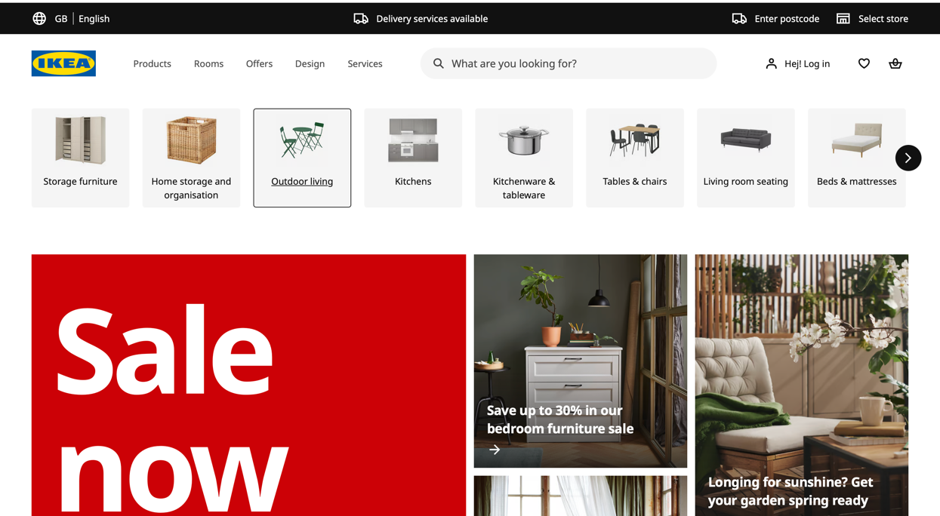
Website: https://www.ikea.com/gb/en/
IKEA UK Product
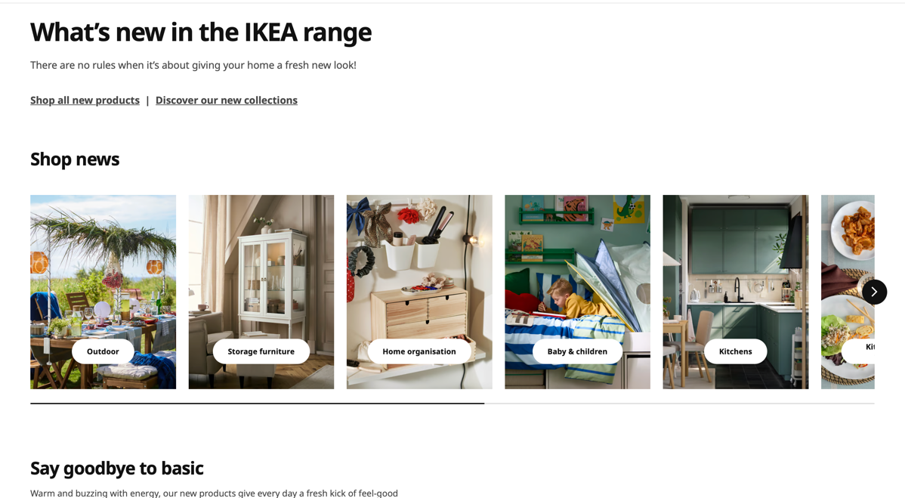
Website: https://www.ikea.com/gb/en/new/?itm_content=Nav&itm_element=Top&itm_campaign=news
IKEA India Website
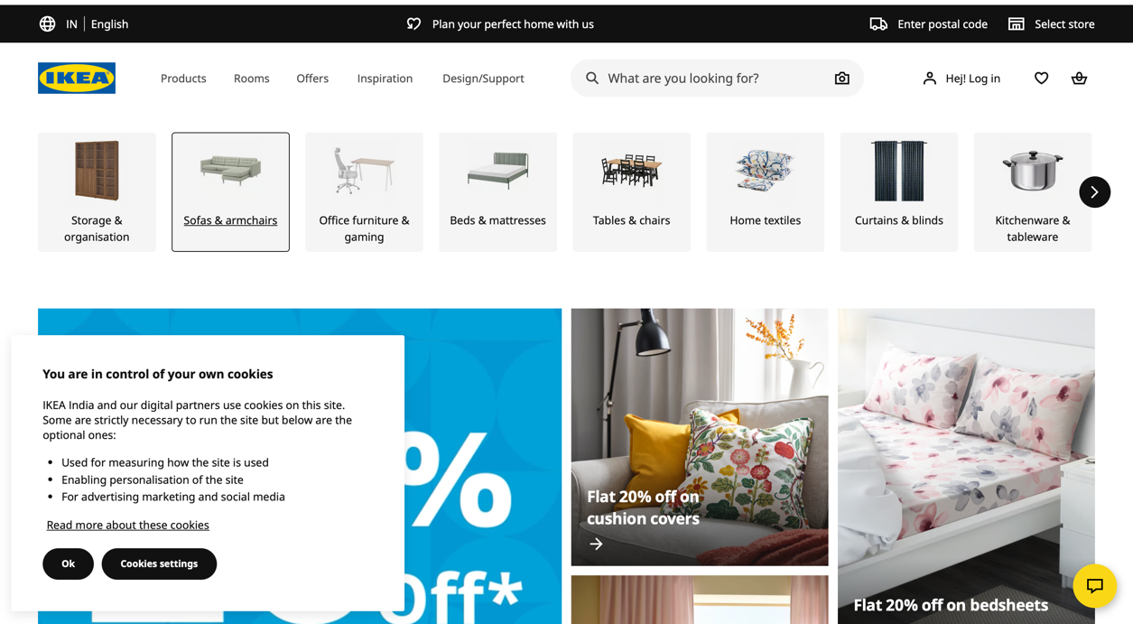
Website: https://www.ikea.com/in/en/
IKEA India Product
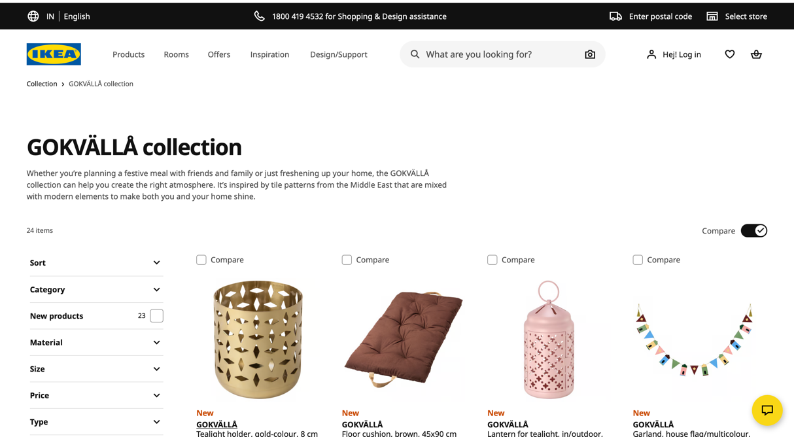
Website: https://www.ikea.com/in/en/cat/gokvaella-collection-60744/

IKEA UK Stores
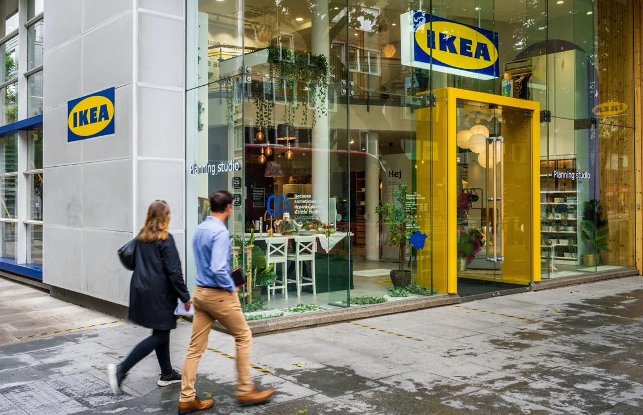
Website: https://www.theguardian.com/business/2021/oct/30/ikea-topshop-oxford-street-london-store-retail
IKEA India Stores
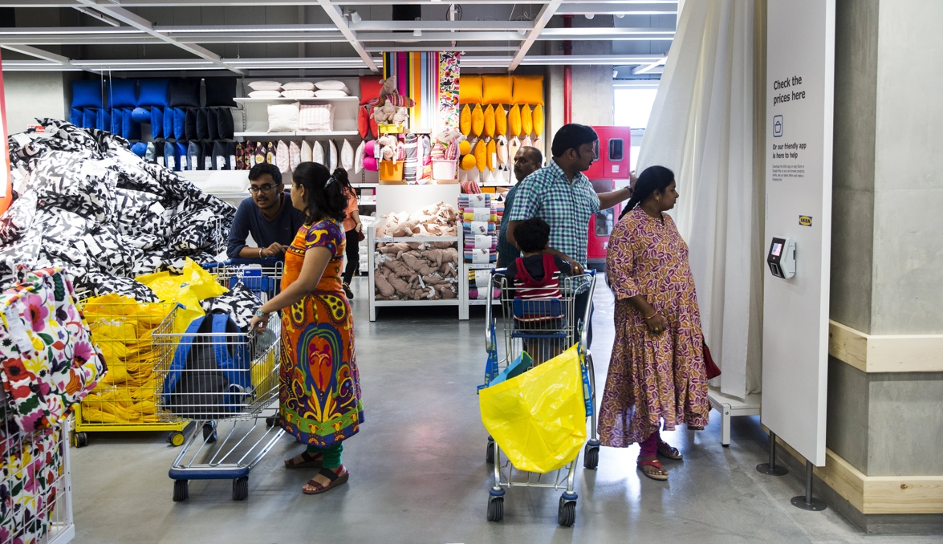
Website: https://www.cnbc.com/2018/08/09/ikea-opens-first-india-store-in-hyderabad.html
IKEA UK Employee

Website: https://www.ikea.com/gb/en/this-is-ikea/work-with-us/why-work-with-us-because-a-job-with-us-is-so-much-more-than-a-job-pub1969c310/
IKEA India Employee

Website: https://www.ikea.com/global/en/stories/sustainability/opening-doors-to-diversity-in-india-230101/

