LCBB4004
Marketing Fundamentals

NAME-RAMNEEK SINGH
STUDENT ID-2225138
COURSE-BA BUSNIESS MANAGEMENT
LECTURER-TUSHARA BALENDRAN



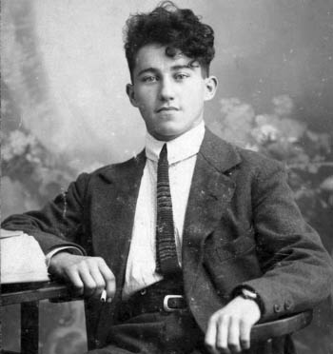
Dassler Brothers Shoe Factory

Adolf Dassler

BACKGROUND OF ADIDAS
Adidas could be a company that was established in Germany in 1924. It makes shoes, clothing, and sports gear. It is the greatest company in Europe and the moment greatest within the world after Nike. Adolf Dassler begun the company with his two brothers. They utilized canvas to make strides the quality of the spikes they made for distinctive occasions and utilize elastic rather than metal
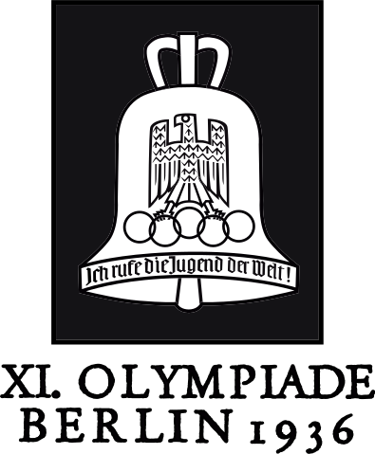
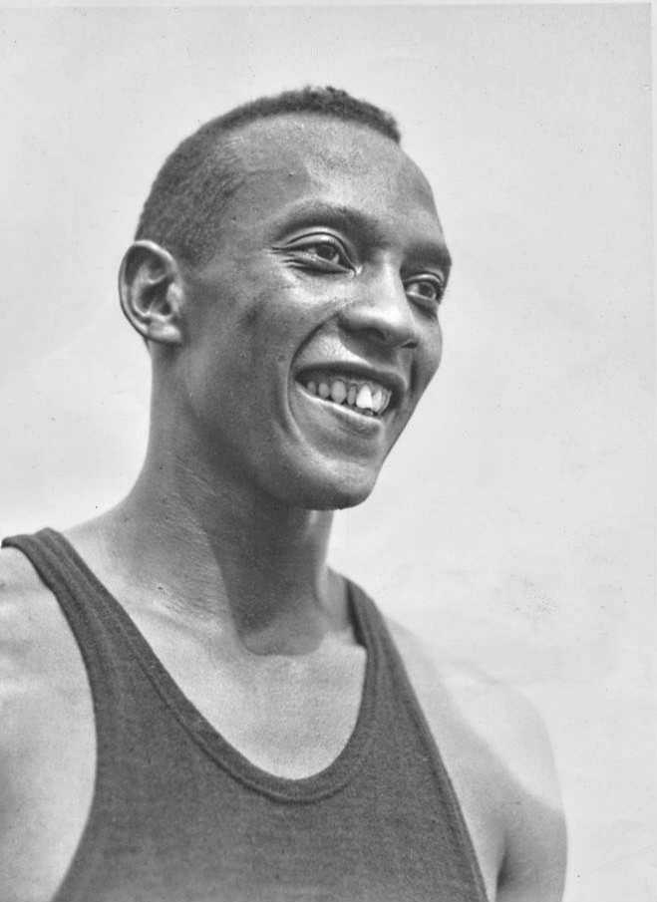
Jesse Owens
Berlin Olympics

In 1936, Dassler contacted Jess Owens to use his spikes at the 1936 Summer Olympics Games. Jess Owens won four gold medals with the help of the Dassler shoes, and the Dassler brothers' marketing of the shoes was very successful. The Dasslers were selling more than 150,000 pairs of shoes a year before World War II began. However, in May 1933 the Dassler brothers split up over political views, with Rudolf founding Puma and Adi renaming his company Adidas, combining his nickname and last name.
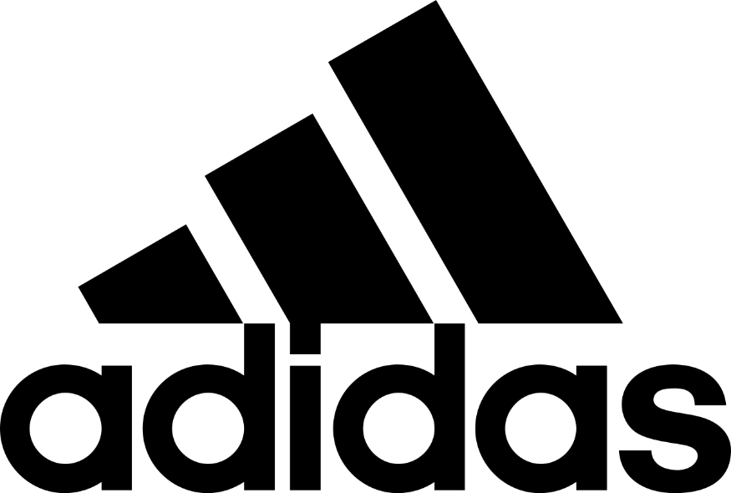
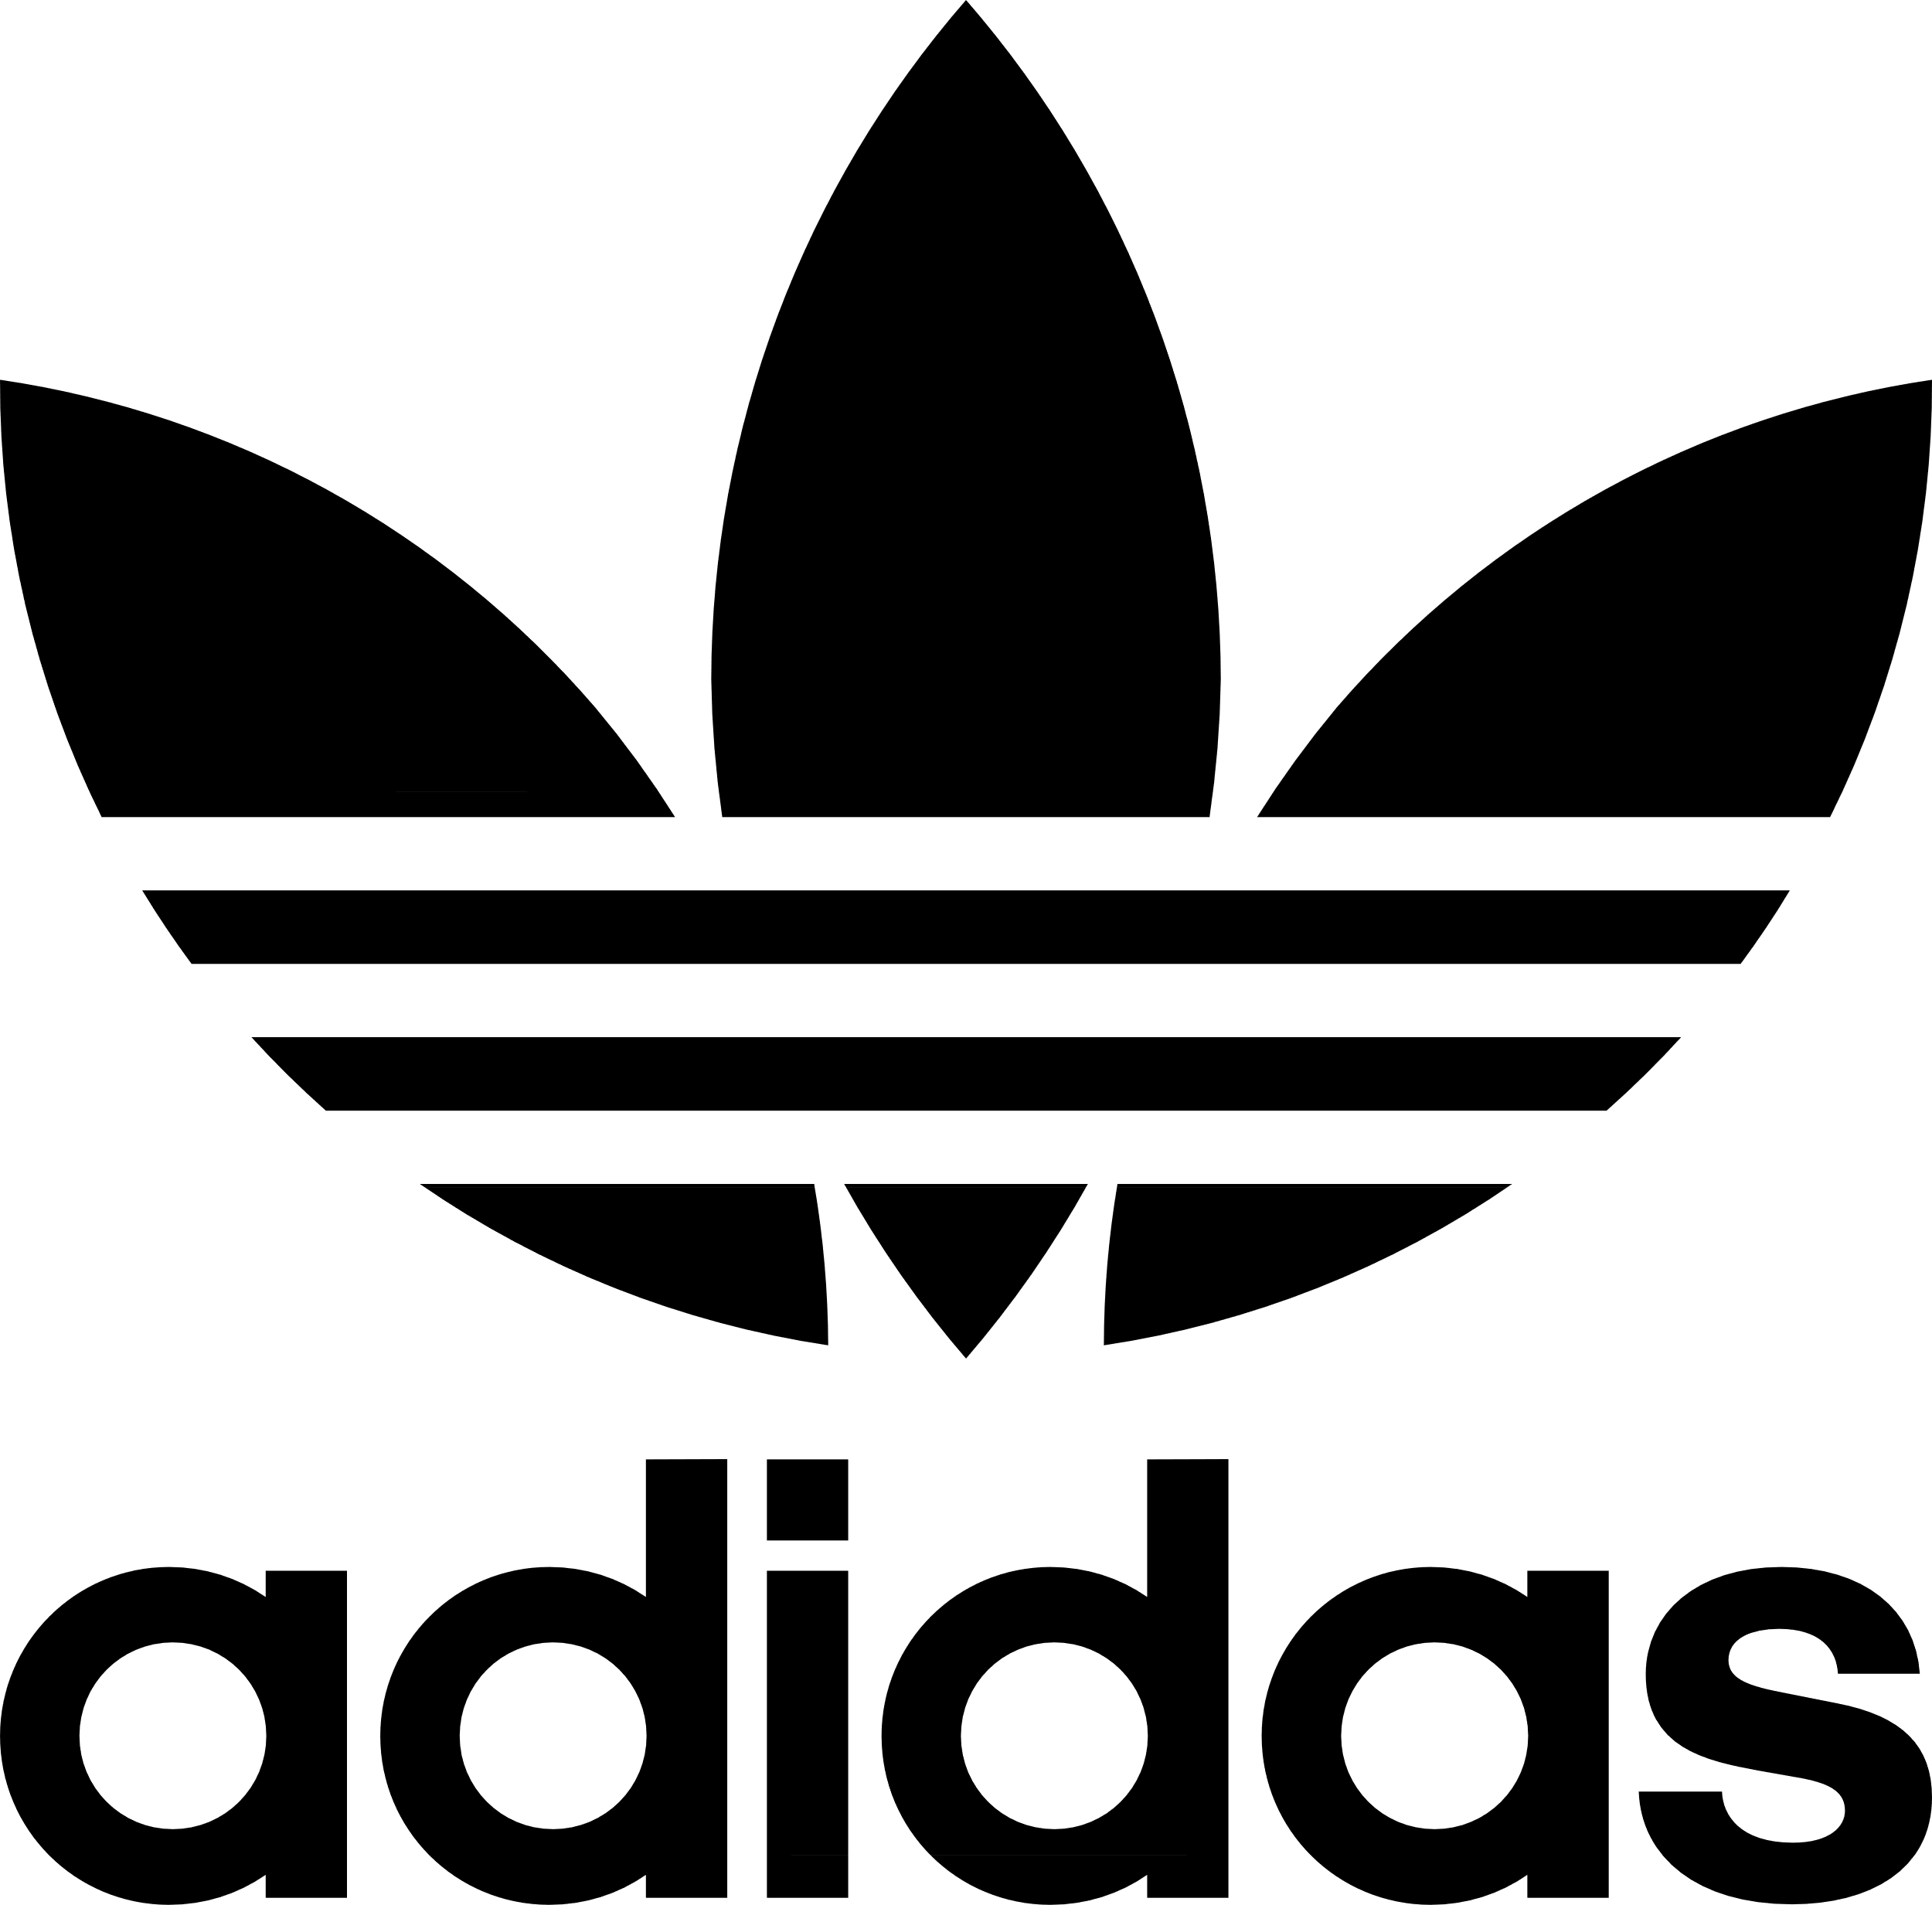

Adidas get its signature 3-stripe symbol from the Finnish athletic footwear brand Karhu Sports, for two bottles of bourbon and the break even with to €1600.The symbol was planned in 1971 and propelled in 1972. After the passing of Adolf Dassler's child Horst Dassler in 1987, the company was bought in 1990 by French industrialist Bernard Tapie, for ₣1.6 billion (presently €243.9 million). Tapie chosen to move generation to Asia. He moreover contracted Madonna for advancement.
• In 1994, FIFA Youth's connection received the most awards.
• In 1997, Adidas AG acquired the ski apparel manufacturer Salomon Gather, changing its name to Adidas-Salomon AG.
• In 1998, Adidas sued the NCAA for violating its rules limiting the size and quantity of commercial logos on team uniforms and apparel.
• From 1993 to 2000, Louis-Dreyfus earned €5.84 billion ($7.5 billion) as the CEO of Adidas. He announced his impending departure in 2000, citing illness.
• In September 2004, Adidas and renowned English fashion designer Stella McCartney launched a joint-venture line.
• On May 3, 2004, Adidas announced that they had agreed to pay Amer Sports in Finland $423 million through their partner firm Salomon Bunch.
• In Admirable 2005, Adidas announced it deliberate to purchase Reebok for $3.8 billion (US$)
• On 11 April 2006, Adidas declared an 11-year bargain to ended up the official NBA clothing supplier.
• By the conclusion of 2012, Adidas was detailing their most elevated incomes ever. Adidas presently has worldwide corporate base camp in Herzogenaurach, Germany and numerous other commerce areas around the world such as London, Tokyo, Australia, Taiwan and Spain.
• In January 2015, Adidas propelled the footwear industry's to begin with reservation portable app. The Adidas Affirmed app permits buyers to induce get to to and save the brand's limited-edition tennis shoes by utilizing geo focusing on innovation.
• In May 2017, Adidas sold TaylorMade golf company (counting Ashworth) to KPS Capital Accomplices for $425 million.
• In Walk 2022, Adidas offer Reebok to the Bona fide Brands Gather
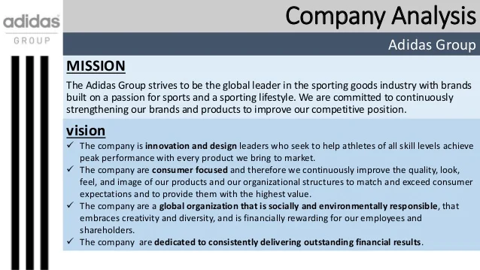

Adidas wants to be the best at making sports gear, and they think that by doing this, they can help their brands and products become even better. Some of the things that make Adidas a great choice when it comes to sports gear are their dedication to quality, their focus on making products that athletes will love, and their desire to keep their brands as strong as possible.
- Developing brand
- Improving expectational experiance
- Creativity

Vision Idea
Adidas vision thought is “to be the arrange pioneers with a center on getting the finest out of the competitors with execution guaranteed things inside the sports promote generally. • Being the arrange leader-In the essential component of this vision enunciation, Adidas re-emphasizes that it isn't a company that sits back and takes after the rest. Instep, it is driven by the imagination and need to lead the rest by setting a quality bar that meets wants of its clients.
PRODUCTS OF ADIDAS

Men's and women's t-shirts, jackets, hoodies, pants and legings are just a few of the garments made by adidas. Designed in 1967, Franz His Beckinsale His Tracksuit was Adidas' first garment. Adidas AG is the world's largest producer of sports bras and the largest in Europe.

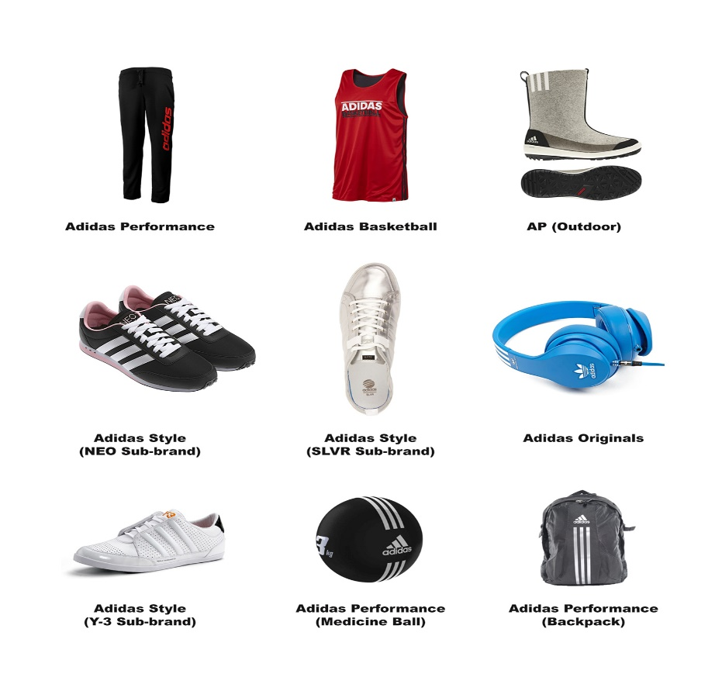
The Argentina national team's 2014 FIFA World Glass shirt was marked by Diego Maradona. Signed Spain national group shirt from the 2014 FIFA World Glass Adidas has continuously prioritized football dress and the gear that goes with them. Adidas is still a major supplier of shirts for clubs and groups competing in worldwide affiliation football. Within the 1950s, when more soccer players started wearing Adidas' light-weight shoes with screw-in cleats, the company seen ceaseless improvement. Taking after that, the company created a line of donning things and presented soccer footballs in 1963. After four a long time, Adidas started creating dress. For a long time, Adidas was the most brand of donning shoes, but competition heightens amid the 1970s, especially from more up to date companies like Nike. In spite of an inventive underwriting course of action with the rap gather Run-D.M.C., makers of the effective melody "My Adidas" (1986), the firm saw reducing showcase offers within the 1980s taking after Adi Dassler's passing in 1978. (Concurring to a 2016 assention with rapper and businessman Kanye West, the organization would once once more collaborate with hip-hop.) Between 1990 and 1993, Bernard Tapie, a scandal-tainted French trade tycoon, claimed Adidas but was incapable to turn the company around. The company was sold to financial specialists, who designated another Frenchman, Robert Louis-Dreyfus, as chairman and CEO. Beneath his authority, Adidas bought the Salomon Gather in 1997. In spite of being most recognized for its winter sports clothing, Salomon too claimed the golf gear firm TaylorMade. In 2001, Taking after Nike's lead, Adidas changed their title to Adidas-Salomon AG and entered the retail advertise. In 2004, the company effectively worked with mold creator Stella McCartney. Adidas sold Salomon in 2005 but kept the TaylorMade title. The following year, the company title was changed back to Adidas AG. Adidas helped buys included the Rockport shoe producer Five Ten and the Reebok company, which fabricated shoes under the Rockport title. TaylorMade was procured by Adidas in 2017.

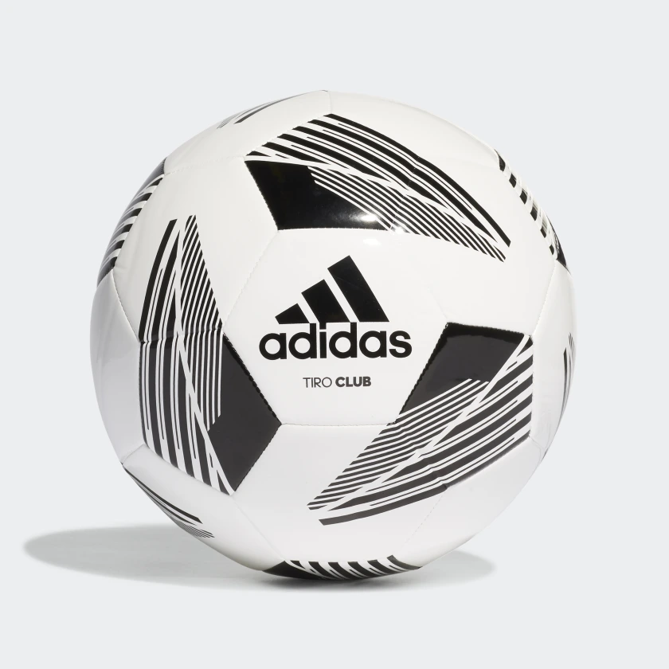

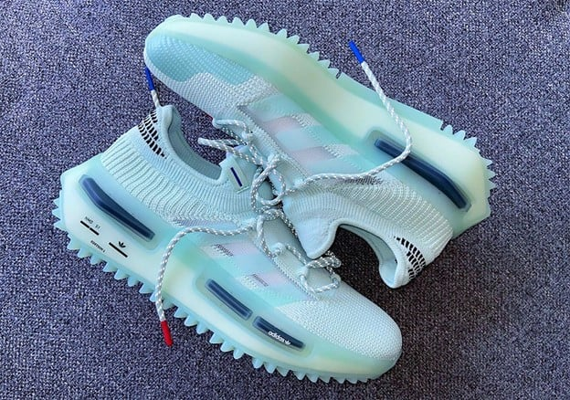
$5,184
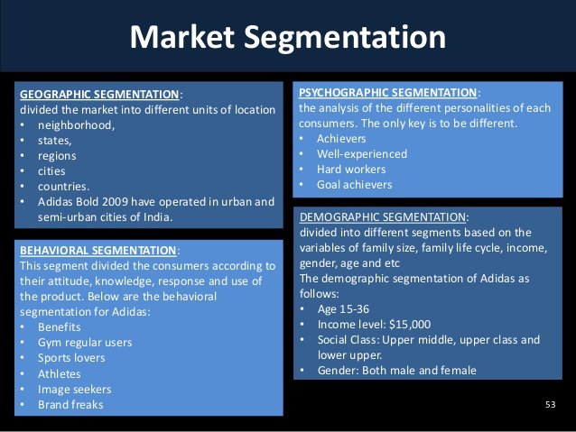
- GEOGRAPHIC SEGEMENTATION
- PSHYCHOGRAPHIC SEGMENTATION
- BEHAVIORAL SEGMENTATION
- DEMOGRAPHIC SEGMENTATION
Britain has been a high-risk advertise for Adidas. In spite of this, Dave Thomas, Adidas India's overseeing chief, remains idealistic almost the country's future. By 2020, the firm pointed to fourfold its deals from Rs. 805 crores. In 2015, the firm locked in Ranveer Singh, a well-known Bollywood on-screen character, as a brand envoy for its merchandise. Ranveer was a rising star at the time. A while later, the organization chosen to capitalise on the people's about over the top dedication to the diversion of cricket to showcase its brand. It rapidly started a new cricket thrust within the nation. The advertisement, FeelLoveUseHate, was made in collaboration with eminent Indian cricketer Virat Kohli. Shockingly, Virat Kohli was let got the company's brand envoy in 2017. The cricketer afterward gotten a profitable contract. 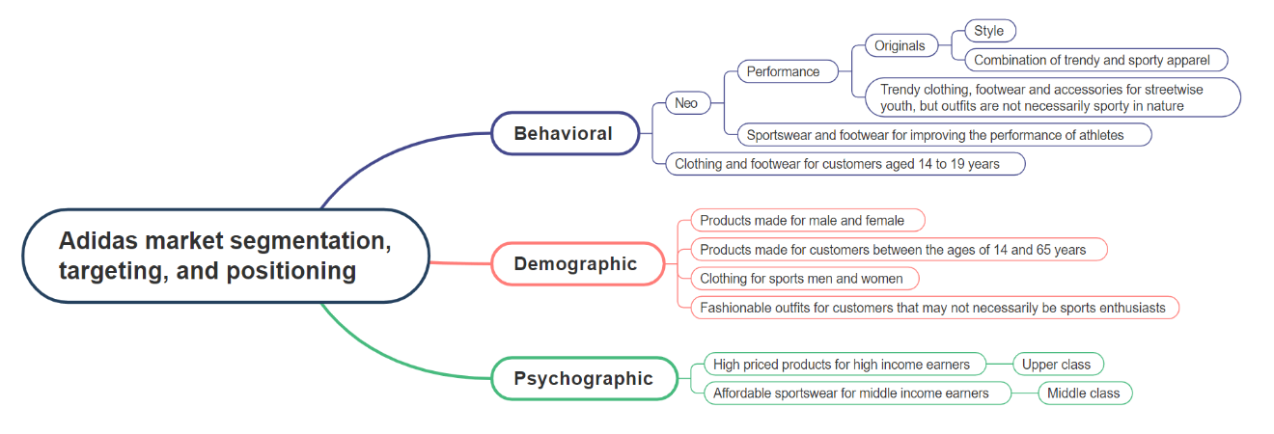
his brand arrange in unmistakable thing in push checking footwear, clothing, decorations, football unit, golf equipment, etc. The expand of Adidas things in addition disconnected concurring to unmistakable wear entertainments for which Adidas gives units and equip. Many of the sports entertainments where the company majors in giving the gather units all comprehensive are:

Alliance football, Baseball, Ball, Cricket, Aerobatic, Ice hockey, Lacrosse, Running, Skateboarding, Tennis, Kabaddi, and Golf.
Adidas has picked up colossal reputation by opening its assistants tallying Reebok, Runtastic, TaylorMade, and Rockport. In show disdain toward of the reality that there are around 110 reinforcements of Adidas Around the world, the reinforcement that outperformed Adidas itself is Reebok footwear and attire. While Runtastic may be a progressed prosperity and Wellness app, TaylorMade is centred on hitting the fairway dress and Rockport offers open discuss footwear, clothing, and embellishments.
In show disdain toward of the reality that this company offers distinctive things, its major thing line is Footwear. Given that Adidas' establishment was built on footwear itself, its footwear is still considered the first solid and athletic inside the promote, taken after by its clothing and additional items.
It can be concluded that the 71-year-old Adidas is still a overwhelming and productive company out there. It has come up with many of the first innovative campaigns and its creative gather has never fizzled to boost the certainty of sports noteworthy others and teenagers inside the company around the world. Adidas has kept up its validity and legitimacy by persistently catering to its target grandstand by giving quality things. Their thousands of outlets all over the world have made the brand easily accessible. With their signature branding, Adidas has made for itself a recognized position inside the exhibit.
Clients with removed way better; much better; the next; more grounded; and made strides the next social position are more likely to buy Adidas things that are more expensive. Clients with a lower social position have the choice of obtaining things that are more sensible to them. Clients who appreciate sports are more likely to purchase wearing stock from Adidas, though clients who do not appreciate sports are more likely to purchase things from Nike. Clients that appreciate street-styled attire would most likely purchase their craved things from Adidas Firsts or Mild, as they share comparable interface. This happens since they have comparative behavioural designs and may relate to one another.
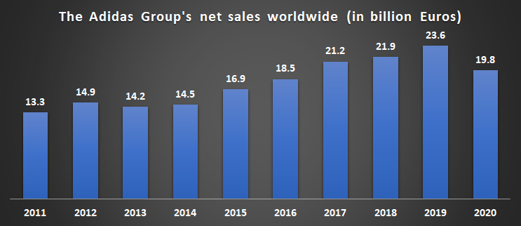
Adidas provides apparel, accessories, and shoes for both male and female customers, thus allowing them to target a wider range of ages and genders. this will help them to better tailor their products and services to the exact requirements of certain demographics, which will help the company to remain competitive and profitable, possibly avoiding powerful rivals.
In May 2017, Adidas sold TaylorMade golf company (including Ashworth) to KPS Capital Partners for $425 million.
In March 2022, Adidas sold Reebok to the Authentic Brands Group, for ca. $2.5 billion.

Referencing
- "The History of Adidas". On This Day In Fashion. Archived from the original on 17 March 2013. Retrieved 16 October 2015.
- "Ranking of the largest sporting goods manufacturers worldwide in 2009, based on revenue". Statista.com.
- "The History of Track Spikes". Freelap USA. 15 February 2014. Retrieved 2 June 2017.
- "Adidas 1 Is the Most Technically Advanced Running Shoe". Popular Mechanics. 7 December 2004.
- "Adidas launches mass-produced ocean plastic trainers". Edie. 15 November 2016.

